Characterisation of a Bi-functional Catalase-peroxidase of Burkholderia cenocepacia

Panagoula Charalabous*¹, Janet M. Risk², Rosalind Jenkins³,
Andrew J. Birss¹, C. Anthony Hart⁴ and John W. Smalley¹

¹Microbiology, and ²Molecular Genetics and Oncology Groups, School of Dental Sciences, ³Biomedical Sciences Proteomics Facility, Department of Pharmacology & Therapeutics,
and ⁴Department of Medical Microbiology and Genito-Urinary Medicine, The University of Liverpool, Daulby Street, Liverpool L69 3GN, UK

Running title: Burkholderia cenocepacia catalase-peroxidase

Key words: catalase-peroxidase, Burkholderia cenocepacia, cystic fibrosis

Author for Correspondence: Dr John W Smalley
Tel +44 151 706 5272;
FAX: +44 151 706 5809;
E-mail: josmall@liv.ac.uk

* Dr P Charalabous, current address: Department of Physiology, School of Biomedical Sciences, Crown Street, Liverpool L69 3BX, UK.

Abstract
Isolates of Burkholderia cenocepacia express a putative haem-binding protein (M_{r} 97kDa) which displays intrinsic peroxidase activity. Its role has been re-evaluated, and we now show that it is a bi-functional catalase-peroxidase, with activity against tetramethylbenzidine (TMB), o-dianisidine, pyrogallol, and 2,2’-azino-bis(3-ethylbenzthiazoline-6-sulphonic acid (ABTS). Both peroxidase and catalase activities are optimal at pH 5.5-6.0. The gene encoding this enzyme was cloned and expressed in E. coli. We have named it katG because of its similarity to other katGs including that from Burkholderia pseudomallei. It is substantially similar to a previously described catalase-peroxidase of B. cenocepacia (katA). Mass spectrometric analysis indicated that the initial katG translation product may be post-translationally modified in B. cenocepacia to give rise to the mature 97kDa catalase-peroxidase.
INTRODUCTION
Burkholderia cenocepacia (genomovar IIIa) isolates are associated with life-threatening lung infections that may progress to septicaemia (“cepacia syndrome”) in cystic fibrosis (CF) patients [1]. These bacteria were shown to express a 97kDa putative haem-binding protein [2], but more recent studies [3] showed that this protein does not bind haem dose-dependently, and is peroxidase positive even without prior exposure to exogenous iron(III) protoporphyrin IX. These newer findings lead to the possibility that it is not a true haem-binding protein. In the present study, we re-evaluated the properties of the 97kDa protein and demonstrated it to be a bi-functional catalase-peroxidase. The gene encoding this protein was cloned and expressed in Esherichia coli, and a survey of its distribution in bacterial strains of the “Burkholderia cepacia complex” was undertaken.

Materials and Methods

Bacterial strains and growth conditions. B. cenocepacia clonal isolates strains BC7, C5424, C6433 and J2315 (expressing the 97kDa putative haem-binding protein) were maintained by subculture on horse-blood agar. For peroxidase and catalase studies the cells were sub-cultured three times on Columbia or M9 Minimal Salts Medium agar (Sigma Chemical Company) before growth in bulk on these solid media as lawn growths for 3 days. Cells were harvested into and washed twice in 0.14M NaCl, 0.1M Tris-HCl, pH 7.5 to remove any contaminating growth medium constituents. For molecular genetic studies, E. coli strains were grown in Luria-Bertani (LB) broth or agar, supplemented with 100µg ampicillin ml⁻¹ where appropriate.

SDS-PAGE and staining for peroxidase and catalase activity. Cell samples of strain J2315 were solubilised in non-reducing sample buffer (37°C for 1h), electrophoresed on 10% acrylamide gels and stained with 3,3’,5,5’-tetramethylbenzidine (TMB)/H₂O₂ [2]. Gels were counter-stained with Coomassie Blue [3] to precisely identify the positions of peroxidase bands. Chromogenic peroxidase substrates o-dianisidine (3,3’-dimethoxybenzidine), pyrogallol (1,2,3-trihydroxybenzene), 4-chloronaphthol, guaiacol (2-methoxyphenol), and ABTS [2,2’-azino-bis(3-ethylbenzthiazoline-6-sulphonic acid (all at 6.3mM) were also tested using the same procedure as for TMB above. Catalase activity was detected in samples as above using the K₃Fe(CN)₆/FeCl₃-H₂O₂ method of Katsuwon and Anderson [4], in which catalase-positive bands appear as clear zones against a dark brown background.

Effect of pH on the peroxidase and catalase activities. Replicate gel tracks of cell samples (strain J2315; 25µg protein) were incubated, after electrophoresis, in 0.14M NaCl buffered at pH 9.0, 8.5, 8.0, or 7.5 with 0.1M Tris-HCl, or at pH 7.0, 6.5, 6.0, or 5.5, buffered with 0.1M sodium acetate/acetic acid, for 1h. The gel strips were developed in K₃Fe(CN)₆/FeCl₃-H₂O₂ or TMB-H₂O₂ to reveal catalase and peroxidase bands, respectively.
pH-activity profiles for whole cell catalase and peroxidase. Peroxidase activity was measured by monitoring ΔA_{645nm} after incubation of cell suspensions (J2315; 250µg protein ml⁻¹) in the above buffers at 20°C with 6.3 mM TMB plus 10mM H₂O₂ [5]. Catalase activity was measured at 20°C in the above suspensions by monitoring ΔA_{240nm} [6], using 8mM H₂O₂ as substrate. Catalase and peroxidise activities were expressed as either pmole H₂O₂ degraded or pmole TMB oxidised per minute.
Protein separation and mass spectrometry. Protein bands from Coomassie Blue-stained 1D gels were excised and destained and dehydrated by incubation with 50% acetonitrile/50mM ammonium bicarbonate for 1h at room temperature, followed by vacuum drying in a SpeedVac (Eppendorf). The gel pieces were rehydrated in 50mM ammonium bicarbonate containing 40ng/µL modified trypsin (Promega) and incubated for 16h at 37ºC. Peptides were extracted from the gel by incubation with 2 changes of 60% acetonitrile/1% trifluoroacetic acid, and the resulting supernatants were again dried in a SpeedVac. The extracts were desalted using C18 ZipTips according to the manufacturer’s instructions (Millipore), and were reconstituted in a final volume of 30µL 5% acetonitrile/0.1% trifluoroacetic acid. Aliquots of 0.5µL sample were spotted onto a MALDI target plate together with an equal volume of 5mg/mL α-cyano-4-hydroxycinnamic acid (LaserBiolabs, France) in 50% acetonitrile/0.1% trifluoroacetic acid. Peptide mass fingerprints were acquired either on a Voyager DE Pro MALDI (Applied Biosystems, California, USA) or a M@LDI (Micromass , Manchester, UK) instrument in positive ion reflector mode. Data were submitted for screening via the Mascot search engine (Matrix Science, London). The mass tolerance was set to 100ppm, and 1 missed cleavage and no modifications were allowed. For LC-MS/MS analysis, aliquots of 5µL sample were delivered into a QSTAR Pulsar i hybrid mass spectrometer (Applied Biosystems) by automated in-line liquid chromatography (integrated LCPackings System, 5mm C18 nano-precolumn and 75μm x 15cm C18 PepMap column (Dionex, California, USA)) via a nano-electrospray source head and 10μm inner diameter PicoTip (New Objective, Massachusetts, USA). A gradient from 5% acetonitrile/0.05% TFA (v/v) to 48% acetonitrile/0.05% TFA (v/v) in 60mins was applied at a flow rate of 300nL/min, and MS and MS/MS spectra were acquired automatically in positive ion mode using information-dependent acquisition (IDA) (Analyst, Applied Biosystems). Database searching was carried out using Mascot with mass tolerances set to 1.2Da for MS and 0.6Da for MS/MS, and with deamidation as a variable modification.
Cloning of the catalase-peroxidase (katG) gene from B. cenocepacia strain J2315. Genomic DNA was amplified by PCR using the primers CACCATGTCGAACGAAGGGCAGT and CGATGTACCACCGCTTTT. PCR was performed with an initial denaturation step at 94°C for 5 min, followed by 35 cycles each of 1 min at 94°C, 1 min at 58°C, 3.5 min at 72°C, and a final extension step at 72°C for 5 min. PCR products were electrophoresed on a 1% (w/v) agarose gel and visualised using ethidium bromide to confirm a single product of the correct size before cloning into pET-100/D-TOPO (Invitrogen) to produce pKatG and transformation of One Shot® TOP 10 chemically competent E. coli cells (Invitrogen). Successful insertion of the gene in the correct orientation was confirmed by restriction analysis.
Sequencing of katG. The katG was sequenced from pKatG plasmid DNA using multiple overlapping IRD-700-labelled forward and reverse primers (MWG-Biotech Ltd., UK; details on request) and employing the SequiThermEXCELTM II DNA Sequencing Kit-LC (Epicentre Technologies) in a LI-COR 4200S auto-sequencer. The sequencing data were viewed using the LI-COR Base ImagIRTM software in conjunction with the Sequencher programme (http://www.genecodes.com).
Expression analysis. BL21 StarTM One Shot E. coli cells were transformed with the pKatG plasmid and induction of expression was undertaken by growth at 37°C in the presence of 0.1M isopropyl β-D-thioglucopyranoside (IPTG; Sigma). Pelleted cells were electrophoresed as above and assessed for catalase and peroxidase activity by in-gel staining.

Results
As previously reported [2], a major peroxidase-positive protein of 97kDa was seen for B. cenocepacia strain J2315 (Fig. 1, tracks b and h). The 97kDa enzyme also showed peroxidase specificity towards o-dianisidine, ABTS and pyrogallol (Fig. 1, tracks c, e, and g), but guaicol (methoxyphenol) and 2-chloronaphthol were not peroxidised (Fig. 1, tracks d and f). Using in-gel K₃Fe(CN)₆/FeCl₃/H₂O₂ staining, the 97kDa peroxidase protein was also shown to display catalase activity (Fig 1, track a), a phenomenon also demonstrated by the clonal isolates BC7, C5424 and C6433 (data not shown). The catalase activity of the 97kDa enzyme of strain J2315 was not inhibited by pre-exposure of the cells for 1h to the specific mono-functional catalase inhibitor 3-amino-1, 2, 4-triazole (20mM). Peroxidase activity against substrates TMB, ABTS and o-dianisidine was also unaffected by the inhibitors isonicotinic acid and niacinamide (all 20mM) [8] (data not shown). In general, the catalase activity visualised by the in-gel assay was stronger than the peroxidase staining.
Both catalase and peroxidase activities were observed in SDS-PAGE gels over the pH range 5.5 to 8.5, whilst little or no activity was seen at pH 9.0 (Fig. 2). Both enzyme activities were generally low at alkaline pHs, and highest over the acid pH range, and scanning densitometry confirmed maximal catalase and peroxidase activities at pH 6.0 and 5.5, respectively. Peroxidase activity of suspensions of whole cells of strain J2315 against TMB was not detected at neutral or alkaline pHs, but maximal activity was seen at pH 6.0 (Fig. 3a). In contrast, low levels of catalase activity of whole cells were observed at alkaline pH, rising in the acid pH range to a maximum at pH 6.0 (Fig 3b).
Masses of tryptic peptides of the 97kDa catalase-peroxidase were obtained by MALDI-TOF mass spectrometry and matches were obtained to the KatG catalase-peroxidases of Burkholderia pseudomallei [9] and Mycobacterium tuberculosis [10], and to an archeal catalase-peroxidase of Haloarcula marismortui [11]. This genomic data was aligned with the sequence of the J2315 strain (http://www.sanger.ac.uk/Projects/B_cenocepacia/) and used to design primers to a putative open reading frame (ORF) of 2211 bases (768 amino acids) on chromosome 2 which was cloned and re-sequenced (accession number DQ112341). This ORF was subsequently identified in the published B. cenocepacia genome (Sanger Institute) and was calculated to have a size of 80.5kDa. A second ORF was also identified at 3612912-3615098 on chromosome 1, which possessed 73% identity and 81% similarity to the first catalase-peroxidase gene at the amino acid level and may represent another catalase-peroxidase protein.

Paired amino acid alignments (BLASTP) revealed a high degree of homology between the B. cenocepacia catalase-peroxidase and the minor catalase-peroxidase described by Lefebre et al. [12], those of other selected bacterial species including the cell-surface catalase-peroxidase of B. pseudomallei (KatG), and the 77kDa iron (III) protoporphyrin IX monomer binding protein (accession number DQ114424; Smalley et al., 2005) (Table 1). Multiple sequence alignment analysis using CLUSTALW revealed striking similarities between the B. cenocepacia catalase-peroxidase and the other selected enzymes in both the C- and N-terminal regions. These included the conserved amino acid triad Arg¹⁰⁴-Trp¹⁰⁷-His¹⁰⁸, and the second haem ligand (His²⁷⁰ ) of M. tuberculosis KatG [13]. Because of the similarities of the catalase-peroxidase to these well-characterised KatG proteins, the gene encoding the B. cenocepacia enzyme was named katG.

IPTG induction of the E. coli BL21Star cells carrying the 80.5kDa catalase-peroxidase gene resulted in a protein product which electrophoresed on 10% gels as a single band with an apparent molecular mass of ~ 80kDa (Fig 4). The recombinant protein stained positively for both peroxidase and catalase showing the gene product to be functionally active (Fig 4). To confirm the identity of the recombinant enzyme expressed in E. coli as the product of katG, MS/MS analysis was performed after SDS-PAGE and trypsin digestion. On 7% acrylamide gels it was found that the recombinant protein was separated into two bands with calculated molecular masses of 79 and 83kDa, denoted R1 and R2, respectively (Fig 5), both of which were positive for peroxidase (data not shown). The observation of the band R2 is in keeping with the expected size of an initial translation product based on the vector system employed which results in the addition of 36 amino acids to the N-terminus of the expressed protein. We speculate that the lower molecular weight band R1 arises as a result of proteolytic cleavage of the initial translation product. In addition to proteins R1 and R2, a very faint Coomassie Blue stained band of approximately 97kDa (denoted R3) was observed which was not expressed by E. coli cells carrying the empty plasmid. This band was peroxidase positive as revealed by TMB staining for a longer time period (data not shown). MS/MS analysis of these three proteins showed them to match B. cenocepacia KatG (Table 2). Taken together these data confirmed that the product of katG was the bifunctional catalase-peroxidase. The presence of a higher molecular weight form of the enzyme suggests that the initial translation product may be post-translationally modified to give the mature 97kDa catalase-peroxidase.

Discussion
We have re-evaluated the role of the 97kDa putative haem-binding protein of B. cenocepacia [2]. This protein shows peroxidase specificity towards tetramethylbenzidine, o-dianisidine, pyrogallol, and 2,2’-azino-bis(3-ethylbenzthiazoline-6-sulphonic acid (ABTS), but not against 4-chloronaphthol and 2-methoxyphenol (guaicol). It also has catalase activity, but is not inhibited by the specific mono-functional catalase inhibitor 3-amino-1,2,4,-triazole. This protein does not show dose-dependent binding of iron(III) protoporphyrin IX in either the monomeric or µ-oxo oligomeric form [3], and does not bind to haem-agarose (Smalley et al., unpublished findings). Collectively, these data show this component is not a true haem-binding protein, but a bi-functional catalase-peroxidase, in contrast to the 77- and 149kDa iron(III) protoporphyrin IX-binding, outer-membrane components which do not possess intrinsic catalase activity, and which are only peroxidase-positive after exposure to, and binding of, iron(III) protoporphyrin IX monomers [3].
Multiple amino acid alignment analysis of the translated B. cenocepacia catalase-peroxidase gene revealed a strong homology with other bacterial catalase-peroxidases, and supported the above biochemical observations. It possessed the Arg⁸⁸-Trp⁹¹-His⁹² triad which is conserved among all known catalase-peroxidases [14], and displayed the greatest cross-species amino acid homology (70.7% identity and 79% similarity) to that of B. pseudomallei KatG, a homo-dimer of subunit size 81.6kDa [15, 16], which plays a role in protecting against hydrogen peroxide [17]. For this reason, the B. cenocepacia catalase-peroxidase gene was named katG.
A catalase-peroxidase gene katA (accession number AF317697) has recently been described in B. cenocepacia strain C5424 by Lefebre et al. [12], which is similar to the gene identified herein.
MS/MS analysis clearly demonstrated that the recombinant catalase-peroxidase was the product of katG. The detection of a higher molecular weight enzyme matching KatG shows that expression of katG in E. coli is also accompanied some post-translational processing and suggests that this step may be more efficient in B. cenocepacia, giving rise to the mature 97kDa catalase-peroxidase. At present however, the nature of any post-translational modifications is unclear. The electrophoretic mobility of the native 97kDa enzyme from B. cenocepacia does not change upon reduction with dithiothreitol, nor does it react with phosphoprotein stains or periodic acid-Schiff reagent (data not shown).
Recent B. cenocepacia J2315 sequence database releases indicate that the katG gene (BCAM2107) may actually be extended by 20 amino acids at the N terminus to give a 756 amino acid, 82.6kDa, protein. This, together with other sequence differences that we have noted between our data, the B. cenocepacia J2315 database sequence and the katA gene of Lefebre et al. [12], may indicate that the ORF is not yet correctly identified. Lefebre et al. [12] also demonstrated a second catalase-peroxidase gene in B. cenocepacia J2315. We confirm the presence of this second gene (BCAL3299) and observe that it is 73% identical and 81% similar to our B. cenocepacia katG at the amino acid level.
B. cenocepacia katA mutants are sensitive to H₂O₂ and katA also appears to contribute to the normal functioning of the TCA cycle [12], but the extent to which the catalase-peroxidase described herein contributes to growth and survival in vivo is not clear. Although the pH of the liquid surface layer of the lung in health is ≈ 6.9 [18], endo-bronchial pHs of around 6.5 have been recorded. In addition, respiratory mucins, to which B. cenocepacia binds specifically [19], are highly sulphated, especially those produced by CF patients [20, 21, 22], and this also contributes to the acidity of the secretions. The pH is also reduced as a result of defective transmembrane conductance regulator function [23] and the mucopurulent secretions formed in the CF lung during infection also have an acid pH [24, 25]. In view of the above and the acid pH optima of the catalase-peroxidase, it is likely that bacterial cells expressing this enzyme would be advantaged in enduring attack by macrophage-derived H₂O₂ in the slightly acidic conditions prevailing in the lung during chronic infection and inflammation. Although members of the “B. cepacia complex” display catalase and peroxidase activities [8], we have generally found that these activities in other species of the complex are very low compared to B. cenocepacia strains [26]. Bacterial catalase-peroxidases display wide substrate specificities [14, 27], but it is not known which compounds represent natural peroxidase substrates for the B. cenocepacia enzyme or whether it plays any role in attacking and degrading other host (macro)molecules for defensive or nutritive purposes.

ACKNOWLEDGEMENT
We would like to thank the Cystic Fibrosis Trust (Grant number CF RS 22) and the MRC Proteomics Initiative for financial support.

References
[1] Hart CA & Winstanley C (2002) Persistent and aggressive bacteria in the lungs of cystic fibrosis children. Brit Medical Bull 61: 81-96.

[2] Smalley JW, Charalabous P, Birss AJ & Hart CA (2001) Detection of heme-binding proteins in epidemic strains of Burkolderia cepacia. Clin Diag Lab Immunol 8: 509-514.
[3] Smalley JW, Charalabous P, Hart CA & Silver J (2003). Transmissible Burkholderia cepacia genomovar IIIa strains bind and convert monomeric iron(III) protoporphyrin IX into the µ-oxo oligomeric form. Microbiology 149: 843-853.

[4] Katsuwon J & Anderson AJ (1992) Characterisation of catalase activities in a root-colonizing isolate of Pseudomonas putida. Can J Microbiol 38: 1026-1032.

[5] Josephy PD, Eling T & Mason RP (1982) The horseradish peroxidase-catalyzed oxidation of 3,5,3’, 5’-tetramethylbenzidine: Free radical and charge-transfer intermediates. J Biol Chem 257: 3669-3675.

[6] Beers RF & Sizer IW (1952) A spectrophotometric assay for measuring the breakdown of hydrogen peroxide by catalase. J Biol Chem 196: 133-140.

[7] Southern EM (1975) Detection of specific sequences among DNA fragments separated by gel electrophoresis. J Mol Biol 98: 503-517.

[8] Lefebre MD & Valvano MA (2001) In vitro resistance of Burkholderia cepacia complex isolates to reactive oxygen species in relation to catalase and superoxide dismutase production. Microbiology 147: 97-109.

[9] Donald LJ, Krokhin OV, Duckworth HW, Wiseman B, Deemagarn T, Singh R, Switala J, Carpena X, Fita I & Loewen P (2003) Characterization of the catalase-peroxidase KatG from Burkholderia pseudomallei by mass spectrometry. J Biol Chem 278: 35687-35692.

[10] Sonnenberg MG & Belisle JT (1997) Definition of Mycobacterium tuberculosis culture filtrate proteins by two-dimensional polyacrylamide gel electrophoresis, N-terminal amino acid sequencing and electrospray mass spectrometry. Infect Immun 65: 4515-4524.

[11] Cannac-Caffrey V, Hudry-Clergeon G, Petillot Y, Gagnon J, Zaccai G & Franzetti B (1998) The protein sequence of an archaeal catalase-peroxidase. Biochimie 80: 1003-1011.

[12] Lefebre MD, Flannagan R S & Valvano MA (2005) A minor catalase/peroxidase from Burkholderia cenocepacia is required for normal aconitase activity. Microbiology 151: 1975–1985.

[13] Zamocky M, Janecek S & Koller F (2000) Common phylogeny of catalase-peroxidases and ascorbate peroxidases. Gene 256: 169-182.

[14] Zamocky M, Regelsberg G, Jakopitsch C & Obinger C (2001) The molecular peculiarities of catalase-peroxidases. FEBS Lett 492: 177-182.

[15] Carpena X, Switala J, Loprasert S, Mongkolsuk S, Fita I & Loewen PC (2002) Crystallisation and preliminary X-ray analysis of the catalase-peroxidase KatG from Burkholderia pseudomallei. Acta Crystallogr D Biol Crystallogr 58: 2184-2186.

[16] Carpena X, Loprasert S, Mongkolsuk S, Switala J, Loewen PC & Fita I (2003) Catalase-peroxidase KatG of Burkholderia pseudomallei at 1.7A resolution. J Mol Biol 327: 475-489.

[17] Loprasert S, Whangsuk W, Sallabhan R & Mongkolsuk S (2003)
Regulation of the katG-dpsA operon and the importance of KatG in survival of Burkholderia pseudomallei exposed to oxidative stress. FEBS Lett 542: 17-21.
[18] Jayaraman S, Song Y & Verkman AS (2001) Airway surface liquid pH in well-differentiated airway epithelial cell cultures and mouse trachea. Am J Cell Physiol 281: C1504-C1511.
[19] Sajjan US, Corey M, Karmali MA & Forstner JF (1992) Binding of Pseudomonas cepacia to normal intestinal and respiratory mucin from patients with cystic fibrosis. J Clin Invest 89: 648-656.
[20] Chace KV, Leahy DS, Martin R, Carubelli R, Flux M & Sachdev P (1983) Respiratory mucous secretions in patients with cystic fibrosis: relationship between levels of highly sulfated mucin component and severity of the disease. Clin Chim Acta 132: 143-155.

[21] Chace KV, Flux M & Sachdev P (1985). Comparisons of physicochemical properties of purified mucus glycoproteins isolated from respiratory secretions of cystic fibrosis and asthmatic patients. Biochem 24: 7334-7341.

[22] Cheng PW, Boat TF, Cranfill K, Yankaskas JR & Boucher RC (1989) Increased sulfation of glycoconjugates by cultures of nasal epithelial cells from patients with cystic fibrosis. J Clin Invest 84: 68-72.
[23] Coakley RD & Boucher RC (2001) Regulation and functional significance of airway surface liquid pH. J Pancreas (Online) 2: 294-300.
[24] Yoon SS, Coakley R, Lau GW, Lymar SV, Gaston B, Karabulut AC, Hennigan RF, Hwang SH, Buettner G, Schurr MJ, Mortensen JE, Burns JL, Speert D, Boucher RC & Hassett DJ. (2006) Anaerobic killing of mucoid Pseudomonas aeruginosa by acidified nitrite derivatives under cystic fibrosis airway conditions. J Clin Invest 116: 436-446.

[25] Bodem CR, Lampton L.M, Miller DP, Tarka EF & Everett ED (1983) Endobrochial pH relevance to aminoglycoside activity in gram-negative bacillary pneumonia. Am Rev Respir Dis 127: 39-41.

[26] Charalabous, P. (2004). Catalase-peroxidases of Burkholderia cenocepacia. PhD Thesis, The University of Liverpool, Liverpool, UK.

[27] Marcinkeviciene JA, Magliozzo RS & Blanchard JS (1995) Purification and characterisation of the Mycobacterium smegmatis catalase-peroxidase involved in isoniazid activation. J Bacteriol 270: 22290-22295.
[28] Long S & Salin M L (2001) Molecular cloning, sequencing analysis and expression of the catalase-peroxidase gene from Halobacterium salinarum. DNA Sequencing 12: 39-51.

[29] Heym B, Alzari P M, Honore N & Cole ST (1995) Missense mutations in the catalase-peroxidase gene, katG, are associated with isoniazid resistance in Mycobacterium tuberculosis. Mol Microbiol 15: 235-245.

[30] Menendez MC, Ainsa JA, Martin C & Garcia MJ (1997) katGI and katGII encode two different catalases-peroxidases in Mycobacterium fortuitum. J Bacteriol 179: 6880-6886.

[31] Morris SL, Nair J & Rouse DA (1992) The catalase-peroxidase of Mycobacterium intracellulare: nucleotide sequence analysis and expression in Escherichia coli. J Gen Microbiol 138: 2363-2370.

[32] Heym B, Zhang Y, Poulet S, Young D & Cole ST (1993) Characterization of the katG gene encoding a catalase-peroxidase required for the isoniazid susceptibility of Mycobacterium tuberculosis. J Bacteriol 175: 4255-4259.

[33] Triggs-Raine BL, Doble BW, Mulvey MR, Sorby PA & Loewen PC (1988) Nucleotide sequence of katG, encoding catalase HPI of Escherichia coli. J Bacteriol 170: 4415-4419.

[34] Brunder W, Schmidt H & Karch H (1996) KatP, a novel catalase-peroxidase encoded by the large plasmid of enterohaemorrhagic Escherichia coli O157:H7. Microbiology 142: 3305-3315.

[35] Bandyopadhyay P & Steinman HM (1998) Legionella pneumophila catalase-peroxidases: cloning of the katB gene and studies of KatB function. J Bacteriol 180: 5369-5374.

[36] Loewen PC & Stauffer GV (1990) Nucleotide sequence of katG of Salmonella typhimurium LT2 and characterization of its product, hydroperoxidase I. Mol Gen Genetics 224: 147-151.

[37] Zou P, Borovok I, Ortiz de Orue Lucana D, Muller D & Schrempf H (1999) The mycelium-associated Streptomyces reticuli catalase-peroxidase, its gene and regulation by FurS. Microbiology 145: 549-559.

[38] Garcia E, Nedialkov Y A, Elliott J, Motin V L & Brubaker R R (1999) Molecular characterization of KatY (antigen 5), a thermoregulated chromosomally encoded catalase-peroxidase of Yersinia pestis. J Bacteriol 181: 3114-3122.

[39] Loprasert S, Sallabhan R, Whangsuk W & Mongkolsuk S (2002) The Burkholderia pseudomallei oxyR gene: expression analysis and mutant characterization. Gene 296: 161-169.

Table 1

Amino acid homology analysis of the B. cenocepacia catalase-peroxidase KatG (GenBank accession DQ112341) with bacterial and archaeal catalase-peroxidases using paired alignment comparisons performed in BLASTP. Accession numbers are from GenBank (gb) or Swiss-Prot (sp).
Organism | Accession no. | Reference | % Identity | % Similarity
Haloarcula marismortui | gbY16851 | Cannac-Caffrey et al. [11] | 56.8 | 69.4
Halobacterium salinarum | gbAF069761 | Long & Salin [28] | 56.4 | 68.9
Mycobacterium bovis | spP46817 | Heym et al. [29] | 60.0 | 71.8
Mycobacterium fortuitum | gbY07865 | Menendez et al. [30] | 58.1 | 65.9
Mycobacterium  intracellulare | spQ04657 | Morris et al. [31] | 58.6 | 69.3
Mycobacterium  tuberculosis | spQ08129 | Heym et al. [32] | 59.9 | 71.6
Escherichia  coli | spP13029 | Triggs-Raine et al. [33] | 59.9 | 71.8
E. coli  (0157: H7) | gbX89017 | Brunder et al. [34] | 55.2 | 66.2
Legionella pneumophila | gbAF078110 | Bandyopadhyay & Steinman [35] | 57.1 | 69.3
Salmonella typhimurium | spP17750 | Loewen & Stauffer [36] | 60.6 | 71.9
Streptomyces reticuli | gbY14317 | Zou et al. [37] | 64.0 | 74.0
Yersinia pestis | gbAF135170 | Garcia et al. [38] | 55.6 | 67.0
Burkholderia pseudomallei | gbAAK72466 | Loprasert et al. [37] | 70.7 | 79.0
Burkholderia cenocepacia | gbDQ114424 | Smalley et al. (2005) | 71.0 | 79.0
Burkholderia cenocepacia | gbAF317697 | Lefebre et al. [12] | 94.0 | 94.0

Table 2
Masses of tryptic peptides derived from the recombinant protein. Analysis was performed with one missed cleavage allowed and deamidation as the only variable modification. A mass tolerance of 1.2Da was allowed for MS and of 0.6Da for MS/MS analysis. R1, R2, and R3 refer to the arrowed bands on Figure 5; m/z, mass/charge; Mr(calc.), calculated relative molecular masses of the sequenced tryptic peptides; (D), deamidation.

Protein | Position | m/z | Mr(calc.) | Sequence
 | 29 - 38 | 564.3347 | 1126.5982 | R.LDLLSQHSSK.T
 | 39 - 61 | 1277.6446 | 2553.2023 | K.TDPLDPGFNYAEAFNSLDLDALR.K
 | 273 - 299 | 901.4813 | 2701.3095 | K.THGAGPADNVGLEPEAAGLEQQGLGWK.N
R1 | 333 - 343 | 700.3453 | 1398.6819 | K.NLFGYEWELTK.S
Overall | 383 - 389 | 449.2351 | 896.4279 | R.FDPVYEK.I
Mascot | 520 - 532 | 681.8758 | 1361.6575 | R.IQGEFNSTQPGGK.K
Score = | 534 - 553 | 955.5686 | 1909.0883 | K.ISLADLIVLAGGAGIEQAAK.R
875 | 555 - 567 | 661.3781 | 1320.6938 | R.AGHDVVVPFAPGR.M
 | 598 - 609 | 643.9088 | 1285.7281 | K.FAVPAEALLIDK.A
 | 639 - 655 | 1005.0381 | 2007.9690 | K.HGVFTDQPETLTVDFFR.N
 | 690 - 701 | 645.8812 | 1288.7139 | R.VDLVFGSNAVLR.A
 | 702 - 715 | 705.8608 | 1409.6674 | R.ALSEVYASADGEAK.F
 | 29 - 38 | 564.3241 | 1126.5982 | R.LDLLSQHSSK.T
 | 39 - 61 | 1277.6765 | 2553.2023 | K.TDPLDPGFNYAEAFNSLDLDALR.K
 | 113 - 127 | 851.9246 | 1701.8362 | R.FAPLNSWPDNVSLDK.A
R2 | 273 - 299 | 901.4947 | 2702.2935 | K.THGAGPADNVGLEPEAAGLEQQGLGWK.N (D)
Overall | 333 - 343 | 700.3926 | 1398.6819 | K.NLFGYEWELTK.S
Mascot | 383 - 389 | 449.2540 | 896.4279 | R.FDPVYEK.I
Score = | 534 - 553 | 955.5824 | 1909.0883 | K.ISLADLIVLAGGAGIEQAAK.R
871 | 555 - 567 | 661.3666 | 1320.6938 | R.AGHDVVVPFAPGR.M
 | 598 - 609 | 643.8862 | 1285.7281 | K.FAVPAEALLIDK.A
 | 639 - 655 | 1005.0239 | 2007.9690 | K.HGVFTDQPETLTVDFFR.N
 | 690 - 701 | 645.8698 | 1288.7139 | R.VDLVFGSNAVLR.A
 | 702 - 715 | 705.8490 | 1409.6674 | R.ALSEVYASADGEAK.F
 | 29 - 38 | 564.3127 | 1126.5982 | R.LDLLSQHSSK.T
 | 39 - 61 | 852.4210 | 2553.2023 | K.TDPLDPGFNYAEAFNSLDLDALR.K
 | 253 - 272 | 1032.0497 | 2060.9659 | R.MAMNDEETVALIAGGHAFGK.T
 | 273 - 299 | 901.4964 | 2701.3095 | K.THGAGPADNVGLEPEAAGLEQQGLGWK.N
R3 | 355 - 368 | 757.3829 | 1512.7321 | K.NAEPTIPHAHDPSK.K
 | 370 - 382 | 737.4313 | 1472.8272 | K.LLPTMLTTDLSLR.F
Overall | 393 - 407 | 876.8862 | 1751.7725 | R.HFMDNPDVFADAFAR.A
Mascot | 520 - 532 | 681.8408 | 1361.6575 | R.IQGEFNSTQPGGK.K
Score = | 534 - 553 | 955.5983 | 1909.0883 | K.ISLADLIVLAGGAGIEQAAK.R
964 | 555 - 567 | 661.3550 | 1320.6938 | R.AGHDVVVPFAPGR.M
 | 598 - 609 | 643.8859 | 1285.7281 | K.FAVPAEALLIDK.A
 | 610 - 628 | 977.5799 | 1953.1081 | K.AQLLTLTAPQMTALVGGLR.V
 | 639 - 655 | 1004.9840 | 2008.9530 | K.HGVFTDQPETLTVDFFR.N (D)
 | 690 - 701 | 645.3592 | 1288.7139 | R.VDLVFGSNAVLR.A
 | 702 - 715 | 705.8491 | 1409.6674 | R.ALSEVYASADGEAK.F

Fig 1

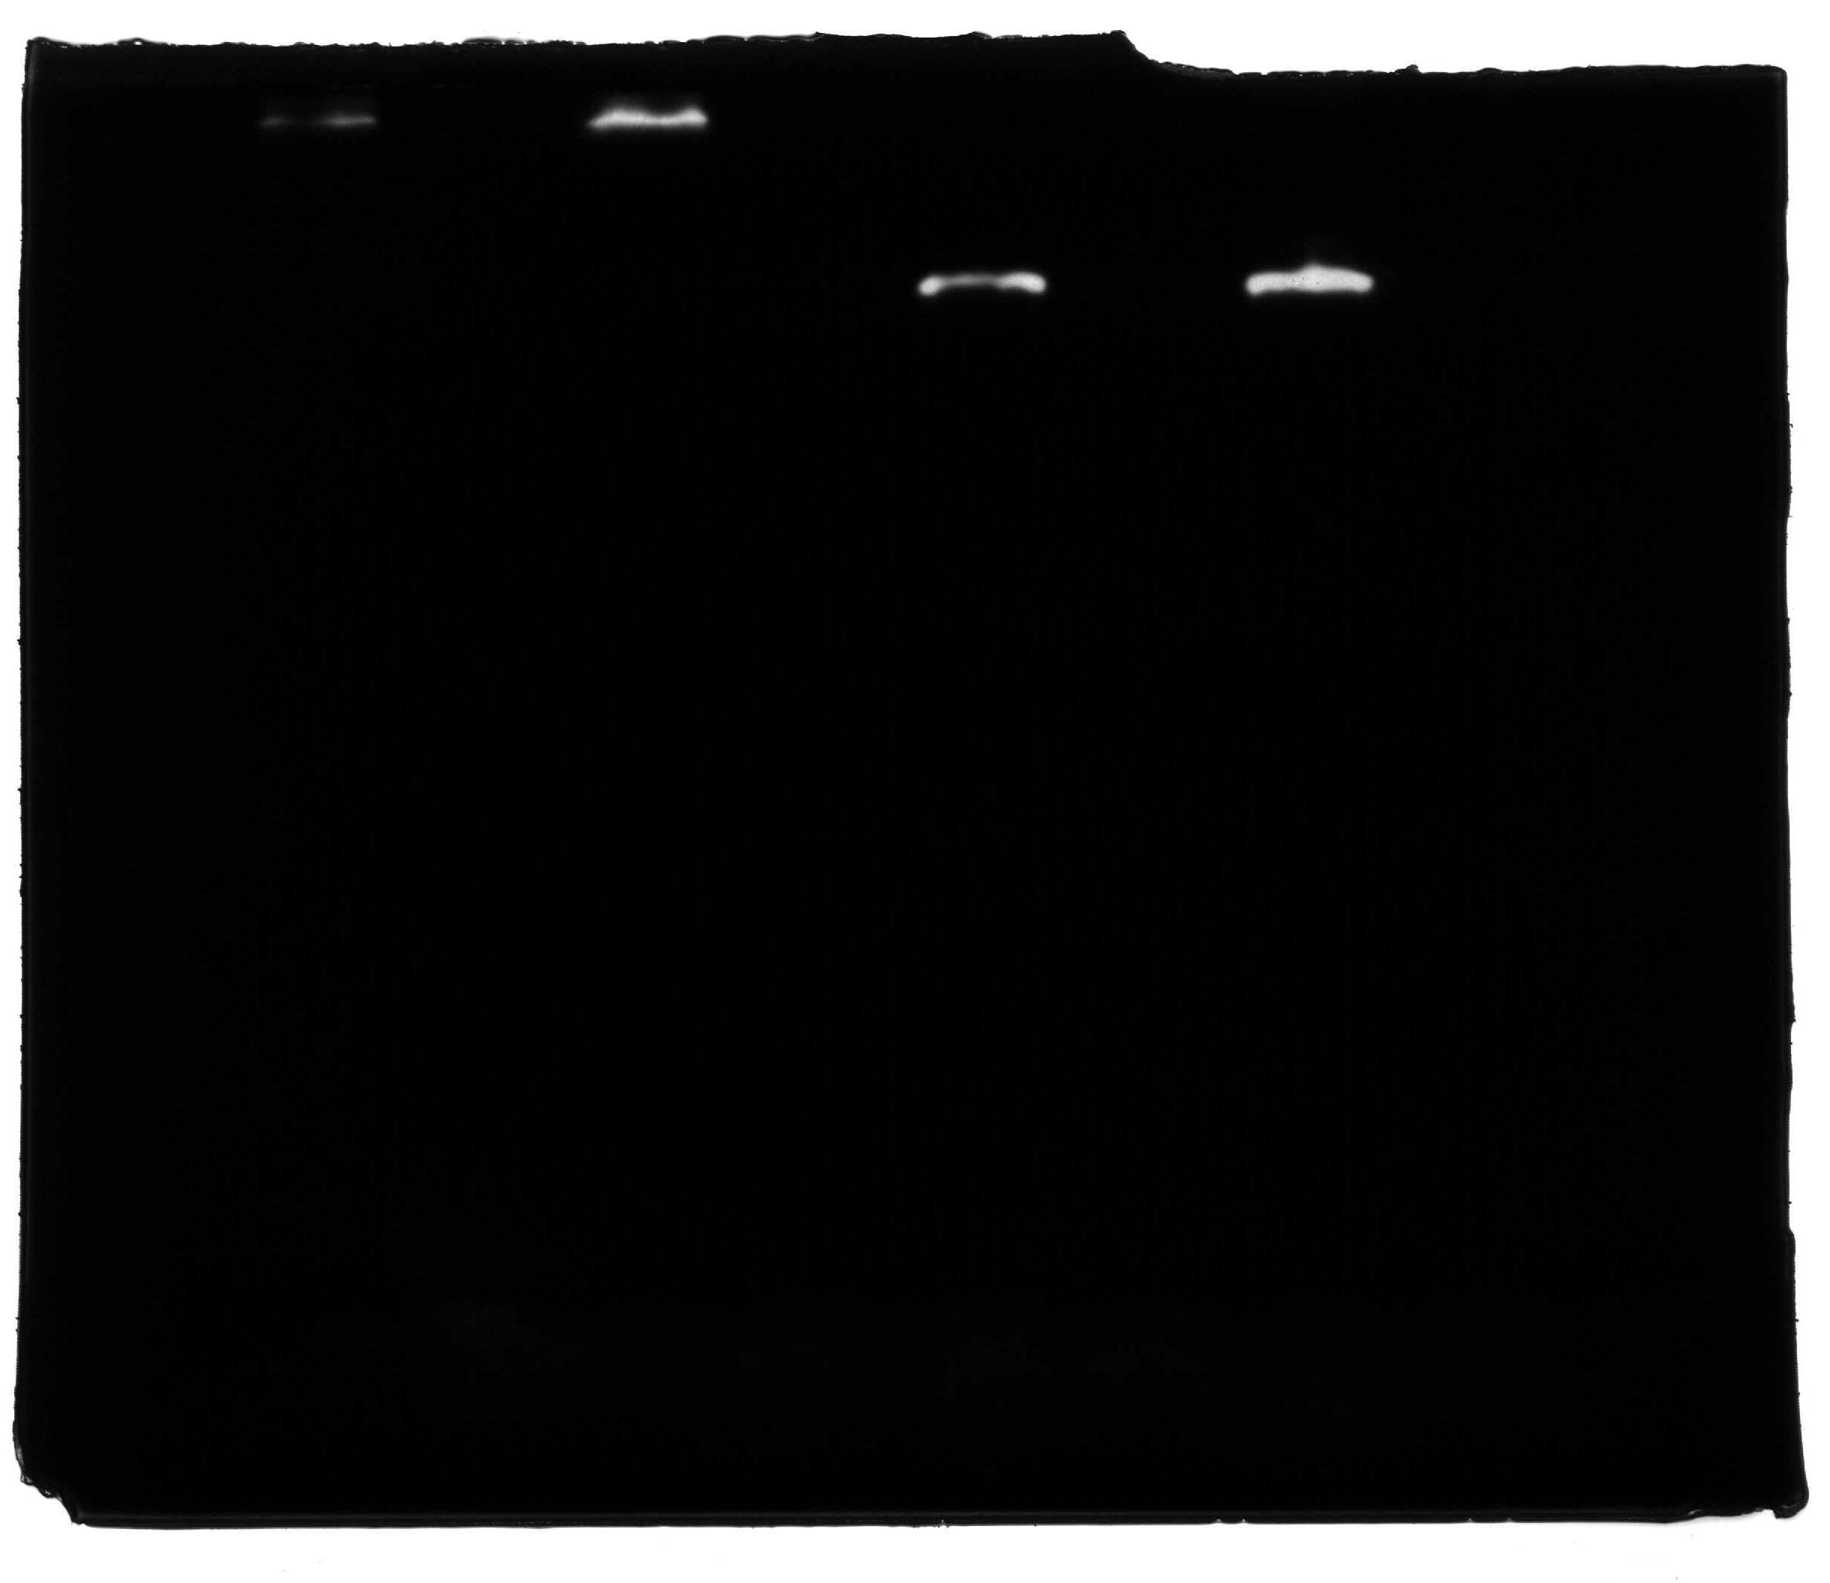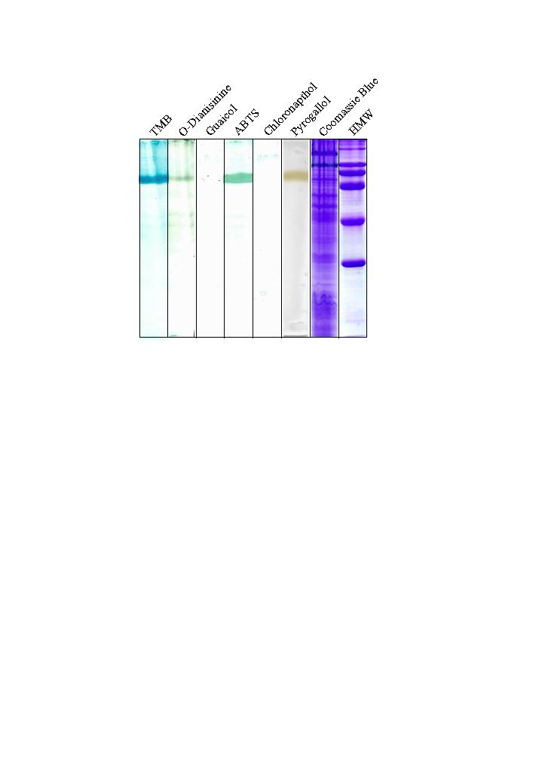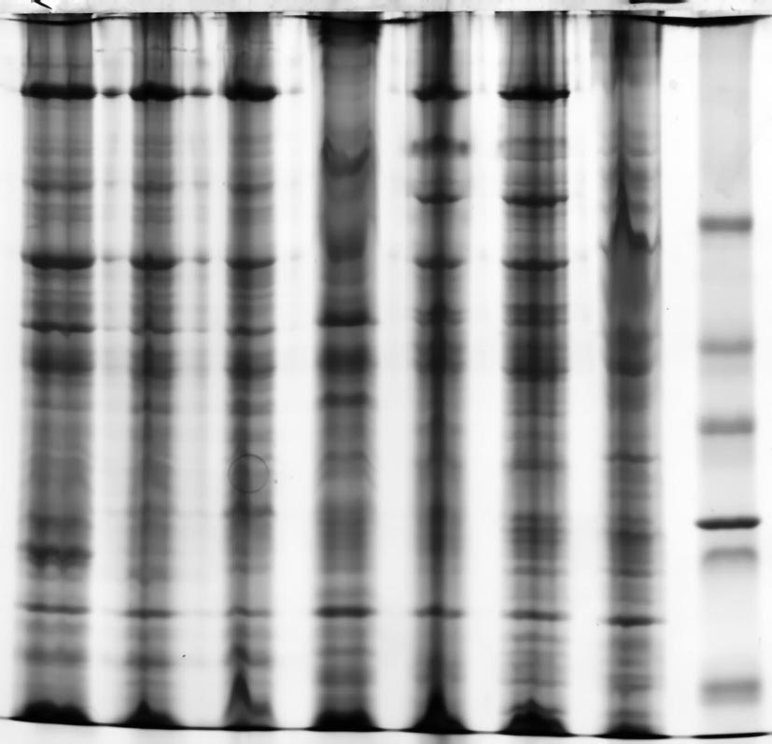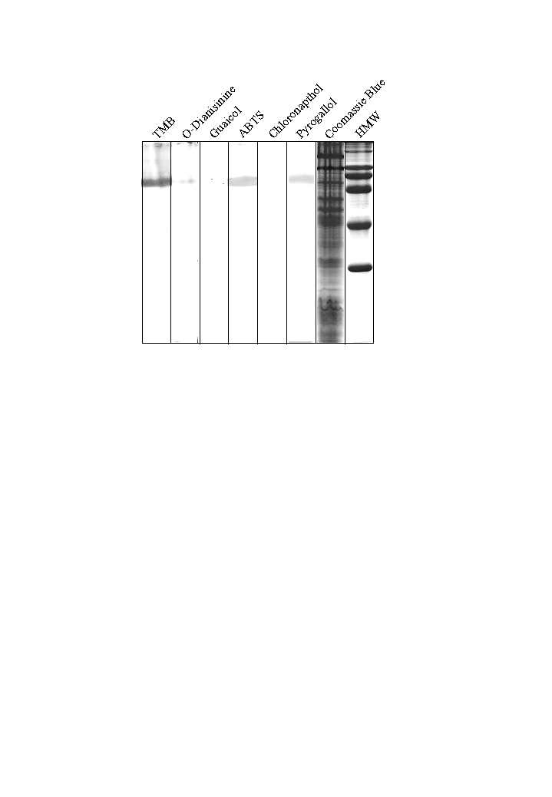
a b c d e f g h
97kDa

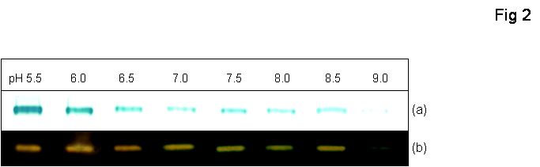

Fig 3

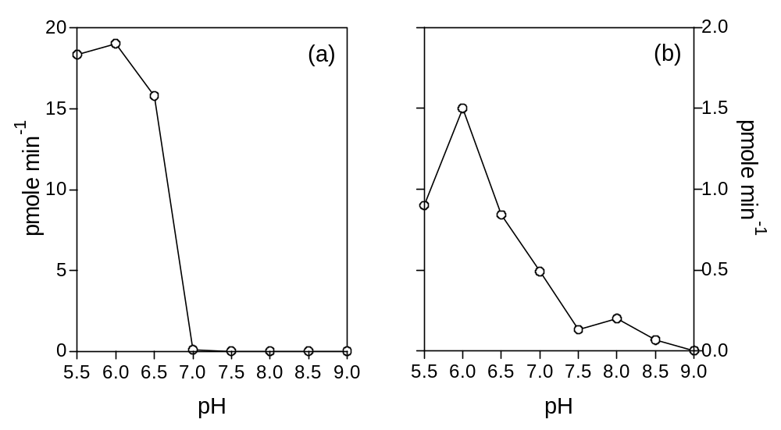

Fig 4

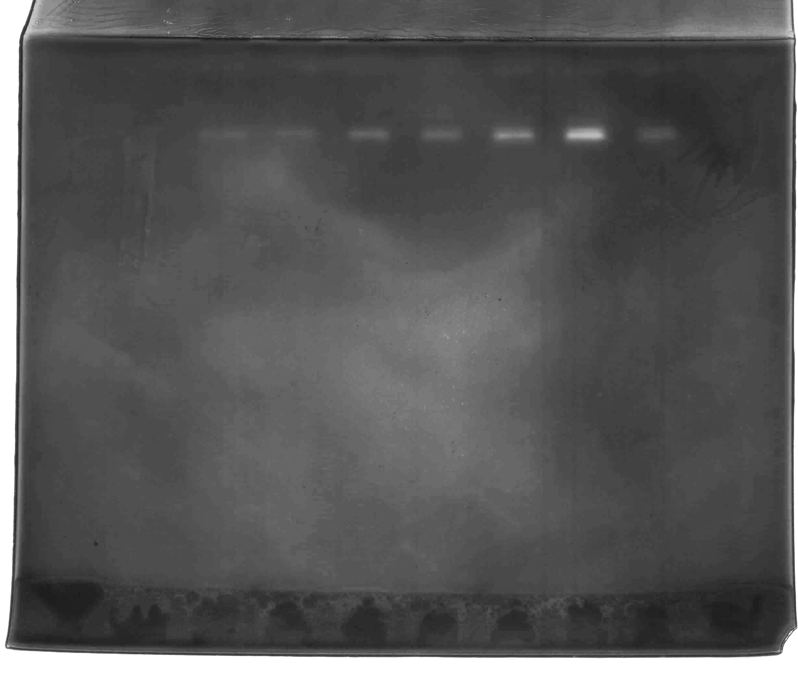
C Per Prot M
≈ 80k K
205kDa

116
97

66

45

29

Fig 5

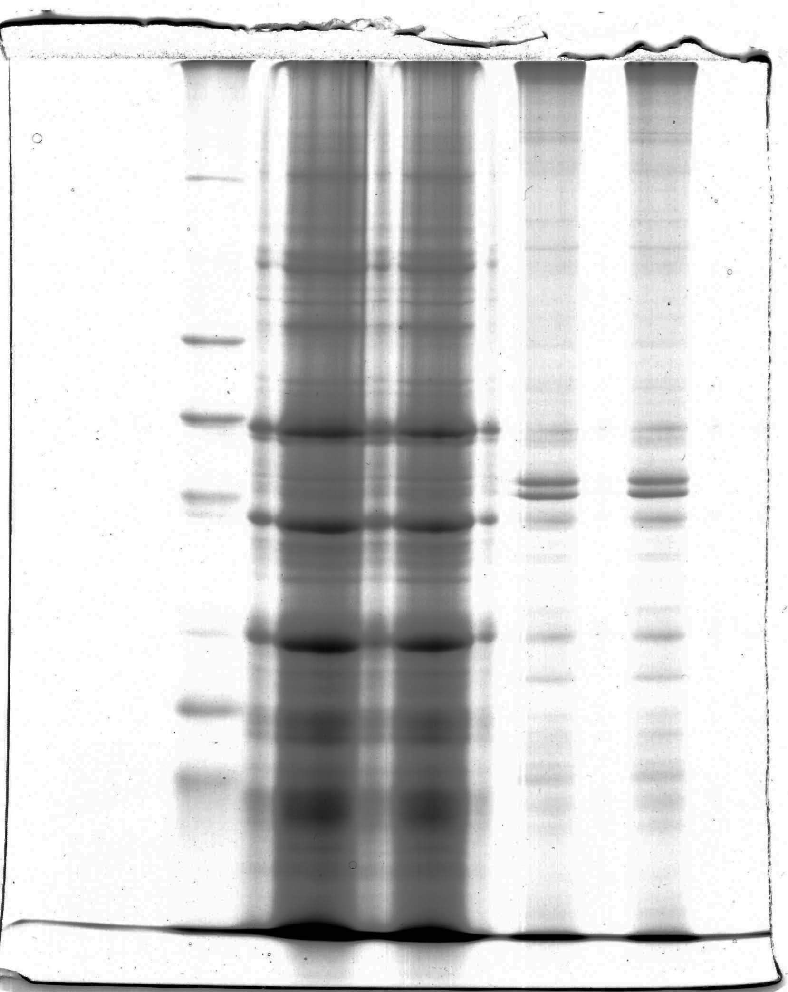
97
83
79kDa
R3
R2
R1
Figure legends

Figure 1: Catalase and peroxidase specificity of the 97kDa protein of B. cenocepacia strain J2315 as shown after SDS-PAGE under non-reducing conditions. Catalase activity was demonstrated using the potassium ferricyanide/ ferric chloride-H₂O₂ method (track a), whilst peroxidase activity was assessed against (b) TMB, (c) o-dianisidine, (d) 2-methoxyphenol, (e) ABTS, (f) 4-chloronaphthol, and (g) pyrogallol. Track h, Coomassie Blue counterstaining for protein following the peroxidase reaction. See Methods for details.

Figure 2: Effect of pH on the activity of the bi-functional catalase-peroxidase as shown after SDS-PAGE under non-reducing conditions. Peroxidase activity (a) was revealed using tetramethylbenzidine-H₂O₂ whilst catalase was assayed using the K₃Fe(CN)₆/FeCl₃-H₂O₂ staining method (b). Gel loadings were 25µg protein per track.

Figure 3: pH activity profile of catalase and peroxidase activities of suspensions of whole cells of B. cenocepacia strain J2315 grown on M9 Minimal Salts Medium agar. Peroxidase was measured using tetramethylbenzidine as substrate (shown as ΔA_{645nm}). Catalase activity was assayed by UV absorbance (shown as ΔA_{240nm}). The reactions were carried out at 20°C.

Fig 4: SDS-PAGE on 10% polyacrylamide gels of BL21Star E. coli cells expressing the catalase-peroxidase, after growth in the presence of 0.1M IPTG. C, catalase; Per, peroxidase; Prot, protein staining; M, molecular weight markers. The in-gel catalase staining was performed at pH 6.0 in 0.5M sodium acetate.

Fig 5: SDS-PAGE of the recombinant B. cenocepacia KatG catalase-peroxidase enzyme on a 7% polyacrylamide gel. Recombinant protein bands R1, R2 and R3 gave mass matches to KatG after trypsinisation and MS/MS analysis (see Table 2). The gel was stained with Coomassie Blue.

