Low Band-Gap Benzothiadiazole Conjugated Microporous Polymers

Shijie Ren,*a,b* Robert Dawson,*b* Dave J. Adams,*b* Andrew I. Cooper*b*\*

Received (in XXX, XXX) Xth XXXXXXXXX 20XX, Accepted Xth XXXXXXXXX 20XX

DOI: 10.1039/b000000x

Low band-gap conjugated microporous polymers (CMPs) based on benzothiadiazole (BTZ) and thiophene-benzothiadiazole-thiophene (TBT) functional groups are prepared. The polymers show moderate surface areas and broad light absorption covering the whole visible light region. Fluorescence of one of the polymers can be readily quenched by the *in situ* blending of fullerene.

Introduction

There is currently much interest in microporous organic polymers (MOPs) in areas including gas adsorption, storage, separations, and heterogeneous catalysis.1-7 For such applications, the good chemical and thermal stability and wide synthetic diversity of MOPs is desirable.8, 9 As a sub-class of MOPs, conjugated microporous polymers (CMPs) can combine microporosity and high surface areas with extended conjugation, suggesting a range of potential applications in energy-related areas.10, 11 Parameters that influence the scope for applications for CMPs include the surface area and pore size distribution, as well as the functionality of the network. Porosity and pore size distribution can be tuned to some degree through monomer selection,9, 12 by reaction solvent choice,13 or by the use of a template.14 A wide variety of chemical functionalities have been incorporated into CMPs, in some cases for specific applications such as light-harvesting,15 fluorescence enhancement,16, 17 supercapacitors,18 or molecular sensing.19

Band-gap control is important for conjugated polymers, for example to achieve specific colour emission in polymer light-emitting diodes (PLEDs).20 Low band-gap conjugated polymers have also been exploited extensively as electron donor materials in polymer solar cells due to their broad and intensive light absorbing ability.21 Recently, band-gap control of CMPs has also been addressed for potential applications in optoelectronics.16 As one of the most common electron-accepting moieties, the benzothiadiazole (BTZ) unit and its derivatives have been incorporated in to conjugated polymers which have been used as active materials in both PLEDs and polymer solar cells.22, 23 However, only very recently has a series of microporous poly(benzothiadiazole) networks been reported and used as photocatalysts to generate singlet oxygen.14 These polymers were later post-synthetically modified to confer water-dispersability and used as heterogeneous photocatalysts.24

In this communication, we report the preparation of a series of low band-gap CMPs based on BTZ unit and its derivative, thiophene-benzothiadiazole-thiophene (TBT). Porous and photophysical properties of these CMPs are characterised in detail, and we show that the fluorescence of one of the polymers can be quenched by the inclusion of C60 in the pores.

Experimental Section

**Chemicals.** 4,7-Dibromobenzo[c][1,2,5]thiadiazole (**M1**), 4,7-bis(5-bromothiophen-2-yl)benzo[c][1,2,5]thiadiazole (**M2**), tetrakis(triphenylphosphine)palladium(0), copper(I) iodide, anhydrous *N*,*N*’-dimethylformamide (DMF), xylene and 20% Et4NOH solution were all purchased from Aldrich and used as received. 1,3,5-Triethynylbenzene (**M3**) was purchased from ABCR. Tris(4-ethynylphenyl)amine25 (**M4**) and tris(4-(4,4,5,5-tetramethyl-1,3,2-dioxaborolan-2-yl)phenyl)amine26 (**M5**) were synthesized according to the reported procedures.

**Synthesis of Polymer Networks by Sonogashira-Hagihara Cross-Coupling Chemistry.** All polymerization reactions were carried out with similar monomer concentration and a fixed reaction temperature and reaction time (100 °C/72 h). The molar ratio of ethynyl to bromo functionalities in the monomer feed was set at 1.5:1 based on our previous findings for CMP networks.9, 11-13 A representative experimental procedure for **BCMP-1** is given as an example:

**BCMP-1.** **M1** (294 mg, 1 mmol), **M3** (150 mg, 1 mmol), tetrakis(triphenylphosphine)-palladium (60 mg), and copper(I) iodide (30 mg) were dissolved in a mixture of anhydrous DMF (5 mL) and Et3N (5mL). The reaction mixture was heated to 100 °C and stirred for 72 hours under a nitrogen atmosphere. The mixture was cooled to room temperature, and the insoluble precipitated network polymer was filtered and washed with chloroform, water, methanol, and acetone (100 mL each) to remove any unreacted monomers or catalyst residues. Further purification of the polymer was carried out by Soxhlet extraction with methanol and CHCl3 successively for 24 hours each. The product was then dried under vacuum for 24 hours at 60 °C to give dark brown powder (yield: 274 mg, 97%). FT-IR (KBr, cm-1): 2203, 1582, 1418, 1345, 880, 844. Anal. Calcd. for C42H12N6S3: C, 72.40; H, 1.74; N, 12.06. Found: C, 67.71; H, 2.11; N, 8.58. The deviation of the elemental analysis results from the theoretical value can be due to remaining end groups and incomplete combustion and is consistent with our previous observations.9, 11-13

**BCMP-2.** **M1** (147 mg, 0.5 mmol), **M4** (159 mg, 0.5 mmol), tetrakis(triphenylphosphine)palladium(0) (40 mg), copper(I) iodide (20 mg), DMF (5 mL) and Et3N (5mL) were used this polymerization. **BCMP-2** was obtained as a black power (yield: 208 mg, 93%). FT-IR (KBr, cm-1): 3034, 2197, 1594, 1505, 1317, 1174, 832. Anal. Calcd. for C66H30N8S3: C, 76.87; H, 2.93; N, 10.87. Found: C, 72.86; H, 3.12; N, 8.48.

**BCMP-3.** **M2** (229 mg, 0.5 mmol), **M3** (75 mg, 0.5 mmol), tetrakis(triphenylphosphine)palladium(0) (40 mg), copper(I) iodide (20 mg), DMF (5 mL) and Et3N (5mL) were used this polymerization. **BCMP-3** was obtained as a black power (yield: 210 mg, 94%). FT-IR (KBr, cm-1): 2189, 1576, 1485, 1341, 1198, 872, 798. Anal. Calcd. for C66H20N6S9: C, 66.64; H, 2.03; N, 7.07. Found: C, 65.02; H, 2.24; N, 5.57.

**BCMP-4.** **M2** (166 mg, 0.36 mmol), **M4** (116 mg, 0.36 mmol), tetrakis(triphenylphosphine)palladium(0) (40 mg), copper(I) iodide (20 mg), DMF (5 mL) and Et3N (5 mL) were used this polymerization. **BCMP-4** was obtained as black power (yield: 218 mg, 99%). FT-IR (KBr, cm-1): 3032, 2189, 1593, 1502, 1317, 1177, 831. Anal. Calcd. for C90H42N8S9: C, 70.93; H, 2.78; N, 7.35. Found: C, 69.67; H, 2.96; N, 6.21.

**Synthesis of Polymer Networks by Suzuki-Miyaura Cross-Coupling Chemistry.** Both of the polymerization reactions were carried out with similar monomer concentration and a fixed reaction temperature and reaction time (160 °C/48 h). The molar ratio of boronic ester to bromo functionalities in the monomer feed was set at 1:1. A representative experimental procedure for **BCMP-5** is given as an example.

**BCMP-5.** To a flame-dried Schlenk tube (100 mL) were charged **M1** (220 mg, 0.75 mmol), **M5** (312 mg, 0.5 mmol), tetrakis(triphenylphosphine)palladium(0) (60 mg), against N2 flow, followed by the addition of degassed xylene (40 mL) and aqueous Et4NOH solution (20% wt., 10 mL). The reaction mixture was then heated at 160 °C for 2 days and then cooled to room temperature. The insoluble precipitated network polymer was filtered and washed four times with chloroform, water, methanol, and acetone (100 mL each) to remove any un-reacted monomers or catalyst residues. Further purification of the polymer was carried out by Soxhlet extraction with methanol and CHCl3 successively for 24 hours each. The product was then dried under vacuum for 24 hours at 60 °C and **BCMP-5** was obtained as black power (yield: 220 mg, 99%). FT-IR (KBr, cm-1): 3118, 2375, 1729, 1594, 1477, 1093, 821. Anal. Calcd. for C54H30N8S3: C, 73.12; H, 3.41; N, 12.63. Found: C, 54.36; H, 2.92; N, 9.29.

**BCMP-6.** **M2** (220 mg, 0.48 mmol), **M5** (200 mg, 0.32 mmol), tetrakis(triphenylphosphine)palladium(0) (40 mg), xylene (5 mL) and Et4NOH solution (20% wt., 10 mL) were used this polymerization. **BCMP-6** was obtained as black power (yield: 218 mg, 99%). FT-IR (KBr, cm-1): 3067, 2372, 1748, 1594, 1482, 1281, 1046, 798. Anal. Calcd. for C78H42N8S9: C, 67.90; H, 3.07; N, 8.12. Found: C, 55.24; H, 2.87; N, 6.01.

**Infrared spectroscopy:** IR spectra were collected as KBr disks using a Bruker Tensor 27.

**Solid-state NMR:** Solid-state NMR and data analysis were carried out by the EPSRC National Solid-state NMR Service in Durham. Both cross polarization and direct excitation experiments were performed using a Varian VNMRS 400 Spectrometer.

**UV-vis spectroscopy:** UV-vis spectra were recorded by a SHIMADZU UV-2550 spectrophotometer using powder samples of the polymers.

**Photoluminescence spectroscopy:** PL spectra were recorded by a SHIMADZU RF-5310PC spectrofluorophotometer using powder samples of polymers. 50 mg of polymer was used to measure the PL spectra of both **BCMP-5** and **BCMP-5-C**. The spectrum of **BCMP-5-C** was normalized to the maximum emission intensity of **BCMP-5** for comparison.

**Gas sorption analysis:** Polymer surface areas were measured by nitrogen adsorption and desorption at 77.3 K using either a Micromeritics ASAP 2420 or ASAP 2020 volumetric sorption analyzer. The surface areas were calculated in the relative pressure (P/P0) range from 0.01 to 0.05. Samples were de-gassed at 120 °C for 15 hours under vacuum (10-5 bar) before analysis.

**Thermogravimetric Analysis (TGA).** TGA analysis was carried out using a Q5000IR analyser (TA Instruments) with an automated vertical overhead thermobalance. The samples were heatedat a rate of 5 oC/min under a nitrogen atmosphere.

Results and discussion

As shown in Scheme 1, the CMPs were synthesized through A2 + B3 Sonogashira-Hagihara cross-coupling reactions of BTZ containing monomers M1 and M2 with alkyne-type monomers M3 and M4 to give **BCMP-1** to **BCMP-4** respectively. **BCMP-5** and **BCMP-6** were prepared via the A2 + B3 Suzuki-Miyaura cross-coupling reactions of M1 and M2 with the boronic ester based monomer M5. **BCMP-1** has been previously reported by Zhang *et al*.14

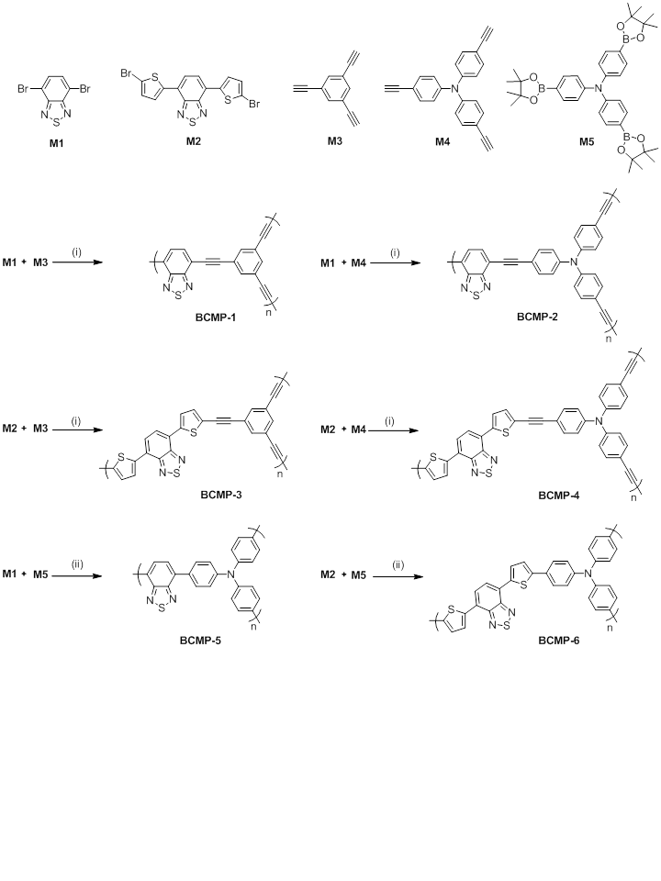

**Scheme 1** Synthesis of the BCMP networks. Reagents and conditions: (i) Pd(PPh3)4, CuI, DMF/Et3N, 100 °C, 72 h; (ii) Pd(PPh3)4, xylene, aq. Et4NOH, 160 °C, 48 h.

Except for **BCMP-1**, which was isolated as a dark brown powder, all polymers were obtained as black powders. The **BCMP** networks were insoluble in all solvents tested including THF, toluene, DMF, and chloroform, and were also found to be chemically stable in various aqueous conditions. Infrared spectra for these polymers are shown in Fig. S1-S2 (see Supporting Information). For **BCMP-1**-**BCMP4**, the characteristic terminal C-C triple bond vibration peaks at about 3300 cm-1 (arising from un-reacted end groups) have a very low intensity, whilst the peaks at around 2200 cm-1, which are characteristic of *bis*-substituted acetylenes, are easily detected. This indicates, qualitatively, a high degree of polymerization.

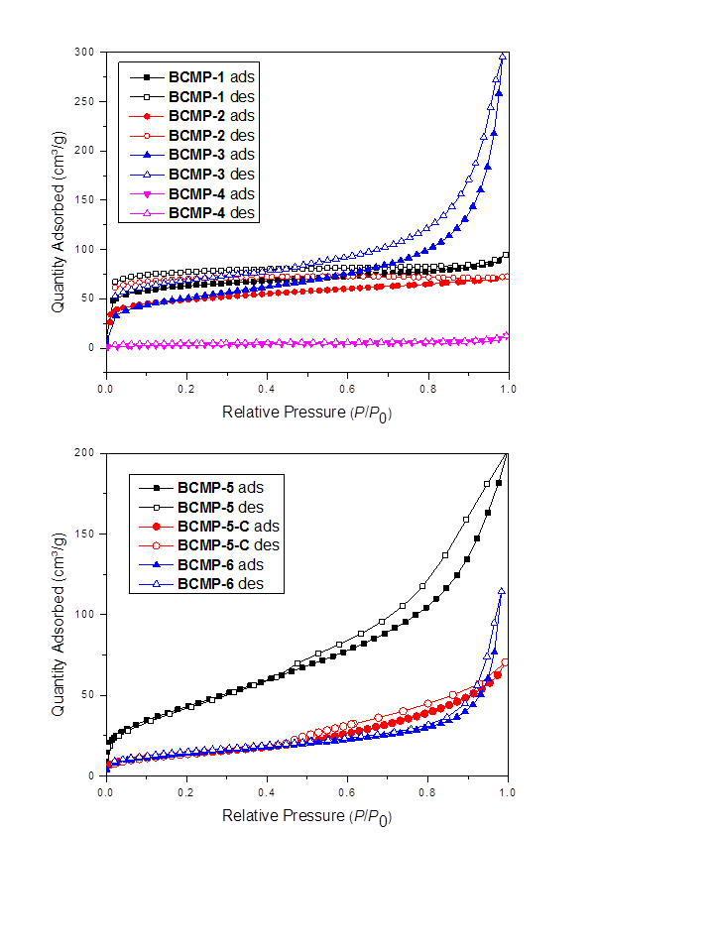

**Fig. 1** Nitrogen adsorption and desorption isotherms measured at 77 K (the adsorption and desorption branches are labelled with filled and empty symbols, respectively).

The porosity in the **BCMP** polymers was investigated by nitrogen adsorption/desorption experiments at 77 K. The isotherms are shown in Figure 1. Of the polymers, **BCMP-1** shows the highest, albeit modest, apparent BET surface area, with a value of 231 m2/g. This is similar to a value reported recently.14 **BCMP-4** shows the lowest value of 12 m2/g. As a general trend, when the same synthetic A2 + B3 methodology was used, polymers prepared from larger monomers (*i.e.*, **BCMP-4** and **BCMP-6**) showed lower surface areas than those from smaller monomers. This observation could be explained by the model we developed previously, where we showed that CMPs constructed with longer connecting struts have lower BET surface areas.12 Overall, the **BCMPs** shown here are less porous than the CMPs we reported previously, which may be due to the more crowded molecular structure of BTZ unit compared to the benzene- or triazine-based units used previously.27 **BCMP-1**, **BCMP-2** and **BCMP-4** gave rise to typical Type I sorption isotherms, indicating a predominantly microporous structure, while the other three polymers show evidence of a H3 hysteresis loop, indicative of the existence of mesopores and/or small macropores.28 A summary of the gas sorption data is shown in Table 1.

|  |  |  |
| --- | --- | --- |
|  | SABET (m2/g)a | Vtotal (cm3/g)b |
| **BCMP-1** | 231 | 0.15 |
| **BCMP-2** | 158 | 0.11 |
| **BCMP-3** | 184 | 0.46 |
| **BCMP-4** | 12 | 0.02 |
| **BCMP-5** | 148 | 0.31 |
| **BCMP-5-C** | 50 | 0.10 |
| **BCMP-6** | 50 | 0.18 |

**Table 1.** Gas sorption data for polymers, including pore properties. a BET surface area calculated over the pressure range 0.01–0.05 P/P0. b Vtotal, total pore volume calculated at P/P0 = 0.99.

Solid-state UV-vis spectra of the **BCMP** networks were recorded and are shown in Figure 2. All six polymers show a broad absorption covering almost the whole visible light region. Although the shapes of the spectra are similar, they do show differences in terms of the onset of the absorption, which correlates with the band gap of the conjugated system. TBT-containing CMPs (**BCMP-3**, **BCMP-4**, and **BCMP-6**) show lower bang-gaps than the corresponding BTZ-based CMPs (**BCMP-1**, **BCMP-2**, **BCMP-5**) due to the additional donor-acceptor effect between the thiophene and BTZ units. Whilst the absorption edge is not sharp, optical band gaps can be estimated. For example, the optical band gaps of **BCMP-1** and **BCMP-3** are approximately 1.98 eV (close to the value estimated by Zhang *et al.* using cyclic voltammetry[14](#_ENREF_14" \o "Zhang, 2013 #11)) and 1.75 respectively. **BCMP-2** shows broader light absorption and lower bang-gap than **BCMP-1** (1.82 eV *vs* 1.98 eV), due to stronger electron donating ability of the triphenylamine unit and a more pronounced intramolecular donor-acceptor effect than the corresponding benzene unit. It is interesting to find that the Sonagashira products **BCMP-1** to **BCMP-4** do not show any fluorescence while the Suzuki polymers **BCMP-5** and **BCMP-6** show strong fluorescence in the solid state with the maximum emission wavelengths located at 607 nm and 692 nm respectively (Figure 2, bottom). This phenomenon may be due to strong intermolecular aggregation induced fluorescence quenching in the alkyne-linked polymers.

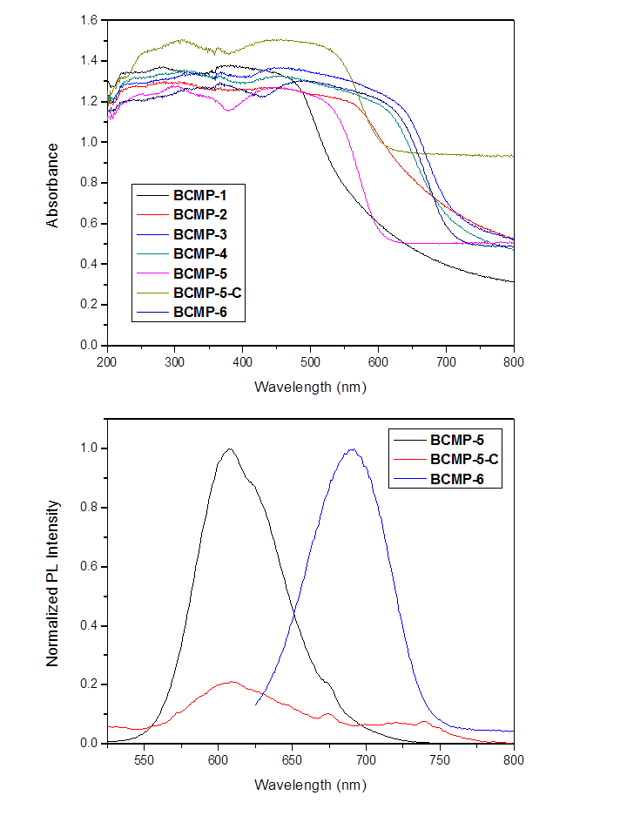**Fig. 2** (Top) UV-vis spectra of BCMP networks and the CMP-C60 complex **BCMP-5-C** and (bottom) photoluminescence spectra of the **BCMP-5**, **BCMP-5-C** and **BCMP-6**.

Fullerene derivatives such as PC61BM and PC71BM are widely used as electron acceptors in polymer solar cells and, most commonly, they are mixed with low band-gap conjugated polymers in solution and spin-coated to form a bulk hetero-junction active layer composed of an interpenetrating network of electron donor and acceptor materials.29, 30 Rao *et al.* have adsorbed C60 into a microporous pyrene-based network and shown that fluorescence quenching occurred.31 Similarly, CMPs are conceptually hyperbranched rigid networks with permanent interconnected pores,10-12 and it is of interest to investigate how fullerenes interact with CMPs when included in the CMP networks.

To investigate the CMP-fullerene interaction, **BCMP-5** was chosen as the host polymer network since it is fluorescent and it has a higher level of porosity than **BCMP-6**. We note that BCMP-5 has a relatively low level of microporosity (Fig. S3 and Fig. S4, Supporting Information) and hence most pores are significantly larger than the diameter of C60. For the inclusion of C60 in the network, **BCMP-5** was soaked in a saturated toluene solution of C60 at room temperature for three days. The resulting polymer-fullerene complex, **BCMP-5-C**, was filtered, washed well with toluene until the filtrate was colourless, and then dried under vacuum. TGA analysis was used to estimate the amount of C60 added (Fig. S5, Supporting Information). The weight loss for **BCMP-5** and **BCMP-5-C** were very similar at 500 oC. However, there was a more pronounced mass loss for **BCMP-5-C** on heating further to 1000 oC (42.3 % as compared to 30.9 % for **BCMP-5**). The mass loss to 250 oC can be explained by entrained moisture and gases and the further loss to 500 oC is presumably due to some degradation of the polymer (approximately 11 % loss for both systems). The extra mass loss for **BCMP-5-C** can be ascribed to entrained C60 and implies that approximately 11% of **BCMP-5-C** by mass comprises C60. To prove the successful inclusion of C60 in the polymer network, solid-state NMR measurements were performed. The spectra of **BCMP-5** and **BCMP-5-C** are shown in Figure 3.



**Fig. 3.** Solid-state NMR spectra of **BCMP-5** and **BCMP-5-C** collected using both cross polarization (CP) and direct excitation (DE) techniques. The asterisk signal denotes teflon background.

In the cross polarization (CP) spectra, both materials show peaks centred around 130.1, 146.8 and 153.6 ppm, which can be assigned to the triphenylamine and the BTZ units. For **BCMP-5-C**, there is small additional signal at 142.4 ppm, which corresponds to the resonances of C60.32 Signals that appear in these CP spectra arise from carbons that are excited indirectly from protons in the material, so any component that does not contain protons will be absent in the spectrum. Material that is dilute in protons (or only has a weak C-H interaction) may cross polarize, but with low efficiency, so may appear but will be under-represented in the spectrum. To look for carbon that is absent in the CP spectrum, a direct excitation (DE) spectrum of **BCMP-5-C** was recorded. The resonances at 130.1, 146.8 and 153.6 ppm were still present. The signal at 142.4 ppm became more pronounced, which suggests it does arise from material dilute in protons and, in this case, from the included C60. At 143.8 ppm, a small signal appeared in the DE spectrum, which can be attributed to more mobile C60. Compared with the peaks from the polymer network, the resonances at 142.4 and 143.8 ppm are much narrower, as expected for C60. The DE spectrum of **BCMP-5** was also recorded and there were no signals in the 140 to 145 ppm range.

Further evidence that C60 was successfully included in the polymer network is the decrease of the BET surface area of **BCMP-5**. N2 sorption isotherms of **BCMP-5-C** were recorded and are shown in Figure 1. The BET apparent surface area of **BCMP-5-C** was calculated to be 50 m2/g, which is nearly 100 m2/g less than for **BCMP-5**. Also, the total pore volume of **BCMP-5** was found to decrease from 0.31 cm3/g to 0.10 cm3/g after the inclusion of C60 (Table 1, the pore size distribution is shown in Fig. S3 and Fig. S4, Supporting Information), commensurate with the decrease in surface area. The decrease in both surface area and pore volume suggests that the encapsulated C60 has been encapsulated in the polymer. The pore size distribution (Fig. S3, Supporting Information) implies that the C60 suggests that the encapsulated C60 has entered the micropores (the low level of microporosity has reduced going from **BCMP-5** to **BCMP-5-C** (Fig. S4)) or has aggregated in the hyperbranched polymer network, affecting gas diffusion into the pores. In bulk hetero-junction solar cells, solution blending of fullerene derivatives with low band-gap conjugated polymers can effectively quench fluorescence of the conjugated polymers and facilitate charge transfer from electron donor to electron acceptor materials.29 With this in mind, we investigated the influence of C60 inclusion on the fluorescence properties of the CMP network. After the addition of C60, the UV-vis absorption of **BCMP-5-C** does not show major changes as compared to **BCMP-5**. However, the photoluminescence is significantly quenched by 80%, suggesting efficient charge transfer from the CMP network to C60 (Figure 2). Despite quenching, the peak maximum is not shifted relative to **BCM-5**. In addition, two minor peaks at approximately 675 nm and 738 nm are also detectable. The peak at 675 nm seems to correlate with a peak that is present in the original **BCMP-5**. The peak at 738 nm may be related to fluorescence directly from C60.33 Hence, it appears that this peak is less affected by quenching that the main peak at 607 nm. Further photophysical studies are currently underway to understand more about the mechanism of the charge transfer process.

Conclusions

A series of BTZ-containing CMPs have been synthesized by transition metal catalyzed cross-coupling polycondensation. The porosity and band gaps of the CMPs can be tuned according to the combination of different starting monomers. Solid state-NMR and gas sorption studies were used to confirm the successful inclusion of C60 in **BCMP-5** network. Preliminary fluorescence quenching studies show efficient charge transfer behaviour in the CMP-C60 complex. This could open up a new method to design efficient light harvesting or energy conversion architectures, particularly since the deposition of fullerenes into the pores of pre-formed CMP materials may lead to morphologies and interfaces that are different from those obtained by blending fullerenes with linear conjugated polymers.

Acknowledgment

We thank the EPSRC for funding (EP/H000925/1) and also the EPSRC and E.ON for funding (EP/G061785/1) through the E.ON-EPSRC strategic call on CCS. Solid-state NMR spectra were obtained at the EPSRC UK National Solid-state NMR Service at Durham. AIC is a Royal Society Wolfson Merit Award holder.

Notes and references

a College of Polymer Science and Engineering, Sichuan University, Chengdu, 610065, China.

b Department of Chemistry and Centre for Materials Discovery, University of Liverpool, Crown Street, Liverpool, L69 7ZD, U.K; E-mail: aicooper@liv.ac.uk

† Electronic Supplementary Information (ESI) available: [details of any supplementary information available should be included here]. See DOI: 10.1039/b000000x/

1. R. Dawson, A. I. Cooper and D. J. Adams, *Polymer Int.*, 2013, **62**, 345-352.

2. R. Dawson, A. I. Cooper and D. J. Adams, *Prog. Pol. Sci.*, 2012, **37**, 530-563.

3. P. Kaur, J. T. Hupp and S. T. Nguyen, *ACS Catalysis*, 2011, **1**, 819-835.

4. N. B. McKeown and P. M. Budd, *Macromolecules*, 2010, **43**, 5163-5176.

5. F. Svec, J. Germain and J. M. J. Frechet, *Small*, 2009, **5**, 1098-1111.

6. A. Thomas, *Angew. Chem. Int. Ed.,* 2010, **49**, 8328-8344.

7. Y. G. Zhang and S. N. Riduan, *Chem. Soc. Rev.*, 2012, **41**, 2083-2094.

8. T. Ben, H. Ren, S. Q. Ma, D. P. Cao, J. H. Lan, X. F. Jing, W. C. Wang, J. Xu, F. Deng, J. M. Simmons, S. L. Qiu and G. S. Zhu, *Angew. Chem. Int. Ed.*, 2009, **48**, 9457-9460.

9. R. Dawson, A. Laybourn, R. Clowes, Y. Z. Khimyak, D. J. Adams and A. I. Cooper, *Macromolecules*, 2009, **42**, 8809-8816.

10. A. I. Cooper, *Adv. Mater.*, 2009, **21**, 1291-1295.

11. J. X. Jiang, F. Su, A. Trewin, C. D. Wood, N. L. Campbell, H. Niu, C. Dickinson, A. Y. Ganin, M. J. Rosseinsky, Y. Z. Khimyak and A. I. Cooper, *Angew. Chem. Int. Ed.*, 2007, **46**, 8574-8578.

12. J. X. Jiang, F. Su, A. Trewin, C. D. Wood, H. Niu, J. T. A. Jones, Y. Z. Khimyak and A. I. Cooper, *J. Am. Chem. Soc.*, 2008, **130**, 7710-7720.

13. R. Dawson, A. Laybourn, Y. Z. Khimyak, D. J. Adams and A. I. Cooper, *Macromolecules*, 2010, **43**, 8524-8530.

14. K. Zhang, D. Kopetzki, P. H. Seeberger, M. Antonietti and F. Vilela, *Angew. Chem. Int. Ed.*, 2013, **52**, 1432-1436.

15. L. Chen, Y. Honsho, S. Seki and D. L. Jiang, *J. Am.Chem. Soc.*, 2010, **132**, 6742-6748.

16. J. X. Jiang, A. Trewin, D. J. Adams and A. I. Cooper, *Chem. Sci.*, 2011, **2**, 1777-1781.

17. Y. H. Xu, L. Chen, Z. Q. Guo, A. Nagai and D. L. Jiang, *J. Am. Chem. Soc.*, 2011, **133**, 17622-17625.

18. Y. Kou, Y. H. Xu, Z. Q. Guo and D. L. Jiang, *Angew. Chem. Int. Ed.*, 2011, **50**, 8753-8757.

19. X. M. Liu, Y. H. Xu and D. L. Jiang, *J. Am. Chem. Soc.*, 2012, **134**, 8738-8741.

20. L. M. Dai, B. Winkler, L. M. Dong, L. Tong and A. W. H. Mau, *Adv. Mater.*, 2001, **13**, 915-925.

21. L. Y. Bian, E. W. Zhu, J. Tang, W. H. Tang and F. J. Zhang, *Prog. Pol. Sci.*, 2012, **37**, 1292-1331.

22. S. H. Park, A. Roy, S. Beaupre, S. Cho, N. Coates, J. S. Moon, D. Moses, M. Leclerc, K. Lee and A. J. Heeger, *Nature Photonics*, 2009, **3**, 297-302.

23. M. H. Chen, J. Hou, Z. Hong, G. Yang, S. Sista, L. M. Chen and Y. Yang, *Adv. Mater.*, 2009, **21**, 4238-4242.

24. H. Urakami, K. Zhang and F. Vilela, *Chem. Commun.*, 2013, **49**, 2353-2355.

25. J. X. Jiang, A. Trewin, F. B. Su, C. D. Wood, H. J. Niu, J. T. A. Jones, Y. Z. Khimyak and A. I. Cooper, *Macromolecules*, 2009, **42**, 2658-2666.

26. Y. Yang, Y. Zhou, Q. G. He, C. He, C. H. Yang, F. L. Bai and Y. F. Li, *J. Phys.Chem. B*, 2009, **113**, 7745-7752.

27. S. Ren, R. Dawson, A. Laybourn, J. X. Jiang, Y. Khimyak, D. J. Adams and A. I. Cooper, *Polymer Chem.*, 2012, **3**, 928-934.

28. K. S. W. Sing, D. H. Everett, R. A. W. Haul, L. Moscou, R. A. Pierotti, J. Rouquerol and T. Siemieniewska, *Pure Appl. Chem.*, 1985, **57**, 603-619.

29. G. Yu, J. Gao, J. C. Hummelen, F. Wudl and A. J. Heeger, *Science*, 1995, **270**, 1789-1791.

30. H. Y. Chen, J. H. Hou, S. Q. Zhang, Y. Y. Liang, G. W. Yang, Y. Yang, L. P. Yu, Y. Wu and G. Li, *Nature Photonics*, 2009, **3**, 649-653.

31. K. V. Rao, S. Mohapatra, T. K. Maji and S. J. George, *Chem.Eur. J.*, 2012, **18**, 4505-4509.

32. K. Suzuki, K. Takao, S. Sato and M. Fujita, *J. Am.Chem. Soc.*, 2010, **132**, 2544-2545.

33. Y.-P. Sun, P. Wang and N. B. Hamilton, *J. Am. Chem. Soc.*, 1993,

**115**, 6378-6381.