Author Accepted Manuscript of
J. M. Read, P. J. Diggle, J. Chirombo, T. Solomon, M. Baylis, Effectiveness of screening for Ebola at airports. The Lancet 385, 23.

http://www.thelancet.com/journals/lancet/article/PIIS0140-6736%2814%2961894-8/fulltext?rss%3Dyes

Effectiveness of screening for Ebola virus at airports

Jonathan M. Read^{1,4}, Peter J. Diggle^{1,3,4}, James Chirombo¹, Tom Solomon^{1,2,4}
Matthew Baylis^{1,4}

1. Institute of Infection and Global Health, University of Liverpool, Liverpool, UK
2. Walton Centre NHS Foundation Trust, Liverpool, UK
3. Division of Medicine, Lancaster University, Lancaster, UK
4. Health Protection Research Unit in Emerging and Zoonotic Infections, University of Liverpool, Liverpool, UK

Corresponding author: Professor Tom Solomon, Institute of Infection and Global Health, University of Liverpool, Liverpool, UK

Screening for symptoms of Ebola virus disease (EVD) in airline passengers whose journey originated from the three most-affected countries – Guinea, Liberia and Sierra Leone – has recently been introduced at selected airports in the UK and the USA.^{1,2} Screening can include health declarations, visual inspection and thermography to detect symptoms. The effectiveness of border screening for other infectious diseases has been considered before, but its role in preventing EVD importation is unknown.³⁻⁵ A recent paper estimated the efficiency of entry screening for airline passengers, but did not consider the influence of the natural history of EVD and journey duration on screening efficacy.⁶

EVD has a mean (standard deviation) incubation period of 9.4 (7.4) days from infection to symptoms developing, and a mean “symptomatic period” (from symptom onset to hospitalization) of 5.0 (4.7) days.⁷ We simulated the timing of infection and development of symptoms for 200 travellers, and related this to the travel duration and success of detection through exit screening, as travellers leave West Africa, and through entry screening, on arrival at destinations. For individuals infected at a random time prior to departure, incubation and symptomatic periods were drawn randomly and independently from the periods’ distributions.⁷ We assumed that screening would detect all symptomatic individuals, and that incubating and symptomatic individuals are equally likely to attempt to travel.

We found exit screening would detect 35.6% (simulated 95% quantile: 23.6% to 48.2%) of infected passengers (Figure 1). The additional benefit of entry screening increased with journey time. After a 24 hour journey, entry screening would increase the overall detection to 41.5% (28.8% to 55.1%) of those infected; thus detecting an additional 6.9% (1.2% to 14.0%) of infected individuals. For 12 hour journeys from West Africa, which are typical for flights to Europe, arrival screening would detect an additional 3.4% (0% to 9.3%) of infected passengers. While we have considered the effectiveness of screening travellers from the affected region, the detection patterns would differ for travellers from settings where hospital admittance may occur earlier during infection.

By the end of September 2014, EVD had been unwittingly transported by two airline passengers: one to Nigeria and one to the USA. Based on the current case number doubling time in Liberia of 23.6 days,⁷ if the epidemic in West Africa is not curtailed and there is no change in international travel patterns, we would expect an additional 29 such infected passengers to have attempted to fly internationally from West Africa by December 31st 2014. Of these, ten (7 to 14) would be prevented from travel by exit screening. Based on previous flight patterns (OAG, total adjusted bookings for July 2014)⁸ we would expect 7% (~1-2 people) and 13% (~2-3 people) of the remaining infected individuals to fly to the UK and USA respectively. Given the additional detection by entry screening and the percentage of travellers arriving at screening airports in these countries (75% and 78% respectively at present), current entry screening procedures would be expected to identify 0 or 1 additional cases in each country between October 1st and December 31st, in the UK, 1 to 2, and in the USA, 1 to 3 would not be detected at entry but might be detected subsequently be daily follow-up. Based on estimated passenger numbers flying to USA and UK (20,739 and 11,073 respectively) for this period, the efficiency of entry screening to detect a single case would be 0.004% for the USA and 0.009% for the UK. Recent reports suggest exit screening within the affected countries is currently 0.21% effective. ⁹

In addition to identifying those infected, entry screening allows health authorities to provide health information to passengers arriving from West Africa, describes actions to take if they become unwell, and facilitates follow-up. Although our analysis shows entry screening will reduce the overall chances of Ebola being brought into a country, the most effective way of restricting its global spread is to control the disease at source in West Africa.
(649 words, 1 figure)

Conflicts of interest
The authors declare no conflicts of interest.

References
1. Ebola screening begins at Heathrow airport. (Accessed 15 October 2014, at http://www.bbc.co.uk/news/uk-29616724.)
2. Enhanced Ebola Screening to Start at Five U.S. Airports and New Tracking Program for all People Entering U.S. from Ebola-affected Countries. 2014. (Accessed 15 October 2014, at http://www.cdc.gov/media/releases/2014/p1008-ebola-screening.html.)
3. Ferguson NM, Cummings DA, Fraser C, Cajka JC, Cooley PC, Burke DS. Strategies for mitigating an influenza pandemic. Nature 2006;442:448-52.
4. Goubar A, Bitar D, Cao WC, Feng D, Fang LQ, Desenclos JC. An approach to estimate the number of SARS cases imported by international air travel. Epidemiology and infection 2009;137:1019-31.
5. Hollingsworth TD, Ferguson NM, Anderson RM. Will travel restrictions control the international spread of pandemic influenza? Nature Medicine 2006;12:497-9.
6. Bogoch II, Creatore MI, Cetron MS, et al. Assessment of the potential for international dissemination of Ebola virus via commercial air travel during the 2014 west African outbreak. The Lancet 2014.
7. Team WHOER. Ebola Virus Disease in West Africa - The First 9 Months of the Epidemic and Forward Projections. N Engl J Med 2014.
8. Traffic Analyser. (Accessed 22 October 2014, at http://oag.com/.)
9. Infection prevention and control measures for Ebola virus disease: Entry and exit screening measures: European Centre for Disease Prevention and Control; 2014 12 October 2014.

Figures
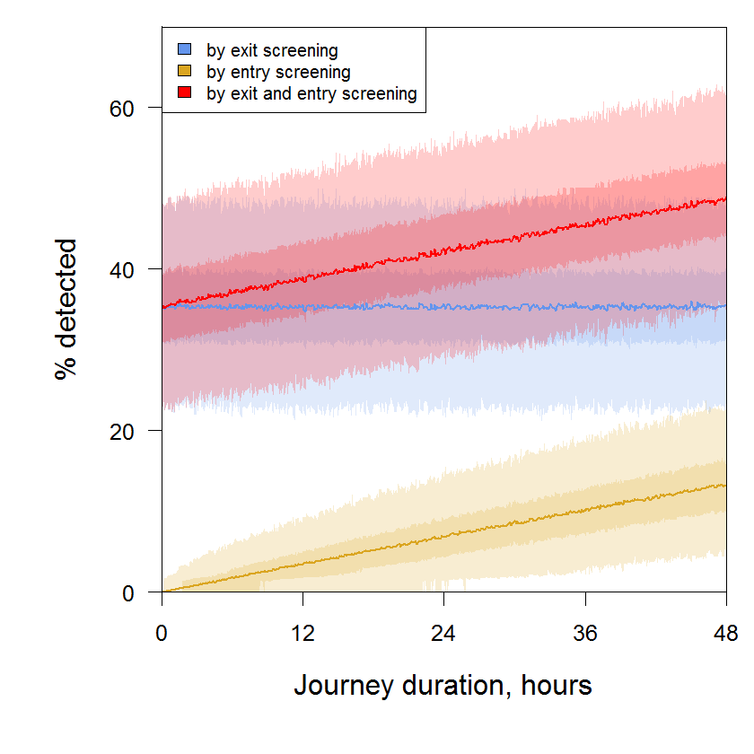
Figure 1 Simulated percentage of passengers infected with Ebola virus that were detected by screening at exit (blue), at entry (yellow), and at both exit and entry (red). Pale shaded regions denote the 95% quantile from multiple simulations; darker shaded regions denote the 50% quantile; thick lines denote the mean. Each of 200 individuals were assigned an incubation and symptomatic period, and randomly assigned a time of infection (constrained by the longest combined interval) prior to the flight departure. Individuals requiring hospitalization prior to departure screening were excluded from screening and boarding within a simulation; this process was repeated 1,000 times and summary statistics calculated for each journey time.

