Dual purpose S-trityl-linkers for glycoarray fabrication on both polystyrene and gold
Johannes W. Wehner,ª Martin J. Weissenborn,^{b} Mirja Hartmann,ª Christopher J. Gray,^{b} Robert Šardzík,^{b} Claire E. Eyers,^{b} Sabine L. Flitsch*^{b} and Thisbe K. Lindhorst*ª
Received (in XXX, XXX) XthXXXXXXXXX 20XX, Accepted Xth XXXXXXXXX 20XX
DOI: 10.1039/b000000x
There is a wide range of immobilisation reactions to tether substrates to a variety of surfaces for array-based analysis. Most of these immobilisation strategies are specific for a particular surface and require an additional linker to be attached to the substrate or surface. Furthermore, the analysis of functionalised surfaces is often restricted to certain analytical techniques and therefore, different immobilisation strategies for different surfaces are desirable. Here we have tested an S-tritylated linker for non-covalent or covalent immobilisation of mannosides to polystyrene or gold surfaces. S-tritylated mannosides with varying linker were readily synthesised and used to add to biorepulsive maleimide-terminated preformed SAMs after in situ deprotection of the S-trityl group. In addition, S-tritylated mannosides themselves formed stable glycoarrays on polystyrene microtiter plates. The glycoarrays were successfully analysed by MALDI-ToF mass spectrometry, SPR spectroscopy, and interrogated with GFP-transfected Escherichia coli cells. This work has shown that a single linker can be used on multiple surfaces to form arrays allowing for ‘orthogonality’ of testing as well as analytical approaches.

Introduction
Microarrays are valuable tools in the analysis of biological interactions in fundamental research and in high-throughput screening and have promising applications as diagnostic devices in the clinic.^{1,2} Among many different microarrays, glycoarrays are carbohydrate-functionalised surfaces which have received much attention in the glycosciences for the investigation of the molecular details of carbohydrate-protein interactions,³⁻⁷ and to study cellular adhesion such as in the context of carbohydrate-specific bacterial colonisation of surfaces.⁸
A key step in the preparation of glycoarrays, which can consist of a variety of materials such as gold, glass or polystyrene, is the immobilisation of the glycoconjugates on the respective surface.⁹⁻¹⁴ A variety of methods has been utilised for this step, involving covalent or non-covalent attachments. Common covalent immobilisation techniques include the amide formation via direct amine coupling into activated esters^{15,16} or via native chemical ligation (NCL),¹⁷ 1,3-dipolar cycloaddition,¹⁸ or Diels-Alder cycloaddition.^{19,20} Each surface type, however, requires specific methods for functionalisation. For example, for the formation of self assembled monolayers (SAMs) on gold, thiol-functionalised derivatives are needed, in order to form Au-S bonds on the surface. Hence, immersion of gold wafers in a solution of thiol-functionalised glycosides has been developed into a common method for the preparation of glyco-SAMs.^{18,19,21} Moreover, carbohydrate thiols have been utilised in the formation of glycoarrays through Michael-type addition to maleimide-terminated surfaces.²² For the formation of glycoarrays on polystyrene, prefunctionalised microtiter plates have been employed for covalent immobilisation.^{8,23} However, direct non-covalent array formation on polystyrene is especially appealing as it requires no additional immobilisation agents. As polystyrene is inherently hydrophobic, hydrophobic interactions or π-π interactions between the glycoconjugate and the polymer surface can used in this case to produce robust glycoarrays.^{3,9,13,24,25}
In the course of our work on the preparation and biological testing of glycoamino acids, we have found that S-trityl-protected low molecular weight glycoconjugates are readily made and purified.^{26,27} This has prompted us to test the direct application of S-tritylated carbohydrate derivatives for the preparation of glycoarrays on different surfaces. De-tritylation would lead to thiol-modified glycoconjugates to allow immobilisation on plain gold or on preformed maleimide-terminated biorepulsive SAMs. On the other hand, the trityl protecting group should also allow preparation of glycoarrays on simple polystyrene microtiter plates, by hydrophobic interactions between the molecule’s trityl fragment and the hydrophobic surface (Figure 1). In this account we report the synthesis of S-tritylated glycosides, their utilisation in glycoarray fabrication on gold as well as on polystyrene and the interrogation of the prepared surfaces with lectins as well as live bacterial cells.
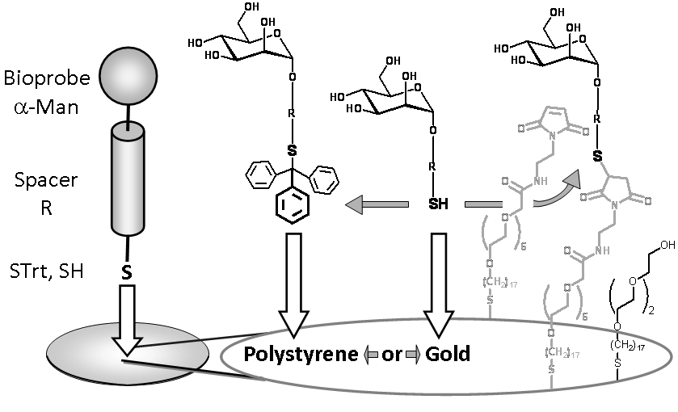
Fig. 1 Dual linkers: Thio-functionalised bioprobes (e.g. carbohydrates as shown for α-d-mannosides) can be directly attached to polystyrene surfaces in their S-tritylated form (left), or added as thiols to gold or maleimide-terminated surfaces (right).
Results & Discussion
Synthesis of S-tritylated glycoconjugates
As we have a long-standing interest in the investigation of mannose-specific lectins, in particular mannose-specific bacterial adhesion, we have made a selection of four S-tritylated mannoside derivatives for this study, 5, 6, 10, and 11 (Scheme 1). We have shown earlier that preparation of mannosides 5 and 6 is readily accomplished by coupling of the well-known 2-aminoethyl mannoside 1²⁸ with the commercially available cysteine derivatives Fmoc-Cys(Trt)-OH (2) or 11-tritylsulphanyl-undecanoic acid (3),^{9,29} leading to the peptide-coupled mannosides 4²⁶ and 6,⁹ respectively. Removal of the Fmoc protecting group and N-acetylation can be effected in one pot yielding the known S-tritylated glycoamino acid 5.²⁶ Then, it was important to add S-tritylated mannoside derivatives to the collection having a longer spacer, because this usually facilitates immobilisation of the respective compound on a surface. Therefore, 6-amino-4-thiahexyl mannoside 7^{8,30} was made and submitted to peptide coupling with the S-tritylated thiols 2 and 3, using HATU and DIPEA. In analogy to the preparation of 4 and 6, this reaction led to the trityl-functionalised mannosides 8 and 11, having considerably longer spacers than their analogues 4 and 6. Removal of the Fmoc protecting group in 8 led to 9 and then acetylation to the N-acetylated target molecule 10 (Scheme 1).
Fabrication and interrogation of glycoarrays on gold
Initially we tested, if the prepared S-tritylated glycosides can be immobilised on gold with concomitant removal of the trityl protecting group. Thus, in situ de-tritylation of 5, 6, 10, and 11 was effected overnight by treatment with trifluoroacetic acid (TFA) and triethylsilane (TES) in dichloromethane.²⁷ Then, the solvent was removed and the crude free thiol dissolved in PBS buffer, centrifuged and the solution applied to the gold surface according to the standard protocol for preparation of SAMs.¹⁷ To test if the immobilisation of in situ deprotected mannosides was successful, the prepared glycoarrays were analysed by MALDI-ToF mass spectrometry.³¹ This mass spectrometric protocol is a reliable method for the analysis of SAMs on gold, in which typically the masses of the disulphides of the respective thiols are detected.¹⁷ Also here, the detected peaks correspond to the disulphides of the thiols derived from 5, 6, 10, and 11 (cf. Supporting Information, Figures S16-S19). Thus, the MS analysis showed the success of glycoarray formation after in situ de-tritylation. In addition, tritylated 6 was deprotected and purified to deliver the pure thiol 6-SH. When pure 6-SH was employed for glycoarray fabrication, mass spectrometric analysis gave very similar results as when the in situ deprotection-immobilisation approach was employed (cf. Supporting Information, Figure S15). The efficiency of immobilisation of in situ deprotected thiols greatly simplifies fabrication of glycoarrays on gold. S-Tritylated derivatives are much easier to purify than free thiols, owing to their greater hydrophobicity. In addition, free thiols are prone to oxidation, forming the respective disulphides, a problem which is circumvented in the in situ deprotection approach.
The same in situ de-tritylation protocol was employed on preformed maleimide-terminal self-assembled monolayers (SAMs) on gold (cf. Figure 1). These SAMs include biorepulsive oligoethyleneglycol units,³² which is important in biological studies to avoid nonspecific protein adsorption. The S-tritylated bioprobes 5, 6, 10, and 11 were treated as above and the non-purified mixtures directly applied to the maleimide-functionalised surface. After 1.5 h reaction time, the surface was rinsed with ethanol and again analysed by MALDI-ToF MS. The MALDI MS spectra showed the corresponding masses of the coupled ligands (Supporting Information, Figures S24-S27). Comparison with the coupling results obtained with previously deprotected and purified thiols revealed that glycoarray formation after in situ deprotection is similarly effective.

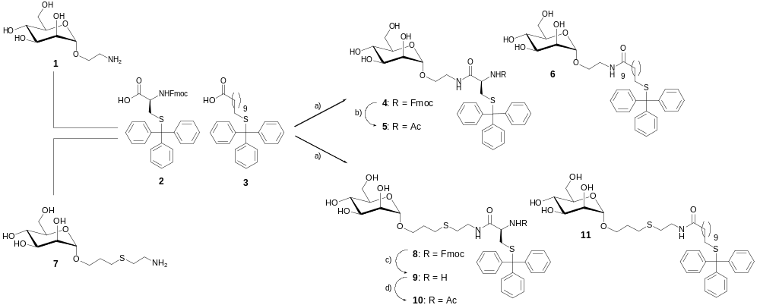

Scheme 1 Synthesis of S-tritylated α-d-mannosides 5, 6, 10, and 11. Reaction conditions: a) HATU, DIPEA, DMF, 0°C → room temp., overnight, 81% (4, from 1 and 2), 74% (6, from 1 and 3), 84% (8, from 7 and 2), 78% (11, from 7 and 3); b) (i) morpholine, DMF, room temp., quant. (ii) Ac₂O, DIPEA, room temp., 4 h, quant.; c) morpholine, DMF, room temp., 67%; d) pyridine, Ac₂O, room temp., overnight, 96%.

As an additional method to test glycoarray formation on gold, SPR spectroscopy was also used. Here, the mannose-specific lectin concanavalin A (ConA) was employed for interrogation of glycoarrays prepared after in situ de-tritylation of a pair of comparable mannosides, 10 having the shorter spacer, and 11, having a longer spacer incorporated. The crude thiols were added to a maleimide-terminated biorepulsive SAM on gold and ConA was allowed to interact with the formed glycoarray. In both cases, the expected carbohydrate-lectin interactions were detected, suggesting glycoarray formation (Figure 2). For the array formed from thiol derived from 11, a much stronger interaction with ConA was measured than for the analogous case using 10. This suggests that (tritylated) thiols having the bioprobe attached to a rather long spacer are better suited for surface immobilisation.
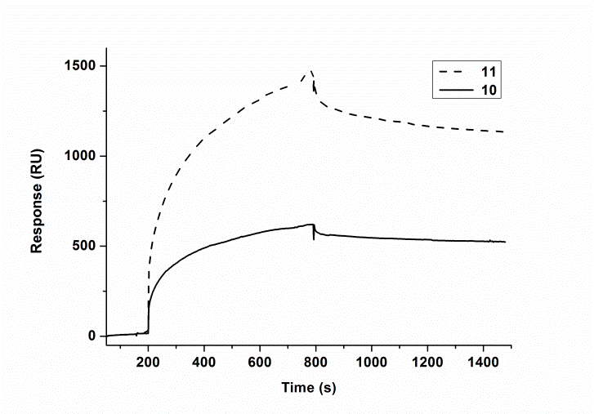
Fig. 2 SPR spectroscopy on surfaces functionalised with 10 and 11 using the lectin ConA was used to prove the formation of glycoarrays after in situ deprotection of tritylated mannosides 10 and 11.
Fabrication and interrogation of glycoarrays on polystyrene
The next step was to employ the S-trityl group in mannosides 5, 6, 10, and 11 (Scheme 1) to anchor these molecules to a hydrophobic polystyrene surface, as it has been shown earlier for another type of tritylated molecules.¹³ For the non-covalent functionalisation of polystyrene microplates hydrophobic molecules have been used regularily. From these studies it is known that the π-π interactions established between the polystyrene surface and the aromatic trityl fragment are strong enough to guarantee a robust direct immobilisation on polystyrene microtiter plates.
First, the reactions conditions for glycoarray fabrication on polystyrene were optimised and methanol was identified as the most suitable solvent for immobilisation of the prepared tritylated glycosides. Then, in order to determine the stability of produced glycoarrays against different washing conditions, a colorimetric phenol-sulphuric acid assay was performed (Figure 3).³³⁻³⁵ This assay allows quantification of glycoconjugates immobilised on surfaces. Washing with ethanol removed the immobilised glycosides completely, as expected. In contrary, washing with twice distilled water and/or PBST buffer led to negligible reduction of carbohydrate content on the surface in case of the glycoarrays formed from the tritylated glycosides 6, 10, and 11. However, the mannoside with the shortest spacer, compound 5, formed the least stable glycoarray on polystyrene which was washed out by water or buffer to over 50% according to the phenol-sulphuric acid assay.
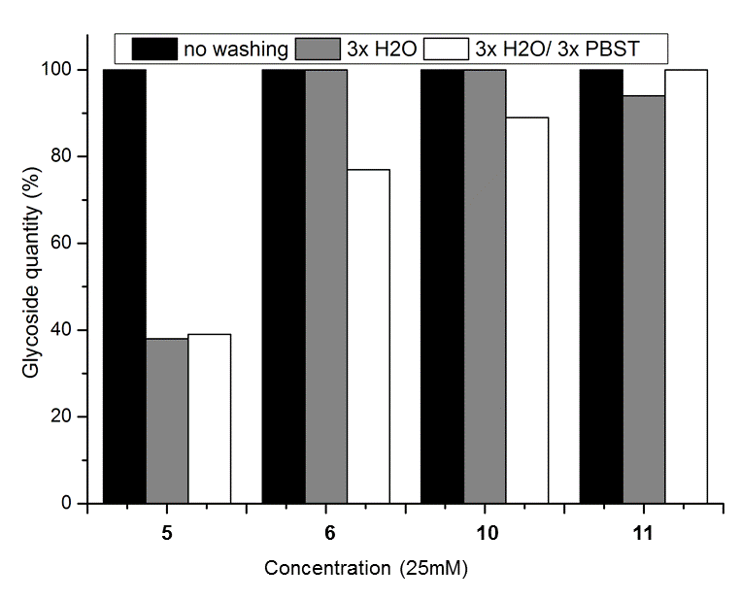
Fig. 3 Removal of compounds 5, 6, 10 and 11 from polystyrene surfaces using different washing steps. Microtiter plate wells were functionalised with 25 mM methanolic solutions of tritylated mannosides 5, 6, 10, and 11, then it was washed with water and/or buffer and the remaining glycoside content on the surface determined by the phenol-sulphuric colorimetric acid assay:. The glycoside content without washing was defined as 100%. Six-fold washing with ethanol removed the glycoarray completely (not shown).
In the next step, the prepared glycoarrays were tested with live bacterial cells in a GFP-assisted adhesion assay, which was established earlier.⁸ Here, the genetically engineered E. coli strain PKL1162 was used.^{8,36} Protocols for cellular adhesion assays on polystyrene microplates usually involve a blocking step with BSA or skimmed milk for example, to prevent unspecific binding of the cells to the microtiter plate surface. However, we could show, that when the tritylated mannosides were used for modification of polystyrene plates, no blocking step was necessary (Supporting Information, Figure S28).
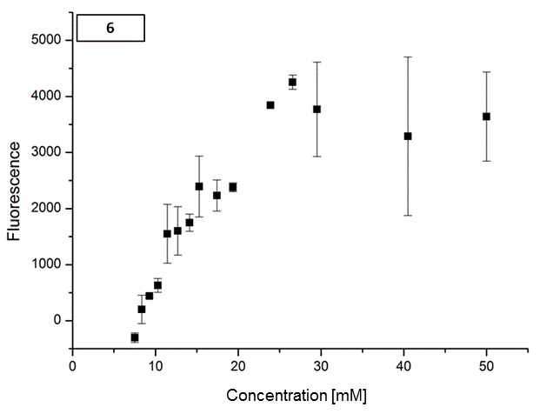
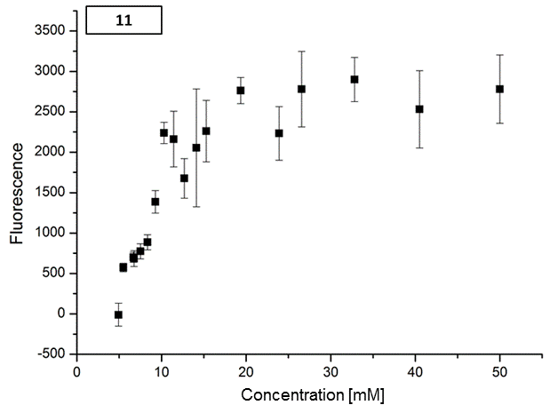
Fig. 4 Bacterial adhesion curves (GFP-tagged E. coli PKL1162) obtained by application of glycoarrays consisting of compounds 6 (top) and 11 (bottom) after 1 h incubation and fluorescence readout.
Glycoarrays on polystyrene were prepared using tritylated mannosides 6 and 11 at different concentrations. Concentration dependency of bacterial adhesion to these two glycoarrays was tested and was found as expected in both cases, with the intensity of the GFP fluorescence increasing with higher concentration of the applied mannoside solutions (Figure 4). A plateau was reached at concentrations between 20 mM and 25 mM. Mannosides 5 and 10 were less suited in this assay. Only little adhesion could be detected and no consistent concentration dependency of bacterial adhesion could be observed in case of these mannosides linked via short spacers (Supporting Information, Figures S31).
After having shown that tritylated mannosides such as 6 and 11 form stable glycoarrays on polystyrene microtiter plates upon direct treatment, testing of inhibition of bacterial adhesion to these surfaces could be tested next. From the results received in the adhesion experiments, 25 mM concentrations appeared optimal to form microarrays for competitive bacterial adhesion inhibition assays. As described earlier,³⁷ serial dilutions of methyl α-d-mannoside (MeMan), a standard inhibitor of mannose-specific bacterial adhesion, were applied to inhibit bacterial adhesion to the two different glycoarrays formed with 6 and 11, respectively. The obtained inhibition curves are depicted in Figure 5. After sigmoidal fitting of the testing results, IC₅₀ values could be deduced, with IC₅₀ (MeMan) ~ 2.9 mM for the inhibition of bacterial adhesion to the surface, modified with mannoside 6 and IC₅₀ (MeMan) ~ 5.3 mM for 11. Thus, the surface prepared from mannosides 11 appears to be slightly more adhesive in this testing system than when 6 was used for glycoarray formation. This finding is in line with earlier results, which have indicated that mannosides having a thiahexyl aglycon moiety show a higher affinity to the mannose-specific lectin of E. coli than mannosides having an ethyl aglycon.³⁷
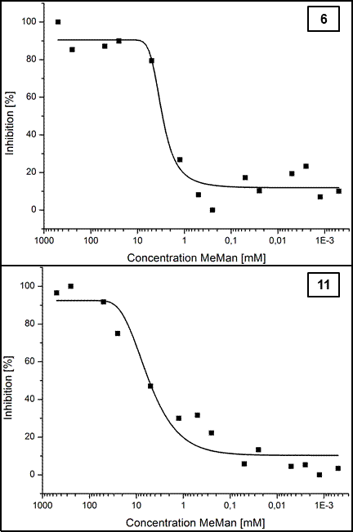
Fig. 5 Inhibition curves of competitive bacterial adhesion inhibition assays using polystyrene glycoarrays prepared from 6 (top) and 11 (bottom). Methyl α-d-mannoside was used as inhibitor and type 1 fimbriated E. coli cells (PKL1162) were used to adhere to the surface.
Conclusions
S-Tritylated mannosides were synthesised and shown to be suitable for the fabrication of glycoarrays on different surfaces such as gold and polystyrene. An in situ deprotection protocol has allowed us to apply tritylated carbohydrate derivatives on plain gold as well as on maleimide-terminal preformed biorepulsive SAMs. As SAMs on gold on one hand and polystyrene microtiter plates on the other can be used in quite different applications, S-tritylated glycoconjugates can be regarded as facile derivatives for orthogonal immobilisation on surfaces of opposite character.
The prepared glycoarrays were analysed by MALDI-ToF MS and were shown to be robust and suited for interrogation with lectins and live bacterial cells. Next, we will further employ this methodology in a 384 well polystyrene microtiter plate format to facilitate inhibitor screening in bacterial adhesion assays.
Experimental
Commercially available starting materials and reagents were used without further purification. Reactions requiring dry conditions were performed under an atmosphere of nitrogen using oven-dried glassware. Anhydrous DMF was purchased from Acros. All other used solvents were purified by distillation. ConA was purchased from Vector labs. Bovine serum albumin (BSA), methyl α-d-mannopyranoside (MeMan) and polyethylene glycol sorbitan monolaurate (Tween® 20) were obtained from Sigma-Aldrich. Microtiter plates with a hydrophobic surface (Corning, no. 3540, low volume 384 wells, flat clear bottom, black polystyrene, nontreated and Corning, no. 3631, 96 wells, flat clear bottom, black polystyrene, nontreated) were obtained from Corning. 2-Aminoethyl α-d-mannopyranoside (1),²⁸ 6-amino-4-thiahexyl α-d-mannopyranoside (7),^{8,30} N-(fluoren-9-yl-methoxycarbonyl)-S-(triphenylmethyl)-l-cysteine-[2-(α-d-mannopyranosyloxy)ethyl]amide (4),²⁶ 11-tritylsulphanyl-undecanoic acid, and 2-(11-tritylsulphanyl-undecanoyl)aminoethyl α-d-mannopyranoside (6)⁹ were prepared according to the literature.
Reactions were monitored by thin-layer chromatography using either silica gel 60 GF254 on aluminium foil (Merck) or RP-18 F254s on aluminium foil (Merck) with detection by UV light and charring with sulphuric acid in EtOH (10 %). Merck silica gel 60 (0.040-0.063 mm) was used for flash chromatography. Analytical HPLC was performed on a Merck Hitachi LaChrom L-7000 series apparatus with a LiChrospher 100 RP-8 (5 μm, Merck) column (for HPLC chromatograms see the Supporting Information.). Preparative MPLC was performed on a Büchi apparatus using a LiChroprep RP-18 column (40–60 μm, Merck) for reversed-phase and a LiChroprep Si 60 column (40–60 μm, Merck) for normal-phase silica gel chromatography. ¹H and ¹³C NMR spectra were recorded on a Bruker DRX-500 or a Bruker AV-600 instrument. NMR spectra were calibrated with respect to the solvent peak (in case of CDCl₃ the reference was tetramethylsilane (TMS)). 2D NMR techniques (COSY, HSQC, HMBC) were used for full assignment of the spectra. ESI MS measurements were performed on a Mariner ESI-ToF 5280 instrument (Applied Biosystems). MALDI-ToF mass spectra were recorded on a Bruker Biflex-III 19 kV instrument with Cl-CCA (4-chloro-α-cyanocinnamic acid) or DHB (2,5-dihydroxybenzoic acid) as matrix. Optical rotation was measured on a Perkin-Elmer polarimeter 341 (Na-D-line: 589 nm, length of cell 1 dm). IR spectra were recorded on a Perkin-Elmer Paragon 1000 FT-IR instrument. For sample preparation a Golden Gate diamond ATR unit with a saphire stamp was used. The SPR experiments were performed on a Biacore 3000 system (GE Healthcare, Sweden) using a gold sensor chip (GE Healthcare). For bacterial adhesion studies and phenol-sulphuric acid assays, a TECAN infinite 200 multifunction microplate reader was employed. The wavelengths of the band pass filters for excitation and emission were 485 and 535 nm, respectively. For the phenol-sulphuric acid assay absorbance at 492 nm was measured.
E. coli bacteria (PKL1162)^{8,36} were used and grown in LB-media + AMP + CAM (100 mg ampicillin, 50 mg chloramphenicol/L) at 37 °C under slight agitation. Buffers were used as follows: PBS buffer solution (pH 7.2): Sodium chloride (8.00 g), potassium chloride (200 mg), sodium hydrogen phosphate-dihydrate (1.44 g), and potassium dihydrogen phosphate (200 mg) were dissolved in bidest. water (1.00 L). PBST buffer solution (pH 7.2): PBS buffer + 0.05 % v/v Tween® 20.

General procedure for in situ de-tritylation of S-protected mannosides
The S-tritylated mannosides (5, 6, 10, or 11, 3 μmol) were dissolved in dichloromethane (1 mL). Then, triethylsilane (5 eq.) and trifluoroacetic acid (5 eq.) were added and the reaction mixture was left for 1.5 h at room temperature and was subsequently treated with further trifluoroacetic acid (5 eq.) and left overnight. Thereafter, the solvent was removed in vacuo and the residue dissolved in 10 mM PBS to obtain a final concentration of the corresponding free thiol of 10 mM. This solution was centrifuged and the supernatant directly applied to the differently modified gold surfaces.

Fabrication of glycoarrays on gold and maleimide-terminated SAMs and their MALDI-ToF MS analysis
A disposable 64-well gold plate (Applied Biosystems) was cleaned with Piranha solution (12 mL, 3:1 conc. H₂SO₄/ 30% H₂O₂) for 30 min, rinsed with distilled water and ethanol and dried under a stream of nitrogen. A solution of carboxylic acid-terminated linkers [HS-(CH₂)₁₇-(OC₂H₄)₆-OCH₂-COOH] and tri(ethylene glycol)-terminated alkanethiol spacers [HS-(CH₂)₁₇-(OC₂H₄)₃-OH] in dry DMSO (final concentration 0.4 mg/mL, molar ratio 1:4) was applied on the plate (~1 μL per well) and left overnight at room temperature to form a mixed SAM. The plate was washed with ethanol and dried under nitrogen. The carboxylic acid groups were activated by spotwise treatment with a solution of EDC, NHS and N-(2-aminoethyl)maleimide (all Sigma-Aldrich, 0.180 M, 0.174 M and 0.174 M, respectively) in dry DMF for 1-2 h, followed by washing with water and ethanol and drying as above. The product formation was analysed by MALDI-ToF MS. Unless otherwise stated all MALDI-ToF MS experiments on gold surfaces were carried out on an Ultraflex II instrument (Bruker Daltonics) in positive reflectron mode. A solution of matrix (2,4,6-trihydroxyacetophenone, 10 mg/mL in acetone) was applied on the gold and allowed to dry before analysis.

Surface plasmon resonance (SPR) analysis using 10 and 11
The gold-coated sensor was cleaned with Piranha solution, rinsed with water and ethanol and dried in a stream of nitrogen. The formation of self-assembling monolayers was performed in the same way as described above. The chip was washed with ethanol, dried under nitrogen and mounted into a chip holder following instructions in the supplier’s manual. After docking in the instrument the sensor was equilibrated with PBS buffer (10 mM, degassed and filtered) at a flow rate of 10 μL/min. For surface activation, 70 μL of a 1:1 mixture of freshly prepared solutions of NHS (0.4 M) and EDC (0.1 M) in water were injected. Reference spot (channel 1) was blocked by injecting 70 μL of aminoethanol-hydrochloride (1 M). Additional channels were modified with N-(2-aminoethyl)maleimide (10 mM, flow rate 10 μL/min) for 10 min and then treated with in situ deprotected mannosides 10 and 11 for about an hour at a flow rate of 3 μL/min.
Binding studies were carried out using the lectin ConA (10 μg/mL, 250 μL) in buffer (0.15 M NaCl, 1 mM CaCl₂, 1 mM MnCl₂, pH 7.0) at a flow rate of 25 μL/min. After the injection a 600 s dissociation sequence was followed.

Fabrication of glycoarrays on polystyrene
A series of 5 to 50 mM stock solutions of tritylated mannosides 5, 6, 10, and 11 (in MeOH) were prepared. A 12 μL sample of each solution was pipetted into a 384 well polystyrene microtiter plate, which was dried by standing overnight at ambient temperature. Each well was then washed three times with deionised water and three times with PBST buffer (20 μL/well each).

Phenol-sulphuric acid assay
To test the stability of glycoarrays formed by immobilisation of 5, 6, 10 or 11 against different washing conditions, these compounds were immobilised as described above followed by 6 washing cycles with ethanol (20 μL/well each) followed by phenol-sulphuric acid assa12 μL of solutions of trityl-protected carbohydrate (50 mM, 25 mM, 12.5 mM solutions in MeOH) were pipetted into a 384 well microtiter plate and the plate was allowed to dry in by standing overnight at ambient temperature. The wells were then washed three times with deionised water and three times with PBST (20 μL/well each). The phenol-sulphuric acid assay was performed according to a literature-known method.³⁴ A 5% phenol solution (4.2 μL/well) was pipetted to the wells, followed by the addition of concentrated H₂SO₄ (21 μL/well). The mixture was incubated for 30 min at room temperature, and the absorbance measured at 492 nm (A492) to determine the amount of carbohydrate immobilised on the microtiter plate. The amount of immobilised 5, 6, 10 and 11 was estimated from the ratio of the absorption at 492 nm of immobilised compounds (subjected to 3 washing cycles with deionised water and/or PBST) to the A492 of the corresponding control (unwashed). Washings with ethanol (6 washing cycles using 20 μL ethanol/well) removed the glycoarrays completely according to the phenol-sulphuric acid assay.

GFP-based bacterial adhesion assay
Determination of bacterial adhesion. Trityl-protected carbohydrates (5, 6, 10, and 11) were immobilised on 384 well microtiter plates as described above. The wells were incubated with E. coli PKL1162 (2 mg/mL PBS buffer) for 1 h (37°C, 120 rpm), and subsequently washed with the same buffer (3 x 20 μL/well). E. coli binding to the mannoside-functionalised surface was monitored by fluorescence measurements at 485/535 nm using a microplate reader.

Inhibition of bacterial adhesion with methyl α-d-mannoside (MeMan). Compounds 6 and 11 (12 μL/well, 25 mM) were immobilised on 384 well microtiter plates as described above. Then, 5 μL of a serial dilution of the standard inhibitor MeMan (1 μM-1000 mM) were pipetted to the plate followed by addition of 5 μL of E. coli (PKL1162) solution (4 mg/mL PBS buffer). The plate was incubated for 1 h (37 °C, 120 rpm) and the wells were then washed with PBS buffer (3 x 20 μL/well). Fluorescence was read out at 485/535 nm.

2-(11-Sulphhydryl-undecanoyl)aminoethyl α-d-mannopyranoside (6-SH)
The tritylated mannoside 6 (50 mg, 75.1 μmol) was dissolved in dichloromethane (1 mL), triethylsilane (60 μL, 376 μmol) and trifluoroacetic acid (58 μL, 751 μmol) were added and the reaction mixture was stirred for 2 h at ambient temperature. The solvent was removed under reduced pressure and the crude product was purified by RP-MPLC (120 g RP-18, A: methanol, B: water, A: 60 % → 95 %, 90 min) yielding the deprotected title compound 6-SH (31.3 mg, 73.6 μmol, 98 %) after lyophylisation. R_{f} 0.33 (methanol / water, 3:1);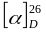= + 40.4 (c = 0.5, methanol); ¹H NMR (500 MHz, CD₃OD, 300 K): δ = 4.76 (d, ³J = 1.7 Hz, 1H, H-1_{Man}), 3.83 (dd, ²J = 11.7 Hz, ³J = 2.3 Hz, 1H, H-6a_{Man}), 3.81 (dd, ³J = 1.7 Hz, ³J = 3.4 Hz, 1H, H-2_{Man}), 3.75 (m_{c}, 1H, OCHHCH₂NH), 3.72-3.67 (m, 2H, H-3_{Man}, H-6b_{Man}), 3.60 (dd~t, ³J = 9.5 Hz, 1H, H-4_{Man}), 3.56-3.51 (m, 2H, H-5_{Man}, OCHHCH₂NH), 3.45-3.32 (m, 2H, OCH₂CH₂NH), 2.49 (t, ³J = 7.1 Hz, 2H, CH₂CH₂SH), 2.19 (t, ³J = 7.5 Hz, 2H, HN(O)CCH₂CH₂), 1.59 (m_{c}, 4H, HN(O)CCH₂CH_{2,} OCH₂CH₂CH₂S), 1.40 (m_{c}, 2H, CH₂CH₂CH₂), 1.35-1.25 (m, 12H, CH₂CH₂CH₂) ppm; ¹³C NMR (125 MHz, CD₃OD, 300 K): δ = 176.5 (C(O)NH), 101.7 (C-1_{Man}), 74.8 (C-5_{Man}), 72.6 (C-3_{Man}), 72.1 (C-2_{Man}), 68.6 (C-4_{Man}), 67.3 (OCH₂CH₂NH), 62.9 (C-6_{Man}), 40.2 (OCH₂CH₂NH), 37.1 (HN(O)CCH₂CH₂), 35.2 (OCH₂CH₂CH₂S), 30.6, 30.5, 30.4, 30.3, 30.2, 29.4 (6 CH₂CH₂CH₂), 27.0 (HN(O)CCH₂CH₂), 25.0 (CH₂CH₂SH) ppm; HR-ESI MS: calcd. for C₃₈H₇₂N₂NaO₁₄S₂ (disulphide): m/z 867.4317 [M+Na]⁺; found: m/z 867.4309 [M+Na]⁺; IR (ATR): ṽ = 3308, 2918, 2850, 1637, 1554, 1463, 1132, 1057, 1031, 975 cm⁻¹.

N-(Fluoren-9-yl-methoxycarbonyl)-S-(triphenylmethyl)-l-cysteine-[6-(α-d-mannopyranosyloxy)-3-thiahexyl]amide (8)
A mixture of Fmoc-l-Cys(Trt)-OH (2, 2.46 g, 4.18 mmol), mannoside 1 (1.37 g, 4.60 mmol), and HATU (1.91 g, 5.02 mmol) was dried for 1 h under vacuum and then dissolved in dry DMF (40 mL). It was cooled to 0°C, DIPEA (853 μL, 5.02 mmol) was added and the reaction stirred overnight at ambient temperature under nitrogen atmosphere. The solvent was removed under reduced pressure and the crude product was purified by column chromatography (methanol / ethyl acetate, 1:12 → 1:9) yielding the title compound 8 (3.01 g, 3.48 mmol, 84 %) as a colourless foam. R_{f} 0.38 (methanol / ethyl acetate, 1:9); 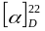 = + 21.8 (c = 0.5, methanol); ¹H NMR (500 MHz, CD₃OD, 300 K): δ = 7.78 (m_{c}, 2H, H-aryl_{Fmoc}), 7.66 (d, ³J = 6.8 Hz, 2H, H-aryl_{Fmoc}), 7.40-7.34 (m, 8H, H-aryl_{Trt}, H-aryl_{Fmoc}), 7.30-7.19 (m, 14H, H-aryl_{Trt}, H-aryl_{Fmoc}), 4.72 (d, ³J = 1.6 Hz, 1H, H-1_{Man}), 4.41 (dd, ²J = 10.6 Hz, ³J = 7.1 Hz, 1H, CHH_{Fmoc}), 4.30 (dd, ²J = 10.6 Hz, ³J = 6.8 Hz, 1H, CHH_{Fmoc}), 4.23 (dd~t, ³J = 6.8 Hz, 1H, CH_{Fmoc}), 3.93 (dd, ³J = 8.4 Hz, ³J = 5.5 Hz, 1H, H-α_{Cys}), 3.82 (dd, ²J = 11.7 Hz, ³J = 2.4 Hz, 1H, H-6a_{Man}), 3.78 (dd, ³J = 3.3 Hz, ³J = 1.6 Hz, 1H, H-2_{Man}), 3.77-3.74 (m, 1 H, OCHHCH₂CH₂S), 3.71 (dd, ²J = 11.7 Hz, ³J = 5.8 Hz, 1H, H-6b_{Man}), 3.67 (dd, ³J = 9.4 Hz, ³J = 3.3 Hz, 1H, H-3_{Man}), 3.61 (dd~t, ³J = 9.6 Hz, 1H, H-4_{Man}), 3.54-3.50 (m, 1H, H-5_{Man}), 3.49-3.43 (m, 1H, OCHHCH₂CH₂S), 3.34-3.23 (m, 2H, SCH₂CH₂NH), 2.62-2.49 (m, 6H, OCH₂CH₂CH₂S, SCH₂CH₂NH, H-β_{Cys}), 1.79 (m_{c}, 2H, OCH₂CH₂CH₂S) ppm; ¹³C NMR (125 MHz, CD₃OD, 300 K): δ = 172.7 (C(O)NH), 158.0 (OC(O)NH), 146.0 (C-aryl_{Trt}), 145.1, 142.6 (C-aryl_{Fmoc}), 130.8, 129.0 (CH-aryl_{Trt}), 128.8, 128.2 (CH-aryl_{Fmoc}), 127.9 (CH-aryl_{Trt}), 126.3, 120.9 (CH-aryl_{Fmoc}), 101.6 (C-1_{Man}), 74.7 (C-5_{Man}), 72.7 (C-3_{Man}), 72.2 (C-2_{Man}), 72.0 (C_{q,Trt}), 68.6 (C-4_{Man}), 68.1 (CH_{2,Fmoc}), 66.9 (OCH₂CH₂CH₂S), 62.9 (C-6_{Man}), 55.7 (C-α_{ys}), 48.4 (CH_{Fmoc}), 40.1 (SCH₂CH₂NH), 35.2 (C-β_{Cys}), 31.9 (SCH₂CH₂NH), 30.6 (OCH₂CH₂CH₂S), 29.3 (OCH₂CH₂CH₂S) ppm; MALDI-ToF MS (DHB): calcd. for C₄₈H₅₂N₂NaO₉S₂: m/z 887.30 [M+Na]⁺; found: m/z 887.50 [M+Na]⁺; calcd. for C₄₈H₅₂KN₂O₉S₂: m/z 903.27 [M+K]⁺; found: m/z 903.48 [M+K]⁺; IR (ATR): ṽ = 3316, 3055, 2924, 1705, 1660, 1521, 1490, 1445, 1318, 1230, 1130, 1084, 1029, 974, 739 cm⁻¹.

S-(Triphenylmethyl)-l-cysteine-[6-(α-d-mannopyranosyloxy)-3-thiahexyl]amide (9)
The Fmoc-protected cysteinyl mannoside 8 (406 mg, 467 μmol) was dissolved in dry DMF (5 mL) under a nitrogen atmosphere and morpholine (250 μL, 2.87 mmol) was added. The reaction mixture was stirred for 1 h at ambient temperature and then another portion of morpholine (250 μL, 2.87 mmol) was added. This was repeated after 3 h and 4 h and stirred overnight. After 18 h the volatile compounds were removed under reduced pressure and the crude product was purified by column chromatography (methanol / ethyl acetate / TEA, 100 : 20 : 1) yielding the title compound 9 (200 mg, 311 μmol, 67 %) as a colourless syrup. R_{f} 0.28 (RP-18, methanol/water, 4:1); 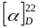 = + 22.8 (c = 0.26, methanol); ¹H NMR (500 MHz, CD₃OD, 300 K): δ = 7.41 (m_{c}, 6H, H-aryl_{Trt}), 7.29 (m_{c}, 6H, H-aryl_{Trt}), 7.22 (m_{c}, 3H, H-aryl_{Trt}), 4.74 (d, ³J = 1.6 Hz, 1H, H-1_{Man}), 3.85-3.77 (m, 3 H, OCHHCH₂CH₂S, H-6a_{Man}, H-2_{Man}), 3.71 (dd, ²J = 11.7 Hz, ³J = 5.7 Hz, 1H, H-6b_{Man}), 3.69 (dd, ³J = 9.6 Hz, ³J = 3.4 Hz, 1H, H-3_{Man}), 3.61 (dd~t, ³J = 9.6 Hz, 1H, H-4_{Man}), 3.55-3.46 (m, 2H, H-5_{Man}, OCHHCH₂CH₂S), 3.41-3.30 (m, 2H, SCH₂CH₂NH), 3.11 (dd~t, ³J = 6.5 Hz, 1H, H-α_{Cys}), 2.65-2.59 (m, 4H, OCH₂CH₂CH₂S, SCH₂CH₂NH), 2.55 (dd, ²J = 12.1 Hz, ³J = 6.1 Hz, 1H, H-βa_{Cys}), 2.40 (dd, ²J = 12.1 Hz, ³J = 7.0 Hz, 1H, H-βb_{Cys}), 1.90 (s, 3H, NHCOCH₃), 1.83 (m_{c}, 2H, OCH₂CH₂CH₂S) ppm; ¹³C NMR (125 MHz, CD₃OD, 300 K): δ = 175.5 (C(O)NH), 146.1 (C-aryl_{Trt}), 130.8, 129.0, 127.9 (CH-aryl_{Trt}), 101.6 (C-1_{Man}), 74.7 (C-5_{Man}), 72.7 (C-3_{Man}), 72.2 (C-2_{Man}), 68.6 (C-4_{Man}), 67.8 (C_{q,Trt}), 66.9 (OCH₂CH₂CH₂S), 62.9 (C-6_{Man}), 55.3 (C-α_{Cys}), 40.0 (SCH₂CH₂NH), 38.3 (C-β_{Cys}), 32.0 (SCH₂CH₂NH), 30.7 (OCH₂CH₂CH₂S), 29.3 (OCH₂CH₂CH₂S) ppm; HR-ESI MS: m/z = [Trt]⁺ 243.1242; calcd. for C₃₃H₄₃N₂O₇S₂: m/z 643.2506 [M+H]⁺; found: m/z 643.2534 [M+H]⁺; calcd. for C₃₃H₄₂NaN₂O₇S₂: m/z 665.2326 [M+Na]⁺; found: m/z 665.2323 [M+Na]⁺; MALDI-ToF MS (DHB): calcd. for C₃₃H₄₂NaN₂O₇S₂: m/z 665.23 [M+Na]⁺; found: m/z 665.47 [M+Na]⁺; IR (ATR): ṽ = 3303, 3062 2921, 1658, 1519, 1488, 1443, 1318, 1261, 1129, 1084, 1054, 1024, 975, 803, 743 cm⁻¹.

N-(Acetyl)-S-(triphenylmethyl)-l-cysteine-[6-(α-d-mannopyranosyloxy)-3-thiahexyl]amide (10)
The glycoamino acid 9 was dissolved in pyridine (2 mL) and acetic anhydride (110 μL, 1.17 mmol) was added. The reaction mixture was stirred overnight at room temperature. Then solvents were removed under reduced pressure, it was codestilled with toluene three times (10 mL each) and the crude product was subjected to RP-MPLC (60 g RP-18, A: methanol, B: water, A: 40 % → 95 %, 120 min) yielding the title compound 10 (154 mg, 225 μmol, 96 %) after lyophylisation. R_{f} 0.31 (ethyl acetate); = + 29.4 (c = 0.5, methanol); HPLCt_{R} = 2.64 min (A = water, B = methanol, A: 20 %, 10 min, 1.2 mL/min); ¹H NMR (500 MHz, CD₃OD, 300 K): δ = 7.38 (m_{c}, 6H, H-aryl_{Trt}), 7.30 (m_{c}, 6H, H-aryl_{Trt}), 7.23 (m_{c}, 3H, H-aryl_{Trt}), 4.73 (d, ³J = 1.6 Hz, 1H, H-1_{Man}), 4.19 (m_{c}, 1H, H-α_{Cys}), 3.83 (dd, ²J = 11.7 Hz, ³J = 2.4 Hz, 1H, H-6a_{Man}), 3.81-3.77 (m, 2H, OCHHCH₂CH₂S, H-2_{Man}), 3.71 (dd, ²J = 11.7 Hz, ³J = 5.6 Hz, 1H, H-6b_{Man}), 3.70-3.67 (m, 1H, H-3_{Man}), 3.61 (dd~t, ³J = 9.6 Hz, 1H, H-4_{Man}), 3.55-3.50 (m, 1H, H-5_{Man}), 3.50-3.45 (m, 1H, OCHHCH₂CH₂S), 3.36-3.24 (m, 2H, SCH₂CH₂NH), 3.62-2.56 (m, 4H, OCH₂CH₂CH₂S, SCH₂CH₂NH), 2.56 (dd, ²J = 12.4 Hz, ³J = 6.3 Hz, 1H, H-βa_{Cys}), 2.49 (dd, ²J = 12.4 Hz, ³J = 7.7 Hz, 1H, H-βb_{Cys}), 1.91 (s, 3H, NH(O)CCH₃), 1.82 (m_{c}, 2H, OCH₂CH₂CH₂S) ppm; ¹³C NMR (125 MHz, CD₃OD, 300 K): δ = 173.0 (CH₃C(O)NH), 172.4 (C(O)NH), 145.9 (C-aryl_{Trt}), 130.7, 129.0, 128.0 (CH-aryl_{Trt}), 101.6 (C-1_{Man}), 74.7 (C-5_{Man}), 72.7 (C-3_{Man}), 72.2 (C-2_{Man}), 68.6 (C-4_{Man}), 68.0 (C_{q,Trt}), 66.9 (OCH₂CH₂CH₂S), 62.9 (C-6_{Man}), 54.0 (C-α_{Cys}), 40.1 (SCH₂CH₂NH), 34.9 (C-β_{Cys}), 31.9 (SCH₂CH₂NH), 30.7 (OCH₂CH₂CH₂S), 29.3 (OCH₂CH₂CH₂S), 22.5 (NHCOCH₃) ppm; HR-ESI MS: calcd. for C₃₅H₄₄N₂NaO₈S₂: m/z 707.2431 [M+Na]⁺; found: m/z 707.2426 [M+Na]⁺; MALDI-ToF MS (Cl-CCA): calcd. for C₃₅H₄₄N₂NaO₈S₂: m/z 707.24 [M+Na]⁺; found: m/z 707.33 [M+Na]⁺, calcd. for C₃₅H₄₄KN₂O₈S₂: m/z 723.22 [M+K]⁺; found: m/z 723.31 [M+K]⁺; IR (ATR): ṽ = 3284, 2926, 1645, 1535, 1489, 1443, 1372, 1202, 1131, 1085, 1055, 1031, 975, 742, 698, 675 cm⁻¹.

6-(10-Tritylsulphanyl-undecanoyl)amino-4-thiahexyl-α-d-mannopyranoside (11)
11-Tritylsulphanyl-undecanoic acid (3, 194 mg, 420 μmol) and HATU (319 mg, 840 μmol) were dried for 1 h under vacuum, dry DMF (2.50 mL) and DIPEA (288 μL, 1.68 mmol) were added and the mixture was stirred for 20 min under a nitrogen atmosphere at ambient temperature. Simultaneously in a different reaction vessel 7 (150 mg, 504 μmol) was dried for 1 h under vacuum, dissolved in dry DMF (2.50 mL) and stirred for 20 min under a nitrogen atmosphere at ambient temperature. The reaction mixture with the preactivated 11-tritylsulphanyl-undecanoic acid (3) and HATU was cooled to 0°C, the solution of mannoside 7 was added and it was stirred under a nitrogen atmosphere at ambient temperature overnight. Then, all volatile compounds were removed under reduced pressure and the crude product was subjected to MPLC (150 g silica column, A: ethyl acetate, B: methanol, A: 99 % → 85 %, 120 min) and RP-MPLC (60 g RP-18, A: methanol, B: water, A: 50 % → 95 %, 120 min) yielding the title compound 11 (242 mg, 327 μmol, 78 %) as a colourless foam. R_{f} 0.29 (ethyl acetate), = +25.3 (c = 0.5, methanol); HPLCt_{R} = 6.11 min (A = water, B = methanol, A: 20 %, 10 min, 1.2 mL/min); ¹H NMR (500 MHz, CD₃OD, 300 K): δ = 7.38 (m_{c}, 6H, H-aryl_{Trt}), 7.26 (m_{c}, 6H, H-aryl_{Trt}), 7.19 (m_{c}, 3H, H-aryl_{Trt}), 4.75 (d, ³J = 1.7 Hz, 1H, H-1_{Man}), 3.85-3.80 (m, 2H, H-6a_{Man}, OCHHCH₂CH₂S), 3.79 (dd, ³J = 3.3 Hz, ³J = 1.7 Hz, 1H, H-2_{Man}), 3.72 (dd, ²J = 11.7 Hz, ³J = 5.6 Hz, 1H, H-6b_{Man}), 3.70 (dd, ³J = 9.3 Hz, ³J = 3.3 Hz, 1H, H-3_{Man}), 3.62 (dd~t, ³J = 9.5 Hz, 1H, H-4_{Man}), 3.56-3.48 (m, 2H, H-5_{Man}, OCHHCH₂CH₂S), 3.37-3.32 (m, 2H, SCH₂CH₂NH), 2.63 (m_{c}, 4H, OCH₂CH₂CH₂S, SCH₂CH₂NH), 2.17 (t, ³J = 7.5 Hz, 2H, HN(O)CCH₂CH₂), 2.11 (t, ³J = 7.4 Hz, 2H, CH₂STrt), 1.89-1.81 (m, 2H, OCH₂CH₂CH₂S), 1.59 (quint., ³J = 7.6 Hz, 2H, HN(O)CCH₂CH₂), 1.38-1.09 (m, 14H, CH₂CH₂CH₂) ppm; ¹³C NMR (125 MHz, CD₃OD, 300 K): δ = 176.4 (C(O)NH), 146.5 (C-aryl_{Trt}), 130.8, 128.8, 127.7 (CH-aryl_{Trt}), 101.6 (C-1_{Man}), 74.7 (C-5_{Man}), 72.7 (C-3_{Man}), 72.2 (C-2_{Man}), 68.6 (C-4_{Man}), 67.6 (C_{q,Trt}), 66.9 (OCH₂CH₂CH₂S), 62.9 (C-6_{Man}), 40.1 (SCH₂CH₂NH), 37.1 (HN(O)CCH₂CH₂), 32.9 (CH₂STrt), 32.1 (SCH₂CH₂NH), 30.7 (OCH₂CH₂CH₂S), 30.5, 30.4, 30.4, 30.3, 30.1, 30.0, 29.7 (7 CH₂CH₂CH₂), 29.3 (OCH₂CH₂CH₂S), 27.0 (HN(O)CCH₂CH₂) ppm; HR-ESI MS: calcd. for C₄₁H₅₇NNaO₇S₂: m/z 762.3469 [M+Na]⁺; found: m/z 762.3453 [M+Na]⁺; MALDI-ToF MS (DHB): calcd. for C₄₁H₅₇NNaO₇S₂: m/z 762.35 [M+Na]⁺; found: m/z 762.52 [M+Na]⁺; calcd. for C₄₁H₅₇KNO₇S₂: m/z 778.32 [M+K]⁺; found: m/z 778.52 [M+K]⁺; IR (ATR): ṽ = 3296, 2922, 2852, 1643, 1544, 1488, 1443, 1130, 1084, 1054, 1030, 975, 811, 741, 697, 676, 616 cm⁻¹.
Acknowledgments
This work was supported by the Evonik Foundation (JWW), the Royal Society (Wolfson Award to SLF), the European Commission (MJW), the EPSRC and SFB 677 (DFG collaborative network). A further thanks goes to Corning for the kind support with free samples.
Abbreviations
DIPEA (N,N-diisopropylethylamine), EDC (1-ethyl-3-(3-dimethylaminopropyl)carbodiimide), HATU (O-(7-azabenzotriazol-1-yl)-N,N,N′,N′-tetramethyluronium hexafluorophosphate), NHS (N-hydroxysuccinimide), PBS (phosphate buffered saline), PBST (phosphate buffered saline + 0.05% v/v Tween® 20), TEA (triethylamine).
Notes and references
ª Otto Diels Institute of Organic Chemistry, Christiana Albertina University of Kiel, Otto-Hahn-Platz 3/4, 24098 Kiel, Germany. Fax:
49-431-880-7410; E-mail: tklind@oc.uni-kiel.de
^{b} School of Chemistry & Manchester Interdisciplinary Biocentre, The University of Manchester, 131 Princess Street, Manchester, M17DN (UK). Fax: 44- 161-275-1311; Tel: -44- 161-306-5172; E-mail: sabine.flitsch@manchester.ac.uk
† Electronic Supplementary Information (ESI) available: Experimental procedures and analytical details (NMR, mass spectrometry, characterization and formation of glycoarrays). See DOI: fill in, please.
1 B. Cao, R. Li, S. Xiong, F. Yao, X. Liu, M. Wang, L. Feng and L. Wang, Appl. Environ. Microbiol., 2011, 77, 8219-8225.
2 M. Fais, R. Karamanska, D. A. Russell and R. A. Field, J. Cereal Sci., 2009, 50, 306-311.
3 S. Fukui, T. Feizi, C. Galustian, A. M. Lawson and W. G. Chai, Nat. Biotechnol., 2002, 20, 1011-1017.
4 R. Jelinek and S. Kolusheva, Chem. Rev., 2004, 104, 5987-6015.
5 K. R. Love and P. H. Seeberger, Angew. Chem., 2002, 114, 3733-3736; Angew. Chem., Int. Ed., 2002, 41, 3583-3586.
6 T. Feizi, F. Fazio, W. Chai and C.-H. Wong, Curr. Opin. Struct. Biol., 2003, 13, 637-645.
7 T. Yue and B. B. Haab, Clin. Lab. Med., 2009, 29, 15-29.
8 M. Hartmann, A. K. Horst, P. Klemm and T. K. Lindhorst, Chem. Commun., 2010, 46, 330-332.
9 M. J. Weissenborn, J. W. Wehner, C. J. Gray, R. Šardzík, C. E. Eyers, T. K. Lindhorst and S. L. Flitsch, Beilstein J. Org. Chem., 2012, 8, 753-762.
10 R. Šardzík, R. Sharma, S. Kaloo, J. Voglmeir, P. R. Crocker and S. L. Flitsch, Chem. Commun., 2011, 47, 5425-5427.
11 S. Serna, S. Yan, M. Martin-Lomas, I. B. H. Wilson and N.-C. Reichardt, J. Am. Chem. Soc., 2011, 133, 16495-16502.
12 J. Voglmeir, R. Šardzík, M. J. Weissenborn and S. L. Flitsch, Omics, 2010, 14, 437-444.
13 L. Zou, H. L. Pang, P. H. Chan, Z. S. Huang, L. Q. Gu and K. Y. Wong, Carbohydr. Res., 2008, 343, 2932-2938.
14 M. C. Bryan, F. Fazio, H.-K. Lee, C.-Y. Huang, A. Chang, M. D. Best, D. A. Calarese, O. Blixt, J. C. Paulson, D. Burton, I. A. Wilson and C.-H. Wong, J. Am. Chem. Soc., 2004, 126, 8640-8641.
15 N. Laurent, R. Haddoub, J. Voglmeir, S. C. C. Wong, S. J. Gaskell and S. L. Flitsch, ChemBioChem, 2008, 9, 2592-2596.
16 N. Laurent, J. Voglmeir and S. L. Flitsch, Chem. Commun., 2008, 44, 4400-4412.
17 M. J. Weissenborn, R. Castagnia, J. W. Wehner, R. Šardzík, T. K. Lindhorst and S. L. Flitsch, Chem. Commun., 2012, 48, 4444-4446.
18 M. Kleinert, T. Winkler, A. Terfort and T. K. Lindhorst, Org. Biomol. Chem., 2008, 6, 2118-2132.
19 B. T. Houseman and M. Mrksich, Chem. Biol., 2002, 9, 443-454.
20 H. S. G. Beckmann, A. Niederwieser, M. Wiessler and V. Wittmann, Chem. Eur. J., 2012, 18, 6548-6554.
21 R. Šardzík, A. P. Green, N. Laurent, P. Both, C. Fontana, J. Voglmeir, M. J. Weissenborn, R. Haddoub, P. Grassi, S. M. Haslam, G. Widmalm and S. L. Flitsch, J. Am. Chem. Soc., 2012, 134, 4521-4524.
22 B. T. Houseman, E. S. Gawalt and M. Mrksich, Langmuir, 2003, 19, 1522-1531.
23 C. Maierhofer, K. Rohmer and V. Wittmann, Bioorg. Med. Chem., 2007, 15, 7661-7676.
24 M. C. Bryan, O. Plettenburg, P. Sears, D. Rabuka, S. Wacowich-Sgarbi and C.-H. Wong, Chem. Biol., 2002, 9, 713-720.
25 F. Fazio, M. C. Bryan, O. Blixt, J. C. Paulson and C.-H. Wong, J. Am. Chem. Soc., 2002, 124, 14397-14402.
26 A. Schierholt, M. Hartmann, K. Schwekendiek and T. K. Lindhorst, Eur. J. Org. Chem., 2010, 3120-3128.
27 J. W. Wehner and T. K. Lindhorst, Synthesis, 2010, 3070-3082.
28 a) M. Kleinert, N. Röckendorf and T. K. Lindhorst, Eur. J. Org. Chem., 2004, 3931-3940; b) T. K. Lindhorst, S. Kötter, U. Krallmann-Wenzel and S. Ehlers, J. Chem. Soc. Perkin Trans. 1, 2001, 823-831; c) J. Dahmen, T. Frejd, G. Gronberg, T. Lave, G. Magnusson and G. Noori, Carbohydr. Res., 1983, 116, 303-307.
29 D. Ryan, B. A. Parviz, V. Linder, V. Semetey, S. K. Sia, J. Su, M. Mrksich and G. M. Whitesides, Langmuir, 2004, 20, 9080-9088.
30 D. Pagé and R. Roy, Bioorg. Medicinal Chem. Lett., 1996, 6, 1765-1770.
31 N. Laurent, J. Voglmeir, A. Wright, J. Blackburn, N. T. Pham,, S. C. Wong, S. C., S. J. Gaskell, and S. L. Flitsch, ChemBioChem, 2008, 9, 883-887.
32 E. Ostuni, R. G. Chapman, R. E. Holmlin, S. Takayama, G. M. Whitesides, Langmuir, 2001, 17, 5605-5620.
33 M. Dubois, K. A. Gilles, J. K. Hamilton, P. A. Rebers and F. Smith, Anal. Chem., 1956, 28, 350-356.
34 S. K. Saha and C. F. Brewer, Carbohydr. Res., 1994, 254, 157-167.
35 T. Masuko, A. Minami, N. Iwasaki, T. Majima, S.-I. Nishimura and Y. C. Lee, Anal. Biochem., 2005, 339, 69-72.
36 A. Reisner, J. A. J. Haagensen, M. A. Schembri, E. L. Zechner and S. Molin, Mol. Microbiol. 2003, 48, 933-946.
37 For a review see: M. Hartmann and T. K. Lindhorst, Eur. J. Org. Chem., 2011, 3583-3609.
38 C. Heidecke and T. K. Lindhorst, Chem. Eur. J., 2007, 13, 9056-9067.
39 N. Nagahori, R. T. Lee, S.-I. Nishimura, D. Pagé, R. Roy, Y. C. Lee, ChemBioChem, 2002, 3, 836-844.

