Spatially Resolved Multicomponent Gels
Emily R. Draper,ª Edward G. B. Eden,ª Tom O. McDonald,ª and Dave J. Adams ^{a,}*
ª Department of Chemistry, University of Liverpool, Crown Street, Liverpool, L69 7ZD, U.K.
* email: d.j.adams@liverpool.ac.uk

Multi-component supramolecular systems could be used to prepare exciting new functional materials, but it is often challenging to control the assembly across multiple length scales. Here, we report a simple approach to forming patterned, spatially resolved multi-component supramolecular hydrogels. A multi-component gel is first formed from two low-molecular-weight gelators that consists of two types of fibers, each formed by only one gelator. One type of fibres of this 'self-sorted network' is then selectively removed by a light-triggered gel-to-sol transition. We show that the remaining network has the same mechanical properties as it would if it were initially formed alone. The selective irradiation of sections of the gel through a mask leads to the formation of patterned multi-component networks, in which either one or two networks can be present at a particular position, which a high degree of spatial control.

Low molecular weight hydrogels are responsive materials, where the self-assembled small molecule gelators are held together by non-covalent forces.^{1,2} These gels are typically responsive to changes in physical parameters such as temperature or pH, going back and forth between a gel and a liquid. Typically, single molecules self-assemble into one dimensional fibers, which form the gel matrix. However, using two different molecules, each of which can individually form a gel, presents the opportunity to tune the properties of the gels further.³⁻⁶ For example, specific functionality could be placed within the gel, or controlled fibrous architectures suitable for bulk heterojunctions⁷ and conductive materials could be formed. Such systems could be extremely useful if the internal spatial structure of the gel could be controlled such that both networks existed in some regions, but only one network existed elsewhere. This could allow gels to be formed with specific functional groups presented only within certain areas of the gel. To build such multi-component networks requires that we are able to control both the primary fibers and their assembled structures in space. This is difficult enough for a single component system, where there are few reliable design rules and it is becoming more and more clear that the process of self-assembly is critical to the final gel properties.⁸
Conceptually, spatially-resolved multi-component networks could be generated if we could form two independent fibrous networks, and then selectively remove one of these networks only at specific points. Selective melting of one network in a two component system has been shown previously.⁹ With a view to optimizing spatial resolution, light-responsive gelators are a clear choice as one component of the system. A number of such gelators exist;¹⁰⁻²¹ however, in all cases these have been investigated as single component systems, where the light-triggered degelation results in a spatially resolved system where one region is a gel and the other a liquid. One example exists where the spectral properties of the gel can be altered using a light-sensitive gelator, with a gel being maintained throughout.²² Light-responsive polymeric gel networks have also been reported.^{23,24} In order to incorporate a light-sensitive gelator as one component of two-gelator system, we need to be able to assemble and then disassemble such a network in the presence of a second gelator network.

Results and discussion
We have recently shown that self-sorted networks can be formed by the slow acidification of a solution containing two different pH-triggered gelators.²⁵⁻²⁷ As the pH decreases slowly, the gelator with the highest pK_{a} assembles first, buffering the system before the pH reaches the pK_{a} of the second gelator. This method most often leads to the assembly of self-sorted fibers, where each fiber only contains one of the two gelators. We showed that this was the case using a combination of small angle neutron scattering and fiber X-ray diffraction.²⁵ We hypothesized therefore that if one of the gelators was not only pH-triggered, but also light-triggered, this method could be used to form our required network (Figure 1).

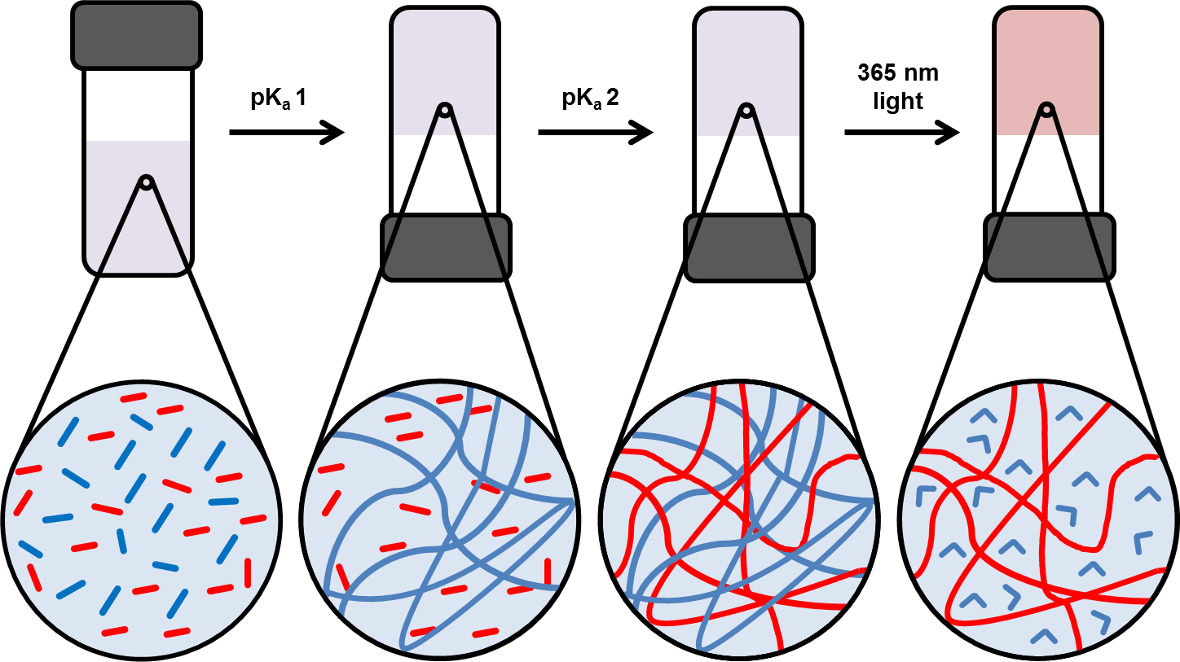
Figure 1. Schematic of assembly process. Spatially resolved multicomponent gels are formed by a three stage process. From left to right, both gelators 1 (blue segments) and 2 (red segments) form a fibrous network at their respective pK_{a}, so a slow pH decrease leads to a sequential assembly and a self-sorted gel (blue and red lines for the fibres consisting of 1 and 2, respectively). The fibrous network formed by gelator 1 is then removed by irradiation with light, either totally as represented here or in a spatially resolved manner using a mask.
A stilbene-based gelator (1) was synthesized by the reaction of the acid chloride of 4,4’-stilbene dicarboxylic acid with phenylalanine ethyl ester, followed by deprotection with lithium hydroxide. The trans-isomer forms hydrogels when the pH of a solution at a concentration of 5 mg/mL of 1 is decreased from 10 to 4. To controllably lower the pH in a uniform manner throughout the sample, we used the slow hydrolysis of glucono-δ-lactone (GdL) to gluconic acid²⁸ as we have described elsewhere.²⁹ A translucent hydrogel is formed (Figure 2a, inset, referred to as gel-1 throughout), which has rheological properties that are typical of this type of low molecular weight hydrogel (Fig. S1, Supplementary Information). The storage modulus (Gʹ) and loss modulus (Gʺ) are relatively independent of frequency, with Gʹ being approximately an order of magnitude higher than Gʺ.
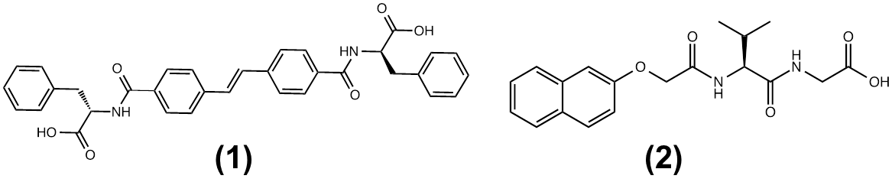
The apparent pK_{a} of 1 is 5.8 and, in agreement with our previous work,³⁰ 1 forms gels when the pH is below this pK_{a}. The corresponding cis-isomer of gelator 1 was formed by irradiation of a solution of 1 with a 365 nm LED at pH 10 (see Fig. S2, Supplementary Information). Attempts to carry out its gelation in a similar manner to that of trans-isomer 1 – by slowly decreasing the pH of the cis-isomer containing solutions – resulted in a precipitate rather than a gel, showing that the cis-isomer is not an effective gelation. When the gel prepared using trans-isomer 1 was irradiated with the 365 nm LED, it converted to a liquid (Figure 2b; see Fig. 4d for rheological data). When a mask was used, selective spatial conversion of the gel to a liquid could be achieved, similar to other light-triggered gelators (Fig. S3, Supplementary Information). Xerogels of gel-1 were imaged using SEM, and the images showed that the gels are a result of the self-assembly of the gelator into a network of fibers (Fig. 2a). After irradiation, the fibers are transformed into ill-defined spherical aggregates (Fig. 2b). These aggregates are similar to those formed on lowering a pH of solutions containing cis-1 using GdL (see Fig. S2c, Supplementary Information).

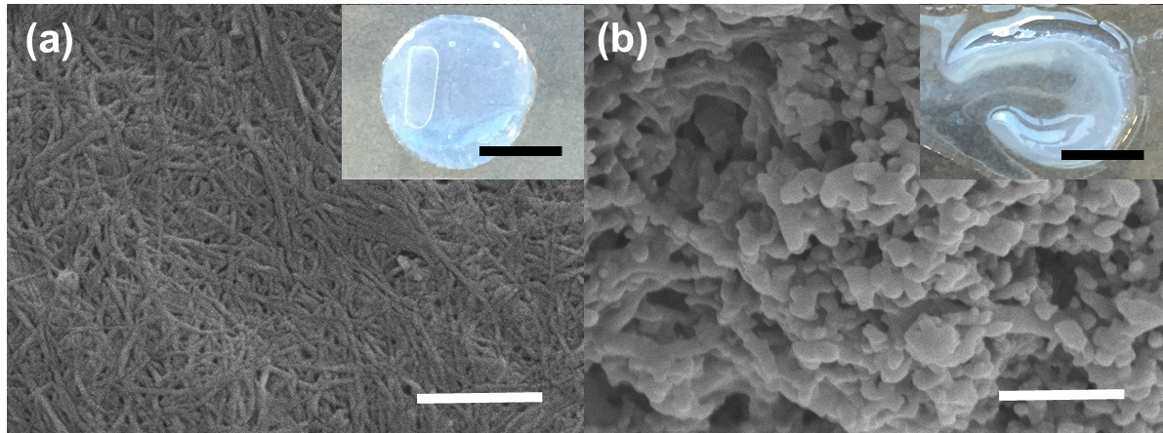
Figure 2. Light-responsive gels formed from 1. a, SEM of gel-1. The inset shows a photograph of the gel before drying for SEM. b, SEM of the structures formed after irradiation of the gel formed in (b) with a 365 nm LED for 30 minutes. The inset shows the effect of the irradiation on the sample when compared to the inset in (a). For both (a) and (b), the scale bar represents 500 nm. For inset photographs the scale bar represents 1 cm.
We then combined 1 with a second gelator, 2, preparing a solution at pH 10 containing both at a concentration of 5 mg/mL (total gelator concentration therefore of 10 mg/mL). Gelator 2 was chosen on the basis of a significantly different molecular structure and the apparent pK_{a} of the terminal carboxylic acid (5.0);³¹ our previous data suggested that both of these factors should encourage self-sorting.^{25,26} Control experiments showed that gels formed from 2 alone (gel-2) were not affected by irradiation by the 365 nm LED, either visually or rheologically (Fig. S5, Supplementary Information).
Gels were formed from the mixed solution again by the addition of GdL, and are referred to as gel-1,2 throughout. The use of GdL and the therefore slow pH change allows us to monitor the gelation process with time.^{25,29} Characterization by NMR spectroscopy can be used to monitor gelation; as the molecules self-assemble and form fibers, the structures become NMR-invisible. The hydrolysis of GdL is highly reproducible. Hence, the pH of a separate solution can be correlated with the NMR data. In a parallel experiment, the evolution of the rheological properties can be measured (Fig. 3a).
The evolution of ¹H NMR spectra throughout the reaction clearly demonstrate that a sequential assembly process occurs, with 1 becoming NMR-invisible before 2. The plot of integral intensity for each gelator is shown in Fig. 3a. This sequential assembly is expected from the higher apparent pK_{a} of 1 as compared to that of 2. As 1 self-assembles, the rheological data shows that a gel is formed. After around 8 minutes, there is an increase in both Gʹ and Gʺ, with a second increase occurring at around 20 minutes. Such a two stage development in the moduli is common for this kind of gelator when using GdL to trigger the gelation.^{29,32} As the pH drops to around 5, 2 also starts to become NMR-invisible, as expected from the pK_{a} of this gelator. Concurrently, there is a significant further increase in both Gʹ and Gʺ. This correlates with gel-2 formed in a single component system being significantly stronger than gel-1. It is noticeable that Gʹ at the point where only 1 has self-assembled is lower than might be expected from the data for 1 alone (Fig. S1, Supplementary Information). We hypothesize that this is due to the network forming in the presence of 2, which may be acting as a surfactant above its apparent pK_{a}. Indeed, Ulijn and co-workers have shown that similar gels can be affected by the presence of surfactant-like gelators.³³ Nonetheless, it is clear that the self-assembly of 1 and 2 is a sequential process across multiple length scales. The final gel-1,2 formed from the self-sorting mixture is both translucent and homogeneous (Fig. 3b). Under a hand-held UV lamp, the fluorescence from the gel is uniform (Fig. 3c), indicating that there is no phase separation or segregation of the gelators over these longer length scales. Based on our previous work, we propose that the sequential assembly leads to a self-sorted two-component network.^{25,26} Proving this is difficult; as we show below, the fibers from both networks look very similar, making differentiation by microscopy impossible. However, if the networks are truly self-sorted then selective removal of one network should leave the other intact (Fig. 1). We show that this is what occurs through mechanical data.
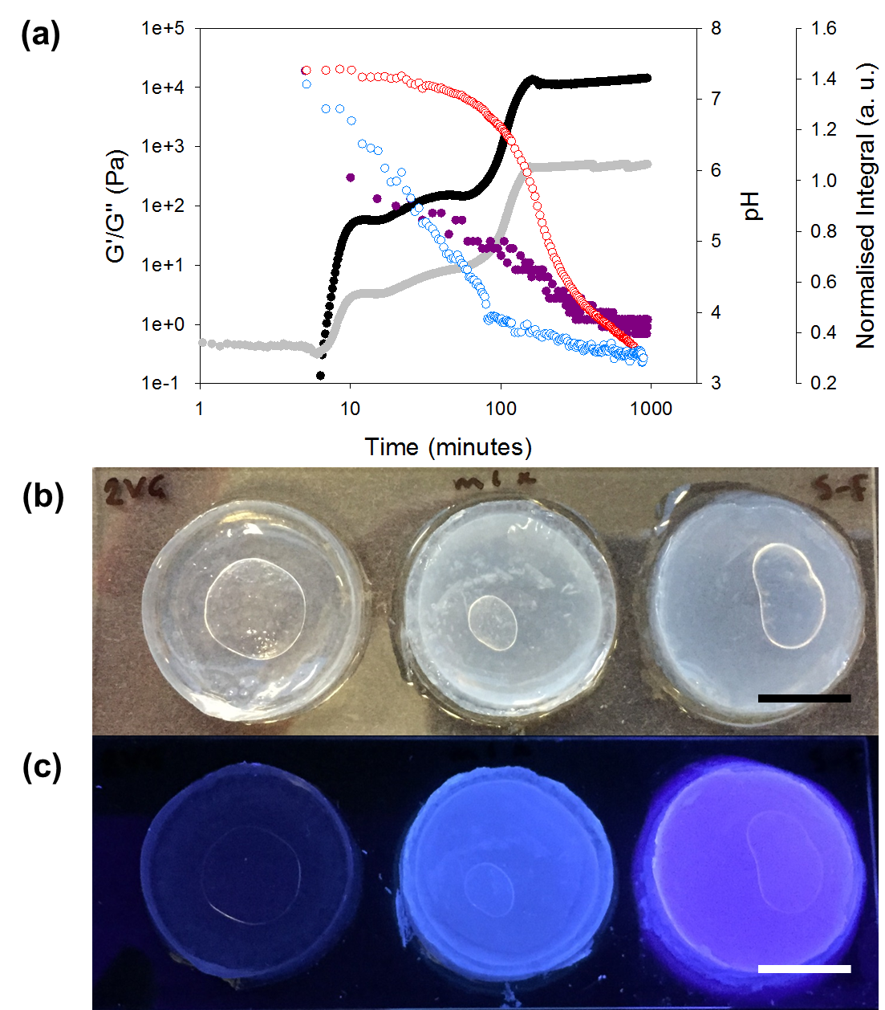

Figure 3. Multicomponent gels a, Evolution of pH (purple), Gʹ (black) and Gʺ (grey), and ¹H NMR integrals (data for 1 in blue and for 2 in red) with time for a mixture of 1 and 2. The sequential assembly of 1 and 2 can be seen from the changes in the NMR integrals, with the concurrent changes in the gel rheology, as each gelator assembles into fibres. The sequential assembly is controlled by the pH of the system. b, From left to right, photographs of gel-2, gel-1,2, and gel-1. c, From left to right, the corresponding gels in (b) under a 365 nm UV lamp, showing the uniform distribution of the gelators in the mixed gel. In all photographs, air-bubbles can be seen under the gels – those were created when the gels were removed from the mould and placed on the slide for imaging, and are not within the gels. Scale bars represent 1 cm.
Unlike the gel-1, when a self-sorted gel-1,2 is irradiated using the 365 nm LED, the gel retains its structural integrity, although the gel strength decreases (Fig. 4a). There was a slow decrease in the rheological data for the irradiated gel compared to the as-prepared gel when the irradiation was carried out over time, with Gʹ decreasing from approximately 3.8 x 10⁴ Pa to 1.9 x 10⁴ Pa (Fig. 4b). After 2 hours irradiation, the rheological data then stabilized, with Gʹ and Gʺ being significantly lower than for the initially as-prepared gel (Fig. 4b). The data was in close agreement with that for the gel-2 (Fig. 4b). As can be seen from the control experiments (Fig. 4c and 4d), the rheological properties of gel-2 are essentially unaffected by light irradiation, whilst those from gel-1 are strongly affected. The implication of this data is that under irradiation the fibers formed from 1 have been selectively removed as 1 is isomerised and that the remaining network is essentially that which would have formed in the absence of 1. This shows a high degree of control over the fiber networks in a supramolecular gel. It should be noted that the temperature of the gels only rose by 2 °C after being irradiated for one hour, so drying out or increased temperature of the gels is unlikely to be a factor in the changes in the rheology of the system. Photographs showing the gels before and after irradiation are shown in Fig. 5a, Fig. 5b, and Fig. 5c.

To the best of our knowledge, this removal of one of the networks within a self-sorted low molecular weight gel is unprecedented. We can further achieve spatial patterning by combining the irradiation step with a mask. Example photographs are shown in Fig. 5d and 5e, where a star-shaped mask (shown in Figure 5f) has been used to pattern the gel. Here, only the star shape was exposed to UV light. As can be seen, the bulk gel structure is maintained, but (most clearly under UV light), it is clear that the network formed by 1 has only been disrupted where the mask was not covering the gel. SEM of the dried sample shows that the areas not irradiated by the LED are still composed of fibers (Fig. 5f), which are similar to the networks formed by 1 and 2. However, in the center of the star where the self-sorted gel has been irradiated, a dense network was found, where fibers covered in spheres can be seen (Fig. 5g). This is consistent with the spherical structures formed by cis-1 being deposited on the fibers formed by the self-assembly of 2.
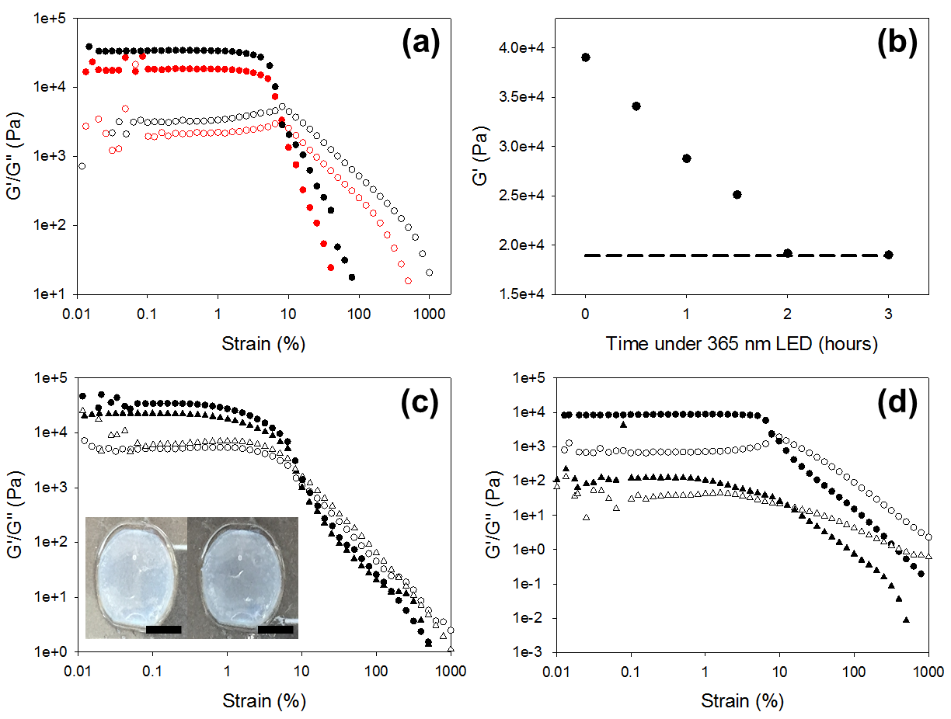
Figure 4. Selective Network Removal. a, Rheological data for a mixed gel-1,2 before irradiation (black data) and after irradiation for 2 hours with a 365 nm LED (red data). Filled symbols, Gʹ; open symbols, Gʺ. b, Rheological data showing the value of Gʹ at 1 % strain for a mixed gel-1,2 after increasing irradiation time (black data) compared to the Gʹ for a gel-2 after irradiation (dashed line). c, Strain sweep of a gel-2 at 5 mg/mL. Triangles before irradiation; circles, after irradiation with 365 nm LED; filled symbols, Gʹ; open symbols, Gʺ. The inset photographs show the gel before (left) and after (right) irradiation. The scale bar represents 1 cm. (d) Strain sweep of a gel-1 before and after irradiation for 90 minutes with a 365 nm LED. Circles, before irradiation; triangles, after irradiation; filled symbols, Gʹ; open symbols, Gʺ. Measurements were recorded at 10 rad/s.

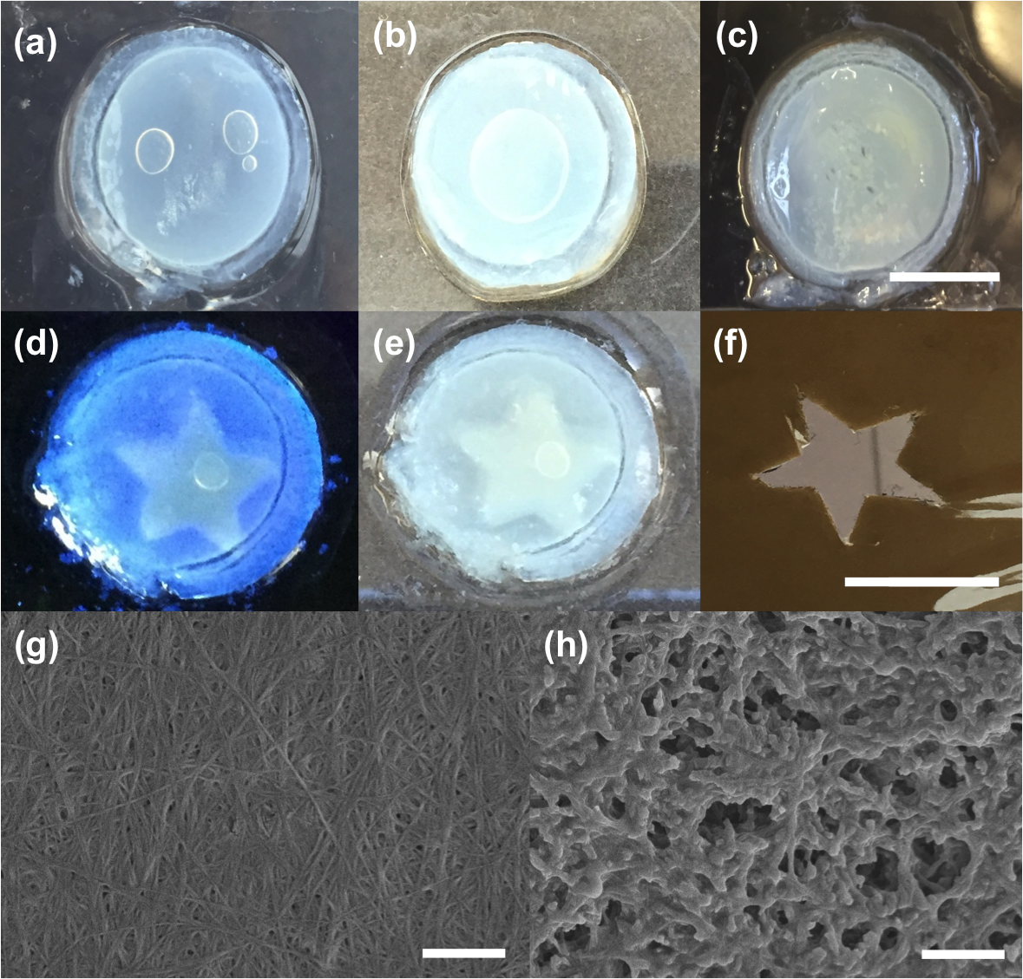
Figure 5. Spatially resolved removal of one network. a-c, Photographs of the gel as initially formed (a), after 30 minutes irradiation (b) and after 2 hours irradiation (c) with a 365 nm LED. d-f, Photographs of a mixed gel irradiated with a handheld 365 nm UV light (d) and under daylight (e) using a mask (f). g-h, Example SEM images for the gel shown in (e) after irradiation, from the edge of the sample (that is, not irradiated) (g) and from the centre of the star shape (that is, irradiated) (h). Scale bars: a-f, 1cm; g-h, 1 μm.
To further prove spatial resolution, we freeze-dried a gel where one half had been irradiated and the other not, again using a mask. The data (Fig. S5) clearly shows that where the gel was exposed to UV light, both cis-1 and trans-1 are present. The region of the gel not exposed to irradiation only contains trans-1.

Conclusions
We have shown how the concept of self-sorted low molecular weight gels can be combined with photo-responsive gelators to allow a high degree of control over the rheological properties of bulk gels. Spatially resolved gels can also be prepared; one network can be selectively removed, which is a huge step forward from the state of the art. This demonstrates that the two networks initially formed must be truly independent, in close analogy with interpenetrating polymer hydrogels.³⁴ To the best of our knowledge, this is the first example of this type of control over multiple-component low molecular weight gels. This methodology opens up the possibility of spatially controlling the rheological properties of a gel, and allows a significant advance over the simple gel / no-gel switch that is normally observed with photoswitchable gelators. We envisage that this methodology could be used to prepare complex structured gels.

Methods
For synthesis details, see Supplementary Information.
Gel formation. A pH switch method was used to form the hydrogels. Single component gels were prepared at a concentration of 5 mg/mL. The gelator was dissolved at high pH in 2 mL of water. In the case of 1, 2 molar equivalents of a 0.1 M sodium hydroxide were used. For 2, one molar equivalent of 0.1 M sodium hydroxide was used. The solution was stirred until all the gelator was dissolved. This solution was then transferred to a vial containing 10 mg of glucono-δ-lactone (GdL) and shaken gently. 1 mL was then transferred to a 20 mL plastic syringe with the nozzle removed to act as a mould. The open top of the syringe was covered with parafilm and the solution was left to gel overnight. The gel was removed from the syringe by gently pushing the plunger. For mixed component gels, separate solutions of each gelator were prepared at 10 mg/mL. 1 mL of each solution was then added together to provide a 2 mL solution with each gelator at a concentration of 5 mg/mL. This solution was then added to 20 mg of GdL and again allowed to gel as above.
Irradiation of the gels. Gels were placed onto a glass microscope slide and placed inside a plastic petri dish with a wet paper towel in to keep the air saturated with water and to prevent the gel drying out. The lid of the petri dish had a hole cut out to allow the LED to be able to irradiate the sample. A 365 nm LED (LedEngin Inc, LZ1-10U600) with a light source powered by a TTi QL564P power supply operating at 1.0 W was used to irradiate gel samples. When using a mask a shape was cut out of a sheet of opaque plastic and placed over the sample prior to irradiation.
Other experimental techniques are described in the Supplementary Information.
Acknowledgements
E.D. thanks the EPSRC for a DTA studentship. D.A. thanks the EPSRC for a Fellowship (EP/L021978/1).
Author contributions
E.D. and D.A. conceived the project and synthesized the gelators. E.D. and D.A. designed the experiments. E.D. carried out the gelation, irradiation and rheological experiments. E.E. carried out the NMR experiments. T.M. carried out the SEM experiments. All authors contributed to writing the paper.

References

1 Terech, P. & Weiss, R. G. Low molecular mass gelators of organic liquids and the properties of their gels. Chem. Rev. 97, 3133-3160 (1997).
2 Weiss, R. G. The past, present, and future of molecular gels. What is the status of the field, and where is it going? J. Am. Chem. Soc. 136, 7519-7530 (2014).
3 Raeburn, J. & Adams, D. J. Multicomponent low molecular weight gelators. Chem. Commun., 51, 5170-5180 (2015).
4 Buerkle, L. E. & Rowan, S. J. Supramolecular gels formed from multi-component low molecular weight species. Chem. Soc. Rev. 41, 6089-6102 (2012).
5 Hirst, A. R. et al. Self-assembly of two-component gels: stoichiometric control and component selection. Chem. Eur. J. 15, 372-379 (2009).
6 Adhikari, B., Nanda, J. & Banerjee, A. Multicomponent hydrogels from enantiomeric amino acid derivatives: helical nanofibers, handedness and self-sorting. Soft Matter 7, 8913-8922 (2011).
7 Sugiyasu, K., Kawano, S.-i., Fujita, N. & Shinkai, S. Self-Sorting organogels with p−n heterojunction points. Chem. Mater. 20, 2863-2865 (2008).
8 Raeburn, J., Zamith Cardoso, A. & Adams, D. J. The importance of the self-assembly process to control mechanical properties of low molecular weight hydrogels. Chem. Soc. Rev. 42, 5143-5156 (2013).
9 Molla, M. R., Das, A. & Ghosh, S. Chiral induction by helical neighbour: spectroscopic visualization of macroscopic-interaction among self-sorted donor and acceptor [small pi]-stacks. Chem. Commun. 47, 8934-8936 (2011).
10 Huang, Y. et al. Supramolecular hydrogels based on short peptides linked with conformational switch. Org. Biomol. Chem. 9, 2149-2155 (2011).
11 Li, X., Gao, Y., Kuang, Y. & Xu, B. Enzymatic formation of a photoresponsive supramolecular hydrogel. Chem. Commun. 46, 5364-5366 (2010).
12 Qiu, Z., Yu, H., Li, J., Wang, Y. & Zhang, Y. Spiropyran-linked dipeptide forms supramolecular hydrogel with dual responses to light and to ligand-receptor interaction. Chem. Commun., 3342-3344 j (2009).
13 Sako, Y. & Takaguchi, Y. A photo-responsive hydrogelator having gluconamides at its peripheral branches. Org. Biomol. Chem. 6, 3843-3847 (2008).
14 Haines, L. A. et al. Light-activated hydrogel formation via the triggered folding and self-assembly of a designed peptide. J. Am. Chem. Soc. 127, 17025-17029 (2005).
15 Muraoka, T., Koh, C.-Y., Cui, H. & Stupp, S. I. Light-triggered bioactivity in three dimensions. Angew. Chem. Int. Ed. 48, 5946-5949 (2009).
16 Doran, T. M., Ryan, D. M. & Nilsson, B. L. Reversible photocontrol of self-assembled peptide hydrogel viscoelasticity. Polymer Chem. 5, 241-248 (2014).
17 Sahoo, J. K., Nalluri, S. K. M., Javid, N., Webb, H. & Ulijn, R. V. Biocatalytic amide condensation and gelation controlled by light. Chem. Commun. 50, 5462-5464 (2014).
18 He, M., Li, J., Tan, S., Wang, R. & Zhang, Y. Photodegradable supramolecular hydrogels with fluorescence turn-on reporter for photomodulation of cellular microenvironments. J. Am. Chem. Soc. 135, 18718-18721 (2013).
19 Yang, R., Peng, S., Wan, W. & Hughes, T. C. Azobenzene based multistimuli responsive supramolecular hydrogels. J. Mater. Chem. C 2, 9122-9131 (2014).
20 Maity, C., Hendriksen, W. E., van Esch, J. H. & Eelkema, R. Spatial structuring of a supramolecular hydrogel by using a visible-light triggered catalyst. Angew. Chem. Int. Ed. 54, 998-1001 (2015).
21 Sun, Z. et al. Multistimuli-Responsive Supramolecular Gels: Design Rationale, Recent Advances, and Perspectives. ChemPhysChem 15, 2421-2430 (2014).
22 van Herpt, J. T., Stuart, M. C. A., Browne, W. R. & Feringa, B. L. A Dithienylethene-Based Rewritable Hydrogelator. Chem. Eur. J. 20, 3077-3083 (2014).
23 Kloxin, A. M., Kasko, A. M., Salinas, C. N. & Anseth, K. S. Photodegradable hydrogels for dynamic tuning of physical and chemical properties. Science 324, 59-63 (2009).
24 Yan, B., Boyer, J.-C., Habault, D., Branda, N. R. & Zhao, Y. Near infrared light triggered release of biomacromolecules from hydrogels loaded with upconversion nanoparticles. J. Am. Chem. Soc. 134, 16558-16561 (2012).
25 Morris, K. L. et al. Chemically programmed self-sorting of gelator networks. Nat Commun 4, 1480, (2013).
26 Colquhoun, C. et al. The effect of self-sorting and co-assembly on the mechanical properties of low molecular weight hydrogels. Nanoscale 6, 13719-13725 (2014).
27 Raeburn, J. et al. Electrochemically-triggered spatially and temporally resolved multi-component gels. Materials Horizons 1, 241-246 (2014).
28 Pocker, Y. & Green, E. Hydrolysis of D-glucono-.delta.-lactone. I. General acid-base catalysis, solvent deuterium isotope effects, and transition state characterization. J. Am. Chem. Soc. 95, 113-119 (1973).
29 Adams, D. J. et al. A new method for maintaining homogeneity during liquid-hydrogel transitions using low molecular weight hydrogelators. Soft Matter 5, 1856-1862 (2009).
30 Chen, L., Revel, S., Morris, K., C. Serpell, L. & Adams, D. J. Effect of molecular structure on the properties of naphthalene−dipeptide hydrogelators. Langmuir 26, 13466-13471 (2010).
31 Houton, K. A. et al. On crystal versus fiber formation in dipeptide hydrogelator systems. Langmuir 28, 9797-9806 (2012).
32 Chen, L. et al. Self-assembly mechanism for a naphthalene−dipeptide leading to hydrogelation. Langmuir 26, 5232-5242 (2010).
33 Fleming, S., Debnath, S., Frederix, P. W. J. M., Hunt, N. T. & Ulijn, R. V. Insights into the coassembly of hydrogelators and surfactants based on aromatic peptide amphiphiles. Biomacromolecules 15, 1171-1184 (2014).
34 Haque, M. A., Kurokawa, T. & Gong, J. P. Super tough double network hydrogels and their application as biomaterials. Polymer 53, 1805-1822 (2012).

