The feasibility of retrofitting existing office buildings to combat energy consumption due to future climate change in three key regions of China

D. H. C. Chow, & S. Sharples

School of Architecture, University of Liverpool.

ABSTRACT: As China goes through the present phase of rapid urbanisation, there is an urgent need to reduce the energy consumption per unit area in buildings in order to mitigate a sudden surge in total energy usage in buildings. At the same time, buildings are expected to last longer, so they will also need to account for effects of future climate change. Much of China’s existing buildings are not considered energy-efficient, and retrofitting these buildings to perform in the future would be a much less energy-intensive strategy than demolishing them and building new replacements. This paper aims to investigate the feasibility of retrofitting existing office buildings in three different climate regions of China. These include the “Cold” region in the north, which includes Beijing; the “Hot Summer Mild Winter” region in the south, which includes Guangzhou, and two regions from the “Hot Summer Cold Winter”, which includes cities such as Shanghai and Nanjing. Using data from the climate model, HadCM3, Test Reference Years are generated for the 2020s, 2050s and 2080s, for various IPCC future scenarios for these cities, and using computer simulation, the feasibility of retrofitting office buildings to perform in the face of climate change in these regions is investigated. For the “Cold” region, simulation results suggest that energy reductions of up to 30% with improvements to the building enclosure is possible by retrofitting current existing office buildings to the current Chinese National Standard for the region. Retrofitting in the ““Hot Summer Mild Winter” region could reduce energy consumption by 45%, but the effects of retrofitting in the “Hot Summer Cold Winter” region are less profound. Requirements for combating possible increases in energy consumption from heating and cooling demands due to future climate change was also investigated, and it was found that with the exception of Shanghai, by simply improving U-Values of the building envelope to the new national standards, the effects of future climate change can be nullified up to the 2080s. Further improvements to having similar standards as developed countries such as England and Wales will have less significance and may not be able to nullify the effects of climate change from the newly retrofitted office buildings. However, this could be achieved by involving other energy-saving strategies and installing suitable energy-saving technologies for the regions.

# INTRODUCTION

Since China opened its markets in 1978, there has been rapid growth and development in its economy. As a direct result, energy consumption has also increased significantly over this period. Similar to other parts of the world, the building sector accounts for roughly a third of the total energy consumption. Researchers such as Wu (2003), Zhou (2007) and Fridley et al. (2008) have suggested that for the whole of China, the building sector is responsible for about 27.5% of the national total energy consumption. Zhong (2007) have shown that as mass urbanization continues, and more buildings to be constructed in the next 20 years, this percentage could rise to 40%. As living standards improve, occupants will also demand higher levels of comfort, which will further increase heating and cooling demands. By the end of 2010, the whole of China has over 43 billion square metres of constructed area, however, only 4-5% of which meet the national building energy standards, and the other 95-96% are classified as “intensive energy consumers” (Zheng 2007, Hong 2009).

In China, the lifespan of many buildings is short even by modern standards. The high turnover rate has resulted in an existing building stock that is fairly young. Zhu & Lin (2004) projected that by 2015, half of China’s existing building stock will have been built after 2000. In 2010, Chen Huai, director of the policy research centre at the Ministry of Housing and Urban-Rural Development, stated that “Only those homes built after 1999 are likely to be preserved in the longer term” due to perceived safety and functionality deficits in older buildings (Qian 2010).

Effects are being made by the government to reduce the amount of energy consumed by buildings in China with more and more stringent building codes for residential, commercial and office buildings. However, despite the comparatively high rates of construction and demolition, most buildings in China do not comply with the latest national building codes. There have been many studies on the improvement of standards and design strategies for new buildings in China and other nearby countries with similar climates, however, relatively few studies have been conducted on the situation for the retrofit of existing office buildings.

This paper aims to investigate the benefits of retrofitting existing office buildings to the standard of the current building code in three major cities (Beijing, Shanghai and Guangzhou) that are situated in three different climate zones in China, and see if retrofitting to the current standard can nullify effects of future climate change in these regions in terms of energy consumption until the end of the century. Data from the climate prediction model, HadCM3, are used in the analysis of the impacts of climate change in the 2020s, 2050s and 2080s.

## Climate Zones in China

There are five main climatic zones in China: “Severe Cold”, “Cold”, “Hot Summer and Cold Winter”, “Moderate”, and “Hot Summer and Warm Winter”, as shown in Figure 1. They have distinctive characteristics, and therefore separate national building codes. This paper will investigate the situation in the “Cold” zone by using weather data for Beijing, the “Hot Summer and Cold Winter” zone with the city of Shanghai, and the “Hot Summer and Warm Winter” zone with the city of Guangzhou.



Figure 1. Climate zones in China and cities investigated

# Climates in Beijing, Shanghai and Guangzhou

The cities of Beijing, Shanghai and Guangzhou were selected to represent situations in three different climate zones in China. The buildings in each zone have very different heating and cooling needs. For example, Guangzhou in the “Hot Summer Warm Winter” zone has very little heating demand, as its winters are relatively mild. Shanghai is in the “Hot Summer, Cold Winter” zone, with days exceeding 40 deg C in the summer, as well as cold sub-zero days in winters. However, as Shanghai is located on the coast, it is generally slightly milder than locations in the same region which are more inland. Beijing also has hot summers, especially around August and early September, and winters are extremely harsh too. The changes in the next 100 years due to climate change for the three climate zones are also significantly different.

## Current Climates

Long running series of real observed data from weather stations in the three cities were not available for this study, so in-depth study of the characteristics of different weather parameters could not be conducted. However, data can be extracted from the existing Test Reference Years, from the Energy Plus program. Figure 2 shows the average monthly range and values for daily maximum and minimum temperatures for Beijing, Shanghai and Guangzhou.

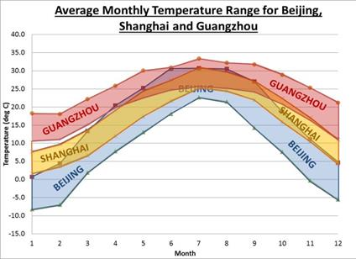

Figure 2. Current monthly average temperature range for Beijing, Shanghai and Guangzhou

## Future Climate Change

The Hadley Centre model (HadCM3) (Gordon 2000) is used to provide future climate data for this study. HadCM3 is a global climate model developed at the Hadley Centre of the Met Office in the UK. It is a Coupled Atmosphere-Ocean General Circulation Model (AOGCM), in which the globe is divided into grid boxes, each measuring 2.50° x 3.75°. The gridboxes used in this paper are gridbox numbers 1952 (which encloses the area with latitude from 38.75°N to 41.25°N, and longitude from 114.375°E to 118.125°E, and includes the city of Beijing), 2337 (which encloses the area with latitude from 28.75°N to 31.25°N, and longitude from 118.125°E to 121.875°E, and includes the city of Shanghai), and 2623 (which encloses the area with latitude from 21.25°N to 23.75°N, and longitude from 110.625°E to 114.375°E. and includes the city of Guangzhou).

Figure 3 shows the extent of the three gridboxes. Unlike weather data from typical weather years, HadCM3 only provide daily values for parameters such as maximum, minimum and average temperatures, humidity, wind speed and downward short-wave flux (solar radiation), based on 4 main future scenarios on carbon emissions, A1F, A2, B2 and B1 (Nakicenovic 2000). For example, the A2 scenario describes a very heterogeneous world where slow and fragmented economic growth Changes in monthly temperature range is assumed, together with a continuation of population growth and continued increase in CO2 emission into the twenty-first century (WMO 2001).

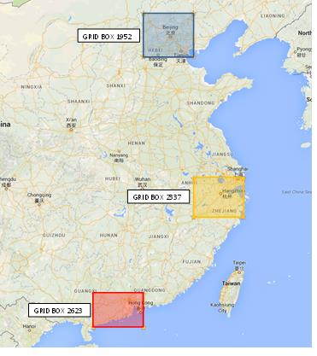Figure 3. Geographically extents of the gridboxes 1952, 2337 and 2623

## Compilation of Future Test Reference Years for Beijing, Shanghai and Guangzhou

Due to the unavailability of extended periods of real historical weather data for the cities, future Test Reference Years (TRYs) were constructed using the “morphing method” (Belcher et al. 2005), which uses differences between monthly averages from “historical periods” and “future periods” in climate models, and impose these onto existing Test Reference Year. For this study, data from HadCM3 are separated into four periods: 2000s (which includes data from 1990-2009); 2020s (which includes data from 2010-2039); 2050s (which includes data from 2040-2069) and 2080s (which includes data from 2070-2099), and the average monthly temperatures under the A2 scenario from resulting TRYs for Shanghai is shown in Figure 4.

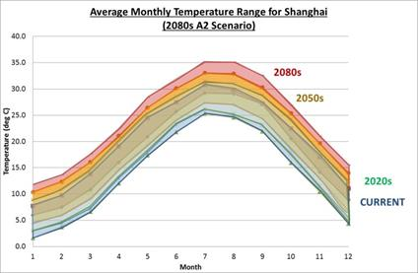

Figure 4. Changes in average monthly temperature range in the TRY for Shanghai under the A2 scenario

# METHODOLOGY

In order to run a large number of simulations quickly, a simple 2nd Order Simulation model (Chow & Levermore 2007) was used with current and future TRYs from Beijing, Shanghai and Guangzhou were inputted as weather files, the average heating and cooling demands were calculated for a series of rectangular-shaped buildings of various sizes (from 1000m2 to 10000m2 in total floor area). The glazing applied is for 60% of the façade areas, and three levels of U-value settings were also used, based on:

a) The current specification of existing buildings in the three cities (before retrofitting)

b) The current national standard for new buildings in the three cities (after retrofitting)

c) The high-specification building with similar standards to the Building Regulations in England and Wales (DCLG 2006) (further improvements)

This is summarised in Table 1. Verification of results from the 2nd Order Simulation model was conducted by comparing samples of the results with one of the leading commercial software simulation packages, IES VE, and the results were very similar in cases with and without direct solar gains. This was to ensure that similarities in results were not a result of cancellation of over-prediction in air temperature with under-prediction in solar gains or vice versa.

As for the actual HVAC systems, in this analysis, a natural gas boiler is assumed for heating, and a chiller for cooling. For the calculation of primary energy consumption, a ratio of 2.579 is applied to electricity for cooling.

|  |  |  |  |  |  |  |  |
| --- | --- | --- | --- | --- | --- | --- | --- |
| Table 1. Physical Properties of the three office types to be simulated for Beijing, Shanghai and Guangzhou | | | | | | | |
| U-Value  (W / m2 K) | Beijing | | Shanghai | | Guangzhou | | High-Spec |
| Existing Building | Current Reg  (JI2070-2012) | Existing Building | Current Reg  (JGJ-134-2010) | Existing Building | Current Reg  (DBJ15-51-2007) | Current Reg for England and Wales |
| Windows | 2.7 | 1.8 | 3.2 | 2.8 | 5.8 | 3.0 | 1.8 |
| Roof | 0.54 | 0.35 | 0.8 | 0.8 | 1.0 | 0.9 | 0.2 |
| Ext. Walls | 0.76 | 0.40 | 1.34 | 1.0 | 1.5 | 1.1 | 0.35 |
| Ground | 0.53 | 0.45 | 1.5 | 1.5 | 1.5 | 1.5 | 2.2 |
| Glazing used | Double-glazing | Double-glazing (low-e) | Double-glazing | Double-glazing | Single-glazing | Double-glazing | Double-glazing (low-e) |

## Internal Gains

In an occupied office building, there will be lighting, equipment and occupants that will increase the heat inside the room. In this study, an extra 30W / m2 has been added in the simulation as internal gains.

## Internal Comfort Range

For the series of simulations, the comfort temperature range was set between 19°C and 24°C, such that if the internal temperature falls below 19°C, heating will be supplied and if it reaches 24°C or above, cooling is activated. As well as testing for energy demands with retrofitting, a second parallel run of simulations was conducted using a bigger

comfort temperature range of 15°C to 28°C (4°C either side of the initial range) to see the effects of greater occupant tolerance.

## Application of External Shading

One of the key passive energy saving strategies for reducing cooling demand is the application of external shading. This is also tested in the thermal performance modeling to verify its effect on office buildings in the three regions under current and future climates.

# RESults and Discussion

## Potential Savings in Heating / Cooling Demands

Figure 5 shows the differences in heating, cooling and total primary energy consumption between existing, retrofitted and high-spec buildings in Beijing, Shanghai and Guangzhou (from definitions in Table 1) under the current climate.

It can be seen that with the exception of Shanghai, retrofitting to the latest standards are highly effective, with a reduction of total primary energy of

30% in Beijing, and 44% in Guangzhou. Retrofitting only reduced total primary energy consumption in Shanghai by 1% (and cooling loads actually increased slightly as a result of retrofitting), and this is mainly due to the fact that there difference between the current building specifications and the previous one is not that great. However, if office buildings in Shanghai are to improve their office buildings further, to the standards similar to the Building Regulations in England and Wales, the reductions from the existing building values are close to 30%. The current standards for Beijing are already very close to the Building Regulations in England and Wales, thus there is very little effect in improving them further. For Guangzhou, further improvements suggest a further 25% reduction from the retrofitted buildings (58% from the current buildings), and so it is a worth further investigation on the feasibility of such applications.

## Effects of Future Climate Change

Figures 6 shows the heating and cooling demands for Existing Buildings, Retrofitted Buildings, and High-Spec Retrofitted Buildings in Beijing for the 2000s, 2020s, 2050s and 2080s, under the two extreme IPCC future scenarios (A1 and B1), together with the medium-high A2 scenario. Results for Shanghai and Guangzhou are summarised in table 2 and table 3 respectively.

With future climate data, cooling demand rises sharply in all three cities, accompanied by a less severe reduction in heating demand (except in Guangzhou where there is virtually no heating demand currently). With the existing building specification, total primary energy consumption for heating and cooling could rise to between 450 kWh / m2 to 500 kWh / m2 by 2080s in Beijing depending on the future scenario, whereas for the retrofitted or high-spec building, this range falls to 320 kWh / m2 to 360 kWh / m2, which is lower than the primary energy consumption for existing buildings under the current climate, showing that retrofitting alone would nullify the effects of future climate change.

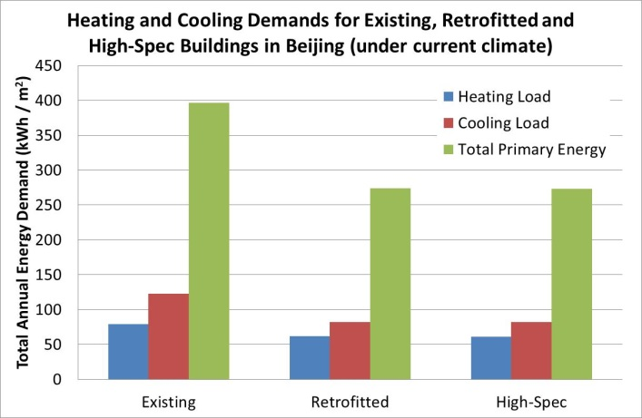 (a)

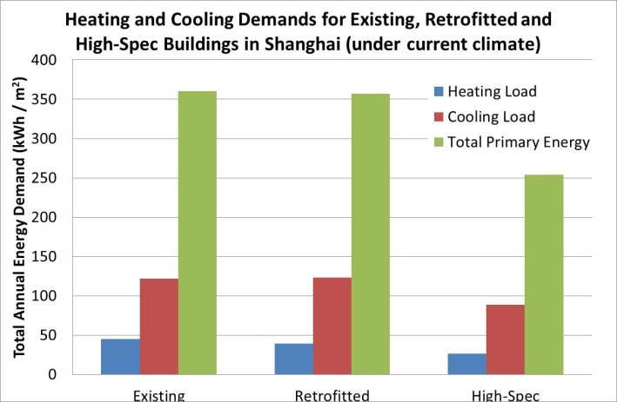 (b)

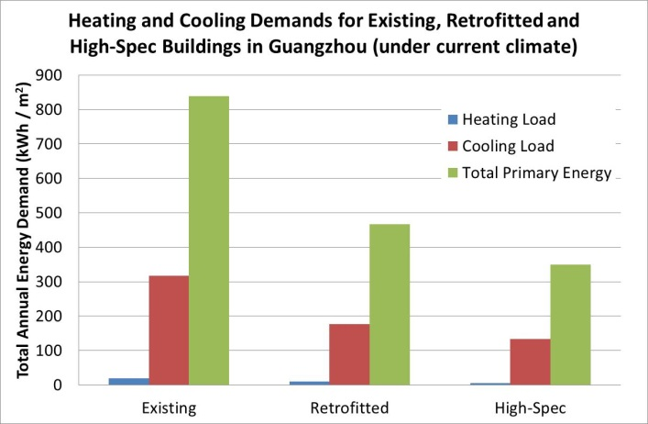 (c)

Figure 5. Comparisons of heating and cooling demands for Beijing (a), Shanghai (b) and Guangzhou (c) under the current TRY

For Shanghai, the primary energy consumption rises from around 360 kWh / m2 to between 428 to 507 kWh / m2 by 2080s. However, the effects of retrofitting are not evident (possibly due to the relatively high previous standards), but improving to the standards in England and Wales will almost nullify the effects, with the consumption reaching 367 kWh / m2for 2080 under the A1 scenario.

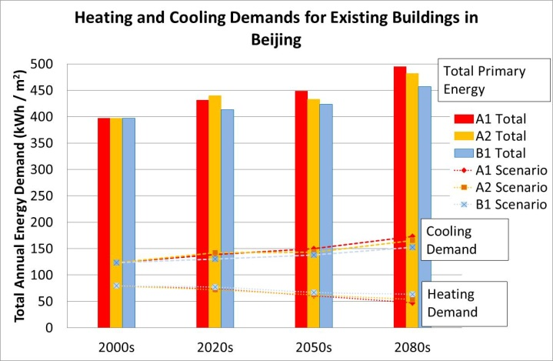 (a)

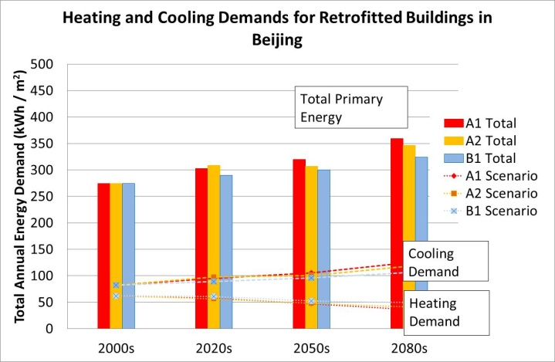 (b)

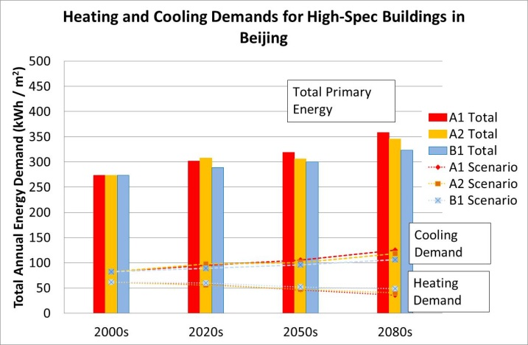 (c)

Figure 6. Heating and cooling demands for existing (a), retrofitted (b) and high-spec (c) office buildings in Beijing under future climate change

For Guangzhou, the current primary energy consumption with existing buildings due to heating and cooling is approximately 840 kWh / m2, and can be almost wholly attributed to cooling demand. This rises to 925 to 1050 kWh / m2 by 2080s. With retrofitted buildings, this is reduced to between 540 to 640 kWh / m2 by 2080s, which represents a 25-35% reduction from present values with existing buildings. Further improvements to the England and Wales standards further reduces this to between 410 and 490 kWh / m2, representing a 49-59% reduction. Guangzhou is the only city in this study where there are significant reductions with subsequent improvements in the building specifications. For Beijing, improving from the current standard and the England and Wales standards have little effect, and for Shanghai, retrofitted existing buildings to the current code have represents little improvement.

Table 2. Heating and Cooling Demands for Existing, Retrofitted and High-Spec office Buildings in Shanghai under future climate change (loads in kWh/m2)

|  |  |  |  |
| --- | --- | --- | --- |
| **Existing** | Heating Load | Cooling Load | Total Primary Energy |
| Current | 45.24 | 122.14 | 360.24 |
| 2020s A1 | 38.30 | 128.24 | 369.03 |
| 2020s A2 | 39.43 | 135.42 | 388.68 |
| 2020s B1 | 42.47 | 128.59 | 374.10 |
| 2050s A1 | 29.72 | 153.35 | 425.21 |
| 2050s A2 | 31.90 | 153.54 | 427.88 |
| 2050s B1 | 35.64 | 141.45 | 400.44 |
| 2080s A1 | 19.27 | 189.05 | 506.83 |
| 2080s A2 | 24.41 | 177.39 | 481.90 |
| 2080s B1 | 31.37 | 153.98 | 428.48 |
|  | | | |
| **Retrofitted** | Heating Load | Cooling Load | Total Primary Energy |
| Current | 39.17 | 123.19 | 356.88 |
| 2020s A1 | 33.04 | 128.54 | 364.54 |
| 2020s A2 | 33.93 | 135.42 | 383.18 |
| 2020s B1 | 36.64 | 129.10 | 369.59 |
| 2050s A1 | 25.70 | 152.48 | 418.95 |
| 2050s A2 | 27.24 | 152.68 | 421.00 |
| 2050s B1 | 31.05 | 141.43 | 395.80 |
| 2080s A1 | 16.31 | 185.83 | 495.57 |
| 2080s A2 | 20.80 | 175.12 | 472.43 |
| 2080s B1 | 27.05 | 153.11 | 421.92 |
|  | | | |
| **High Spec** | Heating Load | Cooling Load | Total Primary Energy |
| Current | 26.63 | 88.20 | 254.10 |
| 2020s A1 | 21.85 | 93.83 | 263.84 |
| 2020s A2 | 22.83 | 98.03 | 275.65 |
| 2020s B1 | 24.84 | 93.50 | 265.98 |
| 2050s A1 | 16.48 | 112.89 | 307.62 |
| 2050s A2 | 17.89 | 111.46 | 305.35 |
| 2050s B1 | 20.45 | 103.22 | 286.65 |
| 2080s A1 | 9.60 | 138.68 | 367.26 |
| 2080s A2 | 12.73 | 129.15 | 345.81 |
| 2080s B1 | 17.34 | 112.01 | 306.21 |

## Other possible changes to reduce energy demand

As mentioned previously, two further parallel set of simulations was run, one with an increased temperature comfort range of 15°C to 28°C, and the second with applied external shading. From figure 7, it can be seen that the effects of extended the comfort temperature range is similar to the effects of retrofitting the building in Beijing, and similar to retrofitting the building to the England and Wales standards with a total primary energy reduction of approximately 30%. The effect of applying external shading is slightly less significant, with a reduction of roughly 20%.

Table 3. Heating and Cooling Demands for Existing, Retrofitted and High-Spec office Buildings in Guangzhou under future climate change (loads in kWh/m2)

|  |  |  |  |
| --- | --- | --- | --- |
| **Existing** | Heating Load | Cooling Load | Total Primary Energy |
| Current | 19.80 | 317.30 | 838.12 |
| 2020s A1 | 14.93 | 332.38 | 872.14 |
| 2020s A2 | 14.41 | 328.92 | 862.69 |
| 2020s B1 | 16.56 | 332.47 | 874.00 |
| 2050s A1 | 7.19 | 357.08 | 928.10 |
| 2050s A2 | 7.64 | 354.38 | 921.59 |
| 2050s B1 | 11.96 | 351.81 | 919.28 |
| 2080s A1 | 1.16 | 406.71 | 1050.07 |
| 2080s A2 | 2.98 | 379.52 | 981.76 |
| 2080s B1 | 8.63 | 355.80 | 926.24 |
|  | | | |
| **Retrofitted** | Heating Load | Cooling Load | Total Primary Energy |
| Current | 10.33 | 177.31 | 467.61 |
| 2020s A1 | 7.20 | 190.29 | 497.96 |
| 2020s A2 | 6.89 | 188.01 | 491.77 |
| 2020s B1 | 8.28 | 188.81 | 495.22 |
| 2050s A1 | 2.72 | 209.66 | 543.43 |
| 2050s A2 | 3.02 | 207.63 | 538.50 |
| 2050s B1 | 5.60 | 202.67 | 528.29 |
| 2080s A1 | 0.15 | 246.36 | 635.51 |
| 2080s A2 | 0.78 | 228.14 | 589.15 |
| 2080s B1 | 3.73 | 207.68 | 539.34 |
|  | | | |
| **High Spec** | Heating Load | Cooling Load | Total Primary Energy |
| Current | 4.76 | 133.43 | 348.88 |
| 2020s A1 | 3.20 | 144.53 | 375.94 |
| 2020s A2 | 2.75 | 142.83 | 371.11 |
| 2020s B1 | 3.65 | 142.58 | 371.36 |
| 2050s A1 | 0.62 | 160.62 | 414.86 |
| 2050s A2 | 0.77 | 158.99 | 410.81 |
| 2050s B1 | 2.26 | 153.89 | 399.14 |
| 2080s A1 | 0.00 | 190.06 | 490.16 |
| 2080s A2 | 0.15 | 176.44 | 455.19 |
| 2080s B1 | 1.15 | 158.49 | 409.90 |

For Shanghai, as seen earlier, the effects of retrofitted to the current code is minimal, but further improvement to the England and Wales standard will have a similar effect as extending the comfort temperature range. The effect is similar to Beijing with a reduction around 30%. External shading also performs similarly to Beijing, reducing total primary energy consumption by about 20%.

In Guangzhou, the extension of comfort temperature does not perform as well as retrofitting (25% reduction compared with 40% with retrofitting to the latest code), and retrofitting to the high-spec (England and Wales) standard can potentially reduce total energy consumption to less than a half.

The effects with applying external shading is significant, but is not as high as extending the comfort range. Similar to Shanghai and Beijing, the reduction with applied external shading is approximately 20%.

In all cases, the extension of comfort temperature range alone would be able to nullify the effects of future climate change up to 2080s, the application of external solar shading can also nullify the effects of climate change up to 2080s for Beijing (with the exception of the A1 scenario), but will not be able to do so in Shanghai, not even for 2050s (with the exception of the B1 scenario). For Guangzhou, the effects of climate change in 2050s can be nullified by external shading alone, but by 2080s, it would not be able to do so (with the exception of the less severe B1 scenario).

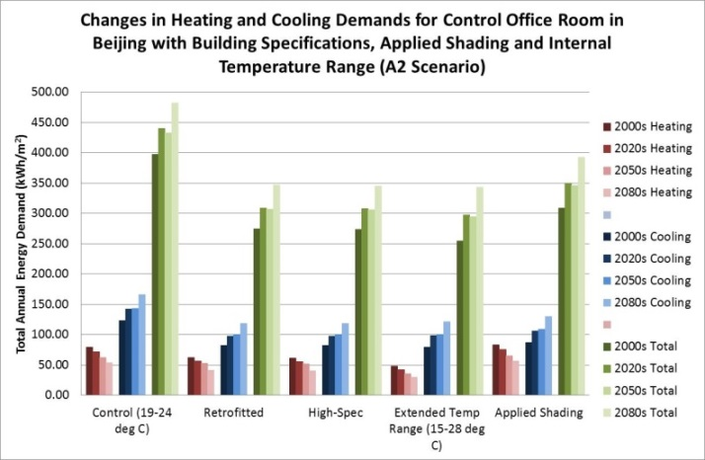 (a)

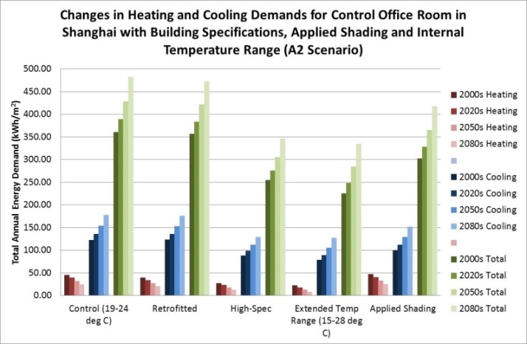 (b)

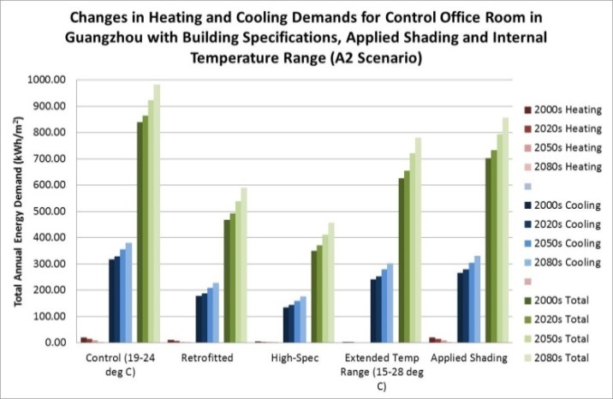 (c)

Figure 7. Comparison of heating and cooling Demands for existing “control” office building, with retrofitted, high-spec, increased internal comfort temperature range and applied external shading for Beijing (a), Shanghai (b) and Guangzhou (c)

## Combination of different strategies

The effects of combining different energy-reducing strategies were also tested to see the full extent of the potential for energy reduction in the future.

Figure 8 shows that for Beijing, the combination of retrofitting (to either the latest code or to high-spec), together with an extended comfort temperature range could reduce total primary energy consumption by about 50%. Combining retrofitting with external shading is slightly less effective, with a reduction of 40%. If the building is not retrofitted, but shading is applied together with an extended comfort range, the reduction is about 45%. With the “optimised” office building, where the U-Values were set with those for the “high-Spec” building, the comfort temperatures set at the wider 15°C to 28°C range, and direct solar gains were excluded by means of external shading, the reduction could be as much as 63% (under current climate) to 54% (comparing under 2080s A1 scenario).

For Shanghai, it was seen that retrofitting alone has limited effects, thus combination of strategies with retrofitting is similar to the effects of those strategies alone. However, combining these strategies with a high-spec office does provide added improvements in reduction. For example, external shading with a high-spec office would provide approximately 35% reduction in total primary energy consumption, whereas a high-spec office with an extended comfort range reduces 50% of the total energy. Shading and extended comfort temperature range for a non-retrofitted office results in a 40% reduction. With an “optimized” office, the reduction could be as high as 60% (under current climate) to 53% (comparing under 2080s A1 scenario).

For Guangzhou, the reduction in energy consumption could be very high. Retrofitting (to the latest national code or to the England and Wales standard) together with either external shading or the extension of comfort temperature range nearly all produced reductions in total primary energy consumption by more than 50% (with the exception of retrofitting to national code and external shading, which had a reduction of approximately 45%). Shading and extended comfort range together reduced consumption by roughly 40%. The “optimized” office in Guangzhou could provide reduction as high as 75% (under current climate) to 67% (comparing under 2080s A1 scenario).

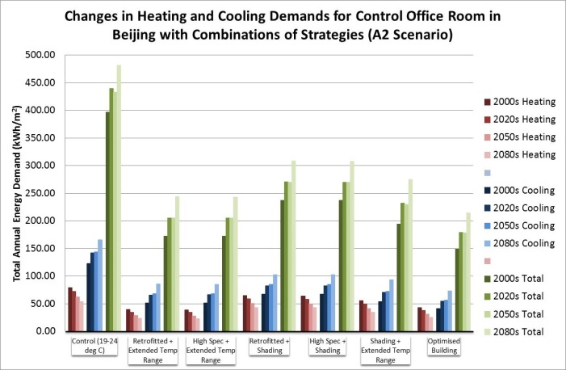 (a)

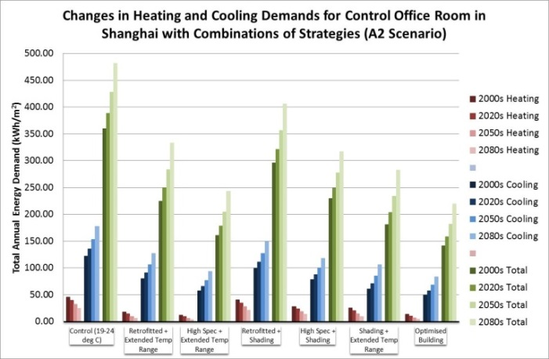 (b)

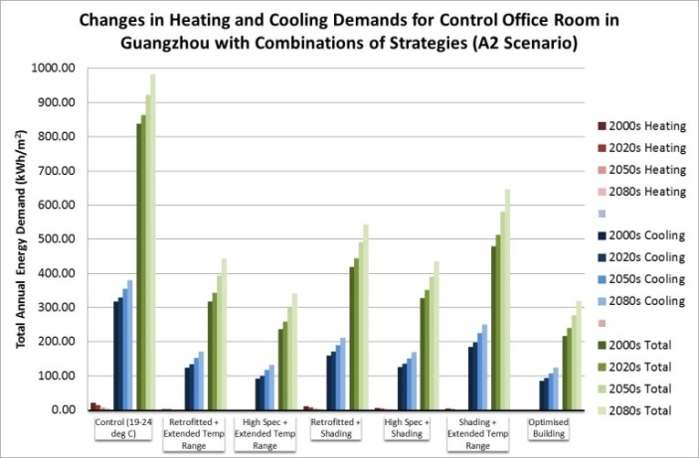 (c)

Figure 8. Comparison of heating and cooling demands for existing “control” office building, with combinations of energy-reducing strategies for Beijing (a), Shanghai (b) and Guangzhou (c)

# Conclusions

The effects of retrofitting to the current building code in the three cities in this study depended highly on the building specification of the existing building. In the case of Shanghai, the existing specifications are already very close to the current building code, thus further retrofitting to the latest code has very little effect. For Beijing and Guangzhou, the required U-Values for key elements are significantly lower in the current codes, thus, for these two cities, the effects of retrofitting is clear. For the case of Beijing, the latest code is already very close to the England and Wales building standards, thus further improving to these standards have limited effects, whereas Shanghai can benefit from another step change in building specification.

Guangzhou is the only city in this study where there are significant improvements with each subsequent retrofit. One reason for this is that the current building stock are still have relatively high U-Values, and the current code could still be improved further to the standard in England and Wales.

With the exception of Shanghai, retrofitting to the current code will reduce total primary energy consumption to an extent that even by 2080s, the requirement for heating and cooling would be lower than that for the current climate with existing buildings. This suggests that retrofitting to the current code is able to nullify the effects of future climate change by the end of this century. The effects appear to be greatest in Guangzhou, partly because there is currently very little heating demand in Guangzhou, so the “benefit” of heating load reduction with future warming does not apply there. Hence the effects of buildings with higher specification become more significant.

The effects of applying external shading and extending the comfort temperature range were also investigated in this paper, and it was found that in Beijing and Shanghai, the effects of extending the comfort temperature range to 15°C to 28°C (from 19°C to 24°C) to an existing building would be similar to retrofitting the building to the standard in England and Wales. This extended comfort range is already in place across much of China, especially in residential buildings, and is one method of reducing energy consumption in most places, and some offices are also adapting to this approach, especially in the south of the country, although retrofitting still performs better than extending the comfort range for Guangzhou. Applying external shading also has a strong positive effect, albeit less so than extending comfort range or retrofitting, and can reduce energy consumption by around 20%.

Combining all the energy-saving strategies (retrofitting, extending comfort range and applying external solar shading) to provide an “optimum” building could reduce total primary energy consumption by between 40% and 75%. The reduction is more significant when comparing under current climate and also more significant in Guangzhou than in Beijing or Shanghai.

Although the effects of climate change were investigated in depth for this study, effects of future urban heat islands due to further urbanisation were not taken into account. This will make the quest for producing low-energy buildings much more challenging, and further work is required to fully investigate and understand the effects of passive strategies on energy consumption in office buildings in China.

References

Belcher, S, Hacker, J, Powell, D. 2005 “Constructing design weather data for future climates” Building Services Engineering Research and Technology Vol. 26.1, pp.49–61.

Chow, DHC & Levermore, G. 2007 “The Effects of Future Climate Change on Heating and Cooling Demands in Office Buildings in the UK” Building Services Engineering Research and Technology, Volume 31,4, pp. 307-323. DOI: 10.1177/0143624410371284

DCLG “Building Regulations – Part L Building Regulations – Conservation of Fuel and Power” NBS / RIBA Enterprises (2006)

Fridley, D.G., Zheng, N., Zhou, N. 2008 “Estimating Total Energy Consumption and Emissions of China’s Commercial and Office Buildings” IBNL-248E, Lawrence Berkeley National Laboratory.

Gordon, C et al. 2000 “A Simulation of SST, Sea Ice Extents Ocean Heat Transports in a Version of the Hadley Centre Coupled Model without Flux Adjustments”, Climate Dynamics, Vol. 16, pp. 147-168.

Hong, T. 2009 “A Close Look at the China Design Standard for Energy Efficiency of Public Buildings” Energy and Buildings, Vol. 41, Issue 4, pp. 426-435.

Nakicenovic, N. 2000 "Emissions Scenarios" Intergovernmental Panel on Climate Change, Cambridge University Press. ISBN 0521 80493 0.

Qian, Y. 2010 “China Daily: ‘Most Homes’ to Be Demolished in 20 Years,’” 2010. http://www.chinadaily.com.cn/china/2010-08/07/content_11113982.htm

WMO, UNEP 2001“IPCC Climate Change 2001, Summary for Policy Makers and Technical Summary of the Working Group I Report”, pp. 63-65.

Wu, Y. 2003 “China Building Energy Efficiency: Current Status, Issues, and Policy Recommendations” China Ministry of Construction.

Zheng, Y. 2007 “Energy-Efficiency in Buildings:- An Imminent Task” Environmental Economy Vol. 11, pp. 23-24.

Zhong, J. 2007 “Development Approach of Renewable Energy and Building Integration Technology” Solar Energy Vol. 5, pp. 40-43.

Zhou, N. 2007 “Energy Use in Commercial Buildings in China: Current Situation and Future Scenarios” 8th ECEEE Summer Study, Lawrence Berkeley National Laboratory,. pp. 1065-1071.

Zhu, X. and Lin, B 2004“Sustainable Housing and Urban Construction in China,” Energy and Buildings, Vol. 36, pp. 1287-1297. http://dx.doi.org/10.1016/j.enbuild.2003.11.007