Implementing Building Information Modelling (BIM) in Energy-Efficient Domestic Retrofit: Quality Checking of BIM Model

**Elaheh Gholami,** [e.gholami@liverpool.ac.uk](mailto:e.gholami@liverpool.ac.uk)

University of Liverpool, United Kingdom

Arto Kiviniemi,  a.kiviniemi@liverpool.ac.uk

University of Liverpool, United Kingdom

Steve Sharples, [steve.sharples@liverpool.ac.uk](mailto:ar1ssx@liverpool.ac.uk)

University of Liverpool, United Kingdom

**Abstract**

Energy efficient retrofitting of the building stock is a contemporary issue in the built environment because of the need to reduce carbon emissions and improve building energy performance. The importance of refurbishing the existing UK housing to help the government achieve its climate change targets has been more widely recognised in recent years, and major programmes of residential retrofit have been instigated. Building Information Modelling (BIM) offers, potentially, a comprehensive and integrated platform for these retrofit programmes. However, BIM has traditionally been applied in medium to large-scale projects. There is only limited research that has investigated the use of BIM’s potentials in small scale and residential refurbishment projects. The ongoing research discussed in this paper aims to investigate the usability of BIM procedures in the retrofit of existing housing through energy performance modelling. The outcomes from this research can be used to develop a framework which utilises BIM to support efficient and effective design and construction processes and informs decision making at all stages of retrofitting projects, thereby improving not just the energy efficiency of the existing housing stock but also the effectiveness of the processes that deliver that efficiency.

Keywords: Retrofit Process, BIM, Energy Efficiency, Domestic Buildings, Solibri Model Checker (SMC)

1. **Introduction**

In the UK around half of primary energy consumption is related to the built environment. Reducing the energy use of existing buildings through energy efficient retrofitting provides considerable opportunities to lessen carbon dioxide emissions and alleviate environmental degradation. The UK government’s target is to reduce greenhouse gas emissions by 80% (compared to 1990 levels) by 2050, and one of the strategies to realize this is the government’s commitment to upgrade the energy efficiency of seven million houses by 2020 (DECC 2012). Given that approximately 75% of current housing will still exist in 2050, enhancing the residential refurbishment process is critical to the UK achieving its emission targets (Crosbie & Baker 2010; TRCCG 2008).

This paper is part of ongoing study exploring how Building Information Modelling (BIM) may be implemented in retrofit process to improve the energy efficiency of existing housing. Firstly, generic obstacles for energy efficient refurbishment process are studied. Then, the potential applications of and challenges to implementing BIM are explored through critically reviewing the literature and by conducting surveys (structured and semi-structured interviews). Finally, a real world retrofit case study is modelled in ArchiCAD and checked against a set of rules in the software Solibri Model Checker (SMC) using neutral Industry Foundation Classes (IFC) format. The processes of detecting the potential clashes, mistakes and missing information in the model using SMC are reported and discussed. This approach is used to explore what level of information is needed at a specific phase and how the potential problems may impact on the accuracy of energy simulation outputs.

1. **Retrofit Challenges**

Energy retrofitting the existing housing in the UK, one of the oldest domestic stocks in Europe, should be a priority to achieve the UK’s climate change target by 2050. More than 4.7 million of the least energy efficient solid wall houses were built before 1919, and the government has committed to providing 1.5 million solid wall homes with insulation to reduce their greenhouse gas emissions (DECC 2011; Baeli 2013). State-of-the-art technologies and novel approaches have been adopted for new constructions, but these techniques must also be adopted for retrofitting. Some ill-considered approaches have been used due to insufficient knowledge of how a building might work (Marianne & Roger 2013). Challenges in the refurbishment process have been identified through an extensive literature review and surveys conducted by the authors in a previous study (Gholami et al 2015). These challenges to the delivery of energy efficient retrofit include: i) concern of occupants about the quality of the refurbishment measures (Novikova et al 2011; Ma & Cooper et al 2012); ii) financial difficulties (Tobias & Vavaroutsos 2009, Eastman et al 2011); iii) insufficient level of user knowledge of the potential solutions and optimal approaches; iv) technical obstacles; and v) inadequate level of knowledge of collaborating teams regarding the novel approaches (Gholami et al 2015). This paper considers how some of these challenges might be alleviated or eliminated by the application of BIM.

1. **BIM Application in Existing Buildings**

Building Information Modelling (BIM), as defined by the Construction Project Information Committee (CPIC), is the “*...digital representation of physical and facility characteristics of a facility creating a shared knowledge resource for information about it forming a reliable basis for decisions during its life cycle, from earliest conception to demolition*” (RIBA 2012). One of the essential criteria to implementing BIM successfully in a project is understanding the reasons to employ BIM, thereby avoiding wasting time and cost on irrelevant detailed information which cannot be useful to achieve the planned aim of the project (Gholami et al 2015). Due to the reverse engineering procedures used in exploiting BIM in building retrofit, the accuracy of captured data is key to delivering accurate outputs. Structure, type and age of existing housing have consequential impacts when developing a framework to utilise BIM regarding the demand of occupants (Gray et al 2013). Reverse engineering has faced different challenging issues when applied to existing buildings (Akbarnezhad et al 2012; El-Omari & Moselhi 2008).

* 1. BIM implementation challenges

The challenges to implementing BIM in energy efficient refurbishment were studied by an extensive literature review and a survey conducted by the researchers (Gholami et al 2015). To provide reliable information the survey was conducted using snowball sampling (Patton 2001; Rowland & John 2004) to reach credible relevant people in the study, which took place between April 2013 and July 2014. The interviews were carried out either face-to-face or using Skype with nine professionals in Finland, United Kingdom and Norway. They had experience and expertise in varied backgrounds i.e. BIM coordinator; business development director; architects; technical director for data performance consultancy; structural engineer; Green Deal manager and civil engineer.

* + 1. Interoperability &BIM data standard

One of the challenges to exploiting BIM in retrofit processes is related to interoperability and BIM data standards. IFC (Industry Foundation Classes) and COBie (Construction Operations Building Information Exchange) are two major standards for BIM data.

The IFC specification is a comprehensive data scheme and also a neutral data format for exchanging and sharing information within the building and facility management industry sector. IFC is the international standard for openBIM and is also registered by the International Standardization Organization (ISO) as the international standard ISO16739. The IFC data structure can be used for sharing construction and facility management data across various applications used in the building domain. It is based on object class definitions representing the things (elements, processes, shapes, etc.) that are used by software applications during construction or facility management processes. The focus of the IFC data model is on those classes that are needed to share information rather than processing it in particular proprietary software (ifcwiki 2015). The IFC scheme covers the whole lifecycle of the buildings and the typical information needs of design, construction and facility management domains (bSI 2015). However, because BIM software are typically domain specific, and thus their information content is limited and structured differently, the implementation of the IFC standard has its limitations and has also suffered with quality problems (Kiviniemi 2008). This has affected its reputation and caused some mistrust for its usability in the industry. Thus, the use of IFC has not been widespread, and has been to just a few countries e.g. Finland and Norway (Kiviniemi et al 2008).

COBie is a formal scheme to organize data from design and construction to facility management purposes, and it provides a standardized level of detail for materials, maintenance information, serial numbers, location, tag, and performance data (East & Carrasquillo-Mangual 2013). However, it does not include any geometrical or architectural data, such as walls, roofs, stairs and slabs, which are crucial for energy efficient retrofit processes.

* + 1. Survey approaches and uncertainty of captured data

Dealing with inaccurate and uncertain data creates challenges for a collaborating team trying to implement BIM in their retrofit projects. Certainty about the captured data is crucial regarding all the functions for BIM applications. Evaluating building fabric is key to executing energy efficient retrofit process owing to the importance of estimating how thermal performance should be enhanced (Cavanagh 2013; Bishop 2013).

* 1. Potential application of BIM in existing building

By creating building prototypes designers can help occupants to understand comprehensively processes and proposed measures. Providing occupants with high quality demos of buildings assists them to compare different alternatives and can motivate them to implement energy efficient measures at the initial planning stages. Also, BIM has the potential to reduce the construction time via clash detection and advanced coordination tools. Furthermore, cost analysis of different alternatives, and the possibility to optimise solutions, makes stakeholders assured about the investment payback. Other potential BIM retrofit benefits are associated with life cycle assessment, operation and maintenance, refurbishing planning, cost analysis and scheduling (Gholami et al 2015).

1. **Applied Research Science Design Method**

The applied methodology for this paper’s ongoing research used the Design Science Research method to deliver a framework that can make a creative contribution to solving identified construction problems in a real-world case study through transforming existing approaches into more effective ones to improve construction issues (March & Smith 1995; Hevner et al 2004; Comlay & Tzortzopoulos 2015; Boland et al 2008).

* 1. Real-world case study

The case study for this research used a 19th century terraced house at 2 Broxton Street, Liverpool in the UK (Figure 1). The research provides a representative process which is systematic in approach and based on practice to retrofit solid wall houses. The UK government has committed to providing 1.5 million solid wall homes with insulation (DECC 2011). The Technology Strategy Board (TSB) launched a competition called *Retrofit for the Future* to motivate and encourage retrofit and reduce carbon emissions. One of TSB’s case studies was 2 Broxton Street, which was retrofitted by the Plus Dane Group to near PassivHaus standards by integrating energy efficient technologies in to the house (Mohammadpourkarbasi & Sharples 2013). In this paper, the case study house, with applied energy efficient retrofit measures, was modelled in ArchiCAD (Figure 2).

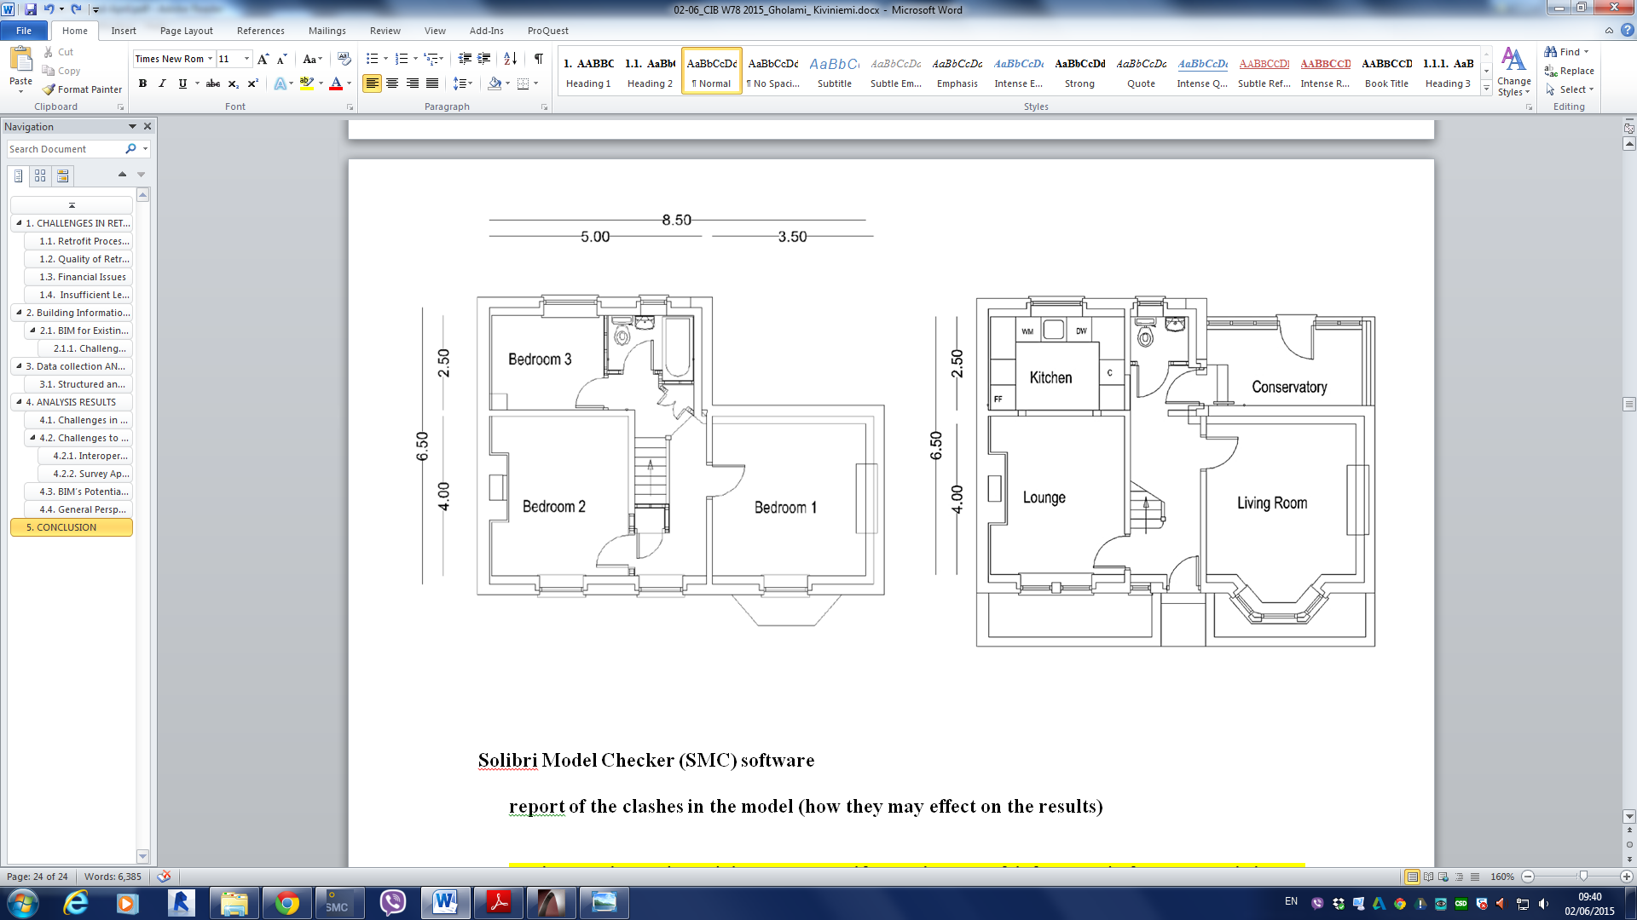



Figure 1: Case study, from left to right: north façade, first floor and ground floor plans (Mohammadpourkarbasi and Sharples, 2013)

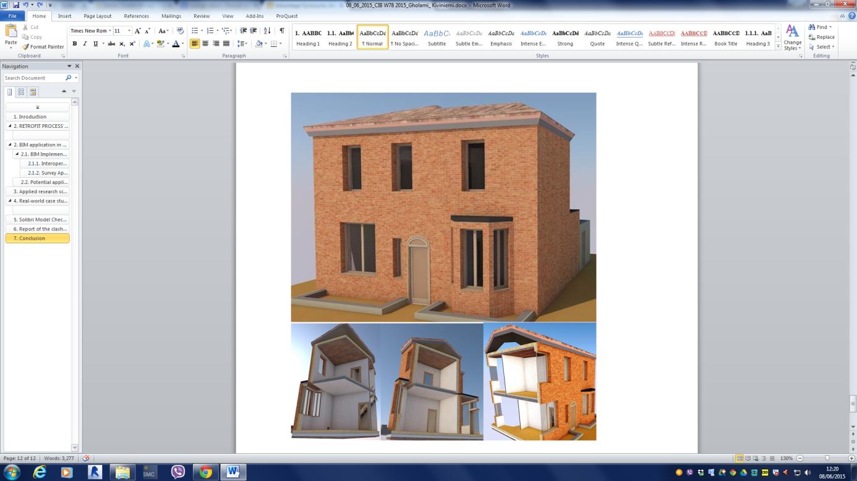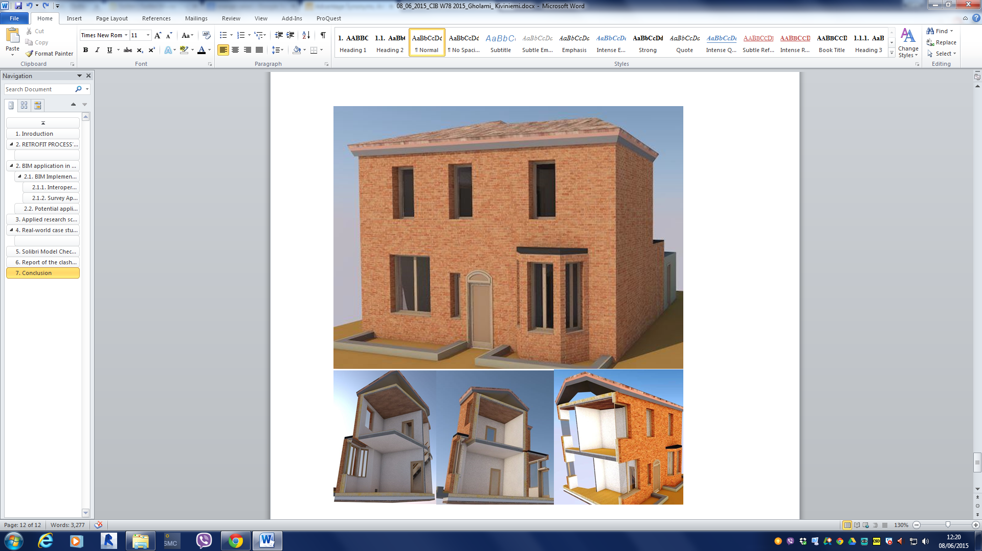

Figure 2: Case study modelled in ArchiCAD

1. Solibri Model Checker Software (SMC)

To achieve an energy efficient building solution, accurate analysis is required based upon the data in the BIM model that is already included in design. The quality and accuracy of the outputs depend on the quality and clarity of the provided information. Solibri Model Checker (SMC) enables involved bodies to be informed regarding the level of detailed information and the importance of specific information at a specific phase of the process. This capability assists designers to set the minimum level of data and determine what information is critical at a certain phase (Solibri 2012). The house at 2 Broxton Street was checked in SMC, which analyzed BIM for physical security, quality, quantity and integrity of the model. Potential problems, such as a clashing components and weaknesses in the design, were revealed through "X-raying" the building model. Generated issues are classified into categories to address and solve them more conveniently (Solibri 2014). The SMC process is shown in Figure 3. SMC can open and check any model from any IFC compliant BIM software. The IFC format contains the building geometry and components and their relationships. The potential benefits of utilizing SMC in this research included being able to open the model using the most common exchange format and check it against set of rules facilitated with 3D visualization of potential issues. Also, the researchers could evaluate the potential problems and check which of these potential issues might have caused problems for the specific target and so decide which need to be resolved for energy simulation and which could be ignored.

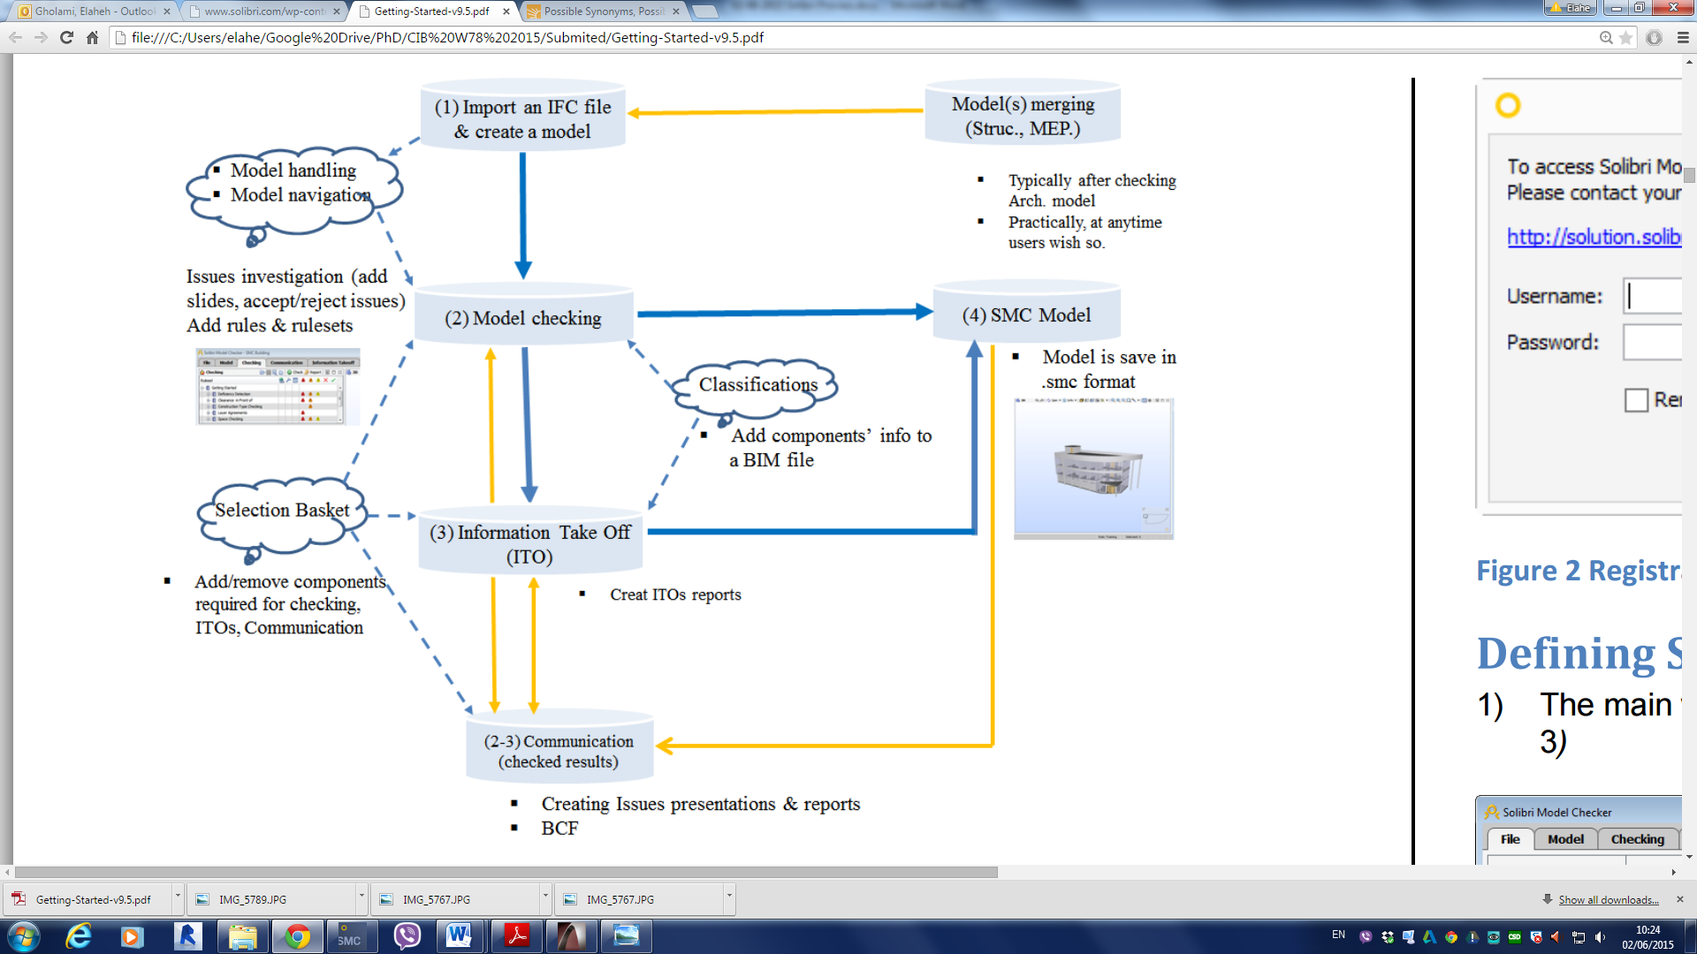

Figure 3: Overview of SMC QA/QC Process (Solibri Model Checker, 2014)

SMC enabled the BIM file to be checked against the required rule sets and to identify potential problems in a model. In comparison with manual checking, this was notably more convenient, faster and more accurate (Solibri 2014).The following show the process adopted to check the model:

* 1. Setting the Ruleset Manager

A ruleset contains information about an order of the rules and possible sub-rulesets, as well as parameter values used for the rules. Rules are parametric, which means that their behavior can be controlled by setting the parametric values. In this research the following rule sets were selected to check the quality of model: BIM Validation Architectural, general Space Check, intersections between Architectural Components, energy analysis. This part is explained in detail in Section 7.

* 1. Classification

In this phase, the building elements that they are not classified, should be classified. As shown in Figure 4, several architectural components which were modelled in ArchiCAD were required to be classified in SMC. In however in classified component, several exterior walls required to be classified in SMC.

* 1. Checking the model

In the Checking Layout, the summarized issues associated with specific rules were shown (Figure 5). It enabled involved bodies to get an inclusive view of the model quality and provided the clashes with a more comprehensive view with the 3D interface. After classification the errors based on the critical, moderate and low severity were checked

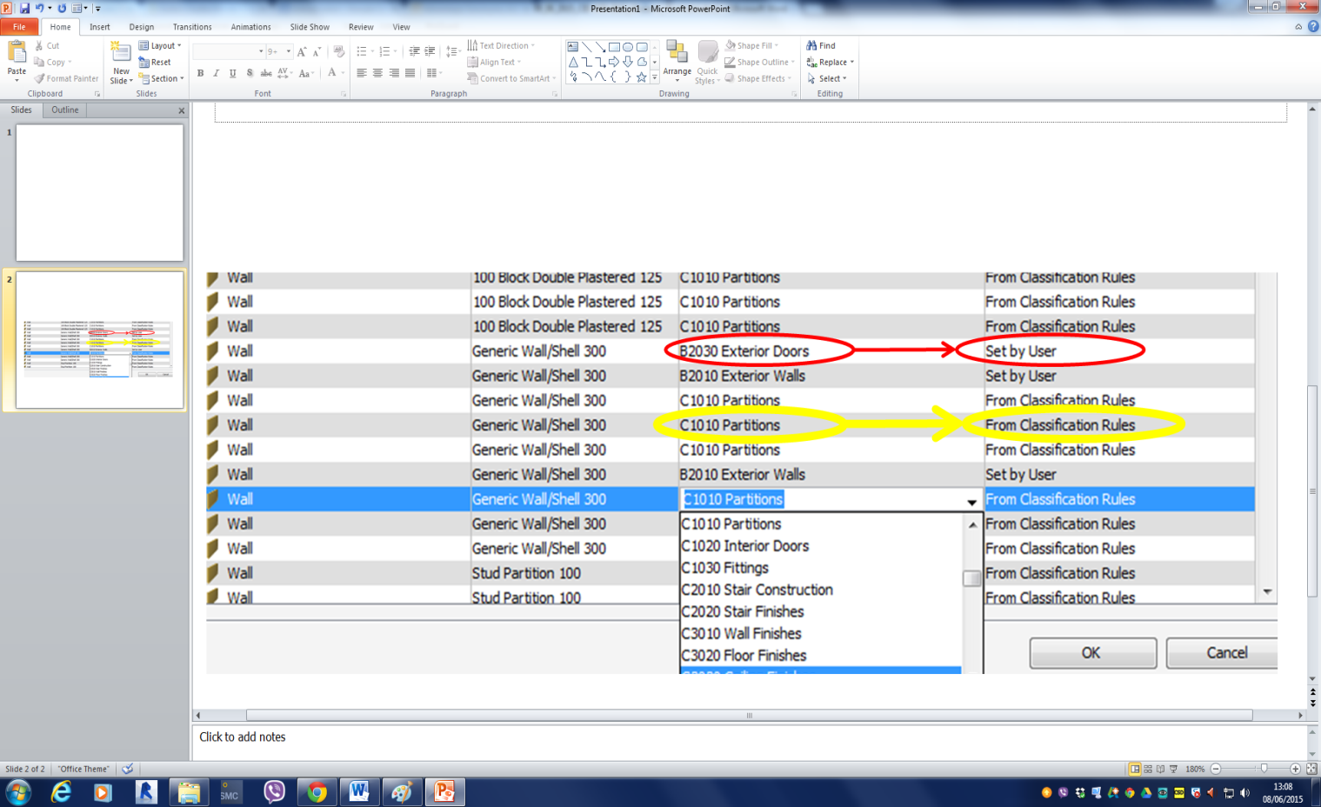

Figure 4: Classifying components in SMC

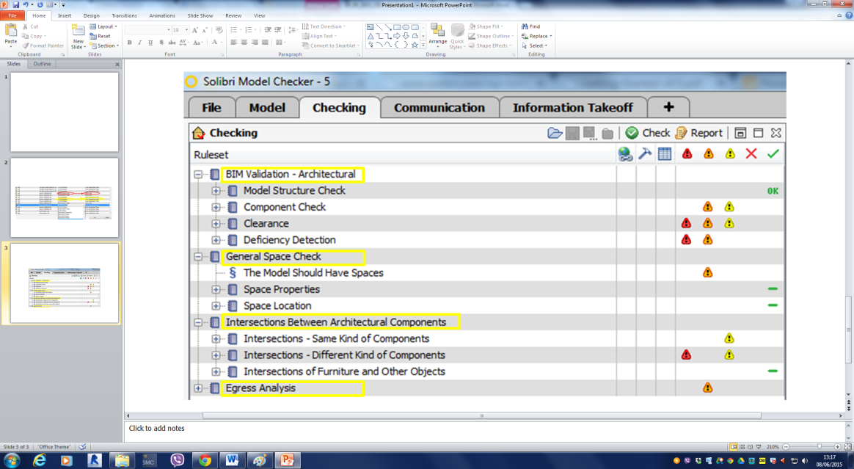

Figure 5: Illustration of checking layout

.

1. **The Importance of the Quality of Shared Information in the Model**

The shared model must provide the necessary information for intended aims. Different domains in AEC industry perform different tasks, and therefore the model for each of these diverse domains must be different. Some of the data were shared between the domains instead of the common misconception of integrated BIM being one model where everyone is working with the same data. This is inevitable owing to the fact that ‘*a model represents reality for the given purpose; the model is an abstraction of reality in the sense that it cannot represent all aspects of reality*’ (Rothenberg 1989).

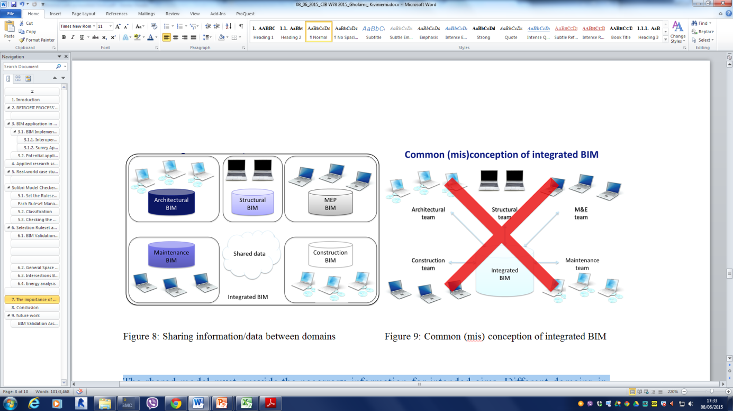

Figure 6: Sharing information/data between domains and common (mis)conception of integrated BIM (Kiviniemi 2005)

1. **Rulesets in Solibri Model Checker**

The following four Ruleset Managers were selected to check the model and report on any potential problems:

* 1. BIM Validation Architectural

This rule set checked that the model followed the correct hierarchy and that components had reasonable dimensions and were located in a correct way. For instance, doors and windows in the model were required to be related to the specific opening objects and had required minimum dimensions. Also, depending on the type of components, the clearance above or in front of component could be checked. In the deficiency detection section, the missing components and their related information in the model required for 4D BIM and 5D BIM were checked. For instance, the material layer thicknesses of components needed to be verified (Solibri 2014). The type of component and the thickness of materials were essential to simulate the energy performance, and inaccurate or missing information associated with these issues could have caused inaccurate or false outputs. For instance, in the 2 Broxton Street case study, the length of a wall component was reported as a potential problems (see Figure ).

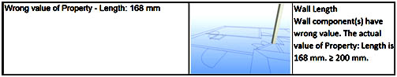

Figure 7: Potential problems associated to the wrong value of component

* 1. General Space Check

The properties of space were checked for typical space related issues regarding how the space types and identification of individual spaces should be in the model and comply with the SMC settings. To run the energy simulation, the space boundaries needed to be defined. Based on the results of SMC, all space boundaries were defined and valid to run the energy simulation.

* 1. Intersections Between Architectural Components

This ruleset checked all intersections of the same type and different types of components in the model. The geometry, location and the boundaries around components, such as slab and walls, were checked. Also, the boundaries of space were checked to review how the components were connected and in contact with associated components. The untouched components that need to be intersected with other components would have affected the energy performance of the building by creating unnecessary thermal bridges. Many potential issues were reported after checking the case study model. One of these issues is shown in Figure .

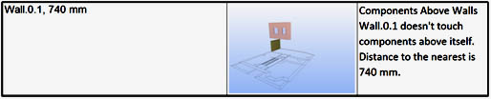

Figure 8: Intersection between components

* 1. Energy analysis

Different energy simulation software may have different requirements that need to be considered in the model. Depending on the energy analysis software, some rules can be skipped or added. Coordinate values, duplication or intersection of walls, windows and doors intersections should be detected for clashes. External walls need to be defined in the model; also doors and windows have to be related to a wall.

In this study the reported critical severity for energy analysis ruleset was related to external wall validation. Building envelope elements were not defined in the model. Also, one moderate severity was reported regarding spaces in the model. The model did not contain any space components. These critical and moderate severities have important effects on the energy analysis. Checking the model against energy analysis ruleset meant it was possible, to detect the clashes before running the energy simulation.

1. **Conclusion**

This ongoing research sought to investigate the feasibility and usability of integrating BIM procedures into the retrofit of existing housing through energy performance modelling. The outcomes from this research will be used to develop a framework which utilises BIM to support efficient and effective design and construction processes and informed decision making in all stages of retrofitting projects improving the energy efficiency of the existing housing stock. Generic obstacles for energy efficient refurbishment process and the potential application of BIM and challenges to implement were studied.

Based on a previous study by the researchers (Gholami et al 2015) dealing with inaccurate and uncertain data is one of the major challenges to achieving energy efficient process. Since the content and accuracy of information are essential for BIM applications for energy simulation, this part of this study addressed this issue and concentrated on ensuring the quality of the information.

A real world retrofit case study was modelled in ArchiCAD and checked against a set of rules in Solibri Model Checker (SMC) using the neutral IFC format. This approach was used to explore what level of information is needed at a specific phase and how the potential problems may effect on the accuracy of output data from energy simulation. BIM validation architecture, general space check, intersection between architectural component and energy analysis were selected as rulesets to check and validate the model. The test indicated that even a model which had been built specifically for energy simulation contained several issues which would affect the outcome of the simulation. Based on this, and the views from survey interviews with industry experts (for example, Bishop 2013, Cavanagh 2013, Koppinen 2014 and Lorimer 2014) it seems very unlikely that a model coming from an architect, who might not necessarily know much about energy simulation, would automatically contain sufficient and accurate information, which makes the quality checking using a tool like SMC an essential part of the BIM process. Generally, in different categories SMC reported potential issues for this simple model as follows: in the “BIM validation ruleset” category two critical, four moderate and two low severity issues were recognized; in the “general space check ruleset” category one moderate issue was found; in the “intersection between architectural components ruleset” category one critical and two low severity issues were located; and in the “energy analysis ruleset” category, one critical and one moderate severity issues were evident. These numbers illustrate the importance of the quality checking of the model in the BIM process.

1. **Future Work**

In future research a real world retrofit case study modelled in ArchiCAD and checked against the required rule sets in Solibri Model Checker will be compared to the traditional way of simulation analysing the efficiency and end results of both approaches. In addition, future work will explore why the results may be different regarding the transformation process and results of native simulation. Finally the results of different simulation methods will be compared to the monitored data of the real building to evaluate which method is more accurate (Figure 7).

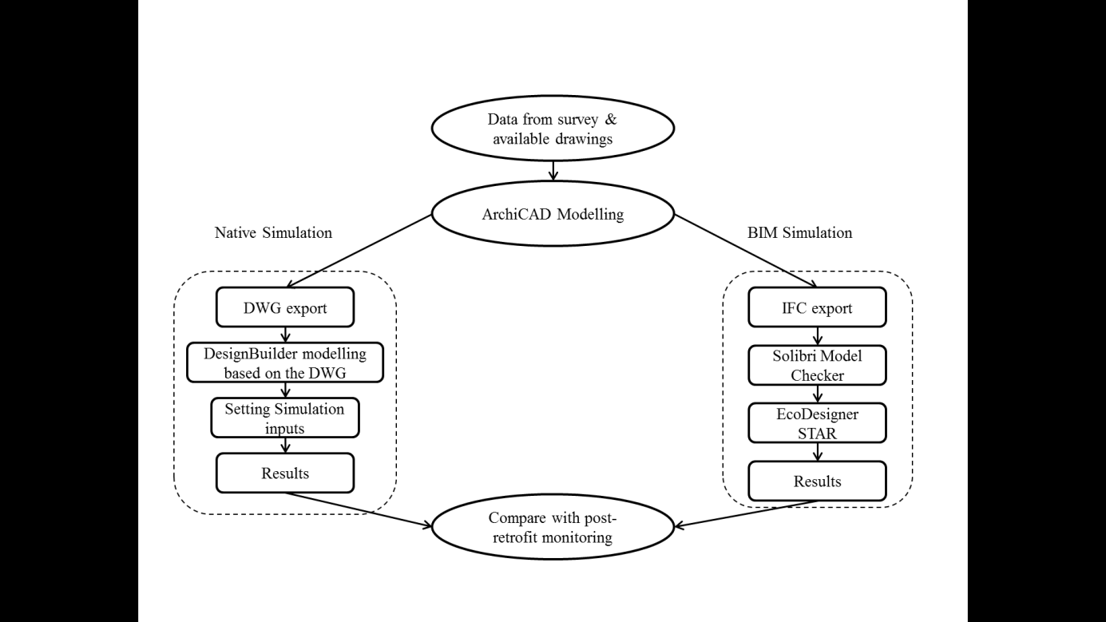

Figure 7: Future research

**References**

Akbarnezhad, A., Ong, K., Chandra, L. and Lin, Z. (2012).  Economic and environmental assessment of deconstruction strategies using Building Information Modelling. Proceedings of Construction Research Congress: Construction Challenges in a Flat World, West Lafayette.

Baeli, M. (2013). Residential Retrofit: 20 Case Studies. London: RIBA Publishing.

Bishop, B. (2013). Interviewed by Elaheh Gholami [face-to-face], 28 November 2013, 10:00.

Boland, R., Collopy, F., Lyytinen, K. and Yoo, Y. (2008).  Managing as designing: Lessons for organization leaders from the design practice of Frank O. Gehry. Design Issues, 24, pp. 10-25.

Building Smart (2015). Summary of IFC releases. Retrieved from http://www.buildingsmart-tech.org/specifications/ifc-releases/summary. [accessed 12/06/2015]

Cavanagh, G. (2013). Interviewed by Elaheh Gholami [face-to-face] 20 November 2013. 14:00.

Comlay, J. and Tzortzopoulos, P. (2015).  Building Information Modelling (BIM) for energy efficiency in housing refurbishments , Euro ELECS Guimaraes,Portugal,2015.

Crosbie, T. and Baker, K. (2010). Energy-efficiency interventions in housing: learning from the inhabitants. Building Research & Information, 38(1), pp. 70-79.

DECC (2011). Department of Energy and Climate Change, The carbon plan: delivering our low carbon future.  Stationery Office, London.

DECC (2012). Department of Energy and Climate Change, Warmer homes, greener homes: a strategy for household energy management. Stationery Office, London.

East, W. and Carrasquillo-mangual, M. (2013). The COBie guide: a commentary to the NBIMs‐us COBie standard (release 3). Building Smart Alliance and National Institute of Building Sciences.

Eastman, C., Teicholz, P., Sacks, R. and Liston, K. (2011). BIM handbook: a guide to building information modelling for owners, managers, designers, engineers, and contractors. Canada: John Wiley.

El-omari, S. and Moselhi, O. (2008).  Integrating 3D laser scanning and photogrammetry for progress measurement of construction work. Automation in Construction JOurnal, 18(1), pp 1-9.

Gholami, E., Kiviniemi, A., Kocaturk, T. and Sharples, S. (2015). Exploiting BIM in energy efficient domestic retrofit: evaluation of benefits and barriers, ICCBEI, Tokyo, 2015.

Gray, M., Teo, M., Chi, S. and Cheung, F. (2013).  Building Information Modeling, an international survey, Australia.

Hevner, A., March, S., Park, J. and Ram, S. (2004). Design science in information systems research. mis quarterly, 28, pp. 75-105.

ifcwiki (2015). Basic information of IFC. Available:

http://www.ifcwiki.org/index.php/basic_informations [accessed 12/06/2015]

ISO (2010). ISO 29481-1:2010(E): building information modeling — information delivery manual. (part 1: methodology and format).

Khemlani, L. (2007). Top criteria for BIM solutions, October issue [www document] from http://www.aecbytes.com. [accessed 12/06/2015]

Kiviniemi, A. (2008) IFC certification process and data exchange problems. Proceedings of the ECCPPM 2008 conference “eBusiness and eWork in AEC” (ISBN 978-0-415-48245-5), pp. 517-522. Sophia Antipolis, France, September 2008.

Kiviniemi, A., Tarandi, V., Karlshøj, J., Bell, H. & Karud, O.J. (2008). Review of the development and implementation of IFC compatible BIM, a technical report for the ERAbuild funders in Denmark, Finland, Norway, Sweden and the Netherlands. Retrieved from http://erhvervsstyrelsen.dk/file/9498/reviewofthedevelopmentandimplementationofifccompatiblebim.pdf [accessed 12/06/2015]

Koppinen, T. (2014). Interviewed by Elaheh Gholami [telephone], 12 February 2014, 09:00.

Lorimer, J. (2014). Interviewed by Elaheh Gholami [telephone], 11 March 2014, 13:00.

Ma, Z., Cooper, P., Daly, D. and Ledo, L. (2012). Existing building retrofits: Methodology and state-of-the-art, Energy and Buildings, 55, pp. 889-902.

March, S. and Smith, G. (1995).  Design and aural science research on information technology. Decision Support Systems, 15, pp 251-266

Mohammadpourkarbasi, H. and Sharples, S. (2013). The eco-refurbishment of a 19th century terraced house: energy and cost performance for current and future UK climates. Buildings, 3, pp. 220-244.

Novikova, A., Vieider, F., Neuhoff, K. and Amecke, H. (2011). Drivers of thermal retrofit decisions – a survey of German single- and two-family houses; Climate Policy Initiative Berlin. Available: http://climatepolicyinitiative.org/wp-content/uploads/2011/12/Drivers-of-Thermal-Retrofit-Decisions-A-Survey.pdf [accessed 12/06/2015]

Patton, M. (2001). Qualitative evaluation and research methods. 3rd. Newbury Park, CA: Sage publications.

RIBA (2012). BIM overlay to the RIBA outline plan of work. Great Britain: RIBA Publishing.

Rowland, A. and John, F., 2004-last update, Research methods snowball sampling [homepage of sage], [online]. Available:<http://srmo.sagepub.com/view/the-sage-encyclopedia-of-social-science-research-methods/n931.xml>. [accessed 12/06/2015]

Solibri (2012). Solibri model checker v7.1. Available: Solibri, 2012. Solibri model checker v7.1 [accessed 12/06/2015]

Solibri (2014) Solibri model checker v9.5, getting started with solibri model checker   [homepage of Solibri], [online]. Available at:

[file:///c:/users/elahe/google%20drive/phd/cib%20w78%202015/submited/getting-started-v9.5.pdf](http://file:///C:/Users/elahe/Google%20Drive/PhD/CIB%20W78%202015/Submited/Getting-Started-v9.5.pdf)

[accessed 12/06/2015]

Suhr, M. and Hunt, R. (2013). Old house Eco Handbook: a Practical Guide to Retrofitting, UK.

Tobias, L. and Vavaroutsos, G.A. (2009).  Retrofitting office buildings to be green and energy-efficient: optimizing building performance, tenant satisfaction, and financial return, urban land institute (ULI), Washington, DC, 2009. Washington, DC: Urban Land Institute.

TRCCG (2008). Three Regions Climate Change Group (TRCCG), Your home in a changing climate. Retrofitting existing homes for climate change impacts. Available: http://climatelondon.org.uk/wp-content/uploads/2012/10/Your-home-in-a-changing-climate.pdf [accessed 12/06/2015]