**Coevolution can explain defensive secondary metabolite diversity in plants**

Michael P. Speed1^ , Andrew Fenton1, Meriel G. Jones2 , Graeme D. Ruxton3 & Michael A. Brockhurst4

6700 words (main text), 9 figures, 1 table, plus Supporting Information

1Dept. of Evolution, Ecology and Behaviour, Institute of Integrative Biology, Faculty of Health & Life Sciences, University of Liverpool, Liverpool, L69 7ZB; 2Functional and Comparative Genomics, Institute of Integrative Biology, Faculty of Health & Life Sciences, University of Liverpool, Liverpool, L69 7ZB;

3School of Biology, University of St Andrews, Fife, KY16 9TH; 4Department of Biology, University of York, Wentworth Way, YO10 5DD.

Author for correspondence:

Michael P Speed

+41517954559

[speedm@liv.ac.uk](mailto:speedm@liv.ac.uk)

**Abstract**

* Many plant species produce defensive compounds that are often highly diverse within and between populations. The genetic and cellular mechanisms by which metabolite diversity is produced are increasingly understood, but the evolutionary explanations for persistent diversification in plant secondary metabolites have received less attention. Here we consider the role of plant-herbivore coevolution in the maintenance and characteristics of diversity in plant secondary metabolites.
* We present a simple model in which plants can evolve to invest in a range of defensive toxins and herbivores can evolve resistance to these toxins and we allow either single-species evolution or reciprocal coevolution.
* Our model shows that coevolution maintains toxin diversity within populations. Furthermore there is a fundamental coevolutionary asymmetry between plants and their herbivores, because herbivores must resist all plant toxins, whereas plants need challenge and nullify only one resistance trait. As a consequence, average plant fitness increases and insect fitness decreases as numbers of toxins increases. When costs apply the model showed both arms race escalation and strong coevolutionary fluctuation in toxin levels across time.
* We discuss the results in the context of other evolutionary explanations for secondary metabolite diversification.

Key words: Coevolution, herbivore, secondary metabolite, specialized metabolism, chemical defence, theoretical modelling.

Summary = 187 words

Introduction = 1723

Methods = 1415

Results = 1966

Discussion = 2094

Acknowledgements= 16

Total = 7214

**Introduction**

Almost all organisms face attack by enemies, whether they be predators, parasites, or animal herbivores feeding on plant tissues. To avoid injury or death organisms invest in traits that prevent attacks, for example hiding, evasive behaviours and threat displays in animals. In addition many organisms have evolved adaptations that minimize the damage caused when attacks do take place, including physical defences such as toughened exterior layers and defensive spines (Ruxton *et al.*, 2004; Schoonhoven *et al.*, 2005; Walters, 2011). A strongly convergent defensive trait across life forms is, however, the possession of poisons that repel attacking enemies by disabling and deterring them and thereby causing the early cessation of attacks.

The molecular nature of many repellent chemical defenses has been characterized in a large and growing number of cases (Eisner *et al.*, 2005; Schoonhoven *et al.*, 2005; Walters, 2011). A common thread in the chemical defence literature is widespread and persistent diversity in defensive toxins (Bennett & Wallsgrove, 1994; Hartmann, 1996; Mithofer *et al.*, 2012; Speed *et al.*, 2012; Moore *et al.*, 2014). Diversity in chemical defence can be considered in terms of variation in the levels at which a particular toxin is expressed within a population and the total number and complement of defensive toxins deployed. In plants, defensive compounds are often chemically diverse, between and within populations. Chemical defence by plants against herbivores and other enemies is so important that it has led to the generation of a so-called “secondary metabolism”, defined as a set of metabolic pathways not required for essential processes of growth and development (though this is certainly a simplification, see Neilson *et al.*, 2013) and hence may be relatively free to diversify (Hartmann, 2007). Molecular mechanisms that promote plant toxin diversity are known to include: gene and genome duplications and consequent exaptation (or “neofunctionalisation”), accumulation of point mutations and multi-locus control leading to variation in metabolic products (Kroymann, 2011; Weng *et al.*, 2012; Moore *et al.*, 2014).

Arguably though, the evolutionary causes of persistent toxin diversification in plants are comparatively poorly understood (Rasmann & Agrawal, 2009); though applications of modern phylogenetic methods are beginning to reveal the evolutionary history of toxicity, for example in the milkweed plants (Agrawal & Fishbein, 2008). There are many potential explanations for the remarkable diversity in plant secondary metabolites (Carmona *et al.*, 2011). Notably Firn and Jones (Jones & Firn, 1991; Firn & Jones, 2003) proposed that selection favours plant lineages with broad biosynthetic capability because it is these lineages that are more likely to “invent” effective, novel toxic compounds and hence gain strong protection from herbivorous enemies. Jones and Firn argued that biological activity is such a rare property of organic compounds that plants must be able to generate high levels of chemical diversity to be able to create new molecules that poison and deter herbivores. In effect plants may be capable of “natural screening” in a manner analogous to artificial screening performed by chemists as they seek molecules with biological activity from a large initial set (Jones & Firn, 1991; Firn & Jones, 2003). While the screening hypothesis provides a general overarching explanation for diversification in plant secondary metabolites, it requires that individuals within plant lineages diversify metabolism for a gain conferred only on their (perhaps distant) descendants. To be plausible this hypothesis then requires negligible costs to production of new metabolites so that there is no short term disadvantage. It also assumes lineage-level selection in which metabolically diversified lineages have greater longevity across phylogenetic timescales than those without secondary metabolic diversification.

Alternative explanations for diversification in plant secondary metabolites (PSMs) are, however, available. A diversity of enemies is an obvious one. In the wild, for example, plants will face pressures from numerous herbivores, as well as microbial enemies. Diversity in numbers and types of enemy must surely be part of the explanation for the repeated diversification in plant secondary metabolism. Furthermore some defensive secondary metabolites may not be toxic, but serve communication functions recruiting arthropod “bodyguards” that will attack herbivore enemies, rather than to function as toxins (Kappers *et al.*, 2005). There may also be synergistic effects between compounds, so that a cocktail of toxins deters much more strongly than one compound alone (see Berenbaum *et al.*, 1991; Rasmann & Agrawal, 2009). In addition there could be complex genetic correlations between defense traits, so that some are more or less likely when others are present. We note though that some explanations of diversity in plant secondary metabolites rely on the relative evolutionary independence of chemical defences which have few pleiotropic and life history constraints and therefore are free to undergo rapid variation and innovation (Hartmann, 2007; Carmona *et al.*, 2011). It has also recently been argued that many defensive compounds have additional uses within plants, so perhaps some of the puzzling diversity of toxins can be attributed to requirements of additional plant functions, not anti-herbivore qualities *per se* (Neilson *et al.*, 2013).

One explanation for plant secondary metabolite diversity that has in our view had insufficient detailed attention is coevolution. Antagonistic coevolution in general terms has been subject to numerous analyses (recent examples of theory and reviews include Gilman *et al.*, 2012; Althoff *et al.*, 2014; Débarre *et al.*, 2014; Hembry *et al.*, 2014), but there are surprisingly few explicit models of plant-herbivore interaction. In the absence of a theoretical analysis the diversifying effects of plant-herbivore coevolution are uncertain. There may for example be “arms race escalation” which can result in the absence of toxin diversity. Moore et al (2014) for example suggest that “*given simple pairwise co-evolutionary arms races, the often extreme variability of PSMs is hard to explain****”***. Alternatively there may be processes of fluctuating selection in which selection for toxicity oscillates over time, causing temporal and spatial diversification (see recent review of coevolutionary theory in Brockhurst *et al.*, 2014, and extension of multi-trait coevolution in Débarre *et al.*, 2014). Hence answering the question of how much toxin diversity is caused by plant-herbivore coevolution is central to understanding the causes of diversification in plant secondary metabolism.

In this paper we examine the proposition that plant-herbivore coevolution is important in accounting for secondary metabolite diversification in plants. Our ideas are influenced by the classic work of Berenbaum, Zangerl and colleagues on the relationships between wild parsnip (*Pastinaca sativa*) and its insect pest, the parsnip webworm (*Depressaria pastinacella*) (Berenbaum *et al.*, 1986; Lee & Berenbaum, 1990; Berenbaum & Zangerl, 1992; Lohman *et al.*, 1996; Zangerl & Berenbaum, 1997; Berenbaum & Zangerl, 1998; Cianfrogna *et al.*, 2002; Zangerl & Berenbaum, 2003). Wild parsnip plants defend themselves against herbivory with up to five kinds of (furanocoumarin) toxin. The use of museum specimens has shown a likely period of initial arms race between plant toxicity and insect detoxification following the parsnip’s introduction into North America in the nineteenth century. Contemporary levels of parsnip toxins are geographically variable and there is often a good match between toxin traits in the plant and corresponding detoxification traits in the webworm (Berenbaum & Zangerl, 1998). Thus webworms often show heightened capacity to detoxify the locally-abundant toxin, and reduced capacity to detoxify locally-rare toxins. We take the wild parsnip example as likely representative of many plant-herbivore relationships, where multiple toxins are present and herbivore resistance is known in some populations. Genomic methods allow recent studies to gain exceptional depth of understanding of the role of defense compounds (Kliebenstein *et al.*, 2005; Züst *et al.*, 2011; Abe *et al.*, 2013; Scholz *et al.*, 2014); however, from an evolutionary perspective, the Berenbaum and Zangerl work is exceptionally useful as it explores a natural “coevolutionary experiment” run in parallel across different populations.

The parsnip and webworm example points to the significance of multiple defensive traits in victim-exploiter coevolution. Multiple interaction traits have been explicitly included in several models of antagonistic coevolution (e.g. Frank, 1993; Sasaki, 2000; Agrawal & Lively, 2003; Fenton *et al.*, 2012; Gilman *et al.*, 2012). The model of Sasaki (2000) for example, assumes multiple interaction resistance-virulence trait pairings in which the susceptibility of the victim is proportional to the number of traits where the exploiter is virulent and the victim is nonresistant. A major finding is that sufficient levels of polymorphism across a sufficient number of interaction traits can prevent invasion by the exploiter. The second notable examination of multiple interaction traits in coevolution is the recent paper by Gilman et al. (2012) which predicts that increasing the number of traits involved in a coevolutionary interaction tends to increase the likelihood that the victim will “escape” the exploiter, which subsequently becomes extinct. A key insight in the Gilman et al. paper is that coevolutionary asymmetry is created and exaggerated as the number of defense traits increases. Victims only need to “beat” their exploiter at one trait to survive, whereas exploiters must “beat” the victim on all defensive traits to gain from the interaction. The higher the number of defensive traits the victim presents, the higher the likelihood that it can beat the exploiter in at least one trait.

To explore the coevolutionary consequences of multiple chemical defences we present a simple coevolutionary model which represents a plant and its herbivorous enemy. The general scenario is inspired by (1) the parsnip and webworm example and (2) the potential utility that multiple toxins may have in beating herbivore enemies (Gilman *et al.*, 2012). Where other models take a generalized, abstract approach to victim-exploiter coevolution, we present a more specific representation of plant-insect interaction. We consider a plant that can deploy one or more toxins, and its herbivore that can resist the toxin with corresponding resistance traits which represent separate detoxification systems. Using this model we explore the consequences for plant and insect fitness, and for their coevolutionary dynamics, as we vary the number of toxin-resistance trait pairs. Unlike other coevolutionary models of multiple traits that often assume a “winner takes all” approach (e.g. Gilman *et al.*, 2012) we assume that the size of gain that the exploiter can make (and the loss to the victim) is continuously variable and limited by its lowest level of resistance against any defence. We show that plants can experience strong coevolutionary pressures to diversify their toxins; by so doing they can not only keep ahead of their insect enemies, but they can repeatedly target herbivore resistance traits that are least well developed. This leads to the long-term persistence of diversity in defensive chemicals.

**Methods: General scenario**

We consider the coevolutionary relationship between a herbivore (of population size *Ne*) and its host plant (population size *Nv*), in a “trait for trait” coevolutionary system. The victim can use one or more defensive traits to protect itself from the exploiter, and in turn the exploiter can evolve phenotypes to counter the effects of these defensive traits. The victim is the food source for the exploiter, so the more food the exploiter gains the higher its chances of surviving to reproduce and conversely, the more damage that is done to the victim’s survival probability. We specifically consider a system similar to that described by Berenbaum (1998) for the wild parsnip and the webworm herbivore, in which there can be multiple toxins and multiple detoxification systems. Hence we simulate a plant as the victim, and a sessile insect larval herbivore that spends its immature period on a single plant and then matures to reproduce as the exploiter.

To protect itself, the plant can invest in a number (*n*) of alternative, costly chemical defences *D1*,...,*Dn*, (with the level of investment in each trait scaled to bound between zero and one). In response the insect is assumed to possess a corresponding number of resistance traits (*I1*,…,*In*, again with the level of investment in each trait scaled to bound between zero and one) with which it can attempt to circumvent each defence by detoxification (for example by P450 enzymes, see Berenbaum & Zangerl, 1992; Berenbaum & Zangerl, 1998). The scalings between 0 and 1 acknowledges our assumptions that these traits are constrained by some physiological maximum, and avoids introducing further parameters to define these maxima. We assume that the defensive value of a toxin trait specifies a fixed quantity of toxin evenly dispersed across plant tissue. The insect’s resistance value specifies a fixed upper limit on the quantity of toxin that the insect can eat during its larval period (assumed to be of fixed duration). We assume a direct biological correspondence between toxin and resistance values, so that for example an insect would require a resistance value of one to safely ingest a toxin quantity of one unit (i.e. toxin value of one) during its larval period. We scale the biological maximum toxin quantity that can be detoxified in this period to one.

In the simplest case there is only one toxin (*D1*) and one corresponding resistance-detoxification trait (*I1*). Suppose *D1*=1 and *I1*=0.5: here the insect can eat half of its maximum potential material before reaching its upper boundary of toxin intake. If, however, *D1*=0.5 (and again *I1*=0.5) then the concentration of the toxin in the plant tissues is halved, and the insect can consume its maximum amount of plant before reaching its upper toxin limit of one. Hence in general the damage to the plant (and gain to the insect) is proportional to (*Ii/Di*) if *Di* ≥ *Ii*, that is victim defensive investment is greater that or equal to associated exploiter resistance. However, if victim defensive investment is less than that of the associate exploiter resistance (*Di* < *Ii*), then the damage to the plant is maximum and the exploiter can consume freely up to its limit of satiation. However, we also impose lower limits *α* and *β* to victim and exploiter survival respectively, to represent some plant tissues that cannot be exploited and some alternative food source for the exploiter. We can now specify the probability of survival of the victim (*Sv*, plant) and exploiter (*Se* insect) respectively as

$S_{v}=\left\{\begin{matrix}α+\left(1-α\right)\left(1-\frac{I_{i}}{D_{i}}\right) & if D_{i}≥I_{i} \\ α & if D_{i}<I_{i}\end{matrix}\right.$ (1)

$S_{e}=\left\{\begin{matrix}β+\left(1-β\right)\left(\frac{I_{i}}{D_{i}}\right) & if D_{i}≥I_{i} \\ 1 & if D_{i}<I_{i}\end{matrix}\right.$ (2)

where **  and ** are bounded between zero and one. For example if we set **=0.1 then the plant has a small chance of surviving even if the insect eats its maximum amount of plant tissue, whereas if **=0 then the plant is entirely eaten if the insect eats to its maximum capacity of plant tissue (and similarly for **).

Multiple defence-resistance trait pairs present a set of potential values for plant damage (equation 1). The realized damage to the plant is now defined as the smallest value of this set, since this represents the maximum that the insect can eat before suffering toxicosis from the relevant toxin. In each plant-insect pairing one trait pair is then the focus of selection. Even if an insect could for example cope with four plant toxins without slowing its feeding rate, the total plant material that it ingests could be limited by a fifth toxin that is present at a higher level than the insect herbivore can completely metabolise in its larval period. Furthermore, assuming ** the insect would die if it had zero values in all *n* traits, while the plant has a value of more than zero for at least one trait; because here the herbivore would have no means of counteracting the plant defences and would be unable to feed.

We assume that there can be a fecundity cost associated with investment in defence (Zangerl & Berenbaum, 1997) or resistance, and take a simple linear cost function, such that fecundity of the plant is reduced by the total investment in defence traits scaled by a non-negative constant *Cv*.

(3)

Values of *Cv*=0 imply no costs; *Cv*=0.125 (which we term low costs) would for example indicate that fecundity reaches zero if a prey invested 1 unit for each of eight defences. Values of *Cv*=0.5 would indicate zero fecundity if the plant invested 1 unit in just two traits (we term this high costs).

Similarly for the insect,

$F_{e}=\left\{\begin{matrix}1-C_{e}\sum_{i=1}^{n}{I_{i}} & if C_{e}\sum_{i=1}^{n}{I_{i}}<1 \\ 0 & if C_{e}\sum_{i=1}^{n}{I_{i}} ≥1\end{matrix}\right.$ (4)

where *Ce* is equivalent to *CV* in plants (equation 3).

Fitness of either party is the product of survival and fecundity measures (*SeFe*, *SvFv*).

**Implementation**

We simulated asexual populations comprising 5x104 individuals for both exploiter and victim, defining heritable trait values (*D1,..,Dn*, *I1,...,In*) for each. At the start of the simulations we assumed no coevolutionary history, so that trait values are close to zero (random values between 0 and 0.01). We paired individual insects and plants randomly, and repopulated subsequent generations by a fitness-biased lottery, in which an individual was selected at random and allowed to produce one offspring if its fitness value was equal to or higher than a random number (from a uniform distribution between 0 and 1). There was no limit on the number of reproductive attempts that an individual could be selected for and the process was iterated until the next generation was complete. Mutation was employed at a rate of 10-5 events per trait per generation, and values of mutants deviated from parental values according to a Gaussian distribution (of standard deviation =0.2). Unless stated otherwise trait values of mutants that fell outside of the boundaries 0 and 1 were reflected back into the allowed parameter values. For many of the simulations reported we set **=0.1 and **=0.1, which means that insects and plants have the same minimum nonzero probability of surviving to reproduce. This prevents extinction in both populations (we later relax this assumption and set **=0 and **=0, allowing extinction). Applying the same costs and the same values for ** and ** means that the only difference between the parties is which is the victim and which the exploiter; this is important in interpreting the results of our simulations (pilot work showed no qualitative difference if we set e.g. **>0, **=0).

We initially consider adaptive evolution without coevolution, so that either insects or plants evolve in relation to fixed traits in the other species. Subsequently we allow coevolution and observed four outcomes of plant-insect interactions (c.f. Brockhurst *et al.*, 2014): (1) Overall arms races, defined as periods of increase in the population average aggregated trait values across a continuous set of generations; (2) Stationary equilibria, in which plant and insect traits ceased to vary after an initial period of dynamic coevolution; (3) Fluctuating coevolutionary dynamics, in which overall aggregate and specific trait levels both increase and decrease over a specified period of time. In addition (4) extinction could be observed in some simulation conditions. To evaluate the evolutionary consequences of variation in defensive traits we recorded the mean fitness of plant and insect populations, and the likelihood of extinction. In all examples we evaluated effects of trait number variation across our three cost regimes (zero, low and high). We present plots from the low cost regime here, but a complete set including all cost regimes is in the Supporting Information (Figs. S1-S6).

**Results 1: Adaptive evolution without coevolution**

Here we fixed either plant or insect traits and allowed the other species to evolve. The results are widely generalizable and not subject to variation with either the number of traits or cost levels (for positive cost values, *Ce,Cv* >0). We illustrate an example with four traits (fixed at values of 0.2, 0.4, 0.6 and 0.8), with low costs (*Ce,Cv*=0.125) in Figure 1.

Against plants with fixed value traits and with sufficiently low costs, each insect resistance trait evolves values to slightly exceed the corresponding plant defence trait (Figure 1a). Here the insects effectively nullify each of the plant toxins, gaining the maximum obtainable benefit from the plant. Just enough is invested in each resistance trait to exceed the corresponding plant toxin value, so the quantifiable benefit from each resistance trait is the same maximum amount (i.e. *Ii/Di* in equation 2 is approximately equal across each trait, with a value just slightly over one). If we include sufficiently high costs however, the insects cannot afford to nullify each toxin completely, and they evolve resistance values lower than the corresponding plant toxin values (not shown here). The potential benefit from each resistance trait again has approximately the same value, for example with high costs (e.g. *Ce*=0.5), *Ii/Di*=0.76, for each trait (*i*=1 to 4).

By contrast if we fix insect resistance traits (at 0.2, 0.4, 0.6 and 0.8), and allow plants to evolve (costly) defences, only one toxin trait evolves, and this is the one that counters the resistance trait with the lowest value (0.2, dark blue line Fig 1b). With low costs (*Cv*=0.125) this toxin evolves close to its maximum (in our simulation, 0.98), providing the highest level of protection possible (loss of plant material to the herbivore is proportional to 0.2/0.98). With higher costs, it evolves to a lower value (e.g., when *Cv*=0.5, evolved trait = 0.81; not shown).

Without coevolution then, plants invest in one trait, which focuses on nullifying the herbivore trait of least resistance; insects by contrast have to invest in a resistance trait for every toxin. Plants gain maximal benefits if they counter the lowest value resistance trait, because here they can gain protection from herbivory for the smallest possible investment. Since *Ii/Di*is proportional to plant loss, the lower the resistance trait, *Ii*, the lower the value of *Di* required to gain an increment of protection from herbivory. Investment in any of the other defensive traits, working against stronger resistance phenotypes, will incur additional costs, but no additional benefits. A consequence of this asymmetry in optimal investment strategies is that insects invest more in total in resistance than plants (in Figure 1, more than twice as much), which suggests that multiple traits have different effects on plant and insect investment and fitness. To explore this prediction further we allowed coevolution and investigated its consequences for investment and fitness.

**Results 2: Effects of varied toxin numbers on fitness, investment and extinction under coevolution**

We now allowed coevolution, that is reciprocal evolution by both plants and insects, and varied numbers of traits (1, 2, 4, 8, 10) and the costs of traits (cost free [*Cv*=0, *Ce*=0], low cost [*Cv*=0.125, *Ce*=0.125] and high cost [*Cv*=0.5, *Ce*=0.5]) simulating coevolution for 2.2x104 generations and replicating each simulation 10 times. We examine the effects of multiple defences on overall investment, fitness and extinction rates.

Consistent with the non-coevolutionary results above, with any cost regime simulated, insects tend to invest more in resistance traits than plants do in toxicity traits. The difference between plant and insect traits, however, increases with trait number (see Figure 2 which shows the population mean value of the total aggregated trait level per individual, for the case with low costs). Given that costs of insect resistance increase with the number of toxin traits (Figure 2), it is perhaps not surprising that the population mean value of insect fitness decreases with increasing trait numbers whereas the population mean for plant fitness increases (low cost example illustrated in Figure 3).

To examine the effect of trait number on extinction rates, we set **=0 and **=0, so that now plants and insects can have zero survival if their trait values are sufficiently inferior to their antagonist’s. We made the populations intrinsically vulnerable to extinction by lowering population sizes (from 5x104 to 5x103 individuals), thereby reducing the absolute number of mutants per generation, and hence constraining the coevolutionary response of the populations. In addition we made values of zero and one absorbing boundaries for traits; mutants with values lower or higher than these boundaries were set to 0 or 1 respectively, rather than reflecting them back into positive values between 0 and 1 as previously. This tends to heighten extinction vulnerability because it reduces genetic variation produced by parents with very low or high trait values, again constraining coevolutionary responses in the population. We ran simulations for 1.2x104 generations replicated 20 times and recorded the frequency of extinctions in either plants or insects. We used the same trait numbers and cost values as in the previous simulations.

Figure 4 shows an illustration of extinction frequencies for plants and insects again for the low-cost example. For any of our cost regimes plant extinction becomes less likely as the number of defensive traits increases. In the example shown (and also in the high-cost example), insect populations tend to become more prone to extinction as the number of trait pairs increases, but we recorded no insect extinctions in the absence of costs to resistance traits.

In summary, increasing the number of toxins and the corresponding resistance traits causes increases in fitness and resistance to extinction for plants, whereas the reverse is the case for their insect herbivores. We next examine the causal basis of these patterns, looking at the dynamics of coevolution within the system.

**Results 3: How multiple toxins affect coevolution**

For the conditions used in Figures 1 and 2 (i.e. 5x104 individuals and **=0 and **=0), we recorded the population mean of the aggregated total of individual toxicity values for each plant $(\sum_{i=1}^{n }{ D_{i}}$) and total resistance values for each insect ($\sum_{i=1}^{n }{I_{i})}$. Where costs apply, the values of aggregated traits are proportional to the total investment made by an individual.

Figure 5 provides illustrations of individual sample runs for 1, 2, 4 and 8 traits. Panels on the top row show the population mean for individual traits in plants (left) and insects (right) and the bottom panel shows overall aggregated values for plants and insects. In all cases there is an initial arms race, both in terms of aggregate value of traits and for individual traits and we examine characteristics of arms races with multiple traits later (see Brockhurst *et al.*, 2014).

A key point is that with coevolution both plants and insects invest in multiple defences, whereas without coevolution (see Results 1) plants need only invest in one toxin that focuses on the weakest part of the insect population’s resistance. With coevolution the insects’ vulnerability switches across generations between traits, so the plant population has to keep up some investment in alternative defences.

A second point that emerges from consideration of these plots is that plant defences vary over a larger range of values than insect resistance traits. A plant trait may be useful in some generations because it focuses on the trait of least resistance in the insect, hence this “focal” toxin evolves to a high level. If the insect population subsequently becomes vulnerable at a different resistance trait, for example because they have reduced investment in a trait that plants do not focus on, then members of the plant population may drop investment in a trait and raise it on an alternative toxin. A consequence is that plant investment can be very variable across generations. In contrast, insects have to maintain some investment in all resistance traits to enable them to eat the plant, so they are not subject to the very rapid and deep loss in value that we can see in plant toxin traits.

This difference in variability can be quantified by calculating the variance of a plant toxin trait and its corresponding insect resistance trait across a period after the initial arms race (after the first 2000 generations). Figure 6 shows this for low costs as the number of traits increases, showing the mean variance of 10 replicates (with error bars 2SEM). The plant trait has higher variance than the insect trait and the highest difference is at the intermediate trait numbers. Figure 7 shows the mean values of a single trait for the same replicate runs as in Figure 6. Plants can be seen to invest less per trait than insects.

Finally here, we examined how often increases in trait numbers lead to some traits becoming “redundant” in the sense that average investment in a trait is reduced effectively to zero. Figure 8 shows the frequency of the mean value of a plant trait falling below an average value of 10-3 per generation(we have not used zero itself as the reflection-mutational mechanism makes zero a very unlikely trait value). The mean frequency of a plant trait becoming redundant per generation is low, but it increases with trait number and with cost level. In contrast, insect traits were never observed to become “redundant” by this measure. We note also that toxin traits that have become redundant are usually later re-used (mean value increases from zero, Figure 5) so that the plants can in effect vary the number of toxins they present to the insect enemies up to the specified maximum for each simulation. It is notable that even when there are 10 toxin traits the frequency of toxin traits becoming and remaining redundant is very small (see illustration of a run in Fig. 5).

**Results 4: How multiple traits affect initial arms races**

Figure 9 shows the initial arms races for different trait numbers, showing the first 3000 generations only. Green lines show the population mean of aggregated total toxin investment by individual plants, and the red lines show the equivalent for aggregated resistance values within individual insects. With one or two traits, plants often lead the initial phase of the arms race, in the sense of escalating overall (population mean aggregate) toxin levels before insects escalate overall resistance levels. With an increasing number of traits, this situation reverses and insects increasingly lead the escalation of overall investment. When the initial arms race is complete, plants invest less overall in defence than insects invest in resistance. These patterns of results are qualitatively similar whether we use this example (*Cv*=0.125, *Ce*=0.125) high- or zero-costs (please see Supporting Information, Fig.S1-3).

In Figure 9 insects typically engage in longer initial periods of escalation than plants. To quantify the duration of arms races in aggregate values of traits, we recorded the correlation coefficient between generation number and aggregate trait value for plants or insects respectively for sequential periods of 100 generations. Table 1 records the earliest generation at which the correlation fell below an arbitrarily low value (*r*=0.1), indicating cessation of the initial period of trait escalation.

Looking first at cost-free defences (Table 1), increasing trait number increases the duration of the arms race for both plants and insects and by this measure insects escalate for longer than plants. Hence more traits confer a longer initial period of coevolutionary arms race. Adding costs adds stochasticity to the system, because the arms race is disturbed as it transitions into fluctuating selection. Consequently the effect of trait number on duration of the arms race becomes less clear as costs are increasingly applied. Hence the effect is not monotonic for insects with low costs, and there is no simple pattern with high costs. A second effect of increasing costs (working from left to right in the table) is to decrease the duration of the arms race as the point where benefits=costs comes sooner.

**Discussion**

Our main question in this paper is why plant chemical defence is often complex, containing multiple compounds that are variable within and between populations? While quite a lot is known about the genomic and metabolic factors that facilitate diversity in compounds produced by secondary metabolism (Hartmann, 1996; Ober, 2005; Kroymann, 2011; Walters, 2011), the fundamental evolutionary causes of this diversity are less well understood (Firn & Jones, 2003; Kroymann, 2011; Mithofer *et al.*, 2012).

One potentially important but poorly explored explanation is that plant-herbivore coevolution drives diversity in plant secondary metabolism. On the face of it then, we think that there is a good case for taking a coevolutionary explanation for the diversification of plant defensive toxins. The landmark work of Berenbaum and Zangerl (Berenbaum *et al.*, 1986; Berembaum *et al.*, 1991; Berenbaum & Zangerl, 1992; Zangerl & Berenbaum, 1997; Berenbaum & Zangerl, 1998; Zangerl & Berenbaum, 2003) on the wild parsnip and its webworm enemy points strongly toward a coevolutionary explanation for toxin diversity. They reported arms race escalation, correlated plant-insect traits which are variable across landscapes, strong genetic components and costs to toxin and resistance traits.

Our theoretical model supports the coevolutionary explanation for toxin diversity in wild parsnip. It predicts that increases in numbers of toxins leads to increases in fitness and decreases in extinction probability for plants, and conversely decreases in fitness and increased extinction rates for the insect enemy. These outcomes were observed at different cost levels, and suggest that increasing toxin number is beneficial *per se* to the persistence of plant populations (c.f. Gilman *et al.*, 2012).

Furthermore we observed mixed modes of coevolution (Brockhurst *et al.*, 2014): both escalation and fluctuation (Brockhurst *et al.*, 2014) in which increasing numbers of costly traits changed the nature of the coevolutionary dynamic. Seen at the level of increasing investment, initial arms races were longer as more trait pairs are incorporated, and “leadership” (which party invests most on average) switches from victim to exploiter. Our model predicts a signature of this kind of coevolution may be higher variance in plant than insect traits across generations. Indeed we found that plants sometimes stopped using toxins in our simulations, whereas insect populations never ceased investment in resistance traits.

In order to put these results in context, we now explore plant-insect coevolution in the model and then consider the significance of coevolution as a potential explanation for diversity in plant secondary metabolism.

**Toxin diversity can be a result of coevolution**

Many of the key results from this model can be explained by the fundamental asymmetry in the effects on plants and insects as the number of traits increases. The explanation is in part given by the Gilman et al. “winner takes all” coevolutionary model (2012) in which the exploiter must “beat” the victim at all trait pairs to win, whereas the victim need only beat the exploiter at one trait to win. In our system, however, there is not a simple winner-loser outcome, both parties can often survive, but with reduced fitness from their interaction. Instead the plant seeks to minimise both herbivore damage and costs of defence; and similarly the herbivore seeks to maximise food intake for the minimal costs allocated to toxin resistance.

In our initial simulations without coevolution, plants invested optimally in a single toxin trait which corresponded with the lowest insect resistance trait, whereas insects had to invest in all resistance traits. Plants did not evolve toxin diversity here. In our later simulations with coevolution, plants still tended to focus investment on a single trait at a time, but because insect resistance traits coevolved, the target of selection on plants constantly shifted between traits across generations. Toxins “on the way up” often coexisted with toxins “on the way down”, so that there was persistent diversity and persistent coevolutionary turnover in toxin strength. Hence plant toxicities remained diverse over evolutionary timescales because of coevolution.

Given the asymmetry in investment it is not surprising then that increasing the number of toxins tends to increase the population average value for plant fitness and reduces the chance of plant extinction. Multiple toxins may then promote adaptive radiation in plants because they successfully reduce herbivory thereby raising local competition and promoting the relative benefits of dispersal (Ehrilch & Raven, 1964). Furthermore (and similar to the model of Gilman *et al.*, 2012) increasing toxin numbers increases the likelihood that plants can completely prevent insects feeding, leading to a greater likelihood of causing insect extinction. Whether plant populations with a greater capacity to generate toxin diversification are less prone to extinction is an interesting but poorly explored question (c.f.Jones & Firn, 1991). Evidence relating the evolution of plant chemical defences to adaptive radiation is mixed. On the one hand the evolution of latex and resin canals does seem to be associated with increased net rates of speciation (Farrell *et al.*, 1991), but on the other, diversification of the milkweed group appears to be associated with a decline in toxicity (Agrawal & Fishbein, 2008). We note though that defensive mutualisms increase net diversification rates in some plant groups (Weber & Agrawal, 2014), hence the relationship between defence and adaptive radiation remains an important possibility.

**Does coevolution explain diversity of plant defensive secondary metabolites?**

One view of plant-herbivore coevolution is that there will be serial replacement of toxins (discussed in Firn & Jones, 2003). As a herbivore evolves resistance to a plant’s toxin we would expect the toxin to be replaced with an alternative compound with a different mode of toxicity. Hence we could expect serial replacement of one plant toxin after another across evolutionary time. In this scenario, toxins in plant populations would be chemically uniform much of the time, swapping toxins at transition points. However, the model here proposes that “old” ineffective toxins frequently regain their protective value before they are lost from plant populations and are maintained by coevolutionary cycling (Figure 5). In reality, every plant species requires compounds from several chemical classes related to secondary metabolites at points in their life history. Each may provide the launch site for a novel metabolite so that potential toxins from multiple chemistries may be available within a population.

The model requires a number of assumptions to predict such persistent diversity. For example costs to both toxicity and resistance traits are necessary for coevolution to enter into periods of fluctuating selection. Without costs, plants and insects escalate their traits to their limits and then enter stationary equilibria unless one party has become extinct. The extent to which costs to plants of defensive toxins can be identified and measured is currently debated (Strauss *et al.*, 2002; Karban, 2011). Some authors for example argue that the production costs of defensive secondary metabolites may be ameliorated by using them as storage compounds (Neilson *et al.*, 2013). Cyanogenic molecules for example, may be used as nitrogen stores in leaves as well as providing chemical defence. Fitness costs have, however, been demonstrated in a number of examples, including the wild parsnip on which our model is (loosely) based (Zangerl & Berenbaum, 1997). It would be informative to compare coevolution and toxin diversity in case studies in which costs were clearly present and absent.

A second key assumption is that the insect can evolve resistance as a countermeasure to a plant toxin. If not, then the evolutionary encounter ends early, and there is no prolonged selection on plants to diversify the range of their toxicities. It may be easier for plants to make different secondary metabolites via small modifications at one point in a long pathway than it is for herbivores to detoxify new poisons. Herbivores may for example require chance duplication of P450 gene(s) to deal with a new toxin without disruption to capacities to deal with existing toxins (Sezutsu *et al.*, 2013). Plant secondary metabolism may also be relatively tolerant of mutational variations (Weng *et al.*, 2012), providing more widespread standing genetic variation than is the case in herbivore detoxification genes.

**Developing coevolutionary models of toxicity**

We have deliberately started with a simple model here, and we note that there is room for development and increasing sophistication. We have for example assumed synchronous life histories between herbivores and plant victims; but perennial plants in some groups often outlive their herbivore enemies reproducing for many seasons. We have not included fixed obligatory costs of each toxin or detoxification system. It may be, however, that a plant incurs a cost merely to have the capacity to generate a new toxin, even if none is actually synthesised. There may be several sources of such costs: the plant will need to keep entire metabolic pathways functioning just to maintain the capacity for toxin production, as well as other systems to prevent autotoxicity. Correspondingly, herbivorous insects may incur a cost to have a detoxification mechanism, again even if it is not used. Clearly such costs would work to reduce the expansion of toxin numbers in plants. Here we have fixed the numbers of toxin and resistance traits; but we can envisage a more elaborate model in which plants can evolve toxin traits de novo (and herbivores evolve resistance de novo) but they pay a cost for each addition. It is not presently clear what the size and form of such costs may be but this is an interesting area for theoretical development and empirical study.

A second point is that we have assumed a simplistic genotype-phenotype match, but it is very likely that there are systems of adaptive plasticity in both plants and insects, varying trait values within lifetimes in response to increased or decreased need. The short term induction of plant chemical defences is widespread and well established (Karban, 2011) and is likely mirrored in detoxification systems within insects. Hence a valuable extension of our model would be to allow adaptive plasticity to co-evolve rather than the traits themselves.

A third point is that we have only included diversity in defences which act at the same point in an attack, what Frank calls a “simultaneous defence” (Frank, 1993). But organismal defences are multi-layered and present successive barriers to enemy success (so called “sequential defences” Frank, 1993; Fenton *et al.*, 2012). Hence we can see a valuable extension of our model would be to evaluate how diversity in chemical defence is affected by coevolution across more than one level of defence, such as physical as well as chemical defences.

As already briefly discussed, the paper of Gilman et al. (2012) is a pivotal study in demonstrating the effects that covariance between traits can have on coevolution. In their initial model they assume that the probability of the antagonist being successful is based on the values of a set of *n* traits that are paired across the two antagonists. They then apply a quantitative genetic analysis to this system. They find that the victim is more likely to evolve a way to neutralise the antagonist as *n* increases or as the correlation between values across traits increases. Essentially each additional trait provides the victim with an additional opportunity to evolve an effective escape mechanism. Correlations between traits constrain the evolution of some traits but facilitate the evolution of others. When correlations are strong it is more likely that the victim’s evolution will be facilitated (or the antagonist’s evolution constrained) in at least one trait; allowing the victim to evolve escape via that trait. However, strong covariance between traits is not inevitable physiologically, and our paper focusses on alternative (non-exclusive) mechanisms that function in the absence of such strong covariance. Future work might usefully explore the interplay between the mechanisms operating in our model and those related to covariance between traits.

Finally, we have used quite simple population structuring and modelling in which there is no sex, and fixed demography, in effect modelling soft selection among alleles which does not affect population sizes. Both of these components can be brought into future versions of the model.

**Conclusions**

Evolutionary biologists are often attracted to the study of diversity within species, since this often points to the complex operation of natural selection. It is perhaps surprising then that relatively little evolutionary investigation has been given to the remarkable diversity seen in plant secondary metabolites. We have presented and evaluated a model which suggests that plant-herbivore coevolution may be one process to explain toxin diversification in plants. Increasing numbers of toxins raises plant fitness and decreases likelihood of extinction; and in turn it can increase the variability of individual plant toxins across generations. In our view there is considerable room for valuable evolutionary work on the persistence of diversity in plant toxins.

**Acknowledgement**

This paper was significantly improved by the perceptive and diligent efforts of two anonymous reviewers.

**References**

**Abe H, Tateishi K, Seo S, Kugimiya S, Hirai MY, Sawada Y, Murata Y, Yara K, Shimoda T, Kobayashi M. 2013.** Disarming the Jasmonate-Dependent Plant Defense Makes Nonhost Arabidopsis Plants Accessible to the American Serpentine Leafminer. *Plant Physiology* **163**: 1242-1253.

**Agrawal A, Fishbein M. 2008.** Phylogenetic escalation and decline of plant defense strategies. *Proceedings of the National Academy of Sciences of the United States of America* **105**: 10057-10060.

**Agrawal AF, Lively CM. 2003.** Modelling infection as a two-step process combining gene-for-gene and matching-allele genetics. *Proceedings of the Royal Society of London. Series B: Biological Sciences* **270**: 323-334.

**Althoff DM, Segraves KA, Johnson MT. 2014.** Testing for coevolutionary diversification: linking pattern with process. *Trends in Ecology & Evolution* **29**: 82-89.

**Bennett R, Wallsgrove R. 1994.** Secondary metabolites in plant defense mechanisms. *New Phytologist* **127**: 617-633.

**Berenbaum M, Nitao J, Zangerl A. 1991.** Adaptive significance of furanocoumarin diversity in *Pastinaca sativa* (Apiaceae). *Journal of Chemical Ecology* **17**: 207-215.

**Berenbaum M, Zangerl A. 1992.** Genetics of physiological and behavioural resistance to host furanocoumarins in the parsnip webworm. *Evolution* **46**: 1373-1384.

**Berenbaum M, Zangerl A. 1998.** Chemical phenotype matching between a plant and its insect herbivore. *Proceedings of the National Academy of Sciences of the United States of America* **95**: 13743-13748.

**Berenbaum M, Zangerl A, Nitao J. 1986.** Constraints on chemical coevolution - wild parsnips and the parsnip webworm. *Evolution* **40**: 1215-1228.

**Brockhurst MA, Chapman T, King KC, Mank JE, Paterson S, Hurst GD. 2014.** Running with the Red Queen: the role of biotic conflicts in evolution. *Proceedings of the Royal Society B: Biological Sciences* **281**: 20141382.

**Carmona D, Lajeunesse MJ, Johnson MTJ. 2011.** Plant traits that predict resistance to herbivores. *Functional Ecology* **25**: 358-367.

**Cianfrogna J, Zangerl A, Berenbaum M. 2002.** Effects of furanocoumarins on feeding behavior of parsnip webworms Depressaria pastinacella. *Journal of Chemical Ecology* **28**: 1365-1375.

**Débarre F, Nuismer S, Doebeli M. 2014.** Multidimensional (co) evolutionary stability. *American Naturalist* **184**: 158-171.

**Ehrilch P, Raven P. 1964.** Butterflies and plants - a study in coevolution. *Evolution* **18**: 586-608.

**Eisner T, Eisner M, Siegler M. 2005.** *Secret weapons: defenses of insects, spiders, scorpions, and other many-legged creatures*: Harvard, Harvard University Press.

**Farrell BD, Dussourd DE, Mitter C. 1991.** Escalation of plant defense: do latex and resin canals spur plant diversification? *American Naturalist* **138**: 881-900.

**Fenton A, Antonovics J, Brockhurst M. 2012.** TWO-STEP INFECTION PROCESSES CAN LEAD TO COEVOLUTION BETWEEN FUNCTIONALLY INDEPENDENT INFECTION AND RESISTANCE PATHWAYS. *Evolution* **66**: 2030-2041.

**Firn RD, Jones CG. 2003.** Natural products–a simple model to explain chemical diversity. *Natural Product Reports* **20**: 382-391.

**Frank SA. 1993.** Evolution of host-parasite diversity. *Evolution*: **47,** 1721-1732.

**Gilman RT, Nuismer SL, Jhwueng D-C. 2012.** Coevolution in multidimensional trait space favours escape from parasites and pathogens. *Nature* **483**: 328-330.

**Gomulkiewicz R, Thompson JN, Holt RD, Nuismer SL, Hochberg ME. 2000.** Hot spots, cold spots, and the geographic mosaic theory of coevolution. *American Naturalist* **156**: 156-174.

**Hartmann T. 1996.** Diversity and variability of plant secondary metabolism: A mechanistic view. *Entomologia Experimentalis Et Applicata* **80**: 177-188.

**Hartmann T. 2007.** From waste products to ecochemicals: Fifty years research of plant secondary metabolism. *Phytochemistry* **68**: 2831-2846.

**Hembry D, Yoder J, Goodman K. 2014.** Coevolution and the Diversification of Life. *American Naturalist* **184**: 425-438.

**Jones CG, Firn RD. 1991.** On the evolution of plant secondary chemical diversity. *Philosophical Transactions: Biological Sciences*: **333,** 273-280.

**Kappers I, Aharoni A, van Herpen T, Luckerhoff L, Dicke M, Bouwmeester H. 2005.** Genetic engineering of terpenoid metabolism attracts, bodyguards to Arabidopsis. *Science* **309**: 2070-2072.

**Karban R. 2011.** The ecology and evolution of induced resistance against herbivores. *Functional Ecology* **25**: 339-347.

**Kliebenstein DJ, Kroymann J, Mitchell-Olds T. 2005.** The glucosinolate–myrosinase system in an ecological and evolutionary context. *Current opinion in plant biology* **8**: 264-271.

**Kroymann J. 2011.** Natural diversity and adaptation in plant secondary metabolism. *Current Opinion in Plant Biology* **14**: 246-251.

**Lee K, Berenbaum M. 1990.** Defense of parsnip webworm against phototoxic furancoumarins - role of antioxidant enzymes. *Journal of Chemical Ecology* **16**: 2451-2460.

**Lohman D, Zangerl A, Berenbaum M. 1996.** Impact of floral herbivory by parsnip webworm (Oecophoridae: Depressaria pastinacella Duponchel) on pollination and fitness of wild parsnip (Apiaceae: Pastinaca sativa L). *American Midland Naturalist* **136**: 407-412.

**Mithofer A, Boland W, Merchant S. 2012.** Plant Defense Against Herbivores: Chemical Aspects. *Annual Review of Plant Biology,* **63**: 431-450.

**Moore BD, Andrew RL, Külheim C, Foley WJ. 2014.** Explaining intraspecific diversity in plant secondary metabolites in an ecological context. *New Phytologist* **201**: 733-750.

**Neilson E, Goodger J, Woodrow I, Moller B. 2013.** Plant chemical defense: at what cost? *Trends in Plant Science* **18**: 250-258.

**Ober D. 2005.** Seeing double: gene duplication and diversification in plant secondary metabolism. *Trends in Plant Science* **10**: 444-449.

**Rasmann S, Agrawal AA. 2009.** Plant defense against herbivory: progress in identifying synergism, redundancy, and antagonism between resistance traits. *Current Opinion in Plant Biology* **12**: 473-478.

**Ruxton GD, Sherratt TN, Speed MP. 2004.** *Avoiding attack: the evolutionary ecology of crypsis, aposematism, and mimicry*: Oxford , Oxford University Press.

**Sasaki A. 2000.** Host-parasite coevolution in a multilocus gene-for-gene system. *Proceedings of the Royal Society B-Biological Sciences* **267**: 2183-2188.

**Scholz SS, Vadassery J, Heyer M, Reichelt M, Bender KW, Snedden WA, Boland W, Mithöfer A. 2014.** Mutation of the Arabidopsis Calmodulin-like protein CML37 deregulates the jasmonate pathway and enhances susceptibility to herbivory. *Molecular Plant*: **12**, 1712-1726..

**Schoonhoven LM, Van Loon JJ, Dicke M. 2005.** *Insect-plant biology*: Oxford, Oxford University Press.

**Sezutsu H, Le Goff G, Feyereisen R. 2013.** Origins of P450 diversity. *Philosophical Transactions of the Royal Society B: Biological Sciences* **368**: [dx.doi.org/10.1098/rstb.2012.0428](http://dx.doi.org/10.1098/rstb.2012.0428).

**Speed MP, Ruxton GD, Mappes J, Sherratt TN. 2012.** Why are defensive toxins so variable? An evolutionary perspective. *Biological Reviews* **87**: 874-884.

**Strauss SY, Rudgers JA, Lau JA, Irwin RE. 2002.** Direct and ecological costs of resistance to herbivory. *Trends in Ecology & Evolution* **17**: 278-285.

**Walters D. 2011.** *Plant defense: warding off attack by pathogens, pests and vertebrate herbivores*: Oxford, Blackwell.

**Weber MG, Agrawal AA. 2014.** Defense mutualisms enhance plant diversification. *Proceedings of the National Academy of Sciences* **111**: 16442-16447.

**Weng J, Philippe R, Noel J. 2012.** The Rise of Chemodiversity in Plants. *Science* **336**: 1667-1670.

**Zangerl A, Berenbaum M. 1997.** Cost of chemically defending seeds: Furanocoumarins and *Pastinaca sativa*. *American Naturalist* **150**: 491-504.

**Zangerl A, Berenbaum M. 2003.** Phenotype matching in wild parsnip and parsnip webworms: Causes and consequences. *Evolution* **57**: 806-815.

**Züst T, Joseph B, Shimizu KK, Kliebenstein DJ, Turnbull LA. 2011.** Using knockout mutants to reveal the growth costs of defensive traits. *Proceedings of the Royal Society B: Biological Sciences*: **278**, 2598-2603.

**Supporting Information**

**Additional supporting information may be found in the online version of this article.**

**Fig. S1. Overall investment during arms race periods, zero costs**

**Fig. S2. Overall investment during arms race periods, low costs**

**Fig. S3. Overall investment during arms race periods, high costs**

**Fig. S4. Fitness and overall investment for different trait numbers and cost regimes**

**Fig. S5. Means of average values and average variances of a selected single trait for different trait numbers and different cost regimes.**

**Fig. S6. Extinction frequencies for different trait numbers and cost regimes**

**Main Text Figure legends**

**Figure 1 Illustration of plant or insect evolution without coevolution (low costs of defence and resistance traits)**

1. Plant’s toxin values are fixed (0.2,0.4,0.6,0.8), insect resistance values evolve. Left panel shows plant traits, right panel shows insect traits. Each line represents mean investment in a single trait. Mutation rate=10-4.
2. Insect toxin values are fixed (0.2,0.4,0.6,0.8), plant resistance values are free to evolve.

**Figure 2 Mean aggregate trait value for defence and resistance traits (low costs of defence and resistance traits)**

White bars=plants; black bars=Insects. Note: first 2000 generations, typically the initial arms race, are ignored here. Error bars=2SE.

**Figure 3 Mean fitness of plants and insects as the number of trait pairs increases (low costs of defence and resistance traits)**

White bars=plants; black bars=Insects. Note: first 2000 generations, typically the initial arms race, are ignored here. Error bars=2SE.

**Figure 4 Frequency of extinction events recorded for plants and animals as the number of trait pairs increases (low costs of defence and resistance traits)**

White bars = plants, black bars = insects.

**Figure 5 Sample output from a single runs (low costs of defence and resistance traits)**

Each panel shows: Top left, value of individual plant defence loci; Top right, value of corresponding insect resistance loci; bottom center overall aggregate investment by plants and insects.

**Figure 6 Average variance of trait 1 in plants and insects vs total number of trait for the low cost regime**

Error bars=2SE. Plant traits in white; insect in black

**Figure 7 mean values of trait 1 in plants and insects vs number of trait pairs in total for the low cost regime**

Error bars=2SEM; plant traits in white; insect in black

**Figure 8 average frequency of a plant trait becoming redundant per generation as the number of traits and costs of toxicity varies**

Black bars, no cost, gray bars low costs, white bars high costs.

Error bars=2SEM.

**Figure 9 Overall aggregate values of plant defence (green) and insect resistance (red) during the initial arms race for different trait numbers (low costs of defence and resistance traits)**

Figures

**Figure 1**

**a**

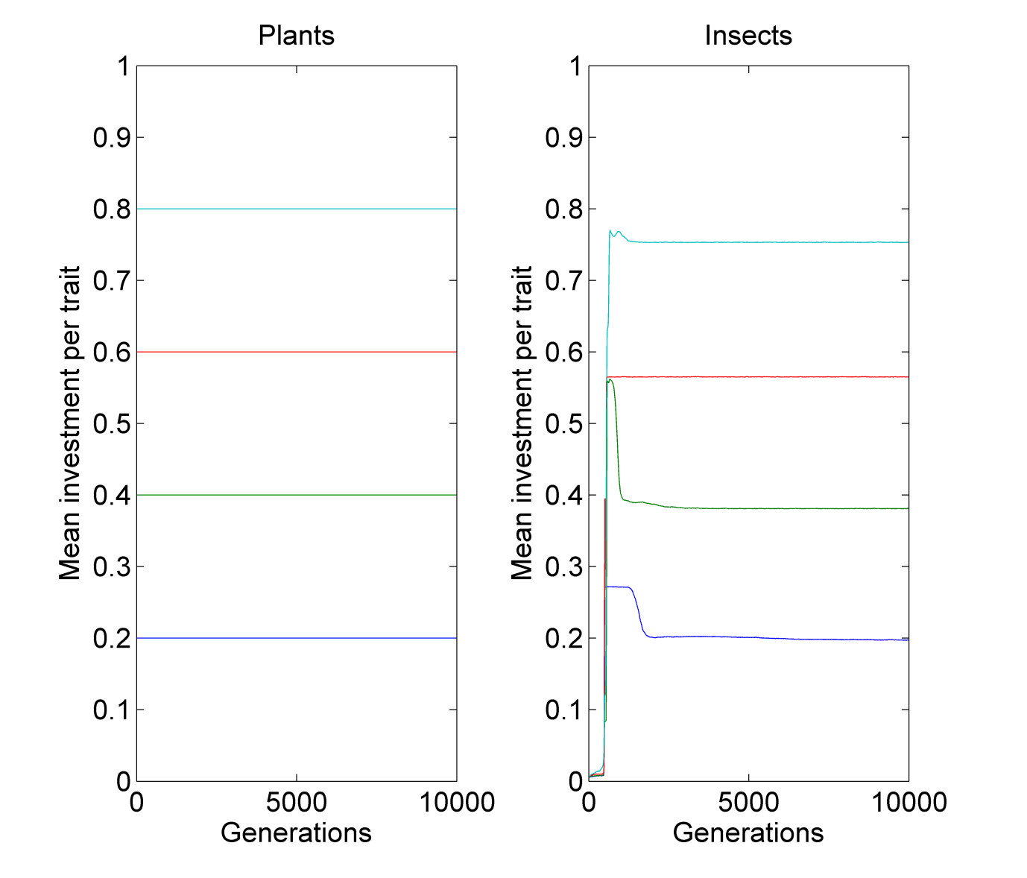

b

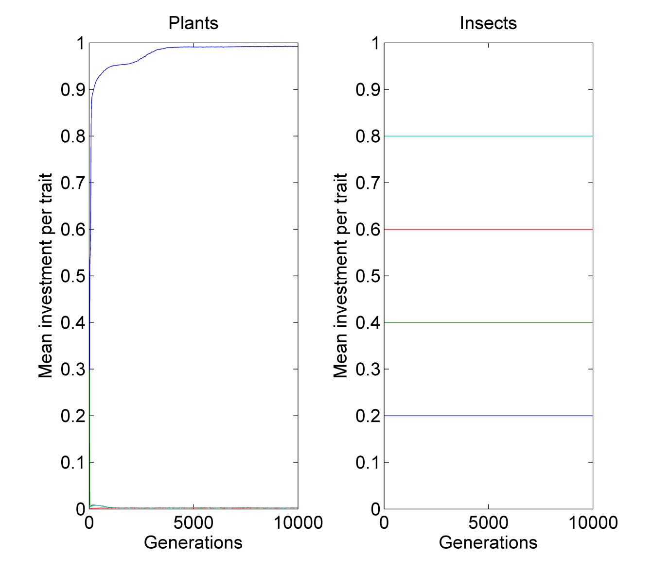

**Figure 2**

**Figure 3**

**Figure 4**

**Figure 5**

1. One trait

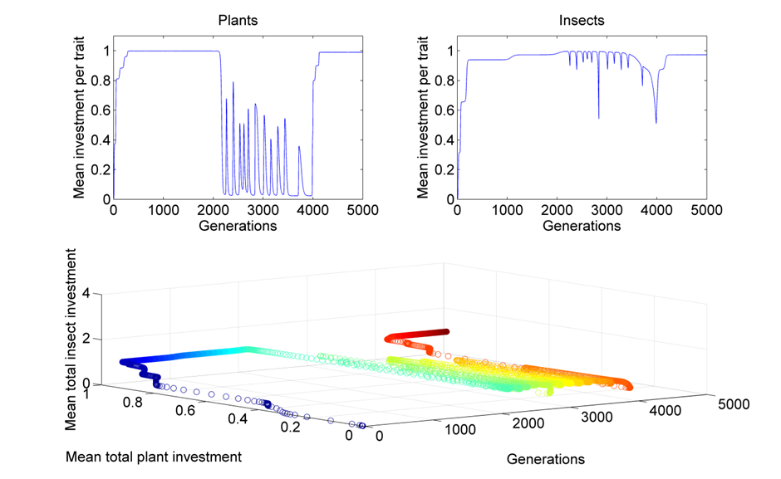

1. Two traits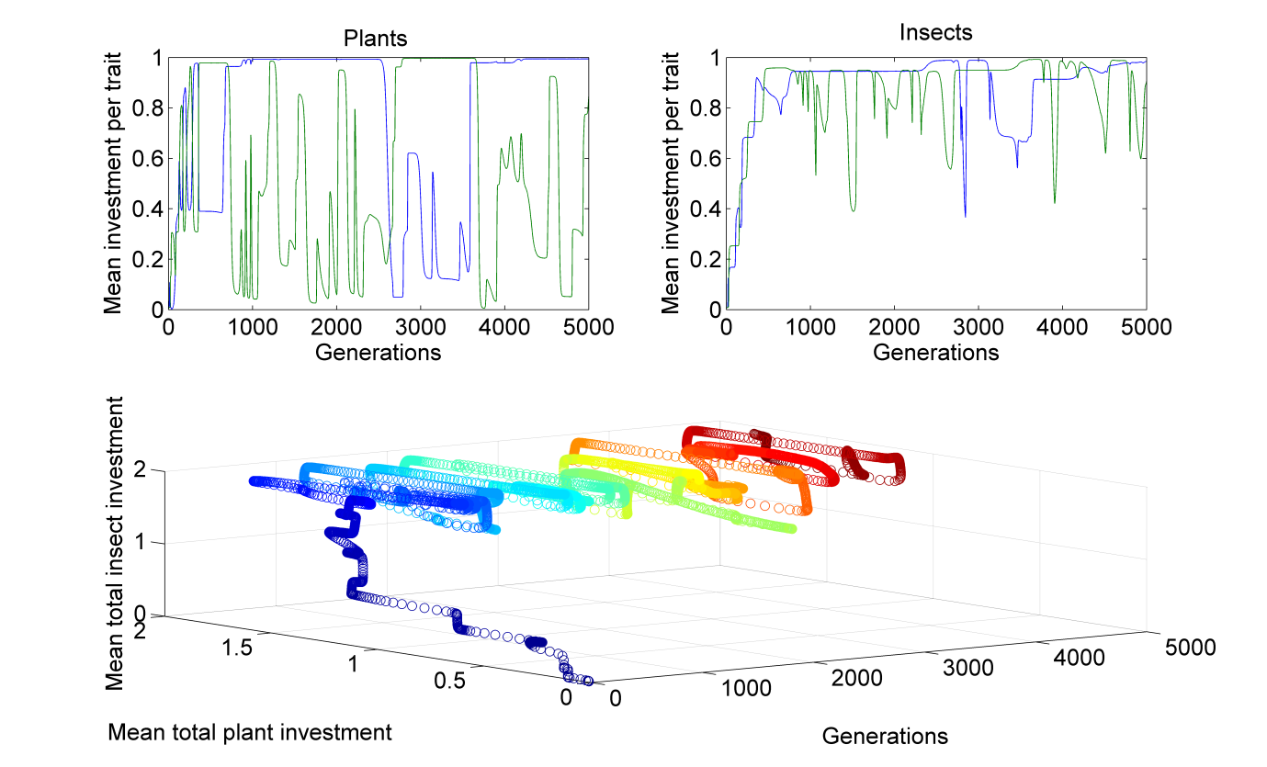
2. Four traits

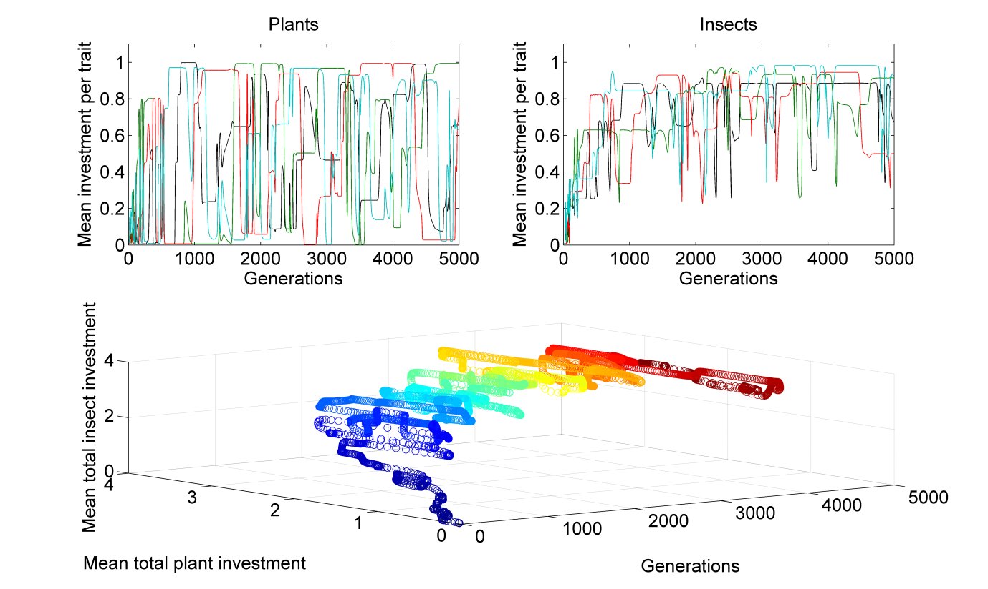

1. Eight traits

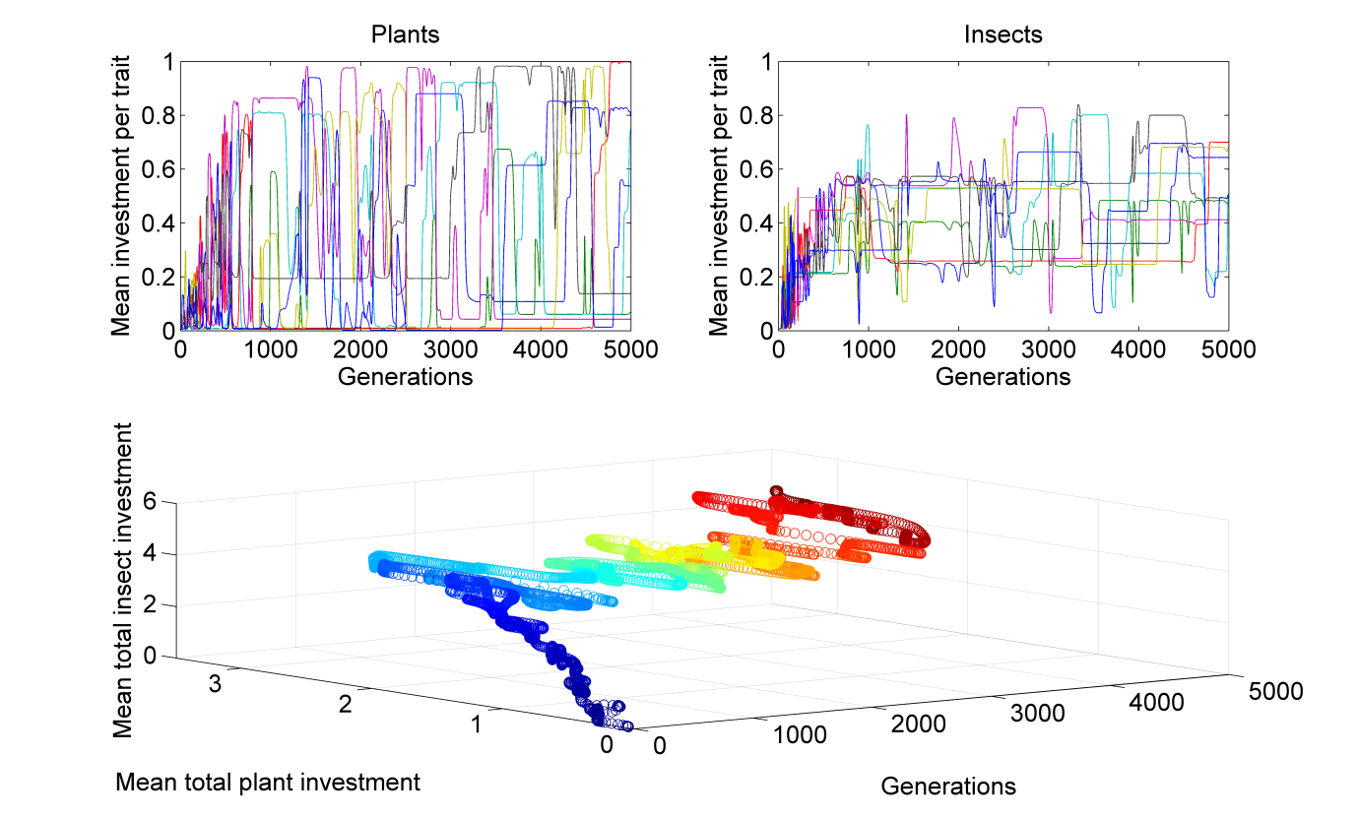

**Figure 6**



**Figure 7**



**Figure 8**

**Figure 9**

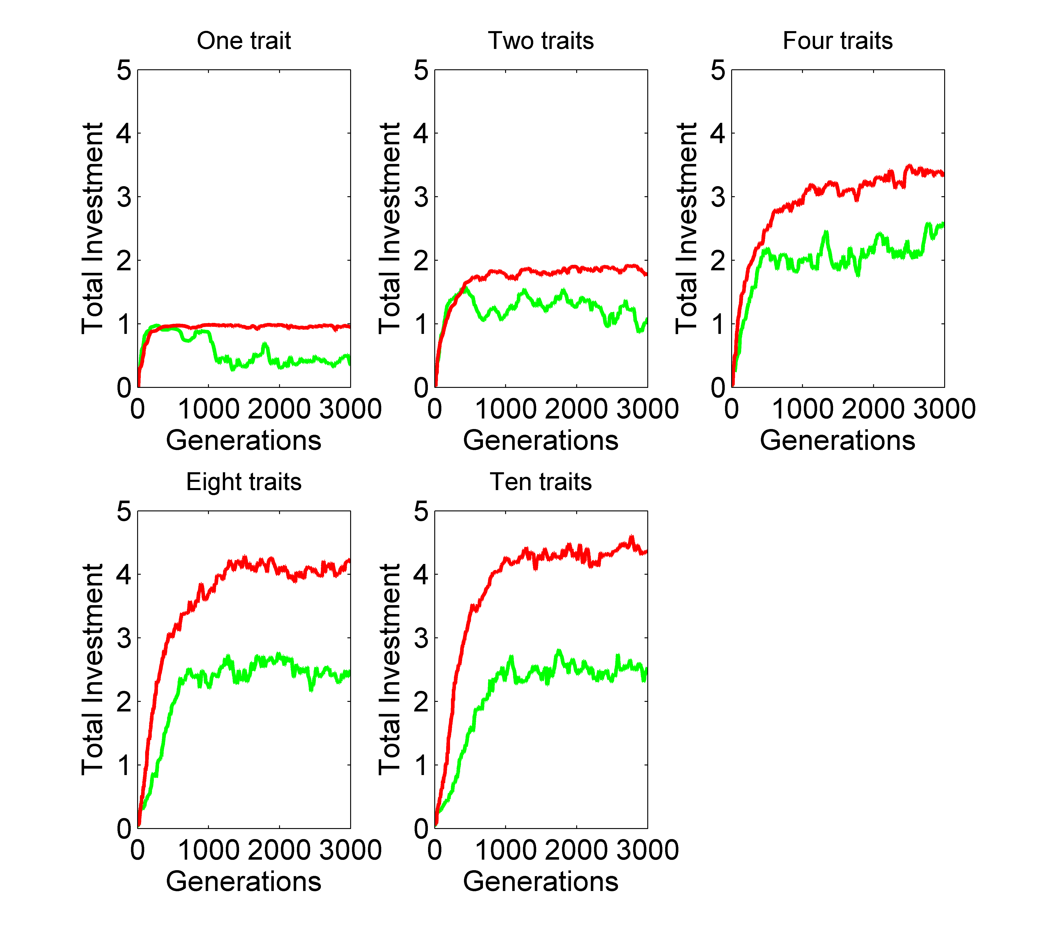

**Table 1: number of generations (to the nearest 100) until the arms race slows and ends**

Measured as the first set of sequential 100 generation sets at which the correlation coefficient between generation number and aggregated trait value falls below 0.1

|  |  |  |  |  |  |  |
| --- | --- | --- | --- | --- | --- | --- |
|  | No cost |  | Low cost |  | High cost |  |
| Trait number | Plant | Insect | Plant | Insect | Plant | Insect |
| 1 | 700 | 1200 | 300 | 600 | 400 | 1000 |
| 2 | 1300 | 2400 | 400 | 600 | 200 | 300 |
| 3 | 1600 | 5800 | 500 | 1100 | 400 | 600 |
| 4 | 2900 | 12700 | 700 | 900 | 600 | 300 |
| 5 | 2900 | 12700 | 700 | 900 | 600 | 300 |
|  |  |  |  |  |  |  |