Table 1. Sources of rainfall data used in the construction of the composite Carlisle record. The three primary records used as the basis for the reconstruction are highlighted in bold, with approximated elevations given in italics N.B. The first initial of the earliest observer is reported as Dr. J. Carlyle by Craddock (1976) and Jones (1983) and as Dr. G. Carlyle by the Bishop of Carlyle (1768)
Station name | Station ID | Observer | Elevation (m) | Years | Notes
Carlisle Abbey Street | 13064 | Dr. J. Carlyle | 35 | 1757-1783 | Start of rainfall measurement in Carlisle. Gauge sited on a wall (Craddock 1976).
Dumfries | - | Dr. Copeland | 50 | 1775-1793 | 1775-1776 values copied from the Dumfires Weekly Journal (decadal year books, UK Met Office archive).
Wigton, Aikbank | - | Rev. J. Golding | 38 | 1792-1809 | No accompanying metadata with measurements recorded in decadal year books (UK Met Office archive).
Carlisle Shaddongate | 13065 | Mr Pitt | 12 | 1801-1824 | Rainfall measurement recommenced in Carlisle. Copper vessel raingauge with funnel and tube. Sited on a garden wall 12ft above the ground (Barnes 1930).
Wigton Cumberland | - | J. Pemberton | 38 | 1822-1826 | Aug, Oct 1822; Jan, Oct, Dec 1824; and Jan 1825 monthly totals in decadal yearbooks identfied as low compared to values reported in North-Western Naturalist (September 1943) by G. Manley (1944). Values provided by J. Pemberton in a letter to the secrertaries of the Yorks. Phils. Soc., 1826. (decadal year books, UK Met Office archive).
Applegarth Manse | 13176 | Rev. W. Dunbar | 54 | 1827-1850 | No accompanying metadata with measurements recorded in decadal year books (UK Met Office archive).
Carlisle Parhambeck Church | 13067 | Rev. Rees | 15 | 1845-1862 | No accompanying metadata with measurements recorded in decadal year books (UK Met Office archive).
Carlisle Cemetery | 13066 | - | 35 | 1860-1981 | Some monthly values during 1860-1862 estimated in archive record: 1860-1920. Interpolated from a nearby location. In 1865 rain gauge on level with the ground, enclosed by own railings 3ft from the gauge and the rails 4-5 ft high. No high trees, site elevated and exposed (decadal year books, UK Met Office Archive).
Carlisle Willow Holmes Wks | 13068 | - | 12 | 1942-current | Missing data: 1964, 1973, Nov 1989 and Jan 2005 in digital record (British Atmospheric Data Centre)
HadNWEP | - | - | - | 1873-2013 | Monthly homogenised regional precipitatiopn series for northwest England (Alexander and Jones 2001).

Table 2. Details of linear regression analyses performed for each stage (A, B, and C) including correction factors and strength of statistical relationship between stations
 | Dependent variable | Independent variable | Overlap period | Slope (b) (correction factor) | Intercept (a) | R²
A | 13064 | Dumfries | 1775-1783 | 0.556 | 5.944 | 0.673
B | 13065 | Wigton Aikbank | 1801-1809 | 0.748 | 7.082 | 0.760
 | 13065 | Wigton Cumberland | 1822-1824 | 0.696 | 16.672 | 0.729
C | 13066 | 13067 | 1860-1862 | 0.953 | 1.115 | 0.957
 | 13066/13067* | 13176 | 1845-1850 | 0.760 | 6.788 | 0.582
 | 13066 | 13068 | 1961-1981 | 0.939 | 0.320 | 0.964
 | 13066/13068* | HadNWEP | 1950-2005 | 0.701 | 5.033 | 0.719
* Adjusted values to primary station 13066 compared with independent variable

Table 3. Analysis of monthly rainfall for Carlisle and other long rainfall records available for northwest, northeast and southern England calculated on the 1873-1971 period common to all records
Site | Total (mm) | Mean (mm) | St. Deviation (mm) | Maximum (mm) | Minimum(mm) | Correlation (r)
Carlisle | 79858.07 | 67.22 | 35.88 | 242.32 | 2.00 | -0.01
Manchester | 90897.57 | 76.51 | 40.85 | 288.00 | 6.30 | -0.01
Appleby | 88178.20 | 74.22 | 41.28 | 230.30 | 1.30 | -0.01
Lake District | 212279.92 | 178.69 | 102.90 | 638.45 | 1.80 | 0.03
HadNWEP | 100612.60 | 84.69 | 40.19 | 245.40 | 3.70 | -0.01
Durham Observatory | 64233.68 | 54.07 | 31.56 | 209.70 | 1.30 | 0.02
Radcliffe Observatory | 65475.12 | 55.11 | 31.97 | 192.90 | 0.60 | 0.01

Table 4. Top 10 wettest and driest years at Carlisle during 1757-2012
Wettest Years |  | Driest Years
Year | Rainfall (mm) | Year | Rainfall (mm)
1903 | 1199.9 | 1855 | 546.2
1877 | 1157.0 | 2003 | 550.6
1954 | 1137.7 | 1788 | 550.9
2012 | 1122.9 | 1955 | 565.4
1839 | 1009.1 | 1784 | 568.0
1900 | 1004.8 | 1996 | 569.1
1768 | 1001.6 | 1989 | 572.2
1967 | 1001.0 | 1933 | 579.4
2008 | 996.2 | 2010 | 589.2
1916 | 989.8 | 1870 | 591.3

Table 5. Top 10 wettest and driest seasons during 1757-2012
Winter |  |  | Spring |  |  | Summer |  |  | Autumn
Year | Rainfall (mm) |  | Year | Rainfall (mm) |  | Year | Rainfall (mm) |  | Year | Rainfall (mm)
Wettest
1764 | 375.7 |  | 1947 | 255.8 |  | 1838 | 388.2 |  | 1954 | 471.1
1834 | 349.1 |  | 1811 | 249.4 |  | 1930 | 387.0 |  | 1773 | 417.0
1995 | 336.3 |  | 1818 | 248.2 |  | 2008 | 384.7 |  | 1903 | 403.4
1903 | 318.5 |  | 1983 | 237.2 |  | 1877 | 380.1 |  | 1779 | 377.3
1877 | 318.1 |  | 1993 | 229.7 |  | 1956 | 372.4 |  | 1944 | 369.0
1796 | 306.6 |  | 1908 | 229.6 |  | 1846 | 367.1 |  | 1772 | 365.4
1853 | 305.1 |  | 1920 | 229.2 |  | 1980 | 365.1 |  | 1967 | 364.3
1925 | 303.8 |  | 1815 | 222.8 |  | 2012 | 362.7 |  | 1938 | 361.8
1869 | 302.5 |  | 1903 | 217.9 |  | 1954 | 351.3 |  | 1839 | 350.6
1860 | 301.3 |  | 2006 | 216.2 |  | 1900 | 350.0 |  | 1918 | 339.7
Driest
1891 | 39.0 |  | 1776 | 68.0 |  | 1995 | 76.8 |  | 1915 | 77.3
1814 | 64.3 |  | 1760 | 70.6 |  | 1983 | 77.8 |  | 1805 | 78.7
1964 | 68.1 |  | 1936 | 71.1 |  | 1976 | 85.3 |  | 1993 | 109.9
1766 | 70.6 |  | 1875 | 76.2 |  | 1800 | 90.6 |  | 1774 | 116.5
1763 | 71.2 |  | 1918 | 77.2 |  | 1847 | 109.4 |  | 1920 | 120.1
1845 | 76.2 |  | 1806 | 79.5 |  | 1821 | 111.8 |  | 2003 | 120.1
1854 | 78.2 |  | 1870 | 79.8 |  | 1869 | 112.0 |  | 1955 | 122.5
1778 | 79.4 |  | 1783 | 80.6 |  | 1984 | 114.3 |  | 1933 | 123.3
1855 | 82.0 |  | 1984 | 81.3 |  | 1832 | 120.1 |  | 1972 | 125.2
1963 | 85.1 |  | 1929 | 81.7 |  | 2003 | 120.6 |  | 1922 | 126.1

Figures
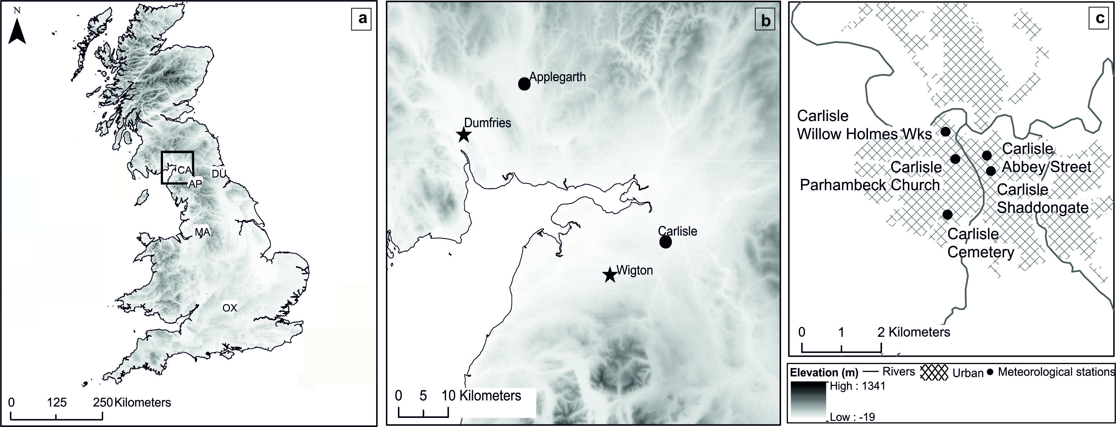
Figure 1. a) Location of sites and rainfall records used ; b) Locations of meteorological stations used to construct the composite rainfall record for Carlisle, with approximate locations of where the Wigton and Dumfries meteorological observations were made shown by a star; and c) Locations of meteorological stations in Carlisle

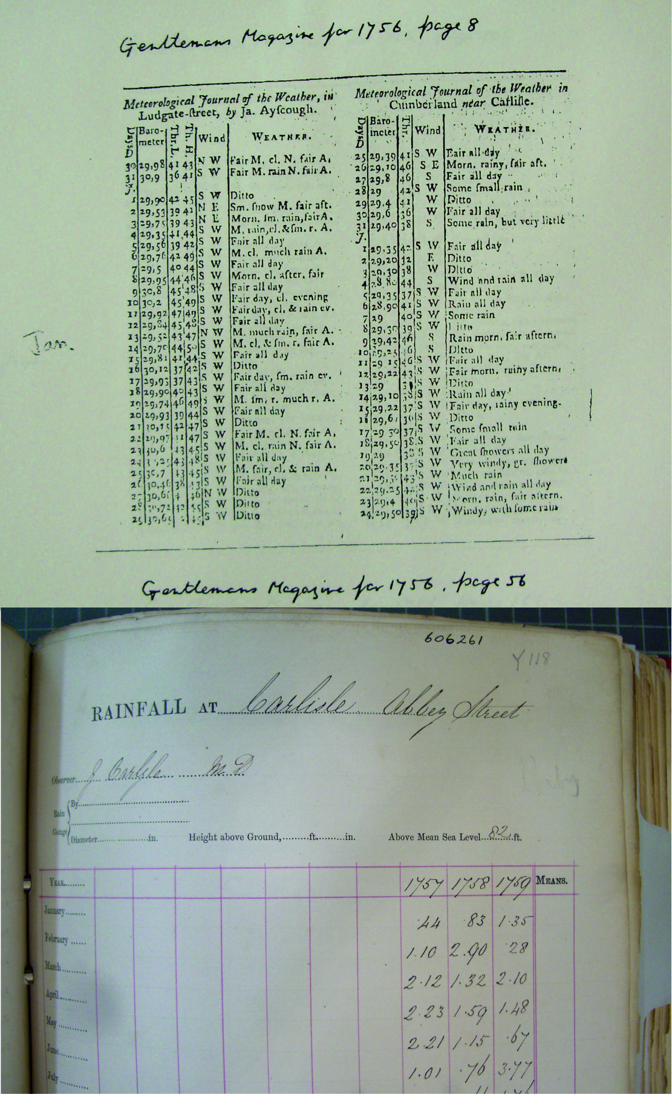
Figure 2. An example of a meteorological journal made in Carlisle, Cumberland (former county name of Cumbria), published in Gentleman’s Magazine for January 1756 (top) and a loose leaf page of Dr Carlyle’s rainfall measurements archived in the Meteorological Office’s decadal yearbooks (bottom). Source: UK Meteorological Office Archive, Exeter

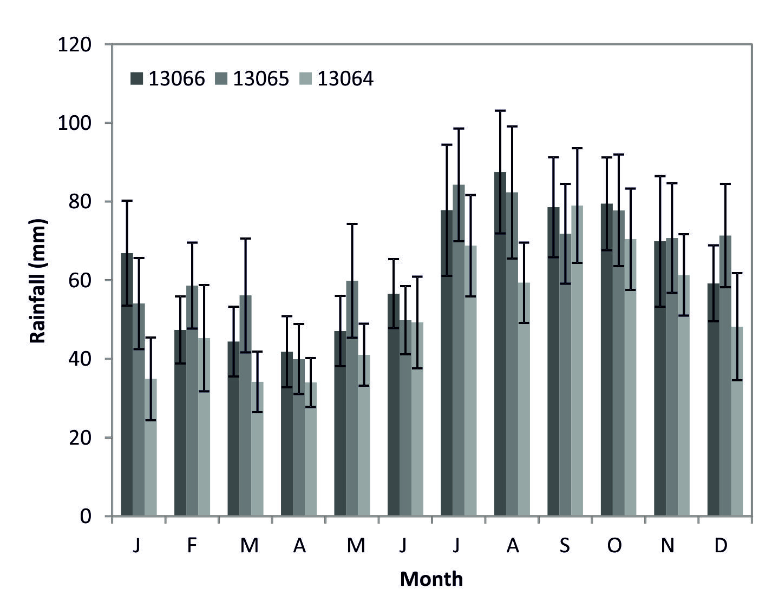

Figure 3. Monthly mean rainfall (Jan-Dec) for 24 years with two standard error bars calculated for the three primary meteorological stations

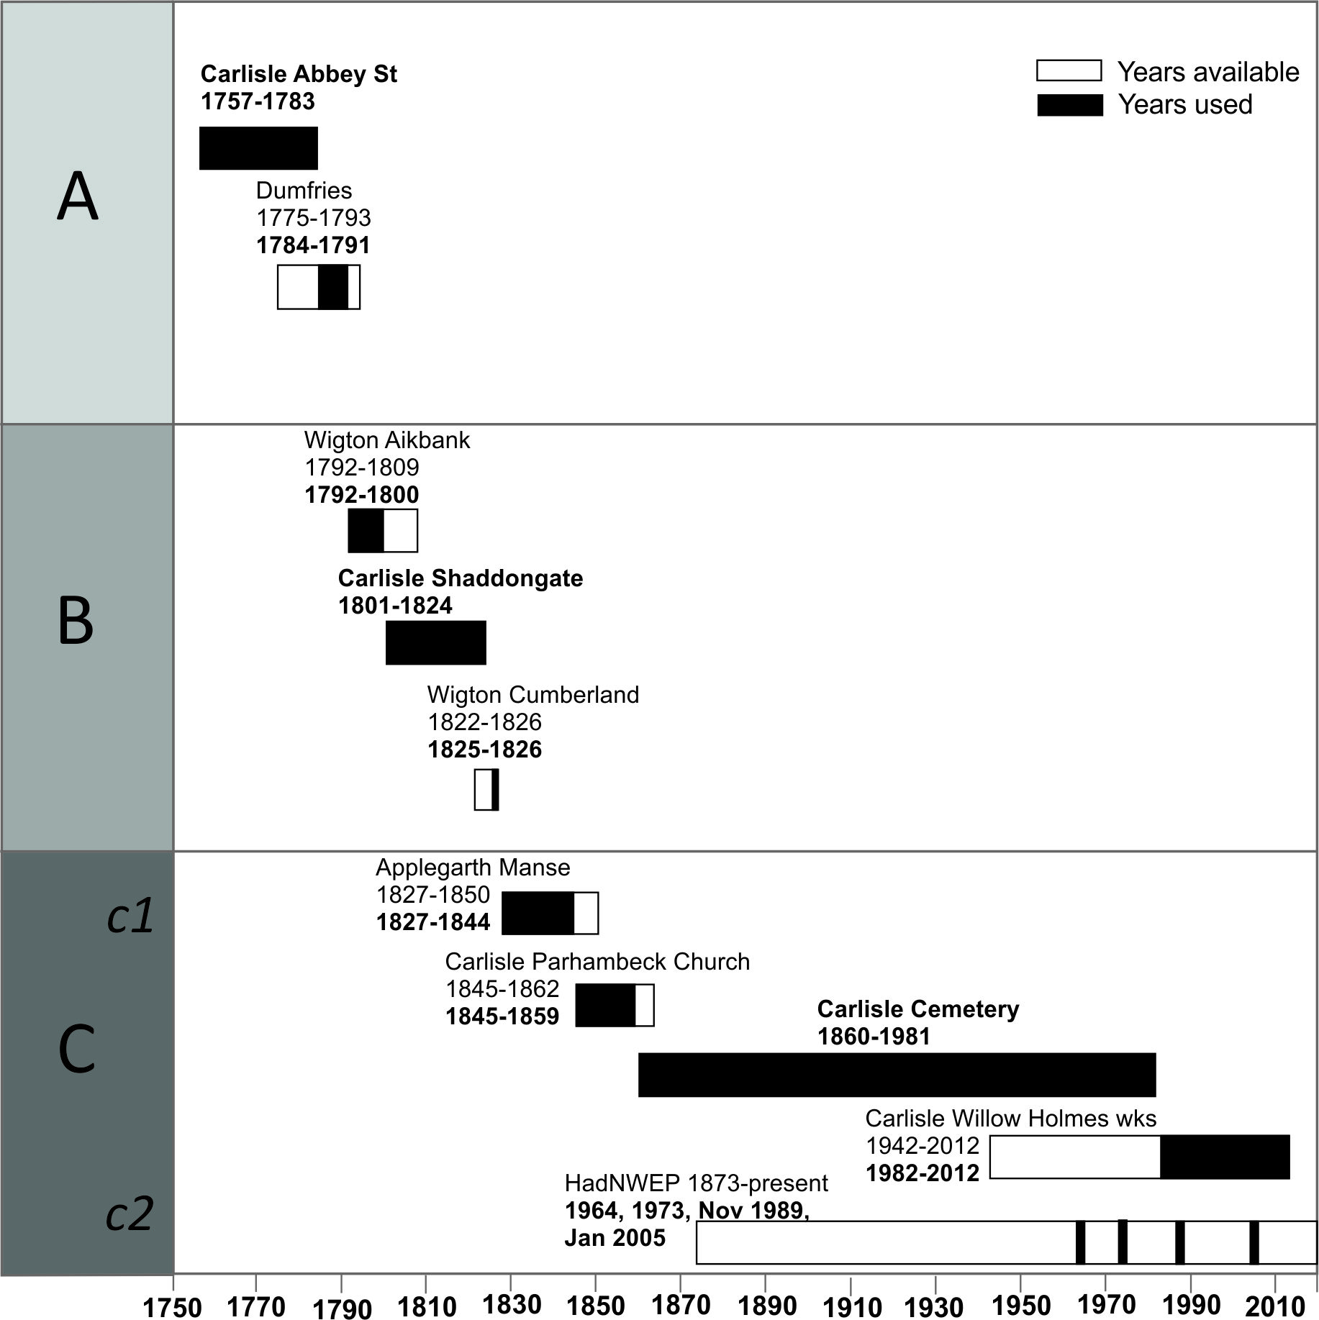

Figure 4. Sources of rainfall data used in the construction of the composite rainfall record for Carlisle for 1757-2012. Rectangular boxes show all years of available data, with shaded areas showing actual years used to construct the rainfall record. Primary station names highlighted in bold and stages of linear regression show by A, B and C shading

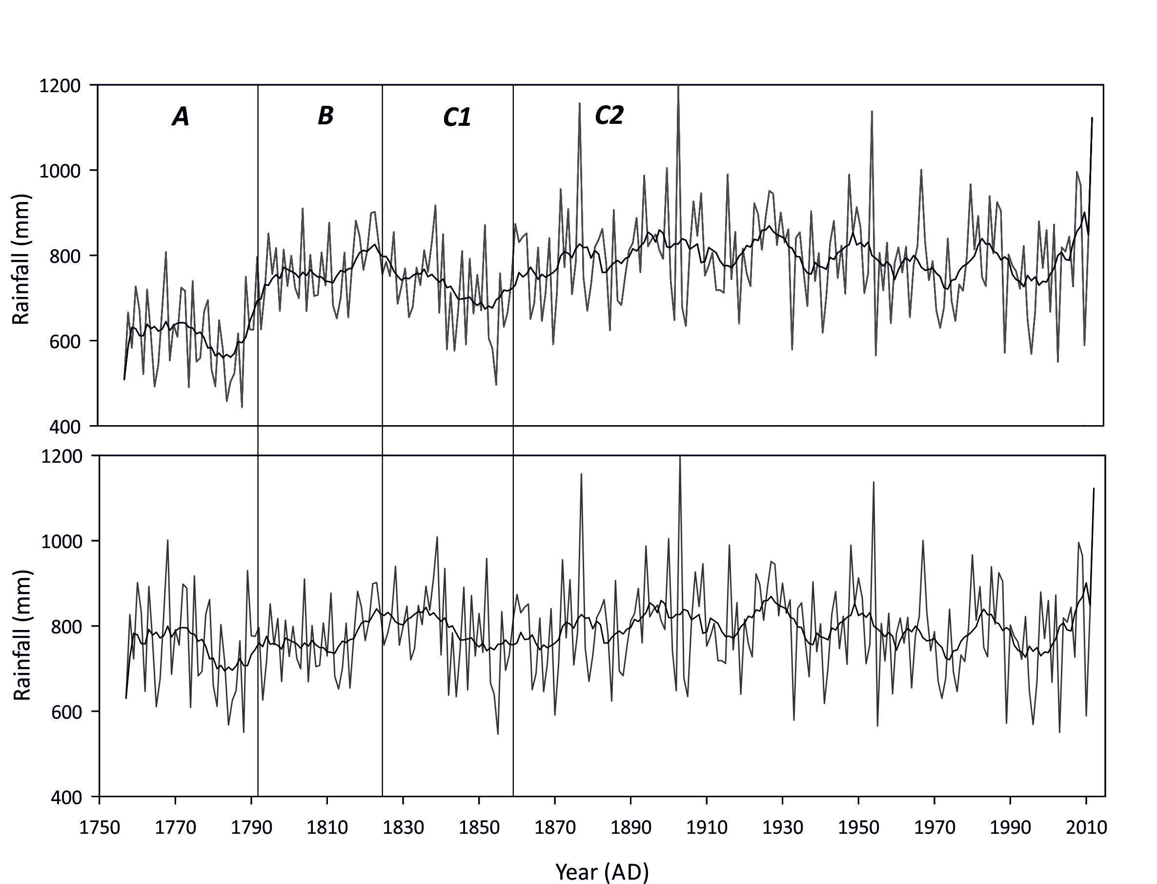

Figure 5. Composite annual rainfall record showing inhomogenous sections A and C1 before 24% and 10% adjustment factors applied (top) and after (bottom)

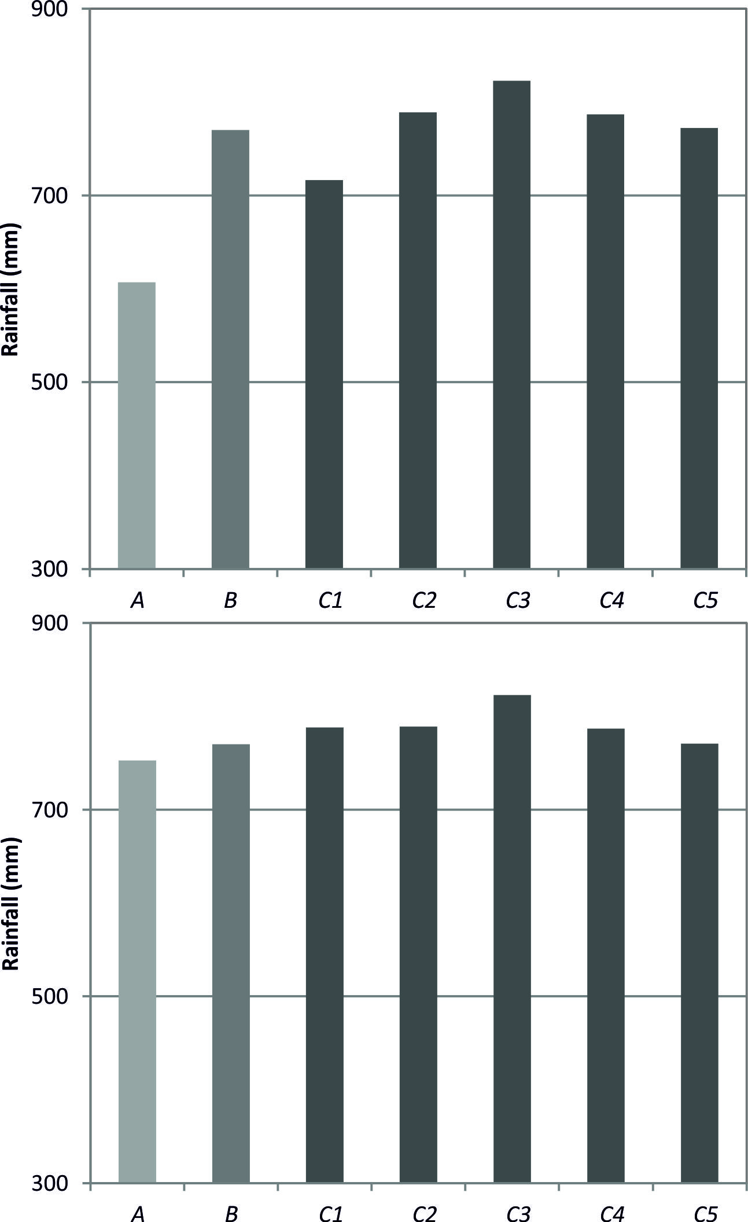

Figure 6. Annual average rainfall totals calculated using 33 years of data from each part of the composite Carlisle rainfall record: A)1757-1789, B) 1792-1824, C1) 1827-1859, C2) 1862-1894, C3) 1897-1929, C4) 1932-1964, and C5) 1967-1999. Top after linear regression, bottom after 24% adjustment to A and 10% adjustment to C1
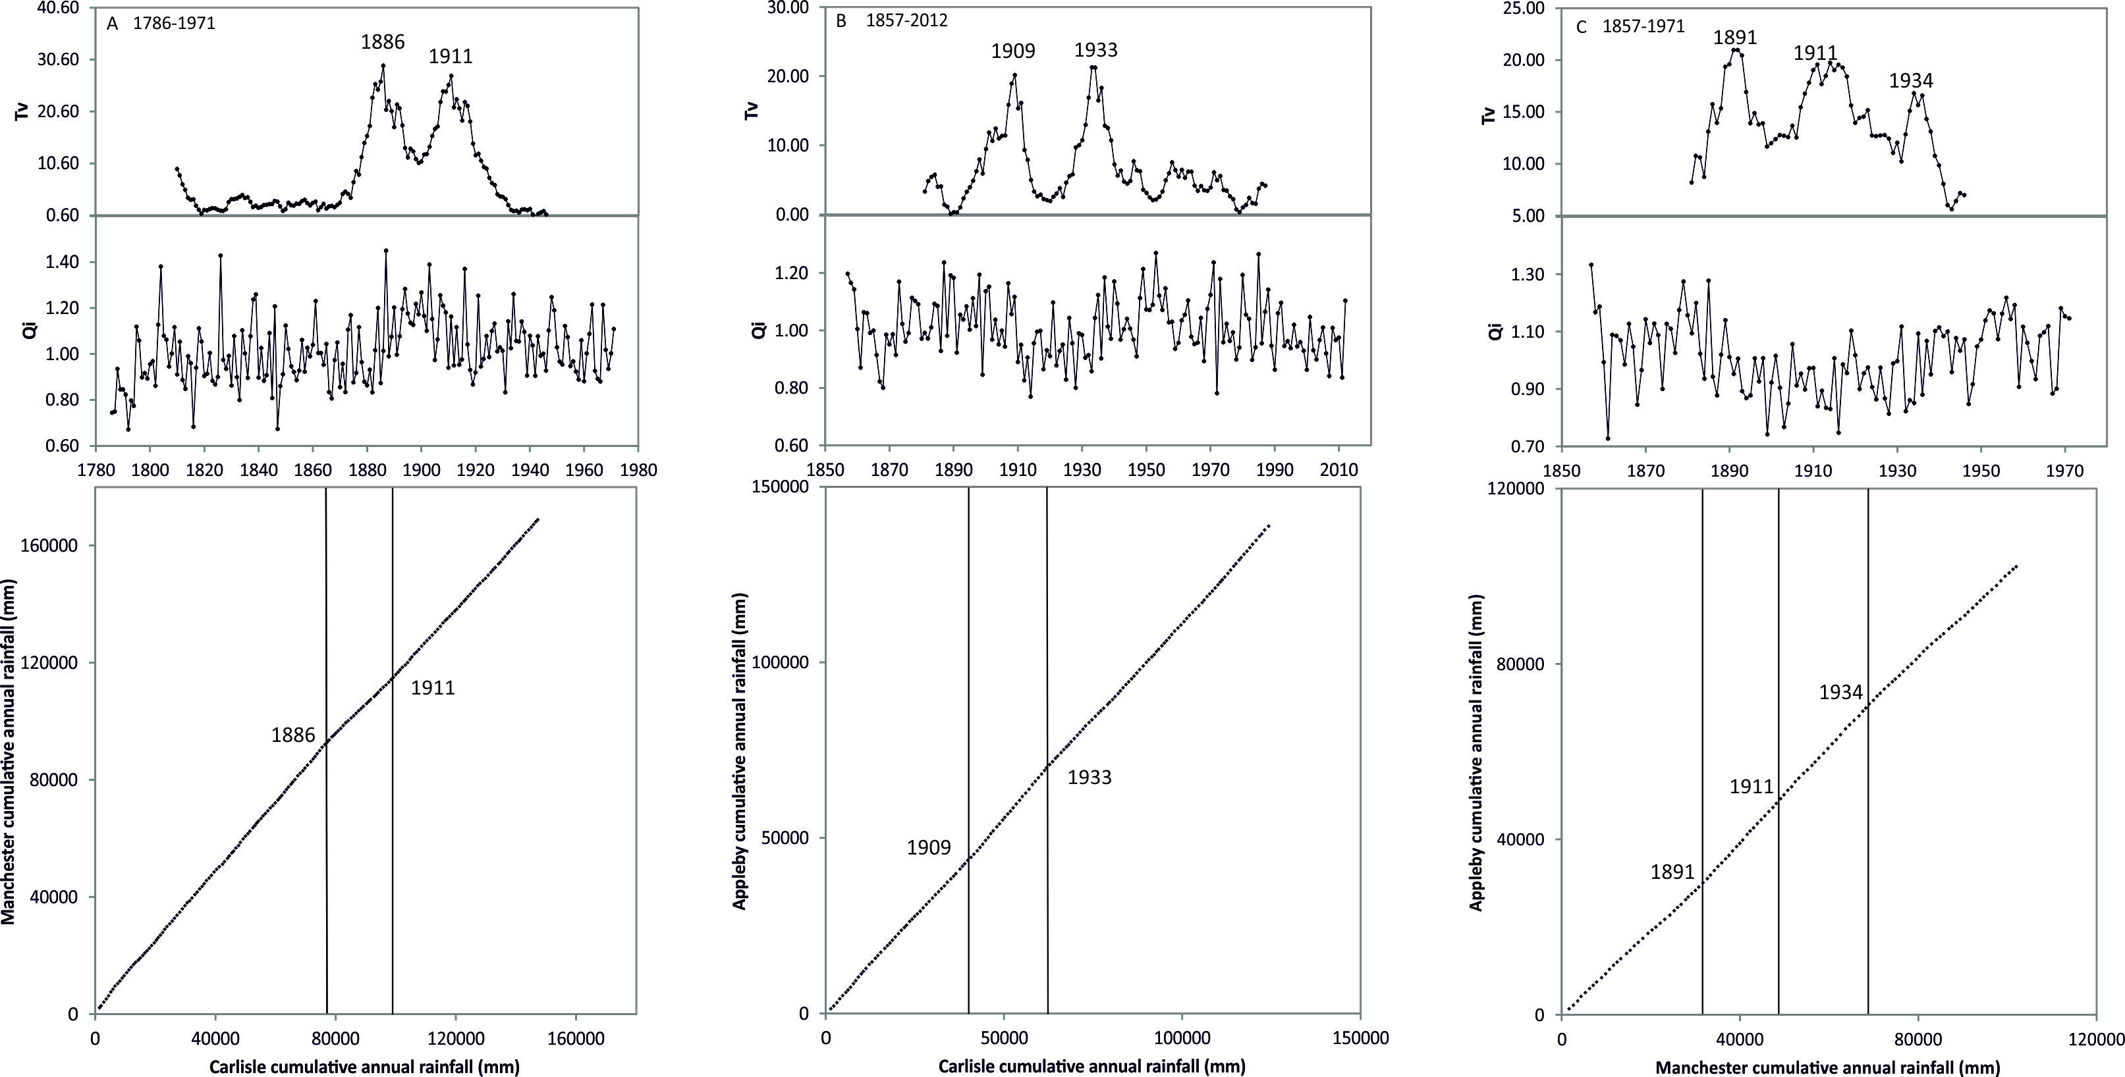

Figure 7. Test statistic (Tv) series (Top) and ratio Qi series (middle) performed following the SNHT approach of Alexandersson (1986). Chosen critical threshold level for Tv is 7.75 at T₉₅, the 95 percent level, for n=25. Double mass curve of cumulative annual rainfall totals (bottom) for A) Carlisle and Manchester, 1786-1971; B) Carlisle and Appleby, 1857-2012; and C) Manchester and Appleby, 1857-1971
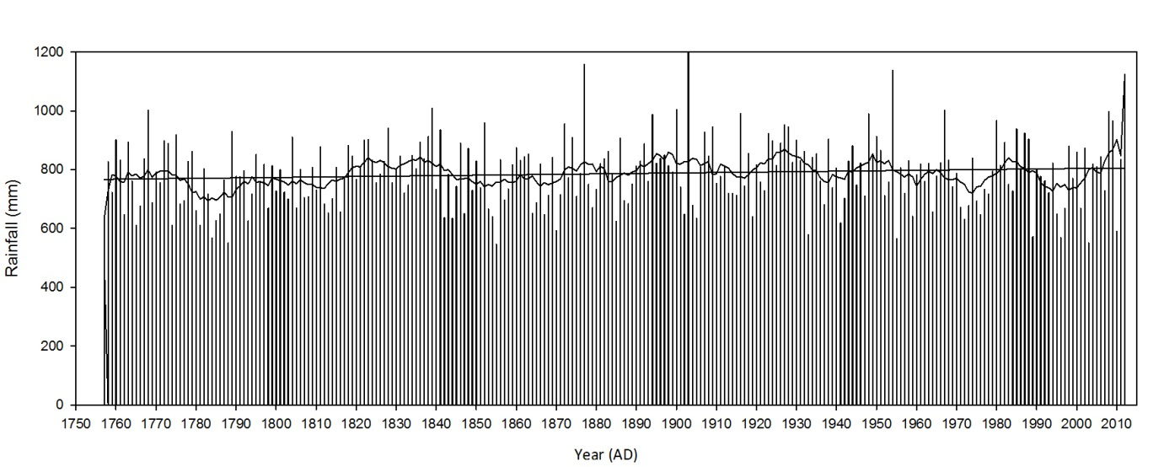
Figure 8. Annual rainfall totals for Carlisle: 1757-2012 with 10 year moving average and linear trend line (r= 0.10, p=0.11)
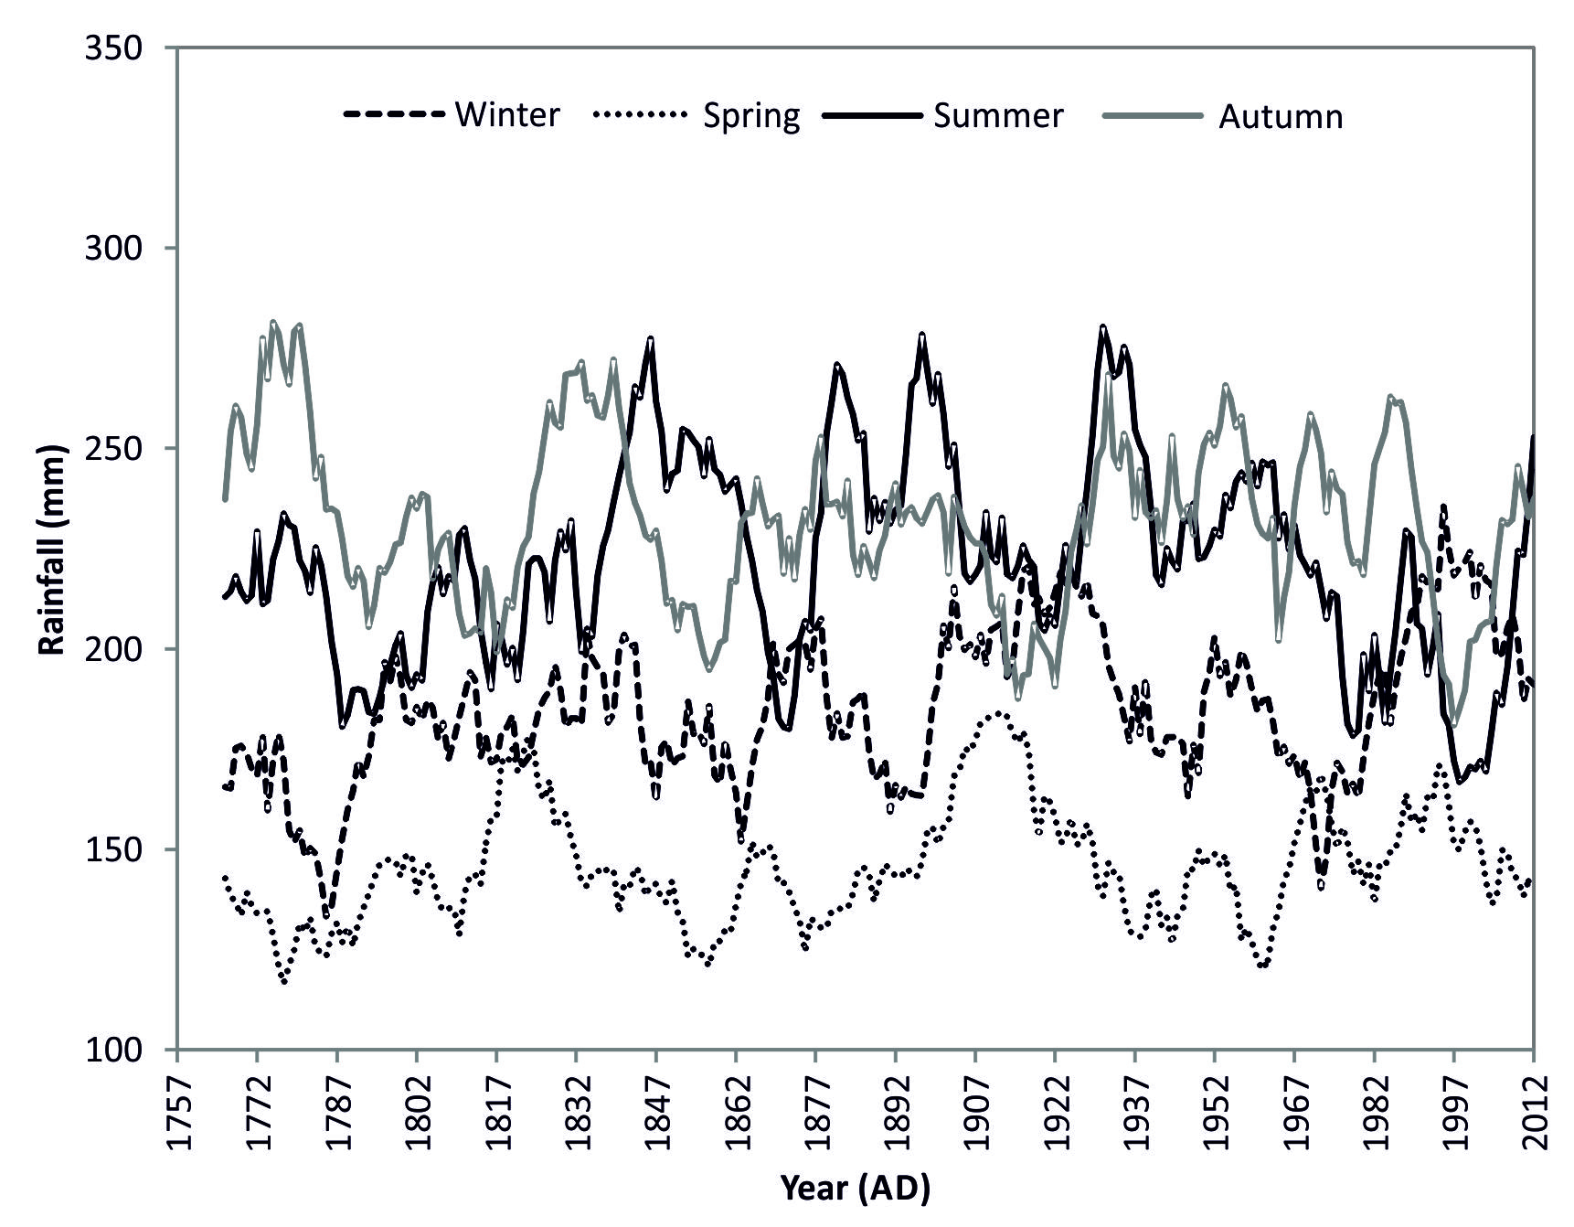
Figure 9. Seasonal rainfall totals at Carlisle shown by ten year moving averages

