DOI: 10.1002/ ((please add manuscript number))
Article type: Full Paper

Controlling Phase Assemblage in a Complex Multi-Cation System; Phase Pure Room Temperature Multiferroic (1-x)BiTi_{(1-y)/2}Fe_{y}Mg_{(1-y)/2}O₃ – xCaTiO₃

Pranab Mandal, Michael J. Pitcher, Jonathan Alaria, Hongjun Niu, Marco Zanella, John B. Claridge*, and Matthew J. Rosseinsky*

Dr. P. Mandal, Dr. M. J. Pitcher, Dr. H. Niu, Dr. M. Zanella, Dr. J. B. Claridge, Prof. M. J. Rosseinsky
Department of Chemistry, University of Liverpool L69 7ZD, UK
E-mail: j.b.claridge@liv.ac.uk, m.j.rosseinsky@liv.ac.uk

Dr. J. Alaria
Department of Physics, University of Liverpool L69 7ZE, UK

Keywords: room temperature multiferroic, magnetoelectric, magnetic impurity, powder neutron diffraction, ferroelectric

A room temperature magnetoelectric multiferroic offers the possibility of applications such as magnetoelectric random access memory. Bulk samples of the perovskite (1-x)BiTi_{(1-y)/2}Fe_{y}Mg_{(1-y)/2}O₃ – xCaTiO₃ (BTFM – CTO) are simultaneously ferroelectric, weakly ferromagnetic and magnetoelectric at room temperature. Single-phase bulk samples of BiFeO₃-related materials are often difficult to synthesise as they are prone to the formation of magnetic secondary phases; this hinders precise quantitative characterisation of intrinsic magnetic and magnetoelectric properties. In BTFM-CTO the volatility of bismuth oxide, and the complex subsolidus reaction kinetics, cause a microscopic ferrimagnetic spinel impurity to form. Here we devise a controlled synthesis route to single-phase bulk samples of BTFM-CTO and determine their intrinsic properties, exemplified by the composition x = 0.15, y = 0.75 which shows a saturated magnetisation of 0.0097 μ_{B} per Fe, a linear magnetoelectric susceptibility of 0.19(1) ps m⁻¹ and a polarisation of 66 μC cm⁻² at room temperature. The onset of weak ferromagnetism and linear magnetoelectric coupling are shown to coincide with the onset of bulk long range magnetic order by neutron diffraction. The synthesis strategy developed here will be invaluable as the phase diagram of BTFM-CTO is explored further, and as an example for the synthesis of other compositionally complex BiFeO₃-related materials.

1. Introduction
A multiferroic material^{[1]} combines ferroelectricity and ferromagnetism in the same phase. The synthesis of a bulk material where both types of long range order are present at room temperature is challenging because the electronic structure requirements of these two states are different and in competition with each other. A strong magnetoelectric coupling^{[2]} between the order parameters would lead to switching of the electrical polarisation (P) by the magnetic field H, or the magnetisation (M) by the electric field E, which has been proposed as a possible candidate to replace the presently used volatile random access memories (RAM).^{[3,4]} A magnetoelectric multiferroic memory would benefit from non-volatility and non-destructive reading of magnetic RAM and the low power, high speed features of ferroelectric RAM.^{[3,4]} Bulk BiFeO₃ exhibits both ferroelectric and long range magnetic order at room temperature, however it is a pure antiferromagnet because the cycloidal magnetic ordering leads to cancellation of the Dzyaloshinsky-Moriya interaction-mediated canted moments, and also prevents any linear magnetoelectric effect.^{[5-8]} The cycloidal ordering can be destabilised in strained and nanostructured films of BiFeO₃ leading to finite magnetisation.^{[9,10]} Electric field-induced switching of magnetisation of a ferromagnetic layer coupled to BiFeO₃ has been demonstrated in thin film devices.^{[10,11]} Powder neutron diffraction and Mössbauer studies show that PbFe_{0.5}Ta_{0.5}O₃, PbFe0_{.5}Ta_{0.5}O₃–PbTiO₃ solid solution and the Aurivillius phases Bi_{n+1}Fe_{n-3}Ti₃O_{3n+3} (3.5 ≤ n ≤ 7) are not long range magnetically ordered at room temperature^{[12-15]}: field -induced switching of ferroelectric domains has been demonstrated in lamellae of [Pb(Zr_{0.53}Ti_{0.47})O₃]_{0.6}—[Pb(Fe_{0.5}Ta_{0.5})O₃]_{0.4} and thin film Bi₆Ti_{2.8}Fe_{1.52}Mn_{0.68}O₁₈ (n = 5) at room temperature^{[16,17]}. Recently, we have reported a generic design route for room temperature multiferroic materials that integrates a percolating network of magnetic ions to produce long range magnetic order with enhanced ferroelectric switching properties at the morphotropic phase boundary (MPB) between two polar phases with different polarisation directions. This was exemplified in the perovskite oxide (1-x)BiTi_{(1-y)/2}Fe_{y}Mg_{(1-y)/2}O₃ – xCaTiO₃ (BTFM – CTO) system, using techniques that definitively proved the coexistence and switchability of both orders within the perovskite structure.^{[18]} The order parameters are not only switchable at room temperature but are also coupled as demonstrated by the linear magnetoelectric effect.^{[18]} Structure at the MPB is complex and has been subject to intense studies; for example both single and multiple phase models have been suggested for PbZr_{1-x}Ti_{x}O3 (PZT).^{[19,20]} Powder X-ray diffraction (PXRD) patterns of BTFM – CTO compositions at the MPB can be fitted to a two phase model with rhombohedral (R3c) and orthorhombic (Pna2₁) unit cells, or to a single monoclinic unit cell in space group Pa (which is a sub group of R3c and Pna2₁) using the Lebail method.^{[18]} The compositions with y ≥ 0.60 reported so far contain small amounts of ferrimagnetic spinel impurities, which complicate the quantitative characterisation of their intrinsic magnetic and magnetoelectric properties. Such impurities commonly form as kinetic products in systems with a mixture of refractory and volatile starting reagents, as the high temperatures required to drive the reaction to completion also promote the evaporation of the volatile component (e.g., phase pure PbMg_{1/3}Nb_{2/3}O₃ (PMN) is difficult to synthesise from refractory MgO, Nb₂O₅, and volatile PbO due to the formation of Pb-deficient pyrochlore impurities^{[21]}). Such secondary phases are common in BiFeO₃-related compounds and are often difficult to eliminate.^{[22-24]}
The synthesis and processing of single phase samples of the ternary oxide BiFeO₃ is complicated by the ready formation of sillenite (Bi₂₅FeO₃₉)-type and mullite (Bi₂Fe₄O₉)-type secondary phases^{[25-27]} which exist in thermodynamic equilibrium with BiFeO₃ between 720 – 1040 K^{[28]}, and whose stability is increased by the presence of trace impurities in the starting materials Bi₂O₃ and Fe₂O₃.^{[25]} Attempts to avoid the formation of these phases by sintering at a higher temperature of 1098 K (above the melting point of Bi₂O₃) can lead to volatilisation of bismuth, which promotes the formation of the Fe-rich mullite phase.^{[25]} Phase pure BiFeO₃ can be prepared when the reaction conditions are suitably controlled, e.g., by using ultrapure (99.9995 %) starting materials reacted at 1073 K under sacrificial powder to prevent bismuth loss.^{[25]} The sillenite and mullite phases do not generate strong features in M(H) experiments as they are paramagnetic at room temperature^{[29-31]}, but strongly magnetic impurities have been shown to form in more complex phase fields (e.g., garnet-type R₃Fe₅O₁₂ impurities in quaternary lanthanide-doped Bi_{1-x}R_{x}FeO₃ derivatives)^{[24]} or under different reaction conditions (e.g., spinel-type Fe₃O₄ impurities in nano-crystalline BiFeO₃)^{[22]}. These secondary phases, which may be present in amounts close to or below the sensitivity limits of X-ray diffraction, are undesirable as they make the observed magnetic properties difficult to interpret correctly.
The synthesis of phase pure BiFeO₃ is challenging, but BTFM-CTO has a more complex composition (it contains five different cations versus two for BiFeO₃) offering many more potential kinetic pathways to formation and decomposition that are not available to BiFeO₃. It also contains a combination of refractory and volatile components: a hydrated magnesium carbonate hydroxide is used in place of MgO as a reactive source of Mg during the synthesis of BTFM-CTO to minimise problems with slow reaction kinetics, but the formation of refractory MgFe₂O₄ as an intermediate phase simply re-introduces this problem in-situ. Once formed, the complete consumption of MgFe₂O₄ requires a stoichiometric quantity of a reactive Bi source, a sufficiently high temperature to overcome the slow kinetics and sufficient heating time; the absence of any one of these factors (e.g., by evaporation of Bi₂O₃) would result in residual amounts of MgFe₂O₄ in the product.
This makes the synthesis of phase pure BTFM-CTO challenging, although does not impede the use of methods such as Mössbauer spectroscopy that directly probe magnetic order at each iron nucleus to demonstrate the long-range magnetic order at room temperature in the multiferroic compositions. We report the development of a synthetic route that affords spinel-free multiferroic BTFM – CTO compositions, and measure their intrinsic magnetic, magnetoelectric and ferroelectric properties.
Figure 1. Magnetic properties of spinel-containing samples of 0.85BiTi_{0.10}Fe_{0.80}Mg_{0.10}O₃ – 0.15CaTiO₃ (x = 0.15, y = 0.80). (a) Selected region of a laboratory PXRD pattern, collected for 8 h over the range 5° ≤ 2θ ≤ 130°, with intensity plotted on a logarithmic scale to emphasise the strongest peak of the cubic spinel impurity (asterisk). (b) Temperature evolution of the nuclear (100)_{p} Bragg peak and the most intense magnetic Bragg peak (†) from 20 powder neutron diffraction (PND) patterns in the range 290 - 525 K (Polaris bank 2, 2θ = 26.5°). The dominant magnetic Bragg peak at ~ 4.5 Å is characteristic of G-type antiferromagnetic ordering in a perovskite. (c) Temperature dependence of thermal remanent magnetisation (left axis, blue line) and ratio of the squared magnetic and (100)_{p} nuclear Bragg peak intensities (I²_{mag} / I²₁₀₀) from PND (right axis, filled diamonds), showing that the onset of magnetisation is coincident with long-range magnetic ordering. Error bars represent one standard deviation. (d) Magnetic isotherms at 300 K (T < T_{N}) and 400 K (T > T_{N}). The constriction in the 300 K M(H) marked by the arrows and the superparamagnetic-like feature in the 400 K M(H) isotherm are consistent with the presence of the spinel-type magnetic impurity phase.
2. Results and Discussion
2.1. Identification of the spinel impurity in BTFM – CTO and its contribution to magnetism
Seven compositions in the range x = 0.15, 0.60 ≤ y ≤ 0.90 were prepared by the previously reported synthesis protocol.^{[18]} DC and AC magnetisation measurements on x = 0.15, y = 0.80 in the temperature range 10 – 650 K show only two magnetic ordering transitions at T_{N} = 367 K and T_{N2} = 586 K (Figure 1c and Figure S2a) and none below room temperature; Mössbauer spectroscopy previously demonstrated that the perovskite phase is magnetically ordered at 300 K and this ordering accounts for the transition at T_{N}^{[18]}, whereas T_{N2} matches closely to a nanocrystalline MgFe₂O₄ spinel phase^{[32]}, whose presence is confirmed by PXRD after a sufficiently long data collection time (Figure 1a). The sample exhibits constricted M(H) loops below T_{N} and superparamagnetic-like M(H) loops above T_{N} (Figure 1d) consistent with the presence of a small amount (~0.7 wt% for x = 0.15, y = 0.80) of ferrimagnetic spinel phase. Above T_{N2}, M(H) isotherms are linear (Figure S2c), showing that the only two magnetic phases present are the spinel impurity and the bulk perovskite. These features are common to all of the measured spinel-containing compositions, whose Néel temperatures (T_{N}) are tunable between 205 K and 441 K (Figure S1). Powder neutron diffraction (PND), which provides a crystallographic probe of long range magnetic order that is sensitive to the different phases present, was employed to verify the Néel temperature of the perovskite for two different spinel-containing compositions: x = 0.15, y = 0.60 and 0.80. The 300 K PND pattern shows an intense reflection at 4.57 Å (Figure 1b) that is not present in the PXRD pattern, which is characteristic of G-type antiferromagnetic ordering in perovskite orthoferrites^{[33]}, and is consistent with the 300 K Mössbauer spectra^{[18]}. The disappearance of this magnetic Bragg peak on warming occurs simultaneously with a sharp decrease in magnetisation (T_{N}) in both of the samples that were measured (x = 0.15, y = 0.80 shown in Figure 1c; x = 0.15, y = 0.60 shown in Figure S3), which provides additional confirmation that this component of the magnetisation arises from intrinsic weak ferromagnetism in the perovskite and is consistent with the onset of a large linear magnetoelectric effect.^{[18]}

2.2. Synthesis of single phase (spinel free) BTFM - CTO
The complete scheme for the optimisation of the synthetic procedure, described below, is illustrated in Figure S4 and full descriptions of all synthetic procedures are given in the Supplementary Information. A shortened version of the previously reported synthetic protocol for x = 0.15, y = 0.80^{[18]} was taken as a starting point, which we refer to as Protocol 1. This protocol was then improved systematically until the ferrimagnetic spinel phase was eliminated. The effectiveness of each successive protocol in reducing the ferrimagnetic MgFe₂O₄ impurity was evaluated qualitatively from the shape of their magnetisation isotherms (Figure S8) and quantitatively from the extracted remanent magnetisation values (M_{r}) at 395 K (i.e. above T_{N} for the perovskite but below T_{N2} for the spinel), which are tabulated in Table S1. Protocol 1 produced a sample with remanent magnetisation of 0.0971 A m² Kg⁻¹ at 395 K. The first three iterations (Protocols 2 – 4) involved replacement of the starting reagent MgCO₃·Mg(OH)₂.3H₂O (Alfa Aesar, 99.996 %) with (MgCO₃)₄·Mg(OH)₂·5H₂O (Sigma Aldrich, 99.99 %); the packing of the reaction pellet in a 10-fold excess of sacrificial powder during sintering to minimise the volatilisation of Bi₂O₃; and the introduction of an extra heating cycle prior to pelletising to react the hydroxide and carbonate precursors at moderate temperatures prior to the final sintering. Together this produced a sample with a remanent magnetisation of 0.0190 A m² Kg⁻¹. Further reduction of the remanent magnetisation was gained after Protocols 5 – 6: this involved replacement of the original Bi₂O₃ starting reagent (Alfa Aesar, 99.99 %) by an ultra-pure Bi₂O₃ reagent (Alfa Aesar, 99.9995 %), followed by replacement of the hand grinding step by a second ball milling step (producing M_{r} = 0.0112 A m² Kg⁻¹). By this point the magnetic spinel impurity content is reduced drastically: its presence is evident only from a small opening of the M(H) loop at 395 K (Figure S8f).
To understand the phase evolution as the reaction proceeds, PXRD patterns were collected from each of the intermediate steps of Protocol 6 (Figure S6). During the three-step heating cycle, sillenite (Bi₂₅FeO₃₉) becomes the first major phase to form at 833 K, with the perovskite then forming the dominant phase at 1023 K with sillenite, Bi_{1.6}Ca_{0.4}O_{2.8}, Bi₅FeTi₃O₁₅ and MgFe₂O₄ spinel present as minor components. After the final firing at 1213 K, the sample appears to be a phase-pure perovskite by PXRD but retains a trace amount of magnetic spinel (Figure S8f). Hence Protocol 6 contains only one milling and firing step between the first appearance of MgFe₂O₄ and arrival at the final product, which is insufficient to remove this phase entirely.
This was addressed in the final protocol (Protocol 7) by using TGA-optimised temperatures with intermediate hand grinding for the initial three-step firing, then inserting two extra milling and sintering steps to the final stages of the protocol. The resulting protocol contains three milling and firing steps between the initial formation of MgFe₂O₄ and the final product. The PXRD patterns from each step of this protocol (Figure S7) show a similar phase evolution to that of Protocol 6, however samples produced in this way appeared to be free of MgFe₂O₄. SEM-EDX analysis and imaging of the pelletised sample confirmed its compositional homogeneity (Figure S17 and S19b). The resulting M(H) data showed no constriction in the 300 K M(H) and a linear isotherm at 395 K (Figure S9), indicating the presence of only one magnetically ordered phase at room temperature. Comparison of the thermal remanent magnetisation of x = 0.15, y = 0.75 (300 ≤ T ≤ 700 K) with that of the original spinel-containing sample of x = 0.15, y = 0.80 from Protocol 0 confirms the improvement in sample purity (Figure S2a,b): only a single magnetic transition is apparent which occurs at 343 K due to long range ordering of the perovskite, where previously there were 2 clear transitions due to the onset of the ferrimagnetic spinel component at 586 K (Figure S2a). Hence the identification of the intermediate formation of MgFe₂O₄ has allowed the development of a protocol that retained Bi₂O₃ stoichiometrically to temperatures where its reaction with the spinel allows elimination of the spinel. Dense pellets produced in this way were used for property measurements.
Figure 2. Diffraction, magnetic and magnetoelectric properties of single phase 0.85BiTi_{0.125}Fe_{0.75}Mg_{0.125}O₃ – 0.15CaTiO₃ (x = 0.15, y = 0.75). (a) Selected portion of laboratory PXRD pattern, collected for 8 h with intensity plotted on a logarithmic scale, which does not contain a spinel peak (expected position marked by asterisk). (b) PND patterns from GEM (bank 3, 2θ = 35 °) showing temperature dependence of the (100)_{p} nuclear reflection and the main magnetic reflection (†) in the temperature range 200 – 400 K. (c) Magnetic isotherms at 300 K (<T_{N}) and 360 K (>T_{N}) confirming the presence of a single magnetic phase. (d) ZFC (black line), FC (red line) magnetisation and TRM (blue line) data (left axis) plotted with the squared ratio of magnetic Bragg peak intensity to (100)_{p} nuclear Bragg peak intensity (I²_{mag}/I²₍₁₀₀₎) obtained from peak fitting to PND patterns (right axis, filled diamonds), showing that the onset of magnetisation occurs simultaneously with the onset of long range magnetic order in the perovskite. The red dotted line shows T = T_{N}. Error bars represent one standard deviation. (e) Linear magnetoelectric effect at 300 K (black squares) and 360 K (red circles). The blue line shows the linear fit to the experimental data (open symbols) and error bars represent standard errors. (f) Temperature dependence of the linear magnetoelectric coefficient (α) (blue squares), error bars represent standard errors. The red dotted line shows T = T_{N}.

2.3. Physical properties of single phase (spinel free) BTFM - CTO
2.3.1. Long range magnetic ordering and intrinsic magnetisation
We will focus on data from a phase pure sample of composition x = 0.15, y = 0.75, prepared by Protocol 7, to take advantage of magnetoelectric measurements over the entire temperature range 5 – 360 K. The sample was phase pure, with no spinel phase detected by laboratory PXRD data collected for 8 h (Figure 2a). Room temperature PND data show the presence of an intense magnetic Bragg reflection at 4.57 Å confirming long-range magnetic ordering in the perovskite (Figure 2b). Zero field cooled (ZFC), field cooled (FC) and thermoremanent magnetisation (TRM) data confirm onset of weak ferromagnetism at T_{N} = 343 K, which is consistent with the appearance of magnetic Bragg peaks in the high temperature PND patterns (Figure 2d). Together with the hysteresis in the M(H) data at 300 K (Figure 2c), the linear M(H) isotherm at 360 K (Figure 2c) and the divergence between ZFC and FC magnetizations at T_{N} (Figure 2d), this demonstrates that the magnetisation arises from canting of the antiferromagnetically ordered Fe³⁺ spins in the perovskite. The extracted saturated magnetisation and coercive field (μ₀H_{c}) at 300 K are 0.0097 μ_{B}/Fe and 0.3067 T respectively (Figure S10). The M(H) loops of a spinel-containing sample of the same nominal composition are provided in Figure S11 for comparison.
2.3.2. Magnetoelectric coupling
To probe coupling between P and M, magnetoelectric measurements were performed on a pellet poled both magnetically and electrically. At 300 K, a linear magnetoelectric effect is observed with linear magnetoelectric susceptibility, α = 0.19 (1) ps m⁻¹. No linear magnetoelectric effect is observed above T_{N} (α = 0.01 (1) ps m⁻¹ at 360 K), where the induced moment is below the instrument sensitivity limit (Figure 2e and 2f). This differs from the spinel-containing samples which retain a small residual linear magnetoelectric effect above T_{N} due to composite effects.^{[18]} The magnetoelectric susceptibility at 10 K is -1.51(1) ps m⁻¹: the temperature dependence of alpha shows reversal of sign above 170 K and disappears near T_{N}. High dc resistivity (2.33 × 10¹² Ω cm at 300 K), low leakage current over the entire measurement range (10 nA at 360 K) and disappearance of alpha at T_{N} (Figure 2f) ensure that the size of the intrinsic magnetoelectric coupling is well-determined.
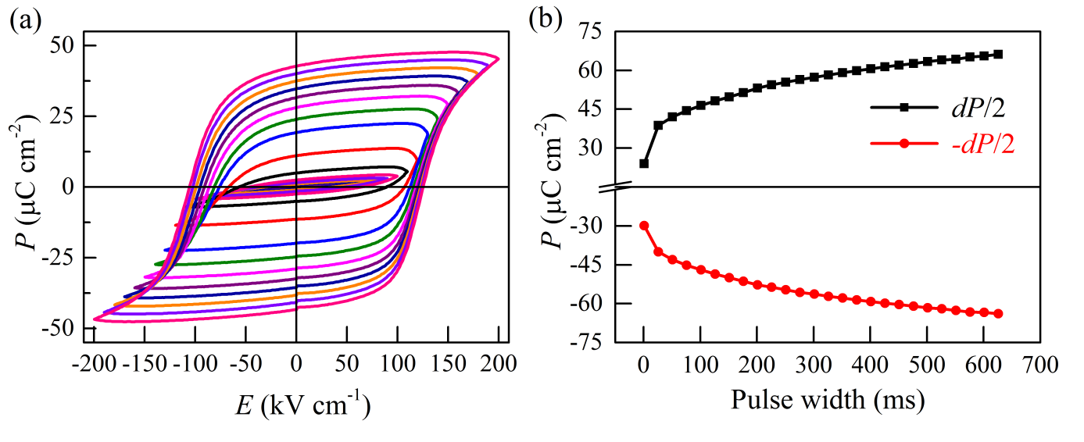
Figure 3. Ferroelectric behaviour of phase pure 0.85BiTi_{0.125}Fe_{0.75}Mg_{0.125}O₃ – 0.15CaTiO₃ (x = 0.15, y = 0.75). (a) P(E) hysteresis loops at increasing electric fields collected at 10 Hz. (b) Remanent polarisation against pulse width from PUND measurements at an electric field of 160 kV cm⁻¹ and pulse delay of 1000 ms.

2.3.3. Ferroelectric behaviour with large polarisation
Highly insulating behaviour and low dielectric loss (tan δ < 0.03 at 100 Hz, Figure S13a) allows ferroelectric measurement up to a field of 200 kV cm⁻¹. Figure 3 shows room temperature polarisation–electric field hysteresis (P(E)) loops collected at a frequency of 10 Hz. Well saturated loops confirm ferroelectricity with maximum polarisation (P_{max}) of 47.7 μC cm⁻² at a measurement field of 200 kV cm⁻¹. Positive-up-negative-down (PUND) measurements confirm that the large measured polarisation is intrinsic (Figure S13b). It should be noted that polarisation measured in P(E)/PUND above the coercive field still increases with the measurement fields. This suggests that polarisation, while switchable, is not saturated since the saturated polarisation is independent of applied electric fields. In these switching fields, the remanent polarisation is a function of pulse width and it tends to saturation at higher pulse width values (Figure S12). To assess the saturated remanent polarisation, PUND measurements were carried out against pulse width at a constant electric field of E = 160 kV cm⁻¹. The remanent polarisations (±dP/2) tend to saturation at high pulse width with P = 66 μC cm⁻² at 626 ms (Figure 3b, Figure S13c). The polarisation value is higher than other known MPB systems such as PZT (P_{r} = 35 μC cm⁻²), NBT – BTO (P_{r} = 37.8 – 40 μC cm⁻²), KBT – NBT (P_{r} = 38 μC cm⁻²), NBT – KBT – BTO (P_{r} = 40 μC cm⁻²).^{[34]}

Figure 4. Depolarisation in 0.85BiTi_{0.125}Fe_{0.75}Mg_{0.125}O₃ – 0.15CaTiO₃ (x = 0.15, y = 0.75). Temperature dependence of (a) d₃₃ measured ex-situ, (b) dielectric permittivity (ε_{r}), (c) heat flow and (d) normalised R_{wp} values from Lebail fits to variable temperature synchrotron XRD data using a single phase monoclinic structural model model (space group P11a); together confirming the first order structural transition at the depolarisation temperature T_{d}, shown by a red dotted line. Arrows indicate measurements on heating and cooling.

2.3.4. Depolarisation and first order phase transition
BTFM – CTO (y = 0.25) and certain Pb-free piezoelectrics show loss of polarisation at a depolarisation temperature (T_{d}) which appears below the Curie temperature (T_{CE}).^{[35,36]} At room temperature, the composition x = 0.15, y = 0.75 shows a longitudinal piezoelectric coefficient (d₃₃) of 36.3 pC N⁻¹. The temperature dependence of d₃₃ measured ex-situ on x = 0.15, y = 0.75 shows a sharp decrease which coincides with the sharp and frequency independent peaks in the permittivity data at T_{d} = 690 K confirming a depolarisation transition (Figure 4a,b). On cooling, the transition in the permittivity data appears at a lower temperature of 650 K. The sharp transition along with the thermal hysteresis in the permittivity and the heat flow data indicate a first order phase transition at T_{d} (Figure 4b and c). The non-zero d₃₃ above T_{d} (d₃₃ = 2.1 and 0.1 pC N⁻¹ at 773 and 1173 K respectively) and absence of any signature of phase transition in DSC measurements up to 1173 K indicates that the Curie temperature is above 1173K. The T_{d} is significantly higher than Pb-free MPB systems such as NBT – KBT (T_{d} = 403 – 443 K), NBT – BTO (T_{d} = 363 – 378 K), NBT – KBT – BTO (T_{d} = 435 K) and comparable to PZT (T_{d} = 659 K)^{[37]} and pseudocubic BFO – BTO (T_{d} = 703 K)^{[34,35]}. Despite the low d₃₃, this high T_{d} is significant in a Pb-free MPB system^{[35]} for high temperature piezoelectric applications.
The precise temperature of the phase transition on warming is dependent on the thermal history of the sample (Figure S14), which is indicative of complex strain effects. Thermal cycling at the slow rate of 2 K min⁻¹ removes this effect to produce samples with a consistent and reproducible phase transition temperature of 690 K on warming (Figure S14). The structural behavior at the depolarisation temperature was then investigated by variable temperature PXRD (I11) of a thermally cycled sample with 107 diffraction patterns collected on warming and cooling in the range 323 – 873 K. Sequential Lebail fits using the room temperature (P11a) unit cell produced good fits up to 690 K from data collected on warming, and up to 610 K from data collected on cooling, but produced very poor fits to patterns collected above these temperatures, indicative of a structural phase transition. This is illustrated by sharp increases in the plots of normalised R_{wp} vs temperature (Figure 4d), which show transition temperatures that are consistent with the hysteresis observed in the dielectric permittivity and calorimetry (Figure 4b and c), indicating that the depolarisation and structural transition occur together within the resolution limit of the measurements. The structural phase transition is confirmed by inspection of the diffraction patterns, which show a discontinuous change at 690 K on warming with the appearance of several new peaks that cannot be indexed to the room temperature cell; this pattern is then retained until the sample is cooled below 610 K (Figure S15). The thermal evolution of the lattice parameters on warming to the phase transition temperature are presented in Figure S16.
3. Conclusion
The identification of the spinel MgFe₂O₄ as a ferrimagnetic impurity phase in the magnetoelectric multiferroic perovskite oxide BTFM-CTO, has allowed the development of a new synthetic protocol to produce single-phase samples by optimising reaction precursors, mixing, grinding and heating protocols systematically. Suppression of Bi₂O₃ volatilisation coupled to repeated milling and sintering eliminated the refractory reaction intermediate MgFe₂O₄; the use of an optimal reactive Mg source and ultra-pure reagents is also essential for minimizing the amount of MgFe₂O₄ formed initially. Physical characterisation of the resulting phase pure samples allowed quantitative determination of the intrinsic magnetic, magnetoelectric and ferroelectric properties at room temperature; the composition x = 0.15, y = 0.75 has a saturated magnetisation of 0.0097 μ_{B} per Fe, magnetoelectric susceptibility of 0.19 (1) ps m⁻¹ and a polarisation of 66 μC cm⁻². Powder neutron diffraction was used to demonstrate that BTFM-CTO exhibits weak ferromagnetism and magnetoelectric coupling only when the perovskite is ordered magnetically; this can be far above room temperature in this system (T_{N} = 367 K for the composition x = 0.15, y = 0.80). The phase pure composition x = 0.15, y = 0.75 was shown to be ferroelectric up to a depolarisation temperature of 690 K where it undergoes a structural phase transition. BTFM-CTO combines high temperature ferroelectricity with intrinsic weak ferromagnetism and magnetoelectric coupling far above room temperature.
4. Experimental Section
Sample preparation protocols:
Comprehensive details of synthesis protocols 0 - 6 are presented in the Supplementary Information; only Protocol 7 (synthesis of single-phase materials) is described here. The starting materials were (MgCO₃)₄·Mg(OH)₂·5H₂O (Sigma Aldrich, 99.99 %), ultra pure Bi₂O₃ (Alfa, 99.9995 %), CaCO₃ (99.997% Alfa Aesar), Fe₂O₃ (99.998% Alfa Aesar), and TiO₂ (99.995% Alfa Aesar). These were ground by hand under a small quantity of acetone. The dried reaction mixture (loose powder) was then loaded in an alumina crucible and subjected to a 3-stage heating cycle of 723 K for 3 h, 923 K for 3 h and 1023 K for 12 h with intermediate hand grinding. The resulting powders were ball milled in ethanol for 22h, dried and pelletised (13 mm diameter and 1 – 2 mm thickness), then calcined at 1053 K for 12 h in a closed alumina crucible lined with Pt foil without any sacrificial powder. The resulting pellet was pulverised and ball milled in ethanol for 22 h, the dried powder was then pelletised (8 mm diameter and ~ 0.5 mm thickness) and packed under sacrificial powder in a Pt-lined alumina boat and calcined at 1203 K for 12 h under an oxygen flow. The pellets were ground and further milled in ethanol for 22 h with 2 weight percent organic binder polyvinyl butyral (Butvar B-98) and 0.2 weight percent MnO₂ (Sigma Aldrich, 99.99%). Dried powders were pressed into pellets (diameter 8 mm, thickness ~ 0.5 mm), pressed isostatically to 200 MPa using to cold isostatic press, packed under sacrificial powder in Pt lined alumina boats and sintered at 1203 K for 12 h under flowing O₂. The heating and cooling rates were 5 K min⁻¹.
During the sintering process, cracks were observed in pellets which could be reduced by decreasing sintering temperature and cooling rate. Spinel free material was obtained in the sintering temperature range 1173 – 1203 K. The final sintering step carried out without sacrificial powder also resulted in spinel free material. Ferroelectric and magnetoelectric measurements were carried out on samples whose final sintering was conducted without sacrificial powder. Density measured using Archimedes balance confirmed 93 % of crystallographic density. The samples were prepared at a scale of 3 g. Pellets were cut into suitable sizes for physical property measurements. As-sintered samples were thermally cycled at 2 K min⁻¹ prior to DSC, d₃₃ and PXRD measurements.
Diffraction experiments:
Routine PXRD characterisation was carried out using a PANalytical X’Pert Pro diffractometer in Bragg-Brentano geometry with a monochromated Co Kα₁ source and position sensitive X‘Celerator detector. Variable temperature PXRD experiments were carried out using the I11 diffractometer at Diamond Light Source (UK) with a position sensitive detector for rapid data collection and an incident wavelength of 0.825959(1) Å. The sample was contained in a spinning quartz capillary of diameter 0.1 mm. The sample was scanned through temperatures of 323 – 873 – 423 K at 6 K min⁻¹ in steps of 10 K, with data collected for 90 seconds at each temperature. Lebail fits were carried out using Topas Academic (version 5). Variable temperature time-of-flight neutron powder diffraction patterns were collected using the Polaris (compositions x = 0.15, y = 0.60 and x = 0.15, y = 0.80) and GEM (composition x = 0.15, y = 0.75) diffractometers at ISIS Spallation Source (UK). Samples were contained in thin walled vanadium cans. The raw intensities of the (100) nuclear peak (I₁₀₀) and the magnetic peak (I_{mag}) were extracted by peak fitting in Topas Academic (version 5). The two peaks were fitted simultaneously using a refined pseudo-Voigt peak shape with a refined Chebyschev background function. The peak shape was constrained to be identical for the two peaks.
Ferroelectric measurements:
Pellets were cut to suitable size (2 – 5 mm²) and polished down to 100 – 160 μm with tolerance of 10 μm using a Tegramin 30 (Struers) semi-automatic polishing machine. Silver paint was applied on both sides of the pellet and approximately 20 μm was bevelled from sides to minimise the likelihood of of dielectric breakdown. The pellet was immersed in silicone oil in a Radiant high voltage test fixture. P(E) and positive-up-negative-down (PUND) measurements were carried out using a Radiant Precision LC ferroelectric tester.
To assess the remanent part of the measured polarisation, PUND measurements were carried out. A typical PUND profile (Figure S13) confirms that the non-remanent part (P^) is much smaller compared to the total polarisation (P*) which contains both remanent and non-remanent parts. The remanent polarisations are calculated as +dP/2 = (P* - P^)/2 and -dP/2 = (-P* - (-P^))/2. In the intermediate state, where the polarisation is switchable but not completely saturated, the remanent polarisations are a function of the pulse width as shown for a commercial PZT ceramic PIC151 (Figure S12a,b).
d₃₃ measurement
For d₃₃ measurements, silver paint was applied on polished pellet. The pellet was immersed in silicone oil in the high temperature sample holder of aixPES equipment (aixACCT Systems GmbH). An electric field of 100 kV cm⁻¹ was applied at 373 K for 15 mins and cooled down at 1 K min⁻¹ to room temperature and the voltage was switched off. The piezoelectric charge coefficient d₃₃ was measured after 24 h of poling in a piezometer PM300 (Piezotest Pte Ltd) using a sinusoidal force of 0.25 N at 110 Hz. For depolarisation measurements, the poled pellet was shorted using a Pt wire clip and depoled at a particular temperature for 1 h in a temperature controlled furnace. The d₃₃ was then measured ex-situ after depoling using the piezometer.
DSC and TGA measurements
Heat flow was measured using differential scanning calorimetry (DSC) option in SDT Q600 (TA Instruments). TGA experiments were performed using a Q500 thermogravimetric analyser (TA instruments). The sample was placed in a Pt pan under flowing air (10 – 20 ml min⁻¹). The heating and cooling rates were 2 – 10 K min⁻¹.
Dielectric measurements:
For dielectric measurements a Pt paste was applied on both sides of pellet and cured at 1123 K for 30 mins. Capacitance (C) and loss (tan δ) were measured using an Agilent LCR meter E4980 by applying an AC voltage of 0.2 V in the frequency range 1 kHz – 1 MHz. Sample was loaded in a custom made sample holder and data was collected using the LABVIEW software program. A ramp rate of 2 K min⁻¹ was used.
Magnetic measurements
Magnetic measurements were carried out using a vibrating sample magnetometer (VSM) option of the MPMS3 system (Quantum Design, USA). Pellet samples were fixed to a quartz sample holder and then loaded into a SQUID probe. Temperature dependence of magnetisation was carried out in zero field cooled (ZFC), field cooled (FC) and TRM (thermo remanent magnetisation) modes. For measurements in the 10 – 395 K range, the sample is cooled down to 10 K under zero applied field and magnetic field of μ₀H = 0.01 Tesla is applied. The moment is measured (i) while warming up (ZFC) to 395 K, (ii) while cooling down from 395 to 10 K under the same applied field (FC). The field is made zero at 10 K and the moment is measured while warming up (TRM). A ramp rate of 3 K min⁻¹ was used. Magnetic measurements in the temperature range 300 – 700 K were carried out using oven option in the MPMS3 system. The Néel temperature (T_{N}) is derived from peak in the derivative of TRM data. The saturated magnetisation was obtained by subtracting the linear contribution from M(H) isotherms as described in previous studies.^{[18,38]}
Magnetoelectric measurements
Linear magnetoelectric measurements were performed using a custom set-up using a SQUID magnetometer MPMS XL7 (Quantum Design, USA). Details and measurement protocol are described in previous works.^{[18,38]} Prior to magnetoelectric measurements, pellets were poled externally using aixPES (as described in reference^{[18]}) and then subjected to a magnetic field (μ₀H) of 2 T for 60 minutes. After removal of fields, electrodes were short circuited for 15 minutes prior to conducting magnetoelectric measurements. The leakage current is low in the entire measurement range (10 nA at 360 K at 4 kV cm⁻¹ for spinel-free composition x = 0.15, y = 0.75) to cause any experimental artefacts.
Scanning Electron Microscopy (SEM) and Energy Dispersive X-ray spectroscopy (EDX)
Scanning electron microscopy was performed with an FE-SEM Hitachi S-4800 equipped with an Oxford Instruments EDX detector. Samples, in powder or pellet form, were attached to a carbon tape stuck on an aluminium stub. In order to minimize the charging effect, a thin layer of gold (2-3 nm) was sputtered on the samples surface. Energy Dispersive X-ray spectroscopy data were collected in at least nine different areas for each sample. The quantification data, for each element, were corrected using a correction factor determined using a standard.

Supporting Information
Supporting Information is available from the Wiley Online Library or from the author.

Acknowledgements
This work was supported by EPSRC under EP/H000925/1. Synchrotron X-ray diffraction experiment was carried out with the support of Diamond Light Source (UK). Time-of-flight neutron diffraction experiments were carried out with the support of ISIS Spallation Source (UK). We thank Dr. C. Tang, Dr. C. Murray and Dr. S. Day for assistance on beamline I11 (DLS), Dr R. I. Smith for assistance on Polaris (ISIS) and Dr. I. da Silva for assistance on GEM (ISIS). MJR is a Royal Society Research Professor.

Received: ((will be filled in by the editorial staff))
Revised: ((will be filled in by the editorial staff))
Published online: ((will be filled in by the editorial staff))

[1] W. Eerenstein, N. D. Mathur, J. F. Scott, Nature 2006, 442, 759.
[2] M. Fiebig, J. Phys. D: Appl. Phys. 2005, 38, R123.
[3] J. F. Scott, Nature Mater. 2007, 6, 256.
[4] M. Bibes, A. Barthelemy, Nature Mater. 2008, 7, 425.
[5] G. A. Smolenskiĭ, I. E. Chupis, Sov. Phys. Usp. 1982, 25, 475.
[6] I. Sosnowska, T. P. Neumaier, E. Steichele, J. Phys. C: Solid State Phys. 1982, 15, 4835.
[7] Y. F. Popov, A. K. Zvezdin, G. P. Vorobev, A. M. Kadomtseva, V. A. Murashev, D. N. Rakov, JETP Lett. 1993, 57, 69.
[8] C. Ederer, N. A. Spaldin, Phys. Rev. B 2005, 71, 060401.
[9] J. Wang, J. B. Neaton, H. Zheng, V. Nagarajan, S. B. Ogale, B. Liu, D. Viehland, V. Vaithyanathan, D. G. Schlom, U. V. Waghmare, N. A. Spaldin, K. M. Rabe, M. Wuttig, R. Ramesh, Science 2003, 299, 1719.
[10] J. T. Heron, M. Trassin, K. Ashraf, M. Gajek, Q. He, S. Y. Yang, D. E. Nikonov, Y. H. Chu, S. Salahuddin, R. Ramesh, Phys. Rev. Lett. 2011, 107, 217202.
[11] J. T. Heron, J. L. Bosse, Q. He, Y. Gao, M. Trassin, L. Ye, J. D. Clarkson, C. Wang, J. Liu, S. Salahuddin, D. C. Ralph, D. G. Schlom, J. Iniguez, B. D. Huey, R. Ramesh, Nature 2014, 516, 370.
[12] S. A. Ivanov, S. Eriksson, N. W. Thomas, R. Tellgren, H. Rundlof, J. Phys. Cond. Matter 2001, 13, 25.
[13] I. P. Raevski, V. V. Titov, M. A. Malitskaya, E. V. Eremin, S. P. Kubrin, A. V. Blazhevich, H. Chen, C. C. Chou, S. I. Raevskaya, I. N. Zakharchenko, D. A. Sarychev, S. I. Shevtsova, J. Mater. Sci. 2014, 49, 6459.
[14] N. A. Lomanova, V. G. Semenov, V. V. Panchuk, V. V. Gusarov, J. Alloys Compd. 2012, 528, 103.
[15] M. Mazurek, D. Oleszak, T. Pikula, M. Karolus, E. Jartych, Acta Phys. Pol., A 2014, 126, 975.
[16] D. M. Evans, A. Schilling, A. Kumar, D. Sanchez, N. Ortega, M. Arredondo, R. S. Katiyar, J. M. Gregg, J. F. Scott, Nature Commun. 2013, 4, 1534.
[17] L. Keeney, T. Maity, M. Schmidt, A. Amann, N. Deepak, N. Petkov, S. Roy, M. E. Pemble, R. W. Whatmore, J. Am. Ceram. Soc. 2013, 96, 2339.
[18] P. Mandal, M. J. Pitcher, J. Alaria, H. Niu, P. Borisov, P. Stamenov, J. B. Claridge, M. J. Rosseinsky, Nature 2015, 525, 363.
[19] J. Frantti, J. Phys. Chem. B 2008, 112, 6521.
[20] N. Zhang, H. Yokota, A. M. Glazer, Z. Ren, D. A. Keen, D. S. Keeble, P. A. Thomas, Z. G. Ye, Nature Commun. 2014, 5, 5231.
[21] S. L. Swartz, T. R. Shrout, Mater. Res. Bull. 1982, 17, 1245.
[22] S. Vijayanand, H. S. Potdar, P. A. Joy, Appl. Phys. Lett. 2009, 94, 182507.
[23] N. Jeon, D. Rout, I. W. Kim, S.-J. L. Kang, Appl. Phys. Lett. 2011, 98, 072901.
[24] C. Nayek, A. Tamilselvan, C. Thirmal, P. Murugavel, S. Balakumar, J. Appl. Phys. 2014, 115, 073902.
[25] M. Valant, A.-K. Axelsson, N. Alford, Chem. Mater. 2007, 19, 5431.
[26] M. S. Bernardo, T. Jardiel, M. Peiteado, A. C. Caballero, M. Villegas, J. Eur. Ceram. Soc. 2011, 31, 3047.
[27] T. Rojac, A. Bencan, B. Malic, G. Tutuncu, J. L. Jones, J. E. Daniels, D. Damjanovic, J. Am. Ceram. Soc. 2014, 97, 1993.
[28] S. M. Selbach, M.-A. Einarsrud, T. Grande, Chem. Mater. 2009, 21, 169.
[29] R. Köferstein, T. Buttlar, S. G. Ebbinghaus, J. Solid State Chem. 2014, 217, 50.
[30] A. A. Zatsiupa, L. A. Bashkirov, I. O. Troyanchuk, G. S. Petrov, A. I. Galyas, L. S. Lobanovsky, S. V. Truhanov, J. Solid State Chem. 2014, 212, 147.
[31] N. Shamir, E. Gurewitz, H. Shaked, Acta Crystallogr. Sect. A 1978, 34, 662.
[32] Q. Chen, Z. J. Zhang, Appl. Phys. Lett. 1998, 73, 3156.
[33] R. L. White, J. Appl. Phys. 1969, 40, 1061.
[34] J. Rödel, W. Jo, K. T. P. Seifert, E.-M. Anton, T. Granzow, D. Damjanovic, J. Am. Ceram. Soc. 2009, 92, 1153.
[35] O. L. Serhiy, E. E. Richard, Sci. Technol. Adv. Mater. 2010, 11, 044302.
[36] P. Mandal, A. Manjón-Sanz, A. J. Corkett, T. P. Comyn, K. Dawson, T. Stevenson, J. Bennett, L. F. Henrichs, A. J. Bell, E. Nishibori, M. Takata, M. Zanella, M. R. Dolgos, U. Adem, X. Wan, M. J. Pitcher, S. Romani, T. T. Tran, P. S. Halasyamani, J. B. Claridge, M. J. Rosseinsky, Adv. Mater. 2015, 27, 2883.
[37] H. Jaffe, J. Am. Ceram. Soc. 1958, 41, 494.
[38] M. J. Pitcher, P. Mandal, M. S. Dyer, J. Alaria, P. Borisov, H. Niu, J. B. Claridge, M. J. Rosseinsky, Science 2015, 347, 420.

Phase pure bulk samples of the room temperature magnetoelectric multiferroic (1-x)BiTi_{(1-y)/2}Fe_{y}Mg_{(1-y)/2}O₃ – xCaTiO₃ are prepared by a synthetic route that balances reaction pathway, starting material reactivity and the loss of volatile Bi₂O₃.

Keywords: room temperature multiferroic, magnetoelectric, magnetic impurity, powder neutron diffraction, ferroelectric

P. Mandal, M. J. Pitcher, J. Alaria, H. Niu, M. Zanella, J. B. Claridge*, and M. J. Rosseinsky*

Controlling phase assemblage in a complex multi-cation system; phase-pure room temperature multiferroic (1-x)BiTi_{(1-y)/2}Fe_{y}Mg_{(1-y)/2}O₃ – xCaTiO₃

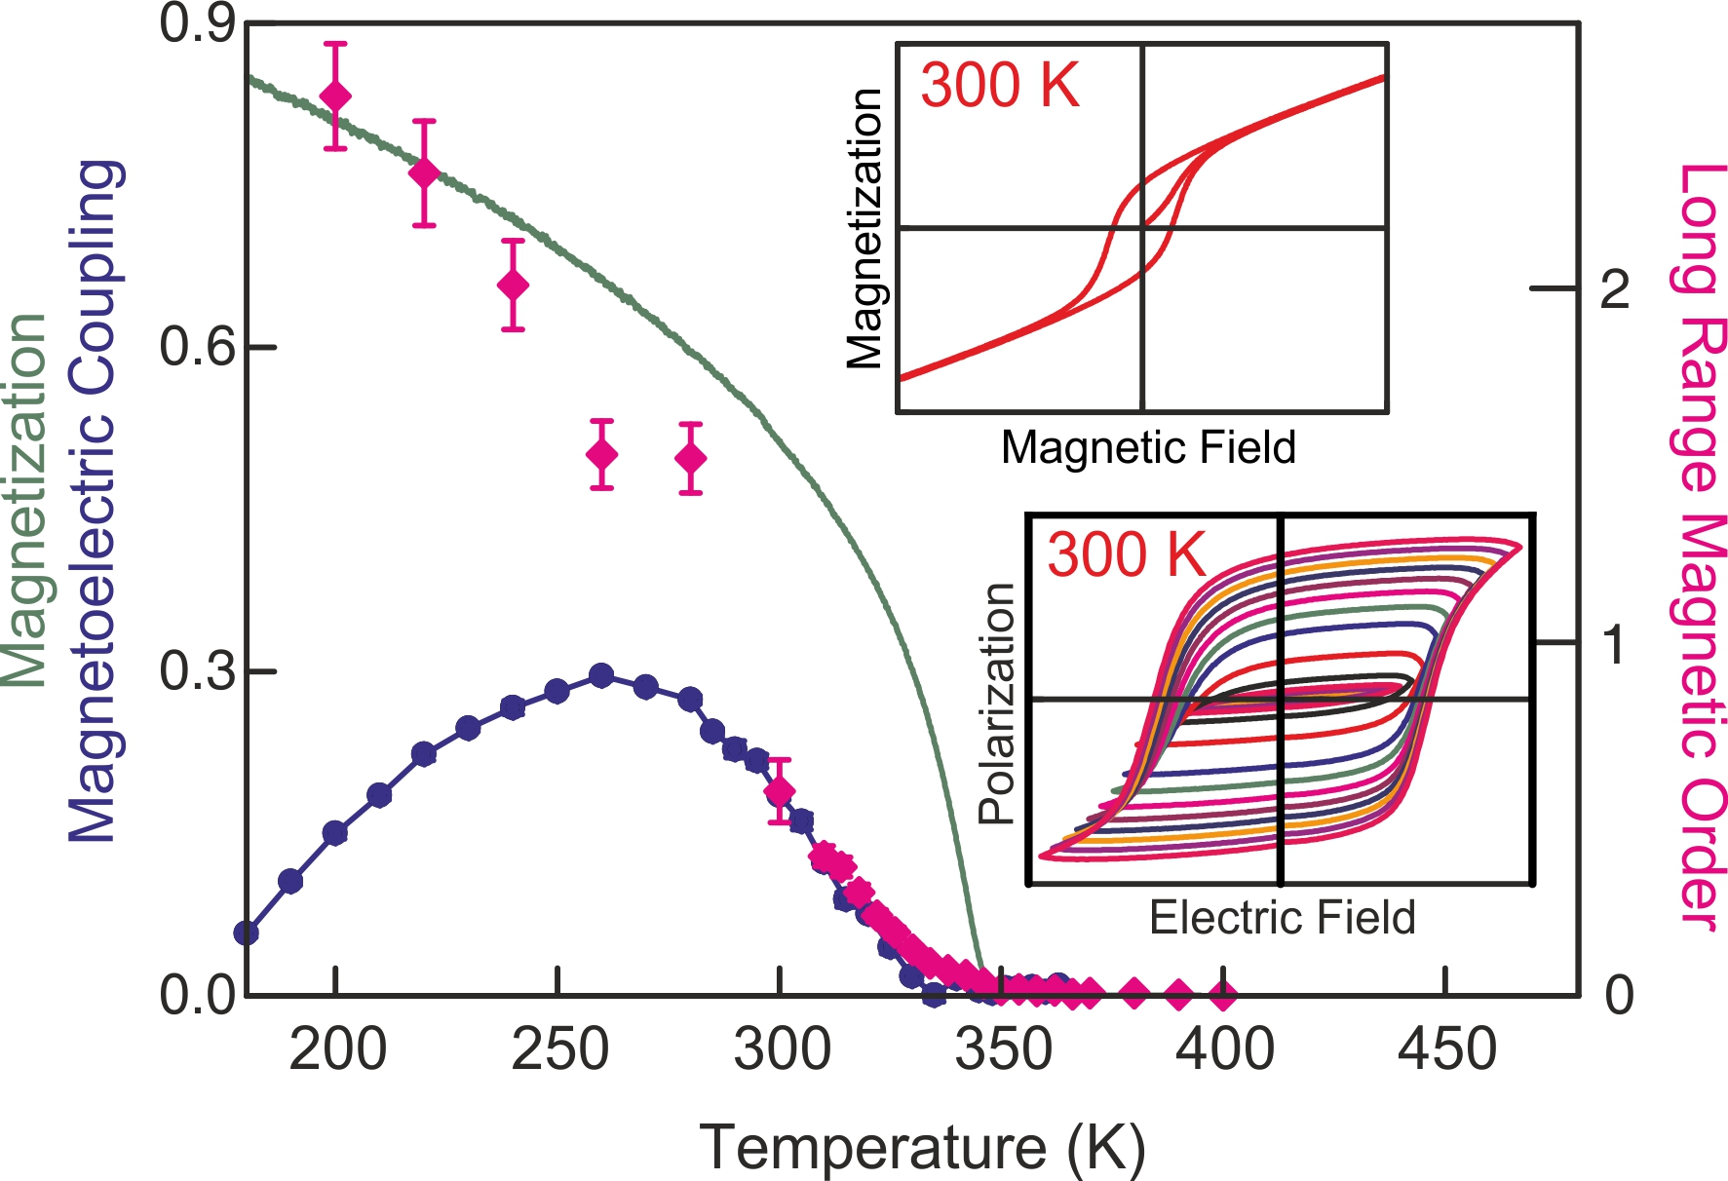
Copyright WILEY-VCH Verlag GmbH & Co. KGaA, 69469 Weinheim, Germany, 2013.

Supporting Information

Controlling phase assemblage in a complex multi-cation system; phase-pure room temperature multiferroic (1-x)BiTi_{(1-y)/2}Fe_{y}Mg_{(1-y)/2}O₃ – xCaTiO₃

Pranab Mandal, Michael J. Pitcher, Jonathan Alaria, Hongjun Niu, Marco Zanella, John B. Claridge*, and Matthew J. Rosseinsky*

Synthesis conditions for Protocols 0 – 6
Protocol 0: Powder samples of (1-x)BiTi_{(1-y)/2}Fe_{y}Mg_{(1-y)/2}O₃ – (x)CaTiO₃, in the compositional range x = 0.15, y = 0.60 – 0.90, were synthesised by a conventional solid-state reaction. High purity starting materials Bi₂O₃ (99.99% Alfa Aesar), CaCO₃ (99.997% Alfa Aesar), Fe₂O₃ (99.998% Alfa Aesar), TiO₂ (99.995% Alfa Aesar) and MgCO₃·Mg(OH)₂·3H₂O (99.996% Alfa Aesar) were used. The Mg precursor was used as received and other starting materials were dried at 473 K overnight before weighing. Synthesis and processing details of compositions x = 0.15, y = 0.60 – 0.90 from Figure 1, Figure S1, Figure S2a,c, Figure S3 and Figure S11 are described in the previous report.^{[18]}
Protocol 1: This protocol is a route to powder samples, obtained by shortening Protocol 0 (the final processing cycle - pellet densification and sintering steps – are omitted). The starting materials were ball milled in ethanol for 22 h and the dried powders were pressed into 8 mm pellets of ~ 0.5 mm thickness. A single pellet was then calcined at 1213 K for 12 h in a closed alumina crucible lined with Pt foil. The step was carried out without using any sacrificial powder.
Protocol 2: This protocol uses the Mg precursor (MgCO₃)₄·Mg(OH)₂·5H₂O (Sigma Aldrich, 99.99 %) instead of MgCO₃·Mg(OH)₂·3H₂O and was used as received. The starting materials were ball milled in ethanol for 22 h. The dried powders were pressed into 8 mm pellets of ~ 0.5 mm thickness and a single pellet was calcined at 1213 K for 12 h in a closed alumina crucible lined with Pt foil. The step was carried out without using any sacrificial powder.
Protocol 3: This protocol uses the Mg precursor (MgCO₃)₄·Mg(OH)₂·5H₂O (Sigma Aldrich, 99.99 %). The starting materials were ball milled in ethanol for 22 h. The dried powders were pressed into 8 mm pellets of ~ 0.5 mm thickness and a single pellet was packed in a 10-fold excess of sacrificial powder and calcined at 1213 K for 12 h in a closed alumina crucible lined with Pt foil.
Protocol 4: This protocol uses the Mg precursor (MgCO₃)₄·Mg(OH)₂·5H₂O (Sigma Aldrich, 99.99 %). The starting materials were ball milled in ethanol for 22 h. The dried reaction mixture (loose powder) was then loaded in an alumina crucible and subjected to a 3-stage heating cycle of 650 K for 3 h, 833 K for 3 h and 1023 K for 8 h to remove hydroxide and carbonates. The resulting powders were re-ground by hand, pelletised (8 mm diameter and ~ 0.5 mm thickness), packed in sacrificial powder and calcined at 1213 K for 12 h in a closed alumina crucible lined with Pt foil.

Protocol 5: This protocol uses the Mg precursor (MgCO₃)₄·Mg(OH)₂·5H₂O (Sigma Aldrich, 99.99 %), and an ultra pure Bi₂O₃ reagent (Alfa, 99.9995 %). The starting materials were ball milled in ethanol for 22 h. The dried reaction mixture (loose powder) was then loaded in an alumina crucible and subjected to a 3-stage heating cycle of 650 K for 3 h, 833 K for 3 h and 1023 K for 8 h. The resulting powders were re-ground by hand, pelletised (8 mm diameter and ~ 0.5 mm thickness), packed in sacrificial powder and calcined at 1213 K for 12 h in a closed alumina crucible lined with Pt foil.
Protocol 6: This protocol uses the Mg precursor (MgCO₃)₄·Mg(OH)₂·5H₂O (Sigma Aldrich, 99.99 %), and an ultra pure Bi₂O₃ (Alfa, 99.9995 %). The starting materials were ball milled in ethanol for 22 h. The dried reaction mixture (loose powder) was then loaded in an alumina crucible and subjected to a 3-stage heating cycle of 650 K for 3 h, 833 K for 3 h and 1023 K for 8 h. The resulting powders were ball milled in ethanol for 22h, dried and pelletised (8 mm diameter and ~ 0.5 mm thickness), then packed in sacrificial powder and calcined at 1213 K for 12 h in a closed alumina crucible lined with Pt foil.

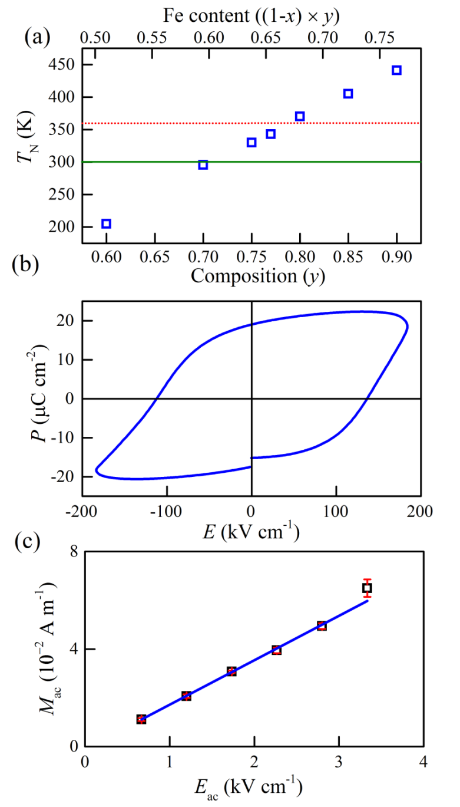
Figure S1. (a) Variation of T_{N} in with composition (y) and Fe content ((1-x)×y) on samples prepared under Protocol 0. The green line denotes T = 300 K and red line indicates the upper temperature limit (T = 360 K) of the magnetoelectric measurements. (b) P(E) loop confirming ferroelectricity in the most Fe rich composition x = 0.15, y = 0.90. (c) Linear magnetoelectric effect at 300 K on composition x = 0.15, y = 0.90.

Figure S2. ZFC (black line), FC (red line) magnetisation at μ₀H = 0.01 T and TRM (blue line) data (left axis)on (a) x = 0.15, y = 0.80 (prepared following Protocol 0) and (b) x = 0.15, y = 0.75 (prepared following Protocol 7). Note the negative TRM is due to the negative remanent magnetic field in superconducting magnet. AC susceptibility on x = 0.15, y = 0.80 plotted in right axis. Magnetic isotherms at 300 K (black line), 400 K (red line) and 650 K (blue line) on (c) x = 0.15, y = 0.80 (prepared following Protocol 0) and (d) x = 0.15, y = 0.75 (prepared following Protocol 7).

Figure S3. TRM data (blue line, left axis) and (I²_{mag} / I²₁₀₀) (filled diamonds, right axis) on x = 0.15, y = 0.60 (prepared following Protocol 0) plotted against temperature. Error bars represent standard deviation.

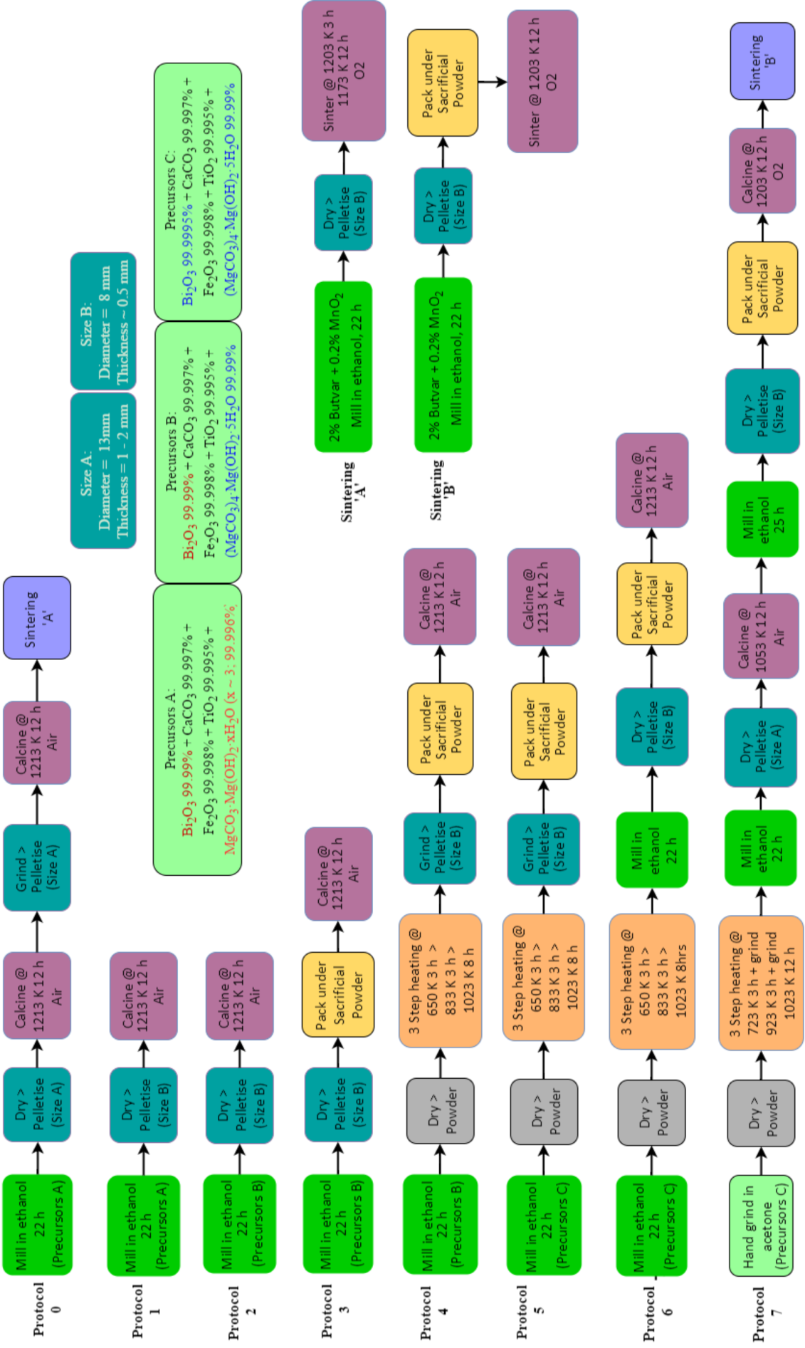

Figure S4. Synthesis flow chart showing Protocol 0 – 7.

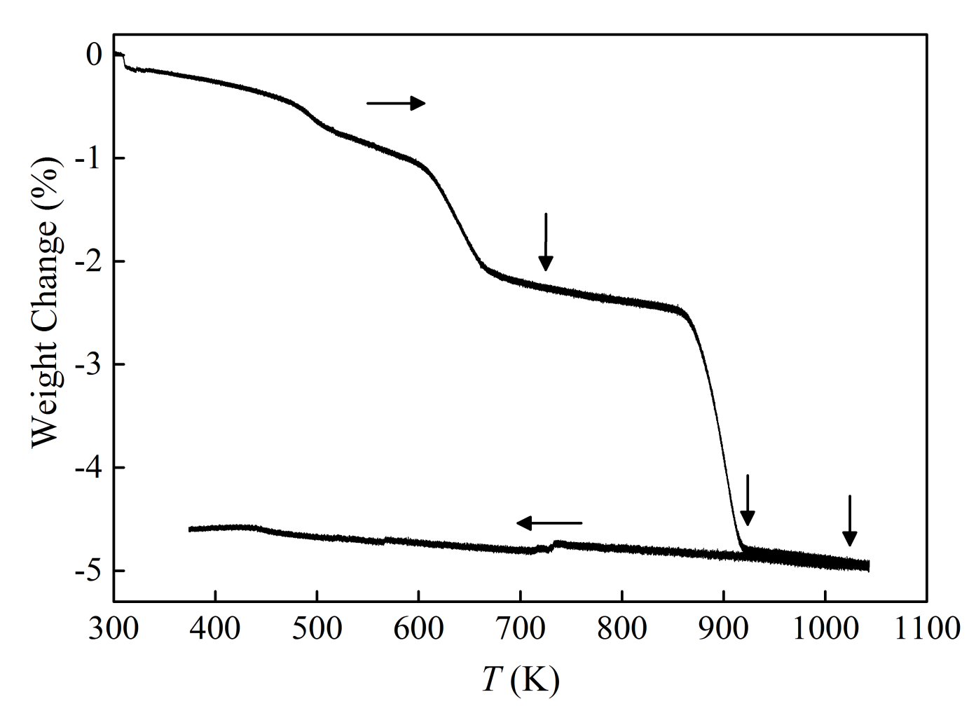
Figure S5. TGA measurements of mixture of starting materials for composition x = 0.15, y = 0.80 after hand grinding under acetone, indicating the decomposition temperatures of carbonates and hydroxides in the mixture. Vertical arrows show selected the temperatures for 3 step heating in Protocol 7.

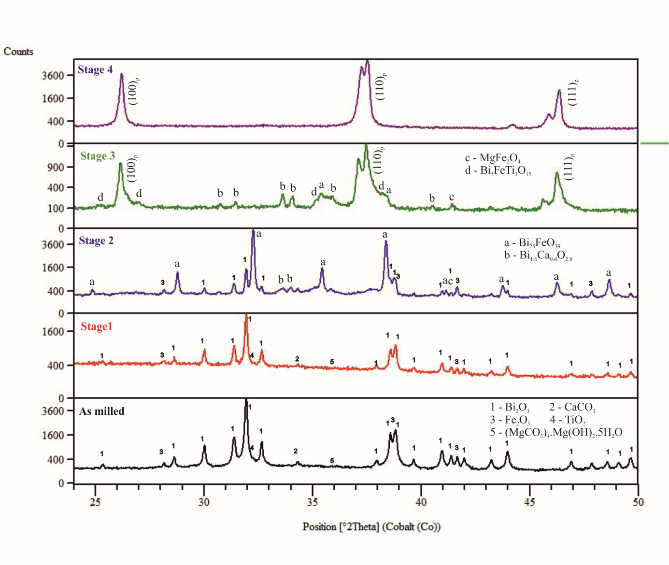
Figure S6. PXRD patterns showing phase evolution at different stages of Protocol 6 on x = 0.15, y = 0.80. Stage 1 denotes pattern of powder heated at 650 K for 3 h after milling of starting materials, stage 2 denotes pattern of powder heated at 833 K for 3 h followed by stage 1, stage 3 denotes pattern of powder heated at 1023 K for 8 h followed by stage 2. The top panel shows pattern of powder calcined at 1213 K for 12 h followed by milling of powder obtained from stage 3.

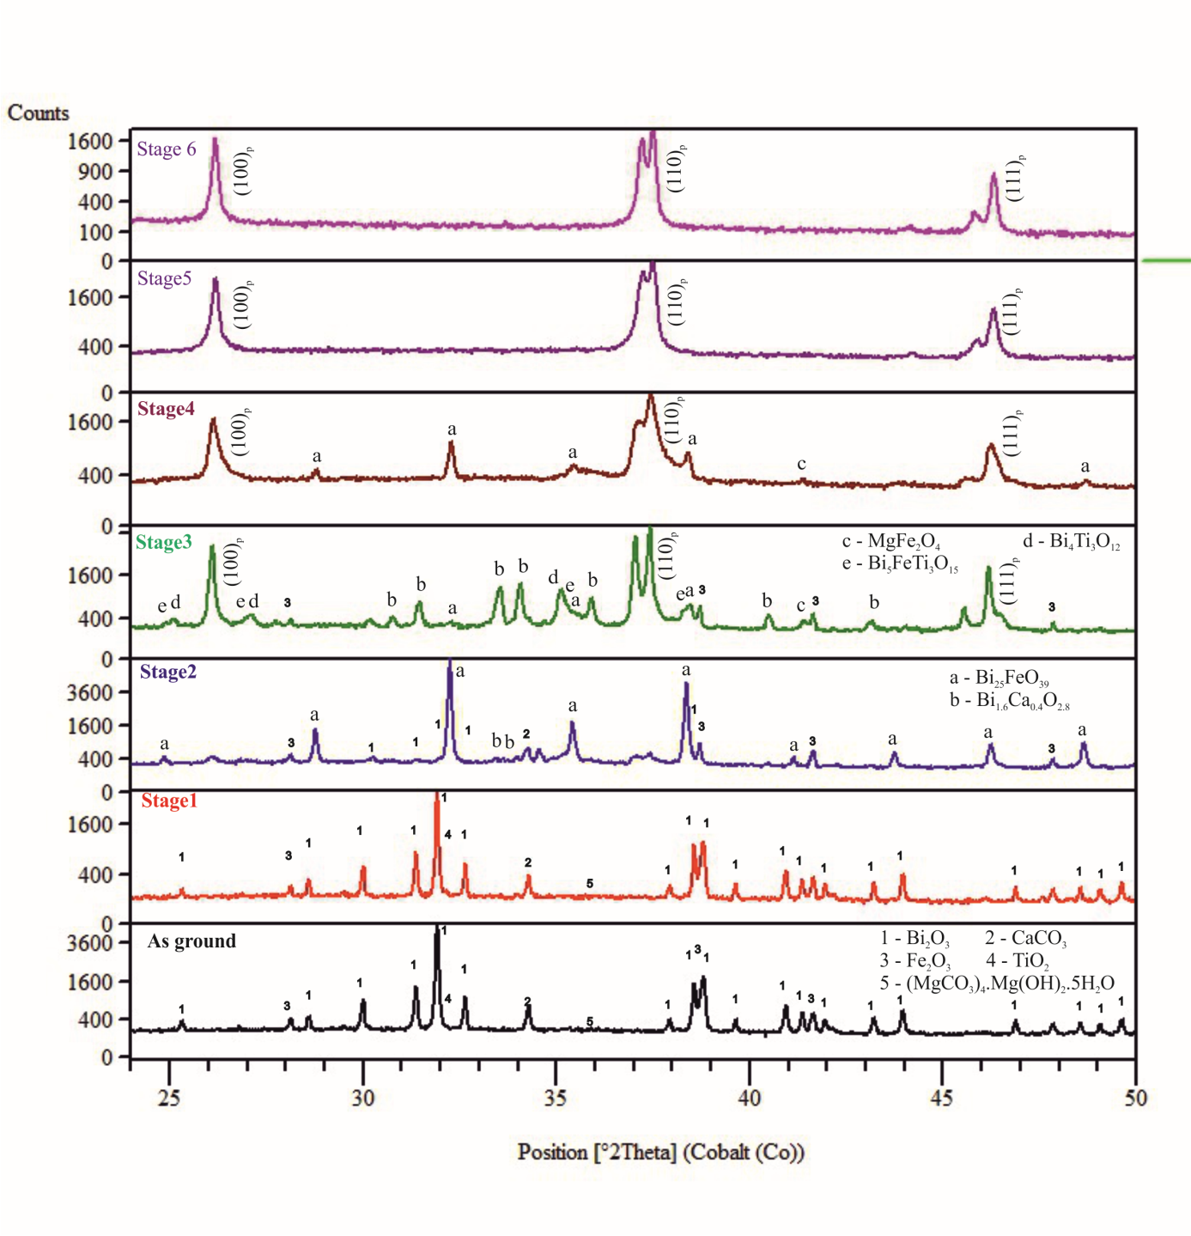
Figure S7. PXRD patterns showing phase evolution at different stages of Protocol 7 on x = 0.15, y = 0.75. Stage 1 denotes pattern of powder heated at 723 K for 3 h, stage 2 denotes pattern of powder heated at 923 K for 3 h followed by stage 1, stage 3 denotes pattern of powder heated at 1023 K for 12 h followed by stage 2, stage 4 denotes pattern of powder heated at 1053 K for 12 h followed by milling of powder obtained from stage 3. Stage 5 denotes patterns of powder from material calcined at 1203 K for 12 h after milling and calcination of powder obtained from stage 4. Stage 6 denotes the powder pattern of final product obtained after milling and calcination of powder obtained from stage 5.

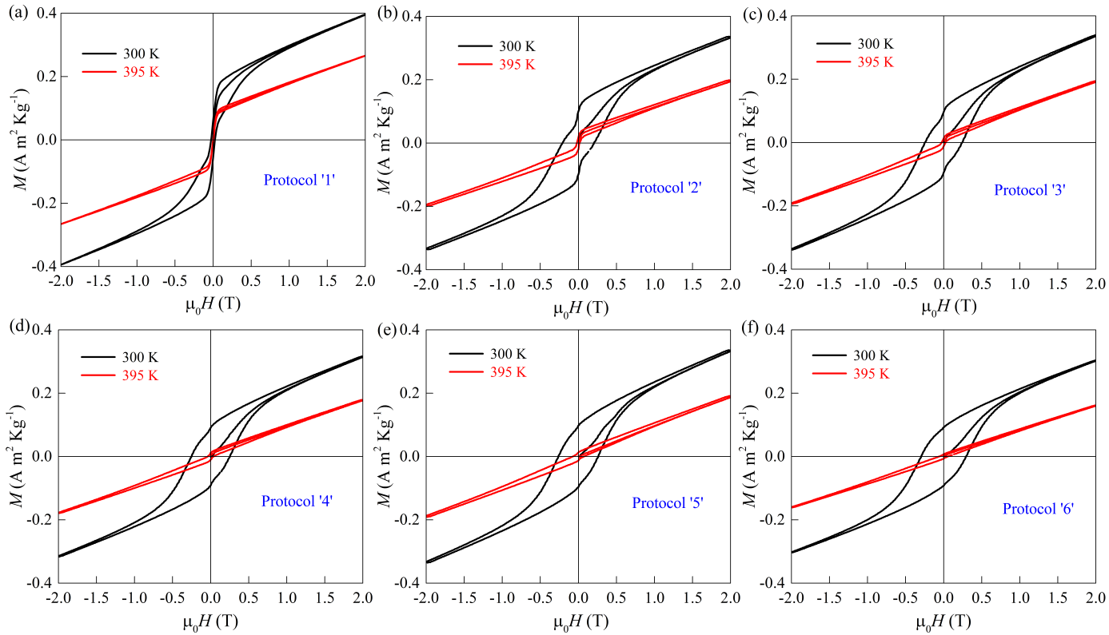

Figure S8. (a) – (f) M(H) isotherms at 300 K (<T_{N}) and 395 K (>T_{N}) on composition x = 0.15, y = 0.80 prepared following synthesis Protocol 1 – 6 respectively.
Table S1. Remanent magnetisation (M_{r}) at 395 K from Protocol 1 – 6.

Protocol | M_{r}  [A m² Kg⁻¹]
1 | 0.0971
2 | 0.0416
3 | 0.0270
4 | 0.0190
5 | 0.0190
6 | 0.0112

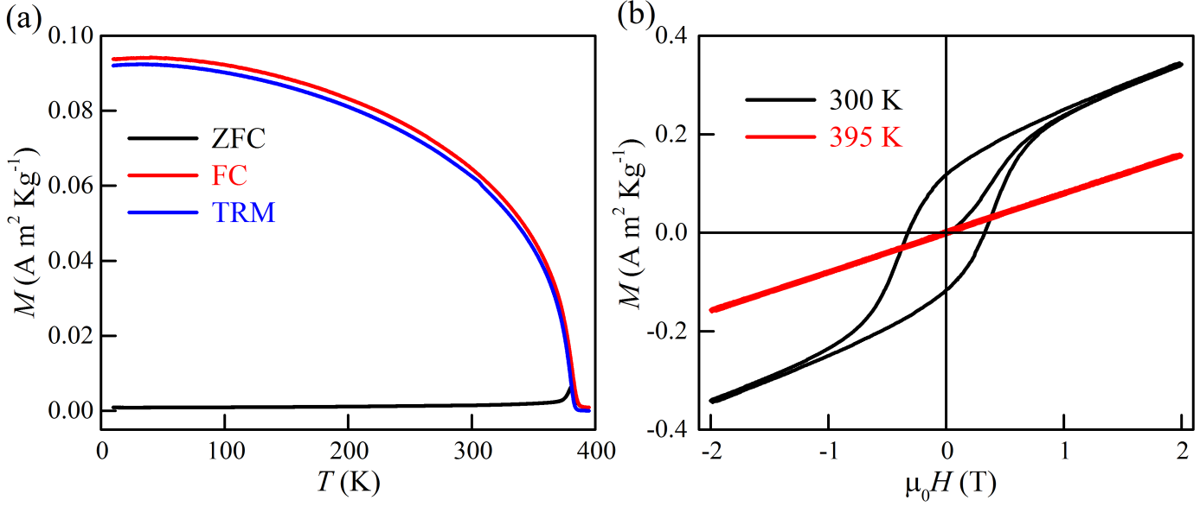

Figure S9. (a) ZFC (black line), FC (red line), TRM (blue line) data and (b) magnetic isotherms at 300 K (black line), 395 K (red line) on composition x = 0.15, y = 0.80 prepared following Protocol 7.

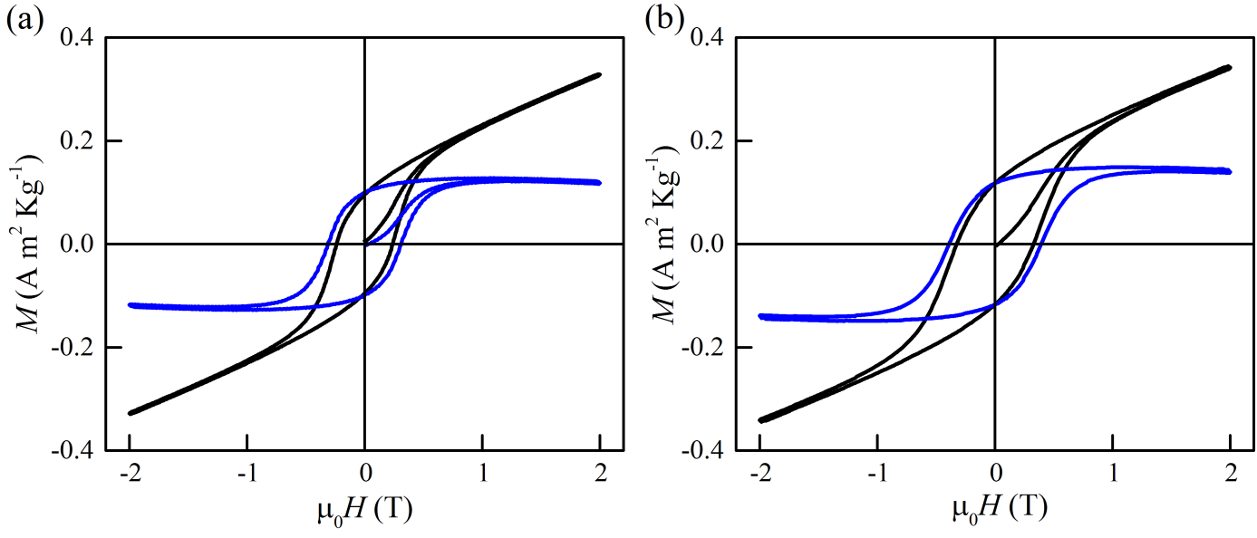
Figure S10. Magnetic isotherms of (a) x = 0.15, y = 0.75 and (b) x = 0.15, y = 0.80 at 300 K prepared following Protocol 7. Black and blue lines represent raw and subtracted data respectively.

Figure S11. (a) Selected portion of laboratory PXRD pattern, collected for 8 h on x = 0.15, y = 0.75 prepared following Protocol 0. The asterisk indicates position of most intense peak of spinel impurity. (b) Magnetic isotherms at 300 K (<T_{N}) and 350 K (>T_{N}) indicating presence magnetic impurity phase.
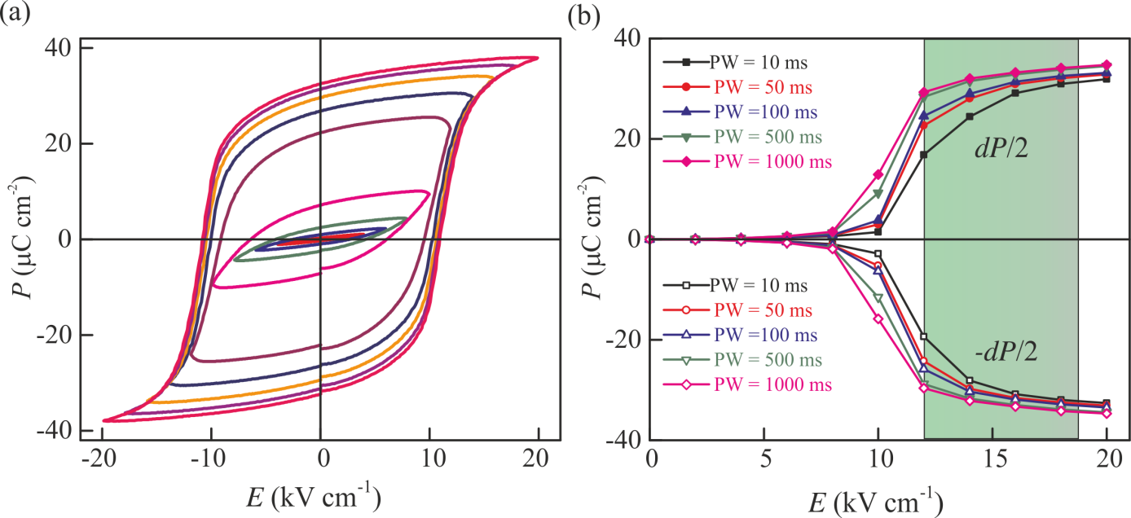
Figure S12. (a) P(E) measurements at 1 Hz on a commercial PZT ceramic (PIC151). (b) Remanent polarisations (± dP/2) plotted against applied electric field at different pulse width. Closed and open symbol represents dP/2 and -dP/2 respectively. In the shaded region the polarisation is switchable but not saturated. The remanent polarisation tends saturation at large pulse width.

Figure S13. PUND measurements on spinel free composition x = 0.15, y = 0.75 prepared following Protocol 7. (a) Dielectric permittivity (black squares, left axis) and loss (red circles, right axis) against frequency, (b) PUND data collected at an electric field of 180 kV cm⁻¹, pulse width of 100 ms and pulse delay of 1000 ms and (c) remanent polarisation plotted against electric field at different pulse width.

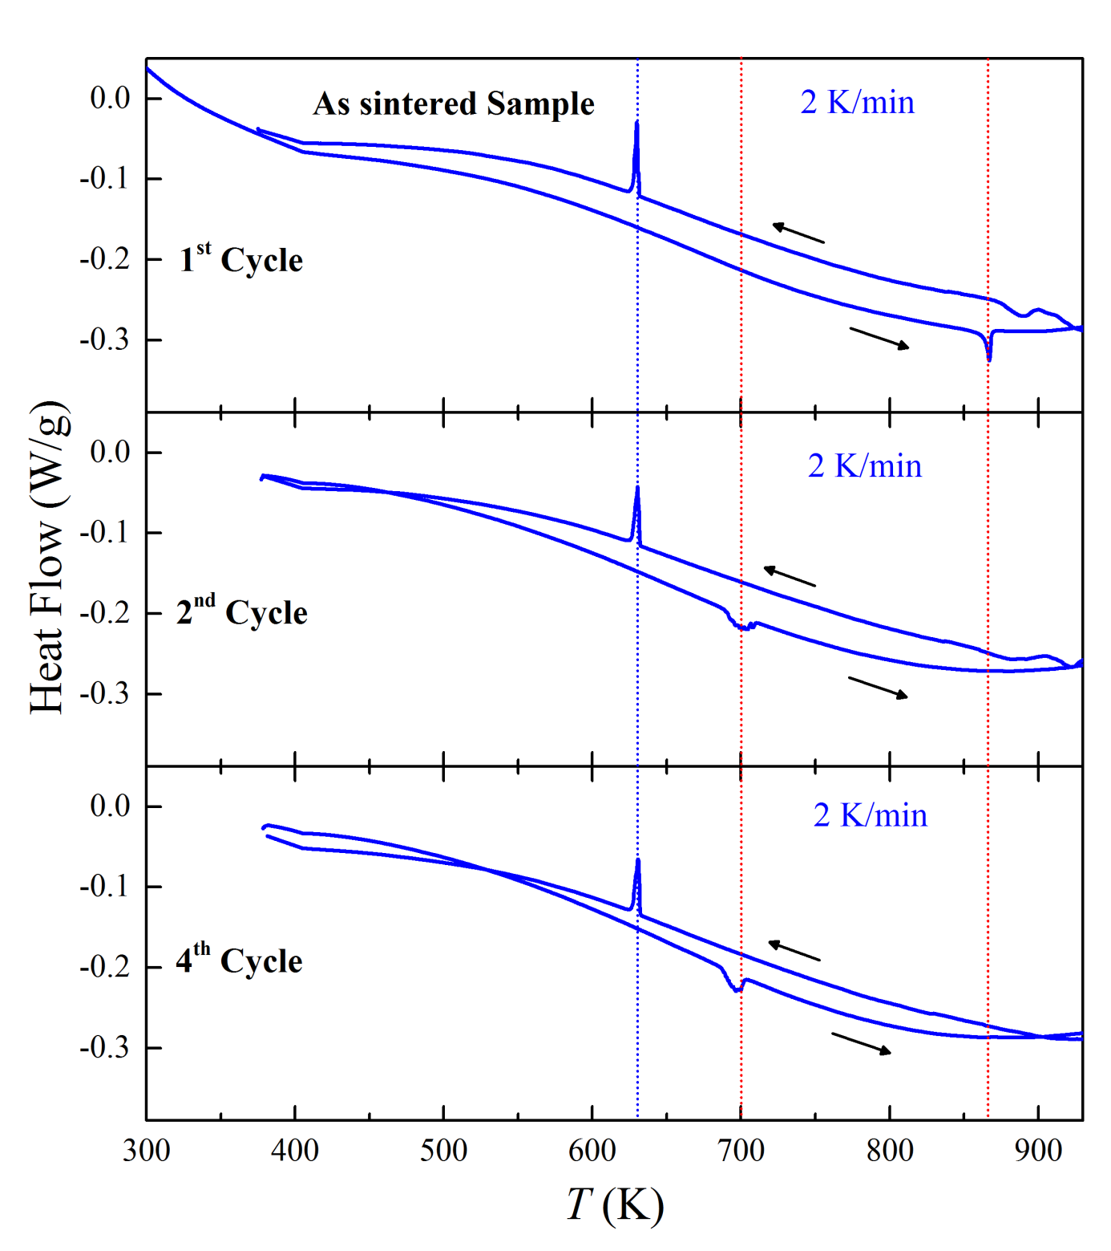

Figure S14. Effect of thermal cycling on the depolarisation temperature (T_{d}) on composition x = 0.15, y = 0.75.

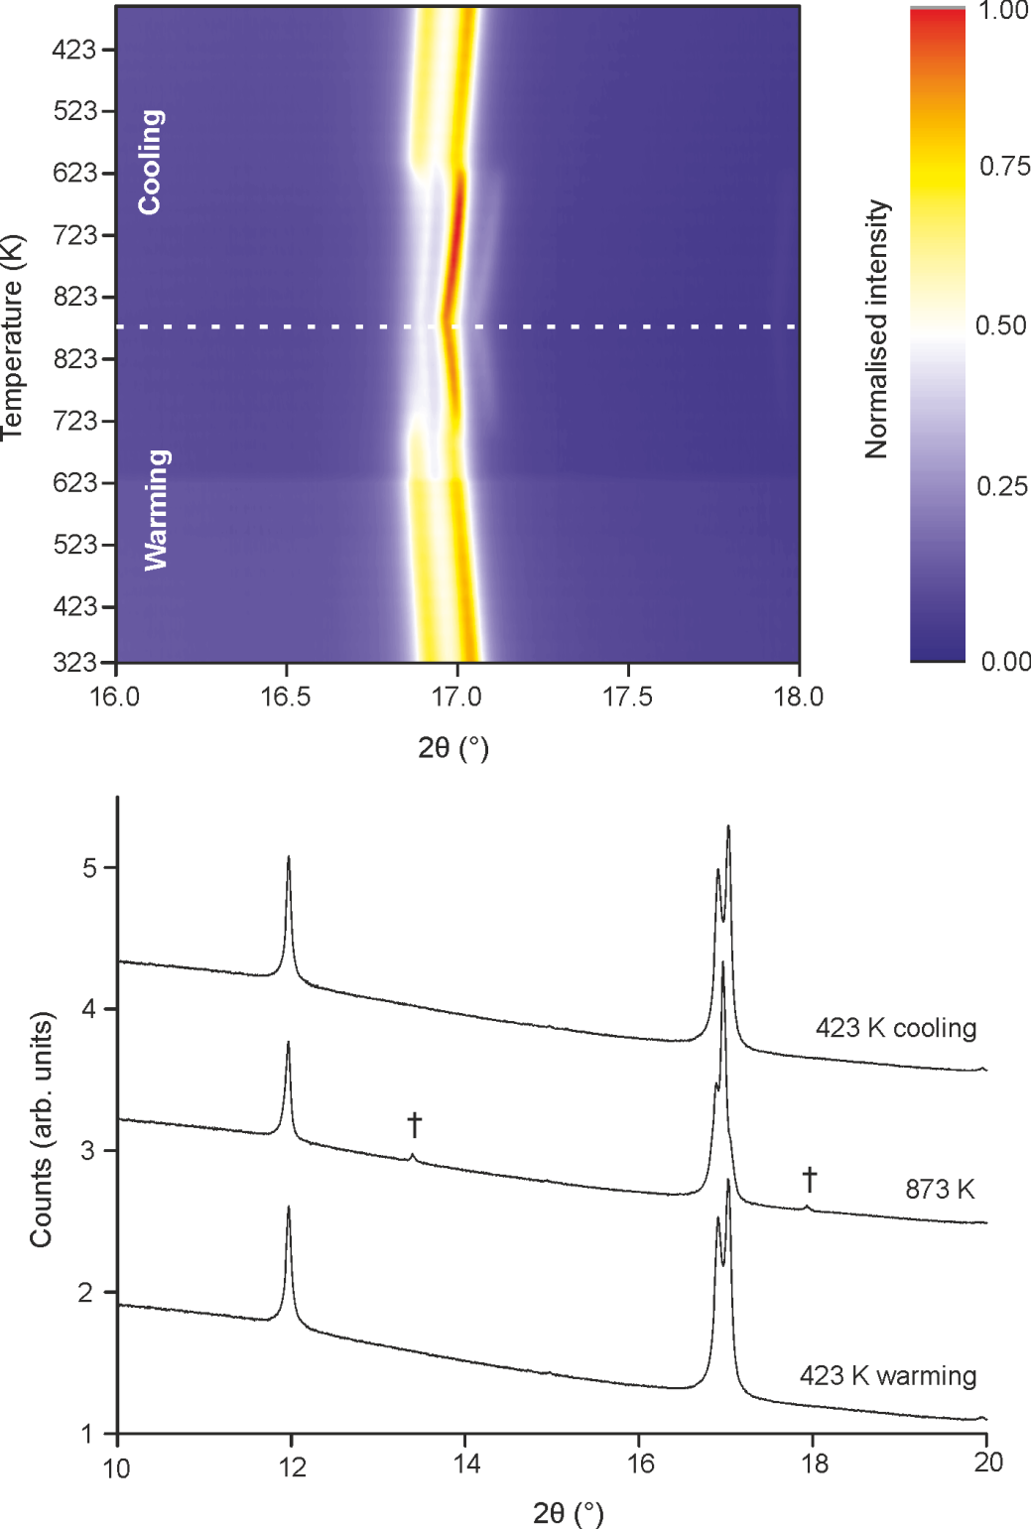

Figure S15. PXRD data (I11) showing the high temperature structural phase transition of x = 0.15, y = 0.75 which occurs simultaneously with depolarisation. (a) Evolution of the (110)_{p} cubic perovskite sub-cell peaks on warming to from 323 to 873 K and subsequent cooling, showing a discontinuous change consistent with a structural phase transition, (b) diffraction patterns collected at 423 K (warming), 823 K, and 423 K (cooling) showing the presence of new peaks (†) at high temperature.

Figure S16. Evolution of the unit cell parameters of composition x = 0.15, y = 0.75, derived from Lebail fits to PXRD data (I11) data collected on warming to 683 K.

Figure S17. SEM images from an un-polished surface of a spinel-free pellet fragment of composition x = 0.15, y = 0.75.
Figure S18. SEM images from a spinel-containing powder sample of composition x = 0.15, y = 0.75.

(b)
(a)
Figure S19. Composition diagrams derived from SEM-EDX compositional analysis of (a) a powder sample of spinel-containing x = 0.15, y = 0.75, and (b) spinel-free pellet sample of x = 0.15, y = 0.75. Black points represent experimental data, red points represent nominal composition.

