Effects of annealing conditions on resistive switching characteristics of SnOx thin films

Jidong Jin ^{a, c}, Jiawei Zhang ª, Remzi E. Kemal ª, Yi Luo ª, Peng Bao ª, Mohammed Althobaiti ^{b}, David Hesp ^{b}, Vinod R. Dhanak ^{b}, Zhaoliang Zheng ^{b}, Ivona Z. Mitrovic ^{c}, Steve Hall ^{c}, Aimin Song ª

ª School of Electrical and Electronic Engineering, University of Manchester, Manchester, M13 9PL, UK

^{b} Department of Physics and Stephenson Institute of Renewable Energy, University of Liverpool, Liverpool, L69 3BX, UK

^{c} Department of Electrical Engineering and Electronics, University of Liverpool, Liverpool, L69 3GJ, UK

Abstract
A resistive random-access memory based on an Al/SnOx/Pt structure is demonstrated. The SnOx thin films were prepared by DC sputtering at room temperature and different post-deposition thermal treatments carried out. We observe a significant improvement of bipolar resistive switching characteristics after annealing at 300 ºC in nitrogen. The obtained memory devices show good stability with a relatively long retention time, exceeding 10⁵ s. The resistance ratio remains above 55 within the duration of 100 endurance cycles. An interface modified space-charge-limited-current model is proposed as a possible switching mechanism. The achieved characteristics of the resistive switching in SnOx films seem to be a promising candidate for nonvolatile memory applications.

Keywords:
Tin compounds; Resistive switching; Annealing;

1. Introduction
The development of resistance random-access memory (RRAM) has progressed rapidly in the past few years due to its simple structure, fast switching speed, low power consumption and compatibility with the fast-developing metal-oxide-semiconductor technologies [1-4]. Various metal oxides such as ZnO [5-7], GaOx [8], IGZO [9], NiO [10], TiO2 [2, 11, 12], CuO [13], ZrO2 [14], and HfO2 [15] have been reported for the RRAM application. Such resistance switching behavior was also observed in a compound semiconductor nano-structure due to the trapping and detrapping of electrons at surface states [16]. The current-voltage (I-V) characteristics of RRAM devices show two distinctive states: low-resistance state (LRS) and high-resistance state (HRS). The switching event from HRS to LRS is called the “set” process, and that from LRS to HRS state is called the “reset” process. For most RRAM devices, a voltage larger than those for set and reset is required in order to activate the resistive switching operation, which is known as the “forming process” [13]. However, some devices do not require a forming process [6-8, 17]. In general, resistance switching can be classified as unipolar or bipolar, according to its dependence on the polarity of the operating voltage [12]. For a unipolar switching device, the switching direction only depends on the amplitude of the applied voltage. Hence, set and reset processes occur at the same voltage polarity. In most cases, unipolar switching can be explained using the so-called filament model and the reset process typically involves Joule heating inside the device [5, 9, 10]. For a bipolar switching device, the switching direction typically depends on the polarity of the applied voltage. Hence, set and reset processes occur at opposite voltage polarities and the electric field plays an important role. The space-charge-limited-current (SCLC) mechanism is the most well-known to explain bipolar switching [14, 18-21].
Tin oxides (SnOx) are wide bandgap metal-oxide semiconductors and are present in two well-known forms namely tin monoxide (SnO) and tin dioxide (SnO2). Thin films of SnO2 typically have a band gap of 3.6 eV and are already used in applications such as transparent conductors, gas sensors and solar cells [22-23]. As-grown SnO2 thin films generally exhibit n-type conductivity, the origin of which has been discussed in terms of intrinsic defects, such as oxygen vacancies and tin interstitials. However, the attribution of conductivity to intrinsic defects is not supported by first-principle calculations [24]. In contrast to SnO2, SnO thin films have a band gap of 2.7-3.4 eV and are currently one of the very limited number of p-type metal-oxide semiconductors [25-29]. The origin of p-type conductivity in SnO has been mainly attributed to Sn vacancies and O interstitials, where tin is in the Sn²⁺ oxidation state [26]. SnO was believed to be metastable at ambient conditions. It can decompose into Sn and SnO2 at temperatures above 300 ºC even in the absence of oxygen [30].
Given that SnOx thin films have been demonstrated for both n-type and p-type thin-film transistors and basic CMOS circuits, it is important to develop SnOx thin film based memory devices since they are basic building blocks in complex circuitry for potential applications. So far, a number of studies have been published on the realization of SnOx thin film based unipolar [31, 32] or bipolar [33, 35] RRAM. It has been established that annealing can greatly degrade [34] or enhance [35] the memory performance. However, the studies into the annealing effects are so far quite limited and, to the best of our knowledge, annealing in only one gas atomosphere has been reported to date. In this paper, the effects of annealing in air and nitrogen atmospheres are investigated for direct current (DC) sputtered SnOx thin film based RRAM devices. Furthermore, a possible switching mechanism for our devices is discussed.

2. Experiments
The RRAM devices with an Al/SnOx/Pt structure were fabricated as shown in Fig. 1(a). SnOx thin films of 50 nm thickness were deposited on a Pt/Glass substrate at room temperature by DC sputtering with an Ar pressure of 10⁻³ mbar using a SnO target (99.9% purity, PI-KEM Ltd.). Aluminum top electrodes with a diameter of 200 µm were deposited by thermal evaporation through a shadow mask. Devices without undergoing annealing or those annealed in air did not show good resistive switching behavior. The best device performance was achieved after the devices were annealed in nitrogen with an optimum annealing temperature identified as 300 ºC. The annealing was carried out using a Linkam annealer with a PR 600 temperature control unit which has 1 ºC temperature accuracy and stability. Only results from devices annealed in nitrogen at 300 ºC are shown in this paper. The devices were characterized using a semiconductor parameter analyzer (E5270B, Agilent Technologies) at room temperature. During the I-V measurements, the top electrode was biased positively and the bottom electrode was grounded. To correlate the device performance and SnOx film compositions, x-ray photoelectron spectra (XPS) were taken on SnOx films under different thermal annealing conditions, using an ultra-high vacuum spectrometer consisting of a twin anode x-ray source and a PSP Vacuum Technology 5-channel electron energy analyzer. The crystal structure of the SnOx film annealed in nitrogen was analyzed by x-ray diffraction (XRD). Furthermore, the band gap of the SnOx films under different thermal annealing conditions were estimated from variable angle spectroscopic ellipsometry (VASE) data measured using a J. A. Woollam M2000 ellipsometer at the three angles of incidence 65 º, 70 º and 75 º in the energy range 0.7 to 5.2 eV (referring to a wavelength range λ = 241.1 to 1686.7 nm).

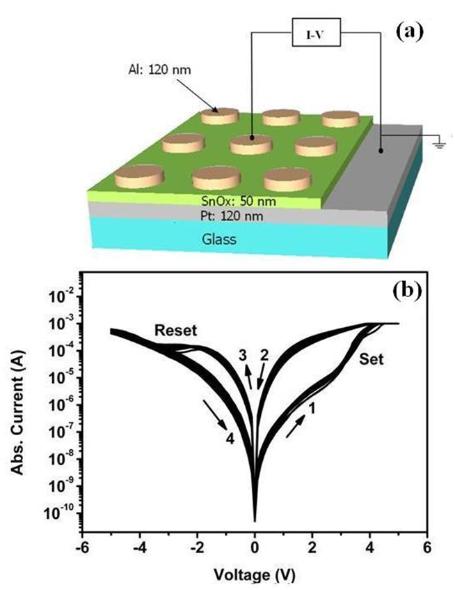
Fig. 1 (a) Schematic diagram of the SnO_{x} RRAM device structure. (b) Typical I-V characteristics of the nitrogen annealed SnO_{x} RRAM device for 100 sweep cycles. The arrows indicate the sweep direction.

3. Results and discussion
Figure 1(b) shows typical I-V characteristics of a SnOx-based RRAM that demonstrates bipolar resistive switching up to 100 cycles. The DC voltage was applied to the top aluminum electrode in a sequence:
0 V→ 5 V→ 0 V→ -5 V→ 0 V. Compliance currents were fixed at 1 mA in both the positive and negative voltage regions to prevent permanent breakdown of the device. We found that a forming process was not required for our SnOx RRAM. The set process was observed in the positive voltage region and the reset process was observed in the negative voltage region.
Figure 2 compares the Sn 3d5/2 XPS spectra from the as-grown sample (a), the sample annealed in air at 300 ºC (b) and the sample annealed in nitrogen at 300 ºC (c). It is worth observing in Fig. 2, that the centroid peak shift towards higher binding energies for air annealed samples. The Sn 3d5/2 line-shapes in Fig. 2 were deconvoluted using Voigt functions into three components ascribed to Sn²⁺ at 486.0 eV, Sn⁴⁺ at 486.7 eV and Snº at 484.1 eV. Figure 3 shows the corresponding O 1s spectra for the as-grown sample (a), the sample annealed in air at 300 ºC (b) and the sample annealed in nitrogen at 300 ºC (c). The binding energy assignment of the three species is in agreement with previous results [36].
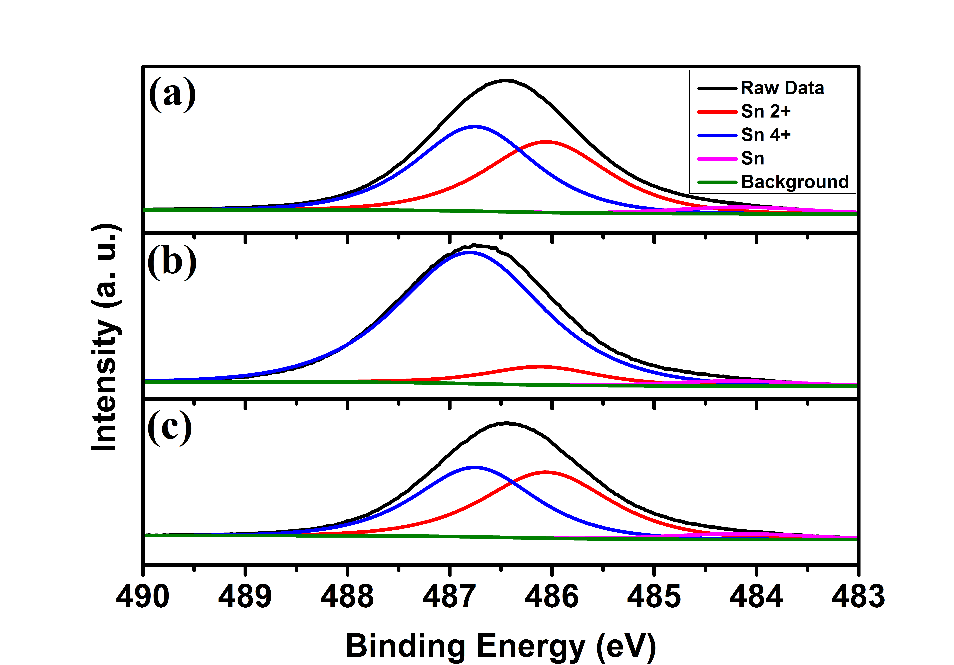
Fig. 2 XPS spectra of the Sn 3d5/2 for (a) the as-grown sample, (b) the sample annealed in air at 300 ºC for 1 hour and (c) the sample annealed in nitrogen at 300 ºC for 1 hour.
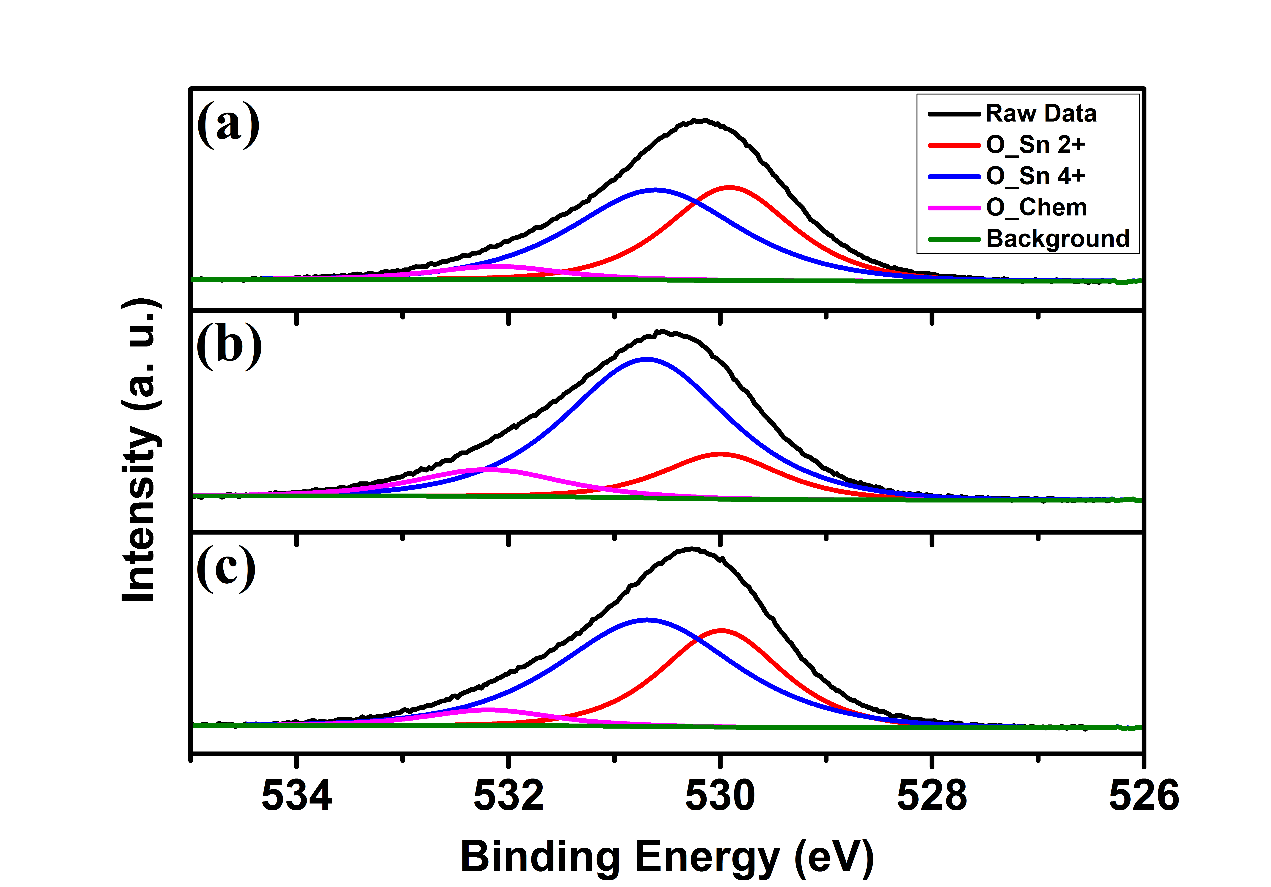
Fig. 3 XPS spectra of the O 1s for (a) the as-grown sample, (b) the sample annealed in air at 300 ºC for 1 hour and (c) the sample annealed in nitrogen at 300 ºC for 1 hour.

Figure 3 shows that the O 1s core-level XPS spectra can also be deconvoluted into three components, namely O-Sn²⁺ at 530.0 eV, O-Sn⁴⁺ at 530.7 eV and chemisorbed oxygen at 532.1 eV. The XPS data in Figs. 2 and 3 both indicate that there are two types of SnOx in the samples. The as-grown sample, without any treatment, shows a composition of 45% Sn²⁺, 51% Sn⁴⁺ and 4% Sn⁰. Annealing in air drastically increases the amount of Sn⁴⁺ in the sample to 88%, with small amounts of Sn²⁺ (9%) and Sn⁰ (3%) also present. Annealing in air also increases the O 1s component at about 532.5 eV, ascribed to chemisorbed oxygen or -OH species in the sample. In contrast, the nitrogen annealed sample has a comparable ratio of Sn²⁺ and Sn⁴⁺ with the as–grown sample (48 % Sn²⁺, 48% Sn⁴⁺ and 4% Sn⁰).
Figure 4 shows the XRD spectrum of SnOx thin film deposited on a glass substrate and then annealed in nitrogen at 300 ºC. The XRD pattern did not display any characteristic peaks, indicating that the film is amorphous. Yabuta et al. reported that annealing tin-oxide thin films in nitrogen could improve the crystalline quality of the films but the resulting crystalline phase is very sensitive to sputtering and annealing conditions [28]. In their experiment, amorphous SnO films were deposited by radio-frequency (RF) sputtering with a SnO target. Lower sputtering powers were found to induce more defects in the tin-oxide films, which were not crystallized even by annealing in nitrogen at 300 ºC. Our DC sputtered SnOx films may be similar to their low-power RF sputtered films. It may be possible that the nitrogen annealing process helped to improve the lattice structure but in the meantime still allowed a sufficient number of defects such as the oxygen vacancies in SnOx film to enable the memory switching effect. We observed that our SnOx RRAM did not require a forming process, which may also be attributed to the nature of the defects in the oxide layer [6].
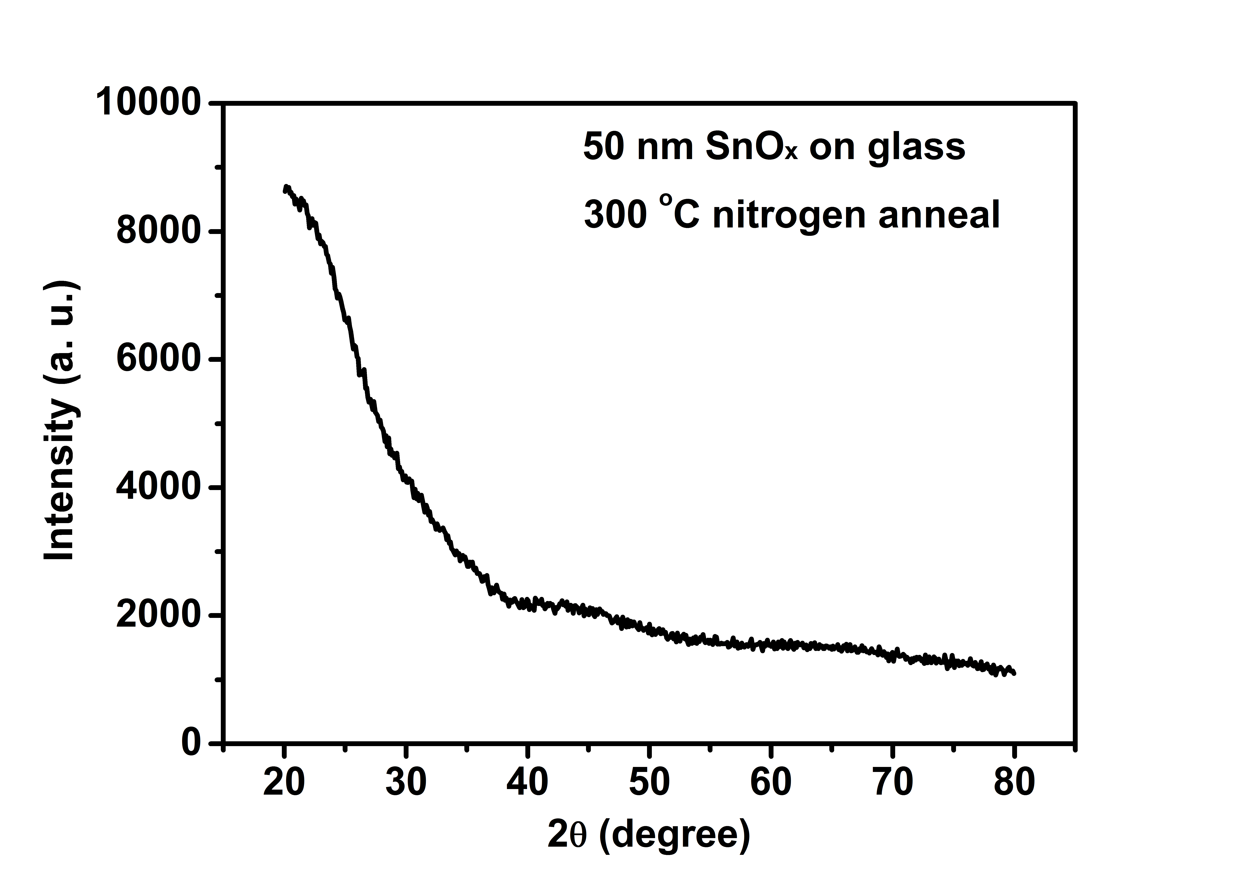
Fig. 4 XRD spectrum of a SnOx thin film deposited on a glass substrate after annealing at 300 ºC for 1 hour in nitrogen.

Figures 5(a) and (b) show the extinction coefficient (k) and absorption coefficient (α) against photon energy (E) respectively for the SnOx samples. The band gap values estimated from the k and α methods are shown in Table 1, where α is calculated from k as α=4πk/λ. The Tauc plot method was used to determine whether the SnOx films have direct or indirect band gap [37, 38]. The indirect band gap approximation of the Tauc plot, (αE)^{0.5} vs E, is shown in Fig. 5(c) for the SnOx samples and it can be seen that the extracted band gap values are smaller than those extracted from the k and α method shown in Table 1. The band gap values determined from the Tauc plot tend to give smaller band gap values [39] due to the use of the square root of the extinction coefficient, which decreases the concave up nature of the curve as shown in Fig. 5(c). The direct band gap approximation of the Tauc plot, (αE)² vs E, was also used to determine the band gap of the SnOx samples, however it yielded anomalously high values much larger than those extracted from the k and α methods shown in Fig. 5(a)-(b) and Table 1. Thus, we infer the indirect band gap nature of SnOx. Furthermore, it is evident that there is a slight increase in band gap after annealing either in air (~ 0.08 eV) or nitrogen (~ 0.05 eV). The sub-band gap absorption peaks could relate to the presence of defect states within the SnOx films. There is a considerable change of the absorption region at ~2.6 eV after annealing in either air or nitrogen as shown in Fig. 5; nitrogen annealing induces lowering of sub-band gap absorption and suggests a reduction of defects, where air annealing appears to enhance absorption and likely increase presence of defect states. It is suggested that a reduction of defects in the nitrogen annealed samples constitutes optimization of the device performance.
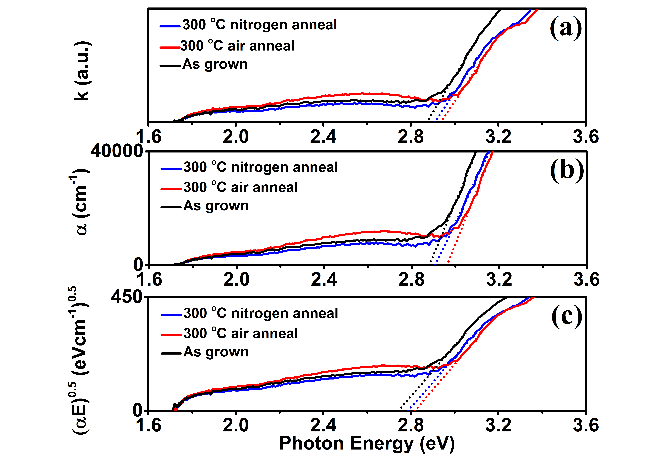
Fig. 5 Band gap extraction of the SnOx films from (a) extinction coefficient, (b) absorption coefficient and (c) indirect band gap approximation of Tauc plot.

TABLE 1: Band gap values (eV) determined from different methods for the SnOx films using VASE

Sample | k method | α method | Tauc plot  indirect band gap approximation
As grown | 2.87 | 2.88 | 2.74
300 ºC air annealed | 2.94 | 2.96 | 2.82
300 ºC nitrogen annealed | 2.91 | 2.91 | 2.79

We now consider the conduction mechanisms in the RRAM device. The I-V curves in the positive and negative voltage regions are re-plotted on log-log scales, as shown in Figs. 6(a) and (b), respectively. The arrows indicate the bias sweep direction. For the positive bias voltage, the I-V curve shows a linear behavior with a slope of 1 in the low voltage region of the HRS, followed by a slope of 2.5, and finally a sharp current rise at a threshold voltage VT ≈ 2.5 V with a steep slope of 7. This behavior can be explained by the trap-controlled SCLC mechanism [40]. According to the SCLC model, the threshold voltage corresponds to the transition voltage from trap-unfilled SCLC region to the trap-filled SCLC region. In the voltage-decreasing scan, the I-V slope becomes 2 again, suggesting that the dominant conduction mechanism of LRS may be explained by the SCLC model with no traps (or deactivated traps after having been filled with electrons). In the low voltage region of LRS, the I-V curve recovers to a linear behavior, showing that ohmic conduction is dominant. In the negative voltage region, as shown in Fig. 6(b), the ohmic conduction was initially observed, followed by trap filled SCLC with a slope of 2, and then a sharp decrease in current near a threshold voltage -2.9 V, which implies a transition from the trap-filled SCLC to the trap-unfilled SCLC.
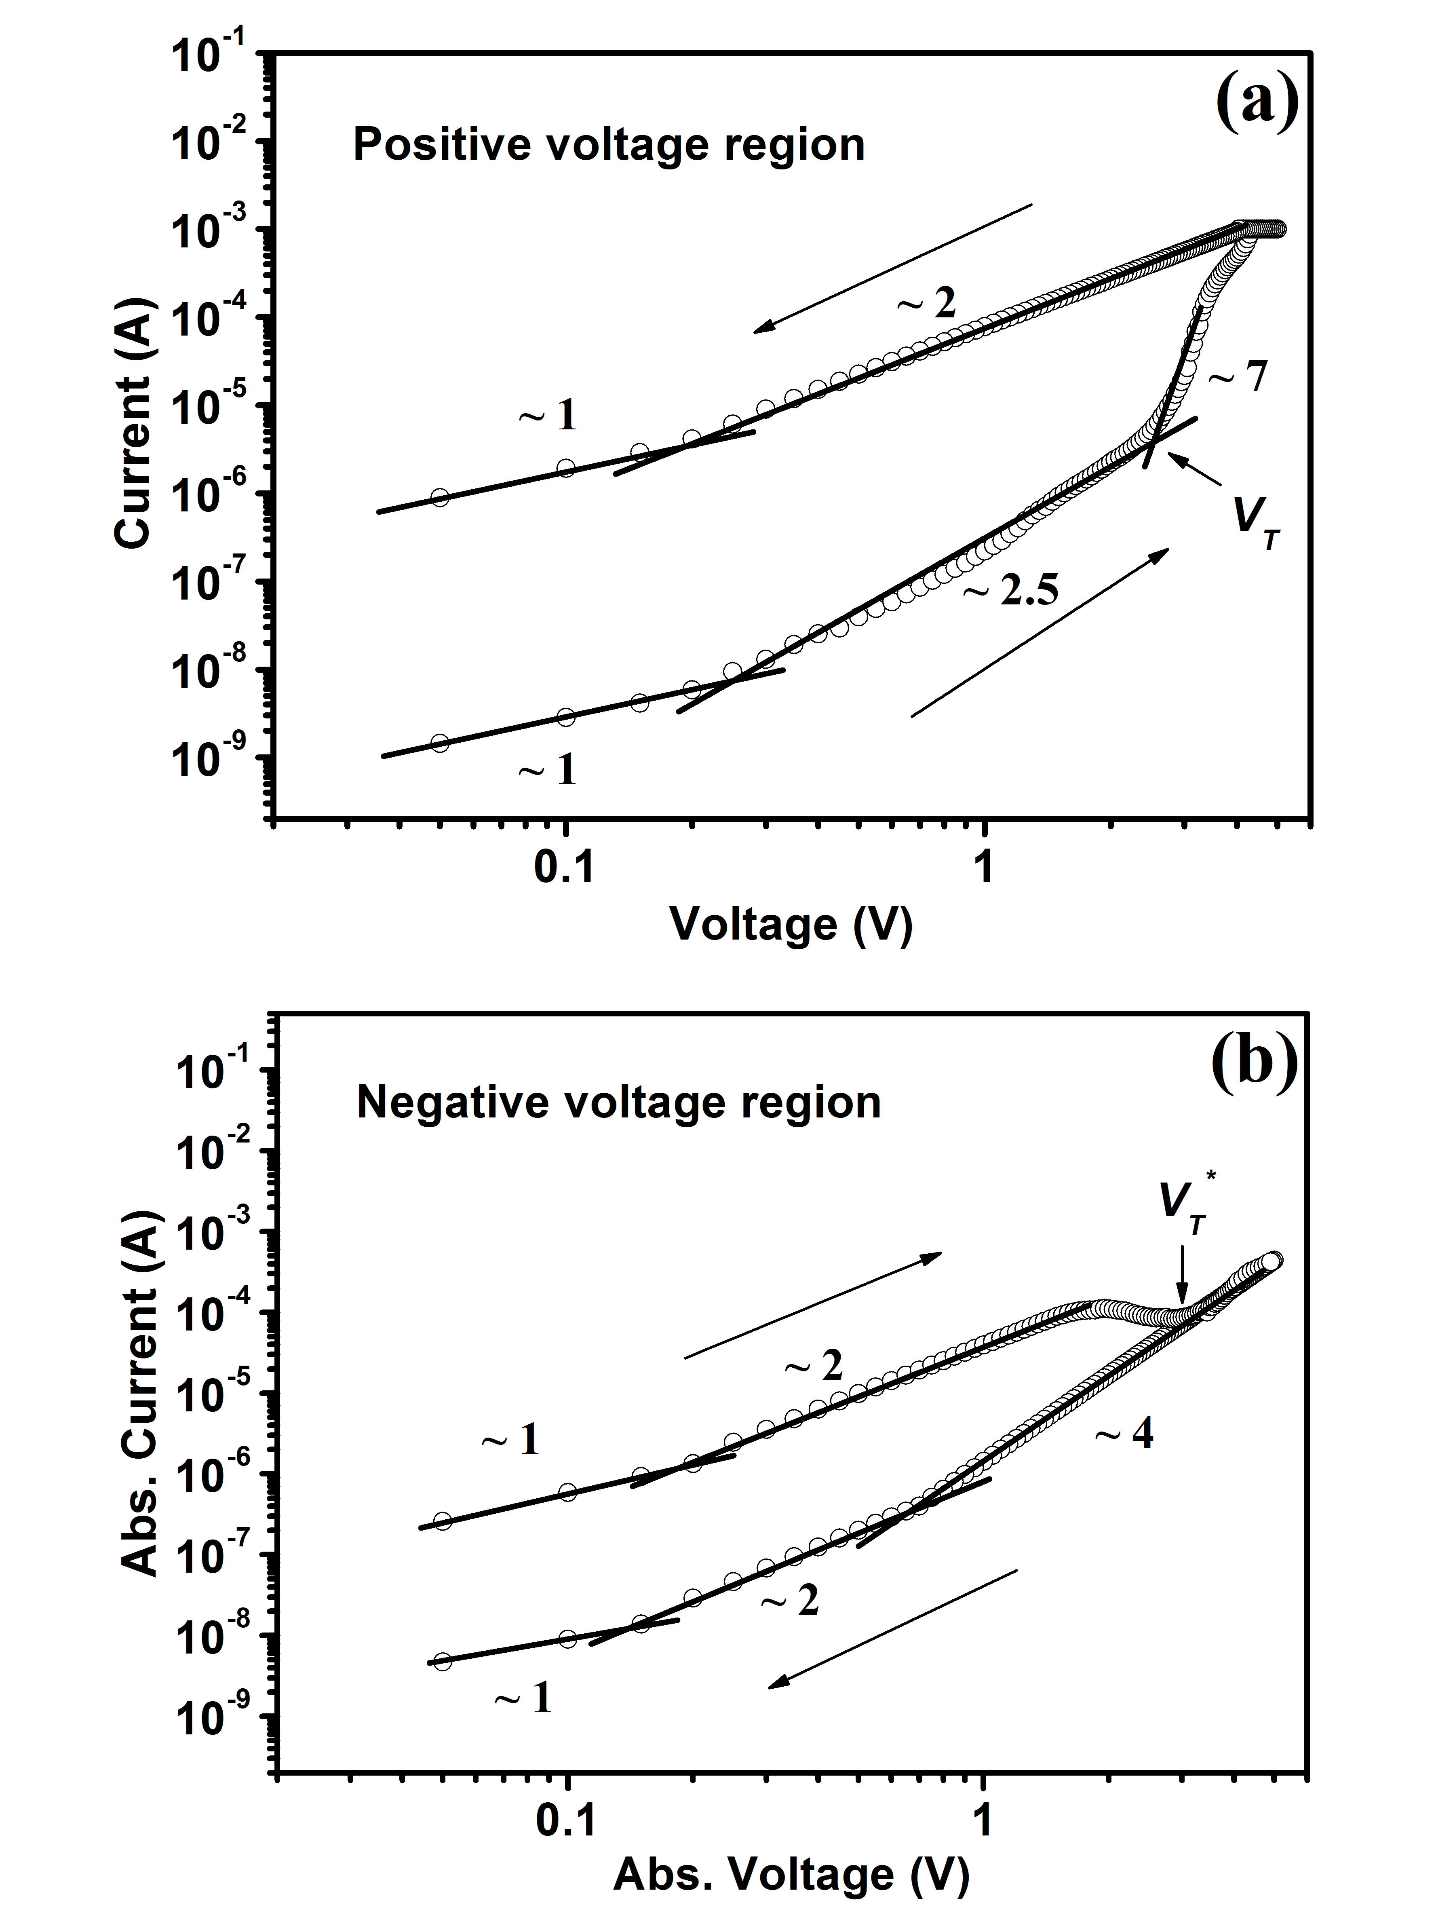
Fig. 6 The I-V characteristics of the nitrogen annealed SnO_{x} RRAM device in (a) positive voltage region and (b) negative voltage region in double-logarithmic scale.
When the I-V characteristics are dominated by an exponential distribution of traps, the trap-controlled SCLC can be expressed by
, (1)
where J is the current density, is the permittivity of free space, is the static dielectric constant, is the electron mobility, V is the applied voltage, d is the film thickness, NC is the effective density of states in the conductive band, Nt is the number of emptied electron traps, Ec is the energy of the conduction band edge, Et is the energy of the traps, kB is Boltzmann’s constant, and T is the absolute temperature. If the majority of electron traps are occupied, the SCLC with no traps can be expressed as
. (2)
The observed resistive switching phenomenon of our device may be explained with this theory. Within both the positive and negative voltage regions, ohmic conduction is dominant in the LRS, suggesting that the injected carrier density is less than thermally generated carrier density. In the positive region, when the applied voltage exceeds 0.2 V, electrons are injected from the bottom electrode and the I-V slope changes from 1 to 2. At this stage, shallow traps are expected to be gradually filled and the I-V characteristics become dominated by traps up to 2.5 V. As such, the SCLC follows Eq. (2). As the applied voltage is further increased, the current voltage shows an abrupt increase, suggesting that the injected electron current begins to be dominated by different trap states [19, 21]. In the voltage-decreasing scan, the I-V slope becomes 2 again, indicating that the dominant conduction mechanism of LRS may be described by the SCLC model with no traps according to
Eq. (1). In the negative voltage region, electrons are expected to be discharged from the occupied traps. Figure 6(b) suggests that trap carriers are released at – 2.9 V with the carrier-transport mode changing from trap-filled SCLC to the trap-unfilled SCLC.
Recently, it has been demonstrated that a combination of the bulk effect such as SCLC conduction and interface modification that occurs between the reactive metal electrode and metal oxide material plays a role in the resistive switching [33, 34]. It is believed that the interface modification also plays an important role in our SnOx memory devices. To explore this possibility, different top electrode metals such as Ag and Pt were tested on SnOx RRAM, but none of them showed good resistive switching operation after annealing in nitrogen. This indicates that Al top electrode has a strong influence on the resistive switching for the SnOx RRAM devices. The SnOx thin films used in our RRAM devices are a mixture of SnO and SnO2, where the standard Gibbs free energy (ΔG) for formation of Al2O3 (ΔG ~ -1582.3 KJ/mol) [41] is far lower than that of and SnO (ΔG ~ -251.9 KJ/mol) [41] and SnO2 (ΔG ~ -568.9 KJ/mol) [42]. Moreover, the Al³⁺/Al reduction potential (-1.66 V) is much lower than that of Sn⁴⁺/Sn²⁺ (0.15 V) and Sn²⁺/Sn⁰ (-0.14 V) pairs. Therefore, the zero-valent Al can be oxidized by SnOx films, resulting in the formation of an Al2O3 interfacial layer and that leads to the presence of oxygen vacancies near the Al/SnOx interface. Hence, by applying a positive voltage at the Al top electrode, oxygen ions can migrate towards the top electrode more effectively, leaving oxygen vacancies in the SnOx film to form the highly conductive filament paths from the bottom to the top electrode, which results in LRS. When a negative voltage is applied to Al top electrode, the oxygen vacancies would be filled by oxygen ions, which results in HRS. Thus, we suggest that the Al/SnOx interface is modified and the migration of oxygen ions plays an important role in the formation of the filamentary path. In addition, we found that replacement of Al by Ag and Pt always results in poor resistive switching behavior. This is presumably due to the difficulty of forming the interfacial layer, since both Ag and Pt have a higher ΔG of oxide formation than SnOx, where ΔG ~ -11.20 KJ/mol for Ag2O [41], ΔG ~ 167.8 KJ/mol for PtO2 [41]. Forming an interfacial layer by oxidizing Ag and Pt with Sn⁴⁺ or Sn²⁺ is also difficult when annealing in nitrogen at 300 ºC, because the reduction potentials of Ag⁺/Ag (0.8 V) and Pt²⁺/Pt (1.2 V) are much higher than that of Sn⁴⁺/Sn²⁺ pair.
To evaluate the reliability of the memory devices, endurance and retention tests were carried out. Figures 7(a) and (b) show the endurance and retention behavior obtained by plotting the resistance data at 1 V. The LRS and the HRS were maintained rather steadily over 100 cycles with a resistance ratio of at least 55. A retention time reaching 10⁵ s was also obtained, showing a decent reliability of the SnOx RRAM devices for nonvolatile-memory applications.
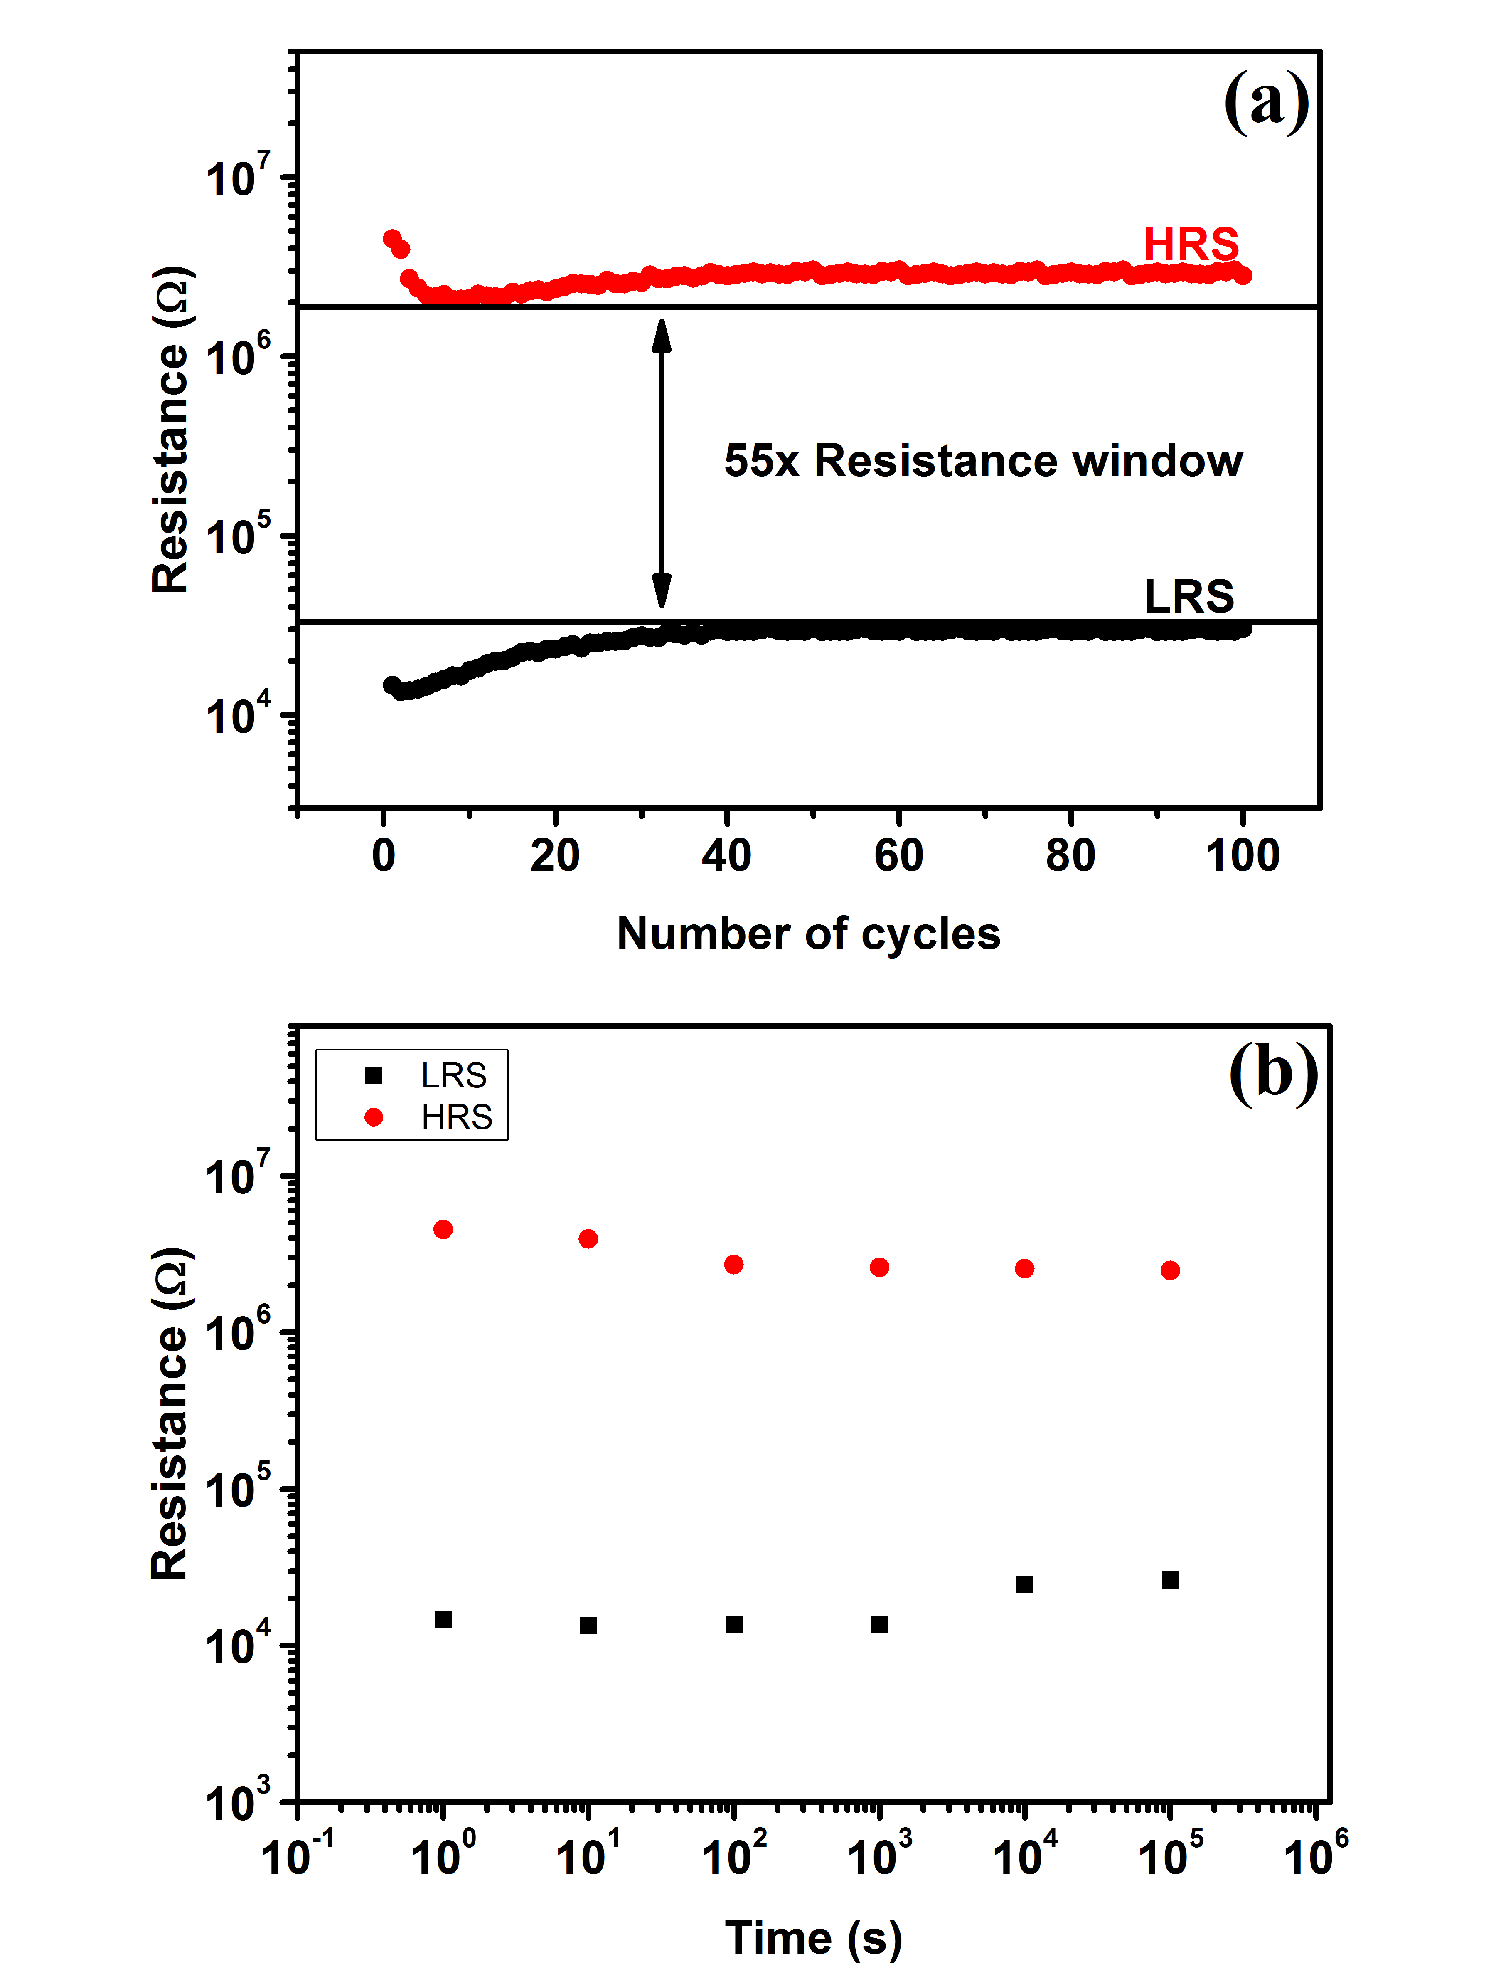
Fig. 7 (a) Endurance and (b) retention performance of the nitrogen annealed SnOx RRAM device.

4. Conclusions
The performance of RRAM devices based on DC sputtered SnOx thin films was investigated. After annealing in nitrogen with an optimum temperature of 300 ºC, the devices exhibited rather stable bipolar-switching operations and a relatively large resistance ratio. We also show that the devices did not require any forming process, which may be attributed to sufficient oxygen vacancies generated in the SnOx layer. The bipolar resistance switching behavior was discussed in terms of an interface modified SCLC model. Our results suggest that the Al/SnOx/Pt structure after a suitable annealing process may be a promising candidate for emerging nonvolatile memory applications.

References
[1] R. Waser, R. Dittmann, G. Staikov and K. Szot, Adv. Mater. 21 (2009) 2632.
[2] J. J. Yang, F. Miao, M. D. Pickett, D. A. A. Ohlberg, D. R. Stewart, C. N. Lau and R. S. Williams, Nanotechnology 20 (2009) 215201.
[3] K. Shibuya, R. Dittmann, S. Mi and R. Waser, Adv. Mater. 22 (2010) 411.
[4] H. Akinaga and H. Shima, Proc. IEEE 98 (2010) 2237.
[5] W. Y. Chang, Y. C. Lai, T. B. Wu, S. F. Wang, F. Chen and M. J. Tsai, Appl. Phys. Lett. 92 (2008) 022110.
[6] N. Xu, L. F. Liu, X. Sun, X. Y. Liu, D. D. Han, Y. Wang, R. Q. Han, J. F. Kang and B. Yu, Appl. Phys. Lett. 92 (2008) 232112.
[7] J. Qiu, A. Shih, W. Zhou, Z. Mi and I. Shih, J. Appl. Phys. 110 (2011) 014513.
[8] X. Gao, Y. Xia, J. Ji, H. Xu, Y. Su, H. Li, C. Yang, H. Guo, J. Yin and Z. Liu, Appl. Phys. Lett. 97 (2010) 193501.
[9] M. C. Chen, T. C. Chang, C. T. Tsai, S. Y. Huang, S. C. Chen, C. W. Hu, S. M. Sze and M. J. Tsai, Appl. Phys. Lett. 96 (2010) 262110.
[10] D. Ielmini, C. Cagli and F. Nardi, Appl. Phys. Lett. 94 (2009) 063511.
[11] D. B. Strukov, G. S. Snider, D. R. Stewart and R. S. Williams, Nature 453 (2008) 80.
[12] D.-H. Kwon, K. M. Kim, J. H. Jang, J. M. Jeon, M. H. Lee, G. H. Kim, X.-S. Li, G.-S. Park, B. Lee, S. Han, M. Kim and C. S. Hwang, Nat. Nanotechnol. 5 (2010) 148.
[13] K. Fujiwara, T. Nemoto, M. J. Rozenberg, Y. Nakamura and H. Takagi, Jpn. J. Appl. Phys. 47 (2008) 6266.
[14] Q. Liu, W. Guan, S. Long, R. Jia, M. Liu and J. Chen, Appl. Phys. Lett. 92 (2008) 012117.
[15] P. Gonon, M. Mougenot, C. Vallee, C. Jorel, V. Jousseaume, H. Grampeix and F. E. Kamel, J. Appl. Phys. 107 (2010) 074507.
[16] A. M. Song, M. Missous, P. Omling, I. Maximov, W. Seifert and L. Samuelson, Appl. Phys. Lett. 86 (2005) 042106.
[17] N. Xu, L. F. Liu, X. Sun, C. Chen, Y. Wang, D. D. Han, X. Y. Liu, R. Q. Han, J. F. Kang and B. Yu, Semicond. Sci. Techno. 23 (2008) 075019.
[18] A. Odagawa, H. Sato, I. H. Inoue, H. Akoh, M. Kawasaki, Y. Tokura, T. Kanno and H. Adachi, Phys. Rev. B 70 (2004) 224403.
[19] D. S. Shang, Q. Wang, L. D. Chen, R. Dong, X. M. Li and W. Q. Zhang, Phys. Rev. B 73 (2006) 245427.
[20] R. Dong, D. S. Lee, W. F. Xiang, S. J. Oh, D. J. Seong, S. H. Heo, H. J. Choi, M. J. Kwon, S. N. Seo, M. B. Pyun, M. Hasan and H. Hwang, Appl. Phys. Lett. 90 (2007) 042107.
[21] W. Y. Chang, J. H. Liao, Y. S. Lo and T. B. Wu, Appl. Phys. Lett. 94 (2009) 172107.
[22] M. Batzill and U. Diebold, Prog. Surf. Sci. 79 (2005) 47.
[23] K. Hara, T. Horiguchi, T. Kinoshita, K. Sayama, H. Sugihara and H. Arakawa, Sol. Energy Mater.Sol. Cells 64 (2000) 115.
[24] A. K. Singh, A. Janotti, M. Scheffler and C. G. Van de Walle, Phys. Rev. Lett. 101 (2008) 055502.
[25] R. Sivaramasubramaniam, M. R. Muhamad and S. Radhakrishna, phys. Status Solidi A 136 (1993) 215.
[26] A. Togo, F. Oba, I. Tanaka and K. Tatsumi, Phys. Rev. B 74 (2006) 195128.
[27] L. Y. Liang, H. T. Cao, X. B. Chen, Z. M. Liu, F. Zhuge, H. Luo, J. Li, Y. C. Lu, and W. Lu, Appl. Phys. Lett. 100 (2012) 263502.
[28] H. Yabuta, N. Kaji, R. Hayashi, H. Kumomi, K. Nomura, T. Kamiya, M. Hirano and H. Hosono, Appl. Phys. Lett. 97 (2010) 072111.
[29] K. Nomura, T. Kamiya and H. Hosono, Adv. Mater. 23 (2011) 3431.
[30] H. Giefers, F. Porsch and G. Wortmann, Solid State Ionics 176 (2005) 199.
[31] K. Nagashima, T. Yanagida, K. Oka and T. Kawai, Appl. Phys. Lett. 94 (2009) 242902.
[32] S. Almeida, B. Aguirre, N. Marquez, J. McClure and D. Zubia, Integr. Ferroelectr. 126 (2011) 117.
[33] X. H. Wu, Z. M. Xu, F. Zhao, X. H. Xu, B. B. Liu, T. Y. Sun, S. S. Liu, W. N. Zhao, and Z. C. Ma, J. Alloys and Compd. 602 (2014) 175–179.
[34] M. K. Hota, J. A. Caraveo-Frescas, M. A. McLachlan, and H. N. Alshareef, Appl. Phys. Lett. 104 (2014) 152104.
[35] D. Chen, S.H. Huang, J. Micro/Nanolith. MEMS MOEMS. 14 (2015) 024501.
[36] J. Szuber, G. Czempik, R. Larciprete, D. Koziej, B. Adamowicz, Thin Solid Films 391 (2001) 198.
[37] F. L. Martinez, M. Toledano-Luque, J. J. Gandia, J. Carabe, W. Bohne, J. Rohrich, E. Strub, and I. Martil, J. Phys. D: Appl. Phys. 40 (2007) 5256.
[38] I. Z. Mitrovic, M. Althobaiti, A. D. Weerakkody, N. Sedghi, S. Hall, V. R. Dhanak, P. R. Chalker, C. Henkel, E. Dentoni Litta, P.-E. Hellström, and M. Östling, Microelectron. Eng. 109 (2013) 204.

[39] M. Di, E. Bersch, A. C. Diebold, S. Consiglio, R. D. Clark, G. J. Leusink, and T. Kaack, J. Vac. Sci. Technol. A 29(4) (2011) 041001.

[40] M. A. Lampert and P. Mark, Current Injection in Solids. Academic, New York, 1970.
[41] D. D. Wagman, W. H. Evans, V. B. Parker, R. H. Schumm, I. Halow, S. M. Bailey, K. L. Churney, and R. L. Nuttall, J. Phys. Chem. Ref. Data 11(Suppl. 2) (1982) 127.
[42] R.L David, CRC Handbook of Chemistry and Physics. 77th ed., CRC. Boca Raton, 1996.

