SUPPORTING INFORMATION
Mechanistic Insight into the Superoxide Induced Ring Opening in Propylene Carbonate Based Electrolytes using in situ Surface-Enhanced Infrared Spectroscopy

J. Padmanabhan Vivekª, Neil Berryª, Georgios Papageorgiou^{b}, Richard J. Nicholsª,
Laurence J. Hardwick^{a*}
ªDepartment of Chemistry, University of Liverpool, Liverpool L69 7ZD, United Kingdom
^{b}Department of Physics, University of Liverpool, Liverpool L69 7ZF, United Kingdom

Corresponding author:
*hardwick@liverpool.ac.uk

Contents page

Page
Number
Figure S1 | SEIRA spectra of 0.1 M TEAClO₄/PC  (a) Deoxygenated  (b) Oxygenated | S3
Figure S2 | SEIRA spectra of 0.1 M LiClO₄/PC  (a) Deoxygenated  (b) Oxygenated | S4
Figure S3 | SEIRA spectra comparing LiClO₄/PC and CsClO₄/PC | S5
Figure S4 | SEIRA spectra comparing LiClO₄/PC and LiClO₄/EC | S6
Figure S5 | Throughput spectra of TEAClO₄/PC and of LiClO₄/PC at OCV | S7
Figure S6 | Standard ATR spectra of PC, TEAClO₄ and PC+ 1M TEAClO₄ | S8
Table S1 | IR band assignments | S9
Figure S7 | - Cyclic Voltammogram of oxygenated 0.1 M LiClO₄/DMSO  - ATR spectrum of DMSO  - SEIRA spectra of oxygenated 0.1 M LiClO₄/DMSO | S10
Table S2 | Coordinates of reactants, transition states and products for data shown in Figure 7 | S11
References |  | S16

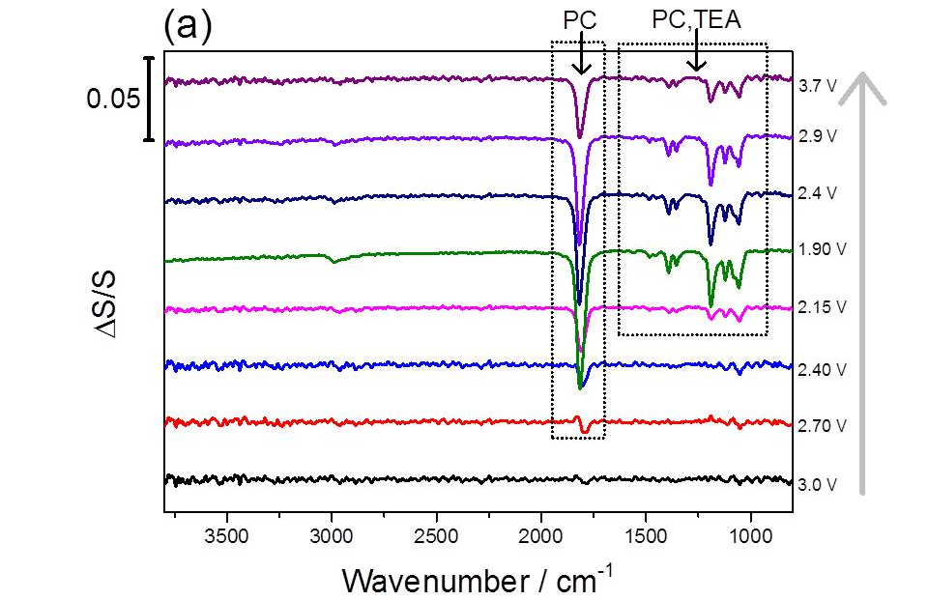
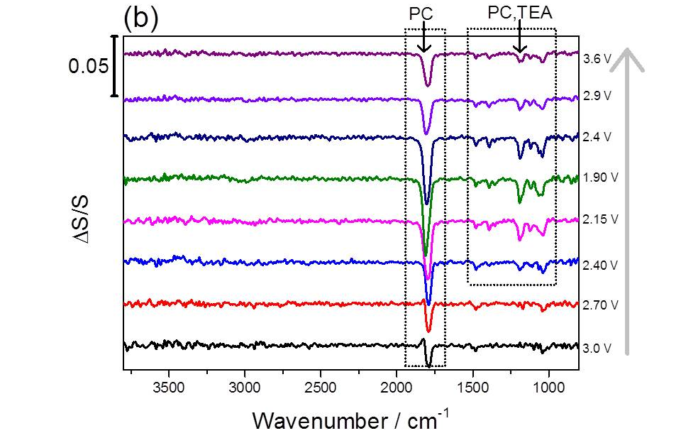
Supplementary figure S1: Expanded view of the SEIRA spectra shown in Figure 3, extending to higher wavenumbers.
(a) Deoxygenated 0.1 M TEAClO₄/PC (b) oxygen saturated 0.1 M TEAClO₄/PC.
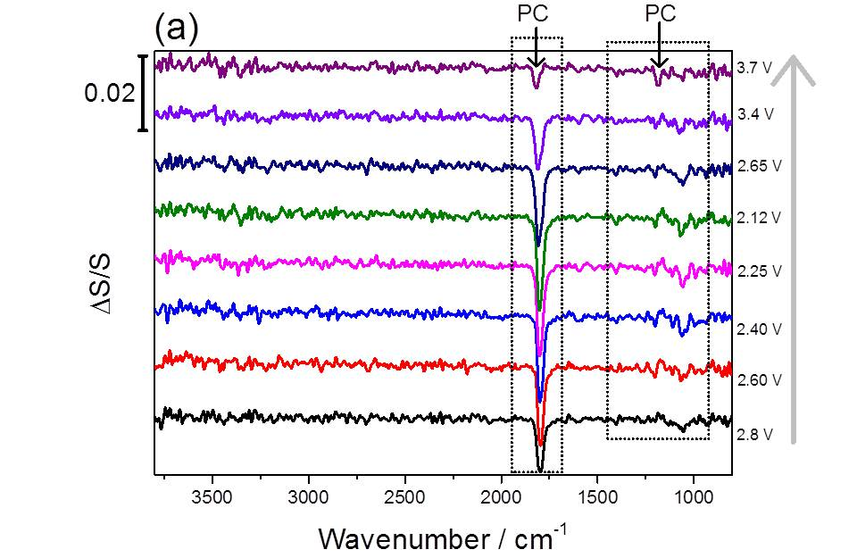
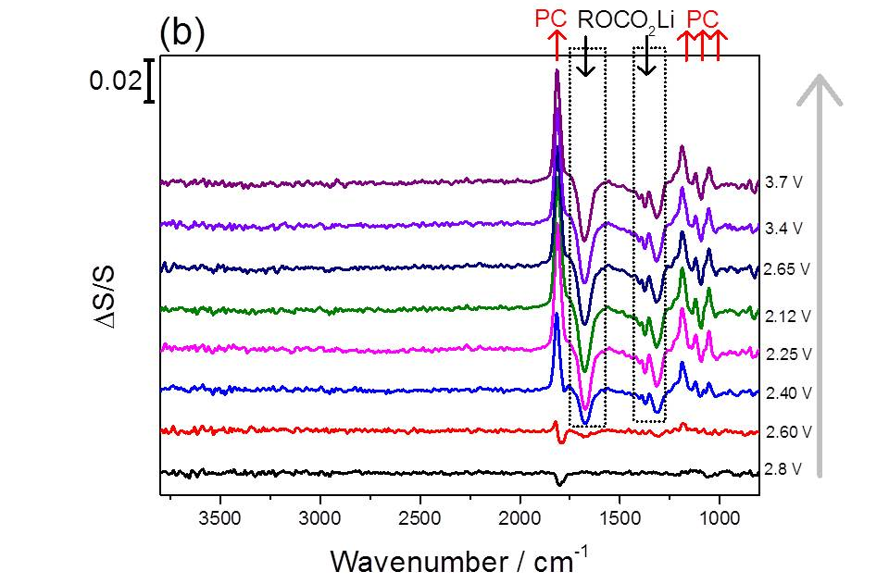
Supplementary figure S2: Expanded view of the SEIRA spectra shown in Figure 5, extending to higher wavenumbers
(a) Deoxygenated 0.1 M LiClO₄/PC (b) oxygen saturated 0.1 M LiClO₄/PC.
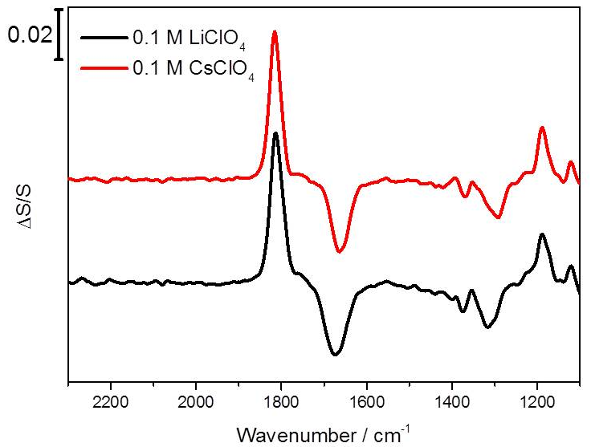
Supplementary figure S3: SEIRA spectra corresponding to PC ring opening in 0.1 M LiClO₄, PC as well as 0.1M CsClO₄, PC

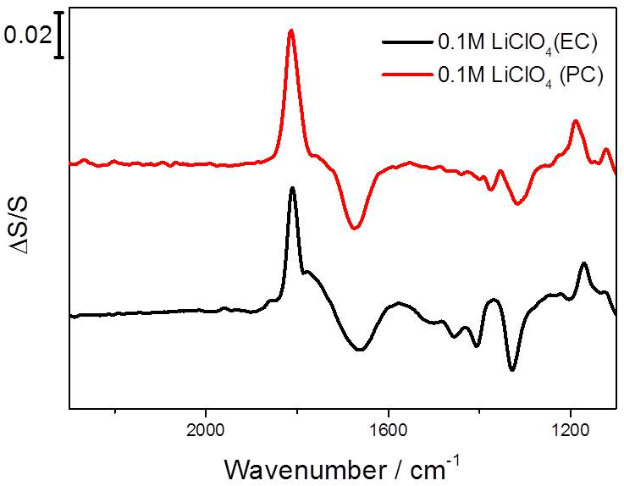
Supplementary figure S4: SEIRA spectra recorded for Au thin film electrode in oxygenated 0.1 M LiClO₄/PC compare to 0.1 M LiClO₄/EC. The downward peak around 1670 cm⁻¹ corresponds to the ring opened species were observed in both cases. SEIRA of EC/LiClO₄ was carried out at 40ºC (above the melting point of EC).

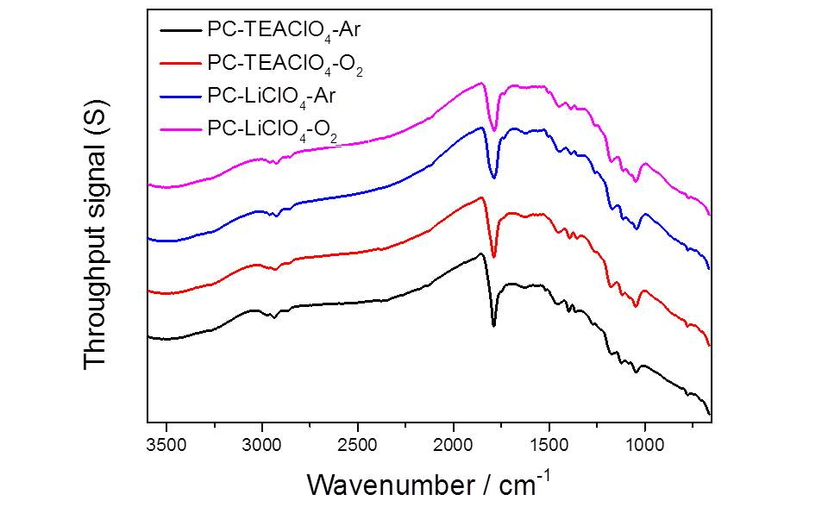
Supplementary figure S5: The original spectra at open circuit potential of PC-TEAClO₄ and of PC-LiClO₄ systems.

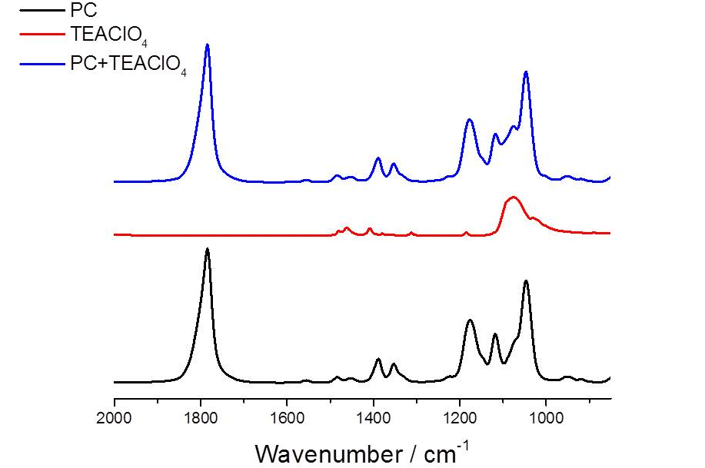
Supplementary figure S6: Standard ATR spectra of PC, TEAClO₄ and PC+ 1M TEAClO₄.

Supplementary Table S1: Band assignment for solvents, salts, model reaction products and main SEIRA bands from graphs presented in the paper.

 | Band Positions | Assignments
Propylene Carbonate | 1787 | ν(C═O)
 | 1556  1484  1452  1389  1353 | τ(CH₂) + ζ(CΗ₂)  ζ(CΗ₃)  ω(CH₂), ω(Ο−CH₂)  ν_{Ring},ω(CH₂)
 | 1118 | ν_{s}(CH₂−CH−CH₃)
 | 1176, 1075  1046 | ν_{s}(C−O−C) + ν_{as}(O−C−O), ν_{s}(C−O) ν_{s}(C−CH₃)
Tetraethylammonium Perchlorate | 1482,  1463,  1408,  1380,  1312 | τ(CH₂)  δ(CΗ₂)  δ_{as}(CΗ₃)  δ_{s}(CΗ₃)  τ(CH₂)
 | 1185 | C-C-N
 | 1077 | ν(ClO₄)
Lithium Propyl  Dicarbonate | 1660 | ν(C═O)
 | 1506  1454  1380  1314 | ν_{s}(C−CH₃)  ζ(CΗ₃)  δ_{s}(CΗ₃)  τ(CH₂)
Lithium Triethoxy Dicarbonate | 1680 | ν(C═O)
 | 1478, 1424, 1342 | τ(CH₂) + ζ(CΗ₂),  ω(CH₂), ω(Ο−CH₂)
Reaction product in PC-LiClO₄ at 2.12 V | 1676 | ν(C═O)
 | 1401, 1375, 1315 | ω(CH₂) + ω(Ο−CH₂), τ(CH₂)
Dimethyl sulfoxide | 2994, 2912  1437, 1406, 1309 | ν_{as}(CΗ₃), ν_{s}(CΗ₃)  δ_{a}(CΗ₃), δ_{a’}(CΗ₃), δ_{s}(CΗ₃)
Reaction product in DMSO-LiClO₄ at 2 V | 1443, 1306, 1290 | δ_{a}(CΗ₃), δ_{s}(CΗ₃), δ(CΗ₃)
* ν=stretching, τ=twisting, ζ=scissoring, δ= bending, ν_{s}= symmetric stretching, ν_{as}= asymmetric stretching, ω =wagging
The band assignments were on the basis of [1]-[8]
_{(a)}  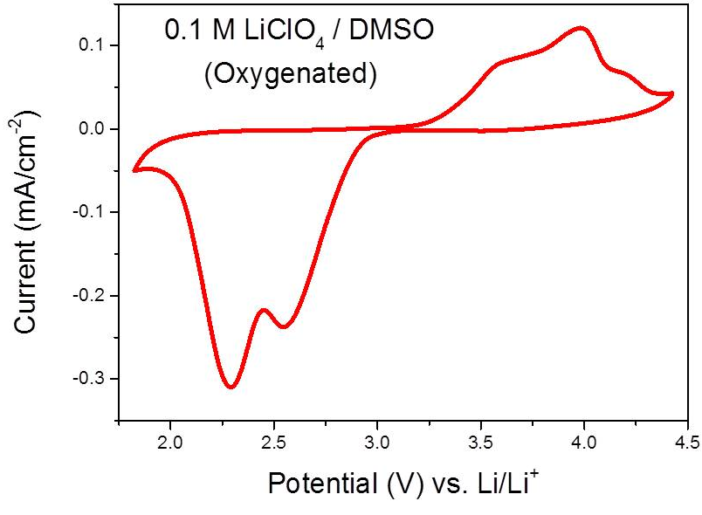 | _{(b)}  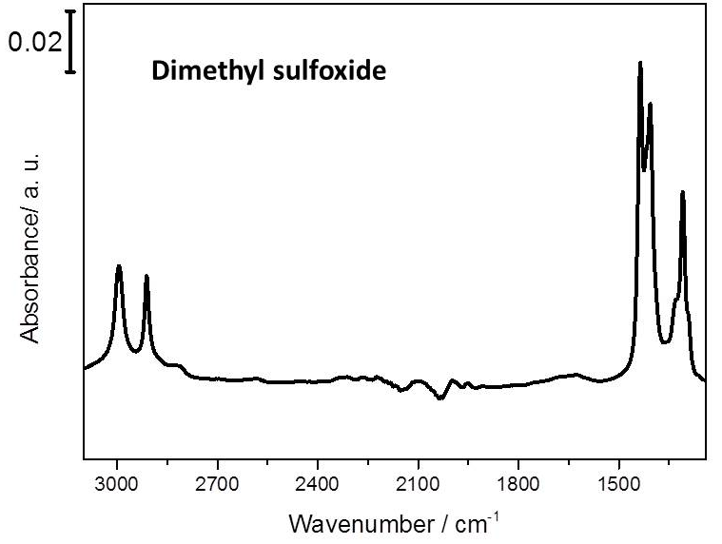
_{(c)}
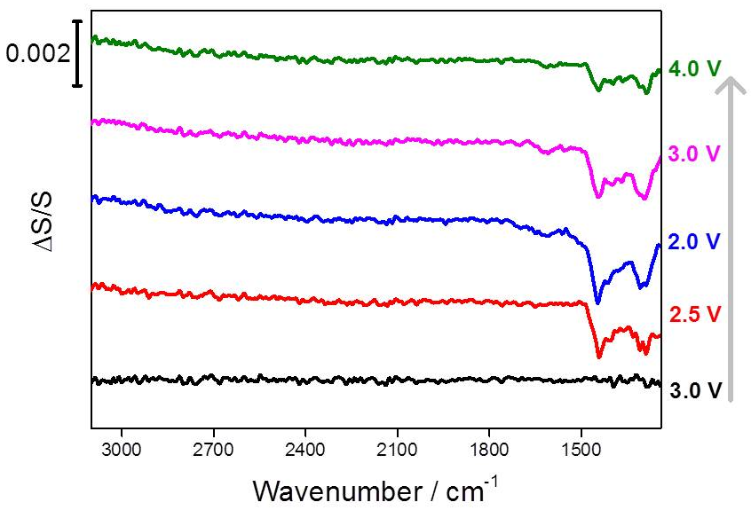

Supplementary figure S7: (a) Cyclic Voltammogram for the reduction of oxygen in 0.1 M LiClO₄/ dimethyl sulfoxide at 0.1 V/s scan rate. (b) Standard ATR spectrum of DMSO. (c) In situ SEIRA spectra obtained on a Au thin film electrode formed on a silicon prism, at representative potentials.

Unlike oxygenated PC/LiClO₄ or EC/LiClO₄ electrolytes, no new downward band can be seen in oxygenated DMSO/LiClO₄, suggesting superior stability of DMSO solvent in Li-O₂ environment.

Table S2
Coordinates of reactants, transition states and products for data shown in Figure 7
PC Li Reactants
6 1.752037000 -0.011479000 0.232270000
8 1.139614000 0.931867000 -0.499134000
6 -0.336000000 0.630212000 -0.579472000
6 -0.433231000 -0.703850000 0.164674000
8 0.979478000 -0.954890000 0.623905000
1 -0.847984000 1.433514000 -0.057640000
1 -0.569461000 0.566822000 -1.637137000
1 -1.007687000 -0.582568000 1.078056000
8 2.950380000 0.132884000 0.448111000
6 -0.856013000 -1.891374000 -0.659608000
1 -0.230859000 -1.990477000 -1.551052000
1 -1.893555000 -1.733567000 -0.952825000
1 -0.781628000 -2.807319000 -0.072882000
8 -2.726374000 0.358210000 -0.204253000
8 -2.669468000 1.132259000 0.846213000
3 2.873562000 1.795759000 -0.404875000

PC Li TS
6 1.737424000 -0.001267000 0.224636000
8 1.156435000 0.910876000 -0.540707000
6 -0.440844000 0.645503000 -0.522633000
6 -0.451790000 -0.692784000 0.206096000
8 0.941812000 -0.902514000 0.691778000
1 -0.795679000 1.496941000 0.043737000
1 -0.662415000 0.633250000 -1.581192000
1 -1.053651000 -0.612426000 1.106767000
8 2.947619000 0.085204000 0.428988000
6 -0.817780000 -1.878125000 -0.653174000
1 -0.170840000 -1.934166000 -1.532915000
1 -1.853376000 -1.757217000 -0.970414000
1 -0.718288000 -2.803260000 -0.085054000
8 -2.616506000 0.419266000 -0.313547000
8 -2.784296000 1.024530000 0.822953000
3 2.924403000 1.671747000 -0.551118000

PC Li Products
6 1.724814000 0.075019000 0.132467000
8 1.527510000 0.421587000 -1.070024000
6 -1.144426000 0.720387000 -0.292960000
6 -0.582051000 -0.572119000 0.299168000
8 0.709801000 -0.369333000 0.888054000
1 -0.926525000 1.572310000 0.352926000
1 -0.802537000 0.899275000 -1.308584000
1 -1.202776000 -0.810269000 1.164944000
8 2.851176000 0.139701000 0.674800000
6 -0.596033000 -1.729844000 -0.682711000
1 0.024574000 -1.506436000 -1.550570000
1 -1.621101000 -1.905156000 -1.016563000
1 -0.230678000 -2.636169000 -0.197989000
8 -2.580025000 0.593962000 -0.400310000
8 -3.161813000 0.635876000 0.759972000
3 3.351750000 0.776332000 -0.978570000

PC TEA Reactants
6 -1.766539000 0.953668000 0.747404000
8 -2.817120000 0.377064000 1.311009000
6 -3.635865000 -0.237869000 0.304810000
6 -2.979298000 0.179615000 -1.022407000
8 -1.858611000 0.983708000 -0.582821000
1 -3.596196000 -1.315757000 0.438429000
1 -4.647876000 0.154884000 0.420319000
1 -2.574855000 -0.705647000 -1.514711000
8 -0.847316000 1.440768000 1.354246000
6 -3.861836000 1.012494000 -1.925120000
1 -4.236750000 1.893030000 -1.397263000
1 -4.713431000 0.412364000 -2.253641000
1 -3.312668000 1.338726000 -2.809655000
8 -1.882825000 -2.600869000 -0.790884000
8 -1.307408000 -1.886803000 0.152246000
7 2.149895000 -0.038914000 0.306199000
6 3.547163000 -0.469307000 -0.049350000
1 4.085546000 0.435518000 -0.330673000
1 3.988422000 -0.841319000 0.875311000
6 3.675322000 -1.509544000 -1.148975000
1 3.427634000 -1.102751000 -2.127790000
1 3.061543000 -2.391403000 -0.964438000
1 4.718430000 -1.829556000 -1.179600000
6 1.303487000 -1.202474000 0.796111000
1 1.142432000 -1.871234000 -0.043135000
1 0.329220000 -0.777801000 1.026713000
6 1.863586000 -1.968444000 1.978600000
1 1.124129000 -2.738811000 2.203577000
1 1.981701000 -1.357970000 2.874410000
1 2.807016000 -2.472188000 1.756469000
6 2.247976000 0.971279000 1.437840000
1 2.888073000 0.516069000 2.192892000
1 1.237043000 1.066578000 1.832869000
6 2.781965000 2.341583000 1.050941000
1 2.859344000 2.925791000 1.969349000
1 2.101396000 2.873317000 0.387577000
1 3.775663000 2.312806000 0.601208000
6 1.435780000 0.625568000 -0.870379000
1 2.197641000 1.229474000 -1.368300000
1 0.698801000 1.289634000 -0.417313000
6 0.709925000 -0.289116000 -1.846829000
1 -0.128722000 -0.798500000 -1.369914000
1 1.350567000 -1.024117000 -2.330454000
1 0.300872000 0.362554000 -2.622343000

PC TEA TS
6 -0.777197000 -1.822743000 -1.202317000
8 -1.564996000 -1.139885000 -1.942605000
6 -2.262853000 0.144368000 -0.894895000
6 -2.064301000 -0.680989000 0.362448000
8 -0.944533000 -1.553597000 0.137020000
1 -1.520292000 0.867028000 -1.201066000
1 -3.214181000 0.144156000 -1.405869000
1 -1.766146000 -0.027495000 1.180547000
8 0.110143000 -2.587575000 -1.527640000
6 -3.301938000 -1.482394000 0.715045000
1 -3.583380000 -2.129440000 -0.119294000
1 -4.123825000 -0.796371000 0.928139000
1 -3.115638000 -2.100498000 1.593932000
8 -2.917904000 1.683587000 0.161169000
8 -1.873081000 2.198658000 0.722068000
7 2.212512000 0.327225000 -0.288276000
6 3.566941000 0.977946000 -0.173778000
1 4.271625000 0.291222000 -0.641357000
1 3.524581000 1.877338000 -0.787306000
6 4.032818000 1.312804000 1.232164000
1 4.207190000 0.418753000 1.829836000
1 3.341330000 1.969348000 1.760876000
1 4.984220000 1.840394000 1.145667000
6 1.109164000 1.258081000 0.186997000
1 1.308683000 1.479499000 1.232721000
1 0.191310000 0.674830000 0.154421000
6 0.944674000 2.544517000 -0.600162000
1 0.103303000 3.067063000 -0.141712000
1 0.678106000 2.370141000 -1.642989000
1 1.823282000 3.191066000 -0.553953000
6 1.975079000 0.019536000 -1.761895000
1 2.203845000 0.940884000 -2.296677000
1 0.908168000 -0.182421000 -1.865281000
6 2.774359000 -1.141535000 -2.328620000
1 2.536520000 -1.193460000 -3.392378000
1 2.470494000 -2.092663000 -1.896247000
1 3.853727000 -1.006287000 -2.240728000
6 2.158309000 -0.982496000 0.499306000
1 3.162458000 -1.405454000 0.430598000
1 1.475142000 -1.637296000 -0.041705000
6 1.688687000 -0.890305000 1.943153000
1 0.630778000 -0.637593000 1.996200000
1 2.260651000 -0.199893000 2.561503000
1 1.797612000 -1.890940000 2.365735000

PC TEA Products
6 -1.482765000 1.892108000 0.342000000
8 -2.505518000 1.932738000 1.015961000
6 -2.820843000 -0.706771000 0.740988000
6 -2.476878000 -0.124377000 -0.640029000
8 -1.383647000 0.772705000 -0.578293000
1 -1.997252000 -0.583532000 1.444554000
1 -3.734045000 -0.298685000 1.165950000
1 -2.093634000 -0.964317000 -1.231886000
8 -0.459841000 2.583859000 0.299471000
6 -3.690176000 0.465064000 -1.342894000
1 -4.080443000 1.304119000 -0.767275000
1 -4.467626000 -0.297152000 -1.444950000
1 -3.409945000 0.811361000 -2.338996000
8 -3.070139000 -2.135342000 0.622188000
8 -1.982190000 -2.792873000 0.369922000
7 1.975025000 -0.075891000 0.119466000
6 3.402534000 -0.552661000 0.135788000
1 4.017931000 0.344045000 0.195344000
1 3.531526000 -1.101702000 1.068328000
6 3.844917000 -1.397116000 -1.046502000
1 3.854905000 -0.826211000 -1.974133000
1 3.233338000 -2.289699000 -1.181967000
1 4.866974000 -1.726545000 -0.851580000
6 0.997960000 -1.233194000 0.202088000
1 1.177080000 -1.860395000 -0.668575000
1 0.015453000 -0.777052000 0.086322000
6 1.068861000 -2.065110000 1.470682000
1 0.319978000 -2.851384000 1.366570000
1 0.811864000 -1.493944000 2.362653000
1 2.038015000 -2.545557000 1.618196000
6 1.769120000 0.807409000 1.345124000
1 2.154446000 0.236559000 2.189957000
1 0.691332000 0.935937000 1.441935000
6 2.413210000 2.181178000 1.276978000
1 2.248890000 2.650275000 2.248538000
1 1.916868000 2.809838000 0.540565000
1 3.490823000 2.153473000 1.104740000
6 1.673214000 0.759690000 -1.127649000
1 2.597605000 1.300056000 -1.341504000
1 0.902332000 1.473169000 -0.822952000
6 1.172487000 0.001466000 -2.347157000
1 0.160106000 -0.364301000 -2.183073000
1 1.813317000 -0.816465000 -2.674629000
1 1.117777000 0.729552000 -3.158908000

References
[1] S. A. Freunberger, Y. Chen, Z. Peng, J. M. Griffin, L. J. Hardwick, F. Bardé, P. Novák, and P. G. Bruce, “Reactions in the Rechargeable Lithium–O2 Battery with Alkyl Carbonate Electrolytes,” J. Am. Chem. Soc., vol. 133, no. 20, pp. 8040–8047, May 2011.
[2] A. M. Haregewoin, E. G. Leggesse, J.-C. Jiang, F.-M. Wang, B.-J. Hwang, and S. D. Lin, “A combined experimental and theoretical study of surface film formation: Effect of oxygen on the reduction mechanism of propylene carbonate,” J. Power Sources, vol. 244, pp. 318–327, Dec. 2013.
[3] W. H. J. de Beer and A. M. Heyns, “The i.r. and Raman spectra of tetraethylammonium hexafluoroantimonate (C2H5)4NSbF6,” Spectrochim. Acta Part A Mol. Spectrosc., vol. 37, no. 12, pp. 1099–1107, Jan. 1981.
[4] D. Aurbach, “In situ FTIR Spectroelectrochemical Studies of Surface Films Formed on Li and Nonactive Electrodes at Low Potentials in Li Salt Solutions Containing CO2,” J. Electrochem. Soc., vol. 140, no. 11, p. L155, Nov. 1993.
[5] Y. Ikezawa and T. Ariga, “In situ FTIR spectra at the Cu electrode/propylene carbonate solution interface,” Electrochim. Acta, vol. 52, no. 7, pp. 2710–2715, Feb. 2007.
[6] S.-I. Pyun, “In-situ spectroelectrochemical analysis of the passivating surface film formed on a carbon film electrode as a function of the water content in 1 M LiPF 6 -EC/DEC solution,” J. Anal. Chem., vol. 363, no. 1, pp. 38–45, Jan. 1999.
[7] T. Zeegers-Huyskens and G. Bator, “Fourier transform infrared and Fourier transform Raman investigation of alkylammonium hexachloroantimonates,” Vib. Spectrosc., vol. 13, no. 1, pp. 41–49, Dec. 1996.
[8] M. Y. Skripkin,P. Lindqvist-Reis,A. Abbasi,J. Mink,I. Persson and M. Sandstrom, “Vibrational spectroscopic force field studies of dimethyl sulfoxide and hexakis(dimethyl sulfoxide)scandium(iii) iodide, and crystal and solution structure of the hexakis(dimethyl sulfoxide)scandium(iii) ion,” Dalton Trans., no. 23, pp. 1477-9226.

