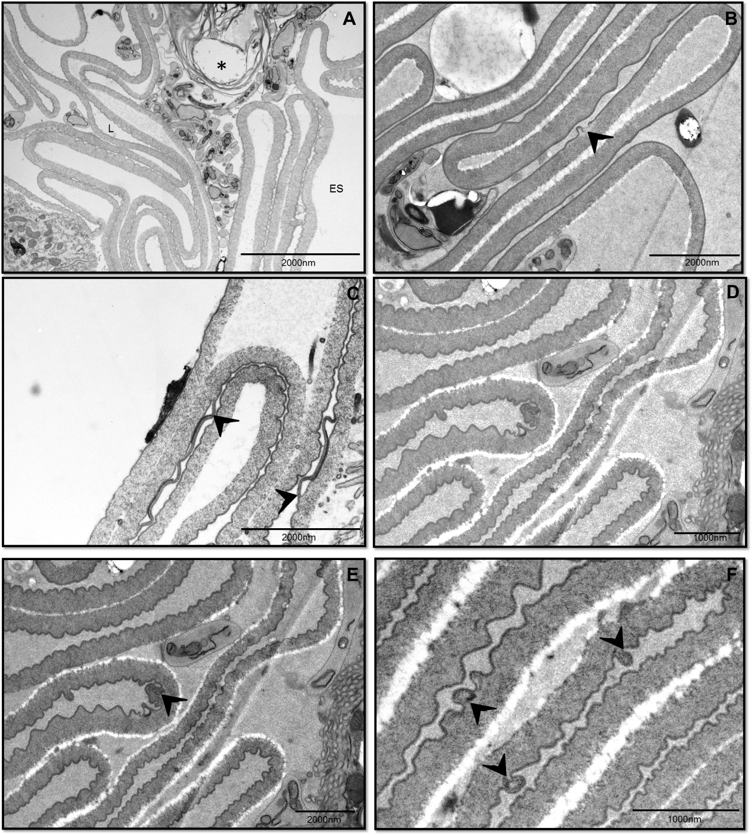
Ch5_S6. Selection of micrographs from infected flies which differ from the norm. A. Image from a fly at 11 d.p.i. Parasites are seen in the lumen (L) and also in the ectoperitrophic space (ES). Within the lumen, a large mass of material can be seen (*), which may be excess PM material. This occurrence can also be seen at 5 d.p.i. B. A small break in PM1 can be seen (arrow). C. PM1 can be seen to be thicker than normal in places as indicated by the arrows. This is not a normal occurrence. D-F. Sometimes PM1 appears crinkly and has small ‘bubbles’ between PM1 and PM2 which may be due to parasites.

