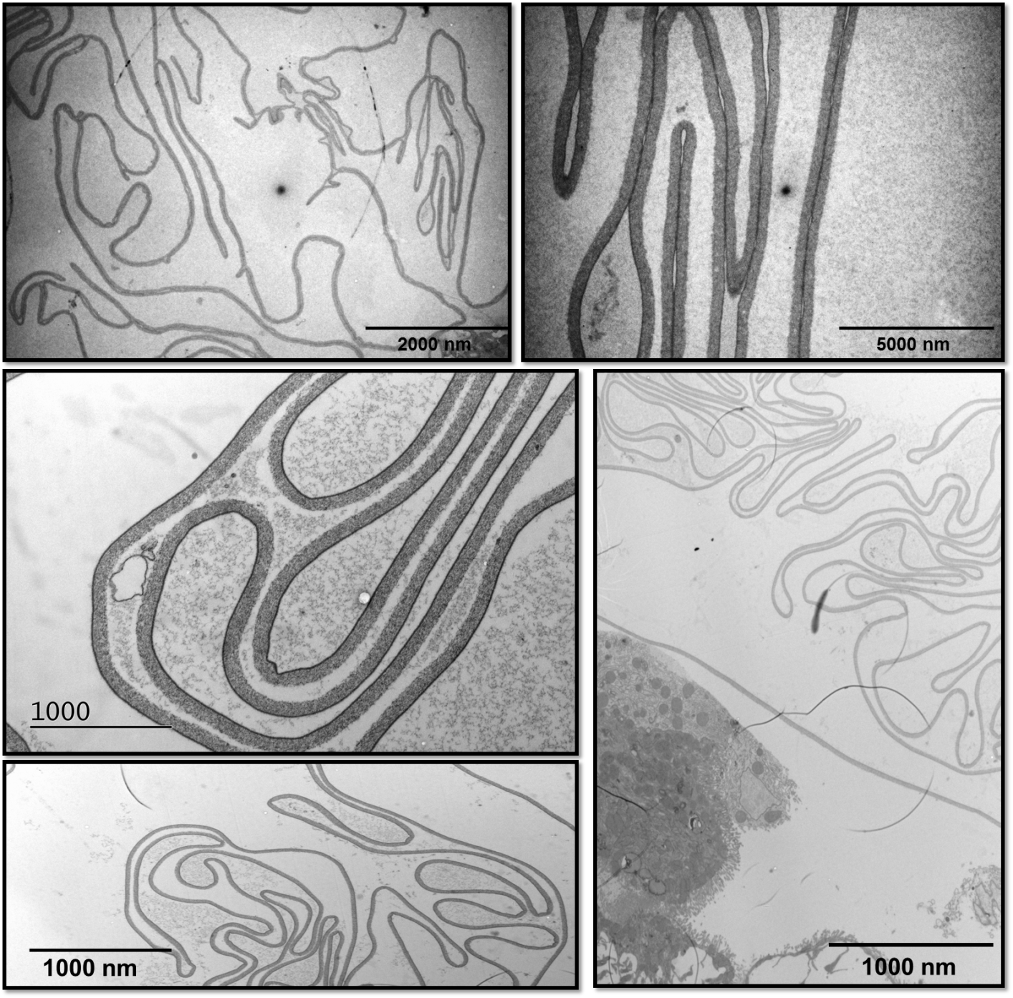

**E**

**D**

**C**

**B**

**A**

***Ch5_S7 Selection of micrographs from the hindgut of naïve and refractory flies.*** A-B Micrographs of the hindguts of naïve flies at 11 days. The PM is unbroken. C-E shows the hindguts of refractory flies at 11 d.p.i, which again shows the PM undamaged.