**Computational model of the interaction of a helium atmospheric-pressure jet with a dielectric surface**

M I Hasan and J W Bradley

Department of Electrical Engineering and Electronics, the University of Liverpool,

Brownlow Hill, L69 3GJ, U.K.

E.mail: [j.w.bradley@liv.ac.uk](mailto:j.w.bradley@liv.ac.uk)

**Abstract.** Using a time-dependent 2D axisymmetric fluid model the interaction of a plasma jet with a dielectric surface has been studied. The model is solved for two consecutive periods of a positive unipolar pulsed waveform. The study concentrates on determining the fluxes of the main oxygen ion species, , and the total accumulated charge on the surface. Approaching the dielectric surface, the streamer head is seen to divert its direction of propagation, spreading out radially approximately 0.2 mm above the dielectric surface. For  generated near the streamer head, this leads to a maximum in their flux to the surface which moves radially outwards with the streamer propagation, driven by the applied electric field in pulse on-time. In the off-time, the flux of drops by at least two orders of magnitude. As a result, the total number of  ions arriving at the surface over one entire pulse period (fluence) has an annular shape limited by the effective contact area of the streamer on the surface. In contrast ions generated in the pulse on-time do not reach the surface due to the direction of the applied electric field. In the off-time, ions generated at the edges of the deformed streamer are pushed by the accumulated surface charge outwards. As a result, the fluence has an annular structure with its maximum being outside the area of the dielectric surface covered by the plasma channel. Solving for the second pulse period shows small changes in the predicted fluences, with largest difference seen with . We see that increasing the flow rate (by a factor of three) shifts the position of the maximum fluence of  outwards, and decreasing the fluence in the second pulse period.

1. **Introduction**

Interest in the use of helium atmospheric-pressure plasma jets (He-APPJs) as sources of chemically and biologically active species for applications in materials processing and medicine has grown significantly in the last decade [1-4]. In many cases the surface or workpiece under plasma bombardment is a dielectric material that can retain surface charge, for instance a polymer web in industrial processing or living tissue (or in-vitro cultures) in new medical therapies. Therefore a proper understanding of the mechanisms of delivery of active species to dielectric surfaces and the nature of accumulated charge is vital for optimizing APPJs to suit a particular application. To-date much of the substantive work in APPJs, whether experimental or numerical, has concentrated on investigating free-stream conditions, in which the helium jet, comprising of plasma generated species, flows into an open air environment without interruption, and do not account for the plasma-surface interaction. Such interaction will both deform the plasma channel on contact and affect the internal plasma mechanisms but also deliver significant particles fluxes (charged and neutral particles) to the surface. Accordingly, optimizing APPJs performance in the presence of a surface based on open-jet studies would seem to have limited validity.

In the last few years, there have been only a limited number of experimental studies concentrating on how a He-APPJ is affected by the presence of a surface. These include a laser-based study of the helium metastable densities in the vicinity of a grounded conducting plate exposed to a jet [5]. It was observed that the presence of a grounded plate caused the plasma channel created by the streamer head exhibited glow-like discharge behaviour. In another optical diagnostic study the fluxes of oxygen and hydroxyl radicals impinging a range of surfaces with different degrees of surface moisture were determined for a He-APPJ [6]. It was found that the typical flux of OH to the surface had a maximum of ~ 1019 m-2s-1, while the O flux was considerably larger at ~ 1021 m-2s-1. Recently, a number of fluid modelling studies have focused on the interaction of atmospheric-pressure plasmas with surfaces, such as biological tissues [7,8] and liquids [9,10] when exposed to a planar dielectric barrier discharge (DBD).

A number of computational studies have modelled the behaviour of plasma in the capillary jet configuration, of relevance to this study. Breden *et al* [11] explored the correlation between the thickness of the target dialectic substrate with the flux of radical and ionic species emanating from a He-APPJs operating in a helium-dry air mixture. With increasing dielectric thickness the fluxes were found to decrease. Other similar configurations, in which the plasma surface interaction is treated, are a Xe-APPJ capillary of complex curved shape exiting into a chamber containing Xe/ Ne [12] and a He RF needle operating in ambient conditions [13].

Here we develop a DBD capillary model similar to that reported in [11], however extend it by considering, a more realistic electrode-capillary geometry; solving for two full periods of the applied waveform taking into account the memory effect and with the inclusion of air humidity. To demonstrate the trends in discharge behaviour we choose two representative ions  and , the latter particularly important in bactericidal effects [14].

1. **Numerical model**

The geometry of numerical model has been chosen to best represent our experimental plasma jet configuration reported in [15], however with slightly modified dimensions. The geometry of the model shown in figure 1 consists of a 30 mm long glass capillary of relative permittivity of 4.7, having an inner diameter of 1 mm and an outer diameter of 4 mm. Two electrodes of zero width and length of 1 mm are positioned on the external surface of the capillary. The upper electrode is a driven anode, while the lower electrode is grounded. A dielectric surface with the same relative permittivity as the capillary is exposed to the jet at a distance of 3 mm from the orifice of the capillary. Beneath the dielectric surface a second grounded electrode is placed. Two dielectric thicknesses of 0.5 mm and 2 mm are considered in the study.

The jet is solved using a 2D axisymmetric fluid model appropriate to the linear capillary geometry. The model consists of two components, one taking into account the hydrodynamic aspects and another to model the plasma processes. The hydrodynamic component computes the steady-state densities of the constituents of the background helium-humid air mixture, which are N2, O2, H2O and He. It also computes the steady-state velocity field of the total mixture. The Reynolds numbers for the flow rates assumed in this study indicate that the flow is a transitional state, which is known to be laminar close to the orifice of the capillary (i.e., the exit of the jet) [16]. Since the model focuses at the zone close to the orifice of the capillary, we assumed the flow conditions to be laminar. The hydrodynamic component consists of 5 equations, which are the mass conservation equation for the gas mixture, the momentum conservation equation for the gas mixture, and three mass fraction equations for the components of the gas mixture except He, which is determined from the pressure constraint. The equations are similar to those describing the helium-air mixture in [17]. The binary diffusion coefficients (diffusion coefficients for one species diffusing into another) used in the hydrodynamic component are computed using the Chapman-Enskog theory, then the effective diffusion coefficients (diffusion coefficient for one species diffusing in the mixture) are computed using a mixture-averaged diffusion formulation [18].

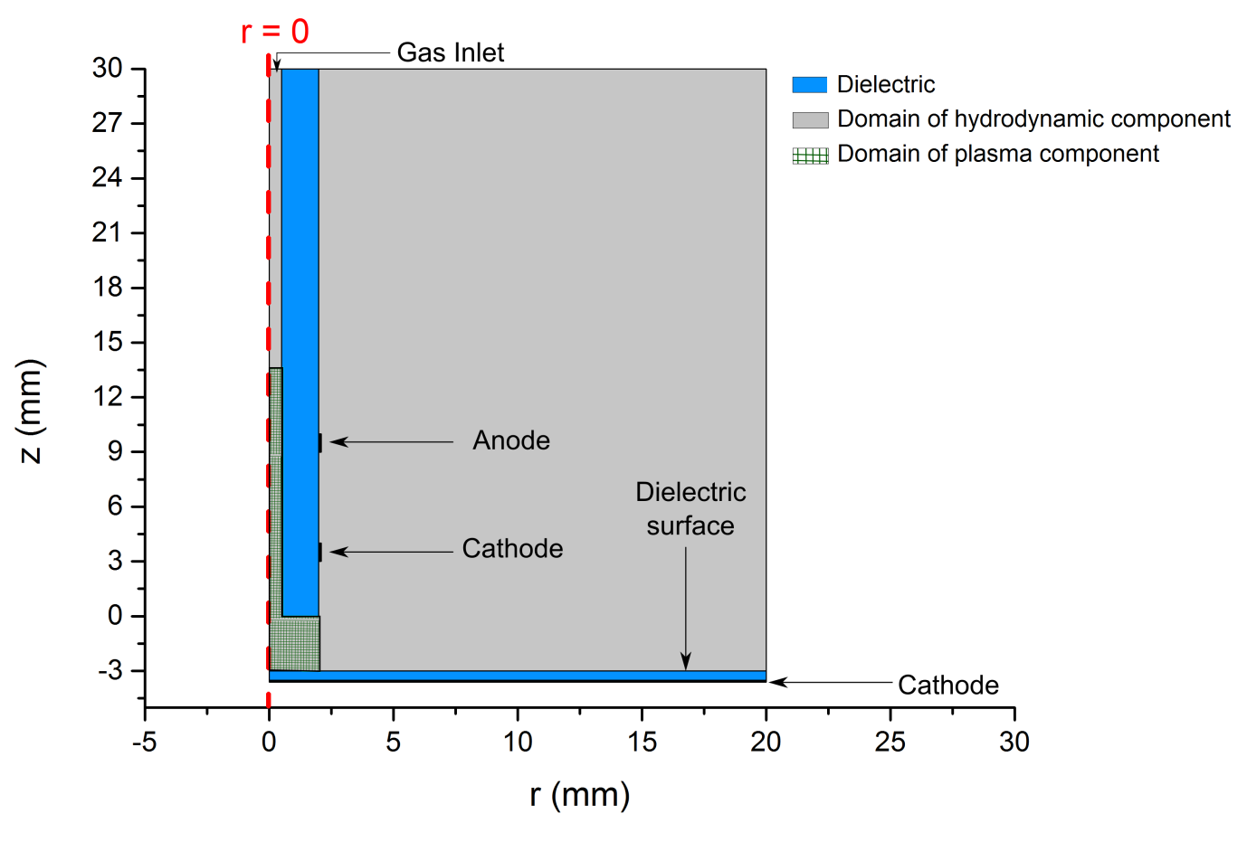

**Figure 1.** The geometry used in the model, with the computational domains for the hydrodynamic component and the plasma component of the models indicated. The electrodes are lines with zero width; they were made bold for illustration only.

The plasma component of the model computes the spatial and temporal evolution of the plasma parameters, which are the electron density *ne*, the electron energy density *nen*, the electric potential *V*, and the densities of the different excited and ionized species. The plasma component follows a total of 21 species with 240 reactions associated with them. The reactions lists can be found in appendix A. The species followed in the simulation are: e- (the electrons), He + , , , , N+ , O+, , , , , , O, H , OH, N, O3 and H2O2, in addition to the background gas constituents. The plasma component solves Poisson equation for the electric potential; it also solves the continuity equation for the species followed in the model and for the electron energy density. The equations of the plasma component are similar to those in [13]. The continuity equation of one of the previously mentioned species is given by equation (1). Because the continuity equation for the electron density in our model slightly deviates from [13], it is discussed here in details; equation (2) is the continuity equation for the electron energy density.

 (1)

 (2)

where *nj* is the density of the *j*th species, *j* is the flux of the *j*th species, which includes three flux components; a diffusion component, an electric field-driven component (only for charges species), and a convection component (for all species except electrons), *Rj* is the generation/loss rate of the *j*th species, *en*and *e*are the fluxes of the electron density and the electron energy density respectively, given by:

 (3)

 (4)

where *e*, *en*,*De*,*Den*are the mobilities and the diffusion coefficients of the electron density and the electron energy density, respectively. In equation (1), the first term in the right hand side *Pr* represents the collisional loss of electron energy due to reactions between electrons and the species followed by the model. The second term in the right hand side *Pim* represents the collisional loss of electron energy in rotational and vibrational excitation reactions with background gas constituents, which are not followed by the model. This term is written explicitly in equation (5). Although the densities of the rotational and vibrational states are not followed by the model, the energy consumed in their creation is accounted for by the term *Pim* in equation (1) to avoid over-estimation of the electron temperature.

 (5)

where  and  are the energies lost by the electrons due to the *j*th reaction with N2 and O2 respectively, *KN2j*and *KO2j*are the reaction coefficients for rotational and vibrational excitations of N2 and O2 respectively, *nN2* and *nO2* are the densities of N2 and O2. The summations in equation (5) run over the excitation reactions of ground state N2 and O2 to different rotational and vibrational states for the corresponding species.

To solve the continuity equations, the transport coefficients (diffusion coefficients and mobilities) for every species are needed. For the electron density and the electron energy density, the transport coefficients are computed using BOLSIG+ [19] as functions of the electron temperature and background gas composition. The diffusion coefficients for ions and neutrals are computed using the Chapman-Enskog theory combined with mixture-averaged diffusion formulation [18]. Ion moblities are determined from their diffusion coefficients via the Einstein relation [20].

The outputs of the hydrodynamic component of the model, namely the densities of the background gas constituents and the velocity field are used as inputs to the plasma component. The velocity field of the background mixture is introduced in the plasma component as a convective flux for all species except the electrons.

The computational domain of the plasma component is chosen to be a sub domain of the computational domain of the hydrodynamic component to save computation time. Both domains are indicated in figure 1. The assumed boundary conditions for both components are explained in appendix B. The model is implemented using COMSOL Multiphysics [21].

1. **Results and discussion**

In all simulations we assume a 7 kV rectangular pulse voltage waveform with duration and rise/fall times of 90 ns and 5 ns respectively as shown in figure 2. The model was computed for two He flow rates, 1 and 3 slm and two dielectric surface thicknesses, 0.5 and 2 mm, creating 4 combinations. For the 0.5 mm dielectric case, an extra period is solved (sequentially) after the first period assuming a frequency of 50 kHz. The level of impurities in the flow is 10 ppm (78.65% is N2, 20.85% is O2, and 0.5% H2O). A spatially uniform initial electron density of 1015 m-3 is assumed in the computational domain. All figures shown in this section are taken for the 3 slm flow rate with a dielectric thickness of 0.5 mm in the first period, unless stated otherwise.

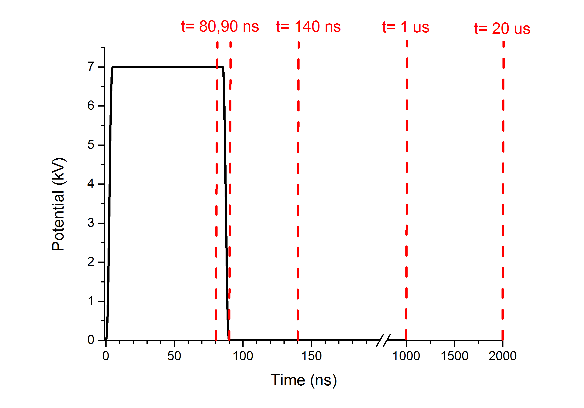

**Figure 2.** A single pulse of the applied voltage waveform, the vertical dashed lines indicate the times at which most of the figures in this work are presented.

* 1. *Surface charge density on the dielectric surface*

In He-APPJs, it is now accepted that a weakly conducting plasma channel is generated by a propagating streamer head (also known as a plasma bullet) [22-25]. As the streamer head approaches the surface of the exposed dielectric, the gap between the plasma channel and the surface narrows causing the electric field in the streamer head to become stronger. The strong electric field directed in the negative z direction (toward the dielectric surface) causes the positive ions in the vicinity of the surface to migrate to the dielectric surface, where they are lost and their positive charge is deposited on the surface of the dielectric.

The deposited surface charge due to the electric field-driven flux (also referred to as the migrative flux) of the positive ions weakens the normal electric field to the surface in the vicinity of the deposited surface charge. This reduces the propagation of the streamer head in that direction. Consequently, the streamer head gradually drifts in the radial direction where the deposited surface charge is still low and the electric field is still strong. This sequence of migrative flux of positive ions to the surface, positive charge deposition, electric field weakening, and the drift of the streamer head in the radial direction toward regions with stronger fields continues. The streamer head while propagating radially expands the plasma channel in the radial direction, increasing the area of the dielectric surface covered by the plasma channel shown in figure 3a, which will be referred to as the contact area. The radial propagation continues until the streamer head extinguishes, which can be a result of the streamer head arriving at a point where the helium mole fraction is equal to the critical helium fraction necessary for the propagation of the streamer head. Or as a result of switching-off the voltage pulse even if it has not arrived to the point of critical helium mole fraction. For the case investigated in this work, the voltage pulse is switched-off before the streamer head arrives to the point of critical helium mole fraction. As soon as the streamer head extinguishes, the plasma channel stops expanding in the radial direction and the contact area stays the same for the rest of the period of the waveform. The expansion of the contact area and the deposited surface charge at different times in pulse period are shown in figure 3(b).

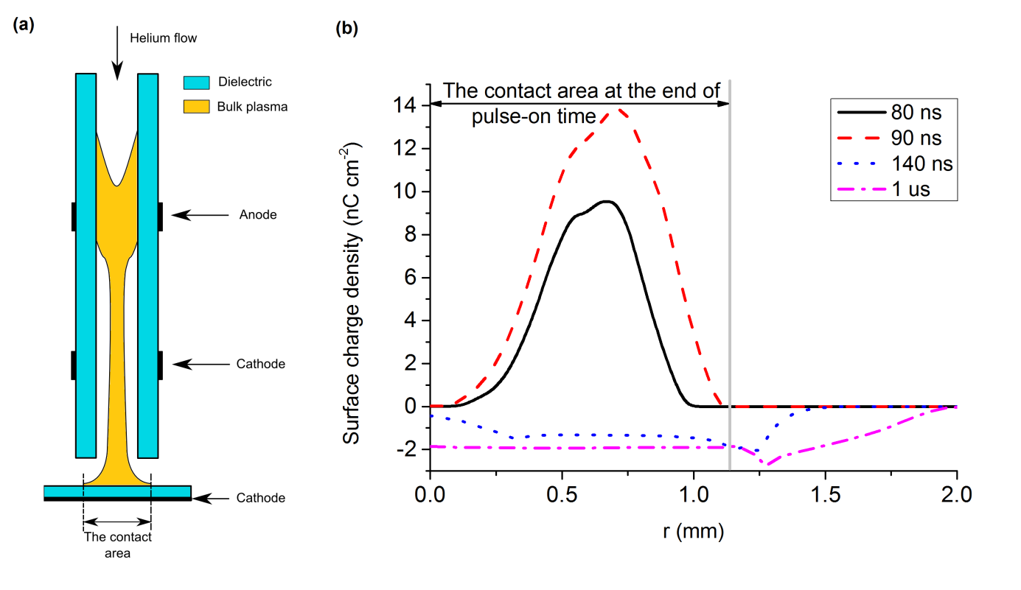

**Figure 3.** (a) Schematic illustration of the contact area between the plasma channel and the dielectric surface. (b) The deposited surface charge density (nC cm-2) on the dielectric surface at 80 ns, 90 ns, 140 ns and 1 s. The grey line represents the radius of the contact area between the plasma channel and the dielectric surface at the end of the pulse-on time.

At the end of the pulse-on time, deposited surface charge on the dielectric surface is positive due to the flux of the positive ions to the surface during this period. The plasma channel formed during the pulse-on time has a high electron density with higher electron temperature compared to the background gas temperature. The plasma channel is well defined by sharp density gradients at its edges. Despite the presence of the sharp density gradients, electrons do not diffuse in the pulse-on time as they are confined in the channel by the high applied positive voltage. As soon as the pulse is switched-off the electric field holding the electrons in plasma channel during pulse-on time decays rapidly in time. As a result, electrons diffuse rapidly to the dielectric surface assisted by the positive surface charge deposited during the pulse-on time, as shown in figure 4. This flux of electrons occurs mainly at the contact area shown in figure 3(a), where the positive surface charge was deposited during the pulse-on time. The high flux of electrons to the dielectric surface causes the net surface charge on the dielectric to become negative in the contact area, as shown in figure 3(b). The change of polarity of the surface charge in the contact area on the dielectric surface keeps the normal electric field directed in the negative z-direction. The new negative surface charge density on the surface maintains the electric field at the surface through the rest of pulse-off time. The electric field induced by the negative surface charge covers an area that is slightly larger than the contact area, as electrons diffuse in all directions.

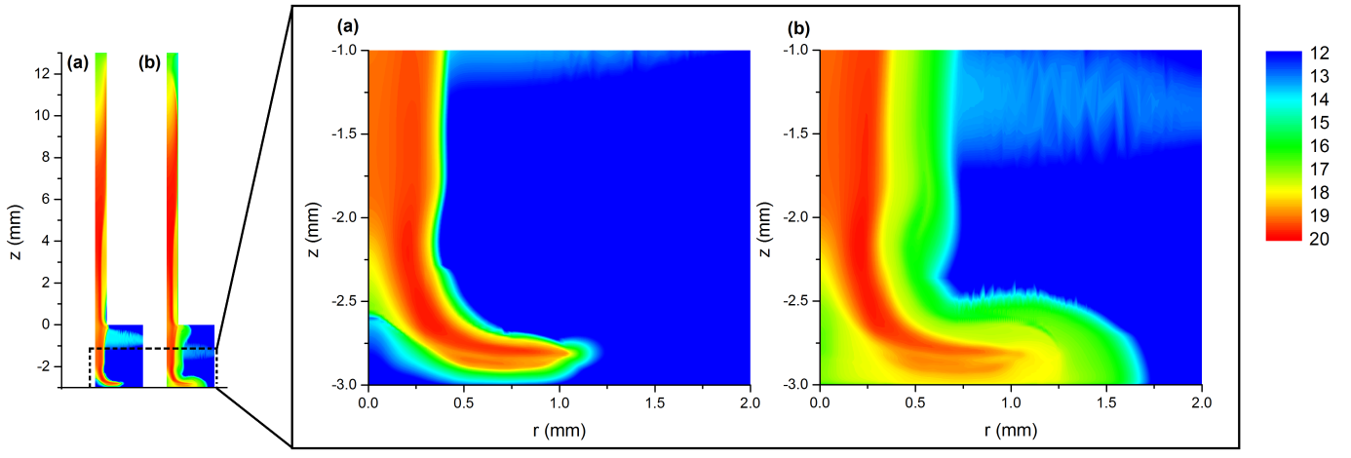

**Figure 4.** The electron density (m-3) is shown in base 10 logarithmic scale at (a) 90 ns and (b) 140 ns. Both times are in the pulse-off time, all panels have the same scale.

This reported behaviour of the surface charge density deposited on the dielectric surface computed here is consistent with experimentally obtained surface charge density profiles in [26], particularly in the spatial distribution and temporal behaviour. The differences in the applied voltage waveform, dielectric properties, level of impurities, and the presence of incident angle in the experimental configuration make exact validation of the model difficult.

* 1. *Oxygen ionic fluxes*

In order to use He-APPJs as sources of ionic species bombarding a dielectric surface exposed to the jet, it is important to know the number of ions arriving to the surface and the spatial distribution they follow. The fluence is a quantity that indicates the total number of ions delivered to the surface during a particular amount of time. We chose the fluxes and the fluences of  and  to be discussed here. The densities of  and and their fluxes to the dielectric surface are shown at different times in figure 5, while the time-integrated fluxes of both species to the dielectric surface are shown in figure 6.

With respect to  ions, as the streamer head propagates radially parallel to the dielectric surface, it creates a plasma channel along its path. The plasma channel, being bulk plasma, is quasi-neutral, which means that the electric field at the dielectric surface is shielded; limiting the flux of  ions to the dielectric surface where it is covered by the plasma channel (the bulk plasma). The streamer head on the other hand is not quasi-neutral. Thus, the electric field is not shielded there, which means a portion of the ions in the head of the streamer head are driven by the normal electric field toward the dielectric surface. For these reasons, the the maximum flux to the dielectric surface at a certain time in the pulse-on time coincides with the location of the propagating streamer head at that time. As the streamer head propagates, the position of the maximum flux moves along with it. Since the flux is associated with the propagating streamer head, it is always confined within the contact area, which expands radially with the propagating streamer head. The radial expansion of the plasma channel can be seen in figures 5(a) and 5(b). The flux of ions to the surface during the pulse-on time has an order of magnitude of 1022 m-2s-1, as seen in figure 5(e).

The normal electric field to the surface in the pulse-off time (directed in negative z direction) attracts  ions inducing a flux to the contact area of the surface. This flux during the pulse-off time has an order of magnitude of approximately 1019 m-2s-1. The lower flux in the pulse-off time compared to the pulse-on time is because the electric field driving the flux in the pulse-off time is much weaker. The surface integrated  flux as function of time is shown in figure 6. In summary, the surface integrated flux of peaks during the pulse-on time while streamer head is propagating parallel to the dielectric surface. In the pulse-off time the surface integrated flux of continues at much lower rate due to induced field by negative surface charge deposited in that period. The flux decreases in time as the density of decays due to recombination reactions, and the negative surface charge is lowered by the positive ions flux to the dielectric surface.

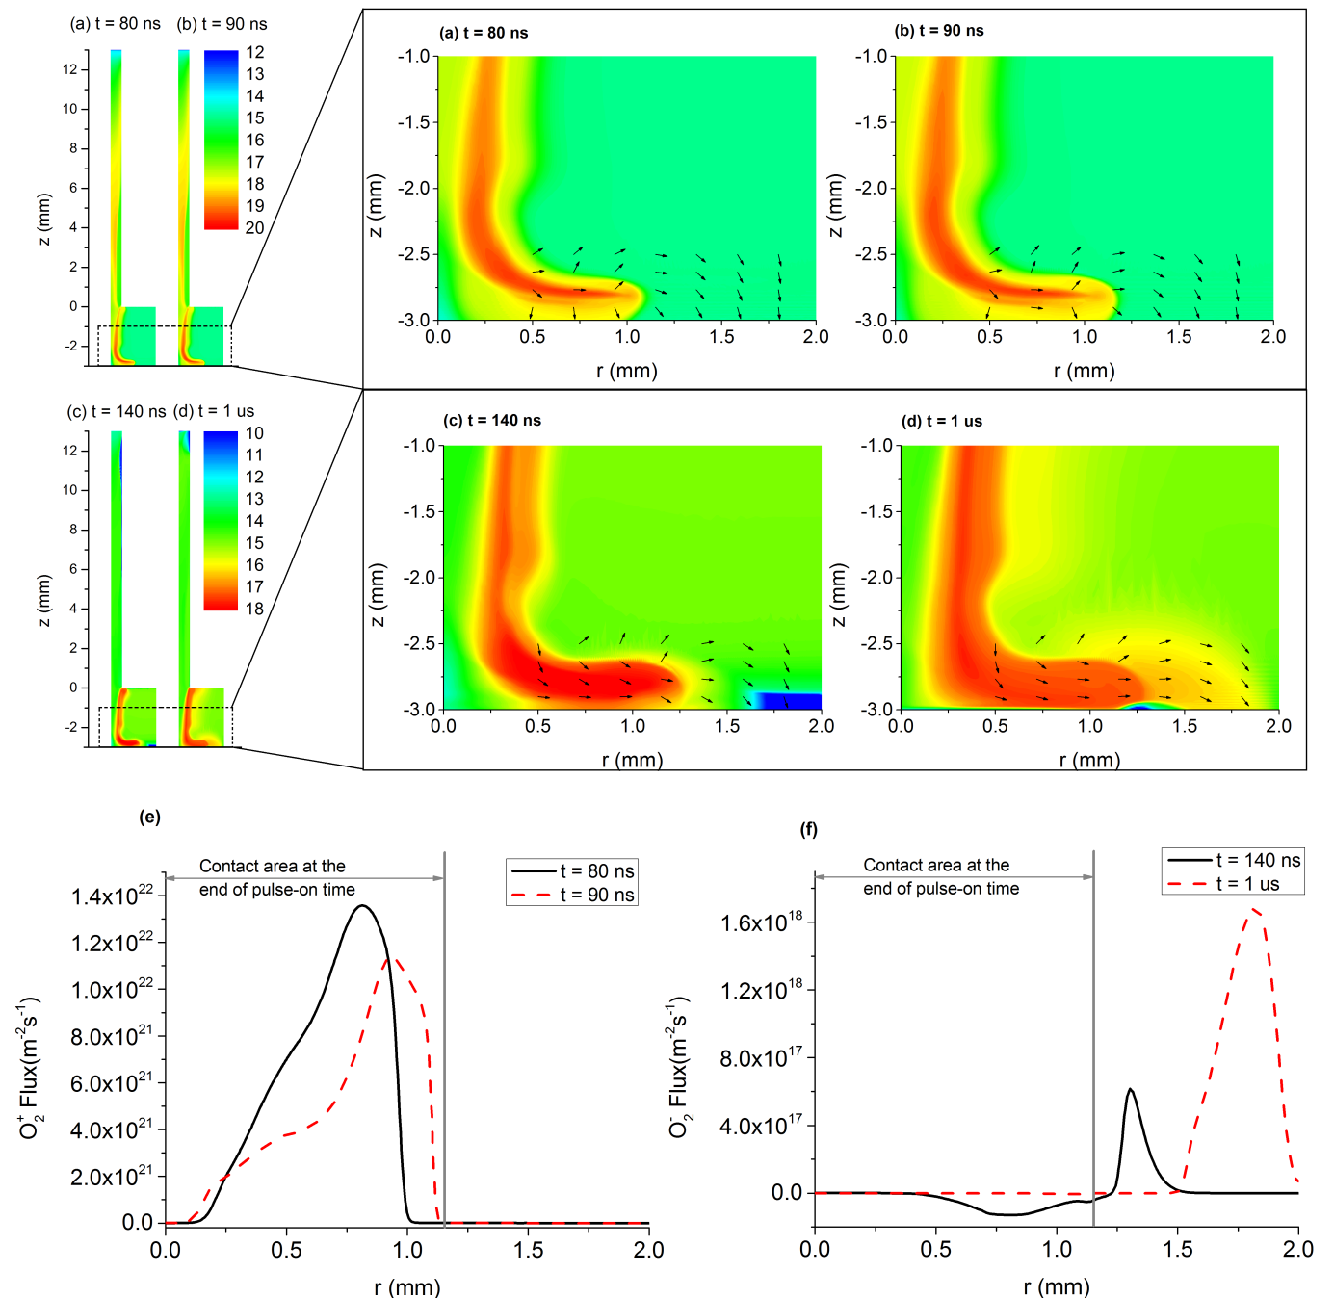

**Figure 5.** The  ions density (m-3) in base 10 logarithmic scale is shown at (a) 80 ns and (b) 90 ns, both panels have the same legend, the  ions density (m-3) in base 10 logarithmic scale is shown at (c) 140 ns and (d) 1 s, both panels have the same legend. The arrows in panels (a)-(d) show the normalized flux of ions and  ions respectively. The normal fluxes to the dielectric surface of (e)  ions and (f)  ions are shown at different times. The flux shown is directed toward the surface.

The flux of  ions during the pulse-on time to the dielectric surface is negligible for two reasons. Firstly, the  ions are mainly generated in the mixing layer between helium dominated zone and air dominated zones, which is distant enough from the dielectric to make the diffusive flux of  ions negligible to the surface. Secondly, although the normal electric field at the dielectric surface is weakened by the deposited positive surface charge, it is still strong enough to prevent  ions from being delivered to the surface even if they are in its vicinity.

The normal electric field to the dielectric surface during the pulse-off time repels  ions and electrons away from the contact area. Outside the contact area, the surface charge deposited is low compared to its counterpart in the contact area, making the grounded electrode under the dielectric surface ‘observable’ to the charged species in the plasma. Since the plasma potential is negative, the direction of the electric field outside the contact area is in the positive z-direction. This field attracts the repelled negative ions from the plasma channel and deposits them on the dielectric surface, causing the negative surface charge density there to grow gradually, which consequently causes the  ions to move further in the radial direction until they are deposited on the surface. This process continues in a similar trend to the parallel propagation of the streamer head in pulse-on time as figures 5(c) and 5(d) show, but with  ions (and other negative ions) instead of positive ions. The flux during the pulse-off time has an order of magnitude of 1018 m-2s-1, as seen in figure 5(f).

The surface integrated fluxes to the whole dielectric surface (including the contact area and the area outside it) of  ions is shown in figure 6. The surface integrated  flux peaks around 1 µs as ions move from the plasma channel to be deposited on the dielectrics surface outside the contact area. Figure 6 also shows that the integrated flux of is significantly larger than the integrated flux of . The reason is that the density of is in general lower than the density of as the model shows. This prediction is consistent with molecular beam mass spectrometric measurements that show consistently higher signal intensities for the positive ions than negative ions in the output plume of the jet [27,28]. In addition, the electric field at the dielectric surface during the pulse-on time is much stronger than what it is during the pulse-off time. For cathode driven streamers as the one simulated in this work, the direction of the pulse-on electric field assists positive ions flux to the surface. The other ions, either positive (such as  and O+) or negative (such as O- and OH-) have a very similar behaviour to  and  respectively.

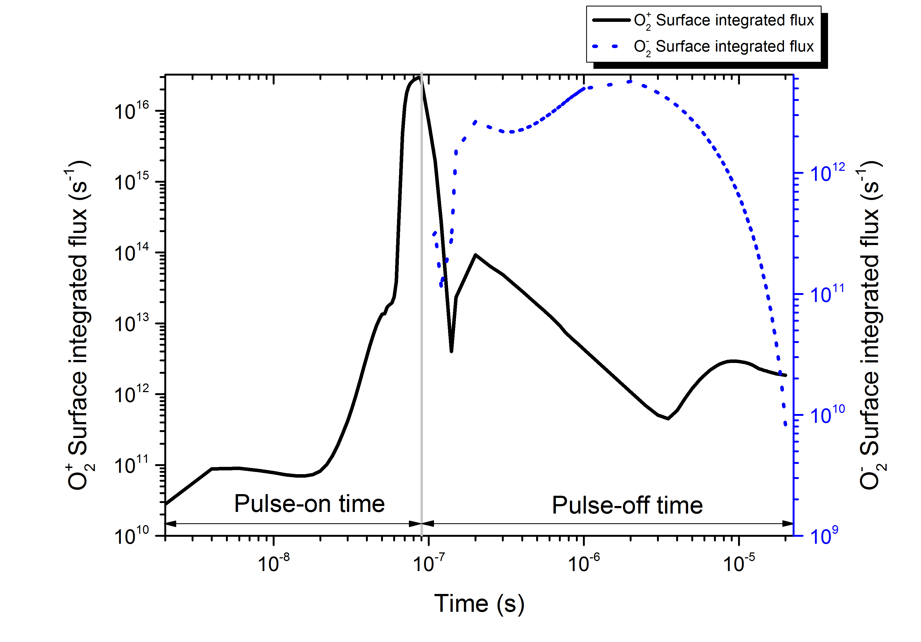

**Figure 6.** The surface integrated fluxes of O2 ionic species to the dielectric surface for 3 slm 0.5 mm dielectric thickness case. The flux shown in the figure is the normal flux toward the surface. The figure uses different logarithmic scale for and  fluxes respectively.

* 1. *Flow rate and dielectric thickness effects*

The physical scenario described in the previous section holds true for all assumed parameters in this work (the two assumed thicknesses of the dielectric and the two assumed flow rates). Figure 7 shows the time-integrated fluxes (also known as the fluences) of ions and  ions at different flow rates and dielectric thicknesses over a single period of 20 s. It is clear from figure 7 that the fluence decreases as the thickness of the dielectric increases. The smaller thickness of the dielectric makes the electric field stronger in the streamer head causing electrons to become more energetic. That leads to more intense ionization and excitation reactions. The higher density of ions and the stronger electric field in 0.5 mm thick dielectric strengthen the fluence to the surface. This trend in the change in the fluences as a function of the dielectric thickness is consistent with [11].

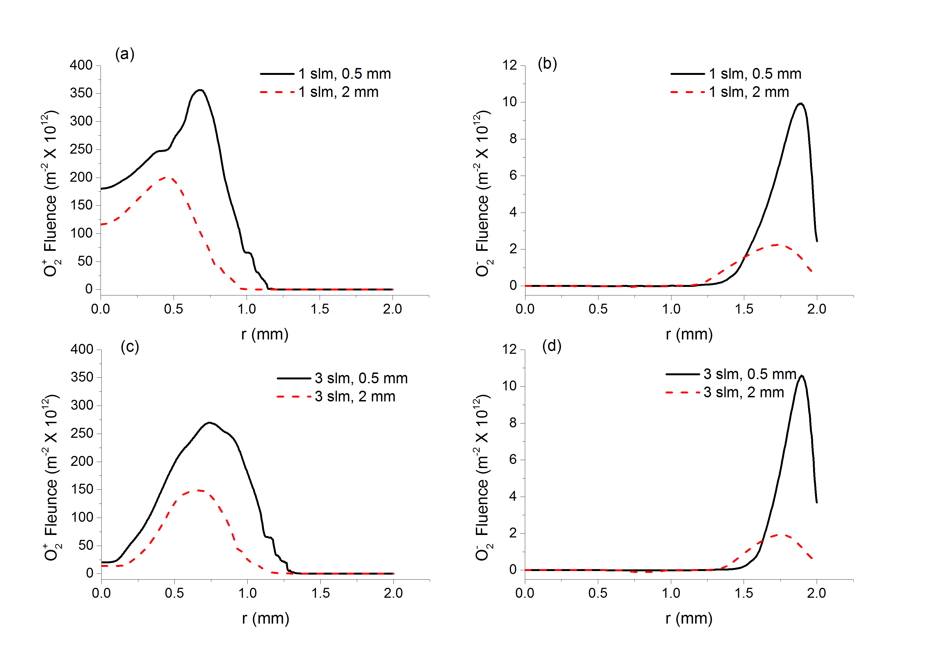

**Figure 7.** (a) The  fluence for 1 slm flow rate for different dielectric thicknesses, (b) the  fluence for 1 slm flow rate for different dielectric thicknesses, (c) the  fluence for 3 slm flow rate for different dielectric thicknesses, and (d) the  fluence for 3 slm flow rate for different dielectric thicknesses. The fluences are positive by definition in the direction toward the surface. Panels (a) and (c) have the same scale; panels (b) and (d) have the same scale. In all panels the vertical axes are normalized by a factor of 11012.

With respect to flow rate, it should be mentioned here that for both of the assumed values of the flow rate in this work, the stagnation point (where the helium jet impacts the surface at normal incidence) is in the helium channel. However, because the 1 slm flow rate corresponds to lower flow velocity, the streamer head propagates at a lower speed compared to the 3 slm case, and its structure changes from annular shape into cylindrical shape (annular shape has its maximum off the symmetry axis compared to cylindrical shape which has its maximum on the symmetry axis). This correlation between the flow velocity of the helium and the characteristics of the streamer head has been reported in [29]. The difference in the propagation speeds of the streamer head makes the fluence cover slightly larger area in the 3 slm case compared to the 1 slm case as shown in figure 7(a) and 7(c). The difference in structure of the streamer head results in a difference in the spatial distribution of fluence being annular shaped in the 3 slm case compared to cylindrical shaped in the 1 slm case.

The  fluence for both flow rates has almost the same maximum value. However, the spatial spread of the fluence in the 1 slm case is greater than the 3 slm case. The reason for this difference is attributed to the difference in radial electric field which transports  ions from the plasma channel to where they are deposited as explained in section 3.2. The radial electric field in the 3 slm case is less spread compared to the 1 slm case as a result of difference in deposited surface charge density in the pulse-off time.

* 1. *Memory effect*

In practical circumstances, the fluxes of ionic species to a dielectric surface exposed to the jet are not only affected by the discharge dynamics in the same period in which the streamer head is generated, they are also affected by the ‘memory’ of the discharge represented by species accumulated from previous periods and surface charge deposited on the inner surface of the capillary and on the surface of the dielectric exposed to the discharge. In this section we discuss the differences between the fluxes of oxygen ionic species ( and ) in a period of the waveform starting from uniform low density assumed conditions representing no ‘memory’ of the discharge, and a second period of the waveform starting from conditions obtained from the first solved period, assuming a frequency of operation of 50 kHz. The species densities and the surface charge densities at the end of the first period are introduced as initial conditions in the second period. The second period was only resolved for surface dielectric thickness of 0.5 mm for the two flow rates assumed in this study (1 slm and 3 slm). A second period of the waveform is not enough for the discharge to reach periodic steady-state conditions, thus it does not represent a full treatment of the memory effect of the discharge. However, it gives an insight of the rule played by the memory of the discharge, which provides an insight of how the frequency of operation affects the fluxes.

The physical scenario described in sections 3.1 and 3.2 still holds when the memory effect is taken into account. The fluences of and  are shown in figure 8 for the first period and the second period for flow rates of 1 slm and 3 slm respectively. The main difference in fluence is in the 3 slm case, where it has annular structure in the first period as figure 8(a) shows, compared to a cylindrical structure in the second period as seen in figure 8(c). The fluence in the second period, shown in figure 8(d), is lower for both flow rates compared to the first period, being more noticeable in the 3 slm case compared to the 1 slm case.

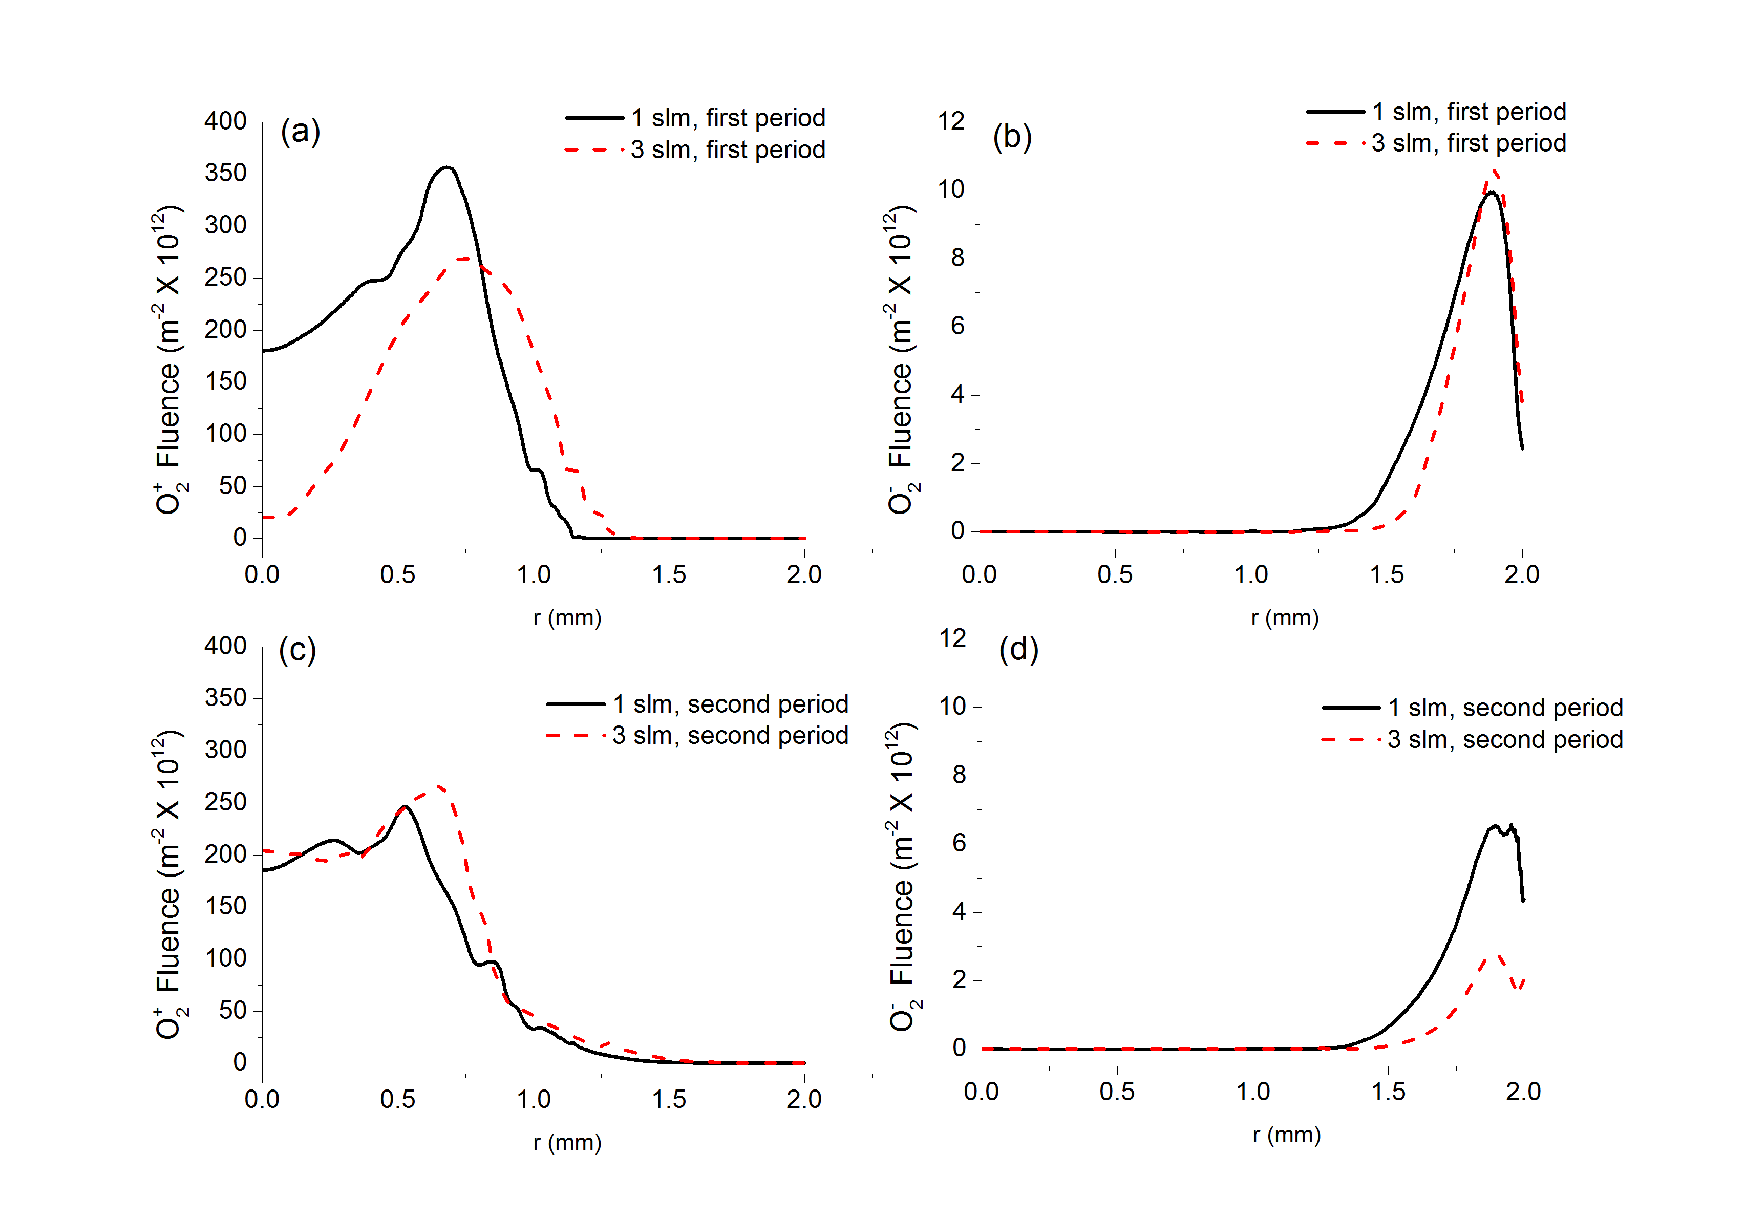

**Figure 8.** (a) The fluence of  in the first period for the two flow rates, (b) the fluence of  in the first period for the two flow rates, (c) the fluence of  in the second period for the two flow rates, (d) the fluence of  in the second period for the two flow rates. Panels (a) and (c) have the same scale, panels (b) and (d) have the same scale. In all panels the fluence is assumed to be positive toward the dielectric surface. In all panels the vertical axes are normalized by a factor of 1012.

The differences in the fluences between the first and the second periods are consequences to two main factors, the first is the residual plasma channel from the previous period, and the second is the remaining surface charge density on the surface of the dielectric. Figure 9(a) shows the initial electron density at t = 0 in the second period for flow rates of 1 slm and 3 slm respectively, while figure 9(b) shows the surface charge density at the same time on the surface of the dielectric for the previously mentioned flow rates. Due to the higher air entrainment in the 1 slm case, the plasma channel decays rapidly in regions entrained heavily with air, while in the 3 slm case it decays at much slower rate. This effect can be noticed clearly in figure 9(a), which shows that in the 3 slm case, the plasma channel remaining from the previous period extends up to the dielectric surface, creating a preferential path followed by the streamer head in the second period. As a result, the streamer head approaches the surface at a close proximity and propagates parallel to the dielectric surface at much closer distance to it compared to the first period. The implications of the closer distance to the surface is a higher flux of positive ions to the surface at the stagnations point, giving the spatial profile of  fluence a more cylindrical structure compared to annular structure in the first period.

The difference in  fluence between the first and the second period is greater compared to the differences in  fluence. The  fluence shown in the second period is lower compared to the first period for both flow rates because of the presence of negative surface charge density from the previous period shown in figures 9(b), which weakens the electric field that drives the ion flux to the surface outside contact area. The decrease in the 3 slm case is greater compared to the 1 slm case, which is a consequence of the channel being in contact with surface in 3 slm case. The contact between the plasma channel and the surface causes the negative surface charge density to decay quickly, which is clearly shown in figure 9(b), leading to less variation of surface charge on the dielectric surface, and as a result, a weaker radial electric field carrying ions from channel to where they are deposited on the surface outside the contact area in the 3 slm case.

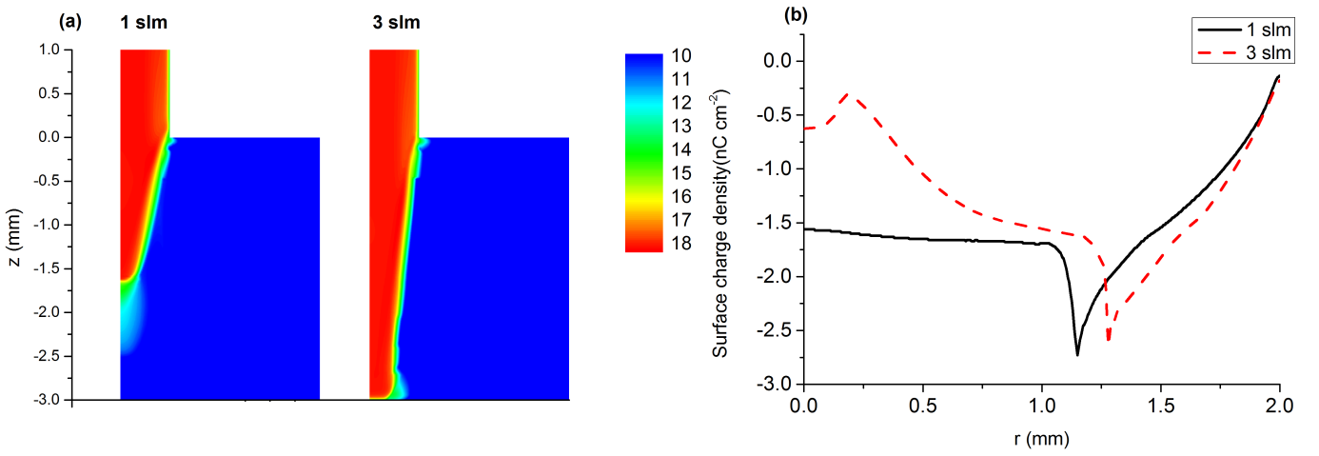

**Figure 9.** (a) The electron density (m-3) in base 10 logarithm scale at t = 20 s (end of the first period-the beginning of the second period) for flow rates of 1 slm and 3 slm. (b) The surface charge density at the dielectric surface (nC cm-2) at the same time for 1 slm flow rate and 3 slm flow rate. The area covered by the dashed black line represents the opening area of the orifice.

The difference in the fluences between the first period and the second period shown in figure 8 emphasizes the memory effect of the discharge. The structure of the residual plasma channel from the previous period is more influential than the remaining surface charge density on the surface, particularly when the channel is in contact with the surface. In the case of contact, the streamer head propagates very close to the surface, increasing the flux of to the surface over the contact area, and weakening the flux of  to the surface outside the contact area. In the non-contact case, the streamer head propagates further away from the surface, causing the spatial structure of the fluence to be similar to the fluence in absence of residual channel from previous periods.

1. **Conclusions**

The interaction between a He-APPJ and a dielectric surface exposed to the jet has been studied using a 2D time dependent numerical model. It is shown that the flux of positive ions ( in particular) is maximum during the pulse-on time, where the flux is driven by the externally applied electric field. During the pulse-off time, the flux to the surface is driven by the surface charge-induced electric field. The flux during the propagation of the streamer head parallel to the surface during the pulse-on time is approximately 1022 m-2s-1 , compared to 1019 m-2s-1 during the pulse-off time. The difference in the flux is attributed to the difference in the intensity of the normal electric field to the dielectric surface. The fluence during a pulse period shows that ions are mainly delivered to the dielectric surface in the contact area between the weakly conducting plasma channel and the dielectric surface.

The flux of negative ions ( in particular) to the dielectric surface during the pulse-on time is negligible, as the direction of the externally applied electric field at the dielectric surface supresses them from arriving to the dielectric surface. During the pulse-off time, the ions move to outside the contact area where they are deposited, as they are repelled by the surface charge induced-electric field in the contact area. The flux during the pulse-off time is approximately 1018 m-2s-1. The fluence during a pulse period shows that ions are delivered to the dielectric surface outside the contact area.

Increasing the dielectric thickness weakens the electric field in streamer head leading to lower fluences of ionic species to the dielectric surface. Increasing the flow rate (assuming low impurity levels) lowers the air entrainment in the jet, making less air molecules available for ionization in the path of the propagating streamer head, which decreases the fluence of  to the surface, and causes it to be more concentrated toward the edge of the contact area.

The memory effect of the discharge is studied by solving a second pulse period of the waveform for two flow rates. It is shown that memory effect has much greater impacts on fluence compared to fluence to the dielectric surface. The presence of negative surface charge on the surface of the dielectric from the previous period weakens the flux to the surface, making the fluence in the second period smaller compared to the first period.

Since the memory effect is related to the frequency of operation, the frequency can be used as an adjustable parameter to control the fluences of ionic species to the dielectric surface to suit a particular application.

**Acknowledgement**

One of the authors MIH would like to thank the Department of Electrical Engineering and Electronics, University of Liverpool for providing him with a Doctoral Training Studentship.

**Appendix A**

The included reactions in the model are listed here. Reactions included in mass continuity equations for the different species are listed in table A1, while reactions included in the loss term described by equation (4) are listed in table A2. The reaction coefficients indicated by f(xair,avg) are computed by convolving the EEDF computed by BOLSIG+ with the cross section data given in the corresponding references. The EEDF is computed by solving the two-terms Boltzmann equation [19] using BOLSIG+ with its input being the cross sections of all the reactions in tables A1 and A2 with a reaction coefficient indicated by by f(xair,avg) .In all tables included in this section, x*air*(dimensionless)is the mole fraction of air, *avg* (eV) is the average electron energy, *Te* (eV) is the electron temperature, *Teg*(dimensionless)is the electron temperature divided by the gas temperature, *T0* (dimensionless) is the gas temperature divided by 300 K.

**Table A1.** List of reactions included in mass conservation system of equations. All rate coefficients have volume units of m3s-1 for two body reactions and m6 s-1 for three body reactions.

|  |  |  |  |  |
| --- | --- | --- | --- | --- |
| **Reaction Number** | **Reaction formula** | **Reaction coefficient** | **Energy cost (eV)** | **Ref.** |
| R1 | e + He  e + He | f(xair,* avg*) |  | [30] |
| R2 | e + He  e + He* | f(xair,* avg*) | 19.80 | [30] |
| R3 | e + He*  e + He | 1.763310-16 | -19.80 | [31] |
| R4 | e + He  2e + He+ | f(xair,* avg*) | 24.58 | [30] |
| R5 | e + He*  2e + He+ | 110-13 *avg*0.6 exp(-7.175/*avg*) | 4.78 | [31] |
| R6 | e + N2  e + N2 | f(xair,* avg*) |  | [30] |
| R7 | e + N2  2e + | f(xair,* avg*) | 15.6 | [30] |
| R8 | e + O2  e + O2 | f(xair,* avg*) |  | [32] |
| R9 | e + O2  2e + | f(xair,* avg*) | 12.06 | [32] |
| R10 | e +   2e + | 7.2810-16 exp(-5.1/*avg*) | 3.4 | [31] |
| R11 | e +   He + He* | 6.138210-15 |  | [31] |
| R12 | 2e + He+  e + He | 710-32 |  | [33] |
| R13 | 2e +   e + 2He | 710-32 |  | [33] |
| R14 | e + He +   3He | 210-39 |  | [33] |
| R15 | e + He+  He | 210-18 |  | [33] |
| R16 | e +   2He | 110-14 |  | [33] |
| R17 | e +   2O | 7.76210-15 | -6.91 | [31] |
| R18 | e + He + He+  He + He* | 110-39 |  | [33] |
| R19 | e + He +   2He + He* | 510-39/Teg |  | [33] |
| R20 | e + He +   He + | 1.510-39 |  | [33] |
| R21 | 2e + He+  e + He* | 610-32 |  | [33] |
| R22 | 2e +   He + He* + e | 110-32 |  | [33] |
| R23 | 2e +    + e | 310-32 |  | [33] |
| R24 | e + He+  He* | 6.7610-19 |  | [33] |
| R25 | e +   He + He* | 8.910-15 |  | [33] |
| R26 | e + H2O  e + H2O | f(xair,* avg*) |  | [33] |
| R27 | e + N2  e + 2N | f(xair,* avg*) | 13 | [33] |
| R28 | e + O2 | f(xair,* avg*) |  | [33] |
| R29 | e + H2O  e + H + OH | f(xair,* avg*) | 9 | [33] |
| R30a | e + OH  e + O + H | 2.0810-13 Te-0.76 exp(-6.9/Te) | 6.9 | [33] |
| R31a | e + N  2e + N+ | 110-14 Te0.5 exp(-14.5/Te) | 14.5 | [33] |
| R32a | e + N2  2e + N + N+ | 4.210-16 Te0.5 exp(-28/Te) | 28 | [33] |
| R33 | e + N+  N | 3.510-18 |  | [33] |
| R34 | e +   2N | 2.810-13 |  | [33] |
| R35 | e +   N2 | 4.810-13 |  | [33] |
| R36 | 2e +   e + O2 | 710-32 |  | [33] |
| R37 | e + O2 +   2O2 | 2.4910-41 |  | [33] |
| R38 | e + N2 +   O2 + N2 | 610-39 |  | [33] |
| R39 | 2e + N+  N + e | 710-32 |  | [33] |
| R40 | e + He + N+  N + He | 210-39 |  | [33] |
| R41 | e + O2 + N+  N + O2 | 610-39 |  | [33] |
| R42 | e + N2 + N+  N + N2 | 610-39 |  | [33] |
| R43 | 2e +   N2 + e | 710-32 |  | [33] |
| R44 | e + O2 +   N2 + O2 | 610-39 |  | [33] |
| R45 | e + N2 +   2N2 | 610-39 |  | [33] |
| R46 | e + O3  O + | 5.8710-15 exp(-1.59/Te) |  | [33] |
| R47 | e + O3  O2 + O- | 2.1210-15  exp(-0.93/Te) |  | [33] |
| R48a | e + O-  O + 2e | 5.4710-14 exp(-2.98/Te) | 2.98 | [33] |
| R49a | e + O2  2O + e | 1.4110-15 exp(-12.62/Te) | 12.62 | [33] |
| R50a | e + O2  O + O- | 1.0710-15 exp(-6.26/Te) | 6.26 | [33] |
| R51 | e + O2 + H2O  H2O + | 1.410-41 |  | [33] |
| R52 | e + He + O  He + O- | 110-43 |  | [33] |
| R53 | e + He + O2  He + | 3.610-43 |  | [33] |
| R54 | e + He + O3  He + O3- | 110-43 |  | [33] |
| R55 | e + O + O2  O + | 110-43 |  | [33] |
| R56 | e + O + O2  O2 + O- | 110-43 |  | [33] |
| R57 | e + O + N2  N2 + O- | 110-43 |  | [33] |
| R58 | e + 2O2  O2 + | 3.610-43 |  | [33] |
| R59 | e + O2 + O3  O2 + O3- | 110-43 |  | [33] |
| R60 | e + O2 + N2  N2 + | 1.2410-43 T0-0.5 |  | [33] |
| R61 | e + O+  O | 410-18 |  | [33] |
| R62 | e +   O2 | 410-18 |  | [33] |
| R63 | 2e + O+  O + e | 710-32 |  | [33] |
| R64 | e + He + O+  He + O | 610-39 |  | [33] |
| R65 | e + O2 + O+  O2 + O | 610-39 |  | [33] |
| R66 | e + N2 + O+  N2 + O | 610-39 |  | [33] |
| R67a | e + O  2e + O+ | 910-14 exp(-13.6/Te) | 13.6 | [33] |
| R68a | e + O2  2e + O + O+ | 5.410-16 exp(-17/Te) | 17 | [33] |
| R69a | e + O2  O- + e + O+ | 7.110-17 exp(-17/Te) | 17 | [33] |
| R70 | e + H2O  H + OH- | f(*X*air, εavg) |  | [30] |
| R71 | e + OH  OH- | 110-21 |  | [33] |
| R72 | e + OH + He  He + OH- | 310-43 |  | [33] |
| R73 | He* + 2He   + He | 1.310-45 |  | [31] |
| R74 | 2He + He+  He + | 110-43 |  | [31] |
| R75 | He* + N2  He + e + | 710-17 |  | [31] |
| R76 | + N2  2He + e + | 710-17 |  | [31] |
| R77 | N2 + He+  He + | 510-16 |  | [31] |
| R78 | 2He*  He + e + He+ | 2.710-16 |  | [33] |
| R79 | O2 + He+  He + | 3.310-17 |  | [33] |
| R80 | He* +   2He + He+ | 110-16 |  | [33] |
| R81 | O2 +   2He + | 110-15 |  | [33] |
| R82 | 2O2  2O + O2 | 6.610-15 exp(-59000/Tg) |  | [33] |
| R83 | He* + He + O2  2He + e + | 1.610-43 |  | [33] |
| R84 | He* + O2  He + e + | 2.610-16 |  | [33] |
| R85 | 2O  O2 | 9.2610-40 |  | [33] |
| R86 | 3N  N + N2 | 3.3110-39 |  | [33] |
| R87 | 2N + N2  2N2 | 7.610-46 exp(500/Tg) |  | [33] |
| R88 | 2N + He  N2 + He | 7.610-46 exp(500/Tg) |  | [33] |
| R89 | 3O  O2 + O | 9.2110-46 |  | [33] |
| R90 | 2O + O2  2O2 | 2.5610-46 |  | [33] |
| R91 | 2O + N  O2 + N | 3.210-45 |  | [33] |
| R92 | 2O + N2  O2 + N2 | 6.4910-47 exp(1039/Tg) |  | [33] |
| R93 | 2O + H2O  O2 + H2O | 1.710-44 |  | [33] |
| R94 | + He+  O2 + He | 210-13 |  | [33] |
| R95 | +   2He + O2 | 110-13 |  | [33] |
| R96 | +   2O + O2 | 110-13 |  | [33] |
| R97 | +   2O2 | 4.210-13 |  | [33] |
| R98 | + He +   3He + O2 | 210-37 |  | [33] |
| R99 | + O2 +   2He + 2O2 | 210-37 |  | [33] |
| R100 | He +   He + O2 + e | 3.910-16 exp(-7400/Tg) |  | [33] |
| R101 | He* +   He + O2 + e | 310-16 |  | [33] |
| R102 | +   2He + O2 + e | 310-16 |  | [33] |
| R103 | O2 +   2O2 + e | 2.710-16 exp(-5590/Tg) |  | [33] |
| R104 | N2 +   N2 + O2 +e | 1.910-18 exp(-4990/Tg) |  | [33] |
| R105 | H2O +   H2O + O2 + e | 510-15 exp(-5000/Tg) |  | [33] |
| R106 | + O2 +   2O2 + N2 | 210-37 |  | [33] |
| R107 | + N2 +   O2 + 2N2 | 210-37 |  | [33] |
| R108 | 2He*  e + | 1.0510-15 |  | [33] |
| R109 | + He*  2He + e + He+ | 510-16 |  | [33] |
| R110 | + He*  He + e + | 210-15 |  | [33] |
| R111 | 2  3He + e + He+ | 310-16 |  | [33] |
| R112 | 2  2He + e + | 1.210-15 |  | [33] |
| R113 | 2N2 2N + N2 | 3.510-15 exp(-113103/Tg) |  | [33] |
| R114 | 2He + He*  He + | 1.510-46 |  | [33] |
| R115 | 2O + He  O2 + He | 110-45 |  | [33] |
| R116 | 2N + O2  N2 + O2 | 3.910-45 |  | [33] |
| R117 | 2N + H2O  N2 + H2O | 3.910-45 |  | [33] |
| R118 | +   2N + O2 | 110-13 |  | [33] |
| R119 | +   N2 + O2 | 2.710-13 |  | [33] |
| R120 | + He +   He + 2O2 | 210-37 |  | [33] |
| R121 | + O2 +   3O2 | 210-37 |  | [33] |
| R122 | + N2 +   2O2 + N2 | 210-37 |  | [33] |
| R123 | N2 +   2He + | 1.410-15 |  | [33] |
| R124 | + O2  2He + e + | 3.610-16 |  | [33] |
| R125 | OH + O  O2 + H | 2.210-17 exp(120/Tg) |  | [33] |
| R126 | O + H2O  2OH | 2.510-20 exp(-8624/Tg) |  | [33] |
| R127 | 2OH  H2O + O | 4.210-18 exp(-240/Tg) |  | [33] |
| R128 | H + OH + H2O  2H2O | 2.4610-42 |  | [33] |
| R129 | H + OH + N2  H2O + N2 | 6.8810-43 |  | [33] |
| R130 | H + OH + O2  H2O + O2 | 6.8810-43 |  | [33] |
| R131 | O + H + H2O  H2O + OH | 2.7610-44 |  | [33] |
| R132 | H + OH + He  H2O + He | 1.5610-43 |  | [33] |
| R133 | O2 + H  O + OH | 3.710-16 exp(-8455/Tg) |  | [33] |
| R134 | O2 +   N2 + | 510-17 |  | [33] |
| R135 | N +   N2 + N+ | 2.410-21 Tg |  | [33] |
| R136 | O- + O2 + N+  O2 + O + N | 210-37 |  | [33] |
| R137 | O- + N2 + N+  N2 + O + N | 210-37 |  | [33] |
| R138 | + N2 + N+  N2 + O2 + N | 210-37 |  | [33] |
| R139 | + O2 + N+  2O2 + N | 210-37 |  | [33] |
| R140 | O- + O2 +   O2 + O + N2 | 210-37 |  | [33] |
| R141 | O- + N2 +   O + 2N2 | 210-37 |  | [33] |
| R142 | O- + He +   O + O2 + He | 210-37 |  | [33] |
| R143 | O- + O2 +   O + 2O2 | 210-37 |  | [33] |
| R144 | O- + O2 +   O2 + O3 | 210-37 |  | [33] |
| R145 | O- + N2 +   N2 + O3 | 210-37 |  | [33] |
| R146 | O- + N2 +   N2 + O2 + O | 210-37 |  | [33] |
| R147 | 2O3  O + O2 + O3 | 1.610-15 exp(-11400/Tg) |  | [33] |
| R148 | O3 + N2  O + O2 + N2 | 1.610-15 exp(-11400/Tg) |  | [33] |
| R149 | O3 + H2O  O + O2 + H2O | 1.610-15 exp(-11400/Tg) |  | [33] |
| R150 | O3 + H  O2 + OH | 7.7810-17 exp(-327.8/Tg) |  | [33] |
| R151 | O3 + O2  O + 2O2 | 1.610-15 exp(-11400/Tg) |  | [33] |
| R152 | O3 + O  2O + O2 | 9.410-17 exp(-11400/Tg) |  | [33] |
| R153 | O3 + O  2O2 | 810-18 exp(-2060/Tg) |  | [33] |
| R154 | 2O + O2  O3 + O | 3.410-46 |  | [33] |
| R155 | O + 2O2  O3 + O2 | 610-46 |  | [33] |
| R156 | O + O2 + O3  2O3 | 2.310-47 exp(-1057/Tg) |  | [33] |
| R157 | O + O2 + N2  N2 + O3 | 1.110-46 exp(510/Tg) |  | [33] |
| R158 | O + O2 + He  He + O3 | 3.410-46 |  | [33] |
| R159 | O- +   3O | 110-13 |  | [33] |
| R160 | O- +   O + O2 | 110-13 |  | [33] |
| R161 | O- + He+  O + He | 210-13 |  | [33] |
| R162 | O- +   O + 2He | 110-13 |  | [33] |
| R163 | O- + N+  O + N | 2.610-13 |  | [33] |
| R164 | + N+  O2 + N | 410-13 |  | [33] |
| R165 | O- + He + He+  2He + O | 210-37 |  | [33] |
| R166 | O- + O2 + He+  He + O + O2 | 210-37 |  | [33] |
| R167 | O- + N2 + He+  He + O + N2 | 210-37 |  | [33] |
| R168 | O- + He +   3He + O | 210-37 |  | [33] |
| R169 | O- + O2 +   2He + O + O2 | 210-37 |  | [33] |
| R170 | O- +   O + 2N | 110-13 |  | [33] |
| R171 | O- +   O + N2 | 2.710-13 |  | [33] |
| R172 | O- + He  He + O + e | 2.510-24 |  | [33] |
| R173 | O- + He*  He + O + e | 310-16 |  | [33] |
| R174 | O- +   2He + O + e | 310-16 |  | [33] |
| R175 | O- + O  O2 + e | 210-16 |  | [33] |
| R176 | O- + O2  O + | 1.510-18 |  | [33] |
| R177 | O- + O2  O3 + e | 510-21 |  | [33] |
| R178 | O- + O3  2O2 + e | 3.0110-16 |  | [33] |
| R179 | O- + H  OH + e | 510-16 |  | [33] |
| R180 | + O  O2 + O- | 1.510-16 |  | [33] |
| R181 | + O  O3 + e | 1.510-16 |  | [33] |
| R182 | O3 +   O + N2 + | 110-16 |  | [33] |
| R183 | O2 + N+  N + | 2.810-16 |  | [33] |
| R184 | He + O3  He + O + O2 | 1.5610-15 exp(-11400/Tg) |  | [33] |
| R185 | He* + O3  He + O + e + | 2.610-16 |  | [33] |
| R186 | He* + N2  He + N + e + N+ | 110-16 |  | [33] |
| R187 | O2 + N + N+  O2 + | 110-41 |  | [33] |
| R188 | N2 + N + N+  N2 + | 110-41 |  | [33] |
| R189 | + O3  2He + O + e + | 3.610-16 |  | [33] |
| R190 | N2 + He+  He + N + N+ | 610-16 |  | [33] |
| R191 | O + He+  He + O+ | 510-17 |  | [33] |
| R192 | O2 + He+  He + O + O+ | 1.0710-15 |  | [33] |
| R193 | O3 + He+  He + O2 + O+ | 1.0710-15 |  | [33] |
| R194 | OH + He+  He + H + O+ | 1.110-15 |  | [33] |
| R195 | O +   2He + O+ | 110-15 |  | [33] |
| R196 | O2 +   2He + O + O+ | 1.0510-15 |  | [33] |
| R197 | O3 +   2He + O2 + O+ | 110-15 |  | [33] |
| R198 | O + N+  N + O+ | 110-18 |  | [33] |
| R199 | O2 + O+  O + | 210-17 |  | [33] |
| R200 | O3 + O+  O2 + | 110-16 |  | [33] |
| R201 | N2 + O+  O + | 4.910-15 |  | [33] |
| R202 | OH + O+  H + | 3.610-16 |  | [33] |
| R203 | He* +   O + He + O+ | 110-26 |  | [33] |
| R204 | +   O + 2He + O+ | 110-16 |  | [33] |
| R205 | He* +   N + He + N+ | 110-26 |  | [33] |
| R206 | O +   N2 + O+ | 110-17 |  | [33] |
| R207 | + He  3He | 4.910-22 |  | [33] |
| R208 | He* + O  He + e + O+ | 2.610-16 |  | [33] |
| R209 | O + He + O+  He + | 110-41 |  | [33] |
| R210 | O + O2 + O+  O2 + | 110-41 |  | [33] |
| R211 | O + N2 + O+  N2 + | 110-41 |  | [33] |
| R212 | He + He* + O  2He + e + O+ | 110-43 |  | [33] |
| R213 | He + He* + O3  2He + O + e + | 1.610-43 |  | [33] |
| R214 | He + O + H  He + OH | 3.210-45 |  | [33] |
| R215 | O- + O+  2O | 2.710-13 |  | [33] |
| R216 | + O+  O + O2 | 210-13 |  | [33] |
| R217 | O3- + O+  O + O3 | 210-13 |  | [33] |
| R218 | O- + He + O+  He + 2O | 210-37 |  | [33] |
| R219 | O- + O2 + O+  O2 + 2O | 210-37 |  | [33] |
| R220 | O- + O2 + O+  2O2 | 210-37 |  | [33] |
| R221 | O- + N2 + O+  N2 + 2O | 210-37 |  | [33] |
| R222 | O- + N2 + O+  N2 + O2 | 210-37 |  | [33] |
| R223 | + He + O+  He + O + O2 | 210-37 |  | [33] |
| R224 | + O2 + O+  2O2 + O | 210-37 |  | [33] |
| R225 | + O2 + O+  O2 + O3 | 210-37 |  | [33] |
| R226 | + N2 + O+  N2 + O + O2 | 210-37 |  | [33] |
| R227 | + N2 + O+  N2 + O3 | 210-37 |  | [33] |
| R228 | OH- + He  He + OH + e | 210-15 exp(-24030/Tg) |  | [34] |
| R229 | OH- + H  H2O + e | 1.810-15 |  | [34] |
| R230 | O- + H2O  OH + OH- | 1.410-15 |  | [34] |
| R231 | OH- +   OH + 2He | 110-13 |  | [34] |
| R232 | OH- +   OH + O2 | 210-13 |  | [34] |
| R233 | M + OH- +   2He + OH + M | 210-37 |  | [34] |
| R234 | e + H2O2 → H2O + O- | 1.57×10-16 |  | [34] |
| R235 | e + H2O2 → OH + OH- | 2.7×10-16 |  | [34] |
| R236 | e + H2O2 → 2OH + e | 2.36×10-15 |  | [34] |
| R237 | 2OH → H2O2 | 1.5×10-17 (Tg/300)-0.37 |  | [34] |
| R238 | H + H2O2 → H2O + OH | 4×10-17 exp(-2000/Tg) |  | [34] |
| R239 | H2O + O- → e + H2O2 | 6×10-19 |  | [34] |
| R240 | H2O2 → 2OH | 2×109 exp(-26821/Tg) |  | [34] |

aThe electron energy costs of the starred reactions were estimated from rate coefficient expression given in literature. It was assumed to be the exponent corresponding to activation energy in Arrhenius equation.

**Table A2.** List of reactions included in implicit term described by equation 4.

|  |  |  |  |  |
| --- | --- | --- | --- | --- |
| **Reaction Number** | **Reaction formula** | **Reaction coefficient** | **Energy cost (eV)** | **Ref.** |
| R1 | e + N2  e + N2(rot) | f(xair,* avg*) | 0.02 | [30] |
| R2 | e + N2  e + N2(v* = 1) | f(xair,* avg*) | 0.29 | [30] |
| R3 | e + N2  e + N2(v = 1) | f(xair,* avg*) | 0.29 | [30] |
| R4 | e + N2  e + N2(v = 2) | f(xair,* avg*) | 0.59 | [30] |
| R5 | e + N2  e + N2(v = 3) | f(xair,* avg*) | 0.88 | [30] |
| R6 | e + N2  e + N2(v = 4) | f(xair,* avg*) | 1.17 | [30] |
| R7 | e + N2  e + N2(v = 5) | f(xair,* avg*) | 1.47 | [30] |
| R8 | e + N2  e + N2(v = 6) | f(xair,* avg*) | 1.76 | [30] |
| R9 | e + N2  e + N2(v = 7) | f(xair,* avg*) | 2.06 | [30] |
| R10 | e + N2  e + N2(v = 8) | f(xair,* avg*) | 2.35 | [30] |
| R11 | e + N2  e + N2(A3Σ) (0 < v < 4 ) | f(xair,* avg*) | 6.17 | [30] |
| R12 | e + N2  e + N2(A3Σ) (5 < v < 9 ) | f(xair,* avg*) | 7 | [30] |
| R13 | e + N2  e + N2(B3Π) | f(xair,* avg*) | 7.35 | [30] |
| R14 | e + N2  e + N2(W3Δ) | f(xair,* avg*) | 7.36 | [30] |
| R15 | e + N2  e + N2(A3Σ) (10 < v) | f(xair,* avg*) | 7.8 | [30] |
| R16 | e + N2  e + N2(B’3Σ) | f(xair,* avg*) | 8.16 | [30] |
| R17 | e + N2  e + N2(a’1Σ) | f(xair,* avg*) | 8.4 | [30] |
| R18 | e + N2  e + N2(a1Π) | f(xair,* avg*) | 8.55 | [30] |
| R19 | e + N2  e + N2(W1Δ) | f(xair,* avg*) | 11.03 | [30] |
| R20 | e + N2  e + N2(C3Π) | f(xair,* avg*) | 11.87 | [30] |
| R21 | e + N2  e + N2(a’’1Σ) | f(xair,* avg*) | 6.17 | [30] |
| R22 | e + O2  e + O2(rot) | f(xair,* avg*) | 0.02 | [32] |
| R23 | e + O2  e + O2(v* = 1) | f(xair,* avg*) | 0.19 | [32] |
| R24 | e + O2  e + O2(v = 1) | f(xair,* avg*) | 0.19 | [32] |
| R25 | e + O2  e + O2(v* = 2) | f(xair,* avg*) | 0.38 | [32] |
| R26 | e + O2  e + O2(v = 2) | f(xair,* avg*) | 0.38 | [32] |
| R27 | e + O2  e + O2(v = 3) | f(xair,* avg*) | 0.57 | [32] |
| R28 | e + O2  e + O2(v = 4) | f(xair,* avg*) | 0.75 | [32] |
| R29 | e + O2  e + O2(a1Δ) | f(xair,* avg*) | 0.98 | [32] |
| R30 | e + O2  e + O2(b1Σ) | f(xair,* avg*) | 1.63 | [32] |
| R31 | e + O2  O + O(1D) | f(xair,* avg*) | 8.4 | [32] |

**Appendix B**

The assumed boundary conditions in the model are explained in this appendix. Since the equations of the model are not explicitly shown. The boundary conditions are only descriptive. Figure B1 shows the modelled geometry with numbered boundaries. The boundaries for both components of the model are explained in table B1. It should be noted here that in figure B1b, Poisson equation is the only equation of the plasma component that is solved in the dielectric tube in addition to hatched area.

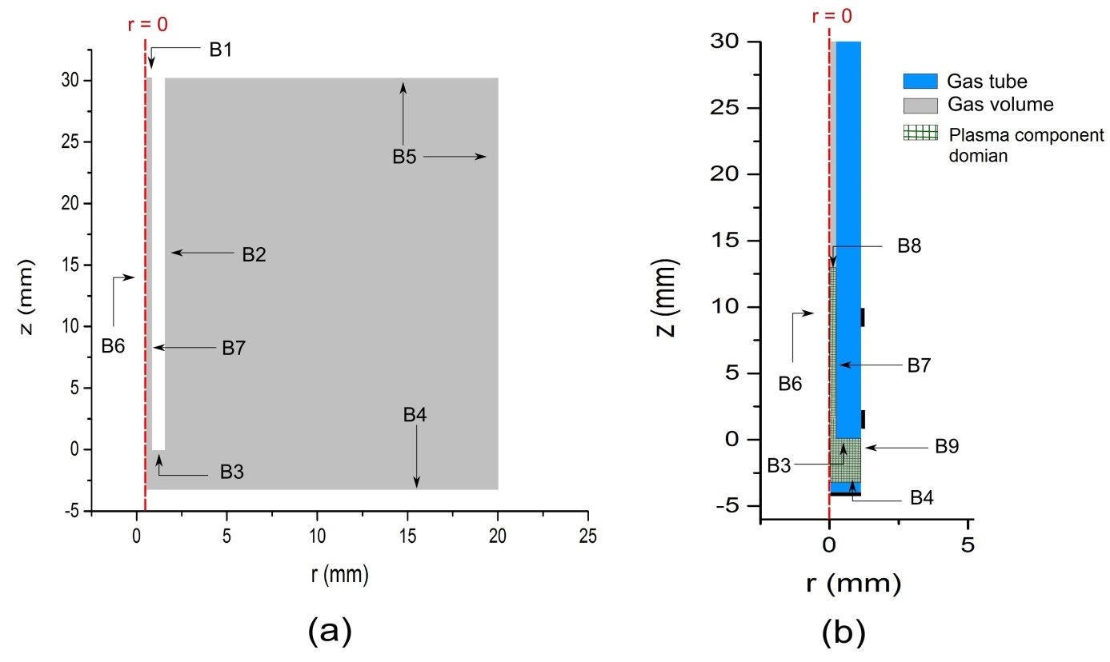

**Figure B1.** The geometry used in the model, (a) the computational domain of the hydrodynamic component is labelled in grey, (b) the computational domain of the plasma component is the hatched area with flow dynamics model domain in the background. The electrodes are lines with zero width; they were made bold for illustration only.

**Table B1.** The modified boundary conditions used in this model for the hydrodynamic component and the plasma component. In this table, *ur* and *uz* are the radial and the axial velocity field components respectively, *n* is the normal flux of the species to the boundary, *qe* is the electron charge, ** is the surface charge density, *n+*and *n-* are the fluxes of positive and negative ionic species to the boundaries, *Dn*is the difference of the normal electric displacement field across a boundary *, n* is the density a species on the boundary, *vth* is the thermal velocity of a species, ** is the mobility of the species, *En* is the normal electric field on the boundary, and ** is a constant equal to 1 if the flux driven by the electric field is directed to the surface, and zero otherwise.

|  |  |  |  |  |
| --- | --- | --- | --- | --- |
| **Boundary** | **Hydrodynamic component** | | **Plasma componenta** | |
| **Velocity condition** | **Background species condition** | **Electrostatic condition** | **Continuity equation conditionb** |
| B1 | Inlet | Fixed mole fraction (99.99% He) | --- | --- |
| B2 | No slip wall | No flux | --- | --- |
| B3 | No slip wall | No flux | Surface charge densityc | Wall losses |
| B4 | No slip wall | No flux | Surface charge densityc | Wall losses |
| B5 | Outlet  (Pressure = 1 atm) | Fixed mole fraction (100% Air) | --- | --- |
| B6 | Symmetry | Symmetry | Symmetry | Symmetry |
| B7 | No slip wall | No Flux | Surface charge densityc | Wall losses |
| B8 | --- | --- | Symmetry | Wall lossesd |
| B9 | --- | --- | Symmetry | Symmetry |

aThe domain of the plasma component also includes the dielectric tube when solving Poisson equation for the electrostatic potential, while the continuity equations of the different species are only solved in the hatched area in figure B1b.

bThis condition is applied for all the species in the plasma component in addition to the equation of electron energy density.

cThe electron flux is also included in the expression as part of the summation over *k* index.

dWall loss condition is assumed on mathematical boundaries for stability issues. Replacing wall loss condition with symmetry condition gives identical results but is numerically unstable.

**References**

[1] Suzuki T, Saburi T, Tokunami R, Murata H and Fujii Y 2006 *Thin Solid Films* **506** 342

[2] Long T M, Prakash S and Shannon M A 2006 *Langmuir* **22** 4104

[3] Stalder K R, McMillen D F and Woloszko J 2005 *J. Phys. D Appl. Phys.* **38** 1728

[4] Stoffels E, Kieft I E and Sladek R E J 2003 *J. Phys. D: Appl. Phys.* **36** 2908

[5] Urabe K, Morita T, Tachibana K and Ganguly B N 2010 *J. Phys. D: Appl. Phys.* **43** 095201

[6] Yonemori S, Nakagawa Y, Ono R and Oda T 2012 *J. Phys. D: Appl. Phys.* **45** 225202

[7] Babaeva N and Kushner M J 2013 *J. Phys. D: Appl. Phys.* **46** 025401

[8] Babaeva N, Ning N, Graves D B and Kushner M J 2012 *J. Phys. D: Appl. Phys.* **45** 115203

[9] Babaeva N, Tian W and Kushner M J 2014 *J. Phys. D: Appl. Phys.* **47** 235201

[10] Tian W and Kushner M J 2014 *J. Phys. D: Appl. Phys.* **47** 165201

[11] Breden D and Raja L 2014 *Plasma Sources Sci. Technol.* **23** 065020

[12] Xiong Z and Kushner M J 2012 *Plasma Sources Sci. Technol.* **21** 034001

[13] Sakiyama Y and Graves D B 2009*Plasma Sources Sci. Technol.* **18** 025022

[14] Babior B M, Kipnes R S and Curnutte J T 1973 *J Clin Invest.***52**3,741–744

[15] Oh J-S,Walsh J L and Bradley J W 2012*Plasma Sources Sci. Technol.* **21** 034020

[16] Xiong R, Xiong Q, Nikiforov A, Vanraes P and Leys C 2012 *J. Appl. Phys.* **112** 033305

[17] Liu X Y, Pei X K, Lu X P and Liu D W 2014 *Plasma Sources Sci. Technol.* **23** 035007

[18] Kee R J, Coltrin M E and Glarborg P 2003 *Chemically Reaction Flow Theory and Practice* John Wiley & Sons (Hoboken NJ) chapter 12.

[19] Hagelaar G J M and Pitchford L C 2005 *Plasma Sources Sci. Technol.* **14** 722–733, the version used of BOLSIG+ is dated 06-2013.

[20] Chen F 2006 *Introduction to Plasma physics and controlled fusion*, 2nd edition Springer NY

[21] COMSOL AB, version 4.3b www.comsol.com

[22] Xiong Z and Kushner M J 2012 *Plasma Sources Sci. Technol.* **21** 034001

[23] Boeuf J-P, Yang L L and Pitchford L C 2013 *J. Phys. D: Appl. Phys.* **46** 015201

[24] Babaeva N Y and Kushner M J 2014 *Plasma Sources Sci. Technol.* **23** 015007

[25] Naidis G V 2011 *J. Phys. D: Appl. Phys.* **44** 215203

[26] Wild R, Gerling T,Bussiahn R, Weltmann K-D and Stollenwerk L 2014 *J. Phys. D: Appl. Phys.* **47** 042001

[27] McKay K, Oh J-S, Walsh J L and Bradley J W 2013 *J. Phys. D: Appl. Phys.* **46** 464018

[28] Oh J-S, Aranda-Gonzalvo Y and Bradley J W 2011*J. Phys. D: Appl. Phys.* **44** 365202

[29] Naidis G V 2012 *Journal of Applied Physics* **112** 103304

[30] SIGLO database, [www.lxcat.net](http://www.lxcat.net) , retrieved on 20 December 2013

[31] Breden D, Miki K and Raja L L 2012 *Plasma Sources Sci. Technol.* **21** 034011

[32] MORGAN database, [www.lxcat.net](http://www.lxcat.net) , retrieved on 20 December 2013

[33] Murakami T, Niemi K, Gans T, O’Connell D and Graham W G (2013) *Plasma Sources Sci. Technol.* **22** 015003

[34] Liu D X, Bruggeman P,Iza F, Rong M Z and Kong M G 2010 *Plasma Sources Sci. Technol.* **19** 025018