Reassessment of the body forces in a He atmospheric-pressure plasma jet: a modelling study

M I Hasan and J W Bradley
Department of Electrical Engineering and Electronics, the University of Liverpool,
Brownlow Hill, L69 3GJ, U.K.
E.mail: j.w.bradley@liv.ac.uk

Abstract: Using a fully self-consistent fluid model, the impact of the plasma on the background gas flow in an atmospheric-pressure helium plasma jet (He-APPJ) impinging ambient air is investigated through determination of the electrohydrodynamic forces (EHD forces) and gas heating effects. Three gas flow compositions have been considered: a pure helium flow, helium with 2% O₂ admixture, and helium with 2% N₂ admixture. In all case, results show that the plasma mainly affects background flow through localized heating, which creates a pressure gradient force acting to increase the flow velocity at the exit of the capillary by approximately 1 to 3 ms⁻¹. The EHD forces on the other hand disturb the flow only slightly. Discharges with O₂ and N₂ admixtures exhibit increased gas heating and EHD forces. This is attributed to the extra rotational and vibrational excitation states available coupling electron energy to the background gas. The findings here indicate that a significant increase in the Reynold number as a result of the presence of the plasma is an unlikely explanation of plasma-induced turbulence observed in atmospheric plasma jet discharges.
- Introduction
Helium atmospheric-pressure plasma jets (He-APPJs) are being developed to be used as sources of reactive species for a wide variety of applications [1-4]. To optimize the performance of He-APPJs as efficient sources of reactive species, it is desirable to be able to control or tailor not only the plasma chemistry but also manipulate its physical properties. For example, for the treatment of heat sensitive surfaces, it is desirable to limit the temperature of the effluent gas at the point of contact. In some potential applications (such as endodontic irrigation) we may want to define the divergence angle of the exit plum or in some materials treatment the position at which the flow becomes turbulent to limit the area of that treatment. In general, for the He-APPJ to be a reliable source of reactive species, the stability of the discharge is an important factor. A stable discharge would insure consistent trends of the generation and the transport of reactive species, enabling the operator of the discharge to control the output reactive species for a particular application.
It has been experimentally shown that the length of the visible plasma jet at exit from the capillary increases as the flow rate is increased [5], allowing for the reactive species generated in the discharge to be delivered to further distances. However, beyond a certain limit [5], the presence of the discharge induces turbulence at flow rates that would have produced a laminar flow regime in absence of the plasma [6-8]. That lowers the limit of the maximum allowed flow rate, and consequently the length of the discharge. Recently, this shortening effect of the plasma on the jet was shown experimentally to be true up to a certain flow rate (for example 5 slm), for higher flow rates the plasma causes an increase in the jet length as reported in [9]. In general, turbulence increases the mixing of the gas constituents [10], which consequently alters the chemical composition of the plasma. The mechanism by which the discharge induces turbulence in the background flow is still unclear.
The presence of the plasma in collision-dominated conditions can affect the background flow via two mechanisms: 1) electrohydrodynamic (EHD) forces in which frictional coupling acts between the charged and neutral species and 2) pressure gradient forces generated by local gas heating, driven by elastic and inelastic electronically driven excitation of the gas molecules. Both forces can alter the flow velocity of the background gas. Turbulent flow in a particular geometry occurs when the Reynolds number Re of the flow exceeds a critical value Re_{crit} for that particular configuration [11]. For a helium flow of velocity of approximately 30 ms⁻¹ at the exit of a capillary with radius of 0.5 mm and at temperature of 300 K this would be at Re = 260. In that sense, the turbulence induced by the plasma can be thought of as being a consequent of one of two scenarios, firstly the plasma increases the flow speed so that it exceeds Re_{crit}, secondly the plasma lowers the value of Re_{crit} itself so a nominally unaffected flow now exceeds this threshold. The first scenario implies that the plasma alters the flow on a macro-scale, while the second scenario implies the plasma alters the flow on a micro-scale.
Dielectric Barrier Discharges (DBD) in which the electrodes are purposely misaligned have been studied and developed as flow actuators by controlling the EHD forces exerted by the plasma on background air [12-14]. Such discharges with plasma densities ∼10²¹ m⁻³ [14] can accelerate static air up to flow velocities approaching 10 ms⁻¹. Since He-APPJs are DBD discharges, it is conjectured that the plasma generated in them increases the flow velocity at the exit of the capillary, causing turbulence to start at a position closer to the exit of the capillary compared to the no plasma case, which has been demonstrated experimentally in [6,7,15]. An increase in the flow velocity causes an increase in the Reynolds number of the flow driving it into turbulent flow regime which would be consistent with the macro-scale scenario described earlier. However, He-APPJs operate at plasma densities ∼10¹⁹ m⁻³ [16] and in which case the EHD forces at work in them would be significantly smaller than those in flow actuators.
The impact of EHD forces of the background flow in APPJs has been investigated numerically from a flow dynamic perspective [17-19], where the presence of the plasma is accounted for by assuming a body force field acting on the neutral flow as a priori in the simulation. In those works, there is an increase of 2 ms⁻¹ approximately in the flow velocity at the exit of the capillary, particularly for flow rates greater than 0.2 slm, which the authors attribute to the EHD forces. However, because those forces are assumed rather than computed, and because the gas heating effect is either ignored or over-simplified, there is still a need for a proper computation of EHD forces and gas heating effects from the perspective of the plasma, which is what we present in this study.
The plasma dynamics of He-APPJs have been also investigated numerically in multiple works [for example 20-22], where the influences of the plasma on the background flow has been neglected. In this work we provide the link between the flow dynamics models with assumed forces and the plasma models with no explicit plasma forces in them, by explicitly computing the EHD forces and the pressure-gradient force generated as a result of heating by the plasma, then analysing their impact of the background gas flow.
We also provide an insight into the possible reasons for the earlier onset of induced turbulence by the plasma.
- Numerical model
The model used in this work is essentially that presented in [23]. Briefly, it is a 2D axisymmetric fluid model simulating a He-APPJ discharge ignited in a 30 mm capillary made of glass, with an inner radius of 0.5 mm and an outer radius of 2 mm. The electrode configuration assumed is a double electrode configuration. Each electrode covers 1 mm of the capillary and the inter-electrode distance is 6 mm. The model consists of a hydrodynamic model that is implemented to solve for the density and the velocity field of the gas mixture. The output of this model is inserted into a discharge model, in which Poisson equation is solved to obtain the electric potential. In addition, the density and the energy continuity equations are solved, assuming a 7 kV rectangular voltage pulse at frequency of 50 kHz, which drives the discharge. The transport coefficients of the electrons and the rate coefficients of the electron-impact reactions are computed using BOLSIG+ [24] as functions of the mean electron energy and the gas composition. The composition of the feedstock helium in addition to the N₂ or O₂ admixture impinges on ambient humid air background (consisting of 78.65% is N₂, 20.85% is O₂, and 0.5% H₂O) is solved by an un-perturbed hydrodynamic model with no plasma effects. The output of the hydrodynamic model is used as an input to the discharge model, where the plasma parameters (the electric potential, the electron density, the electron energy density and the densities of the different reactive species) are solved for.
In contrast to other models we then calculate the EHD and gas heating forces from the plasma model given the neutral particle distribution and re-run the gas hydrodynamic model, so accounting for the effect of plasma on the neutral gas.
2.1 The EHD forces
Generally, the expression of the EHD forces F_{EHD} (in Nm⁻³) is given by equation (1) [25]. The EHD forces consist of three terms. The first term on the right hand side of equation (1) represents the gain of momentum due to the acceleration of the charged species by the electric field in zones where quasi-neutrality does not hold (i.e. the sheath and the head of the bullet). Here, q_{e} (C) is the elementary charge, α_{i} is a constant equal to 1 for positive ions and -1 for negative ions, n (m⁻³) is the number density of electrons/ith ion species. The second term on the right hand side represents the effective drag force due to the loss of momentum as new ions and electrons are created in the fluid. Here, m (kg) is the mass of electrons/ith ion species, u_{e} and u_{i,p} (ms⁻¹) are their respective drift velocities. The third term on the right hand side of equation (1) represents the loss/gain of momentum due to density gradient in the ionic species and the electrons. In that term, T (K) and T_{e} (eV) are the gas temperature and the electron temperature respectively, k_{B} is Boltzmann constant (JK⁻¹).
(1)
As the model is solved, the time integrated EHD forces is computed as , where F_{EHD} is the instantaneous EHD force term given in equation (1), and σ is a dummy variable . is solved over one whole period of the driving wave form and then divided by the duration of the period giving the time averaged EHD force . Please note that the gas temperature T in equation (1) is held constant at 300 K. The perturbation of the flow due to gas heating by the plasma is accounted for in equation (3).
The hydrodynamic model is re-solved with the effects of EHD forces taken into account. The time averaged EHD forces term is added as a source term in the conservation of momentum equation, given by equation (2).
(2)
Where u is the velocity field, μ is the dynamic viscosity of air (assumed to be 1.847610⁻⁵ Pa⋅s), ρ₀ is the density of ambient helium-free air, ρ is the density of helium-air mixture, g is the gravitational acceleration, and P is the pressure defined by the ideal gas law.
2.2 Gas heating effect
Since we are interested in determining the effect of the heating of the neutral gas by the plasma it is necessary to calculate a gas heating term h_{vol} (in Wm⁻³s⁻¹). This term consists of two components; the first is the summation of all the energy gained by the background gas from the electrons through elastic and inelastic reactions with background gas constituents. The second component represents the ohmic heating of the ionic species. Since in this model it is assumed that the background gas and ions are in thermal equilibrium, the energy gained by the ions is eventually transferred to the background gas. The heating term is given by
(3)
where ε_{j} (eV) is the energy cost of jth reaction, k_{j} is the reaction coefficient (m³s⁻¹) for the jth reaction, n_{l} is the lth neutral species, J_{i,m} (Am⁻²) is the ionic current density of the mth ion, and E (Vm⁻¹) is the electric field. The index j runs over elastic reactions, rotational and vibrational excitation reactions with He, N₂, O₂, and H₂O. The index l runs over the four previously mentioned species constituting the background air and the flowing gas. The index m runs over all ionic species.
Equation (3) is integrated in time as the model is solved, giving the time integrated volumetric gas heating defined as, where h_{vol} is the instantaneous volumetric gas heating terms given in equation (3), and σ is a dummy variable.
Taking the time-averaged volumetric heating term into account in the hydrodynamic model requires the addition of heat equation to the model. In the un-perturbed run (plasma free) of the hydrodynamic model, the gas temperature is assumed to be 300 K. The added heat equation to the perturbed hydrodynamic model is given in equation (4).
(4)
where C_{p} is the heat capacity of the helium-air mixture computed as , where C_{pi} is the heat capacity of the ith gas constituent, and x_{i} is the mole fraction of the ith gas constituent computed by the hydrodynamic model, T is the temperature, and κ is the heat conduction coefficient. After the temperature is obtained from equation (4), it is introduced in equation (2) implicitly in the pressure gradient term, where the pressure is defined by the ideal gas lawwhere P is the pressure (Pa). In that sense, the heat induced pressure-gradient force is not added explicitly to equation (2), instead it is included implicitly in the first right hand side term of that equation. The boundary conditions implemented for equation (4) are explained in the appendix.
Solutions from the perturbed hydrodynamic model are compared to those from the original un-perturbed case to evaluate the impact of the discharge on the gas flow. The discharge model is not subsequently re-solved in order to reduce the very high computational cost of solving the plasma model and the hydrodynamic model iteratively. We expect the differences in the subsequent iterations to diminish, based on diminishing differences in the plasma model when solved sequentially [23].
- Results and discussion
Three cases are investigated for the composition of the gas flowing through the capillary, 1) pure helium, 2) 98% helium and 2% O₂, 3) 98% helium and 2% N₂. For the three cases, the discharge is a driven by a unipolar pulsed waveform. The pulse is 7 kV in amplitude, the rise and the fall times are 5 ns as described in [23]. The afterglow is solved to 20 μs, representing a frequency of 50 kHz. Only one pulse is considered. Initial conditions of a relatively high uniform electron density of 10¹⁵ m⁻³ is assumed everywhere in the computational domain in order to compensate for ignoring photozionization, which was shown to have a minor effect in this type of discharges [26,27]. The gas flow rate is chosen to be 0.25 slm for the three cases: at such a low rate the length of the plasma channel is relatively short, which requires a small computational domain and consequently shorter running times and computer memory. The Reynolds number at the exit of the capillary is calculated to be Re ∼ 45 for the three cases, using the expression [28], where d is the inner diameter of the capillary. This value of the Reynolds number corresponds to the laminar flow regime. Nevertheless, the influence of EHD forces and gas heating effect for the low flow rate case can provide an insight into plasma-induced turbulence for higher flow rates, as discussed in section 3.4 below.
The gas composition of the mixture affects the propagation velocity of the bullet [21], which means for the same pulse-on time duration, the length of the plasma channel is different in the three cases considered. Since the time averaged EHD forces are functions of space only, we chose different pulse-on time durations to obtain similar spatial structures of the plasma channel in the three cases. The chosen pulse-on times are sufficient for the bullet to propagate to a point where it extinguishes, approximately at 3.5 mm outside the capillary. The chosen duration of the pulse-on time for the pure helium and the 2% N₂ cases are 65 ns, while for the 2% O₂ case, it is 45 ns.
Results obtained from the model are in good agreements with experimental reports on many aspects of the discharge. For example, the electric field in the head predicted by the model is in the range of tens of kVcm⁻¹ as reported in [29,30]. The velocity of propagation of the bullet is in the order of 10⁵ ms⁻¹ similar to reports in [29-31]. The acceleration of the bullet due to the added admixtures is also experimentally reported in [32] for a helium jet with a slightly different electrode configuration.
  - The velocity of bullet propagation
The addition of N₂ or O₂ to the discharge has two counteracting influences. The first is that it provides the discharge with molecules that require less energy for ionization. The ionization energies of N₂ and O₂ are not only less than the ionization energy of helium, but even less than the excitation energy to metastable helium state. Consequently, the presence of N₂ or O₂ results in higher ionization rates for similar electron energies; leading to a faster propagation of the bullet.
The second influence of the presence of N₂ or O₂ impurities is that they provide a sink of the electron energy through rotational and vibrational excitation states. Energy lost through these channels is dissipated as heat to the background gas as discussed above. This electrons energy loss weakens the electrons ability to excite and ionize air species, thus lowering the velocity of propagation of the bullet.
The electron energy for the cases investigated here lies in a range where the rotational and vibrational loss rate for O₂ is less than its value for N₂ as shown in figure 1. Consequently, the first influence is stronger than the second influence for the 2% O₂ case, while the two influences almost counteract each other for the 2% N₂ case, making the velocity of propagation of the bullet only marginally different to that in the pure helium case with a N₂ admixture.
The relevance of the velocities of propagation of the bullet to the EHD forces comes from the fact that it affects the momentum transferred from the bullet to the background gas. For a higher velocity of propagation, the momentum transferred to the background gas is lower, assuming equal instantaneous EHD forces.
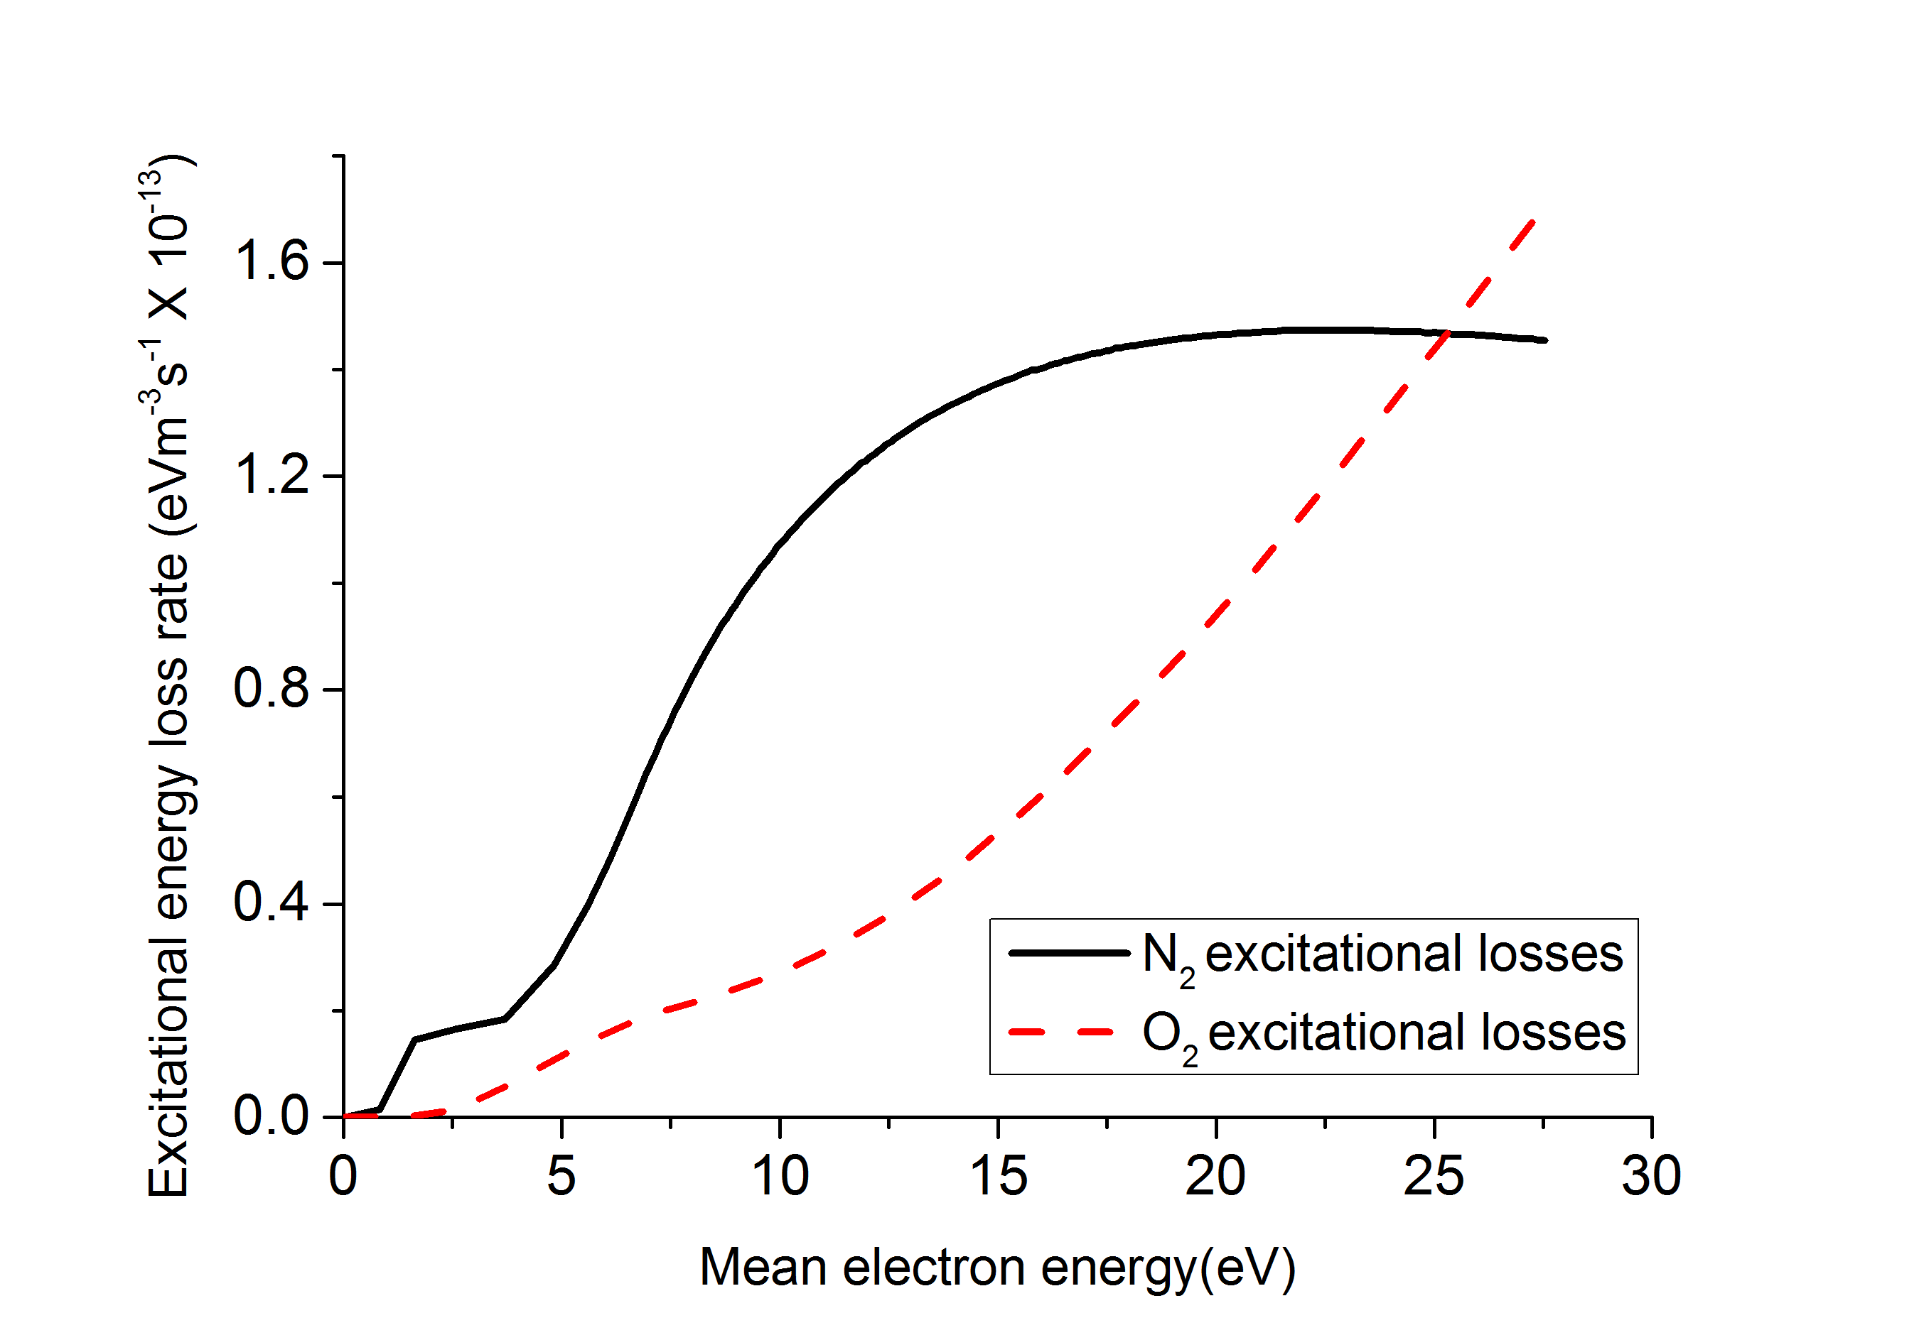
Figure 1. The excitational energy loss rate, defined as, for N₂ and O₂ respectively. In the previous expression ε_{i} (eV) and k_{i} (m⁻³s⁻¹) are the energy cost of the ith excitation reaction and the ith rate coefficient. The index i runs over the rotational and vibrational excitation reactions for N₂ (solid black) and O₂ (dashed red) respectively as function of the electron mean energy.
  - Time averaged EHD forces
The axial and radial time-averaged EHD forces for the three investigated cases are shown in Figure 2. The spatial structure of the time-averaged EHD forces is similar in the three cases. The radial force has its maximum magnitude in the sheath inside the capillary, and in the radial mixing layer outside the capillary. The mixing layer is defined as the transition zone from positions where the gas composition is entirely from the flowing jet to positions where the gas composition is entirely ambient air away from the jet.
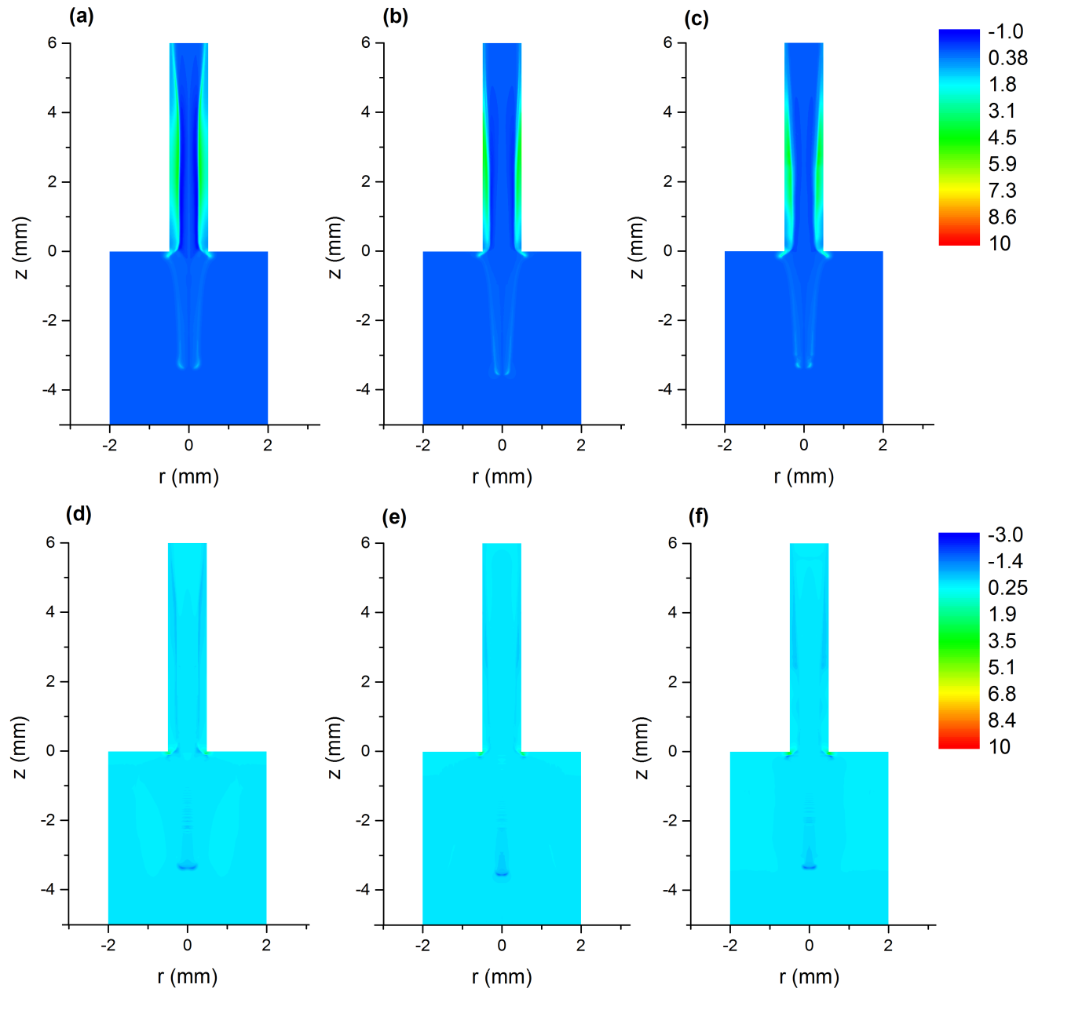
Figure 2. The time averaged radial force for (a) pure helium case, (b) helium admixture with 2% O₂ and (c) helium admixture with 2% N₂. The three panels have the same legend. The time averaged axial force for (d) pure helium case, (e) helium admixture with 2% O₂ and (f) helium admixture with 2% N₂. The three panels have the same legend. All legends are displayed in kNm⁻³.
Examining the radial force in figure 2, it can be seen that the maximum magnitude of the radial force coincides with zones where a strong radial electric field exists or has existed. Those zones are the sheath between the plasma channel and the inner dielectric surface of the capillary, where the time averaged radial force has a maximum of approximately 6 kNm⁻³, and the radial ‘edges’ of the plasma channel outside the capillary, where the time averaged radial force has a maximum of approximately 2 kNm⁻³. These values can be converted to time-integrated forces by multiplying by the period of 20 μs giving 0.12 Nm⁻³s and 0.04 Nm⁻³s respectively. Compared to calculated forces for DBD actuator configurations [12], the time-integrated forces in the helium jet are an order of magnitude lower.
During the pulse-on time, the plasma channel is biased at high positive potential with respect to its surroundings, attracting electrons from its radial and axial edges. As a result, a thin layer of positive charge forms at the edges of the plasma channel, creating a strong electric field. This electric field exists until charge balance is restored, which occurs for example after 100 ns after the pulse is switched off for the pure helium case. The correlation between the radial force and the strong electric fields indicates that the electric field component of the EHD force (of the three components explained in section 2) is the dominant component, which the model confirms by comparing the contribution of the three radial components to the total radial EHD force as function of time.
The axial force is also shown in figure 2; its high magnitude of 5 kNm⁻³, approximately at the edge of the orifice of the capillary is attributed to the strong electric field there during the pulse-on time. The high magnitude of the axial force at the symmetry axis of 2 kNm⁻³ coincides with the axial mixing layer for the assumed flow rate. Converting to time-integrated forces as described above gives corresponding figures of 0.1 Nm⁻³s and 0.04 Nm⁻³s respectively; an order of magnitude lower than for typical air DBD actuators [12].
As the bullet propagates to larger distances down the symmetry axis the air fraction in the background gas increases, causing the bullet propagation velocity to decrease until it arrives at the point where it is ultimately extinguished. The lowering of the propagation velocity increases the exposure time of the background gas to the EHD forces, thus increasing the momentum transferred from the ions to the background gas. The axial forces are mainly exerted by the ions on the background gas during pulse-on time. The time integrated axial forces show insignificant difference from the end of pulse-on time to the end of the period of the waveform. Of the three components constituting the EHD forces, the electric field component dominates over the other two components, with the dominance being approximately an order of magnitude in the radial force, compared to a factor of 2 to 6 in the axial force.
The addition of O₂ or N₂ to the flow affects the EHD forces indirectly by altering the speed and the electric field in the head of the bullet. Figure 2 shows that the EHD forces (the radial and the axial components) for the three cases are almost identical, although the O₂ case has a significantly different propagation speed of the bullet. The reason for the similarity of the O₂ case to the other two cases is that the electric field is stronger in the former case and the propagation speed is higher. Thus, the stronger force (due to the stronger electric field) is applied to the background gas for a shorter time. As a result, the net change in momentum is small.
  - Gas heating
Energy is transferred from the electrons to the background gas constituents either directly through elastic collisions and rotational/vibrational excitations of the background gas constituents, or indirectly through the ohmic heating of ions, which transfers the energy from the electric field to the ions through acceleration, then the ions transfer their energy to the background gas through collisions. Figure 3 shows the time-averaged gas heating term for the three investigated cases. There are two zones where heating term has its maximum magnitude, one inside the capillary and one outside it. The heating term in the capillary has its high magnitude between the anode and the cathode. In this zone, the geometrical electric field is strong (has an magnitude of 10 kVcm⁻¹ without plasma) which adds to the electric field in the head of the bullet, causing the electrons that are accelerated by this combined field as the bullet propagates in that zone, to be more energetic compared to electrons elsewhere, leading to more energy transfer from electrons to the background gas. An additional zone inside the capillary is located close to the walls of the capillary, which can be seen clearly in figure 3(a). This zone coincides with the sheath between the plasma channel and the walls of the capillary. Gas heating in this zone is dominated by the ohmic heating of ions.
The high magnitude of the heating term outside the capillary, particularly in the region -4 mm < z < -1 mm is attributed to the high mole fraction of air. A higher air mole fraction means extra routes are available for the electron energy to be transferred to the background gas constituents. The extra routes are mainly the rotational and vibrational excitations of N₂ and O₂. This zone of local heating extends over the axial mixing layer to the point where the bullet is extinguished.

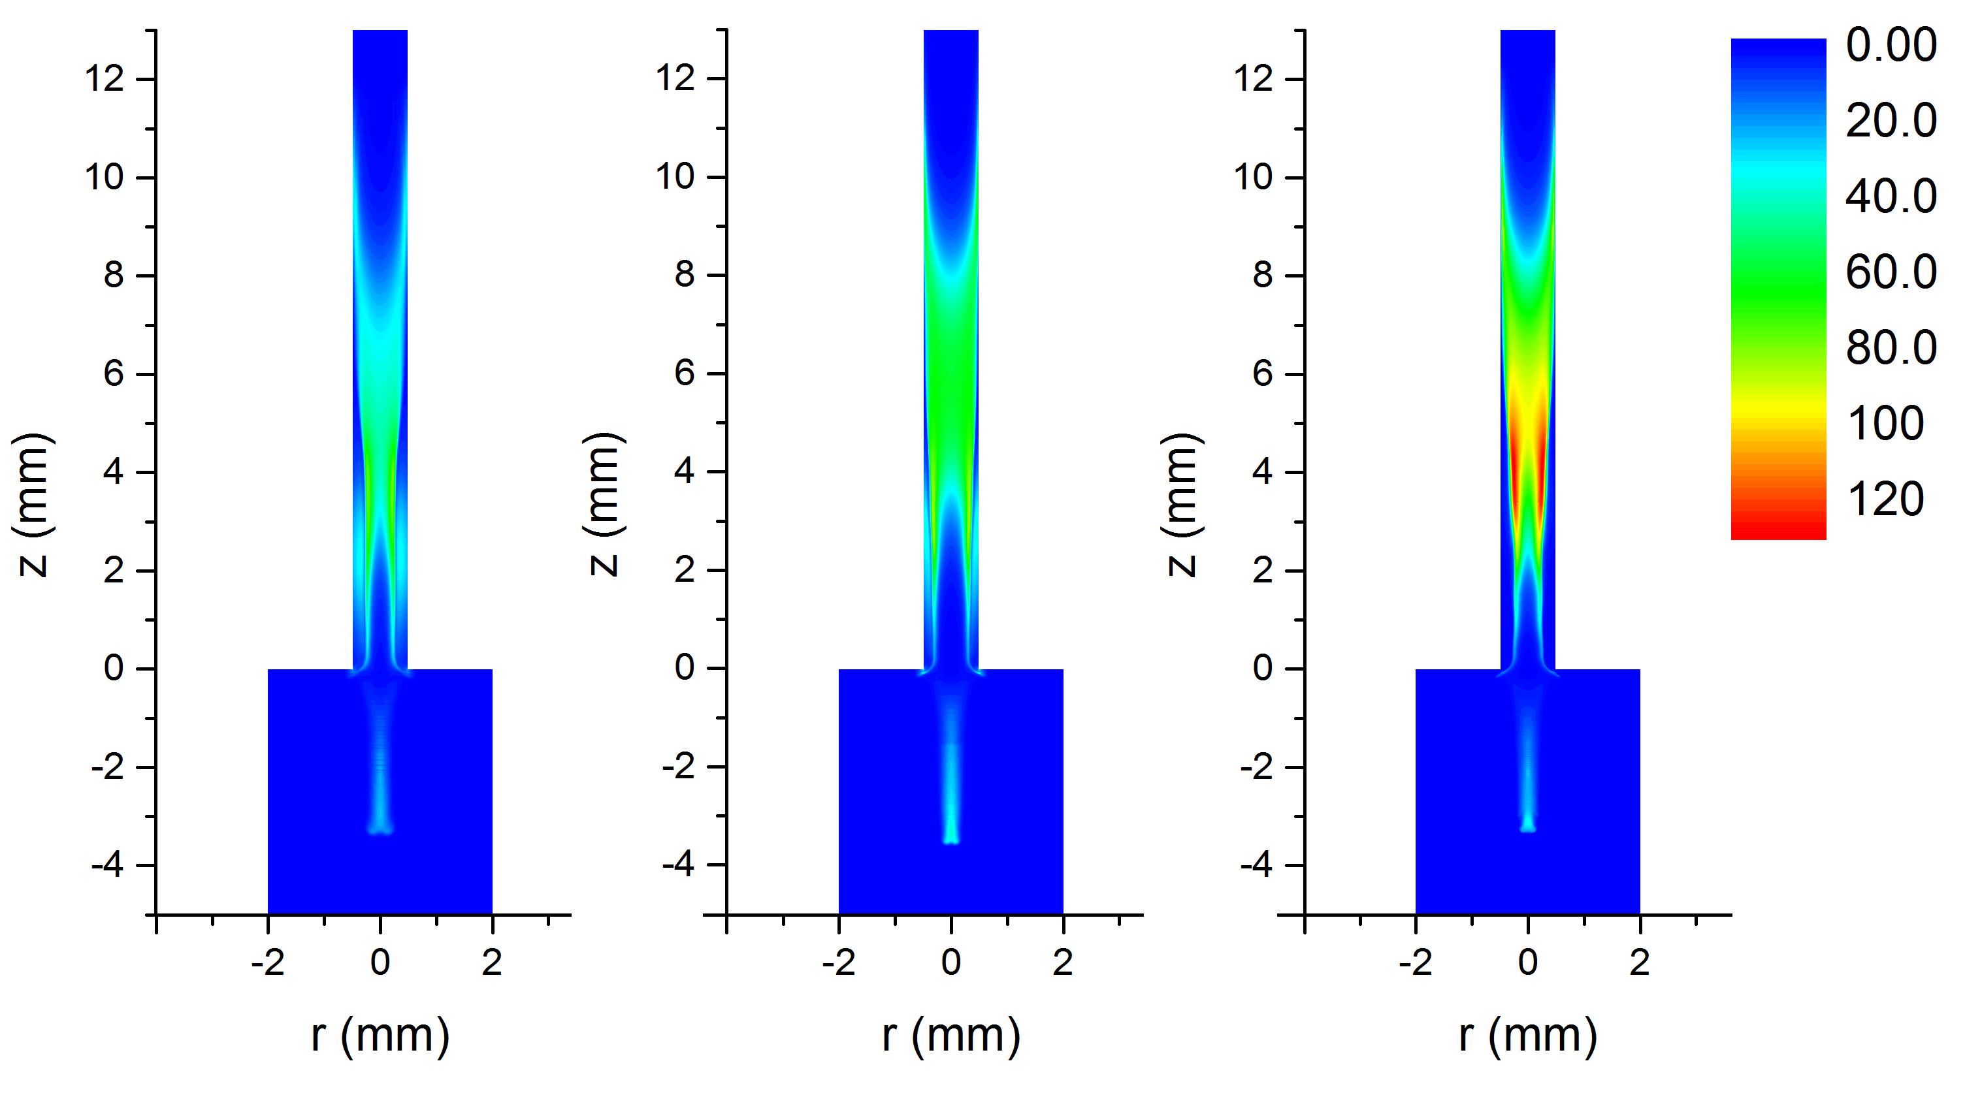
Figure 3. The time averaged heating term for (a) pure helium case, (b) helium admixture with 2% O₂ and (c) helium admixture with 2% N₂. All panels have the same legend, which is displayed in MWm⁻³

It can be also seen from figure 3 that the magnitude of the time averaged gas heating term in the capillary increases from pure helium case, to O₂ case, to N₂ case (the maximum magnitude). The addition of N₂ and O₂ to the flow improves the coupling between the electrons energy and the background gas constituents through rotational and vibrational excited states of N₂ and O₂. The magnitude of the time averaged heating term in N₂ is greater than the O₂ case because the rotational and vibrational losses of the electron energy are greater for the N₂ case as figure 1 shows. The inelastic losses of electrons to the background gas dominate over both the elastic losses and the ohmic heating on the ions during most of the waveform.
It should be noted here that since the main gas heating effect occurs in the capillary, for higher flow rates than the rate assumed here, it is expected that the background gas heating due to the presence of the plasma in the capillary to not change significantly. Since the gas composition in the capillary does not change significantly for high enough flow rates, and since the time scale of the discharge is typically much shorter than the time scale of the flow, there is no reason to expect any difference in the heating inside the capillary.
  - Perturbed gas flow
To evaluate the impact of the presence of the discharge on the background flow, the time averaged force fields discussed in section 3.2 and the time averaged heating term discussed in section 3.3 are introduced into the momentum conservation equation (equation (2)) and the heat equation (equation (4)). A comparison between the steady state un-perturbed flow and the steady-state perturbed flow for the three cases is shown in figure 4.
It should be noted here that the temperatures shown in figure 4(b) are computed under the condition that the thermal flux from the gas to the capillary is zero while in reality it is finite, implying that the temperatures presented here are slightly over-estimated. Determining the heat flux into the capillary is outside the scope of this work. The zero flux assumption is justified by the poor heat conductivity of glass, from which the capillary is made.
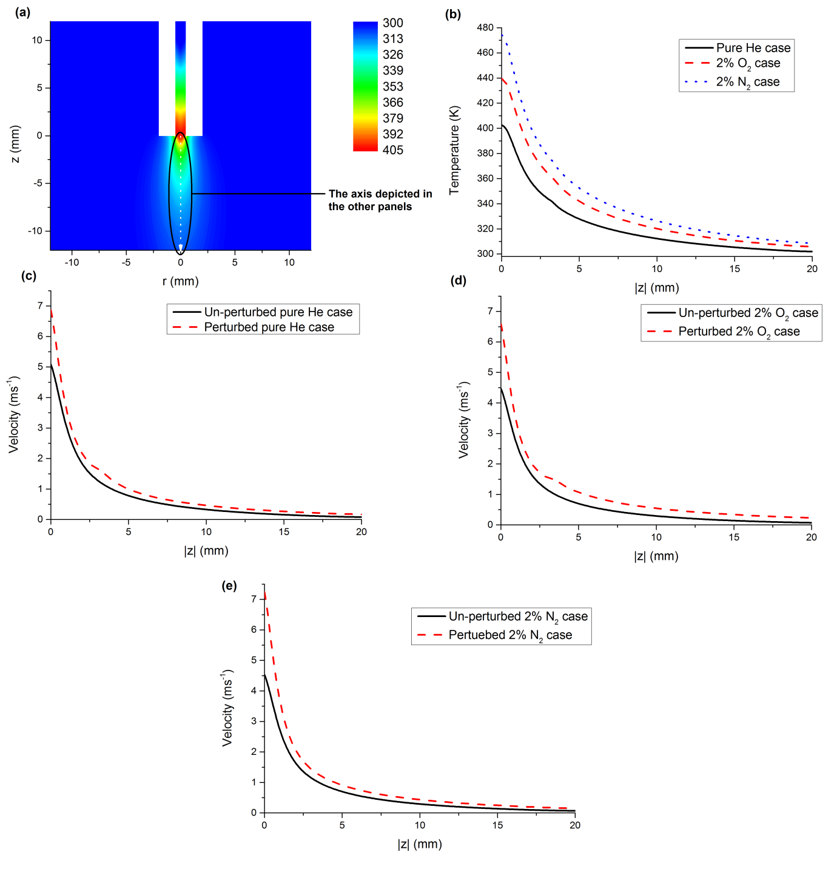
Figure 4. (a) The 2D temperature for the pure helium case, (b) the temperature along the symmetry axis outside the capillary the three cases, (c) the velocity amplitude along the symmetry axis outside the capillary for pure helium case, (d) the velocity amplitude along the symmetry axis outside the capillary for 2% O₂ case (e) the velocity amplitude along the symmetry axis outside the capillary for 2% N₂ case.
As figure 4 shows, the temperature increases significantly due to gas heating, with the highest increase by a factor of 60% for N₂ case, followed by 47% for O₂ case and 33% for pure helium case compared to the assumed gas temperature of 300 K. The added gasses to the flow allow the electrons to lose some of their energy to the background gas through rotational and vibrational excitations. As it is shown in section 3.1, these loses are greater for the N₂ case compared to the O₂ case, explaining why the temperature is greater in N₂ case compared to O₂ case. The 2D distribution of gas temperature for the three cases is similar to figure 4(a), with the maximum temperatures as shown in figure 4(b). This spatial distribution of temperature induces a pressure gradient force that increases the flow velocity outside the capillary as shown in figures 4(c) to 4(e). Since the gas temperature is the highest for the N₂ case, the increase in the flow velocity is the highest for that case, as well, followed by the O₂ case then the pure helium case.
The EHD forces are responsible for the small increase in the velocity in figures 4(c) and 4(d) at approximately |z| = 4 mm. This small difference indicates that the impact of the EHD forces on the flow is significantly weaker compared to the pressure gradient force induced by the temperature. Thus, gas heating is the main factor responsible for altering the gas flow pattern.
Assuming that higher flow rates do not significantly change the gas heating inside the capillary, the increase of the flow velocity is not expected to substantially differ from what is reported here. Consequently, this extra velocity due to the presence of the plasma is unlikely to cause a significant increase in the Reynolds number of the flow to change the flow regime from laminar to transitional or turbulent regime. As a matter of fact, the Reynolds number of the perturbed flow is slightly lower compared to the un-perturbed flow case (approximately 42 for the pure helium case, 34 for the 2% O₂ case and 31 for the 2% N₂ case). The reason for this decrease is that the relative drop in the gas density due to heating is greater than the relative increase in the velocity, which causes the total Reynolds number to decrease. Thus, the results presented here suggest that the physical explanation of the plasma–induced turbulence, described in section 1 as the macro-scale scenario is unlikely, leaving the other scenario (the micro-scale scenario) more probable, where the critical Reynolds number of the flow is effectively reduced due to the presence of the plasma, causing flows which are laminar in the absence of the plasma to become turbulent when the plasma is present.
- Conclusions
The influence of the plasma on the background gas in a He atmospheric-pressure jet has been studied using a 2D axisymmetric model for three different gas composition cases: purely helium, 2% O₂ and 2% N₂ admixtures.
The discharge affects the flow pattern of the background gas in two ways: Firstly, by the EHD forces applied by the charged species and secondly, through gas heating by energetic electrons. For the three investigated cases. It is shown that the magnitude of the EHD forces in a He-APPJ is approximately an order of magnitude lower than typically in DBD air actuator configurations. The electric field term in the expression of the EHD forces dominates over the other two terms (the drag force term and the density gradient term). The EHD forces are mainly applied to the background flow during the pulse-on time, and almost identical in the three investigated cases. The maximum values of the total EHD forces in the radial and the axial directions are approximately 6 and 5 kNm⁻³, respectively.
The gas heating effect has its maximum magnitude inside the capillary, but is also significant in an axial layer outside the capillary due to the strong electric field between the anode and the cathode. The dominant heating mechanism is shown to be the inelastic losses of electrons. The addition of O₂ or N₂ to the flow increases the heating effect of the background gas, due to enhanced inelastic losses of electron. The increases in the gas temperature due to the presence of the plasma are 60, 120 and 160 K for the pure helium, O₂ and N₂ admixture cases, respectively.
Gas heating is shown to be the dominant mechanism responsible for the perturbation of the background gas flow pattern in the three investigated cases. The Reynolds number at the exit of the capillary changes slightly as the increase in the flow velocity is counteracted by the decrease in density due to heating. The results indicate that the impact of the plasma on the flow would not be strong enough to increase the Reynolds number to induce a transition from a laminar flow regime to a turbulent flow regime, making the decrease of the critical Reynolds number to be a more probable explanation.
Acknowledgement
One of the authors MIH would like to thank the Department of Electrical Engineering and Electronics at the University of Liverpool for providing him with a Doctoral Training Studentship.
Appendix
In this appendix, the boundary conditions implemented for the heat equation (equation (4)) are explained. As stated earlier, the heat equation is added to the hydrodynamic model used in [21], for this reason, only the boundary conditions of the heat equation are discussed here. The computational domain for the heat equation is the same as the computational domain of the hydrodynamic model. Since the domain of this discharge model in [23] is smaller than the domain of the hydrodynamic model, the gas heating term in equation (4) exists only in a part of the domain. It is assumed that the heating term has a magnitude of zero everywhere outside the computational domain of the discharge model.
The boundaries are numbered as shown in figure A1, while table A1 lists the assumed boundary conditions on each boundary.

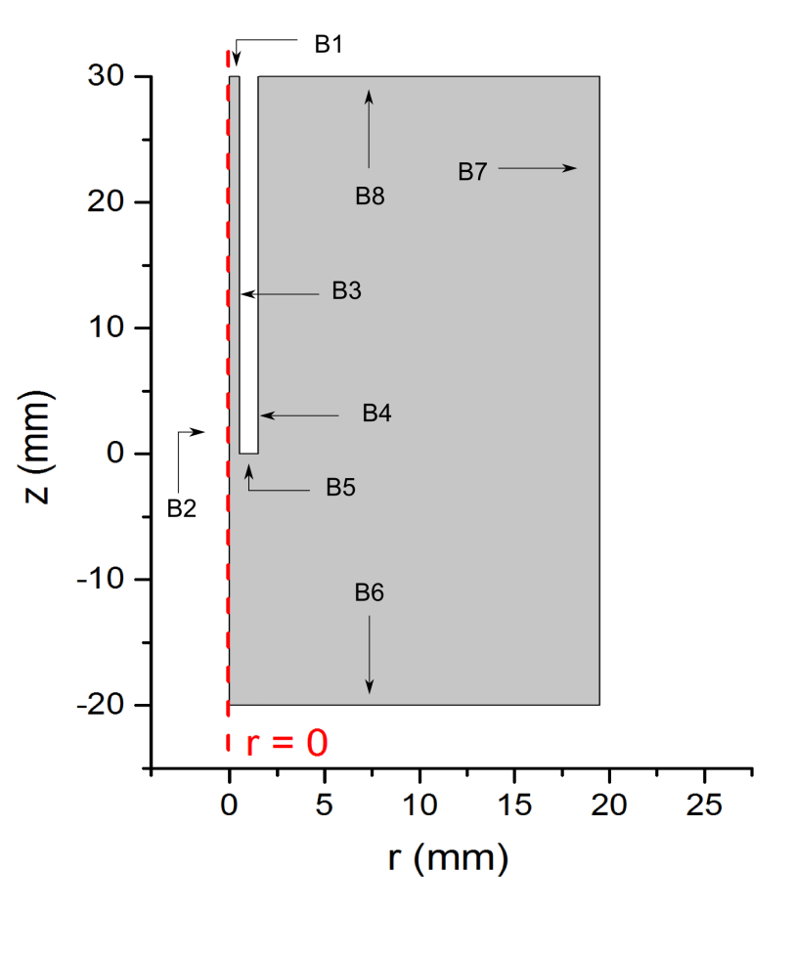
Figure A1. The boundaries numbers used to describe boundary conditions for the heat equation.
Table A1. The boundary conditions used for the heat equation.
Boundary number | The boundary condition
B1 | No thermal flux
B2 | Symmetry
B3 | No thermal flux
B4 | No thermal flux
B5 | No thermal flux
B6 | No thermal flux
B7 | Constant temperature  T = 300 K
B8 | Constant temperature  T = 300 K

In table A1, boundaries B7 and B8 represent the ambient air conditions. The boundary condition implemented on these boundaries does not affect the solution close to the orifice of the capillary.
References
[1] Suzuki T, Saburi T, Tokunami R, Murata H and Fujii Y 2006 Thin Solid Films 506 342

[2] Long T M, Prakash S and Shannon M A 2006 Langmuir 22 4104

[3] Stalder K R, McMillen D F and Woloszko J 2005 J. Phys. D Appl. Phys. 38 1728

[4] Stoffels E, Kieft I E and Sladek R E J 2003 J. Phys. D: Appl. Phys. 36 2908

[5] Karakas E, Koklu M and Laroussi M 2010 J. Phys. D: Appl. Phys. 43 155202

[6] Oh J-S, Olabanji O, Hale C, Mariani R, Kontis K and Bradley J W 2011 J. Phys. D: Appl. Phys. 44 155206

[7] Ghasemi M, Olszewski P, Bradley J W and Walsh J L 2013 J. Phys. D: Appl. Phys. 46 052001
[8] Foletto M, Puech V, Fontane J, Joly L, and Pitchford L C 2014 IEEE Trans. Plasma Sci 42 2436
[9] Robert E, Sarron V, Darny T, Ries D, Dozias S, Fontane J, Joly L and Pouvesle J-M Plasma Sources Sci. Technol. 2014 23 012003
[10] Dimotakis P E 2005 Annual review of fluid mechanics 37 329-356

[11] Hydrodynamic Instability and Transition to Turbulence (Fluid Mechanics and Its Applications) by Akiva M. Yaglom, Uriel Frisch Springer; 2012 edition chapter 2
[12] Boeuf J P and Pitchford L C Journal of Applied Physics 2005 97 103307
[13] Che X,Shao T, Nie W and Yan P 2012 J. Phys. D: Appl. Phys. 45 145201

[14] Boeuf J P, Lagmich Y, Unfer T, Callegari T and Pitchford L C 2007 J. Phys. D: Appl. Phys. 40 652–662
[15] Bradley J W, Oh J-S, Olabanji O, Hale C, Mariani R, and Kontis K 2011 IEEE Transactions on Plasma Science 39 11 2312
[16] Oh J-S, Walsh J L and Bradley J W 2012 Plasma Sources Sci. Technol. 21 034020
[17] Shao X-J, Chang Z-S, Mu H-B, Liao W-L, and Zhang G-J, 2013 IEEE Transactions on Plasma Science 41 4 899

[18] Papadopoulos P K, Vafeas P, Svarnas P, Gazeli K, Hatzikonstantinou P M, Gkelios A and Clement F 2014 J. Phys. D: Appl. Phys. 47 425203
[19] Svarnas P, Papadopoulos P K, Vafeas P, Gkelios A, Clément F and Mavon A 2014 IEEE Transactions on Plasma Science 42 10 2430
[20] Naidis G V 2012 Journal of Applied Physics 112 103304
[21] Breden D, Miki K and Raja L L 2012 Plasma Sources Sci. Technol. 21 034011
[22] Liu X Y, Pei X K, Lu X P and Liu D W 2014 Plasma Sources Sci. Technol. 23 035007
[23] Hasan M I and Bradley J W 2015 Plasma Sources Sci. Technol. 24 055015
[24] Hagelaar G J M and Pitchford L C 2005 Plasma Sources Sci. Technol. 14 722–733, the version used of BOLSIG+ is dated 06-2013.
[25] Leiby C C and Oskam H J 1967 Physics of Fluids 10 1992
[26] Breden D, Miki K and Raja L L 2011 Appl. Phys. Lett. 99 111501
[27] Wu S, Lu X, Liu D, Yang Y, Pan Y and Ostrikov K 2014 Physics of Plasmas 21 103508
[28] McKay K, Oh J-S, Walsh J L and Bradley J W 2013 J. Phys. D: Appl. Phys. 46 464018
[29] Naidis G V 2011 Applied Physics Letters 98 141501
[30] Breden D, Miki K and Raja L L 2012 Plasma Sources Sci. Technol. 21 034011
[31] Mericam-Bourdet N, Laroussi M, Begum A and Karakas E J. Phys. D: Appl. Phys. 2009 42 055207
[32] Wu S, Lu X, and Pan Y Physics of Plasmas (2014) 21 073509

