ppap.20150003.R1
Article Type: Full Paper
Atmospheric-pressure plasma polymerization of acrylic acid: Gas-phase ion chemistry
F Moix¹, K McKay¹, J L Walsh¹ and J W Bradley¹
¹Department of Electrical Engineering and Electronics, University of Liverpool, Brownlow Hill, L69 3GJ, UK

Email: j.w.bradley@liv.ac.uk

Abstract
To improve understanding and characterize the atmospheric-pressure polymerization process, the gas-phase ion chemistry of acrylic acid produced using a microsecond pulsed atmospheric pressure plasma jet has been studied using ambient mass spectrometry. The acrylic acid monomer was introduced into the helium feed prior to entry into the active discharge region of the plasma jet and the pulse duty cycle was varied from 10-90% for frequencies of 5 and 10 kHz. The ionic mass spectra show a rich variety of species up to 450 Da with prominent peaks at masses corresponding to both positive and negative oligomer ions,[nM+H]⁺ and [nM-H]⁻, with up to n = 6 for positive ions and n = 4 for negative ions. Through variation of the pulse voltage parameters the mass distribution of the oligomer ions produced in the outflow can be manipulated. It is determined, from the literature, that formation of these polymers in the plasma discharge was due not only to one polymerization mechanism but several. The multiple mechanisms will result in a branching and cross-linking of the polymer chains, which may affect the properties of the polymer when deposited on a surface.

Introduction
Polymerization of volatile organic compounds (“monomers”) using plasmas has been an intensive area of research for many years and is used to apply polymer-like thin films to different materials to change the surface properties.[,] This process is traditionally done using low-pressure vacuum based plasma technologies. ^{[1,,]} In recent years, however, the use of atmospheric-pressure plasmas for the production of functional thin films has become more commonplace and offers a viable alternative to costly vacuum systems.[,,] Despite the increased use of atmospheric-pressure plasma sources for polymerization, the process is only now starting to be understood and routes to optimisation of the process remain unexplored.[]
Acrylic acid is widely used in plasma polymerization applications due to properties such as high abundance of COOH functional groups, which is advantageous for applications such as adhesion, biocompatibility and wettability.[,,]
The literature suggests that using short high voltage pulses to drive the plasma discharge may offer several advantages to continuous wave plasma discharges such as lower power consumption, enhanced reactive chemistry and high electron energies.[,] In the low-pressure regime pulsed plasmas have also been seen to improve the process of oligomerization of acrylic acid.[]
Here we use an atmospheric-pressure low-temperature pulsed plasma jet to polymerize the acrylic acid vapours. To understand the effect microsecond pulsing has on the plasma chemistry the discharge frequency and duty cycle were varied. The effect of changing the pulse parameters on the ionic composition of the plasma-monomer mixture was monitored using time-averaged ambient mass spectrometry. From the literature and the mass spectra we also determine that unlike conventional polymerization there was more than one polymerization mechanism taking place in the plasma discharge.

Experimental Setup
The plasma jet used in this study was a cylindrical dielectric barrier discharge (DBD). It consisted of a 10 cm glass capillary (outer diameter (OD): 4 mm, inner diameter (ID): 2 mm), with a copper ring electrode attached 0.5 cm from the end of the capillary. The jet was powered using monopolar pulsed excitation. For the pulsed source, high voltage positive monopolar pulses of ∼4.0 kV (V_{p–p}) were generated using a custom-made voltage amplifier combined with a digital pulse generator (DG645, Stanford Research Systems). The frequency was fixed to 5 and 10 kHz and the duty cycle was varied from 10% to 90%. The capillary was fed with helium (purity: 99.996%) at a flow rate of 1.5 SLM (Standard Litres per Minute) and a helium-acrylic acid mixture at a flow rate of 14.6 SCCM (Standard Cubic Centimetres per Minute), this mixture allowed for a stable plasma to be formed at all duty cycles considered. Using the Antoine equation and the Antoine coefficients of Acrylic acid,[] it has been calculated for a liquid temperature of 23 ± 2 ºC that there was approximately 42 ± 6 ppm’s (~0.0042%) of acrylic acid in the discharge. The helium outflow was able to interact with the ambient laboratory air as it passed from the capillary exit to the mass spectrometer entrance. A schematic diagram of the plasma jet and mass spectrometer set up is shown in figure 1.
The applied voltage V(t) and current I(t) were obtained at every operating condition, using a Tektronix P6015A voltage probe and a Pearson current probe. The average powers in the various plasma discharges were calculated by determining the pulse energy as shown in equation 1 and dividing this through by the discharge period as shown in equation 2.

$E_{pulse}=\int_{t_{0}}^{t_{1}}{I\left(t\right)⋅V\left(t\right)dt }$(1)$P_{average}={E_{pulse}}/T$ (2)
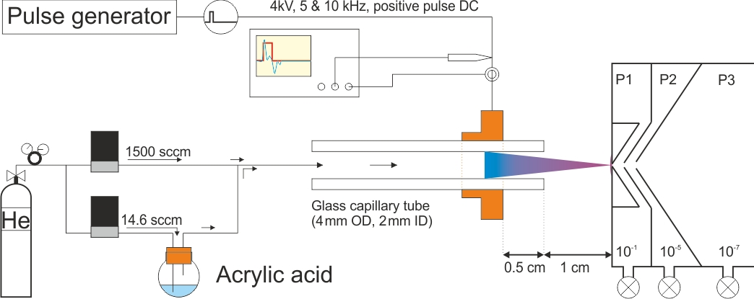
Where t_{o} is the beginning of the current peak and t₁ its end, and T is the pulse period. Where T= 200 µs for 5 kHz and 100 µs for 10 kHz. We can also define a peak power P_{peak} = Max ($IV)$, recorded on the oscilloscope. It was calculated that $P_{average}$ for duty cycles of 10 to 90 %, increased from 37 to 67 mW for 5 kHz and from 67 to 142 mW for 10 kHz and P_{peak} for duty cycles of 10 to 90%, decreased from 61 to 21 W for 5 kHz and from 71 to 35 W for 10 kHz.
Figure 1: Schematic diagram of pulsed plasma jet system and molecular beam mass spectrometer
The mass spectrometer used here was a quadrupole-based (QMS) molecular beam mass spectrometer (MBMS), the HPR-60 manufactured by Hiden Analytical Ltd. It consists of a three stage differentially pumped inlet system separated by aligned skimmer cones and turbomolecular pumps, and has been specifically designed for the chemical analysis of atmospheric pressure plasmas. The pressure reduction stages, (P1)–(P3) shown in figure 1, provide a pressure reduction from atmospheric pressure to 10⁻¹ Torr (P1), 10⁻⁵ Torr (P2) and 10⁻⁷ Torr (P3). The HPR-60 can be used to detect neutral species (RGA mode) as well as both positive and negative ions (SIMS mode). In RGA mode the neutral molecular beam is internally ionized before it reaches the quadrupole stage. In SIMS mode the molecular beam is already ionized and positive and negative ions are separated by applying voltages to the skimmer cones. Positive and negative ions generated by the plasma jet (either between the electrodes or through interactions in ambient air) were readily detected using the HPR-60 system. The plasma jet was aligned with the centre of the sampling orifice and the distance from the end of the capillary was fixed to 1 cm.

Results and Discussion
From previous studies performed by the group [], it is known that the ion chemistry of a pure He jet flowing into atmospheric pressure air consists mainly of water cluster ions, nitrogen ions and oxygen ions. When, however, acrylic acid is added to the helium flow, the ion chemistry dramatically changes (as can be seen in figure 2). Due to the lack of available information on the gas-phase formation of polymerized acrylic acid, this change in ion chemistry can be difficult to explain. In this section, however, we draw on information from several sources where polymer formation and the behaviour of carboxylic acid containing esters are examined, and provide insight into the potential gas-phase formation mechanisms of poly(acrylic acid) in the plasma discharge.
Figure 2(a-d) shows the time-averaged positive and negative ion spectra obtained for the 5 kHz and 10 kHz pulses with a fixed duty cycle of 10%. From 2(a) and 2(b) we see that for both frequencies several positive oligomer ions ([nM+H]⁺, where n=1-6) of acrylic acid were detected in the range 0-450 Daltons (Da). In addition to the positive acrylic acid oligomer series, several other positive acrylic acid fragments and oligomers plus NH₄, CNH₄, CH₅O₂, C₃H₃O and C₂H₄O₂ attachments were also detected. From the negative ion spectra shown in 2(c) and 2(d) we can see that there were also several negative oligomer ions ([nM-H]⁻, where n=1-4) produced in the discharge. Again, we see that as well as the main oligomer peaks other negative acrylic acid fragments OH, CH₃, CH₅O₂ and NOH were also detected in this mass range.
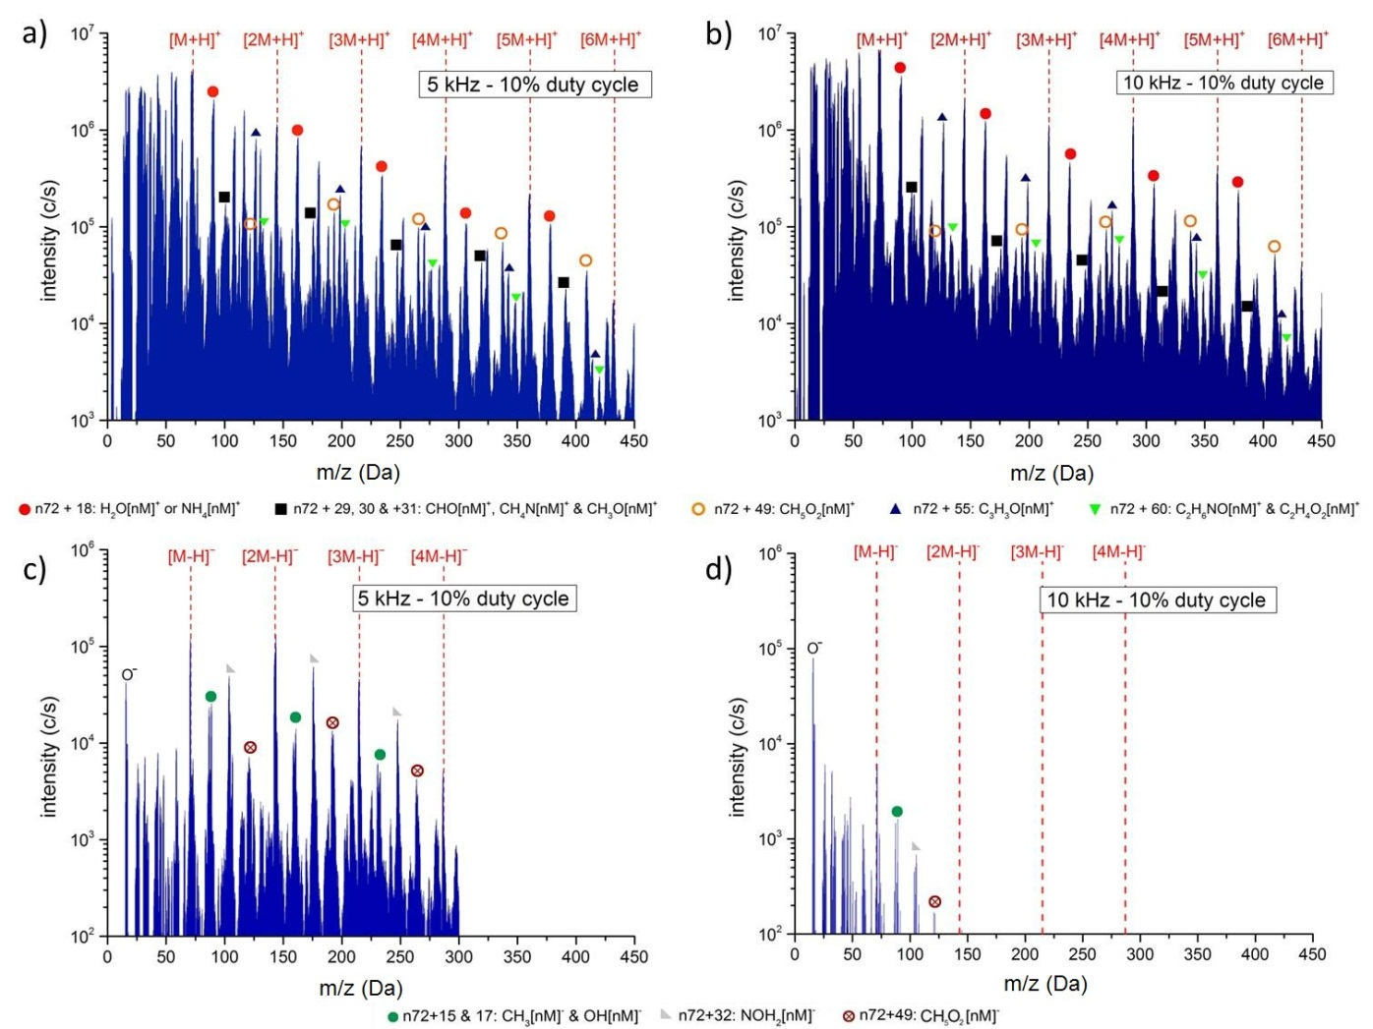
It is clear, from the literature, that there is more than one polymerization mechanism at work in the plasma; this is due to the rich chemistry created in the plasma discharge. Due to the abundance of radical species in the plasma, the main mechanism for polymerization is thought to be radical chain growth (RCG) []. RCG involved a radical species breaking the carbon-carbon double bond in the acrylic acid, providing bonding sites for other monomer units to attach. The chain will be terminated when a non-monomer unit bonds to the available site ^{[1,17]}. The other mechanisms are ionic chain growth and proton transfer. Ionic chain growth (ICG) is similar to RCG, however the double bond is broken by a positive or negative ion ^{[1,17,]}. For the dimer (n=2), proton transfer reactions with hydronium ion (H₃O⁺) and its hydrates (H₃O⁺(H₂O)_{n}) are also important, this mechanism is described in Marotta and Paradisi.[]. Unlike conventional polymerization, where the monomer units are arranged in a linear fashion, plasma polymerization of this type is thought to involve significant chain branching and cross-linking ^{[17]}. It should also be noted that the higher order oligomers were not seen when looking only at the neutral chemistry within the discharge, this was also reported by Marotta and Paradisi when looking at ester chemistry, they attribute it to the oligomer ions undergoing cleaving steps to eliminate stable neutral molecules, it is thought a similar process was at work here ^{[19]}.
Figure 2: Time-average ion spectra for He+Acrylic acid for (a)Positive Ions ,5 kHz 10% duty cycle, (b) Positive Ions, 10 kHz 10% duty cycle (c) Negative Ions, 5 kHz 10% duty cycle, and (d) Negative Ions, 10 kHz 10% duty cycle.
To determine the effect of pulse conditions on the production of the positive and negative oligomer series ions ([nM+/-H]^{+/-}) the duty cycle was varied from 10% to 90%. As the duty cycle was varied the average power in the discharge changed. As applied power/flow (P/F) is a commonly used quantity in the field of polymerization we have used it here to examine oligomer formation for the various conditions studied (see figure 3). We have calculated the average plasma powers as shown in section 2.
In figure 3(a) it can be seen that the intensity of the positive oligomers in the 5 kHz pulse case remained relatively constant until the P/F was increased above 38 mW/slm. For the 10 kHz pulse, however, the intensity of the positive oligomers increased by approximately an order of magnitude as the P/F increased from 45 to 95 mW/slm (fig 3(b)). In the 5 kHz case the negative oligomer ion intensity increased until 37 mW/slm, where again like the positive ion case they started to decrease (fig 3(c)). In the 10 kHz case we see that the de-protonated acrylic acid negative ion ([M-H]⁻) intensity increased as the P/F increased from 75 to 95 mW/slm, however there was a decrease of the higher order oligomers over the same range (fig 3(d)).
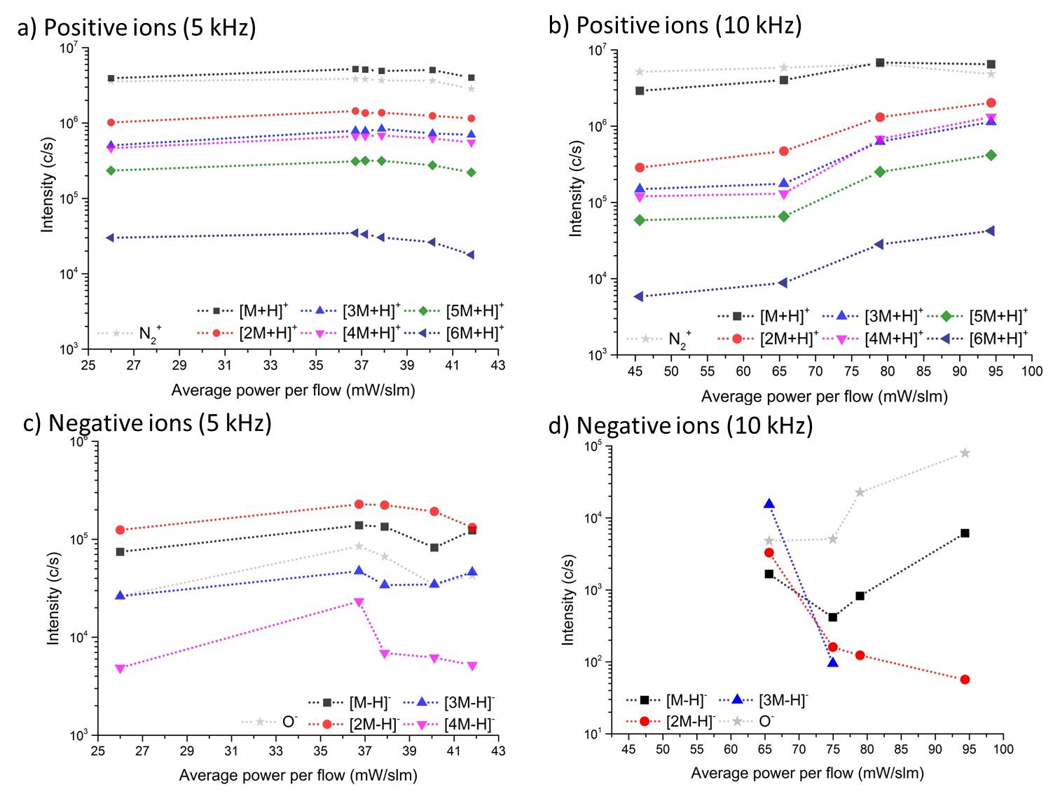
From peak power measurements and the relation that 1 Watt / 1 sccm = 15.5 eV [], we can calculate the peak energy per molecule in our system. For the 5 kHz case the peak powers varied from ~61 W for the 10 µs pulse to 21 W for the 180 µs pulse, this resulted in a variation of the peak energy per molecule from 1.87 eV / molecule to 0.64 eV / molecule in the discharges.^{[1]} These energies are around the typical bond energies in the monomer, showing that for a limited time at least during the pulse period, there is sufficient energy for some fragmentation of the molecule, however averaged over a period the discharge would be operating in an equivalent to the “power deficient regime” identified in low-pressure polymerization,^{[1]} a condition that can lead to good functional retention. From figure 3 and molecular energy calculations it can be seen that positive oligomer formation is linked to both the average power and a peak power. As has been discussed above, there are several polymerization mechanisms at work in the plasma discharge. For the positive oligomer formation, in the 10 kHz case, it is thought that as the average power increased the conditions became more favourable for the formation of radical species. This increase in radicals resulted in increased radical chain-growth polymerization. It is also thought that cationic chain-formation became less important in the discharge as peak power decreased, as this resulted in less small positive ions being formed in the discharge. For the negative oligomer formation, in the 10 kHz case, it is thought that the increase in off-time and the decrease in peak power promoted the formation of negative ions and anionic chain growth.
Figure 3: Trend of the main positive and negative oligomers as a function of average power/flow for (a) positive ions, 5 kHz, (b) positive ions, 10 kHz, (c) negative ions, 5 kHz, and (d) negative ions, 10 kHz.

Conclusions
Here, we have examined the gas-phase formation of acrylic-acid polymer chains, and explored how this formation process was influenced by varying parameters such as frequency and pulse duty cycle. Using time-averaged spectra we have observed several different positive and negative oligomers in the plasma discharge, and we have concluded from the literature that there are several polymerization mechanisms competing in the plasma at the same time. It was also shown that increasing the average power in the discharge by varying the duty cycle resulted in an increase in positive oligomer formation. In a future publication we will investigate the effect of microsecond pulsing on the deposition and quality of polymeric thin-films on a variety of substrates.

Key words: Acrylic acid, mass spectrometry, polymerization, pulsed discharges

References

Table of Contents text and image

This paper investigates the gas-phase ion chemistry produced during polymerization of acrylic acid using a low-temperature atmospheric pressure plasma jet. The jet was driven using microsecond DC pulses; allowing us to examine the effects of average and peak power on the polymerization process. In this paper we also summarise the potential polymerization mechanisms at work in the plasma discharge, and conclude that several mechanisms are competing, which may lead to increased branching and cross-linking of the polymer.

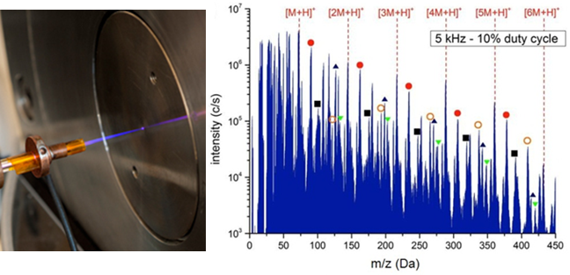

[] H Yasuda, Plasma Polymerisation, Academic Press, Inc., Orlando, FL, 1985
[] H Biedermann, Plasma Polymer Films, Imperial College Press, London 2004
[] J M Kelly, R D Short, M R Alexander, Polymer, 2003, 44, 3173-3176
[] Y J Wang, R B Timmons, J S Jen, F E Molock, Colloids and Surfaces B: Biointerfaces, 2000, 18, 235-248
[] K H Becker, U Kogelschatz, K H Schoenbach, R J Barker, Non-Equilibrium Air Plasmas at Atmospheric Pressure, IOP publishing Ltd., Bristol & Philadelphia 2005
[] R Prata, Y J Koha, Y Babukuttya, M Kogomab, S Okazakib, M Kodamaa, Polymer, 2000, 41, 7355-7360
[] U Lommatzsch, J Ihde, Plasma Processes and Polymers, 2009, 6, 642-648
[] J-S Oh, J W Bradley, Plasma Processes and Polymers, 2013, 10, 839-842
[] K S Siow, L Britcher, S Kumar, H J Griesser, Plasma Processes and Polymers,2006, 3, 392-418
[] L J Ward, WC E Schofield, J P S Badyal, Chem. Mater., 2003, 15, 1466-1469
[] I Topala, N Dumitrascu, G Popa, Nuclear Instruments and Methods in Physics Research B, 2009, 267, 442-445
[] J L Walsh, J J Shi, M G Kong, Applied Physics Letters, 2006, 88, 171501
[] J L Walsh, D X Liu, F Iza, M Z Rong, M G Kong, J. Phys. D: Appl. Phys., 2010,43, 032001
[] S Fraser, R D Short, D Barton, J W Bradley, J. Phys. Chem. B, 2002, 106, 5592-5603
[] C L Yaws, H C Yang, Hydrocarbon Processing, 1989, 68(10), p65-68
[] K McKay, J-S Oh, J L Walsh, J W Bradley, J. Phys. D: Appl. Phys., 2013, 46, 464018
[] J Friedrich, Plasma Processes and Polymers, 2011, 8, 783-802
[] M R Alexander, T M Duc, J. Mater. Chem., 1998, 8(4), 937-943
[] E Marotta, C Paradisi, Journal of Mass Spectrometry, 2005, 40, 1583-1589
[] M Bauer, T Schwarz-Selinger, H Kang, A von Keudell, Plasma Sources Sci. Technol. 2005, 14, 543

