Solvent Mediated Control of the Electrochemical Discharge Products of Non-aqueous Sodium Oxygen Electrochemistry
Iain M. Aldous and Laurence J. Hardwick*
[*] Mr. I. M. Aldous, Dr. Laurence J. Hardwick,
Department of Chemistry, Stephenson Institute for Renewable Energy, University of Liverpool, Liverpool, L69 7ZF, UK
E-mail:hardwick@liverpool.ac.uk
Supporting information for this article is given via a link at the end of the document

Abstract: The reduction of dioxygen in the presence of sodium cations can be tuned to give either sodium superoxide or sodium peroxide discharge products at the electrode surface. Control of the mechanistic direction of these processes may enhance the ability to tailor the energy density of sodium oxygen batteries (NaO₂: 1071 Wh kg⁻¹ and Na₂O₂: 1505 Wh kg⁻¹). Through spectroelectrochemical analysis of a range of non-aqueous solvents we describe the dependence of these processes on the electrolyte solvent and subsequent interactions formed between Na⁺ and O₂⁻. The solvents ability to form and remove [Na⁺--O₂⁻] _{ads} based on Gutmann donor number influences the final discharge product and mechanism of the cell. Utilising surface enhanced Raman spectroscopy and electrochemical techniques herein, we demonstrate an analysis of the response of Na-O₂ cell chemistry with sulfoxide, amide, ether, and nitrile electrolyte solvents.

Intensive research into lithium oxygen (Li-O₂) batteries in recent years has now led to the study of alternative alkali metal oxygen cell chemistries.^{[1]} The inclusion of other alkali metals in research of energy storage devices beyond Li-ion batteries is merited by enhancing sustainability, yet still providing striking theoretical values for specific energy (Na-O₂ 1505 Wh kg⁻¹ K-O₂ 1100 Wh kg⁻¹). The possible reduced oxygen discharge products for M-O₂ electrochemistry include, superoxide (MO₂), peroxide (M₂O₂) and oxide (M₂O) (whereby M=alkali metal) species.^{[2]} With the exception of one recent study detecting LiO₂^{[3]} the main discharge product of Li-O₂ is Li₂O₂^{[4]}. However for Na-O₂ batteries, both Na₂O₂.2H₂O^{[5]} and NaO₂^{[1b, 6]} have been reported, along with KO₂^{[1a]} for K-O₂ batteries.
Although well documented for Li-O₂^{[7]}, Na-O₂ electrolytes have thus far been limited to carbonate, ether and the ionic liquid (IL) N-methyl-N-propylpiperidinum bis(trifluorosulfonyl) imide (PP₁₃TFSI) based electrolytes.^{[6a, 6d]} Carbonate and the aforementioned IL have been shown to be unstable electrolytes for NaO₂.^{[8]} Carbonate based electrolytes were initially shown to give Na₂O₂ as the discharge product, however sodium carbonate and carboxylates have now been detected more recently, and throught to be the major discharge product.^{[8]} These observations match the behaviour observed in Li-O₂ cells cycled in organic carbonates as the main solvent.^{[6d]} Glyme based electrolytes; including tetraethylene glycol dimethyl ether (TEGDME) and diethylene glycol dimethyl ether (DEGDME) have shown evidence of NaO₂, Na₂O₂ and Na₂O₂.H₂O products.^{[6a, 8]} One major aspect of metal-O₂ battery enquiry is the inducement of a solution based mechanism to enhance discharge capacity.^{[6a, 9]} This is achieved through the solvation of superoxide or control of the Lewis acidity of the alkali metal cation and hence the strength of alkali metal superoxide interactions.^{[9b, 10]}
Solvation of superoxide through controlled water content increases discharge product size including toroidal Li₂O₂^{[9a]} and cubic NaO₂.^{[6a, 11]}. Further understanding of this process in Na-O₂ has established that the electrolyte acidic proton content promotes the formation of HO₂ radicals as a phase transfer catalyst.^{[6a, 12]} According to Xia et al^{[6a]} HO₂ enables the removal of superoxide from the surface above 5 ppm H₂O/H⁺ content and a subsequent solution metathesis reaction with Na⁺ creates NaO₂ nuclei that precipitate on the electrode surface. Similarly a recent study by Jirkovsky et al ^{[13]} states that even small amounts of water (10-16 ppm) enhances the oxygen reduction reaction (ORR) kinetics. The suggested mechanism defines the role of water as an active part of surface intermediates, via hydrogen bonding to LiO₂, which promotes the formation of Li₂O₂ and the resulting partial dissociation of H₂O to HO₂ and OH⁻.^{[13]} Superior discharge capacity has been demonstrated with benzoic, and acetic acid in Na-O₂ and along with phenol and ethanol in Li-O_{2.} This provides additional evidence for this phenomenon.^{[6a, 6b]}
In very dry electrolytes (≤ 10 ppm) control of the Lewis acidity of the alkali metal cation through electrolyte solvation allows alkali metal – superoxide ion pairs to form and react within the double layer enhancing discharge capacity.^{[9b]} Once in solution LiO₂ may undergo a 2nd electron addition or a chemical disproportionation reaction to form Li₂O_{2.} These observations were qualitatively compared to Guttmann donor number, whereby high donor number solvents, including dimethylsulfoxide (DMSO), are able to better support a solution based mechanism enhancing battery capacity.^{[9b]} Mid and low ranged donor number solvents lack the solvation power to support a solution based mechanism.^{[9b]} By utilising in situ surface enhanced Raman spectroscopy (SERS) as a interfacial probe, we will investigate the different features for inducing a solution based mechanism on the oxygen reduction reaction (ORR) in relation to the fundamental chemistry of sodium oxygen cells.
Results and discussion: A detailed electrochemical study is presented within the supporting information (Figs. S1 and S2, tables S1-S4). Variations in the CV response are observed that are dependent both on electrode substrate and solvent, however limited mechanistic insight can be directly acquired. SERS data provides insight into surface present species and intermediates. Applying this technique to each electrolyte system it is apparent

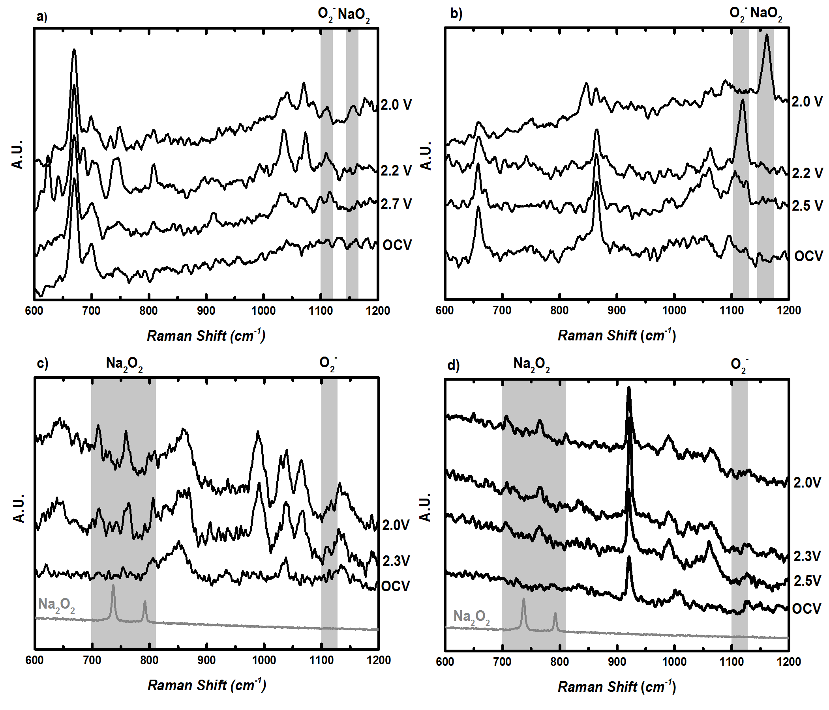

Fig 1. In situ SERS of oxygen enriched 0.1M NaOTf in a) DMSO, b) DMA, c) 1M NaOTf in DEGDME, and 0.1M NaOTf d) MeCN and roughened Au working disc electrodes at 23 °C, 0.1 V s⁻¹ at varying potentials.

that solvent choice can strongly affect the identity of Na_{x}O_{y} species on planar roughened Au electrodes. High donor number solvents, DMSO and DMA, upon discharge detect signals in the region for O₂⁻ and NaO₂ (Fig. 1a, b and Table 1). This agrees with electrochemical analysis for DMSO, where upon exchanging the TEA⁺ with Na⁺, only a small variation in the CV response is noted. Corresponding Raman spectra for systems in the absence of alkali metal cations only display a signal at 1110 cm⁻¹ for the O-O stretch of O₂⁻ adsorbed at the surface.^{[9b]} Moving to DMA there is little change in the spectra upon discharge. The same formation of O₂⁻ and subsequent NaO₂ formation is observed. A blue shift of ca. 5-10 cm⁻¹ is identified from the expected values of 1110 cm⁻¹ (υ_{O-O}, O₂⁻) and 1156 cm⁻¹ (υ_{O-O,} NaO₂), denoting varying interactions of O₂⁻, cation between different solvents.^{[9b, 14]}
Within these systems the mechanism initially forms superoxide in the presence of Na⁺ as shown in Eqs.1 and 2.

O_{2 (ads)} + e⁻ O₂⁻ _{(ads)} (1)
Na⁺ + O₂⁻ _{(ads)} [Na⁺--O₂⁻] _{(ads)} (2)
[Na⁺--O₂⁻] _{(ads)} [Na⁺--O₂⁻] _{(sol)} (3)

The addition of an electron to the surface adsorbed O₂ leads to the formation of superoxide that subsequently interacts with Na⁺ at the interface. This interaction is heavily dependent on the solvation of both O₂⁻ at the surface and the solvation of Na⁺. These interactions control the acidity and basicity of the Na⁺ and O₂⁻. The solvation shell in these cases will consist of anions (O₂⁻ and OTf⁻), cation (Na⁺) and solvent molecules.^{[15]} The OTf⁻ presence is based on the solubility of the salt within each solvent, which induces the formation of contact, solvent separated, and “free” ion pairs in solution.^{[16]} In DMSO, the peak at 1032 cm⁻¹ (Table S5), splits at a potential of 2.0 V vs Na/Na⁺ denoting ion pair formation, but does not observably affect the Na_{x}O_{y} peaks within the spectra.
The interaction between DMSO solvated [Na+--O₂⁻] is highly favourable, allowing the interaction to be ascribed to an ion pair, which corresponds to the detection of the band at 1107 cm⁻¹. This soluble species is easily removed from the surface that explains the quasi reversible nature of O₂ and Na⁺ electrochemistry within DMSO. Furthermore the detection of the signal for NaO₂ at 1156 cm⁻¹ is likely due to the aggregation and precipitation of NaO₂ on the surface as the reductive potential increases to 2.0 V vs. Na/Na⁺. Multiple CV scans within 0.1M Na OTf shows that the quasi reversible process breaks down, and reveals the formation of two oxidation peaks within the initial cycle voltammetric peak (Fig. S3). This corroborates the initial ion pair formation and subsequent aggregation and precipitation of NaO₂ on the surface, as the number of CV sweeps increases, more time has been allowed for NaO₂ to precipitate, that leads to the growth of the second oxidation peak at ca. 2.75 V vs. Na/Na⁺.
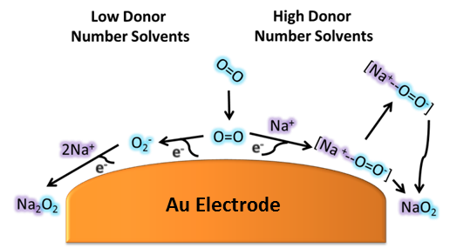
A similar situation is induced by DMA solvated NaOTf, but the change in donation from solvent to cation the Lewis acidity of sodium which may explain the distinct shift from [Na⁺--O₂⁻] to NaO₂ within the spectra. The mechanism here is considered to be as stated in Eq. 1 and 2. This follows upon the removal of NaO₂ from the surface, and subsequent electrolytic saturation within the double layer occurs, aggregation and precipitation of NaO₂ (Scheme 1). However, considering the water content of these systems (≤ 20ppm) and recent data by Xia et al ^{[6a]} the proposed inducement of this reaction through HO₂ formation should enhance the formation of cuboid NaO₂. Therefore in a similar manner that water can solvate and remove O₂⁻ from the surface as suggested by Xia et al^{[6a]}, and similarly with Li-O₂ solvents can induce the removal of Na_{x}O_{y} from the surface. However, we have found no spectroscopic evidence, either indirect or directly of the presence of H₂O or HO₂, as discussed in detail by both Xia et al^{[6a]} and Jirkovsky et al.^{[13]}
The poor conductivity of low concentration salt (0.1M), DEGDME based electrolyte, required that Raman analysis to be carried out at 1M NaOTf, in order to reduce significant overpotentials (Fig 1c). SERS data shows that the main discharge product is Na₂O₂, via the observation of a shifted doublet peak at 710 and 760 cm⁻¹. This is in contrast to the majority of Na-O₂ cell observations on a number of bulk carbon electrodes in which NaO₂ is the major product identified. ^{[6c, 11, 14, 17]} The detection of Na₂O₂ rather than NaO₂ on a planar roughened gold electrode may be due to surface morphology as the current role of surface is unclear in directing preferential formation of NaO₂ or Na₂O₂.^{[17a]} DEGDME is a medium donor number solvent that in Li-O₂ chemistry has been shown to support a solution based mechanism and surface mechanism by increasing the longevity of LiO₂. Here it is believed that a different process is occurring. In this case the lifetime and energetics of the ion pair of [Na⁺--O₂⁻] may increase the amount of Na₂O₂ formed due to the transfer of a second electron, but also due to the kinetic and thermodynamically stability of the products.^{[17a]} Na₂O₂ being shown to be the thermodynamically favourable product over NaO₂ above 10 μm.^{[17a]}

Table 1. Raman Bands for ORR discharge products / cm⁻¹.
 | O₂⁻  (Au-O₂) | Na₂O₂  (736 cm⁻¹) | Na₂O₂  (792 cm⁻¹) | O₂⁻  (O₂⁻) | NaO₂  (1156 cm⁻¹)
DMSO | 488 | - | - | 1107 | 1156
DMA | - | - | - | 1119 | 1161
DEGDME | - | 710 | 760 | 1109 | -
MeCN | - | 706 | 764 | 1108 | -

MeCN based electrolyte SERS data also displays a double band at 714 & 767 cm⁻¹ that is assigned as Na₂O₂ (Fig 1d). The absence of NaO₂ signal suggests preferential Na₂O₂ formation, suggesting that any initially formed NaO₂ is short lived or that superoxide is solely present before a second electron transfer. Hence if a surface bound NaO₂ film is present it rapidly grows beyond kinetic stability allowing for a 2nd electron reduction and a subsequent Na₂O₂ discharge product.^{[17a]} The increased Lewis acidity of Na⁺ in MeCN causes the formation of a dense passivation film of Na₂O₂, which is comparable to the behaviour observed in Li⁺ in the same solvent (Fig S4). The assigned Na₂O₂ signals here are shifted from our Raman standard. This is a similar case for DEGDME as shown in Fig 1c, which we will explain further below.
Scheme 1 Mechanistic scheme of oxygen reduction in non-aqueous solvents in the presence of Na⁺ cations (with H₂O below 20 ppm)

To confirm that the shifted bands assigned as Na₂O₂ are due to reduced oxygen species, careful control SERS experiments have been carried out. Electrolytes purged under Ar do not show any signals assigned to reduced O₂⁻ species as above (Fig S5-S8). In the same spectral region as the higher Na₂O₂ peak in the SERS data there is a corresponding OTf⁻ anion peak at 760 cm⁻¹ at OCV, however there are no peaks that appear around 710 cm⁻¹. The OTf⁻ band does not change in intensity under potential control and so therefore it is established this feature is due to Na₂O₂ due to O₂ present species. The presence of interfacial OTf⁻ can be explained by the formation of ion pairs or aggregation of ion pairs at the interface. The shifted doublet feature assigned to Na₂O₂ is shifted to a lower wavenumber than expected. If this shift is due to H₂O it would be expected to increase the signal to a higher wavenumber.^{[18]} The strong presence of ion-pairs within the double layer may enhance the interaction of surface Na₂O₂ and the OTf⁻ anion which could of explain the observation of the red-shifted bands (by ca. 30 cm⁻¹) of Na₂O₂.
The formation of ion pairs is revealed by the appearance of a peak at 1040 cm⁻¹. This region denotes the ν_{as} SO₃, which is considered the group within the anion that interacts with alkali metal cations.^{[16, 19]} The formation of ion-pairs interacting with the Na atom within Na₂O₂ at the surface may cause this observed shift. These bands relating to ion-pair formation are detected in DMSO and DEGDME, suggesting that ion solvation may influence the discharge product.
Therefore the SERS data provides spectroscopic evidence that the lack of solvation of O₂⁻ in low donor number solvents increases the proximity of O₂⁻ allowing for a second electron reduction to form a thin passivating film of Na₂O₂ (Eq 4-5) (Scheme 1). This mechanism follows:

O_{2 (ads)} + e⁻ O₂⁻ _{(ads)} (4)
2Na⁺ + e⁻ + O₂⁻_{(ads)} Na₂O₂ (5)

In conclusion, in situ SERS investigations have shown that solvent choice can influence the overall surface discharge product of Na-O₂ cell chemistry. Observable, yet shifted, SERS signals for Na₂O₂ in low donor number solvents suggest solvation of initially formed O₂⁻ is important in the control of this mechanism on Au electrodes. Higher solvation leads to the absence of Na₂O₂ due to initial formation of an ion pair between Na⁺ and O₂⁻_{(ads)}, which is removed from the surface and then aggregates and precipitates out later as NaO₂ in the discharge process. Solvents with a lower ability to control the Lewis acidity of Na⁺ do not form an ion pair interaction with O₂⁻ and proceeds via a surface mechanism, whereby upon further oxygen reduction, Na₂O₂ is preferentially formed at the interface.

Acknowledgements
The authors would like to gratefully acknowledge the financial support from the Engineering and Physical Sciences Research Council (EPSRC), U.K., under grant number EP/J020265/1.

Keywords: Superoxide • Sodium Oxygen Battery • Oxygen Reduction Reaction • Surface Enhanced Raman Spectroscopy • Peroxide

[1] aX. Ren, Y. Wu, J. Am. Chem. Soc. 2013, 135, 2923-2926; bP. Hartmann, C. L. Bender, M. Vračar, A. K. Dürr, A. Garsuch, J. Janek, P. Adelhelm, Nat. Mater. 2013, 12, 228-232; cK. M. Abraham, Z. Jiang, J. Electrochem. Soc. 1996, 143, 1-5.
[2] K. M. Abraham, J. Electrochem. Soc. 2015, 162, A3021-A3031.
[3] J. Lu, Y. Jung Lee, X. Luo, K. Chun Lau, M. Asadi, H.-H. Wang, S. Brombosz, J. Wen, D. Zhai, Z. Chen, D. J. Miller, Y. Sub Jeong, J.-B. Park, Z. Zak Fang, B. Kumar, A. Salehi-Khojin, Y.-K. Sun, L. A. Curtiss, K. Amine, Nature 2016, 529, 377-382.
[4] Z. Peng, S. A. Freunberger, L. J. Hardwick, Y. Chen, V. Giordani, F. Bardé, P. Novák, D. Graham, J.-M. Tarascon, P. G. Bruce, Angew. Chemie. Int. 2011, 50, 6351-6355.
[5] aY. Li, H. Yadegari, X. Li, M. N. Banis, R. Li, X. Sun, Chem. Commun. 2013, 49, 11731-11733; bQ. Sun, Y. Yang, Z.-W. Fu, Electrochem Commun 2012, 16, 22-25; cH. Yadegari, Y. Li, M. N. Banis, X. Li, B. Wang, Q. Sun, R. Li, T.-K. Sham, X. Cui, X. Sun, Energy and Environ. Sci. 2014, 7, 3747-3757; dY. C. Zelang Jian, Fujun Li, Tao Zhang, Chang Liu, Haoshen Zhou,, J. Power Sources 2014, 251, 466-469.
[6] aC. Xia, R. Black, R. Fernandes, B. Adams, L. F. Nazar, Nat. Chem 2015, 7, 496-501; bB. D. McCloskey, J. M. Garcia, A. C. Luntz, J. Phys. Chem. Lett. 2014, 5, 1230-1235; cP. Hartmann, C. L. Bender, J. Sann, A. K. Durr, M. Jansen, J. Janek, P. Adelhelm, J. Phys. Chem. Lett. 2013, 15, 11661-11672; dJ. Kim, H.-D. Lim, H. Gwon, K. Kang, Phys. Chem. Chem. Phys. 2013, 15, 3623-3629.
[7] aD. Sharon, D. Hirsberg, M. Afri, A. Garsuch, A. A. Frimer, D. Aurbach, J.Phys. Chem. C 2014, 118, 15207-15213; bQ. Yu, S. Ye, J. Phys. Chem. C. 2015, 119, 12236-12250; cS. A. Freunberger, Y. Chen, Z. Peng, J. M. Griffin, L. J. Hardwick, F. Bardé, P. Novák, P. G. Bruce, J. Am. Chem. Soc. 2011, 133, 8040-8047; dS. A. Freunberger, Y. Chen, N. E. Drewett, L. J. Hardwick, F. Bardé, P. G. Bruce, Angew. Chem. Int. 2011, 50, 8609-8613; eF. Bardé, Y. Chen, L. Johnson, S. Schaltin, J. Fransaer, P. G. Bruce, J. Phys. Chem. C. 2014, 118, 18892-18898.
[8] N. Zhao, X. Guo, J. Phys. Chem. C. 2015, 119, 25319-25326.
[9] aN. B. Aetukuri, B. D. McCloskey, J. M. García, L. E. Krupp, V. Viswanathan, A. C. Luntz, Nat Chem 2015, 7, 50-56; bL. Johnson, C. Li, Z. Liu, Y. Chen, S. A. Freunberger, P. C. Ashok, B. B. Praveen, K. Dholakia, J.-M. Tarascon, P. G. Bruce, Nat Chem 2014, 6, 1091-1099.
[10] C. O. Laoire, S. Mukerjee, K. M. Abraham, E. J. Plichta, M. A. Hendrickson, J. Phys. Chem. C. 2009, 113, 20127-20134.
[11] N. Ortiz-Vitoriano, T. P. Batcho, D. G. Kwabi, B. Han, N. Pour, K. P. C. Yao, C. V. Thompson, Y. Shao-Horn, J. Phys. CHem. Lett. 2015, 6, 2636-2643.
[12] Z. Peng, Y. Chen, P. G. Bruce, Y. Xu, Angew. Chem. Int. 2015, 54, 8165-8168.
[13] J. Staszak-Jirkovský, R. Subbaraman, D. Strmcnik, K. L. Harrison, C. E. Diesendruck, R. Assary, O. Frank, L. Kobr, G. K. H. Wiberg, B. Genorio, J. G. Connell, P. P. Lopes, V. R. Stamenkovic, L. Curtiss, J. S. Moore, K. R. Zavadil, N. M. Markovic, ACS Catal 2015, 5, 6600-6607.
[14] P. Hartmann, C. L. Bender, M. Vračar, A. K. Dürr, A. Garsuch, J. Janek, P. Adelhelm, Nat. Mater 2013, 12, 228-232.
[15] W. Huang, R. Frech, R. A. Wheeler, J. Phys. Chem. 1994, 98, 100-110.
[16] S. Schantz, J. Sandahl, L. Börjesson, L. M. Torell, J. R. Stevens, Solid State Ionics 1988, 28–30, Part 2, 1047-1053.
[17] aC. L. Bender, P. Hartmann, M. Vračar, P. Adelhelm, J. Janek, Adv. Energy. Mater. 2014, 4, 1031863-1031963; bC. L. Bender, Bartuli, W., Schwab, M. G., Adelhelm, P. and Janek, J., Ener. Tech. 2015, 3, 242-248.
[18] H. H. Eysel, S. Thym, Z. Anorg. Allg. Chem. 1975, 411, 97-102.
[19] aJ. M. Alı́a, H. G. M. Edwards, Vib. Spectrosc 2000, 24, 185-200; bA. Brodin, B. Mattsson, K. Nilsson, L. M. Torell, J. Hamara, Solid State Ionics 1996, 85, 111-120; cD. W. James, R. E. Mayes, The Journal of Physical Chemistry 1984, 88, 637-642; dS. F. Johnston, I. M. Ward, J. Cruickshank, G. R. Davies, Solid State Ionics 1996, 90, 39-48; eG. Petersen, P. Jacobsson, L. M. Torell, Electrochimica Acta 1992, 37, 1495-1497; fS. Schantz, The J. Chem. Phys. 1991, 94, 6296-6306; gS. Schantz, L. M. Torell, J. R. Stevens, J. Chem. Phys. 1991, 94, 6862-6867.

Entry for the Table of Contents

COMMUNICATION
A solvent dependency of the oxygen reduction reaction mechanism in the presence of sodium is reported. In high donor number solvents NaO₂ is formed and in low donor number solvents Na₂O₂ formation is observed. |  | 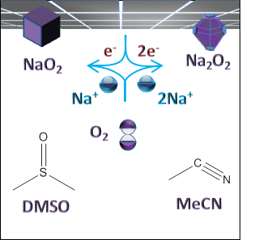 |  | Author(s), Corresponding Author(s)*  Page No. – Page No.  Title

