**Optical modulator utilising InAs Quantum Dots grown on Si**

**I C Sandall1, J S Ng1, J P R David1, H Liu2, and C. H. Tan1**

1 Dept. of Electronic and Electrical Engineering, The University Of Sheffield, Sheffield, UK

2 Dept. of Electronic and Electrical Engineering, University College London, London, UK

E-mail: [i.sandall@sheffield.ac.uk](mailto:i.sandall@sheffield.ac.uk)

**Abstract:**

The potential of using InAs quantum dots, epitaxially grown on a Si substrate, as an optical modulator have been investigated. By exploiting the Quantum-Confined Stark Effect across the quantum dot layers we were able to increase the absorption in the dot layers at a chosen wavelength. This resulted in the first demonstration of an extinction ratio of 5.1 dB at 1310 nm with a reverse bias of 20 V. Higher extinction ratios of 8.6 dB at 7 V and 21.6 dB at 20 V bias were observed at a wavelength of 1355 nm.

PACS Codes: 42.55.Px, 42.60.Fc, 81.05.Ea, 81.07.Ta, 85.60.Bt, 85.60.Dw

1. **Introduction**

Si-based photonic devices have attracted considerable attention over recent years due to the potential to have optical components compatible with Si based CMOS circuitry [1], [2]. Recently great progress has been made at growing In(Ga)As quantum dots on Si [3] and Ge [4] substrates, to realize lasing at a wavelength of 1300 nm [5]. Furthermore we have recently demonstrated the potential of such structures to operate as both photodiodes and as absorption regions of avalanche photodiodes at 1300 nm [6].

For information switching and transmission, it is important to integrate a laser and a modulator on Si to exhibit high-efficiency electrically injected lasing as well as modulation. However, Si-based light emitters and electroabsorption modulators exhibit very low efficiency due to Si having an indirect bandgap. While Si modulators have been realised using large structures (in the order of mm) and large operating voltages were required to achieve sufficient modulation [7],[8], [9], [10] hence they are unattractive for on-chip integration. The large dimensions of these structures were necessary due to the weak dependence of the refractive index with carrier concentration. Ring resonantor structures have been investigated to increase the refractive index change in Si to achieve much smaller modulators [11]. However these devices either have undesirably high operating voltages or are temperature sensitive, requiring temperature stabilisation which increases the overall power consumption [12], [13], [14]. Modulators based on compound III–V semiconductors are attractive as quantum-well (QW) and quantum dot (QD) structures as they can achieve both high-performance lasing and efficient electroabsorption modulation by exploiting the Quantum-Confined Stark Effect (QCSE) which has enabled modulators based on GaAs [15], [16], [17]or InP [18], [19].

In reference [6] the quantum dots grown on Si substrates exhibited the QCSE, shifting the peak responsivity with applied bias, suggesting the possibility of developing optical modulators using these quantum dots. Additional applications of a shift in the absorption would include use as a saturable absorber in a mode locked laser or as an optical amplifier. In this paper we explore using these structures as 1300 nm optical modulators.

1. **Growth, Fabrication and Experimental Details**

The structure used in this work has been described in reference [6]. InAs quantum dots were grown by Molecular Beam Epitaxy on a Si substrate using the same procedures and growth conditions as described in reference 5. The structure, shown in figure 1a, comprises of a GaAs buffer layer grown directly on top of the Si wafer, followed by 50 periods of an undoped Al0.4Ga0.6As/GaAs superlattice with a total thickness of 250 nm. Five periods of InAs/In0.15Ga0.85As dot-in-a-well (DWELL) each separated by a 45 nm GaAs spacer layer, were then sandwiched between a bottom 180 nm thick Al0.4Ga0.6As n+ cladding (Si doped at 1×018 cm-3) and a 180 nm thick p+ Al0.4Ga0.6As cladding (Be doped at 1×1018 cm-3). The structure was originally designed for use as an LED so is lacking a wave guiding structure optimised for an edge coupled electro absorption modulator.

A piece of the wafer described was fabricated into a segmented bar where each section was electrically isolated, as schematically shown in figure 1b. Each section had a stripe width of 100 µm and a length of 500 µm with a 5 µm air gap (created by dry etching) between each section. Due to the incomplete wave guiding in this structure we have not been able to determine the insertion loss of the device. However similar quantum dot geometries grown on GaAs substrates with full wave guiding were reported to have insertion losses of 21 dB [16]and 30 dB/cm [20] at 1300 nm. The main reason attributed for these relatively high losses is a highly asymmetric mode profile in the far field, therefore by improving the symmetry of the mode profile via improved design insertion losses may be reduced.

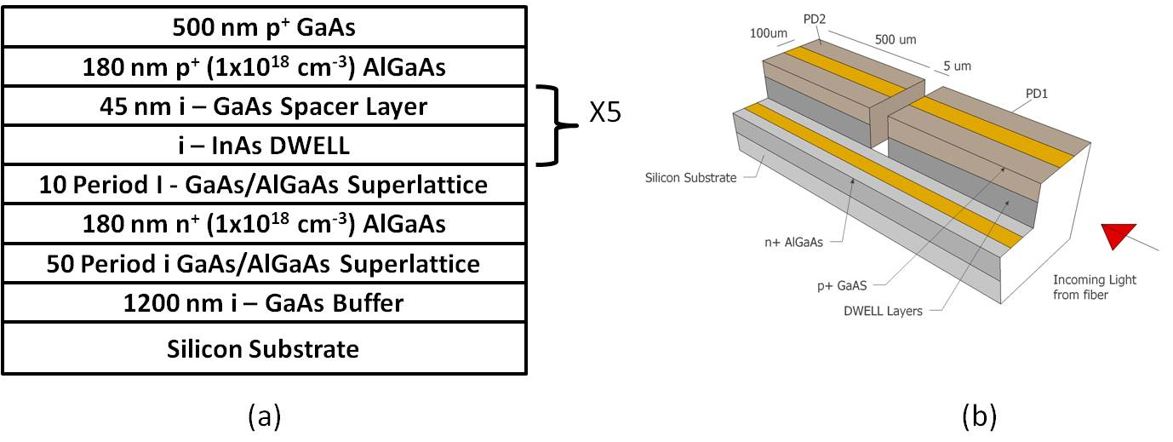

Figure 1: - (a) Structure details of the wafer and (b) the device geometry.

Using the segmented bar, we measured responsivity versus wavelength at different reversed biases. In the experimental setup, dispersed monochromatic light from a monochtromator was focused via free space optics onto the front facet of PD1 and the resultant photocurrent was measured as a function of wavelength. Optical power was measured as a function of wavelength, using an optical power meter. A reflectivity loss of 30% at the air/semiconductor interface was assumed. Responsivity data was obtained from the ration of the photocurrent to the incident optical power after the 30% loss.

To determine the extinction ratio, light from a commercial laser diode (Model ML725B19F-01) was focused via a lens fiber onto the front facet of PD1, which was reverse biased, while the photocurrent in PD2 was being measured. The emission wavelength of the laser diode was varied from 1310 to 1355 nm by varying its temperature between 23 and 65 oC through a Peltier stage. To optimise the coupling of the laser light into PD1, the photocurrent in PD1 was also monitored and maximised while the device position was changed via a translational alignment stage.

1. **Results and discussion**

Measured responsivity of PD1 versus wavelength, as a function of reverse bias (0 to 20 V) is shown in figure 2, and allows us to observe the QCSE. The maximum bias used is 20 V to avoid complications from impact ionisation, which was found to be noticeable at ~ 22 V in these structures [6].A red shift in the responsivity of ~ 75 nm over 0 – 20 V can be observed, concomitant with this is an increase in the responsivity for a given wavelength. The absolute values of the responsivity are approximately an order of magnitude lower than that previously measured using top illumination on large circular mesa diode[6]. We attribute this decrease to (i) poor confinement of the light within the active region caused by insufficient waveguiding, and (ii) loss in coupling the laser light.

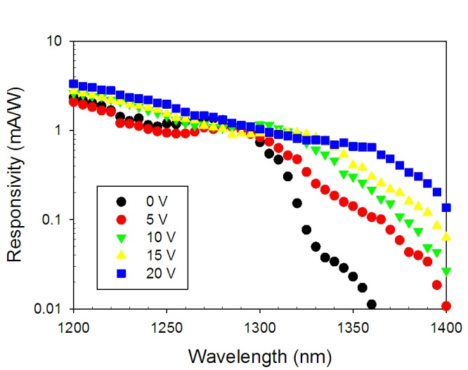

Figure 2: - Responsivity versus wavelength as a function of bias.

To investigate if this change in responsivity can be successfully exploited in a modulator, we varied the applied bias to PD1, and then detect the laser emission transmitted through PD1 using PD2 which was reversed biased at 20 V. We have performed this at two wavelengths, 1310 nm (telecommunication wavelength) and 1355 nm (peak responsivity wavelength at 20 V), with the results shown in figure 3.

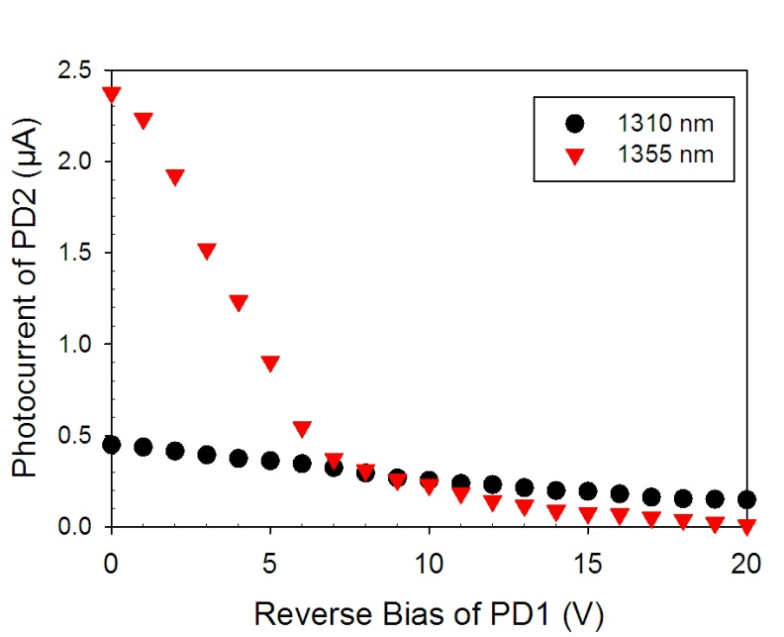

Figure 3: - Photocurrent in PD2 as a function of reverse bias across PD1 (working as a modulator).

At a wavelength of 1310 nm a gradual decrease in the measured photocurrent in PD2 can be observed as the reverse voltage across PD1 is increased. This is in agreement with the results shown in figure 2 where an increase in absorption with bias was observed. This result indicates that this device can operate as a modulator at this wavelength. The photocurrent at 1355 nm shows a much more dramatic decrease with increasing reverse bias in PD1.

A key figure of merit for a modulator is the extinction ratio, as defined in equation (1).

$ExtinctionRatio\left(dB\right)={10 log}_{10}\left(\frac{P_{on}}{P_{off}}\right)$, ( 1 )

where *Pon* and *Poff* are the optical powers transmitted when the modulator is switched on or off, which here are taken as measurements with PD1 biased at 0 and 20 V respectively. This approach will only yield an approximate value for the extinction ratio due to the lack of efficient wave guiding structure in the device as well as lack of optimised coupling into PD2. From a simple slab waveguide calculation of the optical confinement we have estimated that only around 21% of the light is confined to the active layer at a wavelength of 1310 nm. From the responsivity and photocurrent data we estimated the transmitted power, which was used to calculate the extinction ratios of 5.1 dB and 21.6 dB for 1310 and 1355 nm. These values are reasonable when compared to other modulators grown on Si (see table 1) operating around 1300 nm [8], [9], [10]. Our structure has the advantage of requiring simpler fabrication and the potential to be directly integrated with a similar emitter compared to Si Mach-Zender and microring modulators. The calculated extinction ratios are also favourable compared to those measured on previous InAs quantum dots grown on GaAs (also shown in table 1).

**Table 1:** - Review Comparison of reported extinction ratio.

|  |  |  |  |  |
| --- | --- | --- | --- | --- |
| Material System | Static Extinction Ratio (dB) | Applied DC Bias (V) | Operating Wavelength (nm) | Reference |
| Si: Mach-Zender Modulator | 4.2 | 3.3 | 1550 | 8 |
| Si: Microring Resonator | 26 | 8 | 1550 | 10 |
| InGaAs/GaAs: QW (Grown on Si) | 30 | 5.5 | 1050 | 17 |
| GaAs/AlGaAs: MQW  (Grown on GaAs) | 10 | 10 | 850 | 15 |
| InAs QDs (grown on GaAs) | 2.1 | 10 | 1300 | 16 |
| InGaAsP/InP MQW | 3.2 | 20 | 1550 | 18 |
| InAs QDs (Grown on Si) | 21.6 | 20 | 1355 nm | This work |

From figure 3 it can be seen that at 1355 nm there is initially a very sharp decrease in the photocurrent as the bias is increased to around 5 V, followed by a more gradual decrease as the bias is further increased. To investigate this in more detail we have calculated the extinction ratio as a function of bias for both wavelengths, as shown in figure 4.

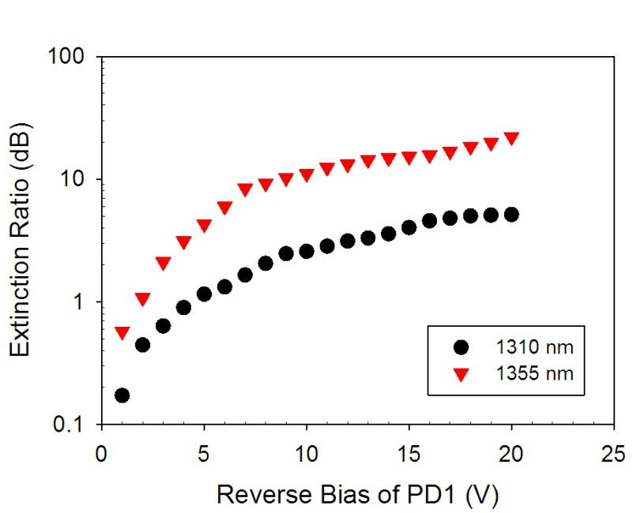

Figure 4: - Extinction ratio versus reverse bias of PD1.

From figure 4, two regimes can be observed. As the bias increases from 0 to 7 V there is a sharp rise in the extinction ratio, reaching 1.8 dB at 1310 nm and 8.6 dB at 1355 nm when biased at 7 V. As the voltage is further increased, there is a more gradual increase in the extinction ratio reaching 5.1 dB at 1310 nm and 21.6 dB at 1355 nm when biased at 20 V. This behaviour of the extinction ratio can be explained qualitatively using observations from in figure 2, where at zero bias the wavelengths of 1310 and 1355 nm are beyond the absorption edge of the quantum dots. As the bias increases the absorption edge moves to longer wavelengths, getting closer to the measured wavelengths resulting in a sharp rise in the extinction ratio. Then at a modest bias the monitored wavelengths coincide with the broad peak of the quantum dot absorption resulting in a much smaller increase in the extinction ratio. To fully understand why the absorption behaves in this manner would require detailed modelling of the QCSE across the multiple DWELL layers which is beyond the scope of this work.

Although a higher extinction ratio has been measured at 1355 nm than at 1310 nm it should be possible to alter the growth conditions of the dots to alter the ground state in the dots so that the peak responsivity occurs 1310 nm. It is also worth remembering that the cladding layers in this structure have not been optimised to fully confine the light to the active region. Neither has the coupling between the two sections been evaluated and maximised. Therefore by addressing these issues it should be possible to further improve the modulation capability of these devices.

For real world application as an optical modulator or switch it is nescercary to know the devices dynamic performance however due to the lack of waveguiding in our structure and some fabrication limitations we have not been able to asses these attributes. There has been a previous report of InAs quantum dots grown on a GaAs substrate which was utilised as an optical modulator with a 3dB bandwidths of 10 GHz [21]. Additionally InAs Quantum dots grown on GaAs have been deployed as high speed lasers [22], [23] and amplifiers [24], [25] with speeds of 40 GHz having been realised. Given the early promise of the laser performance of III-V grown on Silicon substrates which are highly comparable to that obtained when grown on GaAs substrates [3], [4], [5] it seems reasonable to expect similar speed performance in the device reported here as those which have been reported on GaAs substrates.

1. **Conclusions**

In conclusion we have investigated the potential of InAs quantum dots grown on Si substrates to operate as optical modulators at telecommunication wavelengths. We have shown significant QCSE in the responsivity spectra of the devices and that this can be exploited to achieve an extinction ratio of 21.6 dB with an applied bias of 20 V at a wavelength of 1355 nm. Furthermore, it is believed with improvements to both the dot growth and the device fabrication that this value can be further increased.

**Acknowledgements**

This work was funded by the Engineering and Physical Sciences Research Council (EPSRC), UK under grant EP/H031464/1. H. Liu and J. S. Ng would like to thank The Royal Society for funding their University Research Fellowships.

**References**

1 D. Miller, Optical interconnects to silicon, *IEEE J. Sel. Topics Quantum Electron*., **6**, 1312-1317 (2000).

2 R. Soref, The past, present and future of silicon photonics, *IEEE J. Sel. Topics Quantum Electron*., **12**,1678-1687 (2006).

3 J. Yang, P. Bhattacharya, and Z. Mi, High-performance In0.5Ga0.5As/GaAs quantum-dot lasers on silicon with mulitplie-layer quantum-dot dislocation filters, *IEEE Trans. Electron Devices.*, **54**, 2849-2855 (2007).

4 H. Y. [Liu,](http://apps.webofknowledge.com/OneClickSearch.do?product=UA&search_mode=OneClickSearch&colName=WOS&SID=R1BHba9eBdODi952CmM&field=AU&value=Liu,%20HY) T. [Wang,](http://apps.webofknowledge.com/OneClickSearch.do?product=UA&search_mode=OneClickSearch&colName=WOS&SID=R1BHba9eBdODi952CmM&field=AU&value=Wang,%20T) Q. [Jiang,](http://apps.webofknowledge.com/OneClickSearch.do?product=UA&search_mode=OneClickSearch&colName=WOS&SID=R1BHba9eBdODi952CmM&field=AU&value=Jiang,%20Q) R. [Hogg,](http://apps.webofknowledge.com/OneClickSearch.do?product=UA&search_mode=OneClickSearch&colName=WOS&SID=R1BHba9eBdODi952CmM&field=AU&value=Hogg,%20R) F. [Tutu,](http://apps.webofknowledge.com/OneClickSearch.do?product=UA&search_mode=OneClickSearch&colName=WOS&SID=R1BHba9eBdODi952CmM&field=AU&value=Tutu,%20F) F. [Pozzi,](http://apps.webofknowledge.com/OneClickSearch.do?product=UA&search_mode=OneClickSearch&colName=WOS&SID=R1BHba9eBdODi952CmM&field=AU&value=Pozzi,%20F) and A. [Seeds,](http://apps.webofknowledge.com/OneClickSearch.do?product=UA&search_mode=OneClickSearch&colName=WOS&SID=R1BHba9eBdODi952CmM&field=AU&value=Seeds,%20A) Long-wavelength InAs/GaAs quantum-dot laser diode monolithically grown on Ge substrate, *Nature Photon.,* **5**, 416-419 (2011).

5 T. Wang, H. Liu, A. Lee, F. Pozzi, and A. Seeds, 1.3-µm InAs/GaAs quantum-dot lasers monolithically grown on Si substrates, *Opt. Express*, **19**, 11381-11386 (2011).

6 [I. Sandall](javascript:searchAuthor('Sandall,%20I')), [J. S. Ng](javascript:searchAuthor('Ng,%20J')), [J. P. R. David](javascript:searchAuthor('David,%20J')), [C. H. Tan](javascript:searchAuthor('Tan,%20C')), [T. Wang](javascript:searchAuthor('Wang,%20T')), and [H. Liu](javascript:searchAuthor('Liu,%20H')), 1300 nm Wavelength InAs Quantum Dot Photodetector Grown on Silicon, *Opt. Express*, **20**, 10446-10452 (2012).

7 P. Dainesi, A. Küng, M. Chabloz, A. Lagos, Ph. Flückiger, A. Ionescu, P. Fazan, M. Declerq, Ph. Renaud, and Ph. Robert CMOS compatible fully integrated Mach–-Zehnder interferometer in SOI technology, *IEEE Photon. Technol. Lett.*, **12**, 660–-662 (2000).

8 Ling Liao, Dean Samara-Rubio, Michael Morse, Ansheng Liu, Dexter Hodge High speed silicon Mach-Zender modulator, *Opt. Express*, **13**, 3129 – 3135, (2005).

9 L. Liao, D. Lim, A. Agarwal, X. Duan, K. Lee, and L. Kimerling, Optical transmission losses in polycrystalline silicon strip waveguides: effects of waveguide dimensions, thermal treatment, hydrogen passivation, and wavelength, *J. Electronic Materials*, **29**, 1380-1386 (2000).

0 Y. Hu, X. Xiao, H. Xu, X. Li, K. Xiong, Z. Li, T. Chu, Y. Yu and J. Yu1, High-speed silicon modulator based on cascaded microring resonators, *Opt. Express,* **20**, 15079-15085 (2012).

1 Y. Amemiya, T. Tokunga, Y. Tanushis, and S. Yokoyama Optical Modulator Using Metal–Oxide–Semiconductor Type Si Ring Resonator, *Optical Review*, **16** 247–251 (2009).

2 Q. Xu, B. Schmidt, S. Pradhan, and M. Lipson, Micrometre-scale silicon electro-optic modulator, *Nature Letters*, **435**, 325-327 (2005).

3 G. T. Reed, G. Mashanovich, F. Y. Gardes and D. J. Thomson, Silicon optical modulators, *Nature Photonics*, **4**, 518-526, (2010)

4 L. Chen, K .Preston, S. Manipatruni,and M. Lipson, Integrated GHz silicon photonic interconnect with micrometer-scale modulators and detectors. *Opt. Express,* **17,** 15248–15256 (2009)

5 T. H.Wood, Multiple quantum well (MQW) wave-guide modulators, *J. Lightw. Technol.*, **6**, 743–757, (1988).

6 D. B. Malins, A. Gomez-Iglesias, E. U. Rafailov, W. Sibbett, and A. Miller, Electroabsorption and electrorefraction in an InAs quantum dot waveguide modulator, *IEEE Photon. Technol. Lett.*, **19**, 1118-1120 (2007).

7 J. Yang, P. Bhattacharya, and Z. Wu, Monolithic Integration of InGaAs–GaAs Quantum-Dot Laser and Quantum-Well Electroabsorption Modulator on Silicon, *IEEE Photon. Technol. Lett.,* **19**, 747-749 (2007)

8 K. W. Goossen, and D. W. Prather, Fabrication and Yield of Large-Area Quantum-Well Modulators, *IEEE Photo. Technol. Lett.,* **19**, 2054-2056 (2007).

9 Q. Zhao, J.Q. Pan, J. Zhang, B.X. Li, F. Zhou, B.J. Wang, L.F. Wang, J. Bian, L.J. Zhao, W. Wang, Monolithic integration of electroabsorption modulator and DFB laser for 10-Gb/s transmission, *Opt. Comm.,* **260**, 666-669 (2006).

20 I. B. Akca, A. Dâna, A. Aydinli, M. Rossetti, L. Li, A. Fiore, and N. Dagli, Electro-optic and electro-absorption characterization of InAs quantum dot waveguides, *Opt. Express,* **16**, 3439-3444 (2008).

21 W. Liu, R. S. Kim, B. Liang, D. L. Huffaker, and H. R. Fetterman, High-Speed InAs Quantum-Dot Electrooptic Phase Modulators, IEEE PHOTON. TECH. LETT., 23, 1748-1750 (2011)

## 22 [H. Schmeckebier](javascript:searchAuthor('Schmeckebier,%20H')), [G. Fiol](javascript:searchAuthor('Fiol,%20G')), [C. Meuer](javascript:searchAuthor('Meuer,%20C')), [D. Arsenijević](javascript:searchAuthor('Arsenijevi%C4%87,%20D')), and [D. Bimberg](javascript:searchAuthor('Bimberg,%20D')), Complete pulse characterization of quantum dot mode-locked lasers suitable for optical communication up to 160 Gbit/s, Opt. Express, 18, 3415-3425 (2010)

# 23 C. Lee, P. Bhattacharya, T. Frost, and W. Guo, Characteristics of a high speed 1.22 μm tunnel injection p-doped quantum dot excited state laser, Appl. Phys. Lett. **98**, 011103 (2011)

# 24 [H. Schmeckebier](http://profiles.spiedigitallibrary.org/summary.aspx?DOI=10.1117%2f12.854405&Name=H.+Schmeckebier), [G. Fiol](http://profiles.spiedigitallibrary.org/summary.aspx?DOI=10.1117%2f12.854405&Name=G.+Fiol)[, C. Meuer](http://profiles.spiedigitallibrary.org/summary.aspx?DOI=10.1117%2f12.854405&Name=C.+Meuer), [D. Arsenijević](http://profiles.spiedigitallibrary.org/summary.aspx?DOI=10.1117%2f12.854405&Name=D.+Arsenijevi%c4%87), and [D. Bimberg](http://profiles.spiedigitallibrary.org/summary.aspx?DOI=10.1117%2f12.854405&Name=D.+Bimberg), 40-GHz and 160 GHz mode-locked quantum dot laser showsing pulse width of 750 fs at 1.3 µm, Proc. SPIE 7720, 772010 (2010)

 25 G. Fiol, C. Meuer, H. Schmeckebier, D. Arsenijevic´, S. Liebich, M. Laemmlin, M. Kuntz, and D. Bimberg, Quantum-Dot Semiconductor Mode-Locked Lasers and Ampliﬁers at 40 GHz, IEEE J. QUANTUM ELECTRON., 45, 1429-1435, (2009)