Temperature dependence of impact ionization in InAs

Ian C. Sandall,^{1*} Jo Shien Ng,¹ Shiyu Xie,¹ Pin Jern Ker,¹ and Chee Hing Tan^{1,2}

¹ Department of Electronic and Electrical Engineering, The University of Sheffield, Sir Frederick Mappin building, Mappin Street, Sheffield, S1 3JD, U.K.
² c.h.tan@sheffield.ac.uk
* I.sandall@sheffield.ac.uk

Abstract: An Analytical Band Monte Carlo model was used to investigate the temperature dependence of impact ionization in InAs. The model produced an excellent agreement with experimental data for both avalanche gain and excess noise factors at all temperatures modeled. The gain exhibits a positive temperature dependence whilst the excess noise shows a very weak negative dependence. These dependencies were investigated by tracking the location of electrons initiating the ionization events, the distribution of ionization energy and the effect of threshold energy. We concluded that at low electric fields, the positive temperature dependence of avalanche gain can be explained by the negative temperature dependence of the ionization threshold energy. At low temperature most electrons initiating ionization events occupy L valleys due to the increased ionization threshold. As the scattering rates in L valleys are higher than those in Γ valley, a broader distribution of ionization energy was produced leading to a higher fluctuation in the ionization chain and hence the marginally higher excess noise at low temperature.
©2013 Optical Society of America
OCIS codes: (040.5160) Photodetectors; (040.1345) Avalanche Photodiodes; (040.3060)
Infrared; (160.6000) Semiconductor materials; (230.5170) Photodiodes.
____________________________________________________________

References and Links

1. Y. Shimizu, J. Ishii, Y. Kaneko, F. Sakuma, and A. Ono, “State of the arts of the infrared radiation thermometry standards in the middle temperature range at NMIJ,” SICE Annual Conference 1803-1807 (2004).

2.J. D. Beck, C-F. Wan, M. A. Kinch, and J. E. Robinsonl, “MWIR HgCdTe avalanche photodiodes,” Proc. SPIE, Materials for Infrared Detectors, 4454 188-197 (2001).

3. A. Marshall, C. H. Tan, M. Steer and J. P. R. David, “Electron dominated impact ionization and avalanche gain characteristics in InAs photodiodes,” Appl. Phys. Lett. 93, 111107 (2008).
4. A. Marshall, J. P. R. David, and C. H. Tan, “Impact ionization in InAs electron avalanche photodiodes,” IEEE Trans. Electron. Devices 57, 2631 – 2638 (2010).

5. S. J. Maddox, W. Sun, Z. Lu, H. P. Nair, J. C. Campbell, and S. R. Bank, “Enhanced low-noise gain from InAs avalanche photodiodes with reduced dark current and background doping,” Appl. Phys. Lett. 101, 151124 (2012).

6. P. J. Ker, A. Marshall, A. Krysa, J. P. R. David, and C. H. Tan, “Temperature dependence of leakage current in InAs avalanche photodiodes,” IEEE J. Quantum Electron. 47, 1123 – 1128 (2011).
7. A. Marshall, P. Vines, P. J. Ker, J. P. R. David, and C. H. Tan, “Avalanche multiplication and excess noise in InAs electron avalanche photodiodes at 77 K,” IEEE J. Quantum Electron. 47, 858-864 (2011).
8. J. Bude and K. Hess, "Thresholds of impact ionization in semiconductors,” J. Appl. Phys. 72, 3554-3561 (1992).
9. G. Satyanadh, P. R. Joshi, N. Abedin, and U. Singh, “Monte carlo calculation of electron drift characteristics and avalanche noise in InAs,” J. Appl. Phys. 91, 1331-1337 ( 2002).

10. W. K. Ng, C. H. Tan, J. P. R.David, P. A. Houston, M. Yee, and J. S. Ng, “Temperature dependent low-field electron multiplication in In_{0.53}Ga_{0.47}As,” Appl. Phys. Lett. 83, 2820-2822 (2003).

11. D. Harrison, R. A. Abram, and S. Brand, “Characteristics of impact ionization rates in direct and indirect gap semiconductors,” J. Appl. Phys. 85, 8186-8188 (1999).
12. C. H. Tan, G. J. Rees, P. A. Houston, J. S. Ng, W. K. Ng, and J.P.R.David, “Temperature dependence of electron impact ionization in In_{0.53}Ga_{0.47}As,” Appl. Phys. Lett. 84, 2322-232 (2004).
13. C. Jacoboni and L. Reggiani, “Monte Carlo method in transport”, Rev. Mod. Phys. 55, 646 – 703 (1983).

14. M. V. Fischetti, “Monte carlo simulation of transport in technologically significant semiconductors of the diamond and zinc-blende structures. I. Homogeneous transport,” IEEE Trans. Electron. Devices 38, 634-649 (1991).
15. S. Krishnamurthy, M. A. Berding, A. Sher, and A. B. Chen, “Ballistic transport in semiconductor alloys,” J. Appl. Phys. 63, 4540-4547 (1988).

16. Z. M. Fang, K. Y. Ma, D. H. Jaw, R. M. Cohen, and G. B. Stringfellow, “Photoluminescence of InSb, InAs, and InAsSb grown by organometallic vapor phase epitaxy,” J. Appl. Phys. 67, 7034-7039 (1990).
17. P. J. Ker, J. P. R. David, and C. H. Tan, “Temperature dependence of gain and excess noise in InAs electron avalanche photodiodes,” Opt. Express 20, 29568-29576 (2012).
18.Y. S. Kim, M. Marsman, G. Kresse, F. Tran, and P. Blaha, “Towards efficient band structure and effective mass calculations for III-V direct band-gap semiconductors,” Phys. Rev. B 82, 205212 (2010)

________________________________________________________________________

1. Introduction

Detection of weak infrared light is essential to a wide range of applications. While many of these applications, e.g. optical communication systems (1.3 and 1.55 μm) and range-finding (1.55 μm), utilize near infrared light, there are others that rely on longer wavelengths. Some of the examples are atmospheric gas sensing (1.55 and 2.1 μm) and radiation thermometry of “cold” manufacturing processes, where temperatures below 100 °C need to be monitored (1.0 to 5 μm) [1]. It is well known that when the optical signal is weak, external amplification through electronic circuits can add significant noise, degrading the overall signal-to-noise ratio of the systems. Using a light detector that offers internal amplification without adding much associated noise will significantly reduce the negative impact of circuit noise. Avalanche Photodiodes (APDs) are often the detectors of choice when they are designed to provide internal gains through impact ionization in the semiconductors without adding significant noise. Unfortunately in most semiconductor materials the impact ionization process in the APD does introduce some noise because impact ionization is a stochastic process, resulting in a distribution of gain values around the mean gain, M. The associated noise is usually characterized by the excess noise factor, F.
Established infrared APD technologies include Separate-Absorption-Multiplication (SAM) APDs using InGaAs absorbers (such as InGaAs/InP SAM APDs and InGaAs/InAlAs SAM APDs) and HgCdTe APDs. The former can only respond to light with wavelength up to 1.6 μm and are not commercially available in array formats, thus are inappropriate for many applications. The majority of HgCdTe APDs are sensitive to light with up to ~ 4.5 μm wavelength, and can cover most applications. They also exhibit very low F at large M, and are available in focal plan array format (so high-sensitivity imaging is possible) [2]. However the costs of HgCdTe APDs are much higher than those of InGaAs-based SAM APDs and their commercial availabilities are restricted to a handful of manufacturers.
In the past few years, the semiconductor material Indium Arsenide (InAs) has emerged as an alternative avalanche material for very low noise infrared APDs, following reports of desirable avalanche gain and excess noise behaviors that are highly similar to those of HgCdTe APDs. The key desirable attributes are appreciable gains at < 10 V [3] and very low excess noise factor (≤ 2) at large gains of 10 to 30 [4], [5]. Given that InAs APDs are still in a comparatively early stage of technology development, research efforts have so far been focused on experimental studies, as evidenced by the most recent publications being on studies into leakage currents [5], [6] in InAs APD. However, realistic simulation of impact ionization in InAs will help to explain some of the unusual impact ionization behaviors, such as reduced gain for a given reverse bias when temperature decreases [6], [7].
To date there has been little reported work on modeling of impact ionization in InAs; this is due to the lack of detailed knowledge of material parameters and, until fairly recently, limited experimental data. Bude and Hess [8] have previously used a Full Band Monte Carlo Model to study GaAs, InP, InAs and InGaAs, however the majority of the parameters used for InAs were determined from extrapolation of the InGaAs values. Satyanadh et al. [9] have also simulated impact ionization in InAs using an Analytical Band Monte Carlo (ABMC) and calculated the impact ionization rates from the transfer matrix. However there was no experimental data to verify the simulated results. In this work, we present an InAs ABMC with three valleys in the first conduction band that accurately simulate electric field dependence and temperature dependence of the impact ionization coefficient for electrons, α.
For most relatively wide bandgap materials, in which impact ionization occurs when electrons have energies several times the bandgap, a Full Band Monte Carlo model is required for the modeling. However, in InAs experimental data has shown that ionization mainly occurs at low fields, where carriers are still residing in the first conduction band. More critically, to retain the desirable low excess noise factors, InAs APDs should be operated at fields below 70 kV/cm [7]. The first contribution from this work is to study the occupancy probability of hot electrons at such low fields and at different temperatures so that operating conditions to retain low excess noise can be identified.
In InGaAs, impact ionization has been observed at low electric fields with a weak dependence on electric field [10]. This behavior has been attributed to the very gradual increase in the ionization rate with energy, which is due to the limited density of states in the Γ valley [8], [11]. This behavior has been modeled using an ABMC simulation [12] and has shown good agreement with experimental data, including positive temperature dependence of electron ionization coefficient at low electric fields. For these reasons, we have adopted the ABMC to model the temperature dependence of gain and excess noise in InAs, which is the main contribution of this work.

2. Model

The model was implemented according to detailed descriptions in [13]. The conduction band is approximated by a spherical minima, with the electron transport described by one Γ valley, four equivalent L valleys, and three equivalent X valleys. In the model, each carrier moves through the lattice under the influence of the electric field and experiences many scattering events. The scattering mechanisms incorporated are polar phonon, acoustic phonon, ionized impurity, intra-valley acoustic, inter-valley, and impact ionization scattering. Most of the model parameters at room temperature, which are summarized in Table 1, were taken from [14] except for the energy band gap of X valleys from [15]. The scattering rates have been calculated using Eqs. 3 to 8 from [14], where the polar phonon scattering rate has been calculated using an exact density of final states, the acoustic phonon scattering rate was determined via experimental fitting and the intervalley rate is calculated using an “effective” deformation potential. For the calculation of impact ionization scattering rate we have used a Keldysh-like rate where we have removed the factor of two as described by Harrison [9]. Temperature dependence of the InAs bandgap is [16]

in eV, (1)

where T is temperature in Kelvin. The intervalley separation energies are assumed to be independent of temperature. The temperature dependence of the optical phonon scattering rates is altered by the temperature dependence of phonon population. As we are not aware of experimental data for the temperature dependence of other parameters, such as phonon energy and intervalley coupling constants, we have assumed them to be constant.
Using the experimental avalanche gain and excess noise factors in [4], [17] as reference data, which used a 3.5 μm thick InAs p-i-n diode, the model’s impact ionization scattering rate at room temperature was adjusted so that the simulated gain and excess noise factors are in agreement with the reference data. The resultant impact ionization rate at room temperature is described by

s⁻¹, (2)

where E_{i} is the electron initial kinetic energy, and E_{th} is the ionization threshold energy, which is in turn assumed to be energy band gaps of Γ, L, or X valleys, depending on the valley occupied by the initiating electron. We believe this to be a valid assumption as ionization in InAs occurs at significantly lower electric fields, implying lower ionization threshold energies, than wide bandgap materials such as Si and GaAs. Therefore we have assumed the minimum energy required for ionization is defined by the bandgap in each valley. In our model, the temperature dependence of the impact ionization rate is assumed to be entirely dependent on the temperature dependence of E_{th}, and hence the temperature dependence of the energy bandgaps of the Γ, L, and X valleys. Due to the lack of information on temperature dependence of energy band gaps of the L, and X valleys, they are assumed to follow the same behavior as band gap of Γ as described by Eq. 1.
When an electron has experienced an impact ionization event, the remaining energy is distributed equally between the three carriers (two electrons and a hole) and the final electron states are chosen randomly between the available valleys. Since the electron ionization coefficients, which have been obtained experimentally for InAs at 300 [4] and 77 K [7], are defined as the inverse of the mean distance between successive impact ionization events, they can be obtained from the model after running a statistically meaningful number of trials.

Table 1: InAs parameters used in 3-valley Analytical Band Monte Carlo model.

Valley-dependent material parameters
Material parameter | Energy band
 | Γ | L | X
Electron effective mass (m*/m_{o}) | 0.031 | 0.286 | 0.643
Band non-parabolicity (eV⁻¹) | 2.20 | 0.45 | 0.46
Energy band gap (wrt valence band, eV) | 0.356 | 1.146 | 2.206
Number of equivalent valley | 1 | 4 | 3
Intervalley deformation potential (×10⁸eV/cm)
From Γ | N/A | 5.59 | 6.35
From L | 5.59 | 6.35 | 5.59
From X | 6.35 | 5.59 | 3.36
Intervalley phonon energy (meV)
From Γ | N/A | 17.45 | 19.23
From L | 17.45 | 19.23 | 17.45
From X | 19.23 | 17.45 | 19.26
Bulk material parameters
Material parameter | Value
Lattice constant(Å) | 6.04
Longitudinal speed of sound (cm/s) | 4.280×10⁵
Low frequency dielectric constant | 15.15
High frequency dielectric constant | 12.75
Density (g/cm³) | 5.67
Electron acoustic coupling (eV) | 5.8

3. Results and discussion

As described above, at 300 K, the impact ionization scattering rate of our model was adjusted to fit the reference data by Ker et al. [17]. After obtaining agreement with the 300 K reference data we performed simulations using our AMBC at temperatures ranging from 77 to 300K. For a given temperature, other than the ionization threshold energy, no other parameter in the model was altered. The ABMC results are compared to the reference data in Fig. 1 for the temperatures ranging from 77 to 300 K. There is good agreement between the AMBC results and the reference data at all temperatures, demonstrating our AMBC’s ability to accurately describe the physical processes within an InAs APD.

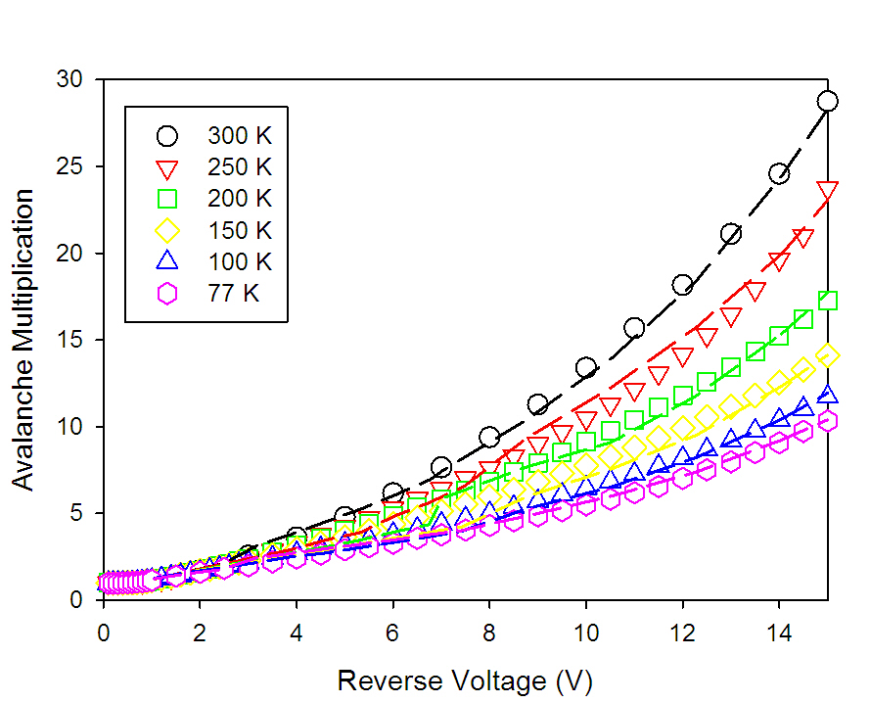

Fig. 1. Avalanche gain versus reverse bias of a 3.5 μm thick InAs p-i-n diode at different temperatures from the ABMC (lines) and the reference data (symbols).

Observing Fig. 1, the avalanche gain decreases as the temperature decreases. This is opposite to the behaviors in wide bandgap semiconductors such as GaAs and Si, where the avalanche gain increases as the temperature decreases, because reduced phonon scattering results in more hot carriers and therefore more impact ionization events.
The model was also used to simulate the temperature dependence of the excess noise in InAs APDs. A comparison of our results with the reference data (from [17]) is shown in Fig. 2. The previously reported experimental data did not show any clear temperature dependence. The simulated data while broadly agreeing with the experimental results does show a weak negative temperature dependence, i.e. the excess noise increases slightly as the temperature decreases. The absence of this temperature dependence in the experimental data is most likely due to the small magnitude of the change and the associated difficulties in performing measurements to this level of accuracy. It may also be the case that the inclusion of an improved temperature dependence of the scattering rates may also reduce the small discrepancies between the modeled and predicted excess noise. However this has not been considered here due to the lack of experimental data for scattering parameters such as intervalley coupling constant and phonon energy.

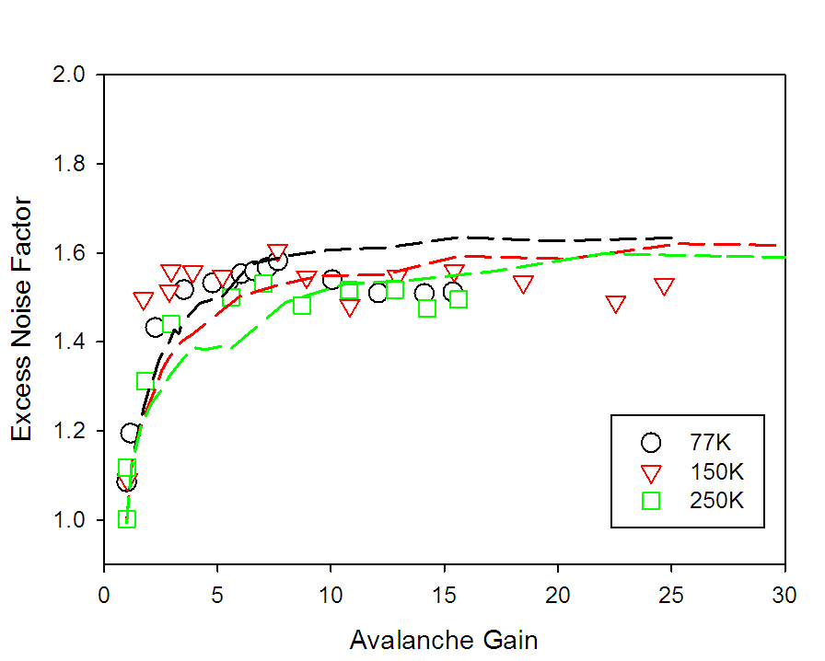

Fig. 2. Excess noise factors as a function of avalanche gain at different temperatures with experimental data shown in symbols and simulated values given by the lines.

In narrow bandgap materials, significant impact ionization can occur at energies as low as the ionization threshold [8]. This may lead to the impact ionization being heavily influenced by the value of the ionization threshold energy.
We proposed that the large Γ-X and Γ-L valley separation energies of InAs result in hot electrons populating the Γ and predominantly bottom of the L-valleys. This coupled with the significance of ionization threshold energy could cause the temperature dependence of avalanche gain to be dominated by the temperature dependence of the ionization threshold energy.
To verify our proposed explanation for the positive temperature dependence of the avalanche gain, the distribution of electrons between the Γ, L and X-valleys in the ABMC was analyzed as functions of electric field and temperature. The percentages of carriers occupying the different valleys are shown in Fig. 3(a) at 300 and 77 K, with a magnified region for the population of the X-valleys in Fig. 3(b). At 300 and 77 K, throughout the electric fields considered, the vast majority of the electrons are found in the Γ and L-valleys.
The values inputted into the model for the valley separations are not known experimentally and there has recently been a larger value for the L-valley to Gamma-valley reported [18] than we have used here. However when we repeat our simulations with these higher values we observe the same temperature effects as reported here, with our conclusions still remaining valid. An increased valley separation does alter the occupation of the valleys (Fig. 3), with a decreased L-valley population. A larger valley separation will increase the confinement of hot carriers in the low scattering environment in the Γ-valley resulting in an increase in the ionization events in the Γ-valleys.

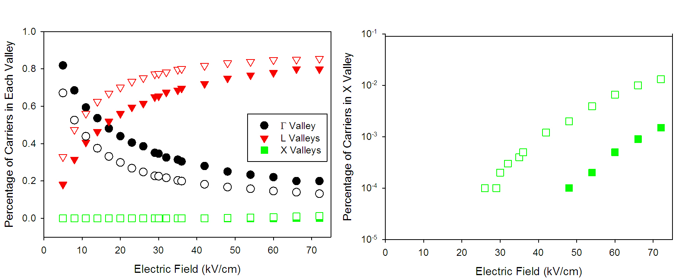

Fig. 3. (a) Percentages of carriers populating the different valleys as a function of electric field, and (b) magnified plot for the X-valley, at 300 (closed symbols) and 77 K(open symbols) .

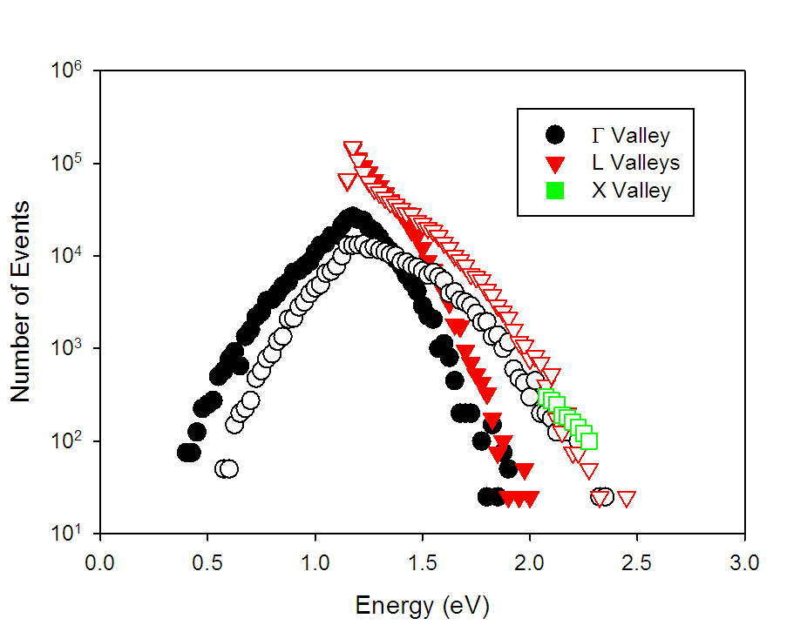

Fig. 4. Number of ionization events as a function of ionization energy at 300 (closed symbols) and 77 K (open symbols), at an electric field of 20 kV/cm.

To further identify which parts (high or low) of the Γ and L-valleys the ionizing electrons occupy, one could analyze the distributions of energy of the ionizing electrons, which are shown in Fig. 4, for 300 and 77 K. In these graphs the energy is measured relative to the conduction band minimum at the Γ point. At 300 K, the vast majority of the ionizing electrons are found in the Γ-valley and the bottom of L-valleys, with negligible contributions from X-valleys. At 77 K, although there are more carriers occupying the L and the X-valleys than those at 300 K (Fig. 3), the vast majority of the ionizing electrons are still those found in the Γ and the bottom of L-valleys, as observed from Fig. 4.
As the influence of E_{th} is the strongest in the relatively low scattering environment in the Γ-valley and at the bottom of L-valleys, we can expect the temperature dependence of E_{th} to dominate over that of phonon scattering, as we proposed earlier. Since E_{th} increases with reducing temperature, leading to fewer impact ionization events, we can expect reduced avalanche gain.
We now turn our attention to the slight increase in excess noise factor as the temperature decreases. The increased E_{th} is expected to increase the significance of dead space effects, which usually leads to lower excess noise, but we do not observe such trend here (Fig. 2). From Fig. 4 as the temperature decreases from 300 to 77 K, the energy distribution broadens (with a higher occupancy of L and X-valleys). Concomitantly this higher-phonon-scattering environment will introduce greater fluctuations in the ionization process, negating the dead space effects, so resulting in an increased excess noise at lower temperatures. Nevertheless, this is not expected to affect the performance of InAs APDs, as the excess noise factors for a wide range of gains at 300 and 77 K remains very low (< 2).
The values of α calculated from the ionization rate by the ABMC model are shown in Fig. 5 at temperatures of 300 and 77 K. The 300 K data agrees with the previously reported values [4]. At a given electric field α decreases with temperature. This behavior is a direct result of the temperature dependence of the ionization threshold energy.
In Fig. 5 for both temperatures two distinct regions can be observed. For electric fields > 20 kV/cm, α increases with field, by ~ one order of magnitude between 20 and 70 kV/cm. Such an increase in α is similar to the behavior observed in other semiconductor materials such as GaAs. For electric fields < 20 kV/cm a much less rapid change with electric field is observed. This behavior is predominantly caused by the very small effective mass of electrons in the Γ-valley leading to low density of states. Therefore at low electric fields the number of states available to impact ionization events is limited. Once the electric field has become sufficiently large (> 20 kV/cm), carriers increasingly occupy the L-valleys, which have a higher density of states, leading to a stronger dependence of α on electric field. To illustrate the origin of this behavior we have also simulated the dependence of α with electric field in InAs at 300 K, but using GaAs electron’s effective mass instead of that of InAs (with all other parameters unchanged). The results, shown as the dashed line in Fig. 5, exhibit the trend similar to that in GaAs and other wide band gap semiconductors, i.e. α increases rapidly with electric field over a wide electric field range.

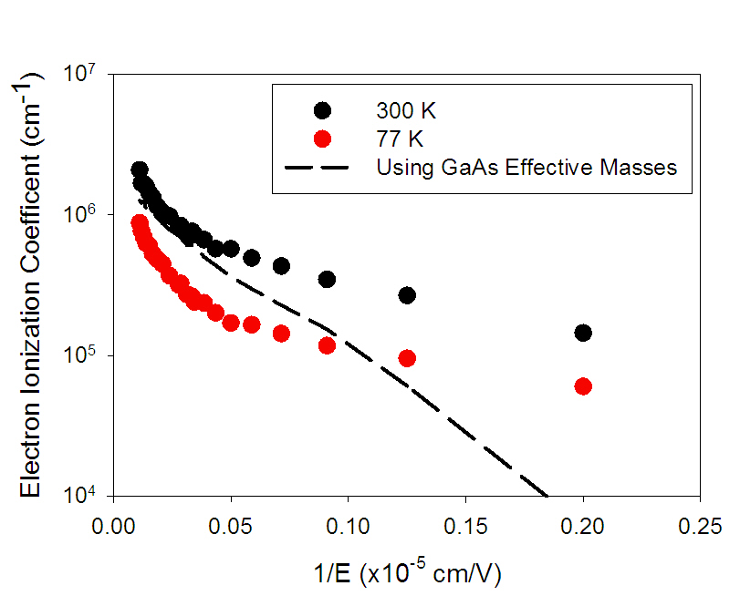
Fig. 5. InAs electron ionization coefficient versus reciprocal electric field at 300 and 77 K. Results obtained using large electron effective mass are shown in dashed line.

4. Conclusions

We have developed an ABMC model to investigate the temperature dependence of impact ionization in InAs. The model can produce an excellent agreement with the experimentally derived multiplication data at all temperatures through the temperature dependence of the ionization energy threshold and bandgap. The simulated avalanche gain shows a positive temperature dependence while the simulated excess noise factor has a negative dependence. We have explained the avalanche gain behavior in terms of the electron population of the different valleys. Majority of impact ionization occur in the Γ and L valleys, so temperature dependence of ionization threshold energy dominates over temperature dependence of phonon scattering. However the excess noise is more strongly influenced by a broad distribution of hot carriers at low temperatures. As discussed previously the small discrepancy between the simulated and measured excess noise may be due to the experimental uncertainty as well as an absence of validated data for the temperature dependence of parameters such as intervalley coupling and phonon energy. We have also used this model to investigate the temperature and electric field dependence of the electron ionization coefficient. We have attributed the low field dependence of α to the low effective mass of electrons in InAs, which gives rise to a low density of states that limits the increase of impact ionization events with field.

Acknowledgments

This work is supported by the UK Engineering and Physical Sciences Research Council (EPSRC) under grant EP/H031464/1 and European Space Agency (Contract No.4000107110/12/NL/CBi). The work of J. S. Ng was supported by the Royal Society University Research Fellowship.

