1300 nm Wavelength InAs Quantum Dot Photodetector Grown on Silicon
Ian Sandall,^{1,*} Jo Shien Ng,¹ John P. R. David,¹ Chee Hing Tan,¹ Ting Wang,² and Huiyun Liu²
¹ Department of Electronic and Electrical Engineering, Sir Frederick Mappin Building, University of Sheffield, Mappin Street, Sheffield, S1 3JD.
² Department of Electronic and Electrical Engineering, University College London,Torrington Place, London, WC1E 7JE

* I.sandall@Sheffield.ac.uk

Abstract: The optical and electrical properties of InAs quantum dots epitaxially grown on a silicon substrate have been investigated to evaluate their potential as both photodiodes and avalanche photodiodes (APDs) operating at a wavelength of 1300 nm. A peak responsivity of 5 mA/W was observed at 1280 nm, with an absorption tail extending beyond 1300 nm, while the dark currents were two orders of magnitude lower than those reported for Ge on Si photodiodes. The diodes exhibited avalanche breakdown at 22 V reverse bias which is probably dominated by impact ionisation occurring in the GaAs and AlGaAs barrier layers. A red shift in the absorption peak of 61.2 meV was measured when the reverse bias was increased from 0 to 22 V, which we attributed to the quantum confined stark effect. This shift also leads to an increase in the responsivity at a fixed wavelength as the bias is increased, yielding a maximum increase in responsivity by a factor of 140 at the wavelength of 1365 nm, illustrating the potential for such a structure to be used as an optical modulator.

©2010 Optical Society of America
OCIS codes: (040.5160) Photodetectors; (040.1345) Avalanche Photodiodes; (040.6040) Silicon; (250.5590) Quantum-well,-wire and -dot devices; (250.0040) Detectors.

References and links
- D. Miller, “Optical interconnects to silicon,” IEEE J. Sel. Topics Quantum Electron. 6, 1312-1317 (2000).
- R. Soref, “The past, present and future of silicon photonics,” IEEE J. Sel. Topics Quantum Electron 12,1678-1687 (2006).
- Y. A. Vlasov, and S. J. McNab, “Losses in single-mode silicon-on-insulator strip waveguides and bends,” Opt. Express 12, 1622-1631 (2004).
- Q. Xiu, B. Schmidt, S. Pradhan, and M. Lipson, “Micrometre scale silicon electro-optic modulator,” Nature 435, 325-327 (2005).
- M. Jutzi, M. Berroth, G. Wohl, M. Oehme, and E. Kasper, “Zero biased Ge-on-Si photodetector on a thin buffer with a bandwidth of 3.2GHz at 1300nm,” Materials Science in Semiconductor Processing 8, 423–427 (2005).
- L. Colace, P. Ferrara, G. Assanto, D. Fulgoni, and L. Nash, “Low dark-current germanium-on-silicon near-infrared detectors,” IEEE Photon. Technol. Lett. 19, 1813–1815 (2007).
- J. Yang, P. Bhattacharya, and Z. Mi, “High-performance In_{0.5}Ga_{0.5}As/GaAs quantum-dot lasers on silicon with mulitplie-layer quantum-dot dislocation filters,” IEEE Trans. Electron Devices 54, 2849-2855 (2007).
- H. Y. Liu, T. Wang, Q. Jiang, R. Hogg, F. Tutu, F. Pozzi, and A. Seeds, “Long-wavelength InAs/GaAs quantum-dot laser diode monolithically grown on Ge substrate,” Nature Photon. 5, 416-419 (2011).
- T. Wang, H. Liu, A. Lee, F. Pozzi, and A. Seeds, “1.3-µm InAs/GaAs quantum-dot lasers monolithically grown on Si substrates,” Opt. Express 19, 11381-11386 (2011).
- P.W. Fry, I. E. Itskevich, D. J. Mowbray, M. S. Skolnick, J. J. Finley, J. A. Barker, E. P. O’Reilly, L. R. Wilson, I. A. Larkin, P. A. Maksym, M. Hopkinson, M. Al-Khafaji, J. P. R. David, A. G. Cullis, G. Hill, and J. C. Clark “Inverted electron-hole alignment in InAs-GaAs self-assembled quantum dots,” Phys. Rev. Lett. 84, 733-736 (2000).
- P. Jin, C. M. Li, Z. Y. Zhang, F. Q. Liu, Y. H. Chen, X. L. Ye, B. Xu, and Z. G. Wang, “Quantum-confined Stark effect and built-in dipole moment in self-assembled InAs/GaAs quantum dots,” Appl. Phys. Lett. 85, 2791-2793 (2004).
- D. B. Malins, A. Gomez-Iglesias, E. U. Rafailov, W. Sibbett, and A. Miller, “Electroabsorption and electrorefraction in an InAs quantum dot waveguide modulator,” IEEE Photon. Technol. Lett. 19 1118-1120 (2007).
- J. Yang, P. Bhattacharya, and Z. Wu, “Monolithic Integration of InGaAs–GaAs quantum-dot laser and quantum-well electroabsorption modulator on Silicon,” IEEE Photon. Technol. Lett. 19, 747-749 (2007).
- X.M. Sun, H. Zhang, H. Zhu, P. Xu, G.R. Li, J. Liu, and H.Z. Zheng, “High responsivity resonant-cavity-enhanced InGaAs/GaAs quantum-dot photodetector for wavelength of 1 µm at room temperature,” IET Electron. Lett. 45, 329-330 (2009).
- M. H. Woods, W. C. Johnson, and M. A. Lampert, “Use of a schottky barrier to measure impact ionization coefficients in semiconductors,” Solid State Electron. 16, 381-394 (1973).
- S.A. Plimmer, J. P. R. David, D. C. Herbert, T. W. Lee, G. J. Rees, P. A. Houston, R. Grey, P. N. Robson, A. W. Higgs, and D. R. Wight, “Investigation of impact ionization in thin GaAs diodes,” IEEE Trans. Electron Devices 43., 1066-1072 (1996).
- C. K. Chia, J. P. R. David, G. J. Rees, S. A. Plimmer, R. Grey, and P. N. Robson, “Impact ionization in Al_{x}Ga_{1-x}As/GaAs single heterostructures,” J. Appl. Phys. 84, 4363-4369 (1998).
- C. K. Chia, J. P. R. David, G. J. Rees, P. N. Robson, S. A. Plimmer, and R. Grey, “Electon multiplication in Al_{x}Ga_{1-x}As /GaAs hetrostructures,” Appl. Phys. Lett. 71, 3877-3879 (1997).
- B. K. Ng, J. P. R. David, R. C. Tozer, M. Hopkinson, G. Hill, and G. J. Rees, “Excess noise Characteristics of Al_{0.8}Ga_{0.2}As avalanche photodiodes,” IEEE Photon. Technol. Lett. 14, 522-524 (2002).
- C. H. Tan, J. C. Clark, J. P. R. David, G. J. Rees, S. A. Plimmer, R. C. Tozer, D. C. Herbert, D. J. Robbins, W. Y. Leong, and J. Newey, “Avalanche noise measurement in thin Si p⁺-i –n⁺ diodes,” Appl. Phys. Lett. 76, 3926-3928 (2000).
- K. F. Li, D. S. Ong, John P. R. David, G. J. Rees, Richard C. Tozer, Peter N. Robson, and R. Grey, “Avalanche multiplication noise characteristics in thin GaAs p⁺-i-n⁺ diodes,” IEEE Trans. Electron Devices 45, 2102-2107 (1998).

1. Introduction

Silicon based photonic devices have attracted considerable attention over recent years due to the potential to have optical components compatible with Si based CMOS circuitry [1,2]. A number of developments have been made over recent years in the development of Si-based waveguides [3] and modulators [4]. For operation at the important telecommunications wavelength of 1300 nm the best Silicon-based infrared detectors are based on growing bulk Ge on Si [5,6]. However currently these devices have higher dark currents than InGaAs diodes limiting their usefulness in practical applications. For example dark current densities of 5 A/cm² for a Ge diode operating at 1300 nm [5] (with an intrinsic region width of 300 nm) and 2 mA/cm² for a Ge diode operating at 1550 nm [6] (with an intrinsic region width of 1 µm), were reported at 1 V reverse bias, while a commercial InGaAs photodiode, such as the Hamamatsu G11193-02R, has a dark current density of 0.1 µA/cm² at 5V reverse bias.
Recently great progress has been made at growing In(Ga)As quantum dots on silicon [7] and Ge [8] substrates, to realize lasing at a wavelength of 1300 nm [9]. Quantum dots are expected to offer several advantages over the current approach of bulk Ge on Si due to their zero dimensional density of states, including lower dark currents at room temperature, although there is the drawback of a reduced absorption coefficient. Additionally Quantum Confined Stark Effect (QCSE) previously observed in In(Ga)As quantum dots grown on GaAs substrates [10,11] could be exploited to form tuneable photodetectors. The QCSE has also previously been utilized to form an optical modulator [12] based on In(Ga)As quantum dots grown on GaAs. Given these potential advantages, it is of interest to evaluate In(Ga)As quantum dots grown on silicon substrates for detector and modulator based applications. The only report so far [13], demonstrating an electroabsorption modulator operating at 1300 nm using QCSE in InGaAs quantum wells grown on silicon, achieved 100% modulation depth at a bias of 5 V. However the complete modulator system consisted of a quantum dot laser and a separate quantum well modulator increasing the complexity of the device growth and fabrication.
In this paper we investigate the use of ~1300 nm wavelength InAs quantum dot structures monolithically grown on Si as photodiodes. We have obtained the characteristics of our diodes in terms of responsivity versus wavelength, forward and reverse bias dark current densities versus bias, as well as avalanche gain versus reverse bias. These results are compared to those reported for bulk Ge on Si photodiodes and APDs that also operate at 1300 nm wavelength. We also discuss the possibility of using such structures as optical modulators at wavelengths ~ 1300 nm by exploiting the QCSE.

2. Growth and fabrication details

InAs/GaAs quantum dots were grown by Molecular Beam Epitaxy on Silicon substrates and then fabricated into mesa diodes with optical access. A schematic diagram summarizing the wafer grown is shown in figure 1(a). It comprises a GaAs buffer layer followed by 50 periods of an undoped AlGaAs/GaAs superlattice. 5 periods of InAs/InGaAs dot-in-a-well (DWELL) each separated by a 45-nm GaAs spacer layer are sandwiched in a p-i-n structure. The indium containing layers were grown at a temperature of 510 °C while the GaAs layers were grown at 580 °C. Previous AFM studies on similar structures [9] estimated a dot density of 4.3 × 10¹⁰ cm⁻², while TEM (figure 1(b)) analysis indicated a dot height of 6 nm and a base width of 25 nm for this wafer. The structure investigated in this work was initially designed to operate as an LED so was not optimised for detection purposes. Circular mesa diodes with radii of 200, 100, 50 and 25 µm were fabricated from the wafer via wet chemical etching and metal depositions of p-contact (Au-Zn-Au) and n-contact (InGe-Au).

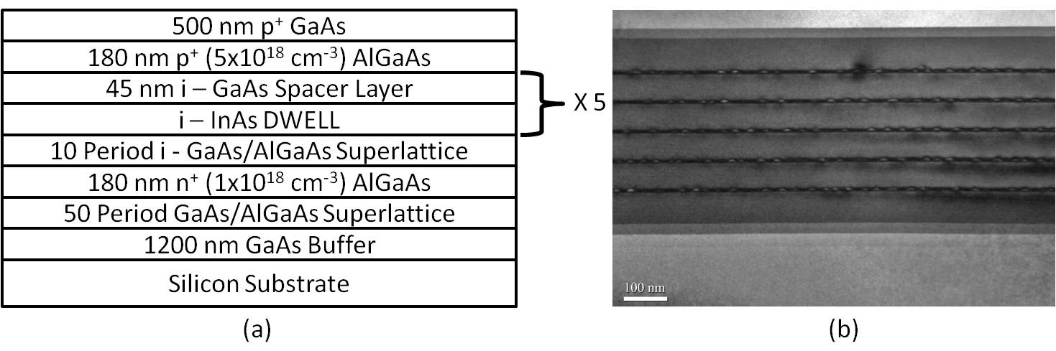

Figure 1:- (a) Schematic of wafer structure. (b) TEM image of the wafer.

3. Results

To assess our diodes as photodiodes operating at 1300 nm wavelength we measured the responsivity of the device and room temperature photoluminescence (PL) spectra from as-grown material, as shown in figure 2. For the responsivity measurements, white light from a tungsten lamp was passed through a monochromator so that light at a chosen wavelength can be focused onto the mesa diode to enable measurements of photocurrent as a function of wavelength. The responsivity for a given wavelength was given by the ratio of the photocurrent, measured using a phase sensitive detection method, to the optical power on the diode, measured using an optical power meter. For the PL spectra a separate piece of sample was excited with a 532 nm CW laser with a variable output power of up to 1 W. The emission from the sample was then collected and focused onto the input slit of a monochromator before being dispersed in wavelength and measured by a liquid nitrogen-cooled Ge detector.

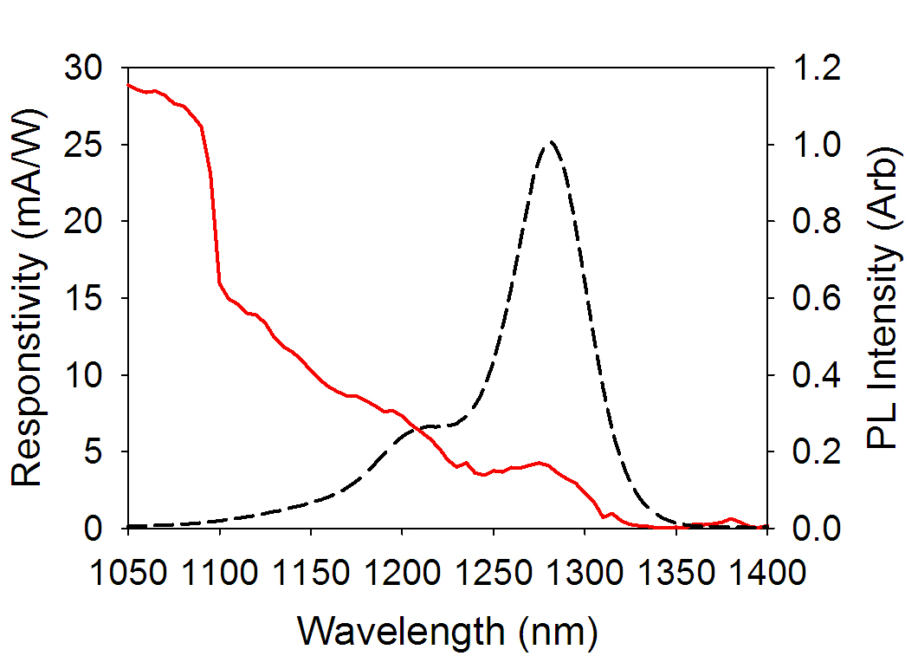

Figure 2:- Room Temperature responsivity of a 200 µm radius device
(left axis, solid line) and photoluminescence spectra (right axis,
dashed line) of the as grown samples.

In figure 2, the main PL peak and a small responsivity peak (5 mA/W) at the wavelength of 1280 nm suggest that the ground state transition of the quantum dots occurs at 1280 nm. There is a secondary peak in the PL at a wavelength of 1210 nm. In excitation power dependant PL measurements (data not shown here), the relative heights of the main and secondary peaks remain constant over the range of excitation powers used (from 20 to 1000 mW), suggesting that the two PL peaks originated from a bi-modal dot distribution in the sample. In the responsivity data, there is a sharp decrease in responsivity at 1100 nm, which is attributed to the wetting layer due to the lack of corresponding PL feature.
The responsivity due to ground state transition of the dots shown in figure 2 is less than that for Ge grown on Si [5] at comparable wavelengths, because there are only 5 layers of dots in our wafer, resulting in incomplete light absorption. In addition to the obvious need to increase the number of dot layers, incorporation of quantum dots in a resonant cavity structure can increase the quantum efficiency. For instance an external quantum efficiency of 90% at ~ 1 µm wavelength was reported for a resonant cavity enhanced photodiode with 23 layers of In(Ga)As quantum dots [14]. Also the wavelength at which peak responsivity occurs (1280 nm for this work) could be increased to 1310 nm through changes to the dots, such as by changing the amount of InAs deposited for the dots growth or post growth annealing.

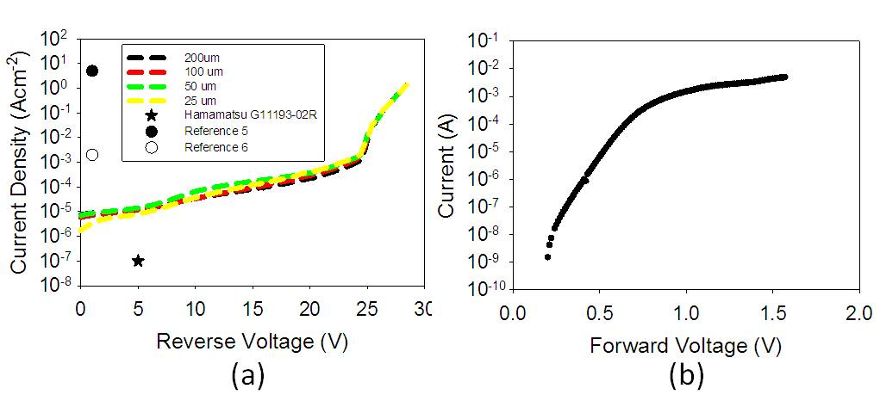
Figure 3:- (a) Dark current densities for 200, 100, 50 and 25 µm radius devices.
The data is compared with Ge on Si and commercial InGaAs photodiodes.
(b) Forward current characteristics of a 200 µm radius mesa diode.

The reverse bias dark current densities of diodes with different radii are compared in figure 3(a). The reverse dark current densities are in good agreement indicating that dark currents are dominated by bulk leakage mechanism(s). At low voltages our diodes exhibited a dark current density ~ 2 orders of magnitude higher than that of commercially available InGaAs photodiodes which respond to 1.3 μm light (also plotted in figure 3(a)). However our dark currents are two orders of magnitude lower than some Ge on Silicon devices [5,6]. A sharp increase in the dark current was observed ~ 25 V, which is considered as the avalanche breakdown voltage of our diodes. For voltages above 27 V the rise in current density appears to be limited by series resistances, which was more clearly observed in and corroborated by our forward bias dark current measurements (figure 3(b)).
To further study the breakdown behaviour we measured the avalanche gain versus reverse bias from the device. The device was illuminated by mechanically chopped light from a 1310 nm wavelength CW laser. The resultant photocurrent was measured as a function of reverse bias. To correct for increase in carrier collection efficiency due to the widening depletion region as the reverse bias increases, the primary photocurrent at low bias was linearly extrapolated to high bias [15]. The measured photocurrent was normalized to the primary photocurrent to yield the avalanche gain, which is shown in figure 4(a). Since no photocurrent saturation was observed at the laser power used, as indicated by our data of zero bias photocurrent versus 1310 nm laser power plotted in figure 4(b), the increase of photocurrent due to increased electron escape probability from high energy states is likely to be small. The primary photocurrent correction technique adopted is therefore appropriate.
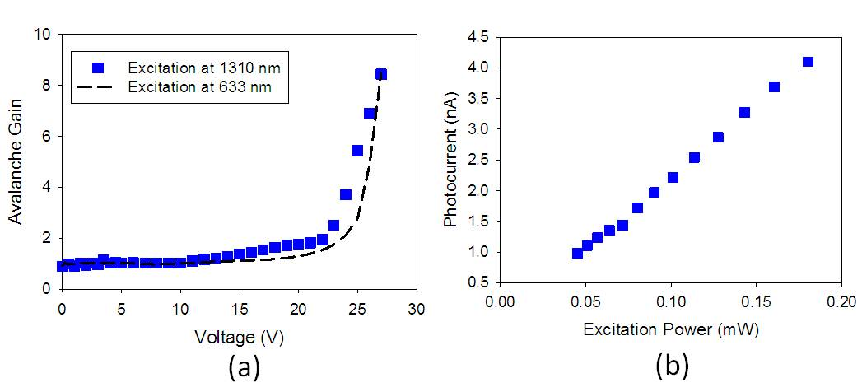
Figure 4:- (a) Avalanche gain data of a 200 µm radius diode measured using lasers with wavelengths of 1300 nm (symbols) and 633 nm (dashed line). (b) Dependence of photocurrent as a function of excitation power.

In figure 4(a), a gradual increase in the multiplication begins at ~ 10 V and continues until more significant avalanche gain occurs at ~ 22 V. The sharp increase in avalanche multiplication between 23 and 26 V is consistent with the rapid rise in dark current densities in figure 3(a), confirming the impact ionization as the dominant breakdown mechanism. Most of impact ionization events are believed to have taken place in either the GaAs barrier layers or the AlGaAs/GaAs grading superlattice for the following reason.
The i-region comprises a total GaAs thickness of 225 nm. GaAs i-layers with similar thickness have exhibited a breakdown voltage ~15 V [16] while the breakdown voltage of a GaAs/AlGaAs superlattice is similar to that of an equivalent alloy [17,18]. Since the breakdown voltage of our device is significantly higher than 15 V, we attribute the large breakdown voltage observed (25 V) to the impact ionization occurring in both the GaAs spacers and GaAs/AlGaAs superlattice. This result suggests that photons can be absorbed in the dot layers and the photo-generated carriers then undergo avalanche multiplication in other layers.
We now consider the origin of the small increase in gain between 10 and 22 V. It is possible that QCSE in In(Ga)As quantum dots [10, 11] may have affected the absorption coefficient of the quantum dots in such a way to cause an increase in photocurrent with reverse bias, which we then interpreted as increase in gain with reverse bias. To assess whether QCSE has influenced our avalanche gain data obtained using 1310 nm light, measurements were repeated using a 633 nm wavelength laser. The light is strongly absorbed by the top GaAs, the AlGaAs p⁺ layer and the GaAs spacer layers so avoiding the QCSE. The 633 nm wavelength data, included in figure 4, shows a unity gain up to 22 V, after which a dramatic increase in the gain is observed. Hence the low voltage increase in gain from the 1300 nm wavelength data is in fact due to changes in the 1300 nm wavelength absorption coefficient versus reverse bias.
Our avalanche gain results indicate that 1.3 μm Si-based APDs using InAs quantum dots are possible. They could be an attractive alternative to current Si-based APDs with Ge absorption layer and Si multiplication layer. Using InAs quantum dots offers lower dark currents at unity gain (as observed in figure 3(a)), the possibility to incorporate Bragg stacks to develop resonant cavity devices, and possible incorporation with wide bandgap AlGaAs which can reduce the excess noise [19] as well as the band to band tunnelling current. On the other hand Si avalanche region provides lower excess noise than GaAs (for example with an avalanche width of 0.3 µm and under pure electron injection a value for the effective ionization coefficient ratio of 0.2 [20] is obtained while for GaAs a value of 0.4 [21] has been measured) while bulk Ge has a larger absorption coefficient than the quantum dots at ~1300 nm wavelength.
The result in figure 4(a) indicates that photon absorption in these dots can be affected by the QCSE. This can be more easily observed from the data of responsivity versus wavelength as a function of reverse bias, which are shown in figure 5.
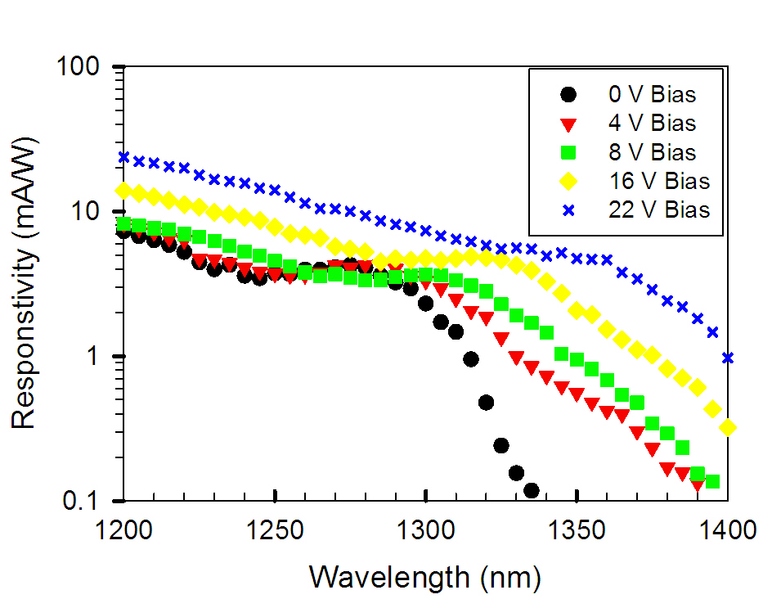

Figure 5:- Responsivity curves from a 200 µm radius device
at various reverse biases.

The position of the peak in responsivity (due to the transition in quantum dots) shifted from 1280 nm at 0 V to 1365 nm at 22 V, corresponding to a change of 61.2 meV in energy. This value is larger than the 30 meV from In(Ga)As quantum dots reported in Refs [10, 11] due to an increase in electric field from 0 to ~ 300 kV/cm, because of the larger change in electric field of 515 kV/cm in our data. For a comparable change in electric field, our results yield a peak shift of 33 meV, consistent with values from Refs [10,11]. Figure 5 also shows a slight increase in the responsivity across all wavelengths at the highest bias, consistent with the avalanche gain results in figure 4(a).
The red shift observed in figure 5 suggests that it may be possible to use these structures to form an optical modulator. A key figure of merit for a modulator is the extinction ratio, defined as the ratio between the optical power of the off and the on signals. Our top illuminated mesa diode configuration used in this work is not optimized for extinction ratio measurement since optical modulators are typically incorporated into a waveguide structure to maximize the absorption. Still the change in the responsivity with reverse bias at a fixed wavelength provides some indication of the potential for this structure as an optical modulator. As impact ionization does not influence the performance of a modulator, we have used gain-normalized responsivity curves to simplify the analysis. At 1300 nm the responsivity increases by a factor of 2.9 as the voltage is increased from 0 to 22 V. There is much room for improvement on this value as currently the absorption of the dots is not optimized for 1300 nm. A larger increase in responsivity was obtained at 1365 nm where responsivity increases by a factor of 140 as the bias increases from 0 to 22 V.

4. Conclusion

In conclusion we have evaluated the potential of In(Ga)As quantum dots grown on silicon as photodiodes by characterising their electrical and optical properties. The responsivity spectra showed a peak related to quantum dot transition at 1280 nm of 5 mA/W, with an absorption tail extending beyond 1300 nm. The measured dark currents are over three orders of magnitude lower than those for Ge on Si detectors and we have observed avalanche gain at 1310 nm. We have also evaluated the influence of the QCSE and considered the relevance of this to developing a quantum dot based optical modulator grown on silicon.

Acknowledgements

The authors thank Mr A. R. Mohmad for his PL measurements of the sample. Both H. Liu and J. S. Ng would like to thank The Royal Society for funding their University Research Fellowships. We would also like to thank the EPSRC for funding under grant EP/H031464/1.

