**Real time and on-site $γ$-ray radiation response testing system for semiconductor devices and its applications**

**Yifei Mu1, Ce Zhou Zhao2, *, Sang Lam2, Chun Zhao3, Yanfei Qi2, Yutao Cai2, Ivona Z. Mitrovic1,**

**Stephen Taylor1, and Paul R. Chalker4,**

1 Department of Electrical Engineering and Electronics, University of Liverpool, Liverpool L69 3GJ, UK; E-Mails: yifei.mu@liverpool.ac.uk (Y.M.); [ivona@liverpool.ac.uk](mailto:ivona@liverpool.ac.uk) (I.Z.M.); s.taylor@liverpool.ac.uk (S.T.);

2 Department of Electrical and Electronic Engineering, Xi’an Jiaotong-Liverpool University Suzhou 215123, China; E-Mail: cezhou.zhao@xjtlu.edu.cn (C.Z.Z.); [yanfei.qi01@xjtlu.edu.cn](mailto:yanfei.qi01@xjtlu.edu.cn) (Y.Q); yutao.cai@xjtlu.edu.cn (Y.C);

3 Nano and Advanced Materials Institute, Hong Kong University of Science and Technology, Kowloon, Hong Kong; E-Mail: gary[zhao@ust.hk](mailto:zhao@ust.hk) (C.Z.);

4 Center for Materials and Structures, School of Engineering, University of Liverpool, Liverpool L69 3GH, UK; [pchalker@liverpool.ac.uk](mailto:pchalker@liverpool.ac.uk) (P.R.C.);

* Corresponding author. Tel.: +86 (0)512 8816 1408.

E-mail address: [cezhou.zhao@xjtlu.edu.cn](mailto:cezhou.zhao@xjtlu.edu.cn) (C.Z.Z).

**Abstract**

The construction of a turnkey real-time and on-site radiation response testing system for semiconductor devices is reported. Components of an on-site radiation response probe station, which contains a 1.11 GBq Cs137 gamma ()-ray source, and equipment of a real-time measurement system are described in detail for the construction of the whole system. The real-time measurement system includes a conventional capacitance-voltage (C-V) and stress module, a pulsed C-V and stress module, a conventional current-voltage (I-V) and stress module, a pulse I-V and stress module, a DC on-the-fly (OTF) module and a pulse OTF module. Electrical characteristics of MOS capacitors or MOSFET devices are measured by each module integrated in the probe station under continuous $γ$-ray exposure and the measurement results are presented. The dose absorption rates of different gate dielectrics are calculated by a novel calculation model based on the Cs137 -ray source placed in the probe station. For the sake of operators’ safety, an equivalent dose rate of 0.01 mSv/h at a given operation distance is indicated by a dose attenuation model in the experimental environment. HfO2 thin films formed by atomic layer deposition are employed to investigate the radiation response of the high-κ material by using the conventional C-V and pulsed C-V modules. The irradiation exposure of the sample is carried out with a dose absorption rate of 0.134 rad/s and $±$ 1 V bias in the radiation response testing system. Analysis of flat-band voltage shifts (∆VFB) of the MOS capacitors suggests that the on-site and real-time/pulse measurements detect more serious degradation of the HfO2 thin films compared with the off-site irradiation and conventional measurement techniques.

Keywords: on-site radiation response, real time I-V/C-V test, high- κ dielectrics, total-dose induced defects, HfO2.

Final published version : http://dx.doi.org/10.1016/j.nimb.2016.01.035

© 2016 This manuscript version is made available under the CC-BY-NC-ND 4.0 license<http://creativecommons.org/licenses/by-nc-nd/4.0/>

1. **Introduction**

Over the past few decades, the size of metal oxide semiconductor (MOS) transistors has continued to shrink in order to achieve higher device density and faster switching speeds. With the decreasing oxide thickness of MOS transistors, the power dissipation of silicon dioxide (SiO2)-based devices increases rapidly due to the increasing gate leakage current [1]-[2]. To meet the requirements of reducing the gate leakage currents and scaling down the transistor size with further increase in the gate capacitance for better channel control, alternative gate insulator materials with higher dielectric constants are considered to replace SiO2 as the gate dielectric [3]. Hafnium-based dielectrics have emerged as the most promising high-κ materials because they have relatively high dielectric constants, relatively large band gap and high thermodynamic stability on silicon [4]-[7]. On the other hand, semiconductor technology has advanced so significantly that semiconductor devices and integrated circuits (ICs) are used in radiation environments such as in satellite communication systems in space as well as military defense and nuclear power plants. Therefore, it is significantly important to investigate the radiation response of semiconductor materials and devices. Over the last thirty years, the effects of total ionizing dose in SiO2 have been investigated extensively. However, to date, very little research has been published on radiation-induced degradation of high-κ thin films (HfO2) after either X-ray exposure or γ-ray irradiation [8]-[10].

γ-radiation is known to induce degradation and failures to the electrical properties of a variety of materials and components thus degrading the device performance [11]-[12]. The degradation and failures are caused by the charge built up in gate dielectrics leading to a shift in the flat band voltage (VFB) or the threshold voltage (VTH). So far, conventional evaluation [13] of γ-ray induced VTH/VFB shift has been carried out in an off-site condition due to radiation safety consideration. The conventional radiation response measurement processes are 1) a MOS device is irradiated by γ-ray under certain voltage biasing condition using a radiation exposure facility; 2) the radiation exposure and voltage biasing are interrupted and the sample is taken out from the on-site irradiation chamber; and 3) electrical characterization of the irradiated devices are performed by traditional current-voltage (I-V) or/and capacitance-voltage (C-V) techniques [8] [13]. According to the mechanism of radiation-induced defects or degradations in semiconductor materials, the interruption of irradiation and voltage biasing may cause a rapid recovery of the VTH/VFB shift [14]-[16]. Moreover, the conventional measurement techniques may underestimate the defects or degradations in dielectrics because the measurements cannot be completed in a very short time (say, a few micro seconds). To precisely detect the effects of total ionizing dose on semiconductor devices, it is necessary to upgrade the conventional evaluation of radiation response to on-site and real-time measurement.

Very few works have been published regarding the development of radiation response testing systems [13] [17]. In this work, a semi-automated laboratory-scale real-time and on-site radiation response testing system is developed to evaluate the VTH/VFB shift of a biased device using a Cs137 γ-ray radiation source. The testing system allows on-site radiation response studies of semiconductor chips or wafer pieces in a safety-compliant environment [18] for the human operators. Meanwhile, pulse and stress techniques are used to monitor the evolution of the gate and drain voltage waveforms. The techniques can measure the characteristics of the electronic devices in milliseconds while the devices are continuously irradiated by γ-rays. The effects of total ionizing dose on VFB shift to HfO2 capacitors with voltage biasing are re-examined by the proposed method.

1. **Experimental setup**

In oxide thin films of semiconductor devices, oxide trapped charges and interface-trap charges induced by ionizing radiation leads to threshold voltage shift or flat band voltage shift [16]. The degradation caused by the trapped charges has a transient recovery because majority of the trapped charges will de-trap in millisecond [19]-[24]. Hence, in the conventional evaluation of γ-ray induced VTH/VFB shift, measurement limitations arise from 1) the interruption between the γ-ray irradiation and the electrical measurement and 2) the testing speed of the traditional I-V or/and C-V techniques. A novel radiation response testing system is developed in this work by integrating an on-site measurement probe station with a real-time testing system. Electrical characterization of semiconductor devices is performed using the developed testing system in milliseconds under continuous γ-ray exposure. A mathematical model has been established to calculate the dose rate absorbed by gate dielectrics in the radiation response testing system. In addition, a lead protection application is proposed to obtain a safe operation environment. The system development and details of the aforementioned factors are described in each section.

*2.1. Real-time and on-site measurement system*

A real-time and on-site radiation response testing system is composed of a program-controlled ionizing radiation probe station and a real-time testing system. The program-controlled ionizing radiation probe station is developed from a conventional program-controlled probe station platform as shown in Fig. 1 (a) [17]. The probe station platform consists of a platform with an x-y adjustable stage, an optical microscope equipped with a digital camera, an on-wafer probe mounted on a precision positioner, a testing sample loading chuck mounted on a rail, and a lead container to keep the γ-ray radiation source at the center of the platform which is surrounded by an annular lead wall. Both the optical microscope and the probe positioner are mounted on robotic arms with the program-control PC placed outside the probe station. The robotic arms can move vertically along the z-axis and horizontally along the y-axis while the lead container mounted on a stage can move in a horizontal plane along the x-axis and the y-axis [17].

To design a desirable and safety-compliant real-time radiation response testing system, a lead container and an annular lead wall are employed to surround the radiation source as illustrated in Fig. 1 (a). The container itself is made of lead and the shield thickness of the lead container is designed to be 5.5 cm to attenuate the γ-ray. A lead cover and a bottom case are developed to preserve and transport the radiation source when the irradiation exposure is in off time as illustrated in Fig. 1 (b). The lead container has a small opening on the top surface where the semiconductor chip under test is placed above. The γ-ray radiation source with an activity of 1.11 GBq is placed into the lead container. The lead wall with the same thickness (5.5 cm) surrounding the container is for blocking any possible sideways γ-radiation from the source.

To perform radiation response measurements, a semiconductor chip needs to be first placed on the loading chuck which is outside the ionization probe station. Since the loading chuck is not in proximity of the radiation source when the semiconductor chip is mounted, the radiation risk to the human operator is negligible. Once the chip is mounted, the loading chuck can be controlled by a PC to move inside the ionization probe station and above the lead-walled container where the γ-ray source is kept. Initially, when the chip or wafer piece is settled on the lead-walled container, the robotic arm holding the optical microscope equipped with a digital camera can be controlled by the PC to move in the y-z direction to a position above the chip for digital imaging of the on-chip devices as shown in Fig. 1 (a) [17]. For initial probe positioning, low magnification of the optical microscope should be used for a zoomed-out view of both the chip and nearby regions. Primary adjustments of the robotic arm hold the probe positioner to move the probe to the top of the chip in the y-z plane. The probe should be within the zoomed-out view of the optical microscope. With the digital imaging of the optical microscope, the probe can be positioned precisely as it is visible on the PC’s screen which displays the real-time view of the optical microscope. By gradual increase of the magnification of the optical microscope and the careful movement of the probe positioner, the devices in the chip can then be probed for electrical measurements while the chip is subjected to γ-ray radiation. The whole process is done through controlling the robotic arms and the optical microscope with digital imaging equipment which are all remote controlled by a PC [17]. The human operator can stay at least one meter away from the radiation source for operating the PC which is outside the ionization radiation probe station. The radiation risk to the human operator is therefore much minimized [17].

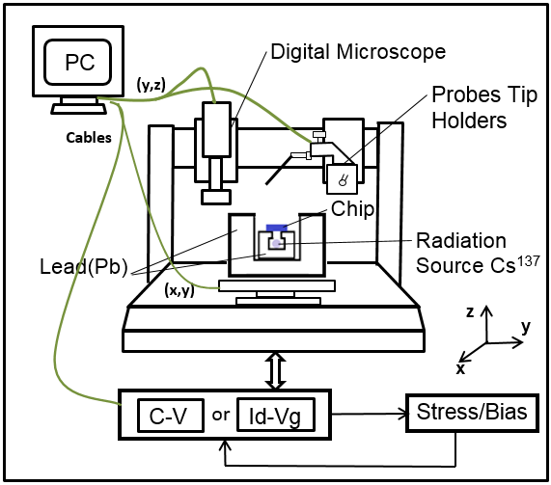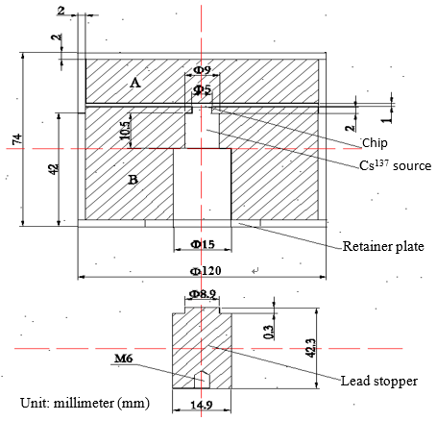

1. (b)

Fig. 1. (a) Real-time and on-site measurement system of γ-ray radiation with stress-and-sense pulse I-V, pulsed C-V or/and pulse On-The-Fly measurement capabilities. (b) Schematic diagram of the lead container with a Cs137 γ-ray radiation source in the ionizing radiation probe station system.

* 1. *Dose attenuation in the experimental environment*

To protect the operators around the system from radiation hazard, a lead container and an annular lead wall are employed to surround the radiation source. The thickness of the lead protection system is calculated to establish a safe experimental environment. In that respect, a calculation model of the dose attenuation in the experimental environment around the system is indicated as illustrated in Fig. 2. A Cs137 γ-ray radiation source is used to irradiate MOS devices in the system. The activity of the Cs137 γ-ray radiation source is 1.11 GBq which gives off 1.11×109 γ-photons per second with energy E = 662 keV. The irradiation dose rate in the air is given by [25]

$\dot{X}=\frac{A· Γ}{R^{2}}$ (1)

where Γ is the exposure rate constant, R is the distance from the source to the operators near the system, A is the activity of the Cs137 γ-ray radiation source. Here, = 6.312×10-19 C·m2·kg-1·Bq-1·S-1 [25], R = 1 m. For the condition of charged ions balancing, the equivalent dose rate in the air under Cs137 γ -ray radiation source is indicate by [25]

${\dot{D}}_{a}=\dot{X}∙\frac{W_{a}}{e}$ (2)

where $\dot{X}$ is the irradiation dose rate in the air, Wa is the average energy consumption of the generation of an ion by an electron in the air, e is the charge of an electron. Here, Wa = 5.42×10-18 J, 1 e = 1.602×10-19 C [25]. For the 1.11 GBq Cs137 γ-ray radiation source,

${\dot{D}}_{a}=\dot{X}∙33.85$ (3)

**Radiation**

**Cs137source**

**R = 1 m**

**Da < 0.01 mSv/h**

Fig.2. Calculation model of the dose attenuation from a Cs137 point radiation source to a technician who operates the ionizing radiation probe station system.

From Eqs. 1, 2, and 3, the equivalent dose rate at one meter (operation distance) away from the source without any protection system can be determined as ${\dot{D}}_{a}≈$ 0.0854 mSv/h. According to the International Commission on Radiological Protection (ICRP) [26] in laboratory, both a lead wall and a lead container are required to be designed to attenuate the equivalent dose rate ${\dot{D}}_{a}$ to be less than 0.01 mSv/h at the operation distance. Hence, ${\dot{D}}_{a}$ at the operation distance is required to be reduced by more than 8.54 times. According to the National Council on Radiation Protection and Measurements (NCRP) No.46 1976 [27], the thickness of the lead container and the lead wall to reduce the dose equivalent rate to be a half of the initial value (0.0854 mSv/h) under Cs137 γ-ray radiation source is 0.65 cm. The thickness of the lead wall and the lead container to reduce the ${\dot{D}}_{a}$ to be 1/K of the initial value is given by [26]

d = 0.65 $×\frac{\log{K}}{\log{2}}$ (4)

where K is a multiple of the attenuation of ${\dot{D}}_{a}$. Here, K should be larger than 8.54 to attenuate ${\dot{D}}_{a}$ to be less than 0.01 mSv/h. From Eq. 4, the shield thickness of the lead wall or the lead container should be no less than 2.06 cm. In case of the operators carrying out the experiments within 1 m around the system, the shield thickness of the lead container and the lead wall in the ionization radiation probe station are designed to be 5.5 cm. The multiple of the attenuation of ${\dot{D}}_{a}$ equals to 352.5 in this case. The real equivalent dose rate at one meter (operation distance) away from the γ-ray source is decreased to 0.242 μSv/h. The human operator can stay at least one meter away from the radiation source for operating the PC which is outside the ionization radiation probe station. The radiation risk to the human operator is therefore much minimized.

* 1. *Dose absorption rate for high-κ dielectrics*



**ᵠ(x)**

**X**

ᐃ**ᵠ**

**ᵠ (x) = ᵠ0 exp (-**µ**x)**

**Cs137source**

**dox**

**d**

**ᵠ0**

**L**

**R**

**l**

**z**

**Device**

Fig.3. Calculation model of the dose absorption rate attenuation of gate dielectrics in the ionizing radiation probe station system.

A point source model has been established in previous work to calculate the dose rate absorbed by gate dielectrics [8]. However, the point source model can only be used when the distance from the radiation source to the irradiated device is 5 times larger than the size of the radiation source. In the ionizing radiation probe station system, the distance between the radiation source and the irradiated device is 0.4 cm and the length of the radiation source is 1 cm. Hence, a calculation model is established in this work to calculate the dose rate absorbed by gate dielectrics in the system. The 1.11 GBq Cs137 γ-ray radiation source emits 1.11109 γ-photons per second with the energy E of 662 keV. The radiation source has radius R of 0.4 cm and length L of 1 cm. The distance from the top surface of the source to the device is d = 0.4 cm. Assume that the radiation source emits γ-photons uniformly. In the calculation model, as illustrated in Fig. 3 [8], the number of particles emitted by the radiation source per unit time and unit volume is given by

$N_{i}=\frac{N\left(E\right)}{LπR^{2}}$ (5)

where N(E) is the number of photons of energy E, emitted per unit time by the source. Here, N(E) = 1.11 $×{10}^{9}$ photons/s. Hence, the number of particles passing through the target dielectric irradiated by a unit volume of the radiation source per unit time, which has a distance of z to the center axis of the radiation source and a distance of l to the surface of the radiation source as shown in Fig. 3, is given by:

$φ_{0}^{'}=\frac{N_{i}2πz}{4π({\left(l+d\right)}^{2}+z^{2})}$ (6)

The total particle flux of the device is given by:

$φ_{0}=\int_{0}^{L}{\int_{0}^{R}{\frac{N_{i}2πz}{4π({\left(l+d\right)}^{2}+z^{2})}dzdl}}$ (7)

Here, $φ_{0}≈1.326×{10}^{8}$ photons/cm2s. The particle flux of the target dielectric is decreased compared with the point source model $φ_{0}≈5.5×{10}^{8}$ photons/cm2s [8].

The attenuation of the particle flux when γ-photons pass through the target dielectric or other materials, which has a thickness of *x*, is given by [8]:

$φ\left(x\right)=φ_{0}exp⁡(-μ_{m}ρx)$ (8)

where μm is the mass attenuation of the target material. Generally, um is expressed as $μ_{m}=μ/ρ$ [28], where μ is the linear attenuation coefficient and $ρ$ is the density of the target material. The mass attenuation values of single elemental materials of energy E = 662 keV are taken from Physical Reference Data of National Institute of Standards and Technology (NIST) [29] as listed in Table 1. The mass attenuation of a compound material [30] is given as follows:

$μ_{m}=μ_{m1}\overline{w_{1}}+μ_{m2}\overline{w_{2}}+{∙∙∙+μ}_{mi}\overline{w_{i}}$ (9)

where $μ_{m1}$ $μ_{m2}$ $μ_{mi}$ are the mass attenuation of the target materials, $\overline{w_{1}},\overline{w_{2}}, ∙∙∙\overline{w_{i}}$ are the mass percentage of the target elements. The mass attenuation values of five materials of energy E = 662 keV have been calculated using Eq. 9 as shown in Table 2. The values of the mass attenuation are from 0.0776 to 0.0952 cm2/g. The mass attenuation indicates the probability of attenuation for a particle when it passes through the target materials of unit thickness. Hence, the dose absorption rate DR of a thin film is given by [8]

$\dot{{ D}_{R}}= \int_{0}^{d_{ox}}{E×}φ_{0}\exp\left(-μx\right)×μ_{m}dx$ (10)

where dox is the thickness of the irradiated material. When the thickness of the irradiated material is extremely small, the dose absorption rate $\dot{D_{R}}$ can be given by,

$\dot{{ D}_{R}}{≈E×φ}_{0}×μ_{m}$ (11)

In this work, the 1.11 GBq Cs137 γ-ray radiation source emits 1.11109 γ-photons per second with energy E = 662 keV. The particle flux $φ_{0}$ and the mass attenuation µm for each material have been calculated using Eq. 7 and Eq. 9. Hence, from Eq. 11, the dose absorption rate DR of the five different materials can be calculated and listed in Table 2. The result clearly shows that the dose absorption rates have extremely small differences at the same γ-ray exposure.

Element O Si Hf Zr La

μm(cm2/g) 0.0777 0.0776 0.0984 0.0739 0.0803

Table 1. The mass attenuation of single elemental materials for energy E = 662 keV.

Thin films Si SiO2 HfO2 ZrO2 LaZrOx

μm(cm2/g) 0.0776 0.0777 0.0952 0.0749 0.0775

DR (rad/s)  0.109 0.109 0.134 0.105 0.109

Table 2. The mass attenuation and the dose absorption rate of the five different materials for energy E = 662 keV.

*2.4. Sample information*

MOS capacitors were fabricated on single crystal n-type silicon <1 0 0> wafers with a resistivity of 1-10 ohm/cm. Before the samples were deposited, they were cleaned with a solution (HF: H2O = 1:30) for 30 seconds to remove native oxides and then were dried in nitrogen. All HfO2 thin film layers were formed by atomic layer deposition (ALD) using an f-200 ALD fabrication machine from MNT Ltd. Tetrakis (dimethylamino) hafnium (C2H6N)4Hf was used as the precursor for HfO2 and H2O was used as the oxidant. The ALD process was performed at 200 $℃$ for both the substrate temperature and chamber temperature. 150 cycles of pulse deposition of HfO2 were grown at a pulse sequence: precursor/purge/water/purge (150 ms / 30 s / 30 ms / 30 s). The thicknesses of the films were determined by an ELLIP-SR-1 ellipsometer with the incident angle of 65° and the wavelength from 300 nm to 800 nm with a step of 25 nm. In order to test the electrical characteristics, MOS capacitors were formed with aluminum as the top electrodes with a diameter of 0.3 mm and a thickness of 500 nm by E-beam evaporation The bottom electrodes were fabricated with aluminum to form ohmic contacts.

1. **Results and Discussion**

To date, the electrical characterization of high-κ dielectrics has been mainly focusing on DC measurements and dynamic measurements [31]-[33]. In DC measurements, a sweeping voltage is applied to obtain the values of capacitance or leakage current of MOS devices in a few seconds, which will underestimate the impact of charge trapping in dielectrics. Initially, the charges are trapped in the oxide or Si/oxide interface under the positive or negative applied field. With the variation of the applied field (sweeping), the trapped charges will be de-trapped in a few milliseconds. However, the forward or reverse sweeping will take a few seconds. It is hard to detect the progress of fast trapping and de-trapping by using DC measurements [34]-[36]. However, in dynamic measurements, trapezoid pulse signals are applied to obtain the values of leakage currents in hundreds of microsecond. Meanwhile, the obtained values of leakage current can be amplified and converted into values of capacitance. Hence, dynamic measurements are employed to analyze the reliability of semiconductor due to the fact that it reduces the impact of charge trapping on the measurement results [34, 36].

In the radiation response measurements, ionizing radiation applying to gate dielectrics generates electron-hole pairs (EHPs). Some of the EHPs recombine in a short time and do not affect the device performance. If a positive electric field is applied to the gate dielectrics, the remaining EHPs will be separated by the electric field. The electrons will be swept out of the oxide in a picosecond. However, the surviving holes transport towards the cathode slowly via defect sites because they have a relatively low mobility [37]-[40]. Some of the surviving holes will recombine with the electrons injected from the silicon substrate, and other holes will be trapped by oxide traps during the transport, forming positive oxide trapped charges. These trapped charges will cause the radiation-induced threshold voltage shift. When the surviving holes approach the silicon-oxide interface, protons (H+) are released and react with silicon-hydrogen (Si-H) bonds to form radiation-induced interface traps [14]-[16]. Apart from hole trapping in the oxide, most gate dielectrics can also trap a significant density of electrons. Some high-*k* films are more prone to generation of negative oxide trapped charges than positive oxide trapped charges [10] [23]. If the applied field and the ionizing radiation are interrupted for a period of time, some of the trapped charges will be de-trapped and this gives rise to a recovery of radiation-induced threshold voltage shift. Hence, off-site radiation response measurements may underestimate the radiation induced degradation. It is significantly important to apply on-site and pulse measurements in the experiments. In this study, DC I-V and stress, conventional C-V and stress, DC on-the-fly techniques are used to compare the results with dynamic measurements.

The characteristics analyzing equipment (and the controlling PC) are placed outside the probe station. A real-time measurement system is comprised of modules capable for conventional C-V, DC I-V, DC on-the-fly, pulsed C-V, pulse I-V, and pulse on-the-fly measurements. In addition, a stress system is applied to each measurement technique and it will generate continuous stress voltage during irradiation or testing. All the electrical measurement instruments (except the digital oscilloscope Rigol DS1302CA) are connected using GPIB cables for programmable control and data acquisition. Together with the PC-controlled movement of the optical microscope, probe positioner and movable stage inside the ionization radiation probe station, the electrical measurement equipment connected to a controlling PC makes the real-time radiation response measurements semi-automated.

* 1. *Electrical characterization via measurement system*

*3.1.1. Conventional C-V and stress*

A conventional C-V and stress measurement system is set up with an Agilent 4284 LCR meter and a PC. Fig. 4 is a schematic diagram showing the measurement of a MOS capacitor using the conventional C-V and stress technique under continuous γ-ray exposure in the ionizing radiation probe station system. The LCR meter generates a sweeping voltage for C-V test or a bias voltage to the gate of the MOS capacitor with a voltage range from -40 V to +40 V and a frequency range from 20 Hz to 1 MHz. Afterwards, the capacitance of the MOS capacitor is recorded and primary C-V curves are plotted by a MATLAB program. The PC controls the system using a GPIB connection cable. Fig. 5 shows a graph of the gate sweeping voltage for C-V test and stress voltage versus the sweeping time in the conventional C-V and stress module. The stress voltage and the sweeping voltage are alternately applied to the MOS device under test by the Agilent 4284 LCR meter. The duration of the stress voltage is controlled by the PC.

In Fig. 6 (a), C-V curves of MOS capacitors with HfO2 dielectrics were measured using the conventional C-V and stress technique from 1 kHz to 1 MHz. The C-V curves with different frequencies were measured by both forward and reverse sweeping voltages. The result of Fig. 6 (a) indicates that the MOS capacitor has appropriate C-V curves from -2 V to +1 V using the conventional C-V and stress technique. In Fig. 6 (b), C-V curves of the MOS capacitors with HfO2 dielectrics were measured using the conventional C-V and stress technique at a frequency of 1 MHz and +1 V bias for a stress period of 10,000 seconds. It can be seen that there is very little negative shift of the flat band voltage under +1 V bias. The result illustrates that very few positive oxide trapped charges and interface traps have been generated or observed in the oxide and silicon-oxide interface by the applied positive bias.

γ-ray radiation

Agilent 4284

LCR meter

LCUR

LPOT

HPOT

HCUR

Metal-Gate

Si

Oxide

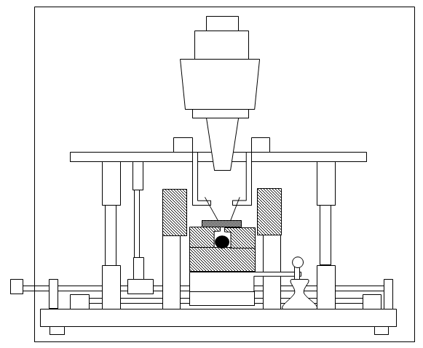

Fig.4. Schematic diagram showing the measurement set-up for a MOS capacitor using the conventional C-V and stress technique under continuous γ-ray exposure in the ionizing radiation probe station system.

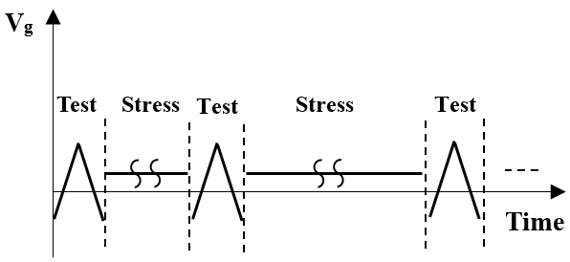

Fig.5. Graph of the gate sweeping voltage for C-V test and stress voltage versus time characteristics of the conventional C-V and stress technique.



(a)



(b)

Fig.6. The conventional C-V and stress technique. (a) C-V curves of MOS capacitors with HfO2 dielectrics from 1 kHz to 1 MHz, (b) C-V curves of the MOS capacitors with HfO2 dielectrics at a frequency of 1 MHz and +1 V bias for a stress duration of 10,000 seconds.

*3.1.2. Pulsed C-V and stress*

A pulsed C-V measurement system is set up with a RIGOL DS1302CA oscilloscope, a RIGOL DG3061A function generator, a KEITHLEY 428 current amplifier and a PC. Fig. 7 shows a schematic diagram of the measurement a MOS capacitor using the pulsed C-V technique under continuous γ-ray exposure in the ionizing radiation probe station system. Initially, the function generator applies a trapezoid pulse signal (VG) to the gate of the MOS capacitor. Afterwards, the leakage current of the capacitor is detected and converted to an output voltage signal (Vout) by the current amplifier. Meanwhile, the output voltage signal is fed to the oscilloscope and data is recorded. These measurement processes can be completed in one millisecond. The capacitance of the MOS capacitor can be expressed as:

$C\left(V_{G}\right)=\frac{V_{out}-V_{offset}}{A*dV_{G}/dt}$ (12)

where VG is the applied gate voltage; Vout is the output voltage from current amplifier, Voffset is the offset voltage to set the amplitude of the trapezoid pulse signal VG; dVG is the variation of the gate voltage; dt is the variation of measuring time; and A is the amplification factor of the amplifier.

Fig. 8. (a) shows a schematic diagram of the measurement of a MOS capacitor using the pulsed C-V and stress technique under continuous γ-ray exposure in the ionizing radiation probe station system. A pulsed C-V and stress measurement system is developed from a pulsed C-V measurement system, an Agilent E3647A DC power supply and a relay. As indicated in Fig. 8 (b), a trapezoid pulse signal VG and a stress voltage are alternately applied to the gate dielectrics. When the system is set to the “stress mode”, the DC power supply will be switched by a relay to apply a continuous stress voltage to the MOS capacitor. Otherwise, the system is switched to the “test mode” and the device is connected to the pulsed C-V system to perform the pulsed C-V measurement. The C-V curves at different stress period are calculated using Eq. 12.

As indicated in Fig. 9 (a), a trapezoid pulse signal VG is applied to the gate of the MOS capacitor with an amplitude of 3 V, an offset voltage Voffset of -0.5 V and an amplification factor (A) of 5. Afterwards, an amplified output voltage signal Vout is obtained. The comparison of C-V curves of the MOS capacitors with HfO2 dielectrics obtained using the conventional C-V technique and the pulsed C-V technique is presented in Fig. 9 (b). The C-V curves obtained using pulsed the C-V technique have extremely small hysteresis of both up and down orientation. A drop from the true capacitance value of the pulsed C-V measurement is observed within the range of 0.5 V to 1 V. The phenomenon is mainly due to the response time of the oscilloscope and the capacitance charging and discharging issues [41]. In consequence, the range of -2 V to 0.5 V of the full C-V curves is the actual capacitance value of the MOS capacitor. The capacitance measured using the pulsed C-V technique is approximately equal to that measured using the conventional C-V technique, while the conventional C-V technique has better stability.

Fig. 10 is a plot of C-V curves of the MOS capacitors with HfO2 dielectrics. The C-V curves were obtained with +1 V bias for a stress duration of 10,000 seconds using the pulsed C-V and stress technique. The trapezoid pulse signal VG and the +1 V bias voltage were alternately applied to the MOS capacitor. The trapezoid pulse signal VG has the same waveform as in Fig. 9 (a). The C-V curves indicate that there is extremely small negative shift of both forward and reverse sweepings. This implies that very few positive oxide trapped charges and interface traps have been generated or observed in the oxide and silicon-oxide interface by the applied positive bias.

Vout

Oscilloscope

(DG 1302CA)

Metal-Gate

Si

Pulse Generator

(DG3061A)

VG

Oxide

Current amplifier

(Keithley 428)

γ-ray radiation

Fig.7. Schematic diagram of the measurement set-up for a MOS capacitor using the pulsed C-V technique under continuous γ-ray exposure in the ionizing radiation probe station system.

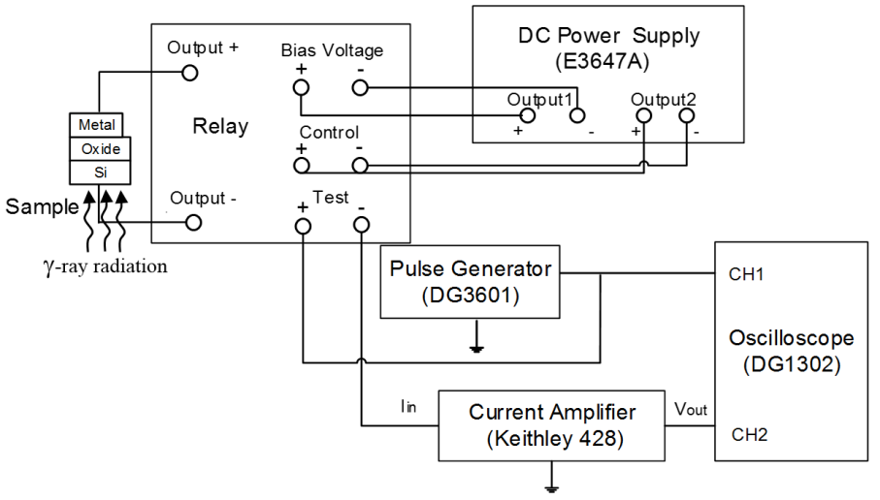

(a)

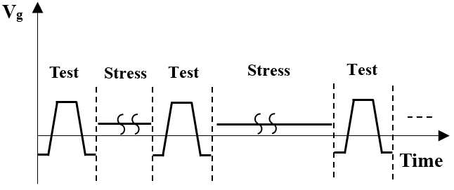

(b)

Fig.8. (a) Schematic diagram of the measurement set-up for a MOS capacitor using the pulsed C-V and stress technique under continuous γ-ray exposure in the ionizing radiation probe station system (b) Graph of the gate voltage for the pulsed C-V test and stress voltage versus time characteristics of the pulsed C-V and stress technique.



(a)



(b)

Fig.9. The pulsed C-V technique. (a) Gate voltage/ output voltage versus the time characteristics of the MOS capacitors with HfO2 dielectrics. (b) Comparison of the C-V curves of MOS capacitors with HfO2 dielectrics measured using the conventional C-V technique and the pulsed C-V technique.



Fig.10. C-V curves of the MOS capacitors with HfO2 dielectrics with +1 V bias for a stress duration of 10,000 seconds measured using the pulsed C-V and stress technique.

*3.1.3. DC* *I-V and stress*

To investigate the reliability of semiconductor materials comprehensively, it is important to evaluate the effect of irradiation on leakage behavior of MOS devices. DC I-V and stress measurements were performed by applying a sweeping voltage and a stress voltage to MOS devices alternately using a KEITHLEY 487 ampere meter and an Agilent E3647A DC power supply. Fig. 11 shows a schematic diagram of the measurement set-up for a MOSFET device using the DC I-V and stress technique in the ionizing radiation probe station system. The waveform of Vg is the same as the waveform shown in Fig. 5. The DC power supply generates a sweeping voltage (Vg) or bias voltage (Vg) with a range of $±$ 35 V to the gate of the MOSFET. A continuous voltage (VD) is supplied to the drain of the MOSFET. Afterwards, the drain current (Id) of the MOSFET is measured by the ampere-meter which has a measuring accuracy at the 1 µA level.

Fig. 12 presents the I-V curves of a MOSFET device from measurements using the DC I-V and stress technique with +1 V bias for a stress duration of 460s. A sweeping voltage and a bias voltage of +1 V were alternately applied to the metal gate of the MOSFET for a stress duration of 460 s. The results shown in Fig. 12 indicate that the threshold voltage of the MOSFET is about -1.7 V. Neither significant hysteresis nor threshold voltage shift of each loop is observed (as the MOSFET is a standard discrete device). The noise of the drain current becomes non-negligible below 1 μA.

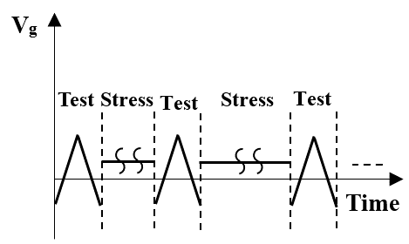

Ampere-meter

(KEITHLEY 487)

Metal-Gate

N-Si

P

P

Source

Drain

DC power supply

(E3647A)

Resistance

CH2 (VD)

CH1 (Vg)

γ-ray radiation

Fig.11. Schematic diagram of the measurement set-up for a MOSFET device using the DC I-V and stress technique under continuous γ-ray exposure in the ionizing radiation probe station system. The waveform of Vg is the same as the waveform shown in Fig. 5.



Fig.12. I-V curves of a MOSFET device from measurements using the DC I-V and stress technique with +1 V bias for a stress duration of 460s.

*3.1.4. Pulse I-V and stress*

A pulse I-V measurement system is set up with a RIGOL DS1302CA oscilloscope, a RIGOL DG3061 function generator and an Agilent E3647A DC power supply. Fig. 13 shows a schematic diagram of such a set-up for a MOSFET measured using the pulse I-V technique under continuous γ-ray exposure in the ionizing radiation probe station system. Initially, a trapezoid pulse signal (VG) is applied to the gate of MOSFET and a continuous DC voltage (VDD) is applied to the drain through a resistor. Afterwards, the drain voltage (VD) is detected by the oscilloscope and is converted to drain current (IDS). The drain current of the MOSFET is expressed as:

$I_{DS}=\frac{V_{DD}}{V_{DS}}(\frac{V_{DD}-V_{D}}{R})$ (13)

where VDD is the continuous voltage applied to the drain; $V_{D}$ is the drain voltage obtained from the oscilloscope and R is the resistance of the resistor between the DC power supply and the MOSFET.

Fig. 14 shows a schematic diagram of the measurement set-up for a MOSFET using the pulse I-V and stress technique under continuous γ-ray exposure in the ionizing radiation probe station system. A pulse I-V and stress measurement system is developed from a pulse Id-Vg measurement system, an Agilent E3647A DC power supply and a relay. The DC power supply applies stress voltages to the gate of MOSFET in the “stress mode”. When the DC power supply is switched to the “test mode” by the relay, the device is connected to the pulse I-V system and pulse I-V measurements are performed then.

Fig.15 (b) shows the I-V curves of a MOSFET from measurements using the pulse I-V and stress technique. A trapezoid pulse signal VG and a +1 V stress voltage are alternately applied to gate dielectrics for a stress duration of 460 s and a DC voltage of +0.1 V is continuously applied to the drain of the MOSFET. The trapezoid pulse signal VG and the drain voltage VD as a function of time are shown in Fig. 15 (a).The result indicates that the threshold voltage of the MOSFET is about -1.6 V and the saturation current is 0.06 mA. There is no significant threshold voltage shift after each stress duration. The noise of drain current becomes non-negligible when the drain current is below 10 µA.

Pulse Generator

(DG3061)

Source

Resistance

Drain

Oscilloscope

(DG1302CA)

Metal-Gate

N-Si

P

P

VG

VD

DC Power Supply

E3647A

γ-ray radiation

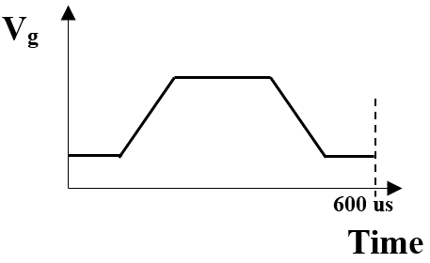

Fig.13. Schematic diagram of the measurement set-up for a MOSFET device using the pulse I-V technique under continuous γ-ray exposure in the ionizing radiation probe station system.

γ-ray

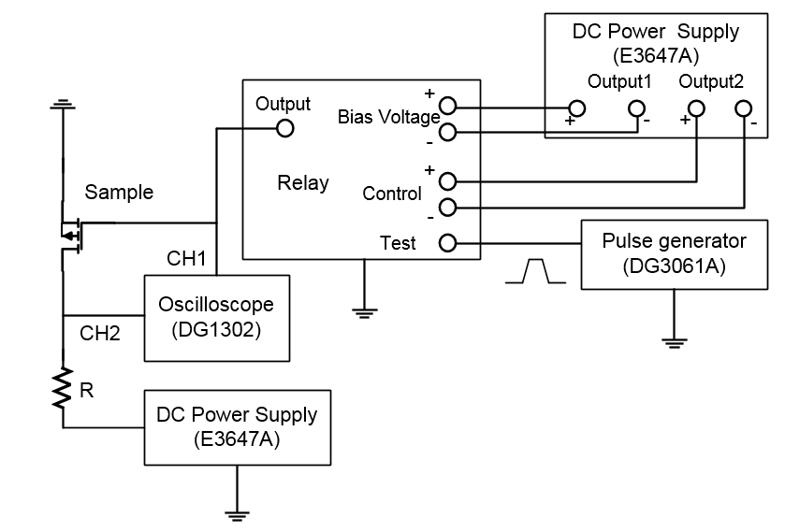

Fig.14. Schematic diagram of a MOSFET measured by the pulse I-V technique and stress under continuous γ-ray exposure in the ionizing radiation probe station system.



(a)



(b)

Fig.15. The pulse I-V and stress technique. (a) Gate voltage/ Drain voltage versus the time characteristics of a MOSFET device. (b) I-V curves of the MOSFET with +1 V bias for a stress duration of 460 s.

*3.1.5. DC on-the-fly and Pulse on-the-fly*

While the pulse I-V technique can detect defects that are generated in extremely short time in the oxide of MOS devices, the rising edge and the falling edge of the trapezoidal signal are intensely sharp. As a result, the charging and discharging currents of parasitic capacitance would significantly affect the measurement of the I-V characteristics. For this reason, a multiple-pulse testing technique is more appropriate to detect the charging/discharging of defects instead of using one pulse waveform technique (pulse I-V and pulsed C-V). On-the-fly (OTF) techniques are suitable for the purpose and the OTF techniques use a continuous stress voltage which contains periodic perturbations to the gate of the MOS device. Afterwards, the drain current is determined from the measurement to analyze the threshold voltage shift of the MOS device. The schematic diagrams illustrating the OTF techniques are similar to those of the pulse/DC I-V and stress techniques. However, the OTF techniques apply a continuous stress voltage to devices even the testing current is applied as shown in Figs.16 and 17. As indicate in the inset of Fig. 18 (b) and the inset of Fig 19. (b), the OTF techniques measure three points of the drain current with respect to the gate voltage to calculate the shift of the threshold voltage in each testing period. During the DC OTF measurements, the DC power supply applies a continuous stress voltage and periodic perturbations to the gate. Afterwards, the ampere meter is used to measure the drain current. During the pulse OTF measurements, a function generator applies multiple trapezoid pulse signals to the gate of the MOSFET and the DC power supply applies a continuous voltage to the drain of the MOSFET. Meanwhile, the drain voltage is detected and converted to drain current using Eq. 13.

The inset of Fig. 18 (b) shows a graph of the gate voltage/drain voltage versus the stress time characteristic. It is obtained by measurements using the DC on-the-fly technique. A continuous stress voltage of +0.5 V and periodic perturbations were applied to the gate dielectrics while a periodic stress voltage +0.5 V was applied to the drain of a MOSFET. The amplitude of the periodic perturbation is $±$ 0.1 V and the pulse width is 3 s. The drain current at different periodic perturbation level (0 V, $±$ 0.1 V) were measured and more than 11 perturbations were applied. The drain current-time characteristics of the MOSFET are shown in Fig. 18 (a), with the leakage current of the MOSFET from 720 μA to 760 µA at different perturbation levels. Afterwards, the threshold voltage shift in each measuring point is calculated from the leakage current using Eqs. 14 to 18. For each perturbation, the transconductance of the MOS device is given by:

$g_{m}≈\frac{∆I_{d}}{∆V_{g}}=\frac{I_{d\left(V_{g}+D_{v}\right)}-I_{d\left(V_{g}-D_{v}\right)}}{2∙D_{v}}$ (14)

where $∆$ Id is the variation of the drain current in one perturbation; $∆$ Vg is the variation of the gate voltage; Id(Vg+Dv) and Id(Vg-Dv) are the drain currents with respect to the gate voltages of Vg + Dv and Vg - Dv; Dv is the magnitude of perturbations. For each contiguous measurement period, the continuous stress voltages are constant. Hence, the variation of the threshold voltage $∆$ Vt (n) is given by:

$∆V_{t}\left(n\right)=-∆\left[V_{g}-V_{t}\left(n\right)\right]=-\frac{∆I_{d}(n)}{g_{m}}$ (15)

where n is the number of measurement times. For each two adjacent measurement period, the variation of the drain current $∆$ Id (n) is given by:

$∆I_{d}\left(n\right)=I_{d}\left(n\right)-I_{d}\left(n-1\right)$ (16)

and the average transconductance for each two contiguous measurement period follows the relation

$g_{m}=\frac{g_{m}\left(n\right)+g_{m}\left(n-1\right)}{2}$ (17)

Hence, the variation of the threshold voltage for N times of measurements using the OTF technique, namely $∆$ Vt (n), can be expressed as

$∆V_{t}≈-\sum_{n=1}^{N}{\frac{I_{d}\left(n\right)-I_{d}\left(n-1\right)}{{[g_{m}\left(n\right)+g_{m}\left(n-1\right)]}/2}}$ (18)

Using Eq. 18, the variation of the threshold voltage determined by measurements using the DC OTF technique is calculated and shown in Fig. 18 (b). The result indicates that the threshold voltage shift is increased with the increasing of stress time, 21 mV threshold voltage shift is measured after 7000 s bias voltage.

The inset of Fig.19 (b) shows the first three pulse perturbations of the gate voltage/drain voltage-time characteristics of the MOSFET measured by the pulse on-the-fly technique. The pulse width of the perturbations is 200 us. Continuous stress voltage of +0.5 V and $±$ 0.1 V periodic perturbations were applied to the gate, +0.5 V bias were periodic applied to drain of the MOSFET. The drain voltage VDS at different periodic perturbation level (0 V, $±$ 0.1 V) were measured. The drain current is calculated from the drain voltage using formula (13) as shown in Fig. 19 (a). The leakage current of the MOSFET is from 725 uA to 755 uA in each perturbation level. Afterwards, the threshold voltage shift in each measuring point is calculated from the leakage current using formulas from (14) to (18). The result indicates that the threshold voltage has no significant shift with the increase of the stress time as indicated in Fig.19 (b). In addition, the first testing point of the pulse OTF technique is tested at time < 1 ms making the testing speed much faster than that of the DC OTF technique.

Ampere-meter

(34401A)

Metal-Gate

N-Si

P

P

Source

Drain

DC power supply

(E3647A)

Resistance

CH2 (VD)

CH1 (Vg)

γ-ray radiation

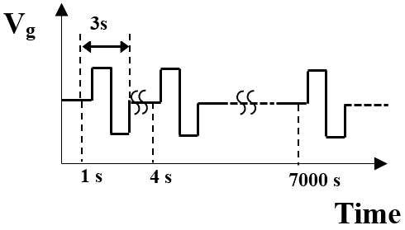

Fig.16. Schematic diagram of the measurement set-up for a MOSFET device using the DC on-the-fly technique under continuous γ-ray exposure in the ionizing radiation probe station system.

γ-ray radiation

Pulse Generator

(DG3601)

Source

Resistance

Drain

Oscilloscope

(DG1302CA)

Metal-Gate

N-Si

P

P

VG

VDS

DC Power Supply

E3647A

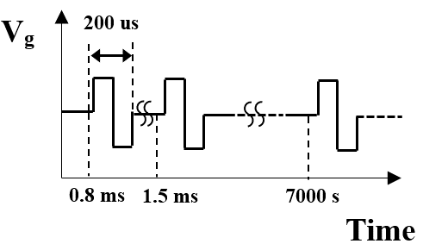

Fig.17. Schematic diagram of the measurement set-up for a MOSFET device using the pulsed on-the-fly technique under continuous γ-ray exposure in the ionizing radiation probe station system.



(a)

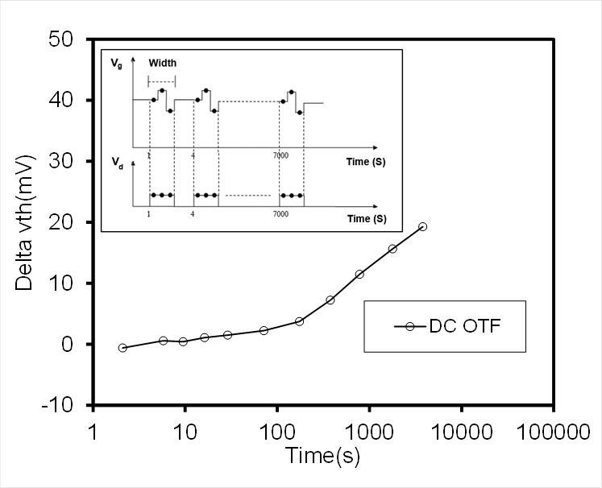

(b)

Fig.18. The DC On-The-Fly (OTF) technique. (a) Drain current versus stress time characteristics of a MOSFET, (b) Threshold voltage shift (ᐃVTH) versus stress time curve of the MOSFET. The inset shows the gate voltage/drain voltage versus stress time characteristics at the periodic width of 3 s.



(a)



(b)

Fig.19. The pulse On-The-Fly (OTF) technique. (a) Drain current versus time characteristics of the MOSFET, (b) Threshold voltage shift (ᐃVTH) versus time curve of the MOSFET. The inset shows the gate voltage/drain voltage versus time characteristics of the MOSFET with the periodic pulse width of 200 μs.

* 1. *Radiation response of high-κ thin films*

Radiation response of capacitors with 20-nm-thick HfO2 dielectrics is determined by the conventional C-V and stress technique and the pulsed C-V and stress technique using the ionizing radiation probe station system. The C-V measurement was performed with both forward and reverse swings from -2 V to 1 V at a frequency of 1 MHz. The pulsed C-V measurements were carried out at VPP of 3 V, Voffset of -0.5 V and pulse edge of 400 µs. 1 V or -1 V bias was continuously applied to the gate dielectrics during the irradiation exposure.

Figs. 20 (a) and (b) illustrate a comparison between the pre-radiation and the post-radiation C-V curves for the HfO2 deposited MOS capacitors which are measured using the conventional C-V and stress technique under 1 V or -1 V bias respectively. After radiation exposure up to 2814 rad, a negative shift up to-100 mV of the gate voltage (Vg) is observed under the positive bias condition as shown in Fig. 20 (a). Under a negative bias, very little positive shift up to 40 mV is observed as shown in Fig. 20 (b). The results indicate that the HfO2 sample exhibits more positive oxide trapped charges than negative oxide trapped charges after exposure and a very little concentration of negative oxide trapped charges has been generated to induce the positive shift of Vg. In addition, there is no measurable interface trap built up with ionizing irradiation of these capacitors because the slope of the C-V curves is stabilized [42] [43]. The comparison between the pre-radiation and the post-radiation C-V curves for the MOS capacitors measured by the pulse stress C-V technique under 1 V or -1 V bias is shown in Figs. 21 (a) and (b). A fall from the true capacitance value of the pulsed C-V measurement is observed within the range of 0.5 V to 1 V. As illustrated before, the phenomenon is mainly due to the response time of the oscilloscope and the capacitance charging and discharging issues [41]. In consequence, the range of -2 V to 0.5 V of the full C-V curves is the actual capacitance value of the capacitor. Under the same total ionizing dose, a negative shift up to-280 mV and a positive shift up to 50 mV of the Vg are observed, respectively, with the continuous positive gate potential and negative gate potential. The results also indicate that a very little concentration of negative oxide trapped charges has been generated in the oxide under -1 V bias. However, more positive oxide trapped charges have been generated under +1 V bias.

A comparison of the radiation induced Vg shift of the capacitors is shown in Fig. 22 for measurements using the four different techniques with 1 V and -1 V bias. At low total dose irradiation (100 rad), there is no significant difference of Vg shift for all techniques and bias conditions. It is suggested that very few oxide trapped charges have been generated by irradiation to change the gate voltage at low total dose levels. After 100 rad irradiation exposure, a large increase of Vg shift is observed as measured by the pulsed C-V and stress technique under +1 V bias. The results indicate that the pulsed C-V technique evaluates precisely the irradiation-caused degradation of the gate dielectrics as the gate voltage shift recovery can take place in microseconds. Very little increase of Vg shift is observed when using the pulsed C-V and stress technique under -1 V bias compared with the conventional C-V and stress technique. It is possible that very few electron traps are generated to induce the measurable positive shift of the gate voltage at a total dose of 2814 rad (HfO2).



(a)



(b)

Fig.20. C-V curves of a MOS capacitor deposited with 20-nm thick HfO2 under the γ-ray exposure of 2814 rad measured by the conventional C-V and stress technique at 1 MHz: (a) +1 V bias, (b) -1 V bias.



(a)



(b)

Fig.21. C-V curves of a MOS capacitor with the HfO2 gate dielectric under the γ-ray exposure for 2814 rad measured by the pulsed C-V and stress technique: (a) +1 V bias, (b) -1 V bias.



Fig.22. Comparison of γ-ray induced Vg shift measured using the developed real-time measurement technique and the conventional technique with the HfO2 gate dielectric of the MOS capacitor irradiated at different total dose levels.

1. **Conclusion**

The development of an on-site and real-time radiation response measurement system has been presented for electrical characterization of semiconductor devices and thin films subjected to γ-ray exposure. The real-time radiation response measurements of semiconductor devices and components during continuous γ-ray irradiation can give a new insight into the electrical characteristics of the devices and materials used in real radiation environments. The system has been successfully used to measure the electrical characteristics of semiconductor devices with pulse and stress techniques with a 1.11 GBq Cs137 -ray source. The C-V or I-V results of MOS capacitors or MOSFET devices measured by each technique have been reported and compared. A reliable measurement system for radiation response studies while maintaining radiation safety of the human operator has been demonstrated by establishing a dose attenuation model in the experimental environment. A dose absorption rate of 0.134 rad/s for HfO2 is calculated by a novel dose rate calculation model in this work. Radiation response of HfO2 thin films has been investigated under $±$ 1 V bias conditions using the conventional stress C-V and pulse stress C-V technique. At a total dose of 2814 rad (HfO2), the results of gate voltage shift suggest that the HfO2 sample exhibits more positive oxide trapped charges than negative oxide trapped charges. It also suggests the real-time and on-site measurements assess more precisely the irradiation-caused degradation of gate dielectrics in HfO2 thin films compared with the conventional measurement technique.

1. **Acknowledgement**

This research was funded in part by the National Natural and Science Foundation of China under the grant no. 11375146, the Suzhou Science and Technology Bureau of China under the grant SYG201223, and the Jiangsu Provincial Science and Technology Supporting Program under the grant BK2012636.

1. **References**

[1] International Technology Roadmap for Semiconductors. Semiconductor Industry Association. [Online]. Available: http://public.itrs.net.

[2] G. D. Wilk, R. M. Wallace, and J.M. Anthony, “High-κ gate dielectrics: Current status and materials properties considerations,” *J. Appl. Phys.,* Vol. 89, NO. 10, pp. 5243-5275. May. 2001.

[3] M. Houssa, L. Pantisano, L. A. Ragnarsson, R. Degraeve, T. Schram, G. Pourtois, S. De Gendt, G. Groeseneken, M.M. Heyns, “Electrical Properties of High-κ Gate Dielectrics: Challenges, Current Issues, and Possible Solutions,” *Materials Science & Engineering R-Report.,* Vol. 51, pp. 37-85. Apr. 2006.

[4] G.D. Wilk, R.M. Wallace, “Electrical properties of hafnium silicate gate dielectrics deposited directly on silicon,” *Appl. Phys. Lett.,* Vol. 74, NO. 19, pp. 2854-2856, Mar. 1999.

[5] A. [Kawamoto](http://ieeexplore.ieee.org/search/searchresult.jsp?searchWithin=%22Authors%22:.QT.Kawamoto,%20Atsushi.QT.&newsearch=true), J. Jameson, and P. Griffin, “Atomic scale effects of zirconium and hafnium incorporation at a model silicon/silicate interface by first principles calculations” *IEEE Electron Device Lett.,* Vol. 22, No. 1, pp. 14-16, 2001.

[6] T. Ma, S.A. Campbell, R. Smith, N. Hoilien, B. He, W.L. Gladfelter, C. Hobbs, D. Buchanan, C. Taylor, M. Gribelyuk, M. Tiner, M. Coppel, J.J. Lee, “Group IVB metal oxides high permittivity gate insulators deposited from anhydrous metal nitrates,” *IEEE Trans. Electron Dev.,* Vol. 48, NO. 10, pp. 2348-2356, Oct. 2001.

[7] L. Kang, B.H. Lee, W.J. Qi, Y. Jeon, R. Nieh, S. Gopalan, K. Onishi, J.C. Lee, “Electrical characteristics of highly reliable ultrathin hafnium oxide gate dielectric,” IEEE Electron Dev. Lett. Vol. 21, pp. 181-183, 2000.

[8] C. Z. Zhao, S. Taylor, M. Werner, P. R. Chalker, R. J. Potter, J. M. Gaskell and A. C. Jones, “High-κ materials and their response to gamma ray radiation,” *J. Vac. Sci. Technol. B*., Vol.27, NO. 1, 411-415, pp. 1071-1023, Jan. 2009.

[9] F. Belgin Ergin, Rasit Turan, Sergiu T. Shishiyanu, Ercan Yilmaz, “Effect of γ-radiation on HfO2 based MOS capacitor,” *Nucl. Inst. Methods Phys. Res. B.,* Vol. 268, NO. 9, pp. 1482-1485, May. 2010.

[10] A. Y. Kang, P. M. Lenahan, and J. F. Conley, “The Radiation Response of the High Dielectric-Constant Hafnium Oxide/Silicon System,” *IEEE Trans. Nucl. Sci.,* Vol. 49, NO. 6, pp. 2636-2642, Dec. 2002.

[11] C. Claeys and E. Simoen, “Radiation Effects in Advanced Semiconductor Materials and Devices,” vol. 57, Heidelberg: Springer Verlag, 2002.

[12] K. Arshak and O. Korostynska, "Radiation-induced changes in thin film structures," *IEE Proceedings - Circuits, Devices and Systems*, vol. 150, NO. 4, pp. 361-366, Aug. 2003.

[13] Y. Mu, C. Z. Zhao, S. Su, Y. Zhao, I. Z. Mitrovic and S. Taylor, “Radiation Response Analyzer of Semiconductor Dies,” *IEEE Physical and Failure Analysis of Integrated Circuits (IPFA),* pp. 682-685, Jul. 2013.

[14] T.P. Ma and P.V. Dressendorfer, “Ionizing Radiation Effects in MOS Devices and Circuits,” Wiley-Interscience, New York, 1989.

[15] F.B. McLean, “A Framework for Understanding Radiation-Induced Interface States in SiO2 MOS Structures,” *IEEE Trans. Nucl. Sci*., vol.27, NO. 6, pp. 1651-1657, Dec 1980.

[16] Oldham TR, McLean FB, Boesch Jr HE and McGarrity JM, “An overview of radiation-induced interface traps in MOS structures,” *Semicond. Sci. Technol*. Vol. 4, NO. 12, pp 986-999, Dec 1989.

[17] Y. Mu, Y. Qi, S. Lam, and C. Z. Zhao, “A Semi-Automated Real-Time Gamma Radiation Response Measurement System for Semiconductor Device Characterisation,” *IEEE International Conference on Electronic Measurement & Instruments (ICEMI), 2015*

[18] Armin Ansari, “Radiation Threats and Your Safety: A Guide to Preparation and Response for Professionals and Community,” *Chapman & Hall/CRC Press* 2010.

[19] J. R. Schwank, M. R. Shaneyfelt, D. M. Fleetwood, J. A. Felix, P. E. Dodd, P. Paillet, V. Ferlet-Cavrois, “Radiation Effects in MOS Oxides,” *IEEE Trans. Nucl. Sci.,* Vol. 55, NO. 4, pp. 1833-1853, Aug. 2008.

[20] E. Yilmaz, B. Kaleli, R. Turan, “A systematic study on MOS type radiation sensors,” *Nucl. Inst. Methods Phys. Res. B.,* Vol. 264, NO. 2, pp. 287-292, May. 2007.

[21] E. Yilmaz, I. Dogan, and R. Turan, “Use of Al2O3 layer as a dielectric in MOS based radiation sensors fabricated on a Si substrate,” *Nucl. Inst. Methods Phys. Res. B.,* Vol. 266, NO. 22, pp. 4896-4898, May. 2008.

[22] P. M. Lenahan, J. P. Campbell, A. Y. Kang, S. T. Liu, and R. A. Weimer, “Radiation-induced leakage currents: Atomic scale mechanisms,” *IEEE Trans. Nucl. Sci.,* Vol. 48, NO. 6, pp. 2101-2106, Dec. 2001.

[23] J. A. Felix, J. R. Schwank, D. M. Fleetwood, M. R. Shaneyfelt, and E. P. Gusev, “Effects of radiation and charge trapping on the reliability of high-κ dielectrics,” *Microelectron. Reliab.,* vol. 44, NO. 4, pp. 563–575, Apr. 2004.

[24] J. T. Ryan, P. M. Lenahan, A. Y. Kang, J. F. Conley, G. Bersuker, and P. Lysaght, “Identification of the atomic scale defects involved in radiation damage in HfO2 based MOS devices,” *IEEE Trans. Nucl. Sci.,* Vol. 52, NO. 6, pp. 2273-2275, Dec. 2005.

[25] R. S. O. Brien, and M. B. Cooper, “Technologically Enhanced Naturally Occurring Radioactive Material: Pathway Analysis and Radiological Impact,” *Appl. Radiat. Isot.,* Vol. 49, NO. 3, pp. 227-239, Mar. 1998.

[26] ICRP, “The 2007 Recommendations of the International Commission on Radiological Protection,” *ICRP Publ. 103 Annals of the ICRP.* Mar. 2007

[27] NCRP, “Alpha-Emitting Particles in Lungs,” *NCRP Publ.* 46, *Basic Criteria, Epidemiology, Radiobiology and Risk.*

[28] Guy Paic, “Ionizing Radiation: Protection and Dosimetry,” *CRC, Boca Raton,* FL, pp. 42–44, 1988.

[29] National Institute of Standards and Technology. Tables of X-Ray Mass Attenuation Coefficients and Mass Energy-Absorption Coefficients. *http://www.nist.gov/pml/data/xraycoef/index.cfm*

[30] F. L. Galeener, D. B. Kerwin, A. J. Miller, and J. C. Mikkelsen, Jr, “X-ray creation and activation of electron spin resonance in vitreous silica,” *Phys. Rev. B.,* Vol. 47, No. 13, pp. 7760-7779, 1993.

[31] G. Puzzilli[a](http://www.sciencedirect.com/science?_ob=ArticleURL&_udi=B6V47-4NDVHMY-3&_user=10&_coverDate=05%2F31%2F2007&_rdoc=1&_fmt=high&_orig=search&_origin=search&_sort=d&_docanchor=&view=c&_searchStrId=1603077256&_rerunOrigin=scholar.google&_acct=C000050221&_version=1&_urlVersion=0&_userid=10&md5=6bb05b7eddde1f71a5f599588aeaa06e&searchtype=a#aff1#aff1), B. Govoreanu[b](http://www.sciencedirect.com/science?_ob=ArticleURL&_udi=B6V47-4NDVHMY-3&_user=10&_coverDate=05%2F31%2F2007&_rdoc=1&_fmt=high&_orig=search&_origin=search&_sort=d&_docanchor=&view=c&_searchStrId=1603077256&_rerunOrigin=scholar.google&_acct=C000050221&_version=1&_urlVersion=0&_userid=10&md5=6bb05b7eddde1f71a5f599588aeaa06e&searchtype=a#aff2#aff2), and F. Irrera[a](http://www.sciencedirect.com/science?_ob=ArticleURL&_udi=B6V47-4NDVHMY-3&_user=10&_coverDate=05%2F31%2F2007&_rdoc=1&_fmt=high&_orig=search&_origin=search&_sort=d&_docanchor=&view=c&_searchStrId=1603077256&_rerunOrigin=scholar.google&_acct=C000050221&_version=1&_urlVersion=0&_userid=10&md5=6bb05b7eddde1f71a5f599588aeaa06e&searchtype=a#aff1#aff1), “Characterization of charge trapping in SiO2/Al2O3 dielectric stacks by pulsed C–V technique,” [*Microelectronics Reliability*](http://www.sciencedirect.com/science/journal/00262714)*,* Vol. 47, NO. 4-5, pp. 508-512, Apr. 2007

[32] D. [Zhang,](http://adsabs.harvard.edu/cgi-bin/author_form?author=Zhang,+W&fullauthor=Zhang,%20W.%20D.&charset=UTF-8&db_key=PHY) B. [Govoreanu, and](http://adsabs.harvard.edu/cgi-bin/author_form?author=Govoreanu,+B&fullauthor=Govoreanu,%20B.&charset=UTF-8&db_key=PHY) X. [Zheng,](http://adsabs.harvard.edu/cgi-bin/author_form?author=Zheng,+X&fullauthor=Zheng,%20X.%20F.&charset=UTF-8&db_key=PHY) “Two-Pulse C-V : A New Method for Characterizing Electron Traps in the Bulk of SiO2/high-κ Dielectric Stacks” *IEEE Trans Electron Device Letters*, Vol. 29, NO. 9, pp. 1043-1046, Sept. 2008.

[33] X. Zheng, W. Zhang and B. Govoreanu, “Energy and Spatial Distributions of Electron Traps Throughout Stacks as the IPD in SiO2 /Al2O3 Flash Memory Application,” *IEEE Trans* [*Electron Devices Letters*,](http://ieeexplore.ieee.org/xpl/RecentIssue.jsp?punumber=16) Vol. 57, No. 1, pp. 288 – 296, Jan. 2010.

[34] C. Leroux, “Characterization and modeling of hysteresis phenomena in high-κ dielectrics,” *IEEE International* *Electron Devices Meeting*, pp. 737–740, 2004.

[35] S. Zafar, A. Callegari and E. Gusev, “Charge trapping in high-κ gate dielectric stacks,” *IEEE International Electron Devices Meeting*, pp. 517–520, 2002.

[36] C. Z. Zhao, J. F. Zhang, G. Groeseneken, R. Degraeve, J. N. Ellis and C. D. Beech, “Interface state generation after hole injection,” *Journal of Applied Physics*, Vol. 90, No. 1, pp. 328-336, Sept 2001.

[37] J.T. Ryan, P. M. Lenahan, A.Y. Kang, J. F. Conley, G. Bersuker, and P. Lysaght, “Identification of the atomic scale defects involved in radiation damage in HfO2 based MOS devices,” *IEEE Trans. Nucl. Sci. vol*. 52, NO.6, pp. 2272-2275, Dec 2005.

[38] P. M. Lenahan and P. V. Dressendorfer, “Effect of bias on radiation induced paramagnetic defects at the silicon-silicon dioxide interface,” *Appl. Phys. Lett.,* Vol. 41, p. 542, 1982.

[39] Y. Cheng, X. Liu, M. Ding, and X. Li, "Total dose response of Al2O3-based MOS structure under gamma-ray irradiation,” *Proceedings of 2014 International Symposium on Electrical Insulating Materials*., pp. 350-353, 2014.

[40] X. Zhou, D. M. Fleetwood, L. Tsetseris, R. D. Schrimpf, and S. T. Pantelides, “Effects of Switched-bias Annealing on Charge Trapping in HfO2 Gate Dielectrics,” *IEEE Trans. Nucl. Sci.,* Vol. 53, no. 6, pp. 3636–3643, Dec. 2006.

[41] C. Zhao, C. Z. Zhao, Q. Lu, X. Yan,2, S. Taylor and P. R. Chalker, “Hysteresis in Lanthanide Aluminum Oxides Observed by Fast Pulse CV Measurement,” *Materials*, Vol. 7, no. 10, pp. 6965-6981, Oct. 2014.

[42] J. R. Schwank, P. S. Winokur, P. J. McWhorter, F. W. Sexton, P. V. Dressendorfer, D. C. Turpin, “Physical Mechanisms Contributing to Device Rebound,” *IEEE Trans. Nucl. Sci.,* Vol. 31. NO. 6, pp. 1434-1438, Dec. 1984.

[43] P. S. Winokur, J. R. Schwank, P. J. McWhorter, P.V. Dressendorfer, D. C. Turpin, “Correlating the Radiation Response of MOS Capacitors and Transistors,” *IEEE Trans. Nucl. Sci.,* Vol. 31. NO. 6, pp. 1453-1460, Dec. 1984.