Climate-driven changes to the spatio-temporal distribution of the parasitic nematode, Haemonchus contortus, in sheep in Europe.
Running head: Climate change and Haemonchus contortus in Europe
Hannah Rose^{1,2,3}, Cyril Caminade^{4,5}, Muhammad Bashir Bolajoko^{1,6}, Paul Phelan⁷, Jan van Dijk⁸, Matthew Baylis^{4,9}, Diana Williams¹⁰, Eric R. Morgan^{2,3}
¹ School of Biological Sciences, Life Sciences Building, University of Bristol, Tyndall Avenue, Bristol, UK, BS8 1TQ
² School of Veterinary Sciences, University of Bristol, Langford House, Langford, Bristol, UK, BS40 5DU
³ Cabot Institute, University of Bristol, Cantocks Close, Bristol, UK, BS8 1TS
⁴ School of Environmental Sciences, University of Liverpool, UK
⁵ Department of Epidemiology and Population Health, Institute of Infection and Global Health, University of Liverpool, The Farr Institute@HeRC, Liverpool, UK, L69 3GL
⁶ National Veterinary Research Institute, P.M.B. 01, Vom, Plateau State, Nigeria
⁷ Animal & Grassland Research and Innovation Centre, Teagasc, Grange, Dunsanny, Co. Meath, Ireland
⁸ Department of Epidemiology and Population Health, Institute of Infection and Global Health, University of Liverpool, Leahurst, Neston, Cheshire, UK, CH64 7TE
⁹ Health Protection Research Unit in Emerging and Zoonotic Infections, University of Liverpool, Neston, United Kingdom
¹⁰ Department of Infection Biology, Institute of Infection and Global Health, University of Liverpool, Liverpool, UK, L3 5RF
Corresponding author: Email: hannah.rose@bristol.ac.uk Tel: +44 117 394 1383
Keywords: Haemonchus contortus, Q₀, gastrointestinal nematode, climate change, Europe, adaptation, distribution shift, infection pressure, climate impact mitigation
Type of paper: original research article (primary research)
Abstract
Recent climate change has resulted in changes to the phenology and distribution of invertebrates worldwide. Where invertebrates are associated with disease, climate variability and changes in climate may also affect the spatio-temporal dynamics of disease. Due to its significant impact on sheep production and welfare, the recent increase in diagnoses of ovine haemonchosis caused by the nematode Haemonchus contortus in some temperate regions is particularly concerning. This study is the first to evaluate the impact of climate change on H. contortus at a continental scale. A model of the basic reproductive quotient of macroparasites, Q₀, adapted to H. contortus and extended to incorporate environmental stochasticity and parasite behaviour, was used to simulate Pan-European spatio-temporal changes in H. contortus infection pressure under scenarios of climate change. Baseline Q₀ simulations, using historic climate observations, reflected the current distribution of H. contortus in Europe. In northern Europe, the distribution of H. contortus is currently limited by temperatures falling below the development threshold during the winter months and within-host arrested development is necessary for population persistence over winter. In southern Europe H. contortus infection pressure is limited during the summer months by increased temperature and decreased moisture. Compared with this baseline, Q₀ simulations driven by a climate model ensemble predicted an increase in H. contortus infection pressure by the 2080s. In northern Europe, a temporal range expansion was predicted as the mean period of transmission increased by 2-3 months. A bimodal seasonal pattern of infection pressure, similar to that currently observed in southern Europe, emerges in northern Europe due to increasing summer temperatures and decreasing moisture. The predicted patterns of change could alter the epidemiology of H. contortus in Europe, affect the future sustainability of contemporary control strategies, and potentially drive local adaptation to climate change in parasite populations.
Introduction
Recent climate change has been associated with observable changes in the phenology and geographic distribution of invertebrates worldwide (Parmesan & Yohe, 2003; Root et al., 2003; Altizer et al., 2013; Kutz et al., 2013). Where invertebrates are associated with disease, climate variability and changes in climate may also affect the spatio-temporal dynamics of disease (Lafferty, 2009; Guis et al., 2011; Rose & Wall, 2011; Wall & Ellse, 2011; Altizer et al., 2013; Kreppel et al., 2014). Trichostrongyloid gastrointestinal nematodes (GINs) are particularly vulnerable to such changes as part of the life-cycle is completed outside the host (Anderson, 2000) and development, mortality and behaviour of the free-living stages is climate-dependent (O’Connor et al., 2006; Sutherland & Scott, 2010; Hernandez et al., 2013). The impact of predicted climate change on the distribution of Haemonchus contortus, a highly pathogenic, blood-feeding GIN infecting sheep and goats, is of particular concern due to the severity of haemonchosis, a form of parasitic gastroenteritis caused by H. contortus infection, which results in significant morbidity and mortality associated with blood loss.
Haemonchus contortus is typically associated with tropical and sub-tropical climates (O’Connor et al., 2006) and climatic limitations play a dominant role in characterising its spatial distribution (O’Connor et al., 2006; Bolajoko et al., 2015; Rinaldi et al., 2015). The impact of climate change on the spatio-temporal distribution of H. contortus is of particular interest in Europe, where heterogeneity in its spatial distribution has been attributed to regional variation in mean temperature and rainfall (Rinaldi et al., 2015). For example, temperatures fall below the minimum development threshold of ~9°C for at least part of the year in some northern (e.g. Sweden and the UK; Troell et al., 2005, Rose et al., 2015b) and alpine regions. In these regions, arrested development within the host is important for the survival over winter of populations of H. contortus (Waller et al., 2004), and limited development and survival of the free-living stages during the cold season prevents infective stages accumulating on pasture, limiting infection pressure (Rose et al., 2015b). Consequently, potential increases in winter air temperature of over 5°C in northern Europe (IPCC, 2013) could result in an increase in the development and survival of H. contortus on pasture during winter, with subsequent increases in infection pressure and disease incidence. Development of larvae is also limited during periods of drought (Eysker et al., 2005), which are more common in southern Europe. Effects of excessively high temperatures and low rainfall in summer might therefore act to offset improved winter conditions for transmission and alter the seasonal epidemiology of haemonchosis, with implications for optimal management interventions.
Climate change impacts are likely to be greatest where H. contortus exists at the edge of its range of climatic tolerance (Lafferty, 2009) and changes in the spatial distribution and prevalence of haemonchosis have already been observed in the United Kingdom in recent decades. Van Dijk et al. (2008) identified an increasing trend in diagnoses of haemonchosis between 1989 and 2006, associated with an increase in temperatures over the same period. Furthermore, the emergence of ovine haemonchosis in Scotland in recent years has been associated with climate warming (Kenyon et al., 2009). Further epidemiologically significant changes in the seasonality of infection pressure (Rose et al., 2015b) and spatial distribution of H. contortus are therefore expected under scenarios of future climate change.
The impact of any changes on welfare, productivity and profitability could be wide-ranging if farmers are unable to respond effectively to these changes. Increased agricultural inputs (e.g. pharmaceutical products and additional feed) and decreased welfare associated with climate-driven increases in prevalence of haemonchosis or range expansion of H. contortus present a real threat to the future sustainability of the European sheep industry. Furthermore, the threat of anthelmintic resistance (Rose et al., 2015a) presents a significant constraint to the adaptive capacity of farmers to changes in disease dynamics in the face of global change. There is therefore a need to develop sustainable animal health management strategies which optimise the use of available resources, underpinned by a detailed understanding of the potential impacts of global changes, including climate and environmental management, on parasites and disease dynamics. Empirical evidence can be used to make qualitative predictions of parasite responses to climate change (e.g. Altizer et al., 2013). However, the present study is the first to quantify the impact of climate change on H. contortus at a continental scale. To evaluate potential future climate-driven changes in the risk of haemonchosis in Europe, and interactions with livestock management, a model based on the basic reproductive quotient of macroparasites, Q₀ (Roberts & Heesterbeek, 1995), incorporating environmental stochasticity and sheep stocking density, was developed for H. contortus and applied at a Pan-European spatial scale.

Materials and methods
Q₀ Model description
The model was built on Roberts and Heesterbeek’s (1995) basic reproduction quotient for macroparasites, Q₀, which provides a threshold quantity to predict the propensity of macroparasite populations to increase (Q₀>1) or decrease (Q₀<1) and therefore provides an index of infection pressure (Heesterbeek & Roberts, 1995; Roberts & Heesterbeek, 1995). Q₀ estimates the average number of second-generation mature adult worms produced by a single adult worm during its lifetime in the absence of density-dependent constraints such as immunity and within-host competition, (Heesterbeek & Roberts, 1995).
Roberts and Heesterbeek (1995) applied the Q₀ model (Equation 1) to the trichostrongylid nematode Trichostrongylus colubriformis, which, like H. contortus, follows a direct life cycle with in-host and free-living stages. Eggs are deposited on pasture in the faeces of the host where they hatch to produce larvae, which moult twice to reach the third, infective stage (L3). L3 then migrate horizontally out of the faeces when there is sufficient moisture and subsequently migrate between soil and herbage (vertical migration). L3 on herbage are accidentally ingested by the host during grazing, where upon they develop to the 4th larval stage (L4) and either undergo arrested development (hypobiosis) or continue to develop to the adult stage. Eggs produced by adult females are then passed in the sheep’s (or goat’s) faeces and the cycle continues. The Q₀ model can be interpreted as sub-components, which characterise two key processes in the trichostrongylid life-cycle: the number of L3 produced by an adult worm during its lifetime (A), based on fecundity (λ), adult mortality (μ) and the probability that an egg will develop to L3 (q); the number of adult parasites produced by each L3 (B), based on the establishment rate of ingested L3 (p), the mortality rate of L3 on pasture (ρ), ingestion rate of L3 by the host (β) and the number of hosts (H) (Roberts and Heesterbeek 1995). Parameters are defined in Table 1.
$$Q_{0}= \frac{qλ}{μ} \frac{βp}{ρ+βH}H$$  A  B | (1)

The parameter q, describing the probability of an egg developing to L3 was expanded (Equation 2) as described by Bolajoko et al. (2015) to incorporate climate-dependence in the life-history of free-living stages, and an additional horizontal migration parameter (m₁). These changes allow for non-linear interactions between development (δ), survival (μ_{i}) and horizontal migration rates and address the importance of horizontal migration behaviour in determining the availability of L3 on pasture (Wang et al., 2014).
$$q= \frac{δm_{1}}{\left(μ_{e}+δ\right)\left(μ_{l3}+m_{1}\right)}$$ | (2)

A vertical migration parameter was added to the model in the present study, m₂, to reflect the distribution of infective third stage larvae (L3) between soil and herbage on pasture (Equation 3; Table 1).
$$Q_{0}=\frac{qλ}{μ}\frac{βp}{ρ+βH}Hm_{2}$$ | (3)
The definition of Q₀ in the present study is therefore extended to include environmental stochasticity. Thus, Q₀ estimates, in the absence of density-dependent constraints and given current environmental conditions, the number of mature adult worms produced by a single adult worm during its lifetime, and provides an instantaneous estimate of potential H. contortus infection pressure.
Model parameterisation
The proportion of total pasture L3 that are found on herbage, m₂, was set at a constant of 0.2 after van Dijk and Morgan (2011) recovered 20-30% of H. contortus L3 from herbage (corrected for recovery rate) and Callinan and Westcott (1986) recovered 4-23% of pasture L3 from herbage at temperatures between 10 and 30°C.
The functions for temperature-dependent development from egg to L3 (δ), and mortality of eggs (μ_{e}) and L3 (µ_{l3}) were derived from data in the literature as described previously (Rose et al., 2015b). Moisture rules constructed by Rose et al. (2015b) to estimate the effect of precipitation and evaporation on the development and migration of H. contortus were adapted to incorporate the combined effects of faecal moisture content on development and horizontal migration. Moisture availability in the 4 days preceding and following egg deposition is important for the development success and horizontal migration of H. contortus (O’Connor et al., 2008; Khadijah et al., 2013). Therefore a 9 day centred cumulative precipitation, P, and 9 day centred cumulative evaporation, E, was used to calculate P/E for each day. If P/E<1 then no eggs yielded L3 on pasture (q=0), whereas if P/E≥1 then the probability of development to L3 and migration onto pasture (q) was estimated as a function of temperature (Table 1).
Temperature-dependent mortality rates of L3 on pasture, ρ, were estimated heuristically from the temperature-dependent mortality rates of L3 in faeces as described previously (Bolajoko et al., 2015).
Mean daily fecundity of adult female H. contortus was estimated to the nearest 100 from the results of individual experimental infections reported by Coyne and Smith (1992b). A 1:1 sex ratio was assumed, therefore the mean fecundity per female worm was divided by 2 to estimate daily fecundity per adult worm, λ.
The instantaneous daily mortality rate of adult worms in the host, μ, was estimated from the mean proportion of unlabelled adult worms surviving 8 weeks in sheep infected with between 0 and 6000 radiolabelled L3 per week (Table 1 in Barger & LeJambre, 1988) as –ln(mean proportion surviving)/56 days. The mean proportion of unlabelled adults surviving 8 weeks was estimated by dividing the number of unlabelled adults recovered at necropsy on day 56 with the number of unlabelled adults recovered at necropsy on day 0.
The probability of establishment of L3 following ingestion by the host, p, representative of immunologically naïve ovine hosts, was as reported by Barger et al. (Table 2 in Barger et al., 1985) for radiolabelled larvae administered to lambs that had been exposed to only 1 week of trickle infection with unlabelled larvae. Thus the labelled larvae that had established could be differentiated from the unlabelled larvae.
The rate at which larvae are ingested by host animals, β, was estimated as a function of herbage consumption rates, c, available biomass per unit area, B, and area of pasture, A, assuming that larvae are homogenously distributed on pasture (Table 1).

Current climate-driven variability in Q₀
To describe the current climate-driven spatio-temporal variability in Q₀ in Europe, the most up to date EOBS gridded climate dataset (0.25º x 0.25º) was used which is based on station measurements for Europe (Haylock et al., 2008). Rainfall (P) and mean (T_{mean}), minimum (T_{min}) and maximum (T_{max}) temperatures were available for the period 1950-2013 at daily temporal resolution. The model was applied to each cell in the gridded dataset and the resulting daily Q₀ estimates were aggregated to estimate annual decadal averages and monthly decadal averages for the 1970s (1970-1979), 1980s (1980-1989), 1990s (1990-1999) and 2000s (2000-2009).
Future climate-driven variability in Q₀
To assess the impact of likely future climate change on the spatial variability of Q₀ in Europe, a subset of five global climate models (HadGem2-ES; IPSL-CM5A-LR; MIROC-ESM-CHEM; GFDL-ESM2M; and NorESM1-M) produced within the Coupled Model Inter-Comparison Project 5 were used (Taylor et al., 2012). This subset was selected to give a wide range of predicted temperature and rainfall changes. As significant temperature and rainfall biases can be simulated by climate models with respect to climate observations, the simulated climatic variables were further calibrated by the Potsdam Institute for Climate Impact Research within the ISI-MIP project framework (Warszawski et al., 2014). This was carried out to ensure statistical agreement between the climate model outputs and the observed Watch Forcing Data dataset for 1960-1999 (Hempel et al., 2013). The Q₀ model was applied to three time windows (20 year averages): 2020s (2011 to 2030); 2050s (2041-2060) and 2080s (2071-2090). All climate model experiments were re-gridded to a uniform half degree square grid at global scale and are presented as ensemble means (mean predictions from all five global climate models) for the European domain [35.5ºN-71ºN, 12ºW-30ºE]. Data were available for four Representative Concentration Pathways (RCP) scenarios (RCP2.6, RCP4.5, RCP6.0, RCP8.5) representing a range of radiative forcings, from the mildest (RCP2.6) to the most extreme (RCP8.5) emissions scenario (Moss et al., 2010).
Finally, to assess the overall impact of likely future climate change on seasonal variation in Q₀ in Europe, mean monthly current and future Q₀ estimates were calculated from the daily gridded estimates for the baseline period (1971-2010) using both EOBS data and the equivalent control (CTL) CMIP5 dataset, and for the 2080s under the RCP2.6 and RCP8.5 scenarios, for Northern Europe [48ºN-59ºN, 12ºW-18.5ºE] and Southern Europe [35.5ºN-44ºN, 10ºW-18.5ºE].

Climate-management interactions
The impact of climate-management interactions on Q₀ predictions was explored by comparing estimates using the current climatic data and either a regionally variable sheep stocking density or a uniform host density of 1. All future Q₀ estimates used the regionally variable sheep stocking density values. For this, a gridded dataset (0.25º x 0.25º) of livestock units (LSU) per hectare of pasture were derived from an aggregated NUTS 3 (Nomenclature Units for Territorial Statistics; EUROSTAT) regional sheep stocking density dataset (Fig. S1; Phelan et al., 2014). Data were presented in LSU per hectare and multiplied by 10 to obtain sheep per hectare (European Commission, 2009).

Results
In the absence of moisture limitations, Q₀ peaked at 20°C, decreasing at higher and lower temperatures due to a trade-off between development and mortality rates (Fig. 1). Q₀ was zero below the predicted lower threshold for development of 9.16°C.

Current climate-driven variability in Q₀ and climate-management interactions
There was considerable spatial variability in the annual mean decadal Q₀ predictions (Fig. 2) associated with climate variability. Q₀>1 (i.e. an increasing population) was predicted throughout Europe whereas Q₀<1 (i.e. decreasing population) was restricted to a few scattered locations in Northern Italy, Eastern Poland, Norway, Bulgaria and the Austria-Slovakia border. Comparison of Q₀ estimates using spatially variable and constant sheep stocking density (H=1) (Fig. 3) indicates that Q₀ is moderated by climate-management interactions whereby Q₀ is increased by higher sheep stocking density (e.g. Norway) and decreased by low sheep stocking density (e.g. eastern Poland).
There was also significant seasonal variability in Q₀ predictions across Europe. Throughout much of Europe, Q₀ values below the critical threshold (Q₀=1) were simulated during the winter months (December – February), indicating suppressed transmission and population decline (Figs. 4 & 5). In Norway, Sweden and Finland this period extended to October-May. Thus, between 1970 and 2013 Q₀<1 was predicted in these regions for 8 months of the year (Fig. 4). Q₀>1 (an increasing population) was predicted for much of Europe between April and November as temperatures rose above the threshold for development (Figs. 4 & 5). However, in some Southern European regions such as Portugal and Spain, the opposite seasonal dynamic was predicted as temperatures remained sufficiently high over winter to allow the development and survival of H. contortus, but conditions were unfavourable for H. contortus during the summer months due to increasing temperatures and decreased rainfall. As a result, Q₀<1 (population decline) was predicted between June and August in some areas in southern Europe and mean Q₀ for the region was low (Figs. 4 & 5b). Monthly decadal output using a variable and constant sheep stocking density is provided as supplementary information (Figs. S2-S9).

Future climate-driven variability and patterns of change in predicted Q₀
A general increase in future Q₀ was predicted (Figs. 5 & 6), driving annual Q₀ above the critical threshold throughout the majority of Europe under all RCPs and all time periods tested (Fig. 7). A greater change was predicted in northern Europe than in southern Europe (Figs. 5 & 6). There are large uncertainties in the multi-model projections. These uncertainties generally increase as a function of time and as a function of severity of emissions (Fig. 5).
The increase in mean annual Q₀ estimates can be attributed to predicted increases year-round in northern Europe (Fig. 5a) and during the autumn and winter months in southern Europe (Fig. 5b). In addition, due to predicted increases in temperatures and moisture limitations during the summer months under the RCP8.5 scenario, a decrease in Q₀ was simulated in northern Europe prior to the peak in September-October (Fig. 5a). This aligns more closely with the current bimodal seasonal pattern of Q₀ in southern European regions, albeit with a significantly greater predicted Q₀ than in current climate.
Discussion
The impact of climate change on the spatio-temporal distribution of the haematophagous nematode, H. contortus, was investigated using an environmentally stochastic model of the basic reproductive quotient (Q₀), which provides estimates of potential infection pressure given prevailing environmental conditions and a threshold quantity to estimate population persistence. Using baseline climatic data representative of the period 1971-2010, Q₀<1 was predicted for northern Europe between November and March as low temperatures limit the development and survival of the free-living stages during the winter period. This reflects observations in these regions that H. contortus is dependent on the arrested development of fourth stage larvae in the host (hypobiosis; Waller et al., 2004; Sargison et al., 2007) and to a lesser extent L3 sequestered in soil (Rose et al., 2015b) to survive the winter period. Simulations using both the RCP2.6 and RCP8.5 climate change scenarios predicted a mean increase in the future transmission season of 2-3 months such that mean Q₀ is greater than 1 throughout the year in northern Europe. This predicted future increase in infection pressure in northern Europe may result in an increased incidence of haemonchosis if current control strategies are insufficient and farmers fail to adapt. Furthermore, simulations of H. contortus population dynamics suggest that the extended period where temperatures remain above the threshold for development may magnify the predicted increase in infection pressure as a result of an increase in cumulative pasture contamination, and a decrease in total L3 mortality during periods that are unfavourable for development (Rose et al., 2015b). The predicted shift in the geographical range of the free-living stages of H. contortus during the winter months may relinquish H. contortus of the selection pressures driving winter hypobiosis (Gaba & Gourbière, 2008), presenting a target for local adaptation to climate change, and increasing infection pressure during this period.
In addition to the predicted increase in infection pressure during the winter months in northern Europe, a decrease in infection pressure during the late summer months was predicted due to an interaction between increased temperature-dependent mortality and development rates, and moisture limitations on development success and migration onto pasture (q). This was more pronounced under RCP8.5 than RCP2.6. The emergence of a bimodal pattern of seasonal infection pressure appears to be a consistent prediction for GINs in temperate and Arctic regions under various scenarios of climate change; a similar pattern was predicted for the GINs H. contortus, Teladorsagia circumcincta and Ostertagia ostertagi infecting ruminants in England (Rose et al., 2015b), and O. gruehneri infecting caribou in North America (Molnár et al., 2013), as well as other parasitic helminths in northern Europe (Fasciola hepatica; Caminade et al., 2015) and invertebrate ectoparasites in Great Britain (Lucilia sericata; Rose & Wall, 2011; Wall & Ellse, 2011). This “summer dip” in infection pressure may play a role in moderating the impact of climate change in northern Europe (Rose et al., 2015b).
The predicted future bimodal pattern of infection pressure predicted for H. contortus in northern Europe is currently observed in southern Europe where, on average, winter temperatures are high enough to permit development and survival of the free-living stages, yet moisture limitations and high temperatures during the summer months limit development success. Q₀ is predicted to increase in southern Europe during the winter months under RCP8.5, while a longer summer break in transmission is predicted where Q₀ falls below 1. In contrast to the decrease in selection pressure for winter hypobiosis in northern Europe, hypobiosis may become increasingly important as a strategy for the future summer survival of H. contortus in southern Europe due to the predicted future reduction in Q₀ during the hot, dry summer months increasing the selection pressure for summer hypobiosis. Similar patterns are seen in semi-arid regions such as Kenya, where hypobiosis is an important strategy for the survival of H. contortus during the dry periods when the transmission of free-living stages is limited (Gatongi et al., 1998).
In addition to climate variability other environmental and livestock management factors that may affect disease risk vary from region to region within Europe due to differing socio-economic, policy and bioclimatic drivers e.g. land use and stocking rates. The contribution of livestock management to spatial variability in disease risk may even outweigh the contribution of climate and provide an opportunity to mitigate the impact of climate change (Morgan & Wall, 2009). By considering the interacting effects of host (sheep) stocking density and climate on Q₀ insights have been gained into the drivers of spatial variability in disease risk. Sheep stocking density moderated the effect of climate variability, increasing spatial heterogeneity in Q₀ predictions. For the majority of Europe, a higher Q₀ was predicted under current regional sheep stocking densities compared with a constant sheep stocking density (1 sheep ha⁻¹), suggesting that current European sheep stocking densities enhance infection pressure and transmission risk of H. contortus. Therefore, predicted future increases in infection will be exacerbated in regions where high future stocking densities are necessary due to limitations such as land availability. However, the extent to which environment and livestock management are likely to change in response to climate change and altered patterns of parasite transmission is difficult to estimate, particularly where host immunity, farm/environmental management, climate and parasites interact (Rohr et al., 2011), and where economic considerations are of paramount importance. Furthermore, the behaviour of farm managers may lag behind the optimal response to climate-driven changes, for example due to variability in adaptive capacity and perception of resilience and risk (Marshall, 2010). As a result, it is common, as in this study, to make climate change impact assessments under the assumption of no change in management. Some recent progress has been made in estimating the impact of climate change on management factors relevant to the epidemiology of gastrointestinal helminths such as H. contortus, such as grazing season length (Phelan et al., 2015). However, this remains a knowledge gap that can largely only be addressed by evaluation of comparative management scenarios (Morgan & Wall, 2009; Wall & Ellse, 2011).
A previous adaptation of the Q₀ model to H. contortus was successful in replicating broad-scale regional variation in frequency of H. contortus in the gastrointestinal nematode fauna of sheep (Bolajoko et al., 2015). Using daily climatic data and with the addition of a vertical migration parameter and variable sheep stocking density, the Q₀ model presented here replicates qualitative spatio-temporal patterns of infection pressure, intensity of infection and incidence of haemonchosis in Europe. The predicted optimal conditions for Q₀ were similar to those previously observed experimentally in vitro (Coyne & Smith, 1992a) and in vivo (Rose, 1963). In the UK, peak diagnoses of haemonchosis are generally made between July and October (van Dijk et al., 2008) corresponding with the peak Q₀ predictions for the region. In Sweden, the absence of infection by H. contortus in naive lambs turned out onto pasture in May (tracer lambs) indicates minimal overwinter survival of H. contortus on pasture in the region (Waller et al., 2004) and reflects the extended period where Q₀<1 was predicted for the majority of Sweden in the current study. The predicted decrease in summer Q₀ in southern and Mediterranean regions is reflected in previously observed decreases in the recovery of H. contortus infective stages from pasture samples in North Limousin, France, during the summer months (Gruner et al., 1980) and reduced intensity of H. contortus infection during the summer in naturally infected goats in Central Spain compared with spring and autumn (Valcárcel & Romerro, 1999).
Potential limitations of the Q₀ approach adopted here lie primarily in the instantaneous nature of the model. For example, the cumulative impact of changes in development and survival of free-living stages on seasonal and inter-annual variation in infection pressure are not captured by the Q₀ model. Furthermore, the development of immunity and the annual rise in faecal egg counts in ewes around the time of parturition (periparturient rise) due to the relaxation of immunity and subsequent resumption of development of larvae that have overwintered as hypobiotic larvae in the host is not included in the model. Therefore changes in the magnitude of the periparturient rise as a result of changes in infection pressure in the previous grazing season are not predicted. However, additional complexity is required to incorporate host-parasite interactions in sufficient detail to capture these processes e.g. Learmount et al. (2006). The simplicity of the Q₀ models thus provides a tractable solution to predicting patterns of change in infection pressure and disease risk in response to changing climate and management at broad spatial and temporal scales. This is especially appropriate for H. contortus, in which egg shedding rates are often high and transmission success depends largely on climatic conditions over a short period of time. General predictions of likely changes in seasonal patterns of transmission potential, such as presented here, are likely to usefully inform parasite control strategies even without additional biological and management detail e.g. by identifying regions where climate change is predicted to have the greatest impact (Rohr et al., 2011).
In conclusion, an overall increase in infection pressure is predicted for H. contortus in Europe under a range of climate change scenarios. Predicted increases and changes in seasonal patterns of infection pressure were greater in northern Europe than in southern Europe, supporting the hypothesis that climate change impacts will be greatest where species exist at the edge of their range (Lafferty, 2009; Rohr et al., 2011), and suggesting that sheep and goat producers in northern Europe are likely to be hardest hit by climate change impacts on H. contortus. Failure to adapt management to these changes could significantly impact animal welfare and threaten the future sustainability of the livestock industry in affected regions.

Competing interests
We have no competing interests
Authors’ contributions
HR extended the Q₀ model and defined model parameters, participated in the design of the study and prepared the manuscript; CC acquired and prepared climatic data, carried out model integrations, participated in the design of the study and prepared the manuscript; MBB contributed to the development of the climate-dependent model components; PP acquired and prepared livestock stocking density data and participated in the design of the study; JvD designed and coordinated the study; MB and DW participated in the study design; ERM conceived, designed and coordinated the study. All authors contributed to early drafts of the manuscript and gave final approval for publication.
Acknowledgments
We acknowledge the ISI-MIP Fast Track project, funded by the German Federal Ministry of Education and Research (BMBF) with project funding reference number 01LFIG. S1201A, for providing the climate model experiments.
We acknowledge the E-OBS dataset from the EU-FP6 project ENSEMBLES (http://ensembles-eu.metoffice.com) and the data providers in the ECA&D project (http://www.ecad.eu). We acknowledge the World Climate Research Programme's Working Group on Coupled Modelling, which is responsible for CMIP, and we thank the Met Office Hadley Centre climate modeling groups for producing and making available their model output. For CMIP the U.S. Department of Energy's Program for Climate Model Diagnosis and Intercomparison provides coordinating support and led development of software infrastructure in partnership with the Global Organization for Earth System Science Portals.
We also thank two anonymous reviewers for their comments.
Funding
The authors acknowledge funding support from the GLOWORM EU-FP7 project (contract number FP7-KBBE-2011-5-288975). CC was also supported by The Farr Institute for Health Informatics Research (MRC grant: MR/M0501633/1)
References
Altizer S, Ostfeld RS, Johnson PTJ, Kutz S, Harvell CD (2013) Climate change and infectious diseases: from evidence to a predictive framework. Science, 341, 514-519. (doi: 10.1126/science.1239401)
Anderson RC (2000) Nematode parasites of vertebrates: their development and transmission. CAB International Publishing, Oxon, UK.
Anon (2002) WATFLOOD Distributed Hydrologic Modelling: User manual. Available at: http://www.civil.uwaterloo.ca/watflood/Manual/02_03_2.htm. Accessed 16/02/2015
Barger IA, Le Jambre LF (1988) Regulation of Haemonchus contortus populations in sheep: Mortality of established worms. International Journal for Parasitology, 18, 269–273. (doi:10.1016/0020-7519(88)90067-7)
Barger IA, Le Jambre LF, Georgi JR, Davies HI (1985) Regulation of Haemonchus contortus populations in sheep exposed to continuous infection. International Journal for Parasitology, 15, 529–533. (doi:10.1016/0020-7519(85)90049-9)
Bolajoko MB, Rose H, Musella V, Bosco A, Rinaldi L, van Dijk J, Cringoli G, Morgan ER (2015) The basic reproduction quotient (Q₀) as a spatial predictor of the seasonality of ovine haemonchosis. Geospatial Health, 9, 333-350. (doi: 10.4081/gh.2015.356)
Callinan APL, Westcott JM (1986) Vertical distribution of trichostrongylid larvae on herbage and in soil. International Journal for Parasitology, 16, 241–244. (doi:10.1016/0020-7519(86)90050-0)
Caminade C, van Dijk J, Baylis M, Williams D (2015) Modelling recent and future climatic suitability for fasciolosis in Europe. Geospatial Health, 9, 301-308. (doi: 10.4081/gh.2015.352)
Coyne MJ, Smith G (1992a) The development and mortality of the free-living stages of Haemonchus contortus in laboratory culture. International Journal for Parasitology, 22, 641-650. (doi:10.1016/0020-7519(92)90013-B)
Coyne MJ, Smith G (1992b) The mortality and fecundity of Haemonchus contortus in parasite-naive and parasite-exposed sheep following single experimental infections. International Journal for Parasitology, 22, 315–325. (doi:10.1016/S0020-7519(05)80009-8)
European Commission (2009) Commission regulation 1200/2009 of 30 November 2009 implementing regulation 1166/2008 of the European Parliament and of the Council on farm structure surveys (FSS) and the survey on agricultural production methods (SAPM), as regards livestock unit coefficients and definitions of the characteristics. Official Journal of the European Union, L329, 23-28.
Eysker M, Bakker N, Kooyman E, van der Linden D, Schrama C, Ploeger HW. (2005) Consequences of the unusually warm and dry summer of 2003 in The Netherlands: Poor development of free living stages, normal survival of infective larvae and long survival of adult gastrointestinal nematodes of sheep. Veterinary Parasitology, 133, 313-321. (doi:10.1016/j.vetpar.2005.05.058)
Gaba S, Gourbière S (2008) To delay once or twice: the effect of hypobiosis and free-living stages on the stability of host-parasite interactions. Journal of the Royal Society Interface, 5, 919-928. (doi:10.1098/rsif.2007.1282)
Gatongi PM, Prichard RK, Ranjan S, Gathuma JM, Munyua WK, Cheruiyot H, Scott ME (1998) Hypobiosis of Haemonchus contortus in natural infections of sheep and goats in a semi-arid area of Kenya. Veterinary Parasitology, 77, 49-61. (doi:10.1016/S0304-4017(97)00207-0)
Gruner L, Mauleon H, Huberts J, Sauve C (1980) A study of ovine gastro-intestinal strongylosis in a sheep flock on permanent pasture II. Population dynamics of parasites on the pasture in 1977 and an epidemiological interpretation. Annales de Recherches Vétérinaires, 11, 133-140.
Guis H, Caminade C, Calvete C, Morse AP, Tran A, Baylis M (2011) Modelling the effects of past and future climate on the risk of bluetongue emergence in Europe. Journal of the Royal Society Interface, 9, 339-350. (doi: 10.1098/​rsif.2011.0255)
Hargreaves GH and Samani ZA (1985) Reference crop evapotranspiration from temperature. Applied Engineering in Agriculture, 1(2), 96-99.
Haylock MR, Hofstra N, Klein Tank AMG, Klok EJ, Jones PD, New M (2008) A European daily high-resolution gridded dataset of surface temperature and precipitation. Journal of Geophysical Research: Atmospheres, 113, D20119. (doi:10.1029/2008JD10201)
Heesterbeek JAP, Roberts MG (1995). Threshold quantities for helminth infections. Journal of Mathematical Biology, 33, 415-434.
Hempel S, Frieler K, Warszawski L, Schewe J, Piontek F (2013) A trend-preserving bias correction – the ISI-MIP approach. Earth System Dynamics, 4, 49-92. (doi:10.5194/esd-4-219-2013)
Hernandez AD, Poole A, Cattadori IM (2013) Climate changes influence free-living stages of soil-transmitted parasites of European rabbits. Global Change Biology, 19, 1028-1042. (doi: 10.1111/gcb.12106)
IPCC (2013) Annex I: Atlas of Global and Regional Climate Projections (van Oldenborgh GJ, Collins M, Arblaster J, Christensen JH, Marotzke J, Power SB, Rummukainen M, Zhou T (eds.)). In: Climate Change 2013: The Physical Science Basis. Contribution of Working Group I to the Fifth Assessment Report of the Intergovernmental Panel on Climate Change (Stocker TF, Qin D, Plattner G-K, Tignor M, Allen SK, Boschung J, Nauels A, Xia Y, Bex V, Midgley PM (eds.)). Cambridge University Press, Cambridge, UK.
Kao RR, Leathwick DM, Roberts MG, Sutherland IA (2000) Nematode parasites of sheep: a survey of epidemiological parameters and their application in a simple model. Parasitology, 121, 85–103.
Kenyon F, Sargison ND, Skuce PJ, Jackson F (2009) Sheep helminth parasitic disease in south-eastern Scotland arising as a possible consequence of climate change. Veterinary Parasitology, 163, 293-297. (doi:10.1016/j.vetpar.2009.03.027)
Khadijah S, Kahn LP, Walkden-Brown SW, Bailey JN, Bowers SF (2013) Effect of simulated rainfall timing on faecal moisture and development of Haemonchus contortus and Trichostrongylus colubriformis eggs to infective larvae. Veterinary Parasitology, 192, 199–210. (doi:10.1016/j.vetpar.2012.10.015)
Kreppel KS, Caminade C, Telfer S, Rajerison M, Rahalison L, Morse A, Baylis M (2014) A non-stationary relationship between global climate phenomena and human plague incidence in Madagascar. PLOS Neglected Tropical Diseases, 8, e3155. (doi:10.1371/journal.pntd.0003155)
Kutz SJ, Checkley S, Verocai GG, Mathieu D, Hoberg EP, Peacock R, Wu JP, Orsel K, Seegers K, Warren AL, Abrams A (2013) Invasion, establishment, and range expansion of two parasitic nematodes in the Canadian Arctic. Global Change Biology, 19, 3254-3262. (doi: 10.1111/gcb.12315)
Lafferty KD (2009) The ecology of climate change and infectious diseases. Ecology, 90, 888-900.
Learmount J, Taylor MA, Smith G, Morgan C (2006) A computer model to simulate control of parasitic gastroenteritis in sheep on UK farms. Veterinary Parasitology, 412, 312-329. (doi:10.1016/j.vetpar.2006.07.012)
Marshall NA. 2010 Understanding social resilience to climate variability in primary enterprises and industries. Glob. Env. Change 20, 36-43. (doi:10.1016/j.gloenvcha.2009.10.003)
Molnár PK, Kutz SJ, Hoar BM, Dobson AP (2013) Metabolic approaches to understanding climate change impacts on seasonal host-macroparasite dynamics. Ecology Letters, 16, 9-21. (doi:10.1111/ele.12022)
Morgan ER, Wall R (2009) Climate change and parasitic disease: farmer mitigation?. Trends in Parasitology, 25, 308-313. (doi:10.1016/j.pt.2009.03.012)
Moss RH, Edmonds JA, Hibbard KA, Manning MR, Rose SK, van Vuuren DP, Carter TR, Emori S, Kainuma M, Kram T, Meehl GA, Mitchell JFB, Nebojsa N, Riahi K, Smith SJ, Stouffer RJ, Thomson AM, Weyant JP, Wilbanks TJ (2010) The next generations of scenarios for climate change research and assessment. Nature, 463, 747-756. (doi: 10.1038/nature08823)
O’Connor LJ, Kahn LP, Walkden-Brown SW (2008) Interaction between the effects of evaporation rate and amount of simulated rainfall on development of the free-living stages of Haemonchus contortus. Veterinary Parasitology, 155, 223–34. (doi:10.1016/j.vetpar.2008.05.010)
O'Connor LJ, Walkden-Brown SW, Kahn LP (2006) Ecology of the free-living stages of major trichostrongylid parasites of sheep. Veterinary Parasitology, 142, 1-15.
Parmesan C, Yohe G (2003) A globally coherent fingerprint of climate change impacts across natural systems. Nature, 421, 37-42. (doi:10.1038/nature01286)
Phelan P, Morgan ER, Rose H, O’Kiely P (2014) Multiple regression analysis of the relationship between bioclimatic variables and grazing season length on European dairy, beef and sheep farms. In: The Future of European Grasslands; 25th General Meeting of the European Grassland Federation (Hopkins A, Collins RP, Fraser MD, King VR, Lloyd DC, Moorby JM, Robson PRH (eds.)), 7-11 September, Aberystwyth, Wales. pp. 100-102.
Phelan P, Morgan ER, Rose H, Grant J, O’Kiely P (2015) Future grazing season length predictions for European dairy, beef and sheep farms based on current regression with bioclimatic variables. Journal of Agricultural Science, in press. (doi:10.1017/S0021859615000830).
Rinaldi L, Catelan D, Musella V, Cecconi L, Hertzberg H, Torgerson PR, Mavrot F, de Waal T, Selemetas N, Coll T, Bosco A, Biggeri A, Cringoli G (2015) Haemonchus contortus: spatial risk distribution for infection in sheep in Europe. Geospatial Health, 9, 325-331. (doi: 10.4081/gh.2015.355)
Roberts MG, Heesterbeek JAP (1995) The dynamics of nematode infections of farmed ruminants. Parasitology, 110, 493-502. (doi:10.1017/S0031182000064830)
Rohr JR, Dobson AP, Johnson PTJ, Kilpatrock AM, Paull SH, Raffel TR, Ruiz-Moreno D, Thomas MB (2011) Frontiers in climate change-disease research. Trends in Ecology and Evolution, 26, 270-277. (doi:10.1016/j.tree.2011.03.002)
Root TL, Price JT, Hal KR, Schnelder SH, Rosenzweig C, Pounds JA (2003) Fingerprints of global warming on wild animals and plants. Nature, 421, 57-60. (doi:10.1038/nature01333)
Rose JH (1963) Observations on the free-living stages of the stomach worm Haemonchus contortus. Parasitology, 53, 469-481. (doi:10.1017/S0031182000073923)
Rose H, Wall R (2011) Modelling the impact of climate change on spatial patterns of disease risk: sheep blowfly strike by Lucilia sericata in Great Britain. International Journal for Parasitology, 41, 739-746. (doi:10.1016/j.ijpara.2011.01.012)
Rose H, Rinaldi L, Bosco A, Mavrot F, de Waal T, Skuce P, Charlier J, Torgerson PR, Hertzberg H, Hendrickx G, Vercruysse J, Morgan ER (2015a). Widespread anthelmintic resistance in European farmed ruminants: a systematic review. Veterinary Record, 176, 546. (doi:10.1136/vr.102982)
Rose H, Wang T, van Dijk J, Morgan ER (2015b) GLOWORM-FL: a simulation model of the effects of climate and climate change on the free-living stages of gastro-intestinal nematode parasites of ruminants. Ecological Modelling, 297, 232-245. (doi:10.1016/j.ecolmodel.2014.11.033)
Sargison ND, Wilson DJ, Bartley DJ, Penny CD, Jackson F (2007) Haemonchosis and teladorsagiosis in a Scottish sheep flock putatively associated with the overwintering of hypobiotic fourth stage larvae. Veterinary Parasitology, 147, 326-331. (doi:10.1016/j.vetpar.2007.04.011)
Sutherland I, Scott I (2010) Gastrointestinal nematodes of sheep and cattle. Wiley-Blackwell, Sussex, UK.
Taylor KE, Stouffer RJ, Meehl GA (2012) An overview of CMIP5 and the experiment design. Bulletin of the American Meteorological Society, 93, 485–498. (doi:10.1175/BAMS-D-11-00094.1)
Troell K, Waller P, Höglund J (2005) The development and overwintering survival of free-living larvae of Haemonchus contortus in Sweden. Journal of Helminthology, 79, 373-379. (doi:10.1079/JOH2005286)
Valcárcel F, Romerro CG (1999) Prevalence and seasonal pattern of caprine trichostrongyles in a dry area of Central Spain. Journal of Veterinary Medicine Series B, 46, 673-681. (doi:10.1046/j.1439-0450.1999.00297.x)
van Dijk J, David GP, Baird G, Morgan ER (2008) Back to the future: developing hypotheses on the effects of climate change on ovine parasitic gastroenteritis from historical data. Veterinary Parasitology, 158, 73-84. (doi:10.1016/j.vetpar.2008.08.006)
van Dijk J, Morgan ER (2011) The influence of water on the migration of infective trichostrongyloid larvae onto grass. Parasitology, 138, 780–788. (doi:10.1017/S0031182011000308)
Wall R, Ellse L (2011) Climate change and livestock parasites: integrated management of sheep blowfly strike in a warmer environment. Global Change Biology, 17, 1770-1777. (doi:10.1111/j.1365-2486.2010.02361.x)
Waller PJ, Ruby-Martin L, Ljungström BL, Rydzik A (2004) The epidemiology of abomasal nematodes of sheep in Sweden, with particular reference to over-winter survival strategies. Veterinary Parasitology, 122, 207-220. (doi:10.1016/j.vetpar.2004.04.007)
Wang T, van Wyk JA, Morrison A, Morgan ER (2014) Moisture requirements for the migration of Haemonchus contortus third stage larvae out of faeces. Veterinary Parasitology, 204, 258-264. (doi:10.1016/j.vetpar.2014.05.014)
Warszawski L, Frieler K, Huber V, Pontiek F, Serdeczny O, Schewe J (2014) The Intersectoral Model Intercomparison Project (ISI-MIP): Project framework. Proceedings of the National Academy of Sciences of the United States of America, 111, 3228-3232

Fig. 1. Temperature-dependent H. contortus Q₀ parameters in the absence of moisture limitations and with sheep stocking density (H) equal to 1. Parameters are defined in Table 1.
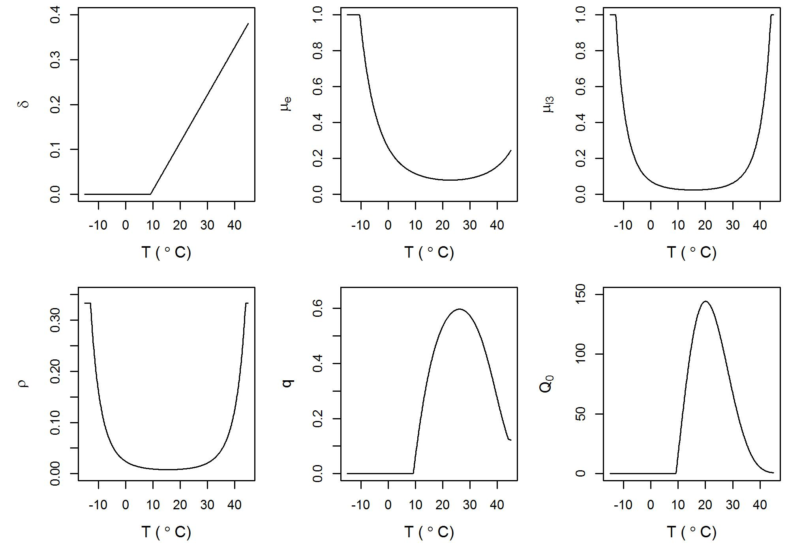
Fig. 2. Annual Q₀ estimates for (a) the 1970s, (b) the 1980s, (c) the 1990s and (d) the 2000s using the EOBS climate dataset and regionally variable sheep stocking density (Fig. S1; Phelan et al., 2014). The white shading depicts regions for which no sheep stocking density data were available.
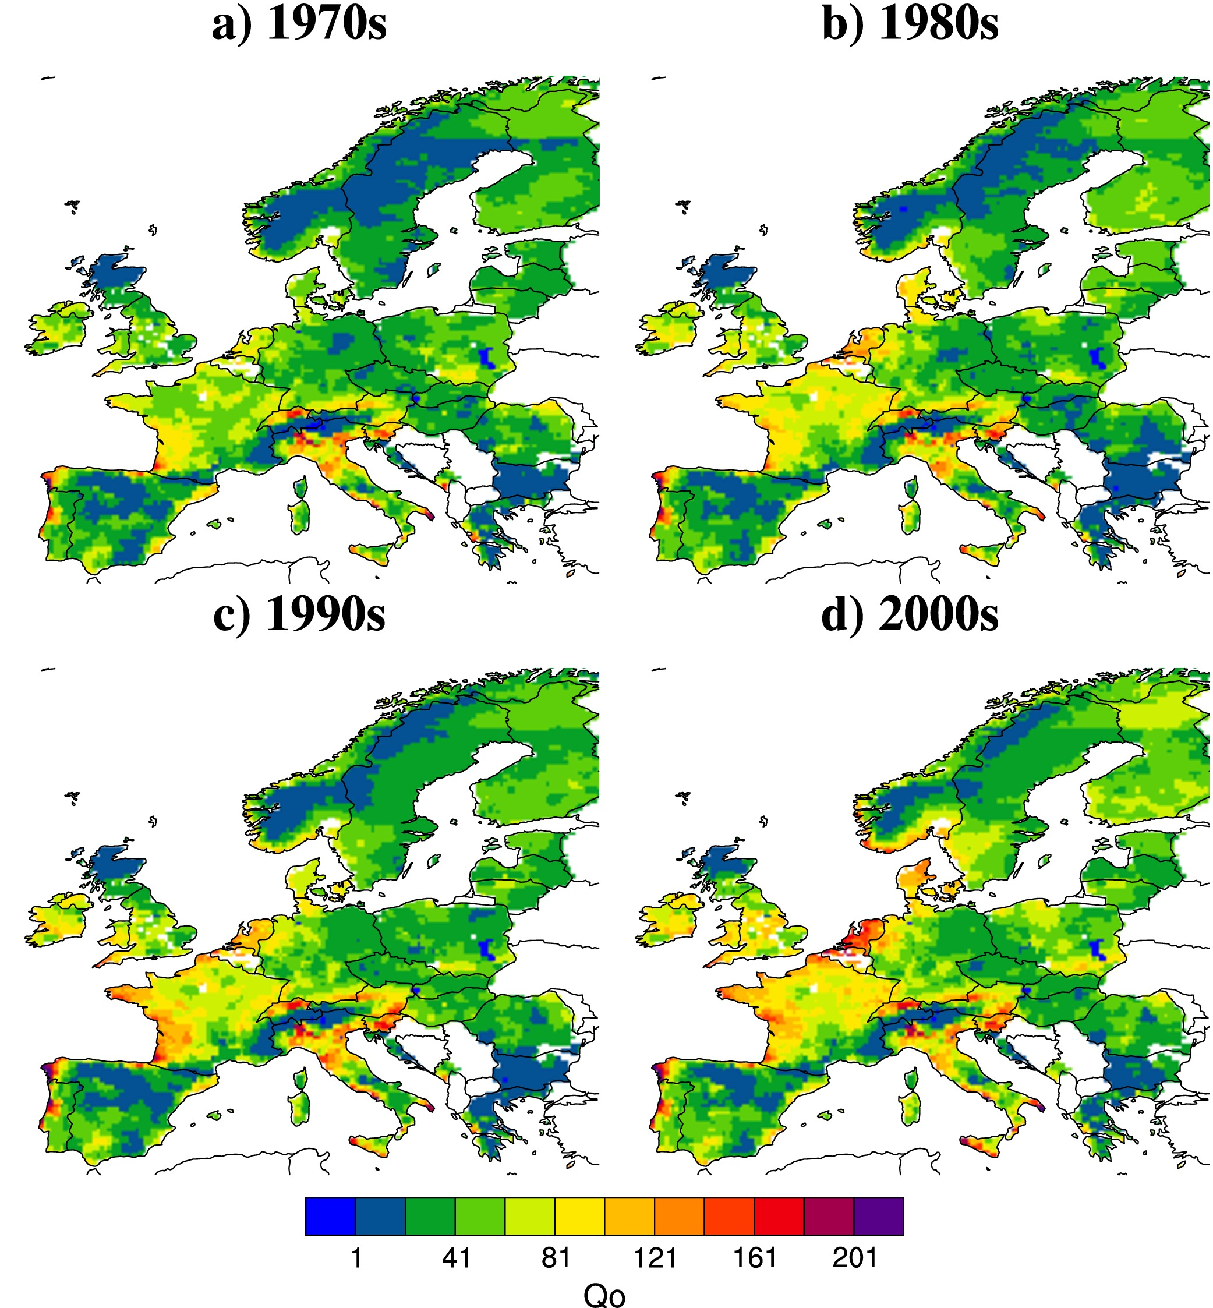
Fig. 3. Annual Q₀ estimates for (a) the 1970s, (b) the 1980s, (c) the 1990s and (d) the 2000s using the EOBS climate dataset. Q0_HCT indicates that these simulations used a constant sheep stocking density (H=1). Note the difference in scale of Q₀ compared with Fig. 2.
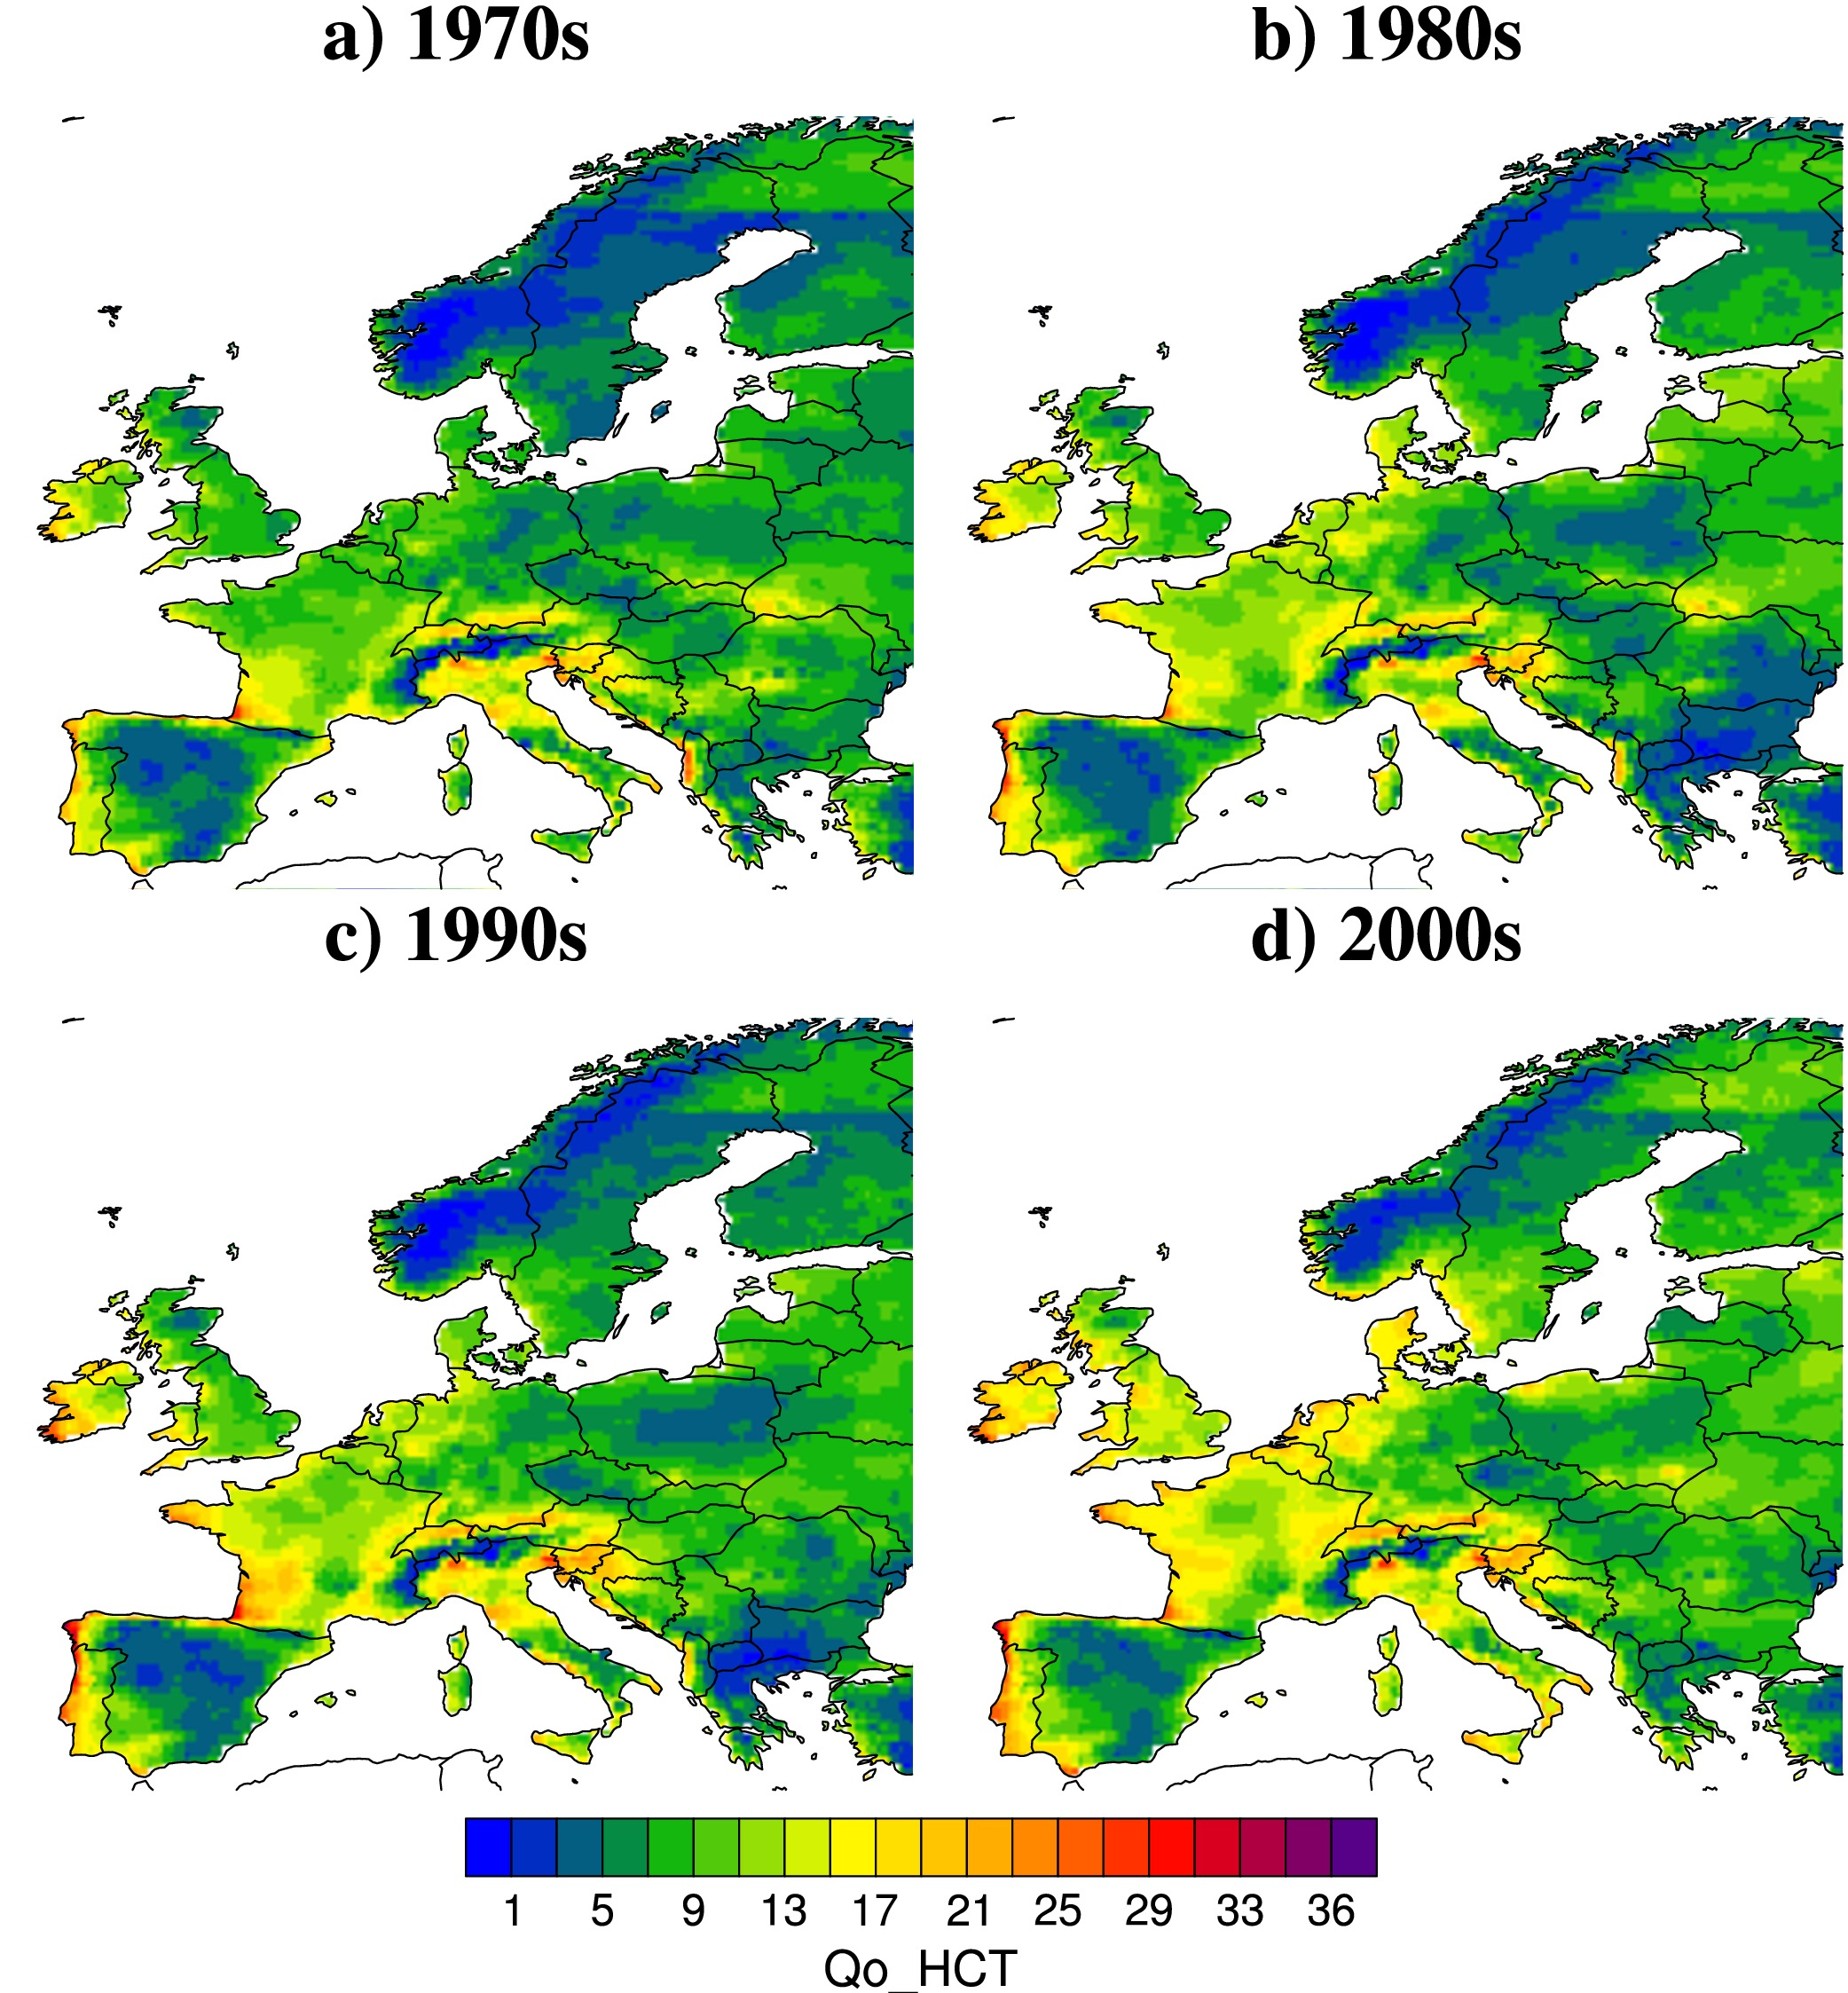
Fig. 4. Monthly Q₀ estimates based on the EOBS climate data for 1970-2013 and a spatially variable sheep stocking density (Fig. S1; Phelan et al., 2015). The white shading depicts regions for which no sheep stocking density data were available.
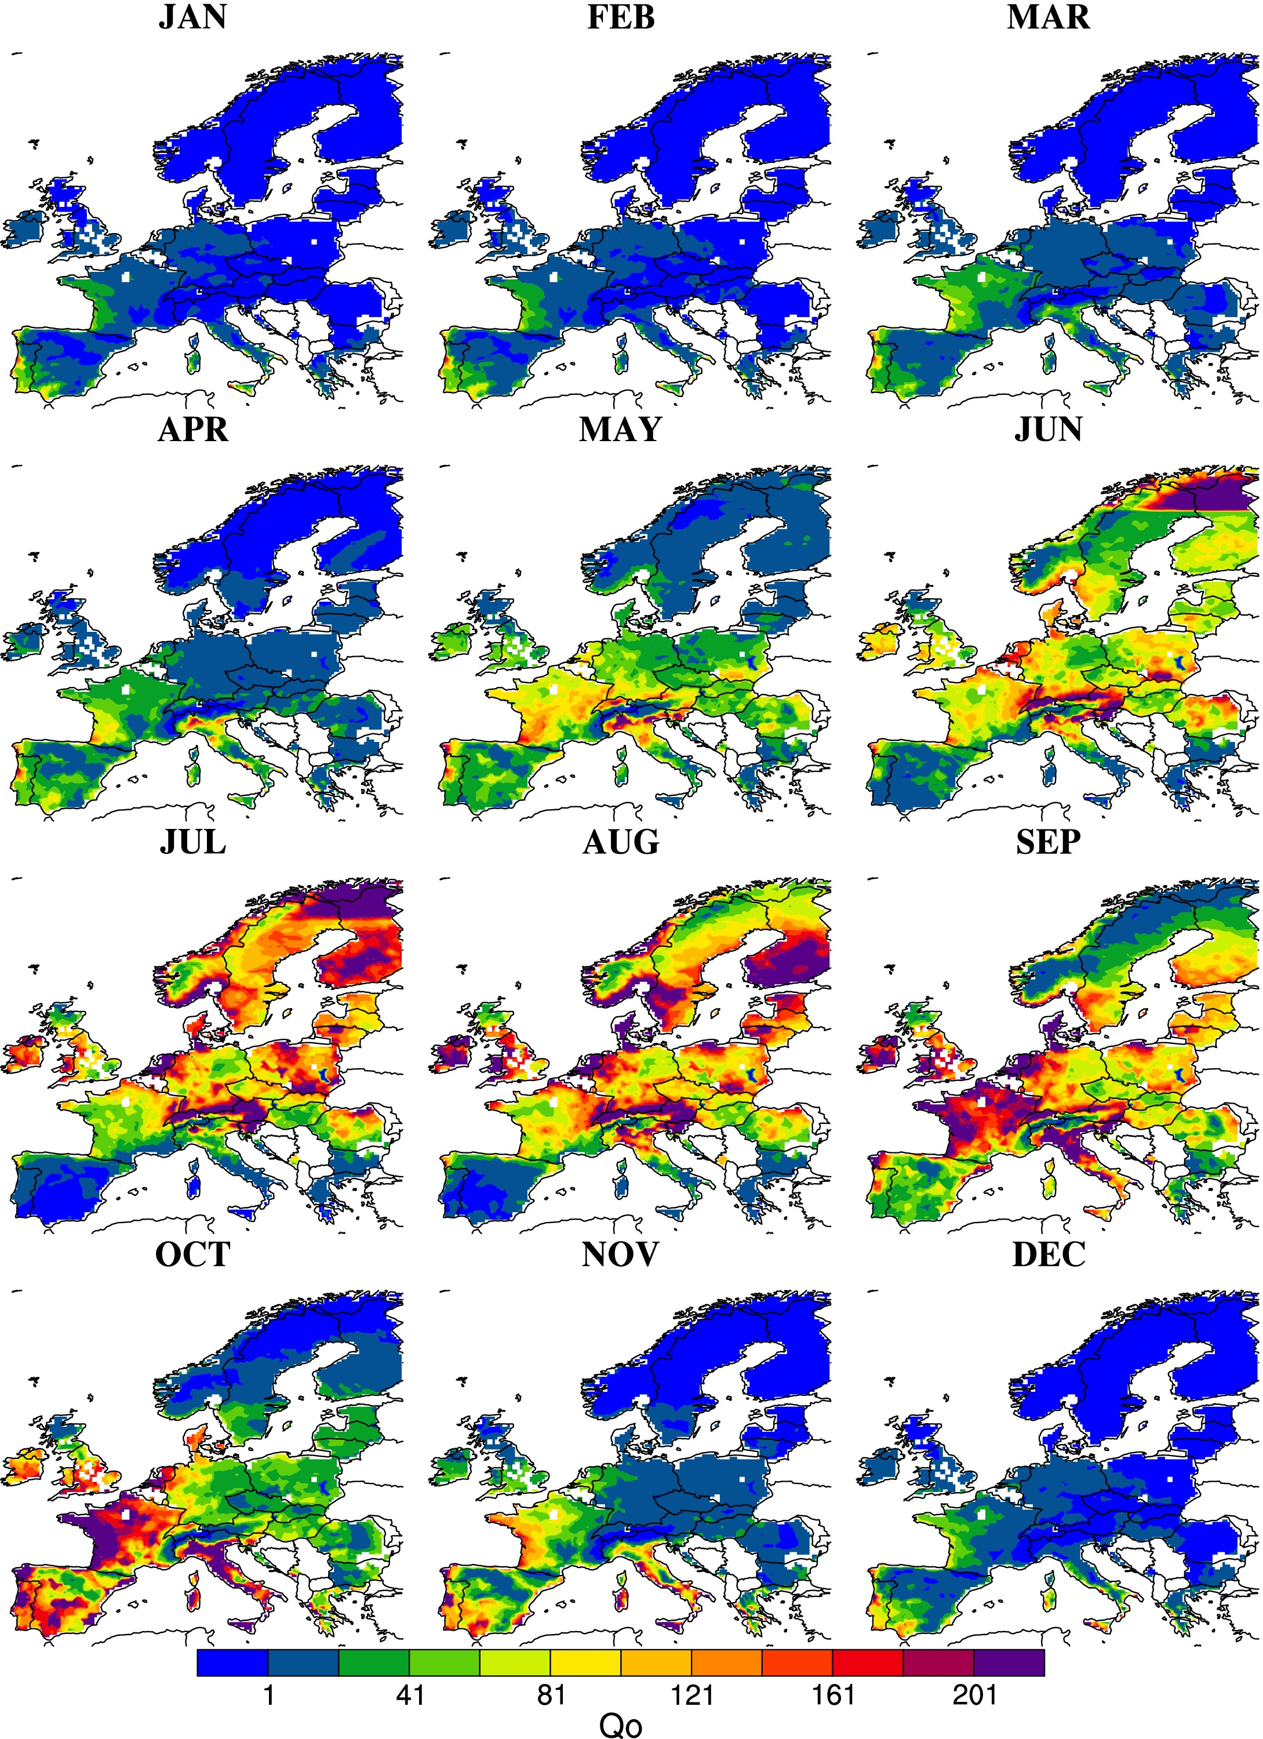
Fig. 5. Change in Q₀ seasonality for (a) Northern Europe [48ºN-59ºN, 12ºW-18.5ºE] and (b) Southern Europe [35.5ºN-44ºN, 10ºW-18.5ºE]. The solid black line shows the Q0 model driven by the EOBS climate observations (1971-2010 average). The solid blue lines show the Q0 model driven by the ensemble mean over the same time period. The solid orange and red lines respectively show the ensemble mean of the Q0 simulations driven by the climate model ensemble for 2071-2090 under the RCP2.6 and RCP8.5 emission scenarios. Dotted lines depict the minimum and maximum within the model ensemble to assess the relative uncertainties.
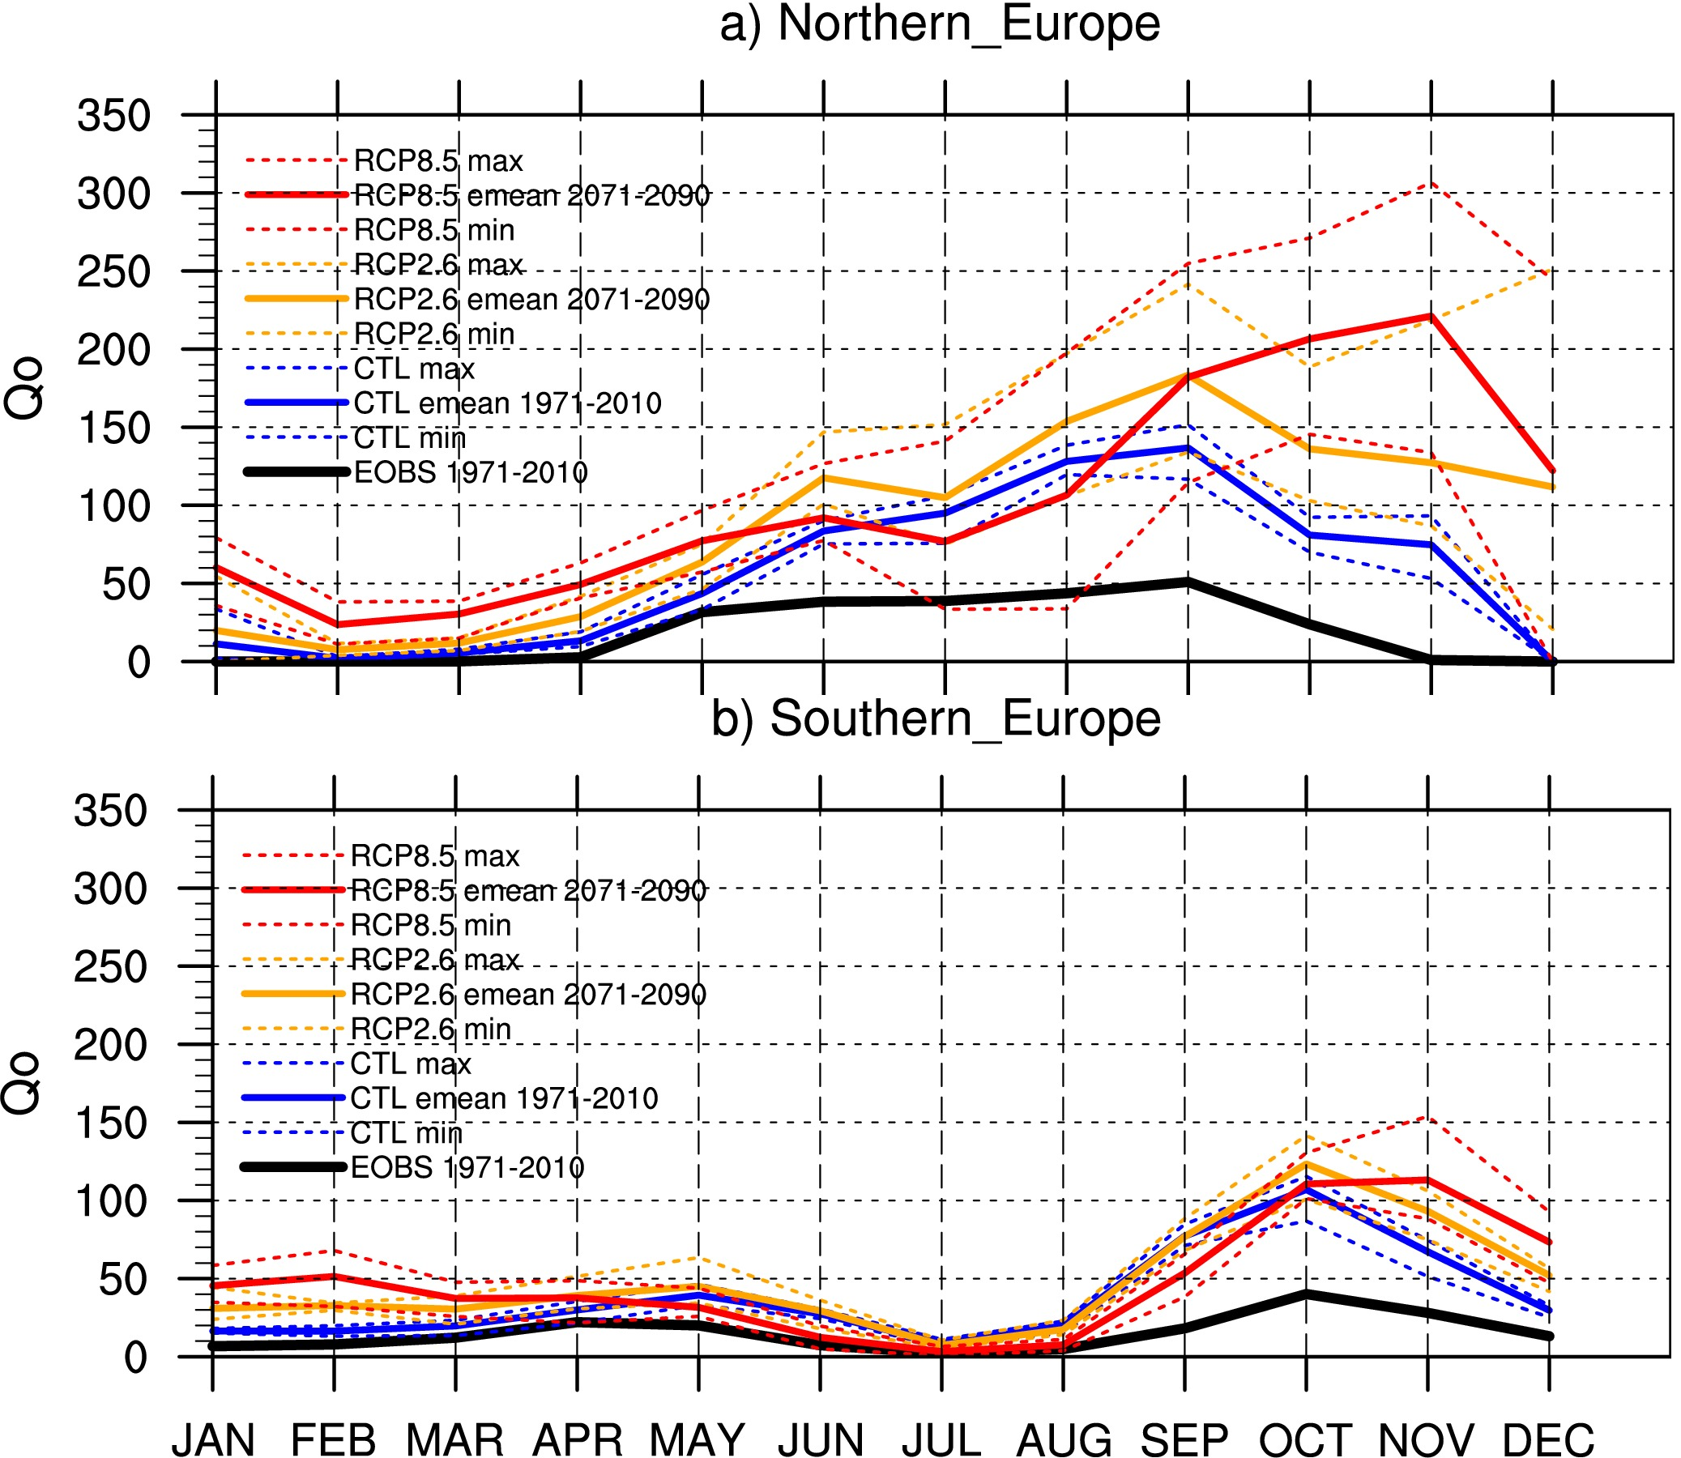
Fig. 6. Change in annual mean Q₀ based on the ensemble mean (Emean) of five climate models shown as future predicted Q₀ anomalies. Q₀ was estimated using the five global climate models for different time slices (rows) and different emission scenarios (columns, lowest e.g. RCP2.6 to highest RCP8.5 emission scenario from left to right). Anomalies have been calculated with respect to the historical experiments (1951-2005 baseline). The white shading depicts regions for which no sheep stocking density data were available.
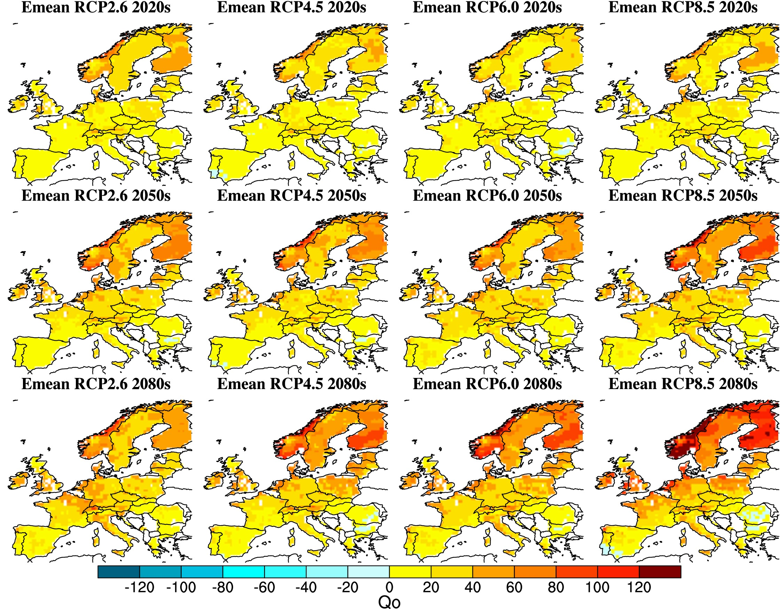
Fig. 7. Absolute annual mean Q₀ values based on the ensemble mean (Emean) of five climate models. Q₀ was estimated using the five global climate models for different time slices (rows) and different emission scenarios (columns, lowest e.g. RCP2.6 to highest RCP8.5 emission scenario from left to right). The white shading depicts regions for which no sheep stocking density data were available.
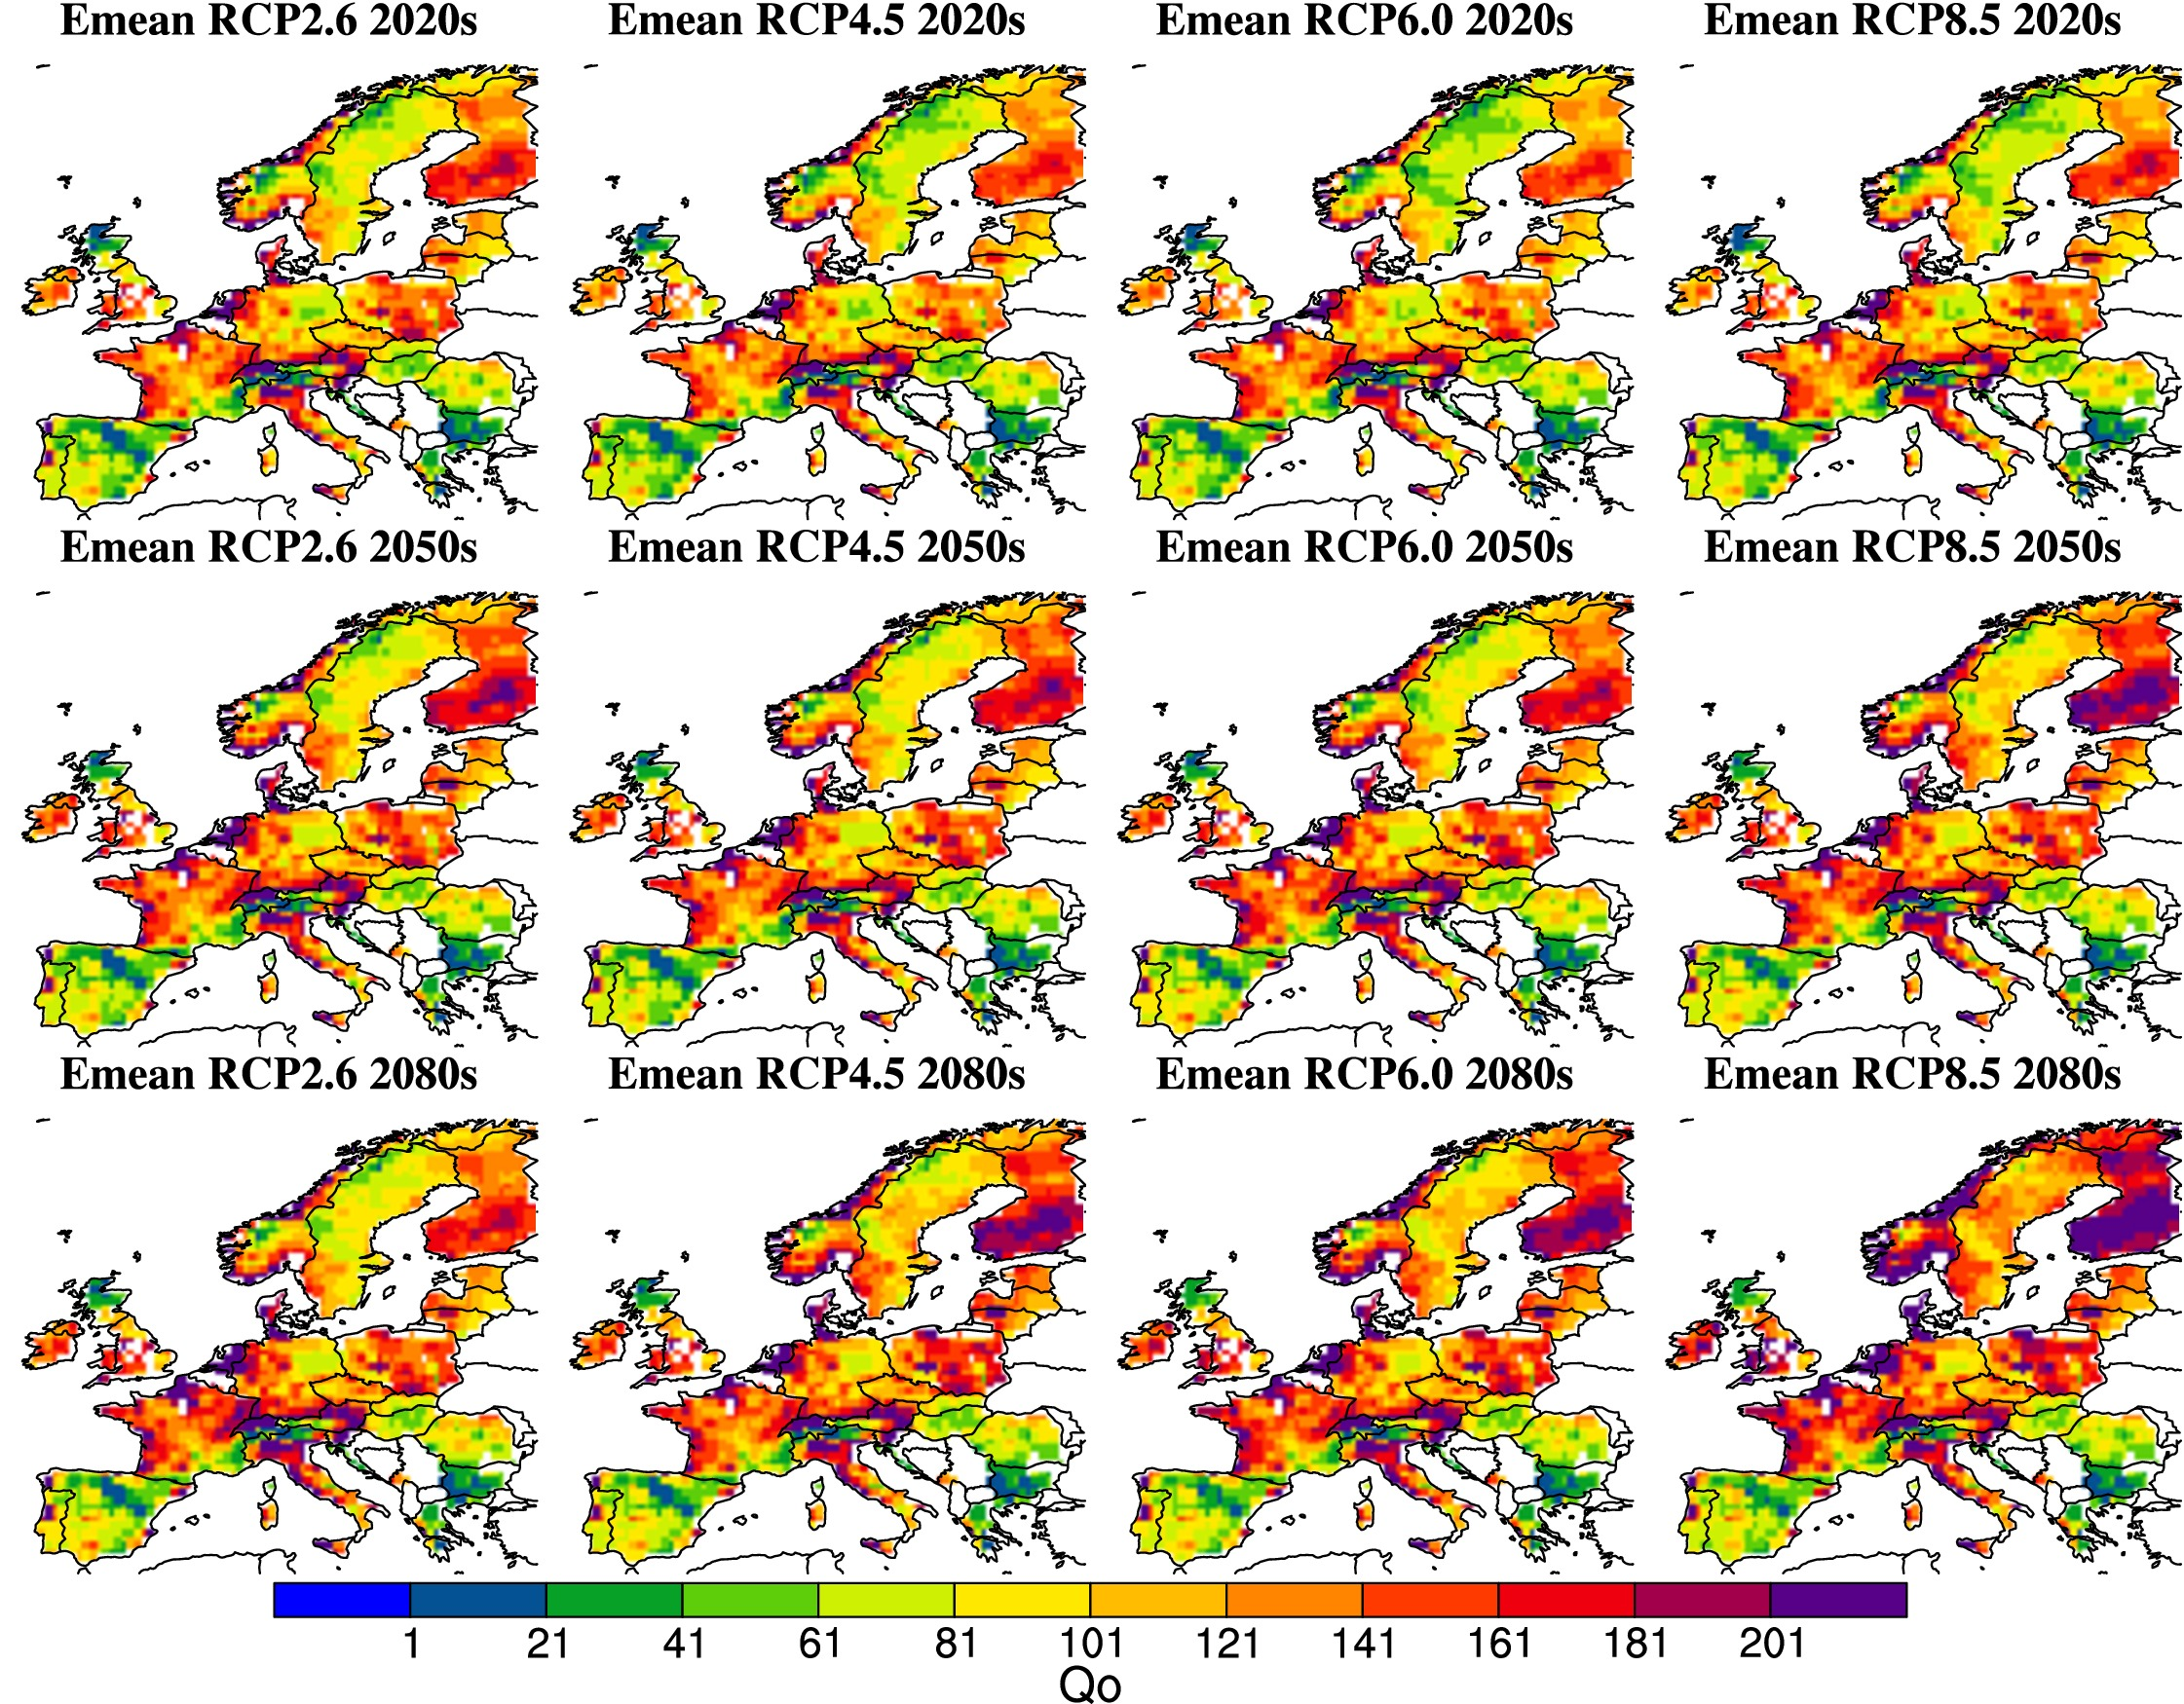

Table 1. Extended Q₀ model parameter definitions and estimates.
Parameter | Definition | Value | Source
H. contortus
$$λ$$ | Fecundity (eggs day⁻¹ adult⁻¹) | 2250 | Coyne & Smith, 1992b
$$μ_{ }$$ | Instantaneous daily mortality rate of adult nematodes | 0.05 | Barger & LeJambre, 1988
$$q$$ | Probability that an egg will develop to L3 and migrate onto pasture | $$\left\{\begin{aligned}\frac{δm_{1}}{\left(μ_{e}+δ\right)\left(μ_{l3}+m_{1}\right)} , P/E≥1 \\ \\ 0, P/E<1\end{aligned}\right.$$ | O’Connor et al., 2008; Khadijah et al., 2013; Rose et al., 2015b
$$δ$$ | Instantaneous daily development rate of eggs to L3 | $$-0.09746+0.01063T_{mean}$$ | Rose et al., 2015b
$$μ_{e}$$ | Instantaneous daily mortality rate of eggs | $$exp⁡(-1.3484-0.10488T +0.00230{T_{mean}}^{2})$$ | Rose et al., 2015b
$$μ_{l3}$$ | Instantaneous daily mortality rate of L3 in faeces | $$exp⁡(-2.62088-0.14399T+0.00462{T_{mean}}^{2})$$ | Rose et al., 2015b
$$m_{1}$$ | Instantaneous daily L3 migration rate between faeces and pasture | 0.25 | Rose et al., 2015b
$$ρ$$ | Instantaneous daily mortality rate of L3 on pasture | $$μ_{l3}/3$$ | Bolajoko et al., 2015
$$m_{2}$$ | Proportion of total pasture L3 that are found on herbage | 0.2 | Callinan & Westcott, 1986; van Dijk & Morgan, 2011
$$p$$ | Probability of establishment of ingested L3 | 0.4 | Barger et al., 1985
Host management
$$β$$ | Rate of ingestion of L3 on pasture | $$\frac{c}{BA}$$ | -
$$c$$ | Daily herbage dry matter intake per host (kg DM day⁻¹) | 1.4 | Kao et al., 2000
$$H$$ | Host density or stocking density (sheep ha⁻¹) | Either regionally variable or held constant | Phelan et al., 2014
$$B$$ | Standing biomass (kg DM ha⁻¹) | 2000 | Leathwick et al., 1992; Kao et al., 2000
$$A$$ | Grazing area (ha) | 1 | -
Climate
$$P$$ | Total daily precipitation (mm) | Daily variable | Haylock et al., 2008; Taylor et al., 2012
$$E$$ | Daily potential evapotranspiration (mm day⁻¹) | $$0.0023 ×0.408 ×Ra\left(\frac{T_{max}+T_{min}}{2}+17.8\right)\sqrt{T_{max}-T_{min}}$$ | Hargreaves & Samani, 1985
$$Ra$$ | Extra-terrestrial radiation (MJm⁻²day⁻¹) | Daily variable | Anon, 2002
$$T_{mean}$$ | Mean daily temperature (°C) | Daily variable | Haylock et al., 2008; Taylor et al., 2012
$$T_{min}$$ | Minimum daily temperature (°C) | Daily variable | Haylock et al., 2008; Taylor et al., 2012
$$T_{max}$$ | Maximum daily temperature (°C) | Daily variable | Haylock et al., 2008; Taylor et al., 2012

SUPPORTING INFORMATION
Fig. S1. Livestock units (LSU) per hectare derived from Phelan et al. [32]. 1 LSU = 10 sheep.
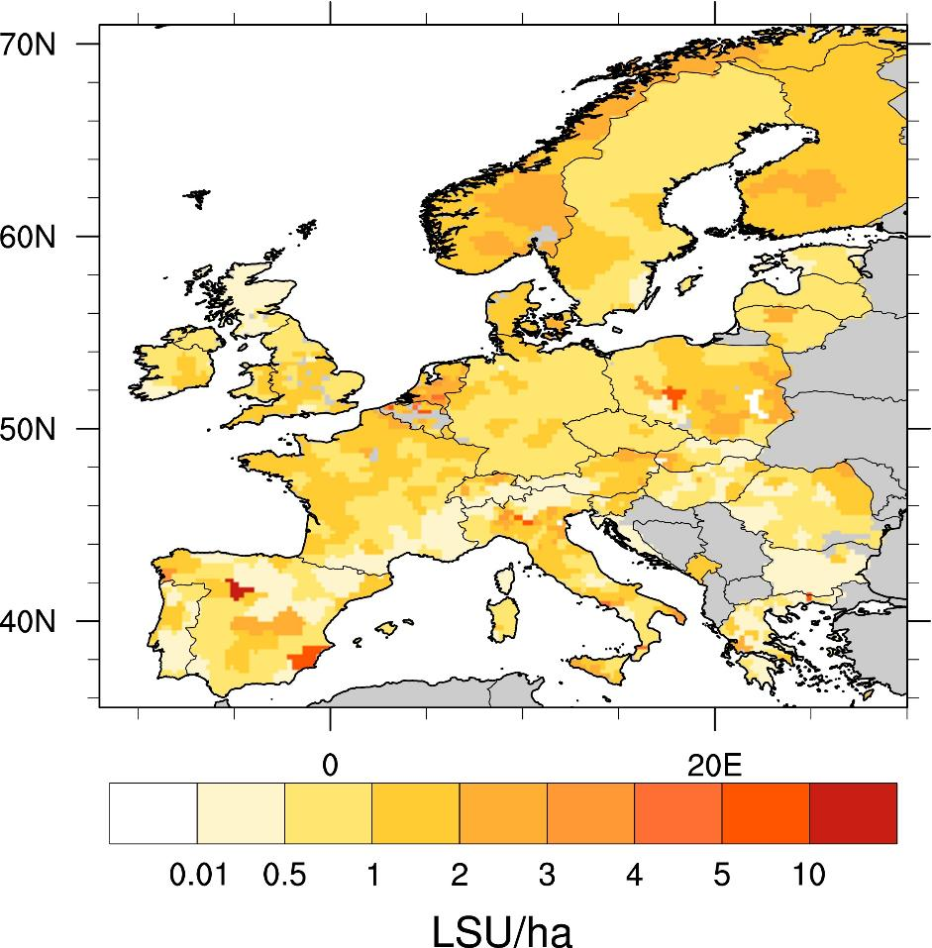

Fig. S2. Monthly Q₀ estimates based on the EOBS climate data for the 1970s (1970-1979) and a spatially variable sheep stocking density (Fig. S1; Phelan et al., 2014). The white shading depicts regions for which no sheep stocking density data were available.
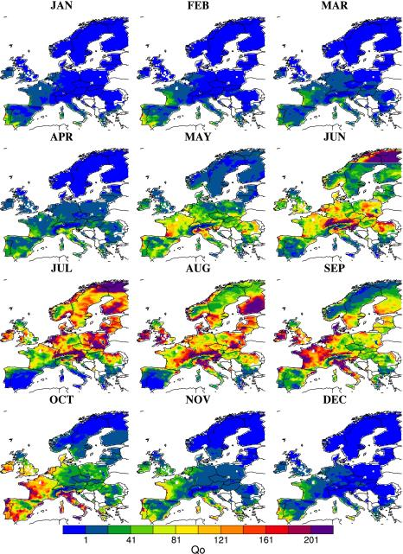

Fig. S2. Monthly Q₀ estimates based on the EOBS climate data for the 1980s (1980-1989) and a spatially variable sheep stocking density (Fig. S1; Phelan et al., 2014). The white shading depicts regions for which no stocking density data were available.
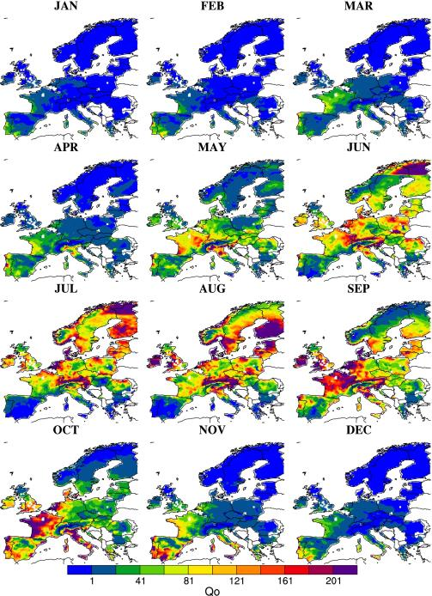

Fig. S3. Monthly Q₀ estimates based on the EOBS climate data for the 1990s (1990-1999) and a spatially variable sheep stocking density (Fig. S1; Phelan et al., 2014). The white shading depicts regions for which no stocking density data were available.
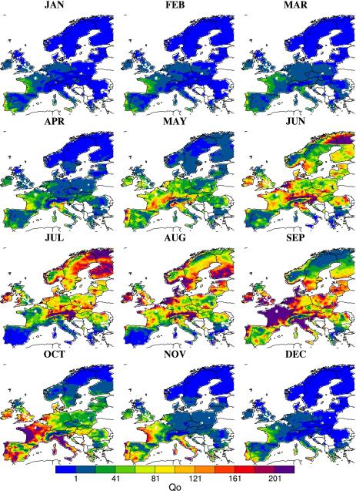

Fig. S4. Monthly Q₀ estimates based on the EOBS climate data for the 2000s (2000-2009) and a spatially variable sheep stocking density (Fig. S1; Phelan et al., 2014). The white shading depicts regions for which no stocking density data were available.
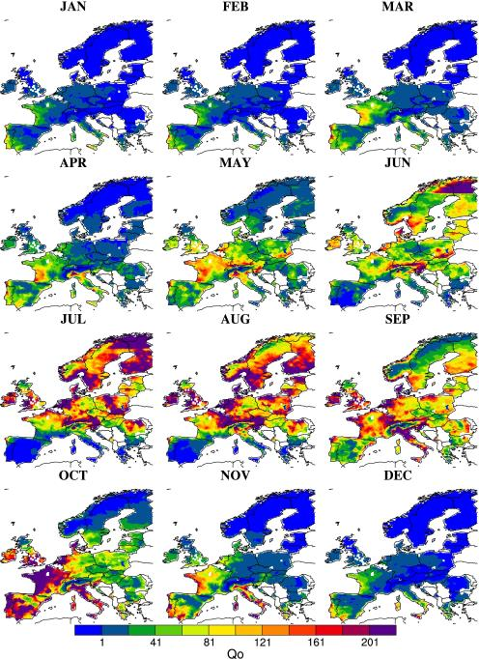

Fig. S5. Monthly estimates Q₀ based on the EOBS climate data for 1970-2013 and a constant sheep stocking density (H=1).
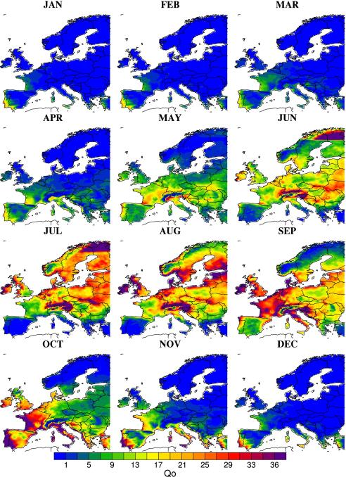

Fig. S6. Monthly Q₀ estimates based on the EOBS climate data for the 1970s (1970-1979) and a constant sheep stocking density (H=1).
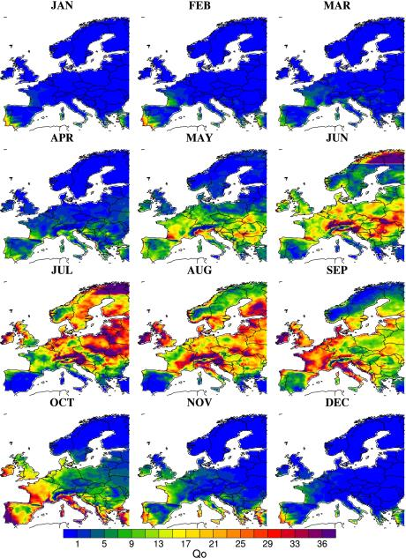

Fig. S7. Monthly Q₀ estimates based on the EOBS climate data for the 1980s (1980-1989) and a constant sheep stocking density (H=1).
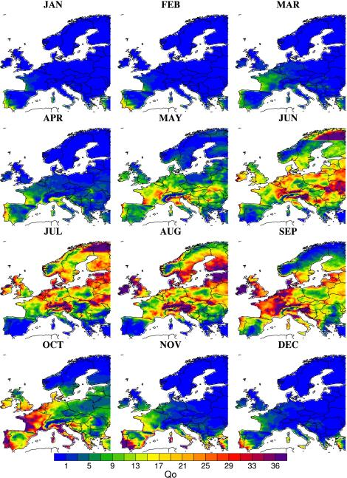

Fig. S8. Monthly Q₀ estimates based on the EOBS climate data for the 1990s (1990-1999) and a constant sheep stocking density (H=1).
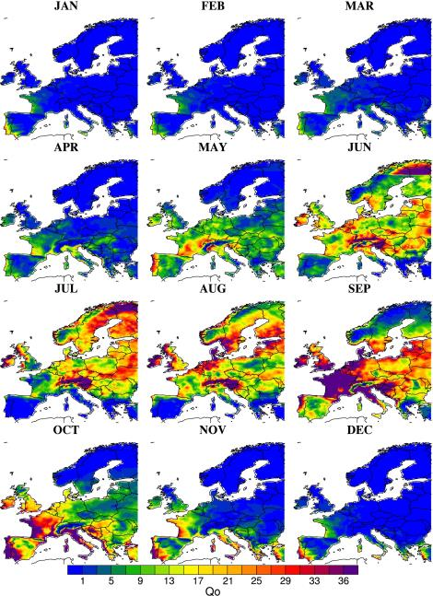

Fig. S9. Monthly Q₀ estimates based on the EOBS climate data for the 2000s (2000-2009) and a constant sheep stocking density (H=1).
