HLA-B*38:02:01 Predicts Carbimazole/Methimazole-Induced Agranulocytosis

Supplementary Info

Supplementary Figure 1. PCA of subjects included in the GWAS.

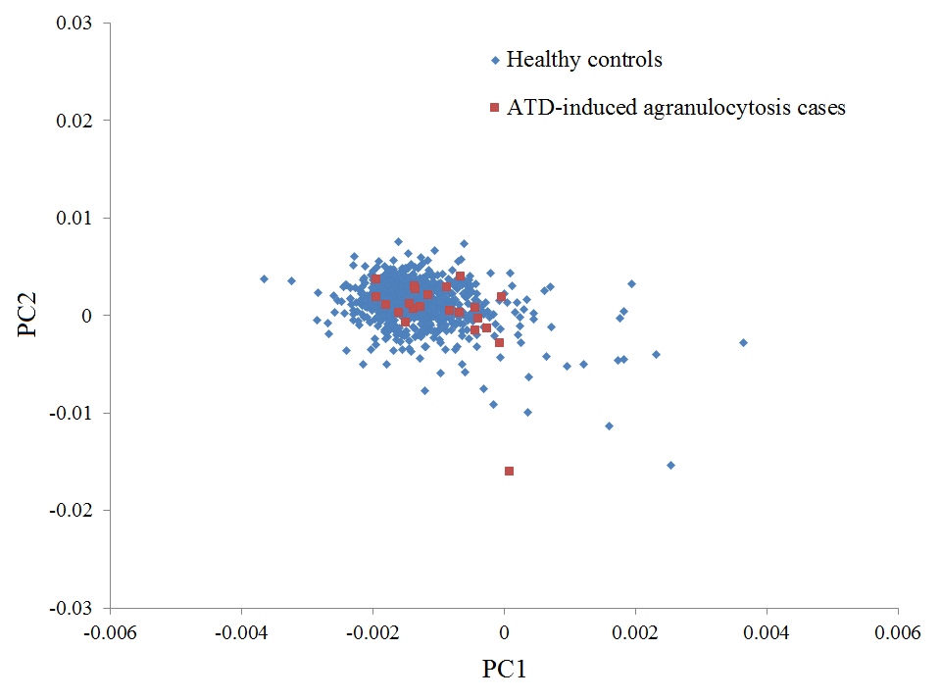

Supplementary Figure 2. QQ plot of the GWAS of ATD-induced agranulocytosis.
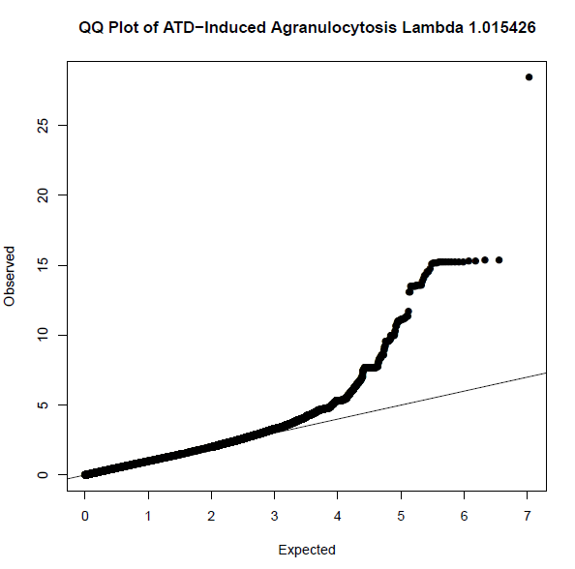

Supplementary Figure 3. The prevalence of HLA-B*38:02:01 in different geographical regions (data from the Allele Frequency Net Database: http://www.allelefrequencies.net/).
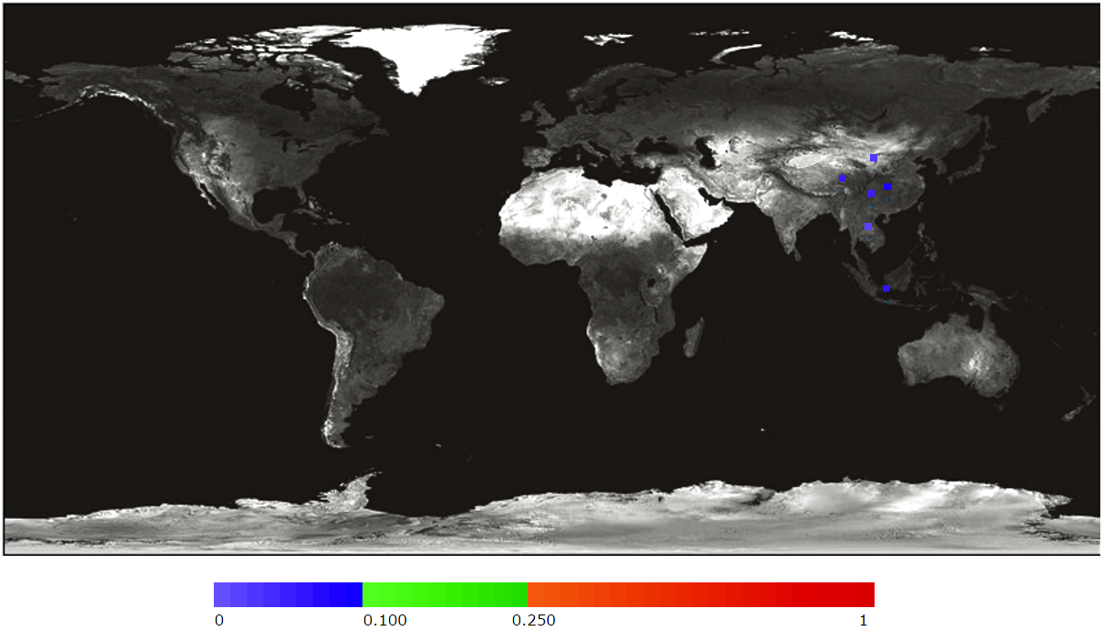
The allele frequency of HLA-B*38:02:01 was estimated to be 4% in Chinese, 5.7% in Indonesian, 2% in Thai, and 0% in South Korean, Bulgarian, and Moroccan.

Supplementary Figure 4. The prevalence of HLA-B*38:02 in different geographical regions (data from the Allele Frequency Net Database: http://www.allelefrequencies.net/).
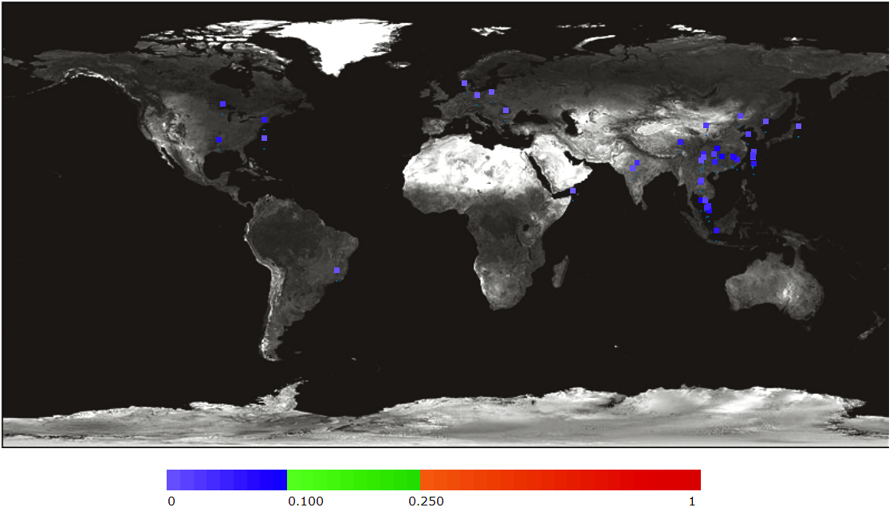
Supplementary table 1. Characteristics of CMZ/MMI-induced agranulocytosis patients.
ID | Sex | Age | ATD use | Cumulative dosage | Course of treatment | Days of onset of agranulocytosis | Concomitant medications | Allergy/co-morbidity | ANC*
ATD01 | F | 22 | CMZ | 960mg | First | 48 | Nil | Nil | 0
ATD02 | F | 35 | CMZ | 630mg | First | 21 | Propranolol | Nil | 0.03
ATD03 | F | 46 | CMZ | 1650mg | First | 55 | Propranolol; Aspirin | Atrial Fibrillation | 0
ATD04 | F | 67 | CMZ | 1020mg | First | 34 | Warfarin; Digoxin; Metoprolol; Ramipril; Furosemide | Congestive heart failure; Atrial Fibrillation; Hypertension | 0
ATD05 | F | 23 | CMZ | 560mg | First | 28 | Nil | Tonsillitis | 0
ATD08 | F | 58 | CMZ | 1080mg | First | 36 | Propranolol | Allergic to tetracycline (Rash); Beta thalassemia trait | 0
ATD09 | F | 42 | CMZ | 1340mg | First | 53 | Nil | Nil | <0.1
ATD11 | F | 50 | CMZ | 600mg | First | 33 | Propranolol | Nil | 0
ATD12 | F | 45 | CMZ | 900mg | First | 30 | Nil | Allergic to PTU (Angioedema) | 0.05
ATD14 | F | 35 | CMZ | Unclear | First | 26 | Nil | Nil | 0
ATD15 | F | 50 | CMZ | Unclear | First | 12 | Nil | Asthma; allergic to seafood | 0
ATD17 | F | 42 | CMZ | 2460mg | First | 41 | Propranolol | Nil | 0.01
ATD19 | M | 36 | CMZ | 1130mg | First | 42 | Nil | Nil | 0.05
ATD20 | F | 41 | CMZ | 960mg | First | 32 | Propranolol | Suspected skin rash with an anti-inflammatory drug | 0
ATD23 | F | 37 | CMZ | Unclear | First | <30 | Nil | Nil | 0.5
ATD24 | F | 56 | CMZ | 150mg | First | 5 | Nil | Nil | 0
ATD26 | F | 31 | CMZ | 525mg | First | 35 | Propranolol | Nil | 0.1
ATD27 | M | 54 | CMZ | 2790mg | First | 62 | Propranolol | Nil | <0.5
ATD18 | F | 43 | MMI | Unclear | First | 19 | Propranolol; Lorazepam | Skin Allergy to Cefuroxime and Co-trimoxazole | 0.1
*ANC: Absolute neutrophil count (unit: x 10⁻⁹/L)

Supplementary table 2. Characteristics of PTU-induced agranulocytosis patients.
ID | Sex | Age | Cumulative Dosage | Course of treatment | Days of onset of agranulocytosis | Concomitant medications | Allergy/co-morbidity | ANC* | Remarks
ATD07 | F | 23 | 8100mg | Later | 27 | Propranolol; Metoprolol; Prednisolone | Nil | 0.26 | Started CMZ and developed rash and fever after 2 months, then switched to PTU for 22 months. Relapsed and resumed PTU, and developed agranulocytosis in 27 days
ATD10 | F | 33 | 1200mg | Later | 3 | Metoclopramide; Rabeprazole | Chronic gastritis, reflux esophagitis | 0.44 | In the first course, patient prescribed PTU for one year without agranulocytosis. Relapsed and resumed PTU, and developed agranulocytosis
ATD13 | F | 29 | 200mg | First | 4 | Amoxicillin | Nil | 0.4 | Started CMZ but stopped after 2 days with unknown reason. Switched to PTU afterwards and developed agranulocytosis
ATD16 | F | 50 | 12000mg | Later | 60 | Propranolol | Septal defect with repair at age 19 | 0.26 | First course with CMZ without development of agranulocytosis; Agranulocytosis occurred at second course with PTU
ATD31 | M | 20 | 12000mg | Later | 60 | Nil | Nil | 0.1 | Reduced ANC (not reached agranulocytosis) after starting CMZ for 6 months, then switched to PTU, ANC dropped significantly, and developed agranulocytosis in 60 days
*ANC: Absolute neutrophil count (unit: x 10⁻⁹/L)

Supplementary table 3. Characteristics of CMZ/MMI-induced neutropenia patients.

ID | Sex | Age | ATD use | Cumulative dosage | Course of treatment | Interval | Concomitant medications | Allergy/co-morbidity | ANC* | Remarks
ATD21 | M | 52 | CMZ | 120mg | First | 4 days | Nil | Nil | 0.78
ATD29 | F | 42 | CMZ | unclear | Later | 6 days | Propranolol | Nil | 0.8 | Fourth course in CMZ, previous courses of CMZ for 5 years
ATD30 | F | 55 | CMZ | unclear | Later | 18 months | Aspirin; Trinitroglycerin; Metoprolol | Ischemic heart disease | 1.4 | Third relaspe of thyrotosicosis. Previous 2 episodes treated over 20 yrs ago
*ANC: Absolute neutrophil count (unit: x 10⁻⁹/L)

Supplementary Table 4. Association of HLA-DRB1*08:03 with ATD- or CMZ/MMI-induced agranulocytosis in the validation cohort.
 | Sample size |  | MAF |  | OR | 95% CI | P-value
 | Case | Control | Case | Control
ATD-induced agranulocytosis | 24 | 75 | 20.8% | 5.6% | 5.71 | (1.91-17.08) | 0.002
CMZ/MMI-induced agranulocytosis | 19 | 59 | 26.3% | 5.7% | 8.73 | (2.64-28.86) | 1.1 x 10⁻⁴
Abbreviation: ATD, anti-thyroid drug; CMZ, carbimazole; MMI, methimazole; PTU, propylthiouracil; MAF: minor allele frequency; OR: odds ratio; CI, confidence interval.

Supplementary table 5. Characteristics of the Filipino CMZ-induced agranulocytosis patient.
ID | Sex | Age | ATD use | Cumulative dosage | Course of treatment | Interval | Concomitant medications | Allergy/co-morbidity | ANC* | Remarks
ATD22 | F | 49 | CMZ | 900mg | First | 30 days | Propranolol; FeSO4 | Nil | 0.43 | Nil
*ANC: Absolute neutrophil count (unit: x 10⁻⁹/L)

Supplementary table 6. Allele frequency of HLA-B*38:02 (data retrieved from http://www.allelefrequencies.net/)
# | Population | % of individuals that have the allele | Allele Frequency (in_decimals) | Sample size
1 | Australia New South Wales Caucasian |  | 0 | 134
2 | Australia Yuendumu Aborigine |  | 0 | 191
3 | Brazil Belo Horizonte Caucasian | 0 | 0 | 95
4 | Brazil Mixed |  | 0.007 | 108
5 | China Beijing |  | 0.008 | 67
6 | China Beijing Shijiazhuang Tianjian Han |  | 0.019 | 618
7 | China Canton Han |  | 0.07 | 264
8 | China Guangxi Region Maonan |  | 0.083 | 108
9 | China Guangzhou |  | 0.06 | 102
10 | China Guangzhou Han |  | 0.043 | 106
11 | China Jiangsu Han |  | 0.021 | 3,238
12 | China Jiangsu Province Han |  | 0.0192 | 334
13 | China North Han |  | 0 | 105
14 | China Sichuan HIV negative |  | 0.074 | 34
15 | China South Han |  | 0.071 | 284
16 | China Southwest Dai |  | 0.056 | 124
17 | China Yunnan Bulang |  | 0.03 | 116
18 | China Yunnan Hani |  | 0.007 | 150
19 | China Yunnan Province Bulang |  | 0.03 | 116
20 | China Yunnan Province Han |  | 0.025 | 101
21 | China Yunnan Province Hani pop 2 |  | 0.007 | 150
22 | Croatia |  | 0 | 150
23 | Cuba Caucasian | 0 | 0 | 70
24 | Cuba Mulatto | 0 | 0 | 42
25 | Czech Republic |  | 0 | 106
26 | Czech Republic NMDR |  | 0.0001 | 5,099
27 | Germany DKMS - China minority |  | 0.0269 | 1,282
28 | Germany DKMS - Poland minority |  | 0 | 20,653
29 | Germany DKMS - Portugal minority |  | 0.0004 | 1,176
30 | Germany DKMS - Turkey minority |  | 0.0002 | 4,856
31 | Germany pop 6 |  | 0.0001 | 8,862
32 | Germany pop 8 |  | 0.0001 | 39,689
33 | Hong Kong Chinese | 10 | 0.054 | 569
34 | India Khandesh Region Pawra |  | 0 | 50
35 | India Mumbai Maratha |  | 0.012 | 91
36 | India West Bhil |  | 0.04 | 50
37 | India West Coast Parsi |  | 0 | 50
38 | Indonesia Java Western | 10.6 | 0.054 | 236
39 | Ireland Northern | 0 | 0 | 1,000
40 | Italy North pop 3 | 0 | 0 | 97
41 | Italy pop 5 |  | 0 | 975
42 | Japan Central |  | 0.001 | 371
43 | Japan pop 16 |  | 0.0028 | 18,604
44 | Japan pop 3 |  | 0.002 | 1,018
45 | Japan pop 5 |  | 0.004 | 117
46 | Macedonia pop 4 |  | 0.002 | 216
47 | Malaysia Jelebu Temuan |  | 0.042 | 25
48 | Malaysia Kedah Baling Kensiu |  | 0.08 | 25
49 | Malaysia Perak Grik Jehai |  | 0.02 | 25
50 | Mexico Mestizo | 0 | 0 | 41
51 | Morocco Nador Metalsa pop 2 |  | 0 | 73
52 | Morocco Settat Chaouya | 0 | 0 | 98
53 | Myanmar, Bamar |  | 0.033 | 46
54 | Myanmar, Kayin |  | 0.034 | 44
55 | Netherlands Leiden |  | 0.001 | 1,305
56 | Oman | 0 | 0 | 118
57 | Philippines Ivatan | 12 | 0.06 | 50
58 | Romania | 0 | 0 | 348
59 | Singapore Chinese | 9.4 | 0.047 | 149
60 | Singapore Chinese Han |  | 0.064 | 94
61 | Singapore Javaneses |  | 0.071 | 51
62 | Singapore Riau Malay |  | 0.045 | 132
63 | Singapore Thai |  | 0.035 | 100
64 | South Africa Natal Zulu | 0 | 0 | 100
65 | South Korea pop 10 |  | 0.008 | 4,128
66 | South Korea pop 3 |  | 0.011 | 485
67 | Taiwan Hakka | 7.3 | 0.036 | 55
68 | Taiwan Han Chinese |  | 0.033 | 504
69 | Taiwan Minnan pop 1 | 12.7 | 0.064 | 102
70 | Taiwan Pazeh | 3.6 | 0.018 | 55
71 | Taiwan pop 2 |  | 0.038 | 364
72 | Taiwan pop 3 |  | 0.026 | 212
73 | Taiwan Puyuma | 2 | 0.01 | 50
74 | Taiwan Saisiat | 2 | 0.01 | 51
75 | Taiwan Siraya | 5.9 | 0.029 | 51
76 | Taiwan Tao | 20 | 0.11 | 50
77 | Taiwan Tzu Chi Cord Blood Bank |  | 0.044 | 710
78 | USA African American |  | 0 | 252
79 | USA African American Bethesda | 0 | 0 | 187
80 | USA African American pop 4 |  | 0 | 2,411
81 | USA African American pop 8 |  | 0 | 605
82 | USA Alaska Yupik |  | 0 | 252
83 | USA Asian |  | 0.066 | 358
84 | USA Asian pop 2 |  | 0.0365 | 1,772
85 | USA Caucasian Bethesda | 0 | 0 | 307
86 | USA Caucasian pop 2 |  | 0.002 | 265
87 | USA European American pop 2 |  | 0 | 1,245
88 | USA Hispanic |  | 0 | 234
89 | USA Hispanic pop 2 |  | 0 | 1,999
90 | USA NMDP Alaska Native or Aleut |  | 0.001 | 1,376
91 | USA NMDP Caribean Black |  | 0.001 | 33,328
92 | USA NMDP Caribean Indian |  | 0.001 | 14,339
93 | USA NMDP Chinese |  | 0.04 | 99,672
94 | USA NMDP European Caucasian |  | 0 | 1,242,890
95 | USA NMDP Filipino |  | 0.1272 | 50,614
96 | USA NMDP Hawaiian or other Pacific Islander |  | 0.0174 | 11,499
97 | USA NMDP Hispanic South or Central American |  | 0.0002 | 146,714
98 | USA NMDP Japanese |  | 0.0033 | 24,582
99 | USA NMDP Korean |  | 0.0096 | 77,584
100 | USA NMDP Mexican or Chicano |  | 0.0003 | 261,235
101 | USA NMDP Middle Eastern or North Coast of Africa |  | 0.0002 | 70,890
102 | USA NMDP South Asian Indian |  | 0.007 | 185,391
103 | USA NMDP Southeast Asian |  | 0.0151 | 27,978
104 | USA NMDP Vietnamese |  | 0.0584 | 43,540
105 | USA North American Native |  | 0 | 187
106 | USA Philadelphia Caucasian | 0 | 0 | 141
107 | USA San Antonio Caucasian |  | 0 | 222
108 | USA South Texas Hispanic |  | 0 | 194
109 | Vietnam Hanoi Kinh pop 2 |  | 0.056 | 170
110 | Wales | 0 | 0 | 1,798

Supplementary Table 7. Power calculation of the GWAS cohort using QUANTO.
OR | MAF of the risk allele
 | 0.01 | 0.03 | 0.05 | 0.1 | 0.15 | 0.2 | 0.25 | 0.3 | 0.35 | 0.4 | 0.45
2 | 0 | 0 | 0 | 0 | 0.0001 | 0.0002 | 0.0003 | 0.0004 | 0.0005 | 0.0005 | 0.0005
3 | 0 | 0.0001 | 0.0003 | 0.0027 | 0.0074 | 0.0129 | 0.0172 | 0.0194 | 0.0195 | 0.0179 | 0.0151
4 | 0 | 0.0007 | 0.0038 | 0.0282 | 0.0648 | 0.095 | 0.1115 | 0.1144 | 0.107 | 0.0929 | 0.0754
5 | 0.0001 | 0.0038 | 0.0205 | 0.1159 | 0.2134 | 0.271 | 0.2909 | 0.2832 | 0.2571 | 0.2197 | 0.1771
6 | 0.0003 | 0.0141 | 0.0663 | 0.273 | 0.4159 | 0.4777 | 0.4873 | 0.464 | 0.4187 | 0.3592 | 0.2923
7 | 0.0008 | 0.0382 | 0.1518 | 0.4592 | 0.6061 | 0.6534 | 0.6498 | 0.6153 | 0.5584 | 0.4849 | 0.4006
8 | 0.0019 | 0.0822 | 0.2717 | 0.6287 | 0.7503 | 0.779 | 0.7666 | 0.7277 | 0.6672 | 0.5879 | 0.4941
9 | 0.0041 | 0.1485 | 0.4087 | 0.759 | 0.8468 | 0.8612 | 0.845 | 0.807 | 0.7482 | 0.669 | 0.5715
10 | 0.008 | 0.2345 | 0.5432 | 0.8491 | 0.9072 | 0.9127 | 0.8962 | 0.8617 | 0.8076 | 0.7318 | 0.6347
11 | 0.0142 | 0.3333 | 0.6614 | 0.9073 | 0.9438 | 0.9445 | 0.9295 | 0.8995 | 0.851 | 0.7803 | 0.686
12 | 0.0235 | 0.4365 | 0.7569 | 0.9435 | 0.9656 | 0.9642 | 0.9513 | 0.9257 | 0.883 | 0.818 | 0.7277
13 | 0.0367 | 0.5365 | 0.8296 | 0.9656 | 0.9787 | 0.9764 | 0.9657 | 0.9442 | 0.9068 | 0.8476 | 0.762
14 | 0.0544 | 0.6276 | 0.8826 | 0.9789 | 0.9866 | 0.9842 | 0.9754 | 0.9574 | 0.9248 | 0.871 | 0.7903
15 | 0.0769 | 0.7066 | 0.92 | 0.9869 | 0.9914 | 0.9892 | 0.982 | 0.9669 | 0.9385 | 0.8897 | 0.8138
16 | 0.1044 | 0.7727 | 0.9458 | 0.9918 | 0.9944 | 0.9925 | 0.9866 | 0.974 | 0.9491 | 0.9049 | 0.8336
17 | 0.1369 | 0.8261 | 0.9634 | 0.9948 | 0.9962 | 0.9946 | 0.9899 | 0.9792 | 0.9575 | 0.9172 | 0.8504
18 | 0.1738 | 0.8684 | 0.9753 | 0.9966 | 0.9975 | 0.9961 | 0.9923 | 0.9832 | 0.9641 | 0.9275 | 0.8648
19 | 0.2147 | 0.9011 | 0.9832 | 0.9978 | 0.9982 | 0.9972 | 0.994 | 0.9863 | 0.9694 | 0.936 | 0.8771
20 | 0.2588 | 0.9261 | 0.9886 | 0.9985 | 0.9988 | 0.9979 | 0.9953 | 0.9887 | 0.9737 | 0.9432 | 0.8879
21 | 0.3052 | 0.9449 | 0.9922 | 0.999 | 0.9991 | 0.9984 | 0.9962 | 0.9906 | 0.9773 | 0.9493 | 0.8972
22 | 0.353 | 0.959 | 0.9946 | 0.9993 | 0.9994 | 0.9988 | 0.997 | 0.9921 | 0.9802 | 0.9545 | 0.9055
Power calculation settings: 20 cases and 775 controls; log additive model; baseline risk was set to be 0.0001.

