The application of a drought reconstruction in water resource management
Authors: A. T. Lennard¹*, N. Macdonald¹, S. Clark^{2,} J.M. Hooke¹
*Corresponding Author, email: a.lennard@liverpool.ac.uk, tel: Tel: 0151 794 2869
Affiliations: ¹School of Environmental Sciences, University of Liverpool, Liverpool L69 7ZT, UK ²Severn Trent Water Ltd, Severn Trent Centre, Coventry, CV1 2LZ. UK
Abstract
This study uses extended (1880s-2012) rainfall series to examine the implications of historical droughts on water supply yield calculations used in water resource management and drought planning across the English Midlands and Central Wales. UK guidance to water companies is to use climate data from the 1920s to present where possible in modelling to inform water resource management and drought plans; but this period excludes several significant droughts of the late nineteenth century. This study uses the standardised precipitation index and hydrological modelling (HYSIM and AQUATOR) to investigate the implications of pre-1920s droughts on water resource management. Although drought characterisation identifies two significant droughts in the pre-1920 period, the impact of these events on reservoir storage is less severe than droughts identified in the post-1920 period, indicating that the use of long climate series in water resource modelling is a valuable tool in assessing the robustness of current water resource modelling used in the water resource sector.
Keywords
Drought Characterisation; Water Resources Management; Reservoir Modelling
Introduction
Drought is a recurring feature of the UK climate. There have been a number of notable drought events throughout the twentieth and twenty-first centuries (1921-1922, 1933-34, 1975-1976, 1995-1996, 2004-2006, 2010-2012) that highlight the UK’s vulnerability. To maintain public water supplies throughout periods of flooding and drought, water supply systems are designed to smooth natural climate variability (Watts et al., 2012). Water resource management includes the use of modelling approaches to simulate water supply systems in order to define the yield, or deployable output, of the water resource system. Environment Agency guidelines state that the assessment of yield should use data from at least 1920 onwards so as to incorporate a number of extreme events. However, this period excludes a number of notable droughts during the late nineteenth century, including a particularly severe drought (1887-1889) and the ‘Long Drought’ (1880-1910) as identified by Marsh et al. (2007).
Under UK legislation, water companies in England and Wales are required to produce water resources management and drought plans to outline how they intend to manage water supplies. Water resources management plans (WRMPs) are produced every five years to define how a water company plans to manage and ensure the security of water supplies over the next 25 years (Environment Agency, 2012). Whilst drought plans are produced every three years, these plans outline the short-term measures required to manage water supplies before, during and after a drought, whilst minimising impacts on the environment (Environment Agency, 2011). A key component of water resource management and drought plans is the calculation of deployable output. This is defined by the Environment Agency (2012) as “the output for specified conditions and demands of commissioned source, group of sources or water resources system as constrained by hydrological yield, licensed quantities, environment, pumping plant/or well/aquifer properties, transfer/or output mains, treatment, water quality and levels of service.”
The UK has a wealth of long climate data series that are currently under-used in water resource management. A number of drought reconstructions have been undertaken (Wells et al. 2004; Marsh et al., 2007; Todd et al., 2013 – an approach applied by Severn Trent Water, 2014a, p35), but little of this information is used to inform water resource management. To date few studies have applied long-series climate data for water resource management; the exceptions being Watts et al. (2012) and Spraggs et al. (2015). Watts et al. (2012) used long severe UK droughts of the nineteenth Century to test water resource systems resilience; whilst Spraggs et al. (2015) used a drought reconstruction (1789-2010) to examine long-term yield or deployable output (DO) for the Anglian Region (UK). The study highlights that the temporal and spatial characteristics of drought variability should be taken into account in water resource management, with an assessment of the water supply system required at local and regional scales. The use of long climate series with an increased number of drought events is valuable in testing the robustness of water resource modelling. Each drought has a unique set of characteristics that may affect a water resource system in different ways. For example, the sequencing of wetter and drier periods during a drought is an important factor in the performance of a supply system (Watts et al., 2012). Marsh et al., (2007) emphasise that characterisation of droughts experienced prior to 1914 could be a useful addition to water resource management strategies.
This paper aims to characterise past drought events from the 1880s to 2012 for the English Midlands and central Wales. Drought characterisation is used to extend the water resources modelling period from 1920-2012 to 1884-2012 for a single water supply zone, within the Severn Trent Water region, permitting investigation of the impacts of pre-1920s droughts on reservoir yields and exploring how meteorological and hydrological drought characteristics impact the water supply system.
Data and Methods
Study Area
The Severn Trent Water supply region, spanning central England and mid-Wales, is approximately 21,000 km², with a varied topography, which includes uplands over 800 metres above sea level (m a.s.l) in the north and west; a central plateau region between 100 to 250 m a.s.l.; with the south and the east of the region situated within the English Lowlands (~50 m a.s.l.). Considerable spatial variation in rainfall exists across the region, ranging from over 1800 mm in the Welsh uplands to ~650 mm in the southeast of the region (Met Office, 2014). Several large towns and cities are within the supply area including Birmingham, Nottingham, Leicester and Stafford (Figure 1). Severn Trent Water supplies approximately 7.4 million people with potable water provision sourced from reservoirs, river abstractions and groundwater, each contributing approximately one third of total supply. The water supply region is divided into 15 water resource zones (Severn Trent Water, 2014a). These zones are defined by the regulating bodies as “the largest possible zone in which customers share the same risk of a resource shortfall” (OFWAT, 2004). This study explores the implications of using long climate data in water resources assessments for just one of these zones: the North Staffordshire Water Resource Zone. Supplying water for a population of approximately 523,000 people, water provision in this resource zone is sourced from both groundwater and an impounding reservoir (Tittesworth Reservoir) on the headwaters of the River Churnet. The Severn Trent Water drought plan (Severn Trent Water, 2014b) identifies that within this water resource zone the 1933-1935 drought had the greatest impact on simulated reservoir storage over the baseline modelling period (1920-2010).
Rainfall
Five long-term daily precipitation series (Figure 1) are available for the study area (British Atmospheric Data Centre, 2014). The rainfall series extend back into the nineteenth century, but vary in length accordingly: Wall Grange (A; 1882-2012), Chatsworth Gardens (B; 1887-2012), Nanpantan Reservoir (C; 1887-2012), Rugby (D; 1872-2012) and Rhayader (E; 1858-2012) (Figure 1). Site E lies outside of the water supply region, however, it is located near the Elan Valley reservoir system that supplies water into the study region These sites are selected based on length of record, the percentage of missing data (sites with more than 20% missing data were rejected) and the identification of nearby weather stations to provide missing data through infilling (Peterson et al., 1998), with each dataset quality control checked for any data gaps, duplicate entries and erroneous data. Data gaps were filled using linear regression techniques and additional data from the nearby weather stations. To produce suitable data based on the relationship between the primary and the secondary station rainfall data (Macdonald et al., 2008). Each rainfall series used to fill gaps are within 10km of the primary weather station. Re-constructed rainfall series were checked for homogeneity, trend and randomness. Inhomogeneous records may be a result of climatic variability or human influence, which include changes in instrumentation. Trend detection was undertaken using the Mann-Kendall trend test to assess for artificial trends in the data that could cause inhomogeneity. Distribution-Free CUSUM was used to test for step jump in annual mean and Rank Difference was used to test for randomness.
The use of long series rainfall data does not come without some uncertainty. For example, Spraggs et al., (2015) note the issue of rain gauge under-catch caused by snowfall during winter months particularly during cold winters in the early 19th Century. Under-catch due to snow may to pose a greater issue in Severn Trent Water study region, particularly amongst rain gauges in upland mid-Wales and the Peak District. Under-catch due to snow remains an uncertainty particularly for rainfall-runoff modelling where runoff signatures can be altered by precipitation stored as snowpack.
PET
Potential Evapotranspiration (PET) is required for rainfall-runoff modelling; it is estimated within this study at a monthly time step, using mean monthly temperature data from the Hadley Centre Central England Temperature (CET) series (Parker et al. 1992). The CET includes daily and monthly minimum, maximum and mean temperatures based on a composite set of measurements that are representative of a triangular area roughly bounded by Bristol, Lancashire and London (Manley, 1974). Whilst concerns have been raised about the applicability of this series away from the central England region (Macdonald et al., 2010), much of the study area falls within the CET area. The Thornthwaite equation is applied to estimate PET (Thornthwaite, 1948); this method requires mean monthly temperature and station latitude, used to calculate the maximum amount of sunshine hours. Monthly PET estimates are calculated for the period 1882-2012 in order to extend the PET data for rainfall-runoff modelling. PET data used in the 1920-2010 modelling is a combination of Met Office Surface Exchange Scheme PET data (MOSES data) (1961-2010) and calculated PET (1918-1961). MOSES data calculates water and energy fluxes at the earth’s surface using a four-layer soil model and the Penman-Monteith equation to calculate PET (Cox et al., 1999). Thornthwaite PET data for the period 1882-2012 are compared against the baseline (1920-2010) PET data; this indicated slight variations between the two data sets; October to April exhibited similar values, May-September PET are typically 10% lower for the Thornthawaite PET dataset. To ensure consistency between the Thornthwaite PET data and baseline (1918-2010) PET data, a modification factor reducing monthly Thornthwaite PET by 10% is applied to the May-September months between 1882-1918.
Drought Characterisation
Drought indices are a commonly used approach to monitor and characterise drought conditions, with a number of different indices applied globally, subject to the type of drought and data availability for an area (a detailed review of drought indices is provided by Heim, 2002 and Mishra and Singh, 2010). The Standardised Precipitation Index (SPI), developed by McKee et al. (1993), uses rainfall data to quantify precipitation deficit or excess across different climates and at multiple timescales, typically of 1-24 months. These timescales reflect the impacts of drought on various water sources; for example, soil moisture deficit responds at a faster rate than streamflow and groundwater. The standardised nature of the SPI allows for the comparison of drought conditions at different locations and between seasons.
The SPI is computed using the following steps:
1) Fit a probability density function to selected accumulation period (e.g. 12 months rainfall totals/ climatic water balance) using L-moments to estimate parameters. A gamma probability distribution was found to be the most appropriate fit for the SPI in this case using a Kolmogorov-Smirnov (K-S) test to compare how well the empirical probability function corresponds to the theoretical cumulative probability function of each dataset (Lloyd-Hughes et al., 2002; Vincente-Serrano et al., 2010; Sienz et al., 2012). Several other univariate distributions have also been recommended (Vincente-Serrano et al., 2010; Stagge et al., 2015).
2) Equiprobabilty transformation of the cumulative probability of the fitted distribution to standard normal distribution to define the SPI value, giving a mean of 0 and a standard deviation of 1.
SPI values are dimensionless units, negative values indicate drier than normal conditions and positive values wetter than normal conditions. In this study drought onset is assumed to occur at an SPI value equal to or less than -1.00 and drought termination is assumed to occur when the SPI returns to 0 or more (Figure 2). The SPI can be used to characterise drought duration, severity and timing of onset and termination. The characterisation is based on the classifications identified in Figure 2. Drought duration is considered to be the number of months of between drought onset at SPI -1.00 or less and a return to SPI 0 or more, drought severity categorised using the SPI classification system (Figure 2) and peak severity the minimum SPI value recorded during the drought event.
The SPI was computed for multiple timescales- 3-month, 6-month, 9-month and 12-month these were compared to identify the most suitable accumulation period. The SPI-12 is well suited to characterising the longest, most significant drought periods. Longer SPI timescales result in a decrease in frequency and increase in duration of individual drought events, with timescales of <6 months masking the most significant drought events, reflecting short term variability in precipitation. This is in agreement with Vincente-Serrano and López-Moreno (2005) who established that identifying the most important droughts requires a timescale greater than 6-months.
This study uses SPI-12, which has been commonly used as an appropriate timescale to reflect the impact of meteorological drought on surface water resources (Hayes et al., 1999; Szalai et al., 2000; Santos et al., 2011; Gocic and Trajkovic, 2014). Five long SPI-12 series are generated using precipitation series (sites A-E) to characterise drought events (drought duration, severity and timing) for individual sites and to establish temporal and spatial patterns across the region.
Globally the SPI has been used in numerous studies to characterise droughts (e.g. Lloyd-Hughes and Saunders, 2002; Livada and Assimakopoulos, 2004; Dubrosky et al. 2009). Within the UK, numerous drought metrics have been used to characterise droughts including the SPI. Previous studies have applied the Palmer Drought Severity Index (PDSI) to re-construct drought in south-east England (Todd et al. 2013) and the Drought Severity Index (DSI) was used for south-west England (Philips and McGregor, 1998), northern England (Fowler and Kilsby 2002) and across the UK (Rahiz and New, 2012).
Examples of the application of the SPI in the UK include Bloomfield and Marchant, 2013; Folland et al., 2015. Bloomfield and Marchant, (2013) use the SPI in the development of a standardised groundwater index methodology. Folland et al., (2015) characterise multi-annual droughts in the English Lowlands using a number of standardised drought indicators including the SPI. Lennard et al., (2014) applied the SPI to analyse drought characteristics in the English Midlands using a short rainfall series (1962-2012), which identified three multi-year droughts (1975-1976, 1995-1997 and 2010-2012) that exhibited spatial and temporal variation across the study region. Whilst this presented some novel results, the instrumental record length (1961-2012) provided insufficient information for informing management decisions. However, the SPI has not been widely used for operational water resource management in the UK.
Water Resource Modelling
Water resource modelling for the assessment of yield requires two processes: (1) rainfall-runoff modelling to simulate river flow and reservoir inflow; and, (2) water supply system modelling to determine yields required to meet water demand. This study utilises the modelling approaches used by Severn Trent Water for their Water Resource Management Plans and Drought Plans following Environment Agency guidelines (Environment Agency, 2012). To assess water resource planning options Severn Trent Water use a modelling approach that combines the runoff-rainfall model HYSIM, and the commercial water resources model Aquator. Further information on the Severn Trent Water modelling methodologies are detailed in their Water Resources Management Plan 2014 (Severn Trent Water, 2014a). Current yield assessments undertaken by Severn Trent Water use data for period the 1920-2010, the reference baseline modelling/data throughout this paper. Yield assessment to extend water resource modelling (inflows into Tittesworth from the Churnet headwaters) for the North Staffordshire water resource zone (NSWRZ) for the period (1884-2012) is referred to as extended modelling/data.
The key differences between the modelling used by Severn Trent Water and the modelling used in this study are:
- Yield assessment for the North Staffordshire water resource zone is extended from the baseline 1920-2010 (90 years) to 1884-2012 (128 years).
- Rainfall data from site A (Figure 1) from the 1880s is used to extend rainfall data applied by Severn Trent Water in baseline modelling (1920-2010).
- PET is calculated is extend PET data used by Severn Trent Water.
Rainfall-runoff Modelling
HYSIM is a conceptual rainfall-runoff model used to model daily streamflow into Tittesworth Resevoir using rainfall data, PET and a number of catchment parameters. The model includes a linked set of storages including interception, upper soil, lower soil and groundwater (Water Resource Associate Ltd, 2006). Catchment parameters include catchment area, soil pore size distribution, rooting depth and soil permeability. HYSIM requires a two-year ‘warm-up period’; therefore simulated reservoir inflows are used from 1884 onwards. The water resource zone investigated in this study includes three sub-catchments of the River Churnet, one that flows into Tittesworth Reservoir and two that are downstream of the reservoir. Modelled streamflow were validated against observed data prior to this study by Severn Trent Water to ensure simulated streamflow are a good representation. PET data used to extend modelled streamflow are calculated at a monthly time step using the Thornthawaite equation, disaggregated across the month as HYSIM uses a daily time step.

Rainfall data at site A (Figure 1), located approximately 4km south-west of Tittesworth Reservoir and the River Churnet catchment are used to extend modelled streamflow. Rainfall data at site A and rainfall data used in the baseline assessment are compared using linear regression and double mass analysis. Daily rainfall totals at site A are lower than the rainfall data used in the baseline analysis. The rainfall data used by Severn Trent in the baseline assessment are a combination of individual rain gauges (1918-1958) and Met Office 5km x 5km gridded rainfall data (1958-2010). The cause of the lower rainfall values at site A is a probable function of altitudinal difference between the location of the rain gauge site A and location of the rain gauges used for the baseline modelling (~100 m a.s.l), as such a modification factor (y=1.13x+0.486), where y=site A data and x=1920-2010 baseline rainfall, was applied to site A. This ensured data consistency between baseline modelling and the extended modelling period, e.g. any observed changes in deployable output (yield) are not as a result of rainfall inconsistencies between periods.
Water Supply System Modelling
Aquator is a complex water resource systems model used to simulate the entire water supply network, including river flows, reservoir storage levels, reservoir compensation flows and water demand (http://www.oxscisoft.com/). The modelling assists water resource management decisions, including deployable output (yield) and levels of service (the frequency that a water company places water use restrictions on consumers). The model simulates daily reservoir storage based on inflows derived through rainfall-runoff modelling (HYSIM) and outflows based on assumed demand and compensation flows. Within the study, modelled reservoir storage is used to assess the implications of past drought events on contemporary water resources. Deployable output is calculated for each water resource zone, with demand increased incrementally until supply failure occurs or more than three water use restrictions are introduced (the levels of service frequency set by Severn Trent Water); deployable output is considered to be the penultimate demand amount before a failure of water supplies to meet demand. This study compares a baseline deployable output figure (1920-2010) to deployable output for the period 1884-2012. Baseline deployable output are calculated for the North Staffordshire WRZ for 1920-2010; deployable output are then recalculated using the 1882-2012 data set.
Results
Drought Characterisation
The SPI-12 series identify several of notable droughts throughout the reconstruction period. Six multi-year severe droughts have been identified 1887-1889, 1893-1897, 1921-1923, 1933-1935, 1975-1977, 1995-1997 at all available sites (Figure 3). These events are selected for characterisation based on their duration and severity.
1887-1889
This drought period can only be fully characterised at sites A, D and E, as sites B and C do not extend fully back through this event, with both series starting (January 1887) within this drought (Figure 4a). Drought duration ranged from 9 (D) to 27 months (A), with peak severity (SPI) at sites A (-3.20) and D (2.14) in January 1888 and the following month at site E (-2.35). Onset and termination timing are variable, with onset in July 1887 (A), October 1887 (D) and November 1888 (E) and termination in June 1888 (D), February 1889 (E) and September 1889 (A). Across the six key droughts identified in the reconstruction, the 1887-1889 event ranks as one of the longest and most severe droughts at site A (Table 1).
1892-1897
The drought event is part of a series of droughts that occurred as part of the ‘long drought’ (1890-1910) described as a series of drought periods punctuated by wet spells (Marsh et al., 2007); with the period 1892-1897 identified as a particularly severe phase. Across the study region, this drought can be characterised as a long duration, moderate event compared to the other events discussed; minimum SPI values varied from -1.3 (D) to -2.26 (E). The number of months considered to be in ‘extreme drought’ (SPI ≤-2.00) ranges from none to four months, which is the lowest count in the droughts characterised. At sites B, D and E the drought was punctuated by a ‘moderately wet’ phase in 1894-1895, which is not identified in the SPI series for sites A and C. This means drought duration at sites B, D and E is recorded in two phases between 1892-1894 and 1895-1897. Duration at sites A and C is 43 months and 52 months respectively, the longest droughts identified in the reconstruction. Timing of onset occured in two phases between November and December 1892 at sites C, D and E and a second onset phase between July and October 1893 at sites A and B. However, timing of termination appears coherent across the region between February and March 1897. The drought was most severe at site C with the longest duration and most months in ‘extreme drought’.
1921-1923
Drought duration varied across the region. Sites B (34) and E (30) experienced the longest events (months), with sites A (14) and C (12) the shortest droughts (months). Each site recorded minimum SPI values below -2.00, classified as an extreme drought, ranging in intensity form -3.95 (B) to -2.36 (A). Drought onset occurred between January (B) and May (A) 1921, with onset at sites C, D E all occurring in April 1921. Termination occurred in two phases, April to June 1922 at sites A and C and September to November 1923 at sites B, D and E. This drought includes the lowest SPI value (-3.95 at site B) across all sites for the entire reconstruction period, suggesting that the event was a particularly acute drought for some parts of the region.
1933-1935
Drought onset occurred between August and September 1933 at sites A, B, D and E; occurring later at site C in February 1934. The drought continued and peaked throughout 1934 terminating in 1935 starting in February (E), June (D), October (A and B) and lastly in November (C). Drought duration ranged from 17 months (E) to 27 months (B). Peak severity ranged from -3.47 (D) to -2.21 (C). Sites A and B display a very similar drought structure in onset, termination and number of months (10) in extreme drought (SPI < -2.00).
1975-1977
Drought onset occurred in late 1975 from October (B, C, D), November (A) to December (E); with peak severity occurring in July (D) and August 1976 (A, B, C, E). Drought severity lessened from September 1976, with termination coherent across sites A, B, C and D in February 1977, whilst the drought continued at site E until August 1977. Drought duration ranged from between 16 and 17 months a site A, B, C and D to 23 months at site E. The drought of 1975-1977, was the most severe in the series at sites C and E.
1995-1998
Drought onset occurred from late 1995 (B, C, D) into early 1996 (A, E) with the drought worsening throughout summer 1996. By November 1996 severity had begun to reduce at all sites, although drought conditions persisted and continued throughout 1997, with termination coherent across the region in January 1998. Drought duration ranged from 21 months (B) to 28 months (D) with months in extreme drought ranging from 0 months (E) to 10 months (B) and peak severity ranged from -2.67 (C) to -1.51 (E).
Drought events appear to be spatially coherent across the region; inter-station correlation analysis between the SPI values reveals a high level of statistically significant correlation between sites (Table 2), influenced by the distance between sites. The strongest relationship is between sites C and D with a correlation coefficient at 0.85; the weakest correlation (0.68) is between sites B and E, the sites furthest apart. Despite the high levels of spatial coherence that are apparent variations in drought structure across the region, particularly in peak severity and months in extreme drought. Within each drought event peak severity was variable by at least 1 SPI drought intensity classification, for example, peak severity across sites A-E during the 1995-1997 drought peak severity ranged from -2.67 at site C to -1.51 at site E.
Analysis of drought characteristics shows that the pre-1920 droughts (1887-1889, 1892-1897) are significant drought events in terms of severity and duration. At site A the 1887-1889 event includes the lowest SPI-12 value recorded (-3.20) and the second longest drought duration (27 months) over a 125 year period. The 1892-1897 drought ranks as the longest drought at site A (43 months) and C (52 months). Each drought has a unique set of characteristics and impacts (Wilhite and Svoboda, 2000); therefore, it would be beneficial to use an extended modelling period to investigate if deployable output is changed and test the robustness of the current modelling period used in water resource management and drought plans.
Water Resource Modelling and Assessment of Deployable Output
Deployable output (DO) calculated for the North Staffordshire water resource zone using the extended reservoir inflow data equates to 152 Ml/d, with a baseline DO for the period 1920-2010 calculated at 153 Ml/d. The baseline DO calculated within this study is 3Ml/d higher than DO value reported for the North Staffordshire WRZ reported in the Severn Trent Water WRMP (Severn Trent Water, 2014a). Baseline DO (1920-2010) for this study had to be re-calculated due to modelling constraints within the water resources model. Inclusion of the 1884-2012 data reduces DO by 0.65%, making no significant difference to the supply and demand balance of the water resource zone. The critical drought for the water resource zone remains the 1933-1935 event as stated in the water company drought plan (Severn Trent Water, 2014b). However, it is beneficial to investigate the impact of the pre-1920 droughts on modelled reservoir storage.
Figure 5 shows simulated reservoir levels for the most severe droughts during the 1884-2012 modelling period plotted with drought trigger curves. Drought trigger curves are a common drought measure used by decision makers to identify when management actions should be activated (Watts et al. 2012). The drought trigger curves, developed by Severn Trent Water (Severn Trent Water, 2014b), are used in conjunction with a suite of indicators to monitor drought conditions, with each trigger threshold resulting in the implementation of a defined set of management actions. Trigger curves C, D and E (Figure 5), all indicating increasing degrees of below normal storage levels, with trigger F indicating exceptionally low storage compared to the seasonal norm. The Severn Trent Water Drought Plan (Severn Trent Water, 2014b) includes an assessment of the frequency of modelled storage at Tittesworth Reservoir crossing drought triggers D and E, which would typically lead to changes in demand and supply-side management changes and/or restrictions.
Modelled storage of the 1887-1889 drought (Figure 5a) reaches a minimum of 52% during August 1887, which is below normal storage levels; management actions at this storage level include raising increased awareness of a potential drought situation. The SPI characterisation would suggest that this drought may have similar impacts on reservoir storage to the 1933-1935 event; however, the impacts of the 1887-1889 event are less severe. The 1893-1897 drought exhibits a more severe response on modelled reservoir storage than the 1887-1889 event. Drought trigger D is crossed in both 1893 and 1894, with minimum reservoir levels of 41% in October 1894. Drought Trigger D is associated with a number of supply-side management options and demand management actions that include increased public awareness of a drought situation and water saving measures. Trigger E is associated with the implementation of water use restrictions e.g. temporary use ban (hosepipe bans).
Discussion
Impact of pre-1920 drought on reservoir storage
The pre-1920s reconstruction includes two notable drought events (1887-1889 and 1893-1897). These droughts rank highly in terms of severity and duration across the NSWRZ. Analysis of the meteorological drought characteristics and application of a long rainfall series indicates that the most severe meteorological droughts are not necessarily the worst water resource droughts. To understand further the relationship between meteorological drought and hydrological drought in a water resource system it is necessary to investigate how the drought characteristics have varying impacts on modelled reservoir levels. The drought characterisation indicates the 1887-1889 and 1933-1935 events have similar drought structures, but the 1887-1889 drought is more severe in terms of maximum severity (SPI -3.2) and drought duration (27 months) than the 1933-1935 benchmark drought, but that the 1933-1935 drought has greater impact on simulated reservoir levels (Figure 5), potentially as a result of antecedent conditions prior to drought onset. During the six months preceding the 1887-1889 drought SPI-12 values are higher than SPI-12 values of the six months preceding the 1933-1935 drought, highlighting the importance of antecedent conditions in the formation of drought.
The comparison between characteristics of the 1887-1889 and 1933-1935 droughts indicates that wetter phases within a drought have a significant impact on reservoir storage, as the 1887-1889 drought shows a rapid decrease in SPI severity between June (SPI-12 -2.2) and July (SPI-12 -1.2) 1888, with a corresponding increase in simulated reservoir storage between August and September 1888 (Figure 5a). The difference between modelled reservoir storage in the winter months of the two droughts (1887-1889 and 1933-1935) identifies winter reservoir recharge remains ‘below’ normal throughout winter (1933-34) exacerbating the drought impact during summer 1934; in contrast the simulated reservoir storage during the winter months of 1887-1888 shows full recovery of the reservoir storage (to 100%).
The 1892-1897 drought event sits within the 1890-1910 ‘Long Drought’. At site A the 1892-1897 drought ranks as the longest duration event (43 months) in the reconstruction record; it can be considered a long duration moderate event. However, the impact of this drought on modelled reservoir storage leads to sustained below normal seasonal reservoir levels throughout 1893 and the summer months of 1894 (Figure 5b). The long-term nature of multiple years below normal can be seen within the long SPI series (Figure 3d and 3e). Whilst these illustrate that the period is notable within the long timeframe of the study as a prolonged period of drier than normal conditions, it does not present a high degree of severity, complementing the findings of Marsh et al. (2007).
Implications for water resource modelling
The evidence from this study indicates that within the WRZ the use of the 1933-1935 drought as a benchmark event is appropriate. Whilst other droughts have been of comparable severity (e.g. 1921-1923; 1975-1977), they have lacked the impact of the 1933-1935 event (more months in extreme drought than any other across all stations considered – 44 months). Whilst this study has only examined one WRZ, it would be beneficial to use this approach across a whole water supply region to understand fully the impact of historic droughts on the water resource system. This may be particularly beneficial if the same events are impacting with similar severity across all WRZs then water resource management is more challenging, but if spatial variability exists then transfers between WRZs may help to mitigate the impacts of drought on water resources. This study indicates that the inclusion of the extended record has little impact on DO calculations, supporting the findings of Spraggs et al., (2015). However, both Spraggs and Wade et al. (2006) note that further extension of the series back to the early nineteenth century results in more severe droughts being included, which impact water resources; so whilst the extension of the series (1880s-1918) provides little modification of DO, further extension potentially incorporating more severe droughts may have significant implications for water resources. Although, the length of extension may come with the caveat of the past potentially being less representative of the current, very long extensions, e.g. Todd (2013) back to the 17th century, identifies a number of very severe droughts, comparable or worse than those within existing records, in a period generally considered as wetter and cooler (Lamb, 1995) highlighting the need for additional understanding of drought characterisation. The most severe droughts span multiple seasons, with most incorporating single if not multiple years of incomplete winter recharge of reservoirs. This poses a considerable challenge when mitigating the impacts of future intensification of the hydrological cycle and associated changes in water supply and demand arising from predicted climate change. Considerable uncertainty exists concerning how future climate changes may impact drought development and propagation, as considerable uncertainty exists in current climate model projections for extremes (Watts et al., 2015). The identification of the importance of antecedent conditions in the formation of the drought supports the finding of Todd et al., (2014) when examining the most severe droughts.
Whilst meteorological drought indicators are a valuable tool, particularly for event monitoring and onset, they currently offer little information on drought impacts across a water resource system. Understanding the link between meteorological and hydrological drought is vital for the application of drought indices in water resource management where the impact of a drought is a function of a number of factors including climate, catchment characteristics, drought characteristics, water demand and antecedent conditions. Further work is required to explore the link between meteorological drought and hydrological drought, particularly links between meteorological drought indices, streamflow, groundwater and water supply systems.
Conclusion
This paper presents an application of the SPI for operational water resources management and an attempt to physically link meteorological drought indices to water resources in the form of modelled reservoir levels at a long timescale. Meteorological drought indices can provide valuable information on drought structure as part of a suite of drought indicators and management tools. Spatial analysis of drought characteristics across the study area indicates a high level of regional spatial coherence of drought. However, sub-regional variations in drought structure exist, particularly in peak severity and months in extreme drought. These variations highlight the importance of regional scale drought studies for research at the water resource management level. Multi-year droughts are a recurring feature of the UK climate, each with a unique set of characteristics; a better understanding of UK drought character offered by the long series provides an insight for water resource management and drought planning.
Acknowledgements
This work was completed as part of a NERC-CASE studentship with Severn Trent Water Limited undertaken at the University of Liverpool. Rainfall data were provided by the Natural Environment Research Council’s British Atmospheric Data Centre (http://badc.nerc.ac.uk)

References
Cox, P.M., Betts, R. a., Bunton, C.B., Essery, R.L.H., Rowntree, P.R., Smith, J., 1999. The impact of new land surface physics on the GCM simulation of climate and climate sensitivity. Clim. Dyn. 15, 183–203. doi:10.1007/s003820050276
Dubrovsky, M., Svoboda, M.D., Trnka, M., Hayes, M.J., Wilhite, D. a., Zalud, Z., Hlavinka, P., 2008. Application of relative drought indices in assessing climate-change impacts on drought conditions in Czechia. Theor. Appl. Climatol. 96, 155–171. doi:10.1007/s00704-008-0020-x
Bloomfield, J.P., Marchant, B.P., 2013. Analysis of groundwater drought building on the standardised precipitation index approach. Hydrol. Earth Syst. Sci. 17, 4769–4787. doi:10.5194/hess-17-4769-2013
Environment Agency, 2012. Water Resources Planning Guidelines, http://wrse.org.uk/sites/default/files/GEHO0612BWPE-E-E.pdf (accessed 23/07/2015).
Folland, C.K., Hannaford, J., Bloomfield, J.P., Kendon, M., Svensson, C., Marchant, B.P., Prior, J., Wallace, E., 2015. Multi-annual droughts in the English Lowlands: a review of their characteristics and climate drivers in the winter half-year. Hydrol. Earth Syst. Sci. 19, 2353–2375. doi:10.5194/hess-19-2353-2015
Fowler, H.J., Kilsby, C.G., 2002. A weather-type approach to analysing water resource drought in the Yorkshire region from 1881 to 1998. J. Hydrol. 262, 177–192.
Gocic, M., Trajkovic, S., 2014. Spatiotemporal characteristics of drought in Serbia. J. Hydrol. 510, 110–123. doi:10.1016/j.jhydrol.2013.12.030
Hayes, M., D. A. Wilhite, M. Svoboda, and O. Vanyarkho, 1999: Monitoring the 1996 drought using the standardized precipitation index. Bull. Amer. Meteor. Soc., 80, 429–438.
Heim, R.., 2002. A Review of Twentieth-Century Drought Indices Used in the United States. Am. Meteorol. Soc. 83, 1149–1165.
Lamb, H.H., 1995. Climate, History and the Modern World. (2nd Edition).
433pp Routledge, 11 New Fetter Lane, London EC4P 4EE.
Lloyd-Hughes, B., Saunders, M. a., 2002. A drought climatology for Europe. Int. J. Climatol. 22, 1571–1592. doi:10.1002/joc.846
Lennard, A., Macdonald, N., Hooke, J., 2014. Analysis of drought characteristics for improved understanding of a water resource system, in: Castellarin, A., Ceola, S., Toth, E., Montanari, A. (Eds.), Evolving Water Resources Systems: Understanding, Predicting and Managing Water–Society Interactions Proceedings of ICWRS2014, Bologna, Italy, June 2014 (IAHS Publ. 364, 2014). IAHS, pp. 404–409.
Livada, I., Assimakopoulos, V.D., 2006. Spatial and temporal analysis of drought in greece using the Standardized Precipitation Index (SPI). Theor. Appl. Climatol. 89, 143–153. doi:10.1007/s00704-005-0227-z
Macdonald, N., Phillips, I. D and Thorpe, J., 2008. Reconstruction of long-term precipitation records for Edinburgh: An examination of the mechanisms responsible for temporal variability in precipitation. Theor. and Appl. Climatol. 92(3–4), 141–154.
Macdonald N., Jones C.A., Davies S. and Charnell-White C., 2010. Developing a historical climatology of Wales from English and Welsh language sources, Weather, 65(3):72-81
Manley, G. 1974. Central England Temperatures: monthly means 1659 to 1973. Q. J. R. Meteorol. Soc., 100, 389-405.
Marsh, T., Cole, G., Wilby, R., 2007. Major droughts in England and Wales, 1800–2006. Weather 62, 87–93. doi:10.1002/wea.67
Met Office (2014) Regional Climate. Available from: http://www.metoffice.gov.uk/climate/uk/mi/ (accessed: 15/11/2014)
Mishra, A.K., Singh, V.P., 2010. A review of drought concepts. J. Hydrol. 391, 202–216. doi:10.1016/j.jhydrol.2010.07.012
McKee, T. B., Doesken, N. J. and Kleist, J., 1993. The relationship of drought frequency and duration to time scales. In: Eighth Conference on Applied Climatology, 17–22 January 1993, Anaheim, California. 17–22.
OFWAT, 2004. Glossary of terms and definitions. Accessed at http://www.ofwat.gov.uk/pricereview/pr04/det_pr_fd04_gloss.pdf
Palmer, W. C., 1965. Meteorological droughts. U.S. Department of Commerce, Weather Bureau Research Paper 45, 58 pp.
Parker, D.E., Legg, T.P., Folland, C.K., 1992. A new daily central England temperature series, 1772-1991. Int. J. Climatol. 12, 317–342. doi:10.1002/joc.3370120402
Peterson, T.C., Easterling, D.R., Karl, T.R., Groisman, P., Nicholls, N., Plummer, N., Torok, S., Auer, I., Boehm, R., Gullet, D., Vincent, L., Heino, R., Tuomenvirta, H., Mestre, O., Szentimrey, T., Salinger, J., Førland, E.J., Hanssen-Bauer, I., Alexandersson, H., Jones, P., Parker, D., 1998. Homogeneity adjustments of in situ atmospheric climate data: A review. Int. J. Climatol. 18, 1493–1517. doi:10.1002/(SICI)1097-0088(19981115)18:13<1493::AID-JOC329>3.0.CO;2-T
Phillips, I.D., McGregor, G.R., 1998. The utility of a drought index for assessing the drought hazard in Devon and Cornwall, South West England. Meteorol. Appl. 5, 359–372.
Rahiz, M., New, M., 2012. Spatial coherence of meteorological droughts in the UK since 1914. Area 44, 400–410. doi:10.1111/j.1475-4762.2012.01131.x
Santos, J.F., Portela, M.M., Pulido-Calvo, I., 2011. Regional Frequency Analysis of Droughts in Portugal. Water Resour. Manag. 25, 3537–3558. doi:10.1007/s11269-011-9869-z
Severn Trent Water, 2014a. Water Resources Management Plan, Appendix A- How Much Water Do We Have. http://www.severntrent.com/category/586
Severn Trent Water, 2014b. Drought Plan 2014. http://www.severntrent.com/upload/pdf/Drought_Plan_2014.pdf (accessed 01/01/2015).
Sienz, F., Bothe, O., Fraedrich, K., 2012. Monitoring and quantifying future climate projections of dryness and wetness extremes: SPI bias. Hydrol. Earth Syst. Sci. 16, 2143–2157. doi:10.5194/hess-16-2143-2012
Spraggs, G., Peaver, L., Jones, P., Ede, P., 2015. Re-construction of historic drought in the Anglian Region (UK) over the period 1798–2010 and the implications for water resources and drought management. J. Hydrol. 1–22. doi:10.1016/j.jhydrol.2015.01.015
Szalai, S., Cs. Szinell, and J. Zoboki, 2000. Drought monitoring in Hungary. Early Warning Systems for Drought Preparedness and Drought Management, World Meteorological Organization Rep. WMO/TD 1037, 182–199.
Thornthwaite CW., 1948. An approach toward a rational classification of climate. Geogr Rev 38(1):55–94
Todd, B., Macdonald, N., Chiverrell, R.C., Caminade, C., Hooke, J.M., 2013. Severity, duration and frequency of drought in SE England from 1697 to 2011. Clim. Change 121, 673–687. doi:10.1007/s10584-013-0970-6
Vicente-Serrano, S.M., Lopez-Moreno, J.I., 2005. Hydrological response to different time scales of climatological drought : an evaluation of the Standardized Precipitation Index in a mountainous Mediterranean basin. Hydrol. Earth Syst. Sci. 9, 523–533.
Vicente-Serrano, S. M., Beguería, S., and López-Moreno, J. I., 2010. A multiscalar drought index sensitive to global warming: The standardized precipitation evapotranspiration index. Journal of Climate, 23, 1696–1718. http://doi.org/10.1175/2009JCLI2909.1
Wade, S.D., Jones, P.D., Osborn, T., 2006. The impact of climate change on severe droughts: implications for decision making. Science Report SC040068/SR3, Environment Agency.
Water Resource Associate Ltd, 2006. HYSIM User Manual. Available at (http://www.watres.com/software/HYSIM/)
Watts, G., Christierson, B. Von, Hannaford, J., Lonsdale, K., 2012. Testing the resilience of water supply systems to long droughts. J. Hydrol. 414-415, 255–267. doi:10.1016/j.jhydrol.2011.10.038
Watts, G., Battarbee, R., Bloomfield, J.P., Crossman, J., Durance, I., Elliot, J., Garner, G., Hannah, D.M., Hess, T., Jackson, C.R., Kay, L., Kernan, M., Knox, J., Mackay, J., Don, T., Ormerod, S., Rance, J., Stuart, M.E., Wade, A.J., Wade, S.D., Weatherhead, K., Whitehead, P.G., Wilby, R.L., 2015. A climate change report card for water. Working technical paper. Climate change and water in the UK – past changes and future prospects 1–30. doi:10.1177/0309133314542957
Wells, N., Goddard, S., Hayes, M.J., 2004. A Self-Calibrating Palmer Drought Severity Index. J. Clim. 17, 2335–2351.
Wilhite, D. A., Svoboda, M, D., 2000. Drought Early Warning Systems in the Context of Drought Preparedness and Mitigation, in: Donald A. Wilhite, M.V.K. Sivakumar and Deborah A. Wood (Eds.). 2000. Early Warning Systems for Drought Preparedness and Drought Management. Proceedings of an Expert Group Meeting held in Lisbon, Portugal, 5-7 September 2000. Geneva, Switzerland: World Meteorological Organization.

Site | A | B | C | D | E
A
B | 0.78
C | 0.78 | 0.78
D | 0.77 | 0.78 | 0.85
E | 0.73 | 0.68 | 0.71 | 0.71

Table 2: Inter-station correlation SPI-12 1887-2012 (using Pearson’s r)
Table 1: Key drought characteristics for notable drought events
Drought Event | Site | Drought Duration (months) | Months in Extreme Drought | Peak Severity | Onset (mm/yyyy) | Termination (mm/yyyy)
1887-1889 | A | 27 | 7 | -3.20 | 07/1887 | 09/1889
 | B | 21 | 8 | -2.95 | 10/1887 | 04/1889
 | C*
 | D | 9 | 1 | -2.14 | 10/1887 | 07/1888
 | E | 15 | 5 | -2.35 | 11/1888 | 02/1889
1892-1897 | A | 43 | 1 | -2.01 | 07/1893 | 02/1897
 | B | 6^{p1} 20^{p2} | 0 | -1.57 | 10/1893 | 02/1897
 | C | 52 | 4 | -2.15 | 11/1892 | 03/1897
 | D | 23^{p1} 9^{p2} | 0 | -1.30 | 12/1892 | 02/1897
 | E | 15^{p1} 19^{p2} | 2 | -2.26 | 12/1892 | 03/1897
1921-1923 | A | 14 | 4 | -2.36 | 05/1921 | 06/1922
 | B | 34 | 12 | -3.95 | 01/1921 | 11/1923
 | C | 12 | 1 | -2.47 | 04/1921 | 04/1922
 | D | 21 | 8 | -2.93 | 04/1921 | 10/1923
 | E | 30 | 6 | -2.69 | 04/1921 | 09/1923
1933-1935 | A | 25 | 10 | -3.10 | 09/1933 | 10/1935
 | B | 27 | 10 | -2.60 | 08/1933 | 11/1935
 | C | 20 | 1 | -2.21 | 02/1934 | 10/1935
 | D | 22 | 14 | -3.43 | 08/1933 | 06/1935
 | E | 17 | 9 | -3.03 | 09/1933 | 02/1935
1975-1977 | A | 16 | 1 | -2.31 | 11/1975 | 02/1977
 | B | 17 | 6 | -2.67 | 10/1975 | 02/1977
 | C | 17 | 10 | -3.31 | 10/1975 | 02/1977
 | D | 16 | 7 | -3.14 | 10/1975 | 02/1977
 | E | 23 | 13 | -3.30 | 12/1975 | 08/1977
1995-1997 | A | 24 | 7 | -2.34 | 01/1996 | 01/1998
 | B | 21 | 10 | -2.52 | 11/1995 | 01/1998
 | C | 26 | 8 | -2.67 | 11/1995 | 01/1998
 | D | 28 | 3 | -2.18 | 09/1995 | 01/1998
 | E | 23 | 0 | -1.51 | 02/1996 | 01/1998
*Start of rainfall record began during 1887 drought ^{p1} Phase 1 ^{p2} Phase 2

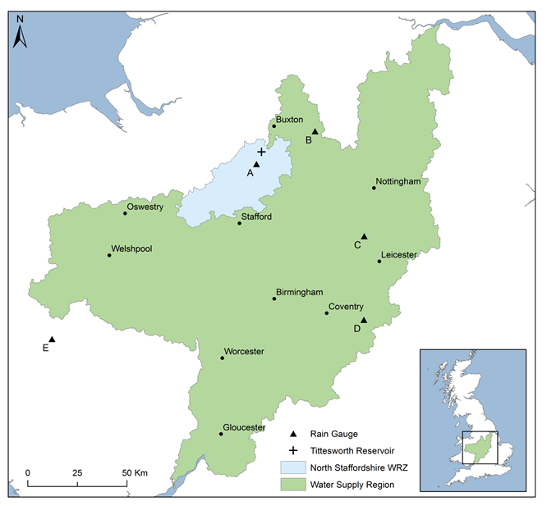
Figure 1: Study area, location of weather stations and location of North Staffordshire Water Resource Zone (WRZ)
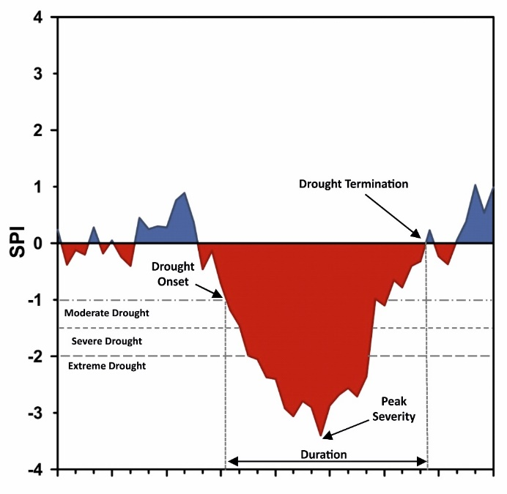
Figure 2: Drought classifications and characteristics

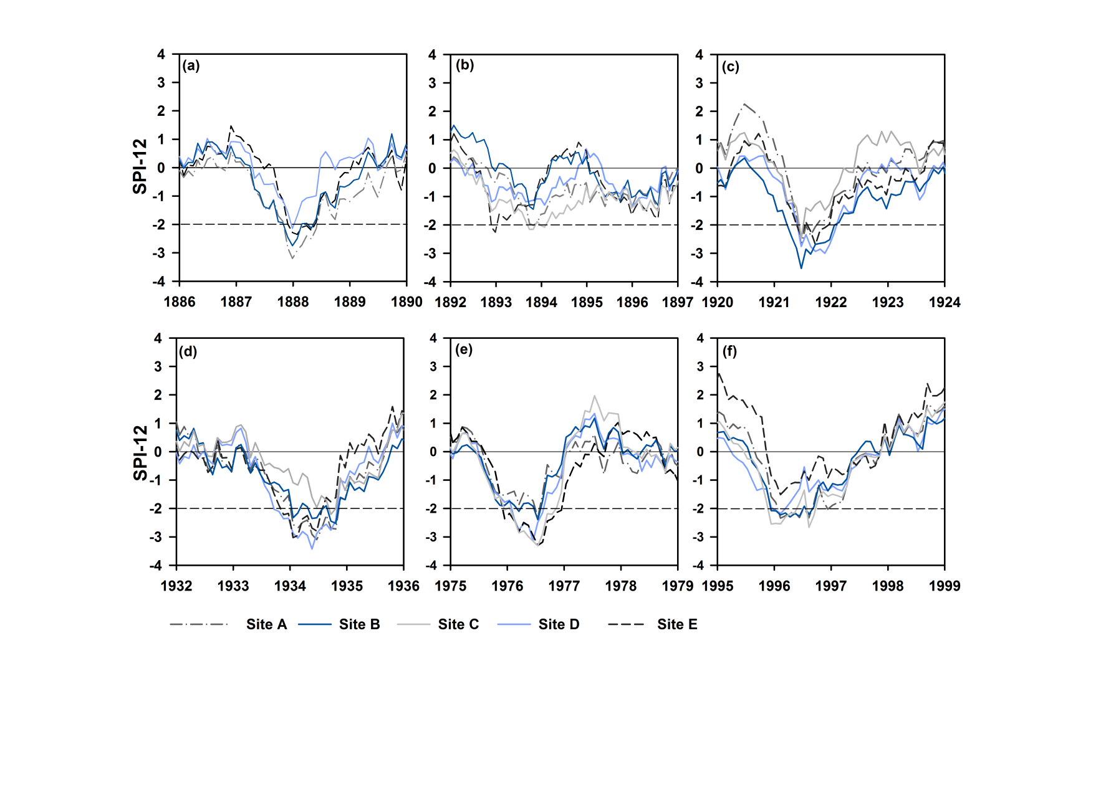
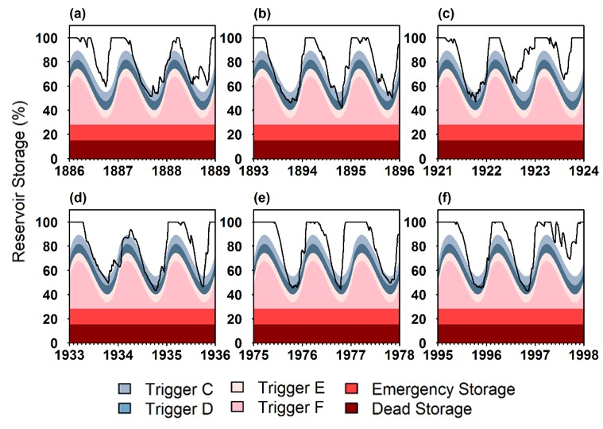
Figure 3: SPI-12 series for sites A-E for the entire length of rainfall record, dashed line indicates extreme drought
Figure 4: SPI-12 series sites A-E for drought periods (a) 1887-1889, (b) 1892-1897, (c) 1921-1923, (d) 1933-1935, (e) 1975-1977, (f) 1995-1997, dashed line indicates extreme drought
Figure 5: Simulated reservoir levels and drought trigger curves for characterised drought periods (a) 1887-1889, (b) 1893-1897, (c) 1921-1923, (d) 1933-1935, (e) 1975-1977, (f) 1995-1997

