Safety and efficacy of subcutaneous tocilizumab in adults with systemic sclerosis: week 48 results from the randomised controlled faSScinate trial

Prof. Dinesh Khanna, MD,¹ Prof. Christopher P Denton, PhD,² Angelika Jahreis, MD,³ Prof. Jacob M van Laar, MD,⁴ Tracy M Frech, MD,⁵ Marina E Anderson, FRCP,⁶ Murray Baron, MD,⁷ Lorinda Chung, MD,⁸ Gerhard Fierlbeck, MD,⁹ Santhanam Lakshminarayanan, MD,¹⁰ Prof. Yannick Allanore, PhD,¹¹ Janet E Pope, MD,¹² Prof. Gabriela Riemekasten, PhD,¹³ Prof. Virginia Steen, MD,¹⁴ Prof. Ulf Müller-Ladner, MD,¹⁵ Prof. Robert Lafyatis, MD,¹⁶ Giuseppina Stifano, MD,¹⁶ Helen Spotswood, PhD,¹⁷ Haiyin Chen-Harris, PhD,³ Sebastian Dziadek, PhD,¹⁸ Alyssa Morimoto, PhD,³ Thierry Sornasse, PhD,³ Jeffrey Siegel, MD,³ Prof. Daniel E Furst, MD¹⁹

¹University of Michigan Scleroderma Program, Ann Arbor, MI, USA; ²University College London, London, UK; ³Genentech, South San Francisco, CA, USA; ⁴University Medical Center Utrecht, Utrecht, Netherlands; ⁵University of Utah, Veterans Affairs Medical Center, Salt Lake City, UT, USA; ⁶University of Liverpool and Aintree University Hospital, Liverpool, UK; ⁷Jewish General Hospital, Montreal, QC, Canada; ⁸Stanford University School of Medicine and Palo Alto VA Health Care System, Palo Alto, CA, USA; ⁹University of Tübingen, Tübingen, Germany; ¹⁰University of Connecticut Health Center, Farmington, CT, USA; ¹¹Paris Descartes University and Cochin Hospital, Paris, France; ¹²Schulich School of Medicine and Dentistry, University of Western Ontario, London, ON, Canada; ¹³Charité University Hospital, German Rheumatism Research Centre, Berlin, Germany; ¹⁴Georgetown University, Washington, DC, USA; ¹⁵Justus-Liebig University Giessen, Kerckhoff Clinic, Bad Nauheim, Germany; ¹⁶Boston University School of Medicine, Boston, MA, USA; ¹⁷Roche Products Ltd., Welwyn Garden City, UK; ¹⁸Roche, Basel, Switzerland; ¹⁹University of California, Los Angeles, CA, USA

Corresponding Author
Dinesh Khanna, MD, MS
Professor of Medicine
Division of Rheumatology, Department of Internal Medicine
University of Michigan Scleroderma Program
300 North Ingalls Street
Ann Arbor, MI 48109, USA
Phone: 734.232.2014
Fax: 734.763.5761
Email: khannad@med.umich.edu

Words: 4466
Graphics: 6 figures, 3 tables
Web Extra Material: 2 figures, 10 tables, Supplementary Materials and Methods
References: 41
Summary (333 words; maximum, 250)
Background Systemic sclerosis (SSc) is a rare disabling autoimmune disease with few treatment options. The efficacy and safety of the interleukin-6 receptor-α inhibitor tocilizumab were assessed in the faSScinate phase 2 trial in patients with SSc.
Methods This global, double-blind, placebo-controlled study enrolled adult patients with progressive SSc of ≤5 years’ duration from first non-Raynaud’s sign or symptom. Patients were randomly assigned (1:1) to weekly subcutaneous tocilizumab 162 mg or placebo for 48 weeks. The primary efficacy endpoint was the difference in mean change from baseline in modified Rodnan skin score (mRSS) at week 24. Gene expression analysis was performed on skin biopsy specimens collected at baseline and week 24. Cartilage oligomeric matrix protein, periostin, autotaxin, and CCL18 serum levels were determined using immunoassays.
Findings Eighty-seven patients received tocilizumab (n=43) or placebo (n=44). The primary endpoint showed a treatment difference of –2·70 mRSS units (95% CI: –5·85, 0·45) in favour of tocilizumab at week 24 but did not meet statistical significance (p=0·0915). At week 48, the treatment difference was –3·55 mRSS units (95% CI: −7·23, 0·12), favouring tocilizumab over placebo (p=0·0579). Exploratory analysis of lung function showed that fewer patients in the tocilizumab arm had a decline in percent predicted forced vital capacity than in the placebo arm by comparison of the cumulative distribution (week 48, p=0·0373). Tocilizumab downregulated the expression of myeloid-associated genes in the skin and decreased circulating levels of CCL18, a chemokine associated with fibrosis and progression of SSc-associated lung disease. The proportions of patients with adverse events/serious adverse events were not different between tocilizumab (42/43 [97·7%]/14/43 [32·6%]) and placebo (40/44 [90·9%]/15/44 [34·1%]) but were higher for serious infections in the tocilizumab group (seven patients) than in the placebo group (two patients).
Interpretation Tocilizumab was associated with a numerical reduction in skin thickening and less decline in forced vital capacity. These efficacy outcomes along with safety data and insights into the potential mechanism of action of tocilizumab support pursuing a phase 3 study.
Funding F. Hoffmann-La Roche/Genentech (ClinicalTrials.gov, number NCT01532869).
Introduction
Systemic sclerosis (SSc) is a rare connective tissue disorder characterised by fibrosis, inflammation, and microvascular injury with heterogeneous clinical presentations. Pulmonary, cardiac, gastrointestinal (GI), and renal complications contribute to patient morbidity and decreased survival.¹
Increasing evidence supports important roles for interleukin-6 (IL-6) in the pathogenesis of SSc,² including B-cell differentiation towards immunoglobulin-secreting plasma cells, T-cell differentiation towards Th17 and Th2 cell types, and transformation of fibroblasts to myofibroblasts leading to extracellular matrix synthesis.² Dermal fibroblasts from SSc patients constitutively express higher levels of IL-6 than found in healthy controls,³ and serum and skin levels of IL-6 are elevated in SSc patients with early disease.^{4,5} In patients with SSc⁶ or SSc-interstitial lung disease (ILD), increased IL-6 levels have been associated with higher mortality, more severe skin involvement, and increased incidence of progressive pulmonary decline.⁴ Although the exact cellular mechanisms of the effects of IL-6 on fibrosis are unknown, myeloid cells are implicated in SSc skin pathogenesis.⁷ mRNA expression of a cluster of macrophage genes, including CD14 in the skin, correlates strongly with modified Rodnan skin score (mRSS), and CD14 expression is prognostic for progressive skin disease.⁸ M2-macrophages appear to play an important role in mediating inflammation and promoting fibrosis through the release of profibrotic factors.^{9,10}
Blockade of the IL-6 pathway reduced skin fibrosis, α−smooth-muscle actin protein expression,¹¹hydroxyproline content, and myofibroblast counts in the bleomycin mouse model.⁵ Initial data in SSc patients indicated that treatment with tocilizumab improved skin sclerosis and SSc-associated polyarthritis.^{12,13}
Autotaxin (ENPP2) is an IL-6–induced enzyme associated with fibrosis development and is elevated in the circulation of SSc patients.¹⁴ ENPP2 catalyses production of lysophosphatidic acid (LPA),¹⁵ and elevated levels of circulating LPA are associated with SSc pathobiology.^{16,17} Serum levels of cartilage oligomeric matrix protein (COMP) correlate with skin fibrosis and predict mortality in SSc patients.¹⁸ Elevated serum levels of chemokine (C-C motif) ligand 18 (CCL18) are associated with scleroderma-associated pulmonary fibrosis and ILD progression,^{19,20} and elevated serum levels of periostin (POSTN) are associated with the degree of skin fibrosis in patients with SSc.²¹

The faSScinate phase 2 trial was conducted to investigate the efficacy and safety of IL-6 blockade with tocilizumab in SSc and to perform exploratory analysis of biomarkers.

Methods
Study design and participants
This randomised, double-blind, placebo-controlled study was conducted in 35 centres across Canada, France, Germany, the United Kingdom, and the United States. Investigators from each centre enrolled eligible patients 18 years of age or older who met the 1980 American College of Rheumatology criteria for SSc²² with ≤5 years’ disease duration since their first non-Raynaud’s sign or symptom and mRSS from 15 to 40 units. At screening, active progressive disease of <1 year’s duration was required—increase of ≥3 mRSS units, involvement of one new body area with increase in mRSS ≥2 units or two new body areas with increase in mRSS ≥1 unit, other documentation of worsening skin thickening in the previous 6 months, or ≥1 tendon friction rub plus ≥1 laboratory criterion (C-reactive protein [CRP] ≥10·0 mg/L, erythrocyte sedimentation rate ≥28 mm/h, or platelets ≥330×1000/μL). All patients provided written informed consent. Patients or caregivers could administer subcutaneous (SC) investigational drug injections. Eligible patients had clinically uninvolved skin in ≥1 body area for study drug injections.
Each site’s institutional review board/ethics committee approved the protocol before the study commenced. The study was conducted in accordance with the Declaration of Helsinki and with Good Clinical Practice.
Randomisation and masking
Patients were randomly assigned (1:1) using an interactive voice/web response system to receive weekly subcutaneous treatment with tocilizumab 162 mg or placebo for 48 weeks followed by open-label weekly tocilizumab for 48 weeks. Randomisation numbers were generated by the sponsor, and randomisation was stratified by joint involvement at baseline (<4 or ≥4 joints on the 28 tender joint count [TJC]). Investigators, patients, and sponsor personnel were blinded to treatment assignment. To prevent potential unblinding, separate assessors evaluated efficacy and safety. The efficacy assessor did not have access to safety data during the double-blind phase of the trial, but the safety assessor had access to both efficacy and safety data. Although some sponsor personnel were unblinded after the primary analysis at week 24, treatment blind was maintained for personnel interacting with sites and site staff until the week 48 database lock.
Procedures
Escape therapy with methotrexate, hydroxychloroquine, or mycophenolate mofetil was permitted after week 24 for patients with ≥20% worsening mRSS from baseline, worsening SSc-associated complications such as arthritis and ILD, or both, as determined by the treating investigator. The primary endpoint was the difference in mean change from baseline in mRSS to week 24. Secondary endpoints included patient-/physician-reported outcomes to weeks 24 and 48 (Health Assessment Questionnaire–Disability Index [HAQ-DI] score, patient global visual analogue scale [VAS, 0-100], physician global VAS, Functional Assessment of Chronic Illness Therapy [FACIT]-Fatigue score, and pruritus 5-D Itch), change from baseline in mRSS to week 48, proportion of patients with change from baseline in mRSS at week 48 greater than or equal to change from baseline in mRSS at week 24, and change from baseline in VAS score (intestinal, breathing, Raynaud’s disease, finger ulcers, overall disease from the Scleroderma Health Assessment Questionnaire–Disability Index [SHAQ-DI]). Exploratory endpoints included proportion of patients achieving minimum clinically important difference²⁴ (improvement ≥0.22 and ≥0·14) in the HAQ-DI at week 48, proportion of patients with 20%/40%/60% and ≥4·7 units (minimum clinically important difference²⁴) improvement in mRSS at weeks 24 and 48, change from baseline at weeks 24 and 48 in pulmonary function measured by forced vital capacity (FVC; mL), percent predicted FVC (%pFVC), percent predicted diffusing capacity for carbon monoxide (%pDLCO), and change from baseline at weeks 24 and 48 in 28 TJC in patients with joint involvement (≥4 tender joints at baseline). Safety monitoring for adverse events (AEs) and serious AEs (SAEs) and laboratory monitoring were performed at least every 8 weeks. Exploratory biomarker analyses included gene expression analysis of skin biopsy specimens collected at baseline and at week 24 and COMP, POSTN, and CCL18 serum levels determined using immunoassays (see appendix for complete method description).
Statistical analyses
A sample size of 36 patients per group (86 patients total, allowing for 15% dropout) was determined to provide 80% power to detect a difference in means for the change in mRSS from baseline to week 24 of 4·7 units, based on an estimated common standard deviation of 6·99²³ using a two-group t-test with a 5% two-sided significance level.
The primary endpoint was analysed using a mixed-model repeated-measures (MMRM) approach. There was no imputation of missing data before the MMRM analyses, and all were stratified by joint involvement at baseline. Patients discontinuing treatment before the end of the double-blind period underwent their last evaluation at the time of discontinuation. Except for exploratory analysis of pulmonary function, which included all available data, all week 48 MMRM analyses of secondary endpoints used data that were censored after initiation of escape therapy. The MMRM approach assumes that data are missing at random; therefore, sensitivity analyses were performed on the primary endpoint to account for data that might not have been missing due to random chance (appendix table S1).
Patients with a missing mRSS assessment at week 24 or week 48 were considered non-responders for analysis of 20/40/60% improvement in mRSS from baseline. Similarly, a non-responder approach was used for the minimal clinically important difference²⁴ for HAQ-DI and mRSS and maintenance of mRSS response. The van Elteren test (stratified by joint involvement) was used to compare the treatment effect on the cumulative distribution of change from baseline in %pFVC and %pDLCO. No adjustment was made for multiplicity in statistical testing for any of the analyses. For SAE rates per 100 patient-years, multiple occurrences of events in a patient were counted, and confidence intervals were based on the Poisson distribution. The analysis population for efficacy was the modified intent-to-treat (mITT) population, which included all randomly assigned patients who received any study drug. No randomly assigned patients were excluded from the mITT population, and patients were analysed by assigned treatment. The safety population included all patients who received study drug and provided ≥1 post-dose safety assessment, summarised by treatment received.

Role of the funding source
The sponsor designed the study in collaboration with the authors. The sponsor collected, analysed, and interpreted the data and drafted the report. All authors contributed to data interpretation, revised the manuscript, and attest to the accuracy and completeness of the reported data. The corresponding author had full access to all data congregates in the study and made the final decision to submit the manuscript for publication.

Results
Patients were randomly assigned from March 13, 2012, to June 18, 2013; the last patient completed the week 48 visit on May 20, 2014. Eighty-seven patients were randomly assigned to treatment and were included in the intent-to-treat and safety populations (figure 1). At week 48, 12 of 44 placebo-treated patients and 6 of 43 tocilizumab-treated patients had received escape therapy. The numbers of patients who withdrew were similar between treatment arms: tocilizumab—safety (n=8 [five AEs, three deaths]), non-safety (n=5 [three patient decision, one lack of efficacy, one lost to follow-up]); placebo—safety (n=4 [AEs]), non-safety (n=7 [five patient decision, one clinician decision, one non-compliance]). Baseline demographics and disease characteristics were well balanced between treatment arms (table 1).
The primary endpoint was not met at week 24. A numerically larger, but not statistically significant, improvement in mRSS was seen with tocilizumab compared with placebo (table 2, figure 2). Least squares mean (LSM) change in mRSS from baseline to week 24 was –3·92 in tocilizumab patients and –1·22 in placebo patients (treatment difference, –2·70 [95% confidence interval (CI): –5·85, 0·45]; p=0·0915). The observed mean (SD) mRSS at week 24 was 21·84 (9·89) for tocilizumab (n=37) and 23·21 (9·26) for placebo (n=38). Results through week 48 showed a continued numerically larger treatment benefit beyond 24 weeks, with LSM change from baseline of –6·33 with tocilizumab and –2·77 with placebo (treatment difference, −3·55 [95% CI: −7·23, 0·12]; p=0·0579) (table 2, figure 2). The observed mean (SD) mRSS at week 48 was 19·56 (10.08) for tocilizumab (n=32) and 22·27 (8·05) for placebo (n=33). Among improvers in mRSS at week 24, more tocilizumab than placebo patients maintained or had further improvement in mRSS at week 48 (placebo, 8/18 [44·4%]; tocilizumab, 15/ 22 [68·2%]). At week 48, a numerically higher proportion of tocilizumab than placebo patients had mRSS improvement of at least 20%, 40%, 60% or of ≥4 7 mRSS units (figure 2). Eight placebo and four tocilizumab patients had an increase in mRSS >5 units and ≥25% from baseline²⁵ at any time to week 24.
For patient- and physician-reported outcomes at weeks 24 and 48, the treatment difference between tocilizumab and placebo patients in LSM change from baseline was not statistically significant. For clinician and patient global VAS and FACIT-fatigue scores, favourable responses for tocilizumab compared to placebo were observed at week 48 (table 2). For the week 48 HAQ-DI result—though not statistically significant—the treatment difference of –0·207 (95% CI: –0·471, 0·056; p=0·1212) favoured tocilizumab versus placebo. In addition, at week 48, a numerically higher proportion of patients receiving tocilizumab than placebo achieved an improvement of ≥0·22 in HAQ-DI (28% vs 7%, respectively; p=0·0111), with identical results for improvement defined as ≥0·14. Overall, with the exception of breathing VAS score, all SHAQ-DI VAS scores at week 48 showed a numerical, but not statistically significant, difference between arms favouring tocilizumab (see appendix and table S2).
Twenty-one tocilizumab and 20 placebo patients had joint involvement. Among these patients, mean (median) TJCs declined from baseline by 4·3 (2·5) (n=16) and 5·10 (4·5) (n=10) with tocilizumab and 2·1 (2·0) (n=17) and 2·9 (2·5) (n=12) with placebo at weeks 24 and 48, respectively.
Patients with SSc are at risk for ILD and progressive decline in FVC.²⁶ Pulmonary function testing showed, on average, a smaller decrease in FVC from baseline for tocilizumab than for placebo at weeks 24 (LSM difference, 136 mL [95% CI: 9, 264]; p=0·0368) and 48 (LSM difference, 120 mL [95% CI: –23, 262]; p=0·0990) (figure 3A).Cumulative distribution plots of change from baseline in %pFVC at weeks 24 (figure 3B) and 48 (figure 3C) indicated that fewer tocilizumab than placebo patients experienced worsening of %pFVC (p=0·009, week 24; p=0·0373, week 48). At weeks 24 and 48, respectively, 3% and 10% of tocilizumab-treated patients compared with 19% and 23% of placebo-treated patients experienced >10% (absolute) decreases in %pFVC from baseline. LSM changes from baseline in %pFVC for tocilizumab versus placebo at weeks 24 and 48, respectively, were –0·7 (95% CI: –3·2, 1·8) versus –4·5 (95% CI: –7·0, –1·9) and –2·6 (95% CI: –5·2, –0·1) versus –6·3 (95% CI: –8·9,-3·8). At week 48, change from baseline in %pDLCO did not reveal differences between placebo and tocilizumab (appendix figure S1). Correlations between improvements in mRSS and change in %pFVC from baseline to week 48 were similar for both treatment arms (tocilizumab, r=–0·311, p=0·121; placebo, r=–0·278, p=0·223; appendix figure S2). Among patients with available week 48 mRSS data, 4 of 32 (13%) tocilizumab-treated patients and 9 of 33 (27.3%) placebo-treated patients received escape therapy.
Exploratory analysis of the circulating biomarkers COMP, POSTN, ENPP2, and CCL18 was conducted on serum samples from all available patients and time points using specific immunoassays (figure 4). Serum levels of COMP, POSTN, ENPP2, and CCL18 at baseline were all significantly elevated compared with those of age- and gender-matched healthy controls (p<0·0001 for all biomarkers; two-tailed t test assuming unequal variance). Treatment with tocilizumab resulted in a significant decrease in serum levels of CCL18 (figure 4A) but no apparent effect on COMP (figure 4B), POSTN (figure 4C), or ENPP2 (figure 4D). Exploratory gene expression analysis was conducted on skin biopsy specimens collected at baseline and week 24 from the forearms of a subset of patients (placebo baseline, n=39; placebo week 24, n=30; tocilizumab baseline, n=34; and tocilizumab week 24, n=28) and of 20 age- and gender-matched healthy controls. First, Gene Set Enrichment Analysis (GSEA²⁷; Assaf Oron and Robert Gentleman: GSEAlm: Linear Model Toolset for Gene Set Enrichment Analysis; R package version 1.30.0) for fibrosis, interferon-α (IFN-α), IL-6, transforming growth factor-β (TGF-β), M1-macrophage, and M2-macrophage gene sets (appendix tables S3, S4, S5, S6, S7, and S8, respectively) was conducted on the microarray data obtained from all available samples. At baseline, fibrosis, IFN-α, IL-6, TGF-β, M1-macrophage, and M2-macrophage gene sets were significantly enriched for genes upregulated by SSc compared with those of healthy controls (p=0·005, appendix table S9). None of these gene sets were significantly enriched for genes downregulated by tocilizumab when comparing week 24 samples to baseline (appendix table S10). However, we observed non-significant enrichment in IFN-α (p=0·07), IL-6 (p=0·095), and M2-macrophage (p=0·105) gene sets for genes downregulated by tocilizumab (appendix table S10); no enrichment was observed in placebo patients (appendix table S11).
Genome-wide analysis of gene expression in these biopsy samples was used to select a set of 83 genes by unsupervised clustering of genes overexpressed in SSc and downregulated by tocilizumab and genes correlating with mRSS (see appendix). Confirmatory analysis was conducted on these 83 genes using nCounter technology (NanoString Technologies; figure 5). Of these 83 genes representing the fibrosis/TGF-β, IL-6, IFN, and myeloid pathways, 62 transcripts were significantly overexpressed and two were significantly underexpressed in SSc patients compared with healthy controls (t-test, Bonferroni correction for multiple comparisons). Clustering analysis of the average gene expression for the placebo baseline, placebo week 24, tocilizumab baseline, and tocilizumab week 24 groups yielded nine clusters representing TGF-β, IL-6/STAT3, M1-macrophage, M2-macrophage, and IFN (figure 5). Analysis of the effect of treatment on change in gene expression levels at week 24 identified 16 genes specifically downregulated by tocilizumab compared with placebo (uncorrected p<0·05). Although most of these genes (12/16) belonged to the M2-macrophage cluster, two belonged to the M1-macrophage cluster, suggesting inhibitory activity of tocilizumab on macrophages in general and M2-macrophages in particular. Gene expression in the IL-6/STAT3 cluster was numerically reduced by tocilizumab at week 24 compared with placebo, but two genes (CCL2 and SOCS3) were significantly downregulated by tocilizumab, possibly reflecting the residual activity of other STAT3-activating factors (e.g. epidermal growth factor [EGF], IL-5, IL-6, hepatocyte growth factor [HGF], leukaemia inhibitory factor [LIF], and BMP2, which are not blocked by tocilizumab. None of the genes in the TGF-β-1 or TGF-β-2 clusters were significantly downregulated by tocilizumab compared with placebo, probably because the expression of these genes was numerically reduced at week 24 in the skin of tocilizumab- and placebo-treated patients, suggesting a tocilizumab-independent reduction in the fibrotic pathway in both treatment groups. Gene expression in the IFN cluster was highly heterogeneous, limiting our ability to identify any apparent pattern of expression in this gene cluster.
Finally, using the same data set, we tested the differential effect of treatment with tocilizumab on a recently developed multi-analyte, longitudinal, pharmacodynamic biomarker (2GSSc skin biomarker²⁸). This biomarker, which yields predicted mRSS values based on the weighted values for THBS1 and MS4A4A mRNA expression, was validated and has been applied to two clinical trials, indicating that it is a robust surrogate outcome measure for the extent of SSc skin disease.²⁹ At baseline, the predicted mRSS values were similar between treatment groups (placebo mean [95% CI]: 16·4 [15·1, 17·8]; tocilizumab mean [95% CI]: 15·5 [14·1, 17·0]; figure 6). Comparison of the change in predicted mRSS at week 24 indicated that treatment with tocilizumab resulted in a significant decrease in predicted mRSS compared with treatment with placebo (Δ placebo mean [95% CI]: –0·98 [–2·99, 1·03]; Δ tocilizumab mean [95% CI]: –4·03 [–7·58, –0·49]; p=0·0488; figure 6).

Safety
At weeks 24 and 48, the proportions of patients with AEs in the tocilizumab (38/43 [88·4%]; 42/43 [97·7%]) and placebo (40/44 [90·9%]; 40/44 [90·9%]) arms were comparable, as were withdrawal rates attributed to AEs (table 3). The most frequently reported AEs included infections, GI disorders, skin/subcutaneous disorders, and musculoskeletal/connective tissue disorders (appendix table S12). Serious infections were more frequent with tocilizumab (seven patients) than placebo (two patients), whereas non-infectious SAEs, including cardiac disorders, GI disorders, and renal and urinary disorders, were more frequent with placebo. Osteomyelitis involving proximal interphalangeal joints occurred in two tocilizumab patients and one placebo patient. No anaphylaxis, GI perforations, or malignancies were observed, and SC injections were well tolerated. Total exposure to study drug before open-label treatment was 34·49 patient-years (PY) for tocilizumab and 36·77 PY for placebo. The overall SAE rate was 66·7% (95% CI: 42·3, 100·1)/100 PY with tocilizumab and 76·1 (95% CI: 50·6, 110·0)/100 PY with placebo, the serious infection rate was 34·8 (95% CI: 18·0, 60·8)/100 PY and 10·9 (95% CI: 3·0, 27·9)/100 PY, and the noninfectious SAE rate was 31·9 (95% CI: 15·9, 57·1)/100 PY and 65·3 (95% CI: 41·8, 97·1), respectively.
Four deaths were reported by week 48.One placebo patient died of cardiac failure, and three tocilizumab patients died of one event each of arrhythmia, multiorgan failure, and lung infection. Only one event, lung infection, was considered related to study drug (see appendix for details).

Laboratory parameters of interest for tocilizumab (elevated alanine/aspartate aminotransferase, decreased neutrophils, and decreased platelets) were mostly grade 1/2 in intensity and were not temporally associated with clinically relevant sequelae such as hepatic events, serious infections, or serious bleeding events.

Discussion
In this first phase 2 randomised controlled trial of tocilizumab for the treatment of SSc, the primary (mRSS) and secondary efficacy endpoints were not met at week 24 or 48. However, consistent improvements in skin thickness through week 48 in the tocilizumab arm were evident, with mRSS improvement at weeks 24 and 48 within published minimal clinically important differences for early, diffuse SSc.²⁴ HAQ-DI, clinician global VAS, and other patient-reported outcomes favoured tocilizumab over placebo, though they did not reach statistical significance. Significantly fewer patients receiving tocilizumab than patients receiving placebo had absolute FVC declines of >10% . ²⁰
The current study shows a clinically meaningful decline in mRSS²⁴ over 1 year in the tocilizumab group compared with the placebo group. Selection of patients with early progressive disease might have been important for observing this effect In fact, eight patients in the placebo group and four patients in the tocilizumab group had progressive skin disease based on an increase in mRSS of >5 units and ≥25% worsening²⁵ at any time between baseline and week 24. Skin thickness is a surrogate for internal organ involvement and mortality in SSc, and patients with attenuated skin thickness have improved survival and physical function^{30,31}Conversely, patients with high mRSS have greater internal organ involvement³² and are at greater risk for death.³⁰
SSc has the highest case fatality among rheumatic diseases, with a cumulative survival rate of 74·9% at 5 years from diagnosis.³³ Cardiopulmonary involvement is the leading cause of death,¹ and FVC is the primary outcome measure in most SSc-ILD and idiopathic pulmonary fibrosis trials.³⁴ Elevated CRP levels have been associated with progressive ILD, and observational cohorts suggest that baseline elevated CRP predicts long-term FVC decline.^{6,35} Although our study was not specifically designed to enrol patients with progressive SSc-ILD, enrolling those with early progressive skin disease and elevated acute-phase reactants likely enriched for SSc patients at high risk for ILD. Our data suggest that tocilizumab may have a disease-modifying effect by slowing the decline in lung function of patients with SSc.
Treatment with tocilizumab resulted in the specific downregulation of skin myeloid– associated genes, including M2-macrophage–associated genes. Perivascular macrophages (resident and/or recruited) contribute to vascular inflammation,³⁶ and M2-macrophages may play an important role in SSc skin pathology through the release of inflammatory and profibrotic factors.¹⁰ It is therefore tempting to speculate that the improvement in skin disease in patients treated with tocilizumab may be attributed to the inactivation and/or depletion of skin macrophages in general and M2-macrophages in particular. Furthermore, treatment with tocilizumab resulted in rapid, sustained reductions in serum levels of the M2-macrophage–associated chemokine CCL18, strengthening the hypothesis that tocilizumab may act, at least in part, by modulating the activity of M2-macrophages. Given that serum CCL18 is a prognostic biomarker that identifies patients at higher risk for the progression of scleroderma lung disease,¹⁹ it is possible that the effect of tocilizumab on circulating CCL18 may be related to the positive clinical effect of tocilizumab on lung function deterioration. These hypotheses will be further explored in the ongoing phase 3 study of tocilizumab in SSc patients.
Tocilizumab tended to inhibit skin expression of genes in the IL-6/STAT3 cluster (n=19), but only two genes from this cluster (CCL2 and SOCS3) were significantly downregulated by tocilizumab at week 24 compared with placebo. This relatively modest apparent effect of tocilizumab on the IL-6 pathway may be the result of residual activity of the multiple additional factors (e.g. EGF, IL-5, IL-6, HGF, LIF, and BMP2) that are known to activate the STAT3 pathway but are not inhibited by tocilizumab. We did not observe specific effects of tocilizumab on genes belonging to the TGF-β clusters or the IFN cluster, suggesting that the clinical effect of tocilizumab may not be mediated through these pathways. However, heterogeneity in the expression of genes associated with these pathways might have prevented the detection of subtle effects of tocilizumab on these genes. Tocilizumab did not affect the serum levels of ENPP2, COMP, or POSTN, three biomarkers related to fibrosis, suggesting that the observed clinical effect of tocilizumab on skin fibrosis may not be mediated by direct inhibition of the fibrosis pathway by tocilizumab. Finally, consistent with the clinical effect of tocilizumab on skin fibrosis as measured by mRSS, treatment with tocilizumab resulted in a significant decrease in the two-gene SSc skin biopsy– predicted mRSS. The magnitude of change in predicted mRSS was similar to that observed clinically.
Overall, after 48 weeks of treatment, safety in faSScinate was consistent with the natural history of SSc and the known safety profile for tocilizumab (table 3, appendix table S12). Reflecting the high morbidity and mortality rates seen in SSc,¹ greater incidences of SAEs, serious infections, and deaths were seen in faSScinate than in clinical trials of tocilizumab in RA.
Three patients in the tocilizumab group and one in the placebo group died, but only one death was judged by the investigator to be related to tocilizumab. Based on the higher number of tocilizumab than placebo deaths in faSScinate, it will be important to assess mortality rates and causes of death carefully during the phase 3 tocilizumab study in SSc, which has just been initiated.
Furthermore, a higher rate of serious infections was observed in the tocilizumab arm. These included bronchitis, lung infection, pneumonia, and sepsis, which are similar to the types of events observed during RA treatment with tocilizumab. Small bone osteomyelitis and infected digital ulcers, however, are infections not commonly observed during therapy with tocilizumab in RA patients and thus may require particular vigilance in SSc patients.
Although the GI tract is the most frequently affected internal organ in patients with SSc,¹ no patients in faSScinate had GI perforations. Most injection site reactions, elevations in alanine/aspartate aminotransferase levels, and decreases in neutrophil and platelet counts were grade 1/2 and involved no clinically relevant sequelae.
No disease-modifying therapy is yet approved for SSc, and its management is based on organ involvement.^{37,38} Methotrexate affected skin thickening without establishing positive effects in patients with other organ manifestations,^{37,39} whereas oral cyclophosphamide modestly improved lung function and skin thickness in studies of patients with SSc-ILD.⁴⁰ Recent data from a clinical trial⁴¹ in haematopoietic stem cell transplantation suggested a disease-modifying effect in patients with SSc; thus, haematopoietic stem cell transplantation may be considered an option for selected patients with rapidly progressing and severe SSc. Data from this trial suggest that tocilizumab may have a broader effect on SSc skin and lung disease than methotrexate and a more favourable risk/benefit profile than cyclophosphamide.
Limitations of this study include selection of week 24 for the primary endpoint; this was based on the assumption that the rapid response of tocilizumab seen in clinical trials of RA would translate to a rapid response in patients with SSc. The relatively high discontinuation rate should be taken into account when interpreting data from this study. FVC was an exploratory endpoint, and high-resolution chest tomography, which was not performed to substantiate the pulmonary function data, is planned for a phase 3 study. Cohort enrichment of patients with a higher probability of skin progression and elevated acute-phase reactants might have contributed to the treatment responses observed.

Conclusion
FaSScinate is the first placebo-controlled study in early SSc demonstrating an improvement of skin sclerosis (albeit not statistically significant) and aclinically relevant improvement in lung function with an acceptable safety profile. The safety profile was consistent with known SSc complications and with the safety profile of tocilizumab. The propensity of SSc patients to develop digital ulcers could increase susceptibility to small bone osteomyelitis and infections of digital ulcers during tocilizumab therapy. Overall, the data suggest a positive benefit/risk profile for tocilizumab in SSc, warranting further investigation.

Research in Context
Evidence before this study
In vivo data demonstrating elevated IL-6 levels in serum and skin biopsy samples of patients with SSc, associated with greater disease activity and higher mortality rates, provided evidence that IL-6 may play an important role in the pathogenesis of SSc. In addition, serum IL-6 levels in patients with early SSc have been shown to predict the extent of future progression of skin disease. Supportive evidence for a role of IL-6 in skin fibrosis was provided by the bleomycin-induced mouse model of scleroderma in which an IL-6 blocking antibody reduced dermal sclerosis in both a prevention model and a therapeutic model. Furthermore, the extent of fibrosis was attenuated in IL-6 knockout mice. Additional preliminary evidence of efficacy came from two therapy-refractory patients with SSc, who experienced improvement in skin thickening after treatment with tocilizumab for 6 months. Myeloid cells have been increasingly implicated in SSc skin pathogenesis. In particular, alternatively activated macrophages appear to play an important role in the pathobiology of SSc by mediating fibrosis through the release of profibrotic mediators such as CCL18.
Several literature searches through the US National Library of Medicine, National Institutes of Health were conducted before protocol finalisation on August 23, 2011. These included the search terms systemic sclerosis or scleroderma and a combination of systemic sclerosis with any of the following search terms: IL-6, biomarkers, CCL-18, review, modified Rodnan skin score, clinical trials, and interstitial lung disease. In addition, rheumatology textbooks written in standard English were reviewed, and an advisory board with experts in the field of systemic sclerosis was convened.

Added value of this study
This is the first placebo-controlled study in patients with early SSc to show efficacy, as evidenced by a clinical, though not a statistically significant, amelioration of skin sclerosis, better patient-reported outcomes, and clinically relevant improvement in lung function in patients treated with the anti–IL-6 receptor-alpha inhibitor tocilizumab. Tocilizumab had an acceptable safety profile in these patients. The biomarker findings suggest that tocilizumab may ameliorate SSc skin disease by inhibiting skin myeloid cells in general and alternatively activated macrophages in particular.

Implications of all the available evidence
Given the lack of disease-modifying treatment options for patients with SSc, combined with the morbidity and mortality associated with this disease, data from the faSScinate trial provide hope regarding a potential future treatment for patients with SSc. FaSScinate was a phase 2 study; therefore, the efficacy and safety of tocilizumab must be further investigated in an adequate, randomised, well-controlled phase 3 trial before definitive conclusions can be drawn about its risk/benefit profile.

Contributors
All authors revised the draft for important intellectual content and approved the final draft for publication. In addition, each made the following contributions:
DK conceived of the study design, participated in patient recruitment, gave advice on data analysis, interpreted the data, drafted the manuscript, reviewed the comments of all coauthors, and made the decision to submit the manuscript for publication.
CPD conceived of and designed the study; participated in patient recruitment; acquired, analysed, and interpreted the data; and drafted the manuscript.
AJ designed the study, provided study oversight, interpreted the data, and drafted the manuscript.
JMvL conceived of and designed the study and acquired data.
TMF acquired data.
MEA designed the study.
MB acquired and interpreted data.
LC acquired and interpreted data and drafted the manuscript.
GF acquired, analysed, and interpreted data and recruited patients.
SL acquired data.
YA acquired, analysed, and interpreted data.
JEP conducted a literature search; developed the protocol; acquired, analysed and interpreted data; and drafted the manuscript.
GR designed the study (endpoints and inclusion/exclusion criteria), acquired and interpreted data, and performed basic research supporting the rationale.
VS designed the study and acquired data.
UM-L analysed and interpreted data.
RL acquired, analysed, and interpreted data.
GS designed the study and acquired, analysed, and interpreted data.
HS conceived of and designed the study and analysed and interpreted data.
HC-H acquired and analysed data and wrote the manuscript.
SD conceived of and designed the study and acquired data.
AM acquired, analysed and interpreted data and wrote the manuscript.
TS acquired, analysed and interpreted data and wrote the manuscript.
JS conceived of and designed the study and acquired data.
DEF designed the study, acquired and analysed data, and wrote the manuscript.

Declaration of interests
DK has received grants from Bristol-Myers Squibb, Genentech/Roche, NIH/NIAID, NIH/NIAMS, PCORI, and the Scleroderma Foundation; and consultancy fees from Actelion, Bayer, Cytori, EMD Serono (Merck), Genkyotex, Gilead, GlaxoSmithKline, Genentech/Roche, Sanofi Aventis, and Seattle Genetics.
CPD has received grants from CSL Behring and GlaxoSmithKline (paid to his institution); consultancy fees from GlaxoSmithKline and Roche (paid to his institution); consultancy fees from Merck-Serono; and speaker fees from Actelion and Bayer.
AJ is an employee of and owns stock options in Genentech, a member of the Roche group, and has been issued a patent (US 8580264 B2).
JMvL has received honoraria from Merck Sharp & Dohme, Pfizer, Roche, and Eli Lilly.
TMF has nothing to disclose.
MEA has received ad board and related fees from Actelion and honoraria from Actelion and Bristol-Myers Squibb and has served as principal investigator of clinical trials for Actelion and Roche.
MB has nothing to disclose.
LC has served on an advisory board for Gilead and a data monitoring committee for Cytori.
GF has nothing to disclose.
SL has nothing to disclose.
YA has received grants from Bristol-Myers Squibb, Roche/Genentech, Inventiva, Pfizer, Sanofi, and Servier; and personal fees from Actelion, Bayer, Roche/Genentech, Inventiva, Medac, Pfizer, Sanofi, Servier, and UCB.
JEP has received research and consulting fees from Roche and consulting fees from Actelion, Bayer, Biogen, Celgene, and Genentech.
GR has received honoraria for lectures and advisory boards outside the submitted work.
VS has received a grant and advisory board fees from Roche.
UM-L has received grants and speaker/advisory board fees from Roche and Chugai.
RL has received grants from Shire, Sanofi, Regeneron, Genentech, UCB, HGS, Precision Dermatology, Biogen, BMS, Inception, Stromedix, PRISM, Pfizer, Boston University, Bristol-Myers Squibb, and PRISM; and consultancy fees from Shire, Sanofi, Regeneron, Roche/Genentech, Biogen, Lycera, Novartis, Celgene, Bristol-Myers Squibb, Amira, Celdara, Celltex, Dart Therapeutics, Idera, Inception, Intermune, Medimmune, Precision Dermatology, Promedior, Zwitter, PRISM, UCB, Actelion, EMD Serono, Akros, Extera, Reneo, Scholar Rock, and Merck.
GS has nothing to disclose.
HS is an employee of Roche Products Ltd. and owns stock in Roche.
HC-H is an employee of Genentech, a member of the Roche group.
SD is an employee of Roche Diagnostics/F. Hoffmann-La Roche AG.
AM is an employee of Genentech, a member of the Roche group.
TS is an employee of Genentech, a member of the Roche group, and holds stocks, stock options, or bond holdings in Genentech.
JS is an employee of Genentech, a member of the Roche group.
DEF has received grants from AbbVie, Actelion, Amgen, Bristol-Myers Squibb, Gilead, GlaxoSmithKline, National Institutes of Health, Novartis, Pfizer, Roche/Genentech, UCB; consultancy fees from AbbVie, Actelion, Amgen, Bristol-Myers Squibb, Cytori, Janssen, Gilead, GlaxoSmith Kline, National Institutes of Health, Novartis, Pfizer, Roche/Genentech, UCB; and speaker fees from AbbVie, Actelion, and UCB.

Acknowledgements
The authors thank Sara Duggan and Meryl Mandle, who provided writing services on behalf of F. Hoffmann-La Roche Ltd., and Sabrina Cheng, MD, for her involvement in the faSScinate trial. The authors also thank Robyn Rourick, Cécile Holweg, and Jason Hackney for their contributions to the biomarker analyses.
References

1 Nikpour M, Stevens WM, Herrick AL, Proudman SM. Epidemiology of systemic sclerosis. Best Practice Res Clin Rheumatol 2010; 24: 857-69.
2 O'Reilly S, Cant R, Ciechomska M, van Laar JM. Interleukin-6: a new therapeutic target in systemic sclerosis? Clin Transl Immunol 2013; 2: e4.

3 Kadono T, Kikuchi K, Ihn H, Takehara K, Tamaki K. Increased production of interleukin 6 and interleukin 8 in scleroderma fibroblasts. J Rheumatol 1998; 25: 296-301.
4 Desallais L, Avouac J, Frechet M, et al. Targeting IL-6 by both passive or active immunization strategies prevents bleomycin-induced skin fibrosis. Arthritis Res Ther 2014; 16: R157.
5 De Lauretis A., Sestini P, Pantelidis P, et al. Serum interleukin 6 is predictive of early functional decline and mortality in interstitial lung disease associated with systemic sclerosis. J Rheumatol 2013; 40: 435-46.
6 Khan K, Xu S, Nihtyanova S, et al. Clinical and pathological significance of interleukin 6 overexpression in systemic sclerosis. Ann Rheum Dis 2012; 71: 1235-42.
7 Christmann RB, Lafyatis R. The cytokine language of monocytes and macrophages in systemic sclerosis. Arthritis Res Ther 2010; 12: 146.
8 Stifano G, Affandi AJ, Mathes AL, et al. Chronic Toll-like receptor 4 stimulation in skin induces inflammation, macrophage activation, transforming growth factor beta signature gene expression, and fibrosis. Arthritis Res Ther 2014; 16: R136.
9 van Lieshout AW, van der Voort R, le Blanc LM, et al. Novel insights in the regulation of CCL18 secretion by monocytes and dendritic cells via cytokines, toll-like receptors and rheumatoid synovial fluid. BMC Immunol 2006; 7: 23.
10 Higashi-Kuwata N, Makino T, Inoue Y, Takeya M, Ihn H. Alternatively activated macrophages (M2 macrophages) in the skin of patient with localized scleroderma. Exp Dermatol 2009; 18: 727-9.
11 Kitaba S, Murota H, Terao M, et al. Blockade of interleukin-6 receptor alleviates disease in mouse model of scleroderma. Am J Pathol 2012; 180: 165-76.
12 Shima Y, Kuwahara Y, Murota H, et al. The skin of patients with systemic sclerosis softened during the treatment with anti-IL-6 receptor antibody tocilizumab. Rheumatology (Oxford) 2010; 49: 2408-12.
13 Elhai M, Meunier M, Matucci-Cerinic M, et al. Outcomes of patients with systemic sclerosis-associated polyarthritis and myopathy treated with tocilizumab or abatacept: a EUSTAR observational study. Ann Rheum Dis 2013; 72: 1217-20.
14 Castelino FV, George LM, Bain G, Goulet L, Lafyatis R, Tager AM. Autotaxin is overexpressed in systemic sclerosis (SSC) skin, mediates bleomycininduced dermal fibrosis via IL6 and is a target for SSC therapy. Ann Rheum Dis 2014; 73(suppl 2): 153.
15 Okudaira S, Yukiura H, Aoki J. Biological roles of lysophosphatidic acid signaling through its production by autotaxin. Biochimie 2010; 92: 698-706.
16 Tokumura A, Carbone LD, Yoshioka Y, et al. Elevated serum levels of arachidonoyl-lysophosphatidic acid and sphingosine 1-phosphate in systemic sclerosis. Int J Med Sci 2009; 6: 168-76.
17 Pattanaik D, Postlethwaite AE. A role for lysophosphatidic acid and sphingosine 1-phosphate in the pathogenesis of systemic sclerosis. Discov Med 2010; 10: 161-67.
18 Hesselstrand R, Andreasson K, Wuttge DM, et al. Increased serum COMP predicts mortality in SSc: results from a longitudinal study of interstitial lung disease. Rheumatology (Oxford) 2012; 51: 915-20.
19 Tiev KP, Hua-Huy T, Kettaneh A, et al. Serum CC chemokine ligand-18 predicts lung disease worsening in systemic sclerosis. Eur Respir J 2011; 38: 1355-60.
20 Prasse A, Pechkovsky DV, Toews GB, et al. CCL18 as an indicator of pulmonary fibrotic activity in idiopathic interstitial pneumonias and systemic sclerosis. Arthritis Rheum 2007; 56: 1685-93.
21 Yamaguchi Y, Ono J, Masuoka M, et al. Serum periostin levels are correlated with progressive skin sclerosis in patients with systemic sclerosis. Br J Dermatol 2013; 168: 717-25.
22 Preliminary criteria for the classification of systemic sclerosis (scleroderma). Subcommittee for scleroderma criteria of the American Rheumatism Association Diagnostic and Therapeutic Criteria Committee. Arthritis Rheum 1980; 23: 581-90.
23 Khanna D, Clements PJ, Furst DE, et al. Recombinant human relaxin in the treatment of systemic sclerosis with diffuse cutaneous involvement: a randomized, double-blind, placebo-controlled trial. Arthritis Rheumatol 2009; 60: 1102-11.
24 Khanna D, Furst DE, Hays RD, et al. Minimally important difference in diffuse systemic sclerosis: results from the D-penicillamine study. Ann Rheum Dis 2006; 65: 1325-29.
25 Maurer B, Graf N, Michel BA, et al; EUSTAR co-authors. Prediction of worsening of skin fibrosis in patients with diffuse cutaneous systemic sclerosis using the EUSTAR database. Ann Rheum Dis 2015; 74: 1124-31.
26 Steen VD, Conte C, Owens GR, Medsger TA Jr. Severe restrictive lung disease in systemic sclerosis. Arthritis Rheum 1994; 37: 1283-89.
27 Subramanian A, Tamayo P, Mootha VK, et al. Gene set enrichment analysis: a knowledge-based approach for interpreting genome-wide expression profiles. Proc Natl Acad Sci U S A 2005; 102: 15545-50.
28 Rice LM, Ziemek J, Stratton EA, et al. A longitudinal biomarker for the extent of skin disease in patients with diffuse cutaneous systemic sclerosis. Arthritis Rheumatol 2015; 67: 3004-15.
29 Rice LM, Padilla CM, McLaughlin SR, et al. Fresolimumab treatment decreases biomarkers and improves clinical symptoms in systemic sclerosis patients. J Clin Invest 2015; 125: 2795-807.
30 Steen VD, Medsger TA Jr. Improvement in skin thickening in systemic sclerosis associated with improved survival. Arthritis Rheum 2001; 44: 2828-35.
31 Clements PJ, Hurwitz EL, Wong WK, et al. Skin thickness score as a predictor and correlate of outcome in systemic sclerosis: high-dose versus low-dose penicillamine trial. Arthritis Rheum 2000; 43: 2445-54.
32 Steen VD, Medsger TA Jr. Severe organ involvement in systemic sclerosis with diffuse scleroderma. Arthritis Rheum 2000; 43: 2437-44.
33 Rubio-Rivas M, Royo C, Simeon CP, Corbella X, Fonollosa V. Mortality and survival in systemic sclerosis: systematic review and meta-analysis. Semin Arthritis Rheum 2014; 44: 208-19.
34 King TE Jr, Bradford WZ, Castro-Bernardini S, et al. A phase 3 trial of pirfenidone in patients with idiopathic pulmonary fibrosis. N Engl J Med 2014; 370: 2083-92.
35 Liu X, Mayes MD, Pedroza C, et al. Does C-reactive protein predict the long-term progression of interstitial lung disease and survival in patients with early systemic sclerosis? Arthritis Care Res 2013; 65: 1375-80.
36 Mathes AL, Christmann RB, Stifano G, et al. Global chemokine expression in systemic sclerosis (SSc): CCL19 expression correlates with vascular inflammation in SSc skin. Ann Rheum Dis 2014; 73: 1864-72.
37 Kowal-Bielecka O, Landewe R, Avouac J, et al. EULAR recommendations for the treatment of systemic sclerosis: a report from the EULAR Scleroderma Trials and Research group (EUSTAR). Ann Rheum Dis 2009; 68: 620-8.
38 Nagaraja V, Denton CP, Khanna D. Old medications and new targeted therapies in systemic sclerosis. Rheumatology (Oxford) 2015; 54: 1944-53.
39 Pope JE, Bellamy N, Seibold JR, et al. A randomized, controlled trial of methotrexate versus placebo in early diffuse scleroderma. Arthritis Rheum 2001; 44: 1351-8.
40 Tashkin DP, Elashoff R, Clements PJ, et al. Cyclophosphamide versus placebo in scleroderma lung disease. N Engl J Med 2006; 354: 2655-66.
41 van Laar JM, Farge D, Sont JK, et al. Autologous hematopoietic stem cell transplantation vs intravenous pulse cyclophosphamide in diffuse cutaneous systemic sclerosis: a randomized clinical trial. JAMA 2014; 311: 2490-98.

TABLES AND FIGURES

 | Placebo 162 mg QW SC  n=44 | Tocilizumab 162 mg QW SC  n=43
Age, years | 48 (12·9) | 51 (11·7)
Female, n (%) | 35 (80) | 32 (74)
White, n (%) | 40 (91) | 38 (88)
Mean duration of SSc,ª months | 19·5 (17·0) | 17·6 (13·9)
Anti-RNA polymerase antibody positive, n (%) | 17 (38·6) | 13 (30·2)
Previous biologic agents, n (%) | 0 | 0
Previous immunosuppressive agents, n (%)^{b} | 19 (43.2) | 22 (51.2)
Concomitant systemic corticosteroid use, n (%)^{c} | 17 (38.6) | 21 (48.8)
Anti-topoisomerase antibody positive, n (%) | 20 (45·5) | 18 (41·9)
Patients with tendon friction rub ≥1, n (%) | 22 (50.0) | 20 (46.5)
TJC28 ≥4, n (%) | 21 (49)^{e} | 20 (47)
TJC28, n (%) | 7 (8·5)^{e} | 7 (8·9)
Total mRSS | 26 (5·9) | 26 (7·2)
Overall HAQ-DI score | 1 (0·7) | 1 (0·6)^{e}
Clinician global VAS | 61 (15·2) | 64 (15·1)
CRP, mg/L | 10 (13·5)^{e} | 10 (13·5)
Platelet count, 10⁹/L | 308 (88·9) | 306 (82·4)
% Predicted FVC | 82% (13)^{f} | 80% (14)
% Predicted DLCO (Hb corr) | 74% (21)^{e} | 73% (19)^{f}
Patients with ≥1 digital ulcer,^{d} n (%) | 10 (23) | 11 (26)
ªDisease duration calculated from time of first non-Raynaud’s sign or symptom.
^{b}Previous or previous/concomitant medications.
^{c}Medications that ended before first study treatment administration excluded. Medication class 'steroids' excluding the following route of administration: nasal nasogastric topical respiratory (inhalation).
^{d}Ulcer at or distal to the proximal interphalangeal joint, with loss of surface epithelialisation.
^{e}n=43.
^{f}n=42.
Data are mean (SD) unless stated otherwise. CRP=C-reactive protein; DLCO (Hb corr)=diffusing capacity for carbon monoxide corrected for haemoglobin; FVC=forced vital capacity; HAQ-DI=Health Assessment Questionnaire–Disability Index; mRSS=modified Rodnan skin score; QW=every week; SC=subcutaneously; TJC28=tender joint count using 28 joints; VAS=visual analogue scale.

Table 1: Baseline demographics and disease characteristics (safety population)

 | PBO 162 mg QW SC  n=44 | TCZ 162 mg QW  SC  n=43 | Difference in means  TCZ-PBO  (95% CI) | p
mRSS

Week 24 | –1·22  n=43 | –3·92  n=41 | –2·70  (–5·85, 0·45) | 0·0915
Week 48 | –2·77  n=43 | –6·33  n=41 | –3·55  (–7·23, 0·12) | 0·0579
HAQ-DI
Week 24 | 0·118  n=42 | 0·137  n=41 | 0·020  (–0·186, 0·225) | 0·8503
Week 48 | 0·205  n=41 | –0·002  n=41 | –0·207  (–0·471, 0·056) | 0·1212
Clinician Global VAS
Week 24 | –7·25  n=41 | –8·24  n=39 | –0·99  (–9·20, 7·23) | 0·8118
Week 48 | –9·39  n=41 | –18·41  n=40 | –9·02  (–19·04, 1·00) | 0·0768
Patient Global VAS
Week 24 | 1·53  n=42 | –2·33  n=42 | –3·85  (–13·04, 5·34) | 0·4063
Week 48 | –2·70  n=41 | –11·00  n=42 | –8·30  (–19·31, 2·71) | 0·1371
FACIT (Fatigue) Score
Week 24 | 1·26  n=41 | 2·68  n=42 | 1·43  (–2·97, 5·82) | 0·5197
Week 48 | 0·36  n=40 | 3·11  n=42 | 2·75  (–1·38, 6·88) | 0·1886
5-D Itch Scale
Week 24 | –1·73  n=41 | –0·94  n=41 | 0·79  (–0·94, 2·51) | 0·3651
Week 48 | –1·08  n=40 | –2·19  n=41 | –1·11  (–3·16, 0·94) | 0·2841
ªNegative change from baseline shows improvement for all efficacy measures, except for the FACIT-Fatigue Scale, where positive change from baseline indicates improvement. A mixed-model repeated-measures analysis was conducted that included the fixed categorical effects of treatment, visit, stratification factor of joint involvement at the baseline visit, and treatment-by-visit interaction and the continuous covariates of baseline score and baseline score-by-visit interaction.
FACIT=Functional Assessment of Chronic Illness Therapy; HAQ-DI=Health Assessment Questionnaire– Disability Index; ITT=intent to treat; PBO=placebo; QW=every week; TCZ=tocilizumab; VAS=visual analogue scale.

Table 2: Least square mean change from baselineª to weeks 24 and 48 in mRSS (primary endpoint) and in patient- and physician-reported outcomes (mITT population)

AEs/SAEs, n (%)ª | Baseline to week 24 |  | Baseline to week 48
 | PBO  162 mg QW SC  n=44 | TCZ  162 mg QW SC  n=43 | PBO  162 mg QW SC  n=44 | TCZ  162 mg QW SC  n=43
Total patients with ≥1 AE | 40 (90·9) | 38 (88·4) | 40 (90·9) | 42 (97·7)
Total patients with ≥1 infectious AE | 18 ( 40·9) | 17 ( 39·5) | 22 (50·0) | 24 (55·8)
Total patients with injection site reactions | 1 (2·3)^{b} | 2 (4·7)^{c} | 2 (4·5)^{b} | 3 (7·0)^{c}
Total patients with ≥1 SAE | 11 (25·0) | 9 (20·9) | 15 (34·1) | 14 (32·6)
Total patients with ≥1 infectious SAE | 1 (2·3) | 6 (14·0) | 2 (4·5) | 7 (16·3)
Total patients with ≥1 non-infectious SAE | 10 (23·0) | 5 (11·6) | 14 (31·8) | 10 (23·3)
Total patients who withdrew due to an AE | 5 (11·4) | 4 (9·3) | 5 (11·4) | 6 (14·0)
Deaths | 1 (2·3) | 1 (2·3) | 1 (2·3) | 3 (7·0)
SAEs by SOC and preferred termª
Infections and infestations | 1 (2·3) | 6 (14·0) | 2 (4·5) | 7 (16·3)
Osteomyelitis | 0 | 2 (4·7) | 1 (2·3) | 2 (4·7)^{d}
Bronchitis | 0 | 1 (2·3) | 0 | 1 (2·3)
Cellulitis | 1 (2·3)^{e} | 0 | 1 (2·3)^{e} | 0
Infected skin ulcer | 0 | 1 (2·3) | 0 | 1 (2·3)
Lower respiratory tract infection | 1 (2·3)^{e} | 0 | 1 (2·3)^{e} | 0
Lung infection | 0 | 1 (2·3) | 0 | 1 (2·3)
Oesophageal candidiasis | 0 | 1 (2·3) | 0 | 1 (2·3)
Pneumonia | 0 | 0 | 0 | 1 (2·3)^{d}
Postprocedural cellulitis | 0 | 0 | 0 | 1 (2·3)
Sepsis | 0 | 0 | 0 | 1 (2·3)^{d}
Cardiac disorders | 3 (6·8) | 0 | 4 (9·1) | 1 (2·3)
Acute myocardial infarction | 1 (2·3) | 0 | 1 (2·3) | 0
Cardiac failure | 1 (2·3) | 0 | 1 (2·3) | 0
Cyanosis | 1 (2·3) | 0 | 1 (2·3) | 0
Arrhythmia | 0 | 0 | 0 | 1 (2·3)
Atrioventricular block | 0 | 0 | 1 (2·3) | 0
Gastrointestinal disorders | 2 (4·5) | 0 | 4 (9·1) | 1 (2·3)
Colonic pseudo-obstruction | 1 (2·3) | 0 | 1 (2·3) | 0
Gastric antral vascular ectasia | 1 (2·3) | 0 | 1 (2·3) | 0
Abdominal distension | 0 | 0 | 1 (2·3) | 0
Abdominal pain | 0 | 0 | 1 (2·3) | 0
Gastritis | 0 | 0 | 0 | 1 (2·3)
Retroperitoneal fibrosis | 0 | 0 | 1 (2·3) | 1 (2.3)
Musculoskeletal and connective tissue disorders | 2 (4·5) | 0 | 2 (4·5) | 2 (4·7)
Scleroderma/systemic sclerosis (worsening) | 2 (4·5) | 0 | 2 (4·5) | 0
Osteoarthritis | 0 | 0 | 0 | 1 (2·3)
Skin and subcutaneous tissue disorders | 0 | 1 (2·3) | 1 (2·3) | 2 (4·7)
Skin ulcer | 0 | 1 (2·3) | 1 (2·3) | 2 (4·7)
Vascular disorders | 2 (4·5) | 1 (2·3) | 2 (4·5) | 1 (2·3)
Hypertension | 0 | 1 (2·3) | 0 | 1 (2·3)
Hypertensive emergency | 1 (2·3) | 0 | 1 (2·3) | 0
Raynaud’s phenomenon | 1 (2·3) | 0 | 1 (2·3) | 0
Blood and lymphatic system disorders | 1 (2·3) | 1 (2·3) | 1 (2·3) | 1 (2·3)
Haemolytic uraemic syndrome | 0 | 1 (2·3) | 0 | 1 (2·3)
Iron deficiency anaemia | 1 (2·3) | 0 | 1 (2·3) | 0
General disorders and administration site conditions | 0 | 1 (2·3) | 0 | 2 (4·7)
Impaired healing | 0 | 1 (2·3) | 0 | 1 (2·3)
Multiorgan failure | 0 | 0 | 0 | 1 (2·3)
Nervous system disorders | 0 | 0 | 2 (4·5) | 0
Headache | 0 | 0 | 1 (2·3) | 0
Subarachnoid haemorrhage | 0 | 0 | 1 (2·3) | 0
Renal and urinary disorders | 2 (4·5) | 0 | 2 (4·5) | 0
Renal failure acute | 1 (2·3) | 0 | 1 (2·3) | 0
Scleroderma renal crisis | 1 (2·3) | 0 | 1 (2·3) | 0
Psychiatric disorders | 0 | 1 (2·3) | 0 | 1 (2·3)
Psychotic disorder | 0 | 1 (2·3) | 0 | 1 (2·3)
ªTotal number of patients with ≥1 event; multiple occurrences of the same event in a patient were counted once.
^{b}Grade 1 haematoma (baseline to week 24) and grade 1 injection site bruising (baseline to week 48).
^{c}Two patients had grade 1 injection site erythema (one each baseline to week 24 and baseline to week 48), and one patient had grade 2 injection site rash (baseline to week 24).
^{d}One TCZ patient who had osteomyelitis by week 24 subsequently had pneumonia and sepsis by week 48.
^{e}Both events occurred in the same patient.
.
AE=adverse event; QW==every week; SAE=serious adverse event; SOC=system organ class; TCZ=tocilizumab.

Table 3. Safety

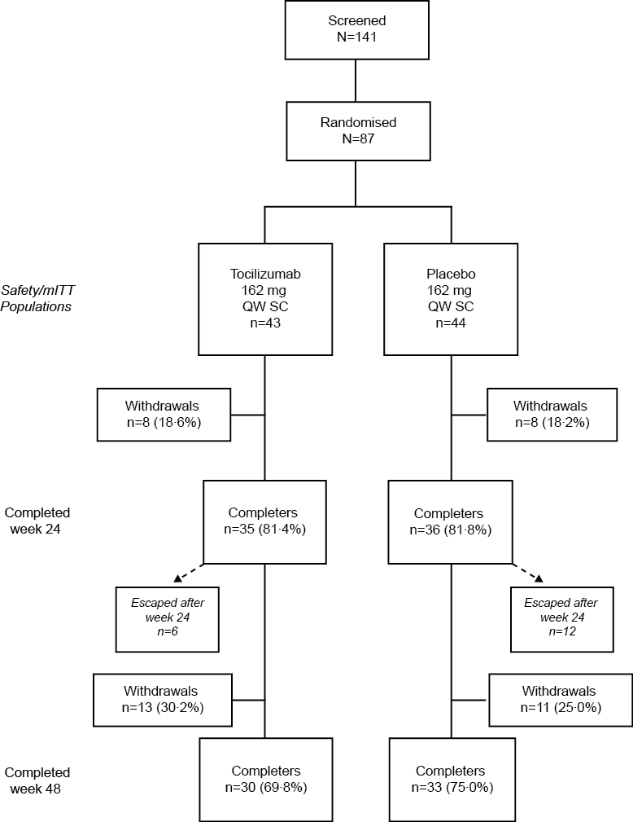

Figure 1: Patient disposition
The mean (median) dose intensity, a measure of compliance (defined as the number of doses actually received divided by the expected number of doses for the time on study expressed as a percentage), was 87·3 (97·9) for placebo and 85·6 (97·9) for tocilizumab.
mITT=modified intent-to-treat; QW=every week; SC=subcutaneously.

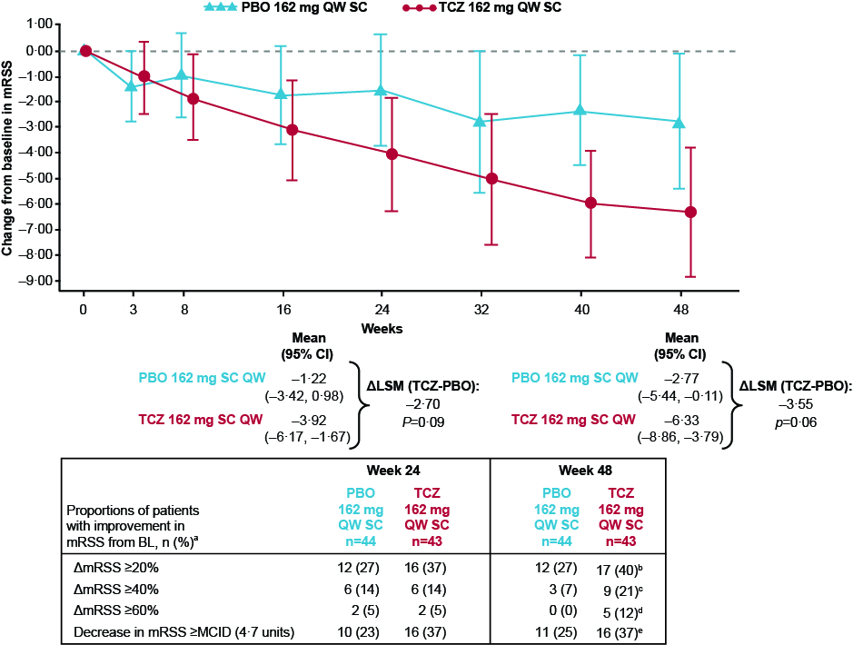

Figure 2: Change from baseline in mRSS
ΔLSM (TCZ-PBO): Difference in least square means between treatment arms. Negative change represents improvement. Means and 95% CI are from the repeated-measures model.
ªNon-responder assumption for missing data. Patients can be counted more than once. For example, a patient with a 40% improvement would be counted as a 20% responder and a 40% responder.
^{b}p=0·2607. ^{c}p=0·0685. ^{d}p=0·0261. ^{e}p= 0·252.
LSM=least squares mean; MCID= minimal clinically important difference; mRSS=modified Rodnan skin score; PBO=placebo; QW=every week; SC=subcutaneously; TCZ=tocilizumab.

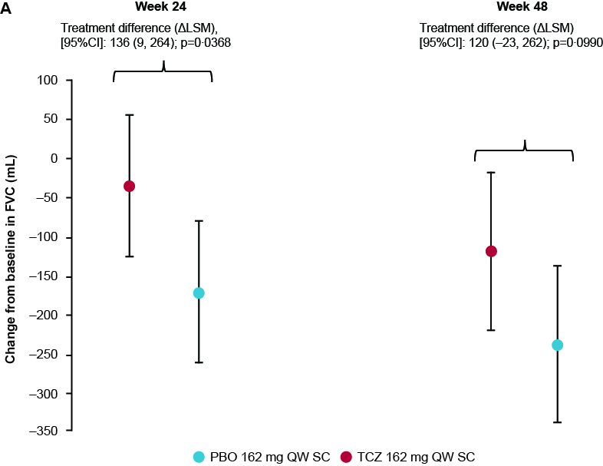

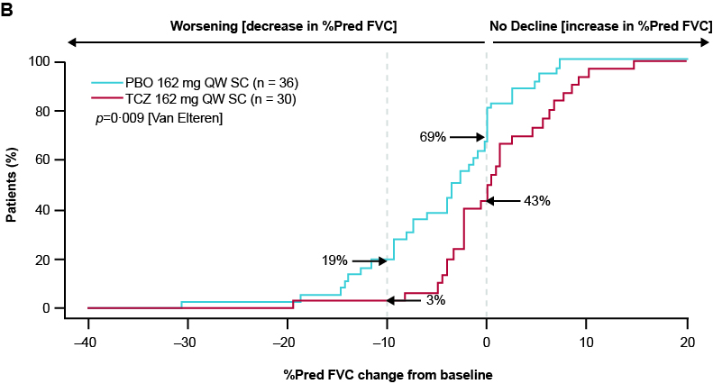

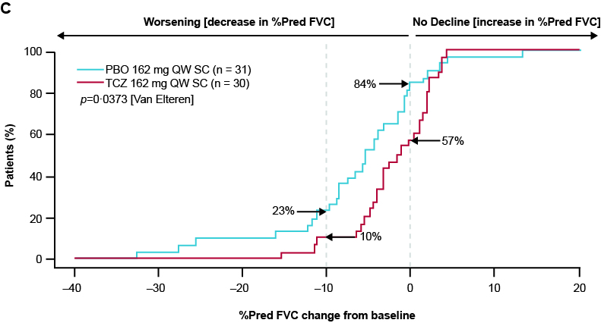

Figure 3: Mean change from baseline
Mean change from baseline in FVC (mL) at weeks 24 and 48 (A). Error bars show 95% confidence intervals for the means for each treatment arm. p value refers to treatment difference. Cumulative distribution of patients by change in percent predicted FVC from baseline to week 24 (B) and week 48 (C) (exploratory analysis). Dotted lines indicate no change (0) and 10% absolute decrease (–10) in percent predicted FVC at weeks 24 and 48 from baseline. (B) 69% vs 43% of patients had an absolute decrease or no change and 19% vs 3% an absolute decrease of at least 10% in the PBO arm and TCZ arm, respectively.
(C) 84% vs 57% of patients had an absolute decrease or no change and 23% vs 10% an absolute decrease of at least 10% in the PBO arm and TCZ arm respectively.

FVC=forced vital capacity; LSM=least squares mean; PBO=placebo; QW=every week; TCZ=tocilizumab.

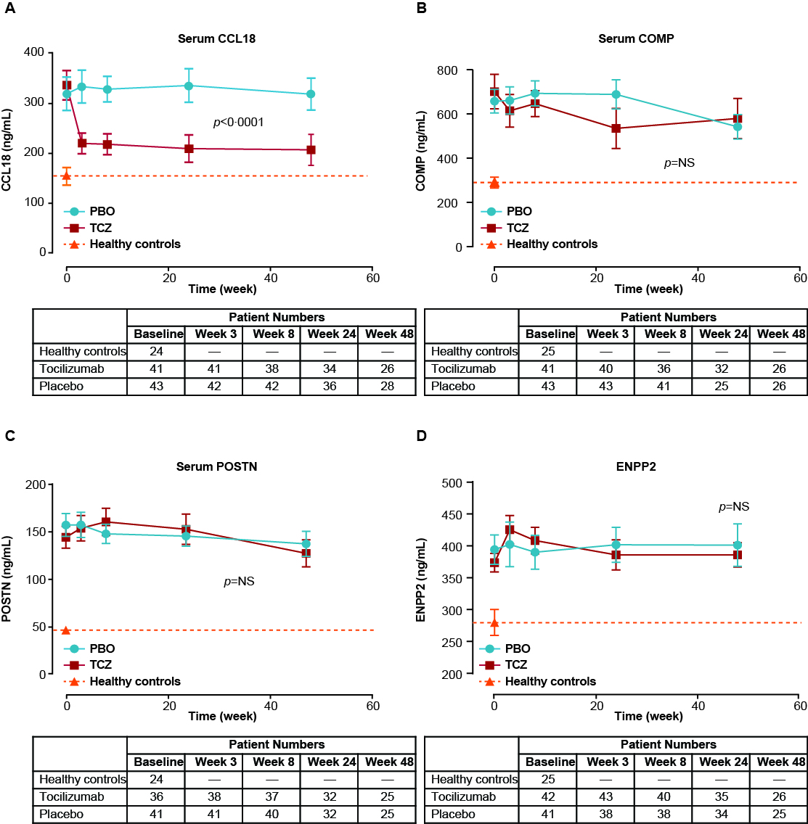

Figure 4: Observed mean ± standard error serum levels of CCL18 (A), COMP (B), POSTN (C), and ENPP2 (D) (ng/mL) at baseline and at weeks 3, 8, 24, and 48 in patients treated with tocilizumab or placebo (exploratory analysis) plus age- and gender-matched healthy controls (baseline only)
P value is for the overall treatment effect of tocilizumab versus placebo based on two-way analysis of variance with treatment, time, and treatment*time as factors. Serum CCL18, COMP, POSTN, and ENPP2 levels in healthy volunteers (triangles), tocilizumab-treated patients (squares), and placebo-treated patients (circles).
COMP=cartilage oligomeric matrix protein; ENPP2=autotaxin; PBO=placebo; POSTN=periostin; TCZ=tocilizumab.
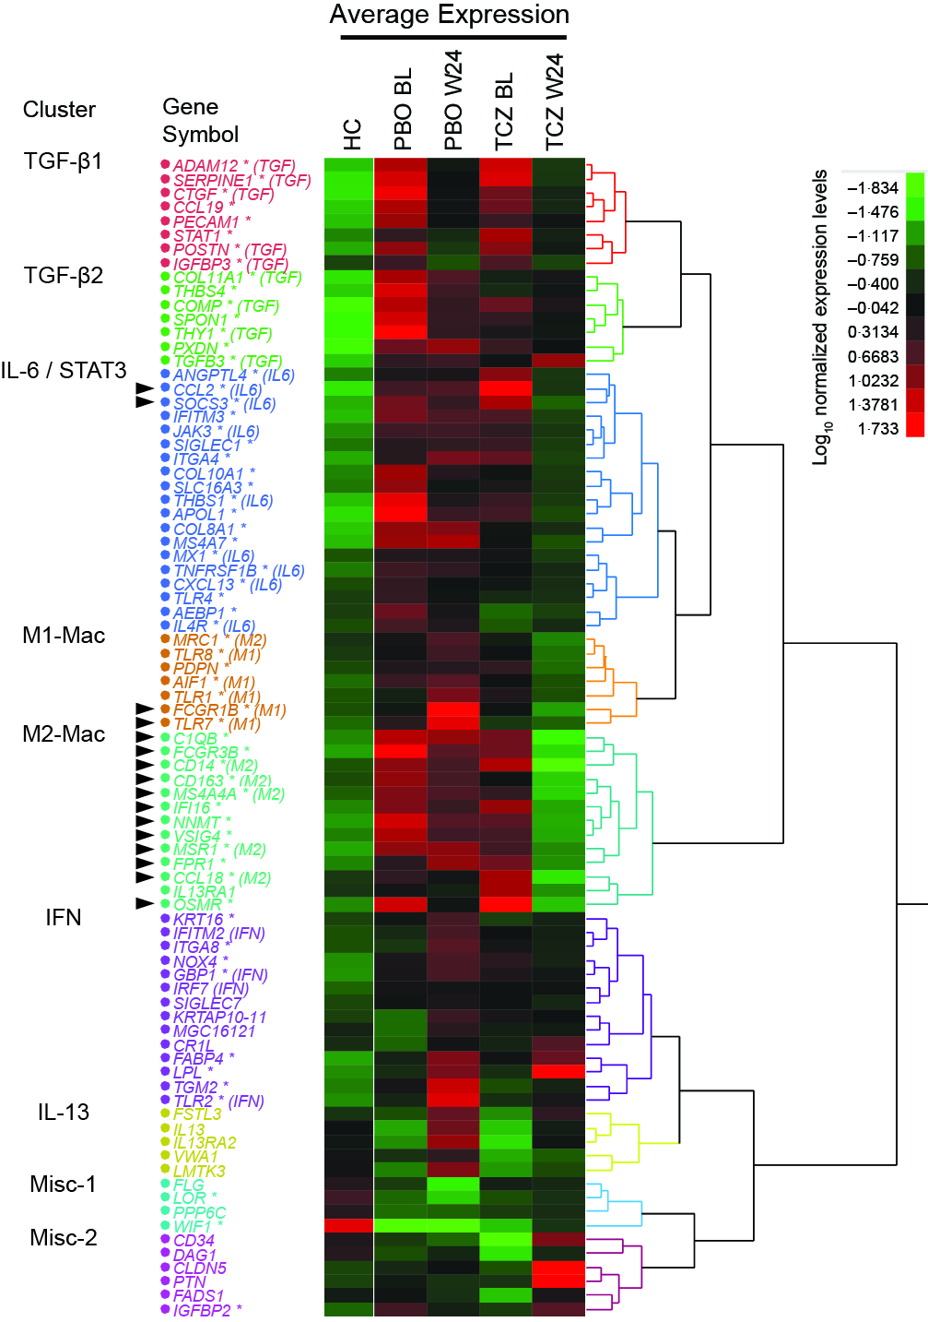

Figure 5: Unsupervised one-way clustering of the mean log₁₀ normalised expression of 83 genes measured using nCounter technology (NanoString Technologies) in the skin biopsy samples of 20 healthy controls and of 42 placebo baseline, 34 placebo week 24, 36 tocilizumab baseline, and 29 tocilizumab week 24 patients
Shades of green denote low expression levels, and shades of red denote high expression levels. Asterisks denote genes significantly overexpressed or underexpressed in SSc patients compared with healthy controls. Arrows indicate 16 genes specifically downregulated by tocilizumab at week 24 compared with placebo (p<0.05, analysis of covariance on difference in gene expression levels between week 24 and baseline, with baseline expression level as linear covariate and treatment as categorical predictor).
BL=baseline; HC=healthy controls; PBO=placebo; TCZ=tocilizumab.

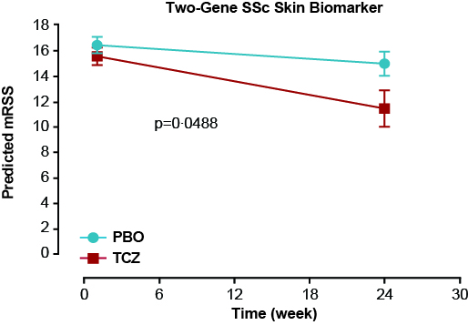
Figure 6. Mean ± standard error of the two-gene SSc skin biomarker predicted mRSS derived from the skin biopsy RNA samples from 42 placebo baseline, 33 placebo week 24, 36 tocilizumab baseline and 29 tocilizumab week 24 patients
Tocilizumab-treated patients (squares) and placebo-treated patients (circles). P value is for the treatment effect of tocilizumab compared with placebo based on analysis of covariance of change in predicted mRSS, with baseline predicted mRSS as linear covariate and treatment as categorical predictor.
mRSS=modified Rodnan skin score; PBO=placebo; TCZ=tocilizumab.

