Rethinking Complexity: vLadimir Shukhov’s Steel LaTtice Structures

Elizaveta Edemskaya, Asterios Agkathidis
elizaveta.edem@gmail.com, asterios.agkathidis@liv.ac.uk, University of Liverpool

Editor’s Note: This space reserved for the Editor to give such information as date of receipt of manuscript, date of receipt of revisions (if any), and date of acceptance of paper. In addition, a statement about possible written discussion is appended.

DOI: Digital Object Identifier to be provided by Editor when assigned upon publication

ABSTRACT
This paper is a critical review on advantages and disadvantages of contemporary digital architecture, in retrospect to Vladimir Shukhov's design techniques, applied in the early 20th century. After investigating Shukhov's structural systems, this paper explores the relationship between performance and form, questioning the necessity of high-complexity structures. It will present unpublished archive material of his early work and stimulate a valuable discussion by comparing it with contemporary projects designed by renowned architects. The study on Shukhov focuses on his tessellation method of double-curved surfaces using simple standardized elements. The study of present digital approaches revolves around leading architects using computational tools (e.g. Foster and Partners, Buro Happold and Arup), who have materialized high complexity structures composed by irregular units. Our findings highlight advantages and disadvantages of contemporary computational approaches.

Keywords: Fabrication and Material Studies, Architectural History, Design Concepts and Strategies, Performative Design

1. INTRODUCTION
Technology, materials and construction are three interdependent components that change architecture. Contemporary architecture started with the Industrial Revolution, which brought new technologies and new construction materials: iron and steel. In recent decades, computation has become a next significant impetus for architectural development [1]. Computation redefined the practice of architecture. Instead of working on compositions, designers construct a parametric computational system, where the form can be generated simply by varying parameter values. On one hand, computational technologies make it possible to design a building of any level of geometric complexity and optimize any design proposal. As Peters and Peters are stating:

'If you find a nice curve of surface somewhere with interesting properties you can incorporate it in your design [2].’

On the other hand, computational technologies create a gap between architects and the final product. Because of insufficient knowledge of algorithmic concepts [3], most practices come up with a building shape and a concept; then invite computational designers to optimize the project. Computational designers generate and explore architectural concepts by writing and modifying algorithms, but how efficient is this approach?

This paper is aiming to rethink and evaluate ad-vantages and disadvantages of computational design techniques, by comparing contemporary performative design methods with Shukhov's pre-computational approach, the most efficient approach of the pre- computational era. In order to narrow down the research area, this investigation will focus on grid shell structures, based on following main research questions:

- What were Vladimir Shukhov's design techniques?
- How do Shukhov's manufacturing and assembling processes differ from contemporary digital design techniques? How does their design logic differ?
- How can today's advanced performative design techniques benefit from Shukhov's design heritage?

2. SHUKHOV'S LATTICE STRUCTURES

One of the most significant of Shukhov's inventions in the field of architecture was the thin metal lattice or grid shell structure. It was developed after detailed investigations searching for the most rational type of rafters that weighed and cost the least and could be quickly assembled. Shukhov suggested a proportion, which at first sight seemed senseless:
α = e = c

where a- length of panels, e - minimal distance between frames, and с - distance between two purlins, dependent on the actual situation [9].

According to the formula, the minimal covering weight could be achieved only if the construction had no purlins, and the distance between trusses was equal to the distance between the missing purlins. The answer to this riddle was the spatial lattice structure, where trusses and purlins were the same, and the distances between trusses and purlins were equal. In 1895 Shukhov got a patent for the invention. The new structures were first presented to the general public at the All-Russian Industrial Art Exhibition in Nizhniy Novgorod in 1896 (figure 01), where Shukhov designed a number of objects using three types of lattice structures: suspension, vaulted and rigid spatial shell.

Suspension lattice structures (figure 02) were based on tension, the most advantageous type of stress for metal constructions. These structures were designed based on Shukhov’s elaborate investigations of material properties. The grid surface comprised of overlapping tensile elements: rolled metal plane or angle-section rods riveted to each other. They were called ‘roofs without trusses’ [8]. The clear, extremely simple suspension structure system and the easy-to-perform node conjunction made on-site construction fast and straightforward.

Vaulted grid-shell constructions (figure 03) did not attract much public attention; however, they brought commercial success to the Bari office [10]. The vaults were formed with thin metal arches turned from the frontal position at a particular angle. Thus, they worked as one continuous resilient truss. 68° was considered the most optimal angle of intersection. One professor, Shukhov’s contemporary, describing his vaulted structures, proposed the angle of 90° instead of 68°, which would have meant a 31% increase in the structure’s weight [5].

Each arch was made with rigid metal strips of equal length, or with angle pieces set edgewise; each piece was equally bent during the assembling process. The most interesting example of a vaulted lattice shell was the covering for the Viksa Works built in 1897–1898. It was the first time in the world’s building practice when double-curved spatial vaults were created with single type rod elements [6].

Shukhov’s lattice-suspended and vaulted structures represented a carrying surface, which could be shaped in any form. It was made of inter-crossing rods and combined the function of trusses (the main floor structural system) and purlins. The density of the grid made it possible to put it on the shell without additional structures. Due to the rational distribution of material along the shape, the grids were 2 to 3 times lighter than roofs with conventional frames [4]. The difference was proportionate to the span of the construction.

The final and most unusual of the grid-shell structures presented at the All-Russian exhibition was the 32-meter-tall lattice hyperboloid water tower. ‘Everything amazed in that first Shukhov tower – everything in it was some structural and geometric puzzle: straight rods and the external silhouette double curvature, the openwork lightness below and the solid heaviness above.’ [6]
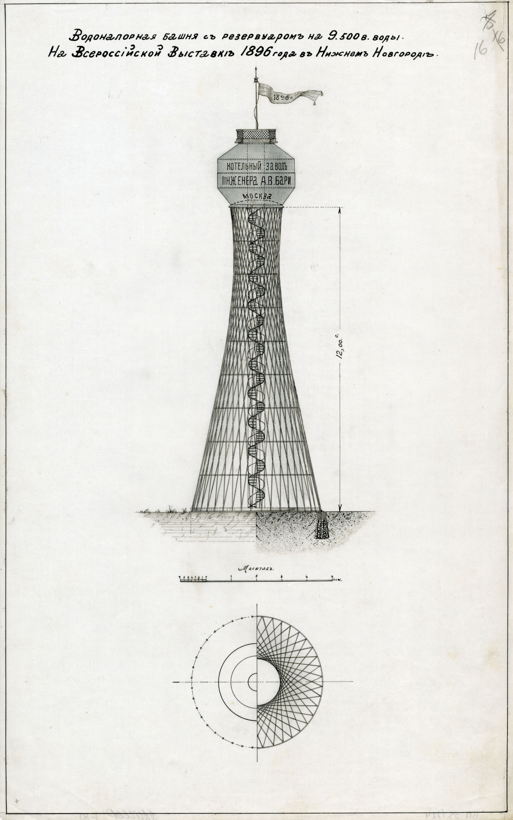
Figure 01: Figure 1.The first Shukhov hyperboloid water tower erected at the 1896 Nizhniy Novgorod exhibition. [Archive of the Russian Academy of Science, F.1508/Op.2/81(16)]
It was a unique structure at that time, which had an unprecedented shape and construction properties. According to Cooper, the idea of such a new structure came directly from imaginary geometry, or hyperboloid geometry, which was invented by the Russian mathematician Lobachevski in 1829 [11]. Shukhov’s biographer Grigory Kovelman writes that Shukhov told him he had been thinking about the properties of hyperboloid structures for a long time, and that he had studied hyperboloid forms at the Technical School. Yet apparently the moment of truth occurred when he saw an upside-down wicker paper basket with a focus on top at the office; Shukhov claimed that was when he clearly understood the hyperboloid structure with its curved surface generated by straight rods [4].
As well as grid-shell coverings, the structure of the lattice tower was a spatial system, where the load was equally spread along the surface. It was formed with angle rods and horizontal hoops embracing the structure. The dense intersections between elements and wide cross-sections granted the tower stability. Aiming to optimize the design process, soon after building the tower, Shukhov presented the standardized elements of the tower structure in a table format (figure 04). With the aid of the table, it became possible to design a new water tower, in keeping with a client’s requirements, in 25 minutes [4]. Despite the standardized approach, each tower had an individual character because the method was based not as much on unification as on optimization.
Figure 02: Suspension lattice structure. [Archive of the Russian Academy of Science, F.1508/Op.2/37, 49]
After the exhibition Shukhov continued developing hyperboloid towers, trying to increase their height. The tallest hyperboloid structure made by Shukhov was the ComIntern Radio Tower on Shabolovskaya Street in Moscow, a construction built to celebrate the international collaboration of Communist parties. It consists of several blocks and is 150 m tall.

Since engineers and architects have started using computer technologies, they rediscovered grid structures that do not dictate the shape of the building and allow forming more complex shapes. However, the shift to relying on algorithms for capturing and communicating designs in architecture has been slow, as many architects still do not have sufficient computer modelling skills. Additionally, since each grid structure is unique and no guides or design and construction recommendations exist regarding these buildings, only large
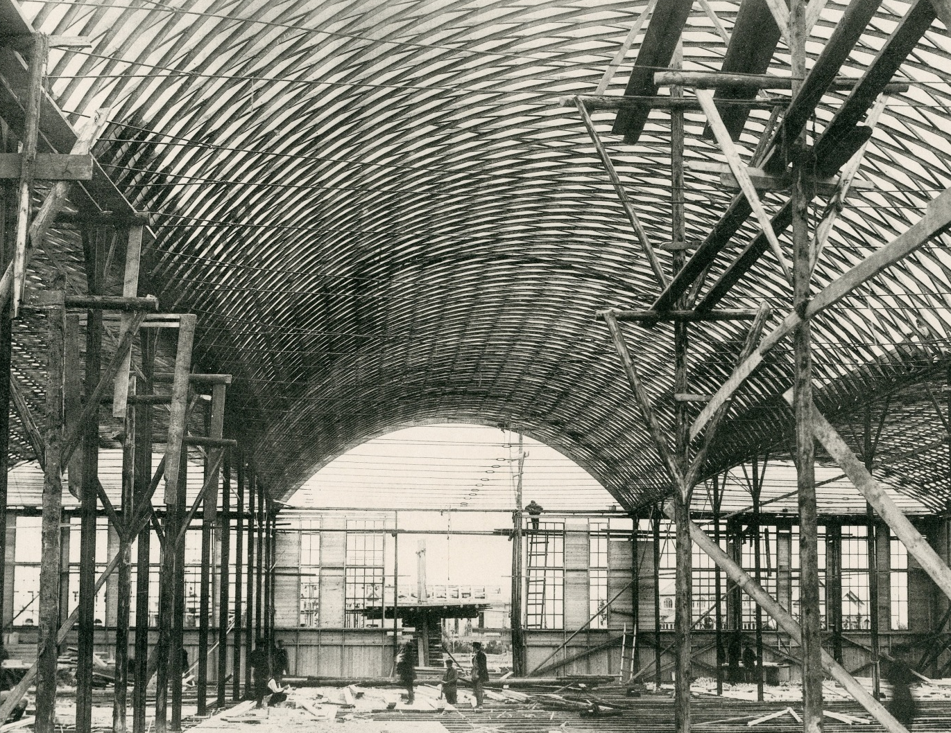

Figure 03: Vaulted lattice structure. [Archive of the Russian Academy of Science, F.1508/Op.1/49, 18]
practices with the knowledge and research back-up available, for example, Buro Happold and Over Arup & Partners, have agreed to take part in such projects [12]. This gap between the conceptual idea and the skill set needed to operate computational technologies contradicts the gist of the parametric approach and leads to a transformation from a method to a style. Striving to understand the current situation in more depth, in the next chapter we will compare the computer-generated grid structure design process with the most effective design and construction methods from the pre-computational era.

To assess the effectiveness of computational design process we have chosen four grid-shell structures with comparable parameters: 30St Mary Axe and the Great Court of the British Museum designed by Foster+Partners [13] and the Radio Tower on Shabolovskaya St (1921) and Viksa Works (1897-98) by Shukhov [14]. The comparison is focused on four main aspects: design process, grid-shell structure, fabrication and assembling.

2. SHABOLOVSKAYA TOWER AND 30 ST MARY AXE TOWER

2.2. Design process
The Radio Tower in Moscow (figure 04) and The Swiss Re building, later rebranded 30 St Mary Axe, are two towers with the similar height (150 and 180 m) with the biggest diameter of 40.3 m and 56.15 m, respectively. The Radio Tower in Moscow is a grid shell structure comprises of six hyperboloid blocks formed with angle rods and horizontal hoops. Its minimal surface and open lattice structure reduce the wind load, the main challenge for
high-rise buildings.

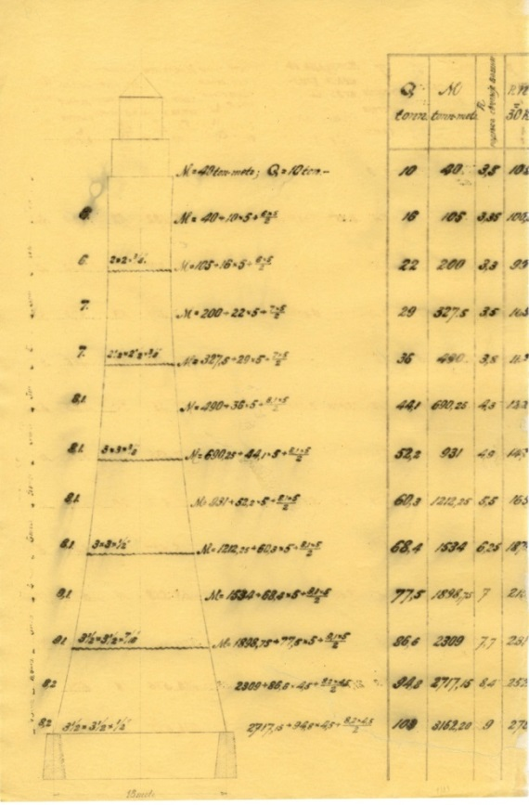
Figure 04: Table of standardised elements by Vladimir Shukhov. [Archive of the Russian Academy of Science, F.1508/Op.1/83, 19 and 20. (First time published)]

The dense intersections between elements and wide cross-sections granted the tower stability, while the multi-level construction system creates additional intersections in the tower's trunk, which reinforce the structure with minimal material consumption [14]. The logic of Shukhov's calculations that led him, to hyperboloid spatial system, were based on exploring structural interdependences and embracing the most important parameters in generative formulas.

The elliptic shape of the Swiss Re building was designed also for reducing the wind load. By the time, Foster + Partners architects invited Mark Burry, a specialist from the Arup Group, to optimize the final shape according to aerodynamic requirements; they developed the initial tower concept using hundreds of card and plastic scale models [15]. The structure of Swiss Re's building consists of a central core and a perimeter steel grid-shell tightened to each other with rolled-steel radial beams. The grid's interlocking horizontal hoops turn the structure into a stiff triangulated shell with a lateral working load that resists wind force and makes the whole construction stable [13].

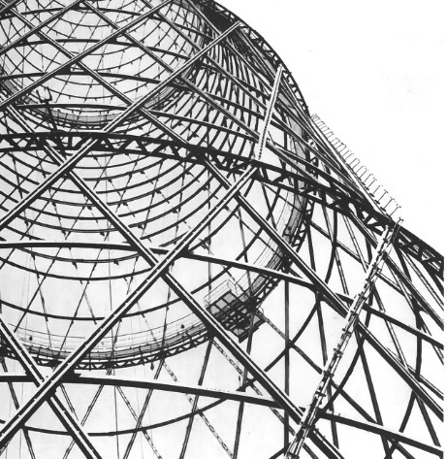
Figure 05: Radio Tower Moscow [© Elisaveta Edemskaya]

2.2. Grid-shell structure

The most significant difference between Shukhov's and computational approaches reveals in the logic of the grid shell structure. The main idiosyncrasy of Shukhov's lattice towers was that he never used equal rings and regular intersections: the intersection points between straight lines in the upper and lower parts are not symmetrical [6]. Rod connections were also shifted from one to another, trying to create as much small-scale, inter-crossing as possible, like in a knitted garment; whereas, The Swiss Re's diagrid system represents a polyhedron compiled with diagonal columns and nodes. The lattice mesh of the hyperboloid pylons in the Shabolovskaya Tower is made of two layers of diagonal double 140 mm U-section rods aligned between two rings. These rings have a truss structure comprising of two L-section rods, which simplifies pylons' connections and makes it possible to fix rods securely. Intermediate U-section rolled metal holding rings fix the rods between the main structural rings.

In the process of connecting the diagonal rods to the rings, they were slightly twisted along the whole length, which was done quite easily due to high material flexibility and because the rod section was relatively small. That granted additional structural stiffness to the construction. In order to stabilize the construction, the number of the rods reduced from the lower pylon to the top.

The Swiss Re's diagrid system comprises of a series of steel two-story A-frames. Each frame consists of two tubular diagonal columns bolted with a two-meter height node. Nodes connect the diagrid shell to the radial beams of the central core and govern the curvature of the building that makes them crucial in the overall structure of the construction. Due to the building's elliptical shape the geometry of each node is different, so the Arup team designed each node in detail during the computer modelling stage [16]. Additionally, in order to stabilize the tower, Arup designed two column types: bigger and heavier for bottom levels and lighter for upper floors.

2.3. Fabrication and assembly

The fabrication and assembly of the Radio Tower was quite simple due to the identical elements throughout the building and highly original 'telescopic' assembly method implemented by Shukhov. All sections were assembled and lifted in large blocks inside the structure with five basic wooden cranes and pulleys [16]. The only issue was bending horizontal U-section rings according to the structure's diameter because it was an expensive process at the time [5]. The simplicity of the design and the assembling method made it possible to build a complex structure using primitive equipment and relying on low-skilled workers. Besides, the 'telescope' assembly method was highly accurate. In another famous hyperboloid tower with similar structural features to the Radio Tower the leeway from the dead centre was only 24 mm [8].

Galankin, Shukhov’s former employee, writes that Shukhov used to make calculations in a unique way: his calculations (figure 06) were so laconic that other specialists found them difficult to understand. In spite of this briefness, if someone asked Shukhov for the specifications of load, rod stress, rod profile and section, rivet quantity, material weight, temperature impact or any other detail, he always had an answer, because his concise calculations covered all these aspects, but nothing that was irrelevant [17].

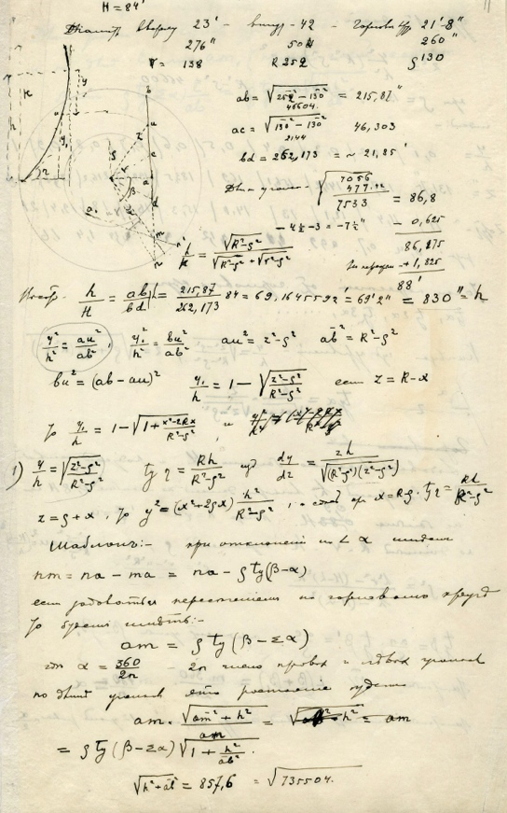
Figure 06: Shabolovskaya Tower’s calculation. [Archive of the Russian Academy of Science, (first time published)]

The main issue in assembling the grid-shell structure for 30 St Mary Axe was that it depended on accurate fabrication [16].'With a triangular grid, there's nothing you can do if all goes wrong’ [18]. Building such a structure was possible only with the aid of advanced 3D-modelling and modern computational fabrication technologies that enable accurate calculation and construction element production with minimum defects and errors. There was the most difficult step of construction, when all 18 nodes were in place around the circumference forming a horizontal hoop, and tie-sections were added to link the nodes. To close the bolt holes, all the tie-sections would have to line up; the process demanded high precision.

3. THE GREAT COURT OF THE BRITISH MUSEUM AND VIKSA WORKS

3.1. Design process and grid-shell structure
The covering for the Viksa Works (Fugure 04) represents the first time in the world's building practice when double-curved spatial vaults were created with single-type rod elements (Khan-Magomedov 2010) [6]. Overall, the roof is divided by three-pinned arches into five segments covered with symmetrical double curvature shells. The single-curvature system was transformed to a double-curved surface simply by bending the longitudinal beams. From the cross to the long sections, the circular-cut dome edges have a bend size equal to 1/6 of the span. The symmetric shape of the double-curved domes made it possible to form them with identically bent rods [15]. 68° was considered the most optimal angle of rods' intersections. One professor, Shukhov's contemporary, describing his structures, proposed the angle of 90° instead, which, as a result, led to a 31% increase in the structure's weight during the calculations [5].
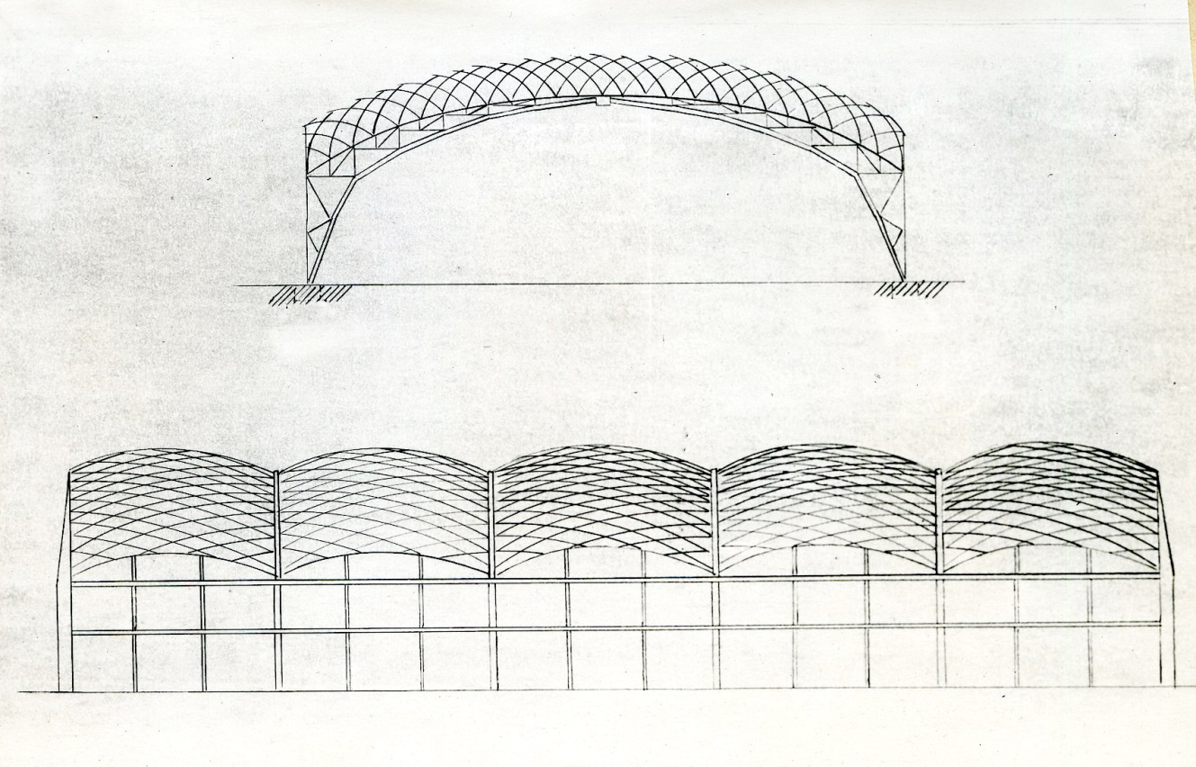
Figure 07: The Viksa Works covering, Archive of the Russian Academy of Science (first time published)

The character of the Great Court covering structure is more complicated. The covering works as a lattice-glazed canopy stretched between the dome's drum of the Reading Room and four sides of the Museum's quadrangle. Its design was generated in two stages. At first, engineers from Buro Happold calculated its geometry using standard static, or linear, computer programming. Then, Chris Williams, a pioneer of design computation, was invited to study the deformation of the roof structure. Using computer software, he designed a 3D simulation model and optimized the mesh of the grid-shell. The grid size was determined by the maximum glass panel size available, so the structure consists of 3,312 unique double-glazed panels. The total weight of the canopy without glazing is 478 tons.

3.2. Fabrication and assembly

Chris Williams designed the highly complicated shape consisting of thousands unique elements relatively easily. Yet although the grid-shell details were successfully prefabricated following 3D models, the process of assembling such a non-standardized structure was expensive and difficult. The final grid construction was formed of radial hollow steel sections (box beams), which were welded to 1,826 structural nodes, each node having a unique design [19]. The engineers were highly concerned about the reliability of the structure; therefore, Happold, instead of using lower grade steel that might contain impurities, chose Grade D steel material, which is usually used in marine and offshore applications [13].

In contrast to the canopy of the Great Court, the construction system of the roof for the Viksa Works, while highly original, was relatively simple and used no extended scaffolds, which are necessary in the assembling of complicated spatial shell structures. This construction system was 40% lighter than other roof structures. Kovelman [8] writes that initially builders even refused to climb on the roof because they could not believe that such a light lattice structure could sustain their weight.

Even though both projects were built in different times and conditions, looking into their data and statistics allows interesting comparisons to arise:
Viksa Works [4]:
- Construction period: 1897–1898 (1 year)
- Dimensions: Length: 75 m, Width: 38.3m
- Area: 2,795.9 sqm
- Span: 14.5m
- Minimum roof height: 6.8 m
- Maximum roof height: 13.25 m
- Rods: Z-section rolled metal: 60.5 mm x 45.6 mm
- Budget: 40 568 roubles

Queen II Great Court
- Construction period: 1998–2000 (2 years)
- Dimensions: Length: 73 m, Width: 97 m
- Area: about 3,692.5 sqm
- Nodes: 1,826, Polygons: 3,312
- Total structure weight: 800 tons, 478 tons of steel, 315 tons of glass
- Steel beams: Minimum steel section depth: 76 mm. Maximal steel section depth: 178 mm
- Budget: £100 million

4. DISCUSSION AND CONCLUSION

It is obvious that the case studies presented here were built in different times and conditions, serving different function, using different technologies, thus an attempt to compare them might seem inappropriate. The design logics behind each of these buildings though, could become a subject of comparison.

By looking at the two grid-shell structures presented, it becomes clear that they were built following fundamentally different principles. Shukhov's design logic, based on crossed rods, minimal asymmetry and displaced detail interconnections is similar to the logic of a wicker basket structure. Thin fragile elements joint together form a strong elastic spatial construction. In contrast, Foster's computational structure is composed by polyhedrons made of beams. It is easy to trace this back to computer modelling, where the most straight-forward way to design and calculate a smooth form is by using a polygon mesh. Each logic is almost the exact opposite of the other: One based on a standardized structural unit, leading to a predetermined form (e.g. hyper paraboloid) and the other based on form, which dictates a mass customized unit.

This discrepancy poses a question: do we use computer technology as a supporting tool, or has it started dictating the design process? Computational technologies make it possible to generate shapes of any level of complexity, but Lynn stresses another issue:

'The computer is not a brain. Machine intelligence might best be described as that of mindless connections. When connecting multiple variables, the computer simply connects them, it does not think critically about how it connects... Even in the most scientific applications of computer simulations it is argued that first an intuition must be developed in order to recognize the nonlinear behavior of computer simulations.' [20].

Nowadays, architects and engineers design forms using the most convenient ways of computation that often lead to overcomplicated structures that are difficult to build. The presented comparison demonstrates that, despite new opportunities given by new technologies, the design logic did not go much further than post and lintel system. If the architecture generated by computational logic is called 'smartgeometry,' perhaps engineers and architects should strive for 'wisegeometry,' geometry based not as much on calculations as on optimal construction logic in the physical world, such as that of Shukhov's structures? Perhaps 'wisegeometry' would start addressing Chris Williams's contemplation in Smartgeometry: 'Computers are no longer a new technology, but their implications for the ways in which people will work are still unclear' [2].

5. IN FAVOR OF SHUKHOV’S ARCHITECTURAL HERITAGE

Today, the state of Shukhov’s architectural heritage is at stake. Although the Bary office had built thousands of constructions across Russia, only a few of them survived. In spite of numerous discussions regarding the importance of Shukhov’s constructions, one of his most famous buildings, the Radio Tower in Moscow, is at the risk of collapse because it has not been restored for 25 years. Following the international conference “Heritage at Risk” in Moscow in 2006, 170 specialists from 33 countries declared the Shabolovskaya Tower a masterpiece of Russian Avant-Garde architecture and proposed it should be on the UNESCO World Heritage list. Sir Norman Foster also interceded for the structure as he said it was “neglected and dying” without “faithful restoration.”

Out of the numerous lattice roof structures designed by Shukhov, only the Viksa Works with its unique double-curved roof has survived. This historical monument of Russian architectural achievement is also in a poor condition as it has been left without a covering for years. If it is not urgently restored, it will soon fall into decay.

REFERENCES
- Castle, H. 'Editorial', Architectural Design, 1(222), 2013, p.5. [DOI: 10.1002/ad.1516]
- Peters, B., Peters, T.,Inside Smartgeometry: Expanding the Architectural Possibilities of Computational Design, John Wiley & Sons, 2013, Chichester. [DOI: 10.1002/9781118653074]
- Peters, B and de Kestelier, X., 'The building of algorithmic', Architectural Design, 1(222), 2013, pp. 9-15. [DOI: 10.1002/ad.1545]
- Kovelman, G. M., Chapter 2. Metal structures of industrial buildings and civil buildings', in Archive of the Russian Academy of Science, The great Russian engineer Vladimir Grigorevich Shukhov (1853-1939), 1958, Moscow, p. F.1508/Op.2/37
- Shukhova, E. M., Vladimir Grigorevich Shukhov: the first engineer of Russia, Bauman MGTY, 2003, Moscow
- Khan-Magomedov, S. O., Vladimir Shukhov, Gordeev, 2010, Moscow
- De Magistris, A., Korobina, I., Ivan Leonidov:1902-1952, Montadori Electra, 2009, Moscow
- Kovelman, G. M., Works of Honorary Academician Engineer Vladimir Grogorevich Shukhov, State Press of literature about construction, architecture and materials, 1961, Moscow
- Shukhov, V. G., Rafters, Russian Press, 1897, Moscow
- Graefe, R., Vladimir G. Suchov 1853-1939. Die Kunst der sparsamen Konstruktion, DVA, 1992, Stuttgart
- Cooper, E., Arkhitektura I mnimosti: the origins of Soviet Avant, Garde Rationalist architecture in the Russian mystica, philosophical and mathematical intellectual tradition, 2000, Phd diss., University of Pennsylvania
- Paoli, C., Past and Future of Grid Shell Structures, 2007, Master's Thesis, Diploma, Massachusetts Institute of Technology
- Hart, S., 'A Brilliant Shell Game at the British Museum', Architectural Record, 2001, 1(189), pp. 149-154
- Rainer G., Otmar, P., Shukhov, F., Shukhov V.G. (1853-1939): Art of construction, 1995, Mir, Moscow
- Burry, M., Scripting cultures: architectural design and programming, 2011, Wiley, London
- Powell, K., 30 St Mary Axe: A Tower for London, 2006, Merrell Publishers Ltd, London
- Galankin, A.N., 'My brief memories', in Archive of the Russian Academy of Science, 1958, Moscow
- Peterson, A., 'London will never look the same again', Building, 2002, 1(46), pp. 42-49
- Anderson, R., The Great Court and The British Museum, 2000, The British Museum Press, London
- Lynn, G., 1997, Animate Form, Princeton Architectural Press, Princeton

