GEOCHEMICAL RECORDS IN SEDIMENTS OF A TROPICAL ESTUARY (SOUTHEASTERN COAST OF BRAZIL)

Eduardo S. Costa1, Caroline F. Grilo2, George A. Wolff3, Anu Thompson4, Rubens C. L. Figueira5, Fabian Sá6, Renato R. Neto7.

1,2,6, 7Departamento de Oceanografia e Ecologia, Universidade Federal do Espírito Santo. 3,4School of Environmental Sciences, University of Liverpool.5Instituto Oceanográfico, Universidade de São Paulo.

email: 1eduoceano@gmail.com, 2carolinegrilo@gmail.com, 3wolff@liverpool.ac.uk, 4anu@liverpool.ac.uk, 5rfigueira@usp.br, 6fabiannetuno@gmail.com, 7rneto@gmail.com

**Abstract**

The Piraquê-Açú and Piraquê-Mirim estuarine system (PAPMES) is considered to be a hydrologically unaltered estuary; however, several human activities including introduction of pollutants may have contributed to changes in this system. We have studied hydrocarbons, major elements (Al, Mg, Fe and Mn), trace elements (As, Ba, Cd, Co, Cr, Cu, Li, Ni, Pb, V and Zn), Corg./Ntotal ratio, and δ13C and δ15N stable isotopic composition of organic matter to assess the natural and anthropogenic depositional record in three sediment cores dated by 210Pb geochronology. The sediments showed a strong terrestrial C3 plant contribution to organic matter input in the rivers (-29.2 ≤ δ13C ≤ -25.1 ‰; 2.1 ≤ δ15N ≤ 5.3 ‰; 23.3 ≤ Corg./Ntotal ≤ 53.9), with a higher phytoplankton influence downstream (-29.3 ≤ δ13C ≤ -20.7 ‰; 0.4 ≤ δ15N ≤ 6.6 ‰, and 15.4 ≤ Corg./Ntotal ≤ 34.4). Greater *n*-alkane concentrations typical of higher plants (*n*C27, *n*C29, *n*C31) confirmed the terrestrial inputs. There was no indication of contamination by petrogenic sources, but relatively high amounts of 17β(H), 21β(H) and 17β(H), 21α(H) terpanes, indicate a possible association with biogenic activities (bacteria). The distributions of major and trace elements were associated with a high lithogenic input and iron and manganese oxides/hydroxides. Although there is little evidence of enrichment by direct human activity, the downstream sediments may be influenced by deforestation for charcoal production which occurred between the 1950s and 70s, exposing soils to weathering and erosion.

*Keywords:* Trace metals, Arsenic, Hydrocarbons, Stable isotopes, Piraquê-Açú and Piraquê-Mirim.

**Introduction**

Estuaries are ecosystems that play an important role in the cycling of inorganic and organic compounds by acting as final receptors and incorporating these compounds into sediments (Medeiros et al., 2005). Due to their hydrophobic properties, persistent organic compounds tend to sorb to suspended particulate material and can be deposited in estuarine sediments (Liu et al., 2006; Ibbotson and Ibhadon, 2010). The particulate material includes clay minerals, iron and manganese oxyhydroxides, carbonates, organic substances (precipitated humic acids) and biological material (algae, bacteria and plankton) that can also serve as a carrier of inorganic compounds (e.g., metals) to sediments (Bahena-Manjarrez et al., 2002; Hatje, 2003; Banerjee et al., 2012; Delgado et al., 2012).

Many of these organic and inorganic compounds have natural sources (Dessai and Nayak, 2009). However, estuaries are often influenced by increased urbanization, which contributes significantly to pollutant accumulation that can reach levels capable of affecting biota and environmental quality (Medeiros et al., 2005; Sabadini-Santos et al., 2009; Silva et al., 2013). To study historical records of pollutant accumulation, sediment cores have been used to assess anthropogenic effects and natural processes in sediments from coastal environments (Chatterjee et al., 2009; Baptista Neto et al., 2010; Monteiro et al., 2012; Zhang et al., 2013).

It is important to differentiate human and natural contributions of organic and inorganic compounds in sediments in order to quantify and produce effective protection of aquatic ecosystems and subsequent mitigating actions (Liu et al., 2010). Anthropogenic contributions to organic and inorganic compounds in estuaries in Espírito Santo State, Brazil have been reported (De Jesus et al., 2004; Souza, 2009; Conti and Nalesso, 2010; Grilo et al., 2013; Costa et al., 2015). However, little is known about the occurrence of such compounds in sediments of the Espírito Santo aquatic system, especially on the Piraquê-Açú and Piraquê-Mirim estuarine system, which is one of the most important estuaries of Espírito Santo. The PAPMES is considered to be well preserved and a nursery for many species of Brazilian fauna and flora (Barroso, 2004). This estuarine system is close to the Doce river which was the site of the biggest Brazilian environmental disaster in recent history. Approximately 50 million cubic meters of waste from a breached iron mine dam including mud possibly containing high levels of Fe, Mn, Cu, Cr, Cd, Hg and As reached the sea, and were deposited over the continental shelf (Escobar, 2015). These elements may also have contaminated the coastal environment, potentially resulting in changes in the fauna and flora.

This study assesses the depositional history of hydrocarbons, metals and arsenic on PAPMES sediments, locates the main sources and processes involved and evaluates the anthropogenic contributions. We analysed the grain size and geochemistry (Corg./Ntotal, δ13C and δ15N, calcium carbonate, and total organic carbon (TOC)) of three sediment cores dated by 210Pb geochronology.

**Materials and Methods**

*Study area and sampling*

The Piraquê-Açú and Piraquê-Mirim estuarine system consists of an incised-valley estuary morphologically controlled mostly by deposits of Barreiras Formation (Silva et al., 2013). The river basin has a catchment area of 448.11 km2 formed by Piraquê-Açú and Piraquê-Mirim rivers (PAR and PMR, respectively) which have a peculiar “Y” shape where the rivers meet. Most of the original vegetation cover was converted to agricultural use including sylviculture of eucalyptus, farming coffee, corn, sugarcane and extensive cattle ranching (Barroso, 2004).

Aracruz and its district (Santa Cruz), João Neiva and Ibiraçú are the four main urban areas in this basin. Their populations are 81,832, 15,809 and 11,178, respectively (Data from the 2010 demographic census; IBGE, 2015).

The tidal regime is characterized as microtidal (with maximum amplitude of 1.8 m) with semidiurnal mixed tides. The estuarine system has an extensive and well developed mangrove system and tidal flats (16.51 km2) with red mangrove (*Rhizophorae mangle*), black mangrove (*Avicenia germanis*) and white mangrove (*Laguncularia racemosa*) as predominant species (Barroso, 2004).

Three sediment cores were collected in February 2010 in PAPMES, one each from Piraquê-Açú river (PA05), Piraquê-Mirim river (PM01) and at the confluence of the two rivers (09bnorte) (Fig. 1). Sampling sites were selected using seismic data of the channel bottom where the sediment layers showed little disturbance. The sediment cores were collected with a percussion corer by a diver. In the laboratory, the cores were sectioned every centimeter to the 10th cm and every 2 cm from that depth and below for metals, arsenic, hydrocarbons, CaCO3, stable isotopes, grain size and TOC analysis. Aliquots of the sectioned sediment were analyzed for 210Pb and 137Cs every 2 cm to the depth of 50 cm then every 10 cm to the bottom of the core. The total lengths of recovery of sediment from the cores were 94 cm, 74 cm and 50 cm from 09bnorte, PA05 and PM01, respectively. The samples were freeze-dried at -40 °C and stored at -20 °C until analysis.

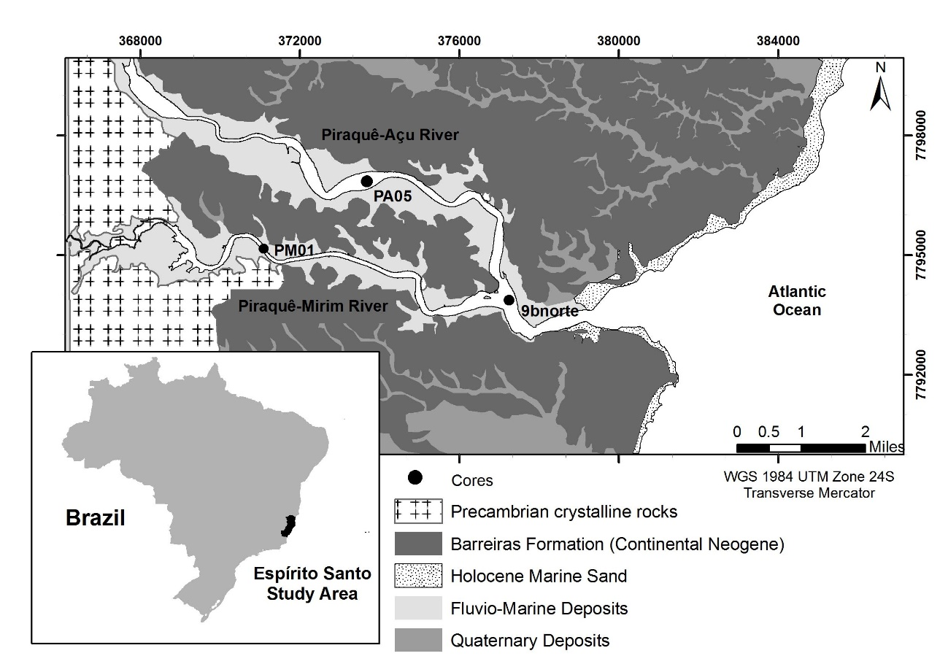

Fig. 1: Sampling map of Piraquê-Açú and Piraquê-Mirim estuarine system and the geological features. (Modified of Silva et al., 2013).

Analyses of hydrocarbons, calcium carbonate, Corg./Ntotal, stable isotopes and grain size were performed as described by Costa et al. (2015).

*Hydrocarbons*

Dry sediment (*ca.* 0.6 g) was extracted in a sonication bath (SONICOR SC – 220TH; 50–60 Hz; 30 min) using a mixture of dichloromethane (DCM):methanol (ratio 9:1, v:v), and 10 µL of 5α(H)-cholestane (101 ng µL-1 dissolvedin DCM) as internal standard. The solvent was concentrated using a rotary evaporator and completely removed under a gentle flow of nitrogen. The hydrocarbon fraction was obtained by passing the extract through a column of silica gel (~0.5 g; 70-230 mesh; 3% deactivated with water), topped up with alumina (Al2O3) and eluted with *n*-hexane 4 mL.

The hydrocarbon fraction was analyzed using a Trace 2000 Series gas chromatograph fitted with an on-column injector and a fused silica capillary column (Agilent J & W DB-5MS, 60 m, 0.25 mm, 0.1 µm), coupled with a mass spectrometer (ThermoQuest Finnigan TSQ-7000). Initial oven temperature was held at 60 °C for 1 min, then heated to 170 ºC at 6 °C min-1 and from 170 °C to 315 ºC at 2.5 ºC min-1 and then held for 12 min at 315 ºC. Helium was used as the carrier gas at a flow rate of 1.2 mL min-1. The mass spectrometer was operated in "full-scan" mode scanning a mass range from between 50-600 Thompsons every second with an ionization energy of 70 eV. The ion source temperature used was 215 °C and the interface between the GC and MS was heated to 320 °C.

The hydrocarbons were identified by comparison of their mass spectra and relative retention times to those available in the literature. *N*-alkanes were monitoring using the m/z 57, 71 and 85 and terpanes using m/z 191. Quantitative data were obtained by comparing the peak areas of the internal standard with the compounds of interest (in the total ion current chromatogram).

*Calcium carbonate analysis*

Calcium carbonate contents were determined by adding hydrochloric acid (10%; 2 mL) till effervescence ceased and then concentrated HCl (12N; ~5 drops) to the samples. Thereafter, the solution was diluted with Milli-Q water, centrifuged (10 min; 3000 rpm), and the supernatant removed. This washing procedure was repeated three times for each sample. The sediment was then freeze dried and weighed, where carbonate content was calculated by difference between the weight before and after carbonate removal.

*Organic carbon (Corg.) and Total nitrogen (Ntotal) analyses*

About 100 mg of the dried sediment was macerated using an agate mortar and pestle for decarbonation. The carbonate was removed by leaving samples in a desiccator above concentrated hydrochloric acid (24h). After this period, samples were weighed into tin capsules and analyzed using an Elemental Analyzer CHNSO (Costech ECS 4010) for quantification of organic carbon and total nitrogen present in the sediment.

*Bulk stable isotopes analyses (δ13Corg. and δ15NTotal)*

Decarbonated sediment (0.1 mg accurately weighed using a high precision balance; XP2U model METTLER TOLEDO) was weighed into tin capsules for stable isotopic analysis and determined in duplicate. Immediately after weighing, the sediment was analyzed along with two standards (USGS40 and USGS41) of L-glutamic acid (U.S. Geological Survey, Reston, Virginia 20192); weighing between 0.5 and 0.75 mg which were used for calibration and calculation of the sample’s isotopic composition. Samples and standards were determined using an Elemental Analyzer CHNSO (Costech ECS 4010), with continuous flow interface (Thermo Scientific ConFlo IV) coupled to an isotope ratio mass spectrometer (ThermoElectron DeltaPlus) (EA - IRMS). The isotope ratio of each sample was referenced against a standard material according to the following formula:

$$δ^{13}C_{org.} or δ^{15}N_{Total} \left(‰\right) = \left[\left({R_{Sample}}/{R_{Standard}}\right)-1\right] x {10}^{3}$$

Where R is the ratio 13C/12C or 15N/14N. Based on replicates of the standards used, the analytical precision was better than 0.1 ‰ to 0.3 ‰ for δ13Corg. and δ15NTotal, respectively.

*Grain size analysis*

The grain size distributions of about 5 g of sieved (<2 mm) and dried sediment, free of organic matter following the addition of hydrogen peroxide with heating (70 °C; 7 h), were determined using a laser particle analyzer (Mastersize 3000 – MALVERN).

*Geochronology analysis*

Sedimentation rates were calculated based on the unsupported Pb *via* CIC (Concentration Initial Constant) Model (Appleby and Oldfield 1978; Joshi and Shukla 1991). 210Pb and 137Cs activities were obtained by gamma spectrometry and its photopeak (47 keV), using a low background Ge detector (EG&G Ortec model GMX 25190P model) with resolution of 1.9 keV to 1332.40 keV photopeak of 60Co, as described by Saito et al*.* (2001a, b) and Figueira et al*.* (2007). To determine sedimentation rate (S in cm y-1) the following formula was used:

$$S={λ ×D}/{Ln \left[{\left(C_{0}^{210}Pb\right)}/{\left(C^{210}Pb\right)}\right]}$$

where λ is the radioactive decay constant of the 210Pb (equal to 0.31076 y-1), D is the distance between the core-top and the measured stratum (cm), C0210Pb is the count of the unsupported 210Pb at the core-top, and C210Pb is the count of the unsupported 210Pb at the measured stratum.

Sedimentation rates based on 137Cs activities were determined by the ratio between the sediment sampling year and sedimentary column depth and the period between 1964, which is the year corresponding to the period of the greatest intensity of atmospheric nuclear tests (Figueira et al. 2007).

*Metal and arsenic analysis*

Aliquots of sediment were stored in plastic bags for elemental analysis and in aluminum containers for organic compound analysis. Plastic bags were pre-cleaned by immersion in nitric acid 2 % for 24 hours and aluminum containers heated at 450 °C for 2 h. Core aliquots were digested according to US EPA Method 3051A (USEPA, 2013). Dry and homogenized sediment (about 0.5 g) was digested with HNO3:HCl (3:1; 12 mL) in Teflon tubes in a microwave oven (CEM, Marx X-Press) with the following programme: 1st ramp 25 °C to 175 °C in 5:30 min; 2nd ramp 25 °C to 175 °C in 4:30 min, both with power of 1600 W. The solution then was cooled and filtered through a Whatman n°1 filter and diluted to 100ml in a volumetric flask, and the solutions analysed by ICP-MS (Inductively Coupled Plasma Mass Spectrometry; Agilent, CX7500).

The elements analyzed by ICP-MS were: Al, As, Ba, Cd, Co, Cr, Cu, Fe, Li, Mg, Mn, Ni, Pb, V and Zn. Reference material (SS-2, EnviroMATTM) was analyzed for method certification and the percentage recoveries of these elements were: 113 % (Al), 106 % (As), 97 % (Ba), 92 % (Cd), 98 % (Co), 121 % (Cr), 94 % (Cu), 100 % (Fe), 108 % (Li), 104 % (Mg), 105 % (Mn), 97 % (Ni ), 81 % (Pb), 108 % (V) and 98 % (Zn).

*Statistical analysis*

Principal component analysis (PCA) with VARIMAX normalized rotation was used to analyze relationships among the observed variables and Pearson’s correlation was used to analyze possible association between the variables. The statistical procedure was carried out using the JMP 10.0 software (SAS Institute Inc.). A normalization test was performed to verify the data distribution and standardization transformation of the data was performed using the mathematical approach as following below:

$$Ζ={\left(Χ-M\right)}/S$$

𝜡 is Z-Score (standard score);

X is score;

M is the mean;

S is the standard deviation;

**Results and Discussion**

*Sedimentation rates*

The sedimentation rates at 9bnorte, PM01 and PA05 were calculated using the maximum 137Cs fallout event corresponding to 1964 (Figueira et al., 2007) and are shown on Fig. 2a, b, c, respectively. The CIC model of the 9bnorte and PM01 sediment cores showed a constant decrease of 210Pb activity (Fig.2 d, e). Average sedimentation rates for 9bnorte, PM01 and PA05 were 0.52 ± 0.08, 0.57 ± 0.09 and 0.59 ± 0.03 cm y-1, respectively. The sedimentation rates from both methods were similar with values of 0.52 and 0.57 cm y-1 for 9bnorte and PM01 calculated from the CIC model and 0.51, 0.59 and 0.59 cm y-1 for 9bnorte, PM01 and PA05, respectively determined by the 137Cs fallout method.

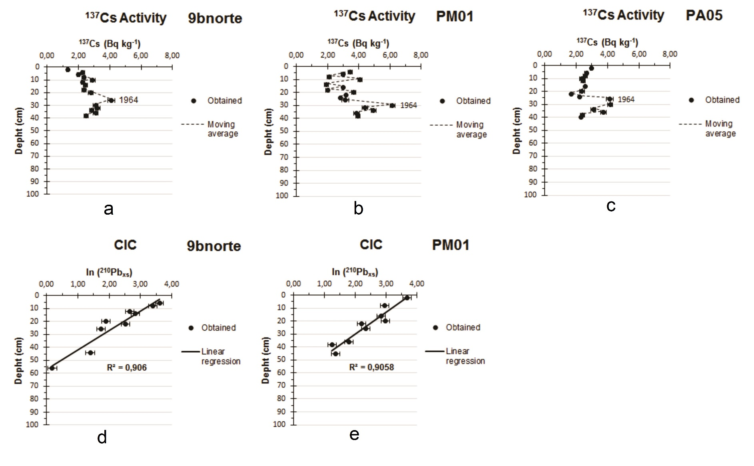

Fig. 2: Depth variation of the 137Cs activities from 9bnorte (a), PM01 (b) and PA05 (c) sediment cores and 210Pbxs activities [Concentration Initial Constant (CIC)] from 9bnorte (d) and PM01 (e) sediment cores.

*Grain size, Calcium carbonate, Total organic carbon (TOC), Corg./Ntotal ratio and δ13C and δ15N isotopes.*

The sediment from the Piraquê-Açú core (PA05 – Fig. 3) has a high TOC content (4.64 – 7.71 %) and calcium carbonate (21.60 – 71.24 %, Fig. 3), the latter likely being associated with native biogenic material, such as bivalves and gastropods as several shells were found in the sediment.

The particle size in the PA05 sediments consisted predominantly of silt but with an increase in sand content towards the surface (Fig. 3). Organic material in coastal environments is usually associated with fine sediments (Ogrinc et al., 2005), but this association does not occur in the PA05 sediments, where the organic material derived from mangroves may be the main contributor to the PA05 TOC.

As for organic matter quality, Corg./Ntotal ratio showed values ​​(23.3 – 32.2; Fig. 3) characteristic of terrestrial vegetation contributions (> 12) (Prahl et al., 1980) since the composition of these plants consist predominantly of lignin and cellulose, which have low nitrogen content (Lamb et al., 2006). The δ13C values ​​for PA05 (-29.1 ‰ – -25.1 ‰) also suggest a terrestrial contribution, which may be associated with organic material from mangrove forests (Meyers, 2003). Smallwood et al. (2003) found δ13C values between -29.5 and -26.5 ‰ in red mangrove (*Rhizophora* *mangle*) leaves, which is an abundant species in PAPMES. Furthermore, the δ15N values ​​ (2.1 – 5.3 ‰) are consistent with this organic input, as higher plants can have values between 3.0 and 18.0 ‰ (Peters et al., 1978; Wada and Hattori, 1991). The greater changes is sediment profiles of isotopes and Corg./Ntotal ratio since the late 1970s could be caused by land use change around the river watershed (Fig. 3).



Fig. 3: PA05 dated vertical distribution of grain size, TOC, CaCO3, δ13C, δ15N and Corg./Ntotal.

However, the stable isotope values found for PA05 are also consistent with a river/estuarine phytoplankton contribution to sedimentary organic matter, especially in the surficial layers of the sediment, as δ13C values between -35 to -25 ‰ and δ15N around 5 ‰ are typical of these organisms (Meyers, 2003). This contribution is better observed by comparing the δ13C and Corg./Ntotal data with typical values compiled by Lamb et al. (2006) (Fig. 4a), showing contributions of freshwater dissolved organic carbon mainly in surficial sediments.

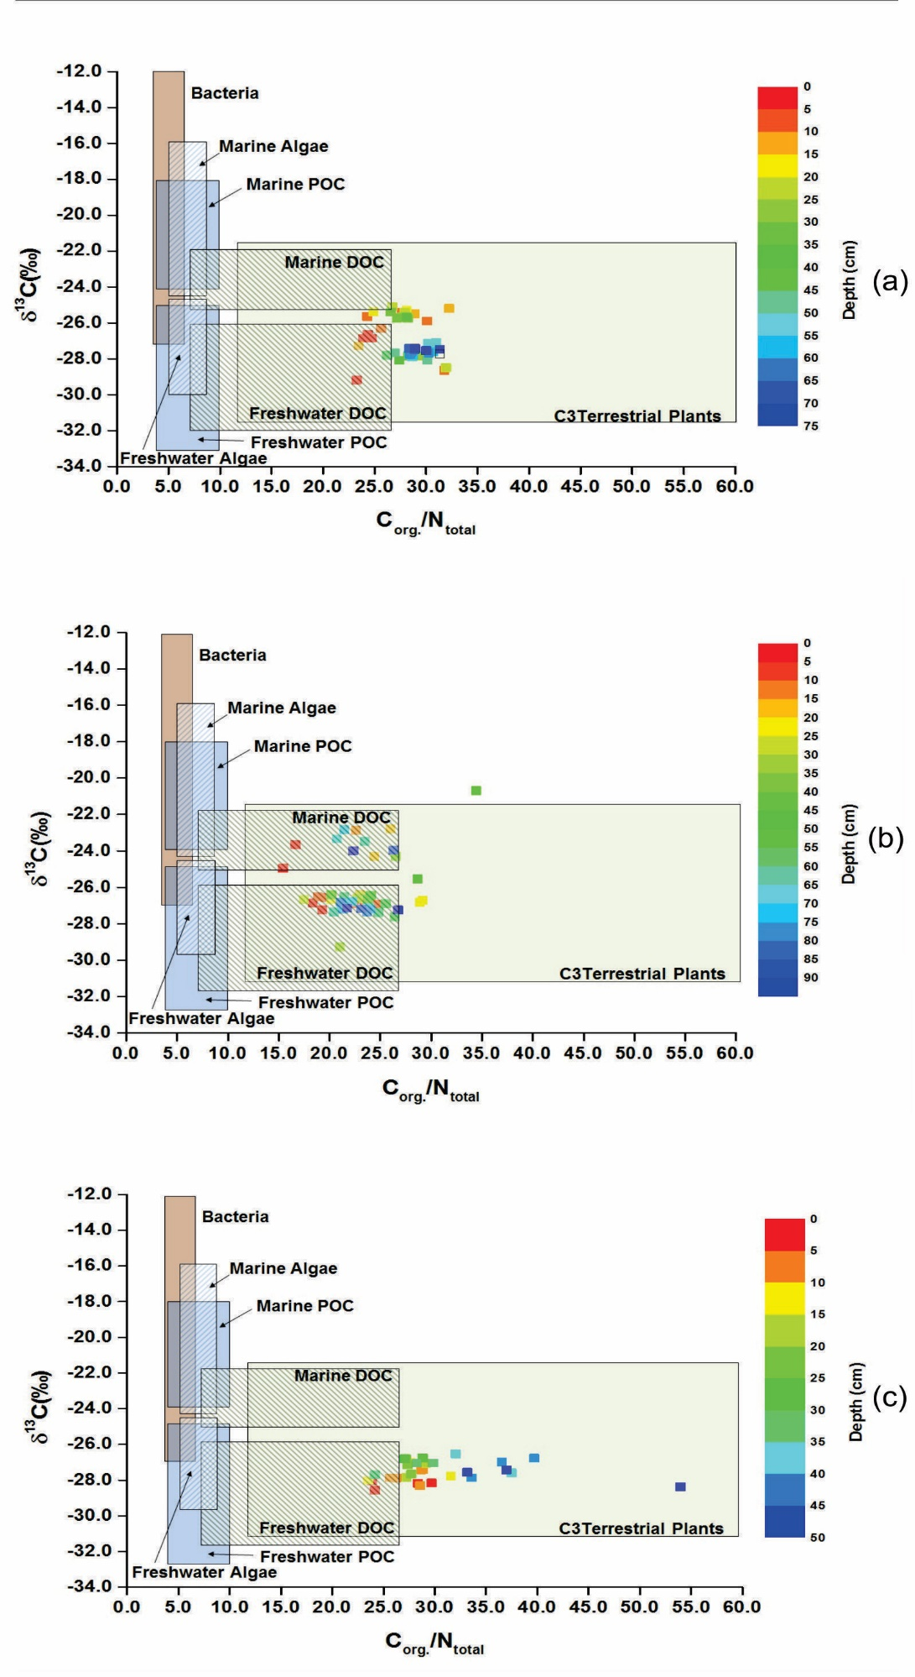

Fig. 4: Plot with δ13C vs. Corg./Ntotal for (a) PA05 core, (b) 9bnorte core and (c) PM01 core, along with typical levels of Corg./Ntotal e δ13C to coastal environment organic ‘‘inputs’’. Adapted from Lamb et al. (2006).

The 9bnorte core showed a strong variation in particle size distribution in the vertical profile, with a predominance of fine particles in almost the entire core (Fig. 5). The grain size profile showed two regions where the sand content increased, the first at the bottom of the core (between 80 and 94 cm) and the second at a depth of 54cm, which could a reflect changes inland usage. Calcium carbonate showed a small variation in vertical distribution, with the highest content at a depth of 56 cm, decreasing towards the surface. Again, the CaCO3 contents could be associated with biogenic material due to the presence of shell fragments in the entire core.

This core was obtained from the region where the waters of the two rivers meet the sea and, as such, is influenced by many factors (river flows, tidal currents, waves, etc.), affecting organic matter contributions (riverine, marine and mangrove) to the sediment. Additionally, different turbulence events in the water column could also influence the quantity and quality of the material deposited there (Huettel et al., 2003). Indeed, the 9bnorte core has a lower TOC content than either PA05 or PM01. This reduced organic carbon could be directly related to the grain size of the sediment, which is affected by local dynamics.



Fig. 5: 9bnorte dated vertical distribution of grain size, TOC, CaCO3, δ13C, δ15N and Corg./Ntotal.

Several sources of organic material and sediments to the 9bnorte location affect particle size and organic carbon as well as the quality of organic matter. Fig. 4b illustrates the contribution of a mixture of materials in the region, showing a strong marine/riverine phytoplankton influence with a terrigenous contribution as well. The algal contribution is corroborated by δ15N values, which are around 5 ‰ (Meyers, 2003), with a strong decrease in the middle of the core, possibly caused by a higher terrestrial plants contribution (δ15N ≈ 0 ‰) (Smallwood et al., 2003; Fogel et al., 2008). This event could be associated with a period of intense deforestation in the surrounding town of Santa Cruz between 1920 and 1950 due to logging, ranching and coffee farming (Loureiro, 2006).

The sediment distributions in core PM01 did not show wide variations. Among the cores studied, PM01 had the highest organic carbon and the lowest CaCO3 content in its sediment composition (Fig. 6), which may be associated with its fine particle size characteristic. The predominance of fine sediments leads to the preservation of TOC (Ogrinc et al., 2005; Gao et al., 2008).

Fig. 6: PM01 dated vertical distribution of grain size, TOC, CaCO3, δ13C, δ15N and Corg./Ntotal.

Despite having a smaller watershed than Piraquê-Açú river, the basin of Piraquê-Mirim river is characterized by less altered conditions (Barroso, 2004), which may contribute to a higher organic contribution from the surrounding vegetation and autochthonous phytoplankton production. According to Boutton (1991) and Meyers (2003), δ13C values of PM01 (-28.6 – -26.5 ‰) may indicate terrigenous and phytoplankton influences on organic composition. This contribution is better visualized by comparing the data of carbon isotopes with the Corg./Ntotal ratio as shown in Fig. 4c, where most of the organic content is derived from C3 terrestrial plants and a small contribution from dissolved organic carbon mainly derived freshwater phytoplankton (Rashid, 1985). The δ15N values found in PM01 sediments may also reflect this terrestrial input (C3 plants; δ15N between -5 and 18 ‰) (Riera et al., 1999; Maksymowska et al., 2000) as well as a freshwater planktonic contributions (Owsens, 1987; Wada and Hattori, 1991) from Piraquê-Mirim river.

*Hydrocarbons*

The highest average concentrations of *n*-alkanes and terpanes were found in PM01, which reflects its high TOC content. For 9bnorte sediments, the highest concentrations of hydrocarbons occurred at the time of decreasing sand deposition and increasing silt content (22 and 62 cm). This may reflect the deposition of finer particles, which would help the incorporation of these organic compounds into the sediment (Thompson and Eglinton, 1978).

The Piraquê-Açú sediment core (PA05) has the lowest average concentrations of these compounds (Fig. 7), which could be related to the greater capacity of particulate material transport compared to Piraquê-Mirim River. This would lead to higher transport of finest sediment particles favoring the deposition of sandy particles, thus reducing the deposition of such organic material with finer grain size material (Zhang et al., 2009). This would explain the lower hydrocarbon concentrations between 5 and 20 cm with increased sand content, which is associated with land use changes between 1950s and late 1970s as logging, coffee farming, cattle and eucalyptus culture (Loureiro, 2006).



Fig. 7: Vertical distribution of the n-alkanes to PA05, 9bnorte and PM01 cores.

Another important factor that could influence the normal hydrocarbon concentrations in the sediments is the proximity between the source and the deposition site. As described above, the organic composition of PAPMES region is strongly influenced by the surrounding mangroves; all cores showed higher concentrations of long-chain n-alkanes (*n-*C25 – *n-*C36) compared to the short-chain compounds (*n-*C13 – *n-*C24), and especially of *n-*C27, *n-*C29, *n-*C31 (Fig. 8). These long-chain alkanes are typical of mangrove inputs (leaves) as these higher plants have this long-chain predominance (Eglinton and Hamilton, 1967; Liebezeit and Woestmann, 2009). Additionally, the strong preference of odd- over even-chain carbon of the *n-*alkanes, which is a feature of epicuticular waxes of higher plants leaves (Eglinton and Eglinton, 2008), in all the cores, reinforces this influence of mangrove on the organic composition of the sediments in the estuary.

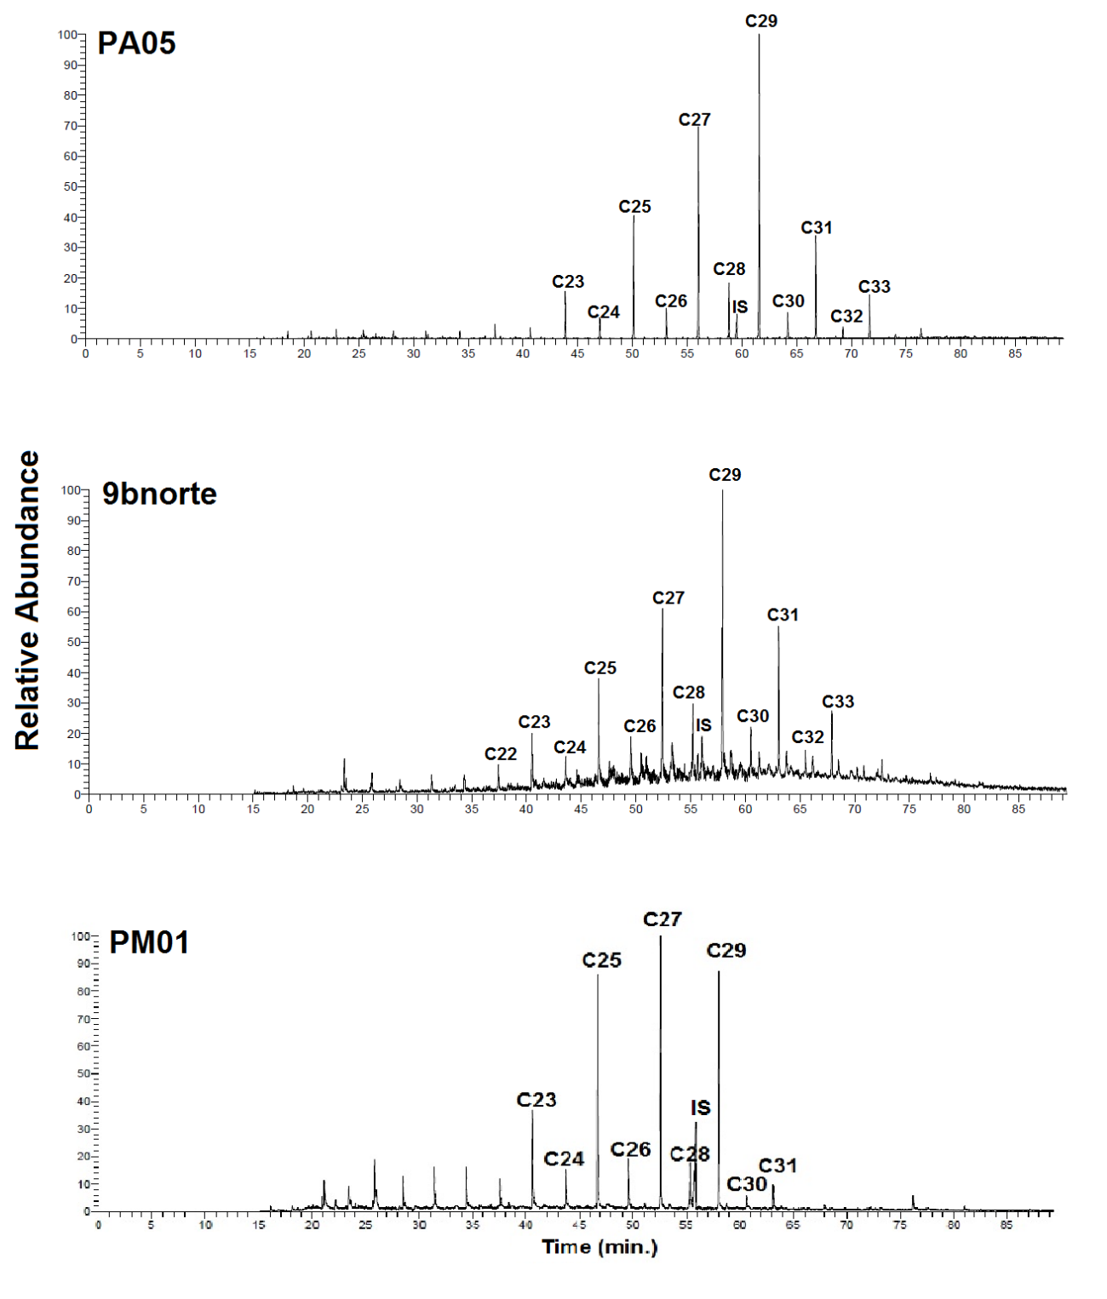

Fig. 8: Selected Ion Current (SIC) chromatogram (m/z = 71) at 3 cm from PA05, 9bnorte and PM01 cores.

There were no characteristic compounds indicating petrogenic contamination in any of the PAPMES cores. Characteristic petroleum-derived biomarkers found in contaminated environments (*e.g*., tri-, and tetracyclic terpanes; 17α(H), 21β(H) hopanes and gammacerane) were absent or in very low concentrations. Instead, a high proportion of compounds with 17β(H), 21β(H) and 17β(H), 21α(H) configuration were found, typically absent in thermally mature petroleum, which may rather be associated with biogenic activity (bacteria) (Yunker and Macdonald, 2003). These characteristics are different from those found by Costa et al. (2015) on the urban Passage Channel estuary in Vitória, Espírito Santo, Brazil, where there are elevated concentrations of petrogenic compounds in sediments including petroleum-derived biomarkers.

The Piraquê-Mirim core (PM01) had the highest average concentration of hopanoids (0.08 μg/g) (Fig. 9), probably reflecting the high TOC contents of the sediments. This again could indicate a high bacterial activity that could change the redox characteristics of the sediments and mobilize metals to surface sediments or water column (Du Laing et al., 2009).



Fig. 9: Vertical distribution of the terpanes concentration to PA05, 9bnorte and PM01 cores.

*Major elements, trace metals and arsenic*

The minimum, maximum and average concentrations of Al, As, Ba, Cd, Co, Cr, Cu, Fe, Li, Mg, Mn, Ni, Pb, V and Zn for the PA 05, 9bnorte and PM01 cores are given in Table 2.

Table 1: Minimum, maximum, average and standard deviation of metals and arsenic for PA05, 9bnorte and PM01 cores.

|  |  |  |  |  |  |  |  |  |  |
| --- | --- | --- | --- | --- | --- | --- | --- | --- | --- |
|  | PA05 | | | 9bnorte | | | PM01 | | |
|  |  | | |  | | |  | | |
|  | Min. | Max. | Avg.  (SD) | Min. | Max. | Avg.  (SD) | Min. | Max. | Avg.  (SD) |
| Al (%) | 3.67 | 6.91 | 5.48 (0.81) | 1.84 | 7.74 | 3.62 (1.02) | 2.03 | 6.17 | 3.72 (0.76) |
| As | 21.32 | 69.63 | 40.78 (8.35) | 34.68 | 87.59 | 53.34 (13.06) | 30.70 | 100.11 | 62.53 (18.67) |
| Ba | 31.21 | 71.27 | 57.03 (6.70) | 27.42 | 116.09 | 54.29 (18.99) | 27.57 | 76.28 | 51.85 (14.29) |
| Cd | 0.68 | 0.92 | 0.75 (0.05) | 0.18 | 1.25 | 0.71 (0.28) | 0.69 | 1.85 | 1.07 (0.31) |
| Co | 3.81 | 7.75 | 6.71 (0.70) | 3.87 | 10.99 | 6.44 (1.35) | 4.37 | 9.71 | 6.21 (1.11) |
| Cr | 40.25 | 95.32 | 79.65 (10.21) | 45.21 | 134.71 | 80.34 (19.21) | 47.78 | 181.66 | 85.79 (33.73) |
| Cu | 8.24 | 25.28 | 14.31 (3.00) | 3.45 | 47.37 | 12.24 (6.96) | 2.93 | 50.72 | 11.44 (9.56) |
| Fe (%) | 4.05 | 6.08 | 5.48 (0.38) | 2.08 | 8.29 | 4.90 (1.54) | 3.73 | 10.57 | 5.66 (1.46) |
| Li | 32.06 | 77.03 | 59.56 (10.25) | 30.71 | 121.02 | 58.88 (18.60) | 22.43 | 79.89 | 47.20 (11.05) |
| Mg (%) | 0.56 | 1.21 | 1.02 (0.11) | 0.85 | 1.83 | 1.27 (0.26) | 0.57 | 1.84 | 1.17 (0.37) |
| Mn | 105.46 | 333.16 | 270.81 (47.17) | 167.23 | 709.12 | 307.97 (126.37) | 123.34 | 1017.47 | 475.28 (234.77) |
| Ni | 12.13 | 29.21 | 20.05 (3.19) | 12.15 | 32.77 | 19.78 (4.45) | 8.36 | 43.67 | 20.20 (8.45) |
| Pb | 13.74 | 23.50 | 18.83 (1.94) | 9.40 | 38.84 | 16.73 (4.44) | 8.95 | 62.27 | 16.57 (9.13) |
| V | 51.95 | 96.01 | 75.00 (10.08) | 53.85 | 125.59 | 82.37 (14.85) | 49.97 | 133.44 | 82.60 (20.95) |
| Zn | 42.38 | 97.93 | 77.09 (10.26) | 38.03 | 122.10 | 65.42 (16.49) | 40.31 | 83.05 | 59.64 (9.85) |

* All the metals and arsenic concentrations are expressed in µg/g, except for Al, Fe and Mg, those are expressed in %.

The vertical distribution profiles of the element concentrations are presented in Fig. 10. The distribution profile for sediments from core PA05 showed only very small variations indicating a homogeneous sediment supply. In the case of PM01 and 9bnorte there were variations in the element concentrations; the highest concentrations of the elements were found at mid-depth in both these cores, with a decreasing trend in concentration towards the surface, except for Ba and Cd in PM01 and Cd, Mg and Pb in 9bnorte.

The elemental, inorganic carbon (IC; CaCO3), TOC, sand, silt and clay principal component analysis (PCA) extracted three components that describe 61.7% of the data variability (Fig. 11). The first principal component (PC 1) with 36.8% of the variability group describes the majority of the elements, e.g. Al, Ba, Cd, Co, Cr, Cu, Fe, Li, Mg, Ni, Pb, Zn and V. Elements such as Al, Ba, Li and Co are considered to be lithogenic and are usually associated with a terrigenous contribution to sediment (Qi et al., 2010). In fact, the concentrations of these elements correlate strongly (Table 2), confirming that the distribution of PC1 grouped elements is strongly controlled by terrigenous sediment supply from the rivers that is deposited in PAPMES. The textural parameters of the sediment (CaCO3, sand, silt and clay) and TOC comprise the second component (PC 2), with 13.3% of the variability, with CaCO3 (indicative of biological material added to the sediment) and sand mainly responsible for this variability. Fine particles and TOC should have a large control on metal distributions in the sediments (Marchand et al., 2006; Zourarah et al., 2009), but this does not appear to be the case as indicated by the high negative eigenvalues. The third component (PC 3) accounts for 13.3% of the data variability, and shows a grouping of As and Mn, indicating a possible As association with the oxides/hydroxides of manganese in the sediment (Liu et al., 2003).



Fig. 10: Vertical distribution of major (Al, Fe and Mg), trace (Ba, Cd, Co, Cr, Cu, Li, Mn, Ni, Pb, V and Zn) and arsenic elements concentration to PA05, 9bnorte and PM01 cores.

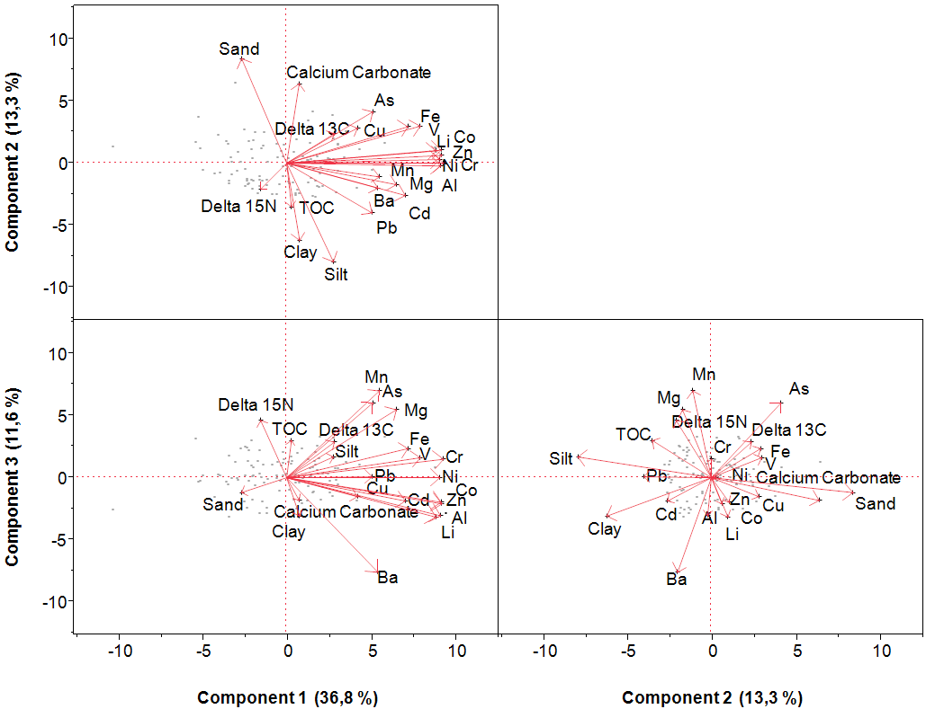

Fig. 11: PCA loading plot (PC1 vs. PC2 vs. PC3) for major and trace elements, TOC, Sand, Silt, Clay, Calcium Carbonate, Delta 13C (δ13C) and Delta 15N (δ15N) of three PAPMES sediment cores (PA05, 9bnorte and PM01)

The Enrichment Factor (EF) was used to better assess the natural/ anthropogenic contribution to the metal and arsenic sediment loads and their distributions. The EF minimizes the over lithogenic influences such as particle size and mineralogical variation (Qi et al*.*, 2010; Zhang et al., 2013). EFs for each element were calculated using the formula:

$${{\left(M/{M_{ref.}}\right)}_{Sample}}/{{\left(M/{M_{Ref.}}\right)}_{Background}}$$

where (M/Mref)sample is the ratio between studied metal and the reference metal in the sample (*e.g.* Al, Li), while (M/Mref.)background is the ratio between the studied metal and the reference metal in an average crustal sample (Ergin et al., 1991). Lithium was used as the reference metal in this study because it is not substantially influenced by human activity (Loring, 1990).

Usually, metal concentrations in shales of continental crust are used as background values for calculating EF (Chatterjee et al., 2007; Chatterjee et al., 2009; Banerjee et al., 2012.). However, these values can vary depending on the location. As the PAPMES is located in a region of extreme influence of the Barreiras Group formation, and has peculiar characteristics as the predominance of kaolinite minerals and iron and manganese oxides (Melo et al., 2002), the concentrations of metals in the deepest sections of the cores were used as background levels to calculate the EF, as the dating based on sedimentation rates showed that sediments were laid down before any main human activity in the region.

The classification proposed by Birch (2003) was used for the evaluation of EFs for the PAPMES sediment cores with the following categories: EF<1 = no enrichment; EF 1 – 3 = low enrichment; EF 3 – 5 = moderate enrichment; EF 5 – 10 = moderately severe enrichment; EF 10 – 25 = severe enrichment; EF 25 – 50 = highly severe enrichment; EF>50 = extremely severe enrichment.

Usually, high concentration of metals and arsenic in sediments is related to human impacts on the aquatic environment, however the EFs for the three studied cores in this work displayed in Fig. 12, indicate that the sediments in PA05 show no enrichment relative to the deep core samples. However, EFs for 9bnorte, showed an enrichment of the elements As, Co, Cr, Cr, Fe, Mg, Mn, Ni, Pb, V and Zn in depths between 10 and 28 cm. This occurred in the mid-1950s, in the district of Santa Cruz, Aracruz, where intense deforestation occurred with felled wood being used for charcoal production and the land used for grazing (Loureiro, 2006). This may have increased the weathering, leaching and erosion of these elements in the region of the confluence of the estuary, where the 9bnorte core was sampled.

At PM01 there is a clear enrichment of the metals Al, Ba, Cd, Co, Pb and Zn toward the surface of the core. Cd, Pb and Zn are usually considered to be contaminants derived from human activity (Price et al., 1999; Qi et al., 2010). However, concomitant enrichment and correlation with Al, Co and Ba (Table 2), which are important metals characteristic of a terrigenous/riverine contributions, indicate that the increase of these elements (Cd, Pb and Zn) derive from the estuarine dynamic mobilization, settling and accumulating in Piraquê-Mirim sediments and not from anthropogenic sources.

Relatively low levels of arsenic (between 0.5 and 8 µg/g) have been reported in coastal sediments around the world and in other Brazilian aquatic environments compared with those found in the PAPMES (Magesh et al., 2013; Xie et al., 2014; Cordeiro et al., 2015; Wang et al., 2015; Sá et al., 2015). High levels of arsenic are normally associated with human activities (Alkan, et al., 2015; Zhuang and Gao, 2015); however Mirlean et al. (2012) report high arsenic levels in marine coastal and mangrove sediments on the coastline of Aracruz, Espírito Santo, Brazil and associate this enrichment with a natural input from Barreiras Group formation sediments. EF analysis of this metalloid indicates that there is no enrichment in this environment with depth, except in 9bnorte, suggesting that PAPMES sediments have naturally high levels of arsenic. The correlation of concentration of As with Fe and Mn (Table 2) supports its association with iron and manganese oxy-hydroxides, possibly derived from leaching and erosion of the Barreiras Group formation sediments as reported by Mirlean et al. (2011).

Table 2: Pearson matrix correlation (p<0.05) between major elements (Al, Fe and Mg), trace elements (As, Ba, Cd, Co, Cr, Cu, Li, Mn, Ni, Pb, V and Zn), grain size, CaCO3 and TOC from three sediment cores of PAPMES (n=123).

|  |  |  |  |  |  |  |  |  |  |  |  |  |  |  |  |  |  |  |  |  |
| --- | --- | --- | --- | --- | --- | --- | --- | --- | --- | --- | --- | --- | --- | --- | --- | --- | --- | --- | --- | --- |
|  | **TOC** | **CaCO3** | **Li** | **Mg** | **Al** | **V** | **Cr** | **Mn** | **Fe** | **Co** | **Ni** | **Cu** | **Zn** | **As** | **Cd** | **Ba** | **Pb** | **Sand** | **Silt** | **Clay** |
| **TOC** | 1.00 |  |  |  |  |  |  |  |  |  |  |  |  |  |  |  |  |  |  |  |
| **CaCO3** | -0.31 | 1.00 |  |  |  |  |  |  |  |  |  |  |  |  |  |  |  |  |  |  |
| **Li** | - | 0.19 | 1.00 |  |  |  |  |  |  |  |  |  |  |  |  |  |  |  |  |  |
| **Mg** | - | -0.20 | 0.39 | 1.00 |  |  |  |  |  |  |  |  |  |  |  |  |  |  |  |  |
| **Al** | - | - | **0.91** | 0.40 | 1.00 |  |  |  |  |  |  |  |  |  |  |  |  |  |  |  |
| **V** | - | - | *0.55* | *0.50* | *0.58* | 1.00 |  |  |  |  |  |  |  |  |  |  |  |  |  |  |
| **Cr** | - | - | **0.72** | *0.63* | **0.74** | **0.70** | 1.00 |  |  |  |  |  |  |  |  |  |  |  |  |  |
| **Mn** | 0.18 | - | 0.19 | *0.68* | 0.32 | 0.38 | *0.67* | 1.00 |  |  |  |  |  |  |  |  |  |  |  |  |
| **Fe** | - | 0.24 | *0.50* | 0.42 | 0.48 | *0.67* | *0.57* | 0.44 | 1.00 |  |  |  |  |  |  |  |  |  |  |  |
| **Co** | - | - | **0.87** | 0.36 | **0.83** | *0.63* | **0.80** | 0.35 | *0.61* | 1.00 |  |  |  |  |  |  |  |  |  |  |
| **Ni** | - | - | **0.77** | *0.54* | **0.77** | *0.66* | **0.86** | *0.50* | *0.50* | **0.77** | 1.00 |  |  |  |  |  |  |  |  |  |
| **Cu** | - | - | 0.40 | 0.24 | 0.38 | 0.29 | 0.41 | 0.18 | - | 0.41 | 0.42 | 1.00 |  |  |  |  |  |  |  |  |
| **Zn** | - | - | 0.**86** | 0.46 | **0.86** | *0.66* | *0.69* | 0.28 | *0.69* | **0.85** | **0.72** | 0.28 | 1.00 |  |  |  |  |  |  |  |
| **As** | - | 0.23 | 0.25 | 0.46 | 0.25 | *0.64* | 0.45 | *0.52* | **0.77** | 0.36 | 0.38 | - | 0.37 | 1.00 |  |  |  |  |  |  |
| **Cd** | - | - | *0.50* | 0.38 | *0.64* | *0.53* | *0.52* | 0.23 | 0.47 | 0.48 | *0.52* | - | *0.64* | - | 1.00 |  |  |  |  |  |
| **Ba** | - | - | *0.60* | - | **0.70** | 0.24 | 0.35 | -0.19 | 0.24 | *0.59* | 0.38 | 0.22 | *0.62* | -0.21 | *0.60* | 1.00 |  |  |  |  |
| **Pb** | - | - | 0.30 | 0.49 | 0.41 | 0.31 | 0.49 | 0.35 | - | 0.33 | 0.43 | 0.26 | 0.34 | - | 0.40 | 0.33 | 1.00 |  |  |  |
| **Sand** | - | 0.32 | - | -0.28 | - | - | -0.23 | -0.26 | - | -0.18 | -0.21 | - | - | - | -0.26 | - | -0.28 | 1.00 |  |  |
| **Silt** | - | -0.28 | 0.19 | 0.30 | - | - | 0.24 | 0.28 | - | 0.19 | 0.22 | - | 0.18 | - | 0.24 | - | 0.26 | **-0.99** | 1.00 |  |
| **Clay** | 0.19 | -0.24 | - | - | - | - | - | - | - | - | - | - | - | -0.30 | 0.30 | 0.35 | 0.22 | -0.37 | 0.28 | 1.00 |

* Italic numbers are correlation higher than 0.50 (strong correlation).
* Bold numbers are correlations higher than 0.70 (very strong correlation).



Fig. 12: Major and trace elements enrichment factor vertical distributions for PA05, 9bnorte and PM01 sediment cores.

**Conclusion**

The PAPMES sediments have high amounts of organic carbon derived from C3 terrestrial plants, probably mangroves, with dissolved fluvial and marine material contributions, especially near the mouth of the estuary. This finding suggests that the mangrove ecosystem around the estuary is the main source of organic material to the sediments of PAPMES. In spite of the high concentration of organic carbon and hydrocarbons, the PAPMES showed no contamination characteristic of petrogenic compounds. Furthermore, organic carbon and hydrocarbons did not show any relationship with metals or arsenic, indicating that the sources of these organic compounds and elements are decoupled.

Fine particles (silt and clay) have little (As, Cd, Co, Cr, Li, Mg, Mn, Ni, Pb and Zn) or no (Al, Cu, Fe and V) influence on the distribution of trace metals and As in the sediments. The terrigenous lithogenic supply (iron and manganese oxy-hydroxides for arsenic) were mainly responsible for the distribution of these elements. The high concentrations of arsenic in all of the sediments analysed suggest that the Barreiras Group formation is the main source of this element to PAPMES.

Sediments of PAPMES showed no evidence of a high enrichment of metals and arsenic derived from human activity, except in the vicinity of 9bnorte. The enrichment of the elements As, Co, Cr, Cr, Fe, Mg, Mn, Ni, Pb, V and Zn in the estuary has been associated with deforestation for charcoal production started in the mid-50’s, enhancing the exposed soil to weathering and erosion of those to the estuary channel.

The estuarine system of Piraquê-Açú and Piraquê-Mirim rivers remains in a well preserved state. The data presented in this work should help environmental agencies to maintain the natural state of this ecosystem and other tropical estuaries. PAPMES is located at less than 50 km from the Doce river which recently suffered a major environmental disaster, when a mining dam collapsed. The mud from this mining waste reached the continental shelf and is likely to migrate, therefore the present study provides a baseline to monitor the fate of the mining waste.

**Acknowledgements**

The authors would like to thank Agência Nacional do Petróleo (ANP), Coordenação de Aperfeiçoamento de Pessoal de Nível Superior – Brazil (CAPES) and Fundação de Amparo à Pesquisa do Espírito Santo – Brazil (FAPES) for financial support. We also thank to Prof. Dr. P.J. DuBowy (Mississippi Valley Division) for his assistance on language, writing and proof reading; To Dr. L.A. Coyne (University of Liverpool), Dr. R. Jeffreys (University of Liverpool), Ms. S. Blackbird (University of Liverpool) and Mr. J. Ball (University of Liverpool) for their support with isotope and Corg./Ntotal analyses; and Dr. A.C. Bastos (Universidade Federal do Espírito Santo) for his support with grain size analyses.

**References**

Alkan, N., Alkan, A., Akbas, U., Fisher, A., 2015. Metal pollution assessment in sediments of the Southeastern Black Sea coast of Turkey. Soil & Sediment contamination. 24 (3), 290-305.

Appleby, P.G., Oldfield, F., 1978. The calculation of Lead-210 dates assuming constant rate of supply 210Pb to sediment. Catena. 5, 1–8.

Bahena-Manjarrez, J.L., Rosales-Hos, L., Carranza-Edwards, A., 2002. A. Spatial and temporal variation of heavy metals in a tropical estuary. Environmental Geology. 42 (6), 575-582.

Banerjee, K., Senthilkumar, B., Purvaja, R., Ramesh, R., 2012. Sedimentation and trace metal distribution in selected locations of Sundarbans mangroves and Hooghly estuary, Northeast coast of India. Environmental Geochemistry and Health. 34 (1), 27-42.

Baptista Neto, J. A., Smith, B.J., Mcallister, J.J., 2000. Heavy metal concentrations in surface sediments in a nearshore environment, Jurujuba Sound, Southeast Brazil. Environmental Pollution. 109 (1), 1-9.

Barroso, G.F., 2004. Assessing the potential for mangrove oyster aquaculture in an estuarine system of the Southeastern coast of Brazil: A geographic information system approach. Ph.D Thesis - **University of Victoria**, Canada.

Birch, G.F., 2003. A test of normalization methods for marine sediment, including a new post-extraction normalization (PEN) technique. Hydrobiologia. 492 (1-3), 5-13.

Boutton, T.W., 1991. Stable carbon isotope ratios of natural materials: ii. Atmospheric, terrestrial, marine, and freshwater environments. In Coleman, D.C. and Fry, B. (Eds.), Carbon Isotopes Techniques.Academic Press Inc., San Diego, p. 173–185.

Chatterjee, M., Massolo, S., Sarkar, S.K., Bhattacharya, A.K., Bhattacharya, B.D., Satpathy, K.K., Saha, S., 2009. An assessment of trace element contamination in intertidal sediment cores of Sunderban mangrove wetland, India for evaluating sediment quality guidelines. Environmental Monitoring and Assessment. 150 (1-4), 307-322.

Chatterjee, M., Silva Filho, E.V., Sarkar, S.K., Sella, S.M., Bhattacharya, A., Satpathy, K.K., Prasad, M.V.R., Chakraborty, S., Bhattacharya, B.D., 2007. Distribution and possible source of trace elements in the sediment cores of a tropical macrotidal estuary and their ecotoxicological significance. Environment International.33 (3), 346-356.

Conti, R.C., Nalesso, R.C., 2010. Status of the population structure of the mangrove crab *Ucides cordatus* (Decapoda: Ocypodidae) on the Piraquê-açu River estuary, Espírito Santo, Brazil. Brazilian Journal of Oceanography.58 (2), 81-92.

Costa, E.S., Grilo, C.F., Wolff, G.A., Thompson, A., Figueira, R.C.L., Neto, R.R., 2015. Evaluation of metals and hydrocarbons in sediments from a tropical tidal flat estuary of southern Brazil. Marine Pollution Bulletin. 92, 259-268.

De Jesus, H.C., Costa, E.A., Mendonça, A.S.F., Zandonade, E., 2004. Distribution and abundance of heavy metals in sediments from Vitória Island estuarine system. Quimica Nova.27 (3), 378-386.

Delgado, J., Boski, T., Nieto, J.M., Pereira, L., Moura, D., Gomes, A., Souza, C., García-Tenorio, R., 2012. Sea-level rise and anthropogenic activities recorded in the late Pleistocene/Holocene sedimentary infill of the Guadiana Estuary (SW Iberia). Quaternary Science Reviews. 33, 121-141.

Dessai, D.V.G., Nayak, G.N., 2009. Distribution and speciation of selected metals in surface sediments, from the tropical Zuari estuary, central west coast of India. Environmental Monitoring and Assessment. 158, 117-137.

Du Laing, G., Rinklebe, J., Vandecasteele, B., Meers, E., Tack, F.M.G., 2009. Trace metal behavior in estuarine and riverine floodplain soils and sediments: A review. Science of the Total Environment. 407, 3972-3985.

Eglinton, T.I., Eglinton, G., 2008. Molecular proxies for paleoclimatology. Earth and Planetary Science Letters. 275 (1-2), 1-16.

Eglinton G., Hamilton, R.J., 1967. Leaf epicuticular waxes. Science. 156 (3780), 1322-1335.

Ergin, M., Saydam, C., Bastürk, Ö., Erdem, E., Yörük, R., 1991. Heavy-metal concentrations in surface sediments from the 2 coastal inlets (Golden Horn estuary and Izmit Bay) of the northeastern sea of Marmara. Chemical Geology. 91 (3), 269-285.

Escobar, H., 2015. Mud tsunami wreaks ecological havoc in Brazil. Science. 350 (6265), 1138-1139.

Figueira, R.C.L., Tessler, M.G., Mahiques, M.M., Fukumoto, M.M., 2007. Is there a technique fo the determination of sedimentation rate based on calcium carbonate content? A comparative study on the Southeastern Brazilian Shelf. Soils and Foundations. 47 (4), 649-656.

Fogel, M.L., Wooler, M.J., Cheeseman, J., Smallwood, B.J., Roberts, Q., Romero, I., Meyers, M.J., 2008. Unusually negative nitrogen isotopic compositions (delta N-15) of mangroves and lichens in an oligotrophic, microbially-influenced ecosystem. Biogeosciences. 5 (6), 1693-1704.

Gao, J., Wang, Y., Pan, S., Zhang, R., Li, J., Bai, F., 2008. Spatial distributions of organic carbon and nitrogen and their isotopic compositions in sediments of the Changjiang Estuary and its adjacent sea area. Journal of Geographical Sciences. 18 (1), 46-58.

Grilo, C.F., Neto, R.R., Vicente, M.A., Castro, E.V.R., Figueira, R.C.L., Carreira, R.S., 2013. Evaluation of the influence of urbanization processes using mangrove and fecal markers in recent organic matter in a tropical tidal flat estuary. Applied Geochemistry. 38, 82-91.

Hatje, V., 2003. Particulate trace metal and major element distributions over consecutive tidal cycles in Port Jackson Estuary, Australia. Environmental Geology. 44, 231-239.

Huettel, M., Røy, H., Precht, E., Ehrenhauss, S., 2003. Hydrodynamical impact on biogeochemical processes in aquatic sediments. Hydrobiologia. 494 (1-3), 231-236.

Ibbotson, J., Ibhadon, A.O., 2010. Origin and analysis of aliphatic and cyclic hydrocarbons in northeast United Kingdom coastal marine sediments. Marine Pollution Bulletin. 60, 1136-1141.

Instituto Brasileiro de Geografia e Estatística (IBGE)., 2015. Demographic census. Available in <http://cod.ibge.gov.br/232FX>. Acessed in 5 Dec. 2015.

Joshi, S.R., Shukla, B.S., 1991. AB initio derivations of formulation for 210Pb dating of sediments. Journal of Radioanalytical and Nuclear Chemistry. 148, 73–79.

Lamb, A.L., Wilson, G.P., Leng, M.J., 2006. A review of coastal palaeoclimate and relative sea-level reconstructions using delta C-13 and C/N ratios in organic material. Earth-Science Reviews. 75 (1-4), 29-57.

Liebezeit, G., Woestmann, R., 2009. n-Alkanes as Indicators of Natural and Anthropogenic Organic Matter Sources in the Siak River and its Estuary, E Sumatra, Indonesia. Bulletin of Environmental Contamination and Toxicology. 83 (3), 403-409.

Liu, E., Shen, J., Yang, L., Zhang, E., Meng, X., Wang, J., 2010. Assessment of heavy metal contamination in the sediments of Nansihu Lake Catchment, China. Environmental Monitoring and Assessment. 161 (1-4), 217-227.

Liu, M., Hou, L.J., Xu, S.Y., Ou, D.N., Yang, Y., Yu, J., Wang, Q., 2006. Organic carbon and nitrogen stable isotopes in the intertidal sediments from the Yangtze Estuary, China. Marine Pollution Bulletin. 52 (12), 1625-1633.

Liu, W.X., Li, X.D., Shen, Z.G., Wang, D.C., Wai, O.W.H., Li, Y.S., 2003. Multivariate statistical study of heavy metals enrichment in sediments of the Pearl River Estuary. Environmental Pollution. 121, 377-388.

Loring, D.H., 1990. Lithium – a new approach for the granulometric normalization of trace metal data. Marine Chemistry. 29, 151-168.

Loureiro, K., 2006. A instalação da empresa Aracruz Celulose S/A e a “moderna” ocupação das terras indígenas Tupiniquim e Guarani Mbya. Revista Ágora. 3, 1-32.

Magesh, N.S., Chandrasekar, N., Kumar, S.K., Glory, M., 2013. Trace element contamination in the estuarine sediments along Tuticorin coast – Gulf of Mannar, southeast coast of Índia. Marine Pollution Bulletin. 73 (1), 355-361.

Maksymowska, D., Richard, P., Piekarek-Jankowska, H., Riera, P., 2000. Chemical and isotopic composition of the organic matter sources in the Gulf of Gdansk (Southern Baltic Sea). Estuarine, Coastal and Shelf Science. 51, 585-598.

Marchand, C., Lallier, V.E., Baltzer, F., Alberic, P., Costa, D., Baillif, P., 2006. Heavy metals distribution in mangrove sediments along the mobile coastline of French Guiana. Marine Chemistry. 98, 1-7.

Medeiros, P.M., Bícego, M.C., Castelão, R.M., Rosso, C.D., Fillmann, G., Zamboni, A.J., 2005. Natural and anthropogenic hydrocarbon input to sediments of Patos Lagoon Estuary, Brazil. Environment International. 31, 77-87.

Melo, V.F., Novais, R.F., Schaefer, C.E.G.R., Fontes, M.P.F., Singh, B., 2002. Mineralogia das frações areia, silte e argila de sedimentos do grupo Barreiras no município de Aracruz, estado do Espírito Santo. Revista Brasileira de Ciência do Solo. 26, 29-41.

Meyers, P.A., 2003. Applications of organic geochemistry to paleolimnological reconstructions: a summary of examples from the Laurentian Great Lakes. Organic Geochemistry. 34 (2), 261-289.

Mirlean, N., Baisch, P.R.M., Travassos, M.P., Nassar, C., 2011. Calcareous algae bioclast contribution to sediment enrichment by arsenic on the Brazilian subtropical coast. Geo-Marine Letters. 31 (1), 65-73.

Mirlean, N., Medeanic, S., Garcia, F.A., Travassos, M.P., Baisch, P., 2012. Arsenic enrichment in shelf and coastal sediment of the Brazilian subtropics. Continental Shelf Research. 35, 129-136.

Monteiro, F.F., Cordeiro, R.C., Santelli, R.E., Machado, W., Evangelista, H., Villar, L.S., Viana, L.C.A., Bidone, E.D., 2012. Sedimentary geochemical record of historical anthropogenic activities affecting Guanabara Bay (Brazil) environmental quality. Environmental Earth Sciences. 65 (6), 1661-1669.

Ogrinc, N., Fontolan, G., Faganeli, J., Covelli, S., 2005. Carbon and nitrogen isotope compositions of organic matter in coastal marine sediments (the Gulf of Trieste, N Adriatic Sea): indicators of sources and preservation. Marine Chemistry. 95 (3-4), 163-181.

Owens, N.J.P., 1987. Natural variation in 15N in the marine environment. Marine Biology. 24, 389-451.

Peters, K.E., Sweeney, R.E., Kaplan, J.R., 1978. Correlation of carbon and nitrogen stable isotopes ratios in sediment organic matter. Limnology and Oceanography. 23, 598-604.

Prahl, F.G., Bennett, J.T., Carpenter, R., 1980. The early diagenesis of aliphatic hydrocarbons and organic matter in sedimentary particulates from Dabob Bay, Washington. Geochimica et Cosmochimica Acta. 44, 1967–1976.

Price, N.B., Brand, T., Pates, J.M., Mowbray, S., Theocharis, A., Civitarese, G., Miserocchi, S., Heussner, S., Lindsay, F., 1999. Horizontal distributions of biogenic and lithogenic elements of suspended particulate matter in Mediterranean Sea. Progress in Oceanography. 44, 191-218.

Qi, S., Leipe, T., Rueckert, P., Di, Z., Harff, J., 2010. Geochemical sources, deposition and enrichment of heavy metals in short sediment cores from the Pearl River Estuary, Southern China. Journal of Marine Systems. 82, S28-S42.

Rashid, M.A., 1985. Geochemistry of Marine Humic Compounds. Springer-Verlag, New York.

Riera, P., Stal, L.J., Nieuwenhuize, J., Richard, P., Blanchard, G., Gentil, F. 1999 Determination of food sources for benthic invertebrates in a salt marsh (Aiguillon Bay, France) by carbon and nitrogen stable isotopes: importance of locally produced sources. Marine Ecology Progress Series. 187,301–307.

Sá, F., Sanders, C.J., Patchineelam, S.R., Machado, E.C., 2015. Arsenic fractionation in estuarine sediments: Does coastal eutrophication influence As behavior. Marine Pollution Bulletin. 96, 496-501.

Sabadini-Santos, E., Knoppers, B.A., Padua Oliveira, E., Leipe, T., Santelli, R.E., 2009. Regional geochemical baselines for sedimentary metals of the tropical Sao Francisco estuary, NE-Brazil. Marine Pollution Bulletin. 58 (4), 601-606.

Saito, R.T., Figueira, R.C.L., Tessler, M.G., Cunha, I.I.L., 2001a. Pb-210 and Cs-137 geochronologies in the Cananéia-Iguape Estuary (São Paulo, Brazil). Journal of Radioanalytical Nuclear Chemistry. 249, 257-261.

Saito, R.T., Figueira, R.C.L., Tessler, M.G., Cunha, I.I.L., 2001b. Geochronologies of sediments in the Cananéia-Iguape estuary and in southern continental shelf of São Paulo. Journal of Radioanalytical Nuclear Chemistry. 250, 109-115.

Silva, A.E., Quaresma, V.S., Bastos, A.C., 2013. Sedimentological sectorization of an estuarine system in a regressive coast, southeast Brazil. Journal of Sedimentary Research. 83, 994-1003.

Smallwood, B.J., Wooler, M.J., Jacobson, M.E., Fogel, M.L., 2003. Isotopic and molecular distributions of biochemicals from fresh and buried Rhizophora mangle leaves. Geochemical Transactions.4, 38-46.

Souza, M.J.B., 2009. Avaliação de metais-traço no sedimento do sistema estuarino dos rios Piraquê-Açu e Piraquê-Mirim (Aracruz - ES). Dissertation (MSc in Chemistry) - Universidade Federal do Espírito Santo.

Thompson, S., Eglinton, G., 1978. The fractionation of a recent sediment for organic geochemical analysis. Geochimica et Cosmochimica Acta. 42 (2), 199-207.

United States Environmental Protection Agency - USEPA. Microwave Assisted Acid Digestion of Sediments, Sludges, soils and Oils. (Technical Resource Document, EPA SW-846/3052). Available in: < http://www.epa.gov/osw/hazard/testmethods/sw846/pdfs/3051a.pdf>. Access in 5 Dec. 2015.

Wada, E., Hattori, A., 1991. Nitrogen in the Sea: Forms, Abundances and Rate Processes. CRC Press, Boca Raton. p.208.

Wang, H., Wang, J., Liu, R., Yu, W., Shen, Z., 2015. Spatial variation, environmental risk and biological hazard assessment of heavy metal in surface sediments of the Yangtze River estuary. Marine Pollution Bulletin. 93 (1-2), 250-258.

Xie, Z., Sun, Z., Zhang, H., Zhai, J., 2014. Contamination assessment of arsenic and heavy metals in a typical abandoned estuary wetland- a case study of the Yellow River Delta Natural Reserve. Environment Monitoring and Assessment. 186, 7211-7232.

Yunker, M.B., Macdonald, R.W., 2003. Alkane and PAH depositional history, sources and fluxes in sediments from the Fraser River Basin and Strait of Georgia, Canada. Organic Geochemistry. 34 (10), 1429-1454.

Zhang, L., Zhang, J., Gong, M., 2009. Size distributions of hydrocarbons in suspended particles from the Yellow River. Applied Geochemistry. 24 (7), 1168-1174.

Zhang, R., Zhang, F., Ding, Y., Gao, J., Chen, J., Zhou, L., 2013. Historical trends in the anthropogenic heavy metal levels in the tidal flat sediments of Lianyungang, China. Journal of Environmental Sciences-China. 25 (7), 1458-1468, 2013.

Zhuang, W., Gao, X., 2015. Distributions, sources and ecologikal risk assessment of arsenic and mercury in the surface sediments of the southwestern coastal Laizhou Bay, Bohai Sea. Marine Pollution Bulletin. 99 (1-2), 320-327.

Zourarah, B., Maanan, M., Robin, M., Carruesco, C., 2009. Sedimentary records of anthropogenic contribution to heavy metal content in Oum Er Bia estuary (Morocco). Environmental Chemistry Letters. 7 (1), 67-78.