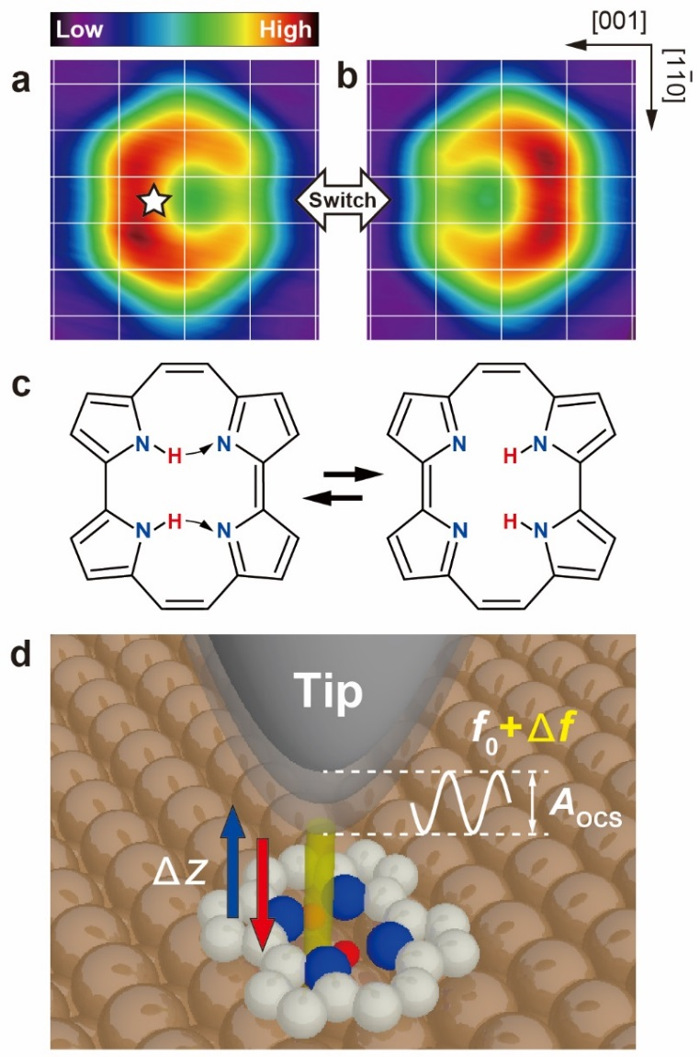
Figure 1 ǀ Porphycene molecule on Cu(110) and schematic of the measurement configuration. a and b, STM images of a single porphycene molecule at 5 K (gap conditions: V_{bias} = –100 mV, I_{t} = 10 nA, size: 1.49 × 1.42 nm²). The white grid represents the surface lattice of Cu(110). The white star indicates the lateral tip position during force spectroscopy in Fig. 2a–c. c, Molecular structure of cis porphycene that can be reversibly switched between the two mirror reflected configurations. The curved arrows depict the hydrogen transfer during tautomerization. d, Schematic of the tip-induced tautomerization experiment. The tip mounted on a tuning fork sensor oscillates at the resonance frequency (f₀) of ~23 kHz with the amplitude (A_{OCS}) of a few Å. The frequency shift (Δf) caused by the interaction (yellow column) between the tip apex and molecule (or surface) is recorded while moving the tip down and up (Δz).

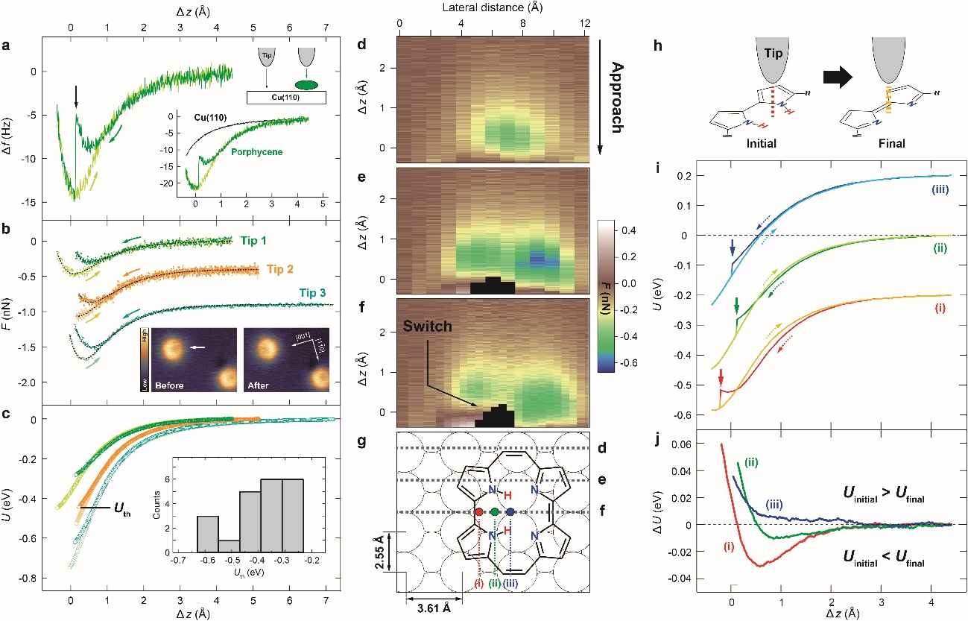 Figure 2 ǀ Force spectroscopy of a single porphycene molecule. a, Background-subtracted Δf(Δz) curves (green: approach, light green: retraction). The inset shows the Δf(Δz) over a molecule (green) and the bare Cu(110) surface (black) before subtraction. The lateral tip position is indicated in Fig. 1a and V_{bias} was set to 0 V during the measurement. The initial tip height was fixed at a gap resistance of 10 GΩ (V_{bias} = 100 mV, I_{t} = 10 pA) over the bare Cu(110) surface and then laterally moved over a molecule with the feedback loop disabled. b, Background-subtracted F(Δz) curves measured with three different tip conditions (labeled Tip 1–3). The black dashed lines represent the fitted result to the Morse potential model $F_{M}=-E_{d}2κ[e^{-κ\left(z-z_{e}\right)}-e^{-2κ\left(z-z_{e}\right)}]$, where E_{d} is the bond energy, κ the decay constant, and z_{e} the equilibrium distance (fitting parameters are listed in Supplementary Table 1). The ∆z is the relative tip height with respect to z_{e} of each approach curve. The inset shows the STM images before and after measurement (white arrow indicates the measured molecule). c, Background-subtracted U(Δz) curves for the three different tips. The inset shows the histogram of the threshold potential (U_{th}) collected from 21 different tip conditions. d‒f, Background-subtracted F(Δz) maps for approach measured along the [001] direction and obtained with Tip 1. The upper edge of the black area in e and f indicates the vertical tip position at which tautomerization takes place. g, Adsorption geometry of porphycene determined by the DFT calculations. The black dashed lines represent the recorded lines of the force maps in d–f. h, Schematic of the initial and final state of tautomerization. i, Background-subtracted U(Δz) curves measured at three different positions over a molecule indicated in g (obtained with Tip 1). For clarity, the curves (i) and (iii) are vertically offset. j, ΔU (= U_{initial} – U_{final}) curves at the three different positions. The ∆z for d–f and i, j represents the relative tip height with respect to z_{e} of the approach curve at the position (ii). Measurement parameters: Tip 1; A_{ocs} = 1 Å, f₀ = 22653 Hz, Q = 18274, Tip 2; A_{ocs} = 1 Å, f₀ = 22645 Hz, Q = 33855, Tip 3; A_{ocs} = 1 Å, f₀ = 22646 Hz, Q = 39143.

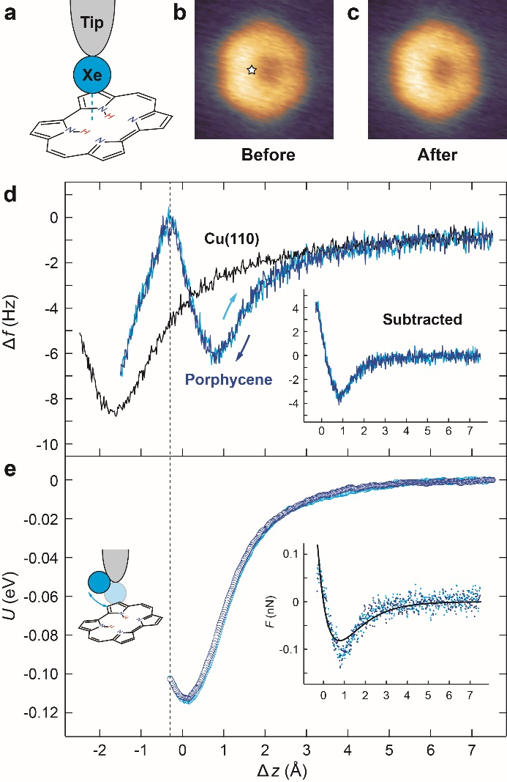
Figure 3 ǀ Force spectroscopy of a single porphycene molecule with a xenon-terminated tip. a, Schematic of the experimental configuration. b, and c, STM images with a xenon-tip before and after the measurement (V_{bias} = 100 mV, I_{t} = 30 pA, 1.4 × 1.4 nm²). The white star indicates the lateral tip position during the measurement. d, Δf(Δz) curve measured over Cu(110) (black) and over porphycene (blue: approach, light blue: retraction). The inset shows the background-subtracted Δf(Δz). The subtraction is implemented in the regime before the second decrease of Δf(Δz) takes place (indicated by the dashed line). e, Background-subtracted U(Δz) curve. The inset shows the F(Δz) curve and the solid lines represent the best fitted result of the approach curve to the Morse potential model with the parameters; [E_{d} (eV), κ (Å⁻¹)] = [0.114(±0.004), 0.98(±0.08)]. The ∆z is the relative tip height with respect to z_{e}. Measurement parameters: A_{ocs} = 1 Å, f₀ = 22646 Hz, Q = 39143.

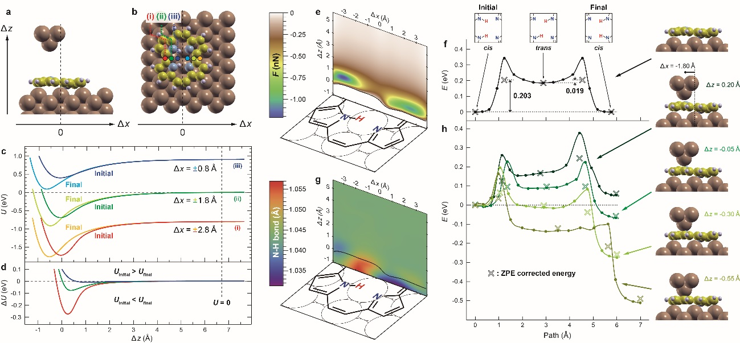
Figure 4 | Calculated force curves and MEPs for the tip‒porphycene‒surface system. a and b, Optimized structure and modeled copper tip. c and d, Simulated background-subtracted U(Δz) and ΔU(Δz) curves. The lateral tip position is indicated by the colored dots in b. “Initial” and “Final” represent the curves over the donor and the acceptor pyrroles, respectively (i.e., corresponding to the curves before and after tautomerization). The ∆z is defined with respect to the potential minimum of the “Initial” curve at the position (ii). The curves for the position (i) and (iii) are vertically offset for clarity. e, Simulated 2D force map over a molecule (only the F < 0 regime is shown). f, MEP for the cis → cis tautomerization of the adsorbed porphycene on Cu(110) determined by the nudged elastic band method. g, 2D plot of the N‒H bond length as a function of the tip position. The black line indicates the F = 0 contour. h, MEPs in the presence of the tip. The corresponding geometry is displayed on the right. The cross markers in f and h represent the ZPE corrected energies. The path length was obtained from the Euclidean distance between the images in configurations space.

