Supplementary Information;
Force-induced tautomerization in a single molecule
Janina N. Ladenthin¹, Thomas Frederiksen^{2,3}, Mats Persson⁴, John C. Sharp⁴, Sylwester Gawinkowski⁵, Jacek Waluk^{5,6}, Takashi Kumagai¹*

¹Department of Physical Chemistry, Fritz-Haber Institute of the Max-Planck Society, Faradayweg 4-6, 14195 Berlin, Germany.
²Donostia International Physics Center (DIPC) ‒ UPV/EHU, E-20018, San Sebastián, Spain.
³ IKERBASQUE, Basque Foundation for Science, E-48013, Bilbao, Spain.
⁴Surface Science Research Centre and Department of Chemistry, University of Liverpool, Liverpool L69 3BX, UK.
⁵Institute of Physical Chemistry, Polish Academy of Sciences, Kasprzaka 44/52, Warsaw 01-224, Poland.
⁶Faculty of Mathematics and Natural Sciences, College of Science, Cardinal Stefan Wyszyński University, Dewajtis 5, 01-815 Warsaw, Poland

*Correspondence to kuma@fhi-berlin.mpg.de
Table of contents
- Tautomers of porphycene
- Simultaneous STM and AFM imaging
- Effect of a long-range electrostatic force on the tip-induced tautomerization
- Reproducibility of the force spectroscopy
- Tip dependence of the tip-induced tautomerization
- Influence of a small bias voltage and tunneling current on the tip-induced tautomerization
- Distribution of the threshold distance of the tip-induced tautomerization
- Tip-induced cis → trans tautomerization
- Position adjustment of the force map
- Force mapping with a different tip
- Fitting parameters for the force curves
- Computational methods
- Calculated force curve
- Minimum energy paths for step-wise and concerted tautomerization
- Red-shift of the N‒H stretching mode frequency
- Relaxation of Xe-terminated tip
- Minimum energy paths for tautomerization in the presence of a Xe-terminated tip
- Tautomers of porphycene
Porphycene has three twofold-degenerate tautomers according to the position of the inner H atoms. In the trans configuration (Fig. 1a) the H atoms are located on the diagonal pyrrole rings, while they are located on the same side in the cis-1 (Fig. 1b) and cis-2 (Fig. 1c) configurations. In the gas phase, calculations have predicted that trans and cis-1 configurations have a comparable total energy (trans is slightly more favorable), but cis-2 is considerably unstable due to the steric hindrance. However, the energetically preferred tautomer on a metal surface is significantly affected by the interaction between the molecule and the surface. Our previous studies have revealed that the cis-1 configuration becomes the most stable state on Cu(110) and molecules are exclusively found in the cis-1 configuration in experiment. On the other hand, the trans configuration becomes the thermodynamically stable state on Cu(111), but trans molecules can be converted to the meta-stable cis-1 configuration via an inelastic electron tunneling process in STM.

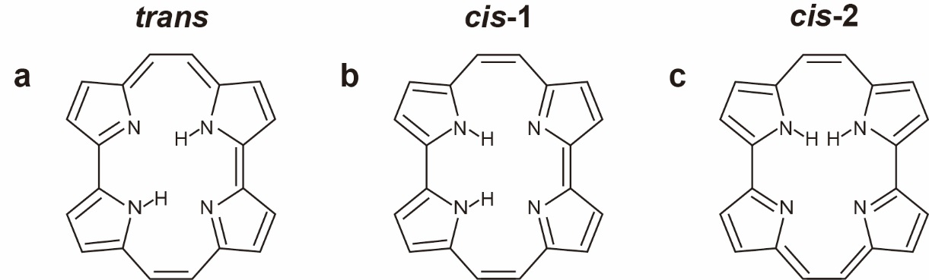
Figure 1 | Different tautomers of porphycene. a, trans b, cis-1 c, cis-2.

- Simultaneous STM and AFM imaging
Figure 2 shows simultaneously recorded STM (tunneling current: I_{t}) and AFM (frequency shift: Δf) images obtained in the constant height mode. In order to record STM images, a small bias voltage (V_{bias}) of ~300 μV was applied to the sample. Such a small bias does not affect Δf signals (see section 6). The gap distance during the measurement was fixed over a Cu(110) surface as follows; first the feedback loop was turned off at the gap resistance of 10 GΩ (I_{t} = 10 pA with V_{bias} = 100 mV), and then the tip was moved down to the surface by 3.5 Å before scanning.

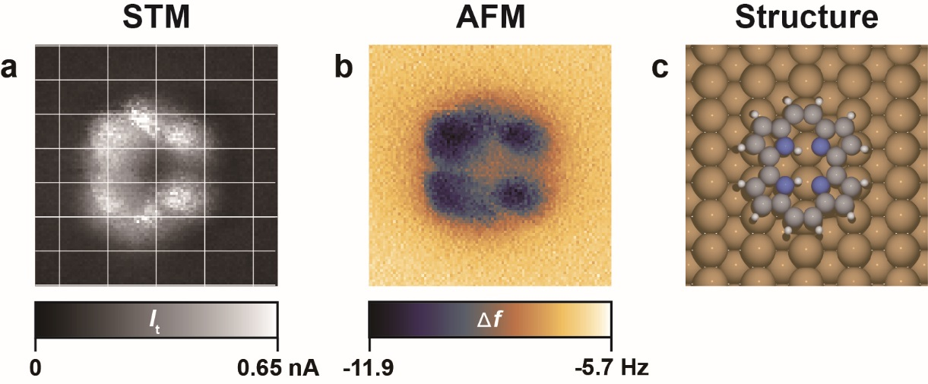
Figure 2 | Simultaneously recorded STM and AFM images. a, STM (I_{t}) image. The white grid lines represent the surface lattice of Cu(110). b, AFM (Δf) image. c, Schematics of calculated structure. Measurement parameters: V_{bias} = 300 μV, the oscillation amplitude (A_{osc}) = 3 Å, the resonance frequency (f₀) = 23216.5 Hz, quality factor (Q) = 47468.
- Effect of a long-range electrostatic force on the tip-induced tautomerization
A contact potential difference (CPD) results in an electrostatic force gradient in the junction that could influence a tip-induced reaction. In order to clarify the effect of this electrostatic force, we examined the tip-induced tautomerization of porphycene under different tip conditions that show a substantially different CPD. The CPD was changed either by applying a pulse voltage or by poking the tip into the surface in a controlled manner. The CPD was evaluated by measuring Δf(V_{bias}) curves over a Cu(110) surface. Figure 3a shows two Δf(Δz) curves measured under different tip conditions that give significantly different CPDs (see inset). Both Δf(Δz) curves show very similar features, although the background is considerably different. Figure 3b displays several background-subtracted force (F) curves obtained under four different tip conditions, which exhibit different threshold forces and distances. However, there is no clear correlation between the threshold potential (U_{th}) and the CPD (Fig. 3c). Therefore, a long-range electrostatic force does not play a crucial role in the tip-induced tautomerization and the observed differences may be due to different atomic structures of the tip apex.
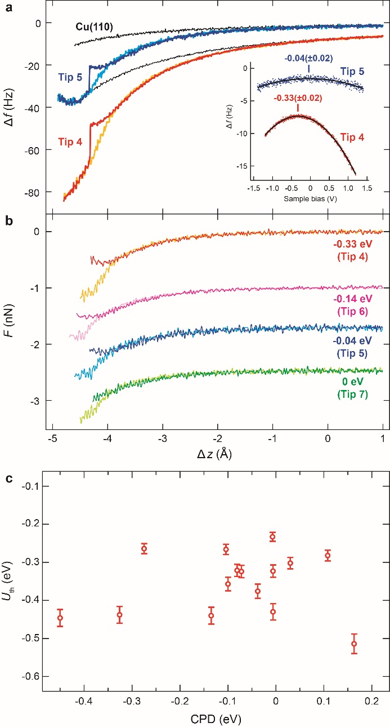
Figure 3 | Force curves measured under tip conditions that gave different CPD. a, Two examples of Δf(Δz) curves measured for a porphycene molecule and a Cu(110) surface measured under two different tip conditions. The inset shows Δf(V_{bias}) curves measured over Cu(110) at a gap resistance of 10 GΩ (V_{bias} = 100 mV and I_{t} = 10 pA). The CPD was determined by fitting the experimental data (dots) to a quadratic function (black solid line). b, Series of background-subtracted F(Δz) curves. The CPD values are indicated in the figure. The relative tip displacement Δz is with respect to the STM set point of V_{bias} = 100 mV and I_{t} = 10 pA over Cu(110). Measurement parameters: Tip 4; A_{ocs} = 1 Å, f₀ = 23213.4 Hz, Q = 51714, Tip 5; A_{ocs} = 1 Å, f₀ = 23234.2 Hz, Q = 20315, Tip 6; A_{ocs} = 1 Å, f₀ = 23215.7 Hz, Q = 49610. Tip 7; A_{ocs} = 1 Å, f₀ = 23224.6 Hz, Q = 34051. c, Threshold potential as a function of the CPD value. 15 different tips were examined.
- Reproducibility of the force spectroscopy
Figure 4 shows six approach curves of Δf(Δz) measured successively over the same porphycene molecule and under the same tip conditions, which demonstrate the reproducibility of force spectroscopy and the tautomerization behavior. The lateral position of the tip was carefully determined by superposing grid lines over the STM image in experiment as shown in the inset to Fig. 4 (blue lines). Note that the Δf values are substantially different compared to those in Fig. 2a of the main text due to different tip conditions. The threshold distance and the Δf value at which tautomerization takes place shows a variation of 0.08 Å and 3.6 Hz, respectively, causing an error of ~100 pN (~60 meV) in the threshold force (potential). This error is most probably due to the small uncertainty of the relative tip position with respect to the molecule.
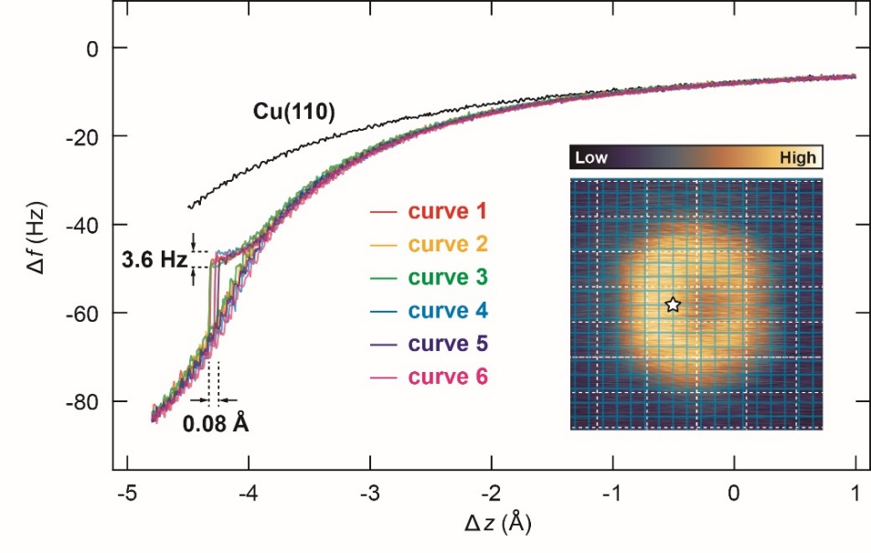
Figure 4 | Six successively-recorded approach curves of frequency shift for a porphycene molecule. The lateral tip position during the measurement is indicated in the STM image (inset). The blue grid lines were superimposed to determine the lateral tip position, while the white dashed lines represent the Cu(110) surface lattice. The black Δf(Δz) curve was measured over the bare Cu(110) surface. The relative tip displacement Δz is defined with respect to the STM set point of V_{bias} = 100 mV and I_{t} = 10 pA over Cu(110). Measurement parameters: Tip 4; A_{ocs} = 1 Å, f₀ = 23213.4 Hz, Q = 51714.
- Tip dependence of the tip-induced tautomerization
Occasionally, a force curve was observed that significantly deviated from the Morse potential model. Figure 5 displays three typical examples (simultaneously recorded Δf(Δz) and I_{t}(Δz) curves) that involve a tautomerization event. The deviation appears when the tip approaches the repulsive regime. Then the Δf value decreases again (Fig. 5a) or approximates a plateau (Fig. 5b and c), and I_{t}(Δz) also deviates from an exponential. Tautomerization takes place after this change. Although we recorded the CPD under these tip conditions, any clear correlation between the CPD and the Δf(Δz) behavior could not be found. Thus the electrostatic force may not be a crucial factor in the observed deviation from the Morse potential model. The deviation might be attributed to a relaxation of the tip apex. Before force spectroscopy measurements, the tip was prepared by the following protocol over a clean Cu(110) terrace; first applying voltage pulse (4‒6 V, 50‒100 ms) several times, and then poking the tip into the surface (1‒2 nm from the STM set point). The force spectroscopy was then carried out if an STM image of a porphycene molecule shows a “good” contrast to determine the lateral tip position. The STM image obtained with Tip 10 (inset of Fig. 5f) is an example of a “bad” contrast that was not used for the measurements. We examined 33 different “good” tip conditions, including two different tuning fork sensors, and the significant deviation of Δf(Δz) curve from the Morse potential model occurred with a probability of ~30 %.

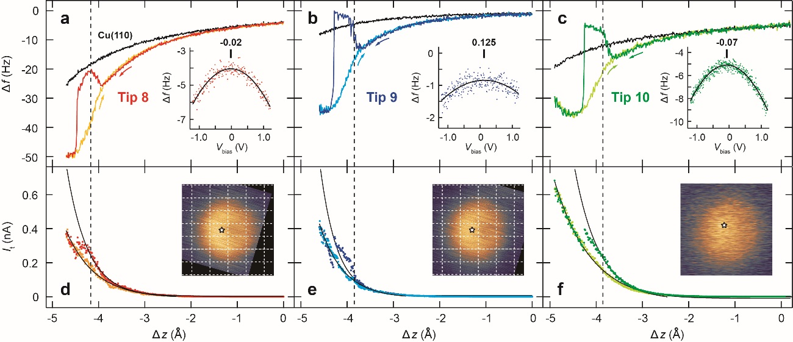
Figure 5 | Examples of frequency shift curves that deviate from the Morse potential model. a–c, Δf(Δz) curves and CPD data measured over Cu(110) at the gap resistance of 10 GΩ (V_{bias} = 100 mV and I_{t} = 10 pA). d–f I_{t}(Δz) curves were simultaneously recorded with Δf(Δz). The inset shows the STM images obtained under the different tip conditions (2 × 2 nm², V_{bias} = 100 mV, I_{t} = 10 pA). The white dashed lines represent the Cu(110) surface lattice (For Tip 10 this lattice could not be determined due to the blurred image). The relative tip displacement Δz is defined with respect to the STM set point of V_{bias} = 100 mV and I_{t} = 10 pA over Cu(110). Measurement parameters: Tip 8; V_{bias} ≈ 60 μV, A_{ocs} = 1 Å, f₀ = 23217.4 Hz, Q = 50264, Tip 9; V_{bias} ≈ 60 μV, A_{ocs} = 1 Å, f₀ = 23234.2 Hz, Q = 20315, Tip 10; V_{bias} ≈ 150 μV, A_{ocs} = 1 Å, f₀ = 23217.4 Hz, = 50264.

- Influence of a small bias voltage and tunneling current on the tip-induced tautomerization
In experiment V_{bias} cannot be exactly zero due to the finite resolution of the instrument, i.e., digital-to-analog convertors (DACs) in Nanonis electronics. A 16-bit resolution of the DACs in our system gives the smallest output resolution of 30 μV in V_{bias} (when the output range of ±1 V is used). Therefore, even if V_{bias} is nominally set to zero, a small tunneling current may flow in the junction due to the unknown offset voltage. The influence of such a small current (and voltage) was found to be negligible from the experiment in which we carried out the tip-induced tautomerization measurement with a controlled V_{bias} applied. First, Δf(Δz) curve was carefully examined over a Cu(110) surface in order to verify that the tunneling current has no influence (crosstalk) on the Δf signal. Figure 6 shows the simultaneously recorded Δf(Δz) and I_{t}(Δz) curves. V_{bias} is applied to the Cu(110) substrate and the positive and negative values of I_{t} represent the bias polarity. I_{t} was collected from the sample to minimize the crosstalk. In Fig. 6, it is clear that the Δf signal is fully independent of the current and voltage. Note that the I_{t}(Δz) becomes unstable and is not reproducible when V_{bias} is set to the nominal zero (see inset of Fig. 6b). This is presumably due to the random fluctuations of the output voltage.

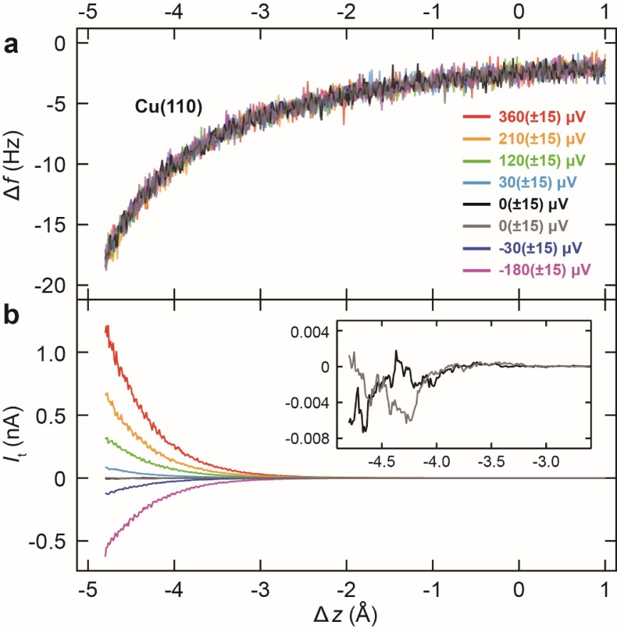
Figure 6 | Simultaneously recorded frequency shift and tunneling current over Cu(110) with a small bias voltage applied. a, Δf(Δz) curves b, I_{t}(Δz) curves. The bias voltages are indicated in a. The relative tip displacement Δz is defined with respect to the STM set point of V_{bias} = 100 mV and I_{t} = 10 pA. The inset in b shows the enlarged I_{t}(Δz) curves measured at V_{bias} = 0 V. Measurement parameters: A_{ocs} = 1 Å, f₀ = 23234.2 Hz, Q = 20315.

Next we examined the tip-induced tautomerization with a controlled V_{bias} applied. Figure 7 displays the simultaneously recorded Δf(Δz) and I_{t}(Δz) curves for a porphycene molecule. When tautomerization occurs, I_{t} showed a discontinuous change and the maximum current of 0.16, 0.25, and 0.35 nA was observed for 30(±15), 60(±15), 90(±15) μV, respectively, just before this event. However, the threshold Δf and Δz are essentially the same for the three cases, clearly indicating a negligible effect of small current and voltage on the tip-induced tautomerization.
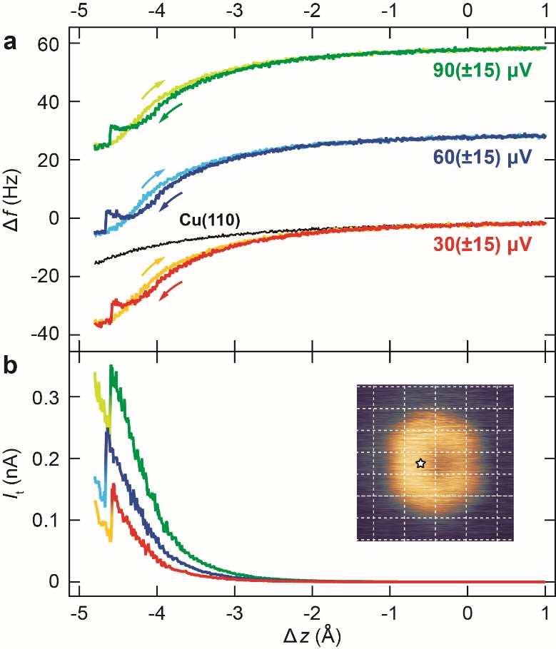
Figure 7 | Simultaneously recorded frequency shift and tunneling current over a porphycene molecule with a small bias voltage applied. a, Δf(Δz) curve. The bias voltages used are indicated in the figure. Δf(Δz) curves for V_{bias} = 60 μV and 90 μV are vertically displaced for clarity. b, I_{t}(Δz) curve during approach. The lateral tip position during measurement is indicated by a star in the inset STM images. The relative tip displacement Δz is defined with respect to the STM set point of V_{bias} = 100 mV and I_{t} = 10 pA over Cu(110). Measurement parameters: Tip 4; A_{ocs} = 1 Å, f₀ = 23213.4 Hz, Q = 51714.

- Distribution of the threshold distance of the tip-induced tautomerization
Figure 8 shows the distribution of the threshold distance (Δz_{th}) at which a tautomerization event takes place, measured with different tip conditions. In Fig. 8a and b, Δz_{th} is defined with respect to the equilibrium distance (z_{e}, i.e., potential minimum) of the approach curve and to the STM set point of V_{bias} = 100 mV and I_{t} = 10 pA over Cu(110), respectively. In either case Δz_{th} shows a comparable distribution (0.6–0.7 Å). It is clear from Fig. 8a that tautomerization takes place near the potential minimum.

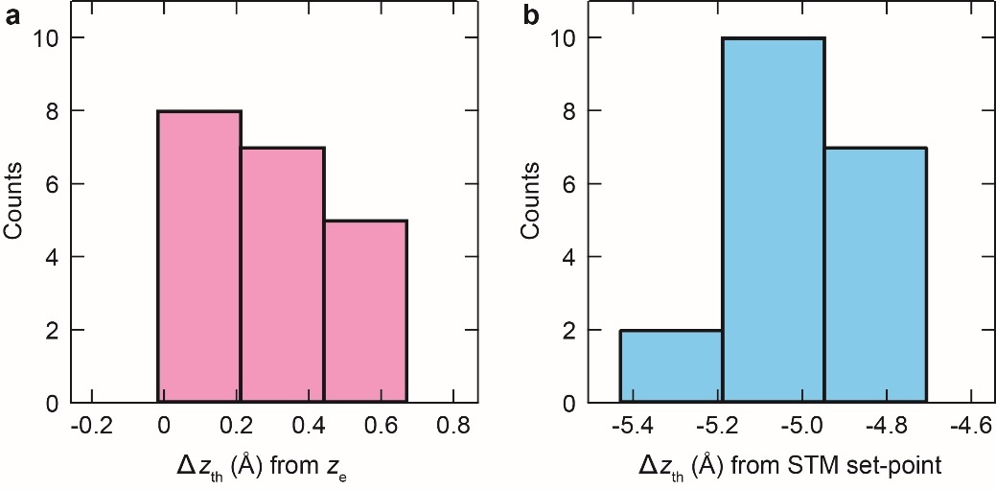
Figure 8 | Threshold distance for the tip-induced tautomerization. Distribution of Δz_{th} defined with respect to z_{e} a and the STM set point b.

- Tip-induced cis → trans tautomerization
In most cases, the cis → cis conversion of porphycene was observed in the tip-induced tautomerization. However, the cis → trans conversion rarely occurred (depending on the tip conditions). Figure 9a and b shows the STM images before and after the measurement in Fig. 9c. In Δf(Δz) curve, a discrete change occurs in the retraction, and then the Δf signal shows fluctuations until around the turning point. After the measurement, the STM image of porphycene becomes symmetric that looks very similar to the trans configuration observed on a Cu(111) surface³. The STM appearance of the trans molecule also suggests that the molecular orientation would be different from the cis form and it appears to be rotated.

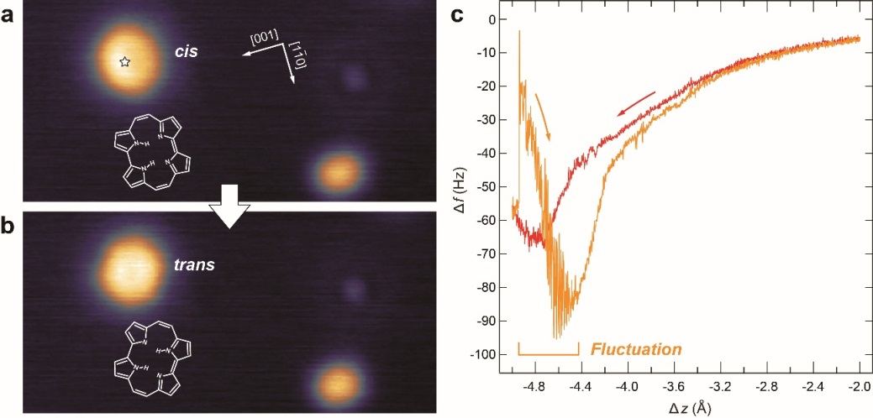
Figure 9 | Tip-induced cis → trans tautomerization. a and b, STM images of porphycene before (cis) and after (trans) the force curve measurement. c, Δf(Δz) curve obtained at the white star position in a. A discrete change of the Δf occurs in the retraction (orange curve) followed by a fluctuating (unstable) Δf signal. The relative tip displacement ∆z is defined with respect to the STM set point of V_{bias} = 100 mV and I_{t} = 10 pA over Cu(110) surface. Measurement parameters: A_{ocs} = 0.5 Å, f₀ = 22640.5 Hz, Q = 60013.

- Position adjustment of the force map
It is not a trivial task to accurately adjust the experimental force map to the calculated structure. We implemented this using the following protocol. In experiment the lateral tip position was determined by superposing the grid lines on images (as shown in the inset of Fig. 4). The lateral tip position can be estimated with respect to the porphycene molecule by comparing to the underlying Cu(110) surface lattice. Assuming that the short-range tip–molecule interaction is determined by the foremost atom on the tip, each force curves measured over the acceptor pyrrole side (blue filled circles in Fig. 10a) should be identical with the spectra at the corresponding position after tautomerization (red open circles in Fig. 10b). Figure 10c shows a series of the recorded spectra that were carefully compared to give the most consistent result; after tautomerization Δf(Δz) curve over the donor pyrrole side should be the same with the corresponding counterpart over the acceptor pyrrole side. The slight deviations between them may be due to experimental uncertainties in determining the precise lateral and vertical tip position (see Fig. 4) and/or due to an asymmetric geometry of the tip apex. However, we believe that this protocol gives an accuracy of ±0.4 Å in the lateral tip position.

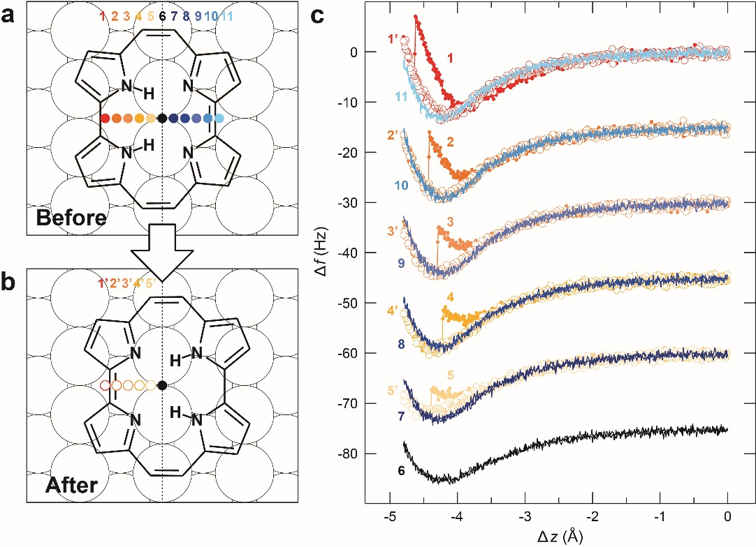
Figure 10 | Position adjustment of force map. a and b, Schematics of the calculated structures before and after tip-induced tautomerization. The lateral tip positions during the force curve measurements are indicated by the colored markers c, Approach and retraction Δf(Δz) curves over a porphycene molecule. The tautomerization is induced exclusively over the donor pyrrole sides (red filled circles in a) and the backward spectra (open red circles in b) are compared to those measured over the acceptor pyrrole side (filled blue circles in a). The relative tip displacement Δz is defined with respect to the STM set point of V_{bias} = 100 mV and I_{t} = 10 pA over Cu(110). Measurement parameters: A_{ocs} = 1 Å, f₀ = 22646 Hz, Q = 39143.

- Force mapping with a different tip
Figure 11a shows the force map obtained under different tip conditions (Tip 3 in Fig. 2b of the main text). Although the maximal attractive force is larger than that in Fig. 2f of the main text, the map shows consistent features.

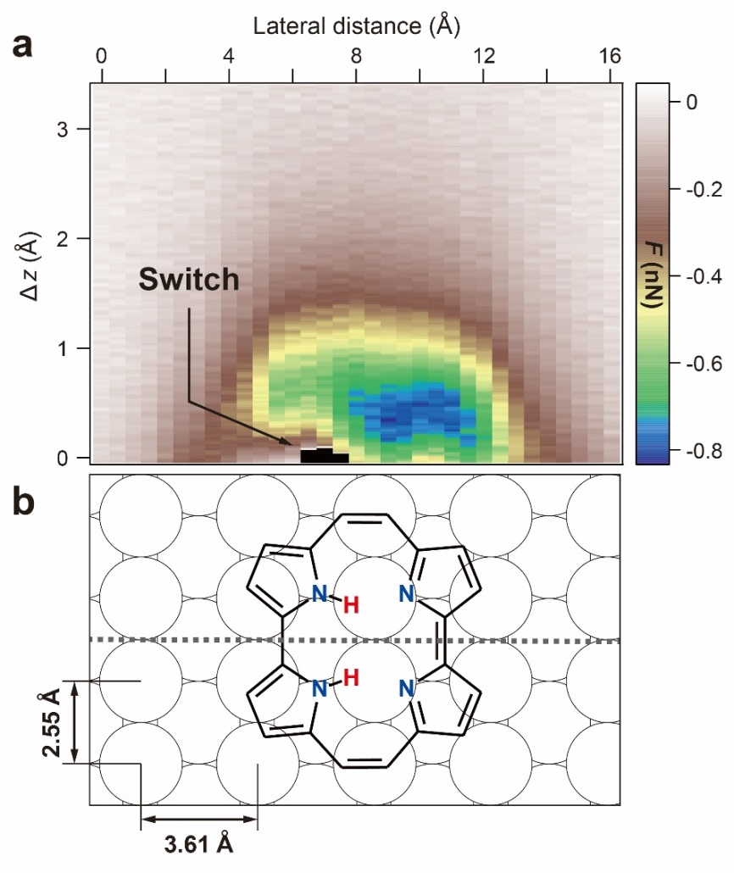
Figure 11 | Force map over a porphycene molecule obtained with Tip 3. The ∆z represents the tip height with respect to z_{e} at position (ii) in Fig. 2g of the main text. Measurement parameters: A_{ocs} = 1 Å, f₀ = 22646 Hz, Q = 39143.

- Fitting parameters for the force curves
Table 1 Fitting parameters used for Fig. 2b of the main text.
 | Forward (approach) |  | Backward (retraction)
 | E_{d} (eV) | κ (Å⁻¹) | E_{d} (eV) | κ (Å⁻¹)
Tip 1 | 0.272 (0.003) | 1.33 (0.02) | 0.444 (0.003) | 1.30 (0.01)
Tip 2 | 0.463 (0.004) | 1.22 (0.05) | 0.678 (0.01) | 1.23 (0.01)
Tip 3 | 0.599 (0.003) | 1.27 (0.01) | 0.720 (0.003) | 1.34 (0.01)

- Computational methods
The total energy, geometries, minimum energy paths (MEPs) and vibrational modes and frequencies of the adsorbed porphycene molecule were determined from periodic, plane-wave density functional theory (DFT) calculations using the Vienna ab-initio simulation program (VASP). The electron-ion core interactions and the exchange-correlation effects were treated using the Projector Augmented Wave (PAW) method and the optB86B version of the van der Waals density functional, , , respectively. The plane-wave cut-off was 400 eV. The Cu(110) surface was represented in a super-cell by a four layer slab with a 4×6 surface unit cell and a 20 Å vacuum region. The tip was modelled by a pyramid of five Cu atoms and the Xe terminated tip was modelled by a Xe atom adsorbed on the Cu apex atom of the pyramid. A 2×2×1 grid was used in the k-point sampling. The structures were relaxed until all forces were less than 0.01 eV/Å, with the bottom two Cu layers kept fixed throughout the geometry optimization at the calculated lattice constant of 3.60 Å. The supercell size was kept fixed for the different structures explored. The vibrational spectrum of the adsorbed molecule on a rigid substrate lattice was calculated by diagonalising the dynamical matrix which was obtained by finite differences of the calculated forces at symmetric ionic displacements of 0.02 Å. The MEPs and the reaction barriers were calculated using the nudged elastic band (NEB) method, .

- Calculated force curve
The total energy for the combined surface–porphycene–tip system was calculated as a function of the relative displacement (Δz) of the Cu₅ cluster to the surface. An example of simulated potential energy curves over the molecule and Cu(110) are shown in Fig. 12. Here the lateral tip position is fixed at Δx = -1.8 Å over the molecule. The background-subtracted potential energy U(Δz) over the molecule was obtained from the difference between potential energies over the molecule and Cu(110) and imposing U = 0 at Δz = 6.7 Å. The corresponding background-subtracted tip-surface force, $F\left(∆z\right)= -\frac{dU}{dz}\left(z\right)$, was obtained by numerical differentiation. The 2D plots, shown in Fig. 4 of the main text and Fig. 13, were obtained by interpolating a series of background-subtracted curves at different lateral positions of the tip.

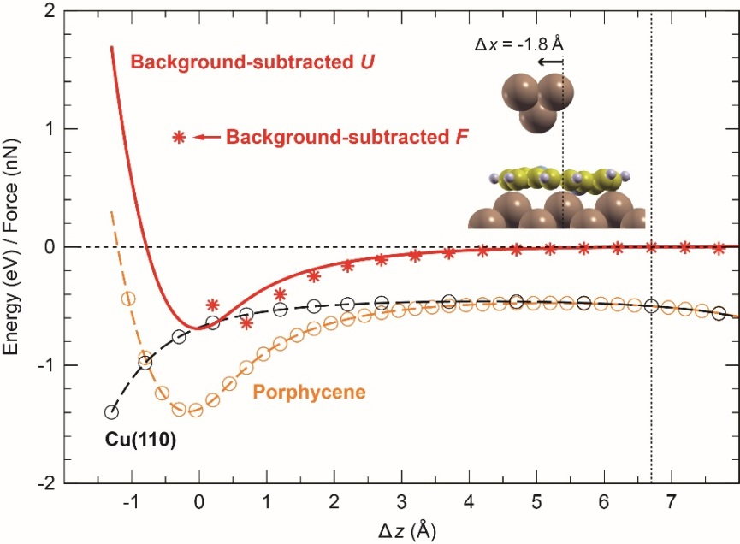
Figure 12 | Calculated total energy and force curves. The Cu₅ tip approach to the Cu(110) surface with or without the adsorbed porphycene molecule. The lateral tip position was is fixed at Δx = -1.8 Å over the molecule. The solid red line and the red symbols represent the background-subtracted U(Δz) and F(Δz), respectively. The relative displacement Δz is defined with respect to the energy minimum of background-subtracted U(Δz).

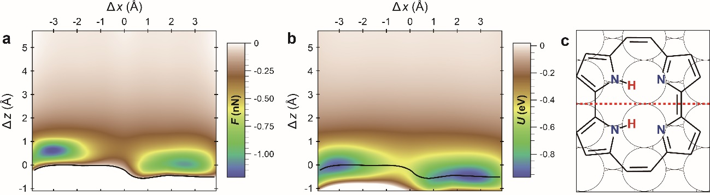
Figure 13 | Contour plots of calculated background-subtracted force and potential map. a, F(Δx, Δz). b, Potential U(Δx, Δz). The black line in a and b indicates the contour of F = 0. c, Schematic of the adsorption structure. The red line represents the vertical plane of the map. The relative displacement Δz is defined with respect to the energy minimum of background-subtracted U(Δz) at Δx = -1.8 Å.

- Minimum energy paths for step-wise and concerted tautomerization
The calculated MEPs for the tautomerization of porphycene between the initial and the final mirror reflected cis configurations predict that the step-wise mechanism is clearly favored over the concerted mechanism. The MEP for the step-wise mechanism (Fig. 4f of the main text) was obtained by constraining the path to pass through one of the two intermediate, degenerate trans configurations, whereas the concerted path was obtained by enforcing reflection symmetry through the vertical mirror plane of the adsorbed molecule in the cis configurations.
As shown in Fig. 4f of the main text, the step-wise path is symmetric with respect to the trans configuration and has a potential energy barrier of 342 and 168 meV for the cis → trans and the trans → cis transitions, respectively. In order to compare these barriers with experiments, one needs at least to correct for the large zero-point energies (ZPE) of the two inner H atoms. The corrected energies for the stable configurations and the transition states are given by,
$U_{C}(X)=U\left(X\right)+ U_{\text{ZPE}}\left(X\right)- U_{ZPE}\left({X=cis}_{i}\right)$, (1)
where U(X) and U_{ZPE}(X) is the potential and the ZPE, respectively, of the configuration X and cis_{i} is the initial cis configuration. Here the ZPE were obtained from the calculated vibrational energies of the two inner H atoms, when only these two atoms were allowed to move. At the barrier configuration, one of the modes is unstable, which shows that this configuration is indeed a transition state. The resulting ZPE corrections reduce the energy barriers to 203 and 19 meV for the cis → trans and the trans → cis transitions, respectively. Note that the ZPE reduction of the energy barrier of about 140 meV is close to the value of about 170 meV for the ZPE of the N–H stretch. Furthermore, the relatively large path length between the initial and final configuration indicates that there are substantial movements of not just the inner H atoms during the tautomerization.
As shown in Fig. 14, the concerted path is also symmetric with respect to the initial and final cis configurations but exhibits only a single potential energy barrier with a height of 628 meV, which is much larger than the barriers for the step-wise path. The ZPE corrections reduces this energy barrier to 352 meV, which is still significantly larger than that of the step-wise path. Furthermore, the barrier configuration has two unstable modes and is therefore not a first order saddle point and a proper transition state.
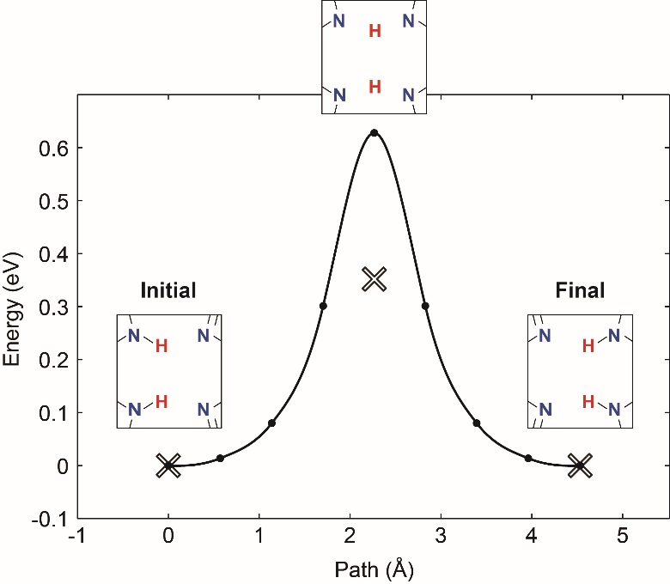
Figure 14 | Concerted tautomerization path for the cis → cis configurations in the absence of a tip. As in Fig. 4f of the main text, the solid line is obtained by an interpolation to the calculated energies of the images (solid circles) in the NEB calculations and their tangential forces along the path, which are not shown. The ZPE corrected energies are indicated by crosses. The path length was obtained from the Euclidean distance between the images in configurations space.

- Red-shift of the N‒H stretching mode frequency
The frequency of the N‒H stretching mode exhibits a red-shift, i.e., a softening of the N‒H bond, when the tip approaches a porphycene molecule. Figure 15a shows the dI/dV spectrum measured over a molecule with the tip fixed at the same position as in the force spectroscopy, e.g., in Fig. 2a–c of the main text. The dI/dV spectrum shows a characteristic dip at the energy of the N‒H stretching excitation. Figure 15b displays the two-dimensional plot of the dI/dV spectra measured at different tip heights defined by I_{t}. It is clear that the dip position shifts to lower voltages (energies) at smaller tip‒molecule distances. This red shift of the vibrational frequency suggests weakening of the N–H bond strength and strengthening of H bonds within the molecular cavity, thus the change in the N–H∙∙∙N geometry that is directly associated with the tautomerization coordinate. This change could cause the reduction of the tautomerization barrier. Note that the dI/dV spectra were measured with the pure STM configuration (not qPlus sensor) in order to obtain better signal-to-noise ratio. It should be noted that due to the absence of the oscillation, the tip height at a given set point defined by tunneling conditions is different from the one in the qPlus configuration and the tip is expected to be closer to the surface approximately as much as an A_{OSC}. Figure 15c shows the calculated N–H harmonic vibrational energies as a function of the tip–molecule distance. For simplicity only a single H-atom in the cavity is considered free to move. The red-shift of the frequency is predicted around the potential minimum (from 0.5 to -0.5 Å) where elongation of the N–H bond also takes place (Fig. 4g of the main text).

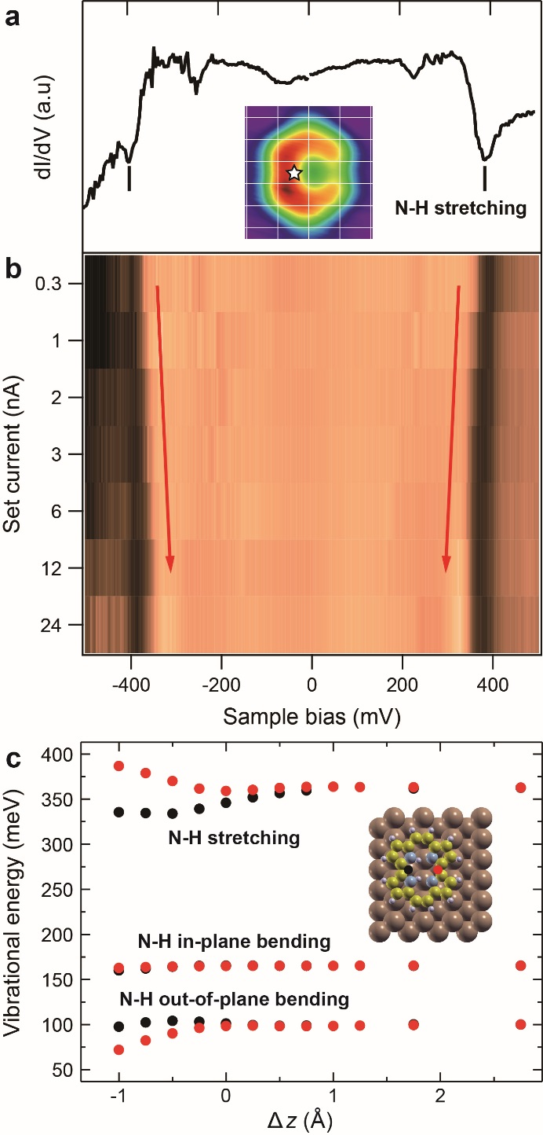
Figure 15 | Red-shift of the N–H stretching mode. a, dI/dV spectrum measured over a porphycene molecule. b, dI/dV spectra measured at different tip heights given by V_{bias} = 0.1 V and the tunneling current indicated on the vertical axis. The lateral tip position during the measurement is indicated by the white star in the STM image shown in the inset. c, Calculated harmonic vibrational energies of N–H modes as a function of Δz and for two different lateral tip positions. The tip position is indicated by the red and black dots in the schematic structure shown in the inset. The relative displacement Δz is defined with respect to the energy minimum of the background-subtracted U(Δz) at Δx = -1.8 Å (see Fig. 12).
- Relaxation of Xe-terminated tip
The simulations with a Xe-terminated tip was carried out by extending our Cu₅ cluster with a Xe atom at the tip apex, as shown in Fig. 16a. The background-subtracted potential energy curves U(Δz) and the corresponding force curves F(Δz) are shown in Fig. 16b. We find that the interaction energy between the adsorbed molecule and the physisorbed Xe atom on the tip is generally much weaker than for the Cu₅ tip. Also the repulsive regime is much softer due to a strong bending of the Xe atom near and in contact with the molecule (Fig. 16c and d). This suggests that a Xe tip is too soft and chemically inert to exert the forces necessary to induce tautomerization.
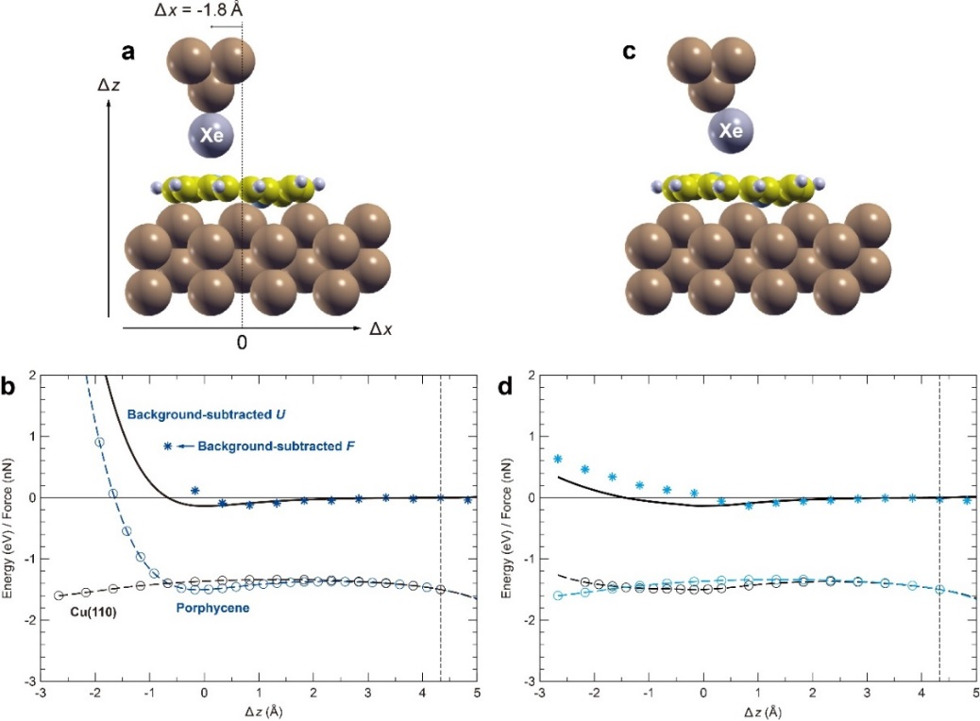
Figure 16 | Model of the Xe-tip approach to adsorbed porphycene on Cu(110). a, Snapshots of the structure during approach of a frozen Xe-tip. b, Force (potential) curve with a frozen Xe-tip. c, Snapshots of the structure during approach of a relaxed Xe atom on the frozen Cu₅ cluster. d, Force (potential) curve with a relaxed Xe atom on the tip. The lateral tip position over the molecule is fixed at Δx = -1.8 Å. The background-subtracted potential energy curve U(Δz) (black line) is obtained as the energy difference between the total energies with and without the adsorbed molecule and by imposing U = 0 at Δz = 4.3 Å. The relative displacement Δz is defined with respect to the energy minimum of U(Δz) with a frozen Xe-tip. Note that when the Xe atom is relaxed, Δz characterizes the relative movement of the rigid Cu-cluster.

- Minimum energy paths for tautomerization in the presence of a Xe-terminated tip.
Figure 17 shows the calculated MEPs with the Xe-tip for the step-wise mechanism (cis → trans → cis). The overall energy barrier is calculated to be 0.72 and 1.07 eV for Δz = -0.7 and -1.7 Å, respectively, and the corresponding ΔU is 101 and 22 meV. It should be noted that the reaction barrier and length are both significantly larger than those of the Cu₅ tip (Fig. 4h of the main text). This difference is due to the Xe atom being in the way for the reaction resulting in large motions of the Xe atoms and the atoms in the molecule in the reaction path.
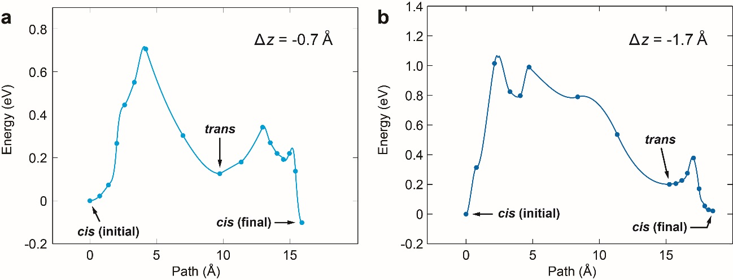
Figure 17 | Tautomerization paths in the presence of a Xe-terminated tip. Calculated MEPs between the initial and final cis configurations for a, Δz = -0.7 Å b, -1.7 Å. Lateral tip position and definition of Δz as in Fig. 16. The interpolation between the calculated images and the path length were obtained as in Fig. 14.
References

Wu, Y.-D. et al., Porphyrin Isomers: Geometry, Tautomerism, Geometrical Isomerism, and Stability. J. Org. Chem. 62, 9240–9250 (1997).
Kumagai, T. et al. Controlling intramolecular hydrogen transfer in a porphycene molecule with single atoms or molecules located nearby. Nature Chemistry 6, 41‒46 (2014).
Ladenthin, J. N. et al. Hot Carrier-Induced Tautomerization within a Single Porphycene Molecule on Cu(111). ACS Nano 9, 7287‒7295 (2015).
Majzik, Z. et al. Simultaneous current, force and dissipation measurements on the Si(111) 7×7 surface with an optimized qPlus AFM/STM technique. Beilstein J. Nanotechnol. 3, 249–259 (2012).
Kresse, G. & Furthmüller, J. Efficient iterative schemes for ab initio total-energy calculations using a plane-wave basis set. Phys. Rev. B 54, 11169 (1996).
Kresse, G. & Joubert, D. From ultrasoft pseudopotentials to the projector augmented-wave method. Phys. Rev. B 59, 1758 (1999).
Dion, M., Rydberg, H., Schröder, E., Langreth, D. C. & Lundqvist, B. I. Van der Waals Density Functional for General Geometries. Phys. Rev. Lett. 92, 246401 (2004).
Román-Pérez, G. & Soler, J. M. Efficient Implementation of a van der Waals Density Functional: Application to Double-Wall Carbon Nanotubes. Phys. Rev. Lett. 103, 096102 (2009).
Klimeš, J., Bowler, D. R. & Michaelides, A. Chemical accuracy for the van der Waals density functional. J. Phys. Cond. Matt. 22, 022201 (2010).
Klimeš, J., Bowler, D. R. & Michaelides, A. Van der Waals density functionals applied to solids. Phys. Rev. B 83, 195131 (2011).
Mills, G., Jónsson, H. & Schenter, G. K. Reversible work transition state theory: application to dissociative adsorption of hydrogen. Surf. Sci. 324, 305–337 (1995).
Henkelman, G., Uberuaga & B. P., Jónsson, H. A climbing image nudged elastic band method for finding saddle points and minimum energy paths. J. Chem. Phys. 113, 9901–9904 (2000).
Kumagai, T. et al. Thermally and Vibrationally Induced Tautomerization of Single Porphycene Molecules on a Cu(110) Surface. Phys. Rev. Lett 111, 246101 (2013).

