Supplementary Materials for

Genomic approach to therapeutic target validation identifies a glucose-lowering GLP1R variant protective for coronary heart disease
R.A. Scott, D.F Freitag et al.,

correspondence to: Dawn.M.Waterworth@gsk.com (D. M. W.); robert.scott@mrc-epid.cam.ac.uk (R. A. S.); nick.wareham@mrc-epid.cam.ac.uk (N. J. W.)

This pdf file includes

Supplementary Methods
Description of case ascertainment, acknowledgement and author lists for Alzheimer’s disease results
Figure S1 to S2
Table S1 to S4

Acknowledgements: We are grateful to the CARDIOGRAM-Exome and the Exome+ Consortia for lookups for Coronary Heart Disease, and to the CHARGE T2D and glycaemic traits, adiposity and blood pressure working groups. We are grateful to IGAP (including CHARGE AD, ADGC and GERAD_EC), PDGene, HRGene, the Pancreatic Cancer Consortium, the Breast Cancer Exome chip consortium (including PGSNPS, SEARCH, SIBS, UKGPCS, UKO), Prostate Cancer Exome chip consortium, and OCAC-UK (Ovarian cancer) Exome chip consortium. We thank staff from the MRC Epidemiology Functional Group Team for study coordination, data collection, data management, associated laboratory work, business operations and research governance. We are grateful to G. Yeo, S. Burgess, S. Kaptoge, R. Sladek and F. Gribble for helpful discussions on the manuscript. We thank L. McCarthy and L. Warren of GSK for their thoughtful comments on the manuscript. We thank all EPIC participants and staff for their contribution to the study, the laboratory teams at the MRC Epidemiology Unit for sample management and Cambridge Genomic Services for genotyping, S. Spackman for data management, and the team at the EPIC-CVD Coordinating Centre for study coordination and administration. We thank the Fenland Study volunteers for their time and help, the General Practitioners and practice staff for assistance with recruitment, the Investigators, Co-ordination team and the Epidemiology Field, Data and Laboratory teams. The MRC-Ely Study is grateful to all the volunteers, and to the staff of St. Mary’s Street Surgery, Ely and the study team. We thank all EPIC participants and staff for their contribution to the EPIC-InterAct study. The Breast Cancer Exome chip working group acknowledges the input of M. Shah and J. Dennis. The authors thank the staff and participants of the ARIC study for their important contributions. The Ovarian Cancer Association Consortium thanks D. Easton (SIBS), S. Kruger-Kjaer (MALOVA), E. Høgdall (MALOVA), G. Chevenix-Trench (AOCS/ACS), J. Gronwald (POCS), S. Ramus (UKO), S. Gayther (UKO), K. Muir (UKGPCS) and P. Pharoah (SEARCH) for enabling the UK Ovarian Cancer Illumina Human ExomeBeadchip and J. Tyrer, J. Dennis, K. Michailidou, H. Song and P. Pharoah for genotype calling and data analysis. EPIC-Ragusa thanks A.I.R.E onlus Ragusa (Italy) for logistic support and Avis Ragusa (Italy) blood donors association for active participation. We thank the sites and key personnel of contributing MORGAM Centers and the MORGAM management group: V. Salomaa, A. Juolevi, E. Vartiainen, P. Jousilahti; J. Virtamo, H. Kilpeläinen; K. Kuulasmaa, Z. Cepaitis, A. Haukijärvi, B. Joseph, J. Karvanen, J. Kontto, S. Kulathinal, M. Niemelä, O. Saarela. T. Palosaari; M. Perola, P. Laiho, M. Sauramo. France: National Coordinating Centre, National Institute of Health and Medical Research (U258), Paris: P. Ducimetière (national coordinator), A. Bingham; PRIME/Strasbourg, Department of Epidemiology and Public Health, EA 3430, University of Strasbourg, Faculty of Medicine, Strasbourg: D. Arveiler, B. Haas, A. Wagner; PRIME/Toulouse, UMR INSERM 1027; and Department of Epidemiology, Toulouse University School of Medicine, Universite Paul Sabatier, Toulouse: J. Ferrières, J-B. Ruidavets, V. Bongard, D. Deckers, C. Saulet, S. Barrere; PRIME/Lille, Department of Epidemiology and Public Health, INSERM U744-Université Lille Nord de France – Institut Pasteur de Lille: P. Amouyel, M. Montaye, B. Lemaire, S. Beauchant, D. Cottel, C. Graux, N. Marecaux, C. Steclebout, S. Szeremeta; MORGAM Laboratory, INSERM U937, Paris: F. Cambien, L. Tiret, V. Nicaud. INSERM and InVS are acknowledged for their support. Italy: EPIMED Research Center, Department of Clinical and Experimental Medicine. University of Insubria, Varese: M. Ferrario , G. Veronesi, F. Gianfagna. University of Milano-Bicocca, Monza, Italy: Giancarlo Cesana, Paolo Brambilla and Stefano Signorini. United Kingdom: PRIME/Belfast, Queen's University Belfast, Belfast, Northern Ireland: F. Kee, A. Evans (former principal investigator), J. Yarnell, E. Gardner; MORGAM Coordinating Centre, Queen's University Belfast, Belfast, Northern Ireland: A. Evans (MORGAM coordinator), S. Cashman, F Kee. UKCRC are acknowledged for their support. S. Blankenberg (Hamburg, Germany), A. Palotie (Cambridge, UK), A. Peters, , D. Tregouet, H. Tunstall-Pedoe; Previous members: K. Asplund, L. Peltonen, D. Shields, B. Stegmayr, P.G. Wiklund. Further relevant details of acknowledgements, funding and contributors to the Alzheimer's disease analyses can be found at ADGC (http://www.adgenetics.org/content/acknowledgements), GERAD (http://www.cardiff.ac.uk/mrc-centre-neuropsychiatric-genetics-genomics/research/themes/neurodegenerative-disorders/alzheimers-disease-research) and CHARGE (http://www.chargeconsortium.com/).

Funding: The Atherosclerosis Risk in Communities (ARIC) study is carried out as a collaborative study supported by National Heart, Lung, and Blood Institute contracts (HHSN268201100005C, HHSN268201100006C, HHSN268201100007C,HHSN268201100008C, HHSN268201100009C, HHSN268201100010C,HHSN268201100011C, and HHSN268201100012C), R01HL087641, R01HL59367 and R01HL086694; National Human Genome Research Institute contract U01HG004402;and National Institutes of Health contract HHSN268200625226C. ARIC infrastructure was partly supported by Grant Number UL1RR025005. The Breast Cancer Exome chip group acknowledges funding from CRUK (C8197/A16565, C1287/A8459, A490/A10124). Genotyping was supported by Cancer Research–UK grant C12292/A11174D. The work on the ADDITION-Ely case-control study and Norfolk Diabetes case-control study was funded by support from the Wellcome Trust and the MRC, with additional support from NHS Research and Development. The MRC-Ely Study was funded by the MRC (MC_U106179471) and Diabetes UK. The Fenland Study is funded by the MRC (MC_U106179471) and Wellcome Trust. The ATBC Study was supported by US Public Health Service contracts N01-CN-45165, N01-RC-45035 and N01-RC-37004 from the National Cancer Institute. Funding for the EPIC-InterAct project was provided by the EU FP6 programme (LSHM_CT_2006_037197). CHD case ascertainment and validation, genotyping, and clinical chemistry assays in EPIC-CVD were supported by grants awarded to the University of Cambridge from the EU Framework Programme 7 (HEALTH-F2-2012-279233), the UK Medical Research Council (G0800270) and British Heart Foundation (SP/09/002), and the European Research Council (268834). Genotyping, quality control and calling of the Illumina HumanExome BeadChip in the Framingham Heart Study was supported by funding from the NHLBI Division of Intramural Research (D. Levy and C. J. O’Donnell). A portion of this research was conducted using the Linux Clusters for Genetic Analysis (LinGA) computing resources at Boston University Medical Campus. Also supported by National Institute for Diabetes and Digestive and Kidney Diseases (NIDDK) R01 DK078616 and K24 DK080140 (J.M.). The MORGAM study has been sustained by European Union FP7 projects CHANCES (HEALTH-F3-2010-242244) and BiomarCaRE (278913), which has supported central coordination, workshops and part of the activities of The MORGAM Data Centre (Helsinki, Finland). MORGAM Participating Centres are funded by regional and national governments, research councils, charities, and other local sources. The Italian component of MORGAM was supported by the Health Administration of Regione Lombardia [grant numbers 9783/1986, 41795/1993, 31737/1997,17155/2004 and 10800/2009]. The Novo Nordisk Foundation Center for Basic Metabolic Research is an independent Research Center at the University of Copenhagen partially funded by an unrestricted donation from the Novo Nordisk Foundation. PROSPER was supported by an investigator initiated grant from Bristol-Myers Squibb. J.W.J is an Established Clinical Investigator of the Netherlands Heart Foundation (2001 D 032). Support for genotyping was provided by the seventh framework program of the European commission (grant 223004) and by the Netherlands Genomics Initiative (Netherlands Consortium for Healthy Aging grant 050-060-810).The research leading to WOSCOPS and PROSPER results received funding from the European Union's Seventh Framework Programme (FP7/2007-2013) under grant agreement n° HEALTH-F2-2009-223004. P.B.M. acknowledges support from the NIHR Cardiovascular Biomedical Research Unit at Barts and The London, Queen Mary University of London, UK. M.I.M. was supported by a Wellcome Trust Senior Investigator Award (098381). A.P.M. is a Wellcome Trust Senior Fellow in Basic Biomedical Science, grant number WT098017. T.M.F. and H.Y. are supported by the European Research Council grant: SZ-245 50371-GLUCOSEGENES-FP7-IDEAS-ERC. I.B. is funded by the Wellcome Trust (WT098051).

Supplementary Methods

Custom imputation process
Genotype imputation was completed in the CoLaus study for 3539 individuals who were typed on the Affymetrix 500K chip but not included in the sequencing experiment. Reference haplotypes were derived from 3983 participants in the previous sequencing study(8) who were both sequenced and genotyped on an Affymetrix 500K chip. Variants within the sequenced region plus all GWAS SNPs within 1 Mbp of the sequenced regions were included in the reference data. Genotype imputation was completed using BEAGLE with the default settings for 3539 individuals from CoLaus and 1,807 individuals from GenOA study who were typed on the Affymetrix 500K or 6.0 chip but not included in the sequencing experiment. Variants with good imputation quality (imputation R² > 0.5) were also included in discovery association analyses.

Data sources for variants taken forward to follow-up
In order to maximise our ability to detect associations of rs10305492 with glycaemic and other intermediate traits or disease outcomes, we sought further follow-up using published data resources or lookups via collaboration with large-scale consortia.
To corroborate the association between rs10305492 and fasting glucose in additional independent studies, we extracted results from those studies containing participants (n = 20,077) in whom the variant had been well imputed (R² or proper_info > 0.8) from a recent genome-wide association study from MAGIC (51). As effect estimates in MAGIC were reported in mM, we converted those to standard deviations (SD) using the SD of fasting glucose in the Fenland study (0.65 mM) (46).
To characterise the association of variants with other quantitative traits, we sought collaboration from a range of additional sources including CHARGE Exome chip working groups (T2D-glycaemic, blood pressure and adiposity working groups), the CVD50 consortium for blood pressure (52), and HRgene (53) for resting heart rate. We were also able to include lookups from a range of individual studies, where they were not included in consortia, and these are detailed in table S1A. Where particular studies were included in consortia-provided results, the relevant individual study estimates were not included to avoid double-counting of results. For results from consortia, we report the sample size contributed, but did not have access to individual level data. For individual studies that contributed results, we report the sample size for each trait and the mean and SD of each phenotype included in analyses.
We also sought to investigate the association of rs10305492 with a range of disease traits including those where a role for GLP1R agonist therapies has been implicated. These included T2D, coronary heart disease (CHD), and cancers (particularly pancreatic cancer). Further details of the studies included in these analyses are provided in table S2. Briefly, for pancreatic cancer, PanScan 1 and 2 data (phs000206.v4.p3) available from the database of Genotypes and Phenotypes (dbGaP) (54) were included along with recently published data from PanScan3 (55). Breast, ovarian, and prostate cancer data were provided by the relevant Exome chip efforts (table S4). Associations with Parkinson’s disease were made available by PDGene, using the latest available data (56). Associations with Alzheimer’s disease were obtained via collaboration with the IGAP (International Genomics of Alzheimer's Project) Exome chip working group, which comprises the Genetic and Environmental Risk for Alzheimer’s Disease (GERAD) Exome Chip Consortium, the Alzheimer's Disease Genetics Consortium (ADGC) and CHARGE. Data used in the preparation of this article was obtained from the Genetic and Environmental Risk for Alzheimer’s Disease_Exome Chip (GERAD_EC) Consortium. The GERAD_EC sample consisted of 6000 cases and 3969 elderly screened controls genotyped on the Illumina HumanExome chip (versions 1.0 and 1.1) at Life and Brain (Germany).

Systematic review of GLP1R-agonist trials
Relevant clinical trials were identified through four recent systematic reviews (20–23). Additional relevant trials were identified through two supplementary literature searches in PubMed. All randomized clinical trials comparing a GLP1R agonist with either placebo or no drug (i.e. no active comparator); in a type 2 diabetic or non-diabetic population, with ≥ 4 weeks drug treatment (i.e. no single dose studies) and ≥ 10 participants per trial arm were included (table S2). Mean treatment differences and standard errors were extracted from text, tables and figures, or calculated from the individual treatment group differences from baseline, or levels post-treatment. Treatment differences and standard errors not reported in the original publication were extracted from the respective meta-analyses. Where available, pre-treatment SDs were extracted from the original articles (table S2). Treatment differences and standard errors were standardized by dividing by the trial specific pre-treatment SD, or by using a weighted-average of pre-treatment SDs, separately for diabetics and non-diabetics (table S2). For trials with more than one GLP1R treatment group (for example, different doses), a trial-specific average treatment effect was calculated by performing a fixed-effect meta-analysis. Finally, trial-specific standardized treatment effects were combined across trials, separately for diabetics and non-diabetics using random effects meta-analysis, to account for differences in dose, drug, and duration.

Details of supplementary searches in PubMed (performed on 11 March 2014)
(liraglutide OR exenatide OR albiglutide) AND (c-peptide OR insulin OR proinsulin) AND (randomized controlled trial OR RCT)
(liraglutide OR exenatide OR albiglutide OR lixisenatide) AND (randomized controlled trial OR randomized controlled study OR RCT)

We used P-values derived from Cochrane’s Q test as a guide to assess whether there were pairwise differences between the genetic and trial estimates. The tests were implemented by performing a fixed-effect meta-analysis of the rescaled genetic estimate with the trial estimate in either non-diabetics or type 2 diabetic patients and noting the p-value for heterogeneity (table S1). Hence for each of the ten traits tested (excluding glucose, since genetic estimates were rescaled to match trial effects for this factor), there were two pairwise comparisons, resulting in a Bonferroni-corrected significance guideline of α = 0.0025 [= 0.05/(2*10)]. Since the analyses of genetics and clinical trials are based on multiple assumptions (such as benchmarking on fasting glucose, pooling across agents and doses), the P-values and corresponding significance guideline should be interpreted in this context and only serve as a general guide to judge whether there are substantial differences between drug and genetic effects.

Calculating sample size requirements to detect effects of the GLP1R genetic variant on non-glycaemic factors
Using changes in fasting glucose as benchmark as follows:
Standardized effect on fasting glucose for:
GLP1R agonists in T2D: -0.49
GLP1R Ala316Thr variant: -0.15
Hence, in patients with T2D, GLP1R agonists appear to be more potent than the GLP1R Ala316Thr variant. The effects of GLP1R agonists on other relevant physiological parameters were considerably weaker than the observed effect on glucose: 0.13 (-0.22, -0.03) SDs for systolic blood pressure, and 0.14 (0.02, 0.26) SDs for heart rate. Assuming that the genetic variant shows similarly weaker effects on these parameters, this would imply an effect size of the genetic variant of 0.04 SDs [=0.13/3.3] for systolic blood pressure and 0.04 [=0.14/3.3] SDs for heart rate. Considering the allele frequency of the variant of ~1% in Europeans, and mean and SD of systolic blood pressure and heart rate reported for European populations (57) this would require >250,000 individuals to have 80% power to detect these effect sizes at α=0.05 (calculated using Quanto v1.2 (58).

Calculating the reduction in coronary heart disease risk attributable to lower fasting glucose levels
Per minor allele, the effect of the GLP1R variant on fasting glucose (in SDs), was -0.15 (95% CI: -0.20 -0.11), which equates to -0.0975 mM (95% CI: -0.13, -0.0715) based on SD of 0.65 mM as observed in the Fenland study. Prospective epidemiological evidence based on individual participant data from 698,782 individuals suggests a log-linear relationship for the association of fasting glucose levels with the risk of coronary disease risk, in individuals with fasting glucose levels above 5.6 mM (59). In these individuals, the hazard ratio for association with coronary heart disease risk was 1·12 (1.08–1.15) per 1 mM higher fasting glucose levels. Based on these data, a reduction in fasting glucose levels by -0.0975 would be associated with a hazard ratio of 0.989 (1.12^{-0.0975}). However, these results should be interpreted with caution since they rely on the assumptions that there is a linear relationship between fasting glucose and coronary disease risk (which appears only to be the case in individuals with levels above 5.6 mM), and that fasting glucose is a causal risk factor for coronary heart disease.

Studies contributing to discovery analyses of type 2 diabetes and obesity-related traits
CoLaus study
The CoLaus study is a community-based study of 6188 European white individuals aged 35 -75 years (42). Participants were drawn from the CHUV University Hospital in Lausanne Switzerland and studied for cardiovascular and metabolic phenotypes. Individuals with data for cardiovascular, metabolic, and psychiatric phenotypes were sequenced (n = 2086). An additional 3539 individuals had GWAS data, enabling genotype imputation.

GEMS study
The GEMS study is a large multinational study designed to explore the genetic basis of the metabolic syndrome control (43). Individuals were recruited from two centers in Europe (Oulu, Finland, and Lausanne, Switzerland), one in the United States (Dallas, TX), one in Canada (Ottawa, Ontario), and one in Australia (Adelaide, South Australia). Dyslipidemic individuals were required to have the combination of an elevated plasma triglyceride (greater than 75th percentile) and a low serum HDL-cholesterol (less than 25th percentile) for their age, sex and country threshold (age 18-75 years) and were non-diabetic. Unrelated normolipidemic controls were required to have plasma triglyceride lower than 50th percentile, serum HDL-cholesterol greater than 50th percentile for their age, sex and country threshold, body mass index (BMI) greater than 25 kg/m², and be greater than 40 years of age. The individuals have phenotypes for cardiovascular and metabolic traits as well as biomarkers of inflammation. Dyslipidemic individuals (n = 787 individuals) and normolipidemic controls (n = 792 individuals), matched by sex, age, and collection center were sequenced.

BMI study
Participants from (8) who had been assessed for BMI and had provided appropriate consent were included in an analysis of BMI phenotype (n = 11,806). This included 2086 individuals from the CoLaus and 1579 individuals from the GEMS studies.

Studies contributing to follow-up analyses of type-2 diabetes and obesity related traits
MRC Ely study
The MRC Ely Study is a population-based cohort randomly selected from people living in Ely and surrounding villages (East Anglia, UK), an ethnically homogenous European ancestry population. The study design, methods, and measurements of the three phases have been described in detail elsewhere (44). The current analyses included individuals aged 35-79 years, from phase 3. We genotyped up to 1722 participants.

EPIC-Norfolk (European Investigation into Cancer and Nutrition)
EPIC-Norfolk: The EPIC-Norfolk study is a cohort study investigating the relationship between diet and incident disease (45). More than 25,639 men and women aged between 45 and 74 were recruited in Norwich and the surrounding area. Individuals were characterized for cardiovascular and metabolic phenotypes. We genotyped up to 20,380 participants with DNA available in the present study.

Fenland study
The Fenland Study is an ongoing, population-based cohort study (started in 2005) designed to investigate the association between genetic and lifestyle environmental factors and the risk of obesity, insulin sensitivity, hyperglycemia and related metabolic traits in men and women aged 30 to 55 years (46). Participants were recruited from General Practice sampling frames in the Fenland, Ely and Cambridge areas of the Cambridgeshire Primary Care Trust in the UK. Participants attended after an overnight fast for a detailed clinical examination, and blood samples were collected. We genotyped up to 6379 participants in the present study.

LOLIPOP Study (London Life Sciences Prospective Population Study)
LOLIPOP is a population-based study of 21,915 individuals identified from the lists of 58 general practitioners in West London (47). Participants are primarily Indian Asians and European whites aged 35-75 years, who have been characterized for cardiovascular phenotypes. Only participants of European ancestry (n = 6565) were genotyped and included in this analysis.

Norfolk Diabetes case-control study
The Norfolk Diabetes case-control study is an ongoing study of white European men and women with T2D in Norfolk (60). All diabetes patients identified through GP diabetes registers in Norfolk, local hospital diabetes clinic and retinal screening programme patient registers were invited to participate. European cases aged 30 years or older were included as cases in this study. T2D was defined by not treated with insulin during the first year of diagnosis. Those with cystic fibrosis, chronic pancreatitis or long term steroid use were excluded from the study. A total of 5587 cases were included in the current analyses. Control participants free of known diabetes at baseline or during follow-up were selected from among EPIC-Norfolk participants (table S4). The study was approved by the Norwich Local Research Ethics Committee.

ADDITION-Ely case-control study
Cases of this study were derived from the ADDITION-Cambridge study, a multi-centre intervention study which focuses on effectiveness of stepwise screening on morbidity and mortality among people with new onset T2D (48). People aged 40-69 years at high-risk of undiagnosed diabetes in East Anglia region participated in the study. Written informed consent was obtained for all participants at the time of the diabetes screening appointment and subsequent diagnostic test. Among adults years participating in the UK Cambridge arm of the ADDITION study, new onset T2D cases were identified via a population-based stepwise screening strategy, including casual glucose, plasma glucose, glycated haemoglobin, and oral-glucose tolerance test. All T2D cases were confirmed by 75 g oral-glucose tolerance test. The controls were selected from the Ely Study (described above). Current analyses included 932 T2D cases and 1487 controls of white European-origin who had DNA available. The Cambridge Research Ethics Committee approved both studies.

GenOA (Genetic Obesity Associations study)
GenOA is a case control study with 1008 obese (BMI>30) Caucasian individuals recruited from the Ottowa obesity weight management clinic and 991 Caucasian controls (BMI less than 40th percentile for age and gender) from the local community (61). One hundred twenty-nine individuals with T2D and 1501 controls were included in follow-up of T2D associations with rs2229579 in CNR2.

Studies contributing to follow-up of GLP1R associations
The EPIC-InterAct study
Individuals from the EPIC-InterAct study were also included in follow-up analyses for T2D and for quantitative traits where available. The InterAct study (62) is a case-cohort study nested within the European Prospective Investigation into Cancer and Nutrition (EPIC) cohorts (63), and includes 12,403 incident cases of T2D and a subcohort of 16,154 individuals (including 778 randomly selected incident T2D cases). We ensured no double-counting of participants by removing individuals from EPIC-Norfolk from analyses of the EPIC-InterAct consortium, where there was potential for overlap.

The Exome+ CHD consortium
This consortium contributed data on the association of the GLP1R variant with risk of CHD in participants of Caucasian ancestry. Studies comprised: the Copenhagen General Population Study (64); the Copenhagen Ischaemic Heart Disease Study (64), the Copenhagen City Heart Study(64), the European Investigation into Cancer and Nutrition – CVD study (EPIC-CVD) (63, 65, 66), the West of Scotland Coronary Prevention Study (WOSCOPS) (67), the Pravastatin in elderly individuals at risk of vascular disease trial (PROSPER) (68) and the MONICA, Risk, Genetics, Archiving, and Monograph (MORGAM) consortium (69, 70). All studies defined CHD according to International Classification of Diseases-Tenth Revision, codes I20 to I25 or subsets thereof (e.g., only I21-I22 for non-fatal events). The majority of events recorded were myocardial infarction and other major coronary events.

IGAP (International Genomics of Alzheimer's Project)

Data used in the preparation of this article were obtained from IGAP (International Genomics of Alzheimer's Project). The consortia of IGAP contributing to the exome chip analysis were the Genetic and Environmental Risk for Alzheimer’s Disease Exome Chip (GERAD_EC) Consortium, The Alzheimer's Disease Genetics Consortium (ADGC), and the Cohorts for Heart and Aging Research in Genomic Epidemiology (CHARGE).

ARIC
The ARIC Study is a prospective cohort study of cardiovascular disease risk in four U.S. communities (71). Between 1987 and 1989, 7082 men and 8710 women aged 45–64 years were recruited from Forsyth County, NC; Jackson, MS (African-Americans only); suburban Minneapolis, MN; and Washington County, MD. The ARIC Study protocol was approved by the institutional review board of each participating university. After written informed consent was obtained, including that for genetic studies, participants underwent a baseline clinical examination (Visit 1) and four subsequent follow-up exams (Visits 2 – 5).
Coronary Artery Disease (CAD) MedStar Study
A premature CAD collection designed to investigate the genetics of plaque stability in acute coronary syndrome (ACS). The full study comprises 452 ACS CAD cases, 491 non-ACS CAD cases, and 483 non-CAD controls (72). Individuals were identified prospectively from the patient population of Cardiovascular Research Institute (MedStar/Washington Hospital Center). Standard criteria were used to identify cases with myocardial infarction and cases diagnosed with clinically significant coronary atherosclerosis without myocardial infarction. In the sequencing study (8), 604 Medstar CAD cases were sequenced and matched by 4228 reference controls from non-Medstar studies based on genetic similarity to the sequenced cases.

DIABNORD
The DIABNORD Study is nested within the Västerbotten Health Survey, which is part of the Northern Sweden Health and Disease Study, a population-based prospective cohort study from northern Sweden (73). Participants with incident T2D were identified from the Diabetes Register in Northern Sweden (DiabNorth). A total of 1000 participants with incident T2D from the DIABNORD Study were genotyped with Illumina HumanExome Beadchip 12 v1.1.

FIA3
FIA3 is a population-based study of myocardial infarction (MI) nested within the Northern Sweden Health and Disease Study, (NSHDS), a population-based cohort study from northern Sweden, which consists of sub cohorts: the Västerbotten Intervention Program (VIP) and the WHO’s Multinational Monitoring of Trends and Determinants in Cardiovascular Disease (MONICA) Study in northern Sweden. Both VIP and MONICA are health examination programs for cardiovascular disease (CVD) and diabetes. Cases are identified through the MONICA study in northern Sweden and its MI incidence registry. For the current study, 2657 cases were genotyped with Illumina HumanExome BeadChip 12 v1.1 (73).

Framingham Heart Study
The FHS is a three generational prospective cohort that has been described in detail previously (74). Individuals were initially recruited in 1948 in Framingham, MA, USA to evaluate cardiovascular disease risk factors. The second generation cohort (5124 offspring of the original cohort and their spouse) was recruited between 1971 and 1975. The third generation cohort (4095 grandchildren of the original cohort) was collected between 2002 and 2005. European-American individuals (n = 8153) had were successfully genotyped on the Illumina HumanExome BeadChip array.

GLACIER
The Gene-Lifestyle interactions And Complex traits Involved in Elevated disease Risk (GLACIER) Study is nested within the Västerbotten Health Survey, which is part of the Northern Sweden Health and Disease Study, a population-based prospective cohort study from northern Sweden. A total of 1000 non-diabetic participants from the GLACIER Study were genotyped with Illumina HumanExome Beadchip 12 v1.1 (73).

HEALTH2008
Health2008 is a population-based epidemiological study of general health, diabetes and cardiovascular disease comprising 771 participants. An oral glucose tolerance test was performed with measurement of plasma glucose and serum insulin at fasting and 30 and 120 min after glucose intake. Health2008 was conducted at the Research Centre for Prevention and Health in Glostrup, Denmark. Informed written consent was obtained from all study participants. The studies were conducted in accordance with the Declaration of Helsinki II and were approved by the local Ethical Committee.

Inter99
The Inter99 cohort is a randomized, non-pharmacological intervention study for the prevention of ischaemic heart disease, conducted on 6,784 randomly ascertained participants aged 30 to 60 years at the Research Centre for Prevention and Health in Glostrup, Denmark (ClinicalTrials.gov: NCT00289237). An oral glucose tolerance test was performed with measurement of plasma glucose and serum insulin at fasting and 30 and 120 min after glucose intake. Subsequently, 6094 participants of Danish nationality and with available DNA were classified as having normal glucose tolerance (n = 4525), impaired fasting glycaemia (n = 504), impaired glucose tolerance (n = 693), screen-detected type 2 diabetes (n = 253), or previously diagnosed type 2 diabetes (n = 119) according to World Health Organization (WHO) 1999 criteria. Informed written consent was obtained from all study participants. The studies were conducted in accordance with the Declaration of Helsinki II and were approved by the local Ethical Committee.

METSIM (METabolic Syndrome In Men) Study

The METSIM Study includes 10197 men, aged from 45 to 73 years, randomly selected from the population register of the Kuopio town, Eastern Finland, and examined in 2005-2010. The aim of the study is to investigate genetic and non-genetic factors associated with the risk of T2D, CVD, and insulin resistance–related traits in a cross-sectional and longitudinal setting. Study protocol includes collection on data on CVD risk factors (smoking, exercise, diet, and history of chronic diseases, including coronary heart disease, stroke, cardiac failure, medication, diabetes, or early onset coronary heart disease in the family), anthropometric and blood pressure measurement, and extensive laboratory measurements.

RISC
The RISC (Relationship between Insulin Sensitivity and Cardiovascular disease) Study is being carried out in 19 European recruiting centers to examine whether insulin sensitivity (directly measured with the euglycemic clamp technique) predicts CVD independently of other factors. The study makes use of ultrasound scans of the carotid artery and takes the thickness of the intima-media layer in the artery wall as an early marker of atherosclerosis (75).

SUPPLEMENTARY FIGURES
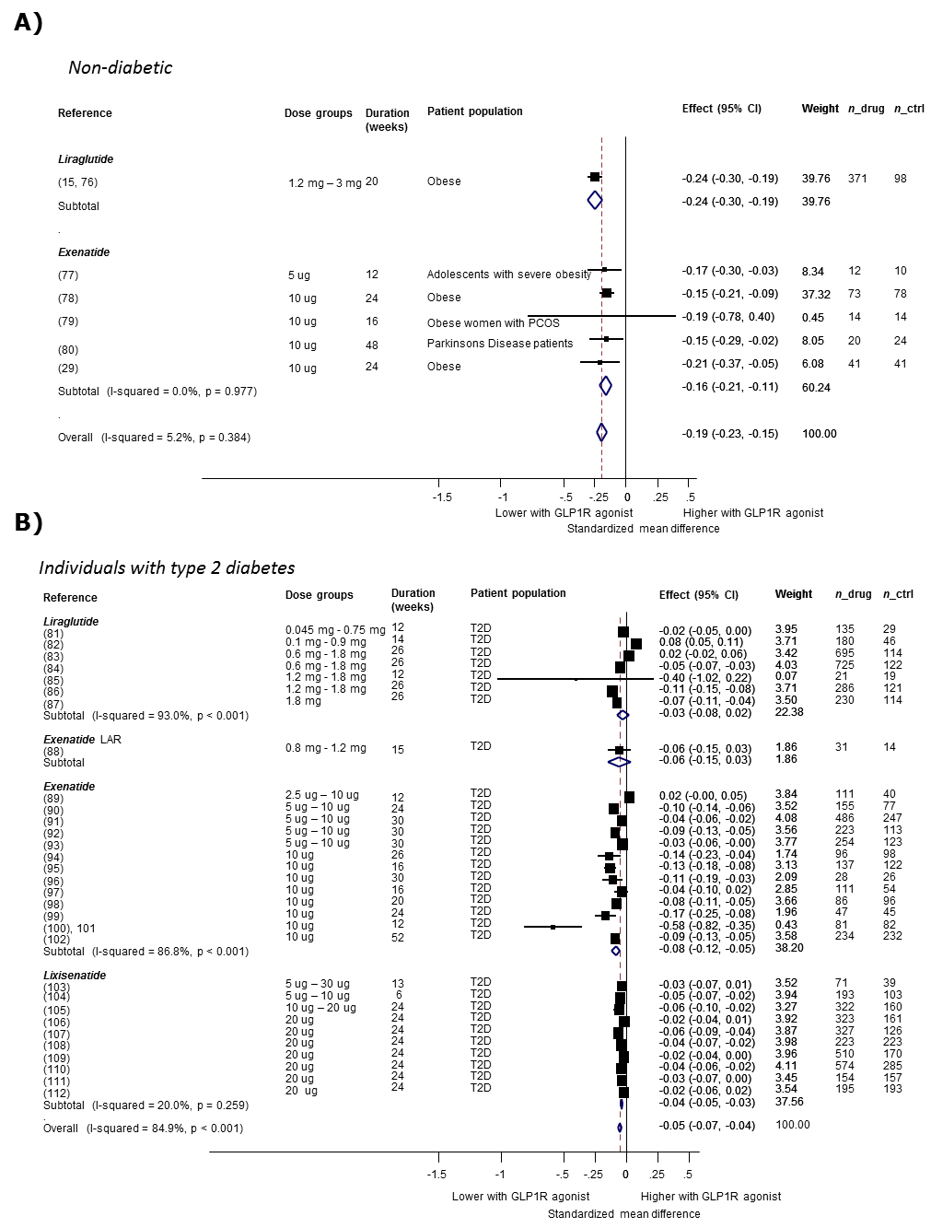
Figure S1. Effects of GLP1R agonists on body weight. (A) Non-diabetic individuals. (B) Individuals with T2D. Summary estimates of standardized difference in weight are shown within drug class and overall.
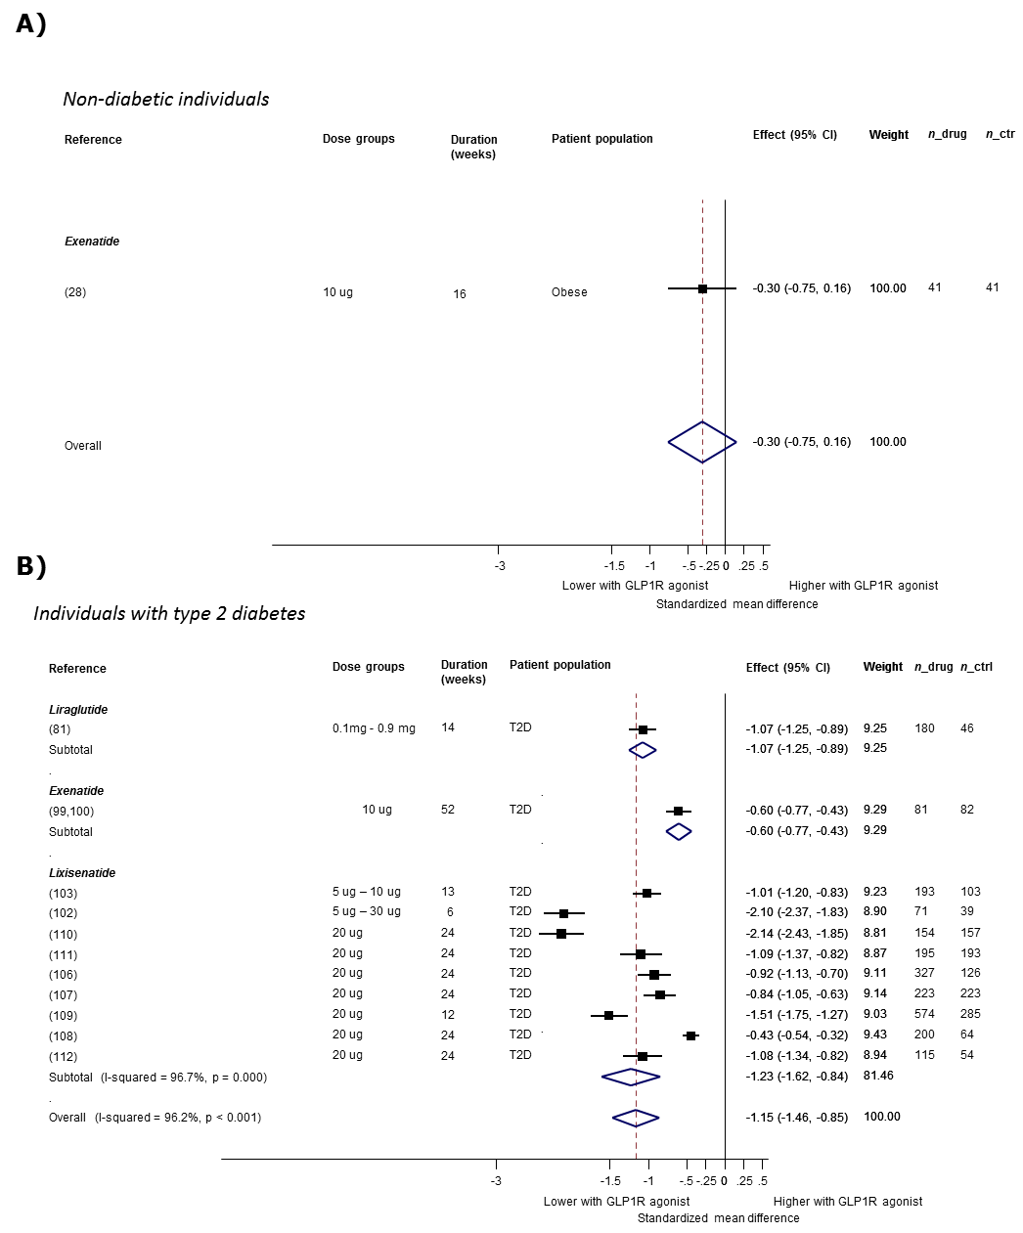
Figure S2. Effects of GLP1R-agonists on 2h glucose. (A) Non-diabetic individuals. (B) Individuals with T2D. Summary estimates of standardized difference in 2-h glucose are shown within drug class and overall.

SUPPLEMENTARY TABLES
Table S1. Study characteristics for disease traits. Descriptives for studies or consortia contributing to disease associations are shown.

Table S2. Comparison of heterogeneity between trial and rescaled genetic estimates. P value for difference between rescaled genetic and trial estimate refers to Cochrane’s Q test heterogeneity value obtained from fixed-effect meta-analysis of the rescaled genetic estimate with the estimate observed in clinical trials, conducted in non-diabetic or type 2 diabetic (T2D) populations. NA: Not applicable, because genetic estimates were rescaled to match the observed trial effects. Bonferroni corrected significance guideline: α = 0.0025 [=0.05/(20)].

Phenotype | Population | P value (Cochrane Q test) | I² | Degrees of freedom
Glucose | Non-diabetic | NA | NA | NA
 | T2D | NA | NA | NA
2-h glucose | Non-diabetic | 0.08 | 66.9 | 1
 | T2D | 2.13x10⁻¹² | 98.0 | 1
Insulin | Non-diabetic | 0.94 | 0.0 | 1
 | T2D | 0.11 | 59.8 | 1
Weight/BMI | Non-diabetic | 2.64x10⁻⁴ | 92.5 | 1
 | T2D | 0.26 | 21.6 | 1
Systolic blood pressure | Non-diabetic | 0.06 | 70.7 | 1
 | T2D | 0.23 | 29.2 | 1
Diastolic blood pressure | Non-diabetic | 0.31 | 2.8 | 1
 | T2D | 0.26 | 21.7 | 1
Heart rate | Non-diabetic | 0.74 | 0.0 | 1
 | T2D | 0.12 | 58.7 | 1
Total cholesterol | Non-diabetic | 0.03 | 78.8 | 1
 | T2D | 0.70 | 0.0 | 1
LDL-cholesterol | Non-diabetic | 0.02 | 80.6 | 1
 | T2D | 0.97 | 0.0 | 1
HDL-cholesterol | Non-diabetic | 0.91 | 0.0 | 1
 | T2D | 0.06 | 71.2 | 1
Triglycerides | Non-diabetic | 0.86 | 0.0 | 1
 | T2D | 0.44 | 0.0 | 1

Table S3. Details of randomized trials contributing to analyses of GLP1R agonist effects included in Fig. 2. n_{drug}: Number of individuals with biomarker measurements receiving study drug. n_{Ctrl}: Number of individuals with biomarker measurements in comparison group (Placebo or no-drug). SD: Baseline SD, used to standardize treatment effects; if blank, weighted average SD was used.
Table S4. Study characteristics for quantitative traits. Descriptives for studies or consortia contributing to discovery and follow up of quantitative trait associations are shown.

