Analyzing urban microclimate air temperature measurements using a novel parameter - the partial sky view factor

AMER AL-SUDANI, STEVE SHARPLES

School of Architecture, University of Liverpool, Liverpool L69 7ZN, United Kingdom

ABSTRACT: Summertime external air temperature measurements and sky view images were taken at twelve locations around a UK housing development to exam the interaction between urban morphology and microclimate factors that affect human thermal comfort inside and outside buildings. Fish eye lens images of the sky were analysed at each measurement point to calculate the sky view factor (SVF). The hottest of the measured days was selected for analysis, with the day being divided in to four time periods. Statistical analyses of the local air temperatures and SVF values attempted to identify relationships between the two parameters, but correlations were not significant. The sky images were then divided in to sectors according to the four cardinal points (norths, east, south and west) and new sky view factors were calculated for each individual sector (called partial sky view factor SVFp). Repeating the statistical analyses using SVFp did now produce significant correlations with air temperature variations around the site. SVFp could be a useful microclimate indicator because it quantifies the openness of the sky in directions that most influence the urban microclimate.
Keywords: microclimate, urban planning, air temperature

INTRODUCTION
Understanding the physical parameters and interactions that define and develop urban microclimates is an essential requirement in promoting the sustainable development of cities. The sky view factor (SVF) and building orientation are two well-known urban morphological parameters that have been investigated extensively in microclimate research (Grimmond et al. 2001). The SVF is defined as ‘the percentage of free sky at specific locations, with values between 0 and 1 representing totally obstructed and totally free spaces’ (Lin et al 2012). The SVF is used in a variety of applications, such as renewable energy assessment, urban heat island (UHI) studies, human biometeorology and microclimate model development (An et al. 2014). In general, the lower the SVF then the lower is the incoming solar radiations during the day and the lower the long wave radiation emitted at night. The surface temperatures and air temperatures of urban spaces will be affected in both cases (Erella and Williamson 2007). Some studies have examined the causal impact of SVF on air temperature (Svensson 2004), while Souza (cited in Krüger et al. 2011)) considered the difficulty of obtaining a clear relationship between the SVF and ambient temperatures. Consequently, the role of SVF as a morphological parameter in urban spaces, in terms to its influence on the air temperature, is still unclear.
On the other hand, orientation is a parameter that has attracted much attention at the urban scale and the individual building scale. There have been many attempts to combine the orientation with other urban morphological parameters, on a microclimate basis, such as the aspect ratio of urban canyons (Ali-Toudert and Mayer 2006)]; geometries of urban courtyards and urban squares (Taleghani et al. 2014) and urban form and urban layout (Košir et al. 2014).
The relationship between the SVF and orientation has been investigated in previous studies in relation to some parameter, such as solar position. Based on field measurements at different periods of the year in Curitiba city in Brazil, Krüger et.al (2011) suggested that the thermal conditions at a site cannot be predicted accurately by the SVF alone - a combined analysis of the SVF and the solar trajectory can yield more precise relationships with air temperature, especially for irregular urban forms. Grimmond et al. (2001) tried to assess a quick and accurate method to estimate the sky view factor by comparing two approaches (a digital camera fitted with a FC-E8 fisheye lens and a LI-COR LAI-2000 Plant Canopy Analyser). Measurements were made at 12 urban canyon sites of varying geometries and orientations at different times of the year. The key findings were that the digital camera provided the more accurate SVF estimation and that the SVF values were insensitive to the direction in which the camera was oriented (N, S, E and W). Matzarakis and Matuschek (2011) were also interested in the rapid estimation of sky view factors. They developed the software SkyHelios, which calculates a continuous sky view factor by combining images of the surrounding surfaces in four directions (for example, N, E, S and W) with an image of the overhead sky. Although this approach is similar to that adopted in this paper’s study i.e. considering the SVF in terms of orientation, SkyHelios cannot consider the relationships between sky view factor, orientation and air temperature variations in urban areas. This study attempted to examine the links between urban morphological characteristics and air temperature as a factor in creating microclimates around buildings.

METHODOLOGY
This study sought to measure external air temperatures at points around an array of urban buildings and compare variations in temperatures with measurements of sky view factors at the points during the course of a 24 hour day (2nd September 2014). For this initial pilot study just one day of data was used to gain a general understanding of the potential relationships between air temperature and sky view factor. Further work is currently being undertaken on data from other times of the year to test how generally applicable the findings from this pilot study might be.
The case study used in this investigation was Minster Court, which is a residential complex occupying about 36,000 m² of land near the city centre of Liverpool, UK, a city which experiences a mild maritime climate The complex comprises of different types of residential buildings. There are two storey single family terrace houses on the east edge and in centre areas; three storey apartment buildings, with pitched roofs, located mainly in the south-east corner and part of the north side. Four and five storey apartment blocks with flat roofs are located on the western side and central part of the complex – see Fig. 1.

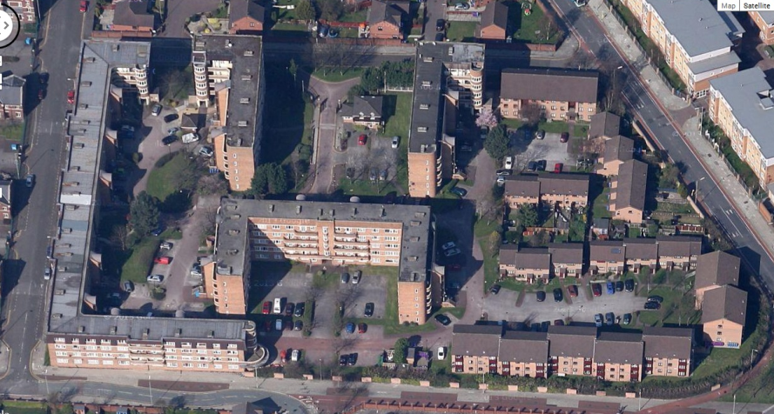
N

Figure 1: Layout of Minster Court dwellings.

External air temperatures were measured around the Minster Court complex during the summer of 2014 using twelve Onset Hobo data loggers mounted in purpose-built shields to protect them from direct solar radiation and rain. The loggers were mounted at heights above ground level of between 2.5m and 3.0m (depending on available access and security issues). All loggers were mounted at a distance of 250mm away from any building surface to avoid convective warming from the walls affecting readings. The data loggers (H1 to H12) were distributed around the centre and edges of the site (Fig. 2). One sensor (H6) failed during the monitoring. Human activities took place in and around Minster Court during both the day and the night and it was decided that it would be interesting to examine links between air temperatures and sky view factors at different periods. Consequently, for analysis purposes, this study divided the day in to four periods, each of six hours. The first period (designated CC) lasted from 12.00 midnight to 06.00; the second period (CH) was 06.00 to 12.00 noon; period HH ran from 12.00 noon to 18.00 while the last period (HC) was from 18.00 to 24.00 (midnight). Air temperature variables for each location - maximum (Tmax), minimum (Tmin), average (Tavg) and air temperature range (ΔT= Tmax-Tmin) - for each period (CC, CH, HH and HC) were calculated and used for statistical analyses. Data for the hottest day of the study (2nd September 2014) are used in this paper, and sky conditions were predominantly clear throughout the day.

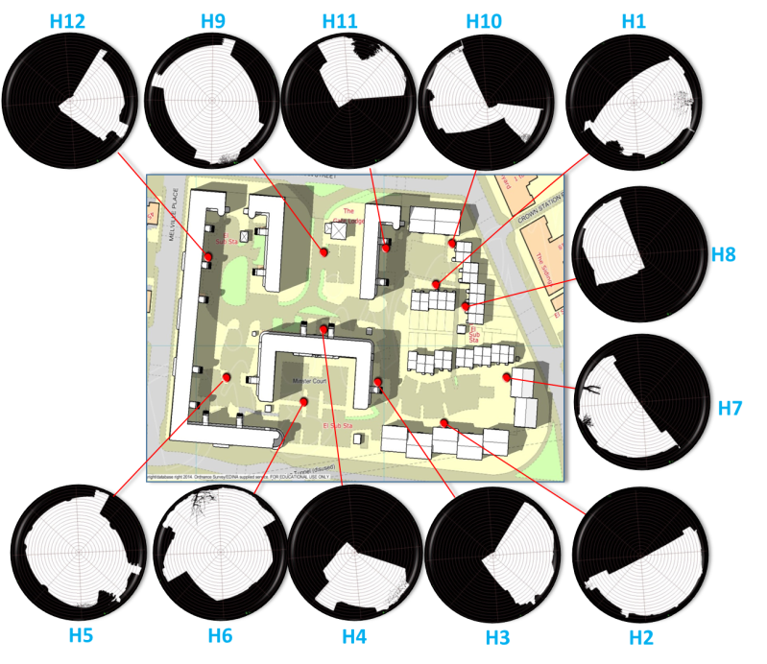

N

Figure 2: The H1 to H12 air temperature measurement sites.

There are many way to calculate SVF, but this study adopted the classic method of using a digital Nikon camera fitted with a FC-E8 fisheye adapter to capture upward fisheye photographs at logger locations and at the height of each data logger. The captured images were input into specialist software to calculate the percentage of open sky at the specific point – results can be seen in Fig. 2. The orientation of the lens and images were known by using a compass and two very small pegs mounted on opposite sides and at equal distances from the lens. A tiny part of the pegs appeared in the fisheye image to represent the north and south directions. The second stage was to input the fisheye images in to AutoCAD 2012 software. The 3rd stage was to draw a line, representing the diameter of the image, from the north to the south. The next step was to use the PLINE command in AutoCAD to trace the sky’s outline to define the sky area inside the image and then, using AutoCAD’s LIST command, to calculate the area of the circle and the area of the sky. The SVF could then be calculated by using Eqn. 1.

$SVF=\frac{area of the sky}{area of the circle }$ (1)

This study was interested in refining the global SVF value by subdividing the sky hemisphere in to four quadrants centred on the four cardinal points of the compass (N, E, S and W) and then calculating partial sky view factors (SVFp ϴ) for each quadrant, where ϴ will be either 0° (N), 90° (E), 180°(S) or 270° (W). Fig. 3 shows the basic steps in the assessment of SVF and SVFp ϴ.

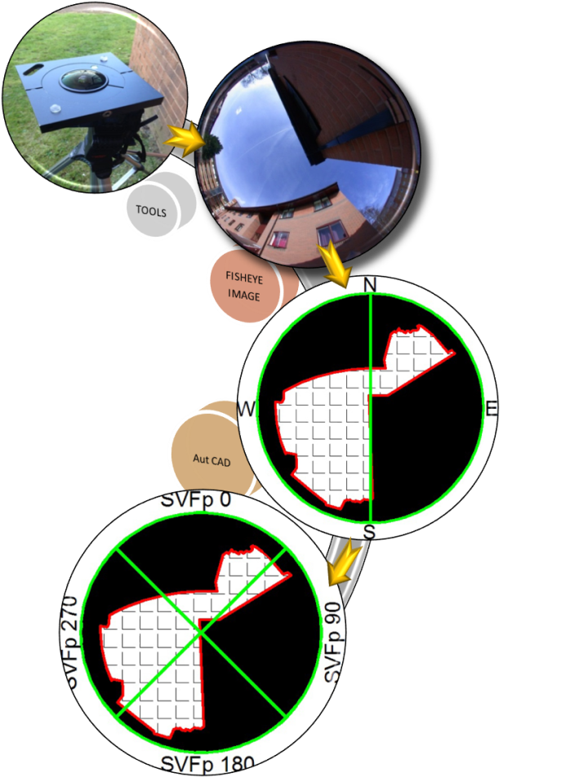

Figure 3: Fish-eye lens analysis of sky view factor and partial sky view factor at Minster Court.

To calculate SVFpϴ, two diagonal and orthogonal lines were drawn across the fisheye image to create the four quadrants (Fig. 3). The area of visible sky in each quadrant was calculated by using AutoCAD’s HATCH and LIST commands and SVFp was calculated using Eqn. 2.

$SVFp =\frac{area of the sky in the quadrant }{area of the circle }$ (2)

Linear regression analyses were carried out in order to analyse the bivariate relationships between SVF and Tmax, Tmin, Tavg and ΔT. In addition, multiple regression analyses were undertaken to examine the influence of the partial sky view factors SVFp 0, SVFp 90, SVFp 180 and SVFp 270 on the various air temperature parameters. For the statistical analyses the data were assessed using the adjusted R² parameter rather than the correlation coefficient R or the correlation of determination R² because the adjusted R² indicates the percentage of variation in any results described by only the independent variables that actually affect the dependent variable i.e. any non-significant variables are discarded from the correlation equations. Therefore, adjusted R² should help identify the correct model between SVF, partial SVF and air temperature variations across the measured Minster Court site. The significance (p-value) is used to assess the validity of any correlations; a p-value ≤ 0.05 is indicating a meaningful correlation.

RESULTS
Figure 4 shows the mean values of Tmax, Tmin, Tavg and ΔT measured at the locations around Minster Court for each of the four periods of the day (CC - 12.00 midnight to 06.00; CH - 06.00 to 12.00 noon; HH 12.00 noon to 18.00; and HC 18.00 to 24.00). For comparsion, data from a University roof-mounted station 600 metres from Minster Court is also shown in Fig. 4 as STATION. Variations between the air temperatures at the measurement sites can be atributed to the urban morphology at each site and the period of the day/night that is being considered. The values of the SVF at each site and the individual components of SVFp that make up a SVF value are shown in Fig. 5. It can be seen how some locations are dominated by a particular SVFp, such as location H4, whereas other locations, such as H9, have a relatively clear view of the sky in all directions. The aim of the statistical analysis was to test if the variations in temperature around the site could be attributed to either the SVF or the SVFp values for the different period of the day.

For the CC period of the day (from 12.00 midnight to 06.00) a simple liner bivariate regression analysis of SVF versus Tmin, Tmax, Tavg and ΔT indicated that, for all models, the correlations were not significant. Therefore, these insignificant models were ignored. For the same CC period multivariate models of predictors (SVFp0, SVFp90, SVFp180 and SVFp270) also failed to identify any significant relationships with air temperature.

For the CH period of the day (06.00 to 12.00 noon) the bivariate analysis found a significant but weak negative relationship between SVF and Tmin, (adjusted R² =34.1%; p = 0.035), which is shown in Fig. 6. For the same CH period the multivariate analyses produced equations for Tmax, Tavg and ΔT that expressed the variations at the locations in terms of some of the SVFp parameters (Eqns. 3, 4 and 5), with all having p≤0.05 and adjusted R² values between 75% and 85%.

For the HH period of the day (12.00 noon to 18.00) bivariate analysis found no significant relationships between SVF and Tmin, Tmax, Tavg and ΔT.

Tmax = 21.3 + 37.4SVFp(180) - 43.1 SVFp(270) (3)

Tavg = 17.4 + 15.5SVFp(180) - 25.1 SVFp(270) (4)

ΔT = 7.7 + 37.3SVFp(180) - 40.8 SVFp(270) (5)

For the same HH period the multivariate analyses produced equations for Tmax, Tavg and ΔT that expressed the temperature variations at the locations in terms of some of the SVFp parameters (Eqns. 6, 7 and 8), with all having p≤0.05 and adjusted R² values between 73% and 95%.

Tmax = 26.8 - 56.1SVFp(0) + 42.0SVFp(270) (6)

Tavg = 22.6 - 30.0SVFp(0) + 26.1SVFp(270) (7)

ΔT = 7.4 - 49.9SVFp(0) + 45.9SVFp(270) (8)

For the HC period of the day (18.00 to 24.00) bivariate analysis found no significant relationships between SVF and Tmax, Tavg, Tmin and ΔT. For the same HC period multivariate analyses produced equations for Tmax, Tavg and ΔT that expressed the temperature variations at the locations in terms of some of the SVFp parameters (Eqns. 9, 10, and 11), with all having p≤0.05 and adjusted R² values between 81% and 85%.

Tmax = 22.1 - 28.9SVFp(0)- 15.8SVFp(180)
+38.0SVFp(270) (9)

Tavg = 18.0 - 13.3SVFp(0)- 5.1 SVFp(180)
+ 12.4 SVFp(270) (10)

ΔT = 5.9 - 19.5SVFp(0) - 15.3SVFp(180)
+ 34.8 SVFp(270) (11)

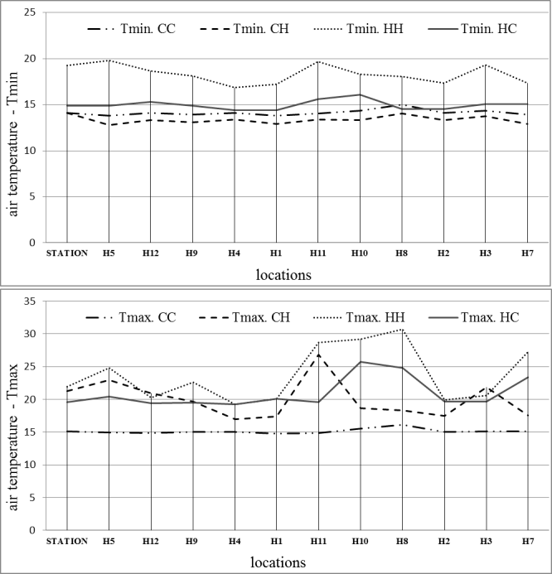

a

.

b
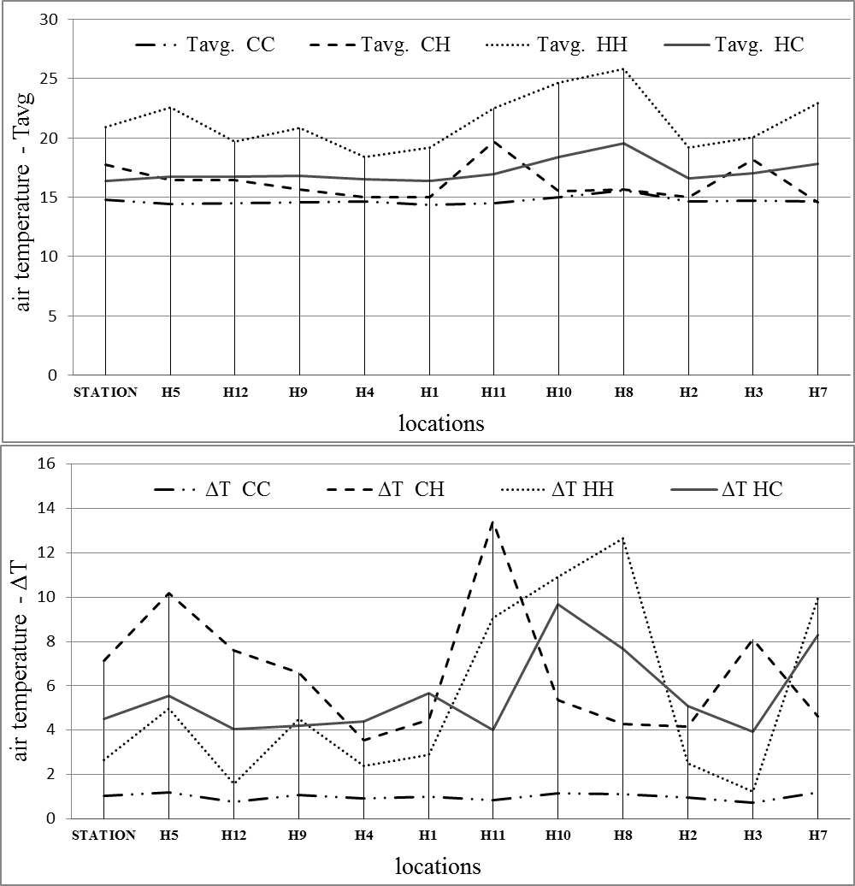

c

d

Figure 4: Variation of air temperatures (a)Tmin, (b)Tmax, (c)Tavg and (d)ΔT at Minster Court locations for different periods of the day .

The positive and negative signs in all the above equations indicate whether the individual partial sky view factor is influencing an increase or decrease in the local microclimate temperature at each site. The relative contributions of the partial sky view factors to Tmax, Tavg, Tmin and ΔT for the morning (CH), afternoon (HH) and evening (HC) periods are shown in Fig. 7.

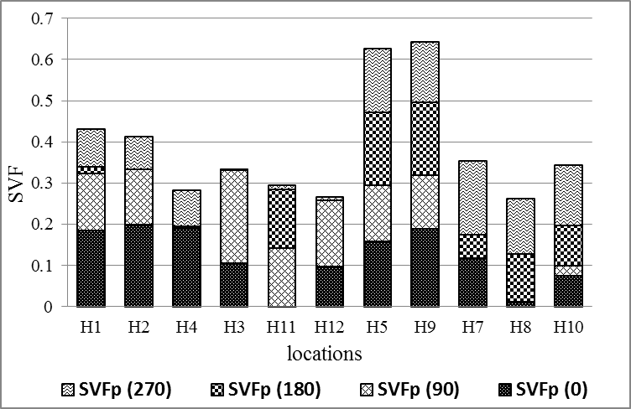

Figure 5: Variation of SVF and SVFp components for the different site locations.

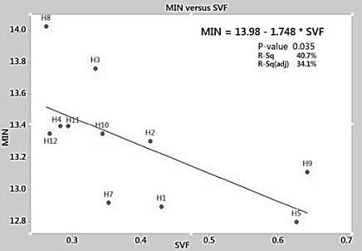

Figure 6: Variation of Tmin with SVF for different locations.

DISCUSSION
The field measurements of air temperatures around the Minster Court development, as shown in Fig. 4, highlighted the variations across the site at any one time. The urban morphological features of the measurement locations are one factor in these variations – for example, by providing shelter from winds or shading from solar radiation. The period of the day can also contribute to influencing the scale of the impact that the morphological features have on microclimate air temperatures. It was for these reasons that this study studied both sky view factors and different periods of a 24 hour day. The statistical analyses suggested that during the night time CC period (12.00 midnight to 06.00) the urban morphological features (as quantified
by both the sky view factors and the partial sky view factors) were having no significant impact on the magnitude of the cross-site temperature differences. This might be expected for a mild UK night with little wind and low net long wave radiative exchanges between the sky and the ground. However, even for the morning (CH), afternoon (HH) and evening (HC) periods, when a more dynamic microclimate environment might be expected, the bivariate analyses suggested that the SVF as an isolated parameter of urban morphology was not significantly correlated with temperature variations.

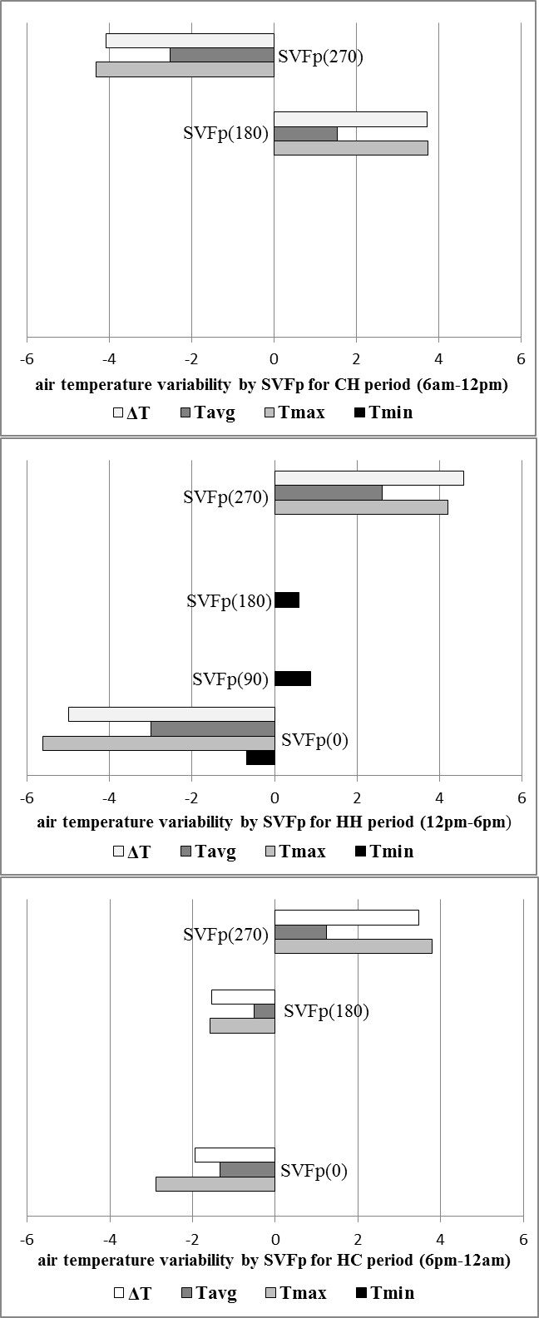

(a)
(b)
(c)

Figure 7: Air temperature variability for different periods of the day related to partial sky view factors.

The findings from this study contradict the conclusions of Chen et al. (2012) and Hien et al. (2010), who found a strong connection between SVF and daytime air temperatures in Hong Kong and Singapore respectively. The findings from this study do support the results from Krüger et al. (2011), who found only a limited SVF role in influencing day time thermal comfort conditions in Curitiba, Brazil.

Because of the contradictory results from the SVF – temperature research literature, it was decided to try and refine the SVF concept by introducing the partial sky view factor SVFp, where the SVFp relates to different quadrants of the sky based on the four cardinal points of the compass. The multivariate statistical analyses suggested that some of the SVFp values were correlating significantly with the changes in air temperatures across the site, dependent upon location and degree of exposure to the different parts of the sky. For example, during the morning CH period (06.00 to 12.00 noon) it was found that that increases in the SVFp(270) reduced air temperatures while increases in SVFp(180) elevated air temperatures Fig.7a. This might be explained by the bigger SVFp(180) values being associated with the measurement locations and their surroundings being exposed to higher levels of morning solar radiation. Conversely, larger SVFp(270) values suggest that the building surfaces to the west are either low in height or distant from the measurement points, and so not contributing any additional heat input to the microclimate via convective and/or radiative heat transfer.

During the afternoon HH period (from 12.00 noon to 18.00) the influence of the size of SVFp(270) is changed due to the changing position of the sun - see Fig.7b. Now, an increase in SVFp(270) leads to an increase in the direct solar radiation reaching the site, especially after 13.00) and so the site-measured temperatures increase with increasing SVFp(270).

For both the afternoon and evening periods the magnitude of the north quadrant partial sky view factor SVFp(0) plays an interesting role, and seen in Figs.7b-7c, and appears as a significant variable in the HH and HC set of equations. The building surfaces involved in SVFp(0) are on the north side of the site but many of them will face south, and so absorb heat from the sun during the course of the day. Consequently, a large SVFp(0) value is indicative of a measurement point some distance from these warmed surfaces, and so temperatures go down as SVFp(0) goes up.

CONCLUSION
Numerous geometric parameters have been developed in an attempt to assess and quantify the effects of urban morphological characteristics on air temperature variations across a complex residential development in Liverpool, UK. For this study, field measurements were used to get the air temperature across the study area during a warm and calm summer day. While the SVF acting alone as an urban morphological indicator did not show significant relationships with air temperature, statistical analyses demonstrated the potential of dividing the SVF according to orientation (the partial sky view factor). The findings suggested that this novel parameter could (i) have predictive uses for estimating microclimate air temperature variations; (ii) is relatively easily calculated and (iii) would be readily understood by architects and planners. Clearly the equations and findings from this study only relate to the specific site examined, and the lack of clarity of the influence of particular periods, like the night time period (CC), or sectors, like SVFp 90, on air temperature, does not necessarily mean they are ineffective parameters – perhaps more measurements sites, or different times of the year would reveal some relationships. However, this investigation has indicated that the potential ability of SVFp to reveal the effect of urban morphologies on air temperature in moderate climates seems to be better than SVF alone. More studies involving field measurements and SVFp calculations for different sites, climates and times of year are needed to confirm the possible wider application of this novel parameter.

REFERENCES
Ali-Toudert, F. & Mayer, H., (2006). Numerical study on the effects of aspect ratio and orientation of an urban street canyon on outdoor thermal comfort in hot and dry climate. Building and Environment, 41(2), pp.94–108.
- An, S.M., Kim, B.S., Lee H.Y., Kim, C. H., Yi, C.Y., Eum, J.H. & Woo, J.H. (2014). Three-dimensional point cloud based sky view factor analysis in complex urban settings. International Journal of Climatology, 34(8), pp.2685–2701.
Chen, L., Ng, E., An, X., Ren, C., Lee, M., Wang, U. & Zhengjun, H. (2012). Sky view factor analysis of street canyons and its implications for daytime intra-urban air temperature differentials in high-rise, high-density urban areas of Hong Kong: A GIS-based simulation approach. International Journal of Climatology, 32(1), pp.121–136.
Erella, E. and Williamson, T. (2007). Intra-urban differences in canopy layer air temperature at a mid-latitude city. International Journal of Climatology, 27, pp.1243–1255.
Grimmond, C.S.B., Potter, S.K., Zutter, H.N. & Souch, C., (2001). Rapid methods to estimate sky-view factors appiled to urban areas. International Journal of Climatology, 21, pp.903–913.
Hien, W.N. & Jusuf, S.K., (2010). Air Temperature Distribution and the Influence of Sky View Factor in a Green Singapore Estate. Journal of Urban Planning and Development, 136(3), pp.261–272.
Košir, M., Capeluto, I.G., Krainer, A. & Kristl., (2014). Solar potential in existing urban layouts - critical overview of the existing building stock in Slovenian context. Energy Policy, 69, pp.443–456.
Krüger, E.L., Minella, F.O. & Rasia, F., (2011). Impact of urban geometry on outdoor thermal comfort and air quality from field measurements in Curitiba, Brazil. Building and Environment, 46(3), pp.621–634.
Lin, T.-P., Tsai, K.-T., Hwang, R.-L. & Matzarakis, A., (2012). Quantification of the effect of thermal indices and sky view factor on park attendance. Landscape and Urban Planning, 107(2), pp.137–146. 9.
Matzarakis, A. & Matuschek, O., (2011). Sky view factor as a parameter in applied climatology - rapid estimation by the SkyHelios model. Meteorologische Zeitschrift, 20(1), pp.39–45.
Svensson, M.K., (2004). Sky-view factor analysis – implications for urban air temperature differences. Meteorological Applications, 11(3), pp.201–211.
Taleghani, M., Tenpierik, M. & van den Dobbelsteen, A., (2014). Heat in courtyards: A validated and calibrated parametric study of heat mitigation strategies for urban courtyards in the Netherlands. Solar Energy, 103, pp.108–124.

