The Potential of Inclined Walls to Reduce Overheating Risk:
A Passivhaus Case Study for UK Current and Future Climates

YAHYA LAVAFPOUR, STEVE SHARPLES

School of Architecture, University of Liverpool, Liverpool L69 7ZN, United Kingdom

ABSTRACT: This study used probabilistic climate change scenarios from the UK Climate Change Projections to determine the future overheating risk in an existing Passivhaus dwelling under a high emission 50 percentile scenario in London. Dynamic thermal simulation modelling software (DesignBuilder) was used to examine the impact of various inclinations of the south façade of the Passivhaus dwelling to make use of the self-shading that this form created. A sensitivity analysis of internal temperatures and thermal comfort conditions in the dwelling as a function of building facade inclination and prevailing climatic conditions was undertaken. The research found that implementing an optimum angle tilted façade would moderate indoor temperature variation between day and night in summer and could potentially act as an effective shading device while still be practical for collecting solar gain in winter. The proposed inclined façade could completely eliminate the risk of overheating for current climates; however, it was found that the tilted facade solely would not be fully capable of eradicating the risk of thermal discomfort overheating, particularly for UK climate scenarios of the 2080s.
Keywords: inclined façade, shading, summer overheating, climate change

INTRODUCTION
In recent decades thermal insulation has been the most frequently used intervention for developing low energy dwellings. Much of the focus on new build and refurbishment in the UK to date has concentrated on thermal comfort during the winter and on the reduction of space heating since space heating is the largest energy use for the housing stock. Highly insulated buildings with a high level of airtightness and energy recovery systems have been successful in minimising heating demand in the UK housing sector. One of the most successful and fastest growing standards, both in the UK and European housing sector is the German Passivhaus standard, which reduce significantly the demand space heating. However, as suggested by building physics researchers (Gupta & Gregg, 2012) and UK climate projections from the Metrological Office (Murphy, et al., 2010), the increase in extreme weather events, such as heatwaves, means that studies of overheating risks and the cooling energy demand must now also be considered, especially the vulnerability of domestic buildings to summer overheating.

According to the UK’s Zero Carbon Hub (Dengel & Swainson, 2012) there is a growing concern in the UK that super insulated, very airtight homes, such as those developed in accordance with Passivhaus principles, might be vulnerable to the risk of summer overheating in future climates. There are a number of well-established passive cooling adaptation measures, such as solar shading, thermal insulation, thermal mass and ventilation, which have received a great deal of research attention and have been already implemented into the housing sector to reduce summer discomfort. The research presented here used a less examined passive approach to reduce overheating based on the potential implementation of the envelope shape as an environmental design strategy which is architectural in nature, and so has both aesthetic and environmental consequences.

PASSIVHAUS CASE STUDY
Passivhaus buildings are constructed using a heavily insulated exterior envelope with large glazed openings to the south (in the northern hemisphere) for maximizing spring, fall and winter solar gain. To obtain Passivhaus certification a building needs to meet a few main criteria (Feist, 2012 ), which include: (i) maximum specific space heat demand of 15 kWh/m² per year to provide a minimum indoor air temperature of 20°C in winter; (ii) total specific primary energy demand of no more than 120 kWh/m² per year; (iii) thermal bridge free and an airtightness of maximum 0.6 air changes per hour (ac/h) at 50 Pascal indoor-outdoor pressure difference. Furthermore, in order to provide a comfortable indoor air temperature in summer, living areas must not exceed 25°C for more than 10 % of the occupied hours in a given year.

The case study used in this paper was Larch House in Ebbw Vale, UK. It was the first zero carbon Passivhaus dwelling in the UK (McLeod, et al., 2013). Its design was based on the strategy of maximizing the benefit of solar heat gains (Ridley, et al., 2014). It uses an average of 9.3 kWh/m² energy for heating and achieved an air tightness result of 0.2 ac/h at 50 Pascal. Larch House has a large glazing area on the south elevation with a window-to-wall ratio of 55% (see Fig. 1), with occupants controlling the shading using external blinds. The house comprises a south-facing living room on the ground floor with windows on the east side and at the rear (north). There is a kitchen on the north side of the house and a south-facing dining room. There are three bedrooms on the first floor. The main bedroom (Bedroom 1) is located on the south façade, bedroom 2 at the rear of the building and bedroom 3 is south-facing on the west side (see Fig. 2).

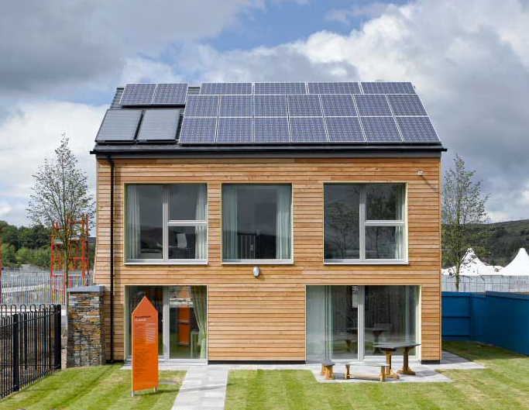

Figure 1: The south facade of Larch House

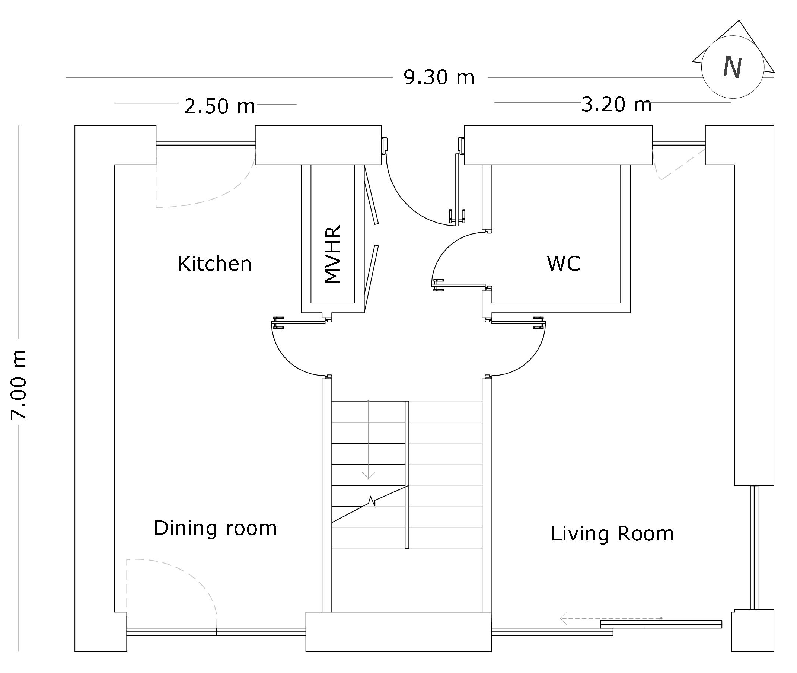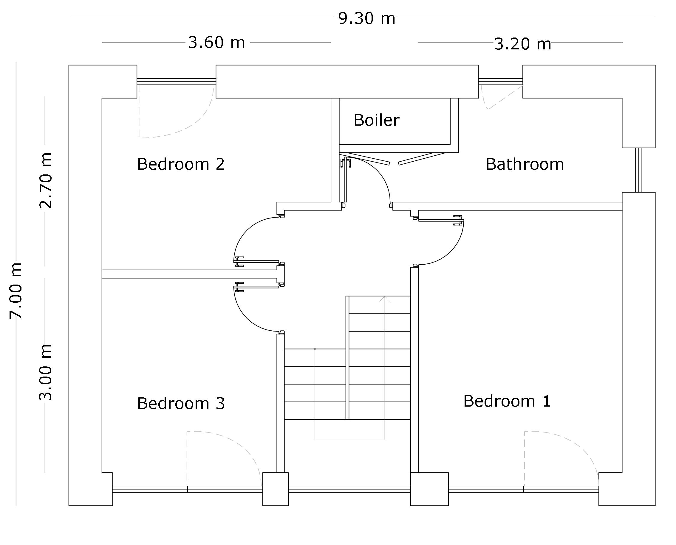

Figure 2: Ground (top) and 1st floor (bottom) plans

PASSIVE OVERHEATING INTERVENTIONS
Passive interventions for reducing overheating are mostly user dependent and include operations such as blinds and window openings. Other passive overheating control options, such as thermal mass and overhangs, are non-user dependent. User-dependent approaches to passive solar control may not properly function due to the occupants not interacting with them as planned. For instance (Haldi & Robinson, 2009) found that occupants adjusted blinds more often on arrival [and departure] than during their presence in a room. Occupants also operated blinds to create privacy and alter view rather than solely for thermal comfort.

One reason for choosing Larch House as a case study for this research was the complaints of overheating that arose during monitoring of the house. Computerised shading devices had been provided, but studies in the house revealed that user preferences often contradicted automated shading control actions and occupants preferred to control the blinds manually or over-ride the automatic system. For the Larch House case study the automatic functioning of the external blinds was disabled at the tenants’ request. The malfunction of the blinds use and window openings in the Larch House case study is believed to be the main reason for overheating problems during summer months (Technology Strategy Board, 2014).

The problematic interaction between the Larch House occupants and the solar overheating control systems was a stimulus for this study’s investigation of an alternative non-user dependent intervention rather than the more conventional approaches such as overhangs and thermal mass. The idea was to test if altering the geometric form of Larch House (by tilting the south facade to give self-shading) might be capable of passively protecting the house from excessive solar gain in summer, both for current and future climate scenarios.

SUMMER THERMAL COMFORT
Guide A from the Chartered Institution of Building Service Engineers (CIBSE Guide A, 2007) is widely used to assess thermal summer comfort in the UK domestic sector (Lomas & Kane, 2013). The Guide suggests two threshold air temperatures to define a warm, uncomfortable indoor environment i.e. a lower temperature threshold that defines the moment occupants will start to feel warm (25°C), and a higher threshold temperature predicting the moment occupants will start to feel hot (28°C for living rooms and 26°C for bedrooms). In order to achieve thermal comfort temperatures should not exceed 25°C for living areas for more than 10% of total occupied hours and/or should not exceed 28°C for living rooms and 26°C for bedrooms more than 1% of total occupied hours.

METHODOLOGY
The research presented here expands on previous pilot study work by the authors (Author, 2015). In that study a comparison of monitored data from Larch House with predictions from the dynamic thermal simulation software DesignBuilder (a user-friendly version of EnergyPlus) established the validity of using DesignBuilder to model the energy performance of Larch House. The study parametrically tested a simple rectangular, single storey dwelling for London summer weather in order to test the effectiveness of inclining the south-facing façade outwards at 5° increments, starting from 90° (vertical façade) to 140° (50° beyond the vertical). It was found that an inclination angle of 110° to115° was effective for the London climate to shade the building in summer without greatly compromising the heating demand in winter. It is worth mentioning that pilot study dwelling had the same 55% window-to-wall ratio in the south façade as Larch House.

In this paper the proposed tilted facades suggested from the pilot study were applied to the architecturally more complicated (and more realistic) Larch House in order to investigate their effectiveness in reducing overheating risk. For this study Larch House was relocated to London, which provides a more challenging climate in terms of overheating risk, both for current and future climates. The aim was to examine whether the self-shading facades could act as an alternative design to overhangs and achieve summer thermal comfort. Thermal analysis data including indoor operative temperatures, transmitted solar radiation through the windows, and overheating rates for selected facades were calculated and an optimum (or near-optimum) façade inclination was defined. The current and future climate projections used for the overheating assessments are listed in Table 1, with the weather data being generated using techniques developed from a project called PROMETHEUS (PROMETHEUS, n.d.) which used UK Climate Projections weather inputs (UKCP09).

Table 1:Weather data used for simulations

Projection | Period | Emission | Probability
Current | 1961-1990 | NA | NA
Projection I | 2030s | High | 50%
Projection II | 2050s | High | 50%
Projection III | 2080s | High | 50%

RESULTS - LARCH HOUSE OVERHEATING RATE IN LONDON CURRENT AND FUTURE CLIMATES
Data representing a 50 percentile high emission scenario Test Reference Year (TRY) for 2030, 2050 and 2080 showed that future outdoor air temperatures will rise over the whole twelve month cycle of the year in the future (Fig. 3). The magnitude of the increase in average summer time dry bulb air temperatures is double the temperature rise for winter. July and August are the hottest months for all four time periods. Average monthly operative temperatures calculated by DesignBuilder are presented for the Larch House living room under current and future weather projections (Fig. 3). It is predicted that the house will experience a slight overheating risk during July and August for the current climate. However, in the future a much higher overheating risk is predicted. The summer average temperature in the living room and main bedroom were 23.9 and 24.1°C respectively. The highest single hourly temperature was in the living room (32.4°C) at 11:00 on 23rd July. The peak hourly operative temperature in the bedroom was calculated on the same day at 14:00 to be 31.4°C.

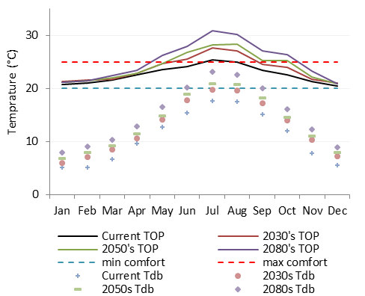

Figure 3: Monthly average outdoor dry-bulb (Tdb) and monthly indoor operative temperature (Top) in the living room of Larch House.

IMPLEMENTATION OF TILTED FAÇADES
The vertical south-facing wall of the London Larch House was replaced with inclined walls to investigate the impact on overheating. Inclination angles of 110° and 115° were adopted to analyse the impact that these shapes created on thermal comfort in summer under current and future climates in London. The simulations were calculated for living room and main bedroom. Operative temperatures were simulated 24 times i.e. three south façades, two rooms and four climates.

Current and 2080s data in the living room are shown in Fig. 4 as representations of all 24 simulations. The curves compare operative temperatures of the vertical and inclined facades. Corresponding heating demands for the alternative designs are also shown.

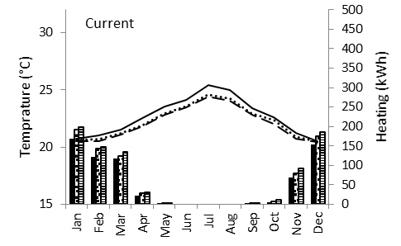

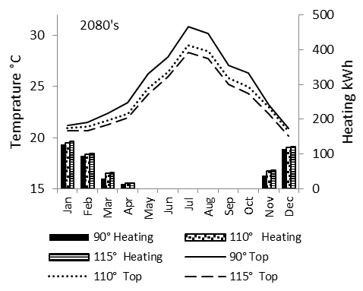

Figure 4: Living room operative temperatures and heating loads for current (top) and 2080s (bottom) climates

Fig. 4 indicates an indoor temperature reduction of up to 2°C degree for the hottest months when comparing the 115° tilted façade to the vertical façade. The difference between the two tilted façades is very small for the current climate; however, due to elevated temperatures and solar radiation levels in the future this difference becomes more pronounced for 2080. There is also a slight increase in heating load for the tilted facades, which is higher for the current climate. Despite this, the increase the heating demand always remains within the Passivhaus limitation of 15 kWh/m². As a result of changing the façade angle, indoor air temperatures dropped for most of the time. The impact of tilting the façade for current climate was small, while the temperature drop for the hottest month in the 2080’s was up to 2.5°C for average monthly calculations. The reduction in indoor temperature was higher during summer months but for the coldest months of the year i.e. January and February, the change in temperature was imperceptible.

Table 2 summarises the annual overheating percentages for the living room and bedroom for both benchmark temperatures i.e. >25˚C and >26˚C/28˚C.

Table 2: Percentage of overheating time

Period | Space | Vertical  90° | Tilt 110° | Tilt  115°
Current | Living room>25°C | 28.2% | 14.6% | 12.2%
Current | Living room>28°C | 2.9% | 0.5% | 0.1%
Current | Bedroom>25°C | 12.3% | 1.7% | 1%
Current | Bedroom>26°C | 4.9% | 0.4% | 0.2%
2030s | Living room>25°C | 43.3% | 26% | 21%
2030s | Living room>28°C | 11.2% | 4% | 3%
2030s | Bedroom>25°C | 21.6% | 10.5% | 7.7%
2030s | Bedroom>26°C | 15.2% | 7% | 5.6%
2050s | Living room>25°C | 48.1% | 30.4% | 25.5%
2050s | Living room>28°C | 16.3% | 8.6% | 7.4%
2050s | Bedroom>25°C | 27.7% | 15.8% | 11.8%
2050s | Bedroom>26°C | 21.3% | 11.9% | 8%
2080s | Living room>25°C | 58.1% | 41.5% | 35.4%
2080s | Living room>28°C | 28.2% | 17.6% | 15.3%
2080s | Bedroom>25°C | 38.3% | 22.1% | 18.9%
2080s | Bedroom>26°C | 31.2% | 18.5% | 14.3%

Although this study has focused on the risk of summer overheating, it is necessary to measure the impact that the proposed tilted geometries will have on heating demand in winter. Weather data were analysed to select a typical day in both summer and winter of current and future climate to indicate an actual performance of the different facades. The chosen days are representative of summer and winter climates. Fig. 5 compares a daily breakdown of the indoor temperature fluctuations and transmitted solar radiation through the windows for the three facade alternatives. During a cold day for current and future climates there is a marginal variation in the indoor temperatures when implementing the tilted façade. It is shown that the solar gain transmitted into the room is reduced during midday and early afternoon when implementing the inclined façades.

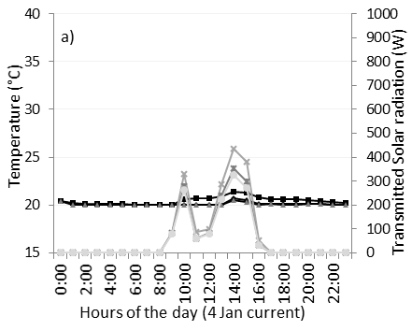

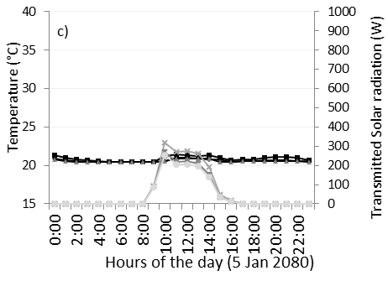

Figure 5: Winter and summer single day analysis in the living room: a) 4th January-current climate; b) 5th July-Current climate; c) 5th January-2080; d) 22nd July- 2080.

DISCUSSION
For current climates the tilted facades have a significant impact on reducing the predicted percentage of overheating compared to the vertical wall. Significant reductions are also evident for future climate climates, with overheating times typically being cut by a half. However, by 2080 overheating is still evident, even for the 115° tilted south façade, and other measures would be need to establish comfort.

According to the predicted data, applying a tilted wall with a 115° inclination angle is effective for reducing potential overheating for current and future climate. There is a significant drop in operative temperature when using a 115° tilted wall whereas operative temperature will not significantly drop in winter. Analysis showed that the implementation of a steeper façade will reduce beneficial solar gain in winter. However, the impact on the operative temperatures (and so thermal comfort and heating requirement) are not severe.
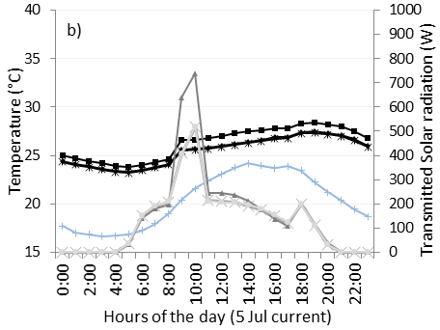

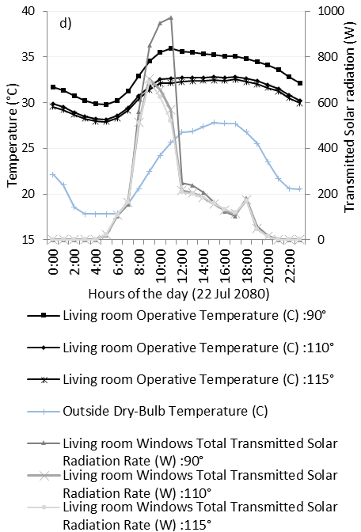

CONCLUSION AND FUTURE WORK
Passivhaus in the UK implies passive interventions to achieve free-running thermal comfort in summer. These interventions are mostly user-dependent and so may not always operate efficiently or effectively due to malfunction of the systems or occupant behaviour. Consequently, as was the case for Larch House, the dwelling may get overheated in summer, even for current climates. The paper considered a novel intervention in which inclined walls were used to create a self-shading strategy for the predominantly glazed south façade of an existing Passivhaus. The proposed tilted façades were analysed alongside with the performance of the existing vertical wall.

It is concluded the overheating risk under the current climate was significantly reduced using a 110° tilted south façade and it was almost fully eradicated using a 115° inclination. However, this reduction of overheating was followed by an increased heating load in the current climate, but which was almost negligible for future climates. The house remained thermally comfortable during winter for all climate scenarios and never exceeded the Passivhaus criteria for heating demand. However, the living room and main bedroom did experience significant overheating for projected future London climates. This risk was reduced by half using the self-shading façade. The geometric consideration could not solely eradicated overheating risks in future.

Manipulating the tilt of the south facing wall will clearly have other impacts on, for instance, daylighting and natural ventilation air flows, and these parameters will be examined in further work using the lighting and computational fluid dynamics CFD algorithms in DesignBuilder.

ACKNOWLEDGEMENT
The authors gratefully acknowledge Justin Bere of Bere:architects who provided the preliminary data regarding the case study

REFERENCES
CIBSE Guide A, (2007). Environmental design, London, UK: The Chartered Institution of Building Services Engineers.
Dengel, A. & Swainson, M., (2012). Overheating in new homes: A review of the evidence, Milton Keynes: IHS BRE Press on behalf of the NHBC Foundation.
Feist, W., (2012) . Passive House Planning Package. Darmstadt: Passive House Institute .
Gupta, R. & Gregg, M., (2012). Using UK climate change projections to adapt existing English homes for a warming climate. Building and Environment 55: p. 20-42.
Haldi, F. & Robinson, D., (2009). Interactions with window openings by office occupants. Building and Environment, 44(12): p. 2378–2395.
Lomas, K. J. & Kane, T., (2013). Summertime temperatures and thermal comfort in UK homes. Building Research & Information, 41(3): p. 259-280.
McLeod, R. S., Hopfe, C. J. & Kwan, A., (2013). An investigation into future performance and overheating risks in Passivhaus dwellings. Building and Environment , 70: p.89-209.
Murphy, J. et al., (2010). UK Climate Projections Science Report, Exeter, UK: Met Office Hadley Centre.
Ridley, I. et al., 2014. The side by side in use monitored performance of two passive and low carbon Welsh houses. Energy and Building 82: p. 13–26.

