Design considerations for the synthesis of polymer coated iron oxide nanoparticles for stem cell labelling and tracking using MRI.
Michael Barrow,a Arthur Taylor,b Patricia Murray,b Matthew J. Rosseinsky,a Dave J. Adamsa*
Iron oxide nanoparticles (IONPs, sometimes called superparamagnetic iron oxide nanoparticles or SPIONs) have already shown promising results for in vivo cell tracking using magnetic resonance imaging (MRI). To fully exploit the potential of these materials as contrast agents, there is still a need for a greater understanding of how they react to physiological conditions. A key aspect is the specific nature of the surface coating, which can affect important aspects of the IONPs such as colloidal stability, toxicity, magnetism and labelling efficiency. Polymers are widely used as coatings for IONPs as they can increase colloidal stability in hydrophilic conditions, as well as protect the iron oxide core from degradation. In this tutorial review, we will examine the design and synthesis approaches currently being employed to produce polymer coated IONPs as cell tracking agents, and what considerations must be made. We will also give some perspective on the challenges and limitations that remain for polymer coated IONPs as MRI contrast agents for stem cell tracking.
Key learning points
1) How and why IONPs are used for tracking stem cells
2) How to synthesise hydrophilic polymer coated IONPs and polymer grafting methods
3) Potential safety problems regarding IONPs
4) Strategies to increase uptake of polymer coated IONPs into stem cells
5) Limitations of stem cell tracking using polymer coated IONPs and MRI

1 Introduction
Stem cells are of great interest for the treatment of a wide range of diseases and disorders owing to their potential ability to regenerate or stimulate the regeneration of diseased host tissue. An important aspect of using stem cells in regenerative therapies is the ability of scientists and clinicians to image them once they are administered to an organism, allowing the tracking of their localisation within the body. This is critical in order to assess the engraftment and migration of the cells, and can give important information in respect to the therapeutic efficacy of the cells, as well as the safety of the therapy.1 Currently, pre-clinical imaging technologies such as optical, photoacoustic, nuclear and magnetic resonance imaging (MRI) are employed for this purpose.2 Stem cell imaging using these techniques usually involves the labelling of the cells with a probe or contrast agent that allows them to be distinguished from the host cells, as shown in Figure 1.
Clinically, MRI is often preferred as it does not suffer from issues such as penetration depth or spatial resolution limitations. An MRI scanner allows visualisation of living tissue by positioning a patient or tissue sample in a position containing a very strong external magnetic field of typically 1.5 T or 3 T in the clinic and up to 21 T pre clinically. A radio frequency pulse is applied through a coil, which causes a tip in the net magnetisation of protons to a plane that is adjacent to the main magnetic field.
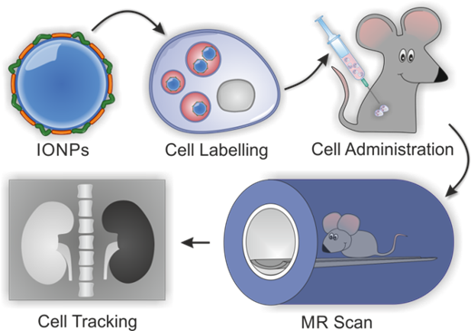
Figure 1 Stem cell tracking using IONPs and MRI: stem cells are first labelled with IONPs in vitro and then administered into a host that can be imaged non invasively using a MR scanner. The region containing the administered cells (e.g. right kidney) is detectable due to an increase in negative contrast caused by changes in the relaxation times of surrounding protons as caused by the presence of IONPs.

The time taken for the recovery of the magnetisation vector to return to its equilibrium state within the magnetic field is known as relaxation time, and is measured in two different ways. The T1 relaxation time corresponds to the rate at which the longitudinal component of the magnetisation vector returns to its equilibrium state and T2 relaxation time corresponds to the decay of the transverse component (axial spin) of the magnetisation vector towards equilibrium. During relaxation, radio waves emitted by protons are detected by receiver coils, which can be used to create MR images.3
External agents can be used as a means to enhance the contrast of MR images by introducing a material that can alter the relaxation times of surrounding water protons (1H MRI contrast agents), or to discriminate between water and other materials in the case of fluorine MRI contrast agents. Contrast agents for 1H MRI usually contain paramagnetic or superparamagnetic materials, which are materials that only become magnetised under the influence of an external magnetic field. Such agents are generally split into T1 and T2 categories: most commonly, T1 contrast agents contain a paramagnetic metal lanthanide complex that alters the longitudinal (T1) relaxation times of surrounding water protons whilst T2 agents, containing a superparamagnetic iron oxide core less than 20 nm in diameter,4 alter the transverse (T2) relaxation times of water protons. The efficiency of contrast agents in decreasing the relaxation time of surrounding protons is normally expressed in terms of their relaxivity, defined as r1 and r2 for longitudinal and transverse relaxivity, respectively. Both types of agents can be introduced into stem cells in vitro thus enabling a contrast distinct to that of the host tissue to be obtained once they are administered to a model organism. IONPs (T2 agents) are now more widely investigated due to their established synthetic procedures, high sensitivity, biocompatibility, and increased paramagnetism per mole of metal compared to gadolinium based T1 contrast agents.4 Figure 2 displays an example of in vivo tracking of stem cells using such systems. Stem cells were labelled with IONPs and then injected intra-aortally via the left carotid artery into animals with an induced acute kidney injury. Accumulation of the cells in the renal cortex is observed via the loss of signal (negative contrast) 1-2 hours after injection of the cells (Figure 2b,e vs. baseline control Figure 2a,d). This effect was seen up to 14 days after administration (Figure 2c).5
There are currently no iron oxide based contrast agents clinically approved for stem cell labelling. The two formally approved products used for labelling, and subsequently removed from the market in 2009, were initially developed as liver specific contrast agents and required the use of a transfection agent to efficiently label stem cells.6 There is now considerable interest in developing novel IONPs for use in stem cell tracking. The ultimate goal is to take tailor-made IONPs from synthesis through to clinical and commercial application. When designing IONPs to be used as MRI contrast agents, one must take into consideration issues related to their interactions with living systems. Long-term stability in hydrophilic conditions is an important requirement. This is
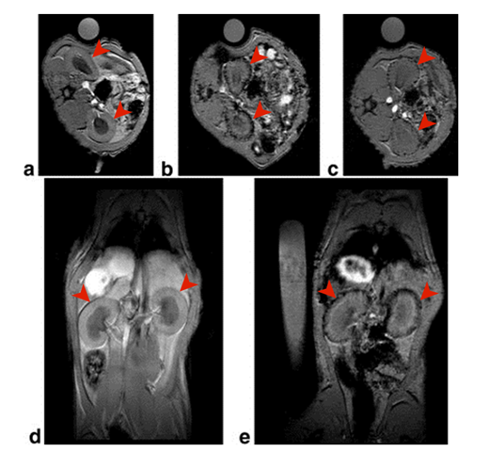
Figure 2 MR images showing accumulation of rat mesenchymal stem cells labelled with IONPs in the cortex (outer portion) of a rat’s kidneys (axial a-c, coronal d-e, kidneys are indicated with arrowheads). T2* weighted gradient echo images. Images were acquired 3 days before injection (a & d), 1-2 hours after injection (b & e) and 14 days after injection (c) with a loss of signal in the renal cortex after cell administration.5 Original image has been annotated to add arrowheads.
normally split into two categories: colloidal stability of the particles and the chemical stability of the iron oxide core. Use of IONPs for any cell labelling and tracking application requires a hydrophilic coating to make the particles stable in aqueous solutions. Stability in aqueous solution is necessary for sample storage and transfer into cell culture medium for labelling; if any sedimentation occurs, it would present negative implications for downstream applications. Colloidal stability in serum is not absolutely essential, although it is desirable if one wants to understand interactions of IONPs with stem cells based on surface properties rather than induced by gravitational forces (sedimentation). Once internalised inside stem cells, the chemical stability of the core of IONPs becomes relevant as they normally become localised within endosomes and lysosomes, where the slightly acidic pH (~4.5) can “erode” particles resulting in a loss of MRI signal. The particles must retain the necessary magnetic properties, altering the T2 relaxation time of the surrounding water protons, for the period of time that is required not only to assess the delivery of the cells but also the efficacy and safety of the therapy. This can range from several days to several months depending on the experimental conditions and model organism. It is important to note that MRI alone is not always efficient enough for tracking stem cells in vivo as, in some cases, the contrast agent might be transferred to the host cells after cell death, giving false positives.2 To work around this problem, many researchers are now adopting multi-modal imaging approaches, combining MRI with other imaging technologies.7
Chemical coatings that result in high cell labelling efficiency with no toxicological effect can be of great advantage to cellular imaging, as these allow greater control of the labelling process without the need of transfection agents that can add extra cost, have possible toxicological implications and require their own clinical approval. Polymers are often preferred to small molecules as coatings as they can provide both colloidal stability and sufficient protection of the iron oxide core at physiological pH. Through various synthetic procedures, the properties of the IONPs can be tailored to maximise all of the properties mentioned above. In this tutorial review, we will discuss the design, polymer selection and synthesis strategies that researchers are following with the intent of developing biocompatible polymer coatings for IONPs as MRI contrast agents for stem cell tracking.
2 Synthesis of Polymer Coated IONPs
The experimental conditions used for the synthesis of IONPs dictate the physical properties of the iron oxide core. The two main techniques for synthesis of IONPs are co precipitation and thermal decomposition. Other less frequently used methods include pyrolysis, hydrothermal reactions and sol-gel synthesis. The volume of literature is vast in terms of synthetic procedures for manufacturing iron oxide cores with the desired shape, size and magnetic properties. For use in biomedical applications, particles need to be stable in water and there are various routes that have been followed using polymers to achieve colloidal stability.
Co-precipitation is a simple technique for producing IONPs by controlled precipitation of iron oxides using stoichiometric amounts of aqueous Fe2+ and Fe3+ salts in the presence of stabilising agents by addition of an alkaline solution in a non-oxidizing environment (Equation 1), to form magnetite (Fe3O4). Magnetite can transform into maghemite (γ-Fe2O3) through various electron or ion transfers depending on the pH and oxygen content of the suspension used for co-precipitation (for example, Equation 2).8

Fe2+ + 2Fe3+ + 8OH- → Fe3O4 + 4H2O (1)

Fe3O4 + 2H+ → γ-Fe2O3 + Fe2+ + H2O (2)

An advantage of this technique is the facile synthesis and the large quantities of IONPs that can be produced. However, the IONPs obtained are normally of a polydisperse nature. A high degree of control over the particle size, magnetic properties, and colloidal stability can be achieved by altering precursor salt concentration, stabilising agent, reaction time and pH.4
Thermal decomposition offers the advantage of producing nanoparticles with a controllable narrow size distribution and crystallinity, which is achieved by altering the ratios of reagents used. The precursors undergo thermal decomposition in high boiling point organic solvents containing surfactants. Examples of iron complexes used for thermal decomposition are: iron oleate, Fe(CO)5 and Fe(acac)3. However to be used for stem cell labelling, the synthesised IONPs need to be transferred to water. In terms of the magnetic properties obtained, there is no overriding advantage for using either co-precipitation or thermal decomposition procedure. For stem cell labelling, many research groups prefer to use the co-precipitation procedure with a polymer stabiliser, which can render the particles hydrophilic, since this is a one step process that can produce significant quantities of IONPs. This procedure is also the most cost effective; if IONPs are to be used for clinical/commercial application, scale-up of reactions would be easier in a water based system, avoiding the use of high boiling point solvents and possible post-modification steps.
In general, IONPs containing Fe3O4 cores are most widely investigated due to their easier synthesis. It is thought that the breakdown of Fe3O4 to γ-Fe2O3 can cause toxicity issues in stem cells,9 which could explain why some researchers prefer to pre oxidise particles prior to labelling.10 Even though it is thought that γ-Fe2O3 is more chemically stable and could be less toxic to stem cells, comparisons between the two phases have not been studied in great detail. This could come from difficulties in synthesising stoichiometrically pure phases, as most synthesised IONPs normally consist of a mixture of phases.
In addition, even though Fe3O4 has slightly higher saturation magnetisation compared to γ-Fe2O3, it is unlikely to increase MRI contrast, for a recent study has shown that particles with very different magnetism generate similar relaxivities following uptake into stem cells.11 For increased contrast, it is more important to increase the mass of IONPs internalised.11
Hydrophilic polymer coatings give colloidal stability through electrostatic or steric repulsion. The nature of the coating will dictate the nanoparticle’s interaction with the cells during labelling as well as their fate once localised to the intracellular environment. A wide range of “biocompatible” polymers and polysaccharides have been investigated as IONP coatings.
The development of living radical polymerization techniques such as atom-transfer radical-polymerization (ATRP) and reversible addition-fragmentation chain-transfer polymerization (RAFT) has expanded the number of polymers that can be investigated, as well as the possible modes of attachment to the IONPs. These techniques also allow the synthesis of statistical and multi-block polymers with well-defined molecular weights and polydispersity through control of the rate of propagation.
Some of the most common polymer modes of attachment are shown in Figure 3, along with modes of assembling polymers around the iron oxide core. A number of potential modes of attachment or interaction are possible: (a) attachment through a polymer end group directly attached to the iron oxide; (b) the polymer is grafted or “clicked” on to pre-synthesised IONPs; (c) a diblock copolymer is used where one block consists of grafting group only and binds to the iron oxide surface; (d) a polymer contains grafting groups throughout and is wrapped around the iron oxide core; (e) electrostatic interactions between coatings with opposite charges, where either one or both of the electrostatic forces come from a polymer; (f) a micelle approach using an amphiphilic polymer containing hydrophilic and hydrophobic sections, multiple hydrophobic iron oxide cores are stabilised through hydrophobic interactions thus making them stable in water.
The most favoured route for stabilisation of IONPs is perhaps direct attachment to the Fe-OH group on the surface of the precipitating nanoparticles. A permanent covalent attachment to particles will be more likely to lead to long-term colloidal stability. Some of the most commonly used functional groups are shown in Figure 4, where a reactive group that has an affinity for Fe-OH is required.12 For example, small alkoxysilane molecules can coat IONPs via attachment to the surface of the IONPs with a silanol group forming a Fe-O-Si bond.3 It is commonly stated that the bond formed between siloxanes and IONPs is covalent, but this is still debated.13 Alkoysilanes are versatile as they can introduce various reactive groups to the IONP surface that can undergo coupling reactions for specific applications. Some of the functional groups that can be introduced are: amine, carboxylic acid, vinyl, and thiol.13, 14 Attachment of silica-based stabilisers can sometimes result in loss of colloidal stability in water. In some cases, the coatings can be rendered hydrophilic through a reaction with a polymer before or after covalent attachment to the iron oxide core. If this is carried out before grafting to the iron oxide, there is risk of self-condensation reaction of siloxanes, so polymer grafting is normally done after binding the alkoxysilane to the iron oxide. Transfer from the organic solvent to the aqueous phase would be required at some stage and this can be difficult to do effectively. Phosphonic acids have a high affinity for Fe-OH, forming Fe-O-P bonds and these have been shown to be more stable than the corresponding Fe-OH carboxylic acid bond.12 Phosphonic acid grafting groups have also been shown to lead to a higher grafting densities compared with carboxylic acid and glycerol containing polymers.15 COOH co-ordination is labile and can easily be removed by temperature or by ligand exchange with a group that has a higher affinity for Fe-OH, such as alkoxysilanes and phosphonic acid.12 Catechol containing reagents such as dopamine are known to have good affinity to IONPs, but can undergo redox transformations resulting in dissociation from the surface of IONPs and loss of colloidal stability. This has led to questions over the use of such chemicals in biological applications.12
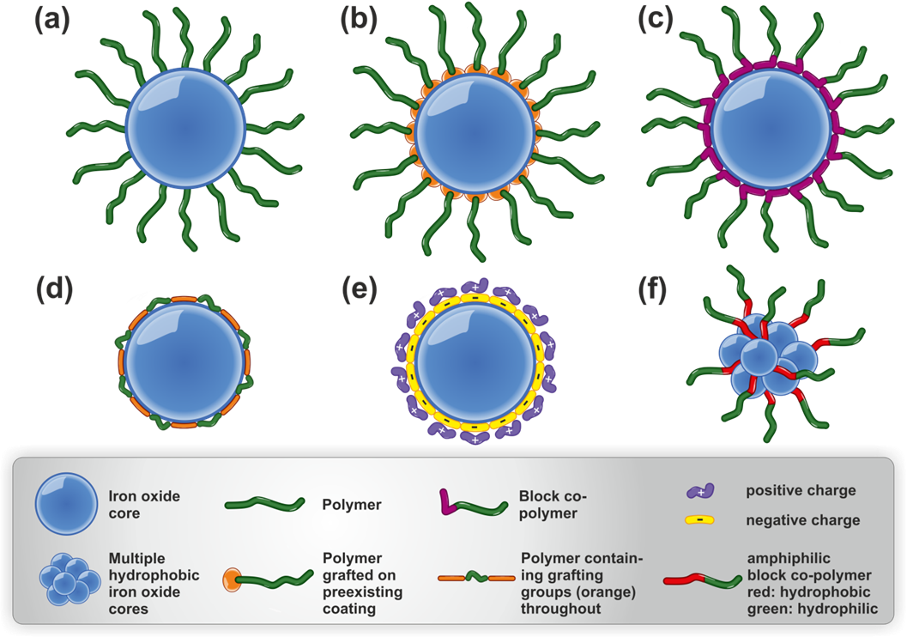
Figure 3 Various polymer-iron oxide stabilization methods (a) attachment comes from a functional group at the end of the polymer (b) the polymer is grafted from or clicked in to a pre-synthesised IONPs (c) a diblock copolymer with one block consisting of grafting groups (d) a polymer contains grafting groups throughout the whole polymer and adopts a wrapping conformation (e) electrostatic between coatings with opposite charges (f) an amphiphilic polymer is used to stabilise hydrophobic IONPs in water.
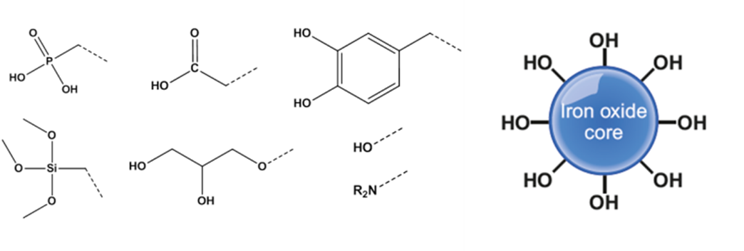
Figure 4 Functional groups that can react with the surface hydroxyl groups on a precipitated iron oxide nanoparticle: Phosphonic acid, carboxylic acid, catechol, hydroxyl, amine, glycerol and siloxanes.

Polysaccharides are attached to IONPs via bonding between OH groups contained throughout the polymer and the Fe-OH on the surface of IONPs. This can occur in situ whilst the IONPs are forming or in a post-modification step, with the polymer wrapping around the IONPs as shown in Figure 3d.

3 Labelling Stem Cells with IONPs
When labelling stem cells with polymer coated IONPs, there are various safety aspects that must be taken into account, as toxicity can arise from both the nature of the polymer coating and the iron oxide core, as well as the labelling conditions used.9, 16 Widespread use of IONPs in the clinic in the form of contrast agents, coupled with key studies that were conducted in the early 1980s suggesting that molecular iron was of very low toxicity, led to the general assumption that IONPs are biocompatible. However, the data presented in the literature is sometimes conflicting, with groups working on the development of IONPs often purporting the safety of their formulations, whereas a smaller, but increasing, number of independent studies report specific toxicities.17 The use of IONPs as a contrast agent for organ imaging differs from its use for stem cell labelling. The former involves the direct intravenous administration of a solution of IONPs, whilst the latter implicates the labelling of cells in vitro, which are then administered to the patient and/or animal model. This has a consequence in how toxicity is perceived and assessed. On the one hand, the mass of iron that is administered in each case is very distinct. The recommended dose of Resovist® and Endorem™ (the previously commercially available and approved IONPs) was 0.80 or 0.56 mg of iron per kg of bodyweight, respectively, with a typical 70 kg patient receiving an infusion of 39 to 56 mg of iron. Labelled stem cells, on the other hand, usually present intracellular iron concentrations in the range of 3 to 30 pg per cell. If bone marrow transplantation is taken as an example, where about 3x106 haematopoietic (CD34+) stem cells are injected per kg of bodyweight, the same patient would receive 2.1x108 cells or a total of 4.2 mg of iron if cells are loaded with 20 pg of IONPs each, which is approximately 10-fold less than an intravenously administered dose. Although the relative dose is smaller, reducing the chances of systemic toxicity, the target cells are different and require a careful assessment of the impact of IONP labelling on their function. Unlike the macrophages of the reticulo-endothelial system (RES, the target cells of Resovist® and Endorem™) stem cells are not professional phagocytes and might be more sensitive to the high intracellular concentrations of iron that are required for adequate contrast.
Stem cell tracking will usually be correlated with an assessment of therapeutic potential, so perturbations in cell health must be kept to a minimum to ensure that the cells can perform their expected functions, which might include migration to the site of injury, integration and differentiation at the target tissue as well as the production and release of small bio-active molecules such as cytokines, chemokines and other proteins that may aid tissue regeneration. In order to fully assess the safety of IONPs, the physicochemical properties of these nanomaterials must be thoroughly evaluated and specific measures of dose defined. Once these aspects have been determined and quantified, they can then be correlated with any effects on cell health.
3.1 Dose and its relation with physicochemical properties
The response of a cell when treated with a compound is usually expressed as a function of dose, usually in an effort to establish a dose-response relationship. When IONPs are taken into consideration, the expression of dose is a difficult issue as no agreement exists on the most appropriate approach, and most investigators utilise the so called gravimetric doses. 18 Here, the most common example is the use of mass per volume of culture medium (µgˑmL-1). What must be taken into account, however, is that this measure is not always the most relevant, particularly when cell labelling is considered. Dose can be expressed at various levels of specificity as shown in Figure 5 and the nominal media mass, surface area or number concentrations are all non-specific and better defined as exposure.19 This is because a cellular response will only take place when nanomaterials come into contact with the cells (delivered dose) or are subsequently internalised by them (cellular dose); a cellular response will not occur when the materials remain suspended in the medium over the course of the experiment. Depending on the physicochemical characteristics of the IONPs, these measures of dose can be very different, which is in contrast to soluble chemicals where it is assumed that the nominal media concentration is proportional to the cellular dose. As IONPs can only be used as contrast agents for cell tracking if they are internalised by cells, the cellular dose is most relevant for their evaluation. Thus, it is imperative to provide this information when performing a comparative assessment of different polymer shells for MRI tracking. A “stealthy” PEGylated IONP, for example, that is not readily internalised into stem cells might have a more favourable toxicity profile in relation to other shells when the exposure dose is considered. However, if such a stealthy shell prevents cellular uptake, the favourable lack of toxicity will come at the expense of (1) not being fit for the proposed applications and (2) the actual inexistence of a cellular dose that prevents a direct comparison with IONPs that are actually internalised by cells.
It is well known that IONP properties such as size, shape, surface charge and functional groups can impact uptake and thus, the cellular dose. Assessment of early toxicological studies was often hampered by the lack of data related to these properties but it is now widely accepted that any reports on the toxicological evaluation of nanoparticles must be accompanied with this information. For polymer-coated IONPs, further information such as the core size, crystalline structure and the magnetisation of the material are all properties that should be reported. It is important to note that particle size and zeta potential can be dramatically affected once IONPs are exposed to cell culture medium, which typically contains foetal calf serum. Proteins in the serum adsorb to the surface of the IONPs, affecting their size and charge. It is therefore important that the size and zeta potential of the IONPs are assessed following incubation in cell culture medium. The strength of the grafting bond plays an important role as competitive interactions between polymers and proteins, as well as incubation temperature, could result
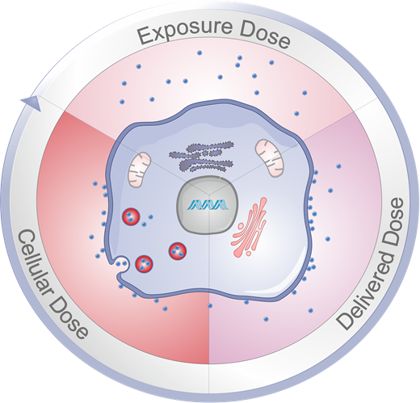
Figure 5 Different levels of specificity can be used when defining dose. Exposure dose is the nominal mass (or number) of IONPs in the culture medium. The delivered (or deposited) dose is the mass (or number) of particles that actually get in contact and interact with the cells. The most specific measure and the one of relevance for cell tracking is the cellular dose, which corresponds to the mass (or number) of particles that are taken up by the cells and that will be responsible for generating contrast in vivo.
in the polymer being detached from the IONP surface, which could have further implications on colloidal stability, toxicity and observed MRI signal over time. Cationic shells appear to generally facilitate delivery of IONPs to cells. The effect of particle size is less clear, with some studies suggesting an optimal size around 50 nm for uptake, although the notion of an “optimal” size has been challenged by some research groups.20 What should always be monitored, however, is the colloidal stability of the IONPs. Studies have shown that the use of transfection agents can affect particle size with the generation of particle aggregates.2 In such cases, gravitational settling might become a dominant force affecting the delivery dose, that is, the amount of IONPs that reach and interact with the cell membrane. This is in undesirable as it can lead to a substantial deposition of IONPs over the cells and the formation of extracellular aggregates that can be very difficult to wash away.

3.2 Labelling and Evaluation
Labelling of stem cells is usually achieved by simply co-culturing the cells of interest with IONPs. Different endocytic mechanisms have been suggested to be involved in IONP internalisation by cells, but there is no clear established relationship between physicochemical properties and specific mechanisms of uptake. Cationic polymer shells appear to facilitate IONP internalisation, which is thought to be related to electrostatic interactions with the negatively charged cell membrane surface thus promoting adsorptive endocytosis. Dextran based shells,2, 21 which are neutral, usually present low uptake and require modifications for efficient uptake. That usually involves small molecules such as transfection agents2 but can also be achieved by direct modification of the polymer shell by adding amine functionalities. We will discuss different polymer systems and levels of uptake that are achieved in stem cells in the following sections. For polymer shells that lead to poor cell internalisation, physical methods such as electroporation, microinjection and “magnetofection”, where IONP-cell contacts are manipulated using magnetic fields, have also been previously reported.2, 22 Avoiding the need to use such methods, however, is one the goals when designing new polymer shells and won’t be discussed in detail here.
When evaluating new IONPs for stem cell labelling, it is important to correlate the exposure dose with the cellular dose. (i.e. uptake). As it was previously mentioned, the cellular dose is the measure of most relevance when stem cell tracking in considered, and the one that should be considered when assessing different IONPs designs. A comparison of the toxicity profile and imaging properties of IONP-labelled cells is most accurately assessed when the cellular dose is used as a reference, as opposed to the commonly employed exposure dose.
The cellular dose of IONPs can be determined by harvesting the cells after the labelling period and then measuring the amount of iron in the sample either by bulk quantification methods, such as inductively coupled plasma atomic emission spectroscopy (ICP-OES) and colourimetric assays or by more refined methods such as cell tracking velocimetry (CTV), where the speed of IONP labelled cells under a magnetic field can be used to calculate the amount of internalised iron. As previously reviewed,2 most of these techniques can provide an accurate quantification of iron, although care must be taken to ensure the cellular dose is not overestimated by the carryover of extracellular (not internalised) aggregates, an issue which is of particular significance when using nanoparticles that are not colloidally stable. Cellular dose is commonly expressed in terms of the mean mass of iron per cell and is generally in the range of 3-30 pg[Fe]/cell. The cellular doses that can be achieved will not only depend on the labelling conditions (exposure dose and time) and the physicochemical characteristics of the IONPs in the relevant culture medium but also with the origin and function of the cells being evaluated and their respective endocytic capacity.
The uniformity of the cellular dose within population is another important parameter that requires assessment and that is usually reported as “labelling efficiency”. We have previously shown by CTV that even for homogenous cell lines, the cellular dose on a cell-to-cell basis can show great variability, even when all the cells in a population are labelled. Labelling efficiency can be qualitatively assessed by image analysis of Prussian blue stained cells, non-invasive imaging techniques such as photothermal microscopy,23 or if a fluorophore is present in the shell, via flow cytometry.11 Although one is likely to find small cell-to-cell variations in IONP content, it is important to ensure that that the labelling is sufficiently uniform within the population of interest. This is particularly important when working with heterogeneous cell populations, where the labelling efficiency between the two or more cell types present in the sample might be different.
If the labelling efficiency is adequate, the cellular dose can then be used has a reference when evaluating the detection limits via MRI, bearing in mind that relaxivity can undergo significant changes when IONPs are internalised in cells.11. Furthermore, in vitro studies focussing on possible effects on cell health can then be carried out to evaluate not only general markers of toxicity but also the specific functions of the target cell. Absence of cell death following labelling is an obvious requirement. However, this is not enough and the assessment of stem cell health should include investigations on proliferation and migration capacity, the preservation of specific surface markers, differentiation potential (“potency”) and functionality of the stem cell and its derivatives as well as whether the labelled cells can induce any immunogenic response. Cell morphology and cytoskeleton integrity can also provide further information on cell health.17, 24 Potency will be stem cell specific and functionality will be correlated to the functions expected from the stem cell or its derivatives. For example, for cells whose function are secretory, this will be defined as the release of hormone and growth factors, whereas in the case of mechanically active cells such as differentiated cardiomyocytes this will be expressed as electric and mechanical activity.25 Stem cells used for therapies in the brain should be evaluated with particular attention, as the central nervous system appears to be exceptionally susceptible to transition metals and oxidative stress17 and one should not only evaluate the health of the stem cells but also that of neighbouring cells such as microglia, which can become activated if exposed to IONPs. A range of assays to evaluate diverse aspects of cell health such as the cell’s metabolic activity, the presence of free radicals and the extent of cell death (if any) are commercially available. However, it is worth noting that sometimes IONPs can interfere with the readout of an assay (such as absorbance, luminescence of fluorescence) and proper controls must be used to avoid misinterpretation.24, 26

3.3 Potential Mechanisms of Toxicity

Once internalised, IONPs are usually trafficked to the lysosomes2, 11 where they stay in the long-term unless mechanisms such as starvation stress result in their release, via extracellular vesicles, in the cell culture medium.27 The presence of large numbers of nanoparticles intracellularly is thought to be a possible cause of cell toxicity. A cell labelled with 10 pg of IONPs with a core of 8 nm, for example, would contain over 10 million nanoparticles with a potentially highly reactive surface area. Additionally, it is well accepted that the acidic environment (pH ~ 4.5) of the lysosomes might result in at least partial dissolution of IONPs with time,6, 28 resulting in iron ions being leached from the particles. These two factors (surface area and leaching of iron ions) are thought to be the main mediators of intracellular toxicity through the generation of reactive oxygen species (ROS). The degradation of IONPs can be quantified using citrate containing buffers at pH 4.5. Although it does not exactly mimic a lysosomal environment, this can be a useful tool for comparing the stability of different iron oxide cores.2 For example, the use of small molecules such as citrate28 and 2,3-dimercaptosuccinic acid29 as coatings appear to lead to a lower stability when compared to the use of polymers. In the case of the former, Soenen et al. compared the acidic stability of the iron oxide core of Endorem™ and Resovist® (both dextran based coatings) with citrate coated very small organic particles (VSOPs) at various pH.28 At pH 4.5 they found that the release of ferric irons was much higher which led to a loss in MRI contrast, whereas Endorem™ still exhibited MRI contrast after 2 weeks. The lack of iron oxide stability of VSOPs was accompanied by a loss of viability and increase in ROS when labelling neural progenitor cells, which was not seen with the dextran based particles. The authors, however, stress that whilst coating does play a major role in the stability of the iron oxide core, this is not the only governing factor. Factors such as core size, core composition, hydrodynamic diameter and the overall available surface area are also likely to contribute to stability in a lysosomal environment.
Cells are constantly generating reactive oxygen species (ROS),30, 31 with mitochondria producing superoxide (•O2-) and hydrogen peroxide (H2O2) species.31 Iron, however, is involved in the generation of the extremely reactive hydroxyl radical (•OH) via Harber-Weiss type reactions (Eq. 3). This occurs via a reduction of ferric iron to ferrous iron (Eq. 4), followed by Fenton chemistry (Eq. 5).31 As such, the formation of these radicals can be catalysed at the surface of the IONPs, or via free iron ions released in the cell’s cytoplasm. Although hydroxyl radicals have a very short half-life (nanoseconds) and a short radius of action (<10 Å),30, 31 they can cause extreme damage to molecules in their vicinity.

• O2- + H2O2 →┬(Fe^(2+)/Fe^(3+) ) • OH + OH- + O2 (3)
Fe3+ + • O2- → Fe2+ + O2 (4)

Fe2+ + H2O2 → Fe3+ + • OH + OH- (5)

Mammalian cells have protective mechanisms against free radicals but it is the imbalance between pro-oxidant and antioxidant factors that can lead to potential damage. Increased production of ROS can result in the oxidation of protein, nucleic acids as well as lipids. Oxidised proteins tend to denature, making them more susceptible to proteolysis. The oxidation of DNA bases, on the other hand, can have more serious consequences. Although this sort of damage always exists at a basal level and repair systems are in place within the cell to remove such defects, if damage occurs at critical sites that cannot be quickly repaired, it can lead to genetic mutations that can play a role in carcinogenesis. In lipids, hydroxyl attack of the double bonds that exist in polyunsaturated fatty acids yields a new radical that can, in turn, abstract a second electron from another fatty acid leading to a chain reaction affecting lipid bilayers, membrane transport and ion channels.31 All these effects can interfere with signal transduction pathways directly or indirectly, promoting cell stress. The response to IONP degradation and related stress will be cell specific, and in some cases, the presence of free iron may even promote cell proliferation, as recently reported for human mesenchymal stem cells (hMSCs).32 In general, however, a small and transient elevation in ROS can be tolerated, but persistent higher levels will lead to cell damage.24 Some recent studies have shown that medium supplementation with iron chelating agents such as deferoxamine can reduce toxic effects in mesenchymal stem cells33 and that the use of antioxidants can reduce toxicity of IONPs to hepatocytes,34 thus indicating that the presence of iron ions and oxidative stress are two important triggers of toxicity.
4. Polymer Design or Selection for Stem Cell Labelling
A wide range of hydrophilic polymers have been investigated as coatings for IONPs but not all of them lead to internalisation into stem cells. The surface properties of IONPs and other nanoparticles are argued to be critical for the interactions they have with the surrounding physiological media and the path they follow in vitro and in vivo.35 For example, there has been a focus on the production of IONPs with polycationic and polyanionic shells as they can lead to considerable uptake into stem cells. A common theme is to compare novel materials against the two formerly clinically approved products, Endorem™ or Resovist®, in one particular stem cell line, although uptake values can be subject of large errors depending on the labelling procedure and quantification method used. As mentioned earlier, whilst the formerly clinically approved products have been used extensively to label stem cells, they were designed as liver-specific MRI contrast agents. For high levels of stem-cell uptake, these two products require the use of a transfection agent. A list of polymer coated IONPs for stem cell tracking will be discussed in the following sections. The structures of some of these polymers are shown in Scheme 1 along with tabulated results (Table 1) which gives information on their mode of assembly and reported uptakes into specific stem cell lines. In some cases, if the hydrophilic polymer shell does not lead to uptake, the particles will be functionalised with a chemical that alters the surface charge and/or alter the protein binding ability in cell culture medium.8 Some researchers also prefer to attach specific cell penetrating peptides to the polymer shell, but this can be expensive and uptake can be generated through other cost effective means, which we will discuss in the following sections.
4.1 Polysaccharides
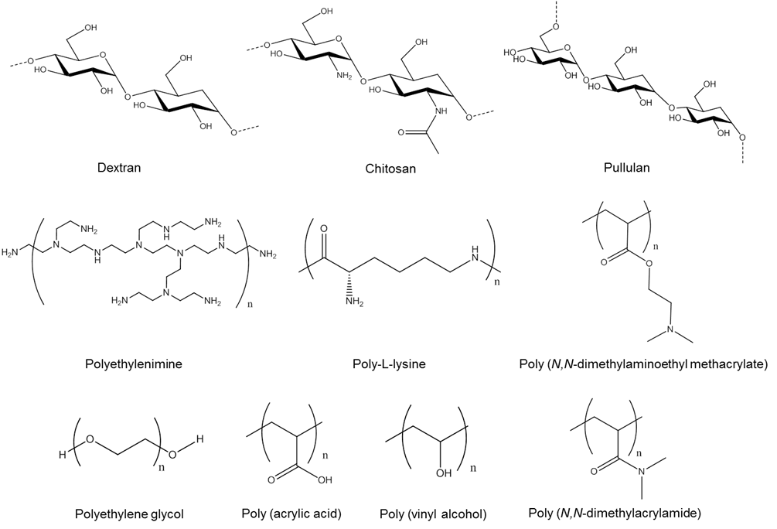

Scheme 1 Polymers commonly used as coatings for IONPs.

Polysaccharides derived from living systems are widely used as coatings for IONPs. They are generally highly water-soluble, biodegradable and inexpensive. Dextran is synthesised from sucrose by certain lactic acid bacteria and is one of the most commonly used polysaccharides; it is also FDA approved as a blood-thinning agent. In fact, the first co-precipitation of IONPs utilised dextran.36 Chitosan is another polysaccharide polymer used for coating IONPs. It consists of statistical amounts of β-(1-4)-linked D-glucosamine and N-acetyl D-glucosamine as a result of the deacetylation synthesis from chitin, found on the exoskeleton of crustaceans. Like dextran, chitosan is highly soluble and biocompatible. Due to the amine groups on the polymer, chitosan carries a slight positive charge at physiological pH. Reddy et al. demonstrated efficient labelling of hMSCs with commercially available Resovist® (carboxy dextran coated) and chitosan coated IONPs with the aid of the transfection agent poly L-lysine (PLL).37 The uptake of both sets of particles were very similar (around 18 pg [Fe]/cell) and neither affected viability, proliferation, surface marker expression and adipogenic and osteogenic differentiation potential. Whilst the chitosan particles did not affect the chondrogenic potential of hMSC, Resovist did, although it is not clear if this was due to the IONP coating or the iron oxide core.
Carboxymethyl functionalised chitosan (CMC) has been investigated as a coating without the use of a transfection agent.38 It was found that conjugation to a pre-formed (3 aminopropyl)trimethoxysilane (APTMS) was a more efficient method for sufficiently coating IONPs with polymer when compared to methods that did not include APTMS. This was achieved first by deacetylation of chitosan, followed by the introduction of a carboxymethyl groups which could be covalently bound to aminosilane coated IONPs using 1-ethyl-3-(3-dimethylaminopropyl) carbodiimide (EDC)-/sulfo N hydoxysuccinimide (NHS) coupling chemistry, a widely used technique for covalent linking of primary amine and carboxylic acid groups (Scheme 2). This led to twice the coverage of polymer using CMC and APTMS instead of CMC alone, which made the surface charge more negative (-14 mV vs – 21 mV) owing to the presence of more carboxymethyl groups in the IONP shell. The uptake of CMC-IONPS and CMC-APTMS IONPs into hMSC was compared and the CMC APTMS particles where shown to be internalized significantly more, which was confirmed by Prussian blue staining and ICP-MS, with the maximum uptake measured at 26.7 pg/cell using a labelling concentration of 50 µg/ml of iron and 24 hours incubation time. Such uptakes did not cause significant cytotoxicity, nor interfere with osteogenic and apipogenic differentiation of hMSCs.38 The limit of detection was suggested to be around 40 cells in an agarose phantom as MRIs of labelled hMSCs exhibited significant negative contrast.

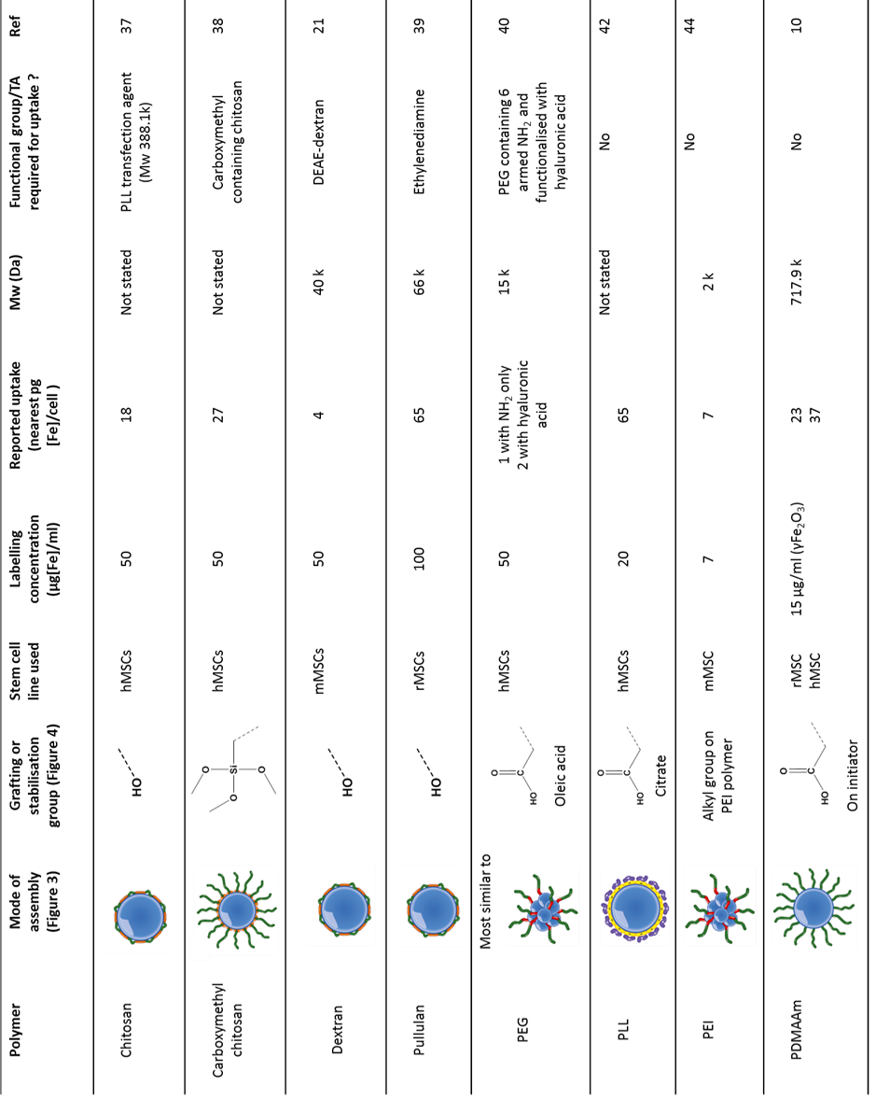

Table 1 Key information of strategies used for designing polymer coated IONPs for optimised stem cell uptake. (Transfection agent - TA, rat mesenchymal stem cells-rMSC, mouse mesenchymal stem cells mMSCs.)

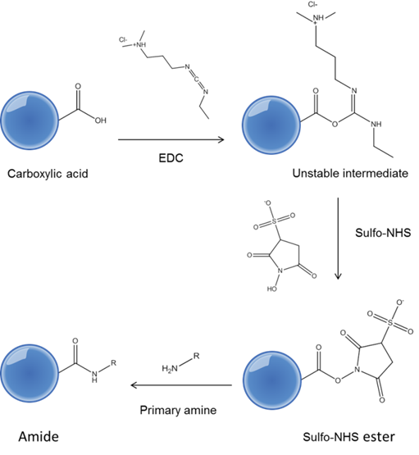

Scheme 2 Covalent conjugation of carboxylic acid functional particles with primary amines. An EDC intermediate is formed, before formation of a sulfo-NHS ester which reacts with a primary amine.
Our research group synthesised a series of dextran-based IONPs with surface charges ranging from -1.5 mV to +18.2 mV using commercially available 40 kDa dextran polymers in a co precipitation approach. We demonstrated that manipulating the surface charge by varying the amine containing DEAE-dextran within the polymer coating can give a degree of control over stem cell uptake. First, the library of particles was shown to be colloidally stable in cell culture medium for 14 days, which far exceeded the 24 hour labelling period. It was important to show that the differences in surface charge were responsible for increased uptake rather than sedimentation of particles. The most positively charged IONPs provided a 6 fold uptake in mouse MSCs (mMSCs) up to 3.8 pg [Fe]/cell with respect to neutral dextran coated particles (Figure 6a) and this trend in uptake was also observed in human and mouse kidney-derived stem cells. Interestingly, we also showed that magnetophoretic mobility of cells (Figure 6b) could be used as an accurate proxy for predicting the resultant MRI contrast of stem cells after labelling, as it is sensitive to both uptake and magnetisation of individual cells (Figure 6c & d).21
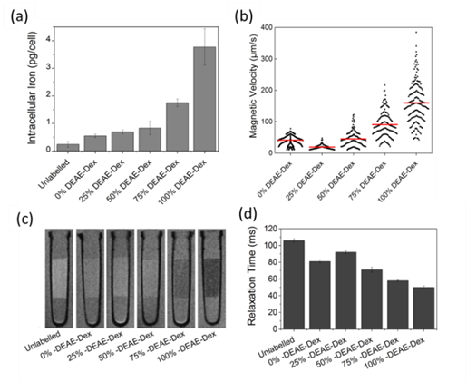
Figure 6 a) Intracellular iron content of cells labelled for 24 h with 50 µg/ml [Fe]. Error bars correspond to the SD from three independent measurements. b) The magnetic velocity of cells labelled for 24 h with 50 µg/ml [Fe]. Data was acquired from a minimum of 100 cells for each condition. Horizontal (red) bars indicate the mean magnetic velocity of the population. c) 7 T MR scan of 3x105 MSCs suspended in a 40 µl agarose phantom, after 24 hrs labelling with 50 µg/ml [Fe] of each SPION (images as obtained with a RARE sequence). d) Relaxation times of the region of interest containing the cells. Error bars represent the standard deviation. Figure reworked from reference with permission.21
Pullulan, containing maltotriose units, has been investigated as a coating for IONPs. One particular study focused on creating pullulan coated IONPs with different surface charges and sizes and evaluating the effect this could have on the uptake into bone marrow derived rat mesenchymal stem cells (rMSCs).39 To vary surface charge, pullulan was functionalised with ethylenediamine to give the polymer a positive charge, and succinic anhydride was introduced to give a negative charge to the polymer. The size of the IONPs was altered through manipulation of the polymer to iron salt ratios. This study evaluated internalization of IONPs with charges ranging from 10 to +12 mV and determined that uptake was lower as the surface charge became more negative; as the charge increases and becomes more positive, the uptake increased. Pullulan alone was not an effective coating for internalization of IONPs. Also, when particles in the range of 69 to 161 nm were compared, uptake was shown to be higher when the IONPs had lower hydrodynamic diameters, up to a maximum uptake of 65 pg [Fe]/cell. All of the uptakes were reflected in the observed shortening of T2 relaxation times of labeled rMSCs suspended in a gel phantom. Again, these labeling procedures were shown to not affect viability or the differentiation potential of the cells.39
Most polysaccharide polymers bind to IONPs through the OH functionality contained in each sugar unit on the polymer “wrapping” around the nanoparticle (Figure 3d & Figure 4). An important issue with these coatings is that heat treatment can cause the polymer to dissociate from the iron oxide. If the polymer is removed from the surface of IONPs, this could have implications on the long term colloidal stability as well as the resistance of the iron oxide core against the slightly acidic lysosomal compartment. Researchers have been able to work around this problem via crosslinking the polysaccharide chains through crosslinkers such as epichlorohydrin for dextran and glutaldehyde for chitosan.
4.2 Functionalisation of “stealthy” polymers
Polyethylene glycol (PEG) derivatives are commonly used as a coating for IONPs due to their hydrophilicity and biocompatibility. It is regarded as a “stealthy” coating due to low uptake of PEG coated materials into most cell types and long circulation time in the blood. However, PEG polymers can be functionalised with certain groups that can lead to stem cell uptake whilst maintaining biocompatibility.
An easy method for preparing PEG coated IONPs through organic to aqueous phase transfer has been reported.40 A library of PEG based polymers were screened for this purpose with functionalities such as OH, SH, COOH and NH2 with different molecular weights and structures. A six-armed PEG-NH2 (15 kDa) derivative was found to be the best polymer system for transferring oleic acid IONPs from chloroform to water, which could be measured by the amount of scattering observed in the resultant solutions by ultraviolet visible spectroscopy (Figure 7). The PEG-NH2 derivative led to uptakes of around 0.6 pg [Fe]/ cell in hMSCs, but this could be further improved by EDC/NHS coupling to hyaluronic acid, a biofunctional polymer, to obtain uptake of 1.5 pg [Fe]/cell. The conjugation of hyaluronic acid was confirmed by Fourier Transform Infrared spectroscopy and zeta potential measurements, as the surface charge went from + 12.8 mV (before conjugation) to – 9.1 mV (after conjugation). It is suggested that the presence of hyaluronic acid could increase the amount of cell surface glycoprotein CD-44 mediated endocytosis40 This strategy is therefore a targeted delivery method, unlike the previously discussed shells that rely on unspecific interactions with the cell’s surface for uptake. In such cases the strong affinity of the shell with cell surface receptors is likely to be of more relevance than specific properties of the IONP shell such as the zeta potential.
The usual strategy for binding PEG based polymers is through the use of functional grafting groups at the end of the polymer (Figure 3a). However, more grafting groups can be added to polymers through living radical polymerisation methods. For example, the versatility of RAFT was demonstrated by synthesising three PEG based block co-polymers with different grafting groups: phosphonic acid, carboxylic acid and glycerol (Figure 3c & Figure 4).15 The three polymers were used to synthesise SPIONs in a co-precipitation approach using various polymer to iron salt ratios whilst keeping the concentration of the iron salts the same for every reaction. This allowed for direct comparison of grafting groups and the effect they can have on the synthesised IONPs.
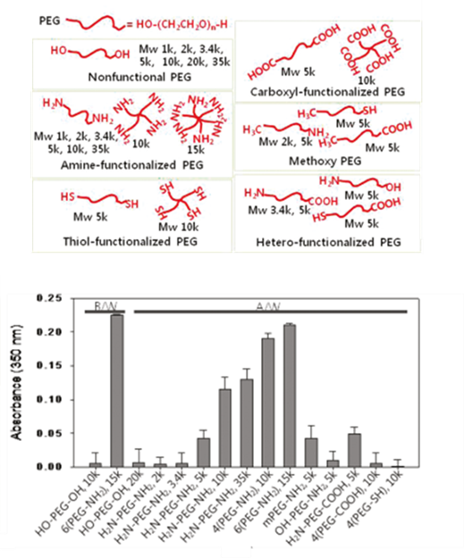
Figure 7 Structure of the functionalised PEG library used for phase transfer of oleic acid coated IONPs into aqueous conditions and a bar chart showing the absorbance of the aqueous phase after transfer of IONPs from chloroform to water. Figures reworked from ref with permission.40
Phosphonic acid groups were shown to have the highest grafting density followed by carboxylic acid and the glycerol derivative. For all of the functional groups, some control over the core size and relaxivity could be obtained through manipulation of the polymer to iron salt ratio used for IONP synthesis. In general, the core size and relaxivity could be increased through decreasing the amount of polymer in the IONP synthesis; however, this can also have a detrimental effect on colloidal stability (Figure 8). Through selection of the chain transfer agent used for the RAFT polymerisation, all polymers contained an alkyne group, which could potentially be used to attach or ‘click’ specific functional groups to the particles to increase uptake into stem cells.15
4.3 Other charged polymers
Polymers bearing a positive charge are widely used to deliver material into cells including IONPs.41 Generation of positive charges on polymer coated IONPs generally comes from polymers or molecules containing amine groups (primary, secondary or tertiary). When the polymers are in an aqueous environment and the pH of the solution is below the pKa of the amine functional group, the amine will become protonated giving it an overall positive charge. Polymers or molecules containing carboxylic acid groups can be used to generate a negative charge.

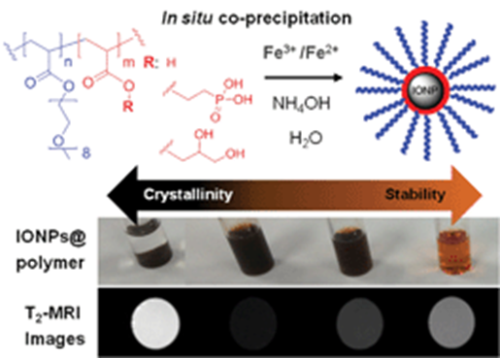
Figure 8 Images showing how core size, relaxivity and colloidal stability can be tuned through selection of grafting group and polymer to iron salt ratio used in co-precipitation reaction. Figure used from ref15
PLL has been used extensively both as a transfection agent for IONPs but also as a coating itself.37, 42, 43 PLL was investigated as a coating for γ-Fe2O3 IONPs at various molecular weights ranging from 146 Da (L-lysine) to PLL polymers up to 579 kDa and compared with Endorem™ using rMSCs and hMSCs.43 The PLL coating was incorporated into already synthesized citrate coated particles through electrostatic interactions (Figure 3e). The percentage of labelled rMSCs was highest when using PLL with a molecular weight of 388100 Da, and was considerably higher than that of Endorem in both rMSCs and hMSCs, although uptake values were not quoted. This was indeed verified when 1000 rMSC cells labelled with PLL and Endorem™ were implanted into the left and right hemisphere of a rat brain respectively (Figure 9). A clear difference in negative contrast can be observed, with PLL labelled cells showing more darkening than Endorem™ labelled cells due to the greater internalisation of IONPs. In addition, the viability of PLL coated particles was shown to be much higher than that of Endorem™.43
Whilst in this study an excess of PLL was left after conjugation with the IONPs, Ju et al. demonstrated that extra washing procedures can be used to wash away any “free” PLL not associated with IONPs, thus lowering the overall PLL to iron oxide ratio, whilst maintaining “safe” uptake into human umbilical MSCs of up to 65 pg [Fe]/ cell.42
Other polycations that have been used as coatings include polyethylenimine (PEI) and poly(N,N-dimethylacrylamide) (PDMAAm). PEI is a polymer containing primary amines that has been shown to have transfection efficiency at a molecular weight of 25 kDa. Like other transfection agents, PEI can also induce cell death and inhibition of cell differentiation. Using relatively low molecular weight PEI (2 kDa) has been shown to improve biocompatibility. The low molecular weight PEI was reacted with a hydrophobic alkyl chain, which allowed for stabilisation of clusters of pre-formed hydrophobic IONPs in water. This represents the micellar structure shown in Figure 3f owing to the amphiphilic nature of the polymers used to

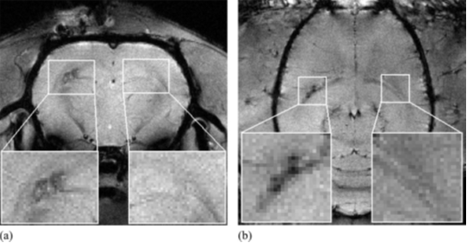
Figure 9 A) Axial and b) coronal MR images of a rat brain with 1000 cells implanted into the left hemisphere labelled with PLL-coated IONPs and 1000 cells implanted into the right hemisphere labelled with Endorem™. Taken from ref with permission.43
stabilise hydrophobic IONPs in water. After successful labelling of mMSCs, the IONPs could be detected in vivo for at least 19 days after transplantation using a clinical 3T MRI scanner with
uptakes of 7 pg [Fe]/cell at highest dose and incubation time (7 µg/ml Fe for 24 hours).44 The hybrid polymer coated IONPs also had no cytotoxic properties.44
PDMAAm coated γ-Fe2O3 IONPs were prepared by co-precipitation of iron salts to form magnetite and oxidised using sodium hyperchlorite to produce “bare” maghemite particles. The particles were then coated with PDMAAm by polymerising (N,N-dimethylacrylamide) in the presence of bare maghemite particles using free radical polymerisation. The particles were compared to Endorem™ with uptakes far greater, up to 36.9 ± 0.5 pg [Fe]/cell in hMSC and 23.2 ± 2.9 pg [Fe]/cell in rMSC, with no change in viability for either.10
Poly(N,N-dimethylaminoethyl methacrylate) has been conjugated to IONPs via ATRP using a “grafting from” approach (Figure 3b). The ATRP initiator was first used to stabilise IONPs using a solvothermal synthesis method. Hydrophilic SPIONs could then be produced by grafting the polymer from the surface of the pre-synthesised IONPs. The molecular weight could be controlled through the ATRP methodology to maximise both gene expression of cells and lower cytotoxicity. The cationic nature of these particles (zeta potential +50 mV before complexation) was used as magneto-transfection agents for DNA. Even without an external magnetic field, the IONPs still exhibited considerable uptake in human embryonic kidney cells HEK 293T cells after just a 10-30 minute incubation periods (up to 3 pg/cell). They also exhibited a surface charge of around + 50 mV before complexation with DNA, which could further increase uptake into stem cells.45
4.4 Protein corona studies of polymer coated IONPs
It has been clearly been demonstrated that charge can affect the internalization of IONPs into various stem cell lines. However, it is still not precisely clear if it is the polymer coating leads directly to uptake, or if it is the polymer and charge specific proteins that are incorporated in the protein corona in cell culture medium during labelling. Most studies suggest that it is the protein corona formed around IONPs that cells “recognise” during labelling. In an effort to understand more about how the coating type affects the fate of IONPs in living systems, there are now more studies emerging focusing on the quantitative analysis of the protein corona that forms around IONPs in cell culture medium.
For labelling of stem cells, IONPs are required to be transferred into culture medium, which will contain salts and proteins that are necessary for their growth and the maintenance of their stem-like phenotype. It is well known that a “protein corona” forms that is specific to the nature and charge of the polymer coating. While there are more studies emerging focussing on the composition of the protein corona formed for particular systems, the role of the corona in stem cell uptake and resistance to physiological pH in an intra/extracellular is not clearly understood. The previously mentioned citrate assay method, which is used to measure the stability of IONPs in physiological pH does not take the formation of a protein corona into account.
Parak’s group has commented on the importance of characterizing nanoparticles in the correct media along with the need for more quantitative data regarding the protein corona formed around IONPs. In their opinion, the three most important technical challenges are 1) insufficient quality of IONPs, in terms of size distribution and agglomeration 2) lack of precise data of nanoparticle concentrations and 3) purification of nanoparticles once the protein corona is formed.35 They also stress with the third point the difficulty of separating nanoparticles plus protein corona from media, as some of the weakly bound proteins in the protein corona may dissociate during the purification process.
Hofmann’s group46-49 have produced a series of research papers based on PVA, PEI and dextran coated IONPs with different surface charges and compared the adsorption of proteins on to the surface in cell serum. These studies highlighted the difficulty of predicting the structure of the protein corona, but they have also demonstrated that the type and surface charge of polymer coated IONPs play a dominant role in protein adsorption. This could affect both colloidal stability and toxicity. The reason why there seems to be no observed correlation between the net charge of adsorbed proteins and the surface properties of the IONPs is likely due to the complexity of protein structure. For instance, conformation, charge distribution and also the hydrophilicity/hydrophobicity of the adsorbed proteins could all affect the zeta potential measurement.
The role of surface charge of IONPs was again investigated with respect to protein adsorption and cell uptake by comparing poly(acrylic acid) coated IONPs (negatively charged) with PEI coated IONPs (positively charged).50 To accurately determine the effect of surface charge on the size of the protein corona formed, both sets of particles were designed to have a hydrodynamic diameter of 30 nm. Once exposed to cell culture medium, the hydrodynamic diameter was found to increase significantly, up to 100 times for PEI-coated and around 30 times for polyacrylic acid-coated IONPs. Maximum uptake of PEI coated IONPs was nearly double that of the PAA coated IONPs.50 This raises the question of whether cell uptake is dependent on hydrodynamic diameter in cell culture medium, as both sets of particles carried a negative charge between -10 and -20 mV.
The protein corona formed around some polymer coated IONPs are now better understood in vitro, but it is still not clear if this reflects the protein corona that forms in vivo. Sakulkhu et al. showed that the composition of the “hard” protein corona (the proteins tightly adsorbed on the IONP surface) can be quite different in vitro and in vivo for positive, negative and neutral PVA coated IONPs.47 Whilst this study did not involve stem cell labelling, it highlights an important point that the protein corona may differ/change in the transition from in vitro to in vivo and this may affect the fate of IONPs, depending on the polymer coating.
5 Conclusions and Perspectives
In this tutorial review, we have covered aspects related to the design and in vitro evaluation of novel polymer coated IONPs. We hope that the recommendations described in this article provide the essential information required to translate novel materials to pre-clinical assessment, particularly when evaluating the therapeutic potential of stem cells with the use of IONPs as a means to image them in vivo. Clinical translation, however, involves a good understanding of the regulatory pathways that although not covered here, can be assessed in a recent review of the subject.51
The use of polymers as coatings for IONPs is well established and there is now a wealth of literature demonstrating how changing the nature and charge of the polymeric shell can dictate the fate of IONPs in vitro and in vivo. The mass of IONPs internalised seems to be the most important parameter for determining the observed MRI contrast of labelled stem cells as IONPs with different sizes, mode of assembly and solution relaxivity have already been shown to have very similar relaxivity once internalised into stem cells.11 There is now a lot of evidence that cationic polymer coatings are the most effective for uptake of IONPs into stem cells and tailoring surface charge can give a degree of control over uptake. Hydrophilic polymers have shown to increase colloidal stability of IONPs, but the role that the polymer shell can play in the integrity of the iron oxide core and resultant toxicity needs to be explored further and provides significant synthetic challenges. Ideally, one should start with IONPs with very similar core size, core phase and hydrodynamic diameter. This could allow comparisons for example, between molecular weight and degree of crosslinking. New emerging polymerisation technologies are increasing the amount of polymers that can be used as IONP coatings as well as the different modes of attachment to IONPs. This review is aimed at highlighting key considerations that must be made when “designing” polymer coated IONPs and these are listed in Figure 10.
It is worth remembering that each type of polymer coated IONP has unique physicochemical properties that are further changed under labelling conditions. Each cell type is also unique, and might respond in different ways to the IONP labelling.
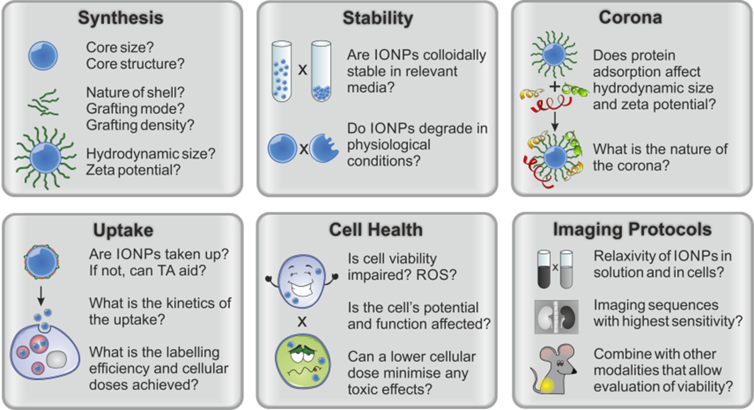

Figure 10 Key considerations and things that should be reported when designing polymer coated IONPs for stem cell tracking.

It is clear that a greater understanding of the physical properties of IONPs in culture medium is needed, along with the cell labelling process itself to achieve the highest mass of IONP uptake without compromising stem cell health and function. As we have discussed here, the protein corona that forms during labelling is influenced by both the charge and coating of the IONP. However, although more studies are emerging to quantify these proteins in detail, the overall role of the protein corona in the fate of IONPs in biological systems e.g. uptake, colloidal stability and toxicity is still not well understood and remains to be determined.
In terms of MRI, it is important to remember there is also the problem upon implantation of knowing whether one is imaging implanted stem cells or host tissue, as there is evidence suggesting that upon cell death contrast agents can be transferred to host cells generating false positives. It is likely that true stem cell tracking through MRI alone is not enough, and MRI combined with another imaging modality such as bioluminescence is required to allow cell viability to be correlated with the anatomical localisation of iron-oxide labelled stem cells as observed via MRI.2, 7,52
Acknowledgements
We thank the UK Regenerative Medicine Platform (UKRMP) funding (MR/K026739/1). We thank Anne Herrmann for help with some figures.

References
1. S. M. Cromer Berman, P. Walczak and J. W. M. Bulte, Wiley Interdisciplinary Reviews: Nanomedicine and Nanobiotechnology, 2011, 3, 343-355.
2. A. Taylor, K. M. Wilson, P. Murray, D. G. Fernig and R. Levy, Chemical Society Reviews, 2012, 41, 2707-2717.
3. S. Laurent, D. Forge, M. Port, A. Roch, C. Robic, L. Vander Elst and R. N. Muller, Chemical Reviews, 2008, 108, 2064-2110.
4. L. Li, W. Jiang, K. Luo, H. Song, F. Lan, Y. Wu and Z. Gu, Theranostics, 2013, 3(8), 595-615.
5. H. Ittrich, C. Lange, F. Tögel, A. R. Zander, H. Dahnke, C. Westenfelder, G. Adam and C. Nolte-Ernsting, Journal of Magnetic Resonance Imaging, 2007, 25, 1179-1191.
6. A. L. Cortajarena, D. Ortega, S. M. Ocampo, A. Gonzalez-García, P. Couleaud, R. Miranda, C. Belda-Iniesta and A. Ayuso-Sacido, Nanobiomedicine, 2014, 1, 1-20.
7. A. Tennstaedt, M. Aswendt, J. Adamczak and M. Hoehn, in Imaging and Tracking Stem Cells, ed. K. Turksen, Humana Press, 2013, pp. 153-166.
8. K. G. Neoh and E. T. Kang, Soft Matter, 2012, 8, 2057-2069.
9. N. Singh, G. J. S. Jenkins, R. Asadi and S. H. Doak, Nano Reviews, 2010, 1, 5358.
10. M. Babič, D. Horák, P. Jendelová, K. Glogarová, V. Herynek, M. Trchová, K. Likavčanová, P. Lesný, E. Pollert, M. Hájek and E. Syková, Bioconjugate Chemistry, 2009, 20, 283-294.
11. A. Taylor, A. Herrmann, D. Moss, V. Sée, K. Davies, S. R. Williams and P. Murray, PLoS ONE, 2014, 9, e100259.
12. C. Boyer, M. R. Whittaker, V. Bulmus, J. Liu and T. P. Davis, NPG Asia Mater, 2010, 2, 23-30.
13. M. Bloemen, W. Brullot, T. Luong, N. Geukens, A. Gils and T. Verbiest, Journal of Nanoparticle Research, 2012, 14, 1-10.
14. O. Veiseh, J. W. Gunn and M. Zhang, Advanced Drug Delivery Reviews, 2010, 62, 284-304.
15. J. S. Basuki, A. Jacquemin, L. Esser, Y. Li, C. Boyer and T. P. Davis, Polymer Chemistry, 2014, 5, 2611-2620.
16. S. J. Soenen, W. J. Parak, J. Rejman and B. Manshian, Chemical Reviews, 2015, 115, 2109-2135.
17. T. R. Pisanic, S. Jin and V. I. Shubayev, in Nanotoxicity, John Wiley & Sons, Ltd, 2009, pp. 397-425.
18. D. Lison, G. Vietti and S. van den Brule, Particle and Fibre Toxicology, 2014, 11, 35.
19. J. Teeguarden, P. Hinderliter, G. Orr, B. Thrall and J. Pounds, Toxicol Sci, 2007, 95, 300 - 312.
20. K. Kettler, K. Veltman, D. van de Meent, A. van Wezel and A. J. Hendriks, Environmental Toxicology and Chemistry, 2014, 33, 481-492.
21. M. Barrow, A. Taylor, D. J. Nieves, L. K. Bogart, P. Mandal, C. M. Collins, L. R. Moore, J. J. Chalmers, R. Levy, S. R. Williams, P. Murray, M. J. Rosseinsky and D. J. Adams, Biomaterials Science, 2015, 3, 608-616.
22. M. Pickard and D. Chari, Nanomedicine, 2010, 5, 217-232.
23. L. K. Bogart, A. Taylor, Y. Cesbron, P. Murray and R. Lévy, ACS Nano, 2012, 6, 5961-5971.
24. S. J. Soenen, P. Rivera-Gil, J.-M. Montenegro, W. J. Parak, S. C. De Smedt and K. Braeckmans, Nano Today, 2011, 6, 446-465.
25. A. V. Naumova, M. Modo, A. Moore, C. E. Murry and J. A. Frank, Nat Biotech, 2014, 32, 804-818.
26. S. M. Griffiths, N. Singh, G. J. S. Jenkins, P. M. Williams, A. W. Orbaek, A. R. Barron, C. J. Wright and S. H. Doak, Analytical Chemistry, 2011, 83, 3778-3785.
27. A. A. Silva, C. Wilhelm, J. Kolosnjaj-Tabi, N. Luciani and F. Gazeau, Pharmaceutical Research, 2012, 29, 1392-1403.
28. S. J. H. Soenen, U. Himmelreich, N. Nuytten, T. R. Pisanic, A. Ferrari and M. De Cuyper, Small, 2010, 6, 2136-2145.
29. Y. Liu and J. Wang, Toxicological Sciences, 2013, 131, 521-536.
30. V. V. Roshchina, Roshchina, V. D. , Ozone and Plant Cell. Kluwer Academic Publishers, 2003, 73-84.
31. J. P. Kehrer, The Haber-Weiss retain and mechanism of Toxicity. Toxicology, 2000.
32. D.-M. Huang, J.-K. Hsiao, Y.-C. Chen, L.-Y. Chien, M. Yao, Y.-K. Chen, B.-S. Ko, S.-C. Hsu, L.-A. Tai, H.-Y. Cheng, S.-W. Wang, C.-S. Yang and Y.-C. Chen, Biomaterials, 2009, 30, 3645-3651.
33. Y.-C. Chen, J.-K. Hsiao, H.-M. Liu, I. Y. Lai, M. Yao, S.-C. Hsu, B.-S. Ko, Y.-C. Chen, C.-S. Yang and D.-M. Huang, Toxicology and Applied Pharmacology, 2010, 245, 272-279.
34. A. Sarkar and P. C. Sil, Food and Chemical Toxicology, 2014, 71, 106-115.
35. P. d. Pino, B. Pelaz, Q. Zhang, P. Maffre, G. U. Nienhaus and W. J. Parak, Materials Horizons, 2014, 1, 301-313.
36. R. S. Molday and D. Mackenzie, Journal of Immunological Methods, 1982, 52, 353-367.
37. A. M. Reddy, B. K. Kwak, H. J. Shim, C. Ahn, H. S. Lee, Y. J. Suh and E. S. Park, J Korean Med Sci, 2010, 25, 211-219.
38. Z. Shi, K. G. Neoh, E. T. Kang, B. Shuter, S.-C. Wang, C. Poh and W. Wang, ACS Applied Materials & Interfaces, 2008, 1, 328-335.
39. J.-i. Jo, I. Aoki and Y. Tabata, Journal of Controlled Release, 2010, 142, 465-473.
40. H. J. Chung, H. Lee, K. H. Bae, Y. Lee, J. Park, S.-W. Cho, J. Y. Hwang, H. Park, R. Langer, D. Anderson and T. G. Park, ACS Nano, 2011, 5, 4329-4336.
41. S. K. Samal, M. Dash, S. Van Vlierberghe, D. L. Kaplan, E. Chiellini, C. van Blitterswijk, L. Moroni and P. Dubruel, Chemical Society Reviews, 2012, 41, 7147-7194.
42. S. Ju, G. Teng, Y. Zhang, M. Ma, F. Chen and Y. Ni, Magnetic Resonance Imaging, 2006, 24, 611-617.
43. M. Babič, D. Horák, M. Trchová, P. Jendelová, K. Glogarová, P. Lesný, V. Herynek, M. Hájek and E. Syková, Bioconjugate Chemistry, 2008, 19, 740-750.
44. G. Liu, Z. Wang, J. Lu, C. Xia, F. Gao, Q. Gong, B. Song, X. Zhao, X. Shuai, X. Chen, H. Ai and Z. Gu, Biomaterials, 2011, 32, 528-537.
45. S.-J. Huang, J.-H. Ke, G.-J. Chen and L.-F. Wang, Journal of Materials Chemistry B, 2013, 1, 5916-5924.
46. A. Petri-Fink, B. Steitz, A. Finka, J. Salaklang and H. Hofmann, European Journal of Pharmaceutics and Biopharmaceutics, 2008, 68, 129-137.
47. U. Sakulkhu, M. Mahmoudi, L. Maurizi, G. Coullerez, M. Hofmann-Amtenbrink, M. Vries, M. Motazacker, F. Rezaee and H. Hofmann, Biomaterials Science, 2015, 3, 265-278.
48. U. Sakulkhu, M. Mahmoudi, L. Maurizi, J. Salaklang and H. Hofmann, Sci. Rep., 2014, 4.
49. U. Sakulkhu, L. Maurizi, M. Mahmoudi, M. Motazacker, M. Vries, A. Gramoun, M.-G. Ollivier Beuzelin, J.-P. Vallee, F. Rezaee and H. Hofmann, Nanoscale, 2014, 6, 11439-11450.
50. M. P. Calatayud, B. Sanz, V. Raffa, C. Riggio, M. R. Ibarra and G. F. Goya, Biomaterials, 2014, 35, 6389-6399.
51. M. Modo, J. Kolosnjaj-Tabi, F. Nicholls, W. Ling, C. Wilhelm, O. Debarge, F. Gazeau and O. Clement, Contrast Media & Molecular Imaging, 2013, 8, 439-455.
52. E. Bull, S. Y. Madani, R. Sheth, A. Seifalian, M. Green and A. M. Seifalian, J Nanomedicine Int, 2014, 9, 1641-1653.

