First experience of effectiveness and safety of bedaquiline for 18 months within an optimised regimen for extensively drug resistant tuberculosis

Joseph M. Lewis ^{1,2}, Paul Hine¹, Jenny Walker³, Saye H. Khoo⁴, Miriam Taegtmeyer⁵, S Bertel Squire⁵, Derek J. Sloan^{5,6}

¹ Tropical and Infectious Diseases Unit, Royal Liverpool University Hospital, Liverpool
² Wellcome Trust Liverpool Glasgow Centre for Global Health Research, University of Liverpool, Liverpool, UK
³ Liverpool Community Health TB Services, Liverpool, UK
⁴ Department of Pharmacology and Therapeutics, University of Liverpool, Liverpool, UK
⁵ Liverpool School of Tropical Medicine, Liverpool, UK
⁶ Liverpool Heart and Chest Hospital, Liverpool, UK

Corresponding Author:
Joseph M. Lewis
Tropical and Infectious Diseases Unit
Royal Liverpool University Hospital
Liverpool
L7 8XP
UK

Email: joseph.lewis@liverpool.ac.uk

Tel: +44 151 706 3835

Word count: 1185 (limit 1200)

References: 15

Key words: tuberculosis, drug resistance, MDR-TB, XDR-TB, bedaquiline

120 Character summary: We describe the first successful use of bedaquiline for 18 months for XDR-TB as part of an optimised background regimen.

First experience of effectiveness and safety of bedaquiline for 18 months within an optimised regimen for extensively drug resistant tuberculosis

Extensively drug-resistant tuberculosis (XDR-TB) is a type of multidrug-resistant (MDR) TB that is resistant to isoniazid, rifampicin, fluoroquinolones and at least one injectable second-line drug. There are insufficient antibiotics for effective combination therapy and mortality exceeds 70%¹. Following successful phase IIb trials², in 2013, the novel mycobacterial ATP-synthase inhibitor, bedaquiline was approved in Europe and the United States for the first 24 weeks of M(X)DR-TB treatment alongside a World Health Organisation (WHO)-approved optimised background regimen (OBR). Phase III trials are ongoing, but cohort data describe good early bacteriological outcomes in France^{3,4}, Italy⁵, the UK⁶, the US⁷, India⁸ and South Africa⁹

However, WHO guidelines presently advocate an M(X)DR-TB total treatment duration of ≥18 months. In the presence of extensive resistance, antibiotic regimens may be sparse when bedaquiline is stopped. The US Centre for Disease Control and Prevention (CDC) recommends continuing bedaquiline beyond 24 weeks if effective treatment “cannot otherwise be provided”, whilst acknowledging the lack of supporting tolerability data¹⁰. Although no fatalities in pre-licensing studies were attributed to the study drug, there were more deaths on bedaquiline than placebo [10 vs 2]². Bedaquiline’s plasma half-life is 4-5 months and QTc prolongation occurs, raising concerns about incremental toxicity and highlighting the need for expedient reporting of clinical experience. Here we describe the first published case of safe bedaquiline treatment extension to 18 months in a patient with pulmonary XDR-TB.

In January 2014, a 20 year old HIV-negative Romanian woman was referred to our unit with a first presentation of smear-positive pulmonary TB. Computed tomography (CT) scans showed multi-focal disease of both lungs. She had no co-morbidities and was initiated on first-line antituberculous chemotherapy (rifampicin-isoniazid-pyrazinamide-ethambutol) but after 2 days the Genotype MDRTBplus 2.0 assay (Hain Diagnostics), performed on the patient’s sputum sample, revealed RpoB and KatG mutations consistent with rifampicin and isoniazid resistance. Therefore she was switched to a WHO-approved MDR-TB regimen (see figure 1). During February, full phenotypic drug susceptibility testing and whole genome sequencing revealed extensive resistance to all first line drugs, all quinolones, all injectables, and prothionamide. Susceptibilities to linezolid, para-aminosalicylic acid (PAS) and azithromycin were confirmed. Phenotypic sensitivity testing to meropenam/imipenem and clofazamine were unavailable, but whole-genome sequencing was performed and identified katG mutations conferring high-level isoniazid resistance, precluding the use of high-dose isoniazid. At week 8 of treatment she was established on a six-drug regimen of bedaquiline, linezolid, pyrazinamide, cycloserine, azithromycin and PAS. Bedaquiline was obtained through a compassionate use programme and introduced at 400mg once daily for 2 weeks, followed by 200mg three times weekly. Figure 1 illustrates progression of her regimen as resistance information became available and throughout the remainder of therapy. Her sputum converted to smear and culture negative 24 days after initiation of the bedaquiline based regimen, and 81 days after starting first-line treatment.

She successfully completed her initial supply of bedaquiline. Between week 32 and 34, she developed painful peripheral neuropathy, confirmed on nerve conduction studies, which prompted discontinuation of linezolid and cycloserine. After discussion with the British Thoracic Society MDR-TB advisory panel and international experts, her remaining regimen was deemed inadequate and her bilateral pulmonary disease excluded surgical management. Therefore clofazamine was introduced at week 32 and bedaquiline was restarted, at a dose of 200mg thrice weekly, at week 38.

Electrocardiograms (ECGs) were reviewed by a consultant cardiologist regularly during bedaquiline administration. Figure 1 shows changes to the QTc interval over time. Initially, whilst the patient was admitted to hospital, ECGs were performed weekly, then less frequently (weekly, bi-weekly or monthly as directed by the cardiologist) once she was discharged; however, there were occasional periods where, due to financial or transportation problems, the patient failed to attend for ECG appointment, which is reflected in occasional periods of several weeks between ECGs in figure 1. From a pre-treatment baseline of 411ms, the QTc increased to 465ms at week 10, before settling to a median of 425ms between week 12 and 40. There was a steep rise in QTc after week 40 (during bedaquiline, clofazimine and azithromycin co-administration). Azithromycin was stopped at week 62, QTc peaked at 495ms in week 68 and the median QTc from week 40 until end of therapy was 472ms. Serum potassium, magnesium and corrected calcium concentrations were always within normal limits and care was taken to avoid QTc prolonging agents other than those required for TB therapy. T-wave inversion in the ECG anterior leads was also noted, though cardiac troponins were normal and the patient reported no cardiac symptoms. No cardiac arrhythmias or other adverse clinical events were reported.

Bedaquiline treatment was continued for a total of 72 weeks (18 months). With no recurrence of sputum smear or culture positivity, gradual weight gain and resolution of active inflammatory changes on serial CT scans the patient is now regarded as cured. Post-treatment follow-up will continue to ensure there is no relapse.

This case describes that bedaquiline administration may be safely extended beyond 6 months, which is an important consideration when balancing the terrible prognosis of XDR-TB against the uncertain efficacy and safety of new antibiotics. The recognised global burden of drug resistant TB increased from 250,000 incident cases in 2009 to 480,000 cases in 2014¹¹. In Eastern Europe, over 20% of new TB patients present with MDR or XDR disease¹¹ and our patient demonstrates the increasingly frequent therapeutic challenges posed by this problem.

Antibiotic options in XDR-TB are always limited to drugs of uncertain efficacy. Of the available agents, bedaquiline’s impressive bactericidal activity in Phase II clinical studies² offers considerable promise. However, current experience and licencing of bedaquiline is limited to administration for 24 weeks of a total 18-24 months treatment duration^{12,13}. This will inevitably generate case management dilemmas when XDR-TB patients are left with sparse regimens for most of their therapy. To minimise the risk of eventual failure or relapse, it seems desirable to continue the most potent agents for longer, and CDC guidelines allow extension of bedaquiline treatment on a case-by-case basis¹⁰. To our knowledge, our case is the first published description of that approach.

A major concern with prolonged bedaquiline use is the risk of toxicity. QTc interval prolongation is regarded as the most significant adverse effect¹³ and we observed this, particularly when bedaquiline was administered with other known QTc prolonging agents (clofazimine and azithromycin). Nevertheless, given the high likelihood of mortality from XDR-TB treatment failure we sought specialist cardiology input for treatment monitoring and persisted with bedaquiline. The therapeutic response was favourable and there were no clinical side-effects. It is noteworthy that our patient was young and previously well; greater caution may be required in older patients with cardiac co-morbidities.

Trials are ongoing to establish whether MDR-TB therapy can be shortened to 9 months¹⁴ and some of these studies include bedaquiline-based regimens¹⁵. However, it will be several years until results are available. In the meantime, clinical use of novel anti-tuberculous drugs and combination regimens will be informed by incremental experience from case reports and case series. In this scenario, our experience that bedaquiline can be safe and effective when continued for up to 18 months in the treatment of pulmonary XDR-TB is important and relevant for other clinicians managing drug-resistant TB.

References

1. Pietersen E, Ignatius E, Streicher EM, et al. Long-term outcomes of patients with extensively drug-resistant tuberculosis in South Africa: a cohort study. Lancet. 2014;383(9924):1230-1239.
2. Diacon AH, Pym A, Grobusch MP, et al. Multidrug-resistant tuberculosis and culture conversion with bedaquiline. N Engl J Med. 2014;371(8):723-732.
3. Guglielmetti L, Le Dû D, Jachym M, et al. Compassionate use of bedaquiline for the treatment of multidrug-resistant and extensively drug-resistant tuberculosis: interim analysis of a French cohort. Clin Infect Dis. 2015;60(2):188-194.
4. Catho G, Couraud S, Grard S, et al. Management of emerging multidrug-resistant tuberculosis in a low-prevalence setting. Clin Microbiol Infect. 2015;21(5):472.e7-e472.e10.
5. Tiberi S, De Lorenzo S, Centis R, Viggiani P, D’Ambrosio L, Migliori GB. Bedaquiline in MDR/XDR-TB cases: first experience on compassionate use. Eur Respir J. 2014;43(1):289-292.
6. van Halsema C, Humphreys S, Bonington A. Extensively drug-resistant tuberculosis: early access to bedaquiline for a UK patient. Eur Respir J. 2014;43(1):292-294.
7. Danckers M, Lesko MB, Adamson R, Leibert E. Compassionate use of bedaquiline in the treatment of pulmonary XDR-TB. Int J Tuberc Lung Dis. 2014;18(12):1522-1523.
8. Udwadia ZF, Amale RA, Mullerpattan JB. Initial experience of bedaquiline use in a series of drug-resistant tuberculosis patients from India. Int J Tuberc Lung Dis. 2014;18(11):1315-1318.
9. Ndjeka N, Conradie F, Schnippel K, et al. Treatment of drug-resistant tuberculosis with bedaquiline in a high HIV prevalence setting: an interim cohort analysis. Int J Tuberc Lung Dis. 2015;19(8):979-985.
10. Mase S, Chorba T, Lobue P, Castro K. Provisional CDC Guidelines for the Use and Safety Monitoring of Bedaquiline Fumarate (Sirturo) for the Treatment of Multidrug-Resistant Tuberculosis. MMWR. 2013;62(RR09):1-12.
11. World Health Organisation. Companion Handbook to the WHO Guidelines for the Programmatic Management of Drug-Resistant Tuberculosis. Geneva; 2014.
12. Falzon D, Jaramillo E, Schünemann HJ, et al. WHO guidelines for the programmatic management of drug-resistant tuberculosis: 2011 update. Eur Respir J. 2011;38(3):516-528.
13. Pontali E, Sotgiu G, Ambrosio LD, Centis R, Migliori GB. Bedaquiline and multidrug-resistant tuberculosis: a systematic and critical analysis of the evidence. Eur Respir J. 2016;(In press).
14. Aung KJM, Van Deun A, Declercq E, et al. Successful “9-month Bangladesh regimen” for multidrug-resistant tuberculosis among over 500 consecutive patients. Int J Tuberc Lung Dis. 2014;18(10):1180-1187.
15. The Evaluation of a Standard Treatment Regimen of Anti-tuberculosis Drugs for Patients With MDR-TB (STREAM). https://clinicaltrials.gov/ct2/show/record/NCT02409290. Accessed July 16, 2015.

Acknowledgements
This work received no specific funding but Joseph M. Lewis is supported by the Wellcome Trust as a Wellcome Trust clinical PhD fellow (grant number 109105/Z/15/Z)

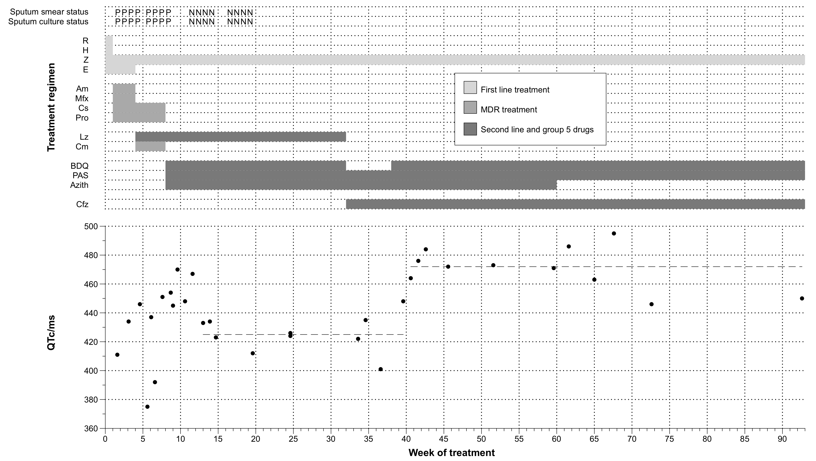
Figure 1: Drug regimen, sputum smear and culture status and corrected QT interval (QTc)/ms of patient by week. Dashed horizontal lines represent median QTc/ms between 12-39 weeks (425ms) and 40-93 weeks (472ms). P= positive sputum smear/culture, N = negative smear/culture. R = rifampicin, H= isoniazid, Z = pyrazinamide, E = ethambutol, Am = amikacin, Mfx = moxifloxacin, Cs = cycloserine, Pro = prothionamide, Lz = linezolid, Cm = capreomycin, BDQ = bedaquiline, PAS = para-amino-salicylic acid, Azith = azithromycin, Cfz = clofazamine.

