Title
Spatial targeting of habitat creation has the potential to improve agri-environment scheme outcomes for macro-moths
Author list
Jamie Alison, jamie.alison@liverpool.ac.uk¹
Simon J Duffield, simon.duffield@naturalengland.org.uk²
Catharina G E van Noordwijk, toos.vannoordwijk@gmail.com³
Michael D Morecroft, Mike.Morecroft@naturalengland.org.uk²
Rob H Marrs, calluna@liverpool.ac.uk⁴
Ilik J Saccheri, saccheri@liverpool.ac.uk¹
Jenny A Hodgson, jenny.hodgson@liverpool.ac.uk¹
¹ Department of Evolution, Ecology and Behaviour, Biosciences Building, University of Liverpool, Crown Street, Liverpool, L69 7ZB, United Kingdom
² Natural England, Cromwell House, 15 Andover Road, Winchester, SO23 7BT, United Kingdom
³ Wiltshire Wildlife Trust, Elm Tree Court, Long Street, Devizes, Wiltshire, SN10 1NJ, United Kingdom
⁴ Department of Earth, Ocean and Ecological Sciences, Jane Herdman Building, University of Liverpool, Brownlow Street, Liverpool, L69 3GP, United Kingdom
Corresponding author
Jamie Alison,
Department of Evolution, Ecology and Behaviour,
Biosciences Building,
University of Liverpool,
Crown Street,
Liverpool,
L69 7ZB,
United Kingdom
jamie.alison@liverpool.ac.uk,
Tel: +447874183350

Running title: Spatial targeting of habitat creation

Summary
- Agri-environment schemes (AES) are a major avenue for habitat creation and restoration across Europe. To maximise benefits for biodiversity, AES interventions are sometimes spatially targeted relative to existing semi-natural habitat (SNH). However, the evidence base for effective spatial targeting is deficient; studies until now have collated data across several taxa and regions, resulting in nonspecific advice that is only useful at the regional scale.
- We present a field study using macro-moths (Lepidoptera) to test (a) the impact of creating grassland habitat on arable field margins, (b) how the impact of this type of AES intervention varies according to species specialism and (c) the potential impact of spatially targeting AES interventions for proximity to semi-natural chalk grassland (CG). We surveyed macro-moths on arable fields with and without AES interventions across a range of levels of connectivity to CG. We also surveyed macro-moths on CG habitat.
- Macro-moth abundance was highest on CG and lowest on arable field centres. The benefits of AES interventions were largest for grassland-associated macro-moths: abundances were ~1.4 times higher on AES margins than control margins for this group.
- CG-associated macro-moths only benefited from AES interventions that were close (<1 km) to large areas (>10 ha) of CG habitat. We estimate that clustering AES interventions around CG could lead to a ~17% increase in CG macro-moth abundance on arable margins across our sampled region, leading to an overall increase of 2.6% within the sampled region.
- Synthesis and applications. We provide evidence that for conservation of species associated with a specific type of semi-natural habitat (SNH), agri-environment scheme (AES) interventions are most effectively positioned close to that habitat. Our study on macro-moths in arable fields with and without AES interventions across a range of levels of connectivity to chalk grassland represents a template for the production of tailored spatial targeting advice. We show that optimal positioning of AES habitat creation depends on the extent of SNH in the surrounding landscape as well as the ecology and life history of species being conserved.

Key-words: connectivity, cropland, generalist, Hampshire, host plant, land sharing, landscape configuration, pollinator, protected area, semi-natural habitat

Introduction
The spread and intensification of agricultural land use has been the major cause of biodiversity declines (Balmford, Green & Phalan 2012) and this has negative implications for human welfare (MEA 2005). To make farmland less hostile for wildlife, governments use various forms of agri-environment scheme (AES) to give farmers financial incentives for habitat creation and restoration. One widespread example is the creation of grassland strips around arable fields through sowing a grass mix or natural regeneration. These strips have benefits for local biodiversity (Merckx et al. 2012; Pywell et al. 2012) and don’t necessarily decrease crop yield at the field scale (Pywell et al. 2015). AES interventions can benefit wildlife, but funding for such measures is limited; the European Union spend over €3 billion per year on AES management, which represents ca. 6% of annual expenditure under the Common Agricultural Policy (European Commission 2015). Given the scale of these investments, it is vital that land managers and governmental bodies use all the tools at their disposal to make AESs as effective as possible.
Biodiversity benefits of AESs are highly dependent on the extent of existing semi-natural habitat (SNH) in the surrounding landscape (Tscharntke et al. 2005). For example, many recent studies show increased wildlife benefits of AES interventions where there is intermediate coverage of SNH nearby (Batáry et al. 2011; Concepción et al. 2012; Scheper et al. 2013). This makes ecological sense; the breeding and foraging resources provided by AESs may be insufficient to maintain independent populations (Whittingham 2007), whilst protected SNH supports high densities of the majority of species (Gillingham et al. 2014) and acts as a population source for nearby farmland (e.g. butterflies and bumble-bees: Öckinger & Smith 2007; bees, hoverflies and herbaceous plants: Kohler et al. 2008; Fuentes-Montemayor, Goulson & Park 2011). As such, farmland that is close to high-quality habitats has been associated with increased floral visitation rate by native pollinators (Ricketts et al. 2008) and increased fruit-set of some types of agricultural plants (Albrecht et al. 2007). An alternative perspective of the biodiversity benefits of SNH can be seen through biodiversity declines associated with agricultural intensification. For example, the abundance of nationally declining macro-moth species is lower where there is greater arable land cover within a 0.8km radius (Merckx et al. 2012). AESs are probably most effective in landscapes with intermediate coverage of SNH because AES resources that are very isolated from SNH cannot be colonised or utilised fully, whist AES resources adjacent to large areas of SNH are to some extent redundant (Tscharntke et al. 2005).
Spatial targeting relative to SNH clearly has potential to increase biodiversity gains per unit investment in AESs. However, the information that is currently available can only direct the allocation of AES interventions in a very broad sense. For example, a recent meta-analysis showed that wildlife benefits of AES interventions were largest in croplands with 1-20% coverage of SNH within 1km (Scheper et al. 2013). This result has potential to inform spatial targeting of AESs at the regional scale, but is probably not useful to inform spatial targeting across one or a few farm holdings.
Furthermore, the few published studies assessing the interaction between AESs and SNH collate data across several taxa, regions and types of AES intervention (Batáry et al. 2011; Concepción et al. 2012; Scheper et al. 2013). Conservation objectives usually prioritise specific habitat types or subsets of species; in England, AESs have been targeted to benefit “nationally important” habitats and species (NE 2014). However, there is a lack of clarity about (1) where to put AES interventions relative to specific types of SNH to maximise biodiversity benefits, and (2) which species groups will benefit most from this spatial targeting.
We carried out a field study of macro-moths (Lepidoptera) to assess the potential for spatial targeting to improve biodiversity outcomes from AESs. Macro-moths are an appropriate indicator taxon because they are species-rich, are major nocturnal pollinators, have known habitat associations and have shown population level responses to environmental change in the UK (Waring & Townsend 2009; Macgregor et al. 2014; Fox et al. 2014). We focus on AES interventions that create small areas of grassland habitat on arable field margins, and we consider the extent of nearby SNH in the form of chalk grassland (CG). Chalk grassland is a priority habitat in the UK which is particularly important for declining macro-moth species, because the larvae of declining moths tend to feed on plants adapted to open, nutrient poor habitats (Fox et al. 2014).
We surveyed arable field margins with AES interventions (treatment) and without AES interventions (control) across a range of connectivity to CG. We also surveyed high-quality CG habitat and arable field centres. To our knowledge this is the first study to simultaneously survey macro-moths on protected semi-natural grasslands as well as arable land with and without AES interventions. We tested the hypotheses that (1) macro-moth abundance on treatment margins is lower than on CG habitat, but higher than on control margins or arable field centres, (2) the impact of AES interventions depends on the habitat association of the macro-moth species in question and (3) for macro-moths associated with CG habitat, the increase in abundance on treatment margins vs control margins is greater when situated at higher connectivity to CG. Finally, taking into account the constraints of the landscape, we estimate how spatial targeting would influence AES outcomes for CG macro-moths in our study region.

Materials and methods
Site selection
Spatial analyses for site selection were carried out in ArcMap 10.1 (ESRI, Redlands, California) using five geographic datasets (see Appendix S1 in Supporting Information for details). Four study landscapes were selected within north-west Hampshire, central southern England (Fig. 1, top and middle). Each landscape was adjacent to a large (>10ha) patch of CG at least partially contained in a Site of Special Scientific Interest (SSSI, UK conservation designation); ultimately, there was a 3.7% coverage of CG habitat within a 1km buffer of all moth survey locations. Landscapes also had >50% coverage of arable land extending approximately 3km from the CG patch. Samples could thus be taken at a range of connectivity to CG habitat whilst minimising confounding effects of non-arable, non-CG land use types. Landscapes also contained holdings in Higher Level Stewardship (HLS, top-tier AES in England, NE 2013) to provide an adequate number of accessible arable fields both with and without AES interventions. The holdings we surveyed were not receiving payments for organic management. We defined an “AES intervention” as AES-funded management that creates an area of grassland at least 6m wide on the margin of an arable field. In each landscape, the most common type of AES intervention was studied (6m buffer strips in landscapes a, c & d, nectar flower mixes in landscape b; see Fig. 1 for locations of landscapes and Table S1 for management details).
We quantified the extent of CG around a given point in space using a connectivity metric that combined information on both distance to and areas of all known habitat patches. We used a negative exponential kernel weighted by CG habitat area (see Appendix S2), and calculated a continuous surface of connectivity to CG across Hampshire at 100m resolution.
Macro-moth surveys
Macro-moth surveys were carried out at 18 survey locations in each landscape (see Appendix S3 for macro-moth survey protocol). Two of 18 survey locations were on CG habitat. The remaining 16 were on the margins and centres of four pairs of large arable fields, spanning the full gradient of connectivity to CG in the landscape (fields >5ha, crops primarily wheat and barley, nectar-rich crops not in flower during surveys). In each pair of fields, one field contained a treatment margin (AES intervention present) and the other contained a control margin (crop cover extends to within 2m of field boundary). Survey locations on arable fields were always situated so that the nearest field boundary backed onto another arable field. In the case of control margins, an AES intervention was not present on either side of that boundary. As well as being physically close (within 1km) and having similar connectivity to CG, the fields in a treatment-control pair were matched where possible on within-field crop (in 8 of 16 cases) and hedge structure (absent, <3m in height or >3m, matched in 12 of 16 cases, hedgerow present on 30 of 32 margin survey locations).
Landscapes were visited one at a time between June 2nd and July 22nd 2014, with each being surveyed for macro-moths for six consecutive good weather nights (Appendix S3). Each night, ten light traps were used to simultaneously sample one survey location on each of the eight arable fields and two survey locations on the CG (as in the bottom panel of Fig. 1). On arable fields, traps were alternated between a margin survey location (placed 5m from the boundary for nights 1, 3 and 5) and a centre survey location (45m from the boundary for nights 2, 4 and 6). Within the CG habitat there was no margin/centre distinction, so survey locations were surveyed twice as often. Sampling simultaneously across an entire landscape minimised confounding between our variables of interest and intrinsic night-to-night variation in macro-moth abundance associated with weather and moonlight (McGeachie 1989).
Moths were identified and released on site. To minimise recaptures of moth individuals, on subsequent visits to a given survey location we placed the moth trap at least 50m from the previous point of survey. This was done so that the attraction radius of light traps did not include any point where moths had been released within the last two good weather nights (Merckx & Slade 2014).
Data analysis
All statistical analyses were carried out in R 3.0.3 (R Core Team 2014). On arable fields, abundance was calculated for each macro-moth species as the sum of counts across the three samples (= trapping occasions) in each survey location in each landscape. CG survey locations were surveyed twice as often as arable survey locations, and comprised six samples. For this reason, each CG survey location was divided into two sets of three samples: one set for when arable fields were surveyed at the margin on the same night, and one for when they were surveyed at the centre. This resulted in a total of 80 observations (64 arable and 16 CG) per species (180 species) summing to 14,400 observations overall.
The abundance of each macro-moth species was used as the response variable in generalised linear mixed models (GLMMs) with Poisson error structures (log link) in the package lme4 (Bates et al. 2014). There was a high level of non-independence in the data caused by spatial and temporal autocorrelation, and by observations of 180 species being drawn from each individual survey location. Furthermore, each species varied in abundance between landscapes according to its phenology and its geographic distribution. To account for these sources of non-independence, random intercepts were included for field, dates of survey, and species identity nested within landscape. A random intercept was also included for each data point in order to model extra-Poisson variation that was present in the data. Observation-level random effects have been shown to be a simple and robust way to account for overdispersion in count data (Harrison 2014).
Three variables were used as fixed effects in GLMMs: “species specialism”, “management” and “connectivity to CG”. “Species specialism” was the result of classifying macro-moth species as either CG species, grassland species, or other species using a guidebook (Waring & Townsend 2009, see Appendix S3 for criteria). “Management” was a composite of three incompletely crossed factors, and we use “management_{full}” as shorthand for the complete set of 5 possible levels: CG, AES intervention, control margin, arable field centre near AES intervention and arable centre near control margin. When testing for effects of “management”, we always produced models with simpler nested versions of this variable; “management_{AES}” (4 levels: CG, AES intervention, control margin, arable centre) assumes no effect of AES interventions at the centres of fields, whilst “managment_{margin}” (3 levels: CG, arable margin, arable centre) assumes no effect of AES interventions at all. “Connectivity to CG” of each survey location was extracted from the connectivity metric produced during site selection (Appendix S2) using the R package maptools (Bivand & Lewin-Koh 2014). This variable was log₂ transformed and centred on the mean prior to model fitting to ensure model convergence.
To test hypothesis (1) that moth abundance on AES interventions was different from other management types, we produced GLMMs using forms of the “management” variable to predict the abundance of all species of macro-moths. To test hypotheses (2) that impact of AES interventions depend on species’ habitat associations and (3) that for CG macro-moths the impact of AES interventions increases with connectivity to CG, GLMMs were produced using fixed effects of “species specialism”, “management” and “connectivity to CG” allowing all possible interactions. Model selection was carried out using an information theoretic approach based on Akaike’s Information Criterion (AIC, Burnham & Anderson 2002). Following Richards (2008), we report models with ΔAIC ≤ 6 except those with a higher AIC than any simpler nested version. For the lowest AIC models, we used Wald Z-tests in the package lme4 (Bates et al. 2014) to determine whether individual parameters differed significantly from zero.
For CG macro-moths, we explored the potential impact of spatially targeting AES interventions close to CG habitat. To do this, we divided land in Hampshire into four categories of connectivity to CG (henceforth referred to as “connectivity bands”: C < -2, -2 ≤ C < 0, 0 ≤ C < 2, and C ≥ 2). These connectivity bands were selected such that each of the four bands would contain at least one of the AES interventions and one of the control margins that we surveyed. Using the lowest AIC model, we predicted CG macro-moth abundance corresponding to four management types (CG, AES intervention, control margin and arable centre) at four levels of connectivity to CG (corresponding to the four connectivity bands: -3,-1,1 and 3). We then multiplied those predictions by the area of each management type in each of the four connectivity bands.
The process of multiplying predicted CG macro-moth abundances by corresponding areas was carried out twice; in the first instance areas were calculated under the existing distribution of AES interventions in Hampshire (status quo). In the second instance, areas were calculated under a hypothetical scenario with maximum spatial targeting of AES interventions towards CG (targeted). This targeted scenario redistributed the same total area of AES interventions across Hampshire, giving priority to arable field margins in the highest band of connectivity to CG (see Appendix S4 for more details). During this process, we allowed AES interventions to fill arable land up to 10m from the field boundary. This was to strike a balance between the widths of the two types of AES intervention that we surveyed; 6m buffer strips were consistently 6m wide, whereas nectar flower mixes were up to 20m wide.

Results
7228 macro-moth individuals of 180 species were captured and identified from 240 light trap samples (Table S2). 7.8% of those individuals belonged to 15 species that were determined a priori to be associated with CG habitat, whilst 15.9% of individuals belonged to 24 species associated with other grassland habitat. The remaining 76.3% of individuals belonged to 141 species that were either associated with other habitats, such as woodland, or of no strong habitat association. There was a substantial overlap in species composition of protected CG and surrounding farmland; of the 125 species captured on CG throughout the study, 106 were also captured on arable fields (see Table S6 for full species list and their abundance on different management types).
Considering all species, and without considering connectivity to CG, the abundance of macro-moths was lowest on arable field centres, intermediate on arable field margins, and highest on CG (Fig. 2a, Table S2). A model using management_{AES} as the sole independent variable outperformed a model with management_{margin} (models 33 and 41, Table S5, ΔAIC = 3.71). The model with management_{AES} also outperformed a model with management_{full} (models 33 and 37, Table S5, ΔAIC = 1.90). Following Richards (2008), the model with management_{full} was omitted because its AIC was higher than that of the simpler nested version. The management_{AES} model was thus the best of the three models, and the parameters of this model reveal that the overall abundance of macro-moths on AES interventions was 1.23 times greater than on control margins (P = 0.017, Fig. 2a, Table S3). Macro-moth abundance was also 1.31 times greater on CG than on AES interventions (P = 0.033, Fig. 2a, Table S3) and 2.94 times greater on AES interventions than on arable field centres (P < 0.001, Fig. 2a, Table S3).
When allowing species specialism and connectivity to CG as predictors of macro-moth abundance, a best model emerged including a three way interaction with the variable management_{AES} (Table 1, version with negative binomial error is in Table S7); the effect of different management types was dependent on connectivity, and this interaction between management and connectivity depended on whether the species in question was a CG species, grassland species or other species. Grassland species responded strongly to AES interventions, with abundances 1.42 times greater than on control margins (at mean connectivity to CG, P = 0.024, Table 1, see also Fig. 2c). For CG species, but not grassland species or other species, connectivity to CG had a strong positive effect on abundance overall (Fig. 3, Fig. S1). In contrast with grassland species, CG species showed a significantly shallower slope with connectivity on control margins than on AES interventions (P = 0.025, Fig. 3, Table 1). This effect means that AES interventions apparently have a more positive effect on abundance of CG macro-moths at higher connectivity to CG. One other model was supported too, and this model did not include an interaction between the effects of AES interventions and connectivity to CG (ΔAIC = 2.13, see models 1 and 2 in Table S5).
We predicted the relative abundance of CG macro-moths under a hypothetical scenario whereby AES interventions were maximally targeted to be close to CG habitat (targeted scenario, Table S4). We compared predicted relative abundance under the targeted scenario with that under the existing distribution of AES interventions (status quo). Predicted relative abundance of CG macro-moths on arable margins across Hampshire was 16.9% higher under the targeted scenario than it was under the status quo. When taking into account all CG and arable land in Hampshire, predicted relative abundance of CG macro-moths was 2.6% higher under the targeted scenario than it was under the status quo.
Discussion
In support of hypothesis (1) we show that overall macro-moth abundance is higher on AES interventions than control margins, lowest on arable field centres, and highest on CG habitat. These results can be explained in light of current knowledge about the ecology and life history of Lepidoptera; abundance is affected by larval food plant availability, nectar sources for adults, presence of landmark features and shelter (Pywell et al. 2004; Dover & Settele 2009). CG habitat provides all of the above because it supports exceptionally high plant biodiversity, including occasional trees and shrubs (Diacon-Bolli et al. 2012). In contrast, the centres of arable fields are featureless crop monocultures. Low abundance here probably corresponds to the absence of food and shelter for most macro-moth species, and in some cases harmful chemical inputs (e.g. insecticides, see Hahn et al. 2015). Arable margins have intermediate macro-moth abundance, which almost certainly relates to the shelter, nectar and larval food plants provided by hedgerows and grass margins (Pywell et al. 2004; Merckx et al. 2012).
The increase in overall macro-moth abundance on AES interventions relative to control margins in this study was small (1.23 times higher), which is unsurprising in light of similar comparisons made in previous studies. Fuentes-Montemayor et al. (2011) and Merckx et al. (2012) both found no significant increase in overall macro-moth abundance on grass margins when compared with conventionally managed alternatives, although Merckx et al. (2012) did find an increase in species richness. When investigating a subset of nine common and widespread macro-moth species, Merckx et al. (2009) found that abundance was 1.40 times higher on 6m grass margins than on standard margins. This resembles strikingly the increase we observed for grassland generalist macro-moths (1.42 times more abundant on AES than control margins), and part of the explanation for this might be that eight of the nine species they studied had grass or herb feeding larvae. Merckx et al. (2009) also found that 6m grass margins were associated with increased macro-moth abundance at the centre of the field, but we found no such effect here.
With respect to hypothesis (2) we show that AES interventions on arable margins result in an increase in macro-moth abundance, but the size of this benefit depends on the habitat association of the species considered (Fig. 2). This provides insights into the mechanisms through which AES interventions benefit macro-moths, which could be used to improve spatial targeting guidelines. For example, here we show that benefits of AES interventions are substantial for grassland generalist species irrespective of connectivity to SNH. This is not true for CG species or other species, so we suggest that overall benefits of AES habitat creation for macro-moths are driven mainly by the provision of larval food plants. Thus, it is the grassland generalist species that largely feel the benefit of this provision; if provision of nectar or shelter were driving changes in abundance, we might expect all three groups of macro-moths to benefit to a similar extent. We can also conclude that AES interventions may provide benefits for generalist species even when they are not spatially targeted - this could satisfy the aims of a scheme if the desired outcome is the provision of ecosystem services rather than the conservation of priority species. However, it must be noted that benefits for such generalist species are predicted to be more substantial when AES interventions are implemented at larger, landscape-scales, because small-scale AES implementation mainly benefits low mobility species whilst large-scale implementation benefits both low and high mobility species (Merckx et al. 2009; Merckx & Macdonald 2015).
In support of hypothesis (3) we show that CG specialist macro-moths only appear to benefit from AES interventions on arable field margins that are close to their core habitat. We suggest that when conservationists recognise certain habitats or species as a priority (as they have done in England, NE 2014), AES habitat creation is probably best targeted at high connectivity to those habitats. This would increase the benefits of AES interventions for specialized species, whilst also benefitting non-specialist (though generally declining, Fox et al. 2014) wider-countryside species. The interaction that we found, where CG macro-moth abundance increased more steeply with connectivity on AES margins, would imply that the best strategy is to cluster interventions around CG to the maximum extent possible. This by itself would be an informative guideline, but it is also interesting to predict approximately the maximum benefit that could be achieved, given that targeting is constrained by the configuration of the landscape and the total area of interventions. Based on land cover in Hampshire, we predicted that the overall abundance of CG macro-moths could be increased by 2.6% as a result of their increased abundance on field margins by 16.9%. Depending on the costs and the willingness of landowners to cooperate with targeting, this potential benefit may compare favourably with other available management options affecting CG species; these may include the creation of new areas of CG habitat. It should be noted that within a 1km buffer of all survey locations in this study, coverage of CG habitat was 3.7%. Batáry et al. (2011) showed that agri-environmental management is most beneficial for arthropods in “simple” landscapes with 0-20% SNH, and almost all of our arable survey locations fell into this category. It remains unclear whether spatial targeting would be effective for CG macro-moths in “complex” landscapes with very high coverage of SNH.
It could be argued that the benefits of AES interventions for CG species are surprisingly large. This is because the interventions we studied were not at all tailored towards CG species: they simply converted a small area of crop cover into grassland, and in one landscape planted flowers to increase nectar availability. One factor contributing to this result is that most of the CG species caught in this study are not overly restricted or rare (see Table S6 for a full species list), hence we were able to collect sufficient individuals to test our hypotheses. However, this is not the first time non-tailored AES interventions have been seen to benefit specialized species. For example, a previous study reported increases in a highly endangered macro-moth species in association with AES hedgerow trees (Merckx et al. 2010).
When predicting the outcome of spatial targeting, note that we are making strong assumptions that the relationships found in our statistical models will remain the same when the landscape configuration is changed. Such assumptions would not hold if connectivity interacts with other landscape variables that we did not consider. Furthermore, the effect of increasing the extent of interventions close to CG may depend on the mechanism that causes macro-moth abundance to be higher on interventions. Because of basic natural history, as well as the steepness of the relationship between connectivity and abundance, we suspect that the AES interventions in this study are not able to support independent viable populations of CG macro-moths. The AES interventions studied here probably provide plenty of nectar for adults in this group, and this is especially true for nectar flower mixes (surveyed in landscape b, Fig. 1); Carvell et al. (2007) found that total flower abundance was significantly greater on pollen and nectar margins than on grass margins, although the species richness of plants in flower did not differ between these two intervention types. Beyond nectar provision, we suspect that AES interventions only afford small quantities of suitable larval food plant for CG macro-moths. For example, larvae of the Small Elephant Hawkmoth Deilephila porcellus (L.) feed primarily on Lady’s Bedstraw Galium verum (L.) (Waring & Townsend 2009). This plant was clearly present on all four CG patches, but was only sighted on 1 of 16 AES interventions.
We propose that CG species eclose almost exclusively on CG habitat, but that they will be attracted to use nectar and scarce larval host plants on AES interventions if they are easily reachable by dispersal. In other words, the AES interventions in this study might function as “sink habitat” for CG macro-moths (Watkinson & Sutherland 1995). If they do (and this remains to be tested), then adding more and more interventions could lead to diminishing returns. This would be because as nectar resources for adults increase, these AES interventions might fail to provide adequate larval resources for CG species, thus the total population size will be increasingly limited by survival from egg to pupa. Even where eggs are laid on host plants in AES interventions, the success of offspring could be strongly reduced by spill-over of sprayed agrochemicals (Hahn et al. 2015). In particularly severe cases AES interventions could represent an “ecological trap” for specialized species, whereby individuals waste time and energy in flight and reproduction with no net benefit to the population. Reducing agrochemical spill-over on AES interventions might make “ecological trap” situations less likely to occur.
We have provided important evidence of the value of general-purpose AESs for different groups of moths. This evidence can be used to interpret how these important nocturnal pollinators can benefit from habitat features created through AES. This information should be very useful for decision-makers, but it must be considered in relation to the goals of the AES. For example, declines in wider countryside moths are ongoing (Fox et al. 2014), and we do not address the fact that farmland that is isolated from SNH might be most in need of enhancements to ecosystem services such as pollination (Ricketts et al. 2008). There are also caveats when using the abundance of adult macro-moths to indicate population size or viability: our results do not ascertain that AES interventions benefit macro-moths at the larval stage. We propose that future work should (1) examine how connectivity to SNH affects the wildlife benefits of large-scale habitat creation that is tailored to priority species (2) consider which landscapes are most in need of the ecosystem services that habitat creation might provide and (3) survey all stages of the life-cycle of the taxon of interest.
Conclusions
We have found compelling evidence that macro-moth abundance on arable field margins can be increased through small-scale AES habitat creation (see also Fuentes-Montemayor, Goulson & Park 2011; Merckx et al. 2012). Furthermore, if adequate geographical and ecological data are available, spatial targeting advice can improve the outcomes of AES habitat creation. For example, if land managers aim to benefit priority species using generic AES interventions, we propose a strategy of clustering interventions around those species’ core habitat. Nevertheless, when targeting habitat creation relative to SNH, the mechanisms through which species are expected to benefit from created habitat must be considered. We hope this work will lay the foundation for similar empirical studies based on different taxonomic groups; this would facilitate the production of a set of generic targeting guidelines that could be applied a priori based on species’ ecological traits.

Acknowledgements
We thank Harold Makant and other advisors at Natural England for their help in finding suitable field sites. We thank land managers from Hampshire County Council, the Hampshire and Isle of Wight Wildlife Trust, the Leckford estate and others for granting permission to carry out moth surveys. We thank the John Spedan Lewis Trust for the Advancement of Natural Sciences for use of their facilities, and Glynne Evans for moth identification advice. We thank Thomas Merckx and one anonymous reviewer for suggestions to improve the manuscript. JA was supported by a Natural Environment Research Council studentship (Grant no. NE/K007696/1).

Data accessibility
Our full dataset, including moth counts and survey locations, is available as of 21st July 2016 from the Natural Environment Research Council’s Environmental Information Data Centre (http://doi.org/10.5285/a8819ca7-1d16-4acf-b27c-983a73e7a7cd, Alison et al. 2016).

Supporting information
Additional Supporting Information may be found in the online version of this article:
Appendix S1. Spatial analysis for site selection
Appendix S2. Calculation of connectivity to chalk grassland
Appendix S3. Moth surveys and species specialism methodology
Appendix S4. Area estimations for land management types
Table S1. Agri-environment scheme intervention details
Table S2. Total macro-moth counts across land management types
Table S3. Model summary when using “management_{AES}” as a predictor
Table S4. The distribution of land management types across four bands of connectivity to chalk grassland in Hampshire
Table S5. Model selection table with AIC
Table S6. Species’ habitat specialism types and abundances
Table S7. Parameters for the negative binomial version of the best model
Figure S1. Predictions of abundance of “grassland” and “other” macro-moths considering connectivity to chalk grassland

References
Albrecht, M., Duelli, P., Müller, C., Kleijn, D. & Schmid, B. (2007) The Swiss agri-environment scheme enhances pollinator diversity and plant reproductive success in nearby intensively managed farmland. Journal of Applied Ecology, 44, 813–822.
Alison, J., Duffield, S.J., Morecroft, M.D. & Hodgson, J.A. (2016) Moth Counts on Chalk Grassland and Surrounding Arable Fields with Agri-Environment Schemes in Hampshire, UK. NERC Environmental Information Data Centre, DOI:10.5285/a8819ca7-1d16-4acf-b27c-983a73e7a7cd.
Balmford, A., Green, R. & Phalan, B. (2012) What conservationists need to know about farming. Proceedings of the Royal Society B: Biological Sciences, 279, 2714–2724.
Batáry, P., Báldi, A., Kleijn, D. & Tscharntke, T. (2011) Landscape-moderated biodiversity effects of agri-environmental management: a meta-analysis. Proceedings of the Royal Society B: Biological Sciences, 278, 1894–1902.
Bates, D., Maechler, M., Bolker, B. & Walker, S. (2014) lme4: Linear mixed-effects models using Eigen and S4. R package version 1.1-7.
Bivand, R. & Lewin-Koh, N. (2014) maptools: Tools for reading and handling spatial objects. R package version 0.8-30.
Burnham, K. & Anderson, D. (2002) Model Selection and Multimodel Inference: A Practical Information-Theoretic Approach. Springer-Verlag, New York.
Carvell, C., Meek, W.R., Pywell, R.F., Goulson, D. & Nowakowski, M. (2007) Comparing the efficacy of agri-environment schemes to enhance bumble bee abundance and diversity on arable field margins. Journal of Applied Ecology, 44, 29–40.
Concepción, E.D., Díaz, M., Kleijn, D., Báldi, A., Batáry, P., Clough, Y., Gabriel, D., Herzog, F., Holzschuh, A., Knop, E., Marshall, E.J.P., Tscharntke, T. & Verhulst, J. (2012) Interactive effects of landscape context constrain the effectiveness of local agri-environmental management. Journal of Applied Ecology, 49, 695–705.
Diacon-Bolli, J., Dalang, T., Holderegger, R. & Bürgi, M. (2012) Heterogeneity fosters biodiversity: Linking history and ecology of dry calcareous grasslands. Basic and Applied Ecology, 13, 641–653.
Dover, J. & Settele, J. (2009) The influences of landscape structure on butterfly distribution and movement: a review. Journal of Insect Conservation, 13, 3–27.
European Commission. (2015) Agri-environment measures, http://ec.europa.eu/agriculture/envir/measures/index_en.htm
Fox, R., Oliver, T.H., Harrower, C., Parsons, M.S., Thomas, C.D. & Roy, D.B. (2014) Long-term changes to the frequency of occurrence of British moths are consistent with opposing and synergistic effects of climate and land-use changes. Journal of Applied Ecology, 51, 949–957.
Fuentes-Montemayor, E., Goulson, D. & Park, K.J. (2011) The effectiveness of agri-environment schemes for the conservation of farmland moths: assessing the importance of a landscape-scale management approach. Journal of Applied Ecology, 48, 532–542.
Gillingham, P.K., Alison, J., Roy, D.B., Fox, R. & Thomas, C.D. (2014) High abundances of species in protected areas in parts of their geographic distributions colonised during a recent period of climatic change. Conservation Letters, 8, 97–106.
Hahn, M., Schotthöfer, A., Schmitz, J., Franke, L.A. & Brühl, C.A. (2015) The effects of agrochemicals on Lepidoptera, with a focus on moths, and their pollination service in field margin habitats. Agriculture, Ecosystems & Environment, 207, 153–162.
Harrison, X.A. (2014) Using observation-level random effects to model overdispersion in count data in ecology and evolution. PeerJ, 2, e616.
Kohler, F., Verhulst, J., Van Klink, R. & Kleijn, D. (2008) At what spatial scale do high-quality habitats enhance the diversity of forbs and pollinators in intensively farmed landscapes? Journal of Applied Ecology, 45, 753–762.
Macgregor, C.J., Pocock, M.J.O., Fox, R. & Evans, D.M. (2014) Pollination by nocturnal Lepidoptera, and the effects of light pollution: a review. Ecological Entomology, 40, 187–198.
McGeachie, W.J. (1989) The effects of moonlight illuminance, temperature and wind speed on light-trap catches of moths. Bulletin of Entomological Research, 79, 185–192.
Merckx, T., Feber, R.E., Dulieu, R.L., Townsend, M.C., Parsons, M.S., Bourn, N.A.D., Riordan, P. & Macdonald, D.W. (2009) Effect of field margins on moths depends on species mobility: Field-based evidence for landscape-scale conservation. Agriculture, Ecosystems & Environment, 129, 302–309.
Merckx, T., Feber, R.E., Parsons, M.S., Bourn, N.A.D., Townsend, M.C., Riordan, P. & Macdonald, D.W. (2010) Habitat preference and mobility of Polia bombycina: are non-tailored agri-environment schemes any good for a rare and localised species? Journal of Insect Conservation, 14, 499–510.
Merckx, T. & Macdonald, D. (2015) Landscape-scale Conservation of Farmland Moths. Wildlife Conservation on Farmland. Volume 1: Managing for Nature on Lowland Farms. pp. 147–166. Oxford University Press, Oxford, UK.
Merckx, T., Marini, L., Feber, R.E. & MacDonald, D.W. (2012) Hedgerow trees and extended-width field margins enhance macro-moth diversity: Implications for management. Journal of Applied Ecology, 49, 1396–1404.
Merckx, T. & Slade, E.M. (2014) Macro-moth families differ in their attraction to light: implications for light-trap monitoring programmes. Insect Conservation and Diversity, 7, 453–461.
Millenium Ecosystem Assessment. (2005) Ecosystems and human well-being: Biodiversity Synthesis, http://www.millenniumassessment.org/documents/document.354.aspx.pdf
Natural England. (2013) Higher Level Stewardship: Environmental Stewardship Handbook, Fourth Edition. Catalogue Code: NE350. publications.naturalengland.org.uk/file/2819648.
Natural England. (2014) HLS Targetting: The Background. Http://www.naturalengland.org.uk/ourwork/farming/funding/es/hls/targeting/background.aspx.
Öckinger, E. & Smith, H.G. (2007) Semi-natural grasslands as population sources for pollinating insects in agricultural landscapes. Journal of Applied Ecology, 44, 50–59.
Pywell, R.F., Heard, M.S., Bradbury, R.B., Hinsley, S., Nowakowski, M., Walker, K.J. & Bullock, J.M. (2012) Wildlife-friendly farming benefits rare birds, bees and plants. Biology Letters, 8, 772–775.
Pywell, R.F., Heard, M.S., Woodcock, B.A., Hinsley, S., Ridding, L., Nowakowski, M. & Bullock, J.M. (2015) Wildlife-friendly farming increases crop yield : evidence for ecological intensification. Proceedings of the Royal Society B: Biological Sciences, 282, 20151740.
Pywell, R.F., Warman, E.A., Sparks, T.H., Greatorex-Davies, J.N., Walker, K.J., Meek, W.R., Carvell, C., Petit, S. & Firbank, L.G. (2004) Assessing habitat quality for butterflies on intensively managed arable farmland. Biological Conservation, 118, 313–325.
R Core Team. (2014) R: A language and environment for statistical computing.
Richards, S.A. (2008) Dealing with overdispersed count data in applied ecology. Journal of Applied Ecology, 45, 218–227.
Ricketts, T.H., Regetz, J., Steffan-Dewenter, I., Cunningham, S.A., Kremen, C., Bogdanski, A., Gemmill-Herren, B., Greenleaf, S.S., Klein, A.M., Mayfield, M.M., Morandin, L.A., Ochieng’, A. & Viana, B.F. (2008) Landscape effects on crop pollination services: Are there general patterns? Ecology Letters, 11, 499–515.
Scheper, J., Holzschuh, A., Kuussaari, M., Potts, S.G., Rundlöf, M., Smith, H.G. & Kleijn, D. (2013) Environmental factors driving the effectiveness of European agri-environmental measures in mitigating pollinator loss - a meta-analysis. Ecology letters, 16, 912–920.
Tscharntke, T., Klein, A.M., Kruess, A., Steffan-Dewenter, I. & Thies, C. (2005) Landscape perspectives on agricultural intensification and biodiversity - ecosystem service management. Ecology Letters, 8, 857–874.
Waring, P. & Townsend, M. (2009) Field Guide to the Moths of Great Britain and Ireland, Second Edn. British Wildlife Publishing, Oxford, UK.
Watkinson, A.R. & Sutherland, W.J. (1995) Sources, Sinks and Pseudo-Sinks. Journal of Animal Ecology, 64, 126–130.
Whittingham, M.J. (2007) Will agri-environment schemes deliver substantial biodiversity gain, and if not why not? Journal of Applied Ecology, 44, 1–5.

Tables
Table 1. Summary of fixed effect parameters in the lowest AIC model predicting the abundance of 180 species of macro-moths (parameters = 30, Log Likelihood = -6521.29, AIC = 13098.57, ΔAIC next best = 2.13, Table S5). This generalised linear mixed model (GLMM, Poisson error, log-link) included a three way interaction between the variables management_{AES} (4 levels: chalk grassland (CG), AES intervention (base level), control margin, arable centre), species specialism (3 levels: CG species, grassland species (base level), or other species) and connectivity to CG. Random intercepts were included for field, dates of survey, and species identity nested within landscape. Observation-level random intercepts were included to account for overdispersion in count data. Models were produced using the package lme4 (Bates et al. 2014) using Wald Z-tests to determine if parameters differed significantly from zero (parameters with P < 0.05 in bold).
Species group | Parameter | Par. estimate | Std. error | Z | P(>|Z|)
Grassland species  (associated with grassland but not chalk grassland) | Intercept for grassland species (on AES intervention at mean connectivity to CG) | -2.916 | 0.316 | -9.240 | <0.001
 | Arable centre | -0.947 | 0.141 | -6.727 | <0.001
 | Control margin | -0.353 | 0.156 | -2.265 | 0.024
 | Chalk grassland | -0.694 | 0.432 | -1.608 | 0.108
 | Connectivity to CG | -0.067 | 0.066 | -1.011 | 0.312
 | Connectivity to CG: Arable centre | 0.198 | 0.074 | 2.686 | 0.007
 | Connectivity to CG: Control margin | 0.050 | 0.083 | 0.599 | 0.549
 | Connectivity to CG: Chalk grassland | 0.397 | 0.195 | 2.038 | 0.042
Other species  (not associated with grassland or chalk grassland) | Intercept for other species (on AES intervention at mean connectivity to CG) | -0.624 | 0.327 | -1.905 | 0.057
 | Arable centre | -0.083 | 0.148 | -0.559 | 0.576
 | Control margin | 0.181 | 0.161 | 1.129 | 0.259
 | Chalk grassland | 1.477 | 0.356 | 4.150 | <0.001
 | Connectivity to CG | 0.072 | 0.063 | 1.155 | 0.248
 | Connectivity to CG: Arable centre | -0.086 | 0.081 | -1.057 | 0.290
 | Connectivity to CG: Control margin | -0.013 | 0.086 | -0.153 | 0.879
 | Connectivity to CG: Chalk grassland | -0.715 | 0.160 | -4.461 | <0.001
Chalk grassland (CG) species  (associated with chalk grassland) | Intercept for CG species (on AES intervention at mean connectivity to CG) | -1.180 | 0.508 | -2.322 | 0.020
 | Arable centre | -0.461 | 0.288 | -1.602 | 0.109
 | Control margin | 0.217 | 0.276 | 0.787 | 0.431
 | Chalk grassland | 0.491 | 0.663 | 0.741 | 0.459
 | Connectivity to CG | 0.535 | 0.131 | 4.088 | <0.001
 | Connectivity to CG: Arable centre | 0.191 | 0.181 | 1.061 | 0.289
 | Connectivity to CG: Control margin | -0.384 | 0.171 | -2.246 | 0.025
 | Connectivity to CG: Chalk grassland | -0.097 | 0.288 | -0.338 | 0.735
Figures
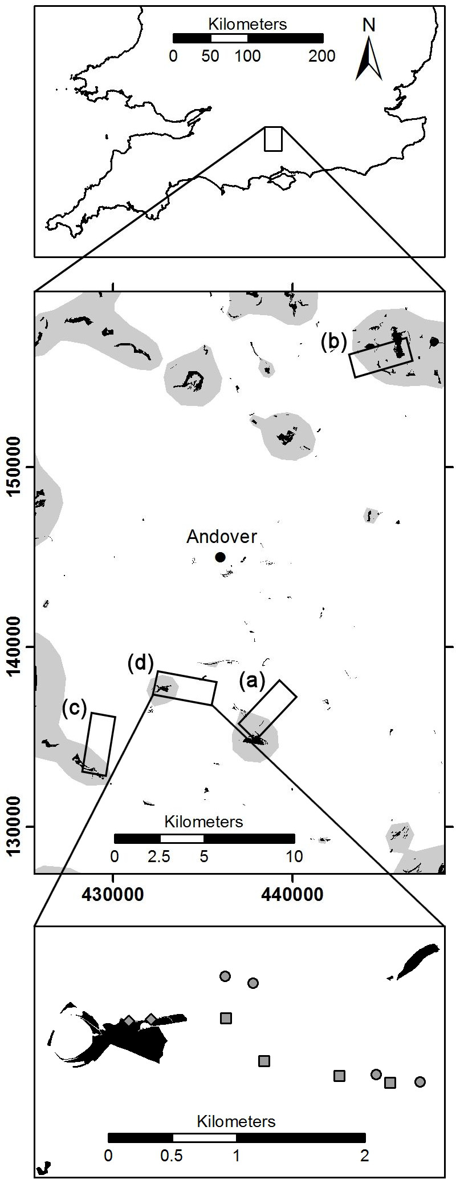
Figure 1. (top) The location of the study region on the island of Great Britain. (middle) Locations of the four study landscapes (a-d) near the town of Andover in north-west Hampshire, central-southern England. Coverage of chalk grassland habitat (black polygons) was obtained from the Hampshire Biodiversity Information Centre (HBIC) and Natural England. The area coloured grey has relatively high connectivity to chalk grassland habitat (above the median connectivity of macro-moth survey locations in this study, calculated as in Appendix S2). All-numeric coordinates from Great Britain’s Ordnance Survey (OS) National Grid are displayed. The latitude and longitude at the centre of this map is approximately 51°12′10″N 01°27′26″W. (bottom) Close-up view of ten survey locations in landscape (d): two on chalk grassland habitat (grey diamonds), four on arable fields with agri-environment scheme interventions (grey squares) and four on arable fields with control margins (grey circles). Not shown here are eight more survey locations that were 45m toward the centres of the arable fields. Contains information from OS licensed under the Open Government License v3.0.

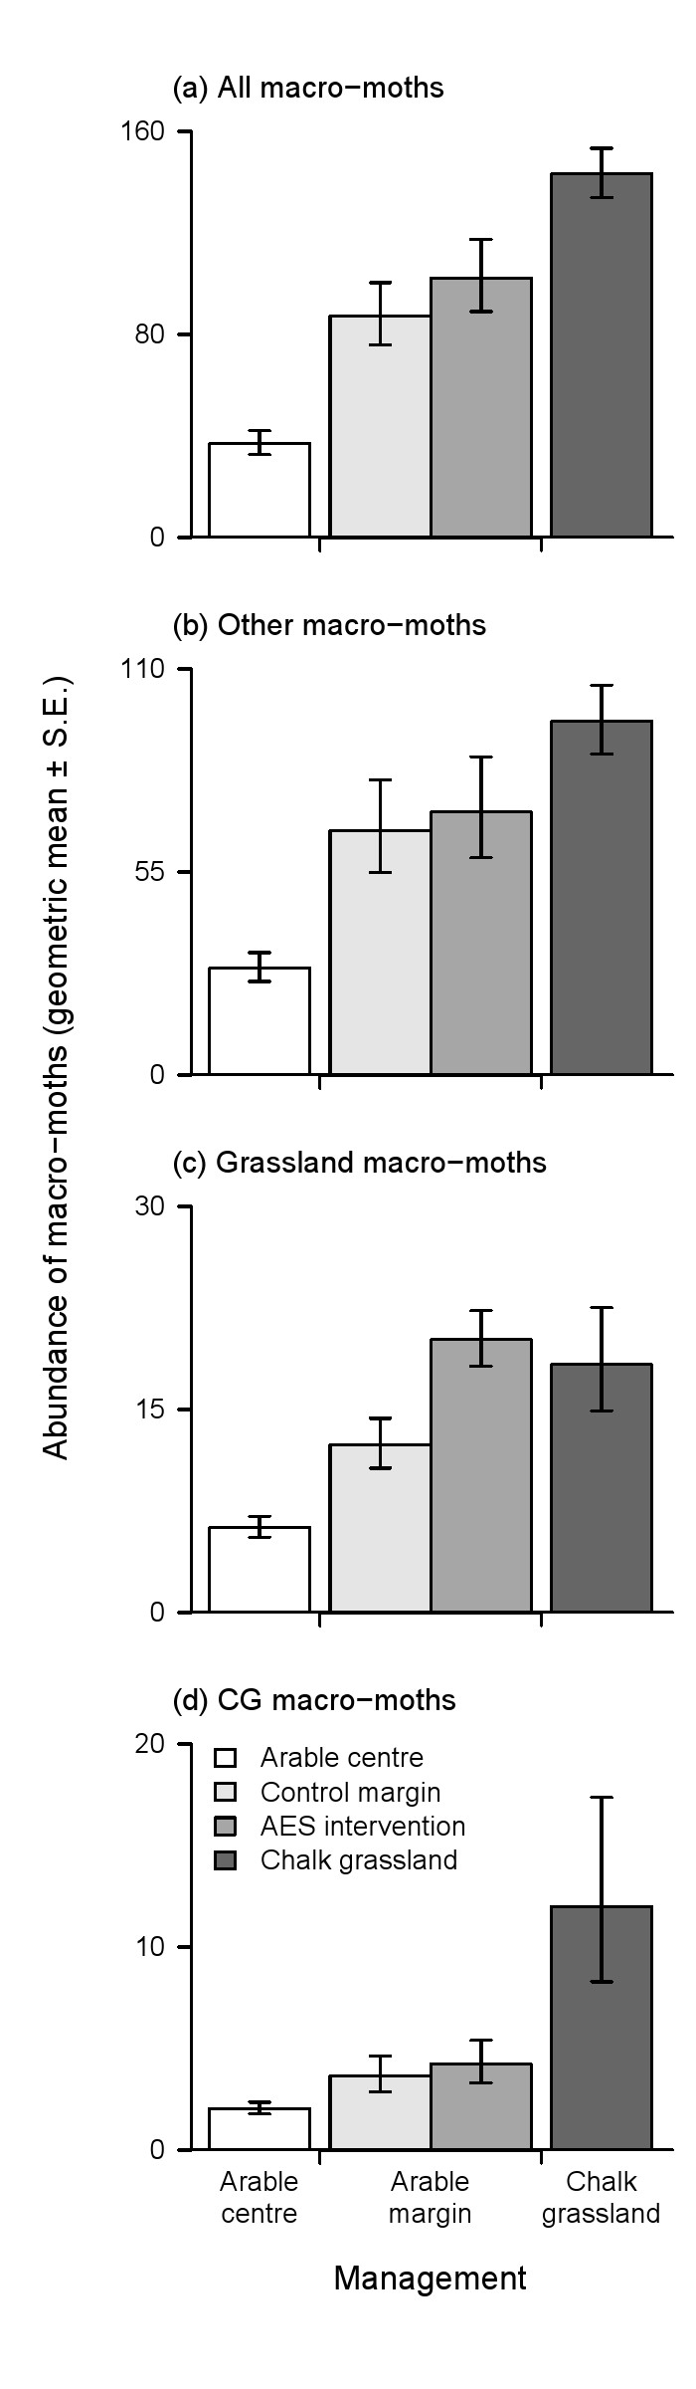
Figure 2. Geometric means ± standard errors of the abundance of (a) all macro-moths (180 species), (b) other macro-moths (141 species), (c) grassland macro-moths (24 species) and (d) chalk grassland (CG) macro-moths (15 species) across survey locations (summed across 3 trapping nights) on each of four land management types: CG habitat (n = 16), arable field centres (45m from field boundary, n = 32), AES interventions (5m from boundary, AES intervention present, n = 16) and control margins (5m from boundary, no AES intervention present, n = 16).

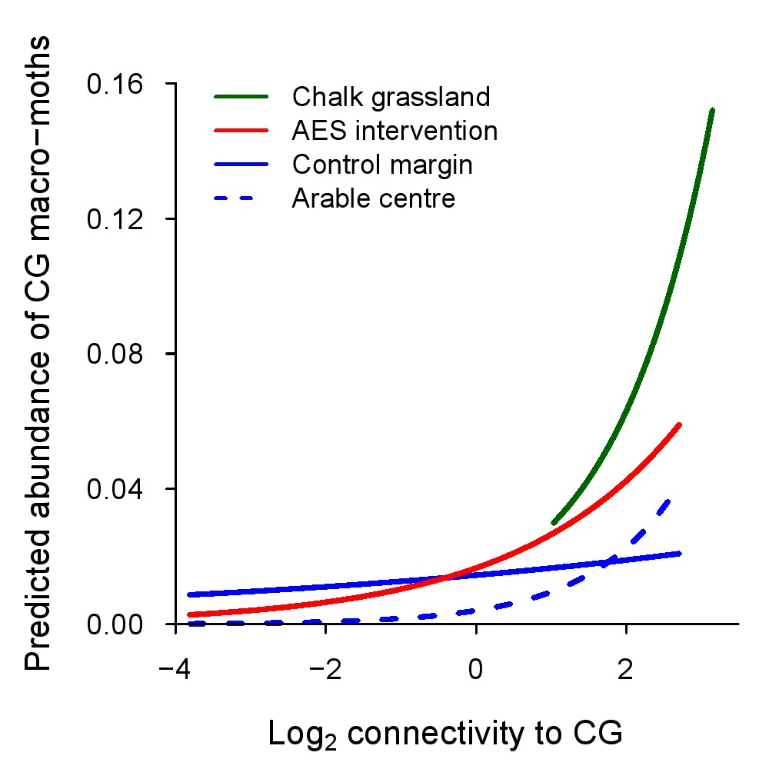
Figure 3. Model-fitted abundance of chalk grassland (CG) macro-moths (15 species) across a range of connectivity to CG on each of four land management types: CG, AES interventions, control margins and arable field centres. Predicted abundance represents the number of individuals of the average CG species across three trapping nights. A high value of connectivity to CG means that a site was closer to larger areas of CG habitat (Appendix S2). Connectivity to CG of zero represents the mean connectivity to CG of macro-moth survey locations in this study. Predictions were produced using the generalised linear mixed model (GLMM) detailed in Table 1, using the range of connectivity to CG that was observed for each management type. Similar figures for “grassland” and “other” species are provided in Fig. S1.

