Preliminary results from PiSARRO, a phase Ib/II study of APR-246, a mutant p53 reactivating small molecule, in combination with standard chemotherapy in platinum sensitive ovarian cancer

Mikael von Euler¹, Klas G Wiman², Hani Gabra³, James D Brenton ⁴, Bristi Basu⁴, Ignace Vergote⁵, Charlie Gourley⁶, Austin Smith⁷, Jessica Alfredsson¹, Nina Mohell¹, and John A Green⁸

¹Aprea, Solna, Sweden; ²Karolinska Institutet, Stockholm, Sweden; ³Imperial College London, London, UK; ⁴University of Cambridge, Cambridge, UK; ⁵University of Leuven, Leuven, Belgium; ⁶University of Edinburgh, Edinburgh, UK; ⁷Theradex Ltd., Crawley, UK; ⁸University of Liverpool, Liverpool, UK.

PiSARRO, p53 Suppressor Activation in Recurrent High Grade Serous Ovarian Cancer, is Aprea’s recently started Phase Ib/II clinical study with APR-246 in combination with carboplatin and pegylated liposomal doxorubicin (PLD) in p53 mutant ovarian cancer.

Introduction:
- p53 is a key tumor suppressor that induces cell cycle arrest, senescence and/or apoptosis upon cellular stress, eliminating tumor cells. p53 mutations are found in more than 50% of cancers and are associated with increased resistance to chemotherapy.
- Ovarian cancer is the sixth most commonly diagnosed cancer among women, and causes more deaths per year than any other cancer of the female reproductive system.
- Despite high response rates from carboplatin in combination with paclitaxel in first-line treatment of ovarian cancer, most patients relapse and develop resistance. Partially platinum sensitive patients relapse after a platinum free interval (PFI) between 6 and 12 months and platinum sensitive patients who relapse after a PFI of more than 12 months and are commonly treated with second -line carboplatin and PLD⁸.
- Mutations in p53 correlate with chemotherapy resistance, early relapse and shortened overall survival⁵.
- In High Grade Serous Ovarian Cancer (HGSOC) 96% of patients have p53 mutations⁴.
- Restoration of wild type function to mutant p53 is a promising strategy for cancer therapy.

Background:
- APR-246 (PRIMA-1^{MET}) is a pro-drug that is converted to the active form MQ, which restores wild type conformation to mutant p53 (Lambert et al. Cancer Cell, 2009).
- APR-246 is the first clinical-stage compound that reactivates mutant p53.
- In the first-in-human Phase Ia study, APR-246 monotherapy was found to have a satisfactory safety and pharmacokinetic profile allowing it to be combined with full dose chemotherapy. Signs of single agent clinical activity were observed in several patients, and p53-dependent biological effects in patient tumor cells were demonstrated⁶. APR-246 was considered safe in patients, with fully reversible CNS related side effects (dizziness, dyskinesia and ataxia). No bone marrow toxicity was seen⁶.
- APR-246 has been shown in vitro to reduce glutathione levels, increase ROS levels and ER stress, and to resensitize ovarian cancer cells to platinum drugs (Mohell et al. Abstract #1801, AACR 2014; Lambert et al. Oncogene, 2010).
- APR-246 displays strong synergy with conventional chemotherapeutic drugs in primary ovarian cancer cells ex vivo (Figure 1) Fransson et al. Abstract #1639, AACR 2015.
- APR-246 reactivates p53 and resensitizes tumor cells to cisplatin, forming a strong rationale for combination treatment with APR-246 and platinum-based chemotherapy.

Clinical study design:
- The ongoing Phase Ib/II study is enrolling patients with recurrent partially platinum sensitive (PFI 6-12 mo) and platinum sensitive (PFI 12-24 mo) HGSOC with positive p53 staining on immunohistochemistry.
- APR-246 is administered as a 6h i.v. infusion on 4 consecutive days every 4 weeks for 6 cycles. On day 4, APR-246 is given concomitantly with carboplatin AUC 5 and PLD 30 mg/m².
- The Phase Ib part has a 3+3 dose escalation design with 3 planned dose levels (Figure 2) based on safety evaluation after cycle one for dose escalation.
- Phase II dose selection will be based on short and long term safety as well as preliminary efficacy data.
- In the Phase II part, 164 patients will be randomized to standard chemotherapy with or without APR-246.
- Patients are followed for safety, response (Recist 1.1 and CA125 (GCIC criteria)), progression and survival as well as several exploratory endpoints.

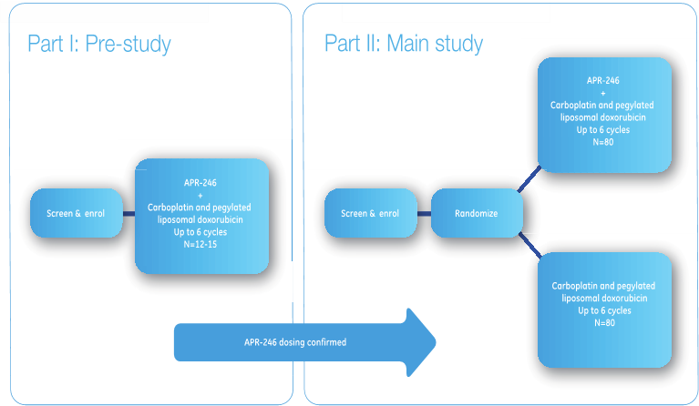

Fig. 2

Translational studies:
- A comprehensive exploratory translational science program with repeat tumor biopsies is included in the study. The key objectives are to identify potential biomarkers for patient selection and for monitoring response to treatment and to further our understanding of the MOA.
- p53 will be sequenced in tumor biopsies. Mutations will be classified structurally, and the possible correlation of treatment response with mutations and/or type of mutant p53 structure will be assessed.
- p53 will also be sequenced from circulating free tumor DNA.
- Circulating cytokeratin 18 in serum will be measured by ELISA, to follow epithelial cell death and apoptosis.
- ER stress biomarkers will be analyzed in tumor biopsies using IHC.
- Multiple markers will be studied using reverse phase protein array and mRNA microarray analyses.

Preliminary results:
- To date patients have been enrolled to all 3 dose cohorts of the Phase Ib and the patients in the first cohort have completed therapy.
- One DLT of ruptured diverticulum occurred at the 2nd dose level leading to expansion of this cohort to 6 patients.
- Main AEs have been hematological (neutropenia, thrombocytopenia), and low grade CNS related effects (dizziness, vertigo, nausea, dysgeusia). No new safety concerns have emerged (Table 1).

Table 1: Summary of Treatment-Emergent Adverse Events by System Organ Class
Safety-Evaluable (N=15)
MedDRA System Organ Class [1][2] | All TEAEs | Related  Any  Grade[3] | Any  Relationship  >=Grade 3[3] | Related  >=Grade 3[3]
Number of Patients | 15 | 15 | 15 | 15
Patients with Any TEAEs | 13 ( 86.7%) | 13 ( 86.7%) | 9 ( 60.0%) | 5 ( 33.3%)
Nervous system disorders | 12 ( 80.0%) | 10 ( 66.7%) | 0 | 0
Blood and lymphatic system disorders | 11 ( 73.3%) | 6 ( 40.0%) | 7 ( 46.7%) | 4 ( 26.7%)
General disorders and administration site conditions | 11 ( 73.3%) | 10 ( 66.7%) | 0 | 0
Gastrointestinal disorders | 10 ( 66.7%) | 9 ( 60.0%) | 2 ( 13.3%) | 1 ( 6.7%)
Infections and infestations | 8 ( 53.3%) | 1 ( 6.7%) | 4 ( 26.7%) | 0
Musculoskeletal and connective tissue disorders | 5 ( 33.3%) | 1 ( 6.7%) | 0 | 0
Respiratory, thoracic and mediastinal disorders | 4 ( 26.7%) | 0 | 0 | 0
Injury, poisoning and procedural complications | 3 ( 20.0%) | 0 | 0 | 0
Metabolism and nutrition disorders | 3 ( 20.0%) | 2 ( 13.3%) | 1 ( 6.7%) | 0
Psychiatric disorders | 2 ( 13.3%) | 0 | 0 | 0
Skin and subcutaneous tissue disorders | 2 ( 13.3%) | 0 | 0 | 0
Cardiac disorders | 1 ( 6.7%) | 0 | 0 | 0
Immune system disorders | 1 ( 6.7%) | 0 | 0 | 0
Investigations | 1 ( 6.7%) | 1 ( 6.7%) | 1 ( 6.7%) | 0
Renal and urinary disorders | 1 ( 6.7%) | 0 | 0 | 0
Reproductive system and breast disorders | 1 ( 6.7%) | 0 | 0 | 0
Vascular disorders | 1 ( 6.7%) | 1 ( 6.7%) | 0 | 0
[1] Number of Patients used as denominator to calculate percentages.
[2] Patients with multiple TEAEs were counted once within a summary category: system organ class, preferred term, maximum grade, or relationship to treatment. Patients with events in more than one category were counted once within each category. Treatment-Emergent Adverse Events (TEAEs) were defined as all AEs that occurred after the first dose of study medication or within 30 day post-treatment period.
[3] Grade: 1=Mild, 2=Moderate, 3=Severe, 4=Life-Threatening, 5=Fatal.

- APR-246 showed linear pharmacokinetics with no accumulation and low inter- and intra- patient variability (Fig. 3). No indication of interaction between APR-246 and chemotherapy was seen.

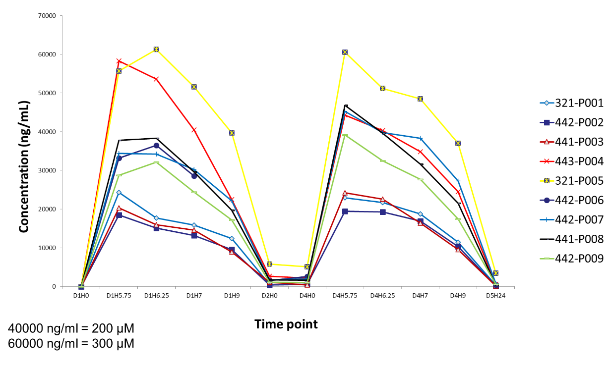
Fig. 3
- The first 3 patients have completed 6 cycles of therapy and are now in follow up. All 3 had partial response (PR) by RECIST and the 2 patients evaluable for CA125 reponse according to GCIG showed (partial = no normalization??? Of CA125??, is not clear from the figure) (Fig 3).
CA 125
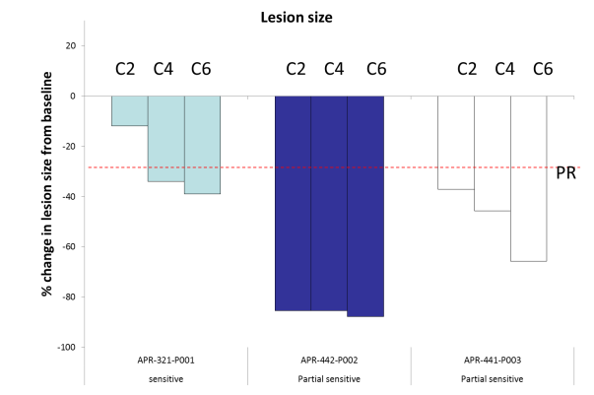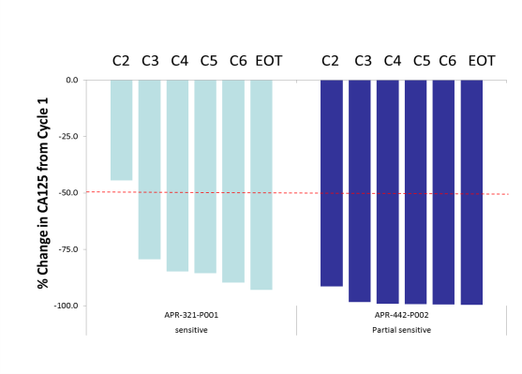

Fig. 3

Conclusions:
- Preliminary data from the PiSARRO phase Ib study indicate that APR-246 can be combined with carboplatin and PLD at relevant doses.
- A possible increase of the chemotherapy related hematological side effects cannot be ruled out at this stage.
- The preliminary efficacy data indicate that APR-246 in combination with chemotherapy has activity in patients with PFI 6-12 mo as well as with PFI 12-24 mo.
- APR-246 in combination with chemotherapy has an encouraging safety and activity profile, supporting continuation of the study in Phase II as soon as the recommended dose for phase II has been established.

References:
- Bykov VJ, Issaeva N, Shilov A, Hultcrantz M, Pugacheva E, Chumakov P, Bergman J, Wiman KG, Selivanova G. 2002. Restoration of the tumor suppressor function to mutant p53 by a low-molecular-weight compound. Nat Med. 8(3):282-8.
- Lambert JM, Gorzov P, Veprintsev DB, Söderqvist M, Segerbäck D, Bergman J, Fersht AR, Hainaut P, Wiman KG, Bykov VJ. 2009. PRIMA-1 reactivates mutant p53 by covalent binding to the core domain. Cancer Cell. 15(5):376-88.
- Mohell et al. Abstract #1801, AACR 2014
- Lambert et al. Oncogene, 2010
- http://p53.free.fr The TP53 Web Site (database)
- Ahmed AA, Etemadmoghadam D, Temple J, Lynch AG, Riad M, Sharma R, Stewart C, Fereday S, Caldas C, Defazio A, Bowtell D, Brenton JD. 2010. Driver mutations in TP53 are ubiquitous in high grade serous carcinoma of the ovary. J Pathol. 221(1):49-56.
- Reles A, Wen WH, Schmider A, Gee C, Runnebaum IB, Kilian U, Jones LA, El-Naggar A, Minguillon C, Schönborn I, Reich O, Kreienberg R, Lichtenegger W, Press MF. 2001. Correlation of p53 mutations with resistance to platinum-based chemotherapy and shortened survival in ovarian cancer. Clin Cancer Res. 7(10):2984-97.
- Pujade-Lauraine et al. JCO, 2010
- Lehmann S, Bykov VJ, Ali D, Andrén O, Cherif H, Tidefelt U, Uggla B, Yachnin J, Juliusson G, Moshfegh A, Paul C, Wiman KG, Andersson PO. 2012. Targeting p53 in vivo: a first-in-human study with p53-targeting compound APR-246 in refractory hematologic malignancies and prostate cancer. J Clin Oncol. 30(29):3633-9.

Disclosures:
The study is sponsored by Aprea AB.

