Analysis by scanning electron microscope with energy- dispersive spectrometry of a wax sample from a writing tablet.
Matthew J. Ponting, Nicola George and Juliet Spedding, Department of Archaeology, Classics and Egyptology, The University of Liverpool.

Introduction
A sample of grey wax from stylus tablet <WT108> was submitted for scanning electron microscope with energy- dispersive spectrometry (SEM-EDS) analysis at the University of Liverpool, with the aim of establishing the chemical composition of the wax and the identification of any inclusions that might be responsible for the black/grey colour of the wax observed during cleaning and conservation.
Method
The SEM used is a JEOL IT300 variable-pressure scanning microscope fitted with both secondary electron (SE) and backscattered electron (BE) detectors together with an ultra-thin window EDS detector controlled by a Thermo EDS system. The sample of wax scrapings was mounted on a metal stub and placed in the sample chamber. No coating was applied. The analysis was conducted in low vacuum mode at an accelerating voltage of 15 kV, counting for 100 secs.
Results
The flakes of wax appeared reasonably uniform and were clearly full of small, angular and plate-like inclusions, generally less than 20 micons in length (Fig. 143).
Fig. 143. BSE image of a representative region of the wax scrapings.
An energy dispersive spectrum collected from across this region revealed that the bulk composition is predominantly carbon, with a small amount of sulphur (Fig. 144).

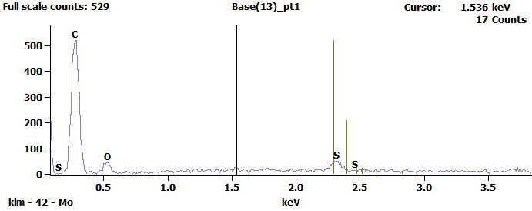
Fig. 144. EDS spectrum of the representative region of the wax scrapings.

Point analysis of individual inclusions indicates that these are carbon with a small amount of sulphur. This information, coupled with the inclusion morphology and the fact that there is no cellular structure apparent would suggest that soot was used to colour the wax. Plate-like soot particles are produced by the burning of coal and charcoal (Jonker and Koelmans 2002: 3727) and the presence of sulphur would be consistent with this.
Discussion
The use of bees-wax coloured with carbon as the writing medium in Roman writing tablets is well known (Wiseman 1955, 5) as is the use of other additives such as verdigris and, in the Ancient Middle East, the mineral orpiment (arsenic sulphide). The latter two additives would colour the wax green and yellow respectively, whilst the addition of carbon imparts a black appearance to the writing surface. The addition of carbon as soot does not appear to be reported in the available literature, but soot is well attested as a source of black pigment in antiquity and Vitruvius describes a method for the production of soot for pigment by burning resin(Vitruvius 7.10.2).
Wiseman also reports experimental work that suggests that the choice of additive also changes the properties of the wax, retarding its solidification, thereby making it easier to impress cuneiform characters. It is suggested that the addition of carbon would have a similar effect, although the implications of the difference between impressed and inscribed writing characters is not discussed.
Bibliography
Jonker, M. and Koelmans, A., 2002 ‘Sorption of polycyclic aromatic hydrocarbons and polychlorinated biphenyls to soot and soot-like materials in the aqueous environment: mechanistic considerations’, Environmental Science Technology, 36: 3725-3734.
Vitruvius, The ten books on architecture, translated by Morris Hicky Morgan (1914).
Wiseman, D., 1955 ‘Assyrian writing boards’, Iraq, 17.1: 3-13.

