A comparison of split-sleeve cold expansion in thick and thin plates
Khurram Amjad¹, Wei-Chung Wang² and Eann Patterson¹
- School of Engineering, University of Liverpool, UK
- Department of Power Mechanical Engineering, National Tsing Hua University, Taiwan, R.O.C.

Abstract
Split sleeve cold expansion is a widely used process in the aerospace industry to enhance the fatigue life of rivet holes in the aircraft structures. In the experimental investigation presented in this paper, the full-field in-plane residual strains and the out-of-plane surface deformations around open cold-expanded holes were measured using stereoscopic digital image correlation in aluminium specimens of two different thicknesses giving thickness to diameter ratios of 0.25 and 1. The results demonstrate that the mechanics of hole deformation is significantly different for the thick and thin specimens. The specimens of 1.6mm thickness underwent a combination of global bending and significant local warping during the cold expansion process. This localised warping caused a decrease in the minimum principal residual strains close to the edge of the hole, which cannot be predicted by the existing theoretical models as they do not account for the complex out-of-plane deformations which have a significant influence on the shape of the resulting residual strain profiles. In contrast, 6.35mm thick specimens did not bend globally mainly because of the higher second moment of area of their cross-sections. The material close to the hole edge bulges out from both the faces of the specimen as a result of plastic deformation during the cold expansion process and the out-of-plane deformations are much more localised and lower in magnitude in comparison to the thin specimens. The plastic zone developed around the expanded hole is more axisymmetric and larger in size for the thick specimens. These results imply that the existing split sleeve cold expansion process is not as effective in creating a uniform compressive residual elastic stress field around the fastener holes in thin as it is in the thick specimens.

¹School of Engineering, University of Liverpool, UK
²Department of Power Mechanical Engineering, National Tsing Hua University, Taiwan, R.O.C.

Corresponding author:
Khurram Amjad
School of Engineering, University of Liverpool, The Quadrangle, Brownlow Hill, Liverpool L69 3GH, UK.
Email: khurram.amjad@liverpool.ac.uk

Keywords
Split sleeve cold expansion, residual strain, digital image correlation method, cold-worked holes, fastener holes

Introduction
Thousands of holes for bolts and rivets are required for the assembly of aircraft structures. These holes act as stress concentrators and are a potential source of fatigue crack initiation. It is a routine practice in the aerospace industry to cold-work such holes to enhance the fatigue endurance of both new and existing airframes. One of the most widely used cold-working or cold expansion processes, called ‘split sleeve cold expansion’, was developed by the Boeing engineer, Champoux in the late 1960s and further developed and marketed by the Fatigue Technology Incorporated (FTI) of Seattle, USA¹. This process involves passing a hardened steel mandrel with an oversized head through an initially undersized hole to plastically expand it. Upon removal of the mandrel, the elastic material surrounding the plastically deformed material causes a spring-back effect, which creates a ring of residual compressive hoop stresses around the cold-expanded hole. The process utilises an internally lubricated, 0.25mm thick stainless steel sleeve, with a split in it, which resides on the mandrel shank. A schematic of the split sleeve cold expansion process is shown in Figure 1. The main purpose of this sleeve is to allow the cold expansion process to be carried out without access to the other side of the component; however it also avoids direct contact of the mandrel head with the internal surfaces of the hole, which minimises distortion of the hole during the expansion process. The manufacturer’s documentation¹ supports the use of the split sleeve technique for cold expansion of holes as small as t/D=0.2, where t and D are the material thickness and hole diameter respectively. However, our discussions with some sectors of the aerospace industry implied that, at these small thickness-to-diameter ratios, components were usually stacked during cold expansion to achieve a more consistent outcome. The aim of this work was to compare the in-plane residual strains and the out-of-plane deformation of holes resulting from split sleeve cold expansion, in thick and thin aerospace material.

For the past three decades, the analysis of the cold expansion process using various experimental techniques has been an active area of research for many researchers, mainly because of its importance in the design of lighter aircraft structures with enhanced structural integrity. The techniques which have been used to study the development of residual strains during cold expansion process can be categorised on the basis of the strain measured i.e. total residual strain or residual elastic strain. In both cases, ‘residual’ indicates that the strain remains locked into the material after the cold expansion process. The residual elastic strain arises from the elastic spring-back of the material around the plastic region and typically is measured non-destructively using diffraction techniques²⁻⁴ or destructively using the Sachs method ^{5&6}. Whereas, the total residual strain is the combination of the residual elastic and plastic strains resulting from elastic-plastic loading during mandrel insertion and the unloading when the mandrel is removed. This paper focuses on the measurement of total residual strains, which are usually determined by measuring the net displacement of the hole between the initial (un-deformed) and final (expanded) state. Moiré was one of the earliest full-field strain measurement techniques used to measure total residual strains resulting from cold expansion^{7 & 8}. Cloud⁷ used moiré photography to produce strain maps for various degrees of cold expansion. The cold expansion process investigated in his work utilized a solid sleeve to expand the hole which remained in place after hole expansion. Link and Sanford⁸ studied the split sleeve cold expansion process using moiré interferometry. They measured radial displacements along a line at 90° around the hole circumference from the sleeve split orientation, for various degrees of cold expansion, on both the mandrel entry and exit faces. Mandrel entry and exit faces refer to the specimen faces from which the mandrel enters or leaves the specimen respectively, during the cold expansion process. The radial displacements were differentiated with respect to the radial length to calculate radial strains. Link and Sanford reported a difference in the radial strain profiles on the mandrel entry and exit faces, which indicated the three-dimensional (3D) nature of the cold expansion process. Another full-field strain measurement technique used to study the cold expansion process is the grid method^{9 & 10}. Ball and Lowry⁹ used the grid method to measure hoop and radial total residual strains on the mandrel entry and exit faces of a 6.35mm thick aluminium alloy specimen as a result of a 5% cold expansion using a split sleeve. They did not provide information about the orientation of the radial direction along which they measured the strains. They also reported a slight difference between the magnitude of the measured strain values on the mandrel entry and exit faces. The difference was more significant for the radial strains than for the hoop strains. More recently Backman and his co-workers¹¹⁻¹³ used the digital image correlation method to measure full-field principal strain maps around cold-expanded holes in aluminium alloy and fibre metal laminate specimens. They chose stereoscopic DIC, and it was used in this investigation, because it provides data fields describing the three-dimensional deformation of the surface of components and is more robust than the techniques discussed above in providing reliable information relating to the large plastic strains at the edge of cold-worked holes. Backman et al¹¹ investigated the effect of hole-to-free-edge distance on the hoop strains around cold-expanded holes in thick (6.35mm) and thin (1.59mm) aluminium alloy specimens. It was reported that as the hole-to-free-edge distance decreased, hoop strains increased exponentially, for both the thick and thin specimens. The strains around cold-expanded holes have also been measured using strain gauges^{14 & 15}. However, strain gauges measure an average strain over their finite gauge length which makes them unsuitable for resolving strains near the hole edge, where the strain gradients are very high.

A significant amount of theoretical work has also been carried out in the past to develop closed form solutions to estimate the total residual strains and residual elastic strains developed around cold-expanded holes. All closed form solutions are based on the assumption of a circular disk with an inner radius being subjected to a uniform pressure. The analytical solutions can be classified according to whether an assumption of plane stress or plane strain is made. An early plane strain model was presented by Rich and Impellizzeri¹⁶ in 1977 who assumed elastic-perfectly plastic loading of a thick plate of finite width with elastic unloading. Subsequently, Wang¹⁷ developed a plane strain model of a thick finite-width plate with elastic non-linear strain hardening for both loading and the unloading that included the Baushinger effect. Interest in plane strain models has declined because observations from experiment showed that out-of-plane deformations were significant. Most plane stress models are based on the work of Hsu & Forman¹⁸ in the 1970s who assumed a hole was being expanded in a thin infinite-wide plate of material represented by an elastic non-linear strain hardening model with elastic behaviour on unloading. In the 1990s, Ball¹⁹ extended this model by assuming elastic non-linear strain hardening with the Baushinger effect present during spring-back. Wanlin²⁰ made the same change to modelling of the spring-back behaviour but considered a plate of finite width; however in 2005 Zhang et al²¹ recast the model by Wanlin to include an explicit solution of the unloading step. This model takes into account the elastic-plastic loading upon mandrel insertion and also addresses the development of a reverse yielding zone around the hole edge, due to the spring-back effect, upon mandrel removal. The investigation presented in this paper pays particular attention to the analysis of the total residual strain field around the region of the split in the sleeve in order to determine the extent to which the expansion deviates from these assumptions.

Experimental procedures

Split sleeve cold expansion
Rectangular coupons, with the geometry shown in Figure 2, were manufactured with a central hole from two aluminium alloy sheets of different thicknesses. Thin specimens were machined from a 1.6mm thick 2024-T3 aluminium sheet and thick ones from a 6.35mm thick 2024-T351 aluminium sheet. The mechanical properties for the two sheet materials provided in Table 1 were determined by performing tensile tests conforming to the ASTM standards^{22 & 23}. All the specimens were 38mm (1.5in) wide and 203mm (8in) long. A central hole was drilled and reamed to a final diameter of 6.36mm in all the specimens giving a thickness-to-diameter ratio of 0.25 and 1. The cold expansion was performed using a hardened steel mandrel (CBM-8-1-N-1-40-V1, FTI, Seattle USA) mounted on a manual puller unit (HP-20, FTI, Seattle, USA). The combination of the oversized mandrel head and size 8-1-N split sleeve (FTI, Seattle, USA) provided a total interference of approximately 4.6%. The nominal diameter of the cold-expanded hole was measured to be 6.58mm, providing a retained expansion of 3.6%.

Four split sleeve cold expansion experiments were performed. In the first two experiments, surface deformations were measured on the mandrel entry face for a thick and a thin specimen. In the final two experiments, surface deformations on the mandrel exit face were measured in a second pair of thin and thick specimens. In all of these experiments, the split in the sleeve was orientated along the longitudinal axis of the specimen, i.e. the 3 o’clock direction in Figure 2.

Table 1. Mechanical properties of the two aluminium sheet materials.

 | 0.2% proof stress  (MPa) | Tensile strength (MPa) | Elastic modulus (GPa) | Elongation (%) | Ramberg-Osgood strain hardening parameter, n
1.6mm 2024-T3 rolling direction | 340±11 | 483±3 | 68.8±4.0 | 17.0±1.3 | 7.75±0.20
1.6mm 2024-T3 transverse direction | 310±5 | 465±2 | 64.5±2.2 | 18.3±0.7 | 7.15±0.18
6.35mm 2024-T351 rolling direction | 315±6 | 506±7 | 73.5±2.7 | 19.3±2.1 | 7.40±0.15
6.35mm 2024-T351 transverse direction | 298±10 | 484±4 | 69.3±2.1 | 20.7±1.9 | 6.19±0.26

Measurement of surface deformations using digital image correlation
The digital image correlation (DIC) method is a non-contact optical technique used for full-field shape and deformation measurements. Sutton et al²⁴ have described a detailed methodology for the implementation of the DIC method for full-field displacement measurement. In this investigation, the area of interest around the hole was painted with white paint (Plasti-kote matt white) before being speckled black (CRC Pro-Matt black) and then images of the region around the hole were captured by a stereo-vision system (Dantec Dynamics, Germany) during the cold expansion process. The optical setup comprised of two identical digital cameras (Guppy PRO F-125, Allied Vision Technologies, Germany) with resolutions of 1292×964 pixels, mounted with an identical pair of 50mm focal length lenses (Schneider Kreuznach, Germany). Two LED light arrays (Dantec Dynamics, Germany) were used to illuminate the specimen surface. The cameras, mounted on a tripod, were positioned at a working distance of approximately 300mm from the specimen surface, providing an effective field of view of about 24mm×19mm and a spatial resolution of 0.019 mm/pixel. Figure 3 shows the optical setups for measuring surface deformations around cold-expanded holes on the mandrel entry and the exit faces. To capture data on the mandrel exit face, the specimen and mandrel were reversed so that the optical set-up did not need to be disturbed. The images, captured by the stereo-vision system, were processed by the DIC software, Istra (Dantec Dynamics, Germany) to evaluate displacement fields and in-plane residual strains around the cold-expanded holes.
Sutton et al²⁵ have highlighted the importance of the speckle pattern, facet size and the strain evaluation method in determining strain distributions and hence the influence of these parameters in making measurements around cold-expanded holes was investigated and is reported in the Appendix. As a consequence, the results presented in Figures 4 to 10, were obtained by performing image correlation with a facet size of 47 pixels, a grid spacing of 5 pixels and the strains were evaluated using the facet distortion method²⁶.

Results and Discussion
The principal strain maps on the mandrel entry and exit faces of the thin and thick specimens are presented in Figure 4. A difference can be observed between the principal strain fields on the mandrel entry and exit faces, which indicates that the strain fields vary through the thickness of the specimen. In figures 5 and 6, the distributions of in-plane principal strains along radial lines are plotted along with the theoretical distributions for the thin and thick specimens respectively. The theoretical strain distributions were obtained by implementing the axisymmetric hole expansion model of Zhang et al²¹ using the mechanical properties provided in Table 1.The axisymmetric assumption of the theory implies that the maximum and minimum principal strains correspond to the hoop and radial strains respectively. It is evident from the experimental data in Figure 4 that the split sleeve cold expansion is not axisymmetric about the hole center but there is symmetry about the longitudinal axis of the specimens which coincides with the location of the split in the sleeve. The peak strains are observed for the radial lines at approximately ±45° from the location of the split sleeve, which are close to the edges of the region influenced by the split in the sleeve during the expansion process. The magnitude of strain distributions decreases circumferentially away from the edges of the split to a minimum at 0° or 180° from the split. This trend is more apparent in the strain profiles for the thin specimens. In both cases, the magnitudes of the principal strains are low along the radial line emanating at the location of the split, which seems to imply that the expansion of hole is less at this location causing a break in the strain distribution around the hole that can also be observed in the principal strain maps in Figure 4. The distributions of minimum principal strain for the thin specimens in figure 5 exhibit a reduction in gradient close to the hole edge which is not present in the data for the thick specimens in figure 6 and appears to be indicative of a maximum close to the edge of the hole. This behaviour is unexpected because it has not been reported in previous experimental investigations and the theoretical model predicts a very rapid increase in strain close to the hole edge.

The hole region between the edges of the split in the sleeve expands as a result of the direct contact of the mandrel head with the internal edge of the hole, which will likely cause material to be 'dragged' through the hole axially rather than expanded radially and circumferentially. This region is expected to be demarcated by a pair of boundaries extending along radial lines that approximately subtend the angle enclosed by edges of the split during hole expansion (see Figure 7). The influence of the split in the sleeve on the overall hole deformation was examined by plotting the shear strains in polar coordinates on the entry face along radial lines at angles between 0° and 50° from the location of the split, in Figure 8. Distinct turning points in distribution of shear strain along the radial lines at 20º and 30º from the location of the split imply that these radial lines intersect with the boundary separating the two distinct deformation regimes. Also, the shear strains are higher along the radial lines at angles between 10º - 30º providing further evidence that the hole expansion deviates from an axisymmetric expansion close to the location of the split in the sleeve. It has been reported in an earlier investigation⁵ that the residual elastic stress distributions along the 0º radial line which corresponds to the position of the split in the sleeve, were significantly different in shape and less compressive in magnitude close to the hole edge in comparison to the distributions along a radial line at 90°. The results in Figure 8 highlight that the split in the sleeve influences the expansion of the hole over a much wider angular range, i.e. -30 º to +30 º and therefore the residual elastic stress distributions developed in this region are expected to be significantly different from the theoretical predictions.

The size of the plastic zone developed around the cold-expanded hole is an indication of the effectiveness of cold expansion process. The development of a larger plastic zone during hole expansion results in a higher spring-back force from the elastic material surrounding the plastically deformed material, thus creating a more compressive residual elastic stress field. Polar plots of the radius of the plastic zone around the cold-expanded hole are presented in Figure 8 and represent the shape of the plastic zone. They were obtained by calculating the von Mises stress, or equivalent tensile stress²⁷, along radial lines at 20º increments around the hole and identifying the radius of the plastic zone as where the von Mises stress was equal to the yield stress, based on the mechanical properties in Table 1. For thin specimens, the plastic zone shape on the mandrel entry and exit faces exhibits a high level of deviation from axisymmetry about the hole centre. On the other hand, on both the entry and exit face in the thick specimens, the plastic zone is more axisymmetric and overall larger in size compared to the thin specimens. The plastic zone on the exit face is consistently slightly larger than on the entry face, which implies that the residual elastic stresses will be higher on the exit face. Several earlier investigations have reported this trend of higher compressive stresses on the mandrel exit face based on data from either the destructive Sachs method⁶ or non-destructive x-ray diffraction technique²⁻⁴. It is pertinent to mention here that the size of the plastic zone developed around the expanded hole for identical specimen geometry and hole expansion level depends on the material properties of the specimen. The material properties provided in Table 1 for the two types of specimens are very similar and there is a negligible difference in the size of theoretical plastic zones for the thin and the thick specimens, presented in Figure 9.

The measured out-of-plane displacements on the mandrel entry and exit faces have been plotted in Figure 10. The direction of positive out-of-plane displacement corresponds to the direction of travel of the mandrel. These out-of-plane displacement fields can be considered to be a combination of a global deformation field caused by the pull-force exerted on the mandrel and a local deformation field close to the hole edge associated with expansion of the hole. The data in Figure 10 implies that the thin specimens undergo localised warping close to the edge of the hole with large positive out-of-plane displacement at the location of the split in the sleeve and smaller out-of-plane deformations on the opposite side of the hole. There is also evidence of global out-of-plane bending of the specimen which is more severe in the vicinity of the split in the sleeve. It is postulated that the decrease in the gradient of the minimum principal strain close to the edge of the hole in thin specimen (see Figure 5) is caused by this local warping i.e. the hole edge being pushed in by the mandrel pulling on the ends of the split in the sleeve at the 0° orientation and slightly pushed out on the opposite side of the hole at the 180° orientation. By contrast, in the thick specimens the surface locally bulges out from both the mandrel entry and the exit faces as a result of plastic deformation of the material around the circumference of the hole during its expansion with negligible global bending of the specimen. The magnitude of this bulge or out-of-plane expansion is higher on the mandrel exit face but overall the localised out-of-plane deformations are lower for the thick specimens, which can be attributed to its higher second moment of area of its cross-section. These results highlight that the mechanics of hole expansion is entirely different for the thick and the thin specimens and the hole expansion in thin specimens deviates significantly from the ideal case of in-plane and axisymmetric radial expansion of the hole. These findings are important in the development of both analytical and numerical models of the cold expansion process that have traditionally utilised assumptions of in-plane stress and axisymmetry.

Conclusions
An experimental investigation has been conducted using the stereoscopic digital image correlation (DIC) method to analyse the surface deformations resulting from the split-sleeve cold expansion process applied to aluminium specimens of two different thickness-to-diameter ratios. The thin specimens underwent a combination of global bending and significant localised warping during the cold expansion process. Close to the edge of the hole, this localised warping caused a reduction in the gradient of the minimum principal strains along radial lines emanating from the centre of the hole. In the thin specimens, the plastic zone developed around the expanded hole was not axisymmetric in shape and there was a significant difference between the size of plastic zones on the mandrel entry and the exit faces at the location of split in the sleeve. On the other hand in the thick specimens, the out-of-plane deformations were much more localised and lower in magnitude compared to the thin specimens. The plastic zone developed around the expanded hole was more uniform about the hole axis and overall larger in size for the thick specimens. This implies that the split sleeve cold expansion is more effective in creating a uniform and more compressive residual elastic stress field in thick specimens than in thin ones. The results clearly demonstrate that the mechanics of hole deformation is significantly different for the thick and the thin specimens.

The theoretical strain predictions did not correlate with the measured strain profiles for either the thicknesses of specimens. This was thought to be primarily due to the assumption of expansion due a uniform pressure in the existing theoretical models that also do not account for the complex out-of-plane deformations which have been observed during cold expansion with a split sleeve and mandrel and are believed to have a significant influence on the residual strain distributions.

The thin specimens used in this investigation were equivalent in thickness to sheet material commonly used in an aircraft fuselage or wing skins and the results indicate that there is a need to review the use of cold expansion processes using a split sleeve and mandrel for holes in thin sheets.

Appendix

Influence of speckle pattern, correlation parameters and strain evaluation method
The DIC algorithm works effectively when each facet in the reference image is statistically unique in terms of its distribution of grey level intensity. In addition, for an accurate displacement or strain measurement, it is important to determine the optimum facet size for minimum correlation uncertainty and in turn this depends on the speckle pattern. Sutton et al²⁵ simplified the selection of a suitable speckle pattern and facet size by providing two rules of thumb (i) image plane speckles should cover an array of at least 3 by 3 pixels and (ii) each facet should contain at least 3 by 3 speckles. Christopher et al²⁸ used a Grey Level Co-occurrence Matrix (GLCM) to determine quantitatively the characteristics of a suitable speckle pattern and proposed that the facet should be approximately 3 times bigger than the critical GLCM offset. While Pan et al²⁹ proposed that the measured displacement uncertainties are related to the mean intensity gradient of the speckle and a suitable speckle pattern possesses a higher value of mean intensity gradient.

A brief investigation was carried out to study the effect of different speckle patterns on evaluated strains around cold-expanded holes. The GLCM approach defined by Christopher et al²⁸ and the mean intensity gradient defined by Pan et al²⁹ were used for the quantitative analysis of the speckle patterns. Three specimens machined from a thin aluminium sheet were painted with a matt white base. A different black paint was used to generate the speckles on each specimen. A matt black paint (CRC Pro Matt Black) was sprayed onto specimen A using the spray can in which it was supplied. While an airbrush (AZTEK A7778, Testors Corp, USA) was used to apply Tamiya Model Matt Black paint to specimen B and Vallejo Model Air Black paint to specimen C. Figure 11 shows the reference images of the three speckle patterns and their corresponding grey-level intensity histograms. The evaluated values of the critical GLCM offset, nominal GLCM contrast and the mean intensity gradients for the three speckle patterns are provided in Table 2.

Cold expansion of the holes was performed on these three specimens and the images of the region around the hole on the mandrel entry face were captured using the stereo-vision setup described above. The image correlation was performed with a facet size of 21 pixels and grid spacing of 5 pixels using the Istra software. Istra utilises a second order displacement function (shape function) to locate and map each facet to its distorted shape. The resultant coefficients of the shape function, representing the first order displacement gradients of a distorted facet, can be directly used to evaluate strains. This method of evaluating strains directly from the shape function coefficients will be referred to as the facet distortion method and is used by Istra if no smoothing filter is used²⁶. Maps of the in-plane maximum and minimum principal strain on the mandrel entry face, evaluated using the facet distortion method, and their corresponding normalized uncertainty maps are shown in Figure 12 for the three specimens. The normalization was performed by dividing the uncertainty values from the Istra software by the corresponding values of evaluated strain.

Figure 12 clearly shows that the uncertainties in the evaluated principal strains were lowest for the speckle pattern produced using a spray can on specimen A, which also has the highest mean intensity gradient (see Table 2). This reinforces the conclusions reported by Pan et al²⁹ that suitable speckle patterns possess higher mean intensity gradients. Christopher et al²⁸ proposed that an optimum speckle pattern possesses a low critical GLCM offset and high nominal GLCM contrast but they did not comment on which of these parameters has a greater influence on the DIC measurements. Specimen A had the highest nominal GLCM contrast but its critical GLCM offset was also slightly higher than the other two specimens. On the basis of these quantitative measures it was concluded that the speckle pattern obtained using the spray can (specimen A) was the most suitable for DIC measurements. The reason for its better performance is probably related to its relatively broad and flat intensity histogram in Figure 11.

Table 2. Comparison of the critical GLCM offset, nominal GLCM contrast and the mean intensity gradient for the three speckle patterns.
 | Specimen A | Specimen B | Specimen C
Critical GLCM offset (pixels) | 12 | 8 | 9
Nominal GLCM contrast | 6000 | 1480 | 680
Mean intensity gradient | 21.4 | 10.1 | 16.1

In order to analyse the effect of the facet size and the strain evaluation method on the evaluated principal strains around the cold-expanded hole, displacements were computed by performing image correlation with the images from specimen A using facet sizes of 21 and 47 pixels with the grid spacing fixed at 5 pixels. The maximum (P1) and the minimum (P2) principal strains were evaluated from the computed displacement data by applying both the facet distortion and the more commonly applied point-wise least squares method proposed by Pan et al^{30 & 31}. Pan et al recommended a strain window between 11×11 and 21×21 points. However, to reduce the risk of over-smoothing of the displacement data, in particular close to the hole edge, a smaller strain window size of 9×9 points was employed. For a quantitative comparison, radial line profiles of maximum and minimum principal strains along three radial lines at +45°,+90° & + 135° from the split in the sleeve have been plotted in Figure 13. These angles were selected to provide exemplar profiles containing high, intermediate and low strain gradients. The strain profiles obtained from the facet distortion method for a facet size of 21 pixels are noisier than those from the point-wise least squares method and in the latter case there appears to be some significant loss of strain resolution close to the hole edge. However, with a facet size of 47pixels, both the facet distortion and the point-wise least squares method provide very similar results with an apparent loss of resolution close the hole edge compared to the results obtained with the smaller facets using the facet distortion method.

References
1. FTI Process Specification 8101J (2014) Cold Expansion of Holes Using the Standard Split Sleeve System and Countersink Cold Expansion. Fatigue Technology Inc. Available at: http://www.fatiguetech.com
2. Lacarac, V.D., Smith, D.J. and Pavier, M.J., The effect of cold expansion on fatigue crack growth from open holes at room and high temperature. Int. J. Fatigue, 2001, 23, 161-170.
3. Stefanescu, D. Experimental study of double cold expansion of holes. J. Strain Analysis, 2003, 38, 339-347.
4. Pina, J.C.P., Dias, A.M., De Matos, P.F.P., Moreira, P.M.G.P. and De Castro, P.M.S.T., Residual stress analysis near a cold expanded hole in a textured alclad sheet using X-ray diffraction. Exp Mech., 2005, 45, 83-88.
5. Özdemir, A.T., and Edwards, L., Measurement of the three-dimensional residual stress distribution around split-sleeve cold-expanded holes. J. Strain Analysis, 1996, 31, 413-421.
6. Özdemir, A.T. and Edwards, L., Relaxation of residual stresses at cold-worked fastener holes due to fatigue loading. Fatigue Fract. Engng. Maters. Struct.., 1997, 20, 1443-1451.
7. Cloud, G.L., Measurement of strain fields near coldworked holes. Exp. Mech., 1980, 20, 9-16.
8. Link, R. and Sanford, R., Residual strains surrounding split-sleeve cold expanded holes in 7075-T651 aluminium. J. Aircraft, 1990, 27, 599-604.
9. Ball, D. and Lowry, D., Experimental investigation on the effects of cold expansion of fastener holes. Fatigue Fract. Engng. M.aters. Struct., 1998, 21, 17-34.
10. Heller, M., Jones, R. and Williams, J., Analysis of cold-expansion for cracked and uncracked fastener holes. Eng. Frac. Mech., 1991, 39, 195-212.
11. Backman, D., Liao, M., Crichlow, L., Yanishevsky, M. and Patterson, E.A., The use of digital image correlation in a parametric study on the effect of edge distance and thickness on residual strains after hole cold expansion. J. Strain Analysis, 2008, 43, 781-789.
12. Backman, D., Cowan, C. & Patterson, E.A., Analysis of the effects of cold expansion of holes using thermoelasticity and image correlation, Fatigue & Fract. Engng. Maters. Structures, 2010, 33(12):809-821.
13. Backman, D. and Patterson, E.A., Effect of cold working on crack growth from holes in fiber metal laminates. Exp. Mech., 2012, 52, 1033-45.
14. Arora, P., Dattaguru, B. and Hande, H.S., A method for estimation of the radius of elastic-plastic boundary around cold-worked holes. J. Test Eval., 1992, 20, 369-75.
15. O'Brien, E., Beneficial residual stress from the cold expansion of large holes in thick light alloy plate. J. Strain Analysis, 2000, 35, 261-276.
16. Rich, D.L. and Impellizzeri, L., Fatigue analysis of cold-worked and interference fit fastener holes. ASTM special technical publication, 1977, 637, 153-75.
17. Wang, G.S., An elastic-plastic solution for a normally loaded center hole in a finite circular body. Int. J. Pres. Ves. & Piping, 1988, 33, 269-284.
18. Hsu, Y.C. and Forman, R.G., Elastic-plastic analysis of an infinite sheet having a circular hole under pressure. J. Appl. Mech., 1975, 42, 347-352.
19. Ball, D.L., ELASTIC‐PLASTIC STRESS ANALYSIS OF COLD EXPANDED FASTENER HOLES. Fatigue Fract. Eng. M., 1995, 18, 47-63.
20. Wanlin, G., Elastic-plastic analysis of a finite sheet with a cold-worked hole. Eng Fract Mech., 1993 46, 465-472.
21. Zhang, Y., Fitzpatrick, M. and Edwards, L., Analysis of the Residual Stress around a Cold‐expanded Fastener Hole in a Finite Plate. Strain, 2005, 41, 59-70.
22. Standard AS. E8/E8M (2011) Standard Test Methods for Tension Testing of Metallic Materials. ASTM international. Available at: http://www.astm.org
23. Standard AS. E646-07 (2007) Standard Test Method for Tensile Strain-Hardening Exponents (n -Values) of Metallic Sheet Materials. ASTM international. Available at: http://www.astm.org
24. Sutton, M., Wolters, W., Peters, W., Ranson, W. and McNeill, S., Determination of displacements using an improved digital correlation method. Image Vision Comput., 1983, 1, 133-139.
25. Schreier, H., Orteu J-J. and Sutton, M.A., Image correlation for shape, motion and deformation measurements. Springer US, 2009.
26. ISTRA 4D 2.4.0 (2012) Software Manual Q-400 System. Dantec Dynamics.
27. Boresi, A.P. and Schmidt, R.J., Advanced Mechanics of Materials. John Wiley & Sons, Inc.: New York, NY, 2003.
28. Lane, C., Burguete, R.L. and Shterenlikht, A., An objective criterion for the selection of an optimum DIC pattern and subset size. Proceedings of the XIth International Congress and Exposition, 2008, 1-9.
29. Pan, B., Lu, Z. and Xie, H., Mean intensity gradient: an effective global parameter for quality assessment of the speckle patterns used in digital image correlation. Opt. Laser Eng., 2010, 48, 469-477.
30. Pan, B., Xie, H., Guo, Z. and Hua, T., Full-field strain measurement using a two-dimensional Savitzky-Golay digital differentiator in digital image correlation. Opt. Eng., 2007, 46, 033601.
31. Pan, B., Asundi, A., Xie, H. and Gao, J., Digital image correlation using iterative least squares and pointwise least squares for displacement field and strain field measurements. Opt Laser Eng., 2009, 47, 865-874.

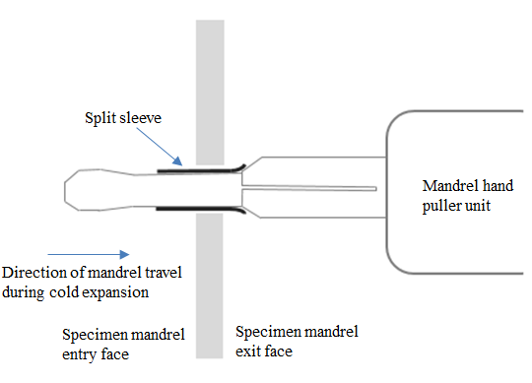

Figure 1. Schematic of split sleeve cold expansion.

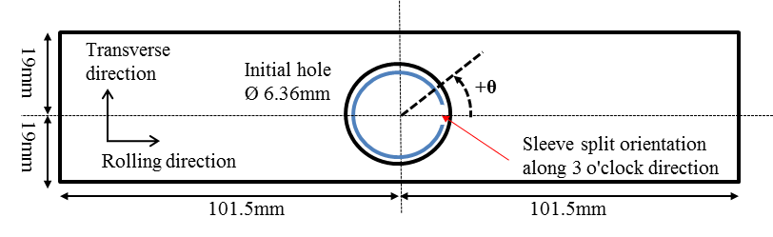
Figure 2. Dimensions of Aluminium specimens (not to scale).
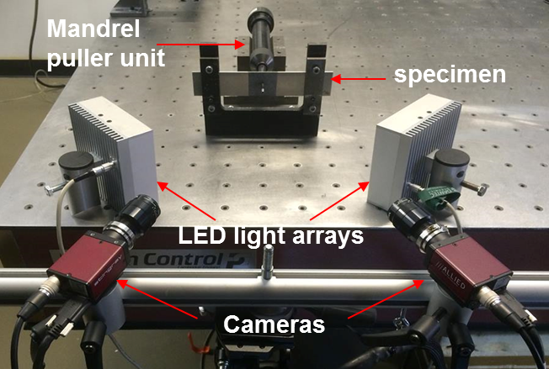
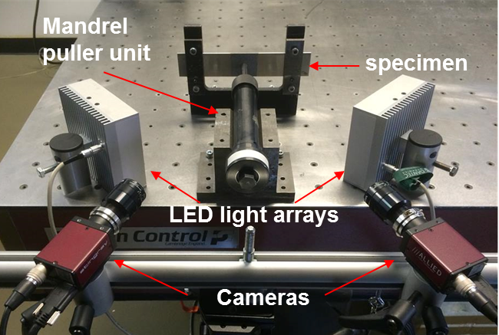
Figure 3. Stereo-vision setup for measuring surface deformations on mandrel entry face (top) and exit face (bottom) of the specimen.
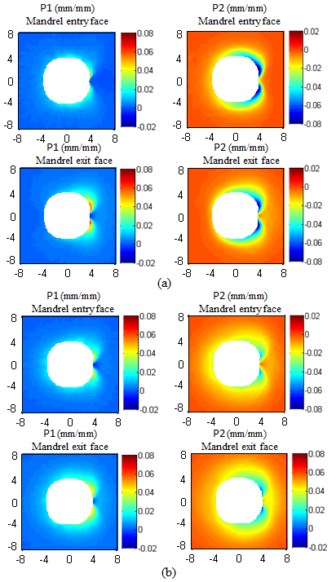
Figure 4. Comparison between the in-plane principal strain fields on the mandrel entry and exit faces for (a) 1.6mm thick specimen and (b) 6.35mm thick specimen. The spatial dimensions are in mm.
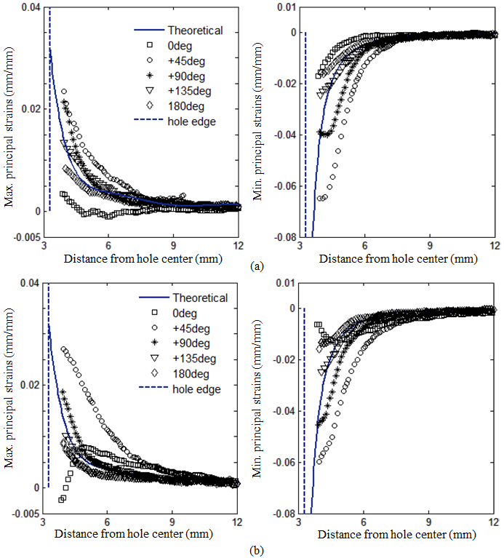
Figure 5. In-plane maximum and minimum principal strains along radial lines from the centre of the hole on (a) the entry face and (b) the exit face for 1.6mm thick specimens.
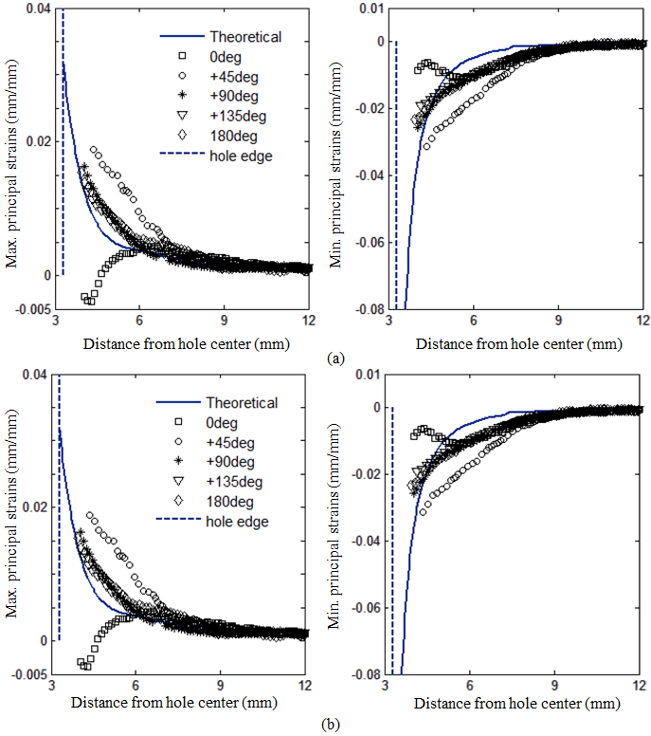
Figure 6. In-plane maximum and minimum principal strains along radial lines from the centre of the hole on (a) the entry face and (b) the exit face for 6.35mm thick specimens.

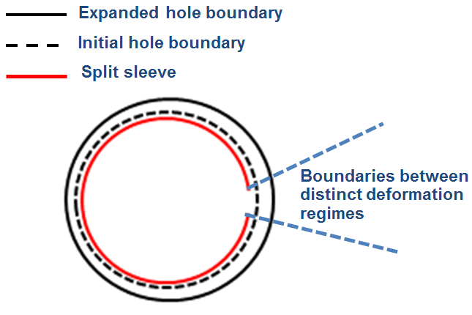
Figure 7. Schematic diagram of the influence of the edges of the split in the sleeve on the hole deformation.

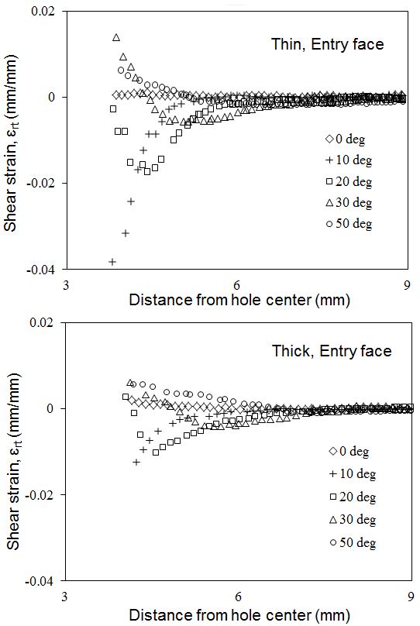

Figure 8. Shear strain components in polar coordinates on the entry face along radial lines from the centre of the hole close to the location of the split in sleeve for 1.6mm thick specimen (top) and 6.35mm thick specimen (bottom).
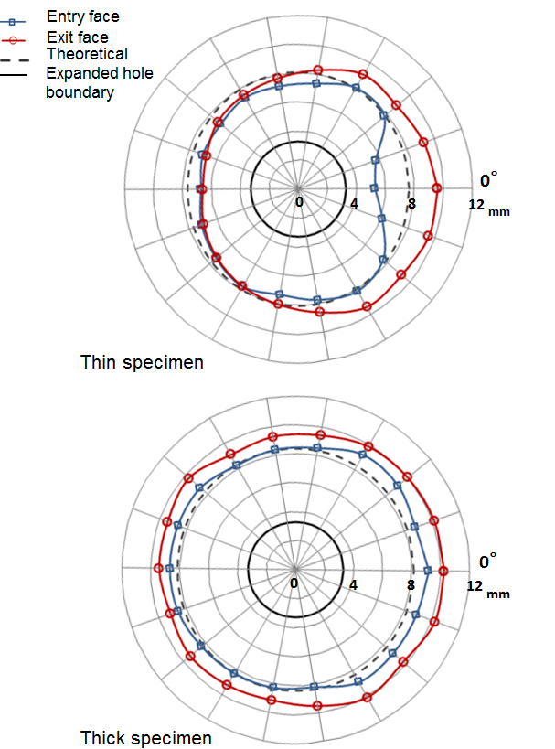
Figure 9. Plots of the shape of the plastic zone for 1.6mm thick specimen (top) and 6.35mm thick specimen (bottom).

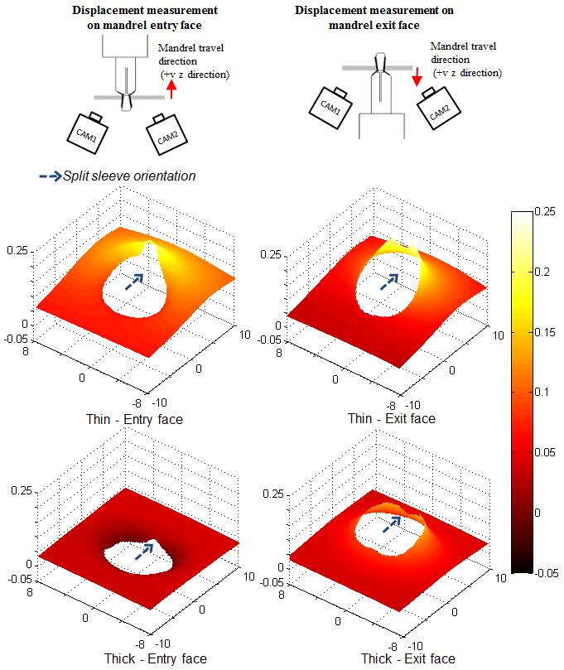
Figure 10. Comparison of the out-of-plane displacement fields on the mandrel entry and exit faces for the thin and thick specimens. All dimensions are in mm.
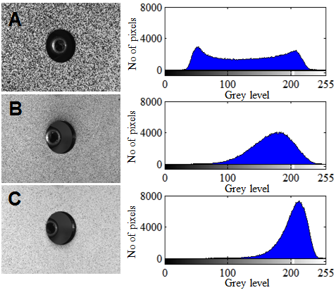
Figure 11. Reference images (left) and corresponding intensity histograms (right) for random speckle patterns produced on specimens A, B and C respectively using CRC Pro Matt black paint in a spray can (top), Tamiya Matt black paint (middle) and Vallejo Model Air black paint (bottom) applied with an airbrush.

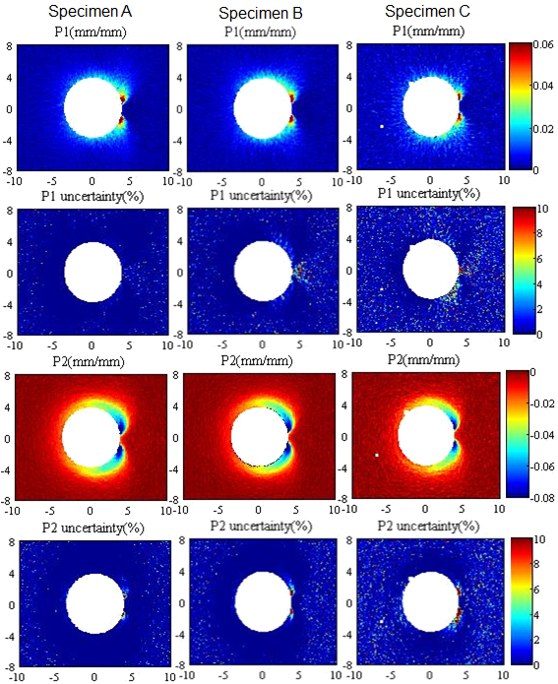
Figure 12. Comparison of normalized uncertainties in the in-plane maximum and minimum principal strains for the speckle patterns applied using the CRC, Tamiya and Vallejo paint as in figure 11. All spatial dimensions are in mm.

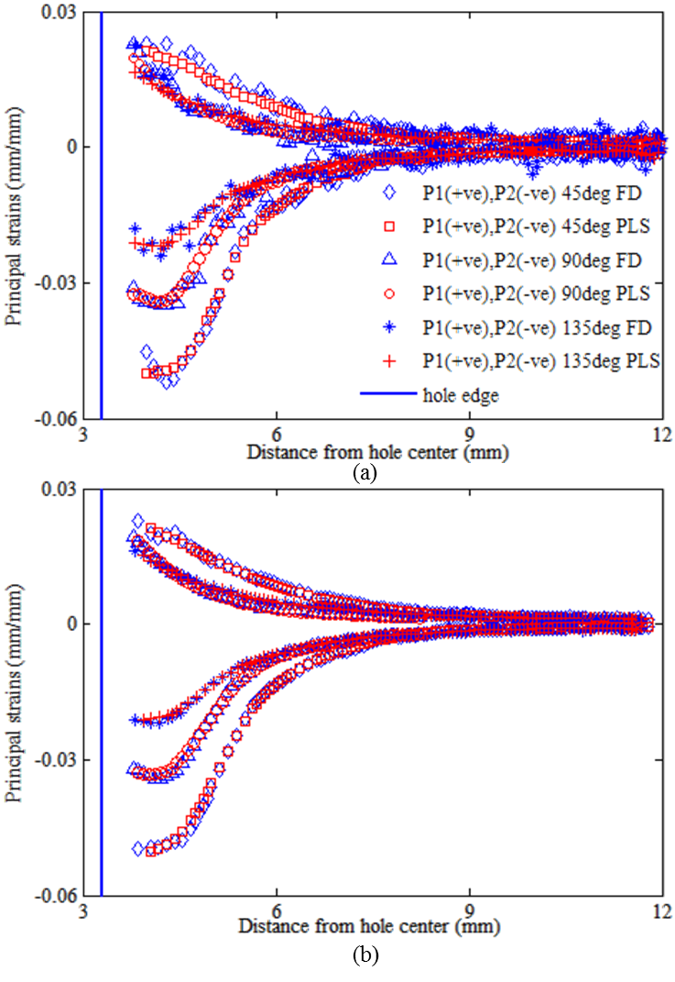
Figure 13. In-plane maximum and minimum principal strains along radial lines from centre of holes obtained using the Facet Distortion (FD) and the Point-wise Least Squares (PLS) method for facet sizes of (a) 21 pixels and (b) 47 pixels.

