The Reforms of Trajan and the End of the pre-Neronian Denarius

Kevin Butcher and Matthew Ponting

While numismatists habitually attribute the creation of Roman imperial coinage to Augustus, it is quite clear that Nero’s role in establishing a stable currency has been understated or completely misunderstood. It was the Neronian aureus and denarius standards, and not the Augustan, that persisted through the first and second centuries. As far as the precious metal issues are concerned, the Neronian coinage marked the beginning of a new era. Subsequent emperors continued to maintain these standards (with one or two exceptions), including Trajan, who is often credited with a major debasement of the denarius.

The reforms introduced by Nero between c. AD 63 and 65 saw the opening of a mint at Rome for striking gold and silver on new weight standards. These standards were lower than those used prior to AD 63-65. The denarius was also issued on a lower standard of fineness, with the addition of about 20% copper. Taken together, the reduction in fineness and weight of the denarius represented about a 25% reduction in the silver content compared with denarii produced just prior to the reforms. This is usually seen as a symptom of Nero’s alleged financial difficulties, and the debasement of the denarius is treated as the first stage in a series of adulterations of the Augustan coinage, rather than the creation of an entirely new coinage.

Several features of Nero’s new denarius coinage had previously gone unnoticed until revealed by our series of analyses. The first was that Nero had instituted a second reform in about AD 68, towards the end of his reign. The new weight for the denarius was maintained, but the fineness was raised, from about 80% to 90% silver. It is not clear why this was done, although public dissatisfaction with the coinage at 80% fine is a possibility.

The second feature worthy of note is that the silver used for virtually all of the reformed coinage appears to have been recycled. It is likely, though not yet proved, that the resource being used was old Republican denarii. Hoards indicate that at the time of Nero the majority of silver coins available were Republican issues, and that those of Augustus and his successors formed a relatively small component of the denarius coinage in use. The success of the Neronian reforms may have depended on the removal of this enormous volume of older, finer coinage. Nero was unable to complete such a huge task within the four or five years between his reforms and his death, but analysis of the coinage of his successors suggests that his policy of recycling continued.

It was the short-lived usurper Otho (AD 69) who returned the silver content of the denarius back to 80% from 90%, possibly because he was short of funds. His successors Vitellius (AD 69), Vespasian (AD 69-79) and Titus (AD 79-81) continued to use the Neronian weight and fineness of 80%. As is well known, in AD 82 Domitian returned the denarius to a pure silver coin (though he did not return to a pre-Neronian weight standard). This experiment does not seem to have been a success, and in AD 85 Domitian reverted to Nero’s 90% standard. His reasons for experimenting with a pure silver denarius remain obscure; it is possible that he was a convinced metallist who wanted to improve the quality of the Neronian coinage, but found the production costs too high and was forced to abandon the scheme (the evidence of the trace elements from our analyses indicates that Domitian continued to recycle old coins). The fact that he also adjusted the weight of the gold coinage at the same time suggests that he may have been attempting to modify the Neronian coinage because, in his view, the system was not working properly. Perhaps the public preferred to retain older, finer coins and this led to an unofficial discrepancy between the value of pre- and post-Neronian reform denarii. That old Republican coinage was still present in large quantities is apparent from hoards of the Flavian period, although there are signs that after Domitian reverted to the 90% standard the quantities of Republican denarii began to diminish. We may wonder whether this signifies the beginning of a concerted attempt to eliminate all pre-Neronian reform denarii from the Roman world.

In AD 99-100 Trajan abandoned Domitian’s 90% standard and returned the denarius to 80% fine. This reform was long misdated to AD 107 and thought to coincide with a withdrawal of obsolete coinage mentioned in a statement in Xiphilinus’ epitome of Cassius Dio and which has traditionally been placed among the events of that year. It was further noted that Trajan issued a rare series of coins that restored old Republican and imperial coins. All three elements seemed to be part of an integrated plan, undertaken for financial motives: the finer Republican and early imperial coins were recalled; then the denarius was debased so that the state could profit; and then ‘restored’ coins were produced to commemorate the coins that had been removed and to reassure the public that nothing underhand had occurred. Proof that the reforms were undertaken for profit was offered by Theodor Mommsen in 1867: he noted that one type of Republican denarius, the legionary denarius issued by Mark Antony, had survived the Trajanic recall, whereas all other Republican denarii seemed to disappear from hoards by the time of Hadrian (AD 117-138). That the Antony denarii were debased seems to have been common knowledge. These had not been profitable to recycle, and therefore they were left untouched. Had the aim been simply to remove obsolete coins, as Cassius Dio seems to claim, the Antony denarii should have been removed along with the rest.

The discovery that the debasement of the denarius back to 80% dates to AD 99-100 and not AD 107 upsets what was once a comfortable scheme, and casts doubt upon the profit motive as the sole explanation for what was happening under Trajan. Furthermore, it has been observed that Mark Antony’s legionary denarii, which seem to have been abundant in Flavian hoards from peninsular Italy, vanish from hoards in that region after Trajan, and are in fact quite rare in hoards in other parts of the empire for much of the second century. If this observation is correct, it is possible that the Antony denarii also went into the melting pot along with other Republican coins, and that their lower silver content was no obstacle to their removal. Cassius Dio may have been recounting a real motive for the elimination of Republican denarii when he said that Trajan removed coinage because it was obsolete.

The hoard evidence leaves little doubt that a major change took place in this period. Republican coins are still present in some quantity in Flavian hoards, but under Trajan and Hadrian they disappear. No other comprehensive removal of denarii had ever taken place on such a scale, and it must represent a considerable commitment by the state to renew the coinage.

Can a study of the trace element profile of Trajan’s denarii shed any light on these events? In an earlier article we noted that the denarii of Trajan’s successor Hadrian were produced from an entirely different source when compared with the denarii of Nero and his successors down to Domitian. Those of Nero to Domitian had been made from recycled materials, whereas those of Hadrian seem to have been produced from a new metal source. The question of whether this change took place at the beginning of Hadrian’s reign, or whether it occurred under Trajan, is one that we aim to examine here.

Analysis
A total of 330 silver denarii covering the reigns of Nerva, Trajan and Hadrian were analysed as part of a continuing project to investigate the composition of Roman silver coinage:

 | Number analysed | Mean silver bullion (Wt. %) | Standard deviation
Nerva | 52 | 89.7% | 3.6
Trajan pre-reform | 31 | 89.2% | 4.4
Trajan post-reform | 165 | 80.9% | 5.4
Hadrian | 82 | 75.9% | 3.2

In addition to the important changes to the silver bullion content there is evidence for a change in the source/s of the silver bullion itself. This was first presented in our 1998 paper where we compared coins of Trajan’s second and fifth Consulship and is re-presented here with additional data including coins from Trajan’s fourth and sixth Consulship.

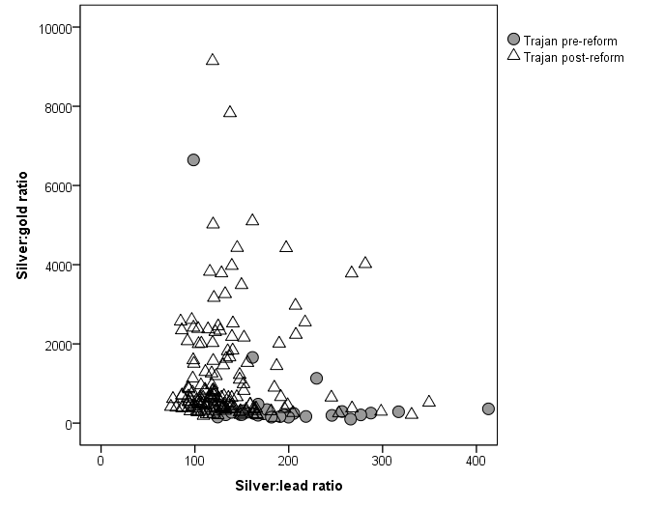

Fig. XX Scatterplot of silver:gold and silver:lead ratios of Trajan’s denarii.

Comparison with the denarii of Nerva and with Hadrian show that what we are seeing is a fairly gradual change in trace element composition that must be indicative of a gradual shift in bullion source across the three reigns.

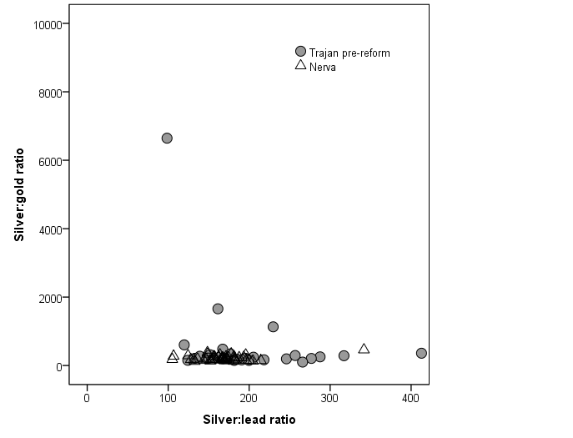 | 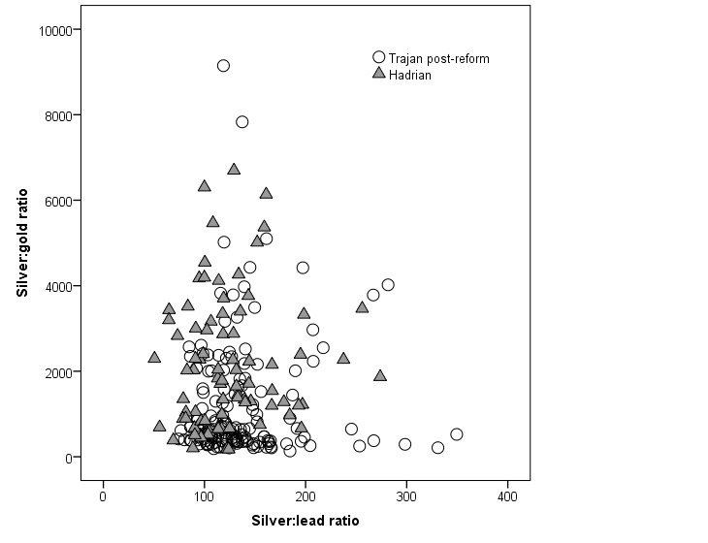
Fig.XX Scatterplot of gold:silver and lead:silver ratios for Trajan’s predecessor (Nerva) and successor (Hadrian).

Trajan’s pre-reform denarii have similar levels of lead and gold to Nerva’s denarii, with some of Trajan’s denarii containing appreciably less lead. With Trajan’s reform, however, comes a change to silver bullion with less gold and more lead, a pattern that becomes much clearer under Hadrian.

A similar picture emerges when the gold and bismuth levels are plotted, here shown together to illustrate the gradual change: from the high gold, low bismuth silver of Nerva; through a moderate gold, moderate bismuth phase prior to Trajan’s early coinage; and finally to metal that is lower in gold and higher in bismuth after Trajan’s reform. Hadrian’s denarii are quite consistently made of silver that is really quite low in gold (<0.25% scaled) and with variable, often high bismuth with scaled values up to 0.28%.

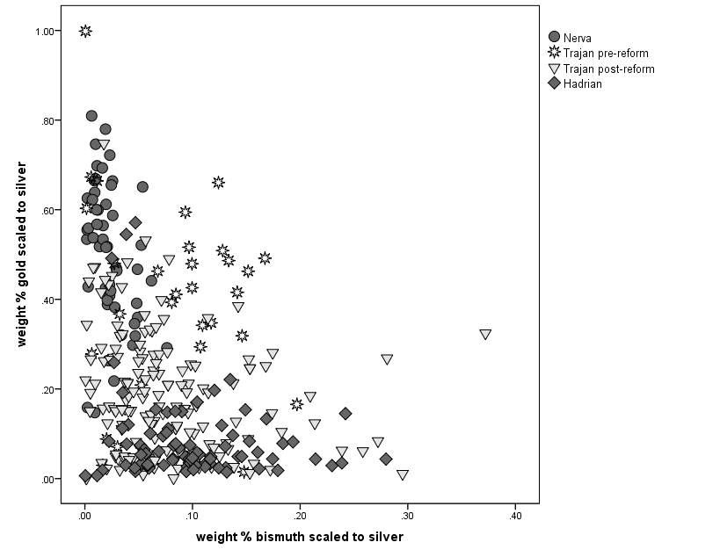
Fig.XX Scatterplot of gold and bismuth scaled to silver for denarii from Nerva to Hadrian.

What this change actually involves is harder to discover. Nerva’s denarii are clearly separated from Hadrian’s in terms of gold and bismuth content, and Trajan’s coinage marks the point of change between the two. The most likely interpretation of the gold/bismuth signature in Nerva’s denarii is that these coins are made from older denarii that were being recycled. Their signatures fit perfectly with the pattern observed under Nero and the Flavians, and it is likely that the main source of metal was Republican coinage, as appears to have been the case ever since the mint of Rome started producing denarii after Nero’s reforms in c. AD 64. The results for Trajan’s pre-reform issues can also be interpreted as representing recycled metal, although it would appear that in this case some of the coinage being recycled came from a different source to that of Nerva’s denarii. Some Julio-Claudian denarii have similar gold and bismuth levels, and perhaps this material was being targeted for recycling at the time.

Under Nerva, therefore, it was business as usual: the mint of Rome continued to produce new denarii from the existing stock of old denarii in circulation. But this is the last time such a signature occurs for the majority of an emperor’s coinage until the late second century. Trajan’s reign, and particularly his reform, marks a major departure from what had gone before. While there is some overlap between the post-reform issues of Trajan and the coins of Nerva and Trajan’s own pre-reform coins, which is probably indicative of some continued recycling, the majority of the post-reform coins appear to be made from different source materials. This is, of course, rather puzzling: if Trajan had intended to recall older coinage in order to profit by reminting it at a lower fineness, why does the gold/bismuth signature of older coinage appear to be rare in his post-reform denarii?

The date is usually given as AD 64, but there seems to be no clear diagnostic indicator that would allow us to place the reform in this year with any certainty: see Butcher and Ponting forthcoming.
Pliny HN 33. 46.
They make a slight comeback in the Severan period outside peninsular Italy. How this might have happened is explored in Murphy 2015.
This figure is an average across the entire reign of Hadrian, and does not represent a single standard. Under Hadrian the fineness varied slightly from issue to issue. See Butcher and Ponting 2012.
Butcher and Ponting 1998; 313
The same signature occurs in a concentration during AD 193, for the coinage of Pertinax and Didius Julianus: Butcher and Ponting 2012: 79, fig. 6c.

