Interface control by chemical and dimensional matching in an oxide heterostructure

Marita O’Sullivan¹, Joke Hadermann², Matthew S. Dyer¹, Stuart Turner², Jonathan Alaria³, Troy D. Manning¹, Artem M. Abakumov², John B. Claridge¹, and Matthew J. Rosseinsky^{1*}
¹Department of Chemistry, University of Liverpool, Crown Street, Liverpool L69 7ZD, United Kingdom.
²EMAT, University of Antwerp, Groenenborgerlaan 171, 2020 Antwerp, Belgium.
³Department of Physics, University of Liverpool, Crown Street, Liverpool L69 7ZD, United Kingdom
*Correspondence to: m.j.rosseinsky@liv.ac.uk
Abstract: Interfaces between different materials underpin both new scientific phenomena, such as emergent behaviour at oxide interfaces, and key technologies, such as the transistor. Control of interfaces between materials with the same crystal structures but different chemical compositions is possible in many materials classes, but less progress has been made for oxide materials with different crystal structures. We show that dynamical self-organisation during growth can create a coherent interface between the perovskite and fluorite oxide structures, which are based on different structural motifs, if an appropriate choice of cations is made to enable this restructuring. Integration of calculation with experimental observation reveals that the interface differs from both the bulk components and identifies the chemical bonding requirements to connect distinct oxide structures.
Main Text: Technological functionality increasingly depends on the nanoscale structure of device components, and particularly on the atomic arrangements at interfaces between different materials as device structures are scaled down^{1, 2}. Heterostructure devices composed of diamond structure components for high-speed electronics³ and opto-electronics⁴ demonstrate interface effects that can be harnessed through atomically controlled, 2D layer-by-layer growth of materials with the same structures but distinct compositions (Fig. 1). Advances in the perfection of oxide heterostructures built from materials of the same crystal structure type with the continuous, crystalline atomic frameworks traditionally confined to semiconductors⁵ have led to the observation of a 2D electron gas at the LaAlO₃/SrTiO₃ perovskite-perovskite interface⁶, measurement of the quantum Hall effect in Zn_{1-x}Mg_{x}O/ZnO⁷, and 2D superconductivity⁸ in a SrTiO₃/SrTi_{1-x}Nb_{x}O₃/SrTiO₃ heterostructure. The wetting condition for the layer-by-layer 2D growth that is essential for coherent heterostructure formation requires geometric dimensional matching at the unit cell level ⁹ to minimise the surface and interface energy of the film with respect to the surface free energy of the substrate¹⁰ when materials with the same crystal structures are considered (Fig. 1a).
Achieving such control in systems with different crystal structures is more challenging: the generation of misfit dislocations due to geometrical or chemical strain can result in semi-coherent interfaces which can adversely affect their functionality. For example, decades of research have been devoted to minimising the threading dislocation density in GaN/Al₂O₃¹¹ heterostructures, using a “compliant” buffer layer of disordered GaN for enhanced efficiency in blue LEDs. Techniques such as the coincidence site lattice model^{12, 13} and the modified embedded-atom-method¹⁴ have been developed to understand this non-isostructural epitaxy. Chemical guidelines for coherent layer-by-layer growth of complex oxides with substantial structural mismatch would enable new classes of artificial phases to be synthesised. Heterostructures have been reported involving phases with closely related crystal chemistry, such as γ-Al₂O₃ on SrTiO₃¹⁵, where both materials have cubic close-packed anion sublattices, the growth of T' cuprates which contain fluorite-like layers (Fig 1e) on fluorite substrates¹⁶ and the growth of Ruddlesden-Popper compounds on perovskites^{17, 18} , which are both composed of the AO and BO₂ layers shown in Fig. 1d. The coherent layer-by-layer epitaxial growth of structurally distinct materials requires overcoming the high levels of chemical bonding strain that arise from the rigid superposition of chemically mismatched structures with the same geometrical dimensions (Fig. 1b). Such growth control would be enabled by the creation of a structural bridge between the two materials, (represented as a green unit in Fig. 1c) using the chemical flexibility afforded by dynamical reconstructions during growth, which involve both the substrate and the growing layer¹⁹, to minimise the energy of the interface, overcoming the crystal chemical strain by structural relaxation.
The effect of geometric and chemical strain between two different crystal structures is illustrated by the difficulty of achieving controlled layer-by-layer growth²⁰ of the oxide ion conducting fluorite (ZrO₂)_{0.92}(Y₂O₃)_{0.08} (YSZ) with the dielectric perovskite SrTiO₃ (STO)²¹, where the resulting extensive structural disorder²², particularly on the anion sublattice, hinders study of the interface structure. The growth of a coherent perovskite-fluorite interface thus exemplifies the general “crystal structure mismatch” heterostructure problem for oxides, which we address with a crystal chemistry-based design approach, leading to a distinct ordered structure and composition that spans the interface between the perovskite and the fluorite.

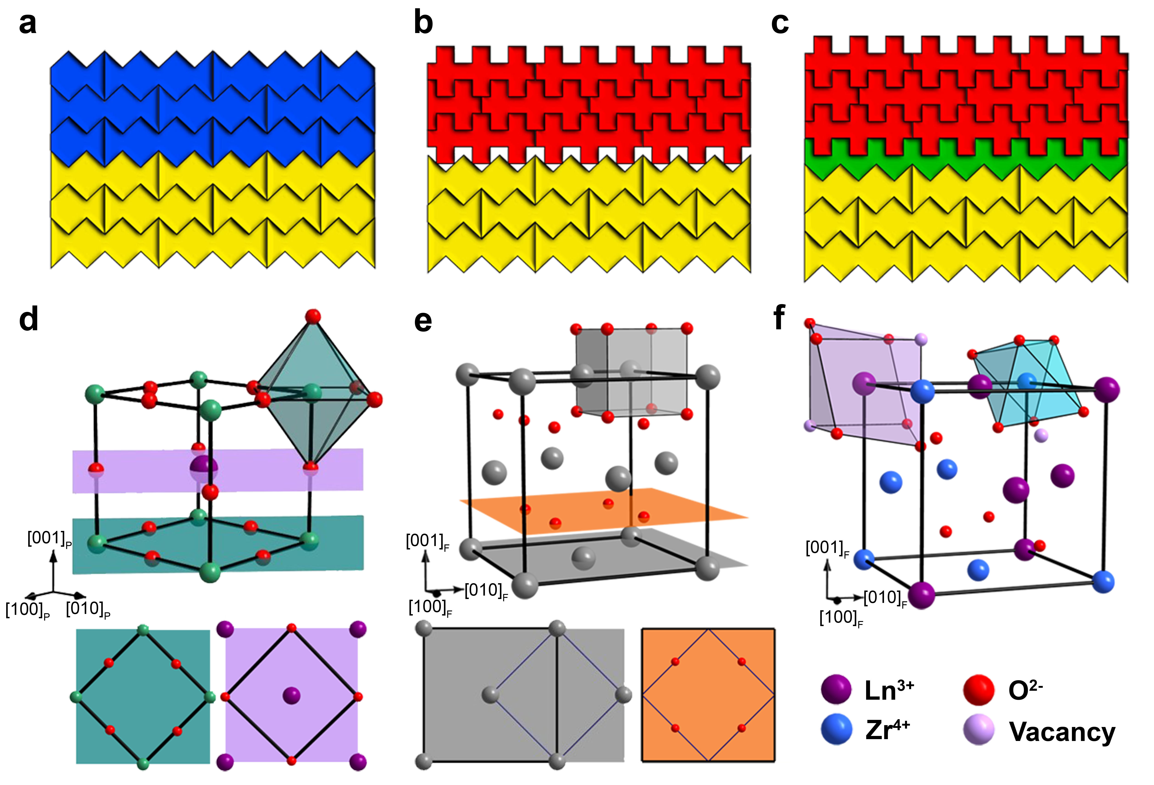
Figure 1. Structural matching of fluorite and perovskite structures for layer-by-layer growth. (a) Jigsaw puzzle view of heterostructure growth. Puzzle piece dimensions represent the unit cell parameters of the material, and the interlocking mechanism represents its sub-unit cell length scale crystal chemistry. The blue and yellow pieces are metrically matched as they are the same size and chemically matched, since the sawtooth edges interlock, corresponding to the growth of isostructural materials with common atomic planes, for example the LaAlO₃/SrTiO₃ interface with the sawtooth apices representing the perovskite octahedra. (b) The red and yellow pieces are metrically matched but chemically mismatched; the sawtooth (yellow) and tongue and groove (red) edges cannot interlock, corresponding to two structurally dissimilar materials, for example fluorite CeO₂/perovskite LaAlO₃ where the square edges represent the cubic polyhedra of the fluorite. This mismatch prevents two-dimensional growth. (c) The introduction of a green piece with the dimensional and crystal chemistry characteristics of both units, analogous to the dual coordination capabilities of the two cations in the pyrochlore (see (f)), bridges the chemically mismatched structures and enables two-dimensional growth. (d) The ABO₃ perovskite structure (A=La, B=Al) consists of close-packed AO₃ defect anion layers where 25% of the anion sites are occupied by the large A cation. The B cations of the BO₂ layer (green plane) occupy the octahedral sites and the A cations in the AO layer (purple plane) occupy 12 coordinate sites²³. (e) The cubic unit cell of the defect fluorite Ln_{0.5}Zr_{0.5}O_{1.75} (Ln=La, Nd) consists of distinct cation (grey plane) and anion (orange plane) layers with cations in a single cubic coordination forming the base of a face centred cubic sublattice and the anions in a simple cubic sublattice²⁴. (f) The Ln₂Zr₂O₇ pyrochlore is derived from fluorite by anion vacancy ordering that generates two distinct cation sites. Ln are in distorted cubic coordination and Zr occupy distorted octahedra.

ABO₃ perovskite has a 1:1.5 cation:anion ratio with distinct structural roles for the twelve coordinate A and octahedral B cations. Perovskite can be viewed as a stacking of alternating mixed cation-anion AO and BO₂ layers along the [001]_{P} direction of the unit cell (Fig. 1d). MO₂ fluorite has a 1:2 cation:anion ratio with cubic coordination of the cation. In contrast to perovskite, fluorite can be described as the superposition of pure anion and cation layers stacked along the [001]_{F} direction of the unit cell (Fig. 1e). The two structures can be epitaxially matched along the common [001] stacking direction by a 45° rotation (<110>_{F}//<001>_{P}) (Supplementary Fig. 1) as observed experimentally²⁵. The oxygen positions in the BO₂ layer of the perovskite define a square motif with similar dimensions to that in the O₂ layer of the fluorite.
Results and discussion.

Pulsed layer deposition of cerate fluorites on perovskites. We identified a range of low mismatch combinations of cerate fluorites with well-characterised perovskite substrates (LaAlO₃/CeO₂ with a compressive lattice mismatch of 0.9 %, (LaAlO₃)_{0.3}(Sr₂AlTaO₆)_{0.7}/Sm_{0.2}Ce_{0.8}O_{1.9} with a tensile mismatch of -0.6 %, SrTiO₃/La_{0.34}Ce_{0.66}O_{1.83} with a compressive mismatch of 0.3 %) for pulsed laser deposition (PLD) growth, but despite the minimal strain and well-defined substrate surfaces, 3D growth was observed in all cases (Supplementary Text, Supplementary Fig. 2). However, there are reports of layer-by-layer growth of fluorite on perovskite with larger strain than in any of these cases, for example, growth of YSZ on perovskite YAlO₃ is achieved in the <110>_{F}//<001>_{P} orientation with a -1.6% lattice mismatch²⁶ (Supplementary Fig. 3). To identify the key factors enabling layer-by-layer fluorite on perovskite growth, we need to explore other systems with 2D growth because the unknown surface structure and termination and limited stability of YAlO₃ at high temperature²⁷ hinder understanding of the growth mechanism.
Pulsed layer deposition of pyrochlore-derived defect fluorites on perovskites: Like the ABO₃ perovskite, the fluorite derived A′₂B′₂O₇ pyrochlore has two distinct cation sites, an eight coordinate cubic A′ site and a six coordinate distorted octahedral B′ site (Fig. 1f), produced by ordering of anion vacancies. At temperatures typical for PLD, pyrochlore source compositions yield the oxygen deficient disordered fluorite phase, A′_{0.5}B′_{0.5}O_{1.75} due to kinetic barriers to the cation ordering²⁸. The resulting pyrochlore-derived defect fluorite has an equal concentration of A′³⁺ and B′⁴⁺ cations coordinated to an average of 7 anions; the reduced oxygen content of the A′_{0.5}B′_{0.5}O_{1.75} disordered fluorite also brings the cation:anion ratio of 1:1.75 closer to that of perovskite. A range of lattice constants and chemistries are available in this fluorite family owing to the presence of two cations able to perform distinct structural roles through their different chemical bonding characteristics. This suggests that these materials are ideal candidates to explore the role of chemical flexibility in the growth of fluorite on perovskite.
The zirconate pyrochlores La₂Zr₂O₇ and Nd₂Zr₂O₇ have respective lattice mismatches of +0.7 % and -0.5 % to the perovskite LaAlO₃, which is built from (001) stacked LaO⁺ and AlO₂⁻ charged layers. Disordered fluorites La_{0.5}Zr_{0.5}O_{1.75} and Nd_{0.5}Zr_{0.5}O_{1.75} were deposited by PLD on atomically flat, annealed substrates with reflection high-energy electron diffraction (RHEED) patterns revealing superstructure reflections at the deposition temperature²⁹ (Supplementary Fig. 4, 5), consistent with the known (√5×√5)R26.6° surface reconstruction driven by La vacancy ordering³⁰. Periodic oscillation of the intensity of the specular spot along the [110]_{P} LaAlO₃ azimuth revealed layer-by-layer growth of Nd_{0.5}Zr_{0.5}O_{1.75} (Fig. 2a) and La_{0.5}Zr_{0.5}O_{1.75} (Supplementary Fig. 6) under optimised growth conditions. Fourier transform of the specular intensity revealed a growth rate of 23 pulses per oscillation. The RHEED patterns consisted of rods throughout growth, confirming the extended 2D nature of the growth mode (Fig. 2a inset) which persists up to 70 oscillations for Nd_{0.5}Zr_{0.5}O_{1.75}. High angle annular dark field scanning transmission electron microscopy (HAADF-STEM) imaging (Fig. 2b, Supplementary Fig. 7) shows the resulting films have a well-ordered and coherent cation interface with the substrate, viewed along the [001]_{P} zone axis. This agrees with the expected epitaxial relationship (Supplementary Fig. 1) for these two structures. This interface permits layer-by-layer growth for the two-cation zirconate chemistry that is not found for the cerate fluorites studied with a lower strain mismatch. Long-range cation ordering is not observed in bulk Ln₂Ce₂O₇, which are disordered fluorites unlike the ordered Ln₂Zr₂O₇ pyrochlores³¹. This suggests that Zr⁴⁺ can more readily adopt a different structural role from an Ln³⁺ cation than Ce⁴⁺ can, demonstrating the significance of the crystal chemistry of the component cations in controlling the interface responsible for the mode of film growth.
The heteroepitaxy achieved throughout the films for the fluorite targets is shown by the observation of only the 00l reflections in out-of-plane diffraction (Fig. 2c) and by narrow rocking curves (Supplementary Fig. 8). The absence of the 111 reflection of the pyrochlore shows that the films are disordered A′_{0.5}B′_{0.5}O_{1.75} fluorites at the growth temperatures. The Pendellosung fringes around the Bragg peaks demonstrate the coherence of the growth (Fig. 2c and inset) and permit determination of the film thicknesses, 26.5 nm for Nd_{0.5}Zr_{0.5}O_{1.75} and 15.6 nm for La_{0.5}Zr_{0.5}O_{1.75}, consistent with measured X-ray reflectivity (Supplementary Fig. 9). The layer thickness nucleated during one RHEED intensity oscillation was determined as half the fluorite cell parameter along the [001] growth direction, corresponding to one cation and one anion layer, the smallest charge neutral unit. Atomic force microscopy (AFM) images of the films indicate a step-and-terrace surface with step heights between 1 and 2 fluorite unit cells consistent with 2D growth (Supplementary Fig. 10). Reciprocal space maps and pole figures show epitaxial growth (Supplementary Fig. 11, 12).
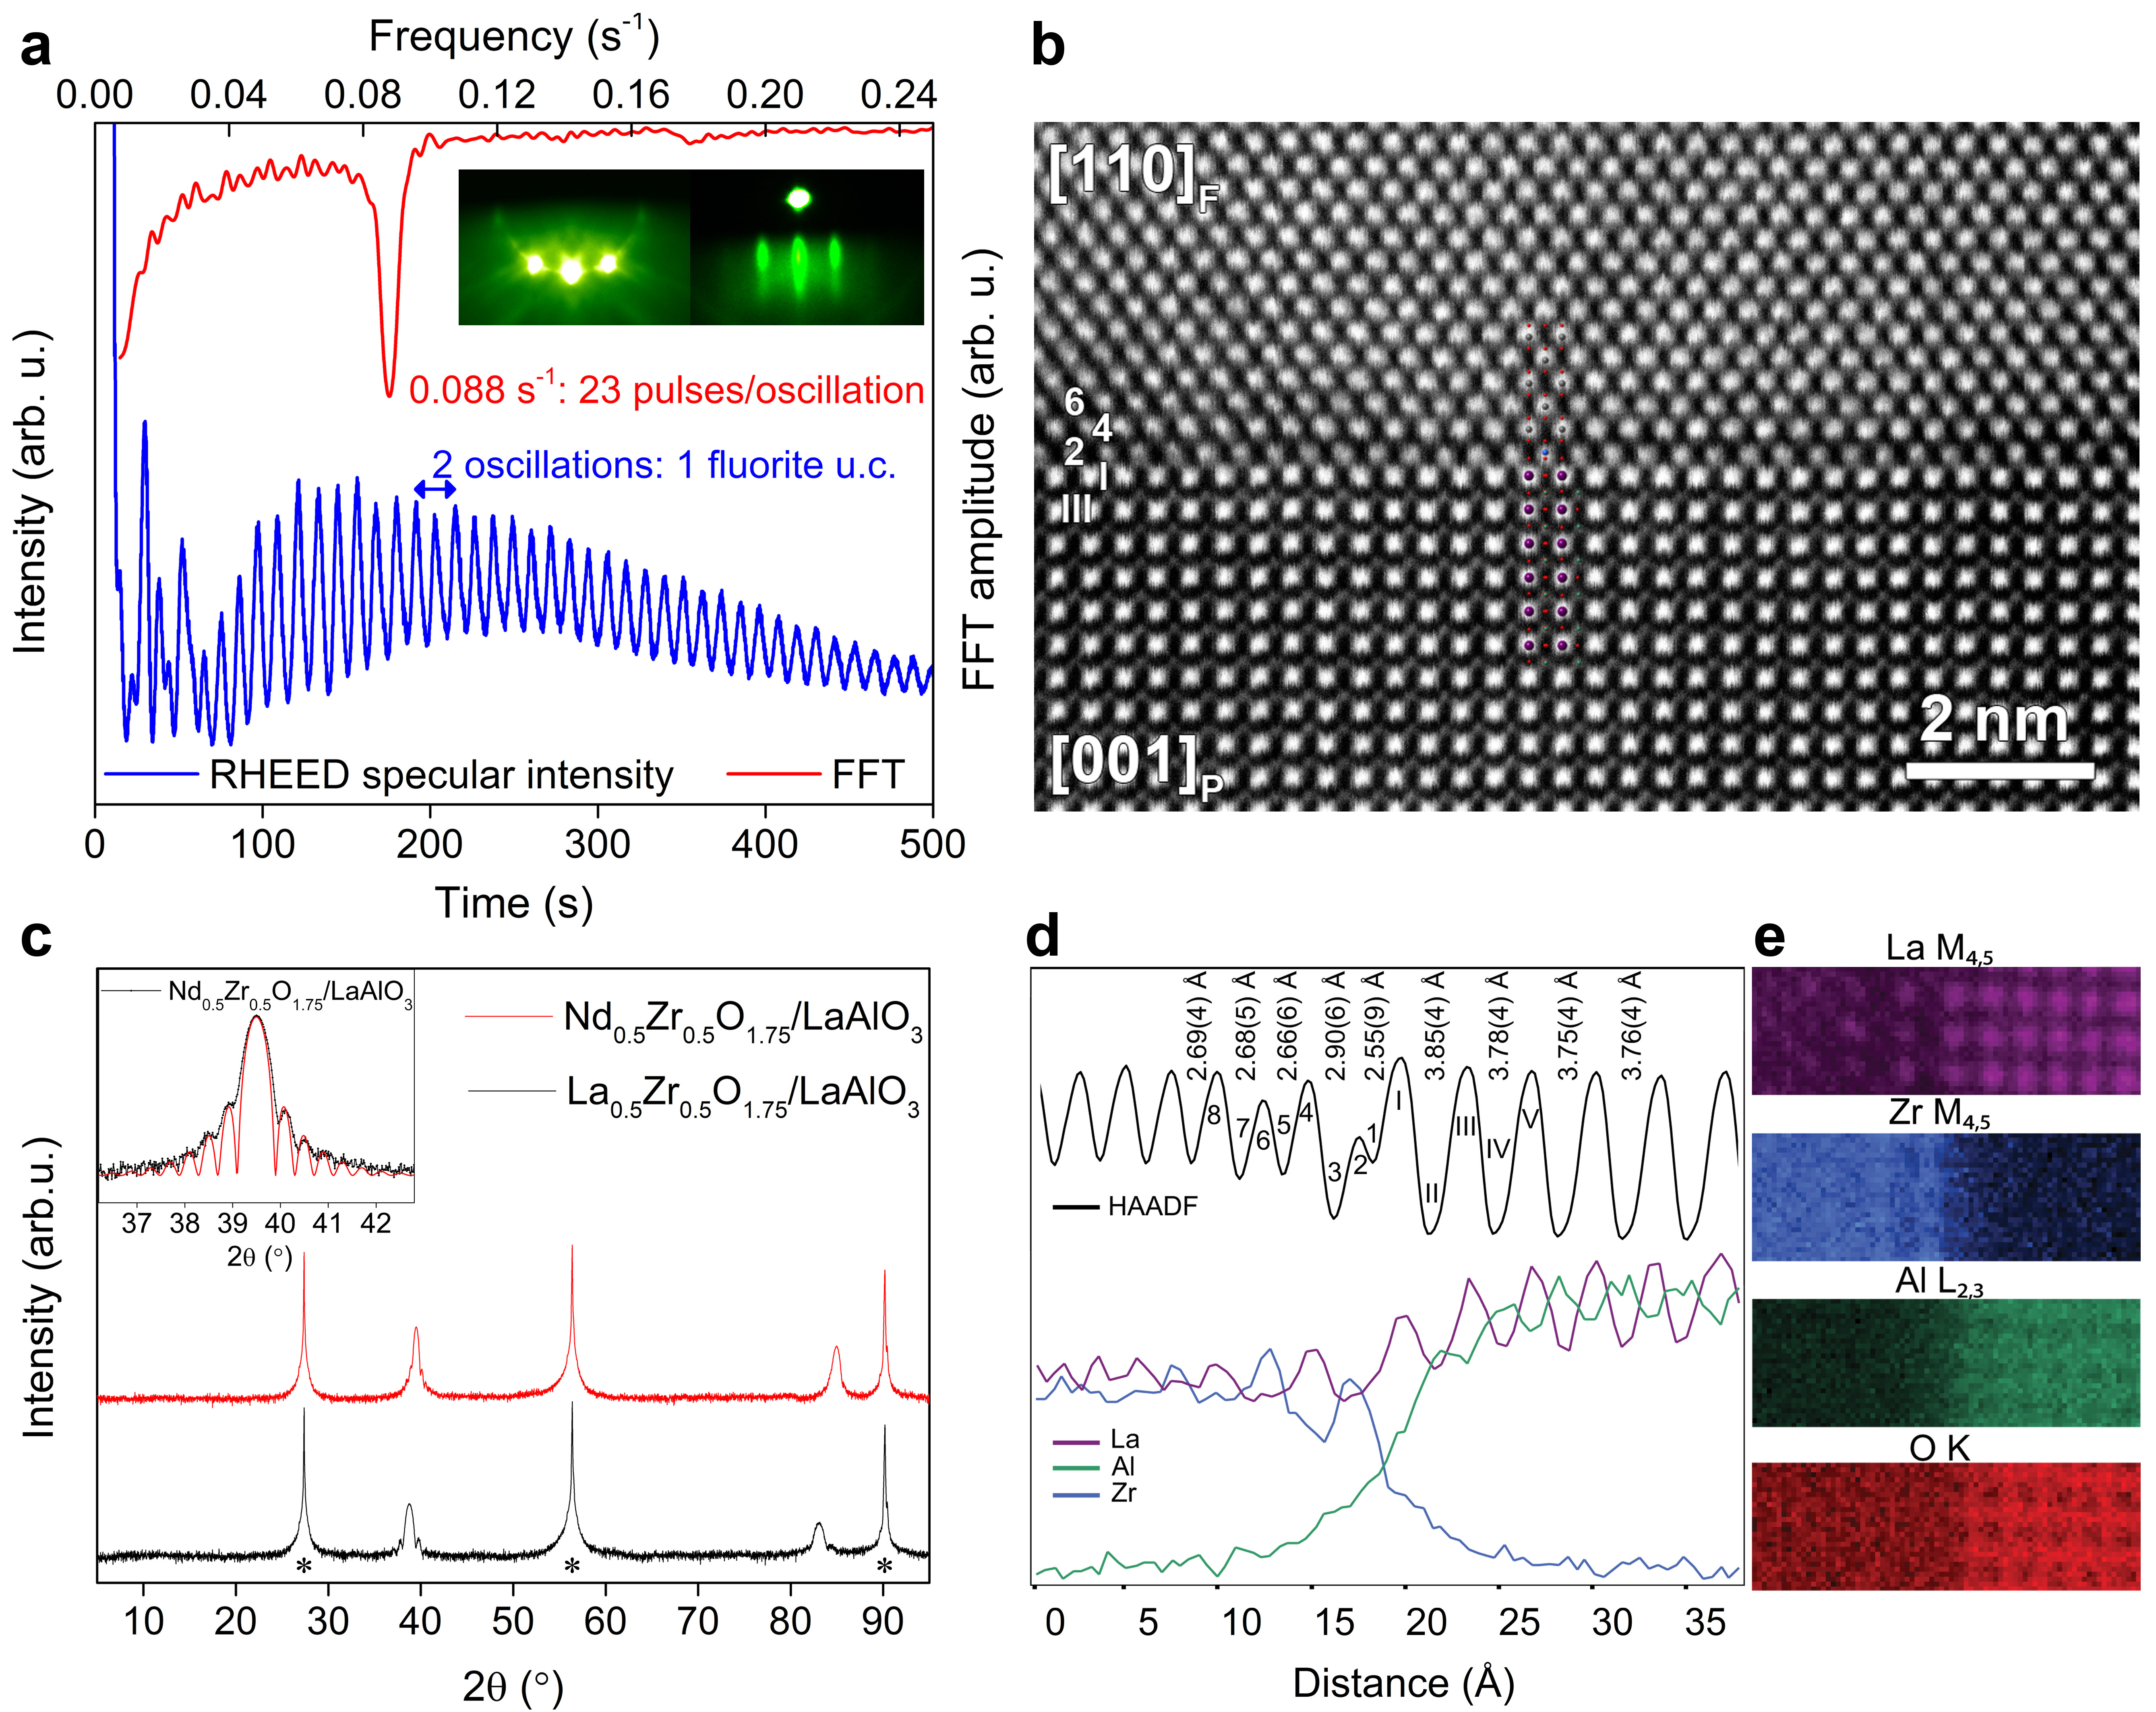
Figure. 2. Structural and chemical measurements of the cations at the LaAlO₃/Ln_{0.5}Zr_{0.5}O_{1.75} interface. (a) Extended layer-by-layer growth of the Nd_{0.5}Zr_{0.5}O_{1.75} defect fluorite on the (001) surface of perovskite LaAlO₃ (left inset) shown by oscillations in the intensity of the specular RHEED spot and the persistence of rod-like diffraction to the end of the deposition (right inset). (b) HAADF-STEM imaging of the LaAlO₃/La_{0.5}Zr_{0.5}O_{1.75} heterostructure. Interface layers are defined using Roman numerals in the perovskite and Arabic numerals in the fluorite increasing with distance from the interface. Cation positions arising from the expected epitaxial relationship between perovskite and fluorite are overlaid on the image. (c) Out-of-plane X-ray diffraction scans of the La_{0.5}Zr_{0.5}O_{1.75} and Nd_{0.5}Zr_{0.5}O_{1.75} films grown on LaAlO₃ (*). Pendellosung fringes about the most intense film Bragg reflection (inset). (d) Intensity profile of the HAADF-STEM image perpendicular to the LaAlO₃/La_{0.5}Zr_{0.5}O_{1.75} interface (black line) and EELS elemental intensity profiles across the interface (colored lines). The intensity drop in layer 2 suggests a systematic decrease in the average Z number of the cations compared to that further into the bulk fluorite where the La and Zr cation concentrations are equal. The interlayer spacings show an alternating distribution of expanded and contracted cation layers at the interface. The EELS intensity profiles identify layers of alternating La and Zr excess. (e) Elemental EELS maps of the LaAlO₃/La_{0.5}Zr_{0.5}O_{1.75} interface.

The perovskite-fluorite interface: visualisation by electron microscopy. The well-ordered interface does not arise from rigid superposition of the two component structures, but involves changes in both dimensions and chemical composition near the interface. The separations between successive heavy cation layers (which dominate the HAADF-STEM intensity) in the perovskite and fluorite bulk materials are 3.75 Å and 2.69 Å respectively. The layers will be denoted by Roman numerals in the perovskite (I-V) and Arabic numerals in the fluorite (1-12) for clarity in the following discussion. Measurement of the interlayer spacings on the HAADF-STEM images in both systems, LaAlO₃/La_{0.5}Zr_{0.5}O_{1.75} (Fig. 2d) and LaAlO₃/Nd_{0.5}Zr_{0.5}O_{1.75} (Supplementary Fig. 13), shows that there is expansion of the final perovskite LaO-LaO interlayer separation (III-I) from 3.75 Å to 3.85(4) Å and the interface perovskite-fluorite separation (I-2) of 2.55(9) Å is shorter than the bulk fluorite value. This is followed by expansion of the second fluorite cation interlayer distance (2-4) to 2.90(6) Å. The chemical identities of the ions in the interface region where these structural relaxations take place are revealed by electron energy-loss spectroscopy (EELS) measurements (Fig. 2e) and energy dispersive X-ray analysis (EDX) (Supplementary Fig. 14). The atomic resolution EELS maps demonstrate a sharp layer termination with minimal cation interdiffusion between perovskite substrate and fluorite film. The LaAlO₃ terminates in a perovskite LaO layer, consistent with the requirement of this termination of [001]_{P} perovskite for c-axis oriented fluorite growth²⁵ and with the predominant view of LaAlO₃ surface termination under the growth conditions as a La-deficient La_{1-x}O layer³⁰. As there is no reduction in the La content of this layer at the interface, the vacancies are filled by lanthanide cations from the fluorite during growth to produce the observed stoichiometric perovskite terminating layer in the buried interface. Alternating Zr and La local maxima in the EELS and EDX spectroscopic data together with simulated HAADF intensity profiles (Supplementary Text, Supplementary Fig. 15) indicate that the first fluorite cation layer is essentially a pure Zr layer, with the second layer enriched in La. These deviations of the fluorite cation ratios from the bulk oscillate over ten fluorite layers. It should be noted that this layered cation ordering is not seen in the pyrochlore structure. The two cations in the fluorite thus disproportionate into alternating layers at the interface with the perovskite. This is also observed for the Nd analogue (Supplementary Fig. 13).
Annular bright field (ABF) STEM imaging was used to probe the anion sublattice in order to identify the structure and to map both cation and anion locations at the interface (Fig. 3). These images reveal a well-ordered network in contrast to the disorder seen in YSZ/SrTiO₃²². The energetics of structural order at the fluorite-perovskite interface indicate several candidate structures (anion-terminated, cation-terminated or rock salt interface³², Supplementary Fig. 16). Only a fluorite structure that terminates with a bulk fluorite oxide (O²⁻)₂ anion layer (corresponding to the orange plane in Fig. 1e, and hereafter referred to as “O₂ -terminated”) is consistent with ABF-STEM images in both the [001]_{P} and [110]_{P} projections (Fig. 3a, b, green). A negative O₂⁴⁻ layer is electrostatically preferred above the terminal LaO⁺ layer, compared to the alternative positive ZrO²⁺ and Zr⁴⁺ layers considered as terminal layers to the fluorite, and leads naturally into the alternating positive and negative layers of bulk fluorite (Supplementary Fig. 17). High resolution O-K edge EELS spectra were collected for each anion-containing layer at the interface (Fig. 3c) and show the transition of the oxygen lattice from perovskite to fluorite, seen in the ABF-STEM images.
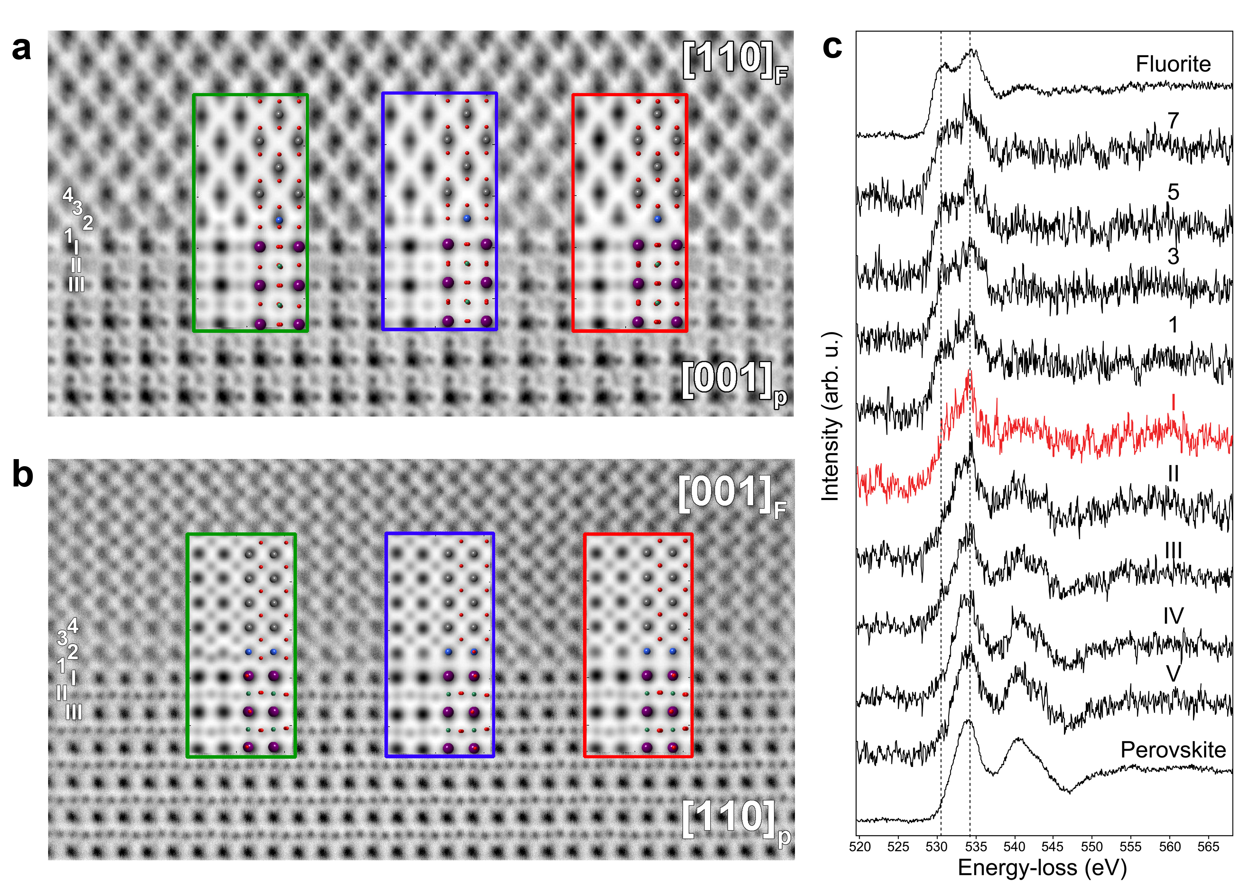
Figure. 3. Establishing the interface structure by identification of the oxide anion sublattice. Annular Bright Field (ABF)-STEM images of the LaAlO₃/La_{0.5}Zr_{0.5}O_{1.75} interface along the (a) [001]_{P} and (b) [110]_{P} zone axes. Models of the fluorite/LaAlO₃ interface (Supplementary Fig. 16) and their simulated ABF-STEM images were compared to the experimental images to map the cation and anion positions. The first model (green) has a pure O₂ layer at the interface followed by a pure Zr layer. The second model (blue) terminates the fluorite with a rock salt structure mixed cation anion ZrO layer, and the third model (red) terminates the fluorite with a pure Zr layer. Comparison of images and models in both (a) and (b) shows that the O₂-terminated (green) model matches best along the two zone axes, with each cation/anion accounted for by the model. (c) Oxygen K edge EELS spectra for each individual anion layer in the structure indicate a different chemical environment in the perovskite and the fluorite layers, with a mixed signal (red) observed in LaO⁺ perovskite layer I at the interface (Supplementary Fig. 21).

Bonding at the perovskite-fluorite interface: density functional theory calculations. The experimentally observed creation of a pure Zr layer at the interface was incorporated in simple density functional theory (DFT) models of the local structure. These consisted of an 11 layer LaAlO₃ block, terminated with a LaO layer at both ends, and an O₂-terminated fluorite block with 16 O₂ layers, and 15 cation layers, the outer two layers composed of Zr and all others Ce (representing disordered La_{0.5}Zr_{0.5}O_{1.75}) (Supplementary Fig. 18). In this way, we approximate the observed modulation in composition. The lateral dimensions correspond to a √2×√2 perovskite cell in the ab plane so each cation layer contains two cations throughout, the defect-free fluorite anion layers contain four oxide ions, with three oxygen vacancies included in the (Ce, Zr)O₂ fluorite block. Five such models, differing in the location of oxide ion vacancies, were constructed and relaxed using DFT (Supplementary Data 1). In the lowest energy DFT structure, the La cations in the terminal LaO perovskite layer I have eleven-fold coordination: the distance from this layer to the next LaO perovskite layer III is larger than in a bulk perovskite, whereas the I-2 spacing to the first fluorite cation layer is smaller than in a bulk fluorite (Fig. 4a, Supplementary Fig. 20, Supplementary Tables 1-3). The computed local oxygen coordination of Zr in the interface layer 2 is different from that of both fluorite and perovskite, with six and seven coordinate environments (Fig. 4b, Supplementary Fig. 20) resembling the Zr bonding in ordered defect fluorite Zr₃Y₄O₁₂³³ and monoclinic ZrO₂³⁴ respectively (Supplementary Fig. 19). Bond valence sums (BVS) of 3.79 and 3.78 for the interfacial Zr ions (Supplementary Tables 4, 5) confirm that the reconstruction can produce chemically reasonable cation environments at the interface (Zr in monoclinic ZrO₂ modelled with the same DFT method has a BVS of 3.77). Anion layers 1 and 3 contain seven oxide ions in total, giving a local stoichiometry of ZrO_{1.75} in layers 1-3 in accordance with that of the experimental system (Ln_{0.5}Zr_{0.5}O_{1.75}). Anion layers 1 and 3 show some structural disruption (Fig. 4b) as one oxide ion is located closer to Zr cation layer 2 than to either anion layer (Supplementary Fig. 20), suggesting that the abrupt distinction between cation and anion layers characteristic of the fluorite breaks down at the interface with perovskite, itself characterised by mixed cation-anion BO₂ and AO layers, while generating appropriate coordination environments for Zr.
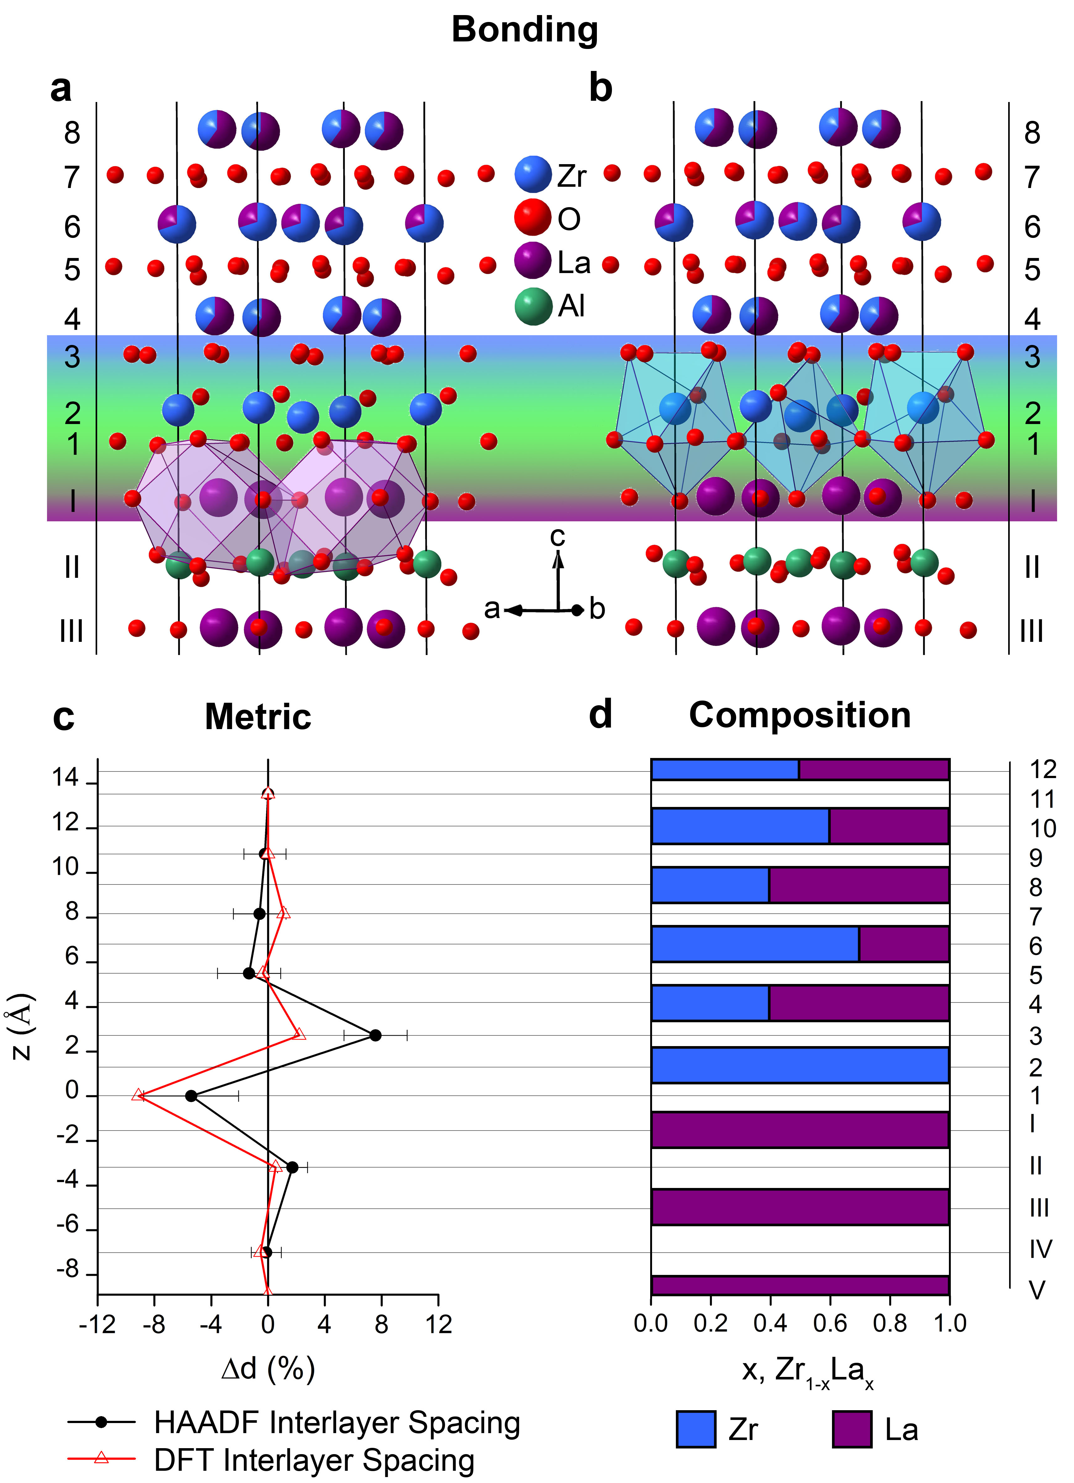

Figure. 4. Crystal chemical description of the restructured interface based on bonding, metric and composition. (a, b) Atomistic model of the LaAlO₃/La_{0.5}Zr_{0.5}O_{1.75} interface, with atomic positions extracted from DFT calculations (Supplementary Fig. 18), and atomic compositions extracted from the simulated HAADF-STEM intensity (Supplementary Fig. 15), showing (a) the final perovskite LaO layer I with an 11 coordinate bonding environment for La (displayed as a polyhedron), consistent with the perovskite A-site, but displaced away from the bulk perovskite (Supplementary Tables 1-3); and (b) the perovskite-fluorite hybrid block (first four layers highlighted by shading) that plays the role of the green piece in Fig. 1c. The Zr-enriched layer 2 adopts a mixed six and seven coordination (both shown as polyhedra) that is not chemically suited to the La³⁺ cation. (c) The inter-cation layer distances calculated by DFT and extracted from the HAADF-STEM intensity profile of the La_{0.5}Zr_{0.5}O_{1.75} sample (Fig. 2d). Δd is the percentage difference between the inter-cation layer separation with respect to the average bulk layer separation (plotted at the midpoint of the two layers e.g., the separation between 2 and 4 is plotted at 3), and z is the distance from the interface. (d) The alternating La/Zr cation ratio of the fluorite layers, obtained from the simulated HAADF-STEM intensity (Supplementary Fig. 15), which dampens over the first five fluorite cation layers 2-10, then recovering the bulk value.

Due to their larger size, only the lanthanide cations of the A′_{0.5}Zr_{0.5}O_{1.75} fluorites can fill the La vacancies of the terminal layer of the LaAlO₃ substrate, and the smaller Zr cations are favored by the six- and seven- coordinate environments in the first fluorite cation layer (2), driving the strong disproportionation of the fluorite into lanthanide- and zirconium-rich layers. The Zr in the first fluorite layer forms long bonds (2.46 Å and 2.75 Å) to the oxygen from the terminating perovskite LaO⁺ layer I through the intervening O₂ anion layer (Supplementary Fig. 20). Only layer I shows a mixed EELS signal for the O-K edge (Fig. 3c), indicating a change in local chemical environment of the oxide in this plane. The Zr bonding to the O in this layer I may reduce underbonding arising from the asymmetric oxide coordination sphere at the boundary between fluorite and perovskite, reinforcing the preference for the higher charge and smaller size of the Zr cation in layer 2. The attractive interaction between the first fluorite cation layer (2) and the final perovskite layer (I) contracts the distance between these two layers, and concurrently expands the interlayer spacing between the terminal (I) and penultimate LaO (III) layers of the perovskite, and between the first two fluorite cation layers (2 and 4). The contraction and expansion of interlayer distances found experimentally is thus well-captured by the DFT model (Fig. 4c). Experimentally, the expansion between layers 2 and 4 is larger than the contraction between I and 2, showing that significant structural relaxation persists beyond the first fluorite layer; however above layer 4, the measured interlayer separation returns to its bulk value more quickly than the cation composition does (Fig. 4d).
The layer-by-layer growth of fluorite on perovskite has been achieved by the formation of an extended interface that bridges the two structures. A′_{0.5}Zr_{0.5}O_{1.75} fluorites are selected by crystal chemistry-based design to favour this, as they contain cations capable of assuming both eight coordinate fluorite and six coordinate perovskite B-site environments, as well as the intermediate seven-fold coordination of the perovskite-fluorite hybrid block in the interface structure. The dynamic structural rearrangement within the zirconate wetting layers produces appropriate chemical environments within the extended interface region to connect the two structures (Fig. 1c). This overcomes the interfacial energy that drives 3D growth of the isostructural cerate fluorites, which have equivalent or better dimensional fit but cannot perform this chemically-enabled structural matching with the LaAlO₃ perovskite substrate. The observed reorganisation enables the bridging of non-isostructural phases based on distinct building units. The resulting interface is a crystallochemical entity which offers structures not found in the bulk, produced by the constraints imposed by the two materials it spans and thus tuneable by their chemistry.
Conclusion.
The atomic rearrangement of both cations and anions in a coherent ordered structure, in contrast to the disordered anion sublattice observed previously²², offers a route to the layer-by-layer heteroepitaxy of materials with different chemical composition, structure, packing and bonding, in turn providing new routes to property integration and control. This can be achieved through the selection of geometrically-matched, multi-cation materials, using cations chosen for their chemical flexibility in adopting alternative bonding and coordination environments at the interface. This approach could be used to study the influence of the reconstructed structural bridge at the interface on the physical properties of heterostructures, at low dislocation densities, or to design third phase buffer layers that maintain coherence throughout the interface between two chemically mismatched systems. As an example, this study opens the way to controllably combining perovskites with the many materials with structures derived from fluorite³⁵, and containing the metal cations known to be stable in multiple coordination environments (e.g., Ti⁴⁺, Hf⁴⁺, Zn²⁺, Ga³⁺, Al³⁺, Fe³⁺), which are necessary to bridge the structures. The existence of spinel-like and perovskite-like layers within the naturally occurring ferrites³⁶ demonstrates the flexible coordination of the Fe³⁺ ion, in contrast to the Cr³⁺ ion, which routinely adopts an octahedral coordination environment. As the ferrites, like perovskite, are based on close-packed anion layers, this approach could be used to integrate these important oxides with non-close-packed anion structures.
Methods:
Sample Growth
All heterostructure samples were grown by pulsed laser deposition of dense ceramic targets of the source material and deposited onto single crystal perovskite substrates. The PLD system consists of a Neocera high vacuum chamber equipped with a high pressure RHEED system, including a kSA 400 analysis system and a Staib electron gun, together with a Coherent Lambda Physik COMPex Pro 248 nm KrF Excimer laser. Laser fluences of 1.82 to 2.46 J/cm² and pulse frequencies of 1 or 2 Hz were used to deposit the thin films. The system operates with a base pressure of 2×10⁻⁸ Torr, and the deposition gas pressure is controlled using a mass flow controller with high purity O₂. The substrates are heated by radiation and the temperature is monitored and controlled with a thermocouple, however the deposition temperatures reported in the main text refer to the temperature of the substrate holder measured using a pyrometer. The heterostructures were deposited at substrate temperatures ranging from 600 to 800 °C with oxygen partial pressures varied between 1 and 10 mTorr.
Diffraction
Phase analysis of the heterostructure samples was carried out by collecting θ/2θ scans using a PANalytical X’Pert Pro diffractometer in Bragg-Brentano geometry with monochromated Co Kα1 radiation (λ = 1.78896 Å). X-ray reflectivity, rocking curves, pole figures and reciprocal space maps were measured using a 4-circle PANalytical MRD diffractometer with a Cu X-ray source. Sample thicknesses determined by simulating the X-ray reflectivity data using IMD software³⁷ were compared with figures extracted from fitting the Pendellosung fringes observed about Bragg peaks in the θ/2θ patterns with a modified sinc function.
Electron Microscopy: High-Angle Annular Dark Field and Annular Bright Field Imaging and High Resolution Energy Dispersive X-ray Spectroscopy
High-angle annular dark-field scanning transmission electron microscopy (HAADF-STEM), annular bright field (ABF)-STEM and EDX-STEM experiments were acquired using a FEI Titan 80-300 “cubed” microscope equipped with a Super-X four quadrant EDX detector, operated at 200 kV. The results were recorded using probes with convergence semi-angles in the 21 – 25 mrad range (with a probe size of about 1 Å). The probe current ranged between 50 and 200 pA. ABF-STEM and HAADF-STEM images were calculated using the QSTEM 2.0 software³⁸. Samples for the electron microscopy study were prepared by focused ion beam (FIB) milling.
Electron Energy Loss Spectroscopy
Spatially resolved EELS experiments were carried out on a similar instrument, operated at 120 kV acceleration voltage. The convergence semi-angle used was 22 mrad (yielding a probe size of about 1 Å), the acceptance semi-angle for EELS was 130 mrad. All maps except the Zr M_{4,5} map were generated by plotting the intensity under the power-law background subtracted EELS edges in each point of the 2D EELS datacube. The Zr M_{4,5} map was generated using the so-called jump-ratio method, due to the strong overlap of the Zr M_{4,5} and the La N_{2,3} edge. In this method, a post-edge image is divided by a pre-edge image, yielding a qualitative result.
Computational details
Atomistic models were constructed on the basis of experimental observations to provide information about likely local structure at the LaAlO₃ / La_{0.5}Zr_{0.5}O_{1.75} interface from density functional theory (DFT) calculations. The models were set up in periodic boundary conditions, with the a / b cell parameters corresponding to a (√2 × √2)R45° expansion of the cubic perovskite cell. In the third direction, the periodic cell was large enough to accommodate roughly 4 nm thick blocks of LaAlO₃ and fluorite with two interfaces between them.
All DFT calculations were performed with VASP³⁹. Calculations used the PBE functional⁴⁰, core electrons were treated within the PAW approximation⁴¹. The cell and atomic positions were optimised until all atomic forces were below 0.01 eV/Å with a 520 eV planewave cutoff energy and 4×4×1 k-point grid.
References:
1. Kroemer H. Nobel Lecture: Quasielectric fields and band offsets: teaching electrons new tricks. Reviews of Modern Physics 2001, 73(3): 783-793.

2. Chambers S. A. Stability at the surface. Science 2014, 346(6214): 1186-1187.

3. Douglas J. P. Si/SiGe heterostructures: from material and physics to devices and circuits. Semiconductor Science and Technology 2004, 19(10): R75.

4. Jain S. C., Willander M., Narayan J., Overstraeten R. V. III–nitrides: Growth, characterization, and properties. Journal of Applied Physics 2000, 87(3): 965-1006.

5. Chakhalian J., Millis A. J., Rondinelli J. Whither the oxide interface. Nat Mater 2012, 11(2): 92-94.

6. Ohtomo A., Hwang H. Y. A high-mobility electron gas at the LaAlO₃/SrTiO₃ heterointerface. Nature 2004, 427(6973): 423-426.

7. Tsukazaki A., Ohtomo A., Kita T., Ohno Y., Ohno H., Kawasaki M. Quantum Hall Effect in Polar Oxide Heterostructures. Science 2007, 315(5817): 1388-1391.

8. Kozuka Y., Kim M., Bell C., Kim B. G., Hikita Y., Hwang H. Y. Two-dimensional normal-state quantum oscillations in a superconducting heterostructure. Nature 2009, 462(7272): 487-490.

9. Demkov A. A., Posadas A. B. Integration of Functional Oxides with Semiconductors, 1 edn. Springer-Verlag New York, 2014.

10. Bauer E., van der Merwe J. H. Structure and growth of crystalline superlattices: From monolayer to superlattice. Physical Review B 1986, 33(6): 3657-3671.

11. Shih H-Y., Shiojiri M., Chen C-H., Yu S-F., Ko C-T., Yang J-R., et al. Ultralow threading dislocation density in GaN epilayer on near-strain-free GaN compliant buffer layer and its applications in hetero-epitaxial LEDs. Scientific Reports 2015, 5: 13671.

12. Bollmann W. Crystal defects and crystalline interfaces. Springer-Verlag, 1970.

13. Erwin S. C., Gao C., Roder C., Lähnemann J., Brandt O. Epitaxial Interfaces between Crystallographically Mismatched Materials. Physical Review Letters 2011, 107(2): 026102.

14. Benedek R., Seidman D. N., Woodward C. The effect of misfit on heterophase interface energies. Journal of Physics: Condensed Matter 2002, 14(11): 2877.

15. Chen Y. Z., Bovet N., Trier F., Christensen D. V., Qu F. M., Andersen N. H., et al. A high-mobility two-dimensional electron gas at the spinel/perovskite interface of γ-Al₂O₃/SrTiO₃. Nat Commun 2013, 4: 1371.

16. Prasad B. D., Salamanca-Riba L., Mao S. N., Xi X. X., Venkatesan T., Wu X. D. Effect of substrate materials on laser deposited Nd_{1.85}Ce_{0.15}CuO_{4−y} films. Journal of Materials Research 1994, 9(06): 1376-1383.

17. Nie Y. F., Zhu Y., Lee C. H., Kourkoutis L. F., Mundy J. A., Junquera J., et al. Atomically precise interfaces from non-stoichiometric deposition. Nat Commun 2014, 5.

18. Yan L., Niu H., Bridges C. A., Marshall P. A., Hadermann J., van Tendeloo G., et al. Unit-Cell-Level Assembly of Metastable Transition-Metal Oxides by Pulsed-Laser Deposition. Angewandte Chemie International Edition 2007, 46(24): 4539-4542.

19. Nakagawa N., Hwang H. Y., Muller D. A. Why some interfaces cannot be sharp. Nat Mater 2006, 5(3): 204-209.

20. Cavallaro A., Burriel M., Roqueta J., Apostolidis A., Bernardi A., Tarancón A., et al. Electronic nature of the enhanced conductivity in YSZ-STO multilayers deposited by PLD. Solid State Ionics 2010, 181(13–14): 592-601.

21. Garcia-Barriocanal J., Rivera-Calzada A., Varela M., Sefrioui Z., Iborra E., Leon C., et al. Colossal Ionic Conductivity at Interfaces of Epitaxial ZrO₂:Y₂O₃/SrTiO₃ Heterostructures. Science 2008, 321(5889): 676-680.

22. Pennycook T. J., Oxley M. P., Garcia-Barriocanal J., Bruno F. Y., Leon C., Santamaria J., et al. Seeing oxygen disorder in YSZ/SrTiO₃ colossal ionic conductor heterostructures using EELS. Eur Phys J Appl Phys 2011, 54(3): 33507.

23. Mitchell R. H. Perovskites: Modern and Ancient. Almaz Press, 2002.

24. Tilley R. J. D. Crystals and Crystal Structures. Wiley, 2006.

25. Cavallaro A., Ballesteros B., Bachelet R., Santiso J. Heteroepitaxial orientation control of YSZ thin films by selective growth on SrO-, TiO₂-terminated SrTiO₃ crystal surfaces. Cryst Eng Comm 2011, 13(5): 1625-1631.

26. Pergolesi D., Fronzi M., Fabbri E., Tebano A., Traversa E. Growth mechanisms of ceria- and zirconia-based epitaxial thin films and hetero-structures grown by pulsed laser deposition. Mater Renew Sustain Energy 2012, 2(1): 1-9.

27. Inoue T., Morimoto T., Kaneko S., Horii Y., Ohki Y. Crystalline structures of YAlO₃ single crystal at high temperatures. Proceedings of 2014 International Symposium on Electrical Insulating Materials (ISEIM); 2014; 2014. p. 208-211.

28. Payne J. L., Tucker M. G., Evans I. R. From fluorite to pyrochlore: Characterisation of local and average structure of neodymium zirconate, Nd₂Zr₂O₇. Journal of Solid State Chemistry 2013, 205: 29-34.

29. Wang Z. L., Shapiro A. J. Studies of LaAlO₃{100} surfaces using RHEED and REM. I: twins, steps and dislocations. Surface Science 1995, 328(1–2): 141-158.

30. Lanier C. H., Rondinelli J. M., Deng B., Kilaas R., Poeppelmeier K. R., Marks L. D. Surface Reconstruction with a Fractional Hole: (√5×√5)R26.6° LaAlO₃ (001). Physical Review Letters 2007, 98(8): 086102.

31. Yamamura H., Nishino H., Kakinuma K., Nomura K. Crystal Phase and Electrical Conductivity in the Pyrochlore-Type Composition Systems, Ln₂Ce₂O₇ (Ln=La, Nd, Sm, Eu, Gd, Y and Yb). Journal of the Ceramic Society of Japan 2003, 111(1300): 902-906.

32. Dyer M. S., Darling G. R., Claridge J. B., Rosseinsky M. J. Chemical Bonding and Atomic Structure in Y₂O₃:ZrO₂-SrTiO₃ Layered Heterostructures. Angewandte Chemie International Edition 2012, 51(14): 3418-3422.

33. Ray S. P., Stubican V. S., Cox D. E. Neutron diffraction investigation of Zr₃Y₄O₁₂. Materials Research Bulletin 1980, 15(10): 1419-1423.

34. Smith D. K., Newkirk W. The crystal structure of baddeleyite (monoclinic ZrO₂) and its relation to the polymorphism of ZrO₂. Acta Crystallographica 1965, 18(6): 983-991.

35. Grey I. E., Mumme W. G., Ness T. J., Roth R. S., Smith K. L. Structural relations between weberite and zirconolite polytypes—refinements of doped 3T and 4M Ca₂Ta₂O₇ and 3T CaZrTi₂O₇. Journal of Solid State Chemistry 2003, 174(2): 285-295.

36. Orlov I., Palatinus L., Arakcheeva A., Chapuis G. Hexagonal ferrites: a unified model of the (TS)_{n}T series in superspace. Acta Crystallographica Section B 2007, 63(5): 703-712.

37. Windt D. L. IMD–software for modeling the optical properties of multilayer films. Comput Phys 1998, 12(4): 360-370.

38. Koch C. T. Determination of core structure periodicity and point defect density along dislocations. 63-02 thesis, Arizona State University, 2002.

39. Kresse G., Furthmüller J. Efficient iterative schemes for ab initio total-energy calculations using a plane-wave basis set. Physical Review B 1996, 54(16): 11169-11186.

40. Perdew J. P., Burke K., Ernzerhof M. Generalized Gradient Approximation Made Simple. Physical Review Letters 1996, 77(18): 3865-3868.

41. Kresse G., Joubert D. From ultrasoft pseudopotentials to the projector augmented-wave method. Physical Review B 1999, 59(3): 1758-1775.

42. Tan H., Turner S., Yücelen E., Verbeeck J., van Tendeloo G. 2D Atomic Mapping of Oxidation States in Transition Metal Oxides by Scanning Transmission Electron Microscopy and Electron Energy-Loss Spectroscopy. Physical Review Letters 2011, 107(10): 107602.

43. Botton G. A., Lazar S., Dwyer C. Elemental mapping at the atomic scale using low accelerating voltages. Ultramicroscopy 2010, 110(8): 926-934.

44. Turner S., Egoavil R., Batuk M., Abakumov A. M., Hadermann J., Verbeeck J., et al. Site-specific mapping of transition metal oxygen coordination in complex oxides. Applied Physics Letters 2012, 101(24): 241910.

45. Egerton R. F. Electron Energy-Loss Spectroscopy in the Electron Microscope. Plenum Press, 1996.

46. Taftø J., Lehmpfuhl G. Direction dependence in electron energy loss spectroscopy from single crystals. Ultramicroscopy 1982, 7(3): 287-294.

47. Brown I. D. The Chemical Bond in Inorganic Chemistry: The Bond Valence Model. Oxford University Press, Oxford, 2002.

48. Brese N. E., O'Keeffe M. Bond-valence parameters for solids. Acta Crystallographica Section B 1991, 47(2): 192-197.

Acknowledgments: This work was supported by EPSRC under EP/H000925/1. MJR is a Royal Society Research Professor. S.T. gratefully acknowledges the FWO for a post-doctoral scholarship and for funding under project number G004413N.
Author contributions: MJR and JBC developed the concept for the study; MOS designed the experiments, along with JA, and prepared and characterised the thin films; MSD performed the computational analysis, JH and AMA performed and analysed the STEM, ST performed and analysed the EELS. MOS and MJR wrote the first draft. All authors discussed the results and further developed the manuscript.
Additional Information: The authors declare no competing financial interests. Supplementary Information accompanies this paper at www.nature.com/naturechemisty. The underlying RHEED, XRD, AFM and computational data can be accessed by registered users at http://datacat.liverpool.ac.uk/id/eprint/74. Those wishing access to the underlying TEM data should contact Prof. Dr. J. Hadermann Joke.Hadermann@uantwerpen.be

Supplementary Information:
Materials and Methods
Supplementary Figures 1-21
Supplementary Tables 1-5
Supplementary Data 1
References 37-48

