Canine babesiosis and tick activity monitored using companion animal electronic health records in the UK.

F Sánchez-Vizcaíno ^{1,2}, M Wardeh ^{1,2}, B Heayns ¹, DA Singleton ¹, JSP Tulloch ^{1,2}, L McGinley ^{1,2}, J Newman ¹, PJ Noble ³, MJ Day ⁴, PH Jones ¹ and AD Radford ^{1,2}.
¹ Institutes of Infection and Global Health and ³ Veterinary Science, University of Liverpool, Leahurst Campus, Chester High Road, Neston, S. Wirral, CH64 7TE, UK.
² NIHR Health Protection Research Unit in Emerging and Zoonotic Infections, University of Liverpool, L69 7BE, UK.
⁴ University of Bristol, School of Veterinary Sciences, Langford, Bristol, BS40 5DU, UK.
Corresponding author: alanrad@liverpool.ac.uk

Abstract (200 words or less).
Recent publications highlighting autochthonous Babesia canis infection in dogs from Essex that have not travelled outside the UK are a powerful reminder of the potential for pathogen emergence in new populations. Here we use electronic health data collected from two diagnostic laboratories and a network of 392 veterinary premises to describe canine Babesia cases and levels of Babesia concern from January 2015 to March 2016, and the activity of ticks during December 2015 to March 2016. In most areas of the UK, Babesia diagnosis in this population was rare and sporadic. In addition, there was a clear focus of Babesia cases in the affected area in Essex. Until February 2016, analysis of health records indicated only sporadic interest in Babesia largely in animals coming from overseas. Following media coverage in March 2016, there was a spike in owner concern that was geographically dispersed beyond the at-risk area. Tick activity (identified as ticks being removed from animals in veterinary consultations) was consistent but low during the period preceding the infections (<5 ticks / 10,000 consultations), but increased in March. This highlights the use of electronic health data to describe rapidly evolving risk and concern that follows the emergence of a pathogen.

Introduction.
Canine babesiosis is caused by several species of an intraerythrocytic protozoan parasite that causes haemolytic disease (Irwin 2009; Cook and Swann 2016). Each species is tick transmitted, and generally maintained by transovarial and transstadial transmission. The geographic distribution of canine babesiosis is therefore largely driven by the habitat of relevant tick vector species, and in Europe has generally been limited to the mainland (Solano-Gallego and Baneth 2011). In the UK, competent vector species were largely considered to be absent, such that until recently, cases were sporadic and generally restricted to animals returning to the UK under the PETS travel scheme (Shaw and others 2003). However, a single fatal case of B. vogeli infection reported in 2006 in a dog living in Ashford, (county of Kent, England) that had no travel history, highlighted the potential for populations of ticks in the UK to establish endogenous infection (Holm and others 2006). Babesia vogeli is transmitted by Rhipicephalus sanguineus ticks, which were known at that time to be present around UK quarantine kennels, in houses and in vehicles (Hoyle and others 2001). More recently, in February 2016, Swainsbury and others (2016) reported three further cases of babesioisis seen in one Essex Veterinary practice during the preceding three months in dogs that also had not travelled abroad. All the affected dogs were exercised in a common area of uncultivated park within Harlow. Subsequently, a tick from one of the affected dogs was identified as Dermacentor reticulatus, and was shown to be carrying B. canis (Phipps and others 2016). These publications were picked up by the media locally on the 13th March 2016 (BBC 2016a), leading to national coverage on the 16th March 2016 (BBC 2016b; Guardian Online 2016).
Such cases are a powerful reminder of how patterns of disease in populations can evolve rapidly, and highlight the need for surveillance systems to monitor them, and facilitate their prevention and control (Matjila and others 2005). Here, we use electronic health data from both veterinary surgeons and diagnostic laboratories to provide a novel national perspective on the status of Babesia in the UK focussing on Babesia diagnosis in dogs, tick activity (as measured by the presence of ticks on animals recorded during consultations) and Babesia concern.

Materials and methods.
Canine Babesia diagnosis: the results of Babesia diagnostic testing at the genus level from two diagnostic laboratories Idexx (Wetherby, UK) and TDDS (Exeter, UK) that carry out polymerase chain reaction assays were collated through SAVSNET (Small Animal Veterinary Surveillance Network). Data is received daily (near real-time). For each sample tested, the species, date of sample receipt at the laboratory, test result at the genus level and the postcode area (first 1 or 2 letters of the postcode) of the submitting practitioner are also captured. All tests were recorded between January 2015 and March 2016. The samples which tested positive for Babesia were mapped using QGIS version 2.8.2-Wien.
Tick activity and Babesia concern: electronic health records were collected in real-time from 392 volunteer veterinary premises (sites) across the UK. These sites are chosen based on convenience, largely because of their use of compliant practice management software systems; currently RoboVet TM and Teleos TM. Each electronic health data were gathered at the end of individual consultations in real-time and included the postcode of the owner, the date of the consultation, as well as the free text field (clinical narrative) written by the attending veterinary practitioner or nurse. Clinical narratives from 1st December 2015 to 31st March 2016 containing the word “tick”, but not “tickl”, “ticki” or “stick”, were identified using a simple free text analysis approach. Positive consultations were then read by a domain expert using a strict case definition to identify only those consultations where ‘a veterinary surgeon or nurse confirmed visual sighting or removal of a tick within the consultation.’ Reference to the historical presence of ticks were excluded from the analyses. Potential ticks that were only seen by owners were also excluded as it was clear from reading the clinical narrative that many owners misidentify skin lesions for ticks (data not presented).
A similar simple text mining approach was used to identify those consultations from January 2015 and March 2016 where reference to Babesia was recorded using the search term “Babesia”. Consultations were also coded as to whether the concern over Babesia related to an overseas or UK risk of infection.
The 95% confidence interval (CI) for the proportion of all consultations in which a tick was referred to was calculated using robust standard errors to allow for the clustering within veterinary premises. These estimates were carried out using R language (version 3.2.0). The spatial distribution of the tick activity and Babesia concern was depicted using QGIS version 2.8.2-Wien.
Ethical approval for this study was received from the University of Liverpool Ethics Committee (000964).

Results.
Samples were submitted for diagnosis of canine babesiosis by polymerase chain reaction (PCR) to the two laboratories used in this study from a total of 101 of the 121 UK postcode areas including 99 in 2015 and 67 in January to March 2016 (Figure 1). A total of 24 samples tested positive, including 13 from 2015 (Figure 1A), and 11 in the first three months of 2016 (figure 1B). The highest number of positive samples originated from veterinary practices in the Chelmsford (CM) postcode area, where the published cases were identified, including one in each of May and October 2015, and three, one and two cases in January, February and March 2016 respectively (total 8 positives). For postcode areas submitting more than 10 samples during the study period, the CM postcode area also had the highest proportion testing positive (8 of 21 submissions; 38.1%).
In total 1,779 of 395,210 (0.4%) consultations collected between 1st December 2015 to 31st March 2016 had a clinical narrative containing the word “tick”. Of these, 196 (11.0%) consultations were identified as having a confirmed tick present in the consultation when read by a domain expert. All weeks were associated with a low level of tick activity (Figure 2A). For all but the last two weeks of the study period, ticks were identified in fewer than 8/10,000 consultations; there was some evidence to suggest a significant increase in tick detection at the end of the study period. The spatial distribution of these 196 consultations as a proportion of the overall number of consultations in each postcode area is shown in figure 2B. Ticks were clearly active over large areas of the UK; the areas with the highest tick activity were SO (Southampton), WF (Wakefield) and FK (Falkirk). None of the 1,973 consultations collected from 17 premises in the CM postcode area between December 2015 and March 2016 were associated tick removal.
In total between January 2015 and March 2016, 59 of 837,141 consultations (0.7 / 10,000 consultations) had a clinical narrative containing the word Babesia, including nine from 2015, two from January 2016, one from February 2016, and 47 in March 2016. None of these concerns related to confirmed cases of Babesia (note the practice reporting the autochthonous cases is not currently part of SAVSNET). Of the 11 consultations occurring up to and including January 2016 before the Babesia media coverage, eight were clearly associated with overseas travel, none expressed concern about UK risk of infection, with the rest not specifying a geographical concern. Of the 48 consultations occurring in February-March 2016, three expressed concern about overseas risk, and 33 with UK risk, 32 of which followed the national media coverage on the 16th March 2016. The location of these 33 owners expressing concern about UK risk is shown in Figure 1B. Of the 10 consultations identified over the entire study period where overseas risk was clearly mentioned, two referred to France and one to each of Turkey, Spain, Greece, Thailand, and Cyprus, with three others just referring to overseas travel.

Discussion.
The emergence of a new disease in a geographical location is often followed by a period of uncertainty driven by incomplete data and evidence. Such an emergence of canine babesiosis was rapidly brought to the attention of the veterinary profession by the timely and thoughtful clinical work of Swainsbury and colleagues in one veterinary practice who linked together their first three cases of canine babesiosis in non-travelled dogs (Swainsbury and others 2016). Here we have used a large scale collection of electronic health data collected in real-time and near real-time from a convenience-based sample of veterinary practices and diagnostic laboratories respectively, to provide additional insight into Babesia infection in the UK, and more specifically the recent emergence of autochthonous Babesia canis in dogs in the South east of England.
Taking data from the clinical narrative on Babesia concern, together with results of Babesia diagnosis from diagnostic laboratories, we have defined a sporadic and low background level of Babesia infection in the UK that is likely to be largely associated with overseas risk. Based on text mining of the clinical narrative, it was clear that prior to this outbreak reported first in February 2016, Babesia was only rarely and sporadically recorded as being discussed in the veterinary consultation, and when it was, it usually related to overseas travel. Over the same time period, canine samples were also being regularly submitted from large areas of the UK to two diagnostic laboratories for Babesia diagnosis by polymerase chain reaction. In total, eight postcode areas submitted 13 positive samples in the year 2015. Since SAVSNET does not collect data from all diagnostic laboratories, the total UK Babesia cases confirmed in dogs may be higher. Whilst we are not able to confirm the travel history of these cases, it seems reasonable based on their sporadic and geographically distributed nature, together with the lack of published evidence of previous foci of autochthonous infection, that these cases also mostly represent animals coming to the UK from overseas. However, clearly we cannot rule out rare cases of UK acquisition. These sporadic cases of canine babesiosis represent a background against which any potential outbreak needs to be considered.
Laboratory data also confirmed a cluster of Babesia cases in the Chelmsford area of Essex, the same postcode area as the four autochthonous cases of Babesia reported in the literature (Phipps and others 2016; Swainsbury and others 2016). Here, we identified a total of eight cases from this same postcode area, the earliest in May 2015. Some of these cases are likely to be the same as those published, but the collection of partial postcode data did not allow us to confirm this. Unfortunately, it is not possible with these kinds of laboratory data to know the travel history of the animals being tested. However, the clustering of these cases does suggest an increased risk for the local dog population, as would be associated with exposure to a local infected tick population. We cannot however rule out that the growing cluster of cases in this postcode area may also reflect: i) increased diagnostic sensitivity by local veterinary surgeons who are likely to be most aware of the Babesia risk to dogs in this area, or ii) to high levels of overseas travel by dogs from this area to known Babesia-endemic areas.
An important question to answer is why these autochthonous cases have come to light now. The clinical signs of babesiosis are often quite severe (Cook and Swann 2016). It therefore seems likely that most cases in owned dogs would seek veterinary care. However, the growing reliance on automated haematological analysers, together with the low index of submission for Babesia in non-travelled dogs, could mean some autochthonous cases are being missed nationally. In the current outbreak, it seems more likely that either the infected ticks have recently arrived, such as an infected female tick dropping off a dog, laying eggs which produce infected larvae, or the ticks have either recently become infected, or recently gained regular contact with dogs in the area. Previous publications make it clear that the vector Dermacentor reticulatus exists in pockets in the UK, and has previously been identified in Essex in Southend, only about 60km from the source of the current outbreak (Jameson and Medlock 2009). It therefore seems probable that these tick populations have existed in local foci for some time. Any sporadic imports of Babesia canis-infected dogs could have recently established a local infection when the tick vector fed on parasitized dogs.
The incubation period of Babesia in dogs is suggested to be 10-28 days (Boozer and Macintire 2003). This would place the infection date for the six cases we identified in 2016 in the Chelmsford area between December 2015 and March 2016. Although our data does not allow us to speciate ticks identified in consultations, our results do make it clear that ticks were active in the UK throughout this winter period. It is striking both that ticks remain active in winter, albeit at presumably low levels, and also that this outbreak was reported at a time of seemingly lowest risk. The coming rising temperatures and tick activity will pose an increased risk for autochthonous infection in this location. Interestingly, ticks were not recorded in consultations from the CM postcode area of the outbreak, but that may be associated with the relatively few consultations currently received each month from that area.
In almost all cases, veterinarians removing ticks in consultations did not indicate the species of the tick in the clinical narrative. Since D. reticulatus can have a distinct morphology, particularly when unfed, this is something veterinarians could perhaps be encouraged to report in their electronic health records if seeing ticks that are not engorged. This could allow tick surveillance by real-time electronic health records to better identify populations of dogs at risk from individual tick-borne diseases. It would also complement existing tick surveillance activities such as Public Health England’s Tick Recording Scheme (Public Health England 2016) or the Big Tick Project (University of Bristol).
Following the first reports of Babesia emergence in the veterinary literature in the UK (Swainsbury and others 2016), there was not surprisingly a proliferation of concern as evidenced by increased Babesia discussion recorded in consultations, and it was clear that this closely followed the media coverage focussing on the risk of acquiring Babesia in the UK. This raised awareness is a vital part of the response to an outbreak. However, this increased awareness seemed poorly focussed on the precise risk area, possibly reflecting the national press coverage. Whilst the veterinary literature did report the geographical focus of the outbreak, the national media did not highlight it, using headlines like “Dog owners in the UK are being warned about an outbreak of an animal disease that is carried by ticks” (BBC 2016b) and often highlighting the fact the disease will likely spread “Tick-borne disease that can kill dogs will spread in UK, experts warn” (Guardian Online 2016). Focussing behavioural change to the high risk populations is a key component of effective outbreak control.
In conclusion, following the initial dedicated work of the veterinary practice team in Chelmsford, we have confirmed the emergence of an increased Babesia risk in dogs attending veterinary practices around the Chelmsford area of the UK; this increased risk is likely to be significantly contributed to by autochthonous infection. In addition to this, a low level of sporadic cases were also diagnosed throughout the UK, which we hypothesise are more likely to be associated with overseas risk. Ticks remain active throughout the winter in the UK. Practitioners should be aware of this localised risk of autochthonous Babesia infection, and are in the best place to focus the early enthusiasm of the media, to ensure the most appropriate local response. Practitioners should remind themselves of such tick transmitted diseases. Health informatics surveillance conducted by SAVSNET can now provide real-time local updates on this and other important pathogens (www.savsnet.co.uk/realtimedata), monitor the response to such outbreaks, and in the future contribute to their early detection.

Acknowledgements.
SAVSNET is a joint initiative between BSAVA and the University of Liverpool. We are grateful to Sally Everett and Katie McConnell for their input to this work. SAVSNET is grateful to the Animal Welfare Foundation for its sponsorship, and to our data providers both in practice (VetSolutions, Teleos, non-corporate practitioners and those part of CVS), and laboratories (Idexx and TDDS in this study). DS is funded partly by the Veterinary Medicines Directorate. MW is funded as part of the Integrate project by the Wellcome Trust (http://www.integrateproject.org.uk/). JN is funded as part of the Farr@HeRC initiative. AR and MW are partly funded, and JT and LM are fully funded, by the National Institute of Health Research Health Protection Research Unit (NIHR HPRU) in Emerging and Zoonotic Infections at the University of Liverpool in partnership with Public Health England (PHE). The views expressed are those of the authors and not necessarily those of the NHS, the NIHR, the Department of Health or PHE.

References.
BBC (2016a) Dog disease babesiosis could spread, vet warns. http://www.bbc.co.uk/news/uk-england-essex-35794126. Accessed 29th April 2016
BBC (2016b) Dog owners warned about new tick disease. http://www.bbc.co.uk/news/science-environment-35815813. Accessed 29th April 2016
BOOZER, A. L. & MACINTIRE, D. K. (2003) Canine babesiosis. Vet Clin North Am Small Anim Pract 33, 885-904, viii
COOK, S. & SWANN, J. W. (2016) Canine babesiosis: autochthonous today, endemic tomorrow? Vet Rec 178, 417-419
GUARDIAN ONLINE (2016) Tick-borne disease that can kill dogs will spread in UK, experts warn. http://www.theguardian.com/lifeandstyle/2016/mar/16/tick-borne-disease-babesiosis-kill-dogs-spread-uk-essex. Accessed 29th April 2016
HOLM, L. P., KERR, M. G., TREES, A. J., MCGARRY, J. W., MUNRO, E. R. & SHAW, S. E. (2006) Fatal babesiosis in an untravelled British dog. Vet Rec 159, 179-180
HOYLE, D. V., WALKER, A. R., CRAIG, P. S. & WOOLHOUSE, M. E. J. (2001) Survey of parasite infections not endemic to the United Kingdom in quarantined animals. Vet Rec 149, 457-458
IRWIN, P. J. (2009). Canine babesiosis: from molecular taxonomy to control. Parasit Vectors 2 Suppl 1, S4.
JAMESON, L. J. & MEDLOCK, J. M. (2009) Results of HPA tick surveillance in Great Britain. Vet Rec 165, 154
MATJILA, T. P., NIJHOF, A. M., TAOUFIK, A., HOUWERS, D., TESKE, E., PENZHORN, B. L., DE LANGE, T. & JONGEJAN, F. (2005) Autochthonous canine babesiosis in The Netherlands. Vet Parasitol 131(1-2), 23-29
PHIPPS, L. P., DEL MAR FERNANDEZ DE MARCO, M., HERNANDEZ-TRIANA, L. M., JOHNSON, N., SWAINSBURY, C., MEDLOCK, J. M., HANSFORD, K. & MITCHELL, S. (2016) Babesia canis detected in dogs and associated ticks from Essex. Vet Rec 178, 243-244
PUBLIC HEALTH ENGLAND. (2016) Tick surveillance scheme. https://www.gov.uk/guidance/tick-surveillance-scheme. Accessed 29th April 2016
SHAW, S. E., LERGA, A. I., WILLIAMS, S., BEUGNET, F., BIRTLES, R. J., DAY, M. J. & KENNY, M. J. (2003) Review of exotic infectious diseases in small animals entering the United Kingdom from abroad diagnosed by PCR. Vet Rec 152, 176-177
SOLANO-GALLEGO, L. & BANETH, G. (2011) Babesiosis in dogs and cats--expanding parasitological and clinical spectra. Vet Parasitol 181, 48-60
SWAINSBURY, C., BENGTSON, G. & HILL, P. (2016) Babesiosis in dogs. Vet Rec 178, 172

Figure legends

Figure 1: Samples testing PCR postive for babesia in A) 2015, and B) January to March 2016. The red dots in B) indicate the locations of owners expressing concern about UK risk of babesia infection in February-March 2016. The red asterisk indicates the Chelmsford (CM) postocde area, the location of the initial outbreak (Swainsbury and others 2016). The yellow areas indicate postcode areas from which no diagnostic samples were received from particiapting laboratories during the study period.
Figure 2: Tick activity in the UK between December 2015 and March 2016 based on reference to ticks in the clinical narrative. A) Seasonality of ticks by week. The grey shadow shows 95% CIs calculated in each week. The dotted lines in black and red indicate the week of the first publication describing three autochthonous cases (Swainsbury and others 2016), and the week of the national media coverage respectively. B) Number of tick consultations per 10,000 consultations in each postcode area. SO (Southampton), FK (Falkirk), WF (Wakefield). The red asterisk indicates the CM postocde area, the location of the initial outbreak.
Figure 1
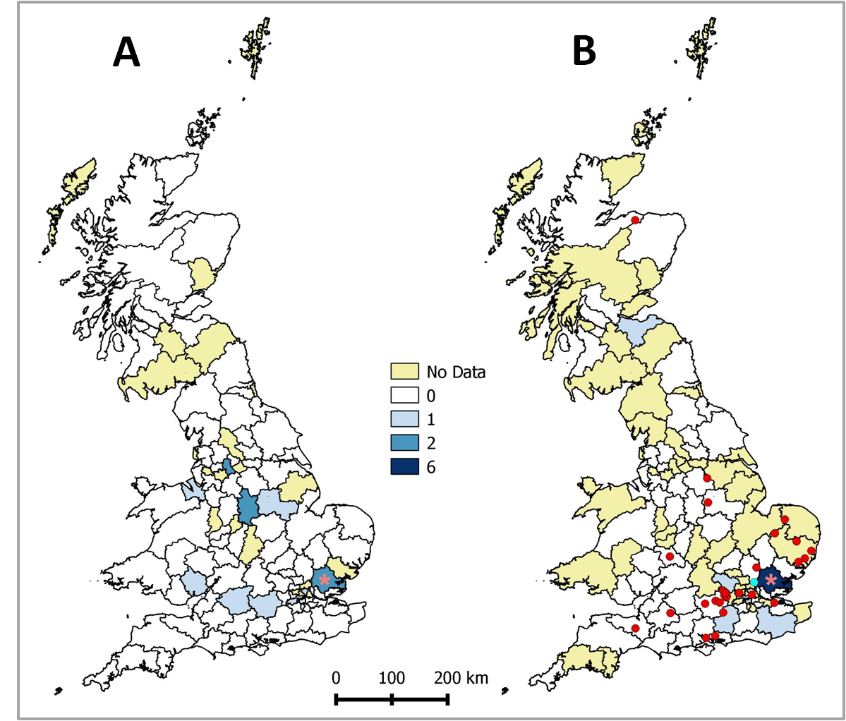

Figure 2
