quasi direct current interruption with an electromagnetically convoluted arc

L M shpanin¹, n y a shammas¹, s b tennakoon¹

g r jones², j e humphries², j w spencer²

¹Staffordshire University, Faculty of Computing Engineering and Technology, UK.
e-mail: l.m.shpanin@staffs.ac.uk
²University of Liverpool, Department of Electrical Engineering and Electronics, UK.
e-mail: G.R.Jones@liverpool.ac.uk

ABSTRACT

This contribution is concerned with an electromagnetically convoluted arc in air at atmospheric pressure for interrupting quasi direct currents (DC). Investigations are reported on the effects of using a separate current for producing the arc convolving electromagnetic field (B-field) to that being interrupted and using a separate R, L, C circuit in parallel with the arc contacts.
Experimental results are presented for the time variation of the currents flowing through the arc gap, the B-field coil and the parallel L, C, R circuit, along with the voltage across the arc gap.

1. INTRODUCTION

The interruption of high levels of DC current at high and medium voltages is attracting much interest because of the advent of power transmission from renewable sources such as wind, solar, etc. Attempts to find an alternative to sulphur hexafluoride (SF6) [1] as the arc quenching medium and to find more efficient DC interruption techniques are ongoing [2, 3]. Current interruption in DC systems is more problematic than in alternating current (AC) systems since there is no natural current-zero available. One of the techniques for producing a current zero artificially during direct current flow is with a current oscillating RLC circuit connected across the interrupter arc gap [1, 4]. The use of such circuits in rotary and non-rotary arc circuit breakers have been previously investigated with arcs in atmospheric pressure SF6 gas [1, 4]. In this paper, the form of electromagnetically convoluted arc unit previously used for interrupting AC arc currents [5] was connected in parallel with an RLC circuit for producing an artificial current zero.
The effects of various parameters (e.g. arc extinction voltage peak, time at which current interruption occurs, re-strike voltages etc.) upon the current interruption process are reported.

2. TEST curcuit and Current Interruption method

The principle of the DC current interruption is based upon two facets (Fig. 1a, b).

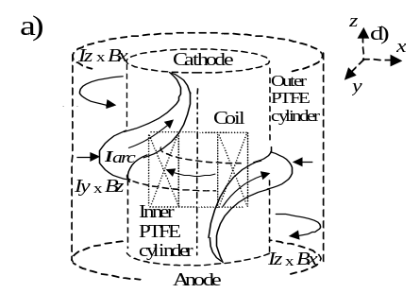

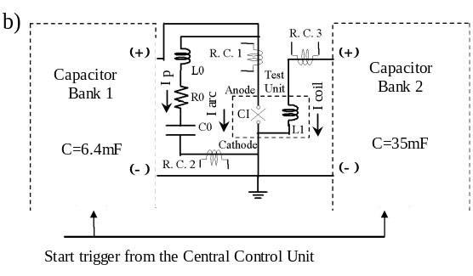

Fig. 1. Schematic diagrams of the two facets involved in the DC current interruption method. a) The convoluted arc unit. b) The parallel L0, C0, R0 and high voltage supply circuits. (L1 - B-field producing coil of interrupter (CI), (Fig. 1a)).
The first is the control and extinction of an arc electromagnetically [5] when the arc contacts (and hence the arc column) extends in parallel along the length and outside of a B-field producing coil (Fig. 1a). The second is the use of a parallel RLC circuit across the convoluted arc gap [4] to generate high-frequency current flow through the arc.
The first facet involves the principle described previously by [3, 5]. The anode arc section is exposed to an outward radial B-field produced by the B-field coil at that location. This causes the arc to rotate in an anticlockwise direction. When the arc gap is fully opened, the cathode arc section is exposed to the inward B-field at the cathode level of the coil, which causes that arc section to counter rotate in a clockwise direction (Fig. 1a). The central arc column section forms a convolute around the inner PTFE cylinder by the action of the axial B-field component at the middle of the coil length upon the azimuthal arc current flow. At current close to zero, the inward Lorenz force vanishes and the arc plasma ring is no longer compressed against the inner PTFE cylinder [3, 5].
The second facet (Fig. 1b), the parallel R0-L0-C0 circuit, is described in [4] and has been adapted for use with the convoluted arc form shown on Fig. 1a. When the length of the convoluted arc is increased around the coil by the Lorenz forces (Fig. 1a), the arc voltage increases, charging the parallel capacitor C0 to the same voltage as that across the arc. If the arc length is suddenly reduced due to self short-circuiting of the arc convolute, the arc voltage is suddenly reduced. As a result, the capacitor discharges itself through the arc. Therefore, if the parallel circuit R0-L0-C0 is connected across the arc gap of the interrupter (CI), Fig. 1b), the discharge of C0 will produce high-frequency current oscillations (Ip) through the arc (I arc) (Fig. 1b). The magnetic field (B-field) producing coil L1 in the test unit (Fig. 1a) is connected separately from the main circuit in order to examine the performance of the DC arc interruption without involving the coil in the arc circuit itself.
The experimental test circuit used is shown in Fig. 1b. It consists of two independently but synchronically operated capacitors bank units (C.B.1 and C.B.2) generating a quasi-direct electrical arc of 1.5kA at 4kV (C.B.1, capacitance of 6.4mF) and a coil current of ~5.8kA, at 4kV (C.B.2, capacitance of 35mF) respectively. Each capacitor bank includes an Ignitron, which is connected in series with a current limiting resistor ~2.7Ω (C.B.1) and ~0.7Ω (C.B.2), and is triggered to conduct a quasi-steady current through the interrupter (CI) via C.B.1 or electromagnetic coil L1 via C.B.2. Both units include Ignitrons to short both DC circuits in order to dump the remaining energy from the capacitor bank units. A series combination of L0-C0-R0 circuit was connected in parallel with the arc convolute test unit (Fig. 1a) having values of 96μH, 66μF and 0.1mΩ respectively. These component values were taken from the previous work deploying similar test circuit, but using a different arc convolute unit [4]. Three CWT type Rogowski current transducers R.C.1, R.C.2, R.C.3 were used to measure the DC current waveforms of the arc (I arc), coil of L1 (I coil) and L0-C0-R0 (Ip) circuits respectively (Fig. 1b).

3. ExperimentAL Results

Fig. 2 shows an example of the time variation of various currents and arc voltage when a quasi
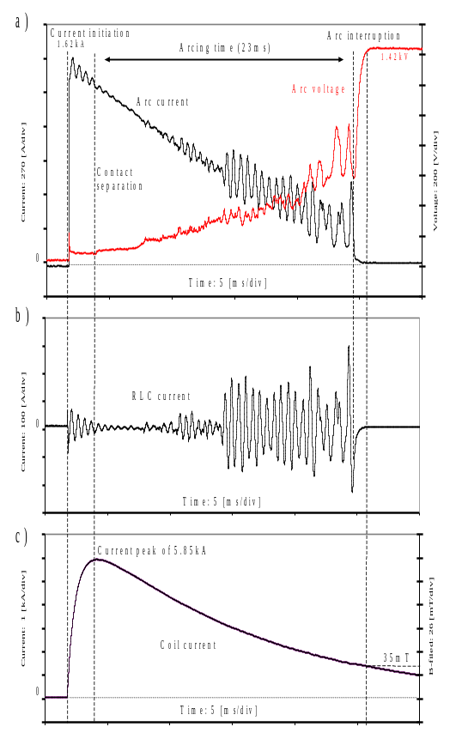
0
0
0
Fig. 2. Time variation of various currents and arc voltage when interrupting a quasi direct current (1.5kA peak, atmospheric pressure air). a) Arc current (I arc) and Voltage; b) R0-L0-C0 current (Ip); c) Coil current (~5.8kA peak producing 150mT B-field). (Initial C.B.1, C.B.2 (Fig.1b) voltages 4kV peak).
direct current of 1.5kA peak was interrupted with a B-field of ~35mT at current interruption. Fig. 2a shows the arc voltage and current waveforms. Fig. 2b shows the current flowing through the R0-L0-C0 circuit (Fig. 1b). Fig. 2c shows the B-field coil current during and post arcing. These results show that high frequency currents of frequency ~2kHz occur during arcing (Fig. 2b).
Fig. 3a compares the time variation of a quasi direct current of peak value1.5kA under different operating conditions. Fig. 3b shows the corresponding arc voltages.
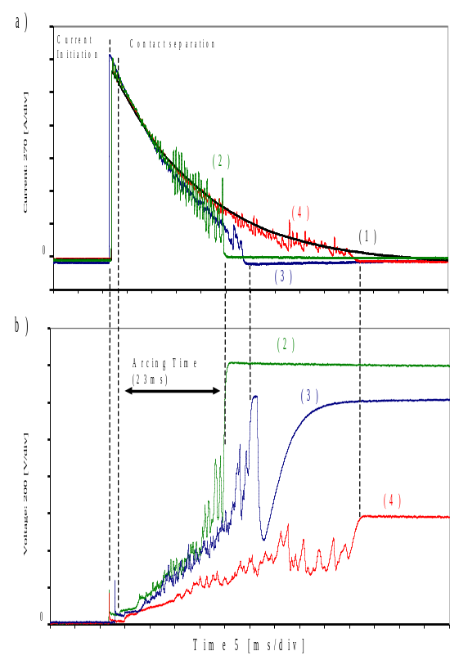
0
0

Fig. 3. Interruption of 1.5kA peak quasi DC under different conditions (air, atmospheric pressure).
a) Interrupter current waveforms b) Voltage waveforms; (1) Contacts closed; (2) Contacts open plus B-coil and R0-L0-C0 connected circuits; (3) Contacts open plus B-coil, without R0-L0-C0 connected circuit (coil peak current ~5.8kA); (4) Contacts open, without B-field circuit, but with R0-L0-C0 circuit connected. (Initial voltages on C.B.1 and C.B.2 = 4kV).

Curve (1) (Fig. 3a) is for capacitor bank C.B.1 discharging through the closed interrupter (CI) (Fig. 1b) showing an uninterrupted current of duration ~80ms. Curves (2) (Fig. 3a, b) are the arc current and voltage waveforms of Figs. 2a, b with ~23ms arc duration (i.e. with B-coil and R0-L0-C0 connected circuits). Figs. 3a, b, curve (3) shows results with a B-field coil (5.8kA peak current) and without the R0-L0-C0 circuit indicating an arc duration of ~26ms. Figs. 3a, b, curve (4) show results without the B-field coil but with the R0-L0-C0 circuit connected, indicating an arc duration of ~55ms.

4. discussion

Previous experimental work [5] suggests that the minimum level of Lorenz force (I x B) required to induce a convoluted arc structure is about 6 - 10N/m. The coil used in the present tests could produce such a force at an arc current of 300 - 400A with a B-field of 20-25mT. An insight into the effect of the B–field producing coil, with and without a parallel R0-L0-C0 circuit, on the quasi DC interruption can be obtained from the current and voltage waveforms shown on Figs. 2 and 3.
The influence of the coil’s B-field along with the parallel R0-L0-C0 circuit (Fig. 1 b) on the convoluted arc produces the high-frequency oscillatory current (Ip) shown on Fig. 2b. These oscillations which occur on both arc (I arc) and R0-L0-C0 (Ip) currents have a recognisable amplitude (~50-100A) about 12ms after contact separation (Figs. 2a, b). The maximum amplitude (~300A) of the high-frequency current oscillations (Ip) was generated just prior to the arc current (I arc) interruption (Fig. 2a). A similar trend is also apparent on the arc voltage curve (Fig. 2a). At times longer than 12ms after contact separation, the length of the arc gap becomes greater than the length of the coil (~70mm) [5], so that the quasi DC arc becomes convoluted and susceptible to repeated self short-circuiting and re-formation (Fig. 2a, b). Fig. 3a (curves (2), (4)) show that the effect of the presence of a B-field coil current (I coil) (Fig. 1b) on the arc current (I arc) is to produce:
a) lower (~ x ½) quasi DC levels at a given time (i.e. current limitation),
b) higher amplitude (~ x 2) high frequency arc current oscillations (i.e. enhancing a forced current zero).

The voltage waveforms during arcing (Fig 3 b) with and without (curves (2), (4) respectively) the B-field coil show similar trends to the current waveforms - the arc voltages and oscillation amplitudes without the coil being lower (~ x ½) than those with the coil. Such reduction in the amplitudes of the current and voltage oscillations suggests that the arc is not lengthening substantially in the absence of the coil current (I coil). The implication is that with the B-field coil, the capacitor C0, in the R0-L0-C0 circuit (Fig. 1b), is charged more significantly to produce the desirable higher amplitude oscillations when arc self short-circuiting occurs.

As already indicated (section 3), the arc duration before current interruption depended upon the parallel circuit conditions. The arc duration time was shortest with both B-field and R0-L0-C0 circuit connected (~ 23ms Fig. 3a curve (2)), intermediate with the B-field but no R0-L0-C0 circuit (~26ms, curve (3)) and longest without both the B-field and R0-L0-C0 (~ 55ms curve (4)). In each case the current level at which interruption occurred was ~300A (curve (2), Fig. 3a), ~150A (curve (3), Fig. 3a) and ~70A (curve (4), Fig. 3a). In addition, there is evidence on curve (3) (with the B-field but without the R0-L0-C0 circuit) of a low level, negative current flowing post arcing.
Comparison of the post arc voltage curves (2), (3), (4), Fig. 3b shows that the residual source voltage following arc extinction is highest when both the B-field and R0-L0-C0 circuit are activated (~1.42kV curve (2)) due to the short arcing duration (and hence reduced power dissipation). The residual source voltage is lowest in the absence of the B-field coil, but with the R0-L0-C0 circuit connected (~0.6kV curve (4)), mainly due to the lower arc voltage (hence lower power dissipation) and despite the prolonged arc duration. With the B-field and without the R0-L0-C0 circuit, the remnant source voltage is intermediate between those of curves (2) and (4) and there is evidence of arc re-ignition in the form of a late voltage collapse (curve (3)). This feature is consistent with the low post arc current already indicated on the corresponding current curve (3), Fig. 3a.

4. CONCLUSIONS

The results presented have provided an insight into the combined use of a parallel R0-L0-C0 circuit with a novel form of convoluted arc in atmospheric pressure air for interrupting quasi direct currents. The results show that:
Stronger high frequency current oscillations, which may be advantageous for direct current interruption, can be produced by the combination of a B-field coil and an R0-L0-C0 circuit connected across the arc gap.
The B-field / R0-L0-C0 circuit combination reduces the time to current interruption compared with the separate use of the B-field and R0-L0-C0 circuit.
The post arc voltage withstand capability is greater with the B-field / R0-L0-C0 combination, with less susceptibility to post arc current flow.
Compared with the work of Zhang et al [4], the present arc convolute form produces similar current interruption levels and arc durations before interruption. In addition it has the following advantages:
a) the high frequency current oscillations (Ip, I arc) gradually increase in amplitude as the arc duration increases to progressively encourage current interruption,
b) the convolute arc is in atmospheric pressure air and ablated material rather than in SF6 gas and at much higher pressure (~ 3 atmospheres).
Future work would need to address the possible effect of the mutual inductance between the arc plasma convoluted loop (Fig. 1a) and the B-field producing coil (L1 (Fig. 1b)) as well as the B-field magnitudes required for the interruption of lower level direct currents.

REFERENCES

[1] H. Nakao, Y. Nakagoshi, M. Hatano, T. Koshizuka, S. Nishiwaki, A. Kobayashi, T. Murao and S. Yanabu, “D.C. Current Interruption in HVDC SF6 Gas MRTB by Means of Self-Excited Oscillation Superimposition”, IEEE Transactions on Power Delivery, Vol. 16, No. 4, pp. 687-693, 2001.
[2] Y. Shiba, Y. Morishita, S. Kaneko, S. Okabe, H. Mizoguchi and S. Yanabu, “Study of D.C. Circuit Breaker of H2-N2 Gas Mixture for High Voltage”, Electrical Engineering in Japan, Vol. 174, No. 2, pp.9-17, 2011.
[3] H. M. Ryan, High Voltage Engineering and Testing, 3rd Edition, Institution of Engineering and Technology (IET), UK, (to be published in July 2012).
[4] J. R. Zhang, G. R. Jones, Z. Ma, M. T. C. Fang, “Interaction of helical arc devices with interconnected networks”, IEE Proc. of Generation, Transmission and Distribution, Vol. 143, No. 1, pp.89-95, 1996.
[5] L. M. Shpanin, G. R. Jones, J. E. Humphries and J. W. Spencer, “Current interruption using electromagnetically convolved electric arcs in gases”, IEEE Transactions on Power Delivery, Vol. 24, No. 4, pp.1924-1930, 2009.

