Antibacterial Effect of Gallium and Silver on Pseudomonas aeruginosa Treated with Gallium-Silver-Phosphate Based Glasses

Sabeel P Valappil*, Susan M Higham

Department of Health Services Research and School of Dentistry, University of Liverpool, Research Wing, Daulby Street, Liverpool, L69 3GN, United Kingdom

Running headline: Antibacterial gallium and silver glass

*Corresponding Author. Mailing address: Department of Health Services Research and School of Dentistry, University of Liverpool, Research Wing, Daulby Street, Liverpool, L69 3GN, UK Tel +44 (0)151 706 5299, Fax +44 (0)151 706 5809 Email: S.Valappil@liv.ac.uk

ABSTRACT
Gallium and silver incorporated phosphate based glasses were evaluated for antibacterial effect on the growth of Pseudomonas aeruginosa, which is a leading cause of opportunistic infections. The glasses were produced by conventional melt quenching methods at 1100⁰C for 1h. Glass degradation studies were conducted by weight loss method. Disc diffusion assay and cell viability assay displayed statistically significant (p ≤ 0.0005) effect on P. aeruginosa growth which increased with decreasing calcium content in the glasses. The gallium ion release rates (1.83, 0.69 and 0.48 ppm.h⁻¹) and silver ion release rates (2.97, 2.84 and 2.47 ppm.h⁻¹) were found to account for this variation. Constant depth film fermentor was used to evaluate the anti-biofilm properties of the glasses. Both gallium and silver in the glass contributed to biofilm growth inhibitory effect on P.aeruginosa (up to 2.68 reduction in log₁₀ values of the viable counts compared with controls). The glasses were found to deliver gallium and silver in a controlled way and exerted cumulative antibacterial action on planktonic and biofilm growth of P. aeruginosa. The antibacterial, especially anti-biofilm, properties of the gallium and silver incorporated phosphate based glasses make them a potential candidate to combat infections caused by P.aeruginosa.

Key words: phosphate-based glass; gallium; silver; constant depth film fermentor; biofilm; Pseudomonas aeruginosa

1. INTRODUCTION
Pseudomonas aeruginosa is a leading cause of opportunistic biofilm infections such as airway infections in cystic fibrosis patients, chronic wound and sinus infections that result in significant morbidity and mortality [1]. Biofilms show a decreased susceptibility to antibiotics, disinfectants and clearance by host defences [1]. Therefore alternative anti-biofilm strategies such as controlled metal ion releasing phosphate-based glasses (PBGs) have attracted considerable interest recently [2-6]. PBGs have unique dissolution properties in aqueous based fluids compared with silicate based glasses such as Bioglass [2]. Moreover, degradation rates and the subsequent antibacterial metal ion release from PBGs can be customized from hours to several weeks by changing the glass composition. Formation of a biofilm follows a sequence of events: microbial surface attachment, cell proliferation, matrix production and detachment. Among these, bacterial adhesion on biomaterial surfaces is a key step in biofilm infections, and it is initiated by the interaction of cells with a surface, a process governed by long-range forces, primarily van der Waals and electrostatic interactions [7]. Silver has already been incorporated into PBGs and found to possess anti-adhesive and antibacterial activity against P. aeruginosa [4]. Recently gallium-doped PBGs emerged as a potential therapeutic agent that was found to inhibit P. aeruginosa growth and biofilm formation in vitro [5] by interfering with bacterial Fe metabolism [8]. The antibacterial action of gallium is reported to be due to its action on ribonucleotide reductase [9], superoxide dismutase, catalase [10] and enzymes involved in oxidative phosphorylation such as cytochromes and others where as silver affect bacterial adhesion and interfere with DNA replication [11]. Gallium and silver display different mechanisms to achieve antibacterial action on P. aeruginosa and therefore coupling such effects, especially their action on multiple targets of bacteria, will improve their therapeutic potential. Therefore the aims of this study were to prepare 3mol% gallium and 5mol% silver incorporated PBGs with increasing calcium content and corresponding decrease in sodium content and evaluates their efficacy against P. aeruginosa.
2. MATERIALS AND METHODS
2.1. Glass preparation
PBGs investigated in this study were produced using NaH₂PO₄ (BDH, ≥98%), P₂O₅ (Sigma, ≥97%), CaCO₃ (BDH, ≥98.5%), Ga₂O₃ (Sigma, 99.99%) and Ag₂SO₄ (Sigma, 99.99%,) by a conventional melt quenching method, at 1100ºC for 1hour. Gallium-silver-doped glasses of general composition (CaO)_{x}(Na₂O)_{47-x}(P₂O₅)₄₅(Ga₂O₃)₃(Ag₂O)₅, where x = 10, 11 and 12, hereafter given the abbreviation C10,C11 and C12 respectively, were prepared along with a sample containing no gallium and silver, hereafter given the abbreviation control, of composition (CaO)₂₀(Na₂O)₃₅(P₂O₅)₄₅.
2.2. Glass degradation and ion release study
All glass samples were sectioned (diameter, 5 mm; thickness, 2 mm) by using an Isomet low speed rotary diamond saw (Buehler Ltd, UK) and each of the sectioned samples were placed in different sterile plastic containers. These containers were filled with 50 mL of deionised water (pH 7±0.5) and placed in an incubator at 37°C. At pre determined time points (2, 4, 6, 8, 24, 32 and 48 h) samples were taken out of their respective containers and blot dried with tissue and then weighed. All samples were then placed in a new set of containers with fresh solution of ultrapure water and placed back into the 37°C incubator. To obtain the rate of weight loss, the initial weight (M₀) of each sample was measured, as was the weight at time t (M_{t}), to give a weight loss per unit area; thus, weight loss = (M₀ -M_{t})/A, where A is the surface area (mm²). The measurements were carried out in triplicate, and data plotted as weight loss per unit area against time. The slope of this graph (determined by fitting a straight line of the form y= mx through the origin) gave a dissolution rate value which was converted to μg mm⁻² h⁻¹. Parallel to the degradation studies, ion release was also monitored using inductively coupled plasma atomic emission spectrometry (ICP-AES) [6]. An ICP-AES spectrometer (Spectro Ciros CCD, UK) was used and the instrument was calibrated for the predicted concentration in the range 0.1–1000 ppb by mixing single element standards obtained from Sigma and diluted in ultrapure water. The data were first plotted as ion release in ppm against time (h). The slope of this graph (determined by fitting a straight line of the form y= mx through the origin) gave an ion release rate value in ppm. h⁻¹.
2.3. Disc diffusion assay
Disc diffusion assays (BSAC Disc Diffusion Method for Antimicrobial Susceptibility Testing, Version 4, 2005) were performed using isosensitest agar (Oxoid, Basingstoke, UK). Isosensitest agar plates were inoculated with a standardised culture of P. aeruginosa (Epidemiological strain, School of Dentistry, University of Liverpool) in PBS at an optical density at 600nm (OD600) of 0.03. The glass discs; control, C10, C11 and C12 were placed on these inoculated plates. The plates were then incubated aerobically for 48h at 30 °C. The diameters of any zones that had formed around the discs were measured in triplicate using calipers.
2.4. Cell viability assay
For the cell viability assay, P. aeruginosa were first inoculated into 10 mL of nutrient broth (Oxoid, Basingstoke, UK) and incubated overnight at 37 °C with 200 rpm agitation in an Orbital Shaker (Stuart Scientific, UK). These overnight grown P. aeruginosa cultures were used to inoculate a 5 mL volume of phosphate buffered saline (PBS, Oxoid) in sterile containers to a standardised optical density (OD₆₀₀=0.03). The glass discs; control, C10, C11 and C12 were added to each of the respective containers and then incubated at 37 °C. At various time intervals (2, 4, 12 and 24 h) serial dilutions of the suspensions were carried out in PBS and 50 μL volumes of the suspension were spread onto McConkey agar (Oxoid, Basingstoke, UK) plates. The plates were then incubated aerobically at 30 °C for 48 h. For each type of disc, viable counts (colony forming units; CFUs) were conducted in triplicate.
2.5. Biofilm growth inhibitory assay
Biofilm growth and inhibition studies were performed in a constant depth film fermentor (CDFF; University College Cardiff, Cardiff, UK) using the most potent glass composition, C10, along with control glass and hydroxyapatite (HA; used as a negative control as it is known to aid biofilm growth but does not undergo degradation like PBGs in aqueous medium). C10, control glass and HA discs, 5 mm in diameter, were placed on each plug in the PTFE pan and recessed to a depth of 300 μm. 1% tryptic soy broth (TSB) was used as the growth medium which drips onto the rotating turntable at a flow rate of 0.5 mL min⁻¹ and is distributed over the PTFE pans by two scraper blades. The CDFF was sterilised in a hot air oven at 140 °C for 3 h. The CDFF was incubated at 37 °C and at pre determined time intervals (6, 12, 24, 48 and 72h) samples were removed aseptically from the CDFF. Disks containing biofilms were placed in 1 mL of PBS, vortexed for 1 min to remove the attached biofilms and to disperse them into the suspension. Serial dilutions of the suspensions were carried out in PBS, with 25 μL aliquots of the diluted suspensions spread onto MacConkey agar plates. The plates were incubated aerobically at 30°C for 48h. For each type of disk, CFUs were determined in triplicate.
2.6. Statistical analyses
Statistical analyses of the data and t-tests were conducted using GraphPad Software (San Diego, USA). A p value higher than 0.05 (p > 0.05) was considered as no statistical difference.

3. RESULTS
Gallium ion release rates (1.83, 0.69 and 0.48 ppm.h⁻¹) and silver ion release rates (2.97, 2.84 and 2.47 ppm.h⁻¹) decreased as the calcium content of the glasses increased (10, 11 and 12 mol %) (Figure. 1a). Ion release rates from the glasses were well associated with the degradation rates of the glasses [6]. The degradation rates of glasses, obtained by applying a line of best fit through the plot of weight loss per unit area of each glass against time showed a decrease in degradation rates (30.33, 25.19 and 21.40 μg mm⁻² h⁻¹) with an increase in calcium content (10, 11 and 12 mol%) (Figure.1). The highest level of ion release rate was displayed by the glass composition with highest degradation rate, C10 (Figure.1).
Disc diffusion assay showed that the zones of inhibition compared with the control decreased as the calcium content of the glasses increased; C10 (19.0 ± 1.0mm), C11 (15.0 ± 0.5mm) and C12 (12.5 ± 1.0 mm). Similar trends followed in cell viability assay as C10, C11 and C12 glasses showed statistically significant (p ≤ 0.0005) reduction in the log₁₀ of the mean number of viable cells compared with control at 4, 12 and 24h (Figure. 2).
P. aeruginosa biofilm on C10 glasses showed a significant difference (p ≤ 0.0376) in the log₁₀ of the viable count at 6h compared with controls (Figure. 3) which became more apparent at 12h and 24h (p ≤ 0.0071). At 48h the log₁₀ of the mean number of viable cells on the C10 started to recover from the previous low at 24h but remained less than both controls (p ≤ 0.0125) and this trend continued until 72h (p ≤ 0.0454) (Figure 3).
4. DISCUSSION
This paper reports the antibacterial effect on P. aeruginosa by PBGs that combine gallium (3 mol%) and silver (5 mol%) ions. These gallium and silver incorporated PBGs were effective at reducing the growth of P. aeruginosa, a causative agent of opportunistic infections [1]. Disc diffusion assay and cell viability assay showed statistically significant (p ≤ 0.0005) effect on P. aeruginosa growth which was inversely proportional to the calcium content of the glasses. The maximum P. aeruginosa biofilm growth inhibition achieved by C10 glasses (2.68 reduction in log₁₀ of the viable count compared with controls) is significantly higher than stand alone gallium [5] or silver [4] glasses (0.86 or 1.48 reduction in log₁₀ of the viable count respectively compared with controls) reported previously. The results in this study thus clearly suggest that both gallium and silver in the C10 glass has the capability to exert a cumulative antibacterial effect on P. aeruginosa under such in vitro conditions. However, Valappil et al. [12] reported the formation of a dead bacterial layer at the interface with the silver-releasing PBGs and S. aureus biofilm causing the re emergence of viable bacteria after 24 h growth in a CDFF. Therefore it is possible that a dead bacterial layer of P. aeruginosa formed in the present CDFF study which triggered the re emergence of viable bacteria after 24 h (Figure 3). Other factors, such as the limitation of diffusion of gallium and silver ions from the PBGs or the drug resistant efflux pump system that could be protecting P. aeruginosa from the toxic gallium and silver ions, also need to be checked in order to unravel the mechanism behind this phenomenon. The fact that the antibiofilm effect on P.aeruginosa was vivid in an iron controlled medium (1%TSB), suggest that the gallium released from the glasses would be more effective in humans, where iron is sequestered by iron-binding complexes to maintain an extremely low concentration of free iron [8]. Due to the consistent local delivery of gallium from the PBG, such iron-binding complexes should not affect the Ga³⁺ concentration. Moreover, it is reported that Ga³⁺ is competent of interacting with the Fe³⁺ dependant enzymes including ribonucleotide reductase [9], superoxide dismutase, catalase [10] and enzymes involved in oxidative phosphorylation such as cytochromes and others. Silver ions, on the other hand, have been shown to reduce bacterial adhesion and interfere with DNA replication, therefore reducing the bacterial biofilm growth [11]. Hence coupling the effect, especially their action on multiple targets of bacteria, of both gallium and silver will make this glass combination an exciting prospect in combating multidrug resistant oppurtunistic pathogens. These results also emphasise the need to explore the collective anti-adhesive and anti-biofilm properties of silver and gallium which could widen the applications of silver-containing antibacterial formulations, e.g. coating of catheters simultaneously with gallium and silver ions to avoid bloodstream infections [13].
5. CONCLUSION
The scarcity of new antibiotics in the pipe line advocates a rising demand for alternative strategies to combat opportunistic pathogens such as P. aeruginosa associated infections. The results from our study indicate that Gallium-Silver-Phosphate Based Glasses, C10 composition in particular, may offer a successful choice to antibiotics treatments or could be used to supplement current therapies, by allowing the controlled and local delivery of antibacterial gallium and silver ions at the site of infection.
Acknowledgements
This research was supported by an induction award (University of Liverpool, UK).
REFERENCES
[1] Donlan RM, Costerton JW. Biofilms: survival mechanisms of clinicallyrelevant microorganisms. Clin Microbiol Rev. 2002; 15: 167.
[2] Abou Neel E A, Pickup D M, Valappil S P, Newport R J, Knowles J C. Bioactive functional materials: a perspective on phosphate-based glasses. J Mater Chem 2009; 19: 690.
[3] Ahmed I, Ready D, Wilson M, Knowles JC. Antimicrobial effect of silver-doped phosphate-based glasses. J Biomed Mater Res A 2006; 79: 618.
[4] Valappil SP, Knowles JC, Wilson M. Effect of silver-doped phosphate-based glasses on bacterial biofilm growth. Appl Environ Microbiol 2008; 74: 5228.
[5] Valappil SP, Ready D, Abou Neel EA, Pickup DM, O’Dell LA, Chrzanowski W. et al. Controlled delivery of antimicrobial gallium ions from phosphate-based glasses. Acta Biomater 2009; 5: 1198.
[6] Valappil SP, Coombes M, Wright L, Owens GJ, Lynch RJM,. Hope CK. et al. Role of gallium and silver from phosphate-based glasses on in vitro dual species oral biofilm models of Porphyromonas gingivalis and Streptococcus gordonii. Acta Biomater 2012; 8; 1957.
[7] Razatos A, Ong YL, Sharma MM,Georgio G. Molecular determinants of bacterial adhesion monitored by atomic force microscopy. Proc Natl Acad Sci USA 1998; 95: 11059.
[8] Kaneko Y, Thoendel M, Olakanmi O, Britigan BE, Singh PK. The transition metal gallium disrupts Pseudomonas aeruginosa iron metabolism and has antimicrobial and antibiofilm activity. J Clin Invest 2007; 117, 877.
[9] Narasimhan J, Antholine WE, Chitambar CR. Effect of gallium on the tyrosyl radical of the iron-dependent M2 subunit of ribonucleotide reductase. Biochem Pharmacol 1992; 44: 2403.
[10] Hassett DJ, Woodruff WA, Wozniak DJ, Vasil ML, Cohen MS, Ohman DE. Cloning and characterization of the Pseudomonas aeruginosa sodA and sodB genes encoding manganese- and iron-cofactored superoxide dismutase: demonstration of increased manganese superoxide dismutase activity in alginate-producing bacteria. J Bacteriol 1993; 175: 7658.
[11] Chaw KC, Manimaran M, Tay FEH. Role of silver ions in destabilization of intermolecular adhesion forces measured by atomic force microscopy in Staphylococcus epidermidis biofilms. Antimicrob Agents Chemother 2005; 49: 4853.
[12] Valappil SP, Pickup DM, Carroll DL, Hope CK, Pratten J, Newport RJ et al. Effect of silver content on the structure and antibacterial activity of silver-doped phosphate-based glasses Antimicrob Agents Chemother 2007; 51: 4453.
[13] De Cicco M, Campisi C, Matovic M. Central venous catheter-related bloodstream infections: pathogenesis factors, new perspectives in prevention and early diagnosis. J Vasc Access 2003; 4: 83.

Figure legends
Figure.1. Relationship between ion release rates (a) gallium, silver (), (b) phosphorous, calcium, sodium (), and rates of degradation () of control and gallium-silver- PBGs as a function of calcium content.
Figure. 2. The effect of C10 (), C11() and C12 () compared with control ( ) glasses on the log₁₀ numbers of CFU.mm⁻³ of P. aeruginosa in PBS suspensions.
Figure. 3. Log₁₀ numbers of CFU.mm⁻² of P. aeruginosa in biofilms formed on HA (), Control () and C10 () glasses.

Figure. 1a.

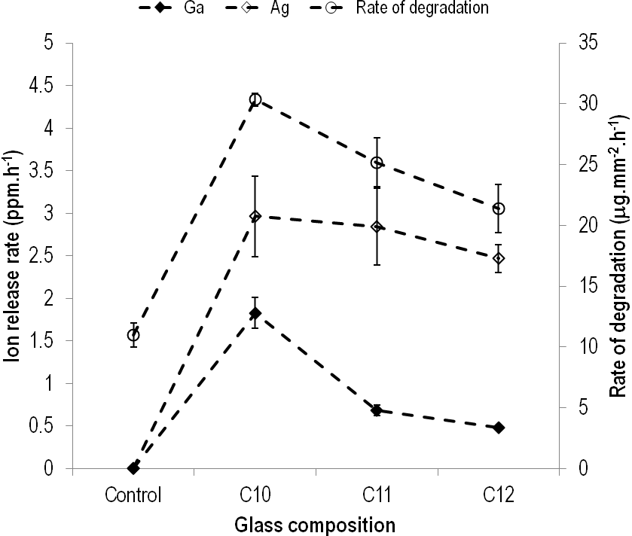

Figure. 1b.

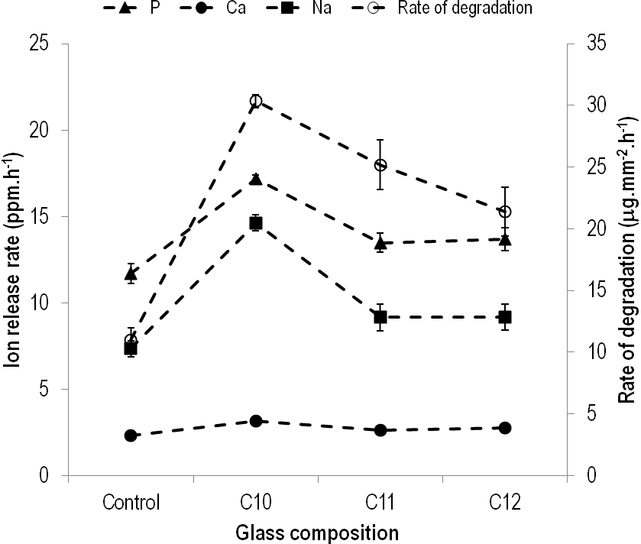

Figure. 2.
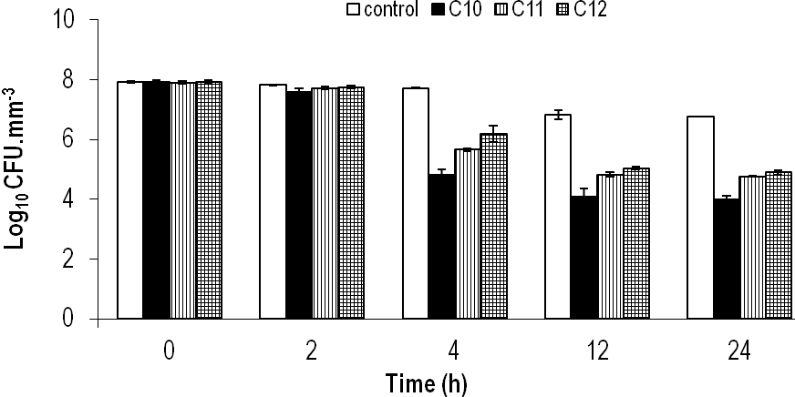

Figure. 3.
