The Development and Application of a Novel LC-MS/MS Method for the Measurement of Dolutegravir, Elvitegravir and Cobicistat in Human Plasma.
Author list: Sujan Dilly Penchalaª*, Sandra Fawcettª, Laura Elseª, Deirdre Eganª, Alieu Amaraª, Emilie Elliot^{b}, Elizabeth Challengerª, David Backª, Marta Boffito^{b}, Saye Khooª
ª Department of Molecular & Clinical Pharmacology, University of Liverpool, Liverpool, UK
^{b} St Stephen’s Centre, Chelsea and Westminster Hospital, London, UK;

*Corresponding author
Address for correspondence

Sujan Dilly Penchala
Bioanalytical Facility
Royal Liverpool University Hospital
4th floor UCD
Prescot Street
Liverpool, L69 3GA
UK
Tel: + 44 (0) 151 706 4076
Fax: + 44 (0) 151 706 4084
sujan@liv.ac.uk

Abstract
Dolutegravir and Elvitegravir belongs to a class of integrase inhibitors which has recently been approved by the FDA for the treatment of HIV-infection. Elvitegravir and its co-administered booster drug, Cobicistat, has shown the potential to be a candidate for a one pill once a day regimen and is currently a component of many clinical trials. A sensitive LC-MS/MS method has been developed and validated for the simultaneous determination of these three drugs in human plasma. A liquid- liquid extraction was used as a sample preparation technique using 100µl of plasma. The method was validated from 10-4000ng/mL for Dolutegravir, Elvitegravir and Cobicistat. Chromatography was performed on XBridge C₁₈ 2.1mm x 50mm column, using an 80:20 methanol/water mobile phase containing 0.1% formic acid on a gradient program. This method was successfully applied for ongoing clinical trials.
Keywords: Dolutegravir, Elvitegravir, Cobicistat, LC-MS/MS, Method Validation

- Introduction
Dolutegravir (DTG) and Elvitegravir (EVG) are recently licensed second generation integrase strand transfer inhibitors (INSTI) used in the treatment of HIV-1 infection. DTG and EVG, like the first generation INSTI, inhibit the HIV replication cycle by preventing binding of the integrase-viral DNA complex to host cell DNA by chelating Mg²⁺ ions in the enzyme’s active site; hence blocking the formation of the HIV-1 provirus and propagation of the viral infection [1].
Several Phase III randomised controlled clinical trials have confirmed the clinical efficacy of DTG in treatment-naïve [2] and –experienced [3] patients. DTG is primarily metabolised via glucuronidation by hepatic glucuronosyltransferase UGT1A1, and as a result has a lower propensity for drug-drug interactions with other antiretroviral agents. DTG is currently prescribed at a licenced dose of 50 mg once daily in treatment naïve patients, and at 50 mg twice daily dose in patients with INSTI mutations (EMC prescribing information January 2014) [4].
Elvitegravir is licensed for use in treatment naïve HIV-infected adults as part of a once daily fixed-dose combination (FDC) containing 245 mg tenofovir disoproxil, 200 mg emtricitabine, 150 mg elvitegravir and 150 mg cobicistat (COBI) (Stribild). Elvitegravir undergoes oxidative metabolism by CYP3A (major route), and glucuronidation via UGT1A1/3 enzymes (minor route) and requires pharmacokinetic boosting (via inhibition of CYP3A) with either ritonavir or cobicistat.
INSTI have well characterised exposure-response relationships; therefore, robust, accurate and sensitive analytical methods are required in order to evaluate the pharmacokinetic properties of these agents in key patient populations in clinical trials and within routine clinical practice. To date there are very few published analytical methods that contain DTG and/or EVG and COBI. Grégoire et al developed a liquid chromatography-tandem mass spectrometry (LC-MS/MS) method for quantification of DTG (calibration range: 25 ng/mL-2000 ng/mL) alongside the second generation NNRTI rilpivirine in plasma. This method employed a protein precipitation step followed by a solid phase extraction step to remove the matrix interference [5]. Similarly, Bennetto-Hood et al have published a sensitive LC-MS/MS method for quantification of DTG in plasma over a calibration range of 5-10,000 ng/mL as a single agent; the method required only small (20 µL) plasma volumes and involved a simple protein precipitation step [6]. LC-MS/MS methods containing EVG are available; these assays involve extraction and quantification of EVG from plasma at therapeutically relevant concentrations (50-5000 ng/mL) alongside other antiretroviral agents using simple protein precipitation [7, 8]. A method for the simultaneous quantification of EVG and COBI is described by Shiomi et al as part of a study assessing the pharmacokinetics and bioequivalence of single-tablet versus separate-tablet regimens of EVG/COBI in Japanese subjects. Extraction was performed using SPE on a Waters HLB plate, and the calibration curves were linear between 20-10,000 ng/mL for EVG and 5-2500 ng/mL for COBI [9].
Here we describe the development and validation of a method for simultaneous quantification of DTG, EVG, and COBI concentrations in plasma by the use of reverse phase HPLC with mass spectrometry (LC-MS/MS). The method employs a liquid-liquid extraction technique and has been validated in accordance with FDA and EMEA guidelines [10, 11].

- Method and Materials
2.1 Method Development

2.1.1. Reagents
Elvitegravir (EVG), and its stable isotope-labelled (deuterated) internal standard d6-Elvitegravir (d6-EVG) together with Dolutegravir (DTG), were purchased from Toronto Research Chemicals (Toronto, ON, Canada). Cobicistat (COBI) was obtained from Alsachim (Illkirch, France) and d5-Dolutegravir (d5-DTG) from TLC Pharmaceutical Standards Ltd (Vaughan, ON, Canada). Quinoxaline (Sigma, UK) was used as an analogue internal standard for COBI.
LC-MS grade methanol, isopropanol, formic acid and tert-Butyl methyl ether (TBME) (reagent grade >98% pure) were obtained from Sigma Aldrich, UK. HPLC grade de-ionised water was produced from an Elga Option 4 water purifier (Elga LabWater, High Wycombe, UK) and was further purified to 18.2 MΩ with a Purelab Classic UVF (Elga LabWater, High Wycombe, UK). Drug-free plasma was obtained from the National blood service (Liverpool, UK).
    - Equipment
The HPLC system included a variable loop Accela autosampler (set at a temperature of 40˚C) and an Accela pump (Thermo Scientific, Hemel Hempstead, UK). The compounds were chromatographically resolved onto a reverse-phase Waters C₁₈ Xbridge column (3.5 μm: 50 mm x 2.1 mm) set at an oven temperature of 40˚C and interfaced with a 2 µm C₁₈ Quest column saver (Thermo Scientific, Hemel Hempstead, UK). Quantification was performed using a Thermo Quantum Access triple quadrupole mass spectrometer interfaced with a heated electrospray ionisation (H-ESI) source (Thermo Fisher Scientific, Hemel Hempstead, UK). TSQ Tune software was used for tuning and optimizing the analytes and data acquisition and processing was performed using LC Quan™ software (Version 2.7, Thermo Scientific, Hemel Hempstead, UK).
2.1.3. Chromatographic Conditions
Mobile phase A contained 0.1% formic acid in deionised water and mobile phase B contained 0.1% formic acid in methanol. A chromatographic gradient at a flow rate of 500 µL/min was used. The Initial gradient was started with 80% mobile phase A and held for 0.5 mins and then decreased to 20% mobile phase A for 2.5 mins, during which the analytes were eluted. The column was washed with 100% mobile phase B for 4 mins and re-equilibrated to original conditions for 2 mins giving a total run time of 9.0 mins. Extracted samples were injected (5 µL) on to the column and the needle was washed with a mixture of water and isopropanol (50:50 v/v) between injections.

    - Mass spectrometry conditions
The mass spectrometer was operated in positive ion electrospray ionisation mode using selective reaction monitoring (SRM). The electrospray voltage was 4.5Kv, the capillary temperature and vaporiser temperature were set at 270°C and 350°C, respectively. The sheath and auxiliary gas pressures were set of 50 and 15 arbitrary units. Argon, used as the collision gas, was delivered at a pressure of 1.5 mTorr.
The m/z transitions for all analytes and deuterated internal standards, as well as optimal collision energies and tube lens parameters, are summarised in Table 1. The scan width was set at 0.01 and the scan time at 0.1s. The peak width settings for Q1 and Q3 were set at unit resolution (0.7).
    - Preparation of calibrators, quality controls and internal standard
Stock solutions of 1mg/mL were prepared in methanol, and these were subsequently diluted in methanol to yield intermediate solutions of 200, 50 and 2.5 µg/mL concentration containing all three analytes. Both the stock and intermediate solutions were stored at -40°C. Working plasma calibration standards (of 50, 1000, and 4000 ng/mL) were prepared by spiking (2% of total plasma volume) drug-free plasma with the intermediate methanolic solutions containing all three drugs. These standards were prepared in bulk, aliquoted out and stored at -40°C. On the day of analysis, the standards were diluted (in duplicate) with drug-free plasma (100µl per calibrator level) to yield a concentration curve ranging from 10 to 4000 ng/mL for each analyte. The intervals in this calibration range were 10, 25, 50, 200, 500, 1000, 2000 and 4000ng/mL, respectively.
Internal QC samples were prepared at low, medium and high (LQC, MQC, HQC) nominal concentration levels: 30 ng/mL (LQC; within 3 times of the assay lower limit of quantification; LLQ), 455 ng/mL (MQC), and 3700 ng/mL (HQC).
Stock and intermediate solutions of each internal standard were prepared separately in methanol and stored at 4ºC. The intermediate solutions were then combined to create a pre-mixed working IS solution (methanol/water 50:50 v/v) containing 1µg/mL of quinoxaline, 2.5µg/mL of d5-DTG, and 2.5µg/mL of d6-EVG.
    - Sample pre-treatment
Liquid/liquid extraction was used to extract the compounds from the plasma. 100µL of plasma sample was added to clean glass tubes. 20 µL of the working internal standard solution was added to the tubes, followed by 2 mL of TBME. The tubes were capped, tumbled for 30 minutes and centrifuged for 5 minutes at 3398 g. The tubes were frozen in a cryogenic bath of solid CO₂ and methanol and the non-frozen supernatant layer transferred to a clean labelled 5ml glass tubes. This fraction was evaporated to dryness under nitrogen stream. The samples were reconstituted in 100 µL of mobile phase (methanol/0.1% formic acid 80:20 v/v). The tubes were vortex mixed for 5 seconds and 100 µL transferred to autosampler vials, ready for injection onto the LC-MS/MS system. LQC, MQC and HQC samples were included in each run, as a way of monitoring the internal performance of the assay.
2.2. Validation methodology
    - Selectivity
Selectivity was assessed by analysing six different lots of blank human plasma. The area response of interfering substances or noise at the retention times of all analytes were acceptable if the % interference was less than 20% of the mean response of the lowest standard in the calibration curve or LLQ (n = 6). Equally, the area response of any interfering substances or noise at the retention time of internal standard were acceptable if the % interference was less than 5% of the mean response of the internal standard areas in 6 LLQ samples.

2.2.2. Accuracy and Precision
Accuracy and precision batches, consisting of a calibration curve and 6 LQC, MQC and HQC samples, were run on 5 separate occasions. The calibration range was set taking into account prior data from the manufacturers’ observed C_{max} under standard dosing of 50mg.
2.2.3. Carryover
Percentage (%) carryover was determined as follows: standards at the assay LLQ (10 ng/mL) and upper limit of quantification (ULQ) (4000 ng/mL) were run in duplicate followed by 3 blank plasma samples. This sequence was run 6 times in succession without cleaning the HPLC column. The % carryover was calculated after each subsequent run, and expressed in relation to the assay LLQ. The EMEA guidelines stipulate that the % carryover should not exceed 20% of the LLQ concentration [11].
    - Dilution integrity
Plasma spiked with DTG, EVG and COBI at a concentration between 160-180% of the assay ULQ was diluted 1:2 and 1:4 with blank plasma. The back calculated concentrations were read off the standard curve, with the appropriate dilution factor applied, and compared against the expected nominal concentration.
    - Recovery and Matrix effects
The % recovery and matrix effects were determined quantitatively in accordance to the recommendations of Matuszewski et al [12]. Overall recovery (process efficiency) was determined by comparing the peak-area response of the analytes from extracted plasma samples spiked at LQC/MQC/HQC concentrations, to the peak area response of analytes spiked at an equivalent concentration in mobile phase. The % matrix effect was calculated by comparing analytes spiked into blank plasma extracts with the peak areas of the analytes in mobile phase at an equivalent concentration.
2.2.6. Stability

Analyte stability in plasma (QC samples; 6 per level) was assessed after heat inactivation at 58ºC for 40 minutes. Freeze–thaw stability was determined over 3 freeze-thaw cycles over a period of 3 days. The “bench top” stability of the QC samples (n=6, per level), was assessed at room temperature over 16 hours. Reinjection reproducibility was evaluated by re-injecting an accepted precision and accuracy batch (6 QC per level) which had been left in the autosampler at 4ºC for 48 hours. Long term stability was evaluated over 10 months.
2.2.7. Anticoagulant effect
Whole venous blood was obtained from two HIV-infected patients receiving DTG as part of their antiretroviral combination therapy. Time matched blood samples were collected using EDTA (BD, Oxford, UK) and lithium heparin (Fisher Scientific UK Ltd, Loughborough, UK) collection tubes. Plasma was processed by centrifugation in accordance with the manufacturer’s instructions. The plasma samples were then extracted as described above.
2.2.8. Application to clinical samples
Our LC-MS/MS method was utilised to characterise DTG, EVG and COBI exposures in a phase I prospective, open-label, study in 16 HIV-negative volunteers (EudraCT 2014-001421-33). The clinical and pharmacokinetic results have been reported elsewhere [13] and here chromatograms for samples collected at the end of a dosing interval (C_{trough}) are presented for EVG, COBI and DTG.

- Results and Discussion
3.1. Method development
During the early phases of method development, several different reverse-phase columns were used for optimisation of the chromatographic conditions, including a Sunfire C₁₈ (Waters), Flurophenyl (Waters), and Fortis C₁₈ (Fortis Technologies, UK) and Xbridge C₁₈ (Waters). Interestingly, a high level of carryover was seen with DTG and EVG when using these columns with an acetonitrile-based mobile phase gradient and wash. A number of wash solvents were evaluated, including various percentages of methanol and 2-propanol in water; but this did not resolve the problem. It was suspected that the carryover was potentially due to retention of the compound on column (as opposed to the injector needle), so the mobile phase was changed to methanol and 0.1% formic acid. Furthermore, an extra wash step was inserted within the gradient, which further reduced the carryover. The methanol-based mobile phase in combination with an Xbridge C₁₈ column (Waters) sufficiently resolved the problem of carryover, reducing it to <20% of the respective LLQ for DTG/EVG upon injection of the second blank.

Initially, a simple protein precipitation technique using acetonitrile and methanol with and without formic acid was applied, based on the methods described in the literature. However, the method showed significant matrix effect for DTG/EVG. This was not the case with cobicistat. A liquid/liquid extraction method with TBME was therefore instigated and showed a great improvement in matrix effect.

  - Method Validation
    - Selectivity
All of the plasma batches chosen (n=6) demonstrated suitable selectivity and minimal background interference; <10% of the signal response at the LLQ for all three analytes. Chromatograms of DTG, EVG and COBI following injection of an extracted blank plasma sample in Figure 1a.
3.2.2. Accuracy and Precision
The inter and intra-assay accuracy and precision at the assay LLQ fell within the designated ±20% of the nominal value, and were within ±15% for all QC levels, as shown in Table 2. Figure 1b depicts the chromatograms of DTG, EVG, and COBI at the assay MQC level.
3.2.3. Carryover
The average % carryover (n=6) present in the first extracted blank sample following injection of an ULQ sample (4000 ng/mL) was 0.10%, 0.08% and 0.03% for DTG, EVG and COBI; representing 38.7%, 33.2% and 10.9% of the assay LLQ, respectively. Upon injection of the second blank plasma sample, the % carryover reduced to 0.02%, 0.03%, 0.008% for DTG, EVG and COBI, which is equivalent to 9.7%, 13.1% and 3.30% of the assay LLQ. Due to high carryover of DTG and EVG, we therefore deemed it necessary to incorporate at least two blank samples after the ULQ standard and QC samples. In addition, as a further precautionary measure, blank samples should be inserted between individual incurred samples, especially if samples originate from different subjects and/or are taken at random times post dosing.
    - Dilution integrity
The back calculated concentrations for samples diluted by a factor of 2 and 4 times were ± 15% of the nominal values. The %CV for the diluted samples was <7% for all analytes.
3.2.5. Recovery and Matrix effects
The mean (SD) % recovery was 78.7 ± 3.18% (%CV=4.04%) for DTG, 85.3 ± 0.87% (%CV=1.02%) for EVG and 72.7 ±3.6% (%CV=4.96%) for COBI. There was no evidence of any matrix effects in EDTA spiked plasma. The recovery and matrix effects at each individual QC level for all 3 analytes is presented in Table 3.
3.2.6. Stability
Data from stability experiments are presented in Table 4. Extracted samples held within the LC-MS/MS autosampler (4-ºC) were stable for up to 48 hours following re-injection; QC concentrations were within ±15% of the respective nominal values. All analytes were stable after heat inactivation and through 3 freeze-thaw cycles (n=6). Samples were stable for up to 16 hours on the bench. QC samples were stable for nearly 10 months.
3.2.7. Anticoagulant effect
Significant (~50%) suppression of the signal response was seen for DTG and d5-DTG in the extracted plasma obtained from lithium heparin (LH) coated tubes, relative to EDTA collected samples. However, as suppression of the signal intensity was uniform for both analyte and internal standard, the resultant back-calculated concentrations of DTG (ng/mL) were comparable to EDTA plasma, as shown in Table 5. This phenomenon was not observed for either EVG or COBI. These data indicate that lithium heparin coated blood tubes are best avoided for collection of DTG samples; and highlight the importance of screening and selecting the most appropriate collection method early in clinical and bioanalytical development.
It is not known if a reduction of the DTG signal is related to ion suppression occurring within the H-ESI source or within the plasma matrix itself prior to extraction. Given that DTG acts by chelating magnesium at the active site of the integrase enzyme, a possible explanation is that DTG/d5-DTG may be binding to polyvalent cations present in LH plasma, whereas divalent cations, such as magnesium and calcium are removed by EDTA. Indeed, DTG absorption in vivo is decreased when co-administered with polyvalent containing antacids, potentially due to chelation with cations in the gastrointestinal tract [14]. A post column infusion (data not shown) revealed no significant changes in DTG/d5-DTG signal intensity following injection of drug-free extracted plasma obtained from LH and EDTA tubes, suggesting that the suppressive effect is unlikely to be occurring “in-source”.
3.2.8. Application to clinical samples
Chromatograms of DTG, EVG and COBI obtained from extracted plasma of HIV-negative subjects receiving DTG (50 mg once daily) or EVG/COBI (150/150 mg once daily) and undergoing blood sampling at 24 hours post dose are presented in Figure 2. The validated assay calibration range encompasses the in vitro protein-adjusted inhibitory concentration of DTG (IC₉₀=64 ng/mL) and EVG (IC₉₅=45 ng/mL) [13].

4. Conclusion
A sensitive and robust LC-MS/MS method has been developed and validated for the accurate measurement of dolutegravir, elvitegravir and cobicistat in human plasma. To the best of our knowledge this is the first method which incorporated all three analytes in one assay. DTG is administered alone, whilst EVG/COBI are usually co-administered as part of a single tablet combination therapy with tenofovir/emtricitabine. This method quantifies multiple analytes in a single assay using smaller sample volumes.
The effect of anticoagulants (lithium heparin versus EDTA) was addressed in detail and highlights the demonstrable benefits of utilising stable isotope-labelled internal standards in such bioanalyses.
Furthermore, this assay will help us understand more clearly the pharmacokinetics of these drugs across different individuals under different treatment scenarios. The incurred sample analysis met the acceptance criteria and the method has been used for the quantification of all three drugs in plasma as part of ongoing clinical trials

Acknowledgements
We wish to acknowledge ViiV Healthcare for all their provision in making this research possible.
We also acknowledge infrastructural support from the Liverpool Biomedical Research Centre funded by Liverpool Health Partners.

Figure legends
Figure 1. Chromatograms of dolutegravir, elvitegravir and cobicistat a) following injection of a blank plasma sample and b) at the assay MQC level.
Figure 2. Chromatograms of dolutegravir, elvitegravir and cobicistat obtained from extracted plasma of HIV-negative subjects receiving a) dolutegravir (50 mg once daily) and b) elvitegravir/cobicistat (150/150 mg once daily) and undergoing blood sampling at 24 hours post dose.

Table 1. Mass transitions and instrument parameters including tube lens and collision energy (CE) of DTG, EVG and COBI, and the internal standards
Compound | Parent ion (m/z) | Product ion (m/z) | Tube lens (units) | CE (V)
Dolutegravir | 420.1 | 277.0 | 112 | 24
Cobicistat | 776.2 | 605.8 | 125 | 24
Elvitegravir | 448.1 | 344.0 | 102 | 32
Dolutegravir-d5 | 425.1 | 276.9 | 94 | 30
Quinoxaline | 313.2 | 245.7 | 103 | 32
Elvitegravir-d6 | 454.1 | 349.6 | 105 | 33

Table 2. Precision (%CV) and accuracy (%Bias) data for dolutegravir, elvitegravir and cobicistat.
Each analytical run consisted of the standard curve, blanks and 6 quality control samples at 3 specified concentrations (LQC, MQC, HQC); assays were run on 5 separate occasions.

 |  | LQC (30ng/mL) |  |  |  | MQC (455ng/mL) |  |  |  | HQC (3700ng/mL)
 |  | Mean (ng/mL) | SD (ng/mL) | CV (%) | Bias (%) | Mean (ng/mL) | SD (ng/mL) | CV (%) | Bias (%) | Mean (ng/mL) | SD (ng/mL) | CV (%) | Bias (%)
Inter-day | DTG | 29.39 | 1.46 | 4.96 | -2.02 | 457.78 | 28.29 | 6.18 | 0.61 | 3868.72 | 179.70 | 4.64 | 4.56
 | EVG | 30.69 | 1.72 | 5.62 | 2.29 | 463.13 | 20.83 | 4.50 | 1.79 | 3949.04 | 170.06 | 4.31 | 6.73
 | COBI | 31.86 | 1.73 | 5.42 | 6.21 | 454.30 | 27.25 | 6.00 | -0.16 | 3874.50 | 192.03 | 4.96 | 4.71
Intra-day | DTG | 29.25 | 0.81 | 2.78 | -2.50 | 463.62 | 21.36 | 4.61 | 1.89 | 3915.75 | 177.72 | 4.54 | 5.83
 | EVG | 31.34 | 1.04 | 3.32 | 4.46 | 470.07 | 22.45 | 4.77 | 3.31 | 4033.67 | 197.19 | 4.89 | 9.02
 | COBI | 32.59 | 1.36 | 4.17 | 8.63 | 464.26 | 27.06 | 5.83 | 2.03 | 4017.68 | 201.13 | 5.01 | 8.59

Table 3. Recovery (%) and matrix effect (%) data for dolutegravir, elvitegravir and Cobicistat.

Analyte | Nominal Concentration (ng/mL) | % Recovery | % Matrix effect
DTG | 30 | 80.65 | 108.01
 | 300 | 80.58 | 109.50
 | 3000 | 75.10 | 106.03
EVG | 30 | 84.47 | 100.65
 | 300 | 85.21 | 107.33
 | 3000 | 86.21 | 107.63
COBI | 30 | 69.95 | 96.38
 | 300 | 71.35 | 97.75
 | 3000 | 76.78 | 97.81

Table 4. Short and long-term stability data of DTG, EVG and COBI under different storage conditions.
Stability | Matrix | QC | Precision (%CV) | Accuracy (%)
Bench-top¥  (16 hours) | DTG | LQC | 6.41 | -4.17
 |  | MQC | 2.32 | 1.34
 |  | HQC | 4.31 | 2.81
 | EVG | LQC | 4.48 | 0.93
 |  | MQC | 3.82 | 10.81
 |  | HQC | 3.56 | -8.00
 | COBI | LQC | 4.31 | 1.42
 |  | MQC | 2.54 | -4.01
 |  | HQC | 4.51 | 5.11
Re-injection¥  (48 hours) | DTG | LQC | 8.45 | 1.90
 |  | MQC | 4.85 | -0.51
 |  | HQC | 7.91 | 2.84
 | EVG | LQC | 4.70 | -6.23
 |  | MQC | 3.62 | -2.17
 |  | HQC | 4.95 | -10.54
 | COBI | LQC | 5.20 | 11.21
 |  | MQC | 5.34 | 8.48
 |  | HQC | 2.77 | 13.41
Heat inactivation* | DTG | LQC | 6.59 | -2.34
 |  | MQC | 10.4 | 8.58
 |  | HQC | 6.78 | 2.96
 | EVG | LQC | 8.74 | -1.35
 |  | MQC | 10.6 | 7.37
 |  | HQC | 7.68 | 0.73
 | COBI | LQC | 6.93 | -3.62
 |  | MQC | 9.16 | 5.33
 |  | HQC | 5.96 | -1.04
Freeze-thaw*  (3 cycles) | DTG | LQC | 6.02 | -8.12
 |  | MQC | 10.3 | -0.26
 |  | HQC | 6.75 | 0.56
 | EVG | LQC | 9.55 | -9.35
 |  | MQC | 8.84 | -11.1
 |  | HQC | 6.10 | -11.6
 | COBI | LQC | 9.91 | -9.84
 |  | MQC | 9.24 | -7.09
 |  | HQC | 9.62 | -6.19
Long term Stability  (10 months) | DTG | LQC | 2.12 | -6.12
 |  | MQC | 5.48 | 8.54
 |  | HQC | 1.11 | -8.11
 | EVG | LQC | 1.81 | -1.90
 |  | MQC | 1.44 | -4.45
 |  | HQC | 1.72 | -1.23
 |  | LQC | 2.12 | 2.15

 | COBI | MQC | 2.84 | 8.84
 |  | HQC | 1.22 | 6.92

Table 5. Anticoagulant effect on DTG and D5-DTG Response
 | DTG Response  (arbitrary units) |  |  | D5-DTG Response  (arbitrary units) |  |  | DTG Concentration  (ng/mL)
(n=3) | LH | EDTA | LH:EDTA ratio | LH | EDTA | LH:EDTA ratio | LH | EDTA | LH:EDTA ratio
Patient 1 | 10728336 | 21348175 | 0.50 | 1466494 | 3071612 | 0.48 | 4044 | 3850 | 1.05
Patient 2 | 10181166 | 16331672 | 0.64 | 1690361 | 2987154 | 0.58 | 3349 | 3042 | 1.10

Figure 1a.

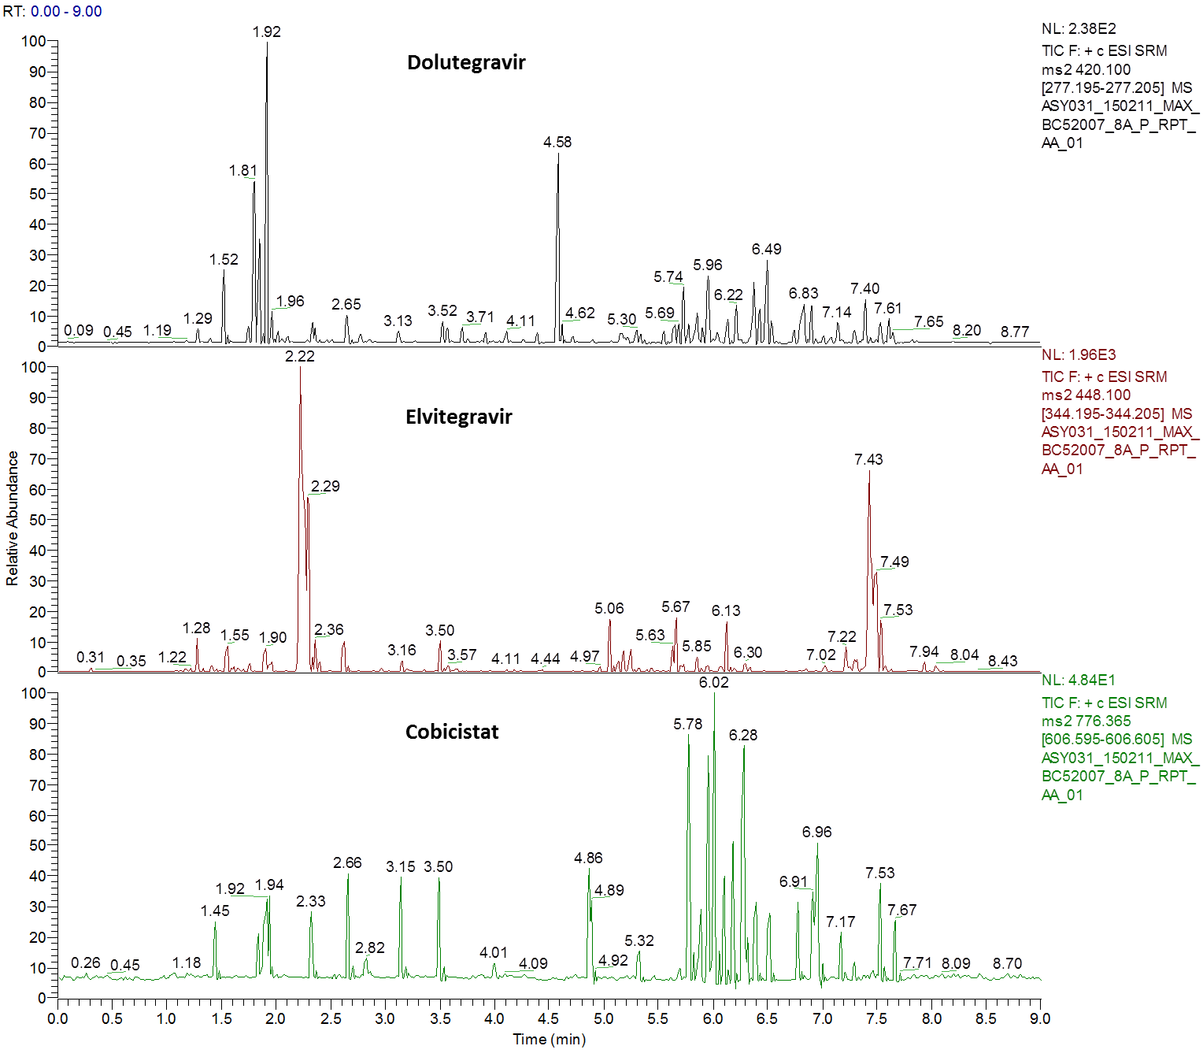

Figure 1b.
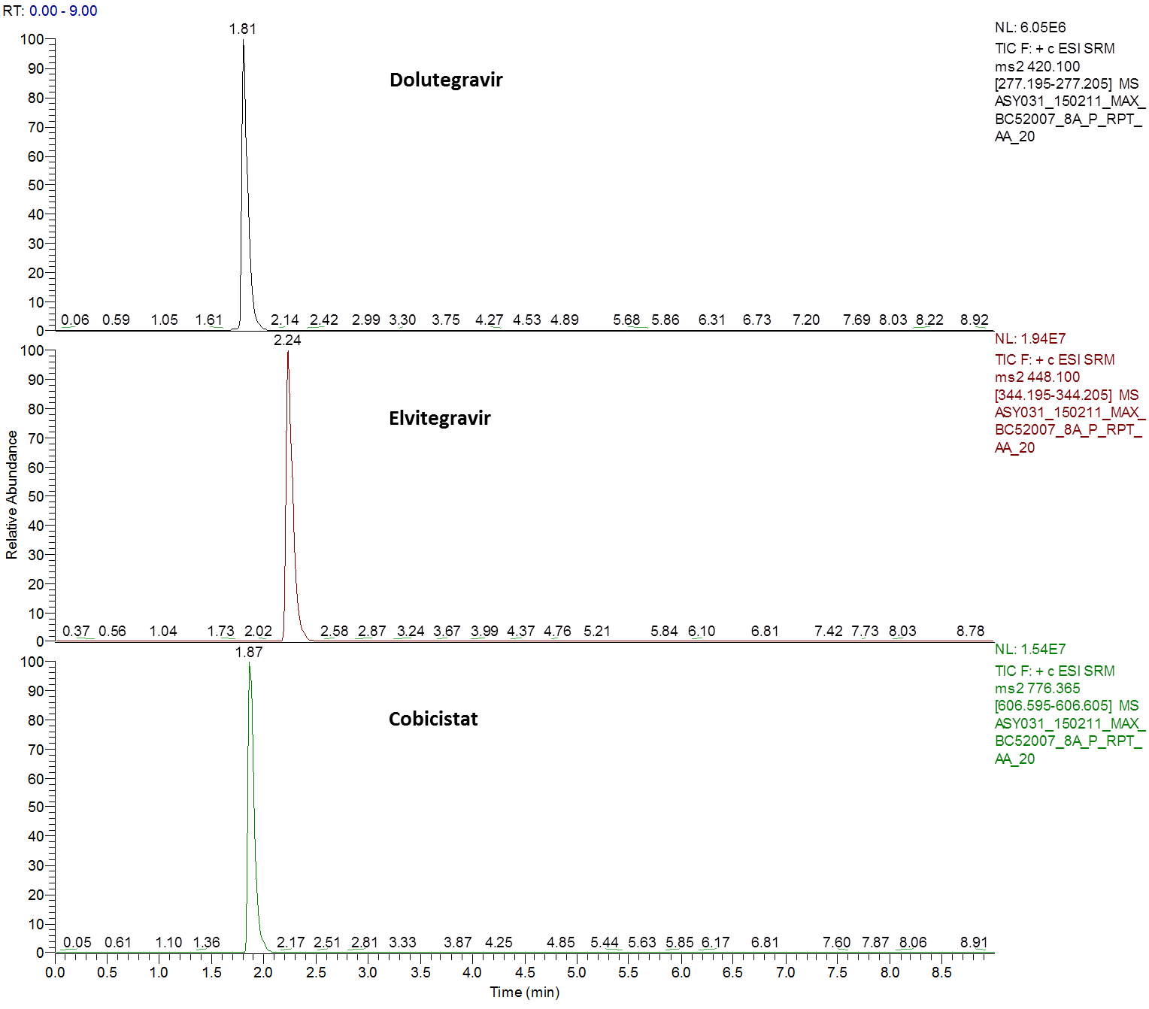

Figure 2a
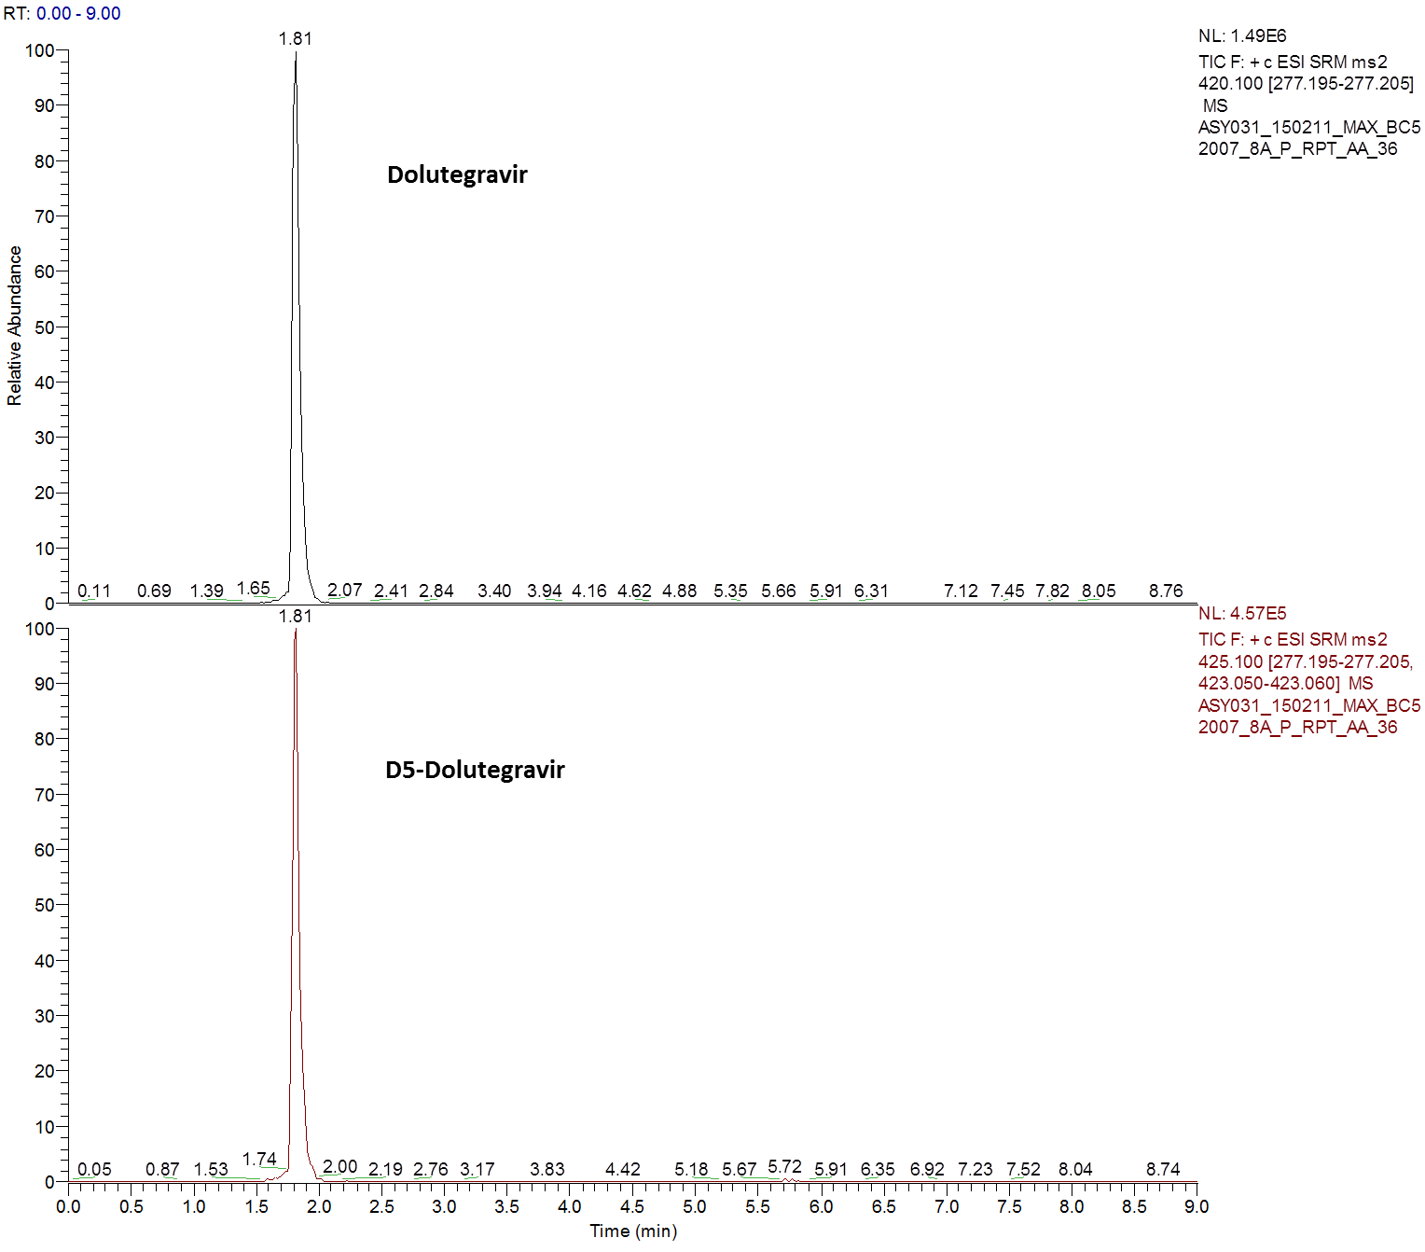

Figure 2b
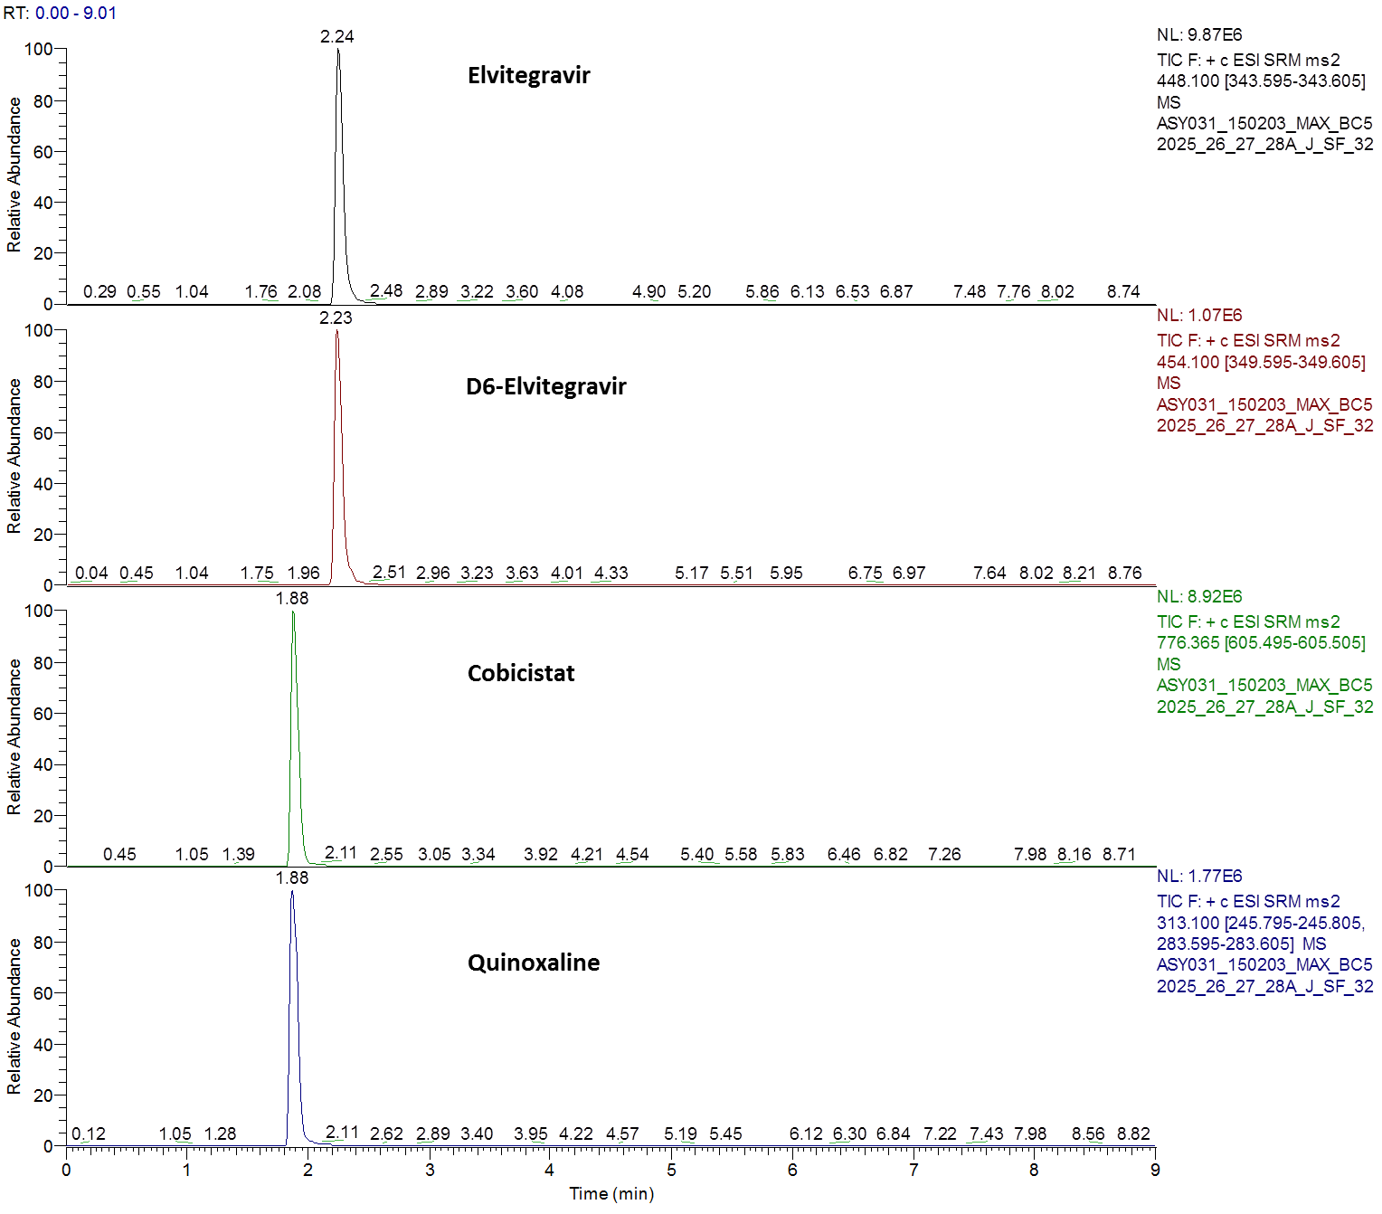

References

[1] Y. Pommier, A.A. Johnson, C. Marchand, Nature reviews. Drug discovery, 4 (2005) 236-248.
[2] M.A. Boyd, D.A. Cooper, The Lancet. Infectious diseases, 13 (2013) 908-909.
[3] A. Castagna, F. Maggiolo, G. Penco, D. Wright, A. Mills, R. Grossberg, J.M. Molina, J. Chas, J. Durant, S. Moreno, M. Doroana, M. Ait-Khaled, J. Huang, S. Min, I. Song, C. Vavro, G. Nichols, J.M. Yeo, V.-S. Group, The Journal of infectious diseases, 210 (2014) 354-362.
[4] Tivicay 50 mg film-coated Tablets Summary of Product Characteristics Available at: https://www.medicines.org.uk/emc/medicine/28545/SPC/Tivicay+50+mg+film-coated+tablets/ (Accessed 10th May 2016).
[5] M. Gregoire, G. Deslandes, C. Renaud, R. Bouquie, C. Allavena, F. Raffi, P. Jolliet, E. Dailly, Journal of chromatography. B, Analytical technologies in the biomedical and life sciences, 971 (2014) 1-9.
[6] C. Bennetto-Hood, G. Tabolt, P. Savina, E.P. Acosta, Journal of chromatography. B, Analytical technologies in the biomedical and life sciences, 945-946 (2014) 225-232.
[7] M. Aouri, A. Calmy, B. Hirschel, A. Telenti, T. Buclin, M. Cavassini, A. Rauch, L.A. Decosterd, Journal of mass spectrometry : JMS, 48 (2013) 616-625.
[8] Z. Djerada, C. Feliu, C. Tournois, D. Vautier, L. Binet, A. Robinet, H. Marty, C. Gozalo, D. Lamiable, H. Millart, Journal of pharmaceutical and biomedical analysis, 86 (2013) 100-111.
[9] M. Shiomi, S. Matsuki, A. Ikeda, T. Ishikawa, N. Nishino, M. Kimura, Y. Kumagai, S. Irie, Clinical pharmacology in drug development, 4 (2015) 218-225.
[10] FDA. Guidance for Industry, Bioanalytical Method Validation. US Food and Drug Administration 2001, Available at: http://www.fda.gov/downloads/Drugs/GuidanceComplianceRegulatoryInformation/Guidances/ucm070107.pdf, (Accessed 9th December, 2015).
[11] EMA. Guideline on bioanalytical method validation. European Medicines Agency, 2009, Available at: http://www.ema.europa.eu/docs/en_GB/document_library/Scientific_guideline/2011/08/WC500109686.pdf, (Accessed 09 December, 2015).
[12] B.K. Matuszewski, M.L. Constanzer, C.M. Chavez-Eng, Analytical chemistry, 75 (2003) 3019-3030.
[13] E. Elliot, A. Amara, A. Jackson, G. Moyle, L. Else, S. Khoo, D. Back, A. Owen, M. Boffito, The Journal of antimicrobial chemotherapy, 71 (2016) 1031-1036.
[14] FDA Clinical Pharmacology Review, Available at: http://www.fda.gov/downloads/Drugs/DevelopmentApprovalProcess/DevelopmentResources/UCM370760.pdf. , (Accessed 9th December, 2015).

