HLA-B*38:02:01 Predicts Carbimazole/Methimazole-Induced Agranulocytosis

Table and Figures

Table 1. Association of rs185386680/ HLA-B*380201 with ATD-induced agranulocytosis.
 | Marker |  | Sample size |  | MAF |  | OR | 95% CI | P-value
 |  |  | Case | Control | Case | Control
ATD-induced agranulocytosis | rs185386680 | Discovery* | 20 | 775 | 37.50% | 3.80% | 36.4 | 12.8-103.7 | 1.3x10⁻²⁴
 | rs185386680 | Replication* | 4 | 387 | 37.50% | 3.70% | 37 | 3.7-367.4 | 9.6x10⁻⁷
 | rs185386680/ HLA-B*380201 | Validation** | 24 | 75 | 37.50% | 2.70% | 53.2 | 13.6-208.9 | 9.0x10⁻¹³
CMZ/MMI-induced agranulocytosis | rs185386680/ HLA-B*380201 | Validation** | 19 | 59 | 47.40% | 3.20% | 265.5 | 27.87-2528.0 | 2.5x10⁻¹⁴
PTU-induced agranulocytosis | rs185386680/ HLA-B*380201 | Validation** | 5 | 16 | 0% | 0% | NA | NA | NA
*versus healthy control
**versus ATD-tolerant control
Abbreviation: ATD, anti-thyroid drug; CMZ, carbimazole; MMI, methimazole; PTU, propylthiouracil; MAF: minor allele frequency; OR: odds ratio; CI, confidence interval.
Figure 1. Manhattan plot of the GWAS of ATD-induced agranulocytosis.
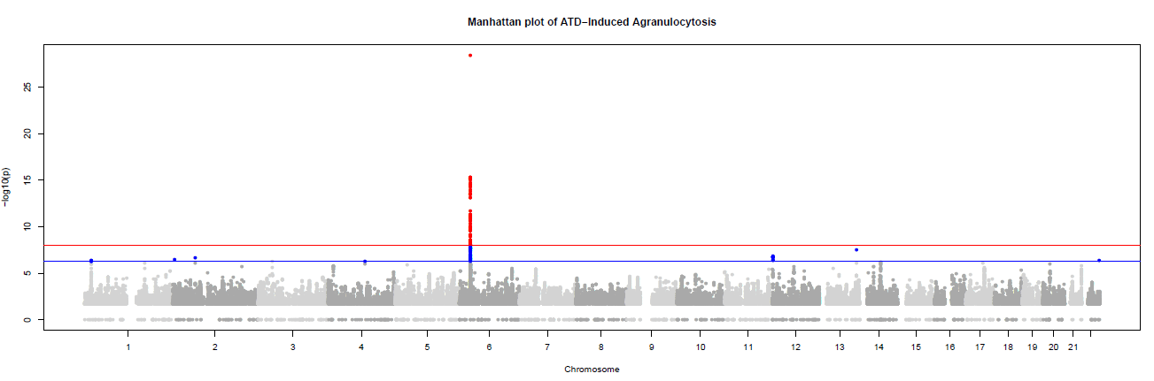
-log10 P values on the y axis plotted against ascending physical position on the x axis. The dotted red line represents the genomewide
significance threshold P values 1x10⁻⁸.

Figure 2. Regional association plot of the region +/- 300kb of rs185386680.
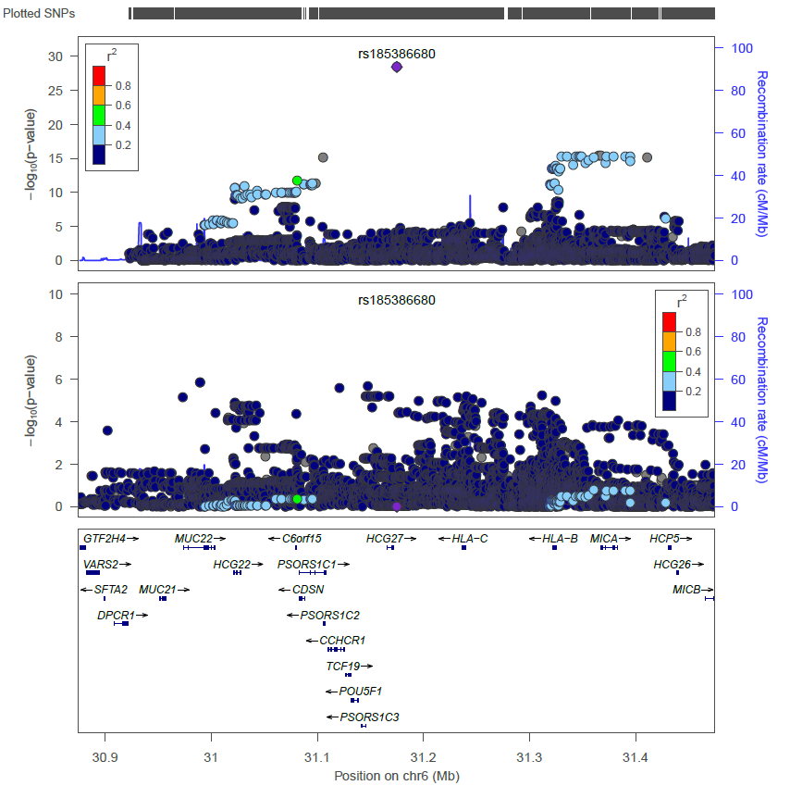
The upper panel shows the original regional association plot; the middle panel shows the regional association plot after conditioning on the genotype of rs185386680; the lower panel indicates the physical location and location of genes in the region.

Figure 3. Flow diagram for calculating numbers needed to screen to prevent one CMZ/MMI-induced agranulocytosis.

