**A Versatile Sonication-assisted Deposition-reduction Method for Preparing Supported Metal Catalysts for Catalytic Applications**

Romen Herrera Padilla,a, b Peter Priecel,b Ming Lin,c Jose Antonio Lopez-Sanchez,b* Ziyi Zhonga*

*a Institute of Chemical and Engineering and Sciences(ICES), Agency for Science, Technology and Research (A∗star), 1 Pesek Road, Jurong Island, Singapore 627833.*

*b Stephenson Institute for Renewable Energy, Chemistry Department, The University of Liverpool, Crown Street L69 7ZD, Liverpool, United Kingdom*

*c Institute of Materials Research and Engineering, Agency for Science, Technology and Research (A∗star), 2 Fusionopolis Way, Innovis, #08-03, Singapore 138634*

*\*Corresponding author:* [*Zhong_ziyi@ices.a-star.edu.sg*](mailto:Zhong_ziyi@ices.a-star.edu.sg)*; J.Lopez-Sanchez@liverpool.ac.uk.*

**Abstract**

This work aims to develop a rapid and efficient strategy for preparing supported metal catalysts for catalytic applications. The sonication-assisted reduction-precipitation method was employed to prepare the heterogeneous mono- and bi-metallic catalysts for photocatalytic degradation of methyl orange (MO) and preferential oxidation (PROX) of CO in H2-rich gas. In general, there are three advantages for the sonication-assisted method as compared with the conventional methods, including high dispersion of metal nanoparticles on the catalyst support, the much higher deposition efficiency (DE) than those of the deposition-precipitation (DP) and co-precipitation (CP) methods, and the very fast preparation, which only lasts 10-20 seconds for the deposition. In the AuPd/TiO2 catalysts series, the AuPd(3:1)/TiO2 catalyst is the most active for MO photocatalytic degradation; while for PROX reaction, Ru/TiO2, Au-Cu/SBA-15 and Pt/γ-Al2O3 catalysts are very active, and the last one showed high stability in the lifetime test. The structural characterization revealed that in the AuPd(3:1)/TiO2 catalyst, Au-Pd alloy particles were formed and a high percentage of Au atoms was located at the surface. Therefore, this sonication-assisted method is efficient and rapid in the preparation of supported metal catalysts with obvious structural characteristics for various catalytic applications.

**1. Introduction**

In preparation of heterogeneous catalysts, the conventional methods such as impregnation method are usually difficult to control particle size, local composition, crystal phase and morphologies. The recent developments in nanoscience and nanotechnology may offer better possibility for designing and preparing heterogeneous catalysts with control at even atomic level. For example, recently designed bimetallic Pt-M electrocatalysts (M = V, Ti, Co, Fe, Ni, ...) were reported to show improved resistance to poisonous substances in comparison with the conventional Pt catalysts [1], and the so-called “oxide-on-metal inverse catalysts” were prepared with more active coordinatively unsaturated (CUS) centers confined at the interface between a transition metal oxide (TMO) particle and a noble metal (NM) particle for catalytic applications [2]. In addition, although the DP and CP methods work quite well for preparation of some catalysts, particularly for the supported gold catalysts [3], the deposition efficiency (DE, which is defined as the percentage of real metal loading to the theoretic metal loading) is usually below 30% except the case using urea as the precipitation agent [4],which means majority of Au is washed off in most of the catalyst preparations.

It has been demonstrated that sonication is an effective tool to generate and facilitate the deposition of metal particles onto support surface. During the sonication process, extreme conditions such as high transient temperature (≥ 5000 K), pressure (≥ 20 MPa) and very high cooling rates (≥ 1010 KS-1) can be reached [7], which can be utilized to decompose some volatile compounds used in the sonochemical synthesis. Meanwhile, the collapse of the bubbles can generate high speed micro-jets in the liquid medium near the solid surface [8],which can propel the small particles to the solid surface. Gedanken et al. [5,6] did a systematic work on sonochemical synthesis of supported catalysts. However, most of the preparations need long-term sonication to decompose the precursor compounds and their deposition efficiency is still in doubt.

The deposition-reduction process is widely used for supported catalyst preparation [9-11], in which there is involvement of complicated interactions, e.g., the interaction between metal particle and capping agent when a capping agent is used, the particle-particle interaction and the particle-support interaction, etc. The former may involve chemical or hydrogen bond formation while the later are often related to the electrostatic interaction and/or chemical bonding formation [12]. The reduction step could be very fast but the deposition step probably not, or with low deposition efficiency. How to control the above mentioned interactions to realize a highly efficient deposition and dispersion of metal particles onto support is still a big challenge [13]. Previously we investigated the interaction of Au colloids with amino acids such as lysine, and found that, at low pH values, lysine molecules can crosslink Au colloids, and this crosslinking is stronger than the electrostatic repulsion among the Au colloids. In this case, large Au particles or linear Au aggregates will be obtained because of the crosslinking; however, at high pH values and under sonication, only isolated Au particles are obtained. At the high pH values, the amino acid capped Au colloids become more negatively charged on surface and their electrostatic repulsion is stronger than that at low pH values, preventing their fast aggregation. Meanwhile, the application of sonication can break the Au linear aggregates and drive the Au colloids to deposit on the support surface with high efficiency. In other words, in the case without sonication, large Au particles and low deposition efficiency will be obtained. In addition, when the solution pH value is close to the isoelectric point (IEP) of the catalyst support, the electrostatic repulsion between the Au colloids and the catalyst support such as TiO2(with IEP about 6) becomes weak, which will facilitate deposition of Au colloids [14, 15]. Basedon the finding, we invented a sonication-assisted precipitation-reduction for preparation of supported Au catalysts on a series of supports [16, 17]. This method is fast, suitable for the deposition of Au onto supports with isoelectric point (IEP) above 5 with very high dispersion. However, we still wondered whether this method could be extended to the preparation of other supported metal catalysts and in particular, bi-metallic catalysts, as the latter often lead to different catalytic behaviors from the mono-metal catalysts. Also, the influence of some preparation parameters on catalyst preparation and the metal deposition efficiency were still not studied.

In this work, we employ the novel sonication method [16, 17] to prepare various mono- and bi-metallic catalysts supported on several supports at varied experimental conditions, and apply the catalysts for two types of important reactions: (i) the photo-degradation of methyl orange (MO) and (ii) the preferential oxidation (PROX) of CO in H2-rich gas. The first reaction is related to the treatment of industrial wastewater and the second to H2 gas purification for industrial applications.

**2. Materials and methods**

*2.1. Reagents.*

Metal precursors such as hydrogen tetrachloroaurate trihydrate (HAuCl4.3H2O; 99 %), palladium(II) chloride (PdCl2, 99.99 %), rhodium chloride, and sodium borohydride (NaBH4; 99 %), L-Lysine (≥98 %), sodium hydroxide (NaOH ≥98 %), tetraethylammonium hydroxide (TEAOH), aluminum nitrate, zinc oxide and cerium oxide and other chemicals such as methyl orange were purchased from Sigma Aldrich, and titanium (IV) dioxide P25 (TiO2 ≥99,5 %) and γ-Al2O3 (Puralox, UR-160, with a surface area of ca 160 m2/g) were the gifts of Degussa and SASOL, respectively.

*2.2. Preparation of the one dimensional (1D) Al2O3 and CeO2 nanorods*

The synthesis of Al2O3 and CeO2 nanorods followed the hydrothermal method for the synthesis of 1D Fe2O3 except using Al(NO3)3 or Ce(NO3)4 as the precursor. Typically, 5.0 g of Al(NO3)3.9H2O was added to 30 ml of 20 wt. % aqueous TEAOH solution in an autoclave, which was then heated in an oven at a temperature of 80 oC for 10 h. After the reaction, the precipitate was washed with DI water for four times, dried in a vacuum oven at 100 oC overnight and calcined at 500 oC for 3 h [18, 19].

*2.3. Sonication preparation of the supported catalysts.*

All glassware were cleaned with aqua regia (HCl/HNO3, 3:1 v/v), followed by thoroughly rinse with double distilled MilliQ water prior to use. The sonication-assisted catalyst preparation followed our previous report [16,17]using lysine as the capping agent and NaBH4 as the reducing agent, and the used catalyst supports were TiO2-P25, γ-Al2O3 and CeO2 nanorods, the commercial γ-Al2O3 from SASOL, ZnO, CeO2, etc. In a typical catalyst preparation, 0.5 g of TiO2 was put in 10 ml deionized water, and 5.08 ml of 0.01 M HAuCl4 and 5.08 ml of 0.01 M lysine (Lys) were added subsequently. The pH of the suspension was adjusted to 5–6 with 0.1 M NaOH. The suspension was subjected to sonication (Vibracell 500 Watt Ultrasonic processor, 20 kHz, 39 % energy efficiency) for 20 s, and during the sonication freshly prepared NaBH4 (0.1 M, 5–10 times the Au molar number) was injected instantly and the pH value at the end point was measured. The suspension immediately turned dark in color and was washed with deionized water for 4 times by using centrifuge. In the case of Pd catalysts, PdCl2 was used as precursor and a low pH value below 3 was used because PdCl2 was not dissolved well in water at high pH values.

*2.4. Photocatalytic and PROX reactions*

The photocatalytic degradation of methyl orange (MO) was carried out at 25 oC using 10 ml MO solution (40 mg/l) and 20 mg of solid catalyst under irradiation of the visible light (400-800 nm) with a chiller. The MO concentration was measured by a UV-vis spectrophotometer by comparing the peak intensity at 465nm. Prior to the reaction, the solution containing the photocatalyst was stirred for 2 h in the absence of any light to saturate the adsorption of MO on the catalyst surface. The PROX reaction was carried out in a fixed bed reactor at atmospheric pressure using a gas mixture of 1 % CO, 1 % O2, 78 % H2, 20 % He at a GHSV of 5000 h-1, or a mixture of 100 ppm CO, 100 ppm O2, 99.78 % H2, 0.2 % He at a GHSV of 50 h-1 (the two gas mixtures were purchased from National Oxygen Pte. Ltd., Singapore). The reactant and product gases were analyzed with a GC Shimadzu-14B equipped with both TCD and FID detectors.

*2.4. Characterizations*

The UV-vis absorption spectra of methyl orange and UV-vis diffuse reflectance spectra of titania supported catalysts were measured on a Shimadzu UV-2550 UV-vis spectrophotometer. The structural features of the catalysts were observed employing a transmission electron microscope (TEM, Tecai TF20 Super Twin, 200 kV). High resolution TEM images, high-angle annular dark field scanning-TEM (HAADF-STEM) studies and detailed elemental composition or energy-dispersive X-ray spectroscopy (EDS) analysis were carried out on a FEI Titan 80-300 electron microscope (200 kV), which was equipped with an electron beam monochromator and energy dispersive X-ray spectroscopy (EDX). Powder XRD analysis was conducted on a Bruker D8 Advance X-ray diffractometer with CuKα1 radiation. X-ray photoelectron spectroscopy (XPS) spectra were recorded in an ESCALAB 250 spectrometer and Al Kα radiation was used as the X-ray source. The C1s peak at 285 eV was used as a reference for the calibration of the binding energy (BE). The Au and Pd concentrations were determined by dissolving the catalysts in [aqua regia](https://en.wikipedia.org/wiki/Aqua_regia) and measured by Inductively Coupled Plasma Optical Emission Spectrometry (ICP-OES, Varian, VISTA-MPX ) analysis. The DE value is calculated according to the formula below:

DE = 100 × real metal loading measured by ICP/theoretic metal loading (added

metal amount).

**3. Results and discussion**

*3.1. Sonication-assisted preparation of the supported catalysts and hydrothermal synthesis of the one dimensional (1D) support.*

As shown in Fig.1, the 1D γ-Al2O3 and CeO2 are successfully prepared, the diameter of these nanorods is between 10 and 20 nm, and the aspect ratio between 5 and 20. These 1D nanostructures together with some commercial metal oxides are used as the catalyst supports.

In the sonication-assisted deposition-reduction preparations, experimental conditions such as types of metal and support, pH value, Au/Pd ratio, solvent, reagent addition sequence are varied. In general, it is found that this method is able to prepare various supported metal catalysts with high dispersion, including Au, Pt, Rh, Ru and Pd supported on Al2O3, TiO2, ZnO and CeO2, etc. The sizes of most metal particles are usually between 2-6 nm (Fig.1), varying a little with the change of metal, support as well as the pH value (pH was usually maintained above 6). In the Pd/γ-Al2O3 catalyst and Au-Pd bimetallic catalysts, the metal particles are in the range of 5-20 nm in size (the TEM image is not shown here). The large Pd particle size and wide distribution probably are related to the nature of Pd and low pH value used, because the PdCl2 precursor is not completely dissolved in high pH aqueous solution. However, the low pH value leads to the growth of large particles due to the crosslinking of metal particles by lysine molecules [14]. Ethanol and ethanol-H2O mixtures with various ethanol/H2O ratios were also employed as the solvent. However, it was found that the use of ethanol solvent led to the formation of larger metal particles, including Au and Pd, etc. The addition sequence of the reagent in the sonication-assisted preparation of Au-Pd catalysts was also varied. For example, to avoid the low solubility problem of PdCl2 in H2O, we dissolved PdCl2 or HAuCl4 + PdCl2 in water at low pH below 3, followed by addition of NaBH4 and lysine in the solution with sonication. We also first deposited Au on the support at one pH value followed by the deposition of Pd at another pH on the Au-deposited catalyst (catalyst 6 in table 1), or vice versa (catalyst 7). Unfortunately, these approaches don’t lead to the formation of very uniformly dispersed metal catalysts. Their TEM images are shown Fig. S1 (supporting formation) and their catalytic performances will be mentioned later.

In addition, it is seen from Fig.1 that the Pt particles supported on the γ-Al2O3 nanorods are not spherical but in the triangle or oval shape. Upon a close look at these Pt particles, they should be small aggregates composed of 2-3 individual particles each. The most uniform metal particles are Au supported on various supports, and Rh supported on TiO2 (Fig.1). Once the metal particles are deposited on the support, the catalysts were calcined at 300 oC in air to completely remove the capping lysine molecules on them. Since this calcination temperature is much lower than that required for the other capping agents such as thiols [13], it has little effect on the final metal particle size. This low temperature calcination is one of the merits of the lysine capping agent.

One of the important indicators for a successful preparation of the catalysts is the deposition efficiency (DE). Table 1 lists some of the DE values of the prepared catalysts by this sonication method. The highest DE value is observed for catalyst 1 (Au/TiO2) and 2 (AuPd (3:1)/TiO2), which is 92 %. With the increase of Pd content, this DE value is decreased but still above 70 %. These DE values are much higher than those of the catalysts prepared by co-precipitation and deposition-precipitation methods [13]. Therefore, this sonication-assisted method for catalyst preparation is fast and versatile, suitable for many types of catalyst preparation with high DE values.

*3.2. Au-Pd catalysts for photocatalytic oxidation of MO and their structural characteristics.*

Photocatalytic reactions are important to environmental remediation because nowadays there is increasing pollution of water resources and air. It is desired to find cheap and sustainable solutions to purify these media [20, 21, 22]. In this work photocatalytic degradation of MO is employed to test the photocatalytic property of the catalysts.

A number of mono- and bimetallic catalysts were tested for this reaction, including Au, Cu, Pd, Pt, and Au-Pd, Au-Cu, Au-Fe, Au-Co, Au-Pt and Au-Rh and Au-Ru supported on TiO2. It was found that the supported Au-Pd series catalysts exhibited high catalytic activities. Fig. 2 displays the measured UV-vis spectra of MO after 1 h reaction on some catalysts, from which it can be seen that MO was degraded as its peak intensity at ca. 465 nm was decreased. Fig. 3 shows the calculated MO conversions after 3 h reaction at 25 oC based on the peak area changes at 465 nm. The oxidized Pd/TiO2 catalyst shows only a negligible MO conversion of 0.9 % after the 3 h reaction while that on Au/TiO2 is 10.4 %, indicating that Pd (actually it is PdO, which will be explained later) is not active for this reaction but Au is. For the Au-Pd/TiO2 catalysts that have a total theoretic metal loading of 2 wt. % but with various Au/Pd atomic ratios, the MO conversion is increased with increase of Pd content at the beginning. The maximum MO conversion is achieved on catalyst 2 (2wt%AuPd(3:1)/TiO2), which is ca. 49.5 % (Fig. 3), although in this catalyst the theoretic Au loading is lower than that in catalyst 1 (Au/TiO2). It is clear there should be a synergetic interaction between Au and Pd which leads to a significant increase in catalytic activity. However, with further increase of the Pd content, the catalytic activity becomes lower again, probably because of the decrease of the most active Au sites on the catalyst surface. Since the Au component is quite active for this reaction, a number of catalysts with 2 wt. % Au and 1 wt. % of the 2nd metal were prepared and tested, and the catalytic performances are also shown in Fig. 3 (see the right side of the red dot line in Fig. 3). The addition of Cu, Pt, Ni, Co and Rh leads to increase of the catalytic activity as compared with that of Au/TiO2, but all of them are still much poorer than the catalyst 2 (2wt%AuPd(3:1)/TiO2), indicating the addition of these metals is not as good as Pd in promoting the catalytic performance of MO degradation. Therefore, next we will focus on AuPd/TiO2 catalysts only.

We further prepared the 2wt%AuPd(3:1)/TiO2 catalysts by varying the preparation method or conditions, e.g., by using impregnation method and inverse sonication method (see Table 1). After the 3 h reaction, the impregnation method prepared 2wt%AuPd(3:1)/TiO2 showed only a MO conversion of 12.1 %, while the catalysts 5, 6 and 7 in Table 1 showed MO conversion of 15.9 %, 22.9 % and 9.8 % respectively. All of them are much lower than that of the catalyst 2 (Fig.3). We wondered why these catalysts have so much difference in catalytic performance. As shown in Table 1, the catalyst 2 has a little higher Au loading than that of the catalyst 5, 6 and 7. The measured XRD patterns are shown in Fig.4A. Unfortunately no Au and Pd diffractions are observed because of the high dispersion and low loading of both Au and Pd. The main diffraction peaks of metallic Au should be located at 2θ = 38.2 and 44.4o, while that of metallic Pd at 40.1 and 46.7o, thus the Au-rich AuPd alloy and Pd-rich AuPd alloy should exhibit diffraction peak between 38.2 and 40.1o and between 44.4 and 46.7o respectively [23]. The measured UV-vis spectra for the catalysts are shown in Fig.4B. The Au nanoparticles have an intristic interband transition around 2.5 eV thus exhibit a surface plasmon resonance (SPR) band maximum at around 560 nm for Au/TiO2 [24]. This peak is not seen in the spectra of AuPd/TiO2 catalysts, indicating the suppression of the plasmonic band of Au by Pd and a strong interaction between Au and Pd. Differing from Au nanoparticles, Pd nanoparticles only exhibit broad optical resonances that have been assigned to the so-called localized surface plasmons (LSPs) due to the fact that the d-band overlaps with the s- and p-bands in the whole range of interest [24]. The change of optical property of Au after Pd addition is probably related to the change of electronic structure, which can partly confirm alloying of Au and Pd [25-28].

TEM analysis was further carried out for the catalyst 2 of 2wt%AuPd(3:1)/TiO2 and the result is shown in Fig. 5 and 6. The quantification from EDX analysis from large area samples give a ratio of Au:Pd =65:35. The intensity in HAADF-STEM images is proportional to the atomic number (Z2) of atoms, thus it can easily differentiate Au and Pd atoms due to difference between their atomic numbers. Fig.5 (A) shows a low magnification HAADF-STEM image of 2wt%AuPd(3:1)/TiO2 catalyst. Since Pd nanoparticles have lower contrast than Au, no individual Pd nanoparticles are observed on the substrate, indicating that the supported metal particles could be the mixture of Pd and Au. Fig. 6B presents a high magnification STEM image of metal particles. The uniform contrast presented by the particle further strongly suggests an alloy structure of Au and Pd, rather than core-shell or bi-particle structures. A point EDX analysis acquired from one nanoparticle gave a composition of Au:Pd =69:31, confirming the alloy structure of particles. The high resolution TEM image (Fig. 6B) shows a 10-nm sized AuPd nanoparticle on the TiO2 substrate. The lattice spacing measured for TiO2 is 0.350 nm, corresponding to TiO2 (101) plane with a standard value of 0.352 nm. The 0.6% error indicates the TEM instrument was well calibrated. The lattice distance of AuPd nanoparticle is 0.199 nm, which is between 0.195 and 0.204 nm, the distances of Pd(200) and Au (200) planes respectively. This measured distance is close to that of AuPd alloy with a ratio of 3:1 (0.202 nm), suggesting the metal nanoparticles are the alloy of Pd and Au.

XPS analysis was conducted for some catalysts to reveal their surface structural features. The measured Au4f7/2 binding energy appears in the range of 83.2 to 83.6 eV (Table 2), which is lower than that of bulk gold. Probably there is a shift of electron from Pd or oxygen-vacancy in TiO2 to Au, leading to the partial negative charging of Au. Table 2 and Fig. 7 give more details of XPS results. By comparing the catalyst 2, 3 and 8 in Table 2, it is seen that with increase of the Pd concentration, the surface Au/Pd ratio is decreased, which is accompanied by the increase of surface Pd2+ concentration. These observations indicate that, besides alloying of Au with Pd, which can modify the electronic property of Au, the number of surface Au sites is also important for high catalytic activity. When the Au/Pd ratio is below 3:1, more surface sites are occupied by Pd2+, leading to the decreased catalytic activity. More interesting information can be obtained by comparing the catalyst 2 with catalyst 6 and 7. In the catalyst 2, Au and Pd components are simultaneously reduced and deposited on the catalyst support, while in catalyst 6 and 7, Pd and Au are reduced and deposited in different sequences. In catalyst 6 and 7, both the surface Au and bulk Au concentrations (Table 1) are lower than that of the catalyst 2. On the surface of the catalyst 7, there is a very high surface Pd2+/(Pd2+ + Pd0) ratio of 0.41, because in this sample the Au was deposited first then followed with Pd deposition. Probably in this sample the surface of AuPd particles is PdO-rich, which could explain its lowest catalytic activity (only 9.8 % MO conversion after the 3 h reaction) in these three catalysts. For catalyst 8, its surface is 100 % covered by Pd2+, indicating Pd2+ is not active in this reaction. It can be further deduced that the alloying of Au-Pd can stabilize the metallic Pd0 although probably there is a slight shift of the electron from Pd to Au. The trace amount of surface PdO in the catalyst 2 (Table 2 and Fig. 7) may contribute to the formation of the so-called “oxide-on-metal inverse catalysts” as reported by Bao et al. [2]. Actually the Au-Pd particles supported on various catalyst supports have been widely investigated for different catalytic applications. Besides the size or dispersion effect on the catalytic performance, there are various structural features for the Au-Pd particles that can impact their catalytic performance. They could form separate Au and Pd particles, alloy particles and core-shell structures. For example, it was reported that the calcination of homogenous Au/Pd alloys on Al2O3 surface resulted in progressive enrichment of Pd at the metal particle surface and decrease in the catalytic activity [29]. On the other hand, Au@Pd nanoparticles supported on silica were transformed into random alloy particles at 300 °C [30]. Cybula et al. [23] found that for the AuPd/TiO2 catalyst for phenol degradation reaction under UV light, the catalytic performance is highly dependent on the catalyst calcination temperature. The catalyst calcined at 350 and 400 °C exhibited the highest photocatalytic activity while that calcined above 450 oC became poorer in catalytic performance. It was found that the higher calcination temperature caused a segregation of the two metals and a gold-enrichment in the shell region of Au/Pd bimetallic nanoparticles. Even in the alloyed particles, the distribution of Au and Pd was not homogeneous [23]. This situation is quite similar to our case: Au-Pd alloy particles are formed and certain amount of Pd2+ is observed on the surface. Combining literature with our results, we thus propose that the ideal catalyst should have a structure of alloyed Au-Pd structure with an Au/Pd atomic ratio around 3, and with trace amount of PdO islands decorating the Au-Pd surface, as shown in Fig. S2.

*3.3. Supported metal catalysts for PROX reaction.*

The catalysts prepared by the sonication-assisted method were tested for the low temperature preferential oxidation (PROX) reaction because it is an important industrial reaction used for purification of H2 in hydrogen fuel cells [31, 32]. Nowadays the majority of the world’s hydrogen supply is produced by reforming hydrocarbons [33, 34]. This ‘reformate’ hydrogen contains significant quantities of CO that poison current fuel cell devices. The PROX reaction removes CO through selective (preferential) oxidation of CO while avoiding oxidation of hydrogen in reformate.

For the PROX reaction, a series of metals were screened and it was found that Ru/TiO2 [35], Au-Cu/SBA-15[36] and Pt/Al2O3 catalysts exhibited high catalytic activities. The Ru/TiO2 and Au-Cu/SBA-15 catalysts were tested previously at high GHSVs close to 20000 h-1 and both of them were able to lower the CO concentration to several ppm (Table 3). At above 200 oC on the Ru/TiO2 catalyst the methanation reaction was the dominant reaction rather than PROX reaction [35]; while Au-Cu/SBA-15 catalyst was extremely active even at room temperature. However the catalyst was not stable and was deactivated due to the reversible alloying of Au and Cu [36]. We prepared the 2wt%Pt/γ-Al2O3 nanorods catalyst by the impregnation method and the sonication-assisted method in this work. As shown in Fig. 8, the sonication method prepared 2wt%Pt/γ-Al2O3 is able to lower the CO concentration from 10000 ppm to ca. 51 ppm at ca. 160 oC, while the impregnation method prepared 2wt%Pt/γ-Al2O3 can only lower the CO concentration to ca. 1700 ppm at ca. 200 oC. The sonication method prepared catalyst is very stable. Upon a 100 h on stream lifetime test, no deactivation was observed. We further increased the Pt loading to 3 wt. % and lowered the CO concentration to ca. 100 ppm in the feeding gas, and both the γ-Al2O3 nanorods and commercial γ-Al2O3 from SASOL were used as the support. It is observed in Fig.9 and table 3 that the 3wt%Pt/γ-Al2O3 (SASOL) is able to lower the CO concentration to several ppm at a reaction temperature of ca. 100 oC, much lower than the 3wt%Pt/γ-Al2O3 nanorods, which shows the highest CO removal at ca. 150 oC. The detailed reason for this catalytic performance is not yet clear. However, it is obviously that the sonication method prepared catalysts are promising for practical catalytic applications, particularly when a two-stage reaction configuration is applied, in which the first stage reaction will remove most of CO while the second stage reaction will lower the CO concentration to several ppm.

**4. Conclusion**

In this work, we have extended the sonication-assisted precipitation-reduction to the preparation of various mono- and bi-metallic catalysts supported on various catalyst supports, and applied the catalysts for photocatalytic degradation of MO and PROX reactions. In general, there are three advantages for the sonication method as compared with the conventional methods, including the high dispersion of metal nanoparticles on the catalyst support, the much higher DE values than those of the DP and CP methods, and the very fast preparation as the deposition only takes 10-20 seconds.

The photocatalytic degradation of MO over a series AuPd/TiO2 shows that the AuPd(3:1)/TiO2 catalyst is much more active than the other catalysts, mainly because of the high dispersion of the metal particle, the formation of Au-Pd alloy particles and the decoration of trace amounts of PdO on the Au-Pd alloy particles. It is found that, besides the solution pH value, the addition of the metal solution into the NaBH4 solution in the preparation (the inverse sonication method) and the separate deposition of Au or Pd lead to the phase separation of Au and Pd, which is not conducive to the catalytic activity.

For the PROX reaction, the highly dispersed Ru/TiO2, Au-Cu/SBA-15 and Pt/γ-Al2O3 catalysts prepared by the sonication method are found to be very active. The Pt/γ-Al2O3 catalyst is also quite stable. Moreover, it is found that the Pt/γ-Al2O3 (SASOL) catalyst is able to lower the CO conversion to several ppm at a quite lower reaction temperature (100 oC), indicating a promise for practical application.

**Acknowledgements**

Romen Herrera Padilla is grateful to the support of the ARAP PhD programme of Agency for Science, Technology and Research in Singapore (A*star), and Ziyi Zhong thanks financial support of the project from ICES (ICES/15-1G4B01) and Drs. Carpenter and Borgna for their kind support of this collaboration with University of Liverpool in UK. Also, the authors thank Ms. Zhan Wang for XPS measurement.

**References**

1. D. Xu, S. Bliznakov, Z. Liu, J. Fang, N. Dimitrov, Composition-dependent electrocatalytic activity of Pt-Cu nanocube catalysts for formic acid oxidation. Angew. Chem. Int. Ed. 49,7 (2010) 1282-1285.
2. Q. Fu, F. Yang, X. Bao, I[nterface-confined oxide nanostructures for catalytic oxidation reactions](http://pubs.acs.org/doi/abs/10.1021/ar300249b). Acc. Chem. Res, 46, 8 (2013) 1692–1701.
3. M. Khoudiakov, M. C. Gupta and S. Deevi, [Au/Fe2O3 nanocatalysts for CO oxidation: a comparative study of deposition–precipitation and coprecipitation techniques](http://www.sciencedirect.com/science/article/pii/S0926860X05002498), Appl. Catal. A, 291, 1-2(2005),151-161.
4. R. Zanella, S. Giorgio, C. R. Henry and C. Louis, Alternative methods for the preparation of gold nanoparticles supported on TiO2*,* J. Phys. Chem. B, 106, 31 (2002) 7634-7642.
5. K. S. Suslick, S. B. Choe, A. A. Cichowlas, M. W. Grinstaff, Sonochemical synthesis of amorphous iron, Nature, 353 (1991) 414-416.
6. K. S. Suslick and G. J. Price, Application of ultrasound to materials chemistry, Annu. Rev. Mater. Sci., 29 (1999) 295-326.
7. A. Gedanken, X. Tang, Y. Wang, N. Perkas, Y. Koltypin, M. V. Landau, M. Herskowitz, L. Vradman, U[sing sonochemical methods for the preparation of mesoporous materials and for the deposition of catalysts into the mesopores](http://dx.doi.org/10.1002/1521-3765(20011105)7:21%3C4546::AID-CHEM4546%3E3.0.CO;2-L), Chem. Eur. J., 7 (2001) 4546-4552.
8. S. Bhattacharyya, A. Gabashvili, N. Perkas and A. Gedanken, [Sonochemical insertion of silver nanoparticles into two-dimensional mesoporous alumina](http://pubs.acs.org/doi/abs/10.1021/jp072152n)*.* J. Phys. Chem. C, 111, 30 (2007)11161-11167.
9. J. D. Grunwaldt, M. Maciejewski, O. S. Becker, P. Fabrizioli and A. Baiker, Comparative study of Au/TiO2 and Au/ZrO2 catalysts for low-temperature CO oxidation, J. Catal., 186, 2 (1999)458-469.
10. J. D. Grunwaldt, C. Kiener, C. Wögerbauer and A. Baiker, [Preparation of supported gold catalysts for low-temperature CO oxidation via “size-controlled” gold colloids](http://www.sciencedirect.com/science/article/pii/S0021951798922989), J. Catal*.*, 181, 2 (1999), 223-232.
11. F. Porta, L. Prati, M. Rossi and G. Scari, N[ew Au (0) sols as precursors for heterogeneous liquid-phase oxidation catalysts](http://www.sciencedirect.com/science/article/pii/S0021951702937450). J. Catal., 211, 2(2002) 464-469.
12. G. E. Brown. Jr, V. E. Henrich, W. H. Casey, D. L. Clark, C. Eggleston, A. Felmy, D. W. Goodman, M. Grätzel, G. Maciel, M. I. McCarthy, K. H. Nealson, D. A. Sverjensky, M. F.Toney and J. M. Zachara, Metal oxide surfaces and their interactions with aqueous solutions and microbial organisms.Chem. Rev*.*, 99, 1 (1998) 77-174.
13. P. Gunawan, R. Xu, Z. Zhong, Heterogeneous gold catalysts for selective oxidation reactions, in Z. Ma, S. Dai (Eds), Heterogeneous gold catalysts and catalysis, RSC Publishing, London, 2014, pp288-400.
14. Z. Zhong, J. Luo, T. P. Ang, J. Highfield, J. Lin, A. Gedanken, [Controlled organization of Au colloids into linear assemblies](http://pubs.acs.org/doi/abs/10.1021/jp047683f), J. Phys. Chem. B, 108, 47 (2004)18119-18123.
15. Z. Zhong, S. Patskovskyy, P. Bouvrette, J. H. T. Luong and A. Gedanken, [The surface chemistry of Au colloids and their interactions with functional amino acids](http://pubs.acs.org/doi/abs/10.1021/jp037056a)*,* J. Phys. Chem. B, 108, 13 (2004)4046-4052.
16. Z. Zhong, J. Lin., Highly dispersed metal catalysts, US Patent 8926937B2.
17. Z. Zhong, J. Lin, S-P Teh, J. Teo, F.M. Dautzenberg, A rapid and efficient method to deposit gold particles onto catalyst supports and its application for CO oxidation at low temperatures, Adv. Funct. Mater, 17,8 (2007)1402-1408.
18. Z. Zhong, J. Ho, J. Teo, S. C. Shen, A. Gedanken**,** Synthesis of Porous α-Fe2O3 nanorods and deposition of very small gold particles in the pores for catalytic oxidation of CO,Chem. Mater, 19 (2007)4776-4782.
19. Z. Zhong, J. Teo, M. Lin, J. Ho, Synthesis of porous α-Fe2O3 nanorods as catalyst support and a novel method to deposit small gold colloids on them. Topic. Catal. 49 (2008)216-226.
20. K. Rajeshwar, Solar energy conversion and environmental remediation using inorganic semiconductor–liquid interfaces: the road traveled and the way forward. J. Phys. Chem. Lett. 2(2011) 1301–1309.
21. K. Rajeshwar, A. Thomas, C. Janáky, Photocatalytic activity of inorganic semiconductor surfaces: myths, hype, and reality. J. Phys. Chem. Lett*. 6(* 2015)139–147.
22. Á. Veres, J. Ménesi, C. Janáky, G. F. Samu, M. K. Scheyer, Q. Xu, F. Salahioglu, M.V. Garland, I. Dékány, Z. Zhong, New insights into the relationship between structure and photocatalytic properties of TiO2 catalysts, **RSC Adv*.***, 5(2015) 2421-2428.
23. A. Cybula, J. B. Priebe, M. M. Pohl, J. W. Sobczak, M. Schneider, A. Zielinska-Jurek, A. Brückner, A. Zaleska, The effect of calcination temperature on structure and photocatalyticproperties of Au/Pd nanoparticles supported on TiO2, Appl. Catal. B: Environ. 152–153 (2014) 202–211.
24. H. Gao, J. McMahon, M. Lee, J. Henzie, S. Gray, G. Schatz, T. Odom, Rayleigh anomaly-surface plasmon polariton resonances in palladium and gold subwavelength hole arrays Optics Express. 17 (2009) 2334–2340.
25. T. Pakizeh, C. Langhammer, I. Zoric, P. Apell, M. Kall, Intrinsic Fano interference of localized plasmons in Pd Nanoparticles, NANO Lett. 9, 2, (2009) 882-886.
26. Y. W. Lee, N. H. Kim, K. Y. Lee, K. Kwon, M. Kim, S. W. Han, [Synthesis and characterization of flower-shaped porous Au-Pd alloy nanoparticles](https://scholar.google.com/citations?view_op=view_citation&hl=en&user=Ea37XKIAAAAJ&citation_for_view=Ea37XKIAAAAJ:YsMSGLbcyi4C). J. Phys. Chem. C. 112 (2008) 6717 –6722.
27. Y. W. Lee, M. Kim, Z. H. Kim, S. W. Han, [One-step synthesis of Au@ Pd core−shell nanooctahedron](https://scholar.google.com/citations?view_op=view_citation&hl=en&user=Ea37XKIAAAAJ&citation_for_view=Ea37XKIAAAAJ:u-x6o8ySG0sC). J. Am. Chem. Soc. 131 (2009) 17036 –17037.
28. X. F. Lang, P. G. Yin, T.T. You, L. Guo, Chemical effects in SERS of pyrazine adsorbed on Au–Pd bimetallic nanoparticles: a theoretical investigation. ChemPhysChem, 13(2012)237 – 244.
29. A. Tanaka, K. Fuku, T. Nishi, K. Hashimoto, H. Kominami, Functionalization of Au/TiO2 plasmonic photocatalysts with Pd by formation of a core–shell structure for effective dechlorination of chlorobenzene under irradiation of visible light. J. Phys. Chem. C 117 (2013) 16983–16989.
30. T. Nakagawa, H. Nitani, S. Tanabe, K. Okitsu, S. Seino, Y. Mizukoshi,

T.A.Yamamoto, Structural analysis of Au/Pd nanoparticles dispersed in

porous silica matrix by TEM, XRD and XAFS, Ultrason. Sonochem. 12

(2005) 249–254.

1. M. J. Kahlich, H. A. Gasteiger, R. J. Behm, Kinetics of the selective CO oxidation in H2-rich gas on Pt/Al2O3 J. Catal. 171 (1997) 93−105.

## F. Marino, C. Descorme, D. Duprez, [Noble metal catalysts for the preferential oxidation of carbon monoxide in the presence of hydrogen](http://www.sciencedirect.com/science/article/pii/S0926337304003820) Appl. Catal., B. 54 (2004) 59−66.

1. G. W. Huber, J. W. Shabaker, J. A. Dumesic, Raney Ni–Sn catalyst for H2 production from biomass-derived hydrocarbons. Science, 300 (2003) 2075–2077.
2. S. Alayoglu, A.U. Nilekar, M.Mavrikakis, B. Eichhorn, Ru–Pt core–shell nanoparticles for preferential oxidation of carbon monoxide in hydrogen, Nat. Mater. 7 (2008) 303-308.
3. N. Perkas, J. Teo, S. Shen, Z. Wang, J. Highfield, Z. Zhong, A. Gedanken, Supported Ru catalysts Prepared by Two Sonication-assisted Methods For Preferential Oxidation of CO in H2, PhysChemChemPhys (PCCP),13 (2011) 15690-15698.
4. X.Li, S. S. F. See, J. Teo, Y. L. Foo, A. Borgna, M. Lin, Z. Zhong, Activation and Deactivation of Au-Cu/SBA-15 Catalyst for Preferential Oxidation of CO in H2-rich Gas. ACS Catal. 2 (2012), 2, 360-369.

**Tables**

**Table 1. ICP analysis of the catalyst composition** _____________________________________________________________________

Catalyst no. Theoretic atomic ICP analysis DE(%) pH

ratio of Au/Pd _____________________________________

Au (wt%) Pd (wt%) Total (wt%)

1 (2wt%Au/TiO2) 1:0 1.84 0.0 1.84 92 5.5

2(2wt%AuPd/TiO2) 3:1 1.55 0.29 1.84 92 1.6

3(2wt%AuPd/TiO2) 1:1 1.17 0.63 1.79 89 1.4

4(2wt%AuPd/TiO2) 1:3 0.45 1.05 1.50 75 1.4

5(2wt%AuPd/TiO2-R) 3:1 1.39 0.21 1.60 80 9.6

6 ( 2wt%Pd-Au/TiO2) 3:1 1.31 0.16 1.60 74 2.8/1.3

7( 2wt%Au-Pd/TiO2) 3:1 1.29 0.26 1.60 77 3.0/2.8

_________________________________________________________________________________________________

Notes: DE=deposition efficiency.

Catalyst 1-4: NaBH4 was added into the slurry Au and Pd precursors, lysine solution and support.

Catalyst 5(#27): Au and Pd precursor solution was added into slurry containing NaBH4, lysine and the

catalyst support (inverse sonochemical method).

Catalyst 6 (#31): Pd was deposited first followed with Au deposition.

Catalyst 7(#32): Au was deposited first followed with Pd deposition.

**Table 2. XPS analysis results of the catalysts** _____________________________________________________________________

Catalyst no. Theoretic composition Au BE Surface Au/Pd Surface Pd2+/(Pd2+ + Pd0)

(eV)

1- 2wt%Au/TiO2  2(2:0) 83.2 ∞

2 -2wt%AuPd/TiO2 2 (3:1) 83.3 1.59 0.059

3- 2wt%AuPd/TiO2 2(1:1) 83.5 0.64 0.34

6- 2wt%Pd-Au/TiO2 2 (3:1) 83.4 1.06 0.052

7- 2wt%Au-Pd/TiO2 2 (3:1) 83.60 1.03 0.41

8-2wtPd%/TiO2 2(0:2) 0 1.0

_________________________________________________________________________________________________

**Table 3. Catalytic performances of several catalysts for PROX reaction**

____________________________________________________________________________________

Catalyst Reaction temperature CO concentration (ppm) Stability tested (h)

(oC) before reaction After reaction

____________________________________________________________________________________

10 (2wt%Pt/Al2O3) 150-200 10000 2-5 100

11(2wt%Ru/Al2O3) 200-270 10000 5-10 20

12(2wt%Cu-Au/SBA-15) * 25 10000 5-10 12

____________________________________________________________________________________

Figure captions.

Fig. 1. TEM images of the supported metal catalysts prepared by the sonication-assisted method.

Fig. 2. Catalytic degradation of MO under visible light at 25 oC (1 h).

Fig. 3. Catalytic degradation of MO under visible light after 3 h reaction at 25 oC.

Fig. 4. XRD patterns (A) and UV-vis spectra (B) of some catalysts.

Fig. 5. HAADF-STEM images of the 2-2wt%AuPd(3:1)/TiO2 catalyst after oxidation in air at 300 oC.

Fig. 6. Low (A) and high (B) resolution TEM images of the 2-2wt%AuPd(3:1)/TiO2 catalyst after oxidation in air at 300 oC.

Fig. 7. XPS analysis of the supported catalysts oxidized in air (before reaction).

Fig. 8. PROX reaction on Pt supported catalysts. The catalysts were reduced in 5 % H2 at 300 oC for 40 minutes prior to the reaction. The catalytic reaction was carried out in the flow of 1 % CO, 1 % O2, 78 % H2, 20 % He at a GHSV of 5000 h-1.

Fig. 9. PROX reaction on Pt supported catalysts. (left) TEM image of the 3%Pt/Al2O3 (SASOL), and (right) the catalytic performances of the 3%Pt/Al2O3 catalysts. Two kinds of Al2O3 supports were used. One was Al2O3 nanorods with and without calcination, and the other was γ-Al2O3 from SASOL. The catalysts were reduced in 5 % H2 at 300 oC for 40 minutes prior to the reaction. The catalytic reaction was carried out in the flow of 100 ppm CO, 100 ppm O2, 99.78 % H2, 0.20 % He at a GHSV of 50 h-1.

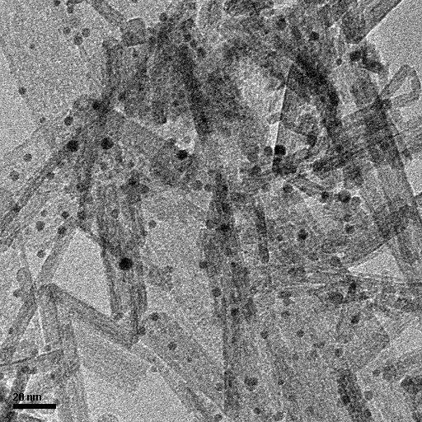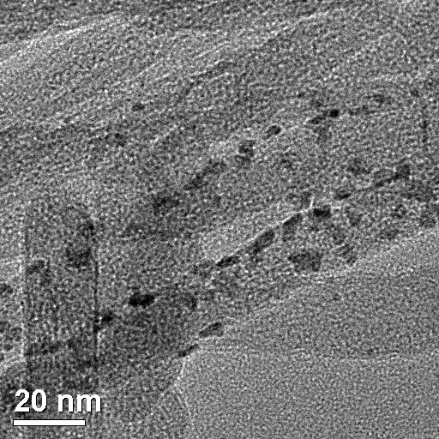

2%Pt/Al2O3

20nm

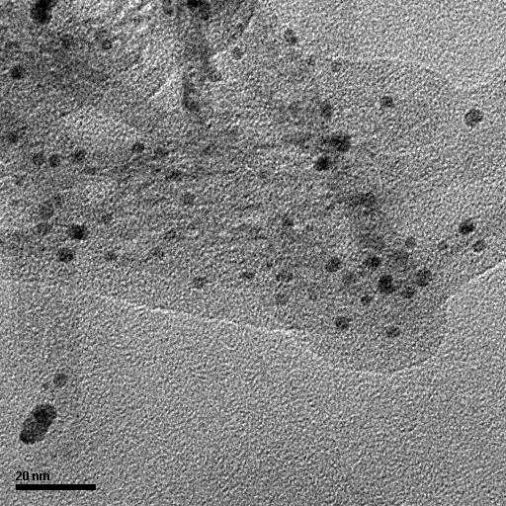

2%Au/CeO2

2%Au/Al2O3

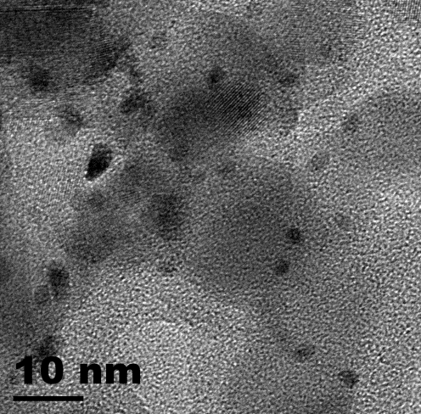

2%Pt/TiO2

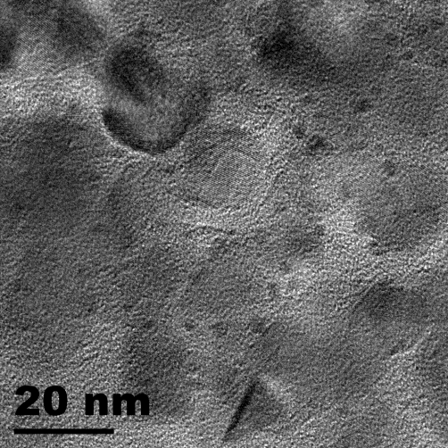

2%Rh/TiO2

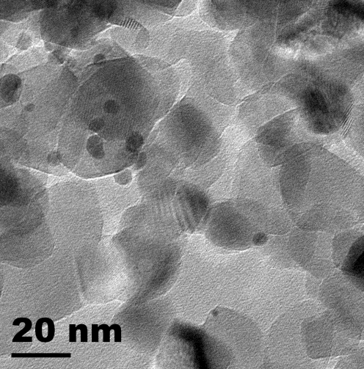

2%AuPd(1:1)/TiO2

20nm

20nm

Fig. 1. TEM images of the supported metal catalysts prepared by the sonication-assisted method.



Fig. 2. Catalytic degradation of MO under visible light at 25 oC (1 h).



Fig. 3. Catalytic degradation of MO under visible light after 3 h reaction at

25 oC.



Fig. 4. XRD patterns (A) and UV-vis spectra (B) of some catalysts.

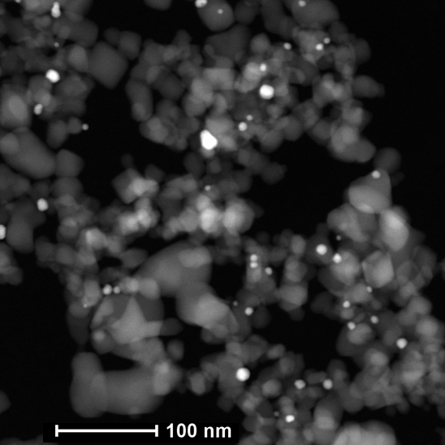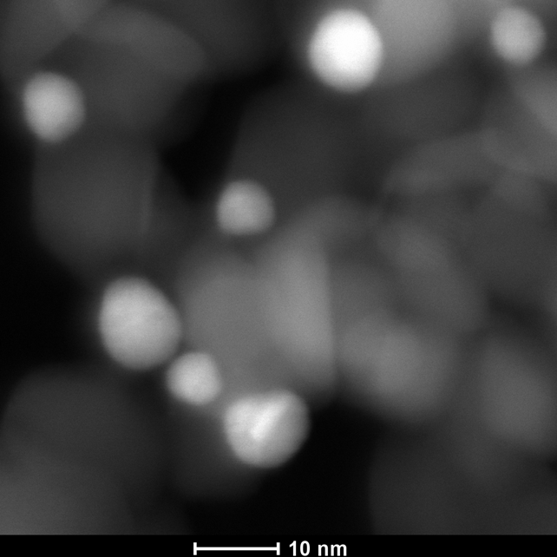

A

B

Fig. 5. HAADF-STEM images of the 2wt%AuPd(3:1)/TiO2 catalyst after oxidation in air at 300 oC.

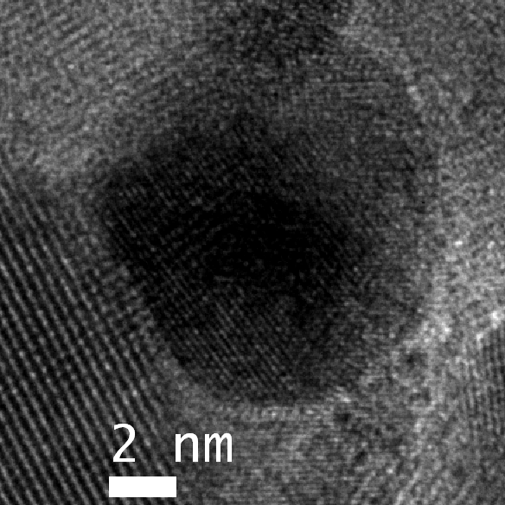

**0.199 nm**

**0.350 nm**

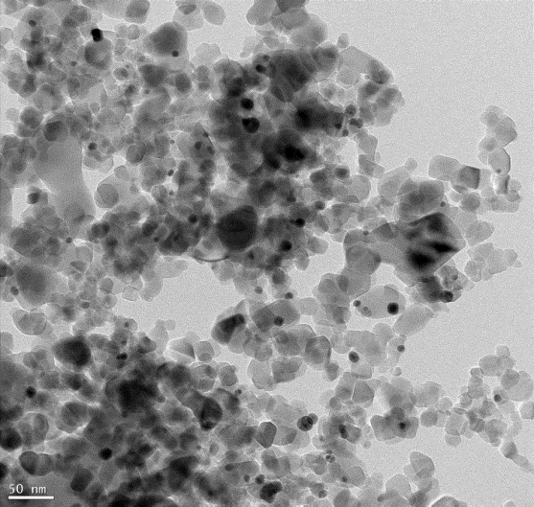

A

B

Fig.6. Low (A) and high (B) resolution TEM images of the 2-2wt%AuPd(3:1)/TiO2 catalyst after oxidation in air at 300 oC.



Fig. 7. XPS analysis of the supported catalysts oxidized in air (before reaction).



Fig. 8. PROX reaction on Pt supported catalysts. The catalysts were reduced in 5 % H2 at 300 oC for 40 minutes prior to the reaction. The catalytic reaction was carried out in the flow of 1 % CO, 1 % O2, 78 % H2, 20 % He at a GHSV of 5000 h-1.

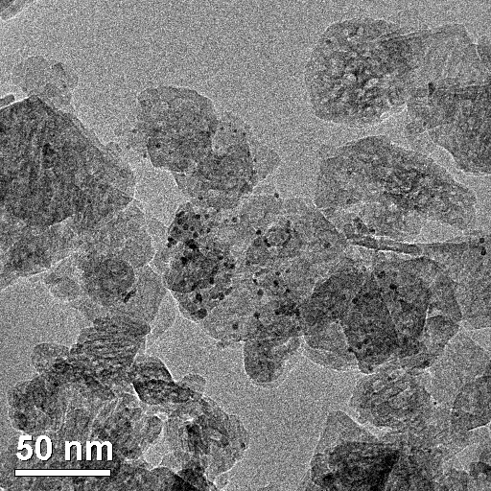

Fig. 9. PROX reaction on Pt supported catalysts. (left) TEM image of the 3%Pt/Al2O3 (SASOL), and (right) the catalytic performances of the 3%Pt/Al2O3 catalysts. Two kinds of Al2O3 supports were used. One was Al2O3 nanorods with and without calcination, and the other was γ-Al2O3 from SASOL. The catalysts were reduced in 5 % H2 at 300 oC for 40 minutes prior to the reaction. The catalytic reaction was carried out in the flow of 100 ppm CO, 100 ppm O2, 99.78 % H2, 0.20 % He at a GHSV of 50 h-1.

Graphic abstract

NaBH4

**SONICATION**

**ASSISTED**

**SYNTHESIS**

[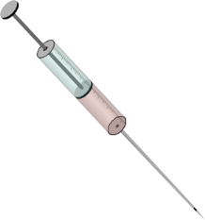](http://www.google.com.sg/url?sa=i&rct=j&q=&esrc=s&source=images&cd=&cad=rja&uact=8&ved=0CAcQjRxqFQoTCJS01tP5ickCFYeOlAodbxYEAw&url=http://www.clker.com/clipart-10625.html&psig=AFQjCNEO-A-azfsBka6lP-XJ7uR--fiu7w&ust=1447385584805775)

MO photo-

degradation

M1+ M2,

Lysine

support

PROX reaction

Supported metal catalysts

Supporting formation:

**A Versatile Sonication-assisted Deposition-reduction Method for Preparing Supported Metal Catalysts for Catalytic Applications**

Romen Herrera Padilla,a, b Peter Priecel,b Ming Lin,c Jose Antonio Lopez-Sanchez,b* Ziyi Zhonga*

*a Institute of Chemical and Engineering and Sciences(ICES), Agency for Science, Technology and Research (A∗star), 1 Pesek Road, Jurong Island, Singapore 627833.*

*b Stephenson Institute for Renewable Energy, Chemistry Department, The University of Liverpool, Crown Street L69 7ZD, Liverpool, United Kingdom*

*c Institute of Materials Research and Engineering, Agency for Science, Technology and Research (A∗star), 2 Fusionopolis Way, Innovis, #08-03, Singapore 138634*

*\*Corresponding author:* [*Zhong_ziyi@ices.a-star.edu.sg*](mailto:Zhong_ziyi@ices.a-star.edu.sg)*; J.Lopez-Sanchez@liverpool.ac.uk.*

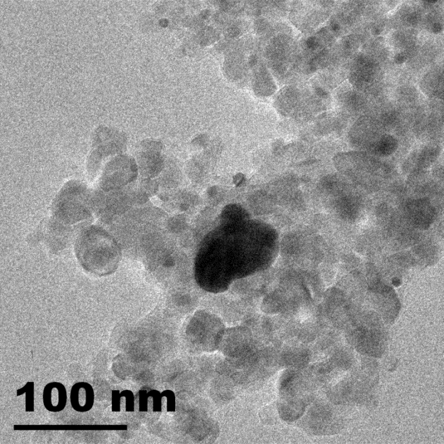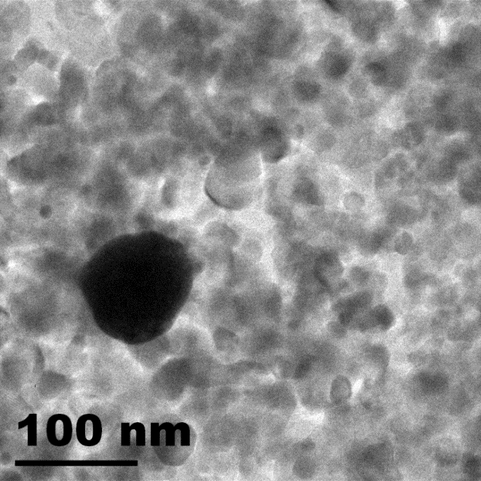

A

B

Fig. S1. TEM images of the two 2wt%AuPd(3:1)/TiO2 catalysts prepared by changing the deposition sequence of Au and Pd. (A) Pd was first deposited followed with Au deposition (catalyst 6 in table 1), and (B) Au was first deposited followed with Pd deposition (catalyst 7 in table 1). The catalysts were calcined in air at 300 oC for 1h. Some big particles were identified in these two samples besides some small particles.

= PdO

= Au

= Pd

TiO2

Fig. S2. Ideal AuPd/TiO2 catalyst for MO degrading reaction.