Willis’s investigations into medieval vaults:
a digital re-presentation

Nicholas Webb

In 1841 Robert Willis; Jacksonian Professor at the University of Cambridge, mechanical engineer and future holder of the Royal Gold Medal for architecture, delivered his address to the Royal Institute of British Architects discussing the design and construction of medieval vaults, which was published the following year (Willis 1842). Here Willis set out hypotheses such as the relationship of vault rib arcs to their radii and apex heights, as well as the rib arc centre point’s relationship to its impost line. His address was based on the principle that medieval vault construction was formed using a tracing floor plan in relation to a system of projections up and down to create the full geometry of vault ribs, rather than using stereometry as seen in neo-gothic design and construction. Alongside his text descriptions, Willis used architectural representation techniques such as orthographic plans, sections and isometric drawings, as well as sketch perspectives. Whilst these serve their purpose, relating the text to the images can often be difficult based on the complexity of the topic in question, particularly for those with little or no knowledge of medieval vaults. Therefore, the aim here is to digitally re-present the figures used by Willis to make them more accessible to all, and also demonstrate up-to-date techniques that are being used to investigate the work of Willis further as part of a larger research project.

At the University of Liverpool a small team of researchers are investigating medieval vault design and construction in the British Isles, which is inspired by the work of Willis and provides accurate documentation to further research his hypotheses (Webb and Buchanan 2016). The project uses digital techniques such as laser scanning and photogrammetry to acquire precise digital models of medieval vaults, including some of those discussed by Willis, for example Exeter Cathedral and Wells Cathedral. Three-dimensional digital modelling forms a key part of the analysis process, and, as a pre-requisite to ascertain research questions for the project, it became clear that in attempting to understand the words and images that Willis uses that a digital re-presentation of his original publication had the potential to make them richer in terms of content and clearer in terms of the reader or viewer’s understanding of the topic. This paper should be seen as a position piece that will explore the development of representation techniques throughout history and how these can influence our understanding of works of architecture. A visual re-appraisal of samples from Willis’s publication investigating vault design and construction will then be given through the use of digital techniques.

Willis and the development of representation techniques
Mediating tools in architecture are not new; links between drawing and construction can be traced back to the Near and Far East, Mesopotamia, Ancient Egypt and Greece. Throughout history architects, master builders and scholars have made use of devices that represent buildings, primarily to enable their construction, rather than being the literal ‘maker’ of the buildings themselves (Pérez-Goméz and Pelletier 2000). A significant example of this can be seen in Haselberger’s discovery of architectural drawings scribed into the stonework of the ruins at the Temple of Apollo in Didyma, Turkey (Hadingham 2008). However, there is little evidence elsewhere to support the widespread use of scale drawings, although as we will see, representation tools were still used. In terms of pre-Renaissance representation such as the medieval period, master masons would have predominantly designed mentally and communicated their ideas verbally or using full scale drawings and models. In this way, medieval masons would have been like their ancient counterparts as they were directly in charge of, and worked directly in, the spaces they were designing. Evidence such as the tracing floor above the north porch at Wells Cathedral supports the use of full-scale drawings, where building elements were drawn on a prepared plaster screen floor and then translated into the final building constructions.

After the widespread introduction of paper, architects and designers could experiment with ideas rapidly and communicate them more effectively with others, resulting in increased dialogue and critique, using techniques such as perspective sketches to visualise design ideas. However, Renaissance theorists such as Alberti believed that orthogonal drawings were most appropriate for architectural representation, not perspective images, as they enabled a more objective communication of design ideas. Alberti stated this was because orthogonal drawings allow measurements to be taken, enabling translation of them for construction or analysis purposes (Ackerman 2002). This demonstrates a shift towards drawing to scale rather than drawing at full scale or 1:1, with the role of mediating techniques becoming increasingly important. However, the reality was that most Renaissance architects did use perspective images to convey their ideas and this became the dominant technique in the discipline that would not be significantly challenged until the nineteenth century with the introduction of axonometric and isometric drawings.

Axonometric drawings in Europe were introduced, as is often the case with technological advances, because of their potential use in military operations. They offered geometric qualities in which correct measurements could be taken, offering accuracy in all three axes for construction purposes (Ackerman 2002). Additionally, their use as an analytical tool via calculus and geometry ‘made it possible to see graphic data not as a more or less approximation of sight, but as a way of calculating and predicting abstract qualities or behaviours’ (Allen 2009, 14). This highlights the use of axonometric drawings beyond their visual qualities and suggests their advantages in analysis and critique of designs. However, isometric drawings, a form of three-dimensional drawing represented orthographically on a two-dimensional page, also existed in the early nineteenth century. Isometric drawings work by constructing a base line with two 30° angles, rather than two 45° angles as with axonometric drawings, and then projecting heights vertically. This foreshortens the angles projected in comparison to the standard axonometric and consequently can be easier to read, particularly for a layperson. This was one of the main representation techniques used by Willis in his study of medieval vaults, for example in his drawing of the vault of Henry the Seventh’s Chapel, Westminster, which demonstrates some details of the vaults from below, but most importantly shows us the vault’s construction from the roof space as well. The inventor of isometric drawings in 1822 was William Farish, who also happened to be Willis’s predecessor as Jacksonian Professor at the University of Cambridge. Farish invented isometry in response to the pressing need to represent mechanical drawings objectively due to the emergence of technologies in the Industrial Revolution; he understood that perspective images distorted the true geometry of objects (Krikke 2000). Evidence indicates that Willis attended Farish’s lectures, as sketches and notes recorded by Willis from them still survive (Buchanan 2013, 35). As a graduate of Cambridge and subsequently an academic there, this gives evidence to Willis’s use of isometric drawings under the influence of Farish. Willis showed creativity in developing designs for drawing tools, for example the ‘cymagraph’ which was used for tracing mouldings of vault ribs. This had a stylus which was mounted on a carriage holding a pencil that simultaneously traced the profile of the moulding contours (Buchanan 2013, 60). Here we have evidence of Willis using the most up-to-date techniques, as well as further developing them himself in search of a clearer and more objective understanding of the subjects in question.

Beyond the work of Willis and Farish using isometric drawings, we see the increased significance of axonometric drawings in the research of Auguste Choisy in the 1870s. Similarly to Willis, Choisy adopted axonometric drawings as a way of visually describing the history of medieval and ancient architecture (Ackerman 2002). He believed they could ‘demonstrate what he assumed to be the deterministic principles according to which the great buildings of history were achieved’ (Pérez-Goméz and Pelletier 2000, 314). Choisy’s work is a therefore another key example in demonstrating how representation techniques can be used to augment our understanding of historic architecture; revealing a more objective truth. The use of such drawings meant that unseen features could be seen, such as worms-eye views from the underside of a building or structure; effectively explaining design elements such as wall construction.

Digital representation techniques
In his 1842 publication, Willis used a combination of orthographic plans, sections, elevations and isometric drawings, in addition to perspective sketches. Additionally, we have evidence of Willis using physical models in his lectures to further communicate his ideas (Buchanan 2013, 158). As noted previously, we see that Willis employed contemporary architectural representation techniques to disseminate his hypotheses on medieval vault construction, and was also seeking to improve his survey methods through the invention of machines such as the ‘cymagraph’. Moving forward to the 21st century, we can confidently assume therefore, that Willis would have similarly used made use of the most up-to-date technologies if he was researching today. For both surveying and dissemination today, this can be seen in the form of computer aided architectural techniques. The widespread introduction of the computer since the late 1980s has rapidly changed the architectural profession, and by the start of the 21st century visual imagery created using three-dimensional digital software had become extensive due to fast paced developments in computing. Kalay (2004) stated that computer aided architectural techniques have shook ‘…the foundations of the profession as no other invention has done before.’

In a research context, we increasingly see how digital techniques can be utilised. Examples using digital representation tools in historic architecture and archaeology began to emerge in the mid-1990s, with publications such as ‘Virtual Archaeology’ (Forte and Siliotti 1997) and ‘Rendering Real and Imagined Buildings’ (Novitski 1998) focussing on the use digital modelling as a visualisation tool. Moving forwards, the use of digital tools became increasingly complex with emphasis moving towards analysis of architecture in addition to representation. This can be seen, for example, in the work of Jane and Mark Burry (2006) where 3D digital modelling was used to explore and understand the complex geometries created by Gaudi at the Sagrada Familia church in Barcelona, enabling the building’s continuing construction. Another example is the project to digitally reconstruct and analyse destroyed German synagogues by Martens and Peter (2002). The use of digital techniques to accurately survey historic works of architecture is highlighted by Richens and Herdt (2009), who identified that hand drawings of ancient ionic columns had previously been drawn incorrectly, and subsequent digital representations offered a more objective basis for analysis purposes, and an opportunity for dissemination of information. The following sections discuss how similar digital tools have been explored to re-present Willis’s original figures, and the potential benefits these have in terms of enhancing our understanding of them.

Re-presentation of Willis’s original figure 3
The first and simplest method chosen to enhance Willis’s original figures was to overlay them with additional information. For this Willis’s figure 3 was chosen, which is derived from a vault in the south transept of Westminster Abbey and is presented in perspective on the left hand side and in section on the right hand side of the image (see figure 1).
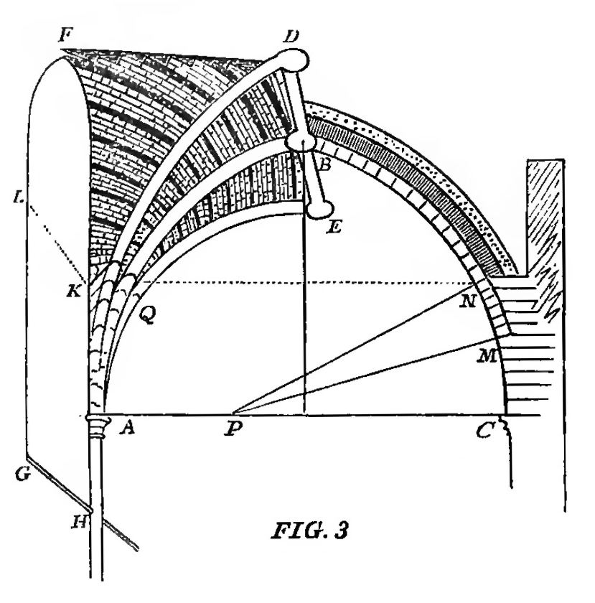
Figure 1
Willis’s original figure 3 that visually describes a vault derived from the south transept of Westminster Abbey (Willis 1842, figure 3).

Although the diagram successfully encompasses all elements discussed by Willis, these can at times be difficult to decipher in relation to the text due to the complexity of the topic. Therefore the first step taken was to segment the accompanying text into smaller sections discussing the different elements of the vaults, and then to pair these individual sections with a re-presented figure. The original figure was edited using Photoshop, where highlights were added in red as well as fading out areas of the figure if not discussed by Willis in that particular section. For example, the first re-presented figure was based on the text: ‘The left hand half of this diagram represents a portion of the vault in perspective, including the entire spandrel solid (if I may be allowed the expression), which is contained by the two semi-diagonal ribs AD AE and the wall’ (Willis 1842, 4). Consequently, the ribs were highlighted in red on the left hand side of the image, and the right hand side of the image was faded out. This is demonstrated in the top image of figure 2. To enhance this sectioning further, the accompanying images and text were presented as a parallax webpage, with the relevant text highlighted in relation to the corresponding image, and as you scroll down the page the images and text change accordingly, making the overall process easier to understand. The full online version of the webpage can be found here and a mock-up can be seen in figure 2. Web addresses for all of the digital content can also be found at the end of the paper.

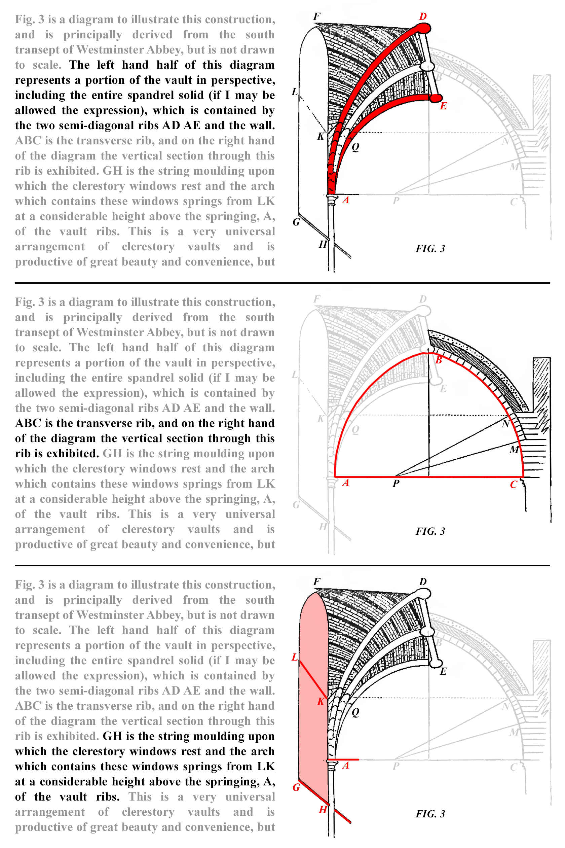
Figure 2
Mock-up of the parallax webpage re-presenting Willis’s original figure 3 using digital enhancements. The full webpage can be found here.

Re-presentation of Willis’s original figure 9
The second method builds upon the first techniques used for the re-presentation of Willis’s original figure 3. Again, augmented images were paired with the relevant descriptive text, as well as adopting the same format of viewing the article as part of a parallax webpage. The main difference in this second method was, rather than using Willis’s original figures and adding graphical enhancements, instead they were fully re-drawn in three dimensions as digital models. Rhinoceros 5, a solid modelling programme, was chosen for this based on its ability to create models with complex geometries, such as medieval vaults. To demonstrate this re-presentation Willis’s original figure 9 was used, which is a wireframe image showing an intermediate, or tierceron vault construction, in the form of an isometric drawing (see figure 3).
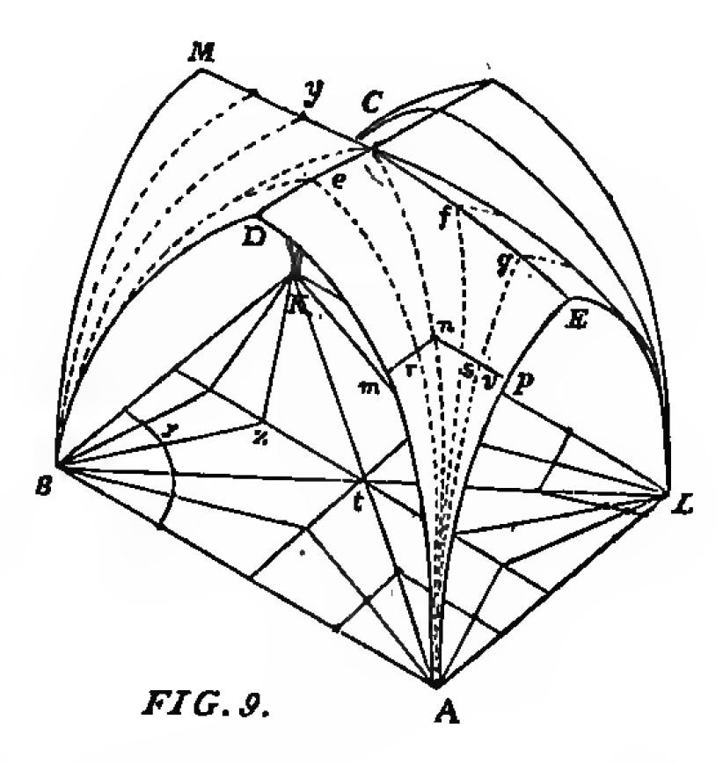
Figure 3
Willis’s original figure 9 illustrating a tierceron or intermediate vault (Willis 1842, figure 9).

Redrawing Willis’s original figure digitally was advantageous as it added graphical clarity as well as enabling additional information to be shown that is discussed by Willis but not drawn. For example, once Willis finishes discussing his basic diagram of a vault with tierceron ribs with ‘one tierceron between the transverse and diagonal ribs, and two between the wall rib and diagonal rib’ (Willis 1842, 10), he mentions cathedrals with different tierceron arrangements such as ‘three and one’ in the nave at Exeter cathedral and ‘three and two’ in the nave at Norwich. Here we have shown these different arrangements in the digital models, not only in one quarter of the bay compartment, but also across the entire bay. In addition to digitally re-presenting the basic wireframe model used by Willis, the full forms of the vaults themselves have been added, using the existing wireframe as the rib extrados lines. This offered further visual enhancement and clarity to the descriptions that Willis gives (see figure 4 and the following link).
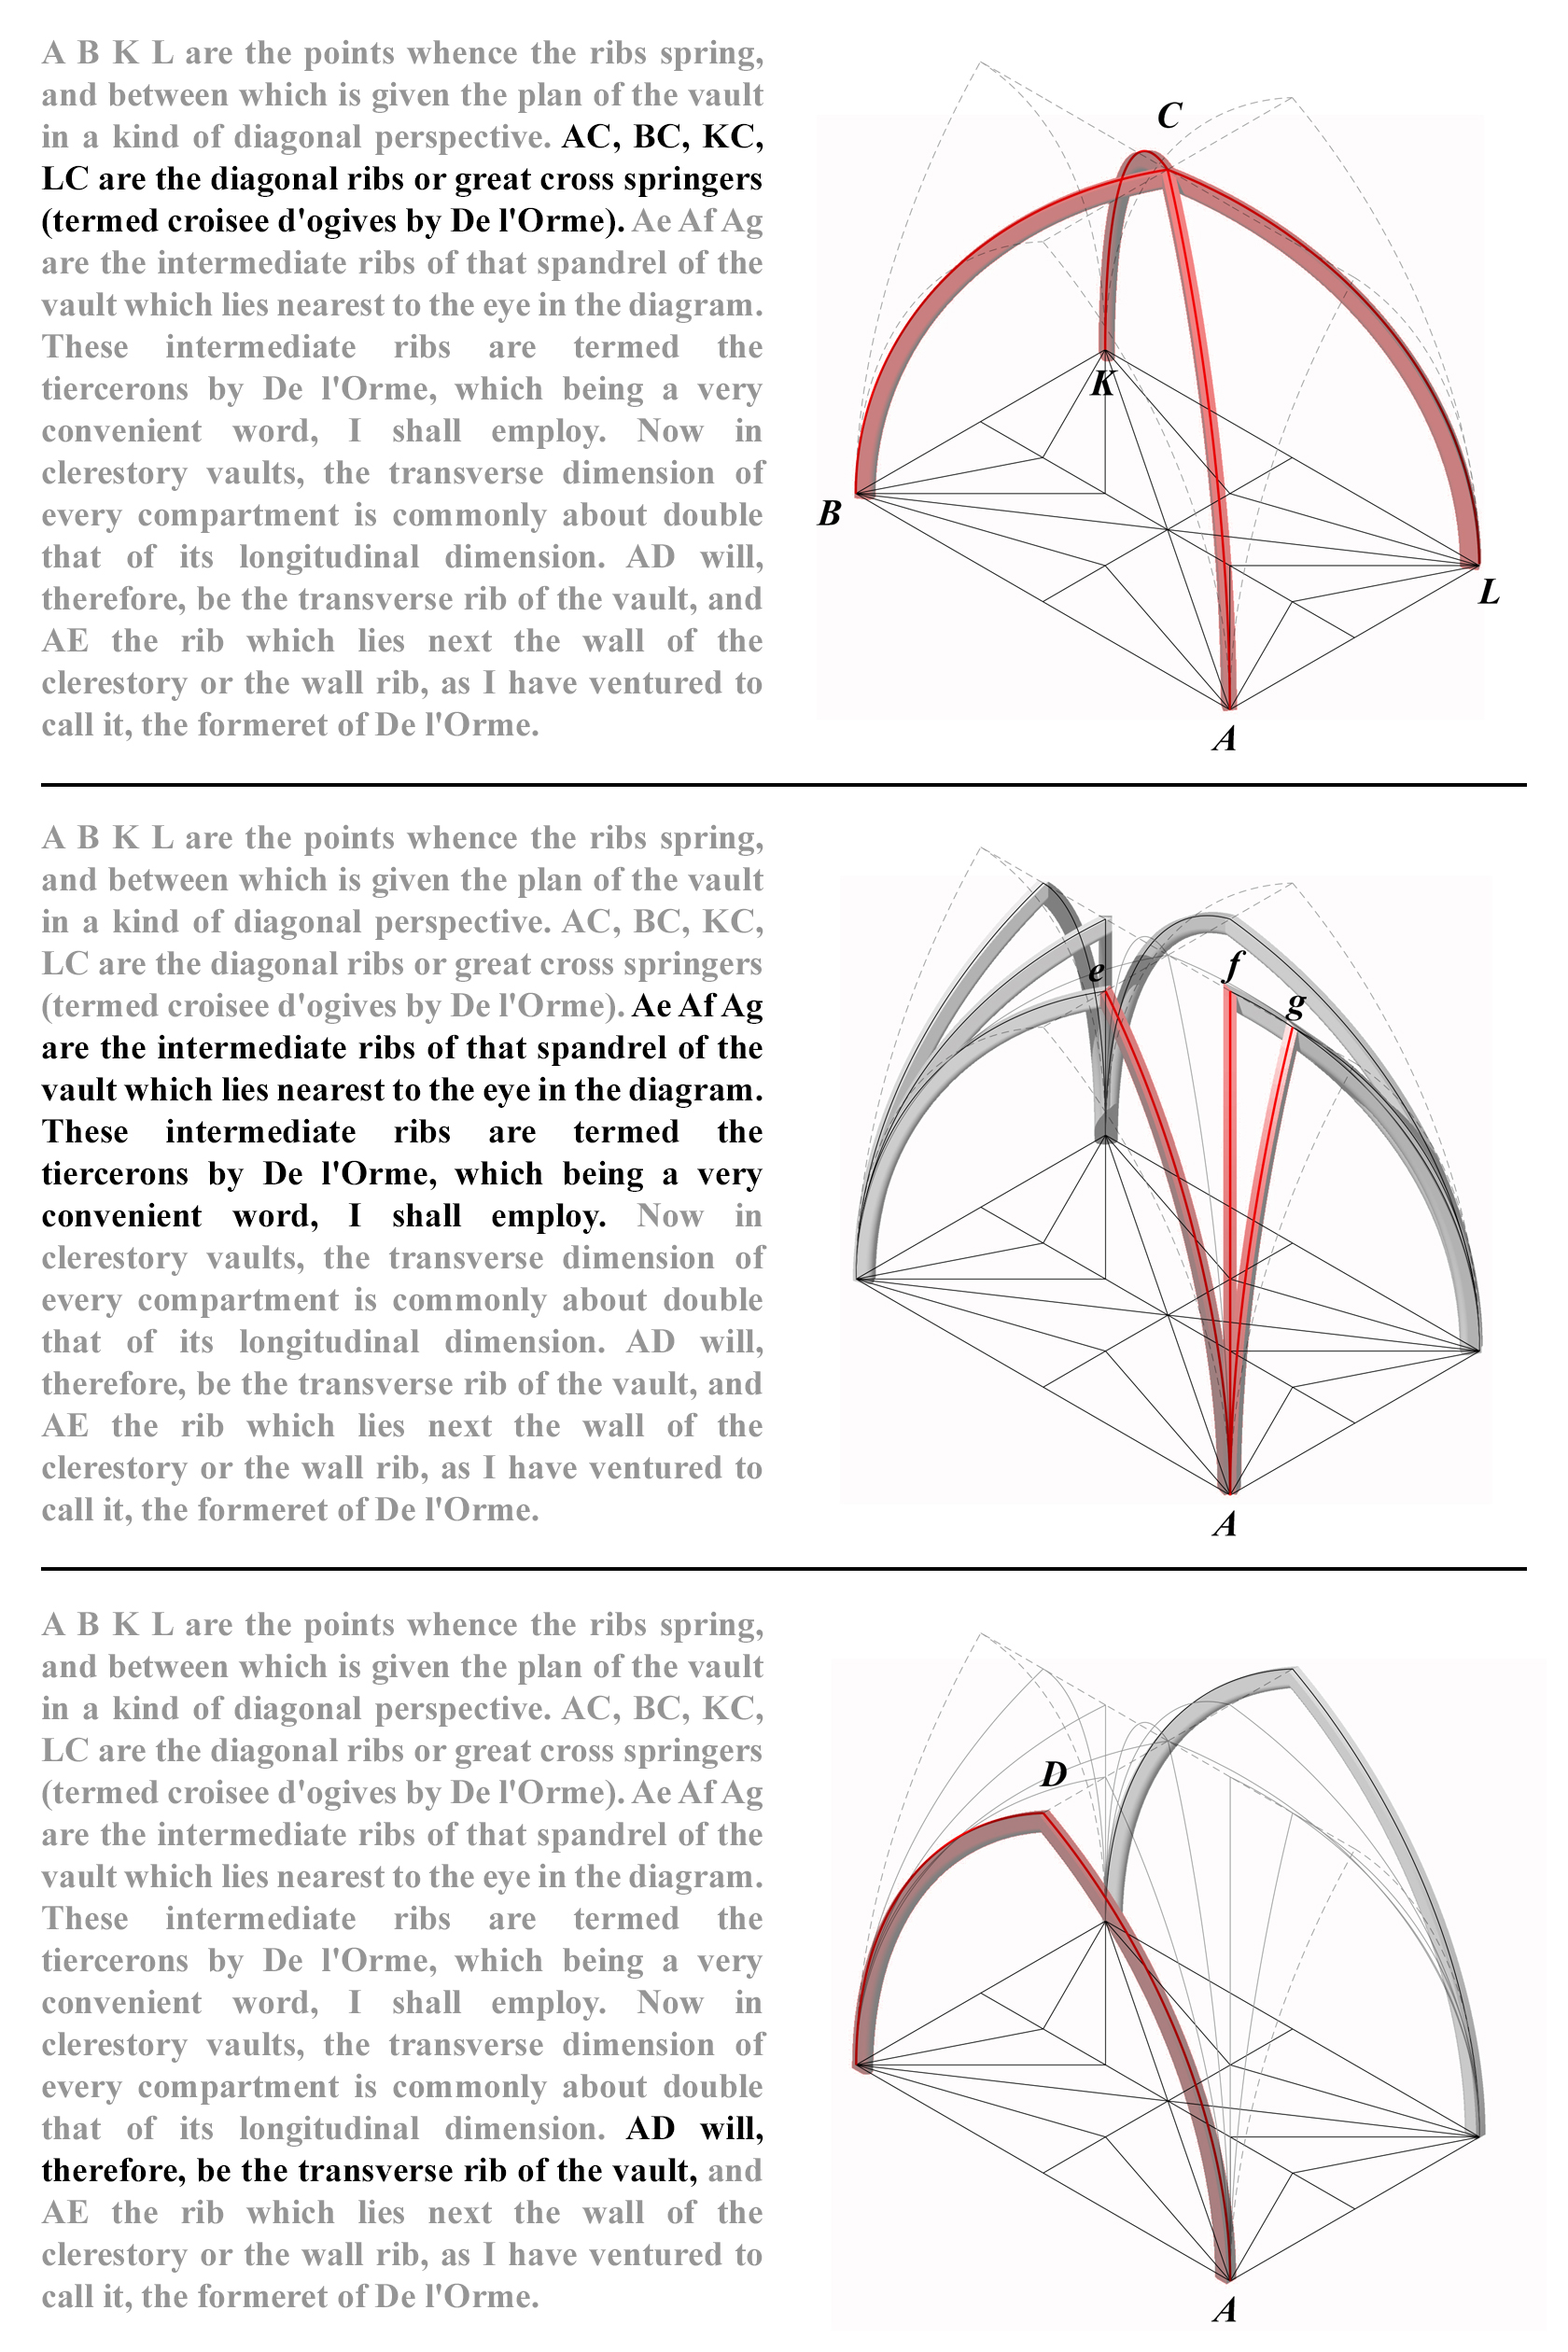
Figure 4
Mock-up of a re-presentation of Willis’s original figure 9 using three-dimensional digital modelling. The full parallax webpage can be found via the following link.

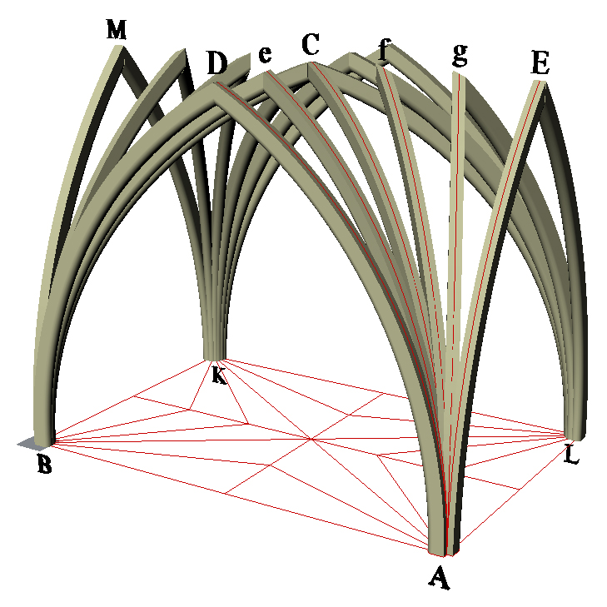
Although this re-presentation aims to make clearer Willis’s original figure, it still has limitations as a series of static images on a screen. Therefore, as an additional presentation, the three-dimensional model itself was also embedded into the webpage using Sketchfab, a platform for sharing and publishing 3D content. This enabled rotation, zooming and exploration of the model in further detail (see figure 5 and the following link). This gives the viewer of Willis’s work additional accessibility and control over what they would like to view as they can compare it to the text and explore at their own will.
Figure 5
A screenshot of the three-dimensional digital model re-presenting Willis’s original figure 9, embedded as part of a webpage via the following link.

Re-presentation of Willis’s original figure 10
One of the more complex diagrams that Willis used can be found in his original figure 10, which combines a vault bay plan and section (see figure 6). The original figure and accompanying text discusses the design process required to ascertain the curvature of various ribs in a vault bay with a flat ridgeline, such as diagonal, tierceron and stilted ribs. Although the original figure contains all of the information required in relation to the text, the complexity, particularly in overlaying the plan and section together, makes interpreting the presentation challenging at times.

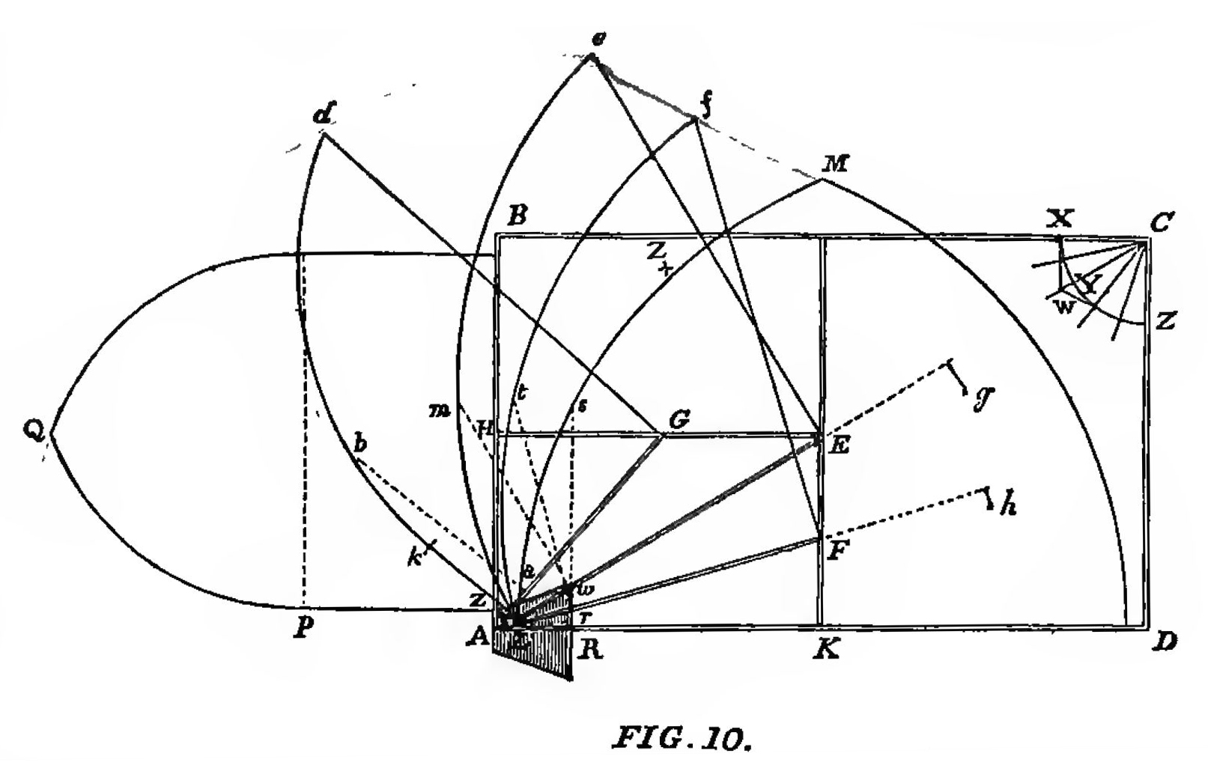
Figure 6
Willis’s original figure 10 illustrating a vault bay and the design process required to ascertain the various rib curvatures (Willis 1842, figure 10).

Therefore in the final experiment a digital animation was chosen to re-present the original figure and accompanying text, screenshots of which are shown in figure 7, with the animation itself presented online through the following link. SketchUp, another 3D modelling programme, was used to create a digital wireframe version of the diagram. For this the vault ribs were presented horizontally in plan as well as vertically in section, closer to the form of an actual vault, rather than overlaying them both as a flat image as seen in the original figure. Once a series of viewpoints of the three-dimensional wireframe model were created, these were exported as a video file from SketchUp to create an animation, and then the relevant sections of Willis’s text were added at intervals using Windows Movie Maker. The main advantage of this method in comparison to the previous two was, as an animation, the viewer can see the transitions between the different sections discussed by Willis more clearly, allowing further exploration compared to static images. Additionally this enables the viewer to further understand the full three-dimensional geometry of the vault bay example.
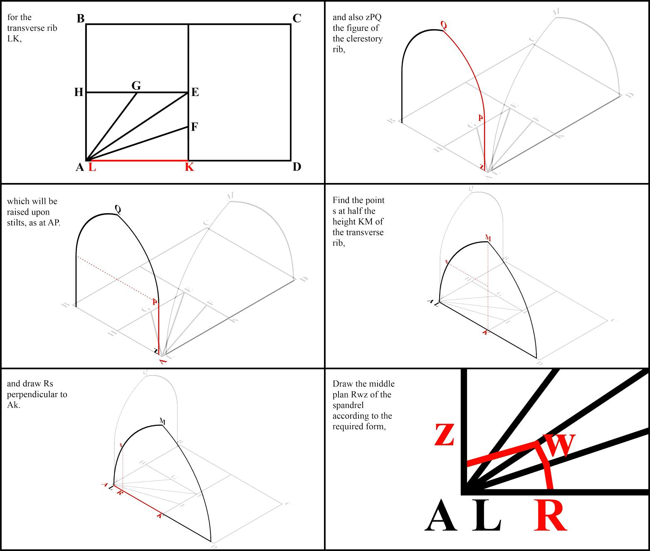

Figure 7
Screenshots from an animation digitally re-presenting Willis’s original figure 10. The full animation can be found via the following link.

Reflections and conclusions
The three re-presentations of Willis’s original figures aim to enhance the viewer’s understanding of his research, and consequently their understanding of medieval design and construction. The ability to deconstruct the original text and figures into a number of segmented sections makes clearer each step of the process. This is logistically possible through the use of digital techniques, specifically webpages and animations, as they enable layering of information with no concerns over space, as would be the case in a physical book or journal. Using digital tools builds on Willis’s use of innovative techniques; such as presenting his hypotheses isometric and sectional drawings, rather than sketches and perspectives in most cases. Similarly, in investigating medieval vault design and construction today, we are using the most up-to-date representation techniques available to us.

Future investigations will aim to enhance the re-presentations further. The main critique of the first two methods, primarily using parallax webpages, is that they still show static images. This is first improved by adding a three-dimensional digital model to the re-presentation of Willis’s original figure 9, and further enhanced in the third re-presentation using the animation. This has the benefit of showing the transition between different elements discussed by Willis; however, the viewer has less control over the speed of the presentation. Therefore the next step will be to include animations as part of the parallax webpages, and further explore the integration of three-dimensional digital models. As this paper is based on a larger investigation into medieval vault design using digital techniques, the experiments described here are vital in further considering dissemination techniques for the observations and findings acquired at sites across the British Isles such as Wells Cathedral and Exeter Cathedral.

Acknowledgements
I would like to thanks Martin Winchester for his assistance in creating the parallax webpages and Alex Buchanan for initiating the ‘Tracing the Past’ research project.

References

Ackerman, J.S. (2002) Origins: Representation in the visual arts. Cambridge, MA: The MIT Press.

Allen, S. (2009) Practice - architecture, technique and representation. 2nd edn. New York: Routledge.

Buchanan, A. (2013) Robert Willis (1800-1875) and the foundation of architectural history. United Kingdom: The Boydell Press.

Burry, J. and Burry, M. (2006) Sharing hidden power - communicating latency in digital models, 24th eCAADe Conference Proceedings.

Forte, M. and Siliotti, A. (1997) Virtual archaeology: RE-creating ancient worlds. United States: Harry N. Abrams.

Hadingham, E. (2008) Unlocking Mysteries of the Parthenon. Available at: http://www.smithsonianmag.com/history/unlocking-mysteries-of-the-parthenon-16621015/?all (Accessed: 11 July 2016).

Kalay, Y.E. (2004) Architecture’s new media: Principles, theories, and methods of computer-aided design. Cambridge, MA: The MIT Press.

Krikke, J. (2000) Axonometry: A matter of perspective, IEEE Computer Graphics and Applications, 20(4), 7–11.

Martens, B. and Peter, H. (2002) Developing Systematics regarding virtual reconstruction of synagogues, ACADIA Conference Proceedings. 349-356.

Novitski, B.J.J. (1998) Rendering real and imagined buildings: The art of computer modeling from the palace of Kublai khan to Le Carbusier’s villas. United States: Rockport Publishers.

Pérez-Gómez, A. and Pelletier, L. (2000) Architectural representation and the perspective hinge. Cambridge, MA: The MIT Press.

Richens, P. and Herdt, G. (2009) Modelling the ionic capital, 27th eCAADe Conference Proceedings. 809-816

Webb, N. and Buchanan, A. (2016) Tracing the past. Available at: http://www.tracingthepast.org.uk/ (Accessed: 26 May 2016)

Willis, R. (1842) ‘On the Construction of the Vaults of the Middle Ages’, Transactions of the Royal Institute of British Architects, 1(2) 1–69.

Website addresses for digital content

Re-presentation of Willis’s original figure 3 as a parallax webpage.
http://www.tracingthepast.org.uk/willis-3/

Re-presentation of Willis’s original figure 9 as a parallax webpage.
http://www.tracingthepast.org.uk/willis-9/

Re-presentation of Willis’s original figure 9 as a 3D model.
http://www.tracingthepast.org.uk/willis-9b/

Re-presentation of Willis’s original figure 10 as an animation.
http://www.tracingthepast.org.uk/willis-10/

