DOI: 10.1002/((please add manuscript number))
Article type: Communication

Hyper-Porous Carbons from Hypercrosslinked Polymers

Jet-Sing M. Lee, Michael E. Briggs, Tom Hasell, and Andrew I. Cooper*

J.-S. M. Lee, Dr M. E. Briggs, Dr T. Hasell, Prof. A. I. Cooper
Department of Chemistry and Centre for Materials Discovery, University of Liverpool,
Crown Street, Liverpool, L69 7ZD, UK.
E-mail: aicooper@liverpool.ac.uk

Keywords: carbon, porous, hypercrosslinked polymer, carbon dioxide storage, hydrogen storage

Porous carbonaceous materials have been of interest for many years because of applications^{[1]} such as gas separation,^{[2]} water purification,^{[3]} catalysis,^{[4]} electromagnetic interface shielding,^{[5]} and energy storage in batteries,^{[6]} supercapacitors,^{[7]} and fuel cells.^{[8]} Porous carbons are appealing because of their relatively low cost and their ease of preparation from a variety of natural and synthetic precursors. Porous carbons are noted for their high surface areas (> 1000 m² g⁻¹) and pore volumes (> 0.5 cm³ g⁻¹); they also have good chemical, thermal, and mechanical stability, high electrical conductivity, and they can be processed for various applications.^{[9]} Porous carbonaceous materials are traditionally prepared by physical activation, chemical activation, or by a combination of the two.^{[10]}
Highly porous carbons have been produced in the past with the use of KOH as a chemical activating agent, through precursors including linear polymers,^{[11, 12]} carbon nanotubes,^{[13]} and graphene oxide.^{[14]} A number of microporous solids have been precursors for carbonaceous materials with advanced properties, including zeolitic imidazolate frameworks (ZIFs),^{[15]} metal-organic frameworks (MOFs),^{[16]} porous aromatic frameworks (PAFs),^{[17]} conjugated microporous polymers (CMPs),^{[18]} and hypercrosslinked polymers (HCPs)^{[19]}. The choice of precursor material can affect the functionality in the resultant carbons. For instance, carbonized ZIFs have been used for supercapacitor electrodes,^{[20]} carbonized MOFs as oxygen reduction catalysts and lithium sulphur batteries,^{[21]} carbonized PAFs for gas storage,^{[22]} carbonized CMPs as chemosensors, electrocatalysis and supercapacitors,^{[23, 24]} and carbonized HCPs for benzene/chlorobenzene vapour absorption and as a porous carbon support for oxygen reduction reactions.^{[25]} While these materials show good performance for their respective applications, many of the microporous precursors involved costly starting materials (e.g., PAFs, many MOFs and CMPs) or expensive catalysts for their preparation (e.g., CMPs, PAFs). Also, some of these precursor porous materials are prepared under rigorous anhydrous and anaerobic conditions (e.g., PAFs), which makes scale-up challenging.
HCPs are microporous materials synthesized from cheap organic monomers that show good stability and potential for synthetic diversification. Permanent porosity in HCPs is a result of extensive cross-linking, which prevents the polymer chains from collapsing into a dense, non-porous state. HCPs have been known for many years and are scalable.^{[26]} They can be prepared using a formaldehyde dimethyl ether cross-linker through a simple one-step Friedel-Crafts reaction, which opens up this approach to a large library of polymers derived from simple aromatic monomers.^{[27]} HCPs can exhibit a range of surface areas, pore-size distributions, and surface functionalities that can be tuned by changing the aromatic monomer, the reaction stoichiometry, or by the inclusion of functionalised aromatic co-monomers. Benzene-derived HCPs have received renewed interest due to their high uptake of CO₂ (15.3 mmol g⁻¹ at 40 bar) and their potential application in the purification of syngas.^{[28, 29]} However, this high CO₂ uptake is also associated with swelling of the polymer, which could cause limitations for some practical applications.
Our aim was to find a simple process that could be used to further improve the properties of HCPs. Ideally, the surface area of the materials would be increased while minimizing the pronounced swelling that is observed with CO₂ or with other adsorbed species, such as organic liquids. Here, we describe how a simple carbonization process can be used to significantly enhance the surface areas of HCPs, whilst simultaneously preventing swelling of the material. These results are transferable across a family of three related HCPs, derived from three low-cost monomers; benzene, thiophene, and pyrrole.
Benzene, thiophene and pyrrole were hypercrosslinked according to known literature methods,^{[27]} and the resulting polymers are referred to as HCP-Ben, HCP-Th and HCP-Py (Scheme 1). Thermogravimetric analysis (TGA) in nitrogen was performed to determine the thermal stability of the HCPs, mimicking the conditions that would be used for the carbonization (Figure S1). HCP-Th and HCP-Py show some mass loss below 100 °C; this was ascribed to evaporation of physisorbed atmospheric water since the S and N atoms present in these polymers are known to have a strong affinity for water. HCP-Ben shows high thermal stability with little mass loss below 500 °C and only 30 % mass loss up to 1000 °C, whereas HCP-Th and HCP-Py show continuous mass loss up to 80 % and 96 %, respectively, at 1000 °C.
Carbonized HCPs were obtained by mixing the HCPs with KOH in a 1:4 ratio and heating at various temperatures between 700 and 1000 °C, followed by extraction of residual salts and drying. The carbons are referred to as BenΔ, ThΔ and PyΔ, with Δ signifying the carbonization temperature. The apparent Brunauer–Emmett–Teller (BET) surface areas of the synthesized carbons are shown in Figure 1a; Ben750, Th850, and Py800 were observed to have the highest BET surface areas of 3105 m² g⁻¹, 2682 m² g⁻¹, and 4334 m² g⁻¹, respectively, and these materials were therefore evaluated in more detail. Nitrogen sorption isotherms for the HCPs Ben750, Th850, and Py800, are shown in Figure 1b. The physical properties of these carbons and their HCP precursors are summarized in Table 1. Following International Union of Pure and Applied Chemistry (IUPAC) classification,^{[30]} these isotherm shapes include examples that are Type Ib (associated with a broad range of micropores), Type II (associated with the presence of macropores), and Type IVa (associated with mesoporous characteristics). The isotherms of the carbonization precursors (HCP-Ben, HCP-Th and HCP-Py) are all Type II signifying the presence of macropores within the HCPs, though it should also be stressed that these materials can swell in liquid nitrogen.^{[31]} The HCPs precursors have surface areas and total pore volumes of 1382 m² g⁻¹ and 1.52 cm³ g⁻¹ for HCP-Ben, 484 m² g⁻¹ and 0.33 cm³ g⁻¹ for HCP-Th, and 322 m² g⁻¹ and 0.25 cm³ g⁻¹ for HCP-Py. Carbonization with KOH resulted in increased microporosity for Ben750, Th850, and Py800, while Py800 also showed a large increase in mesoporosity. The N₂ isotherms of Ben750 and Th850 are Type Ib; most of the nitrogen uptake occurs at P/P₀ < 0.02, indicating a mostly microporous structure, which is also apparent from comparison of the micropore volume with the total pore volume (Table 1). Py800 shows a Type IVa isotherm associated with a mesoporous material with a relatively small portion (33 %) of its total pore volume derived from micropores, as seen in the pore size distribution of the material (Figure S2). Py800 also shows an extremely high surface area of 4334 m² g⁻¹ which, to our knowledge, is the highest reported to date for an organic derived activated carbonaceous material.^{[12, 13, 32]}
The nitrogen isotherms and pore size distributions for the synthesized carbons are shown in Figure S3. The carbonization products of HCP-Ben at 700 °C and 750 °C show Type Ib isotherms, indicating high microporosity (Figure S3a). As the carbonization temperature was raised to 850 °C, the isotherms display some Type IVa character with a hysteresis loop gradually appearing at P/P₀ = 0.5, this is accompanied by a widening of the pore size distribution (Figure S3b) and is due to the formation of mesopores at higher activation temperatures. The higher temperatures led to a decrease in surface area from 3105 m² g⁻¹ for Ben750 to 3049 m² g⁻¹ and 2730 m² g⁻¹ for Ben800 and Ben850, respectively (Table S1). At 900 °C, the isotherm is Type IVa, indicating of a mesoporous material. When the carbonization temperature is increased from 850 °C to 900 °C, the surface area drops from 2730 m² g⁻¹ to 1584 m² g⁻¹; this is primarily due to a reduction in the micropore volume from 0.76 cm³ g⁻¹ to 0.31 cm³ g⁻¹; the total pore volume remains approximately constant. Increasing the carbonization temperature to 1000 °C resulted in a substantial loss of porosity, with the isotherm displaying Type II characteristics, indicating the presence of mostly macropores and a surface area loss of only 196 m² g⁻¹ due to the collapse of most micro- and mesopores. In general, the average pore size distribution shifts from being micro- to mesoporous as more material is removed with increasing temperature, this eventually leads to pore collapse and the formation of lower surface area carbons. Carbonized samples produced from HCP-Th and HCP-Py show a similar trend with increasing temperature. HCP-Th carbonized at 700 °C and 800 °C show Type Ib isotherms suggesting a mainly microporous material with surface areas of 1593 m² g⁻¹ and 2138 m² g⁻¹, respectively (Figure S3c). Upon raising the carbonization temperature to 850 °C, the isotherm shifts to Type IVa indicating mesopores with a large surface area of 2682 m² g⁻¹; the micropore content was still relatively high constituting about 46 % of the total pore volume. A further increase in temperature to 900 °C results in a dramatic decrease in surface area to 403 m² g⁻¹, and a Type II isotherm. Carbonized HCP-Py at 700 °C displays a Type Ib isotherm with the surface area of 3122 m² g⁻¹, primarily ascribed to microporosity. An increase in carbonization temperature to 800 °C gives a Type IVa isotherm and yields a mesoporous material with an extremely high surface area of 4334 m² g⁻¹ (Figure S3e). Upon a further increase in temperature to 850 °C, the material still possesses a Type IVa isotherm, though the micropore and total pore volumes are decreased, resulting in a lower surface area of 3112 m² g⁻¹. At higher temperatures, the poor mass recovery of the carbons precluded porosity testing. All ThΔ and PyΔ carbons retain some of their respective parent heteroatoms showing that the incorporation of heteroatoms is possible using selected heteroatom containing precursors (Table S2).
Field emission scanning electron microscopy (FE-SEM) was used to study the morphology of the HCPs and various carbonized products. The images all show similar morphologies for the carbonized samples at 800 °C and their precursor polymers (Figure S4). It can be concluded that the morphology is generally retained with these carbonization conditions. Powder X-ray diffraction (PXRD) patterns of the HCPs and their carbonized products in Figure S5 exhibit a characteristic peak located at 44°, corresponding to the (101) plane of hexagonal graphite, thus revealing their amorphous nature and low degree of graphitization.^{[33]} The Raman spectra of Ben800, Th800, and Py800 present two first-order Raman bands for disordered (D) at ~1350 cm⁻¹ and graphitic (G) carbon at ~1590 cm⁻¹ attributed to the breathing mode of k-point phonons of A_{1g} symmetry and the in-plane stretching motion of symmetric sp² C–C bonds respectively (Figure S6).^{[24, 34]} Inductively coupled plasma optical emission spectroscopy (ICP-OES) was also investigated for Ben750, Th850, and Py800 and detected only trace amounts of Fe and K (Table S3). Due to this, we can exclude its influence on gas absorption measurements.
The composition of the precursor polymers and the resultant carbonaceous materials were investigated by X-ray photoelectron spectroscopy (XPS) (Table S4-9, Figure S7-12). HCP-Ben and its carbonized product, Ben800 contains C and O, while HCP-Th and Th800 also contain S and HCP-Py and Py800 N (Figure S7). Residual Fe was not detected in any of the samples, however trace amounts of Cl remain in the polymer after synthesis (Table S5), though this appears to be removed in the carbonization process and was not detected in any of the carbons. HCP-Ben shows a Cl 2p peak at 200.1 eV representative of C-Cl, HCP-Th a peak at 199.7 eV suggest low levels of FeCl, and HCP-Py a peak at 196.8 eV and 200.1 eV for N-Cl and C-Cl respectively (Figure S8).^{[35, 36]} A primary peak was seen for C 1s for all samples at 284.5 eV corresponding to C-C and C-H species, followed by peaks at 286.0 eV, 287.5 eV, 289.2 eV, and 290.9 eV for C-O and C-N, C=O, carbonates, and π to π* transitions respectively (Figure S9).^{[36, 37]} The increase in π to π* after carbonization is likely due to the material becoming more graphitic in nature. Peaks for O 1s were observed at 530.7 eV, 532.1 eV, 533.5 eV, and 535.5 eV which correspond to oxides, carbonates, C=O, and C-O-H, respectively (Figure S10).^{[36]} XPS of HCP-Th shows S 2p peaks at 163.4 eV and 163.9 eV for C-S-H and C-S-C species respectively (Figure S11). Upon carbonization, Th800 loses all C-S-H species as expected, and gives rise to two new species at 165.1 eV and 168.1 eV for R₂-SO and a sulfate/sulfone species respectively.^{[36, 38]} The XPS of HCP-Py shown a largely pyrrolic peak at 399.7 eV, followed by peaks at 398.2 eV and 400.9 eV for pyridinic and graphitic-nitride respectively (Figure S12).^{[39]} Following carbonization, the graphitic-nitride content increases from 7 % in HCP-Py to 19 % in to Py800, in line with what we expect (Table S9).
The CO₂ uptake of each carbonized HCP was tested at room temperature (ca. 298 K) and these results are shown in Figure 2a with the full CO₂ uptake isotherms for the three HCPs and the highest surface area carbons, Ben750, Th850, and Py800, shown in Figure 2b. Table 1 summarizes the amount of CO₂ adsorbed by the materials at a pressure of 1 bar and 10 bar. HCP-Ben adsorbs 1.6 mmol g⁻¹ of CO₂ at 1 bar.^{[29]} HCP-Th has a lower uptake of 1.3 mmol g⁻¹ of CO₂ at 1 bar, likely due its reduced surface area and the low affinity of sulfur with CO₂. Although the HCP-Py has the lowest surface area of 322 m² g⁻¹ of the three HCPs, it has the highest CO₂ uptake of 2.1 mmol g⁻¹ at 1 bar, possibly due to the presence of the nitrogen containing heterocycles in the polymer, which are known to aid in CO₂ adsorption.^{[40]} The CO₂ uptakes of all HCPs were increased through direct carbonization with KOH activation. We found that the CO₂ uptake is, approximately, linearly proportional to the surface areas of the carbons irrespective of the carbonization precursor (Figure 2a). The CO₂ sorption isotherms for the carbonized HCPs all have a similar shape and show a roughly linear uptake of CO₂ with increasing pressure (Figure 2b) up to 1 bar. We also evaluated the CO₂ adsorption performance of these carbons up to 10 bar (Figure 2c). The isotherms shapes are all similar over this pressure range, and none of the materials is close to saturation at 10 bar. Py800, in particular, shows a CO₂ isotherm that is almost linear with pressure. The highest CO₂ uptake at 10 bar was recorded for Py800, which adsorbs up to 22.0 mmol g⁻¹ of CO₂ at 10 bar; these are very high CO₂ uptakes in comparison to other leading materials under these conditions, such as MOF-205 (10.9 mmol g⁻¹),^{[41]} PPN-4 (11.6 mmol g⁻¹),^{[42]} Maxsorb (13.5 mmol g⁻¹),^{[43]} CN-2800 (13.9 mmol g⁻¹),^{[13]} and COF-102 (15.5 mmol g⁻¹).^{[44]} Ben750 and Th850 also have high CO₂ uptakes of 15.6 mmol g⁻¹ and 13.2 mmol g⁻¹, respectively. A similar isotherm shape was observed previously for swellable HCPs, although the CO₂ uptake was lower (6.8 mmol g⁻¹).^{[29]} HCP-Ben was shown to swell visibly in the presence of CO₂, with the degree of swelling being related directly to the CO₂ density. This could pose design problems for some practical applications; for example, swelling could increase the working back-pressure. Carbonization removes the flexibility of the HCPs, and observation of Ben750, derived from HCP-Ben, in a high-pressure view cell (40 bar of pure CO₂, 298 K) gave no evidence of any swelling (Figure S13). Hence, swelling can be eliminated and CO₂ adsorption increased via carbonization. For example, the CO₂ uptake for HCP-Ben was 15.3 mmol g⁻¹ at 40 bar,^{[29]} while Ben750 adsorbs a greater quantity of CO₂ (15.6 mmol g⁻¹) at only 10 bar. Since the CO₂ isotherms were not fully saturated at 10 bar, the adsorption temperature was lowered to investigate the maximum possible CO₂ adsorption capacity for these carbons (195 K / 1 bar). Ben750 and Th850 retains a Type Ib isotherm and Py800 retains a Type IVa isotherm (Figure 2d). These carbonized materials show remarkable CO₂ uptakes of 36.8 mmol g⁻¹, 34.7 mmol g⁻¹, and 49.4 mmol g⁻¹ for Ben750, Th850, and Py800, respectively. These uptake results are far higher than other comparison materials under the same conditions such as the non-carbonised HCP-Ben (14.1 mmol g⁻¹), a commercial activated carbon (8.7 mmol g⁻¹), and zeolite 13X (7.4 mmol g⁻¹).
The H₂ uptake capacities of the carbonized HCPs were also investigated at pressures up to 10 bar (Table 1). For all carbons, irrespective of the carbonization precursor or temperature, we observed a roughly linear relationship between the apparent BET surface areas and the H₂ uptake in 1 bar at 77.3 K (Figure 3a). Py800, demonstrated the highest H₂ uptake of 3.6 wt% at 1 bar and 77.3 K. The H₂ uptake was significantly improved by carbonization, with HCP-Ben, HCP-Th, and HCP-Py having H₂ uptakes of 1.1 wt%, 0.9 wt%, and 1.0 wt%, respectively (Figure 3b). Ben750, Th850, and Py800 also show high H₂ uptakes of 4.0 wt%, 3.7 wt%, and 5.6 wt%, respectively at 10 bar / 77.3 K, and all materials reach saturation under these conditions (Figure 3c). These are amongst the highest H₂ uptakes reported to date for any porous carbon materials at 10 bar,^{[13, 45]} and these relatively inexpensive materials outperform zeolite-,^{[46]} carbide-,^{[47]} and MOF-derived carbons.^{[48]} Ben750 and Py800 also outperforms the previously reported carbonized N-rich HCP, synthesized from a non-commercial monomer, which adsorbed 2.6 wt% H₂ at 1 bar and 77.3 K.^{[49]}
In summary, we have shown that carbonization of HCPs with KOH activation can be used to generate highly porous carbons that show attractive properties for CO₂ and H₂ adsorption. Our method can produce porous carbonaceous materials with surface areas as high as 4334 m² g⁻¹ using low cost precursors while allowing heteroatoms to be incorporated by the choice of feedstock. It is likely that other HCP precursors might yield even better materials, not only as sorbents but also for other applications such as energy storage, catalysis, and gas separations. For example, there are over 25 million aromatic molecules in the REAXYS database, many of which are susceptible to Friedel-Crafts alkylation and hence the formation of HCPs via this route. It is overwhelming likely, therefore, that HCP precursors wait to be discovered to produce carbonaceous materials with properties that surpass those reported here.

Experimental Section
Materials: Benzene, thiophene, pyrrole, dimethoxymethane, iron(III) chloride, 1,2-dichloroethane, potassium hydroxide, and activated carbon were purchased from Sigma Aldrich. Methanol was purchased from Fisher Scientific. Zeolite 13X was purchased from Micromeritics. High purity nitrogen was purchased from BOC. All chemicals were used as received without any further purification. Deionised (DI) water was used in purifications.
Synthesis of Hypercrosslinked Polymers: The hypercrosslinked polymers were synthesized using a previously reported literature method.^{[27]} The monomer (either benzene, thiophene or pyrrole; 50 mmol) was added to 1,2-dichloroethane (100 mL) under nitrogen in a 250 mL two-necked Radley’s flask equipped with a reflux condenser. Dimethoxymethane (8.8 mL, 100 mmol) was added and the mixture was stirred for 10 min. Iron(III) chloride (16.2 g, 100 mmol) was then added and the mixture was heated under reflux at 80 °C overnight. After cooling the dark brown/black precipitate was filtered and washed with methanol. The solids were further purified by Soxhlet extraction with methanol for 1 day then dried under vacuum at 70 °C for 1 day. Gravimetric yields for all polymers were > 90 %. Elemental analysis: HCP-Ben, C: 85.50 %, H: 5.45 %; HCP-Th, C: 52.79 %, H: 3.20 %, S: 23.40 %; HCP-Py, C: 58.80 %, H: 5.10 %, N: 11.02 %.
Synthesis of Carbonized Materials: In a typical procedure, hypercrosslinked polymer (1.0 g) and KOH (4.0 g, 71.2 mmol) were thoroughly mixed using a pestle and mortar. The mixture was placed in a ceramic boat and inserted within a tube furnace. The furnace was purged with N₂ at room temperature for 30 min, heated to the specified temperature at a rate of 5 °C min⁻¹, held at the set temperature for 2 h and finally cooled to room temperature. The residue was washed thoroughly with DI water, 1 M HCl, and DI water until the filtrate attained pH 7. Further purification of the carbons was carried out by Soxhlet extraction with methanol overnight. The resultant carbons were dried under vacuum for 1 day at 70 °C.

Supporting Information
Supporting Information is available from the Wiley Online Library or from the author.

Acknowledgements
We thank EPSRC (EP/H000925/1) for financial support. We thank Dr Buyi Li and Dr Thanchanok Ratvijitvech for preliminary HCP samples, Iain Aldous for Raman spectroscopy, Thomas Whittles and Dr Vin Dhanak for XPS measurements, Dr Meera Vijayaraghavan for the high pressure view cell experiment, and Rob Clowes for gas sorption advice.

Received: ((will be filled in by the editorial staff))
Revised: ((will be filled in by the editorial staff))
Published online: ((will be filled in by the editorial staff))

[1] S. Subramoney, Adv. Mater. 1998, 10, 1157.
[2] H. W. Kim, H. W. Yoon, S.-M. Yoon, B. M. Yoo, B. K. Ahn, Y. H. Cho, H. J. Shin, H. Yang, U. Paik, S. Kwon, J.-Y. Choi, H. B. Park, Science 2013, 342, 91; A. F. Ismail, L. I. B. David, J. Membr. Sci. 2001, 193, 1.
[3] K. Konieczny, G. Klomfas, Desalination 2002, 147, 109; M. A. Shannon, P. W. Bohn, M. Elimelech, J. G. Georgiadis, B. J. Marinas, A. M. Mayes, Nature 2008, 452, 301.
[4] Y. Yang, K. Chiang, N. Burke, Catal. Today 2011, 178, 197; J.-S. Yu, S. Kang, S. B. Yoon, G. Chai, J. Am. Chem. Soc. 2002, 124, 9382.
[5] D. D. L. Chung, Carbon 2001, 39, 279; M. H. Al-Saleh, U. Sundararaj, Carbon 2009, 47, 1738.
[6] A. D. Roberts, X. Li, H. Zhang, Chem. Soc. Rev. 2014, 43, 4341.
[7] L. Qie, W. Chen, H. Xu, X. Xiong, Y. Jiang, F. Zou, X. Hu, Y. Xin, Z. Zhang, Y. Huang, Energy Environ. Sci. 2013, 6, 2497.
[8] B. Fang, J. H. Kim, M. Kim, J.-S. Yu, Chem. Mater. 2009, 21, 789.
[9] A. Stein, Z. Wang, M. A. Fierke, Adv. Mater. 2009, 21, 265.
[10] M. Sevilla, R. Mokaya, Energy Environ. Sci. 2014, 7, 1250; J. Wang, S. Kaskel, J. Mater. Chem. 2012, 22, 23710; C. Bouchelta, M. S. Medjram, O. Bertrand, J.-P. Bellat, J. Anal. Appl. Pyrolysis 2008, 82, 70.
[11] B. Adeniran, R. Mokaya, Nano Energy 2015, 16, 173; Y. Yuan, I. Cabasso, H. Liu, The Journal of Physical Chemistry B 2008, 112, 14364.
[12] A. Silvestre-Albero, J. Silvestre-Albero, M. Martínez-Escandell, F. Rodríguez-Reinoso, Ind. Eng. Chem. Res. 2014, 53, 15398.
[13] B. Adeniran, R. Mokaya, J. Mater. Chem. A 2015, 3, 5148.
[14] Y. Zhu, S. Murali, M. D. Stoller, K. J. Ganesh, W. Cai, P. J. Ferreira, A. Pirkle, R. M. Wallace, K. A. Cychosz, M. Thommes, D. Su, E. A. Stach, R. S. Ruoff, Science 2011, 332, 1537.
[15] K. S. Park, Z. Ni, A. P. Côté, J. Y. Choi, R. Huang, F. J. Uribe-Romo, H. K. Chae, M. O’Keeffe, O. M. Yaghi, Proc. Natl. Acad. Sci. 2006, 103, 10186.
[16] H.-C. Zhou, S. Kitagawa, Chem. Soc. Rev. 2014, 43, 5415.
[17] T. Ben, H. Ren, S. Ma, D. Cao, J. Lan, X. Jing, W. Wang, J. Xu, F. Deng, J. M. Simmons, S. Qiu, G. Zhu, Angew. Chem., Int. Ed. 2009, 48, 9457.
[18] A. I. Cooper, Adv. Mater. 2009, 21, 1291.
[19] C. D. Wood, B. Tan, A. Trewin, H. Niu, D. Bradshaw, M. J. Rosseinsky, Y. Z. Khimyak, N. L. Campbell, R. Kirk, E. Stöckel, A. I. Cooper, Chem. Mater. 2007, 19, 2034.
[20] W. Chaikittisilp, M. Hu, H. Wang, H.-S. Huang, T. Fujita, K. C. W. Wu, L.-C. Chen, Y. Yamauchi, K. Ariga, Chem. Commun. 2012, 48, 7259.
[21] S. Zhao, H. Yin, L. Du, L. He, K. Zhao, L. Chang, G. Yin, H. Zhao, S. Liu, Z. Tang, ACS Nano 2014, 8, 12660; K. Xi, S. Cao, X. Peng, C. Ducati, R. Vasant Kumar, A. K. Cheetham, Chem. Commun. 2013, 49, 2192.
[22] T. Ben, Y. Li, L. Zhu, D. Zhang, D. Cao, Z. Xiang, X. Yao, S. Qiu, Energy Environ. Sci. 2012, 5, 8370; Y. Li, T. Ben, B. Zhang, Y. Fu, S. Qiu, Sci. Rep. 2013, 3, 2420.
[23] K. Yuan, P. Guo-Wang, T. Hu, L. Shi, R. Zeng, M. Forster, T. Pichler, Y. Chen, U. Scherf, Chem. Mater. 2015, 27, 7403; M. E. Bhosale, R. Illathvalappil, S. Kurungot, K. Krishnamoorthy, Chem. Commun. 2016, 52, 316.
[24] J.-S. M. Lee, T.-H. Wu, B. M. Alston, M. E. Briggs, T. Hasell, C.-C. Hu, A. I. Cooper, J. Mater. Chem. A 2016, 4, 7665.
[25] L. D. Asnin, V. A. Davankov, A. V. Pastukhov, Y. A. Shchurov, Russ. Chem. Bull. 2009, 58, 2217; K. Song, Z. Zou, D. Wang, B. Tan, J. Wang, J. Chen, T. Li, J. Phys. Chem. C 2016, 120, 2187.
[26] W. Li, A. Zhang, H. Gao, M. Chen, A. Liu, H. Bai, L. Li, Chem. Commun. 2016, 52, 2780; V. A. Davankov, M. P. Tsyurupa, React. Polym. 1990, 13, 27; N. A. Peppas, K. P. Staller, Polymer Bulletin 1982, 8, 233; M. P. Tsyurupa, V. A. Davankov, React. Funct. Polym. 2002, 53, 193.
[27] B. Li, R. Gong, W. Wang, X. Huang, W. Zhang, H. Li, C. Hu, B. Tan, Macromolecules 2011, 44, 2410.
[28] R. Dawson, T. Ratvijitvech, M. Corker, A. Laybourn, Y. Z. Khimyak, A. I. Cooper, D. J. Adams, Polym. Chem. 2012, 3, 2034.
[29] R. T. Woodward, L. A. Stevens, R. Dawson, M. Vijayaraghavan, T. Hasell, I. P. Silverwood, A. V. Ewing, T. Ratvijitvech, J. D. Exley, S. Y. Chong, F. Blanc, D. J. Adams, S. G. Kazarian, C. E. Snape, T. C. Drage, A. I. Cooper, J. Am. Chem. Soc. 2014, 136, 9028.
[30] M. Thommes, K. Kaneko, A. V. Neimark, J. P. Olivier, F. Rodriguez-Reinoso, J. Rouquerol, K. S. W. Sing, Pure Appl. Chem. 2015, 87, 1051.
[31] V. A. Davankov, M. P. Tsyurupa, Hypercrosslinked Polymeric Networks and Adsorbing Materials: Synthesis, Properties, Structure, and Applications, Elsevier, 2011.
[32] M. Jordá-Beneyto, F. Suárez-García, D. Lozano-Castelló, D. Cazorla-Amorós, A. Linares-Solano, Carbon 2007, 45, 293.
[33] J. Han, G. Xu, H. Dou, D. R. MacFarlane, Chemistry – A European Journal 2015, 21, 2310.
[34] N. J. Bell, Y. H. Ng, A. Du, H. Coster, S. C. Smith, R. Amal, J. Phys. Chem. C 2011, 115, 6004.
[35] A. P. Grosvenor, B. A. Kobe, M. C. Biesinger, N. S. McIntyre, Surf. Interface Anal. 2004, 36, 1564; K. L. Tan, B. T. G. Tan, E. T. Kang, K. G. Neoh, Physical Review B 1989, 8070.
[36] J. F. Moulder, J. Chastain, Handbook of X-ray Photoelectron Spectroscopy: A Reference Book of Standard Spectra for Identification and Interpretation of XPS Data, Physical Electronics, 1995.
[37] A. Mezzi, S. Kaciulis, Surf. Interface Anal. 2010, 42, 1082; B. P. Payne, M. C. Biesinger, N. S. McIntyre, J. Electron Spectrosc. Relat. Phenom. 2011, 184, 29.
[38] B. J. Lindberg, K. Hamrin, G. Johansson, U. Gelius, A. Fahlman, C. Nordling, K. Siegbahn, Phys. Scr. 1970, 1, 286.
[39] T. Kondo, D. Guo, T. Shikano, T. Suzuki, M. Sakurai, S. Okada, J. Nakamura, Sci. Rep. 2015, 5, 16412; S. Kundu, W. Xia, W. Busser, M. Becker, D. A. Schmidt, M. Havenith, M. Muhler, Phys. Chem. Chem. Phys. 2010, 12, 4351; A. Muthukrishnan, Y. Nabae, T. Hayakawa, T. Okajima, T. Ohsaka, Catalysis Science & Technology 2015, 5, 475; L. R. Radovic, I. F. Silva, J. I. Ume, J. A. Menéndez, C. A. L. Y. Leon, A. W. Scaroni, Carbon 1997, 35, 1339.
[40] M. G. Plaza, C. Pevida, A. Arenillas, F. Rubiera, J. J. Pis, Fuel 2007, 86, 2204; G.-P. Hao, W.-C. Li, D. Qian, A.-H. Lu, Adv. Mater. 2010, 22, 853.
[41] H. Furukawa, N. Ko, Y. B. Go, N. Aratani, S. B. Choi, E. Choi, A. Ö. Yazaydin, R. Q. Snurr, M. O’Keeffe, J. Kim, O. M. Yaghi, Science 2010, 329, 424.
[42] D. Yuan, W. Lu, D. Zhao, H.-C. Zhou, Adv. Mater. 2011, 23, 3723.
[43] S. Himeno, T. Komatsu, S. Fujita, J. Chem. Eng. Data 2005, 50, 369.
[44] H. Furukawa, O. M. Yaghi, J. Am. Chem. Soc. 2009, 131, 8875.
[45] H. Wang, Q. Gao, J. Hu, J. Am. Chem. Soc. 2009, 131, 7016; Z. Weigang, F. Vanessa, E. Aylon, M. T. Izquierdo, C. Alain, J. Phys.: Conf. Ser. 2013, 416, 012024.
[46] N. Alam, R. Mokaya, Energy Environ. Sci. 2010, 3, 1773; H. Nishihara, P.-X. Hou, L.-X. Li, M. Ito, M. Uchiyama, T. Kaburagi, A. Ikura, J. Katamura, T. Kawarada, K. Mizuuchi, T. Kyotani, J. Phys. Chem. C 2009, 113, 3189; M. Armandi, D. Drago, M. Pagani, B. Bonelli, M. Santarelli, Int. J. Hydrogen Energy 2012, 37, 1292.
[47] M. Sevilla, R. Foulston, R. Mokaya, Energy Environ. Sci. 2010, 3, 223; Y. Gogotsi, C. Portet, S. Osswald, J. M. Simmons, T. Yildirim, G. Laudisio, J. E. Fischer, Int. J. Hydrogen Energy 2009, 34, 6314.
[48] H. Jiang, Y. Feng, M. Chen, Y. Wang, Int. J. Hydrogen Energy 2013, 38, 10950; W. Wei, Z. Xia, Q. Wei, G. Xie, S. Chen, C. Qiao, G. Zhang, C. Zhou, Microporous Mesoporous Mater. 2013, 165, 20.
[49] X. Yang, M. Yu, Y. Zhao, C. Zhang, X. Wang, J.-X. Jiang, J. Mater. Chem. A 2014, 2, 15139.

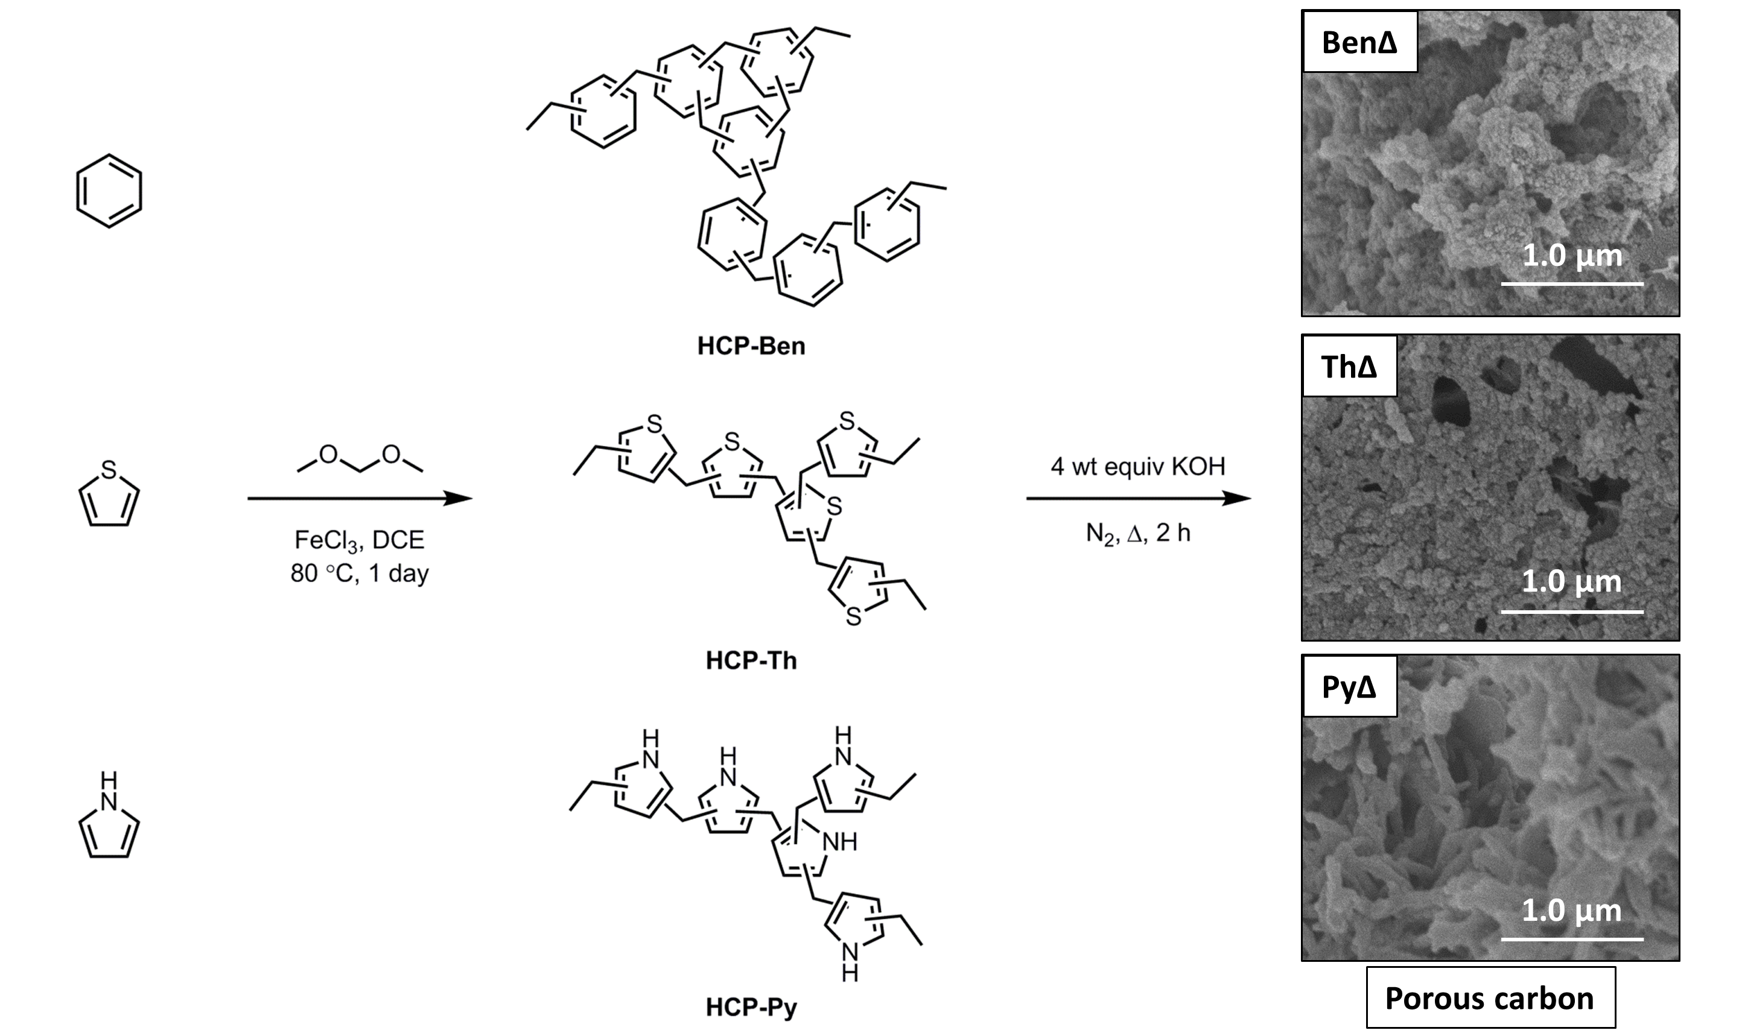
Scheme 1. Synthesis of the hypercrosslinked polymers and the subsequent carbonization method.

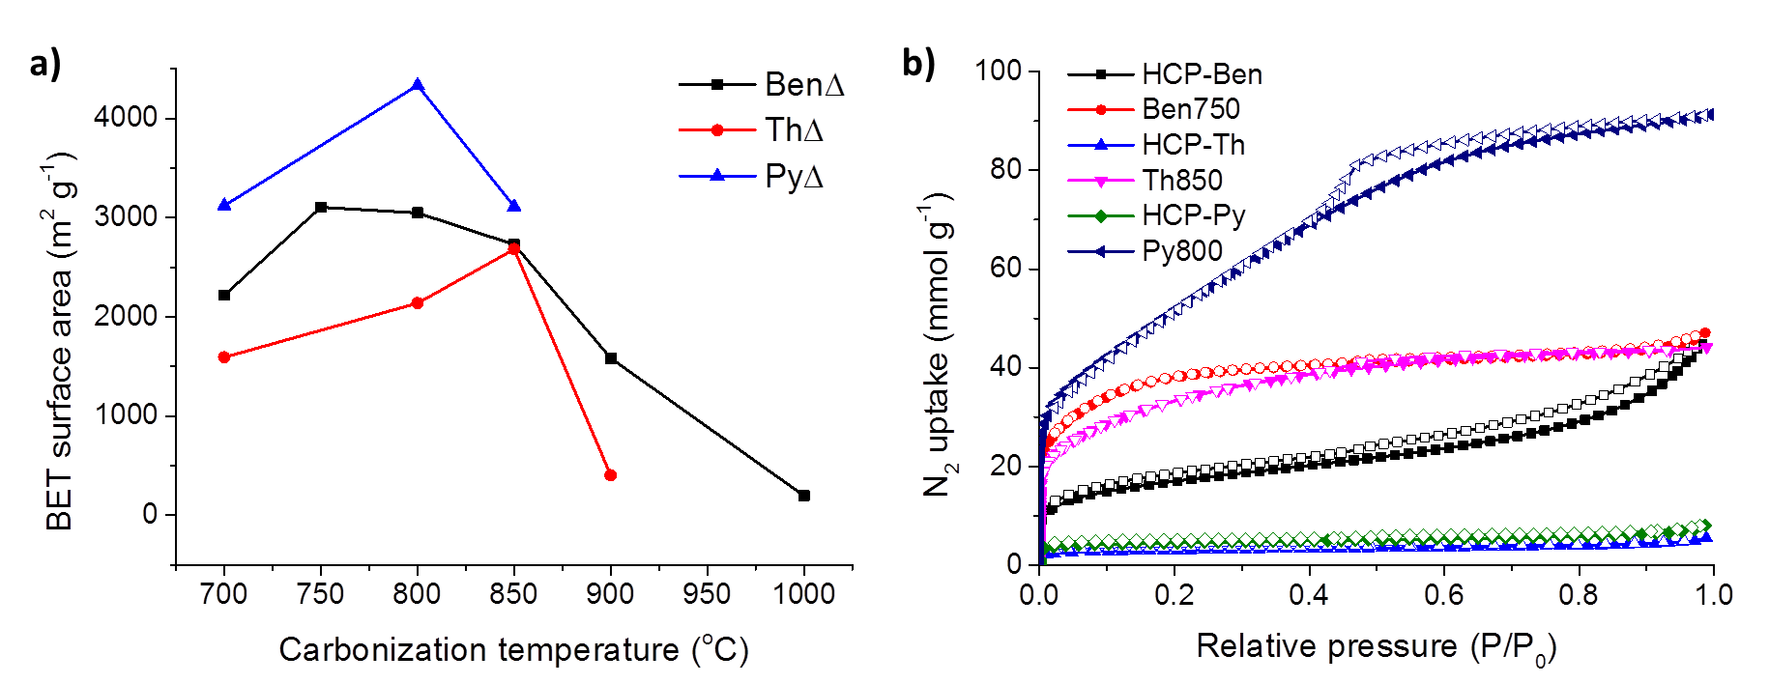
Figure 1. (a) BET surface areas of carbonized HCPs at various temperatures. (b) Nitrogen adsorption-desorption isotherms of HCPs and the porous carbons at 77.3 K (the adsorption and desorption branches are labelled with filled and empty symbols, respectively).

Table 1. Physical properties, CO₂ uptake and H₂ uptake of HCPs and optimized carbons.
 |  | Pore volume^{b)} (cm³ g⁻¹) |  |  | CO₂ uptake^{d)} (mmol g⁻¹) |  | H₂ uptake^{e)} (wt%)
Sample | Surface area ^{a)} | Total pore volume | Micropore volume | Pore size^{c)} (Å) | 1 bar  CO₂ | 10 bar  CO₂ | 1 bar  H₂ | 10 bar  H₂
HCP-Ben | 1382 | 1.52 | 0.40 | 12/15 | 1.6 | - | 1.1 | -
HCP-Th | 484 | 0.33 | 0.22 | 15 | 1.3 | - | 0.9 | -
HCP-Py | 322 | 0.25 | 0.14 | 9 | 2.1 | - | 1.0 | -
Ben750 | 3105 | 1.58 | 1.00 | 11 | 3.3 | 15.6 | 3.0 | 4.0
Th850 | 2682 | 1.51 | 0.70 | 12 | 2.4 | 13.2 | 2.5 | 3.7
Py800 | 4334 | 3.14 | 1.05 | 13/22-47 | 3.5 | 22.0 | 3.6 | 5.6
^{a)} BET surface area; ^{b)} Calculated by single point pore volume; ^{c)} Pore size distribution maxima calculated by NL-DFT; ^{d)} CO₂ uptake at 298 K at various pressures; ^{e)} H₂ uptake at 77.3 K at various pressures.

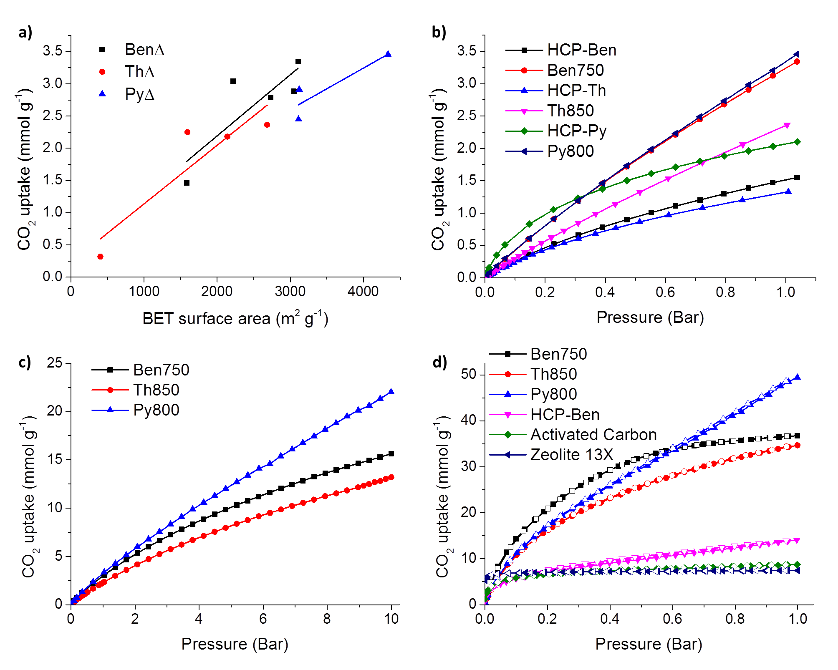
Figure 2. (a) Correlation of CO₂ uptake with BET surface area for carbonized HCPs at 1 bar; (b) CO₂ sorption isotherms at 298 K over pressure range 0 to 1 bar; (c) CO₂ sorption isotherms at 298 K over pressure range of 0 to 10 bar; (d) CO₂ adsorption-desorption isotherms at 195 K and 1 bar (the adsorption and desorption branches are labelled with filled and empty symbols, respectively).

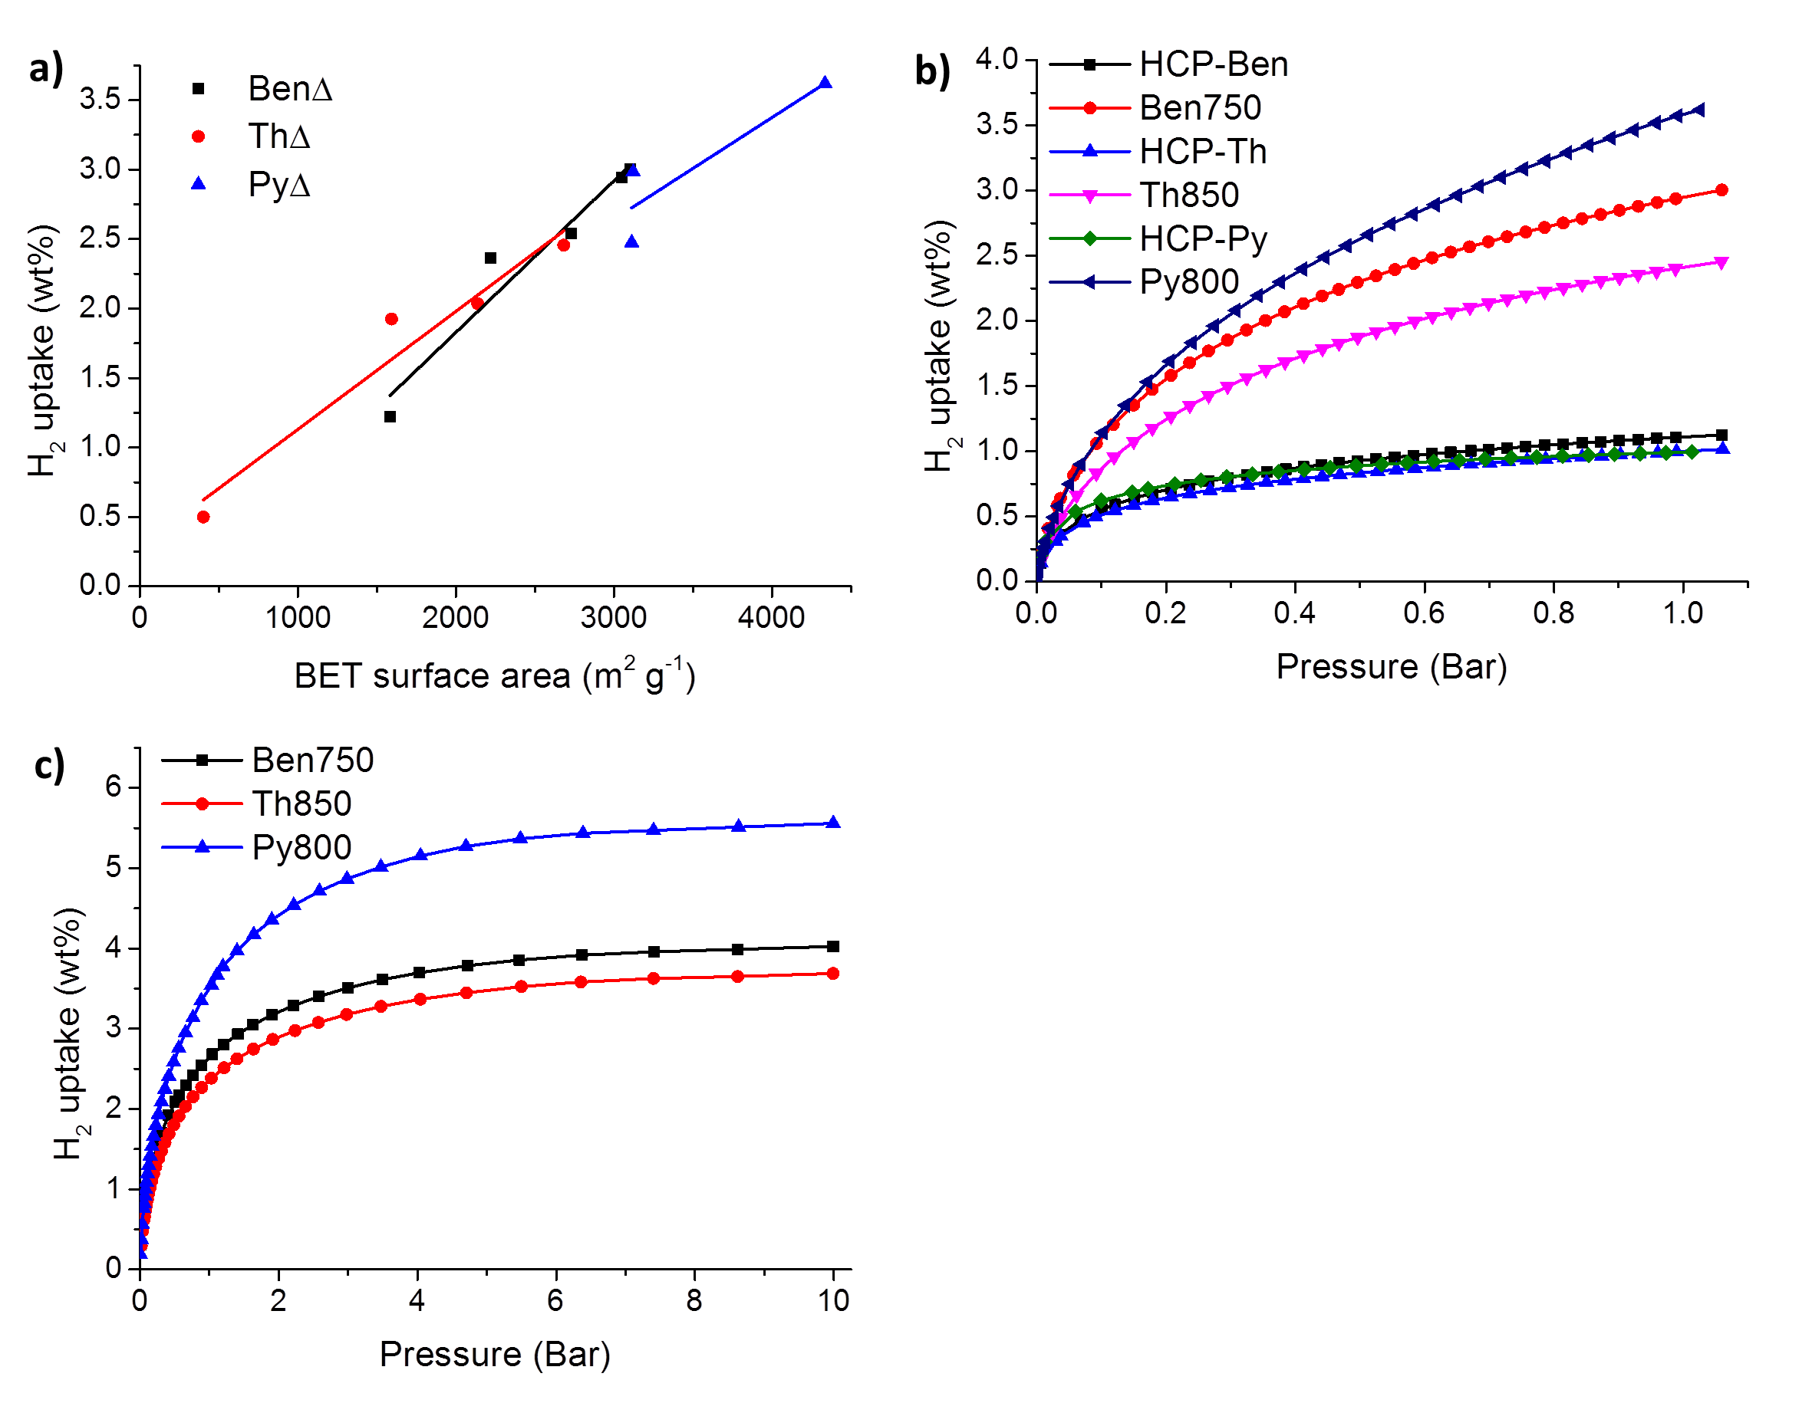
Figure 3. (a) Correlation of H₂ uptake with BET surface area for carbonized HCPs at 1 bar; (b) H₂ sorption isotherms at 77.3 K over pressure range 0 to 1 bar and (c) H₂ sorption isotherms at 77.3 K over pressure range of 0 to 10 bar.
Porous carbons with extremely high surface areas are produced through the carbonization of hypercrosslinked benzene, pyrrole and thiophene. Such carbons show largely microporous and mesoporous domains and exhibit Brunaeur-Emmett-Teller (BET) surface areas up to 4300 m² g⁻¹. The best performing material also displays exceptionally high CO₂ and H₂ uptakes.

Keyword: carbon, porous, hypercrosslinked polymer, carbon dioxide storage, hydrogen storage

J.-S. M. Lee, M. E. Briggs, T. Hasell, A. I. Cooper*

Hyper-Porous Carbons from Hypercrosslinked Polymers



