Review Article
Diagnostic Hematology

Current Pathological and Laboratory Considerations in the Diagnosis of Disseminated Intravascular Coagulation

Running title: Diagnosis of DIC

Cheng-Hock Toh, M.D.^{1,2}, Yasir Alhamdi, Ph.D.¹, and Simon T. Abrams, Ph.D.¹

Institute of Infection and Global Health¹, University of Liverpool; Roald Dahl Haemostasis & Thrombosis Centre², Royal Liverpool University Hospital, Liverpool, United Kingdom

Corresponding author: Cheng-Hock Toh
Roald Dahl Haemostasis & Thrombosis Centre, Royal Liverpool University Hospital, Liverpool, L7 8XP, United Kingdom
Tel: +44-(0)151-795-9637
Fax: +44-(0)151-7065810
E-mail: Toh@liverpool.ac.uk

Abstract

Systemically sustained thrombin generation in vivo is the hallmark of disseminated intravascular coagulation (DIC). Typically, this is in response to a progressing disease state that is associated with significant cellular injury. The etiology could be infectious or noninfectious, with the main pathophysiological mechanisms involving cross-activation among coagulation, innate immunity, and inflammatory responses. This leads to consumption of both pro- and anticoagulant factors as well as endothelial dysfunction and disrupted homeostasis at the blood vessel wall interface. In addition to the release of tissue plasminogen activator (tPA) and soluble thrombomodulin (sTM) following cellular activation and damage, respectively, there is the release of damage-associated molecular patterns (DAMPs) such as extracellular histones and cell-free DNA. Extracellular histones are increasingly recognized as significantly pathogenic in critical illnesses through direct cell toxicity, the promotion of thrombin generation, and the induction of neutrophil extracellular trap (NET) formation. Clinically, high circulating levels of histones and histone–DNA complexes are associated with multiorgan failure, DIC, and adverse patient outcomes. Their measurements as well as that of other DAMPs and molecular markers of thrombin generation are not yet applicable in the routine diagnostic laboratory. To provide a practical diagnostic tool for acute DIC, a composite scoring system using rapidly available coagulation tests is recommended by the International Society on Thrombosis and Haemostasis. Its usefulness and limitations are discussed alongside the advances and unanswered questions in DIC pathogenesis.
Key Words: Disseminated intravascular coagulation, Damage-associated molecular patterns, Molecular markers

Introduction

Normal hemostasis is a well-orchestrated process whereby adequate amounts of thrombin are generated at the site of vascular injury. This results in the formation of a firm stable clot involving tight coordination between pro- and anticoagulant pathways as well as pro- and antifibrinolytic systems to maintain circulatory flow without perturbation from the growing thrombus [1]. These physiological processes are pathologically altered to varying degrees in patients developing disseminated intravascular coagulation (DIC). In DIC, an excess of thrombin is generated and continued by inciting factors to overwhelm the homeostatically controlled hemostatic process (Fig. 1), which can then disseminate systemically [2]. This concept has been taken into consideration by the International Society of Thrombosis and Haemostasis (ISTH) Scientific and Standardization Committee, which defines DIC as “an acquired syndrome characterized by intravascular activation of coagulation with loss of localization arising from different causes. It can originate from and cause damage to the microvasculature, which if sufficiently severe, can produce organ dysfunction” [3]. This statement from collective experts in the field summarizes our understanding of the pathogenic concepts involved and shape our clinical considerations and management.

Pathophysiological considerations

As DIC is an intermediary mechanism of disease from conditions such as sepsis, trauma, obstetrical calamities, or cancer, there will be disease-specific pathogenic factors that influence both coagulation activation and its functional consequences [4]. A major challenge in treating patients with DIC is in identifying the predominant mechanism among the heterogeneous overlapping effects, which can also vary with time. Key themes for the clinician to consider (Fig. 2) include
- The multifaceted role of thrombin generation in vivo
Understanding the diverse and opposing thrombin-orchestrated effects is important in judging and refining management approaches when the fine homeostatic balance of normal thrombin generation is lost in DIC. Thrombin is typically associated with procoagulant properties in cleaving fibrinogen into fibrin and also activating platelets, on which tenase (FIXa/VIIIa) and prothrombinase (FXa/Va) complexes assemble to propagate coagulation [5]. Conversely, thrombin also has anticoagulant properties through thrombomodulin (TM)-dependent protein C (PC) activation, and these mechanisms are well reviewed elsewhere [6]. Equally, thrombin is also pivotal in affecting opposing aspects of fibrinolysis, i.e., promoting through stimulating endothelial cell release of tissue plasminogen activator (tPA) [7] to generate plasmin, and conversely, inhibiting through plasminogen activator inhibitor 1 (PAI-1) [8] induction and thrombin-activatable fibrinolysis inhibitor (TAFI) activity [9]. Whilst the DIC process could consume these different pathway components proportionately, the triggering pathology can influence the rate of thrombin generation and direct its function [10]. One example of disease-specific tailoring of DIC is the significantly more intense coagulant response in early trauma. Together with the extensiveness of endothelial cell activation, the excessive surge in thrombin leads to overdrive of tPA-triggered fibrinolysis and indiscriminate fibrin(ogen)olysis, as observed in a baboon model of DIC following blockade of the PC anticoagulant pathway to enhance thrombin generation [11].
- Concomitant cellular dysfunction, especially in the microcirculation
Cell surfaces and site-specific vascular endothelial features control the processes consequent to thrombin generation [12]. The microvasculature is particularly affected in DIC because of its higher endothelial-cell surface to blood volume ratios [13]. Receptors of the PC pathway, i.e., the endothelial PC receptor (EPCR) and TM, are among the most relevant as both have direct pleiotropic effects on coagulation and inflammation. Activated protein C (APC) when bound to EPCR can directly cleave and activate protease-activated receptor 1 (PAR1) to generate anti-inflammatory, antiapoptotic, and endothelial-barrier-protective effects [14]. These are directly opposite to those generated by thrombin on PAR1 and exemplify the yin-yang balance between thrombin and APC in harmonizing the coagulation and inflammatory processes at the blood-endothelial interface [6]. The lectinlike domain of TM has been implicated in reducing the proinflammatory effects of high-mobility group box protein 1 (HMGB1) released from the nucleus [15]. Consequently, loss of EPCR and TM through receptor shedding or endothelial downregulation in microvessels with low constitutive expression could shift the thrombin–PC axis toward site-specific thrombosis and barrier destabilization. This has been reported in cerebral malaria with DIC [16], especially as Plasmodium falciparum-infected erythrocytes bind EPCR to reduce APC generation [17, 18].
- The overlapping contribution of innate immune activation and inflammation
Significant cross-talk between these components with the coagulant response has been increasingly characterized as immunothrombosis [19, 20]. With cell damage and death common to all the causes of DIC, there is triggering of damage-associated molecular patterns (DAMPs) leading to promotion of thrombin generation [21]. Cross-activation of pathways such as the complement system [22] results in reciprocal escalation causing further cell damage and an increased release of nuclear breakdown products, such as histone–DNA complexes (nucleosomes) and double-stranded DNA [23]. Elevated circulating histone levels occur in patients with DIC [24], and mechanistically, they bind phospholipid surfaces to damage cell membranes [25, 26]. Functional consequences include platelet aggregation and thrombocytopenia [27], thrombi that are more resistant to lysis [28], and vascular leakage as well as a release of proinflammatory cytokines and extracellular traps from leucocytes, especially neutrophils [25]. Referred to as neutrophil extracellular traps (NETs), these are prothrombotic [29] by providing a scaffold for assembling clot components including tissue factor, degrading tissue factor pathway inhibitor (TFPI), and histone-dependent Factor VII-activating protease activity [30] as well as a platelet polyphosphate release [31]. In addition to suppressing TM-dependent PC activation [32], histone 4 can induce prothrombin autoactivation in vitro [33]. Such a mechanism would generate thrombin independently of activation of the coagulation cascade if present in vivo. The infusion of histones in experimental models leads to DIC with the spectrum of hemorrhage and microvascular thrombosis [24, 25]. Blocking histones reduces thrombin generation [25] and ameliorates cardiac dysfunction and acute lung injury in murine models of sepsis [34] and trauma [25], respectively.

The clinical presentations of DIC
In general, physicians tend to consider the possibility of DIC only when there is extensive and uncontrollable bleeding from multiple sites. As mentioned earlier, hybrid pathology with increasing bruising or bleeding and ischemic changes secondary to microvascular thrombosis is characteristic of DIC. Bleeding can be secondary to various reasons including thrombocytopenia, platelet dysfunction, consumption of clotting factors, increased vascular permeability, excessive fibrinolysis, and interference of fibrin degradation products (FDPs) with clot firmness. Thrombosis can be secondary to reduced levels of anticoagulant factors, platelet activation, NETs, histone-induced cell damage, and procoagulant effects. Clinically, this may be subtle, especially with insidious microcirculatory obstruction leading to organ dysfunction.

The laboratory aspects

General principles

DIC is a clinical-laboratory diagnosis, and laboratory changes need to be interpreted with knowledge of the patient’s underlying disorder [35]. In a relevant clinical scenario, several laboratory parameters are analyzed together as part of a diagnostic algorithm that includes prothrombin time (PT), activated partial thromboplastin time (aPTT), the platelet count, fibrinogen level, and a marker of fibrin degradation, e.g., D-dimer or the soluble fibrin monomer (SFM) [35]. None of these markers are taken in isolation, and a combination of results at different time points is particularly helpful in determining the presence of DIC (Table 1). It must also be emphasized that certain profiles may be more indicative of certain pathological mechanisms, e.g., hyperfibrinolysis is typically characterized by very low fibrinogen levels with very high concentrations of FDPs.

Composite scoring systems

The ISTH scoring system of routine global coagulation tests provides a framework for diagnosing DIC that also standardizes criteria for clinical studies. This is now well validated in different settings, and a cumulative score of 5 or more from increased PT, reduced platelet counts and fibrinogen levels, together with elevated FDPs forming the basis of our approach [36]. There are country-specific refinements [37], which similarly confirm the independent prediction of mortality by the ISTH DIC score and its added prognostic value to the Acute Physiology and Chronic Health Evaluation (APACHE) II system [4, 38]. Specific caveats for the individual parameters are discussed in the sections below, and our practice relies on a high index of suspicion for increasing abnormalities, with particular emphasis on serial monitoring. Conceptually, this is encapsulated as “nonovert DIC” by the ISTH, where subtle hemostatic dysfunction could provide forewarning of an overt DIC process [3]. Indeed, several studies have shown how scoring for abnormal trends in PT, platelets, and/or _{D}-dimer has identified patients deteriorating clinically with new organ failure [39-41]. Clinicians and laboratory staff who are caring for critically ill patients with disorders that can potentially trigger DIC (e.g., sepsis, trauma, malignancy, and certain obstetrical conditions) should be vigilant to this aspect of management. The presence of “normal” values for PT, platelets, and/or _{D}-dimers in such patients upon admission should not mean the end of monitoring of these parameters. Awareness of the possibility of DIC should trigger serial monitoring of these parameters, and other measurements may be requested to confirm nonovert DIC (see the section below). This strategy provides a safeguard for the early recognition of DIC in such patients, with a major impact on management and prognosis.

Specific test considerations

There are certain caveats in interpreting results from the recommended tests:

1. PT and aPTT

In general, physicians only consider a diagnosis of DIC when the PT and aPTT are considerably prolonged. Since aPTT can be shortened owing to increased Factor VIII levels from the acute phase response, aPTT prolongation may lag behind the clinical manifestations [42]. There is also the potential influence of heparin and the considerable variation in sensitivity of aPTT reagents [43]. As such, the ISTH DIC Subcommittee recommends PT as the coagulation test of choice [36, 44], and in laboratories where PT in seconds is not reported, the international normalized ratio (INR) could provide reliable information [45]. Although the different sensitivities of thromboplastin reagents to coagulation defects induced by DIC and vitamin K antagonists need to be considered, the use of human recombinant thromboplastins generally negates these differences. Even with the greater variability of tissue-derived thromboplastins, the conversion into a limited point range from 0 to 2 within the ISTH scoring system minimizes any variation among thromboplastins [45]. It is also important to recognize that prolonged PT in DIC may also be due to other etiologies such as vitamin K deficiency or liver disease, which may not improve with treatment of DIC.

2. Platelet count

Thrombocytopenia is the commonest laboratory diagnostic feature of DIC [42] but may also be due to drugs, hemodilution, marrow failure, splenomegaly, or infections [46]. In DIC, platelet activation can be a source of inaccuracy when using automated platelet counting [47]. Thrombocytopenia in DIC is often accompanied by abnormal platelet function with functional defects enhancing the bleeding risk and heightened platelet aggregation [48], with a release of procoagulant components able to promote thrombosis. The finding that the von Willebrand factor-cleaving protease ADAMTS-13 (a disintegrin and metalloproteinase with a thrombospondin type 1 motif, member 13) can be reduced in patients with DIC [49] may be particularly relevant in the latter scenario and has been linked to organ dysfunction, especially renal impairment [50]. Furthermore, thrombocytopenia is but one snapshot of the vicious cycle of events that could be histone mediated in amplifying cell death and dysfunction and propagating thrombin generation. In intensive-care settings, high levels of circulating histones on admission are significantly associated with the development of subsequent moderate-to-severe thrombocytopenia [51]. Of interest is the likelihood of multicomponent interaction in vivo involving NETs as activated platelets can also stimulate NETosis [52]. This needs careful consideration ahead of transfusing platelets purely on the basis of the count, especially as there is now evidence that this could promote thrombosis and death in consumptive disorders [53].

3. Fibrinogen level

Rather than a low absolute value, e.g., less than 1 g/L, which has a low sensitivity (22%) and high specificity (100%) for DIC [54], we tend to give importance to a decreasing fibrinogen level as it is also an acute-phase reactant [44]. It is important that the laboratory use a Clauss fibrinogen assay with awareness that the presence of high FDPs can interfere with clot endpoints and artefactually lower fibrinogen estimates [55].

4. Fibrin-related markers

As prolonged PT and thrombocytopenia are also seen in liver disease, the finding of elevated levels of biomarkers of fibrin formation can help to diagnose DIC. In terms of which fibrin-related marker to use, SFM is theoretically a better early indicator of coagulation activation in reflecting the intravascular action of thrombin on fibrinogen [56]. This appears to hold true in intensive care settings: with SFM being more sensitive than FDPs or _{D}-dimer in detecting early abnormalities in PT and platelet counts. However, the downstream markers of fibrin formation, i.e., FDP and _{D}-dimer, are more statistically significant than SFM in distinguishing sepsis from systemic inflammatory response syndrome [56]. In general, _{D}-dimer estimates are more readily available in most hospital laboratories and better standardized in view of their usefulness in excluding venous thromboembolic disease [57]. Nonetheless, different commercial assays have different normal ranges, which are not interchangeable. For _{D}-dimer cutoff levels in DIC scoring, we recommend that individual laboratories assign scores for moderate and strong elevation based on 25% and 75% quartiles derived from samples from intensive-care patients [58]. A further consideration is in monitoring _{D}-dimer elevation as accuracy may be an issue, because most assays have been developed for their negative predictive value in excluding venous thromboembolism. Clinicians should also be aware that increasing levels may be from renal and/or liver impairment affecting clearance [59].

Other measurements

Besides the above-described tests, several other markers have been proposed as useful in diagnosing DIC. Most of these molecular markers, e.g., thrombin-antithrombin (TAT) complexes and prothrombin fragment₁₊₂, are available only in specialized laboratories and even then are not routinely performed and standardized to this setting.

Protein C and antithrombin (AT)

Significant reductions in these endogenous anticoagulants correlate with DIC severity and adverse outcomes [60-62]. However, their sensitivity for early DIC is unclear as DIC is usually obvious from the global coagulation tests when levels are below 50% of normal [61]. Indeed, worsening trends in PT, platelets, and _{D}-dimer provide sufficient robustness without needing PC or AT levels [39]. Large clinical studies have also shown that it is not PC/AT but PT and _{D}-dimer changes that significantly relate to mortality when analyzed as continuous variables [41].

Thromboelastography

With automation of theomboelastography (TEG) to provide point-of-care assessment of coagulation, there is a potential for real-time assessment of a more comprehensive picture of the hemostatic condition [63]. In DIC, Sivula et al [64] identified hypocoagulation in patients with overt DIC, while those without DIC showed hypercoagulation. However, both hyper- and hypocoagulability TEG changes have been linked with adverse clinical events in DIC-relevant diseases [65], and a systematic review of TEG in sepsis confirmed this variability [66]. Often, the values fall within normal reference ranges, and the overall superiority of these tests over conventional tests in DIC has not been proven. Only in cardiac surgery is the use of TEG sufficiently cost and clinically effective. As such, we do not routinely use TEG in DIC and await results from large prospective trials.

Potential assays

With the increasing relevance of DAMPs in the cross-talk among coagulation, inflammation, and innate immunity, levels of circulating histones and histone–DNA complexes as well as double-stranded cell-free DNA could have translational relevance in patients with DIC. In 199 patients with suspected DIC, histone–DNA complexes and cell-free DNA levels correlated with the severity of DIC scores [23]. Levels were also significantly higher in nonsurvivors as compared to survivors. As to circulating histones, their direct infusion into mice at high doses induces features of DIC [24]. However, no clinical studies have yet shown their value as diagnostic or prognostic markers in human DIC. Future work is therefore warranted.

Conclusion

While coagulation activation is its hallmark, our perspective of DIC is that it is indicative of when the host response changes from being protective to becoming maladaptive with potentially lethal consequences. This is because the presence of DIC increases the chances of mortality beyond those of the primary disease. As such, its early recognition with disease-specific targeting provides the best chance of a successful outcome. With its dynamic progression and varying manifestations (Fig. 2), DIC is not a condition whereby the specialist in coagulation can deal with the patient in isolation or remotely from the laboratory. We are a part of a multispecialty clinical team that provides critical care support in decision-making around bleeding and thrombotic risks and benefits from interventions.

Authors’ Disclosures of Potential Conflicts of Interest
No potential conflicts of interest relevant to this article were reported.

References

1 Crawley JT, Zanardelli S, Chion CK, Lane DA. The central role of thrombin in hemostasis. J Thromb Haemost 2007;5(S1):95-101.
2 Taylor FB Jr, Wada H, Kinasewitz G. Description of compensated and uncompensated disseminated intravascular coagulation (DIC) responses (non-overt and overt DIC) in baboon models of intravenous and intraperitoneal Escherichia coli sepsis and in the human model of endotoxemia: toward a better definition of DIC. Crit Care Med 2000;28(9S):S12-9.
3 Taylor FB Jr, Toh CH, Hoots WK, Wada H, Levi M; Scientific Subcommittee on Disseminated Intravascular Coagulation of the International Society on Thrombosis and Haemostasis. Towards definition, clinical and laboratory criteria, and a scoring system for disseminated intravascular coagulation. Thromb Haemost 2001;86:1327-30.
4 Bakhtiari K, Meijers JC, de Jonge E, Levi M. Prospective validation of the International Society of Thrombosis and Haemostasis scoring system for disseminated intravascular coagulation. Crit Care Med 2004;32:2416-21.
5 Kjalke M, Monroe DM, Hoffman M, Oliver JA, Ezban M, Roberts HR. Active site-inactivated factors VIIa, Xa, and IXa inhibit individual steps in a cell-based model of tissue factor-initiated coagulation. Thromb Haemost 1998;80:578-84.
6 Rezaie AR. Regulation of the protein C anticoagulant and antiinflammatory pathways. Curr Med Chem 2010;17:2059-69.
7 Levin EG, Marzec U, Anderson J, Harker LA. Thrombin stimulates tissue plasminogen activator release from cultured human endothelial cells. J Clin Invest 1984;74:1988-95.
8 Gelehrter TD and Sznycer-Laszuk R. Thrombin induction of plasminogen activator-inhibitor in cultured human endothelial cells. J Clin Invest 1986;77:165-9.
9 Wang W, Boffa MB, Bajzar L, Walker JB, Nesheim ME. A study of the mechanism of inhibition of fibrinolysis by activated thrombin-activable fibrinolysis inhibitor. J Biol Chem 1998;273:27176-81.
10 Satta N, Toti F, Feugeas O, Bohbot A, Dachary-Prigent J, Eschwège V, et al. Monocyte vesiculation is a possible mechanism for dissemination of membrane-associated procoagulant activities and adhesion molecules after stimulation by lipopolysaccharide. J Immunol 1994;153:3245-55.
11 Taylor FB Jr, Hoogendoorn H, Chang AC, Peer G, Nesheim ME, Catlett R, et al. Anticoagulant and fibrinolytic activities are promoted, not retarded, in vivo after thrombin generation in the presence of a monoclonal antibody that inhibits activation of protein C. Blood 1992;79:1720-8.
12 Aird WC. Endothelium and haemostasis. Hamostaseologie 2015;35:11-6.
13 Monahan-Earley R, Dvorak AM, Aird WC. Evolutionary origins of the blood vascular system and endothelium. J Thromb Haemost 2013;11(Sl):46-66.
14 Riewald M, Petrovan RJ, Donner A, Mueller BM, Ruf W. Activation of endothelial cell protease activated receptor 1 by the protein C pathway. Science 2002; 296:1880-2.
15 Abeyama K, Stern DM, Ito Y, Kawahara K, Yoshimoto Y, Tanaka M, et al. The N-terminal domain of thrombomodulin sequesters high-mobility group-B1 protein, a novel antiinflammatory mechanism. J Clin Invest 2005;115:1267-74.
16 Moxon CA, Chisala NV, Mzikamanda R, MacCormick I, Harding S, Downey C, et al. Laboratory evidence of disseminated intravascular coagulation is associated with a fatal outcome in children with cerebral malaria despite an absence of clinically evident thrombosis or bleeding. J Thromb Haemost 2015;13:1653-64.
17 Moxon CA, Wassmer SC, Milner DA Jr, Chisala NV, Taylor TE, Seydel KB, et al. Loss of endothelial protein C receptors links coagulation and inflammation to parasite sequestration in cerebral malaria in African children. Blood 2013;122:842-51.
18 Turner L, Lavstsen T, Berger SS, Wang CW, Petersen JE, Avril M, et al. Severe malaria is associated with parasite binding to endothelial protein C receptor. Nature 2013;498:502-5.
19 Engelmann B and Massberg S. Thrombosis as an intravascular effector of innate immunity. Nat Rev Immunol 2013;13:34-45.
20 Esmon CT, Xu J, Lupu F. Innate immunity and coagulation. J Thromb Haemost 2011;9(S1):182-8.
21 Ito T. PAMPs and DAMPs as triggers for DIC. J Intensive Care 2014;2:67.
22 Conway EM. Reincarnation of ancient links between coagulation and complement. J Thromb Haemost 2015;13(S1):S121-32.
23 Kim JE, Lee N, Gu JY, Yoo HJ, Kim HK. Circulating levels of DNA-histone complex and dsDNA are independent prognostic factors of disseminated intravascular coagulation. Thromb Res 2015;135:1064-9.
24 Nakahara M, Ito T, Kawahara K, Yamamoto M, Nagasato T, Shrestha B, et al. Recombinant thrombomodulin protects mice against histone-induced lethal thromboembolism. PLoS One 2013;8:e75961.
25 Abrams ST, Zhang N, Manson J, Liu T, Dart C, Baluwa F, et al. Circulating histones are mediators of trauma-associated lung injury. Am J Respir Crit Care Med 2013;187:160-9.
26 Alhamdi Y, Zi M, Abrams ST, Liu T, Su D, Welters I, et al. Circulating histone concentrations differentially affect the predominance of left or right ventricular dysfunction in critical illness. Crit Care Med 2016;44:e278-88.
27 Fuchs TA, Bhandari AA, Wagner DD. Histones induce rapid and profound thrombocytopenia in mice. Blood 2011;118:3708-14.
28 Longstaff C, Varjú I, Sótonyi P, Szabó L, Krumrey M, Hoell A, et al. Mechanical stability and fibrinolytic resistance of clots containing fibrin, DNA, and histones. J Biol Chem 2013;288: 6946-56.
29 Martinod K and Wagner DD. Thrombosis: tangled up in NETs. Blood 2014; 123:2768-76.
30 Yamamichi S, Fujiwara Y, Kikuchi T, Nishitani M, Matsushita Y, Hasumi K. Extracellular histone induces plasma hyaluronan-binding protein (factor VII activating protease) activation in vivo. Biochem Biophys Res Commun 2011;409: 483-8.
31 Semeraro F, Ammollo CT, Morrissey JH, Dale GL, Friese P, Esmon NL, et al. Extracellular histones promote thrombin generation through platelet-dependent mechanisms: involvement of platelet TLR2 and TLR4. Blood 2011;118:1952-61.
32 Ammollo CT, Semeraro F, Xu J, Esmon NL, Esmon CT. Extracellular histones increase plasma thrombin generation by impairing thrombomodulin-dependent protein C activation. J Thromb Haemost 2011;9:1795-803.
33 Barranco-Medina S, Pozzi N, Vogt AD, Di Cera E. Histone H4 promotes prothrombin autoactivation. J Biol Chem 2013;288:35749-57.
34 Alhamdi Y, Abrams ST, Cheng Z, Jing S, Su D, Liu Z, et al. Circulating histones are major mediators of cardiac injury in patients with sepsis. Crit Care Med 2015;43:2094-103.
35 Levi M, Toh C, Thachil J, Watson HG. Guidelines for the diagnosis and management of disseminated intravascular coagulation. Br J Haematol 2009;145:24-33.
36 Toh CH, Hoots WK; SSC on Disseminated Intravascular Coagulation of the ISTH. The scoring system of the Scientific and Standardisation Committee on Disseminated Intravascular Coagulation of the International Society on Thrombosis and Haemostasis: a 5-year overview. J Thromb Haemost 2007;5:604-6.
37 Gando S, Saitoh D, Ogura H, Fujishima S, Mayumi T, Araki T, et al. A multicenter, prospective validation study of the Japanese Association for Acute Medicine disseminated intravascular coagulation scoring system in patients with severe sepsis. Crit Care 2013;17:R111.
38 Wada H, Gabazza EC, Asakura H, Koike K, Okamoto K, Maruyama I, et al. Comparison of diagnostic criteria for disseminated intravascular coagulation (DIC): diagnostic criteria of the International Society of Thrombosis and Hemostasis and of the Japanese Ministry of Health and Welfare for overt DIC. Am J Hematol 2003;74: 17-22.
39 Toh CH and Downey C. Performance and prognostic importance of a new clinical and laboratory scoring system for identifying non-overt disseminated intravascular coagulation. Blood Coagul Fibrinolysis 2005;16:69-74.
40 Kinasewitz GT, Zein JG, Lee GL, Nazir SA, Taylor FB Jr. Prognostic value of a simple evolving disseminated intravascular coagulation score in patients with severe sepsis. Crit Care Med 2005;33:2214-21.
41 Dhainaut JF, Shorr AF, Macias WL, Kollef MJ, Levi M, Reinhart K, et al. Dynamic evolution of coagulopathy in the first day of severe sepsis: relationship with mortality and organ failure. Crit Care Med 2005;33:341-8.
42 Levi M and Meijers JC. DIC: which laboratory tests are most useful. Blood Rev 2011;25:33-7.
43 Kitchen S, Cartwright I, Woods TA, Jennings I, Preston FE. Lipid composition of seven APTT reagents in relation to heparin sensitivity. Br J Haematol 1999;106:801-8.
44 Wada H, Thachil J, Di Nisio M, Mathew P, Kurosawa S, Gando S, et al. Guidance for diagnosis and treatment of DIC from harmonization of the recommendations from three guidelines. J Thromb Haemost 2013;11:761-7.
45 Kim HK, Hong KH, Toh CH; Scientific and Standardization Committee on DIC of The International Society on Thrombosis and Haemostasis. Application of the international normalized ratio in the scoring system for disseminated intravascular coagulation. J Thromb Haemost 2010;8:1116-8.
46 Thiele T, Selleng K, Selleng S, Greinacher A, Bakchoul T. Thrombocytopenia in the intensive care unit-diagnostic approach and management. Semin Hematol 2013;50:239-50.
47 Kim SY, Kim JE, Kim HK, Han KS, Toh CH. Accuracy of platelet counting by automated hematologic analyzers in acute leukemia and disseminated intravascular coagulation: potential effects of platelet activation. Am J Clin Pathol 2010;134:634-47.
48 Yaguchi A, Lobo FL, Vincent JL, Pradier O. Platelet function in sepsis. J Thromb Haemost 2004;2:2096-102.
49 Hyun J, Kim HK, Kim JE, Lim MG, Jung JS, Park S, et al. Correlation between plasma activity of ADAMTS-13 and coagulopathy, and prognosis in disseminated intravascular coagulation. Thromb Res 2009;124:75-9.
50 Ono T, Mimuro J, Madoiwa S, Soejima K, Kashiwakura Y, Ishiwata A, et al. Severe secondary deficiency of von Willebrand factor-cleaving protease (ADAMTS13) in patients with sepsis-induced disseminated intravascular coagulation: its correlation with development of renal failure. Blood 2006;107:528-34.
51 Alhamdi Y, Abrams ST, Lane S, Wang G, Toh CH. Histone-associated thrombocytopenia in patients who are critically ill. JAMA 2016;315:817-9.
52 Caudrillier A, Kessenbrock K, Gilliss BM, Nguyen JX, Marques MB, Monestier M, et al. Platelets induce neutrophil extracellular traps in transfusion-related acute lung injury. J Clin Invest 2012;122:2661-71.
53 Goel R, Ness PM, Takemoto CM, Krishnamurti L, King KE, Tobian AA. Platelet transfusions in platelet consumptive disorders are associated with arterial thrombosis and in-hospital mortality. Blood 2015;125:1470-6.
54 Yu M, Nardella A, Pechet L. Screening tests of disseminated intravascular coagulation: guidelines for rapid and specific laboratory diagnosis. Crit Care Med 2000;28:1777-80.
55 Mackie IJ, Kitchen S, Machin SJ, Lowe GD; Haemostasis and Thrombosis Task Force of the British Committee for Standards in Haematology. Guidelines on fibrinogen assays. Br J Haematol 2003;121:396-404.
56 Toh JM, Ken-Dror G, Downey C, Abrams ST. The clinical utility of fibrin-related biomarkers in sepsis. Blood Coagul Fibrinolysis 2013;24:839-43.
57 Nieuwenhuizen W. A reference material for harmonisation of D-dimer assays. Fibrinogen Subcommittee of the Scientific and Standardization Committee of the International Society of Thrombosis and Haemostasis. Thromb Haemost 1997;77: 1031-3.
58 Dempfle CE, Wurst M, Smolinski M, Lorenz S, Osika A, Olenik D, et al. Use of soluble fibrin antigen instead of D-dimer as fibrin-related marker may enhance the prognostic power of the ISTH overt DIC score. Thromb Haemost 2004;91:812-8.
59 Olson JD. D-dimer: An overview of hemostasis and fibrinolysis, assays, and clinical applications. Adv Clin Chem 2015;69:1-46.
60 Choi Q, Hong KH, Kim JE, Kim HK. Changes in plasma levels of natural anticoagulants in disseminated intravascular coagulation: high prognostic value of antithrombin and protein C in patients with underlying sepsis or severe infection. Ann Lab Med 2014;34:85-91.
61 Koyama K, Madoiwa S, Nunomiya S, Koinuma T, Wada M, Sakata A, et al. Combination of thrombin-antithrombin complex, plasminogen activator inhibitor-1, and protein C activity for early identification of severe coagulopathy in initial phase of sepsis: a prospective observational study. Crit Care 2014;18:R13.
62 Gando S, Kameue T, Nanzaki S, Nakanishi Y. Disseminated intravascular coagulation is a frequent complication of systemic inflammatory response syndrome. Thromb Haemost 1996;75:224-8.
63 Dempfle CE and Borggrefe M. Point of care coagulation tests in critically ill patients. Semin Thromb Hemost 2008;34:445-50.
64 Sivula M, Pettilä V, Niemi TT, Varpula M, Kuitunen AH. Thromboelastometry in patients with severe sepsis and disseminated intravascular coagulation. Blood Coagul Fibrinolysis 2009;20:419-26.
65 Haase N, Ostrowski SR, Wetterslev J, Lange T, Møller MH, Tousi H, et al. Thromboelastography in patients with severe sepsis: a prospective cohort study. Intensive Care Med 2015;41:77-85.
66 Müller MC, Meijers JC, Vroom MB, Juffermans NP. Utility of thromboelastography and/or thromboelastometry in adults with sepsis: a systematic review. Crit Care 2014;18:R30.

Table 1. Disseminated intravascular coagulation (DIC) International Society of Thrombosis and Haemostasis (ISTH) scoring criteria

1. In a patient with an underlying disorder that is associated with overt DIC, obtain results from the global coagulation tests (prothrombin time, platelet count, fibrinogen, and a fibrin-related marker).

2. Score the test results:
- Platelet count (≥ 100: 0, < 100: 1, < 50: 2)

- Elevated levels of a fibrin-related marker, e.g., _{D}-dimer, fibrin degradation products (no increase = 0, moderate increase = 2, strong increase = 3)

- Prolonged prothrombin time (< 3 seconds: 0, ≥ 3 but < 6 seconds: 1, ≥ 6 seconds: 2)

- Fibrinogen level (≥ 1 g/L: 0, < 1 g/L: 1)
3. Calculate the score:
- ≥ 5 compatible with overt DIC: repeat scoring daily

- < 5 suggestive of nonovert DIC: repeat scoring daily

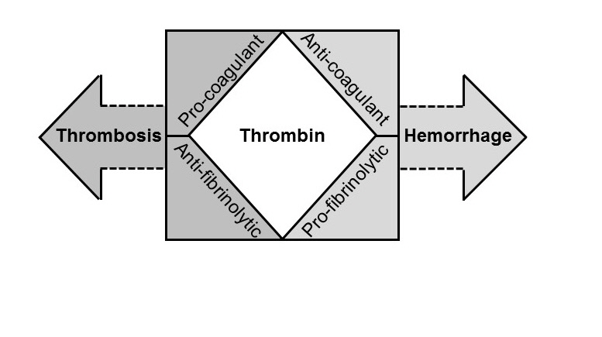

Fig. 1. Diverse and opposing effects of thrombin.

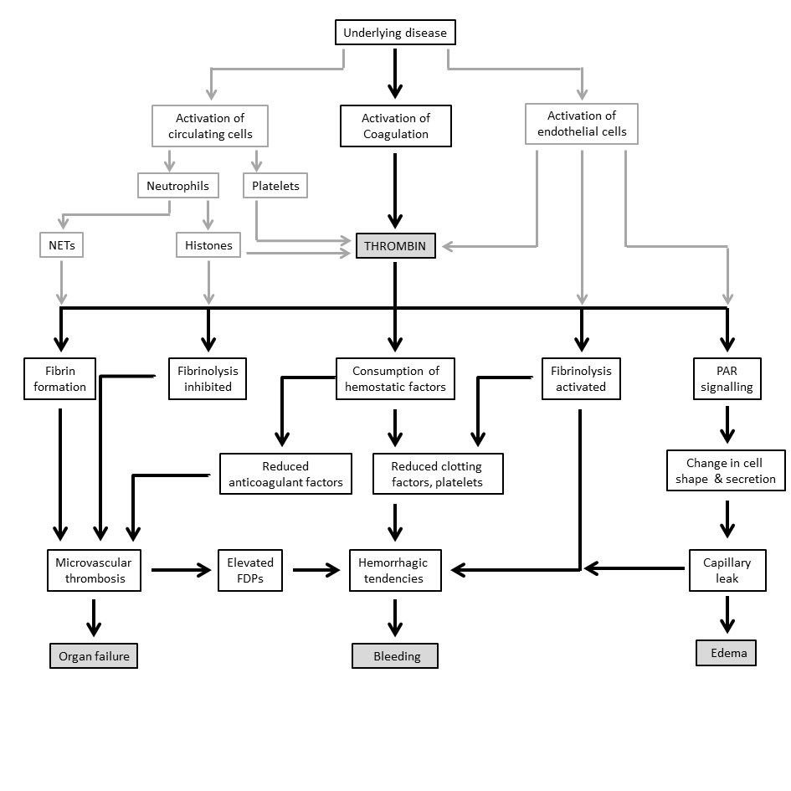

Fig. 2. Pathophysiological considerations in the clinical presentation of DIC. Systemic activation of coagulation together with cellular activation (endothelial cells, neutrophils, and platelets) leads to excessive thrombin generation and its functional consequences.
Abbreviations: FDP, fibrin degradation products; NETs, neutrophil extracellular traps; PAR, protease-activated receptor.

